-

ECC Report 206

Compatibility studies in the band 5725-5875 MHz between SRD equipment for wireless industrial applications and other systems
Approved 31 January 2014

Executive summary

This report investigates the possible deployment of Wireless Industrial Applications (WIA) using technologies different from Ultra-Wide Band in the frequency range 5725 to 5875 MHz and their possible impact on the others systems and services allocated/identified in this and adjacent frequency ranges. Those wireless industrial applications are intended to be operated in the frequency range 5725 to 5875 MHz and are further described in ETSI TR 102 889-2 0.
Industrial applications require "robust" wireless technologies to be used for their critical wireless links in industrial environments. Wireless applications allow savings of often complex and expensive cables, cable protection and plugs, and offer an increased mobility and flexibility as well as the wear and tear free transmission medium. These advantages are particularly high in the area of:
- monitoring and mobile worker communication;
- wireless sensors and actuators at moving parts;
- setups that require flexibility in terms of tool or machine reconfigurations.
The current regulations allow the deployment of SRDs in the frequency range from 5725 to 5875 MHz but limited to 25 mW while WIA are planned to be operated at 400 mW.
Relating to the channel utilization, it was noted that a factory using WIA would need 76 MHz to operate on a given site, however since part of this 76 MHz may not be available for WIA usage due to other possible users (RTTT, BFWA…), there would be a need to identify more than 76 MHz for WIA in order to ensure that they can be operated. Therefore, for some of the compatibility studies, the WIA was assumed to have access to the whole spectrum 5725 to 5875 MHz.
It should be noted that WIA with a maximum e.i.r.p. of 400 mW limited to indoor deployment (assuming
15 dB attenuation for the wall loss and similar device quantities) would have an impact on the others services/systems similar to the impact resulting from SRD devices deployed outdoor according to the existing regulations (25 mW). Therefore, an indoor restriction may be seen as equivalent to the existing regulations and thus sufficient for the protection of others services/systems.
Independent on the above consideration, the Table below provides an overview of the conducted study results.
Table 1: Summary of the compatibility studies
Service/Systems | Results | Comments
Radiolocation  5.725-5.850 GHz | Large separation distances are required under worst case assumptions without mitigation technique.  Thus, DFS/DAA is required with the following detection thresholds:  - -65 dBm in 1 MHz  - -60.5 dBm in 3 MHz  - -52 dBm in 20 MHz  The adjacent band coexistence appears possible.  Note 1, Note 4 | A DAA mitigation technique that is fully in operation at all times is mandatory. This must be ensured by the manufacturers of the WIA devices. Moreover, as the frequency band in question is dedicated to military services in some European countries, thus further reaching restrictions may apply.  DFS as developed for WLAN and BFWA does not allow detecting all types of radars (cf. e.g. ECC Report 192 [34] ). Recommendation ITU-R M.1638 [6], which lists the radar characteristics for the 5 GHz range, is under revision in ITU WP 5B. Due to the ongoing process this report at hand does not encompass all types of radars.  Part of the spectrum may be blocked by radars
RTTT  5.795-5.805 GHz,  5.805-5.815 GHz (used by some administrations) | No interference is expected in the case of OBU RTTT.  In the case of RTTT RSU the separation distances without DAA mitigation techniques are depending on the environment:  - Urban environment 100 m  - Suburban environment 1000 m  - Rural environment 2500 m  DAA mitigation techniques were not studied but the same threshold as for ITS may be considered.  Note 2, Note 4
BFWA  5.725-5.875 GHz | The separation distances without DAA mitigation techniques are depending on the environment:  - Urban environment no separation distance required  - Suburban environment less than 3 km  - Rural environment between 3 km (C/I criterion) and  10 km (I/N criterion)  Thus, DAA with a threshold of -99 dBm on WIA device level is required in suburban and rural environments.  Note 1, Note 2, Note 3, Note 4, Note 5
FSS  5725-5875 MHz | The deployment of WIA is compatible with FSS if TPC  (based on a minimum power strategy) is implemented and the assumptions on the number of devices are met  (see Table 52)
Radio Amateur Service  5725-5850 MHz | Under worst case assumptions, separation distances may be needed. Considering more realistic cases, the separation distances are significantly reduced.  Note 2 | It should be noted that the most sensitive amateur service operations are globally harmonised at 5760-5762 MHz
Radio Amateur Satellite Service  5830-5850 MHz | No interference is expected.  Note 2.
ITS  5855-5875 MHz | Required separation distances without DAA mitigation techniques are depending on the environment:  - Urban environment 100 m  - Rural environment 2500 m  Thus, DAA with a threshold of -85 dBm on WIA device level is required.  Note 1, Note 2, Note 3, Note 4, Note 5
Non Specific SRD  5725-5875 MHz | Under worst cases assumptions, separation distances may be needed. Considering a realistic case, no separation distance is needed | Limited information on the SRDs deployed in the band was provided
Note 1: DFS/DAA on device level may not be possible for all WIA applications. Further developments may show automated solutions so that a sensing procedure may be able to coordinate centralized the spectrum.
Note 2: Due to the fact that TPC was found necessary to meet the FSS protection criterion, TPC was assumed when conducting the compatibility studies.
Note 3: Higher threshold would be possible with the use of centralized sensing.
Note 4: A registration/ notification / light licensing procedure for WIA could help in enforcing the required separation distances (e.g. to tolling bridges, RTTT).
Note 5: If both systems (interferer and victim) are based on IEEE 802.11, coexistence between those systems might be possible using an updated CSMA/CA protocol. However, this is still to be demonstrated.

TABLE OF CONTENTS

0 Executive summary 2
1 Introduction 9
2 Overview of industrial applications using technologies different from Ultra-WideBand (UWB) 10
2.1 Manufacturing Cell or subunit automation 10
2.2 Factory hall (or plant subunit) automation 11
2.3 Plant level wide applications 11
2.4 Operation of the three classes 12
3 SERVICES and systems IN THE BAND 5725-5875 MHZ 15
3.1 Radiolocation Service 17
3.1.1 Technical characteristics 17
3.1.2 Operational characteristics of Radiolocation systems 17
3.1.3 Protection criteria 18
3.2 Road Transport and Traffic Telematics (RTTT) Systems 20
3.2.1 Parameters 20
3.2.2 Protection Criteria 22
3.3 Fixed Service 22
3.3.1 Point-to-Point Links 23
3.3.2 Broadband Fixed Wireless Access (BFWA) Systems 23
3.3.2.1 BFWA Parameters 23
3.4 FIXED SATELLITE (E-S) SERVICE (FSS) 26
3.5 AMATEUR AND AMATEUR-SATELLITE (S-E) SERVICES 27
3.5.1 Characteristics for the Amateur Service 27
3.5.2 Characteristics for the Amateur-Satellite Service 28
3.6 INTELLIGENT TRANSPORT SYSTEMS (ITS) 29
3.6.1 Parameters 30
3.7 Short Range Devices (SRD) 33
3.7.1 General (non-specific) SRD 33
3.7.2 Tank Level Probing Radar (TLPR) 33
4 COMPATIBILITY STUDIES 35
4.1 Radiolocation Service 35
4.1.1 MCL Calculations 35
4.1.1.1 Methodology for calculating interference from WIA into Radar 35
4.1.1.2 Determination of required separation distance 39
4.1.2 Aggregated impact 39
4.1.3 DFS consideration 41
4.1.4 Conclusion 41
4.2 Road Transport and Traffic Telematics (RTTT) Systems 41
4.2.1 MCL Calculations 42
4.2.1.1 MCL calculations - RTTT RSU 42
4.2.1.2 MCL calculations - RTTT OBU 44
4.2.2 SEAMCAT simulations 45
4.2.2.1 Scenario Outline 45
4.2.2.2 Interference Transmitter WIA with 25 mW e.i.r.p. 45
4.2.2.3 Interference Transmitter WIA with 400 mW e.i.r.p. and TPC 46
4.2.3 Conclusions 52
4.3 Broadband Fixed Wireless Access (bfwa) 53
4.3.1 MCL calculations - BFWA 53
4.3.2 SEAMCAT simulations 54
4.3.2.1 WIA with 25 mW e.i.r.p. 55
4.3.2.2 WIA with 400 mW e.i.r.p. 56
4.3.2.3 WIA 400 mW -with Transmit Power Control (TPC) 57
4.3.2.4 WIA 400 mW -with Transmit Power Control (TPC) and Detect and Avoid (DAA) 60
4.3.3 Summary and Conclusions for BFWA 67
4.4 Fixed Satellite (E-s) Service (FSS) 69
4.4.1 Method of calculating the interference from all WIA types into an FSS Satellite Receiver 71
4.4.2 Conclusions 74
4.5 Amateur Service 74
4.5.1 Compatibility between WIA interferer and the Amateur Service victim 74
4.5.1.1 MCL calculations 74
4.5.2 Compatibility between Amateur Service interferer and WIA victim 76
4.5.2.1 MCL calculations 76
4.5.3 Conclusions 77
4.6 Amateur-satellite (s-E) Service 78
4.6.1 MCL - Amateur Service victim 78
4.6.2 Compatibility between Amateur Service interferer and WIA victim 79
4.6.3 Conclusions 79
4.7 INTELLIGENT TRANSPORT SYSTEMS (ITS) 79
4.7.1 MCL calculations 80
4.7.1.1 MCL - OBU 80
4.7.1.2 MCL - RSU 81
4.7.2 SEAMCAT simulations ITS 83
4.7.2.1 Scenario outline 83
4.7.2.2 Interference Transmitter WIA with 25 mW e.i.r.p. 84
4.7.2.3 Interference Transmitter WIA with 400 mW e.i.r.p. and TPC 85
4.7.2.4 Interference Transmitter WIA with TPC and with DAA 86
4.7.3 Summary and Conclusions 88
4.8 Compatibility between WIA and short range devices 89
4.8.1 Compatibility between WIA interferer and SRD victim 89
4.8.1.1 SRD type I 89
4.8.1.2 SRD type III 90
4.8.2 Compatibility between SRD interferer and WIA victim 91
4.8.2.1 SRD type I 91
4.8.2.2 SRD type III 92
4.8.3 Conclusion on WIA sharing with SRDs 92
4.9 Adjacent band studies 93
4.9.1 Radiolocation 93
4.9.2 BFWA 94
4.9.3 Guard band in the WIA channel plan 94
5 CONCLUSIONs 95
ANNEX 1: INDUSTRIAL WIreless APPLICATIONS PARAMETERS AND DEPLOYMENT SCENARIOS 98
ANNEX 2: estimations of the number of wireless industrial automation devices other than UWB (WIA) 115
ANNEX 3: Path loss models USEd in Seamcat simulations 118
ANNEX 4: PRopagation models used in MCL calculations 121
ANNEX 5: SEnsing procedure 122
ANNEX 6: List of referenceS 129

LIST OF ABBREVIATIONS

Abbreviation | Explanation
APC  AS | Adaptive Power Control  Amateur Service
BFWA | Broadband Fixed Wireless Access
BPSK | Binary Phase Shift Keying
CENELEC | French: Comité Européen de Normalisation Électrotechnique; English: European Committee for Electrotechnical Standardization
CEPT | European Conference of Postal and Telecommunications Administrations
CS | Central Station
CW | Contiguous Wave
DC | Duty Cycle
DAA | Detect And Avoid
DFS | Dynamic Frequency Selection
dRSS | desired Received Signal Strength
E-s | Earth to space
EC | European Commission
ECC | Electronic Communications Committee
ECCM | Electronic Counter-Counter Measures
e.i.r.p. | equivalent isotropically radiated power
ERP | Effective Radiated Power
ETSI | European Telecommunications Standards Institute
EU | European Union
FHSS | Frequency Hopping Spread Spectrum
FM | Frequency Modulation
FSS | Fixed Satellite Service
GFSK | Gaussian Frequency Shift Keying
IARU | International Amateur Radio Union
IEEE | Institute of Electrical and Electronic Engineers
ILR | Interference Link Receiver
ILT | Interference Link Transmitter
iRSS | Interfering Received Signal Strength
ITS | Intelligent Transport System
IVC | Inter-Vehicles Communications
LEO | Low Earth Orbits
MCL | Minimum Coupling Loss
OBU | On Board Unit
P-MP | Point-MultiPoint
QPSK | Quaternary Phase Shift Keying
R2V | Roadside to Vehicle
RSU | Road Side Unit
RTTT DSRC | Road Transport and Traffic Telematics, Dedicated Short-Range Communications
s-E | Space to Earth
SEAMCAT | Spectrum Engineering Advanced Monte Carlo Analysis Tool
SRD | Short Range Device
SRdoc | System Reference document
SSB | Single Side Band
StdDev | Standard Deviation
TDMA | Time Duplex Multiple Access
TLPR | Tank Level Probing Radar
TPC | Transmit Power Control
TS | Terminal Station
UWB | Ultra Wide Band
VLR | Victim Link Receiver
VLT | Victim Link Transmitter
V2R | Vehicle to Roadside
WG FM | Working Group Frequency Management
WIA | Wireless Industrial Applications
WLAN | Wireless Local Area Network

Introduction
This report investigates the possible deployment of Wireless Industrial Applications (WIA) using technologies different from Ultra-Wide Band in the frequency range 5725 to 5875 MHz and their possible impact on the others systems and services allocated/identified in this and adjacent frequency ranges. Those wireless industrial applications are intended to be operated in the frequency range 5725 to 5875 MHz and are further described in ETSI TR 102 889-2 [1].
Industrial applications require "robust" wireless technologies to be used for their critical wireless links in industrial environments. Wireless applications allow savings of often complex and expensive cables, cable protection and plugs, and offer an increased mobility and flexibility as well as the wear and tear free transmission medium. These advantages are particularly high in the area of:
- monitoring and mobile worker communication;
- wireless sensors and actuators at moving parts;
- setups that require flexibility in terms of tool or machine reconfigurations.

Different functions can be mastered substantially more efficient by a wireless network of data acquisition terminals, robotic type equipment or automated guided vehicles.
The current regulations allow the deployment of SRDs in the frequency range from 5725 to 5875 MHz but limited to 25 mW (see Table 2).
Table 2: Regulatory parameters related to Annex 1 to ERC/REC 70-03 [2]
Frequency Band | Power / Magnetic Field | Spectrum access and mitigation requirement | Channel spacing | ECC/ERC Decision | Notes
i: 5725-5875 MHz | 25 mW (14 dBm)  e.i.r.p | No requirements | No spacing | - | -

Part of the WIA in a factory may be deployed trough the existing regulatory framework.

Overview of industrial applications using technologies different from Ultra-WideBand (UWB)
In a larger industrial plant, if a chemical or oil-/and gas industry process plant ("process automation") or e.g. an automotive discrete manufacturing plant (discrete or "factory automation"), there are and will be always many different wireless systems and technologies for different purposes in parallel to each other (partly or completely overlapping).
The subdivision of such systems into three main classes can be typically done into:
  - Manufacturing cell or sub-unit automation;
  - factory hall or plant sub-unit automation and
  - plant level automation.
The classes are described below in more details.

Manufacturing Cell or subunit automation
The lowest control system level can be a part of a line in an automotive plant or a normal discrete manufacturing cell or a subunit in process automation (e.g. a reactor with a local control to which sensors and actuators are connected). Typically lower range (e.g. 10 m to 30 m range) but most demanding for latency and robustness, are capable to live with fast movements, integrated antennas and many obstacles (nearly complete shielding).
One such cell unit has one wireless system with in average 30 devices.
Up to 10 such units/manufacturing cells can be in close proximity, so that their interference area overlaps.
The area related local device density at 10 m range therefore is typically 10x30 devices per 10x10 m² or 0,33 to 3 devices per m² (at 30 m to 10 m range respectively).
The cell automation data packets as such are typically quite small and have 16 octets on air (e.g. 4 octets of user data, 12 octets for addressing, control and error protection) and have to be sent every 50 ms in each direction.
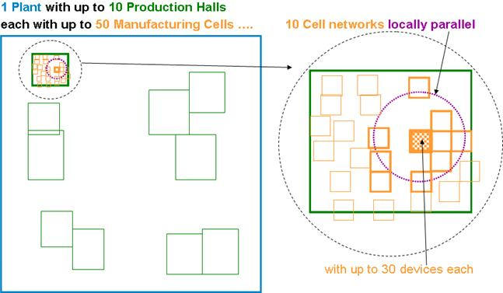
Figure 1: Example of a 1 plant with 10 production halls and 50 manufacturing cells

Factory hall (or plant subunit) automation
Medium Control System level, where e.g.:
  - whole production lines or moving applications (e.g. moving through a factory hall in discrete manufacturing e.g. automated guided vehicles, rail hanging power screwdrivers), or
  - whole production units in process automation:
    - Cover a larger area (e.g. 100 m x 100 m). This is solved by an industrial WLAN or a mesh type technology (TDMA schemes used) to safely cover a larger area with.
    - In average 100 devices and still low latencies.
Also here the master is in need of higher duty cycles and high power to cover the range without line of sight:
Up to 5 such independent systems can be within range of each other (are within "interference" range).
The area related local device density at 100 m range therefore is approx. 5 x 100 devices per 100 x 100 m² or 0,022 per m² at 100 m range.
The hall/subunit automation data packets as such are typically medium size with 200 octets on air (e.g. 140 octets of user data, 60 octets for addressing, networking, control and error protection) and have to be sent every 200 ms in each direction.
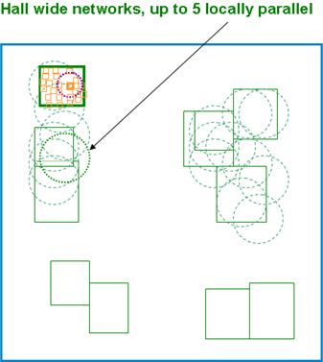
Figure 2: Example of hall wide networks, up to locally parallel

Plant level wide applications
Control system level covering up to the whole plant, typically an industrial mesh technology:
Able to cover e.g. 1 km x 1 km but typically with mesh technology to increase robustness against typical industrial influences (moving obstacles, interference/coexistence).
One such mesh system can have up to 1000 connected devices, but each device only having to cover a smaller range (100 m) and the mesh covers the larger distances needed, without excessive power needs.
There may be up to 3 independent such mesh networks operating in parallel in the whole plant.
Up to max. 50 devices of the 3 clusters can be within range of each other (are within "interference" range).
The area related local device density at 100 m range therefore is approx. 50 devices per 100x100 m² or 0.025 per m² at 100 m range.
The plant level automation data packets are typically medium size with 105 octets on air (e.g. 50 octets of user data, 55 octets for addressing, networking, control and error protection) and have to be sent every 500 ms in each direction.

Operation of the three classes
All of these 3 levels are operated in parallel (partially or completely overlapping interference area), and often by different operators and connected to different Control Systems. Each of the many wireless systems has to be allowed to switch on and off and vary the number of connected active devices and data amount transferred, depending of the needs of the many different production cells/subunits/ lines in order to maximise individually production, quality, safety and do service, troubleshooting and installation work on the productions units.
Parallel means that at most parts of the plant, the three "wireless" classes operate overlapping, preferably in the same frequency band for maximal flexibility of coexistence management reasons, to increase spectrum efficiency and to have the same needed spectrum properties like industrial-interference-free, power efficiency (range) and bending/damping by obstacles.
Normally, in total about 76 MHz of preferably continuous spectrum would be required to support applications from the 3 classes to operate seamless within a given environment without any restriction. This would still require a clever site planning which is not always possible as the different wireless solutions are from different vendors. However, recent and future developments of more intelligent sharing mechanisms will facilitate automatic seamless operation of these 3 classes even if less spectrum is made available.
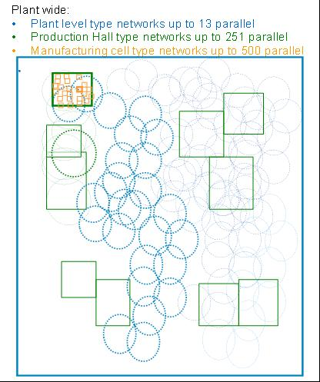
Figure 3: Example of a combination of 3 classes
Table 3 shows the extreme low latency and application availability requirements of many industrial wireless applications.
Table 3: Industrial application
Characteristic | Manufacturing cell | Factory hall | Plant level
Indoor/outdoor application | Indoor | Mostly indoor | Mostly outdoor
Spatial dimension LxWxH [m³] | 10 x 10 x 3 | 100x100x10 | 1000 x 1000 x 50
Number of devices (typically) | 30 | 100 | 1000
Number of parallel networks  (= clusters) | 10 | 5 | 5
Number of such clusters per plant | 50 | 10 | 1
Typical Number of locally parallel devices | 300 | 500 | 250
Network type | Star | Star/Mesh | Mesh
S, Typ. packet size [on air, byte] | 16 | 200 | 105
Maximum allowable latency (end-to-end) incl. jitter/retransmits [ms] | 5 ± 10 % | 20 ± 10 % | 20 ± 10 %
T, Update Time [ms] | 50 ± 10 % | 200 ± 10 % | 500 ± 10 %
Packet Loss Rate  (involved outside latency) | 10⁻⁹ | 10⁻⁹ | 10⁻⁹
Application availability | Exceeds 99,999 % (less than 300 s accumulated outage per annum).
Typical operational distance | Depends on individual use case and frequency of operation.
Note: To account for up and downlink information, 2 telegrams have been assumed.

Additional technical details are provided in ANNEX 1: (see also the ETSI SRdoc [1]).

Relating to the spectrum requirements, it was noted that the WIA system would need 76 MHz to operate on a given site, however since part of this 76 MHz may not be available locally for WIA usage due to other possible users (RTTT, BFWA…), there would be a need to identify more than 76 MHz for WIA systems in order to ensure that they can operate. This would mean that toward Europe, WIA would be spread over more than 76 MHz, resulting in a decrease of the possible number of WIA systems operating per channel and at the same time as given in the previous section.

SERVICES and systems IN THE BAND 5725-5875 MHZ
Table 4 provides the extract from the ITU Radio Regulations [3] for the bands used through this report.
Table 4: Extract of Article 5 of the ITU Radio Regulations
Region 1 | Region 2 | Region 3
5 725-5 830  FIXED-SATELLITE (Earth-to-space)  RADIOLOCATION  Amateur  5.150 5.451 5.453 5.455 5.456 | 5 725-5 830  RADIOLOCATION  Amateur  5.150 5.453 5.455
5 830-5 850  FIXED-SATELLITE (Earth-to-space)  RADIOLOCATION  Amateur  Amateur-satellite (space-to-Earth)  5.150 5.451 5.453 5.455 5.456 | 5 830-5 850  RADIOLOCATION  Amateur  Amateur-satellite (space-to-Earth)  5.150 5.453 5.455
5 850-5 925  FIXED  FIXED-SATELLITE (Earth-to-space)  MOBILE  5.150 | 5 850-5 925  FIXED  FIXED-SATELLITE (Earth-to-space)  MOBILE  Amateur  Radiolocation  5.150 | 5 850-5 925  FIXED  FIXED-SATELLITE (Earth-to-space)  MOBILE  Radiolocation  5.150
Footnotes of RR Art. 5 relevant for CEPT countries:
5.150 The following bands: 5 725-5 875 MHz (centre frequency 5 800 MHz), and ... are also designated for industrial, scientific and medical (ISM) applications. Radio communication services operating within these bands must accept harmful interference which may be caused by these applications. ISM equipment operating in these bands is subject to the provisions of No. 15.13.
5.451 Additional allocation: in the United Kingdom, the band 5 470-5 850 MHz is also allocated to the land mobile service on a secondary basis. The power limits specified in Nos. 21.2, 21.3, 21.4 and 21.5 shall apply in the band 5 725-5 850 MHz.
5.455 Additional allocation: in Armenia, Azerbaijan, Belarus, Cuba, the Russian Federation, Georgia, Hungary, Kazakhstan, Latvia, Moldova, Mongolia, Uzbekistan, Kyrgyzstan, Tajikistan, Turkmenistan and Ukraine, the band 5 670-5 850 MHz is also allocated to the fixed service on a primary basis. (WRC-03)

The following table provides an overview ERC Report 25 [4] for the bands 5725 to 5875 MHz.
Table 5: Allocation / Identification of spectrum according to ERC Report 25 [4]
Frequency range | European Common Allocation | ECC/ERC  harmonisation  measures | Application | European  footnotes | Standard | Notes
5725-5830 MHz | FIXED-SATELLITE (E/S)  RADIOLOCATION  Amateur  Mobile  5.150 EU2  EU22 |  | Amateur |  | EN 301 783
5725-5830 MHz |  | ECC/REC/(06)04 | BFWA |  | EN 302 502 | Within the band 5725-5875 MHz
5725-5830 MHz |  |  | Defence systems |  |  | Tactical and weapon system radars
5725-5830 MHz |  |  | ISM |  |  | Within the band 5725-5875 MHz
5725-5830 MHz |  | ERC/REC 70-03 | Non-Specific SRD |  | EN 300 440 | Within the band 5725-5875 MHz
5725-5830 MHz |  | ERC/REC 70-03 | Radiodetermination applications |  | EN 302 372 | Within the band 4500-7000 MHz for  TLPR application
5725-5830 MHz |  | ERC/REC 70-03 | RTTT |  | EN 300 674 | Within the band 5795-5805 MHz.  RTTT in the band 5805-5815 MHz  on a national basis
5725-5830 MHz |  |  | Weather Radars |  |  | Ground based and airborne
5830-5850 MHz | FIXED-SATELLITE (E/S)  RADIOLOCATION  Amateur  Amateur Satellite (S/E)  Mobile  5.150 EU2  EU22 |  | Amateur Satellite (S/E) | EU23 |  | Within the band 5830-5850 MHz
5830-5850 MHz |  | ECC/REC/(06)04 | BFWA |  | EN 302 502 | Within the band 5725-5875 MHz
5830-5850 MHz |  |  | Defence systems |  |  | Tactical and weapon system radars
5830-5850 MHz |  |  | ISM |  |  | Within the band 5725-5875 MHz
5830-5850 MHz |  | ERC/REC 70-03 | Non-Specifics SRDs |  | EN 300 440 | Within the band 5725-5875 MHz
5830-5850 MHz |  | ERC/REC 70-03 | Radiodetermination applications |  | EN 302 372 | Within the band 4500-7000 MHz for  TLPR application
5830-5850 MHz |  |  | Weather radars |  |  | Ground based and airborne
5850-5925 MHz | FIXED  FIXED-SATELLITE (E/S)  MOBILE  5.250 | ECC/REC/(06)04 | BFWA |  | EN 302 502 | Within the band 5725-5875 MHz
5850-5925 MHz | FIXED  FIXED-SATELLITE (E/S)  MOBILE  5.250 |  | FSS |  | EN 301 443 | Priority for civil networks
5850-5925 MHz | FIXED  FIXED-SATELLITE (E/S)  MOBILE  5.250 |  | ISM |  |  | Within the band 5725-5875 MHz
5850-5925 MHz | FIXED  FIXED-SATELLITE (E/S)  MOBILE  5.250 | ECC/DEC/(08)01  ECC/REC(08)01 | ITS |  | EN 302 571 | Within the band 5875-5925 MHz.  Within the band 5855-5875 MHz
5850-5925 MHz | FIXED  FIXED-SATELLITE (E/S)  MOBILE  5.250 | ERC/REC 70-03 | Non-Specific SRDs |  | EN 300 440 | Within the band 5725-5875 MHz
5850-5925 MHz | FIXED  FIXED-SATELLITE (E/S)  MOBILE  5.250 | ERC/REC 70-03 | Radiodetermination applications |  | EN 302 372 | Within the band 4500-7000 MHz for  TLPR application
EU2: Civil-military sharing.
EU22: The band 5250-5850 MHz is utilised for a variety of radiodetermination applications falling within the radionavigation and radiolocation services. This band will be subject to further detailed consideration.
EU23 In the sub-bands 5660-5670 MHz (earth to space), 5830-5850 MHz (space to earth) and 10.45-10.50 GHz the amateur-satellite additionally operates on a secondary and non-interference basis to other services. In making assignments to other services, CEPT administrations are requested wherever possible to maintain these allocations in such a way as to facilitate the reception of amateur emissions with minimal power flux densities.

The following services and systems are covered within this study following the approach considered in previous ECC Reports (see for example [5]):
- Section 3.1: Radiolocation Service
- Section 3.2: Road Transport and Traffic Telematic (RTTT) Systems
- Section 3.3: Fixed Service (Point-to-Point Links) and Broadband Fixed Wireless Access (BFWA)
- Section 3.4: Fixed-Satellite (E-s) Service (FSS)
- Section 3.5: Amateur Service, Amateur-satellite (s-E) Service
- Section 3.6: Intelligent Transport Systems (ITS)
- Section 3.7: Short Range Devices including:Non-specific Short Range Devices and Tank Level Probing Radar (TLPR) applications

It should be noted that at the date of finalization of this report, CEPT was conducting studies relating to the possible introduction of Digital Air To Ground Communications (DA2GC) system in the frequency bands 1900-1920 MHz, 2010-2025 MHz and 5855-5875 MHz. However, those studies were not completed at the time this report was finalised; therefore, this case was not considered in this report.

In addition, the EC has issued a Mandate calling for studies to consider additional bands for RLANs in the 5 GHz frequency range. Since those studies were at initial stage when this Report was approved, this case was not considered.

Radiolocation Service
The bands between 5725 MHz and 5850 MHz are allocated to the Radiolocation service on a primary basis.

Technical characteristics
Recommendation ITU-R M.1638 [6] provides characteristics of radars operating under the Radiolocation services in the frequency range 5250-5850 MHz. Within this range, the band between 5725 MHz and 5850 MHz is used by many different types of radars on fixed land-based, ship borne and transportable platforms. It should be noted that most of these radars are designed to operate not only in the 5725-5850 MHz band but in a larger portion of the band 5250-5850 MHz.
The following table contains technical characteristics of representative systems deployed in this band. This includes a subset of the radars contained in Recommendation ITU-R M.1638 [6], which are relevant for the frequency band 5725-5850 MHz (radars L, M, N, O and Q) and three additional radars operated by administrations within CEPT (X, Y and Z). This information is generally sufficient for calculation to assess the compatibility between these radars and other systems.
Frequency hopping is one of the most common Electronic-Counter-Counter-Measures (ECCM). Radar systems that are designed to operate in hostile electronic attack environments use frequency hopping as one of its ECCM techniques. This type of radar typically divides its allocated frequency band into channels. The radar then randomly selects a channel from all available channels for transmission. This random occupation of a channel can occur on a per beam position basis where many pulses on the same channel are transmitted or on a per pulse basis. This important aspect of radar systems should be considered and the potential impact of frequency hopping radar should be taken into account in sharing studies.
It should be emphasized, that the Recommendation ITU-R M.1638 is under revision in ITU WP 5B, and that the new radars proposed to be added in a revised version of Recommendation ITU-R M.1638 [6] are not accounted for in this report (e.g. bi-static radars).

Operational characteristics of Radiolocation systems
There are numerous radar types, accomplishing various missions, operating within the Radiolocation service throughout the whole range 5250- 5850 MHz, and specifically within the 5725-5850 MHz band. Test range instrumentation radars are used to provide highly accurate position data on space launch vehicles and aeronautical vehicles undergoing developmental and operational testing. These radars are typified by high transmitter powers and large aperture parabolic reflector antennas with very narrow pencil beams. The radars have auto-tracking antennas which either skin-track or beacon-track the object of interest. Periods of operation can last from minutes up to 4-5 hours, depending upon the test program. Operations are conducted at scheduled times 24 hours/day, 7 days/week.
Shipboard sea and air surveillance radars are used for ship protection and operate continuously while the ship is underway as well as entering and leaving port areas. These surveillance radars usually employ moderately high transmitter powers and antennas which scan electronically in elevation and mechanically a full 360 degrees in azimuth. Operations can be such that multiple ships are operating these radars simultaneously in a given geographical area. Other special-purpose radars are also operated in the band 5250-5850 MHz.
Also, in this band operate tactical radar mounted on mobile vehicles used for providing airspace surveillance.
It shall be emphasized that some radar systems are designed such that they are robust against interference however this was designed in order to encompass any problems during their operations and not to cope with possible interference resulting from underlay technology.

Protection criteria
The desensitising effect on radars operated in this band from other services of a CW or noise-like type modulation is predictably related to its intensity. In any azimuth sectors in which such interference arrives, its power spectral density can simply be added to the power spectral density of the radar receiver thermal noise, to within a reasonable approximation. If power spectral density of radar-receiver noise in the absence of interference is denoted by N₀ and that of noise-like interference by I₀, the resultant effective noise power spectral density becomes simply I₀+N₀. An increase of about 1 dB for the Radiolocation radar would constitute significant degradation. Such an increase corresponds to an (I+N)/N ratio of 1.26, or an I/N ratio of about –6 dB. These protection criteria represent the aggregate effects of multiple interferers, when present. The tolerable I/N ratio for an individual interferer depends on the number of interferers and their geometry, and needs to be assessed in the course of analysis of a given scenario. The aggregation factor can be very substantial in the case of certain communication systems, in which a great number of stations can be deployed.
Table 6: Characteristics of Radiolocation systems
Characteristics | Radar L | Radar M | Radar N | Radar O | Radar Q | Radar X (Note 1) | Radar Y (Note 1) | Radar Z
Function | Instrumentation |  |  | Surface and air search |  |  |  | Search
Platform type | Ground |  |  |  | Ship | Ground /Vehicle
Tuning range (MHz) | 5350-5850 |  | 5400-5850 |  | 5450-5825 | 5400-5850 |  | 5250-5850
Modulation | None |  | Pulse /  chirp pulse | Chirp pulse | None |  |  | Non-Linear FM
Tx power into antenna (kW) | 2800 | 1200 | 1000 | 165 | 285 | 12 | 12 | 70
Pulse width (µs) | 0.25, 1.0, 5.0 | 0.25, 0.5, 1.0 | 0.25-1 (plain)  3.1-50 (chirp) | 100 | 0.1, 0.25, 1.0 | 4-20 | 4-20 | 3.5, 6, 10
Pulse rise/fall time (µs) | 0.02-0.5 | 0.02-0.05 | 0.02-0.1 | 0.5 | 0.03/0.05/ 0.1 | No detail | No detail | N/A
Pulse repetition rate (pps) | 160, 640 | 160, 640 | 20-1280 | 320 | 2400/1200/ 750 | 1000-7800 | 1000-7800 | 2500/3750
Chirp bandwidth (MHz) | N/A | N/A | 4.0 | 8.33 | N/A | No detail | No detail
RF emission bandwidth  –3 dB –20 dB (MHz) | 0.5-5 | 0.9-3.6  6.4-18 | 0.9-3.6  6.4-18 | 8.33  9.9 | 5.0/4.0/1.2  16.5/12.5/7.0 | 5 | 5
Antenna pattern type | Pencil |  |  |  | Fan | N/A
Antenna type | Parabolic |  | Phased Array |  | Travelling wave feed horn array | N/A |  | Phased Array
Antenna polarization | Vertical/Left-hand circular |  |  |  | Horizontal | Vertical |  | Horizontal
Antenna main beam gain (dBi) | 54 | 47 | 45.9 | 42 | 30.0 | 35 | 35 | 31.5
Antenna elevation beam width (degrees) | 0.4 | 0.8 | 1.0 | 1.0 | 28.0 | N/A | N/A | 43.8
Antenna azimuthal beam width (degrees) | 0.4 | 0.8 | 1.0 | 1.0 | 1.6 | N/A | N/A | 1.75
Antenna horizontal scan rate (degrees/s) | N/A (Tracking) |  |  |  | 90 | N/A (tracking) | 180/360 | 120/180
Antenna horizontal scan type | N/A (Tracking) |  |  |  | 30-270 °  Sector | N/A
Antenna vertical scan rate (degrees/s) | N/A (Tracking) |  |  |  | N/A
Antenna vertical scan type (degrees) | N/A (Tracking) |  |  |  | Fixed | N/A
Antenna side-lobe (SL) levels (dB) | -20 | -20 | -22 | -22 | -25 | -40 | -40 | N/A
Antenna height (m) | 20 | 8-20 | 20 | 20 | 40 | 10 | 10 | 6 – 13
Receiver IF 3 dB bandwidth (MHz) | 4.8, 2.4, 0.25 | 4, 2, 1 | 2-8 | 8 | 1.2, 10 | 4 | 4 | N/A
Receiver noise figure (dB) | 5 | 5 | 11 | 5 | 10 | 5 | 5 | ≤ 13
Minimum discernable signal (dBm) | –107 | –100 | –107,–117 | –100 | -94 (short)  -102 (wide) | -103 | -103 | -108
Note 1: Radars X and Y can operate both in fixed frequency and in hopping mode: the following parameters have to be taken into account in the different compatibility studies in the band 5725-5875 between industrial applications using technologies different from UWB and Radiolocation service.
Frequency hopping characteristics
Frequency band: 5250 to 5850 MHz or 5470 to 5850 MHz
type of frequency hopping: random
hopping rate: 300 to 1500 Hz
number of frequency: 1 frequency /10 MHz

Road Transport and Traffic Telematics (RTTT) Systems
ECC/DEC/(02)01 [7] has identified the frequencies for RTTT applications in the band 5.795-5.815 GHz, ECC/DEC(02)01 has been withdrawn by ECC/DEC/(12)04. The band 5795-5805 MHz is for use by initial road-to-vehicle systems, in particular road toll systems, with an additional sub-band, 5805-5815 MHz, to be used on a national basis to meet the requirements of multi-lane road junctions.

Parameters
The regulatory parameters (maximum power levels) for RTTT are given in Annex 5 of ERC/REC 70-03 [2]. The RTTT parameters used in this Report are taken from the EN 300 674 [8] developed by ETSI and the BS EN 12253 [9] developed by CENELEC. It should be noted that the EN 300 674 deals with both Road Side Units (RSU) and On-Board Units (OBU) and is divided in two parts, the part 1 providing general characteristics and test methods, the part 2 containing the essential requirements under article 3.2 of the R&TTE Directive [10].
Table 7: Summary of characteristics of the RTTT systems
 | Road Side Units | On Board Units
Frequency range (MHz) | 5795 and 5815
e.i.r.p. | 2 W (33 dBm) standard for -35° ≤ θ ≤ 35°  18 dBm for θ > 35°  8 W (39 dBm) optional | Maximum re-radiated sub-carrier e.i.r.p.:  -24 dBm (Medium data rate)  -14 dBm (High data rate)
Antenna gain | Left circular polarised 13 dBi  Linear polarised 10 dBi  (assumed front-to-back ratio of 15 dB) | 1 – 10 dBi (see Figure 6)
Transmitter Bandwidth | 1 MHz | 500 kHz
Receiver bandwidth | 500 kHz | 200 MHz – 1.4 GHz (not used)
Polarization | left circular | left circular
Receiver sensitivity (at the receiver input) | -104 dBm (BPSK) | -60 dBm
Co-channel C/I (dB) | 6 for 2-PSK,  9 for 4-PSK,  12 for 8-PSK | Not defined

The following figure depicts the RTTT frequency utilization for 1.5 MHz sub-carrier frequency, according the ETSI EN 300 674 [8]. The location of downlink channels from RSU to OBU and the location of uplink channels from OBU to RSU become visible.
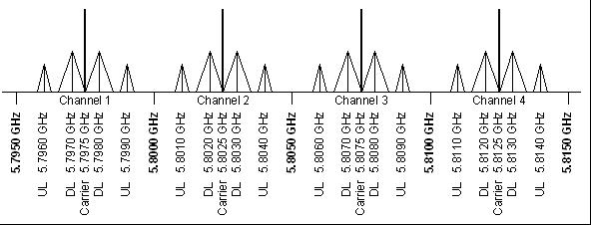
Figure 4: RTTT frequency utilization for 1.5 MHz sub-carrier frequency, according the EN 300 674

The transmit power limits of RTTT downlink, uplink and out of band emissions are depicted in the following Figure.
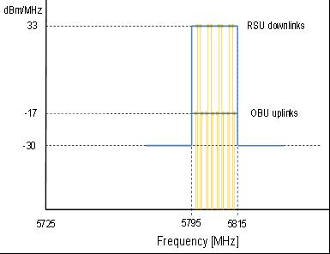
Figure 5: e.i.r.p. limits of RTTT
It is proposed to use as a typical antenna pattern of RSU an antenna gain of -5 dBi Vert.Lin.Pol. for all azimuth directions for RTTT RSU. The gain will be higher when within the RTTT communication zone however it is not likely the WIA radio will be located within the communication zone.
The gain in the horizontal plane is roughly the same in all directions since the RSU antennas are tilted down, (typically 45 to 55 degree). Therefore, the difference of gain is varying not much in different directions when the considered station is far enough from the antenna. There are some differences depending on azimuth angle however these differences are smaller than the differences because of different RSU types.
For the OBU antenna model, the following model is proposed:

Gain [dB] = -4.5-(0.004*Az)-(0,0002*Az*Az)

This is illustrated in the following figure.

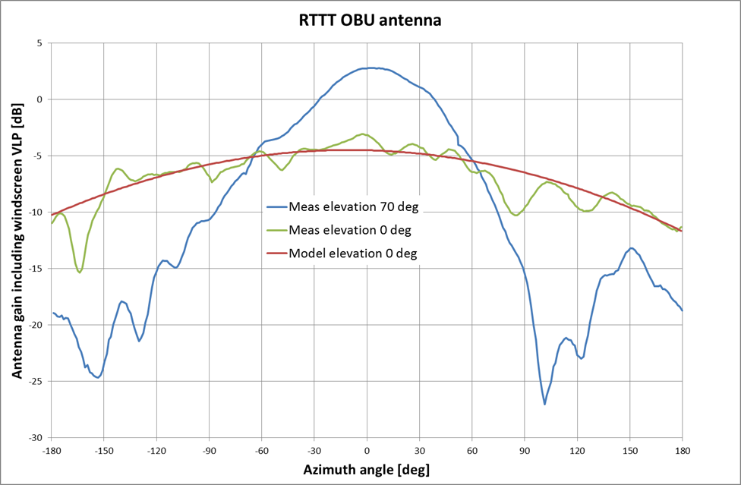
Figure 6: Antenna pattern OBU

Protection Criteria
On Board Unit (OBU)
The OBU requires a -60 dBm signal in order to function at all and to understand commands from the RSU. Assuming negligible re-radiation loss and a signalling distance of 8 m, the received signal strength at the OBU should be -59 dBm or higher . This corresponds to power density of -56 dBm/MHz. Assuming that simple BPSK is used, the required margin is 6 dB and thus the protection criterion in term of the maximum acceptable interference power at the OBU would be -62 dBm/MHz on-axis.
Road Side Unit (RSU)
The RSU, when operating in BPSK mode requires a 6 dB margin over its receiver sensitivity: this gives -107 dBm at the receiver input or density of -98 dBm/MHz at the input to an antenna with a -9 dB off-axis gain. Since the RSU antenna points at the road surface, noon-axis gain is taken into consideration.

Fixed Service
In this frequency range, two types of Fixed Service links may be deployed: Point-to-Point links and Point-to-Multipoint links as Broadband Fixed Wireless Access (BFWA) systems.
ECC Report 173 [11] indicates that in “the lightly licensed 5.8 GHz frequency band FWA (fixed and nomadic) operation continues to be possible on a national basis under the framework set by ECC Recommendation ECC/REC(06)04 [12] and ETSI Harmonised Standard EN 302 502 [13]. Coexistence considerations result in a low e.i.r.p. constraints and a need to implement a demanding Dynamic Frequency Selection (DFS) feature for the protection of primary Radiodetermination service.”
“The band is unlicensed/light licensed, from 5.725 to 5.850 GHz.
From 5.85 to 5.95, some use is indicated, mostly for P-MP. The licensing regime appears to be mostly link-based. Few countries indicated a significant use, including the Russian Federation (1400 P-P links, 600 P-MP Base Stations, infrastructure and broadcasting).
National frequency plans have been declared in majority of answers.”

Point-to-Point Links
Recommendation ITU-R F.383-7 [14] defines the channel arrangements for the lower 6 GHz band. Depending on which channel arrangements are chosen, the frequency range may extend from 5850-6425 MHz. ERC/REC 14-01 [15] defines the CEPT harmonised channel plans for Radio-frequency channel arrangements for high capacity analogue and digital radio-relay systems operating in the band 5925-6425 MHz.
The harmonised CEPT arrangements are based on recommends 1 of Recommendation ITU-R F.383-7 [14], which does not extend below 5925 MHz. There is a limited deployment of Point-to-point links, therefore this case is not considered in the compatibility studies.

Broadband Fixed Wireless Access (BFWA) Systems
ECC Report 101 [5] indicated that Broadband Fixed Wireless Access (BFWA) refers to wireless systems that provide local connectivity for a variety of applications and using a variety of architectures, including combinations of access as well as interconnection. ECC Report 068 [16] depicts the different architectures of BFWA and provides the relevant information on these different kinds of networks including technical parameters to ensure compatibility with other systems. The following section provides the main parameters for one BFWA architecture, Point to Multipoint (P-MP).

BFWA Parameters
The technical parameters of the BFWA systems were provided by a BFWA operator in Germany. A P-MP system with a Central Station (sector antenna 120°) and a Terminal Station (direction antenna, 22dBi) was assumed to be representative for the majority of BFWA systems
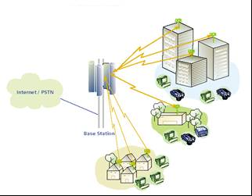
Figure 7: Typical BFWA P-MP deployment scenario (from ECC Report 068 [16])
The technical parameters of the BFWA system used in this study can be found in the following table.
Table 8: BFWA system parameters
Parameter | BFWA P-MP
Topology | Receiver Sectored Central Station (CS)  Transmitter Terminal Stations (TS)
Channel bandwidth | 20 MHz
Duplex/  Access scheme | TDD/TDMA
Max Tx power dBm TS (conducted) | 14 dBm
Max e.i.r.p. | 36 dBm
Max Power density spectral (dBm/MHz) e.i.r.p. | 23 dBm/MHz
Adaptive power control dB | 12 dB
Antenna CS (Rx antenna-> Victim Link Receiver) | 16 dBi, sector antenna 120°, 4° down tilt  See Figure 8.
Antenna height CS | 30 m
Antenna TS (Tx antenna-> Victim Link Transmitter) | 22 dBi (see Figure 9 below)
Antenna height TS | 10 m
Receiver sensitivity 64-QAM | -68 dBm
Fading Margin | 10 dB
Minimum wanted power at TS and BS (Sensitivity – fade margin) | -58 dBm
Protection ratio 64 QAM | C/(I+N) 24 dB  C/N=C/I=27 dB
I/N | 0 dB
Receiver Noise floor | -95 dBm
Link lenght | Typical 1 km
Path loss model | Spherical diffraction (outdoor, outdoor)  see ANNEX 3:

The following figures provide an overview of the BFWA antenna pattern.
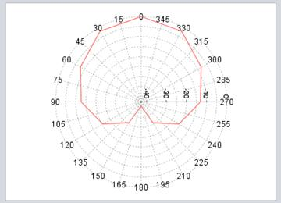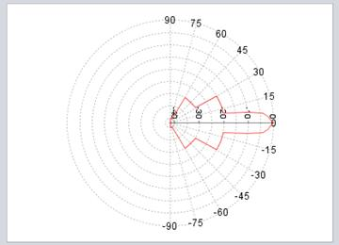
Figure 8: Horizontal and Vertical Pattern of BFWA CS Rx

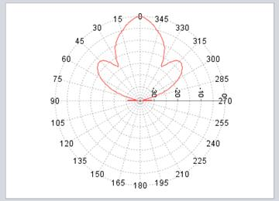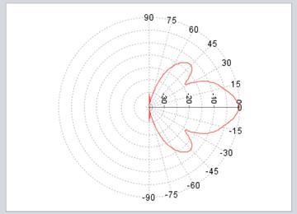
Figure 9: Horizontal and Vertical Pattern of BFWA Ts

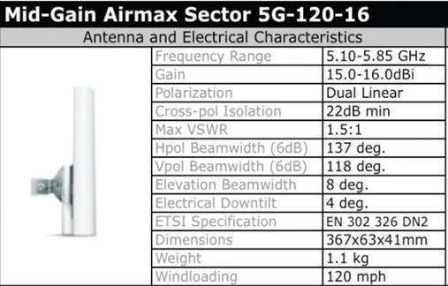
Figure 10: Typical P-MP Central station (Ubiquiti Networks, www.ubnt.com)

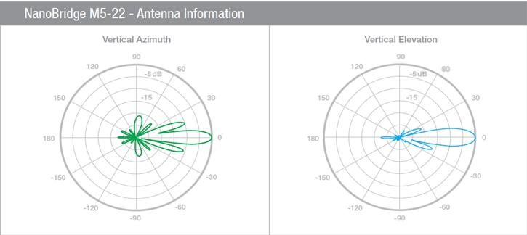

Figure 11: Typical BFWA Terminal Station antenna pattern (Ubiquiti Networks, www.ubnt.com)

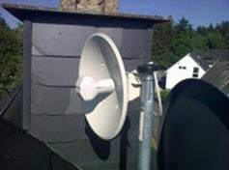
Figure 12: Typical BFWA TS antenna (Ubiquiti Networks, www.ubnt.com)

FIXED SATELLITE (E-S) SERVICE (FSS)
FSS deployments use the whole band 5725-5925 MHz and it is used by transmitting earth stations in the Earth-to-space direction operating only to satellites in geostationary orbits. In the 125 MHz portion of the band up to 5850 MHz, this is a Region 1 allocation only (i.e. only Europe, Africa, and some of the northernmost countries in Asia). Above 5850 MHz the band is part of the heavily utilised FSS global uplink band and most of the currently operating satellites (INTELSAT & New Skies for instance) have receive transponders in this upper portion of the band.
The following table provides details of the selection of satellites that have been taken as representative of those requiring protection in the visible portion of the geostationary orbit from Europe. The parameters shown are those required in sharing studies with the WIA systems. In these frequency bands, the satellite beams cover very large areas of the Earth (using global, hemispherical, zonal or regional beams) as can be seen by the satellite footprint coverage plots in Annex 6 of ECC Report 68 [16].
Table 9: Sample Satellite Data taken from ITU filings for the band 5725-5875MHz
Satellite | Sub-satellite longitude | Part of Frequency range  5725-5875 MHz used | Satellite Maximum Receive Gain G_{sat}(dBi) | Space Station Receiving System Noise Temperature T_{sat} (Kelvin)
A | 5º West | Whole band | 34 | 773
B | 14º West | Whole band | 26.5 | 1200
C | 31.5º West | > 5850 MHz | 32.8 | 700
D | 3º East | Whole band | 34 | 773
E | 18º West | >5850MHz | 32.8 | 700
F | 53º East | Whole band | 26.5 | 1200
G | 59.5º East | Whole band | 34 | 1200
H | 66º East | >5850 MHz | 34.7 | 700
I | 359º East | >5850 MHz | 32.8 | 700

The following figure shows the basic sharing scenario between WIA terminals and the FSS service. The studies reported in the following section address the aggregate emissions of a large number of WIA terminals into the main beam of satellite receivers.

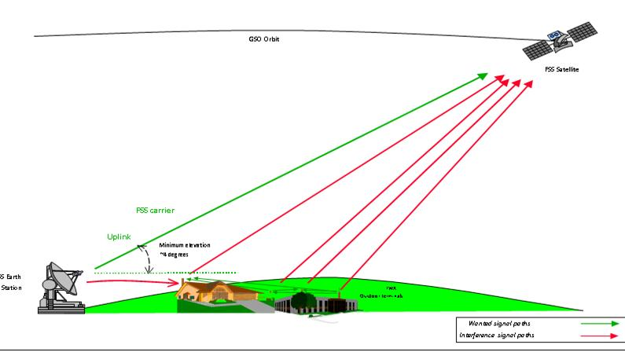
Figure 13: FSS/WIA Sharing Scenario in the band 5725-5875 MHz

AMATEUR AND AMATEUR-SATELLITE (S-E) SERVICES
The amateur and amateur-satellite (s-E) services have harmonised allocations in all three ITU Regions in the frequency range 5725-5850 MHz with secondary status as follows:
Table 10: Allocations for Amateur Services
Frequency | Service
5725-5830 MHz | Amateur
5830-5850 MHz | Amateur  Amateur Satellite (space-to-Earth)

The operational characteristics of amateur stations and amateur-satellite stations vary significantly. However based on the IARU Region-1 VHF Managers Handbook they can be categorised as:
  - Weak signal reception of Narrowband Terrestrial and EME (Moonbounce) operation in the sub-band 5760-5762 MHz, including propagation beacons.
  - Data and multimedia systems (point to-point links and area repeaters) in other parts of the band.
  - Low-power satellite downlinks within 5830-5850 MHz (typically from LEO Cubesat satellites).

Characteristics for the Amateur Service
Recommendation ITU-R M.1732-1 [17] provides characteristics of stations operating in the amateur service for use in sharing studies:
Table 11: Examples of Amateur Service characteristics in the band 5725-5850 MHz
Parameter | CW-Morse, EME | SSB Voice | FM Voice | Digital Voice and Multimedia
Transmitter Power⁽¹⁾ (dBW) | 3 – 20  (typically: 13) | 3 – 20  (typically: 13) | 3 – 20  (typically: 10) | 1-10  (typically: 6)
Transmitter Feeder Loss (dB) | 1 – 2  (typically: 1) | 0 – 10  (typically: 1) | 0 – 10  (typically: 1) | 1 – 6  (typically: 1)
Antenna gain (dBi) | 0 – 40  (typically: 33) | 0 – 40  (typically: 33) | 0 – 40  (typically: 33) | 0 – 30  (typically: 27)
Typical e.i.r.p.(dBW) | 1 – 45  (typically: 45) | 1 – 45  (typically: 45) | 1 – 45  (typically: 42) | 10 – 40  (typically: 32)
Antenna polarisation | Horizontal, Vertical, | Horizontal, Vertical | Horizontal, Vertical | Horizontal, Vertical.
Receiver IF bandwidth (kHz) | 0.4 | 2.7 | 9  15 | 2.7, 6, 16, 130, 10500
Receiver Noise Figure⁽²⁾ (dB) | 1 – 7  (typically 1 | 1 – 7  (typically 1) | 1 – 3  (typically 2) | 2
(1) Maximum powers are determined by each administration.
(2) Receiver noise figures for bands above 50 MHz assume the use of low-noise preamplifiers.

In order to simplify studies, it is assumed a typical terrestrial CW/SSB amateur station uses a 0.9 m (33 dBi) dish directional antenna, 13 dBW (20 Watt transmitter), and has a 1 dB NF receiver optimised for the 5760-5762 MHz band. The receiver LNA is assumed to be at the antenna feedpoint, so feeder losses for the receiver situation can be ignored (i.e. assumed to be 0dB).
The determination of the maximum tolerable interference level from emissions of a single WIA device at the Amateur Service (AS) receiver is based on ECC Report 172 [18], where it is said that this level should be lower than N + (I/N) where N is the AS receiver inherent noise level and I/N the interference to noise ratio. The interference to noise ratio can be taken as –10 dB as given in ECC Report 172 [18].

Characteristics for the Amateur-Satellite Service
In the 5GHz bands the Amateur Satellite service has two distinct ITU secondary allocations:
  - 5650-5670 MHz Earth-to-Space only (i.e. for uplinks);
  - 5830-5850 MHz space-to-Earth only (i.e. for downlinks).

As Wireless Industrial Applications are being studied for the frequency range 5725-5875 MHz, only sharing with reception of amateur satellite space-to-Earth downlinks need be considered, as the uplink allocation is outside of the WIA frequency range.
Recommendation ITU-R M.1732-1 [17] provides characteristics of stations operating in the amateur-satellite service for use in sharing studies:
Table 12: Characteristics of Amateur-Satellite systems in the space-to-Earth direction
Parameter | CW-Morse | SSB, FM, Digital Voice, Data
Transmitter Power ⁽¹⁾ (dBW) | 10 | 10
Transmitter Feeder Loss (dB) | 0.2 – 1 | 0.2 – 1
Transmitting antenna gain (dBi). | 0 – 6 | 0
Typical e.i.r.p.(dBW) | 0 – 15 | 9 – 15
Antenna polarisation | Horizontal, Vertical,  LHCP, RHCP | Horizontal, Vertical,  LHCP, RHCP
Receiver IF bandwidth (kHz) | 0.4 | 2.7, 16, 50, 100
Receiver Noise Figure ⁽²⁾ (dB) | 1 – 3  (typically: 1) | 1 – 3  (typically: 2)
⁽¹⁾ Maximum powers are determined by each administration.
⁽²⁾ Receiver noise figures for bands above 50 MHz assume the use of low-noise preamplifiers.

Most current amateur satellites are typically nano or picosats (also called ‘cubesats’) that occupy slightly elliptical Sun-Synchronous low earth orbits (LEO) of 600-800km altitude. These smaller satellites have relatively low power and antenna gain.
As geostationary systems are generally not in use, it may be noted that for CW systems, therefore, a practical issue arises due to LEO Doppler shift that requires slightly wider Rx rf bandwidth. Therefore, many amateurs would in practice stick to a single 2.4 kHz BW using the SSB-Voice system. Therefore, for the purpose of this report, only the SSB-Voice case is considered in the sharing studies.
For sharing studies 0 dBW Tx Power, 0.5 dB feeder loss and 3 dB antenna gain for a patch antenna are assumed for the satellite; and the amateur receiving ground station is assumed to be similar to the Amateur Service (see section 4.5).
It should be noted that most amateur satellite downlinks are coordinated and harmonised in a sub-band at 5840-5842 MHz.

INTELLIGENT TRANSPORT SYSTEMS (ITS)
Administrations are recommended to make the frequency band 5855-5875 MHz available for ITS non-safety applications in order to support and enhance ITS all over Europe (see ECC/REC/ (08)01 [33]). Non-safety applications means Inter Vehicle Communication (IVC) and Roadside to Vehicle (R2V) communication. Examples of non-safety applications includes:
  - Internet access;
  - Points of interest notification;
  - Traffic control.

Safety related ITS applications are intended to be used in the band 5.875 to 5.925 GHz (ECC/DEC/(08)01 [36] and Commission Decision 2008/671/EC [37]).
ITS applications can be summarized as follows:
- Inter-Vehicles Communications (IVC) (this includes multi-hop routing involving several vehicles):
  - Linear (e.g. for convoys of vehicles);
  - Vehicle cluster covering several lanes (e.g. for lane management, overtaking assist).
- Vehicle to Roadside (uplink) V2R and Roadside to Vehicle R2V (downlink):
  - One vehicle to beacon;
  - Beacon to one vehicle;
  - Beacon to many vehicles (broadcast, short range and long range);
  - Beacon to selected vehicles.
- Cluster of vehicles communication, including to roadside beacon.
More details can be found in ECC Report 101 [5].

Parameters
ECC Report 101 [5] considers the following list of parameters for ITS systems (see also SRdoc ETSI TR 102 492-1 [19]).
Table 13: Systems parameters
Parameter | Value | Comments
Frequency stability | 1ppm | This figure takes account of the frequency tolerance allowed by IEEE 802.11 [20], together with the expected Doppler variation from a vehicle closing speed of 400 km/h.
Maximum radiated power (e.i.r.p.) | Equipment classes:  A 10 dBm  B 20 dBm  C 33 dBm | Transmitter power control (TPC) with a 30 dB range.
Antenna beam shape/gain | RSU: 10 dBi  OBU: 5; 8 dBi | See Figure 14 and Figure 15
Modulation scheme | BPSK  QPSK 16QAM 64QAM | This is the standard set within IEEE 802.11 [20]
Data rates | 3/4.5 /6/9/ 12/18 /24/27 Mbit/s | This is the standard set within IEEE 802.11 [20]. As an option two channels may be combined to produce double data rates (up to 54 Mbit/s). Default data rate is 6Mbit/s.
Channel Bandwidth | 10 MHz, option 20 MHz | This is the standard set within EEE 802.11 [20].
Communication mode | Half-duplex, broadcast | Half-duplex and broadcast are believed to be adequate for the applications considered to date.
Receiver sensitivity | -92dBm/MHz | Based on -82 dBm for a bandwidth of 10 MHz
Protection criterion | C/I=6dB | For a classical BPSK signal

Communication channels will be open for the applications within the respective usage category (either road safety related or not, i.e. used for traffic management).
The required power levels (e.i.r.p.) range from 3 dBm to 33 dBm to achieve communication distances of up to 1000 m.
The technical parameters used for interference assessment are given in the following table.
Table 14: Technical parameters of ITS devices used for compatibility study
Characteristics | Value | Unit
Receiver bandwidth | 10 | MHz
Receiver sensitivity | -82 | dBm
Receiver sensitivity | -92 | dBm/MHz
Antenna gain | 8 | dBi
Receiver sensitivity at antenna | -100 | dBm/MHz
C/I | 6 | dB
Allowable Interfering Power at receiver | -98 | dBm/MHz
Allowable Interfering Power at receiver antenna | -106 | dBm/MHz
Transmitter Characteristics
Bandwidth | 10 | MHz
Tx_{out}, e.i.r.p | 33 | dBm
Tx_{out} e.i.r.p per MHz | 23 | dBm/MHz
Assumed value for TPC | 8 | dB
Net Tx_{out} e.i.r.p | 15 | dBm/MHz
Antenna Gain | 8 | dBi

Table 15: ITS Channel utilization
Channel type | Centre frequency | CH No. | Channel spacing | Default data rate | TX power limit | TX power density limit
G5CC | 5 900 MHz | 180 | 10 MHz | 6 Mbit/s | 33 dBm e.i.r.p | 23 dBm/MHz
G5SC2 | 5 890 MHz | 178 | 10 MHz | 12 Mbit/s | 23 dBm e.i.r.p | 13 dBm/MHz
G5SC1 | 5 880 MHz | 176 | 10 MHz | 6 Mbit/s | 33 dBm e.i.r.p | 23 dBm/MHz
G5SC3 | 5 870 MHz | 174 | 10 MHz | 6 Mbit/s | 23 dBm e.i.r.p | 13 dBm/MHz
G5SC4 | 5 860 MHz | 172 | 10 MHz | 6 Mbit/s | 0 dBm e.i.r.p | -10 dBm/MHz
G5SC5 | As required in EN 302 571 for the band 5470-5725 MHz |  | several | dependent on channel spacing | 30 dBm e.i.r.p (DFS master) | 17 dBm/MHz
 |  |  |  |  | 23 dBm e.i.r.p (DFS slave) | 10 dBm/MHz

The e.i.r.p. given in Table 15 are based on the values given in EN 302 571. However, the calculations are provided based on an e.i.r.p of 33 dBm since it is allowed by the regulations (see ECC Recommendation (08)01 and Commission decision 2008/671/EC).
Typical antenna pattern for the two ITS devices RSU and OBU are shown in Figure 14 and Figure 15. It is an essential design feature of communications between vehicles, or between vehicles and local infrastructure beacons, that they are directed more or less horizontally in a typical omni-directional pattern with typically 8 dBi gain in the horizontal plane.
The RSU and OBU antenna gain is 5 dBi vertical linear (8 dBi left circular) with an elevation angle of 10° see Figure 15.
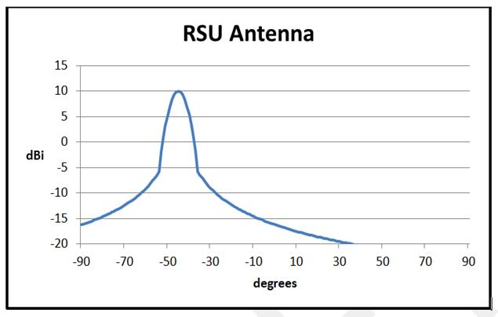
Figure 14: Horizontal antenna pattern RSU (antenna gain: 10 dBi)

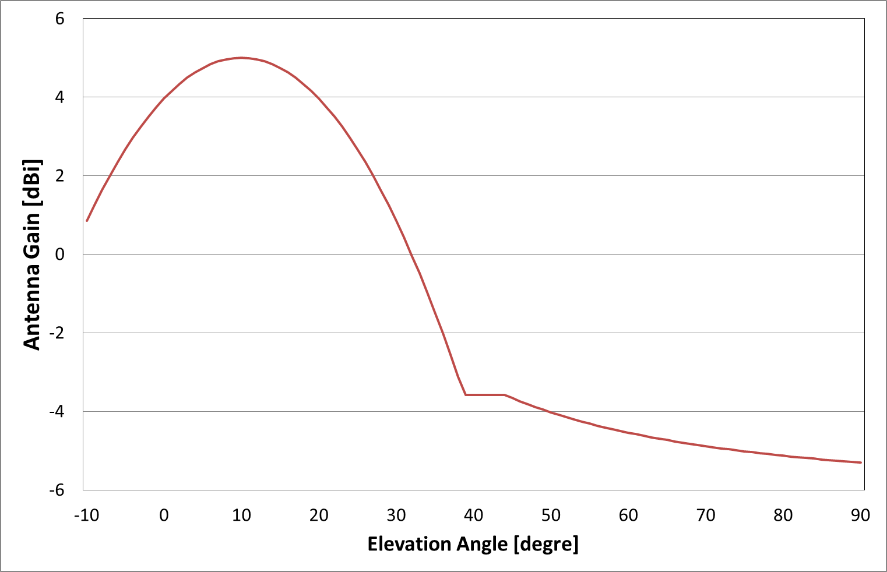
Figure 15: Horizontal antenna pattern OBU (antenna gain: 5 dBi)
The antenna pattern from Figure 14 has been used in this report for RSU and the antenna pattern from Figure 15 has been used in this report for OBU.

Short Range Devices (SRD)

General (non-specific) SRD
As specified in Annex 1 of ERC/REC 70-03 [2], the frequency band 5725-5875 MHz is used by non-specific SRD. This use should comply with the technical characteristics as shown below.
Table 16: Technical characteristics of SRD
Frequency Band | Power | Antenna | Channel Spacing | Duty Cycle (%)
5725-5875 MHz | 25 mW e.i.r.p | Integral (no external antenna socket) or dedicated | No channel spacing - the whole stated frequency band may be used | No duty cycle restriction

In addition to these regulatory technical characteristics, assumptions on some parameters had to be made in order to carry out compatibility studies. Three kinds of SRD were considered for the interference assessment (see the following table) as in previous CEPT studies (see for example [5]). Updated system parameters and examples of real existing equipment were not available at the time this report has been created.
Table 17: SRD parameters
Parameter | SRD I | SRD II | SRD III | Comments
Typical bandwidth BW (MHz) | 0.25 MHz | 20 MHz | 8MHz | Note 1, Note 2.
TX Power, dBm e.i.r.p. | +14 | +14 | +14
Ant. Gain, dBi | 2 to 20 | 2 to 24 | 2
Ant. Polarization | Circular | Circular | Vertical
Receiver sensitivity, dBm | -110 | -91 | -84
Protection criterion, dB | I/N=0dB | C/I=8dB | C/I=20dB
FkTB | -105 dBm/MHz | N/A | N/A
Max OoB RX interference, dBm | -35 | -35 | -35 | E.g. limit for Rx blocking
Duty cycle : % | Up to 100% | Up to 100% | 100%
RX wake-up time (if applicable) | 1 sec | 1 sec | N/A | For battery operated equipment
Note 1: The given bandwidths are for non-spread spectrum modulation.
Note 2: For spread spectrum modulation (FHSS, DSSS and other types) the bandwidth can be up to
100 MHz

Tank Level Probing Radar (TLPR)
Tank Level Probing Radar (TLPR) are installed in closed metallic tanks or reinforced concrete tanks, or similar enclosure structures made of comparable attenuating material, holding a substance, liquid or powder. TLPR utilizes bandwidths that extend over multiple frequency bands allocated to numerous radio services. The emission limits for TLPR are specified outside the tank (see EN 302 372 [22]).
Given the attenuation resulting from the tank of TLPRs and their low susceptibility to interference to narrow band signals, it is considered that compatibility studies for the protection of TLPR are not necessary (see CEPT Report 26 [23]).
The power limits for these bands are -41.3 dBm/MHz e.i.r.p. outside the tank but in reality the power levels outside the actual tank are much lower than this maximum value. The value of -41.3 dBm/MHz e.i.r.p. is based on a standard test tank of 500 litres. The reason for doing so is as follows. Levels outside an installed tank are in many cases difficult if not impossible to measure because average is ranging from 8 to 100,000 cubic meters. In practice therefore a test tank of 500 litre is used that fits for example in an anechoic chamber. The practical outside levels of an installed tank however are lower (varying from 20dB to 30dB thanks the cavity attenuation) than the -41.3 dBm/MHz limit the test tank emits. Therefore no interference is expected from TLPR on WIA.
It was also considered in the past that compatibility studies for TLPR are not necessary (see CEPT Report 26 [23]).

COMPATIBILITY STUDIES
The section details the compatibility studies between the industrial applications using other technologies different from UWB (WIA) systems (see section 2 and ANNEX 1:) and other radio communications services and systems (see section 3).
The following table provides an overview of the WIA systems considered for the compatibility studies.
Table 18: WIA characteristics
Characteristic | WIA I | WIA II | WIA III | WIA IV
Indoor/Outdoor | Indoor | Indoor | Outdoor | Outdoor
Transmit power (dBm) | 26 | 26 | 26 | 26
Bandwidth (MHz) | 1 | 20 | 3 | 20
Transmit power (dBm/MHz) | 26 | 13 | 21 | 13

Radiolocation Service
This section of the report examines the prospects of co-channel sharing between radar systems and the industrial applications using other technologies different from UWB operating in frequency band 5725-5850 MHz. Information and technical characteristics of the considered radars can be found in section 3.1. This section provides basic calculations of the interference level from a single WIA device into radars and identifies the need for mitigation techniques which are described in subsequent sections.

MCL Calculations

Methodology for calculating interference from WIA into Radar
The determination of the maximum tolerable interference level from emissions of a single WIA device at the radar receiver is based on Recommendation ITU-R M.1461 [24], where it is said that this level should be lower than N + (I/N) where N is the radar receiver inherent noise level and I/N the interference to noise ratio. The interference to noise ratio can be taken as –6 dB as given in Recommendations ITU-R M.1461 and ITU-R M.1638 [6].
Interference from WIA into Radars
In this section, the method used to calculate the potential interference to Radiolocation devices is based on the Minimum Coupling Loss (MCL) required between radars and WIA systems. The separation distances can be calculated using the free space propagation model.
$$MCL=P_{T_WIA}+Corr-I_{Radar}$$
where
MCL Minimum Coupling Loss in dB
P_{T_WIA} Maximum Transmit Power, before antenna and feeders (WIA) in dBW
Corr Bandwidth correction factor:
if BW_{Radar} smaller than BW_{WIA} : $10log\left(\frac{{BW}_{Radar}}{{BW}_{WIA}}\right)$
if BW_{Radar} larger than BW_{WIA}: 0
and where:
BW_{Radar} Receiver Noise Bandwidth (Radar) in Hz
BW_{WIA} Transmitter Bandwidth (WIA) in Hz
I_{Radar} Maximum Permissible Interference at Receiver after antenna and feeder (Radar) in dB
The MCL is then converted into the required propagation loss L_{P} as follows:
$$L_{P}=MCL+G_{T_WIA}-L_{T_WIA}+G_{R_Radar}-L_{R_Radar}-L_{Wall Loss}$$
where
G_{T_WIA} Gain of the WIA antenna in dBi
L_{T_WIA} WIA feeder loss in dB
G_{R_Radar} Gain of Radar antenna in dBi
L_{R_Radar} Radar feeder loss in dB
L_{Wall Loss} Wall loss in dB, 15 dB for indoor systems and 0 dB for outdoor systems
The required separation distances d (in meters) were calculated, assuming free space propagation, from:
$$d=\frac{λ}{4π}∙{10}^{\left(\frac{L_{P}}{20}\right)}$$
where λ is the wavelength given in meters.
For these calculations, basic assumptions have been chosen for the WIA parameters transmit power and antenna gain, leading to an e.i.r.p. of 26 dBm:
- in a bandwidth of 1 MHz and 20 MHz for the indoor case (WIA I and WIA II)
- In a bandwidth of 3 MHz and 20 MHz for the outdoor case (WIA III and WIA IV)

Table 19: Separation distances WIA I (1 MHz – indoor) – Radar systems
Parameter |  | Radar L | Radar M | Radar N | Radar O | Radar Q | Radar X & Y | Radar Z
 | Receiver IF3dB bandwidth B (MHz) | 4.8 | 4 | 8 | 8 | 10 | 4 | 1
  Radar
 | Antenna main beam gain | 54 | 47 | 45.9 | 42 | 30 | 35 | 31.5
 | Antenna height (m) | 20 | 15 | 20 | 20 | 40 | 10 | 10
 | Radar feeder loss (dB) | 0 | 0 | 0 | 0 | 0 | 0 | 0
 | Minimum discernible signal (dBm) | -107 | -100 | -107 | -100 | -102 | -103 | -108
 | Receiver noise figure F (dB) | 5 | 5 | 11 | 5 | 10 | 5 | 13
 | Noise level kTB (dBm) | -107.2 | -108.0 | -104.9 | -104.9 | -104.0 | -108.0 | -114.0
 | Noise level kTBF(dBm) | -102.2 | -103.0 | -93.9 | -99.9 | -94.0 | -103.0 | -101.0
 | Max acceptable interference level with I/N -6dB (dBm) | -108.2 | -109.0 | -99.9 | -105.9 | -100.0 | -109.0 | -107.0
WIA I | WIA e.i.r.p (dBm) outdoor | 26 | 26 | 26 | 26 | 26 | 26 | 26
WIA I | WIA feeder loss | 0 | 0 | 0 | 0 | 0 | 0 | 0
WIA I | Antenna Gain (dBi) | 0 | 0 | 0 | 0 | 0 | 0 | 0
WIA I | Bandwidth (MHz) | 1 | 1 | 1 | 1 | 1 | 1 | 1
Calculations | Bandwidth correction factor (dB) | 0.0 | 0.0 | 0.0 | 0.0 | 0.0 | 0.0 | 0.0
Calculations | Minimum coupling loss (dB) | 134.2 | 135.0 | 125.9 | 131.9 | 126.0 | 135.0 | 133.0
Calculations | Wall Loss (dB) | 15.0 | 15.0 | 15.0 | 15.0 | 15.0 | 15.0 | 15.0
Calculations | Required propagation loss (dB) | 173.2 | 167.0 | 156.8 | 158.9 | 141.0 | 155.0 | 149.5
Calculations | Frequency (MHz) | 5800 | 5800 | 5800 | 5800 | 5800 | 5800 | 5800
Calculations | Wavelength (m) | 0.05 | 0.05 | 0.05 | 0.05 | 0.05 | 0.05 | 0.05
Calculations | Free space distance (km) | 1873 | 916 | 286 | 364 | 46 | 230 | 122

Table 20: Separation distances WIA II (20 MHz – indoor) – Radar systems
Parameter |  | Radar L | Radar M | Radar N | Radar O | Radar Q | Radar X & Y | Radar Z
Radar | Receiver IF3dB bandwidth B (MHz) | 4.8 | 4 | 8 | 8 | 10 | 4 | 1
Radar | Antenna main beam gain | 54 | 47 | 45.9 | 42 | 30 | 35 | 31.5
Radar | Antenna height (m) | 20 | 15 | 20 | 20 | 40 | 10 | 10
Radar | Radar feeder loss (dB) | 0 | 0 | 0 | 0 | 0 | 0 | 0
Radar | Minimum discernible signal (dBm) | -107 | -100 | -107 | -100 | -102 | -103 | -108
Radar | Receiver noise figure F (dB) | 5 | 5 | 11 | 5 | 10 | 5 | 13
Radar | Noise level kTB (dBm) | -107.2 | -108.0 | -104.9 | -104.9 | -104.0 | -108.0 | -114.0
Radar | Noise level kTBF (dBm) | -102.2 | -103.0 | -93.9 | -99.9 | -94.0 | -103.0 | -101.0
Radar | Max acceptable interference level with I/N -6dB (dBm) | -108.2 | -109.0 | -99.9 | -105.9 | -100.0 | -109.0 | -107.0
WIA II | WIA e.i.r.p (dBm) outdoor | 26 | 26 | 26 | 26 | 26 | 26 | 26
WIA II | WIA feeder loss | 0 | 0 | 0 | 0 | 0 | 0 | 0
WIA II | Antenna Gain (dBi) | 0 | 0 | 0 | 0 | 0 | 0 | 0
WIA II | Bandwidth (MHz) | 20 | 20 | 20 | 20 | 20 | 20 | 20
Calculations | Bandwidth correction factor (dB) | -6.2 | -7.0 | -4.0 | -4.0 | -3.0 | -7.0 | -13.0
Calculations | Minimum coupling loss (dB) | 128.0 | 128.0 | 122.0 | 128.0 | 123.0 | 128.0 | 120.0
Calculations | Wall Loss (dB) | 15.0 | 15.0 | 15.0 | 15.0 | 15.0 | 15.0 | 15.0
Calculations | Required propagation loss (dB) | 167.0 | 160.0 | 152.9 | 155.0 | 138.0 | 148.0 | 136.5
Calculations | Frequency (MHz) | 5800 | 5800 | 5800 | 5800 | 5800 | 5800 | 5800
Calculations | Wavelength (m) | 0.05 | 0.05 | 0.05 | 0.05 | 0.05 | 0.05 | 0.05
Calculations | Free space distance (km) | 917 | 410 | 181 | 230 | 33 | 103 | 27

Table 21: Separation distances WIA III (3 MHz – outdoor) – Radar systems
Parameter |  | Radar L | RadarM | Radar N | Radar O | Radar Q | Radar X & Y | Radar Z
Radar | Receiver IF3dB bandwidth B (MHz) | 4.8 | 4 | 8 | 8 | 10 | 4 | 1
Radar | Antenna main beam gain | 54 | 47 | 45.9 | 42 | 30 | 35 | 31.5
Radar | Antenna height (m) | 20 | 15 | 20 | 20 | 40 | 10 | 10
Radar | Radar feeder loss (dB) | 0 | 0 | 0 | 0 | 0 | 0 | 0
Radar | Minimum discernible signal (dBm) | -107 | -100 | -107 | -100 | -102 | -103 | -108
Radar | Receiver noise figure F (dB) | 5 | 5 | 11 | 5 | 10 | 5 | 13
Radar | Noise level kTB (dBm) | -107.2 | -108.0 | -104.9 | -104.9 | -104.0 | -108.0 | -114.0
Radar | Noise level kTBF (dBm) | -102.2 | -103.0 | -93.9 | -99.9 | -94.0 | -103.0 | -101.0
Radar | Max acceptable interference level with I/N -6dB (dBm) | -108.2 | -109.0 | -99.9 | -105.9 | -100.0 | -109.0 | -107.0
WIA III | WIA e.i.r.p (dBm) outdoor | 26 | 26 | 26 | 26 | 26 | 26 | 26
WIA III | WIA feeder loss | 0 | 0 | 0 | 0 | 0 | 0 | 0
WIA III | Antenna Gain (dBi) | 0 | 0 | 0 | 0 | 0 | 0 | 0
WIA III | Bandwidth (MHz) | 3 | 3 | 3 | 3 | 3 | 3 | 3
Calculations | Bandwidth correction factor (dB) | 0.0 | 0.0 | 0.0 | 0.0 | 0.0 | 0.0 | -4.8
Calculations | Minimum coupling loss (dB) | 134.2 | 135.0 | 125.9 | 131.9 | 126.0 | 135.0 | 128.2
Calculations | Wall Loss (dB) | 0.0 | 0.0 | 0.0 | 0.0 | 0.0 | 0.0 | 0.0
Calculations | Required propagation loss (dB) | 188.2 | 182.0 | 171.8 | 173.9 | 156.0 | 170.0 | 159.7
Calculations | Frequency (MHz) | 5800 | 5800 | 5800 | 5800 | 5800 | 5800 | 5800
Calculations | Wavelength (m) | 0.05 | 0.05 | 0.05 | 0.05 | 0.05 | 0.05 | 0.05
Calculations | Free space distance (km) | 10530 | 5152 | 1609 | 2049 | 259 | 1294 | 398

Table 22: Separation distances WIA IV (20 MHz – outdoor) – Radar systems
Parameter |  | Radar L | Radar M | Radar N | Radar O | Radar Q | Radar X & Y | Radar Z
Radar | Receiver IF3dB bandwidth B (MHz) | 4.8 | 4 | 8 | 8 | 10 | 4 | 1
Radar | Antenna main beam gain | 54 | 47 | 45.9 | 42 | 30 | 35 | 31.5
Radar | Antenna height (m) | 20 | 15 | 20 | 20 | 40 | 10 | 10
Radar | Radar feeder loss (dB) | 0 | 0 | 0 | 0 | 0 | 0 | 0
Radar | Minimum discernible signal (dBm) | -107 | -100 | -107 | -100 | -102 | -103 | -108
Radar | Receiver noise figure F (dB) | 5 | 5 | 11 | 5 | 10 | 5 | 13
Radar | Noise level kTB (dBm) | -107.2 | -108.0 | -104.9 | -104.9 | -104.0 | -108.0 | -114.0
Radar | Noise level kTBF (dBm) | -102.2 | -103.0 | -93.9 | -99.9 | -94.0 | -103.0 | -101.0
Radar | Macceptable interference level with I/N -6dB (dBm) | -108.2 | -109.0 | -99.9 | -105.9 | -100.0 | -109.0 | -107.0
WIA IV | WIA e.i.r.p (dBm) outdoor | 26 | 26 | 26 | 26 | 26 | 26 | 26
WIA IV | WIA feeder loss | 0 | 0 | 0 | 0 | 0 | 0 | 0
WIA IV | Antenna Gain (dBi) | 0 | 0 | 0 | 0 | 0 | 0 | 0
WIA IV | Bandwidth (MHz) | 20 | 20 | 20 | 20 | 20 | 20 | 20
Calculations | Bandwidth correction factor (dB) | -6.2 | -7.0 | -4.0 | -4.0 | -3.0 | -7.0 | -13.0
Calculations | Minimum coupling loss (dB) | 128.0 | 128.0 | 122.0 | 128.0 | 123.0 | 128.0 | 120.0
Calculations | Wall Loss (dB) | 0.0 | 0.0 | 0.0 | 0.0 | 0.0 | 0.0 | 0.0
Calculations | Required propagation loss (dB) | 182.0 | 175.0 | 167.9 | 170.0 | 153.0 | 163.0 | 151.5
Calculations | Frequency (MHz) | 5800 | 5800 | 5800 | 5800 | 5800 | 5800 | 5800
Calculations | Wavelength (m) | 0.05 | 0.05 | 0.05 | 0.05 | 0.05 | 0.05 | 0.05
Calculations | Free space distance (km) | 5159 | 2304 | 1017 | 1296 | 183 | 579 | 154

Determination of required separation distance
Although the above calculations are showing large separation distances, it is expected that the necessary separation distances are limited by the value of the radio-horizon H_{e} which is calculated with the following formula:
$$H_{e}\left[km\right]=4.12∙\left(\sqrt{h_{WIA}}+\sqrt{h_{Radar}}\right)$$
where h_{WIA} and h_{Radar} correspond to the antenna heights of the WIA and radar respectively.

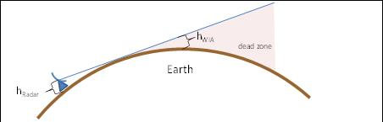
Figure 16: Radar and WIA horizon

Table 23: Separation distance - horizon
Characteristic | Factory hall | Plant level
Range of antenna high WIA | 2 to 6 m | 1.5 to 50 m
Typical Antenna high WIA | 4 m | 2 m to 50 m
He (hRadar=10 m) | 21.2 km | 18.9 km to 42.2 km
He (hRadar=15 m) | 24.2 km | 21.8 km to 45.1 km
He (hRadar=20 m) | 26.7 km | 24.3 km to 47.6 km
He (hRadar=40 m) | 34.3 km | 31.9 km to 55.2 km

In case, radars are installed on top of terrain relieves to improve their range by setting them over ground clutter, the effective radar height should be considered and the separation distance increased accordingly.
With the assumed antenna heights for h_{WIA} and h_{Radar}, the required separation distance is in the order of 20 to 55 km.

Aggregated impact
This section provides considerations on the aggregated impact.
The number of WIA seen by a radar is a function of the distance between radar and WIA location and the radar antenna beam width. If the radar is located far away, all the active transmitters of a factory can be visible (see Annex 1). The below figures are aimed to illustrate the situation.
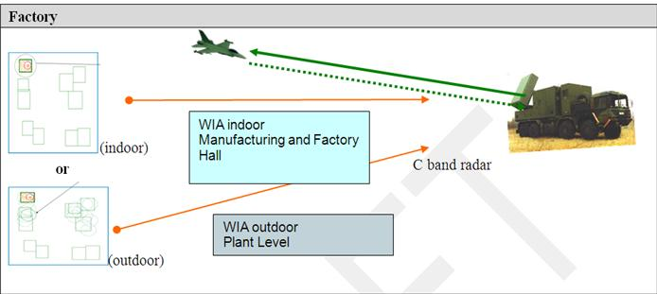
Figure 17: Cohabitation synoptic of WIA and military radar

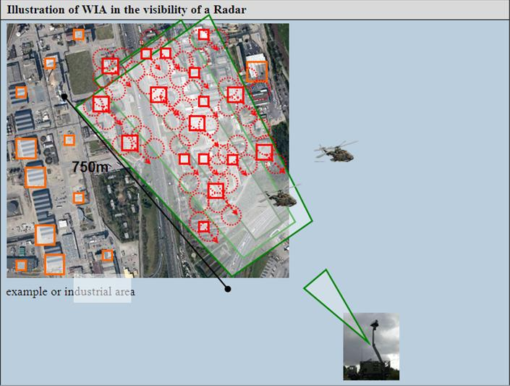
Figure 18: cohabitation synoptic of WIA in an industrial area and military radar
The aggregated impact has not been considered in this report. Further analysis may be required to assess the aggregated impact on the radar.

DFS consideration
Dynamic Frequency Selection (DFS) is a mechanism which may allow WIA to detect radar in order to operate without causing undue interference to radar operating in the 5725 to 5850 MHz bands. The same mechanism also enables BFWA systems to operate in the 5725 to 5850 MHz band, at least in those countries that have implemented the ECC/REC/(06)04 [12]. DFS is a mitigation technique, intended to sense the presence of radar signals in a given channel and prevent WIA signals from transmitting on that channel.
ANNEX 5: provides the methodology to determine the threshold to detect radar systems. Such a methodology has been used to determine DFS detection thresholds for RLAN, BBDR and BFWA at 5 GHz.
The following table provides an overview of the calculated threshold depending on the WIA under consideration.
Table 24: DFS thresholds
Characteristics of the Radars | Radar L | Radar M | Radar N | Radar O | Radar Q | Radar X & Y | Radar Z
DFS Detection threshold Th (dBm) – WIA 1 MHz | -39.51 | -46.19 | -48.68 | -55.80 | -53.43 | -65.19 | -49.53
DFS Detection threshold Th (dBm) – WIA 3 MHz | -34.73 | -41.41 | -43.91 | -51.03 | -48.66 | -60.41 | -44.76
DFS Detection threshold Th (dBm) – WIA 20 MHz | -26.50 | -33.18 | -35.67 | -42.79 | -40.42 | -52.18 | -36.52

Conclusion
It can be concluded that mitigation techniques are required to enable the sharing between WIA systems and fixed frequency radars.
In the co-channel interference assessment with radiolocation (i.e. below 5850 MHz), mitigation techniques such as an efficient DFS mechanism may improve the compatibility issue noting that frequency hopping radars may trigger on all available channels.
DFS may not allow detecting all types of radars. In particular, some incompatibility may remain with frequency hopping radars. However, this issue has already been identified for other radio systems using DFS.
The Recommendation ITU-R M.1638 [6] is under revision in ITU WP 5B. The report at hand is based on only those radars which are already described in Recommendation ITU-R M.1638 that is in force. The report at hand does not encompass the newly introduced types of radars in the ITU working document.

Road Transport and Traffic Telematics (RTTT) Systems
The RTTT characteristics and parameters are provided in section 3.3.2. WIA and RTTT systems can operate on the same channel, therefore coexistence problems can be expected at both sites. Two main types of potential interference situation have been identified:
  - interference from WIA (indoor / outdoor) on the RTTT Road Side Unit (RSU) and vice versa.
  - interference from WIA (indoor / outdoor) on the RTTT On Board Unit (OBU) and vice versa.

Section 4.2.1 contains MCL calculations, and section 4.2.2 SEAMCAT simulations.

MCL Calculations
The calculations developed in this section used the same propagation model as in ECC Report 101 [9] (see ANNEX 4:).

MCL calculations - RTTT RSU

Separation distances between WIA interferer and RTTT RSU victim
The antenna main beam of RTTT RSU is directed to the lane. Therefore, only the RTTT side lobe is considered relevant in the below calculations.

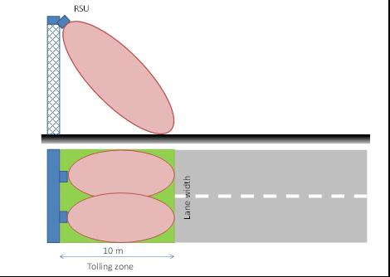
Figure 19: Sharing RSU on the road

The results of calculations for the separation distances between interferer WIA (indoor) with 1 MHz bandwidth and the victim RTTT RSU are provided in the following table.

Table 25: Interferer WIA I (bandwidth 1 MHz – indoor) - Victim RTTT RSU
 |  | Propagation model (see Annex 5)
LINK BUDGET | Units | Urban | Suburban | Rural | ETSI TR 102- 492
Emission part: WIA-I (1 MHz – indoor)
Bandwidth | MHz | 1 | 1 | 1 | 1
Tx out, e.i.r.p. | dBm | 26 | 26 | 26 | 26
Effect of TPC (dB) | dB | 0 | 0 | 0 | 0
Wall loss | dB | 15 | 15 | 15 | 15
Antenna Gain | dBi | 0 | 0 | 0 | 0
Net Tx power density | dBm/MHz | 11 | 11 | 11 | 11
Reception part: RSU RTTT
Receiver bandwidth | MHz | 0.5 | 0.5 | 0.5 | 0.5
Receiver sensitivity | dBm | -104 | -104 | -104 | -104
Antenna gain | dBi | 10 | 10 | 10 | 10
C min per MHz at antenna input | dBm/MHz | -111 | -111 | -111 | -111
Protection criterion
Criterion C/I | dB | 6 | 6 | 6 | 6
Acceptable interfering power at receiver | dBm/MHz | -107 | -107 | -107 | -107
Allowable Interfering power level 'I' at receiver antenna input | dBm/MHz | -117 | -117 | -117 | -117
MAIN LOBE WIA - SIDE LOBE RTTT
Sidelobe attenuation | dB | 15 | 15 | 15 | 15
Required Attenuation | dB | 113 | 113 | 113 | 113
Separation distance WIA RTTT | m | 329 | 567 | 1037 | 525

The following table provides an overview of the separation distances for the RTTT RSU as a victim.
Table 26: Separation distances (m) – WIA Interferer - RTTT RSU Victim (Side lobe)
 | Propagation model (see Annex 5)
WIA type | Urban | Suburban | Rural | ETSI TR 102- 492
WIA I – 1 MHz indoor | 329 | 567 | 1037 | 525
WIA II – 20 MHz indoor | 164 | 258 | 357 | 173
WIA III – 3 MHz outdoor | 569 | 1054 | 2117 | 1255
WIA IV – 20 MHz outdoor | 366 | 640 | 1192 | 622

Separation distances between RTTT RSU interferer and WIA victim
The results of calculations for the separation distances between interferer RTTT RSU and the victim WIA are provided in the following table.
Table 27: Separation distances (m) - RTTT RSU Interferer (Side lobe) - WIA Victim
 | Propagation model (see Annex 5)
WIA type | Urban | Suburban | Rural | ETSI TR 102- 492
WIA I – 1 MHz indoor | 111 | 159 | 182 | 95
WIA II – 20 MHz indoor | 140 | 210 | 279 | 134
WIA III – 3 MHz outdoor | 387 | 681 | 1280 | 678
WIA IV – 20 MHz outdoor | 312 | 534 | 958 | 482

MCL calculations - RTTT OBU

Separation distances between WIA interferer and RTTT OBU victim
The below Table provides the main parameters for the OBU
Table 28: parameters Victim RTTT OBU
Reception part: OBU RTTT | Unit | Value
Receiver bandwidth | MHz | 200
Receiver sensitivity | dBm | -60
Antenna gain | dBi | 10
Protection criterion C/I | dB | 6
Sidelobe attenuation | dB | 15

The results of calculations for the separation distances between interferer WIA and the victim RTTT OBU are provided in the following table.
Table 29: Separation distances (m) - WIA Interferer - RTTT OBU Victim
 |  | Propagation model (see Annex 5)
WIA type | Antenna gain | Urban | Suburban | Rural | ETSI TR 102- 492
WIA I – 1 MHz and WIA II – 20 MHz indoor | Main lobe | 77 | 91 | 91 | 57
WIA I – 1 MHz and WIA II – 20 MHz indoor | Side lobe | 16 | 16 | 16 | 16
WIA III – 3 MHz and WIA IV – 20 MHz outdoor | Main lobe | 183 | 291 | 421 | 206
WIA III – 3 MHz and WIA IV – 20 MHz outdoor | Side lobe | 77 | 91 | 91 | 57

Separation distances between RTTT OBU interferer and WIA victim
The results of calculations for the separation distances between interferer RTTT OBU and the victim WIA
are provided in the following table.
Table 30: Separation distances (m) - RTTT OBU Interferer – WIA Victim
 |  | Propagation model (see Annex 5)
WIA type | Antenna gain | Urban | Suburban | Rural | ETSI TR 102- 492
WIA I – 1 MHz indoor | Main lobe | 5 | 5 | 5 | 5
WIA I – 1 MHz indoor | Side lobe | 1 | 1 | 1 | 1
WIA II – 20 MHz indoor | Main lobe | 7 | 7 | 7 | 7
WIA II – 20 MHz indoor | Side lobe | 1 | 1 | 1 | 1
WIA III – 3 MHz outdoor | Main lobe | 64 | 65 | 65 | 44
WIA III – 3 MHz outdoor | Side lobe | 12 | 12 | 12 | 12
WIA IV – 20 MHz outdoor | Main lobe | 41 | 41 | 41 | 31
WIA IV – 20 MHz outdoor | Side lobe | 7 | 7 | 7 | 7

SEAMCAT simulations

Scenario Outline
The following figure depicts the scenario outline, which is valid for victim link receiver (VLR) RSU. Extra scenario outlines are depicted, if this simulation case varies from the following scenario outline.
The offset between victim link (RTTT) and interfering link (WIA) is used as a variable in the simulations to show the required separation distance. Mostly the distance between road and closest WIA is shown.
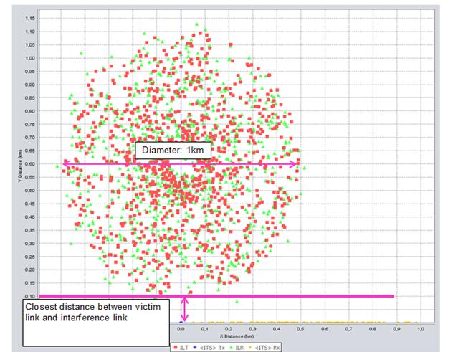
Figure 20: SEAMCAT scenario outline RTTT vs WIA

Interference Transmitter WIA with 25 mW e.i.r.p.
The first SEAMCAT simulations are provided with interference transmit power e.i.r.p. of 25 mW in order to show the influence of WIA with 25 mW according to the existing regulations. This can be used as a reference scenario (existing situation).
The devices (OBU and RSU) of RTTT have different parameters. Therefor the simulation carried out for VLR RSU and VLR OBU. Table 31 provides the simulation results for VLR OBU and

Table 32 provide the result for VLR RSU.
Table 31: Simulation results, ILT with e.i.r.p. of 25 mW, Victim Link Receiver (VLR): OBU
Parameter | Scenario 01 | Scenario 02 | Scenario 03
Tx power conducted WIA | 9 dBm
ILT->VLR path | IEEE 802.11 plugin :  - Log-Normal before BP: 3  - Log-Normal after BP: 4
ILT->VLR path | BP distance: 500 m (Rural) | BP distance: 50 m (Suburban) |  | BP distance: 5 m (Urban)
Closest distance between VLR and ILT | 5 m | 5 m |  | 5 m
dRSS(Mean ; StdDev) | -62 dBm ;  10 dB | -62 dBm ;  10 dB |  | -62 dBm  9 dB
iRSS_{unwantend}  (Mean ; StdDev) | -76.1 dBm  3.0 dB | -86 dBm  5 dB |  | -101 dBm  7 dB
iRSS_{blocking}  (Mean ; StdDev) | -79.1 dBm  3.0 dB | -89 dBm  5 dB |  | -104 dBm  7 dB
Prob that dRSS/iRSS < C/I | 0.9 % | 0.3 % |  | 0 %

Table 32: Simulation results, ILT with e.i.r.p.=25 mW, VLR: RSU
Parameter | Scenario 04 |  | Scenario 05 | Scenario 06
Tx power conducted WIA | 9 dBm
ILT->VLR path | IEEE 802.11 plugin :  - Log-Normal before BP: 3  - Log-Normal after BP: 4
ILT->VLR path | BP distance: 500 m (Rural) | BP distance: 50 m (Suburban) |  | BP distance: 5 m (Urban)
Closest distance between VLR and ILT | 5 m | 5 m |  | 5 m
dRSS(Mean ; StdDev) | -94.5 dBm ;  6,0 dB | -95,0 dBm ;  6,0 dB |  | -94.9 dBm  5.9 dB
iRSS_{unwantend}  (Mean ; StdDev) | -102.9 dBm  4.7 dB | -112.9 dBm  7.5 dB |  | -131.4 dBm  7.5 dB
iRSS_{blocking}  (Mean ; StdDev) | -119.3 dBm  28.6 dB | -127.2 dBm  27.5 dB |  | -145.0 dBm  26.8 dB
Prob that dRSS/iRSS < C/I | 72.8 % | 29.1 % |  | 1.5 %

Interference Transmitter WIA with 400 mW e.i.r.p. and TPC

Scenario Outline for VLR OBU and VLR RSU
The following figures depict the scenario outline, which are valid for Victim Link Receiver (VLR) RSU and OBU. Extra scenario outlines are depicted, if this simulation case varies from the following scenario outline.
An offset between victim link (RTTT) and interfering link (WIA) is used, because a WIA device on the road is unrealistic.
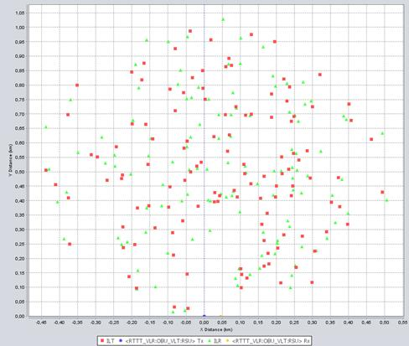
Figure 21: Scenario outline for 1 simulation event
The WIA are spread in an area of 1000 m diameter. The RSU is assumed to be located outside of the factory where the WIA are deployed.
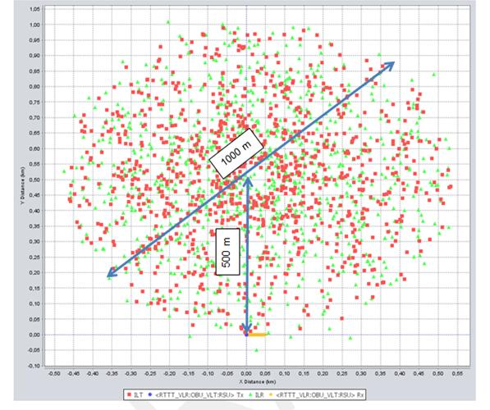
Figure 22: Scenario outline for 1000 simulation events

The length of the link between the RTTT RSU and the RTTT OBU is assumed to be 50 m maximum, in order to ensure that the received power is above the susceptibility of the receivers.

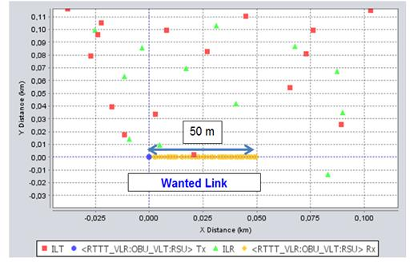
Figure 23: RSU – OBU link

Victim receiver: OBU
The following table present the simulation results for ILT with e.i.r.p.=400 mW, with adaptive Transmit Power Control (TPC) for the different environment Rural, Suburban and Urban between ILT and VLR. The VLR is the OBU of RTTT.
Table 33: VLR: OBU; ILT WIA with TPC, Separation distance between ILT and VLR 0 m
Parameter | Scenario 07 | Scenario 08 | Scenario 09
Victim link transmitter | RSU
Frequency | 5835 MHz Note
Victim link receiver | OBU
Reception bandwidth | 200.000 kHz
ILT Tx power conducted | 21 dBm (antenna gain 5 dBi)
Power Control | Power control step size: 6 dB  Min threshold: Outdoor: -4 dBm; Indoor -24  Dynamic range: 30 dB
ILT->VLR path | IEEE 802.11 plugin :  - Log-Normal before BP: 3  - Log-Normal after BP: 4
ILT->VLR path | BP distance: 500 m (Rural) | BP distance: 50 m (Suburban) | BP distance: 5 m (Urban)
Closest distance between VLR and ILT | 0 m | 0 m | 0 m
dRSS  (Mean ; StdDev) | -61 dBm  10 dB | -61 dBm  10 dB | -61 dBm  10 dB
iRSS_{unwantend}  (Mean ; StdDev) | -71 dBm  3 dB | -77 dBm  5 dB | -89 dBm  8 dB
iRSS_{blocking}  (Mean ; StdDev) | -74 dBm  3 dB | -80 dBm  5 dB | -92 dBm  8 dB
Prob that dRSS/iRSS < C/I | 6,1 % | 3.5 % | 0.9 %
Note: The frequency was set virtually to the middle of the band used for the WIA.

Victim receiver: RSU - separation distance 0 m
The following table present the simulation results for ILT with e.i.r.p.=400 mW, with adaptive transmit power control (TPC) for the different environment Rural, Suburban and Urban between ILT and VLR. The VLR is the RSU of RTTT.
Table 34: VLR: RSU; ILT WIA with TPC, Separation distance 0 m
Parameter | Scenario 10 | Scenario 11 | Scenario 12
Victim link transmitter | OBU
Frequency | Uniform distributed min.: 5797 MHz max.: 5872 MHz  Note
Victim link receiver | RSU
ILT Tx power conducted | 21 dBm (antenna gain 5 dBi)
Power Control | Power control step size: 6 dB  Min threshold: Outdoor: -4 dBm; Indoor -24  Dynamic range: 30 dB
ILT->VLR path | IEEE 802.11 plugin :  - Log-Normal before BP: 3  - Log-Normal after BP: 4
ILT->VLR path | BP distance: 500 m (Rural) | BP distance: 50 m (Suburban) | BP distance: 5 m (Urban)
Closest distance between VLR and ILT | 0 m | 0 m | 0 m
dRSS  (Mean ; StdDev) | -93.7 dBm;  6.6 dB | -93.3 dBm;  6.5 dB | -93.4 dBm  6.6 dB
iRSS_{unwantend}  (Mean ; StdDev) | -91.6 dBm;  4.8 dB | -104.6 dBm,  7.4 dB | -119.3 dBm  8.7 dB
iRSS_{blocking}  (Mean ; StdDev) | -108.4 dBm ;  28.1 dB | -117.7 dBm,  27.7 dB | -132.0 dBm  27.0 dB
Prob that dRSS/iRSS < C/I | 94.4 % | 64.6 % | 12.6 %
Note: The frequency of the victim was virtually randomly distributed through the whole WIA band to achieve an average result.

Separation distance 100 m
The scenarios 13 up to 15 simulate the case, that the minimum distance between the road with RTTT and the industrial plant is 100 m (offset in y axis is 600 m). This is illustrated in the following figure.
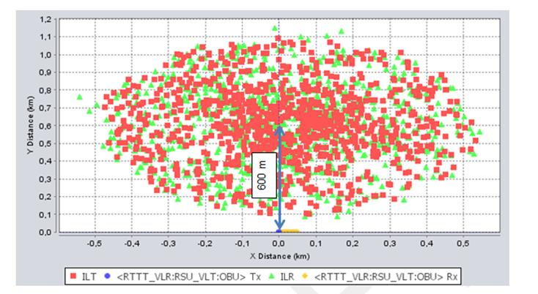
Figure 24: Separation distance 100 m
The simulation results for VLR RSU with a separation distance of 100 m between VLR and ILT are provided in Table 35.
Table 35: VLR: RSU; ILT WIA with TPC, Separation distance 100 m
Parameter | Scenario 13 | Scenario 14 | Scenario 15
Victim link transmitter | OBU
Frequency | Uniform distributed min.: 5797 MHz max. : 5872 MHz
Victim link receiver | RSU
ILT Tx power conducted | 21 dBm (antenna gain 5 dBi)
Power Control | Power control step size: 6 dB  Min threshold: Outdoor: -4 dBm; Indoor -24  Dynamic range: 30 dB
ILT->VLR path | IEEE 802.11 plugin :  - Log-Normal before BP: 3  - Log-Normal after BP: 4
ILT->VLR path | BP distance: 500 m (Rural) | BP distance: 50 m (Suburban) | BP distance: 5 m (Urban)
Closest distance between VLR and ILT | 100 m | 100 m | 100 m
dRSS  (Mean ; StdDev) | -93.3 dBm  6.7 dB | -93.2 dBm  6.9 dB | -93.4 dBm  6.6 dB
iRSS_{unwantend}  (Mean ; StdDev) | -96.7 dBm  4.3 dB | -108.4 dBm  6.1 dB | -126.8 dBm  6.1 dB
iRSS_{blocking}  (Mean ; StdDev) | -111.5 dBm  28.6 dB | -121.5 dBm  28.2 dB | -140.7 dBm  27.9 dB
Prob that dRSS/iRSS < C/I | 87.6 % | 47.3 % | 1.3 %

Victim receiver: RSU - Separation distance 500 m, 1000 m and 2500 mThe scenarios 16 up to 18 (see Figure 25: Separation distance between 500 m and 2500 m
) simulate the case, that the minimum distance between the road with RTTT and the industrial plant is 500 m (offset in y axis is 1000 m), 1000 m (offset in y axis is 1500 m) and 2500 m (offset in y axis is 3000 m). The scenario 19 and 20 simulate the case, that the environment is suburban and the minimum distance between road with RTTT and industrial plant is 500 m and 1000 m.

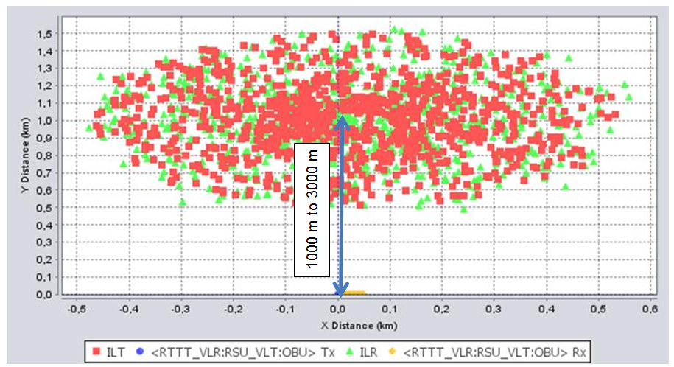
Figure 25: Separation distance between 500 m and 2500 m
The simulation results for VLR RSU with a separation distance of 500 m, 1000 m and 2500 m between VLR and ILT provided Table 36.
Table 36: VLR: RSU; ILT WIA with TPC, Separations distance 500 m to 2500 m
Parameter | Scenario 16 | Scenario 17 | Scenario 18 | Scenario 19 | Scenario 20
Victim link transmitter | OBU
Frequency | Uniform distributed min.: 5797 MHz max. : 5872 MHz
Victim link receiver | RSU
ILT Tx power conducted | 21 dBm (antenna gain 5 dBi)
Power Control | Power control step size: 6 dB  Min threshold: Outdoor: -4 dBm; Indoor -24  Dynamic range: 30 dB
ILT->VLR path | IEEE 802.11 plugin :  - Log-Normal before BP: 3 and Log-Normal after BP: 4
ILT->VLR path | BP distance: 500 m  (Rural) |  |  | BP distance: 50 m  (Suburban)
Closest distance between VLR and ILT | 500 m | 1000 m | 2500 m | 500 m | 1000 m
dRSS  (Mean ; StdDev) | -93.6 dBm ;  6.6 dB | -93.2 dBm;  6.8 dB | -93.7 dBm  6.5 dB | -93.5 dBm ;  6.8 dB | -92.8 dBm;  6.8 dB
iRSS_{unwantend}  (Mean ; StdDev) | -103.5 dBm  4.1 dB | -109.8 dBm  3.9 dB | -120.3 dBm  4.0 dB | -118,1 dBm  4.7 dB | -124.7 dBm;  4.3 dB
iRSS_{blocking}  (Mean ; StdDev) | -119.2 dBm  29.0 dB | -124.4 dBm  28.5 dB | -135.4 dBm  28.6 dB | -133.1 dBm  28.8 dB | -137.3 dBm  27.9 dB
Prob that dRSS/iRSS < C/I | 70.7 % | 40.6 % | 3.6 % | 8,8 % | 0,8 %

Conclusions
The results for the OBU as victim are summarised in Table 39.
Table 37: Summary table of C/I interference probability for VLR OBU
Scenario | Rural | Suburban | Urban
ILT: e.i.r.p.=25 mW reference without TPC  Closest distance between ILT and VLR: 5 m in y axis | 0.9 % | 0.3 % | 0.0 %
ILT: e.i.r.p.=400 mW reference with TPC  Closest distance between ILT and VLR: 0 m in y axis | 6.1 % | 3.5 % | 0.9 %

For the VLR OBU and ILT with 25 mW e.i.r.p. no interference is expected. For the VLR OBU and ILT with 400 mW e.i.r.p. the C/I interference probability is acceptable in Urban environment. But in Suburban and Rural environment the interference probability goes up to 3.5 % in Suburban and up to 6.0 % in Rural environments.

The results for the RSU as victim are summarised in Table 40.Table 38: Summary table of C/I interference probability for VLR RSU
Scenario | Rural | Suburban | Urban
ILT: e.i.r.p.=25 mW reference without TPC  Closest distance between ILT and VLR: 5 m in y axis | 72.8 % | 29.1 % | 1.5 %
ILT: e.i.r.p.=400 mW reference without TPC  Closest distance between ILT and VLR: 0 m in y axis | 94.4 % | 64.6 % | 12.6 %
ILT: e.i.r.p.=400 mW reference with TPC  Closest distance between ILT and VLR: 0 m in y axis | - | - | 8 %
ILT: e.i.r.p.=400 mW reference with TPC  Closest distance between ILT and VLR: 100 m in y axis | 87.6 % | 47,3 % | 1,3 %
ILT: e.i.r.p.=400 mW reference with TPC  Closest distance between ILT and VLR: 500 m in y axis | 70,7 % | 8,8 % | -
ILT: e.i.r.p.=400 mW reference with TPC  Closest distance between ILT and VLR: 1000 m in y axis | 40,6 % | 0,8 % | -
ILT: e.i.r.p.=400 mW reference with TPC  Closest distance between ILT and VLR: 2500 m in y axis | 3,6 % | - | -

For the VLR RSU and ILT with 25 mW e.i.r.p. harmful interference is only expected in the rural and suburban environment (the interference probability goes up to 29.1 % in suburban and up to 72.8 % in rural environments). The C/I interference probability is acceptable in Urban environment.
For the RSU and the ILT with 400 mW e.i.r.p. separation distances are required: Urban 100m, Suburban 1000 m and Rural environment 2500 m. However, a coordination procedure between WIA and RTTT may be possible, if the position of the RTTT RSU is known.
DAA mitigation techniques were not considered, but the use of DAA mitigation techniques according ETSI TS 102 792 Annex D are recommended.

Broadband Fixed Wireless Access (bfwa)
The BFWA characteristics and parameters are provided in section 3.3.2.
Section 4.3.1 contains MCL calculations, and section 4.3.2 SEAMCAT simulations.

MCL calculations - BFWA
The following table provides the required separation distances calculated assuming the propagation conditions specified in Note 1.
Table 39: MCL calculations – SIR
Input | Case 1 | Case 2 | Case 3 | Case 4
f/GHz | 5.75 | 5.75 | 5.75 | 5.75
Interferer: WIA
Tx power mW | 400 | 400 | 25 | 25
Tx power dBm/BWi | 26.02 | 26.02 | 13.98 | 13.98
Receiver Bandwidth BWi kHz | 1000 | 1000 | 1000 | 1000
Tx power dBm/BWv | 26 | 26 | 14 | 14
Victim definition: BFWA CS
sensitivity dBm/BWv | -68 | -68 | -68 | -68
BWv kHz | 20000 | 20000 | 20000 | 20000
signal level above Sens dB | 10 | 10 | 10 | 10
SIR dB | 27 | 27 | 27 | 27
Feeder loss dB | 0 | 0 | 0 | 0
max permissible interf dBm/BWv | -85 | -85 | -85 | -85
Reception antenna gain dBi | 16 | 16 | 16 | 16
Interference assessment
Propagation exponent n (Note 1) | 2 | 3.5 | 2 | 3.5
Additional wall loss aw dB (Note 1) | 0 | 10 | 0 | 10
Protection distance r, m (Note 1) | 9255 | 96 | 2314 | 43
Note 1: propagation model PL=32.5dB+20log(f/GHz)+n*10*log(r/m)+ aw

Table 40: MCL calculations – I/N objective
Input | Case 1 | Case 2 | Case 3 | Case 4
f/GHz | 5.75 | 5.75 | 5.75 | 5.75
Interferer: WIA
Tx power mW | 400 | 400 | 25 | 25
Tx power dBm/BWi | 26.02 | 26.02 | 13.98 | 13.98
Receiver Bandwidth BWi kHz | 1000 | 1000 | 1000 | 1000
Tx power dBm/BWv | 26 | 26 | 14 | 14
Victim definition: BFWA CS
BWv kHz | 20000 | 20000 | 20000 | 20000
max permissible interf dBm/BWv | -95 | -95 | -95 | -95
Reception antenna gain dBi | 16 | 16 | 16 | 16
Interference assessment
Propagation exponent n (Note 1) | 2 | 3.5 | 2 | 3.5
Additional wall loss aw dB (Note 1) | 0 | 10 | 0 | 10
Protection distance r, m (Note 1) | 29266 | 185 | 7316 | 84
Note 1: propagation model PL=32.5dB+20log(f/GHz)+n*10*log(r/m)+ aw

Under worst case conditions (Free Space loss), the BFWA link can be affected by 400mW WIA within a radius around the WIA between 10 and 30 km. This situation is much less critical in urban environments with distances between 100m and 200m. These scenarios will be further analysed in the following sections.

SEAMCAT simulations
In this section a probabilistic analysis is provided using the SEAMCAT tool (www.seamcat.org).
The IEEE plugin was used in SEAMCAT in order to be able to consider also an urban-like propagation model (Model_C_IEEE_802_11_rev2, Date 17/10/2012), see also ANNEX 3:).
The following configuration was used in the simulations:
  - Breakpoint distance 5m for urban environments
  - Breakpoint distance 50m for suburban environments
  - Breakpoint distance 500m for rural environments

WIA with 25 mW e.i.r.p.
The SEAMCAT simulations were carried out with interference transmit power e.i.r.p. of 25 mW in order to show the influence of the existing regulation on BFWA (reference scenario).
The Terminal Station (Tx) is assumed to be at the center of the factory and the distance between the Terminal Station and the Based Station (Rx) is 1 km (as shown in the following figure).
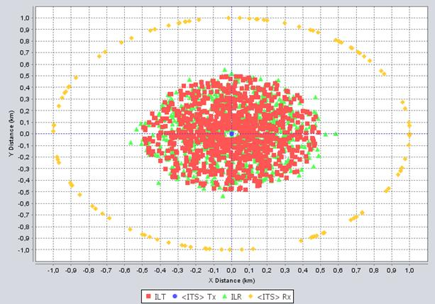
Figure 26: Scenario outline for WIA with 25 mW e.i.r.p.
The following table summarises the assumptions of the SEAMCAT simulations. Scenario 1, 2 and 3 consider different propagation conditions for the interfering path (Interfering Link Transmitter to Victim Link Receiver):
  - Scenario 1: Rural propagation
  - Scenario 2: Suburban propagation
  - Scenario 3: Urban propagation

Table 41: VLR: BFWA; ILT WIA with TPC
Parameter | Scenario 1 | Scenario 2 | Scenario 3
Victim link Receiver | BFWA CS
Frequency | Uniform distributed min.: 5807 MHz max.: 5865 MHz  Note
Reception bandwidth | 20.000 kHz
Propagation model on the victim link | Spherical diffraction outdoor- outdoor (see ANNEX 3:)
C/(I+N) | 24 dB
Coverage radius | 1000 m
ILT->ILR path | IEEE 802.11 plugin :  BP distance: Indoor 5 m; Outdoor 500 m (Rural)
ILT->VLR path | IEEE 802.11 plugin :  - Log-Normal before BP: 3  - Log-Normal after BP: 4
ILT->VLR path | BP distance: 500 m (Rural) | BP distance: 50 m (Suburban) | BP distance: 5 m (Urban)
ILT->VLR path | None, Interfering link distributed around the VLR  - Distance between VLR and ILT from 500m to 1000m
dRSS | -56 dBm | -56 dBm | -56 dBm
iRSS_{unwantend}  (Mean ; StdDev) | -72 dBm  1.5dB | -87 dBm  2.0 dB | -115 dBm  2.1 dB
iRSS_{blocking}  (Mean ; StdDev) | -93.2 dBm  0.8 dB | -108.1 dBm  1.4 dB | -136.9 dBm  1.3 dB
Prob that dRSS/iRSS<C/(I+N) | 100 % | 0.7 % | 0 %
Prob I>N (I/N=0dB) | 100 % | 100 % | 0 %
Note: The frequency of the victim was virtually randomly distributed through the whole WIA band to achieve an average result

These results are confirming that, in urban environments (breakpoint distance 5m in the path loss model), no problems are expected. In suburban environments (break point distance 50 m) there is only a problem with I/N criteria. In rural (break point distance 500m) there is a high risk of harmful interference. These results are valid for 25 mW e.i.r.p. system with 5 dBi antenna gain.
Devices operating with 25 mW (Annex 1 to ERC/REC 70-03 [2]) would produce an interference probability (C/I+N) between 0% and 100%. It should be noted that in this scenario the BFWA antenna main beam is assumed to be always pointing to the WIA installation and thus the simulations shows a worst case.

WIA with 400 mW e.i.r.p.
SEAMCAT simulations were conducted with WIA operating at 400 mW, without any consideration of mitigation techniques. Scenario 4, 5 and 6 considered different propagation conditions in the interfering path (Interfering Link Transmitter to Victim Link Receiver):
  - Scenario 4: Rural propagation conditions
  - Scenario 5: Suburban propagation conditions
  - Scenario 6: Urban propagation conditions

The scenario is identical to the previous simulation with 25 mW.
Table 42: SEAMCAT results WIA with 400 mW e.i.r.p. without mitigations
Parameter | Scenario 4 | Scenario 5 | Scenario 6
Victim link Receiver | BFWA CS
Frequency | Uniform distributed min.: 5807 MHz max.: 5865 MHz
Reception bandwidth | 20.000 kHz
Propagation model on the victim link | Spherical diffraction outdoor- outdoor
C/(I+N) | 24 dB
Coverage radius | 1000 m
Interfering Transmitter | WIA 400 mW – 5 dBi antenna gain
ILT->VLR path | IEEE 802.11 plugin :  - Log-Normal before BP: 3  - Log-Normal after BP: 4
ILT->VLR path | BP distance: 500 m (Rural) | BP distance: 50 m (Suburban) | BP distance: 5 m (Urban)
ILT->VLR path | None, Interfering link distributed around the VLR  - Distance between VLR and ILT from 500m to 1000m
dRSS  (Mean ; StdDev) | -56 dBm | -56 dBm | -56 dBm
iRSS_{unwantend}  (Mean ; StdDev) | -60 dBm  1.5 dB | -75 dBm  2.0 dB | -103dBm  2 dB
iRSS_{blocking}  (Mean ; StdDev) | -81.2 dBm  0.8 dB | -102 dBm  2.8 dB | -130.8 dBm  2.7 dB
Prob that dRSS/iRSS<C/(I+N) | 100 % | 100 % | 0 %
Prob I>N (I/N=0dB) | 100 % | 100 % | 0,1 %

These results are confirming the MCL calculations in section 4.3.1, that in urban environments (breakpoint distance 5m in the path loss model) no problems are expected. In suburban (break point distance 50 m) and rural (break point distance 500m) environments there is a high risk of harmful interference.
It should be noted that in this scenario the BFWA antenna main beam is assumed to be always pointing to the WIA installation and thus the simulations shows a worst case.
Based on the propagation path loss from the worst case scenario 5 the effect of the mitigation techniques APC and LBT are analysed in the next sections.

WIA 400 mW -with Transmit Power Control (TPC)
The impact of the Transmit Power Control (TPC) is considered in this section. TPC as described in ANNEX 1: is implemented in the simulations.
Three scenarios are considered, where the Terminal Station (TS) of the BFWA is deployed outside from the factory and were the distance between the TS and the center of the factory is increased.
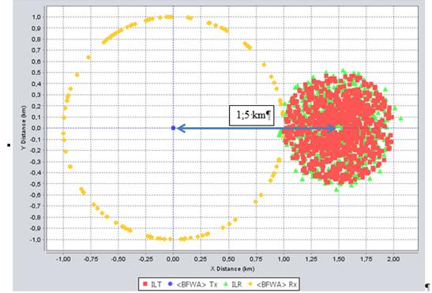
Figure 27: Scenario outline for WIA for scenario 7- Suburban

The following table provides the results for suburban environment.
Table 43: SEAMCAT results WIA with 400 mW e.i.r.p. with TPC in Suburban environment
Parameter | Scenario 7 | Scenario 8 | Scenario 9
Victim link Receiver | BFWA CS
Frequency | Uniform distributed min.: 5807 MHz max.: 5865 MHz
Reception bandwidth | 20.000 kHz
Propagation model on the victim link | Spherical diffraction outdoor- outdoor (see ANNEX 3:)
C/(I+N) | 24 dB
Coverage radius | 1000 m
Interfering Transmitter | WIA 400 mW – 5 dBi antenna gain
ILT->ILR path | IEEE 802.11 plugin :  BP distance: Indoor 5 m; Outdoor 500 m (Rural)
ILT->VLR path | IEEE 802.11 plugin :  - Log-Normal before BP: 3  - Log-Normal after BP: 4
ILT->VLR path | BP distance: 50 m (Suburban)
ILT->VLR path | None, Interfering link distributed around the VLR
Offset distance between ILT  (center of the factory) and VLR (TS) | 1.5 km | 2 km | 3 km
dRSS | -56 dBm | -56 dBm | -56 dBm
iRSS_{unwantend}  (Mean ; StdDev) | -75 dBm  2.0 dB | -89.5 dBm  2.9 dB | -109 dBm  8 dB
iRSS_{blocking}  (Mean ; StdDev) | -102.1 dBm  2.7 dB | -116.5 dBm  3.3 dB | -136 dBm  8 dB
Prob that dRSS/iRSS<C/(I+N) | 99.9 % | 1.6 % | 0 %
Prob I>N (I/N=0dB) | 100 % | 99.4 % | 0 %

In the rural environment, the considered distances between the BS and the centre of the factory are larger.

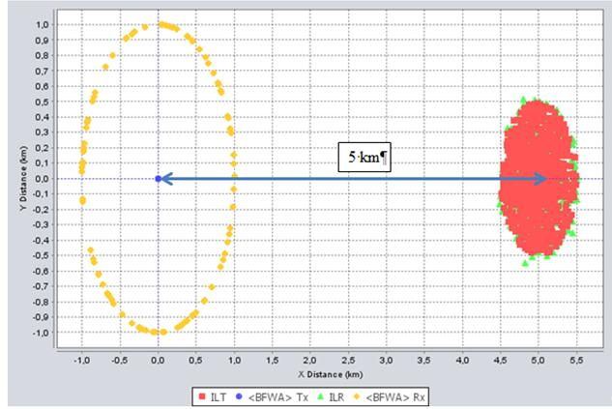
Figure 28: Scenario outline for WIA for scenario 10 – Rural

Table 44: SEAMCAT results WIA with 400 mW e.i.r.p. with TPC in Rural environment
Parameter | Scenario 10 | Scenario 11 | Scenario 12
Victim link Receiver | BFWA CS
Frequency | Uniform distributed min.: 5807 MHz max.: 5865 MHz
Reception bandwidth | 20.000 kHz
Propagation model on the victim link | Spherical diffraction outdoor- outdoor (ANNEX 3:)
C/(I+N) | 24 dB
Coverage radius | 1000 m
Interfering Transmitter | WIA 400 mW – 5 dBi antenna gain
ILT->ILR path | IEEE 802.11 plugin :  BP distance: Indoor 5 m; Outdoor 500 m (Rural)
ILT->VLR path | IEEE 802.11 plugin :  - Log-Normal before BP: 3  - Log-Normal after BP: 4
ILT->VLR path | BP distance: 500 m (Rural)
ILT->VLR path | None, Interfering link distributed around the VLR
Offset distance between ILT (center of the factory) and VLR (TS) | 3 km | 7 km | 10 km
dRSS | -56 dBm | -56 dBm | -56
iRSS_{unwantend}  (Mean ; StdDev) | -93 dBm  8 dB | -107 dBm  11 dB | -109 dBm  11 dB
iRSS_{blocking}  (Mean ; StdDev) | -114 dBm  8 dB | -134 dBm  11 dB | -137 dBm  11 dB
Prob that dRSS/iRSS<C/(I+N) | 0.6 % | 0 % | 0 %
Prob I>N (I/N=0dB) | 66 % | 7.4 % | 0.1 %

The simulation above showed that TPC only is not sufficient to protect BFWA in all scenarios.
For the suburban environment a separation distance offset of 2 km is required to fulfil the interference criteria C/(I+N) of 24 dB and separation distance offset of 3 km is required to fulfil the interference criteria I/N of 0 dB.
For the rural environment a separation distance offset of 3 km is required to fulfil the interference criteria C/(I+N) of 24 dB and separation distance offset of 10 km is required to fulfil the interference criteria I/N of 0 dB.

WIA 400 mW -with Transmit Power Control (TPC) and Detect and Avoid (DAA)

Sensing on BFWA TS
The additional mitigation technique detect and avoid (DAA) is considered in this section. The same methodology as for the Radiolocation Service in used in order to determine the thresholds (see Annex 5). The WIA are sensing for the power transmitted by the TS.
The following table provides the threshold depending on the WIA system.
Table 45: DAA Thresholds for BFWA
Characteristics of the BFWA | WIA I | WIA II | WIA III
Tx power into antenna peak (dBm) | 14,00 | 14.00 | 14.00
BFWA bandwidth (MHz) | 20 | 20 | 20
Characteristics of a WIA device
WIA e.i.r.p (dBm) outdoor | 26 | 26 | 26
Bandwith (MHz) | 1 | 20 | 3
Antenna gain (dBi) | 5 | 5 | 5
WIA spectral density power (dBm/MHz) at the antenna connector | 21 | 8 | 16
Characteristics of the DAA
Receiver sensitivity (dBm) | -68 | -68 | -68
Interference level (dBm/MHz) | -105 | -105 | -105
DAA Detection threshold (dBm) | -112 | -99 | -107

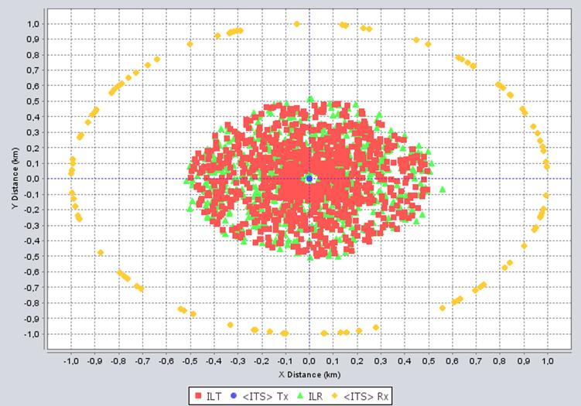
Figure 29: Simulation outline for SEAMCAT simulations with DAA

The following table provides the results for simulations were different thresholds are considered for WIA.

Scenarios 14 and 15 correspond to the case where a central station is sensing (see ANNEX 5:). Scenario 13 considers the case where the sensing is implemented on each of the devices.
Table 46: SEAMCAT results WIA with 400 mW e.i.r.p. with TPC and DAA
Parameter | Scenario 13 | Scenario 14 | Scenario 15
Victim link Receiver | BFWA CS
Frequency | Uniform distributed min.: 5807 MHz max.: 5865 MHz
Reception bandwidth | 20.000 kHz
Propagation model on the victim link | Spherical diffraction outdoor- outdoor
C/(I+N) | 24 dB
Coverage radius | 1000 m
Interfering Transmitter | WIA 400 mW – 5 dBi antenna gain
ILT->ILR path | IEEE 802.11 plugin  Breakpoint distance Indoor: 5m; Outdoor: 500 m  (see ANNEX 3:)
DAA Threshold | -112 dBm/1 MHz  -107 dBm/3 MHz  -99 dBm/20 MHz | -112 dBm/1 MHz  -107 dBm/3 MHz  -99 dBm/20 MHz | -99 dBm/1 MHz  -99 dBm/3 MHz  -99 dBm/20 MHz
Sensing path  VLT-ILT | IEEE 802.11 plugin, Breakpoint distance 500m
ILT->VLR path | IEEE 802.11  plugin Breakpoint distance (500 m) | IEEE 802.11 plugin Breakpoint distance (50 m) | IEEE 802.11  plugin Breakpoint  distance (50 m)
dRSS | -56 dBm | -56 dBm | -56 dBm
iRSS_{unwantend}  (Mean ; StdDev) | -97 dBm  9dB | -111 dBm  9 dB | -102  8.5 dB
iRSS_{blocking}  (Mean ; StdDev) | -110.1 dBm  3 dB | -125 dBm  3 dB | -122 dBm  3 dB
Prob that dRSS/iRSS<C/(I+N) | 4 % | 0 % | 0 %
Prob I>N (I/N=0dB) | 43 % | 3 % | 19.5 %

The following table provides the results for simulations were a single threshold is considered for all WIA. Scenario 17 correspond to the case where a central station is sensing (see ANNEX 5:). Scenarios 16 and 18 considers the case where the sensing is implemented on each of the devices
Table 47: SEAMCAT results WIA with 400 mW e.i.r.p. with TPC and DAA
Parameter | Scenario 16 | Scenario 17 | Scenario 18
Victim link Receiver | BFWA CS
Frequency | Uniform distributed min.: 5807 MHz max.: 5865 MHz
Reception bandwidth | 20.000 kHz
Propagation model on the victim link | Spherical diffraction outdoor- outdoor
C/(I+N) | 24 dB
Coverage radius | 1000 m
Interfering Transmitter | WIA 400 mW – 5 dBi antenna gain
ILT->ILR path | IEEE 802.11 plugin  Breakpoint distance Indoor: 5m; Outdoor: 500 m  (see ANNEX 3:)
DAA Threshold | -99 dBm/20 MHz
Sensing path  VLT-ILT | IEEE 802.11 plugin, Breakpoint distance 500m |  | IEEE 802.11  plugin, Breakpoint distance 50m
ILT->VLR path | IEEE 802.11 plugin Breakpoint distance (500 m) | IEEE 802.11 plugin Breakpoint distance (50 m) | IEEE 802.11  plugin Breakpoint  distance (50 m)
dRSS | -56 dBm | -56 dBm | -56 dBm
iRSS_{unwantend}  (Mean ; StdDev) | -104 dBm  6 dB | -119 dBm  6 dB | -92  6 dB
iRSS_{blocking}  (Mean ; StdDev) | -113 dBm  5 dB | -129 dBm  5 dB | -118 dBm  5 dB
Prob that dRSS/iRSS<C/(I+N) | 0.3 % | 0 % | 3.4 %
Prob I>N (I/N=0dB) | 8.5 % | 0.5 % | 69.6 %

Detection on BWFA TS seems sufficient to meet the BFWA C/I protection criteria; to fulfil the I/N objective a centralised sensing could help.
A sensing antenna to be installed on top of the industrial plant would improve the detection process since there will be a better propagation conditions on the sensing path to detect the possible victim link. In addition, this will allow having the possibility to implement a higher gain antenna for the sensing purpose.
It should be noted that the directional antenna of BFWA TS is directed with 4° elevation angle pointing in the direction of the sky and making difficult the detection by the WIA. Therefore, the detection of the BFWA CS is considered.

Sensing on BFWA CS
In this section, a centralized detector is assumed to implement DAA in order to detect the BFWA CS. Therefore, addition simulations were conducted with VLR BFWA TS and VLT BFWA CS.
In the case of BFWA CS, the elevation angle of the direction antenna is -4°, which means that they can be directed toward or nearby for the WIA devices.
Simulation outline

The CS is transmitting in the direction of a TS which is located in the area of the factory. In the following figure the TS is located at the centre of the factory.

- 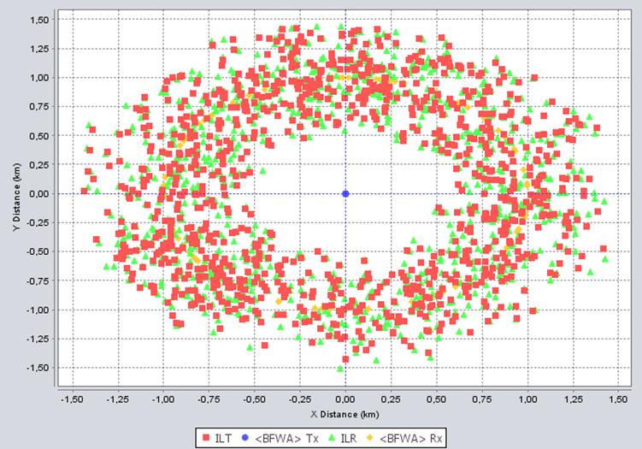
Figure 30: Simulation outline for VLT: BFWA TS at the center of the factory
The following table provides the results of simulations assuming that the TS is located at the center of the factory.
Table 48: SEAMCAT results WIA with 400 mW e.i.r.p. with TPC and DAA on the CS
Parameter | Scenario 22 | Scenario 23
Victim link Receiver | BFWA CS
Frequency | Uniform distributed min.: 5807 MHz max.: 5865 MHz
Reception bandwidth | 20.000 kHz
Propagation model on the victim link | Spherical diffraction outdoor- outdoor
C/(I+N) | 24 dB
Coverage radius | 1000 m
Interfering Transmitter | WIA 400 mW – 5 dBi antenna gain
ILT->ILR path | IEEE 802.11 plugin  Breakpoint distance Indoor: 5m; Outdoor: 500 m (see ANNEX 3:)
DAA Threshold | -90 dBm for 20 MHz
Sensing path  VLT-ILT | IEEE 802.11 plug in BP=500 m | Spherical diffraction
ILT->VLR path | IEEE 802.11 plugin  Breakpoint distance 50 m (Suburban)
dRSS | -50 dBm | -50 dBm
iRSS_{unwantend}  (Mean ; StdDev) | -98 dBm  7 dB | -104 dBm  6 dB
iRSS_{blocking}  (Mean ; StdDev) | -109 dBm  8 dB | -111 dBm  7 dB
Prob that dRSS/iRSS<C/(I+N) | 0.2 % | 0 %
Prob I>N (I/N=0dB) | 37 % | 7.9 %

Also here the C/I objective is fulfilled. But also in this configuration, there is still a risk of interference to the BFWA that the I/N objective is exceeded.
In general, there should be no deployment of BFWA CS within the factory except if so agreed between the factory manager and the BFWA manager.
Additional scenarios are considered as follows:
The following figure shows a sample where the TS is located at the edge of the factory.
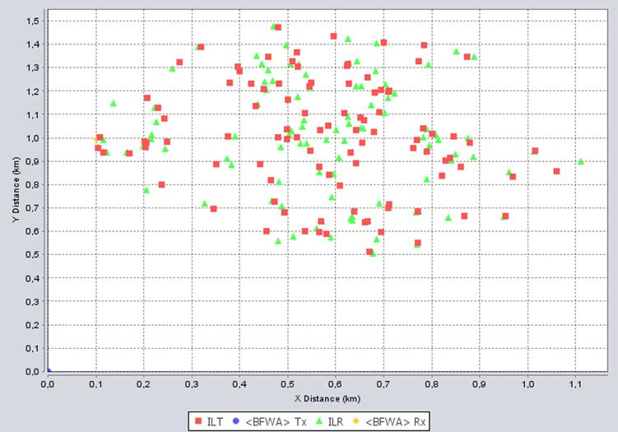
Figure 31: Scenario outline for Scenario 24
Two scenarios considered the cases where the CS is located at one edge of the factory and the TS is located at the other edge.
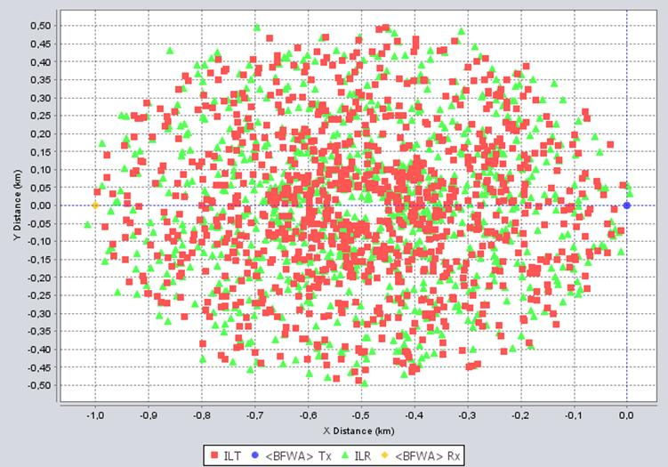
Figure 32: Scenario outline for Scenario 25 and 26

The following table provides the results for the three scenarios above. Two different DAA thresholds for the centralised detector are considered in two last scenarios.
Table 49: SEAMCAT results WIA with 400 mW e.i.r.p. with TPC and DAA
Parameter | Scenario 24 |  | Scenario 25 |  | Scenario 26
Frequency | Uniform distributed min.: 5807 MHz max.: 5865 MHz
Reception bandwidth | 20.000 kHz
Interfering Transmitter | WIA 400 mW – 5 dBi antenna gain
DAA Threshold | -85 dBm/20 MHz | -85 dBm/20MHz |  | -80 dBm/20MHz
Sensing path VLT-ILT | Spherical diffraction
ILT->VLR path | IEEE 802.11 plugin  Breakpoint distance (50 m) (Suburban)
Offset X relative to VLR | 500 m |  | Factory in the middle between VLT and VLR
dRSS | -50 dBm |  | -50 dBm |  | -50 dBm
iRSS_{unwantend}  (Mean ; StdDev) | -114 dBm  11 dB |  | -104 dBm  6 dB |  | -103 dBm  6 dB
iRSS_{blocking}  (Mean ; StdDev) | -121 dBm  12 dB |  | -110 dBm  7 dB |  | -106 dBm  7 dB
Prob that dRSS/iRSS<C/(I+N) | 0 % |  | 0 % |  | 0 %
Prob I>N (I/N=0dB) | 5 % |  | 9.3 % |  | 27 %

Summary and Conclusions for BFWA

The use of TPC is not sufficient to meet the BFWA interference criteria.
For the suburban environment no harmful interference is expected, with or without mitigation techniques.
For the suburban environment a separation distance offset of 2 km is required to fulfil the interference criteria C/(I+N) of 24 dB and separation distance offset of 3 km is required to fulfil the interference criteria I/N of 0 dB.
For the rural environment a separation distance offset of 3 km is required to fulfil the interference criteria C/(I+N) of 24 dB and separation distance offset of 10 km is required to fulfil the interference criteria I/N of 0 dB. These results are valid for 400mW e.i.r.p. system with 5 dBi antennas and adaptive transmit power control (TPC).
The DAA mechanism within the WIA devices seems sufficient to meet the C/I BFWA interference criteria. To fulfil the I/N objective a centralised sensing could help; such a more efficient sensing procedure would be a centralized sensing device with an antenna to be installed on top of the industrial plant, with the advantage of better propagation conditions to the victim link and the possibility to choose a higher gain antenna for the sensing purpose.
It should be noted that devices according to the existing regulations with 25 mW having in the same SEMCAT scenario also a potential of interference in the rural and suburban environment.
Table 52 summarises the main SEAMCAT results.
Table 50: Summary of the results for BFWA
Simulation case | Interference criteria | Interference Path (ILT VLR)
Simulation case | Interference criteria | Rural | Suburban | Urban
WIA with 25 mW e.i.r.p. without mitigation techniques According existing regulations | C/(I+N) | 100 % | 0,7 % | 0 %
 | I/N | 100 % | 100 % | 0 %
WIA with 400 mW e.i.r.p.  without mitigation techniques | C/(I+N) | 100 % | 100 % | 0 %
WIA with 400 mW e.i.r.p.  without mitigation techniques | I/N | 100 % | 100 % | 0.1 %
WIA with 400 mW e.i.r.p.  With TPC and closest distance between VLR and VLT (3 km) | C/(I+N) | 0.6 % | 0 % | -
 | I/N | 66 % | 0 % | -
WIA with 400 mW e.i.r.p.  With TPC and closest distance between VLR and VLT (10 km) | C/(I+N) | 0 % | - | -
 | I/N | 0.1 % | - | -
WIA with 400 mW e.i.r.p. With TPC and DAA threshold -112 dBm/1MHz; -107dBm/3MHz;  -99dBm/20MHz  Sensing path (VLTILT) Rural environment | C/(I+N) | 4 % | 0 % | -
 | I/N | 43 % | 3 % | -
WIA with 400 mW e.i.r.p. With TPC and DAA threshold -99 dBm for 1MHz; 3MHz; and 20MHz  Sensing path (VLTILT) Rural environment | C/(I+N) | - | 0 % | -
 | I/N | - | 19.5 % | -
WIA with 400 mW e.i.r.p. With TPC and DAA threshold -99 dBm / 20MHz  Sensing path (VLTILT) Rural environment  Centralize Sensing | C/(I+N) | 0.3 % | 0 % | -
 | I/N | 8.5 % | 0.5 % | -
WIA with 400 mW e.i.r.p. With TPC and DAA threshold -99 dBm / 20MHz  Sensing path (VLTILT) Suburban environment | C/(I+N) |  | 3.4 % | -
 | I/N |  | 69.6 % | -
WIA with 400 mW e.i.r.p. With TPC and DAA threshold -90 dBm / 20MHz  Sensing path (VLTILT) Suburban  Centralize Sensing Position relative to BFWA Rx | C/(I+N) |  | 0.2 %
 | I/N |  | 37 %
WIA with 400 mW e.i.r.p.  With TPC and DAA threshold -90 dBm / 20MHz  Sensing path (VLTILT) Spherical diffraction  Centralize Sensing Position relative to BFWA Rx | C/(I+N) |  | 0 %
 | I/N |  | 7.9 %

Fixed Satellite (E-s) Service (FSS)
This section provides methods and results of sharing studies between different types of WIA systems and geostationary satellite networks of the Fixed Satellite Service (FSS) in the frequency band 5725-5875 MHz.
The study adopted the ΔT/T approach described in Appendix 8 of the ITU Radio Regulations [25] in order to assess the impact of interference from a large number of WIA devices in the field-of-view of a satellite antenna beam. Although not directly suitable for use in the case of inter-service sharing, it does provide a very simple method of analysing the impact without much knowledge of the characteristics of the carriers used on the satellite network requiring protection. In this technique, the interference from the WIA into the satellite receivers is treated as an increase in thermal noise in the wanted FSS network and hence is converted to a noise temperature (by considering the interference power per Hz) and compared with tolerable percentage increases in noise temperature. Moreover, as explained in Appendix 5 of the ITU RR for the band 5725-5875 MHz, this calculation has to be done separately for uplink and downlink. This approach has the advantage that very few satellite parameters are required to be known and a detailed link budget for every type of carrier (especially those most sensitive to interference) is not required for the satellite network requiring protection.
Recommendation ITU-R S.1432 [26] deals with the allowable error performance degradations to the FSS below 15 GHz. For a source of interference that is neither FSS systems, it recommends number 4:
“that error performance degradation due to interference at frequencies below 15 GHz should be allotted portions of the aggregate interference budget of 32% or 27% of the clear-sky satellite system noise in the following way:
  - 6% for other systems having co-primary status;
  - 1% for all other sources of interference.

Methods of calculating the interference from WIA devices into an FSS Satellite Receiver
In this sharing case of interference from WIA devices into an FSS satellite receiver, the study takes only into account the uplink case.
Consequently, the limitation of increase of equivalent noise temperature is expressed by the following relationship:
(1)
where,

ΔT_{sat} : | apparent increase in the receiving system noise temperature at the satellite, due to an interfering emission (K);
T_{sat} | the receiving system noise temperature at the satellite referred to the output of the receiving antenna of the satellite (K)
Y | noise increase allowed (e.g. 1%, 6%, etc.).

In the case under consideration here, ΔT_{sat} is the contribution of aggregate emissions from WIA devices at the input of satellite receiver. Assuming that WIA interference can be treated similarly to thermal noise, the following relationship can be assumed (linear scale, not dB):
(2)
where,

e.i.r.p._{WIA} | the aggregate e.i.r.p. spectral density of the WIA transmitters in the satellite beam and in the direction of the satellite (W*Hz⁻¹);
g_{sat} | the gain of receiving antenna of the satellite in the direction of WIA interferer (linear ratio, relative to isotropic);
K | Boltzmann’s constant (1.38x10⁻²³ J/K);
L | uplink Free Space path loss (linear power ratio). Note that this could also include gaseous attenuation due to absorption by water vapour and oxygen molecules

Combining the equations (1) and (2), we find:
(3)

For a nominal range of 38 000 km (distance from Europe to a satellite at the same longitude) and a carrier frequency of 5.9 GHz, the propagation loss L=10Log(l) is about 200 dB.
The logarithmic form of equation (3) is then:
(4)

where:

e.i.r.p._{WIA} | e.i.r.p._{WIA}=10Log(e.i.r.p._{WIA}) dBW/Hz the expression of e.i.r.p._{WIA} in dB,
Y | noise increase allowed (e.g. 1%),
G_{sat} | G_{sat}=10Log(g_{sat}) the value in dB of the linear satellite antenna gain
G_{sat}/T_{sat} | G_{sat}/T_{sat} is the figure of merit “G/T” at the satellite receiver input derived from the values of G_{sat} and T_{sat} given in Table 9

Method of calculating the interference from all WIA types into an FSS Satellite Receiver
The following steps describe the interference calculation from all WIA types into an FSS satellite receiver.
Step 1: Calculation of transmit power per WIA device:

$$P_{WIA_Dev}[dBW]=P_{WIA}[dBW]+G_{WIA}[dBi]-L_{Wall}[dB]-L_{TPC}[dB]$$

The calculations include the consideration of the TPC (see ANNEX 1:). A summary of the TPC average values are given below. In order to show the benefit of TPC, a table provides an overview of the impact of WIA if TPC is not implemented.
Table 51: Average TPC Value
WIA | Average reduction of transmit power for indoor WIA [dB] | Average reduction of transmit power for outdoor WIA [dB]
1 MHz | 5.0 | -
3 MHz | 11.5 | 21.8
20 MHz | 8.94 | 19.9

For the 25mW devices, no TPC is considered.
Step 2: Calculation of total aggregated transmit power per WIA type in consideration of number of WIA devices in Europe, number of channel used by WIA devices and the activation factor (Average Tx ratio (%))
- WIA 1 MHz (25 mW): NCh=150
- WIA 1 MHz (400 mW): NCh=140
- WIA 3 MHz (400 mW): NCh= 28
- WIA 20 MHz (400 mW): NCh= 7

$$P_{Total}\left[\frac{dBW}{Hz}\right]=P_{Total}[dBW]-10*log\left(B_{WIA}\left[Hz\right]\right)$$

The following assumptions were used for the deployment of WIA (details can be found under ANNEX 1:).
Table 52: Assumptions about the number of active wireless devices per application environment
 | Application Environment
 | Manufacturing cell (Indoor) | Factory hall  (Indoor) |  |  | Plant level  (Outdoor)
Bandwidth [MHz] | 1 | 1 | 3 | 20 | 3 | 20
Number of simultaneously active WIA devices per EU at 5.8 GHz (25% of total amount) | 273 162 | 136 581 | 546 | 16 390 | 1 639 | 5 463

It is assumed that the number of simultaneously active WIA devices per EU at 5.8 GHz is representative of the number of WIA devices which would be seen in the main beam of the satellite or nearby. These numbers were derived assuming worst case assumptions (see ANNEX 2:).
Step 3: Calculation of total aggregated transmit power per WIA type with regard to the WIA bandwidth
$$P_{Total}\left[\frac{dBW}{Hz}\right]=P_{Total}[dBW]-10*log\left(B_{WIA}\left[Hz\right]\right)$$

Step 4: Calculation of e.i.r.p. WIA with the total aggregated transmit power per WIA type with regard to bandwidth and the gain of satellite
$$P_{Total}\left[\frac{dBW}{Hz}\right]=P_{Total}[dBW]-10*log\left(B_{WIA}\left[Hz\right]\right)$$

Step 5: Calculation of increase space station receiving system noise temperature per WIA type
$${∆T}_{Sat_j}\left[K\right]=\frac{{eirp}_{WIA}\left[\frac{W}{Hz}\right]}{k\left[\frac{Ws}{K}\right]*l};l={10}^{\frac{L_{FS}[dB]}{10}}$$
Step 6: Calculation of total increase space station receiving system noise temperature due to all WIA types
$${∆T}_{Sat}\left[K\right]=\sum_{j∈WIA}{{∆T}_{Sat_j}\left[K\right]}$$
Step 7: Noise increase in percentage depending on space station receiving system noise temperature
$$Y [\%]=\frac{{∆T}_{Sat}\left[K\right]}{T_{Sat}\left[K\right]}$$
The procedure is illustrated by the example of WIA type “Manufacturing cell” with e.i.r.p.=25 mW in the following Table.
Table 53: Noise Example for WIA type "Manufacturing cell" with e.i.r.p.=25 mW – on Satellite A
Step | Parameter | Symbol | Manufacturing cell
Step | Parameter | Symbol | Value | Unit
1 | Number of WIA devices in Europe (Table 102) | N_{WIA} | 273162
2 | Transmit power e.i.r.p. of WIA device | P_{WIA} | 25 | mW
2 | Transmit power e.i.r.p. of WIA device | P_{WIA} | -16 | dBW
3 | WIA Tx antenna gain in direction of satellite | G_{WIA} | -5 | dBi
4 | Wall Attenuation | L_{Wall} | 15 | dB
5 | Attenuation of average Transmit power control | L_{TPC} | 0 | dB
6 | Tx power per device | P_{WIA_Dev} | -36 | dBW
7 | Average Tx ratio (%) | R_{Tx} | 100%
8 | Bandwidth of WIA | B_{WIA} | 1 | MHz
9 | Number of channels | N_{CH} | 150
10 | Total (aggregated) WIA e.i.r.p. in direction of satellite | P_{total} | -3.4 | dBW
 |  |  | -63.4 | dBW/Hz
11 | Gain of satellite receiving antenna in the direction of WIA | G_{sat} | 34 | dBi
12 | Free Space path loss | L_{FS} | 199.8 | dB
13 | Step 10 + Step 11 | e.i.r.p._{WIA} | -29.4 | dBW/Hz
14 | ∆T_{sat} increase for contribution of WIA devices per WIA type | ∆T_{sat_j} | 0.9 | K
15 | Space Station Receiving System Noise Temperature | T_{sat} | 773 | K
16 | ∆T_{sat} / T_{sat} increase from all WIA devices per WIA device type | Y_{WIA} | 0.11 %

The following table provides the noise increase at the FSS receivers if TPC is not implemented.
Table 54: Noise increase (%) in the satellite – TPC not activated
Satellite | Noise increase of Manu-facturing cell [%] | Factory hall |  |  | Plant level |  | Sum of Noise increase [%]
Satellite | Noise increase of Manu-facturing cell [%] | Noise increase of 1 MHz [%] | Noise increase of 3 MHz [%] | Noise increase of 20 MHz [%] | Noise increase of 3 MHz [%] | Noise increase of 20 MHz [%] | Sum of Noise increase [%]
A | 0.011 | 1.77 | 0.01 | 0.27 | 1.14 | 2.85 | 6.04
B | 0.001 | 0.20 | 0.00 | 0.03 | 0.13 | 0.32 | 0.69
C | 0.010 | 1.49 | 0,01 | 0.23 | 0.95 | 2.38 | 5.06
D | 0.011 | 1.77 | 0.01 | 0.27 | 1.14 | 2.85 | 6.04
E | 0.010 | 1.49 | 0.01 | 0.23 | 0.95 | 2.38 | 5.06
F | 0.001 | 0.20 | 0.00 | 0.03 | 0.13 | 0.32 | 0.69
G | 0.007 | 1.14 | 0.01 | 0.17 | 0.73 | 1.83 | 3.89
H | 0.015 | 2.30 | 0.02 | 0.35 | 1.47 | 3.68 | 7.84
I | 0.010 | 1.49 | 0.01 | 0.23 | 0.95 | 2.38 | 5.06

The following table provides the noise increase at the FSS receivers if TPC is implemented as described in Annex A1.4.
Table 55: Noise increase (%) in the satellite – TPC activated
Satellite | Noise increase of Manu-facturing cell [%] | Factory hall |  |  | Plant level |  | Sum of Noise increase [%]
Satellite | Noise increase of Manu-facturing cell [%] | Noise increase of 1 MHz [%] | Noise increase of 3 MHz [%] | Noise increase of 20 MHz [%] | Noise increase of 3 MHz [%] | Noise increase of 20 MHz [%] | Sum of Noise increase [%]
A | 0.11 | 0.30 | 0.001 | 0.015 | 0.006 | 0.01 | 0.45
B | 0.01 | 0.04 | 0.000 | 0.002 | 0.001 | 0.00 | 0.05
C | 0.09 | 0.26 | 0.000 | 0.012 | 0.005 | 0.01 | 0.38
D | 0.11 | 0.30 | 0.001 | 0.015 | 0.006 | 0.01 | 0.45
E | 0.09 | 0.26 | 0.000 | 0.012 | 0.005 | 0.01 | 0.38
F | 0.01 | 0.04 | 0.000 | 0.002 | 0.001 | 0.00 | 0.05
G | 0.07 | 0.20 | 0,000 | 0.009 | 0.004 | 0.01 | 0.29
H | 0.15 | 0.40 | 0.000 | 0.019 | 0.008 | 0.02 | 0.58
I | 0.09 | 0.26 | 0,000 | 0.012 | 0.005 | 0.01 | 0.38

Conclusions
The results provided in this section indicated that the deployment of WIA will comply with the FSS interference thresholds (1%) if TPC with 30 dB dynamic range (see A1.4) is implemented. Therefore, it is concluded that the deployment of WIA is compatible with FSS in this frequency range. If the numbers given in Table 55 for the WIA deployment are exceeded, compatibility may no longer be ensured.
Remarks:
- The 3 MHz systems will be deployed using a 5 MHz channel arrangement; this means that only 3 MHz over each 5 MHz will be used by the WIA.
- Calculations assumed that all WIA deployed in the 5.8 GHz range in the EU are used in the bandwidth of the satellites and are seen by the satellites.

Amateur Service

Compatibility between WIA interferer and the Amateur Service victim

MCL calculations
As a first step, the determination of the maximum tolerable interference level from emissions of a single WIA device at the Amateur Service (AS) receiver is based on ECC Report 172 [18], where it is said that this level should be lower than N + (I/N) where N is the Amateur Station receiver inherent noise level and I/N the interference to noise ratio. The interference to noise ratio can be taken as –10 dB as given in ECC Report 172 [11].
The propagation model from ANNEX 4: is used for the calculation of separation distance. But only the worst case environment/models “Rural” and “ETSI” are considered. A 20 dB rejection in the side lobe is considered.
Table 56: Separation distances (km) for Amateur Service Victim –WIA I (1 MHz – indoor) Interferer
 | Units | CW-Morse | SBB Voice | FM Voice | Digital
Emission part: WIA-I - 1 MHz
Bandwidth | MHz | 1 | 1 | 1 | 1
Tx out, e.i.r.p. | dBm | 26 | 26 | 26 | 26
Average reduction of transmit power by TPC (dB) | dB | 0 | 0 | 0 | 0
Wall loss | dB | 15 | 15 | 15 | 15
Antenna Gain | dBi | 0 | 0 | 0 | 0
Maximum transmit power of interferer | dBm | 11 | 11 | 11 | 11
Reception part: Amateur Service
Receiver bandwidth | MHz | 0.0004 | 0.0027 | 0.009 | 0.0027
Receiver noise | dBm | -147 | -139 | -132 | -138
Antenna gain | dBi | 33 | 33 | 33 | 27
N min per MHz at antenna input | dBm | -180 | -172 | -165 | -165
Bandwidth correction factor | dB | -34 | -26 | -20 | -26
Protection criterion
Criterion I/N | dB | 10 | 10 | 10 | 10
MAIN LOBE WIA - MAIN LOBE Amateur Service
Required Attenuation | dB | 167.0 | 167.3 | 166.5 | 160.3
Separation distance WIA Amateur Service (Rural) | km | 45.4 | 46.4 | 41.0 | 28.4
Separation distance WIA Amateur Service (ETSI) | km | 53.2 | 54.6 | 46.9 | 30
MAIN LOBE WIA - SIDE LOBE Amateur Service
Side lobe attenuation (dB) | dB | 20 | 20 | 20 | 20
Required Attenuation | dB | 147.0 | 147.3 | 146.5 | 140
Separation distance WIA Amateur Service (Rural) | km | 11.2 | 11.5 | 10.1 | 7.0
Separation distance WIA Amateur Service (ETSI) | km | 9.7 | 9.9 | 8.5 | 5.5

The following table provides an overview of the calculated separation distances for AS victim – WIA interferer. Separations distances were also calculated considering the implementation of TPC as described in Annex A1.4.
Table 57: Separation distances (km) for Amateur Service Victim – WIA Interferer
WIA type | Antenna gain | CW-Morse |  | SBB Voice |  | FM Voice |  | Digital
WIA type | Antenna gain | Rural | ETSI TR 102- 492 | Rural | ETSI TR 102- 492 | Rural | ETSI TR 102- 492 | Rural | ETSI TR 102- 492
WIA I – 1 MHz indoor | Main lobe | 45.4 | 53.2 | 46.4 | 54.6 | 41.0 | 46.9 | 28.4 | 30.0
WIA I – 1 MHz indoor | Side lobe | 11.2 | 9.7 | 11.5 | 9.9 | 10.1 | 8.5 | 7.0 | 5.5
WIA I – 1 MHz indoor with TPC | Main lobe | 32.0 | 34.7 | 32.7 | 35.6 | 28.9 | 30.6 | 20.1 | 19.6
WIA I – 1 MHz indoor with TPC | Side lobe | 7.9 | 6.3 | 8.1 | 6.5 | 7.2 | 5.6 | 5.0 | 3.6
WIA II – 20 MHz indoor | Main lobe | 18.3 | 17.5 | 18.7 | 18.0 | 16.5 | 15.5 | 11.5 | 9.9
WIA II – 20 MHz indoor | Side lobe | 4.5 | 3.2 | 4.6 | 3.3 | 4.1 | 2.8 | 2.8 | 1.8
WIA II – 20 MHz indoor with TPC | Main lobe | 9.8 | 8.2 | 10.0 | 8.4 | 8.9 | 7.2 | 6.2 | 4.6
WIA II – 20 MHz indoor with TPC | Side lobe | 2.4 | 1.5 | 2.5 | 1.5 | 2.2 | 1.3 | 1.5 | 0.8
WIA III – 3 MHz outdoor | Main lobe | 92.7 | 127.3 | 94.6 | 130.5 | 83.6 | 112.2 | 58.1 | 71.9
WIA III – 3 MHz outdoor | Side lobe | 23.0 | 23.1 | 23.4 | 23.7 | 20.7 | 20.4 | 14.4 | 13.1
WIA III – 3 MHz outdoor with TPC | Main lobe | 20.3 | 19.8 | 20.7 | 20.5 | 18.3 | 17.5 | 12.7 | 11.1
WIA III – 3 MHz outdoor with TPC | Side lobe | 5.0 | 3.6 | 5.1 | 3.7 | 4.5 | 3.2 | 3.1 | 2.0
WIA IV – 20 MHz outdoor | Main lobe | 52.2 | 63.1 | 53.3 | 64.7 | 47.1 | 55.6 | 32.7 | 35.6
WIA IV – 20 MHz outdoor | Side lobe | 12.9 | 11.5 | 13.2 | 11.7 | 11.7 | 10.1 | 8.1 | 6.5
WIA IV – 20 MHz outdoor with TPC | Main lobe | 13.0 | 11.6 | 13.3 | 11.8 | 11.7 | 10.1 | 8.2 | 6.5
WIA IV – 20 MHz outdoor with TPC | Side lobe | 3.2 | 2.1 | 3.3 | 2.2 | 2.9 | 1.8 | 2.0 | 1.2

As a second step, calculations are done assuming:
- 30 dB rejection in the side lobe as given in Recommendation ITU-R F.699 [35].
- that the Radio Amateur station is receiving a power above the sensitivity allowing for a relaxed interference criterion I/N of 0 dB, considering that the station of the Amateur Service will receive a power 3dB higher than the sensitivity.

The following table provides the results of calculations considering the revised assumptions.
Table 58: Separation distances (km) for Amateur Service Victim – WIA Interferer
WIA type | Antenna gain | CW-Morse |  | SBB Voice |  | FM Voice |  | Digital
WIA type | Antenna gain | Rural | ETSI TR 102- 492 | Rural | ETSI TR 102- 492 | Rural | ETSI TR 102- 492 | Rural | ETSI TR 102- 492
WIA I – 1 MHz indoor | Main lobe | 22.6 | 22.7 | 23.1 | 23.3 | 20.4 | 20.0 | 14.2 | 12.8
WIA I – 1 MHz indoor | Side lobe | 2.8 | 1.8 | 2.8 | 1.8 | 2.5 | 1.5 | 1.7 | 1.0
WIA I – 1 MHz indoor with TPC | Main lobe | 15.9 | 14.8 | 16.3 | 15.2 | 14.4 | 13.1 | 10.0 | 8.4
WIA I – 1 MHz indoor with TPC | Side lobe | 2.0 | 1.1 | 2.0 | 1.2 | 1.8 | 1.0 | 1.2 | 0.6
WIA II – 20 MHz indoor | Main lobe | 9.1 | 7.5 | 9.3 | 7.7 | 8.2 | 6.6 | 5.7 | 4.2
WIA II – 20 MHz indoor | Side lobe | 1.1 | 0.6 | 1.1 | 0.6 | 1.0 | 0.5 | 0.7 | 0.3
WIA II – 20 MHz indoor with TPC | Main lobe | 4.9 | 3.5 | 5.0 | 3.6 | 4.4 | 3.1 | 3.1 | 2
WIA II – 20 MHz indoor with TPC | Side lobe | 0.5 | 0.3 | 0.6 | 0.3 | 0.5 | 0.2 | 0.3 | 0.2
WIA III – 3 MHz outdoor | Main lobe | 46.1 | 54.3 | 47.1 | 55.6 | 41.6 | 47.8 | 28.9 | 30.6
WIA III – 3 MHz outdoor | Side lobe | 5.7 | 4.2 | 5.8 | 4.3 | 5.1 | 3.7 | 3.6 | 5.6
WIA III – 3 MHz outdoor with TPC | Main lobe | 10.1 | 8.5 | 10.3 | 8.7 | 9.1 | 7.5 | 6.3 | 4.8
WIA III – 3 MHz outdoor with TPC | Side lobe | 1.2 | 0.7 | 1.3 | 0.7 | 1.1 | 0.6 | 0.7 | 0.4
WIA IV – 20 MHz outdoor | Main lobe | 26.0 | 26.9 | 26.5 | 27.6 | 23.4 | 23.7 | 16.3 | 15.2
WIA IV – 20 MHz outdoor | Side lobe | 3.2 | 4.9 | 3.3 | 2.1 | 2.9 | 1.8 | 2.0 | 1.2
WIA IV – 20 MHz outdoor with TPC | Main lobe | 6.5 | 4.9 | 6.6 | 5 | 5.8 | 4.3 | 4.1 | 2.8
WIA IV – 20 MHz outdoor with TPC | Side lobe | 0.5 | 0.4 | 0.8 | 0.4 | 0.7 | 0.3 | 0.4 | 0.2

Compatibility between Amateur Service interferer and WIA victim

MCL calculations
The propagation model from ECC Report 101, Section 5.2 [5] is used for the calculation of separation distance. But only the worst case environment/models “Rural” and “ETSI” are considered.
The results of calculations of separation distances between the interferer Amateur Service (AS) and the victim WIA (indoor) with 1 MHz bandwidth are listed in Table 59.The rejection in the side lobe of the Radio Amateur transmitter is assumed to be 20 dB.
Table 59: Amateur Service Interferer and WIA I (bandwidth 1 MHz – indoor) Victim
 | Units | CW-Morse | SBB Voice | FM Voice | Digital
Emission part: Amateur Service
Bandwidth | MHz | 0.0004 | 0.0027 | 0.009 | 0.0027
Tx out, e.i.r.p. | dBm | 45 | 45 | 42 | 32
Average reduction of transmit power by TPC (dB) | dB | 0 | 0 | 0 | 0
Wall loss | dB | 15 | 15 | 15 | 15
Antenna Gain | dBi | 33 | 33 | 33 | 27
Transmitter feeder loss | dB | 1 | 1 | 1 | 1
Maximum transmit power of interferer | dBm | -4 | -4 | -7 | -11
Reception part: WIA (1 MHz indoor)
Receiver bandwidth | MHz | 1 | 1 | 1 | 1
Receiver sensitivity | dBm | -84 | -84 | -84 | -84
Antenna gain | dBi | 0 | 0 | 0 | 0
C min per MHz at antenna input | dBm | -84 | -84 | -84 | -84
Bandwidth correction factor | dB | 0 | 0 | 0 | 0
Protection criterion
Criterion C/I | dB | 6 | 6 | 6 | 6
MAIN LOBE WIA - MAIN LOBE Amateur Service
Required Attenuation | dB | 119 | 119 | 116 | 106
Separation distance WIA AS (Rural) | m | 1592 | 1592 | 1292 | 592
Separation distance WIA AS (ETSI) | m | 886 | 886 | 686 | 292
MAIN LOBE WIA - SIDE LOBE Amateur Service
Side lobe attenuation (dB) | dB | 20 | 20 | 20 | 20
Required Attenuation | dB | 99 | 99 | 96 | 86
Separation distance WIA AS (Rural) | m | 333 | 333 | 260 | 83
Separation distance WIA AS (ETSI) | m | 161 | 161 | 125 | 53

The following table provides an overview of the calculated separation distances for WIA victim – AS interferer.
Table 60: Separation distances (m) for WIA Victim – Amateur Service Interferer
Interferer type | Antenna gain | WIA – I (1 MHz indoor) |  | WIA – II (20 MHz indoor) |  | WIA – III (3 MHz outdoor) |  | WIA – IV (20 MHz outdoor)
Interferer type | Antenna gain | Rural | ETSI TR 102- 492 | Rural | ETSI TR 102- 492 | Rural | ETSI TR 102- 492 | Rural | ETSI TR 102- 492
CW-Morse/SBB Voice | Main lobe | 1592 | 886 | 2105 | 1246 | 6893 | 5312 | 5995 | 4479
CW-Morse/SBB Voice | Side lobe | 333 | 161 | 462 | 226 | 1707 | 965 | 1485 | 814
FM Voice | Main lobe | 1292 | 686 | 1707 | 965 | 1963 | 1144 | 4863 | 3468
FM Voice | Side lobe | 260 | 125 | 361 | 175 | 426 | 208 | 1205 | 630
Digital | Main lobe | 592 | 292 | 1831 | 1051 | 969 | 488 | 5214 | 3777
Digital | Side lobe | 83 | 53 | 392 | 191 | 165 | 89 | 1292 | 686

Considering a side lobe rejection of 30 dB instead of 20 dB, the distances calculated for the side lobe case will be further reduced by a factor of 2.

Conclusions
In co-channel case where the antenna main lobes are pointing at each other, the required MCL between outdoor WIA using TPC and stations in the Amateur Service can be significant. A more realistic scenario would be an indoor used WIA with TPC in the side lobe of the amateur service; this scenario requires separation distances up to 2 km. All this results were derived based on rural propagation conditions (very close to free space loss), which maybe applicable for amateur stations but not for WIA installations, which are normally deployed in urban environments with many obstacles and buildings. With more realistic propagation conditions (e.g. urban/suburban environment) separation distance well below 1 km are expected. In addition, the study is based on an I/N protection criterion, which ignores that the victim link works mostly with a margin above its sensitivity.
It should be noted that the most sensitive amateur service operations are globally harmonised at 5760-5762 MHz (CW, SSB etc), where long distance reception occurs close to the noise floor. Administrations may wish avoiding this most sensitive channels for the high power WIA outdoor devices 3 MHz (prohibit the use of channel 152 centred at 5760 MHz).
It should be noted that devices according to the existing regulations with 25 mW also have a potential of interference.WIA as a victim the WIA would require separation distances of about 2.5 km. under worst case conditions.

Amateur-satellite (s-E) Service

MCL - Amateur Service victim
The same approach as for the Radio Amateur is considered. It is expected that the Radio Amateur receiving station will be pointing at the sky and therefore only the side lobe calculations are considered in this section and the results can be directly extracted from section 4.5.
In the following, separation distances are determined assuming an I/N of -10 dB, 20 dB rejection in the side lobe.
Separations distances were also calculated considering the implementation of TPC as described in Annex A1.4.
Table 61: Separation distances (km) for Amateur Satellite Service Victim – WIA Interferer
WIA type | CW-Morse
WIA type | Rural | ETSI TR 102- 492
WIA I – 1 MHz indoor | 11.2 | 9.7
WIA I – 1 MHz indoor with TPC | 7.9 | 6.3
WIA II – 20 MHz indoor | 4.5 | 3.2
WIA II – 20 MHz indoor with TPC | 2.4 | 1.5
WIA III – 3 MHz outdoor | 23.0 | 23.1
WIA III – 3 MHz outdoor with TPC | 5.0 | 3.6
WIA IV – 20 MHz outdoor | 12.9 | 11.5
WIA IV – 20 MHz outdoor with TPC | 3.2 | 2.1

The following table provides calculations considering a side lobe rejection of 30 dB and I/N of 0 dB.
Table 62: Separation distances (km) for Amateur Satellite Service Victim – WIA Interferer
WIA type | CW-Morse
WIA type | Rural | ETSI 102- 492
WIA I – 1 MHz indoor | 2.8 | 1.8
WIA I – 1 MHz indoor with TPC | 2.0 | 1.1
WIA II – 20 MHz indoor | 1.1 | 0.6
WIA II – 20 MHz indoor with TPC | 0.5 | 0.3
WIA III – 3 MHz outdoor | 5.7 | 4.2
WIA III – 3 MHz outdoor with TPC | 1.2 | 0.7
WIA IV – 20 MHz outdoor | 3.2 | 2.1
WIA IV – 20 MHz outdoor with TPC | 0.5 | 0.4

Compatibility between Amateur Service interferer and WIA victim
The same approach as for the Radio Amateur is considered. It is expected that the Radio Amateur receiving station will be pointing at the sky and therefore only the side lobe calculations are considered in this section and the results can be directly extracted from section 4.5.
Table 63: Separation distances (m) for WIA Victim – Amateur Service Interferer
Interferer type | WIA – I (1 MHz indoor) |  | WIA – II (20 MHz indoor) |  | WIA – III (3 MHz outdoor) |  | WIA – IV (20 MHz outdoor)
Interferer type | Rural | ETSI TR 102- 492 | Rural | ETSI TR 102- 492 | Rural | ETSI TR 102- 492 | Rural | ETSI TR 102- 492
CW-Morse/SBB Voice | 333 | 161 | 462 | 226 | 1707 | 965 | 1485 | 814
FM Voice | 260 | 125 | 361 | 175 | 426 | 208 | 1205 | 630
Digital | 83 | 53 | 392 | 191 | 165 | 89 | 1292 | 686

Considering a side lobe rejection of 30 dB instead of 20 dB, the distances calculated for the side lobe case will be further reduced by a factor of 2.

Conclusions
It should be noted that the most sensitive Amateur-Satellite Service operations are globally harmonised at 5840-5842 MHz (CW), where long distance reception occurs close to the noise floor.
For the reception of Radio Amateur Satellites (which are Space-to-Earth only in the 5830-5850 MHz allocation), the realistic situation is that the WIA will be not be directly seen by the Radio Amateur stations, since their main beams will be pointing in the direction of sky. The calculations have assumed a 20 dB rejection in the receive antenna side-lobes. An optimised antenna can provide an even higher rejection (about 30dB, based on Recommendation ITU-R F.699), facilitating the compatibility between WIA and receive stations for Amateur Satellites.

INTELLIGENT TRANSPORT SYSTEMS (ITS)
The characteristics of ITS are given in section 3.6 (see also SRdoc ETSI TR 102 492-1 [19]).
WIA and ITS systems can operate on the same channel, therefore coexistence problems can be expected at both sites.
Regarding coexistence studies, two main types of potential problems have been identified:
  - interference from WIA (indoor / outdoor) on the ITS On-Board Unit (OBU) and vice versa,
  - interference from WIA (indoor/outdoor) on the ITS Road Side Unit (RSU) and vice versa.

Section 4.7.1 contains MCL calculations, and section 4.7.2 SEAMCAT simulations.

MCL calculations

MCL - OBU

Separation distances between WIA interferer and ITS OBU victim
The results of calculations of separation distances between the interferer WIA (indoor) with 1 MHz bandwidth and the victim ITS OBU are provided in Table 64.
Table 64: Interferer WIA I (1 MHz – indoor) - Victim ITS OBU
 | Units | Propagation model
 | Units | Urban | Suburban | Rural | ETSI TR 102- 492
Emission part: WIA I (1 MHz indoor)
Bandwidth | MHz | 1 | 1 | 1 | 1
Tx out, e.i.r.p. | dBm | 26 | 26 | 26 | 26
Effect of TPC (dB) | dB | 0 | 0 | 0 | 0
Wall loss | dB | 15 | 15 | 15 | 15
Antenna Gain | dBi | 0 | 0 | 0 | 0
Net Tx power | dBm | 11 | 11 | 11 | 11
Reception part: ITS - OBU
Receiver bandwidth | MHz | 10 | 10 | 10 | 10
Receiver sensitivity | dBm | -82 | -82 | -82 | -82
Antenna gain | dBi | 8 | 8 | 8 | 8
C min at antenna input | dBm | -90 | -90 | -90 | -90
Protection criterion
Criterion C/I | dB | 6 | 6 | 6 | 6
Allowable Interfering power level 'I' at receiver antenna input | dBm | -96 | -96 | -96 | -96
Acceptable interference power level at receiver | dBm | -88 | -88 | -88 | -88
MAIN LOBE WIA - MAIN LOBE ITS
Required Attenuation | dB | 107 | 107 | 107 | 107
Separation distance WIA ITS | m | 239 | 395 | 635 | 315
MAIN LOBE WIA - SIDE LOBE ITS
Sidelobe attenuation (dB) | dB | 12 | 12 | 12 | 12
Required Attenuation | dB | 95 | 95 | 95 | 95
Separation distance WIA ITS | m | 125 | 182 | 229 | 113

The following table provides an overview of the calculated separation distances for ITS OBU victim – WIA interferer.
Table 65: Separation distances (m) for ITS OBU Victim – WIA Interferer
WIA type | Antenna gain | Propagation model
WIA type | Antenna gain | Urban | Suburban | Rural | ETSI TR 102- 492
WIA I – 1 MHz indoor | Main lobe | 239 | 395 | 635 | 315
WIA I – 1 MHz indoor | Side lobe | 125 | 182 | 229 | 113
WIA II – 20 MHz indoor | Main lobe | 203 | 329 | 496 | 244
WIA II – 20 MHz indoor | Side lobe | 104 | 148 | 162 | 88
WIA III – 3 MHz outdoor | Main lobe | 533 | 979 | 1945 | 1131
WIA III – 3 MHz outdoor | Side lobe | 281 | 473 | 813 | 407
WIA IV – 20 MHz outdoor | Main lobe | 454 | 816 | 1576 | 875
WIA IV – 20 MHz outdoor | Side lobe | 239 | 394 | 635 | 315

Separation distances between ITS OBU interferer and WIA victim

The following table provides an overview of the calculated separation distances for ITS OBU interferer – WIA victim.
Table 66: Separation distances (m) for ITS OBU Interferer –WIA Victim
WIA type | Antenna gain | Propagation model
WIA type | Antenna gain | Urban | Suburban | Rural | ETSI TR 102- 492
WIA I – 1 MHz indoor | Main lobe | 93 | 129 | 129 | 74
WIA I – 1 MHz indoor | Side lobe | 32 | 32 | 32 | 27
WIA II – 20 MHz indoor | Main lobe | 203 | 329 | 496 | 244
WIA II – 20 MHz indoor | Side lobe | 104 | 148 | 162 | 88
WIA III – 3 MHz outdoor | Main lobe | 425 | 758 | 1448 | 789
WIA III – 3 MHz outdoor | Side lobe | 224 | 366 | 574 | 284
WIA IV – 20 MHz outdoor | Main lobe | 454 | 816 | 1577 | 876
WIA IV – 20 MHz outdoor | Side lobe | 239 | 395 | 635 | 315

MCL - RSU

Separation distances between WIA interferer and ITS RSU victim

The results of calculations of separation distances between the interferer WIA (indoor) with 1 MHz bandwidth and the victim ITS RSU are provided in Table 67.
Table 67: Interferer WIA I (bandwidth 1 MHz – indoor) - Victim ITS RSU
 | Units | Propagation model
 | Units | Urban | Suburban | Rural | ETSI
Emission part: WIA-I - 1 MHz
Bandwidth | MHz | 1 | 1 | 1 | 1
Tx out, e.i.r.p. | dBm | 26 | 26 | 26 | 26
Effect of TPC (dB) | dB | 0 | 0 | 0 | 0
Wall loss | dB | 15 | 15 | 15 | 15
Antenna Gain | dBi | 0 | 0 | 0 | 0
Net Tx power density | dBm/MHz | 11 | 11 | 11 | 11
Reception part: ITS - RSU
Receiver bandwidth | MHz | 10 | 10 | 10 | 10
Receiver sensitivity | dBm | -82 | -82 | -82 | -82
Antenna gain | dBi | 10 | 10 | 10 | 10
C min per MHz at antenna input | dBm/MHz | -102 | -102 | -102 | -102
Protection criterion
Criterion C/I | dB | 6 | 6 | 6 | 6
Allowable Interfering power level 'I' at receiver antenna input | dBm/MHz | -108 | -108 | -108 | -108
Acceptable interference power at receiver | dBm/MHz | -98 | -98 | -98 | -98
MAIN LOBE WIA - MAIN LOBE ITS
Required Attenuation | dB | 109 | 109 | 109 | 109
Separation distance WIA ITS | m | 266 | 445 | 749 | 373
MAIN LOBE WIA - SIDE LOBE ITS
Sidelobe attenuation (dB) | dB | 12 | 12 | 12 | 12
Required Attenuation | dB | 97 | 97 | 97 | 97
Separation distance WIA ITS | m | 140 | 210 | 279 | 134

The following table provides an overview of the calculated separation distances for ITS RSU victim – WIA interferer.
Table 68: Separation distances (m) for ITS RSU Victim – WIA Interferer
WIA type | Antenna gain | Propagation model
WIA type | Antenna gain | Urban | Suburban | Rural | ETSI TR 102- 492
WIA I – 1 MHz indoor | Main lobe | 266 | 445 | 749 | 373
WIA I – 1 MHz indoor | Side lobe | 140 | 210 | 279 | 134
WIA II – 20 MHz indoor | Main lobe | 226 | 371 | 585 | 289
WIA II – 20 MHz indoor | Side lobe | 118 | 170 | 204 | 104
WIA III – 3 MHz outdoor | Main lobe | 594 | 1105 | 2236 | 1342
WIA III – 3 MHz outdoor | Side lobe | 312 | 534 | 958 | 482
WIA IV – 20 MHz outdoor | Main lobe | 505 | 921 | 1812 | 1038
WIA IV – 20 MHz outdoor | Side lobe | 266 | 445 | 748 | 373

Separation distances between ITS RSU interferer and victim WIA
The following table provides an overview of the calculated separation distances for ITS RSU interferer – WIA victim.
Table 69: Separation distances (m) for WIA Victim – ITS RSU Interferer
WIA type | Antenna gain | Propagation model
WIA type | Antenna gain | Urban | Suburban | Rural | ETSI TR 102- 492
WIA I – 1 MHz indoor | Main lobe | 93 | 129 | 129 | 74
WIA I – 1 MHz indoor | Side lobe | 32 | 32 | 32 | 27
WIA II – 20 MHz indoor | Main lobe | 118 | 170 | 205 | 104
WIA II – 20 MHz indoor | Side lobe | 51 | 51 | 51 | 37
WIA III – 3 MHz outdoor | Main lobe | 425 | 758 | 1448 | 789
WIA III – 3 MHz outdoor | Side lobe | 224 | 366 | 574 | 284
WIA IV – 20 MHz outdoor | Main lobe | 454 | 816 | 1577 | 876
WIA IV – 20 MHz outdoor | Side lobe | 239 | 395 | 635 | 315

SEAMCAT simulations ITS

Scenario outline
The following figure depicts the scenario outline, which are valid for victim link receiver (VLR) RSU. Extra scenario outlines are depicted, if the simulation case varies from the following scenario outline.
The offset between victim link (ITS on a road) and interfering link (WIA) is used as a variable in the simulations to show the required separation distance. Mostly the distance between road and closest WIA is shown.
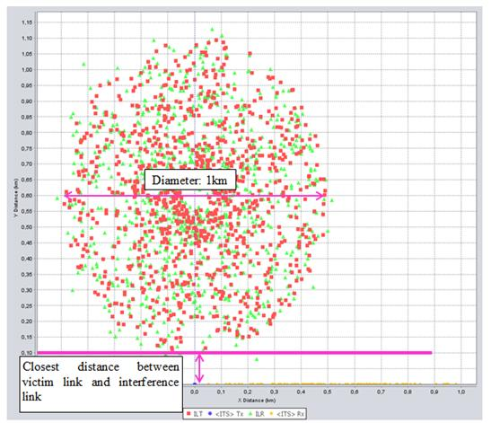
Figure 33: SEAMCAT scenario outline

Interference Transmitter WIA with 25 mW e.i.r.p.
The first SEAMCAT simulations are provided with interference transmit power e.i.r.p. of 25 mW in order to show the influence of WIA with 25 mW according to the existing regulations. This can be used as a reference scenario (existing situation).
Table 70: Simulation results, ILT with e.i.r.p.=25 mW; Separation between VLR and VLT: 5 m
Parameter | Scenario 04 | Scenario 05 | Scenario 06
Tx power conducted WIA | 9 dBm
ILT->VLR path | IEEE 802.11 plugin :  - Log-Normal before BP: 3  - Log-Normal after BP: 4
ILT->VLR path | BP distance: 500 m (Rural) | BP distance: 50 m (Suburban) | BP distance: 5 m (Urban)
Closest distance between VLR and ILT | 5 m | 5 m | 5 m
dRSS(Mean ; StdDev) | -73.6 dBm  11.1 dB | -74.3 dBm  11.1 dB | -74.0 dBm  10.5 dB
iRSS_{unwantend}  (Mean ; StdDev) | -81.8 dBm  4.3 dB | -93.8 dBm  6.5 dB | -109.4 dBm  6.5 dB
iRSS_{blocking}  (Mean ; StdDev) | -92.7 dBm  6.6 dB | -104.4 dBm  7.9 dB | -120.3 dBm  8.3 dB
Prob that dRSS/iRSS < C/I | 53.7 % | 1.2 % | 0.0 %

The result of the simulation with 25mW and only 5m separation distance shows only coexistence problems in the rural environment.
Table 71: Simulation results, ILT with e.i.r.p.=25 mW, Separation between VLR and VLT
Parameter | Scenario 01 | Scenario 02 | Scenario 03
Tx power conducted WIA | 9 dBm
ILT->VLR path | IEEE 802.11 plugin :  - Log-Normal before BP: 3  - Log-Normal after BP: 4
ILT->VLR path | BP distance: 500 m (Rural) | BP distance: 500 m (Rural) | BP distance: 50 m (Suburban)
Closest distance between VLR and ILT | 100 m | 1000 m | 100 m
dRSS(Mean ; StdDev) | -73.8 dBm ;  11.4 dB | -74.3 dBm ;  11.0 dB | -73.8 dBm  10.6 dB
iRSS_{unwantend}  (Mean ; StdDev) | -83.4 dBm  3.6 dB | -93.7 dBm  2.1 dB | -96.1 dBm  5.0 dB
iRSS_{blocking}  (Mean ; StdDev) | -94.6 dBm  6.1 dB | -104.7 dBm  5.5 dB | -107.1 dBm  6.9 dB
Prob that dRSS/iRSS < C/I | 40.8 % | 0.4 % | 0.1 %

The coexistence problem with 25 mW in the rural environment can be solved with 1km separation distance.

Interference Transmitter WIA with 400 mW e.i.r.p. and TPC
The following table present the simulation results for ILT with e.i.r.p.=400 mW, with adaptive transmit power control (TPC) for the different environment Rural, Suburban and Urban between ILT and VLR.
Table 72: Simulation results, ILT with e.i.r.p.=400 mW and with TPC – Separation distance of 100 m
Parameter | Scenario 07 | Scenario 08 | Scenario 09
Tx power conducted WIA | 21 dBm (antenna gain 5 dBi)
Power Control | Power control step size: 6 dB  Min threshold: Outdoor: -4 dBm; Indoor -24  Dynamic range: 30 dB
ILT->VLR path | IEEE 802.11 plugin :  - Log-Normal before BP: 3  - Log-Normal after BP: 4
ILT->VLR path | BP distance: 500 m (Rural) | BP distance: 50 m (Suburban) | BP distance: 5 m (Urban)
Closest distance between VLR and ILT | 100 m | 100 m | 100 m
dRSS(Mean ; StdDev) | -74.1 dBm ;  10.8 dB | -74.2 dBm  10.8 dB | -75.5 dBm  10.8 dB
iRSS_{unwantend}  (Mean ; StdDev) | -85.6 dBm  2.0 dB | -88.7 dBm  2.0 dB | -99.7 dBm  5.3 dB
iRSS_{blocking}  (Mean ; StdDev) | -96.8 dBm  5.5 dB | -99.8 dBm  5.6 dB | -110.6 dBm  7.1 dB
Prob that dRSS/iRSS < C/I | 29.3 % | 14.8 % | 0.3 %
Note: The frequency of the victim was virtually randomly distributed through the whole WIA band to achieve an average result
Table 73: Simulation results, ILT with e.i.r.p.=400 mW and with TPC –various separation distances
Parameter | Scenario 10 | Scenario 11 | Scenario 12
Tx power conducted WIA | 21 dBm (antenna gain 5 dBi)
Power Control | Power control step size: 6 dB  Min threshold: Outdoor: -4 dBm; Indoor -24  Dynamic range: 30 dB
ILT->VLR path | IEEE 802.11 plugin :  - Log-Normal before BP: 3  - Log-Normal after BP: 4
ILT->VLR path | BP distance: 500 m (Rural) | BP distance: 500 m (Rural) |  | BP distance: 500 m (Rural)
Closest distance between VLR and ILT | 1500 m | 2000 m |  | 2500 m
dRSS(Mean ; StdDev) | -74 dBm ;  11 dB | -74 dBm  11 dB |  | -74 dBm  10.8 dB
iRSS_{unwantend}  (Mean ; StdDev) | -89 dBm  2 dB | -92 dBm  2 dB |  | -95 dBm  2 dB
iRSS_{blocking}  (Mean ; StdDev) | -99 dBm  5 dB | -103 dBm  5 dB |  | -106 dBm  5 dB
Prob that dRSS/iRSS < C/I | 13.1 % | 3.4 % |  | 0.4 %

With a separation distance of 100 m the protection criterion can be fulfilled only for the urban environment (see Table 74). For rural environments (see Table 75) a separation distance of 2 500 m would be needed.

Interference Transmitter WIA with TPC and with DAA
The previous section showed that TPC only is not sufficient for the protection of ITS in suburban and rural environments. Therefore an additional mitigation technique like detect and avoid (DAA) is considered. The same methodology as for the Radiolocation Service in used in order to determine the thresholds (see ANNEX 5:).
The following table provides the threshold depending on the WIA system.
Table 74: DAA Thresholds for ITS RSU
Characteristics of the ITS Road Side Unit | WIA I | WIA II | WIA III
Tx power into antenna peak (dBm) | 23.00 | 23.00 | 23.00
ITS bandwidth (MHz) | 10 | 10 | 10
Characteristics of a WIA device
WIA e.i.r.p (dBm) outdoor | 26 | 26 | 26
Bandwith (MHz) | 1 | 20 | 3
Antenna gain (dBi) | 5 | 5 | 5
WIA spectral density power (dBm/MHz) at the antenna connector | 21 | 8 | 16
Characteristics of the DFS
Receiver sensitivity (dBm) | -82 | -82 | -82
Interference level (dBm/MHz) | -98.00 | -98.00 | -98.00
DFS Detection threshold Th (dBm) | -96,00 | -82.99 | -91.23

Table 75 provides the simulation results for the DAA procedure with different detection threshold levels for each WIA device type for the worst cas rural scenario.
Table 75: Simulation results, ILT with TPC and DAA (different detection thresholds), Separation distance 5 m
Parameter | Scenario 13
Tx power conducted WIA | 21 dBm (antenna gain 5 dBi)
Power Control | Power control step size: 6 dB  Min threshold: Outdoor: -4 dBm; Indoor -24  Dynamic range: 30 dB
Spectrum sensing characteristics | Sensing reception bandwidth and corresponding detection threshold :  - 1 MHz -96 dBm  - 3 MHz: -91 dBm  - 20 MHz: -83 dBm  Probability of failure: 0 %
ILT->VLR path | IEEE 802.11 plugin :  - Log-Normal before BP: 3  - Log-Normal after BP: 4
ILT->VLR path | BP distance: 500 m (Rural)
Closest distance between VLR and ILT | 5 m
dRSS(Mean ; StdDev) | -67.3  10.7 dB
iRSS_{unwantend}  (Mean ; StdDev) | -95.3 dBm  7.1 dB
iRSS_{blocking}  (Mean ; StdDev) | -103.9 dBm  6.8 dB
Prob that dRSS/iRSS < C/I | 1 %

In addition, simulations were conducted in order to consider that all WIA systems implement DAA with the same detection threshold level of -85 dBm and The closest distance between VLR and ILT is 5 m.
Table 76: Simulation results, ILT with TPC and DAA, Separation distance 5 m
Parameter | Scenario 14 |  | Scenario 15 | Scenario 16
Tx power conducted WIA | 21 dBm (antenna gain 5 dBi)
Power Control | Power control step size: 6 dB  Min threshold: Outdoor: -4 dBm; Indoor -24  Dynamic range: 30 dB
Spectrum sensing characteristics | Detection threshold: Indoor/Outdoor: -85 dBm  Probability of failure: 0 %  Sensing reception bandwidth: 1 MHz, 3 MHz, 20 MHz
ILT->VLR path | IEEE 802.11 plugin :  - Log-Normal before BP: 3  - Log-Normal after BP: 4
ILT->VLR path | BP distance: 500 m (Rural) | BP distance: 50 m (Suburban) |  | BP distance: 5 m (Urban)
Closest distance between VLR and ILT | 5 m | 5 m |  | 5 m
dRSS(Mean ; StdDev) | -67 dBm  11 dB | -67 dBm  11 dB |  | -67 dBm  11 dB
iRSS_{unwantend}  (Mean ; StdDev) | -106 dBm  11 dB | -92 dBm  6 dB |  | -97 dBm  6 dB
iRSS_{blocking}  (Mean ; StdDev) | -100 dBm  4 dB | -101 dBm  6 dB |  | -106 dBm  6 dB
Prob that dRSS/iRSS < C/I | 0.4 % | 2.5 % |  | 0.0 %

It is shown that even in rural environments the protection of ITS can be ensured by DAA mitigation techniques. The implementation of a single threshold for all types of WIA may be sufficient.

Summary and Conclusions
Table 79 summarises the main SEAMCAT results.
Table 77: Summary table
Scenario | Rural | Suburban | Urban
ILT: e.i.r.p.=25 mW reference without TPC  Closest distance between ILT and VLR: 5 m | 53.7 % | 1.2 % | 0.0 %
ILT: e.i.r.p.=25 mW reference without TPC  Closest distance between ILT and VLR: 100 m | 40.8 % | 0.1 % | -
ILT: 25 mW reference without TPC  Closest distance between ILT and VLR: 1000 m | 0.4 % | - | -
ILT: e.i.r.p.=400 mW with TPC  Closest distance between ILT and VLR: 100 m | 29.3 % | 14.8 % | 0.3 %
ILT: e.i.r.p.=400 mW with TPC  Closest distance between ILT and VLR: 1500 m | 13.1 % | - | -
ILT: e.i.r.p.=400 mW with TPC  Closest distance between ILT and VLR: 2000 m | 3.4 % | - | -
ILT: e.i.r.p.=400 mW with TPC  Closest distance between ILT and VLR: 2500 m | 0.4 % | - | -
ILT: e.i.r.p.=400 mW with TPC and with DAA (Detection threshold 1 MHz: -96 dBm; 3 MHz: -91 dBm; 20 MHz:. -83 dBm)  Closest distance between ILT and VLR: 5 m | - | 1.0 % | -
ILT: e.i.r.p.=400 mW with TPC and with DAA (Detection threshold -85 dBm in the bandwidth of the WIA systems)  Closest distance between ILT and VLR: 5 m | 0.4 % | 2.5 % | 0.0 %

Coexistence issues with 25 mW are only expected in rural environments and could be solved with 1km separation distance.
The results for 400m W devices are:
  - Without DAA, a separation distance should be implemented (100 m in Urban environments and 2500 m in Rural environments).
  - Alternatively, the implementation of DAA would allow mitigating interference.

Note, if a centralised sensing is implemented (for example with a specific antenna on the roof of the factory), the DAA threshold may be increased since the gain of the antenna could be increased and the propagation conditions on the detection path would be improved (see ANNEX 5:).

Compatibility between WIA and short range devices
The characteristics of SRD are given in section 3.7. Two systems are considered in this section (SRD type I – maximum antenna gain and SRD type III) in order to cover this case.
The same propagation model as given in ANNEX 4: is considered for the MCL calculations.

Compatibility between WIA interferer and SRD victim

SRD type I
The following table provides the results of the separation distances calculated for WIA I indoor and for SRD type I with maximum antenna gain (20 dBi). For this case a side lobe attenuation of 30 dB is assumed.
Table 78: Interferer WIA I (bandwidth 1 MHz – indoor) - Victim SRD type I with maximum antenna gain
 | Units | Urban | Suburban | Rural | ETSI TR 102- 492
Emission part: WIA I - 1 MHz indoor
Bandwidth | MHz | 1 | 1 | 1 | 1
Tx out, e.i.r.p. | dBm | 26 | 26 | 26 | 26
Effect of TPC (dB) | dB | 0 | 0 | 0 | 0
Wall loss | dB | 15 | 15 | 15 | 15
Antenna Gain | dBi | 0 | 0 | 0 | 0
Net Tx power density | dBm/MHz | 11 | 11 | 11 | 11
Reception part: SRD type I
Receiver bandwidth | MHz | 0.25 | 0.25 | 0.25 | 0.25
Receiver noise | dBm/MHz | -114 | -114 | -114 | -114
Noise Figure F | dB | 9 | 9 | 9 | 9
Antenna gain | dBi | 20 | 20 | 20 | 20
N per MHz at antenna input (kTBF-gain) | dBm/MHz | -125 | -125 | -125 | -125
Protection criterion
Criterion I/N | dB | 0 | 0 | 0 | 0
Allowable Interfering power level 'I' at receiver antenna input (kTBF-gain+I/N) | dBm/MHz | -125 | -125 | -125 | -125
MAIN LOBE WIA - MAIN LOBE SRD
Required Attenuation | dB | 136 | 136 | 136 | 136
Separation distance WIA SRD | m | 1129 | 2287 | 5165 | 3734
MAIN LOBE WIA - SIDE LOBE SRD
Sidelobe attenuation | dB | 30 | 30 | 30 | 30
Required Attenuation | dB | 106 | 106 | 106 | 106
Separation distance WIA -> SRD | m | 226 | 371 | 585 | 289
The following table provides an overview of the calculated separation distances for SRD type I maximum antenna gain.
Table 79: Separation distances (m) for WIA Interferer - SRD type I maximum antenna gain Victim
WIA type | Antenna gain | Propagation model
WIA type | Antenna gain | Urban | Suburban | Rural | ETSI TR 102- 492
WIA I – 1 MHz indoor | Main lobe | 1129 | 2287 | 5165 | 3734
WIA I – 1 MHz indoor | Side lobe | 226 | 371 | 585 | 289
WIA II – 20 MHz indoor | Main lobe | 562 | 1040 | 2084 | 1231
WIA II – 20 MHz indoor | Side lobe | 111 | 158 | 182 | 95
WIA III – 3 MHz outdoor | Main lobe | 1952 | 4250 | 10546 | 8933
WIA III – 3 MHz outdoor | Side lobe | 392 | 690 | 1300 | 692
WIA IV – 20 MHz outdoor | Main lobe | 1256 | 2580 | 5935 | 4424
WIA IV – 20 MHz outdoor | Side lobe | 252 | 419 | 689 | 343
It has to be noted that the SRD are expected to be deployed mostly indoor resulting in a reduction of the separation distances. The following table provides an overview of the calculated separation distances for SRD type I maximum antenna gain deployed indoor.
Table 80: Separation distances (m) for WIA Interferer - SRD type I maximum antenna gain indoor Victim
WIA type | Antenna gain | Propagation model
WIA type | Antenna gain | Urban | Suburban | Rural | ETSI TR 102- 492
WIA I – 1 MHz indoor | Main lobe | 506 | 921 | 1814 | 1039
WIA I – 1 MHz indoor | Side lobe | 98 | 138 | 145 | 80
WIA II – 20 MHz indoor | Main lobe | 252 | 419 | 689 | 343
WIA II – 20 MHz indoor | Side lobe | 32 | 32 | 32 | 27
WIA III – 3 MHz outdoor | Main lobe | 874 | 1713 | 3703 | 2486
WIA III – 3 MHz outdoor | Side lobe | 175 | 278 | 395 | 192
WIA IV – 20 MHz outdoor | Main lobe | 562 | 1040 | 2084 | 1231
WIA IV – 20 MHz outdoor | Side lobe | 111 | 158 | 182 | 95

SRD type III
The following table provides an overview of the calculated separation distances for SRD type III Isotropic antenna).
Table 81: Separation distances (m) for WIA Interferer - SRD type III Victim
WIA type | Propagation model
WIA type | Urban | Suburban | Rural | ETSI TR 102- 492
WIA I – 1 MHz indoor | 662 | 1250 | 2576 | 1596
WIA II – 20 MHz indoor | 330 | 568 | 1039 | 526
WIA III – 3 MHz outdoor | 1145 | 2323 | 5260 | 3817
WIA IV – 20 MHz outdoor | 736 | 1410 | 2960 | 1891

It has to be noted that the SRD are expected to be deployed mostly indoor resulting in a reduction of the separation distances. The following table provides an overview of the separation distances for SRD type III deployed indoor.
Table 82: Separation distances (m) for WIA Interferer - SRD type III indoor Victim
WIA type | Propogation model
WIA type | Urban | Suburban | Rural | ETSI TR 102- 492
WIA I – 1 MHz indoor | 296 | 504 | 885 | 444
WIA II – 20 MHz indoor | 148 | 225 | 304 | 146
WIA III – 3 MHz outdoor | 513 | 936 | 1847 | 1062
WIA IV – 20 MHz outdoor | 330 | 568 | 1039 | 526

Compatibility between SRD interferer and WIA victim

SRD type I
The following table provides an overview of the calculated separation distances for SRD type I maximum antenna gain (20 dBi). In this case a side lobe attenuation of 30 dB is assumed.
Table 83: Separation distances (m) for SRD type I maximum antenna gain Interferer – WIA Victim
WIA type | Antenna gain | Propagation model
WIA type | Antenna gain | Urban | Suburban | Rural | ETSI TR 102- 492
WIA I – 1 MHz indoor | Main lobe | 87 | 115 | 115 | 68
WIA I – 1 MHz indoor | Side lobe | 4 | 4 | 4 | 4
WIA II – 20 MHz indoor | Main lobe | 227 | 372 | 586 | 289
WIA II – 20 MHz indoor | Side lobe | 26 | 26 | 26 | 22
WIA III – 3 MHz outdoor | Main lobe | 403 | 713 | 1350 | 724
WIA III – 3 MHz outdoor | Side lobe | 76 | 89 | 89 | 56
WIA IV – 20 MHz outdoor | Main lobe | 506 | 922 | 1815 | 1040
WIA IV – 20 MHz outdoor | Side lobe | 98 | 138 | 145 | 81

It has to be noted that the SRD are expected to be deployed mostly indoor resulting in a reduction of the separation distances. The following table provides an overview of the calculated separation distances for SRD type I maximum antenna gain deployed indoor.
Table 84: Separation distances (m) for SRD type I maximum antenna gain indoor Interferer – WIA Victim
WIA type | Antenna gain | Propagation model
WIA type | Antenna gain | Urban | Suburban | Rural | ETSI TR 102- 492
WIA I – 1 MHz indoor | Main lobe | 20 | 20 | 20 | 20
WIA I – 1 MHz indoor | Side lobe | 1 | 1 | 1 | 1
WIA II – 20 MHz indoor | Main lobe | 98 | 138 | 145 | 81
WIA II – 20 MHz indoor | Side lobe | 5 | 5 | 5 | 5
WIA III – 3 MHz outdoor | Main lobe | 181 | 287 | 413 | 202
WIA III – 3 MHz outdoor | Side lobe | 16 | 16 | 16 | 16
WIA IV – 20 MHz outdoor | Main lobe | 227 | 372 | 586 | 289
WIA IV – 20 MHz outdoor | Side lobe | 26 | 26 | 26 | 22

SRD type III
The following table provides an overview of the calculated separation distances for SRD type III. In this case, calculations are not done for the side lobe, since the results will be similar as in the main lobe.
Table 85: Separation distances (m) for SRD type III Interferer – WIA Victim
WIA type | Propagation model
WIA type | Urban | Suburban | Rural | ETSI TR 102- 492
WIA I – 1 MHz indoor | 41 | 41 | 41 | 31
WIA II – 20 MHz indoor | 140 | 209 | 279 | 134
WIA IV – 3 MHz outdoor | 249 | 413 | 675 | 335
WIA IV – 20 MHz outdoor | 312 | 533 | 957 | 481

It has to be noted that the SRD are expected to be deployed mostly indoor resulting in a reduction of the separation distances. The following table provides an overview of the separation distances for SRD type III deployed indoor.
Table 86: Separation distances (m) for SRD type III indoor Interferer – WIA Victim
WIA type | Propagation model
WIA type | Urban | Suburban | Rural | ETSI TR 102- 492
WIA I – 1 MHz indoor | 7 | 7 | 7 | 7
WIA II – 20 MHz indoor | 51 | 51 | 51 | 37
WIA IV – 3 MHz outdoor | 109 | 156 | 177 | 93
WIA IV – 20 MHz outdoor | 140 | 209 | 279 | 134

Conclusion on WIA sharing with SRDs
The below Table summarises the calculated separation distances for expected urban environment for the protection criterion I/N 0dB.
Table 87: Separation distances (m) to protect SRD
 | WIA indoor | WIA outdoor
SRD mainbeam, outdoor | 1 km | 2 km
SRD sidelobe, outdoor | 0.2 km | 0.4 km
SRD sidelobe, indoor | 0.1 km | 0.2 km

Those distances are expected to be reduced essentially if considering the real usage of SRDs with a margin above sensitivity.
It has also to be noted that:
  - The number of SRD currently using this band is very low.
  - SRD 25 mW may be part of WIA deployment and therefore their deployment will be managed by the “operator” of WIA.

Adjacent band studies
This section investigates the possible impact of WIA on systems operation in the adjacent bands. Only limited consideration has been given to this issue.

Radiolocation
For the case that a WIA installation is using bands above 5.725 GHz, the adjacent band impact needs to be assessed to possible radars below 5.725 GHz
Based on the worst radar X in relation to the DFS threshold (see ANNEX 5:) the required distances and threshold values were recalculated to account for the adjacent band case.
Table 88 shows the distances under worst case conditions and Table 89 for the more realistic indoor case and non line of sight conditions.
Table 88: Radar separation distances free space loss, WIA outdoor
 | Unit | Co-channel | OOB | OOB | OOB
Frequency | GHz | 5.75 | 5.75 | 5.75 | 5.75
Bandwidth (BW) | MHz | 4 | 4 | 4 | 4
BW1 | MHz | 1 | 1 | 1 | 1
Tx power WIA | dBm/BW1 | 21 | -20 | -30 | -40
Antenna gain radar | dBi | 35 | 35 | 35 | 35
WIA antenna gain | dBi | 5 | 5 | 5 | 5
Nise figure radar F | dB | 4 | 4 | 4 | 4
Noise radar | dBm/BW | -104 | -104 | -104 | -104
Wall attenuation | dB | 0 | 0 | 0 | 0
I/N | dB | -6 | -6 | -6 | -6
Imax | dBm/BW | -110 | -110 | -110 | -110
Propagation exponent (2= LOS) | dB | 2 | 2 | 2 | 2
Separation distances | km | 2595 | 13 | 4. | 1.3

Table 89: Radar separation distances free space loss, WIA indoor
 | Unit | Co-channel | OOB | OOB | OOB
Frequency | GHz | 5.75 | 5.75 | 5.75 | 5.75
Bandwidth (BW) | MHz | 4 | 4 | 4 | 4
BW1 | MHz | 1 | 1 | 1 | 1
Tx power WIA | dBm/BW | -30 | -30 | -30 | -30
Antenna gain radar | dBi | 35 | 35 | 35 | 35
Antenna WIA | dBi | 5 | 5 | 5 | 5
Noise figure radar F | dB | 4 | 4 | 4 | 4
Noise floor radar | dBm/BW | -104 | -104 | -104 | -104
Wall attenuation | dB | 10 | 10 | 10 | 10
I/N | dB | -6 | -6 | -6 | -6
Imax | dBm/BW | -110 | -110 | -110 | -110
Propagation exponent (2= LOS) | dB | 2 | 2.5 | 3 | 3.5
Separation distances | m | 1301.1 | 310.1 | 119.2 | 60.2

It may be concluded based on the above calculations that the coexistence between WIA above 5.725 and radars below 5.725 GHz is possible in real life.

BFWA
A similar exercise as in the previous section was conducted for BFWA.
Table 90: BFWA separation distances free space loss, WIA outdoor
 | Unit | Co-channel | OOB | OOB | OOB
Frequency | GHz | 5.75 | 5.75 | 5.75 | 5.75
Bandwidth (BW) | MHz | 4 | 4 | 4 | 4
BW1 | MHz | 1 | 1 | 1 | 1
WIA Tx power | dBm/BW | 21 | -20 | -30 | -40
Antenna gain BFWA | dBi | 16 | 16 | 16 | 16
Antenna gain WIA | dBi | 5 | 5 | 5 | 5
Noise figure BFWA | dB | 6 | 6 | 6 | 6
Noise floor BFWA | dBm/BW | -95 | -95 | -95 | -95
Wall attenuation | dB | 0 | 0 | 0 | 0
I/N | dB | 27 | 27 | 27 | 27
Fade margin | dB | 10 | 10 | 10 | 10
Smin | dBm/BW | -58 | -58 | -58 | -58
SIR | dB | 27 | 27 | 27 | 27
Imax | dBm/BW | -85 | -85 | -85 | -85
Propagation exponent n 1 (interfering path) | dB | 2 | 2 | 2 | 2
Separation distances | m | 9221.8 | 82.2 | 26.0 | 8.2

It is also here expected that the OOB and spurious emissions of WIA is not producing harmful interference to BFWA.
For all other adjacent band scenarios (e.g. ITS above 5.875 GHz) it is assumed that the conclusions for radars and BFWA are also valid here.

Guard band in the WIA channel plan
It should be noted that a guard band of 2.5 MHz is planned in the WIA channel arrangement. This implies that the frequency range 5725 to 5727.5 MHz and 5872.5 to 5875 MHz will not be used providing additional protection to the Radiolocation operating below 5825 MHz and to the “safety” ITS operating above 5875 MHz.

CONCLUSIONs
Relating to the channel utilization, it was noted that the WIA system would need 76 MHz to operate on a given site, however since part of this 76 MHz may not be available for WIA usage due to other possible users (RTTT, BFWA…), there would be a need to identify more than 76 MHz for WIA systems in order to ensure that they can operate. For some of the compatibility studies, the WIA was assumed to have access to the whole spectrum 5725 to 5875 MHz.
It should be noted that WIA systems with a maximum e.i.r.p. of 400 mW limited to indoor deployment (assuming 15 dB attenuation for the wall loss and similar devices quantities) would have an impact on the others services/systems similar to the impact resulting from SRD devices deployed outdoor according to the existing regulations (25 mW) [2]. Therefore, an indoor restriction may be seen as equivalent to the existing regulations and thus sufficient for the protection of others services/systems.
Independent on the above consideration, the Table below provides an overview of the conducted study results.
Table 91: Summary of the compatibility studies
Service/Systems | Results | Comments
Radiolocation  5.725-5.850 GHz | Large separation distances are required under worst case assumptions without mitigation technique.  Thus DFS is required with the following detection thresholds:  - -65 dBm in 1 MHz  - -60.5 dBm in 3 MHz  - -52 dBm in 20 MHz  The adjacent band coexistence appears possible.  Note 1, Note 4 | A DAA mitigation technique that is fully in operation at all times is mandatory. This must be ensured by the manufacturers of the WIA devices. Moreover, as the frequency band in question is dedicated to military services in some European countries, thus further reaching restrictions may apply.  DFS as developed for WLAN and BFWA does not allow detecting all types of radars (cf. e.g. ECC Report 192 [34]). Recommendation ITU-R M.1638 [6], which lists the radar characteristics for the 5 GHz range, is under revision in ITU WP 5B. Due to the ongoing process this report at hand does not encompass all types of radars.  Part of the spectrum may be blocked by radars
RTTT  5.795-5.805 GHz, 5.805-5.815 GHz (used by some Administrations) | No interference is expected in the case of OBU RTTT.  In the case of RTTT RSU the separation distances without DAA mitigation techniques are depending on the environment:  - Urban environment 100 m  - Suburban environment 1000 m  - Rural environment 2500 m  DAA mitigation techniques were not studied but the same threshold as for ITS may be considered.  Note 2, Note 4
BFWA  5.725-5.875 GHz | The separation distances without DAA mitigation techniques are depending on the environment:  - Urban environment no separation distance required  - Suburban environment less than 3 km  - Rural environment between 3 km (C/I criterion) and 10 km (I/N criterion)  Thus DAA with a threshold of -99 dBm on WIA device level is required in suburban and rural environments.  Note 1, Note 2, Note 3, Note 4, Note 5
FSS  5725-5875 MHz | The deployment of WIA is compatible with FSS if TPC  (based on a minimum power strategy) is implemented and the assumptions on the number of devices are met  (see Table 52).
Radio Amateur Service  5725-5850 MHz | Under worst case assumptions, separation distances may be needed. Considering more realistic cases, the separation distances are significantly reduced.  Note 2 | It should be noted that the most sensitive amateur service operations are globally harmonised at 5760-5762 MHz
Radio Amateur Satellite Service  5830-5850 MHz | No interference is expected.  Note 2.
ITS  5855-5875 MHz | Required separation distances without DAA mitigation techniques are depending on the environment:  - Urban environment 100 m  - Rural environment 2500 m  Thus DAA with a threshold of -85 dBm on WIA device level is required.  Note 1, Note 2, Note 3, Note 4, Note 5
Non Specific SRD  5725-5875 MHz | Under worst cases assumptions, separation distances may be needed. Considering a realistic case, no separation distance is needed | Limited information on the SRDs deployed in the band was provided
Note 1: DFS/DAA on device level may not be possible for all WIA applications. Further developments may show automated solutions so that a sensing procedure may be able to coordinate centralized the spectrum.
Note 2: Due to the fact that TPC was found necessary to meet the FSS protection criterion, TPC was assumed when conducting the compatibility studies.
Note 3: higher threshold would be possible with the use of centralized sensing.
Note 4: A registration/ notification / light licensing procedure for WIA could help in enforcing the required separation distances (e.g. to tolling bridges, RTTT).
Note 5: If both systems (interferer and victim) are based on IEEE 802.11, coexistence between those systems might be possible using an updated CSMA/CA protocol. However, this is still to be demonstrated.
Relating to Direct Air To Ground Communications, it should be noted that the work relating to the identification of spectrum was still on going at the time where this ECC Report was developed, therefore, those systems were not considered in the framework of this report.
In addition, in the framework of Agenda item 1.1 WRC-15, CPG is investigating the possibility to introduce RLAN in the frequencies under consideration for WIA. In addition, the EC has issued a Mandate calling for studies in the 5 GHz frequency range. Since those studies are still at an initial stage, this case was not considered in this report.

Those additional studies may result in the implementation of additional mitigation techniques.

- INDUSTRIAL WIreless APPLICATIONS PARAMETERS AND DEPLOYMENT SCENARIOS
  - Technical Parameters
    - Transmitter Parameters
      - Transmitter output power
For the manufacturing cells, it is expected that the existing regulations (25 mW) is sufficient.
For the other applications which may operate at distances up to 100 m under non line of sight condition a e.i.r.p. up to 400 mW (26 dBm) is required .
      - Transmitter masks
The following table provides the steps of the 1 MHz mask.
Table 92: Transmit Spectrum mask for 1 MHz system
Frequency offset | Transmit Power | Reference Bandwidth
± 500 kHz | 26 dBm | 1 MHz
± 550 kHz | –20 dBc | 1 MHz
± 2 MHz | –20 dBm | 1 MHz
Larger than 3 MHz | –40 dBm | 1 MHz

This is further illustrated in the following figure.

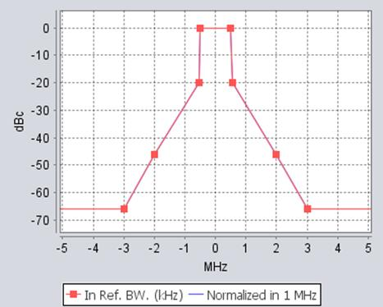
Figure 34: WIA - 1 MHz emission mask
The following table provides the steps of the 3 MHz mask.
Table 93: Transmit Spectrum mask for 3 MHz system
Frequency offset | Transmit Power | Reference Bandwidth
± 1,5 | 26 dBm | 3 MHz
± 3,5 | Relative: –20 dBc  Absolut: -20 dBm | 1 MHz
± 7,5 | -30 dBm | 1 MHz  (ERC/REC 74-01) [27]

This is further illustrated in the following figure.

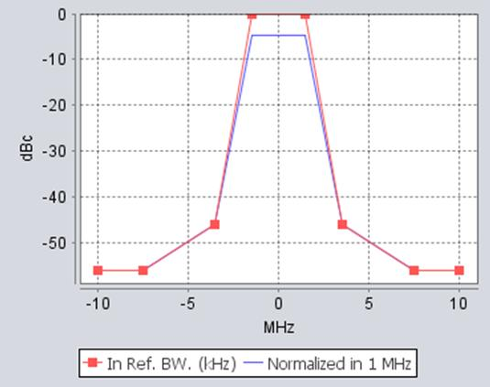
Figure 35: WIA - 3 MHz emission mask
The following table provides the steps of the 20 MHz mask.
Table 94: Transmit Spectrum mask for 20 MHz system
Frequency offset | Transmit Power | Reference Bandwidth
± 9 | 26 dBm | 20 MHz
± 11 | -20 dBr | 1 MHz
± 20 | -28 dBr | 1 MHz
± 30 | -43 dBr | 1 MHz

This is further illustrated in the following figure.

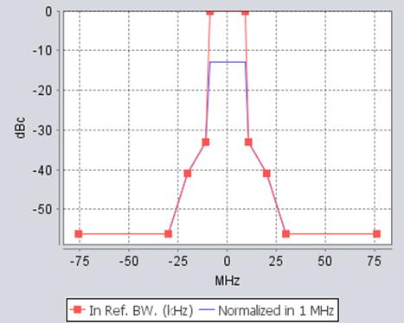
Figure 36: WIA - 20 MHz emission mask
      - Antenna Characteristics
No restrictions on antenna characteristics, according to the description in section 6.3.2 of ETSI TR 102 889-2 V1.1.1 (2011-08) [1].
The default antenna type is omnidirectional (collinear dipole antenna). Therefore, Recommendation ITU-R F.1336-3 [28] should be used. Following section (1.a) in section formula (2.1) Recommendation ITU-R F.1336-3 [28] the expression of antenna gain in dBi at elevation angle Θ in degrees is given by:

where:
Θ: absolute value of the elevation angle relative to the angle of maximum gain (degrees)
Θ₃: the 3 dB beamwidth in the vertical plane (degrees)
k: sidelobe factor for all antennas operating in the 3-70 GHz range, the parameter k should be 0.
G(Θ) : gain relative to an isotropic antenna (dBi)
G₀ : the maximum gain in the azimuth plane (dBi)

The WIA antenna is shown in the following figures. The hinge mounting allows various orientations. Therefore, in simulations, a random antenna tilt between 0º and 90º (for azimuths between 0º and 360º) is taken into account.
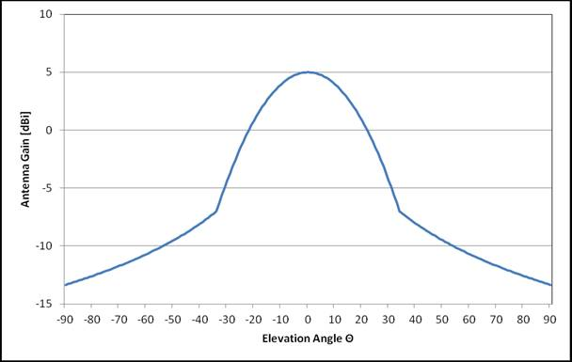
Figure 37: Antenna pattern according Recommendation ITU-R F.1336 [28]
The following material provides information on typical WIA antennas.

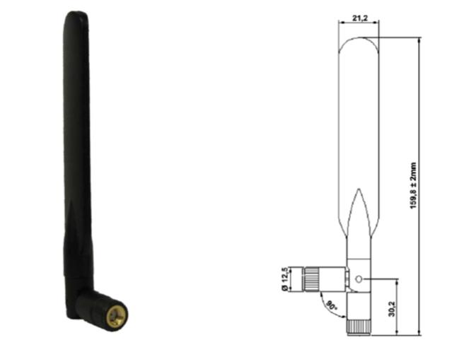
Figure 38: Example of dual band antenna (Siemens AG)

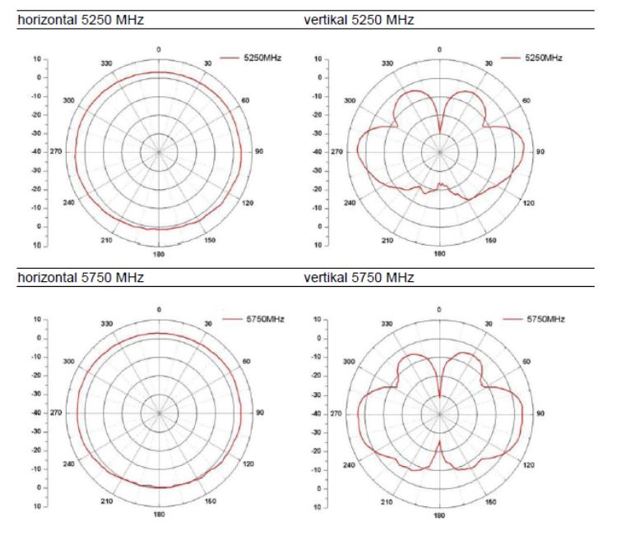
Figure 39: Antenna pattern of dual band antenna (Siemens AG)

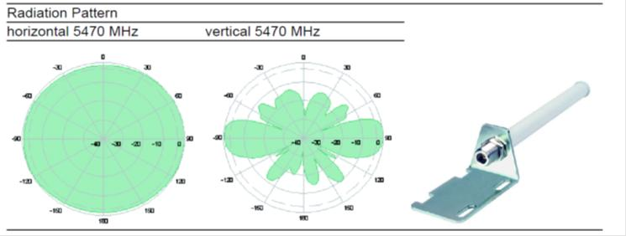
Figure 40: Antenna pattern of dual band antenna (Hirschmann Automation and Control GmbH)

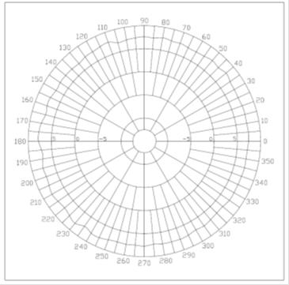 | 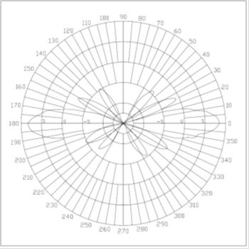
Figure 41: H-Plane field pattern (WIMo GmbH) (left) - E-plane field pattern (WIMo GmbH) (
      - Bandwidth
As different technologies are used, the typical occupied bandwidth for a single device varies between 1 MHz and 20 MHz. Frequency Hopping as well as non-frequency hopping technologies is used. The parallel use of all tree classes requires a preferably continuous spectrum of 76 MHz..
      - Receiver parameters
Most of the technologies used in the industrial applications are based on specifications such as IEEE 802.11 [20], IEEE 802.15.1 [29] and IEEE 802.15.4 [30]. The relevant receiver parameters including the receiver sensitivity and protection criteria (C/I) can be found in the following table.
Table 95: Receiver parameters
Characteristic | Unit | WIA 1 MHz | WIA 3 MHz | WIA 20 MHz
Bandwidth | MHz | 1 | 3 | 20
Receiver sensitivity | dBm | -84 | -90 | -88
Protection criteria C/I | dB | 6 | 6 | 6

      - Channel access techniques
For maximised spectrum efficiency, including sharing among all wireless industrial applications present, a spectrum sharing mechanism appropriate for industrial applications is required. Various channel access techniques are under consideration: TDMA, CSMA and adaptive FHSS.
An example of that is also Frequency Agility. Frequency Agility is the ability of a system to operate according to frequency or channel assignments of a centralized or distributed control mechanism, which will define the configuration of all devices within an industrial site or subarea thereof. Configurations may change over time depending on the application requirements. If non-contiguous spectrum is assigned, then the Frequency Agility feature is supposed to operate across all assigned sub-bands.
Cognitive features for wireless industrial applications are under development and this may allow dynamically adapting the configuration of the WIA installation to the local requirements in terms of frequency regulations and other SRD users.
    - Summary of technical parameters
The following table provide an overview of the characteristics of WIA operating with 1 MHz, 3 MHz or 20 MHz channel bandwidths.
Table 96: Technical parameters of WIA system
Parameter | System for Manufacturing Cell | System for Factory Hall | System for Plant
max e.i.r.p. | 25 mW (14 dBm) | 400 mW (26 dBm) | 400 mW (26 dBm)
Receiver sensitivity | -84 dBm in 1 MHz | -84 dBm in 1 MHz  - 90 dBm in 3 MHz  -88 dBm @ 6 MBit/s in 20 MHz | - 90 dBm in 3 MHz  -88 dBm in 20 MHz
Channel bandwidth (MHz) | 1 MHz | 1 MHz, 3 MHz and 20 MHz | 3 MHz and 20 MHz
Channel spacing (MHz) | 1 MHz | 1 MHz, 5 MHz and 20 MHz | 5 MHz and 20 MHz
Min. Number of hopping channels | no requirements | - | no requirements
Max. Number of hopping channels | BW_{Total}/1 MHz | - | BW_{Total}/5 MHz
Topology | Star | Star/Mesh | Mesh
Duty Cycle | 20 % | 20 % | 20 %
Antenna | See Annex 1 | See Annex 1 | See Annex 1
Antenna height (m) | 0.5 m to 3 m | 0,5 m to 10 m | 0.5 m to 50 m

The manufacturing cells can be deployed under the existing regulatory framework of ERC/REC 70-03 Annex 1 [2].
  - Deployment Scenarios
All of the three wireless classes (cell or sub-unit automation; factory hall or plant sub-unit automation and plant level automation) are operated in parallel. Parallel means that at most parts of the plant, the three "wireless" classes operate overlapping, preferably in the same frequency band for maximal flexibility of coexistence management reasons, to increase spectrum efficiency and to have the same needed spectrum properties like industrial-interference-free, power efficiency (range) and bending/damping by obstacles.
    - Channelization
The establishment of coexistence is a combination of technical and/or organizational measures to ensure the interference-free operation of wireless industrial applications in their environments. Coexistence between wireless industrial automation communication systems can be achieved by uncoupling the dimensions frequency, time and space. Consequential the WIA with 1 MHz, 3 MHz and 20 MHz use separate frequency bands in a given cell.

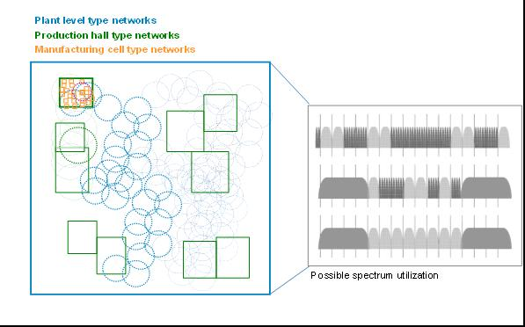
Figure 42: Possible channel pattern
The use of WIA systems with 1 MHz, 3 MHz and 20 MHz bandwith depends on the requirement of industrial application.
The WIA industry is considering a channel plan with 5 MHz grid for the deployment of WIA systems based on the channels given in the following table. The first 2.5 MHz at the edges of the band are not planned to be used.
Table 97: Possible channels
Channel No. | Channel centre frequency [MHz] | Channel No. | Channel centre frequency [MHz] | Channel No. | Channel centre frequency [MHz]
145 | 5725 | 156 | 5780 | 167 | 5835
146 | 5730 | 157 | 5785 | 168 | 5840
147 | 5735 | 158 | 5790 | 169 | 5845
148 | 5740 | 159 | 5795 | 170 | 5850
149 | 5745 | 160 | 5800 | 171 | 5855
150 | 5750 | 161 | 5805 | 172 | 5860
151 | 5755 | 162 | 5810 | 173 | 5865
152 | 5760 | 163 | 5815 | 174 | 5870
153 | 5765 | 164 | 5820 | 175 | 5875
154 | 5770 | 165 | 5825
155 | 5775 | 166 | 5830

The channel plans for 1 MHz, 3 MHz and 20 MHz are further described in the following sections.
    - WIA with 1 MHz bandwidth
WIA with 1 MHz uses a frequency spread scheme. Instead of generating a wideband signal, the useful signal is divided into numerous narrowband signals, the carrier frequency of these signals changes during transmission based on a hopping scheme. The spread technique is a Frequency Hopping Spread Spectrum (FHSS) technique with a simple modulation technique such as Gaussian Frequency Shift Keying (GFSK). WIA with 1 MHz bandwidth divides the available band into single channels each with a channel width of 1 MHz.
It is possible to use the following channel by WIA systems with 1 MHz bandwidth:
where:
is the channel center frequency
is the channel starting frequency, defined as 5730 MHz
is the channel number 0 to 140
    - WIA with 3 MHz bandwidth
WIA with 3 MHz bandwidth uses DSSS as spreading scheme. The available band is divided into single channels with a channel width of 5 MHz. These channels are non-overlapping channels, because the channel width is greater than the channel bandwidth.
The possible channel centre frequency for the WIA systems with 3 MHz bandwidth can be calculated with following equation:
where:
is the channel center frequency
is the channel starting frequency, defined as 5725 MHz
is the channel number 146 to 174
    - WIA with 20 MHz bandwidth
The WIA with 20 MHz bandwidth offers a lot of data rates depending on the applied modulation schemes and multiplex mechanism. The modulation schemes supported are:
  - Binary Phase Shift Keying (BPSK): 6 and 9 Mbit/s,
  - Quaternary Phase Shift Keying (QPSK): 12 and 18 Mbit/s,
  - 16-Quadrature Amplitude Modulation (16-QAM): 24 and 36 Mbit/s,
  - 64-Quadrature Amplitude Modulation (64-QAM): 48 and 54 Mbit/s.
To implement undisturbed communication, e.g. for transmission of real-time fieldbus traffic, in various WIA systems with 20 MHz bandwidth within the same area of coverage, is recommended to use non-overlapping channel. WIA with 20 MHz bandwidth divides the available band into non-overlapping channels each of 20 MHz channel bandwidth with a minimum space of 20 MHz between the center frequencies of the channels.
The possible channel center frequency for the WIA systems with 20 MHz bandwidth can calculate with following equation:
Where:
is the channel center frequency
is the channel starting frequency, defined as 5725 MHz
is the channel number 147 to 173
is an example of channel number of non-overlapping channels: 149, 153, 157, 161, 165, 169 to 173
    - Channel utilisation in a factory
The use of WIA systems with 1 MHz, 3 MHz and 20 MHz bandwidth depends on the requirement of industrial application. Figure 43 depicts three different examples of WIA channelization (see also section A1.2.1 for additional details).

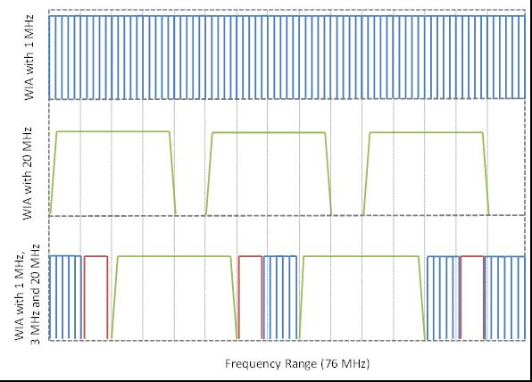
Figure 43: Example of channelization
Three deployment scenarios shall be considered.
      - Case 1: Only indoor WIA systems with 1 MHz bandwidth and 400 mW e.i.r.p.
250 WIA systems with 1 MHz bandwidth use the required frequency range of 76 MHz within the industrial plant.
The following assumptions were made:
  - The WIA system with 1 MHz bandwidth use a frequency hopping spread spectrum (FHSS) for signal spreading.
  - The duty cycle per WIA system with a bandwidth of 1 MHz, which contains of 2 WIA devices is nearly 30 %. That mean, each WIA system with a bandwidth of 1 MHz use 30 % or each WIA device with a bandwidth of 1 MHz use 15% of available time.
  - Per timeslot only 75 from 500 WIA devices with 1 MHz bandwidth are simultaneously active over the frequency range of 76 MHz.
  - One WIA device with 1 MHz bandwidth is active in each of the 75 x 1 MHz channels
      - Case 2: Only WIA systems with 20 MHz bandwidth and 400 mW e.i.r.p.
40 WIA systems with 20 MHz bandwidth use three non-overlapping channels over the required frequency range of 76 MHz.
The following assumptions were made:
  - 30 WIA systems deploy indoor and 10 WIA Systems deploy outdoor
  - The WIA system with 20 MHz bandwidth use OFDM for signal spreading.
  - The system architecture of WIA systems with 20 MHz bandwidth allows only one active device per system and channel.
  - The number of 20 MHz width channels is 3.
  - The number of simultaneous active systems and active devices per 1 out of 3 channels is around 13, distributed over the whole industrial plant area.
  - The number of simultaneous active indoor WIA devices is 10 per 20 MHz channel.
  - The number of simultaneous active outdoor WIA devices is 3 per 20 MHz channel.
      - Case 3: Mixed scenario of all WIA type and 400 mW e.i.r.p.:
The following devices are simultaneously active in the frequency range of 76 MHz:
  - 250 WIA systems with 1 MHz bandwidth are deployed indoor,
  - 4 systems with 3 MHz bandwidth: 3 are deployed outdoor and 1 is deployed indoor
  - 40 systems with 20 MHz bandwidth: 10 are deployed outdoor and 30 are deployed indoor

The following assumptions are valid:
  - Bullet point level 2
    - Bullet point level 3

  - WIA systems with 20 MHz bandwidth
    - Two 20 MHz channels are available for the mixed scenario.
    - The number of simultaneously active devices with 20 MHz bandwidth per channel is 20.
    - Indoor 15 WIA device and outdoor 5 WIA devices simultaneously active per channel.
  - WIA systems with 3 MHz bandwidth
    - Three channels with 3 MHz bandwidth are used by four WIA systems with 3 MHz bandwidth.
    - One outdoor WIA device is active on each 3 MHz channel.
    - In addition, on one out of these three available channels is one indoor WIA device active.
  - WIA systems with 1 MHz bandwidth
    - The 250 WIA systems with 1 MHz bandwidth can use 27 channels with 1 MHz bandwidth.
    - The consequence of reduced available frequency range is that around 3 WIA devices with 1 MHz bandwidth operate simultaneously per channel over the whole industrial plant (indoor).

Table 98: Summary in case of mixed scenario
Parameter | 20 MHz | 3 MHz | 1MHz
Indoor | 15 | 1 | 3
Outdoor | 5 | 1 | None
  - Geographical deployment of WIA
The following table provides an estimation of the number of wireless industrial automation devices other than UWB (WIA) over Germany. This estimation considers the deployment of WIA equipment in both large and small plants.
Table 99: Deployment of WIA in Germany
Parameters | Values
Population / Germany | 80 000 000
Population / Frankfurt am Main | 690 000
Plants / Frankfurt am Main | 4
Plants / Germany | 533
Wireless Devices / Germany | 12 590 000
Area Germany km² | 357 000
Wireless devices Germany/km² | 34.3

The numbers given for Germany are further defined for each of the WIA system in the following table.
The information relating to Germany is then extended to the whole EU considering a ratio of 4,1 between Germany and the rest of Europe (additional information on the derivation of this ratio is given in ANNEX 2:).
Table 100: Deployment of WIA in EU
Parameters | Values
Automation ratio EU/Germany | 4,1
Wireless Devices EU | 51 496 000
Area EU km² | 10 180 000
Device density EU/km² | 5.06

WIA devices may be deployed at 2.4 GHz, at 5 GHz (5.15 - 5.35 / 5.47 - 5.725 GHz and at 5.8 GHz resulting in a decrease to about 25 % of the devices to be considered in the compatibility studies in the 5.8 GHz band. The following table provides an overview of the WIA deployment considering these three bands.
Table 101: Distribution of WIA devices via different frequency ranges
 | Long term number of wireless industrial automation devices in EU
Anticipated number of WIA equipment | 51 496 000
Percentage of WIA device deployed at 2.4 GHz | 50%
Percentage of WIA device deployed at 5.15-5.725 GHz | 25%
Percentage of WIA device deployed at 5.725-5.875 GHz (5.8 GHz) | 25%
Number of WIA devices at 5,8 GHz | 12 874 000
Percentage of WIA device with 25 mW e.i.r.p. percentage | 75%
Number of WIA devices with e.i.r.p.>25 mW at 5.8 GHz in the EU | 3 218 500

It should be noted that another study (see ANNEX 2:) anticipated a deployment of 14 300 000 equipment worldwide in 2015. Based on this information, it is expected that the numbers above may provide an overestimation of the number of WIA equipment to be deployed over the EU.
    - Assumptions for a realistic deployment scenario
The following table depicts the assumption about the number of wireless devices per application environment.

Table 102: Assumption about the number of wireless devices per application environment
 | Application Environment
 | Manufacturing cell | Factory hall |  |  | Plant level
Bandwidth [MHz] | 1 | 1 | 3 | 20 | 3 | 20
Transmit power e.i.r.p. [mW] | 25 | 400 | 400 | 400 | 400 | 400
Spatial dimension [m] | 10 x 10 x 3 | 100 x 100 x 10 |  |  | 1 000 x 1 000 x 50
Network type | Star | Point-to-Point/Star/Mesh |  |  | Star/Mesh
Location | Indoor | Indoor |  |  | Outdoor
Number of devices per wireless system | 30 | 2 | 500 | 100 | 500 | 150
Number of locally parallel systems/units (=cluster) | 10 | 10 | 1 | 3 | 3 | 1
Number of such clusters / plant | 50 | 25 | 1 | 10 | 1 | 10
Number of systems / plant | 500 | 250 | 1 | 30 | 3 | 10
Number of devices / plant | 15000 | 500 | 500 | 3000 | 1500 | 1500
Number of devices/Germany (533 plants) | 7995000 | 266500 | 266500 | 1599000 | 799500 | 799500
Number of devices/Europe (ratio EU/Germany=4.1) | 32 779 500 | 1 092 650 | 1 092 650 | 6 555 900 | 3 277 950 | 3 277 950
Number of simultaneously active devices per plant | 500 | 250 | 1 | 30 | 3 | 10
Number of simultaneously active devices per Germany | 266500 | 133250 | 533 | 15990 | 1599 | 5330
Total number of simultaneously active WIA devices per Europe (ratio EU/Germany=4.1) | 1 092 650 | 546 325 | 2 185 | 65 559 | 6 556 | 21 853
Number of simultaneously active WIA devices per EU at 5.8 GHz (25% of total amount) | 273 162 | 136 581 | 546 | 16 390 | 1 639 | 5 463

  - Transmit Power Control (TPC) Mechanism
The implementation of TPC in WIA is under consideration in order to decrease the impact of their deployment on the other users of the frequency range 5725-5875 MHz.

The key parameters of WIA devices/systems are depicted in the following table.

Table 103: Characteristics of WIA devices
 | WIA 1 MHz | WIA 3 MHz | WIA 20 MHz
Transmit power e.i.r.p. | 26 dBm | 26 dBm | 26 dBm
Receiver sensitivity | -70 dBm | - 90 dBm | -88 dBm
Path loss capability | 96 dB | 116 dB | 114 dB
Max Distance | 48 m | 179 m | 157 m
Number of Devices per plant | 500 | 500 | 3000

The transmit power reduction is dependent on received power (Transmit power [dBm]-Path Loss [dB]) and the receiver sensitivity. There is a direct relationship between TPC Value (Transmit power reduction) and fade margin. The calculation of fade margin is done as follows:

Fade Margin [dB] = Transmit Power [dBm] - Path Loss [dB] - (Receiver Sensitivity + 3 dB)

The relationship between TPC value and fade margin is depicted in the following table.

Table 104: Relationship between TPC Value and Fade Margin
TPC Value [dB] | Fade Margin [dB]
30 | >30
27 | <30
24 | <27
21 | <24
18 | <21
15 | <18
12 | <15
9 | <12
6 | <9
3 | <6
0 | <3

    - TPC Indoor
The probability of transmit power reduction of WIA devices depending on distance between transmitter and receiver is listed in the following for each WIA type. The following assumptions will form the basis of further considerations.
- The distance between WIA devices is uniform distributed between 1 and maximum transmission distance for WIA-I:1 MHz and between 1 m and 100 m for WIA-II: 3 MHz and WIA-III: 20 MHz
- The distances are calculated with SEAMCAT path loss Model_C_IEEE_802_11_rev2 (Break point: 5m, Log-normal distribution before break point: 3 dB and after BP: 4dB) and fading margin (see ANNEX 3:).

Table 105: Probability of Transmit Power Reduction
Transmit power Reduction [dB] | WIA 1 MHz |  | WIA 3 MHz |  | WIA 20 MHz
Transmit power Reduction [dB] | Distance [m] | Probability | Distance [m] | Probability | Distance [m] | Probability
0 | 40 | 0.20 | 150 | 0.00 | 128 | 0.00
3 | 32 | 0.14 | 121 | 0.01 | 106 | 0.13
6 | 27 | 0.15 | 99 | 0.19 | 88 | 0.17
9 | 22 | 0.10 | 81 | 0.15 | 72 | 0.14
12 | 18 | 0.07 | 67 | 0.09 | 59 | 0.10
15 | 15 | 0.08 | 56 | 0.09 | 48 | 0.09
18 | 12 | 0.05 | 46 | 0.10 | 39 | 0.07
21 | 10 | 0.04 | 37 | 0.08 | 32 | 0.05
24 | 8 | 0.03 | 30 | 0.03 | 27 | 0.05
27 | 7 | 0.04 | 25 | 0.04 | 22 | 0.04
30 | 5 | 0.13 | 20 | 0.22 | 18 | 0.17

The cumulative distribution function of TPC value is depicted in the following figure.

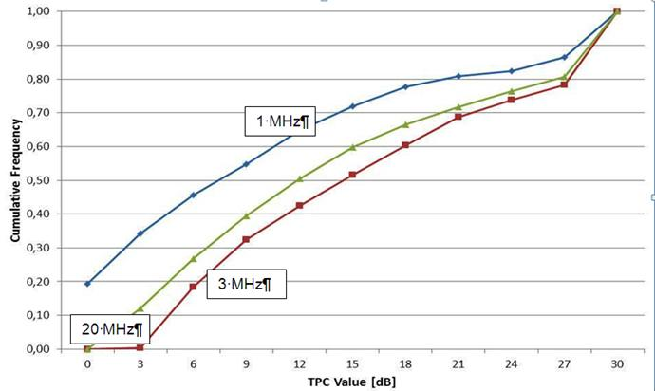
Figure 44: Cumulative distribution function of transmit power control value (WIA-indoor)

The result of transmit power reduction by the use of TPC is listed in the following table.
Table 106: Average reduction of transmit power (Indoor)
WIA | No. of Device | Aggregate e.i.r.p. [dBm] |  | Average reduction of transmit power (dB)
WIA | No. of Device | without TPC | with TPC | Average reduction of transmit power (dB)
1 MHz | 500 | 53.01 | 47.97 | 5.04
3 MHz | 500 | 53.01 | 41.53 | 11.48
20 MHz | 3000 | 60.79 | 51.85 | 8.94

    - TPC Outdoor
The probability of transmit power reduction of WIA devices depending on distance between transmitter and receiver is listed in the following table for each WIA type. The following assumptions will form the basis of further considerations.
- The distance between WIA devices is uniform distributed between 1 m and 100 m
- The distances are calculated with SEAMCAT path loss Model_C_IEEE_802_11_rev2 (Break point: 500 m, Log-normal distribution before BP: 3 dB and after BP: 4 dB) and fading margin.
Table 107: Probability of Transmit Power Reduction
Transmit power Reduction [dB] | WIA 1 MHz |  | WIA 3 MHz |  | WIA 20 MHz
Transmit power Reduction [dB] | Distance [m] | Probability | Distance [m] | Probability | Distance [m] | Probability
0 | 177 | 0.00 | 1000 | 0.00 | 923 | 0.00
3 | 119 | 0.12 | 852 | 0.00 | 736 | 0.00
6 | 87 | 0.32 | 685 | 0.00 | 606 | 0.00
9 | 66 | 0.48 | 557 | 0.00 | 499 | 0.00
12 | 51 | 0.61 | 435 | 0.00 | 358 | 0.00
15 | 38 | 0.69 | 322 | 0.00 | 260 | 0.12
18 | 29 | 0.78 | 229 | 0.24 | 177 | 0.28
21 | 22 | 0.86 | 151 | 0.22 | 119 | 0.16
24 | 14 | 0.89 | 107 | 0.15 | 87 | 0.11
27 | 11 | 0.95 | 78 | 0.12 | 66 | 0.08
30 | 5 | 1.00 | 59 | 0.28 | 51 | 0.25

The cumulative distribution function of TPC value is depicted in the following Figure.

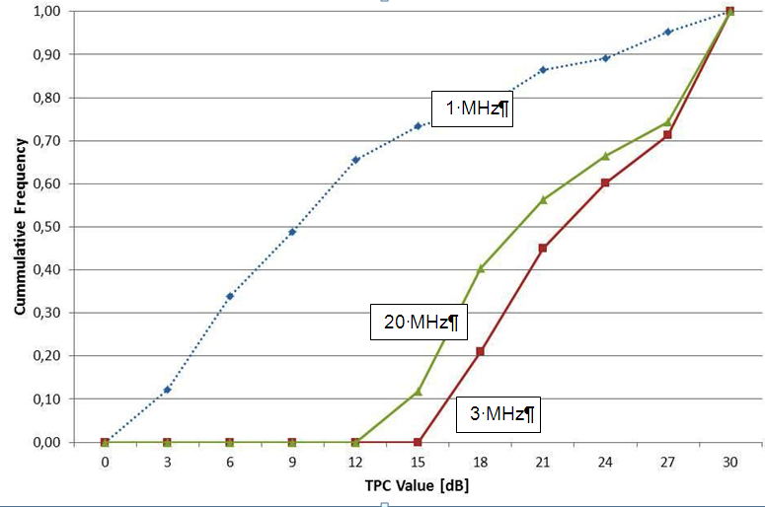
Figure 45: Cumulative distribution function of transmit power control value (WIA-Outdoor)
    - Overview of the TPC values
The results of average reduction of transmit power achieved by implementing TPC are listed in the following table.
Table 108: Average reduction of transmit power (Outdoor)
WIA | No. of Device | Aggregate e.i.r.p. [dBm] |  | Average reduction of transmit power (dB)
WIA | No. of Device | Without TPC | With TPC | Average reduction of transmit power (dB)
1 MHz (*) | 500.00 | 53.01 | 44.53 | 8.48
3 MHz | 500.00 | 53.01 | 31.18 | 21.83
20 MHz | 3000.00 | 60.79 | 40.89 | 19.90
(*) calculations are provided for WIA I (1 MHz) outdoor for information only since WIA I are not expected to be deployed outdoor.
- estimations of the number of wireless industrial automation devices other than UWB (WIA)
A study from from IMSResearch (see [31]) indicated that worldwide around 15 million wireless automation devices would be deployed in year 2015.
Information made available in ETSI while developing the SRdoc [1]are as follows:
The number of plants per Germany is focused primarily on large industrial plants. But the total number of wireless devices is not affected by other micro, small or medium plants or factories. The following table provides an overview of the deployment anticipated in Germany.
Table 109: Deployment of WIA in Germany
Parameters | Values
Population / Germany | 80 000 000
Population / Frankfurt am Main | 690 000
Plants / Frankfurt am Main | 4
Plants / Germany | 533
Wireless Devices / Germany | 12 590 000
Area Germany km² | 357 000
Wireless devices Germany/km² | 34.3

The value added by enterprise size class is in European countries [32] is further depicted in the following table.
Table 110: Enterprise size in Europe
Country | Value added by enterprise size class, mining and quarrying and manufacturing, 2008  (% share of size class in total sectoral value added)
Country | Micro (0-9) | Small (10-49) | Medium (50 - 249) | Large (+250)
EU (27 Countries) | 7 |  | 23.5
Belgium | 6.30 | 13.5 | 21.4 | 53.8
Bulgaria | 5.90 | 17.6 | 34.3 | 58.7
Czech Republic | 9.10 | 11.3 | 24.4 | 42.1
Denmark | 5.90 | 15.2 | 24.5 | 55.1
Germany | 3.30 | 10.3 | 21.5 | 64.9
Estonia | 6.60 | 20.3 | 42.7 | 30.4
Ireland | 2.30 | 7.3 | 24.2 | 66.3
Greece
Spain | 11.30 | 25.5 | 23.6 | 39.6
France | 10.30 | 15.7 | 20.6 | 53.1
Italy | 13.00 | 27.8 | 26.5 | 32.6
Cyprus | 23.40 | 36.2 | 23.5 | 16.9
Latvia | 5.70 | 20.8 | 42 | 31.4
Lithuania | 3.40 | 15.8 | 37.7 | 43.2
Luxembourg | 1.60
Hungary | 4.40 | 9.4 | 17.8 | 68.4
Malta
Netherlands | 7.90 | 18.9 | 26.4 | 46.8
Austria | 4.60 | 12 | 24.1 | 59.3
Poland | 7.30 | 10 | 25.3 | 57.3
Portugal | 9.40 | 23.6 | 32.2 | 34.8
Rumania | 4.30 | 12.7 | 24.1 | 58.9
Slovenia | 10.20 | 14.4 | 25.6 | 49.7
Slovakia | 3.20 | 12.7 | 24 | 60.1
Finland | 5.80 | 12.1 | 17.8 | 64.2
Sweden | 6.30 | 12.5 | 19.4 | 61.6
United Kingdom | 7.60 | 14.8 | 22.4 | 55.2

The automation ratio EU/Germany is also an acceptance of the industry and based on economic estimates The number of persons employed in manufacturing is around 7 million in Germany. That’s around 24 % of all persons employed in manufacturing in Europe. Another fact is that in Germany more automation technology is in use. For this reason the automation ratio EU/Germany was set to 3.
The number of residents can’t be used for an assessment of the industrial wireless devices in Europe. The number of inhabitants (see column 3, Table 111) isn’t equal to the number of persons employed in manufacturing (see column 6, Table 111).
Table 111: Statistical data from Eurostat yearbook 2012 ‘
Country | GDP  (€ 1000 million) 2010 | Population Demographic balance, 2010 |  | Population age structure by major age groups, 1990 and 2010 (% of the total population) | Number of persons employed in Manufacturing, 2008 |  | Value added, 2008
 |  | Million | % | 15 -64 years old | Million | % | Manufacturing
EU (27 Countries) | 9191 | 501.0 | 100 | 67.0 | 29 | 100 | 1652.60
Belgium | 353 | 10.8 | 2.2 | 65.9 | 0.59 | 2.0 | 49.20
Bulgaria | 36 | 7.6 | 1.5 | 68.9 | 0.64 | 2.2 | 4.30
Czech Republic | 145 | 10.5 | 2.1 | 70.6 | 1.37 | 4.7 | 31.70
Denmark | 234 | 5.5 | 1.1 | 65.6 | 0.39 | 1.3 | 28.70
Germany | 2499 | 81.8 | 16.3 | 65.9 | 7.10 | 24.3 | 453.8
Estonia | 15 | 1.3 | 0.3 | 67.8 | 0.12 | 0.4 | 2.2
Ireland | 156 | 4.5 | 0.9 | 67.3 | 0.20 | 0.7 | 30.5
Greece | 230 | 11.3 | 2.3 | 66.7
Spain | 1063 | 46.0 | 9.2 | 68.2 | 2.41 | 8.3 | 126.7
France | 1933 | 64.7 | 12.9 | 64.8 |  |  | 203.3
Italy | 1549 | 60.3 | 12.0 | 65.7 | 4.41 | 15.1 | 211.7
Cyprus | 17 | 0.8 | 0.2 | 70.1 | 0.04 | 0.1 | 1.2
Latvia | 18 | 2.2 | 0.5 | 68.9 | 0.14 | 0.5 | 1.9
Lithuania | 27 | 3.3 | 0.7 | 68.9 | 0.23 | 0.8 | 2.7
Luxembourg | 42 | 0.5 | 0.1 | 68.3 | 0.04 | 0.1 | 5.4
Hungary | 98 | 10.0 | 2.0 | 68.6 | 0.76 | 2.6 | 19.3
Malta | 6 | 0.4 | 0.1 | 69.6
Netherlands | 591 | 16.6 | 3.3 | 67.1 | 0.75 | 2.6 | 59.3
Austria | 284 | 8.4 | 1.7 | 67.5 | 0.63 | 2.2 | 46.7
Poland | 354 | 38.2 | 7.6 | 71.3 | 2.56 | 8.8 | 57.2
Portugal | 173 | 10.6 | 2.1 | 66.9 | 0.77 | 2.6 | 19.0
Rumania | 122 | 21.5 | 4.3 | 69.9 | 1.40 | 4.8 | 15.5
Slovenia | 36 | 2.0 | 0.4 | 69.4 | 0.23 | 0.8 | 6.7
Slovakia | 66 | 5.4 | 1.1 | 72.4 | 0.44 | 1.5 | 8.0
Finland | 180 | 5.4 | 1.1 | 66.4 | 0.42 | 1.4 | 32.1
Sweden | 347 | 9.3 | 1.9 | 65.3 | 0.75 | 2.6 | 50.3
United Kingdom | 1697 | 62.0 | 12.4 | 66.1 | 2.80 | 9.6 | 185.2

The ratio of gross domestic product (GDP) between Germany (2.499 billion €) and Europe (12.27 billion €) is 4.1.
The number of employee in manufacturing is 7.103 million for Germany and 29 million for Europe. The ratio of employee in manufacturing between Europe and Germany is 4.1.
The ratio of value added between Europe (16.695 billion €) and Germany (4.538 billion €) is 3.6.
The mean value of ratio of GDP, ratio of number of employees in manufacturing and ratio of value added is 3.8.
In order to assess the deployment of WIA over the whole EU based on the data from Germany, the value of 4,1 is considered as a ratio between Germany and the EU as a worst case assumption (the same ratio could be considered for the whole CEPT).
Table 112: Deployment of WIA in EU
Parameters | Values
Automation ratio EU/Germany | 4,1
Wireless Devices EU | 51 496 000
Area EU km² | 10 180 000
Device density EU/km² | 5.06
- Path loss models USEd in Seamcat simulations
This annex provides information on the propagation model which was used in the SEAMCAT simulations.
The models are based on:
  - Spherical diffraction as defined in SEAMCAT;
  - Line Of Sight (Free space loss);
  - Free space loss with 3,5 exponent;
  - IEEE model as defined in the SEAMCAT library.

The following figure shows a comparison of the IEEE model depending on the breakpoints with other models.

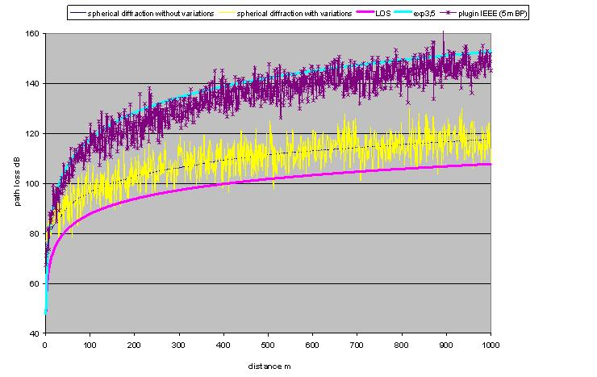
Figure 46: comparison IEEE model with 5m breakpoint distance with
spherical diffraction and LOS/exp3.5

The IEEE plugin was used in SEAMCAT in order to be able to consider also an urban-like propagation model (Model_C_IEEE_802_11_rev2, Date 17/10/2012).
The following configuration was used in the simulations:
  - Breakpoint distance 5m for urban environments
  - Breakpoint distance 50m for suburban environments
  - Breakpoint distance 500m for rural environments

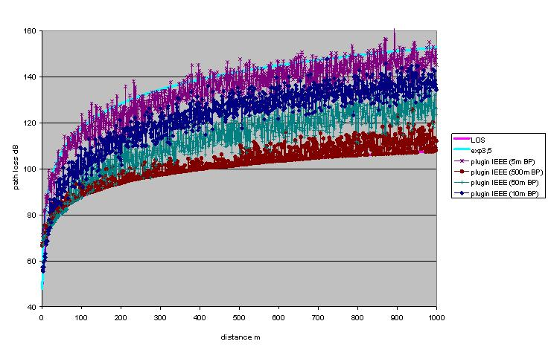
Figure 47: in SEAMCAT used IEEE model compared to LOS and exponent 3.5

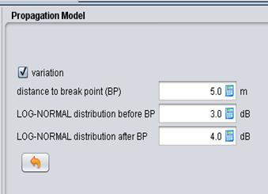
Figure 48: IEEE 802.11 plugin for SEAMCAT
The following figure provides a comparison of additional path loss models (for example including the model used for the MCL calculations (see ANNEX 4:).
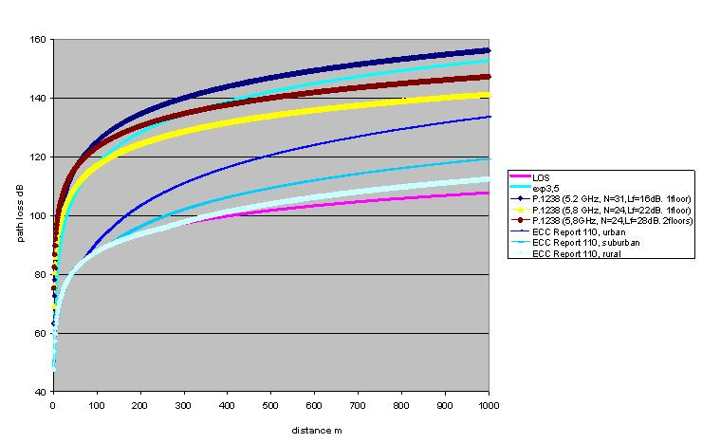
Figure 49: comparison of other indoor path loss models

- PRopagation models used in MCL calculations

The calculations developed in the MCL sections in this report used the same propagation model as in ECC Report 101 [5].

The propagation model has two breakpoints and is as follows:

$$\left\{\begin{matrix}20log⁡\left(\frac{λ}{4πd}\right) & d≤d_{0} \\ 20\log\left(\frac{λ}{4πd_{0}}\right)-10n_{0}log\left(\frac{d}{d_{0}}\right) & d_{0}≤d≤d_{1} \\ 20\log\left(\frac{λ}{4πd_{0}}\right)-10n_{0}log\left(\frac{d_{1}}{d_{0}}\right)-10n_{1}log\left(\frac{d}{d_{1}}\right) & d>d_{1}\end{matrix}\right.$$

The used values of the breakpoints and pathloss factors depend on the environment and are given in the following table.
Table 113: Parameters for propagation models
 | Urban | Suburban | Rural | ETSI TR 102- 492
Breakpoint distance d₀ (m) | 64 | 128 | 256 | 15
Pathloss factor n₀ beyond the first break point | 3.8 | 3.3 | 2.8 | 2.7
Breakpoint distance d₁ (m) | 128 | 256 | 1024 | 1024
Pathloss factor n₁ beyond the first break point | 4.3 | 3.8 | 3.3 | 2.7

The first three columns are according to ECC Report 101 and the last column the ITS SRdoc ETSI TR 102 492-1 [19].

- SEnsing procedure
  - General considerations
This section provides the methodology based on link budget analysis; that is used for the determination of the DFS detection threshold to protect radars.

The threshold is determined from two link budget analyses, (1) and (2) whose description is provided below. This is based on the assumption of a symmetrical propagation path between the interfering system with DFS (this system is quoted as Int ) and the radar (RL) and also that the transmitter and receiver bandwidths of the radar are the same:

(1): The link budget gives the propagation losses PL to limit the interference level coming from the interfering system Int towards the radar receiver below the noise level minus 6dB (I/N=-6dB). Let d be the separation distance.
(2): The link budget gives the propagation losses PL to allow the interferer Int to detect at the distance d the presence of a radar. Therefore, the interference level coming from the radar towards the receiver of the Int system will be used as the detection threshold at the antenna connector (Th).

Note that:
- : spectral density of the interferer (dBm/MHz)
- : Antenna gain of the interferer
- : Bandwidth of the interferer
- : power of the interferer (dBm)

- : Ambient noise (dBm/MHz) with noise temperature of T=290°K, a reference bandwidth B_{o}=1 MHz and F the noise figure in dB
- the maximum allowable level of interference on the RL
- : spectral desity of the radar (dBm/MHz)
- : Antenna gain of the radar
- : Bandwidth of the radar
- : power of the radar (dBm)
- : Detection threshold at the antenna connector (dBm/MHz)
- : Detection threshold at the antenna connector (dBm) in the bandwidth of the interferer
- : Propagation losses

If >
(1)
(2)
=>

If <
(1)
(2)
=>
Finally, these calculations lead to the same formula:

in dBm over the bandwidth of the interferer

Note: The ECC Report 68 indicated that an appropriate detection threshold Th_{FWA} should be -69dBm (close to -67.18dBm which can be calculated using this method) over the BFWA bandwidth.

Calculations for WIA, applying the equation above give the following results.
Table 114: DFS threshold WIA – 1 MHz
Characteristics of the Radars | Radar L | Radar M | Radar N | Radar O | Radar Q | Radar X & Y | Radar Z
Tx power into antenna peak (kW) | 2800 | 1200 | 1000 | 165 | 285 | 12 | 70
Tx power into antenna peak (dBm) | 94.47 | 90.79 | 90.00 | 82.17 | 84.55 | 70.79 | 78.45
Radar bandwidth (MHz) | 4.8 | 4 | 8 | 8 | 10 | 4 | 1
Noise figure (dB) | 7 | 4 | 2.3 | 3 | 3 | 5 | 13
Characteristics of a WIA device
WIA e.i.r.p (dBm) outdoor | 26 | 26 | 26 | 26 | 26 | 26 | 26
Bandwith (MHz) | 1 | 1 | 1 | 1 | 1 | 1 | 1
Antenna gain (dBi) | 5 | 5 | 5 | 5 | 5 | 5 | 5
WIA spectral density power (dBm/MHz) at the antenna connector | 21 | 21 | 21 | 21 | 21 | 21 | 21
Characteristics of the DFS | Radar L | Radar M | Radar N | Radar O | Radar Q | Radar X & Y | Radar Z
Noise level (dBm/MHz) | -106.98 | -109.98 | -111.68 | -110.98 | -110.98 | -108.98 | -100.98
DFS Detection threshold Th (dBm) | -39.51 | -46.19 | -48.68 | -55.80 | -53.43 | -65.19 | -49.53

Table 115: DFS threshold WIA – 3 MHz
Characteristics of the Radars | Radar L | Radar M | Radar N | Radar O | Radar Q | Radar X & Y | Radar Z
Tx power into antenna peak (kW) | 2800 | 1200 | 1000 | 165 | 285 | 12 | 70
Tx power into antenna peak (dBm) | 94.47 | 90.79 | 90.00 | 82.17 | 84.55 | 70.79 | 78.45
Radar bandwidth (MHz) | 4.8 | 4 | 8 | 8 | 10 | 4 | 1
Noise figure (dB) | 7 | 4 | 2.3 | 3 | 3 | 5 | 13
Characteristics of a WIA device
WIA e.i.r.p (dBm) outdoor | 26 | 26 | 26 | 26 | 26 | 26 | 26
Bandwith (MHz) | 3 | 3 | 3 | 3 | 3 | 3 | 3
Antenna gain (dBi) | 5 | 5 | 5 | 5 | 5 | 5 | 5
WIA spectral density power (dBm/MHz) at the antenna connector | 16 | 16 | 16 | 16 | 16 | 16 | 16
Characteristics of the DFS | Radar L | Radar M | Radar N | Radar O | Radar Q | Radar X & Y | Radar Z
Noise level (dBm/MHz) | -106.98 | -109.98 | -111.68 | -110.98 | -110.98 | -108.98 | -100.98
DFS Detection threshold Th (dBm) | -34.73 | -41.41 | -43.91 | -51.03 | -48.66 | -60.41 | -44.76

Table 116: DFS threshold WIA – 20 MHz
Characteristics of the Radars | Radar L | Radar M | Radar N | Radar O | Radar Q | Radar X & Y | Radar Z
Tx power into antenna peak (kW) | 2800 | 1200 | 1000 | 165 | 285 | 12 | 70
Tx power into antenna peak (dBm) | 94.47 | 90.79 | 90.00 | 82.17 | 84.55 | 70.79 | 78.45
Radar bandwidth (MHz) | 4.8 | 4 | 8 | 8 | 10 | 4 | 1
Noise figure (dB) | 7 | 4 | 2.3 | 3 | 3 | 5 | 13
Characteristics of a WIA device
WIA e.i.r.p (dBm) outdoor | 26 | 26 | 26 | 26 | 26 | 26 | 26
Bandwith (MHz) | 20 | 20 | 20 | 20 | 20 | 20 | 20
Antenna gain (dBi) | 5 | 5 | 5 | 5 | 5 | 5 | 5
WIA spectral density power (dBm/MHz) at the antenna connector | 8 | 8 | 8 | 8 | 8 | 8 | 8
Characteristics of the DFS | Radar L | Radar M | Radar N | Radar O | Radar Q | Radar X & Y | Radar Z
Noise level (dBm/MHz) | -106.98 | -109.98 | -111.68 | -110.98 | -110.98 | -108.98 | -100.98
DFS Detection threshold Th (dBm) | -21.50 | -28.18 | -30.67 | -37.79 | -35.42 | -52.18 | -36.52

In the above calculations, the same level for the DFS threshold for indoor case and outdoor case since the wall attenuation is compensated on the two paths.
  - Considerations on central sensing
In this section the requirements for WIA systems (Interfering transmitter IT, transmitting to its wanted receiver WR) to detect BFWA systems (Wanted transmitter WT transmitting to the victim receiver VR) is analysed. IT is able to monitor the WT, which is the basis for the sensing mechanism which is called LBT in this section.

The following abbreviations and definitions are valid in this annex:

  - Dimensions: r/m, P/dBm, S/dBm, SIR/dB, f/GHz, All antennas 0dBi
  - VR Victim receiver (BFWA)
    - N: Noise floor kTBF of VR (-95 dBm/20MHz)
    - F: Noise figure of VR, (BFWA 6 dB)
    - S: Signal strength received at the VR from WT (Pwt)
    - SNR: signal to noise ratio, or C/N at VR
    - SIRmin: Signal to interference ratio, or C/I at VR (27 dB)
    - WT Wanted transmitter (victim link, BFWA)
    - Pwt Transmit power of WT (CS) (BFWA 14 dBm)
    - Gs Antenna gain WT (22 dBi)
  - IT Interfering Transmitter (WIA)
    - Pit Transmit power of IT (SRD 21 dBm)
    - Antenna gain IT 5dBi
    - WR Wanted receiver (Interfering Link)
    - Plbt: LBT power received at WR from WT (Pwt)
    - Pthr: power threshold for the LBT mechanism at IT
  - I: Interfering power at VR,
  - n: Path loss exponent n (e.g. n=2 free space loss)
  - Rint: radius around VR; inside interference can occur (S-I<SIRmin)
  - Rsig: radius around VR; inside the victim link works wit S-N<SNRmin
  - Rdet: radius around WT; inside the IT can detect the WT
  - Wall: wall attenuation dB

The following figure explains the investigated scenario. Within a radius of Rint around the VR the IT can exceed the protection objective of the VR (e.g. C/I). Within a radius of Rdet around the WT the IT can detect the WT (Threshold is exceeded).
In the light blue area in the following figure 7 LBT is working effectively. The red area is the so called “hidden node”, where the IT is not able to detect the WT.

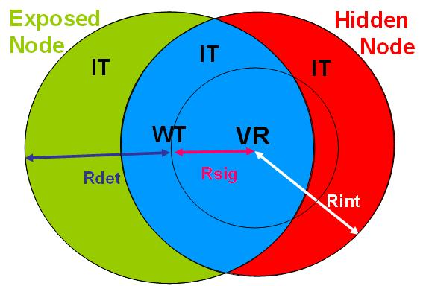
Figure 50: Hidden node and Exposed node

The situation is simplified because each BFWA station is assumed to transmit and receive simultaneously (TDD).

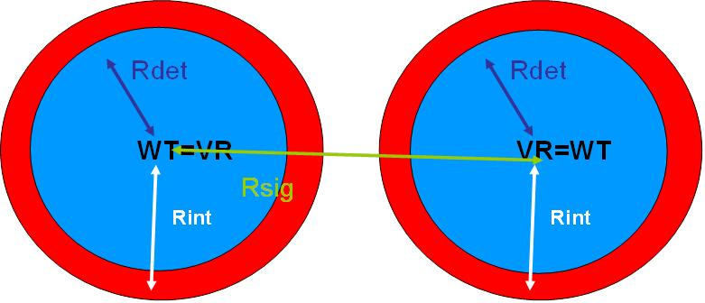
Figure 51: Illustration of the scenario

The formulas given hereafter are the basis for the analysis.

Signal strength at the BFWA receiver:
S (at VR)= N + SNR = Pwt (BFWA)+ Gsbfwa+Gebfwa- PL(Rsig) (1)

The interference power at the BFWA receiver:
I (at VR)= S - SIRmin = Pit (SRD)+Gswia(p)+Gebfwa(p)-Wall- PL(Rint) (2)

The threshold power at the SRD:
Pthr (at SRD) = Pwt (BFWA)+Gsbfwa(p)+Gewia(p)-Wall- PL(Rdet) (3)

Path loss model:
PL = 32.5+10*n*log(R/m)+20*log(f/GHz) (4)

(1)+(4) -> 10n*log(Rsig) = Pwt+ Gsbfwa+Gebfwa -N-SNR-32.5-20logf (5)
(2)+(4) -> 10n*log(Rint) = Pit+ Gswia(p)+Gebfwa(p)-Wall-N-SNR+SIRmin-32.5-20logf (6)
(3)+(4) -> 10n*log(Rdet) = Pwt+ Gsbfwa(p)+Gewia(p)-Wall-Pthr-32.5-20logf (7)

Relation Rdet/Rint: (7)-(6) -> 10n*log(Rdet/Rint)=Pwt-Pit-Pthr+N+SNR-SIRmin (8)

Under the assumption Rdet=Rint the WI system should be perfectly able to detect the BFWA system and thus with formula (8) it follows:

. Pthr=Pwt-Pit+N+SNR-SIRmin (9)

Table 119 shows the required LBT threshold values using formula above with variable WIA bandwidth (1MHz, 3 MHz, 20 MHz) and 3 different SNR values (27dB, 37 dB, 47 dB).

Table 117: LBT thresholds for different SNR
 | WIA I | WIA III | WIA II | WIA I | WIA III | WIA II | WIA I | WIA III | WIA II
BW1/MHz WIA | 1 | 3 | 20 | 1 | 3 | 20 | 1 | 3 | 20
BW2/MHz BFWA | 20 | 20 | 20 | 20 | 20 | 20 | 20 | 20 | 20
Pit dBm/BW1 e.i.r.p. | 21 | 21 | 21 | 21 | 21 | 21 | 21 | 21 | 21
Pit dBm/BW2 e.i.r.p. | 21 | 21 | 21 | 21 | 21 | 21 | 21 | 21 | 21
Pwt dBm/BW2 | 14 | 14 | 14 | 14 | 14 | 14 | 14 | 14 | 14
NF dB | 6.00 | 6.00 | 6.00 | 6.00 | 6.00 | 6.00 | 6.00 | 6.00 | 6.00
N dBm/BW2 | -94.99 | -94.99 | -94.99 | -94.99 | -94.99 | -94.99 | -94.99 | -94.99 | -94.99
SNR dB | 27.00 | 27.00 | 27.00 | 37.00 | 37.00 | 37.00 | 47.00 | 47.00 | 47.00
Smin dBm/BW | -67.99 | -67.99 | -67.99 | -57.99 | -57.99 | -57.99 | -47.99 | -47.99 | -47.99
SIRmin dB | 27.00 | 27.00 | 27.00 | 27.00 | 27.00 | 27.00 | 27.00 | 27.00 | 27.00
Pthr dBm/BW2 | -101.99 | -101.99 | -101.99 | -91.99 | -91.99 | -91.99 | -81.99 | -81.99 | -81.99
Pthr dBm/BW1 | -115 | -110.23 | -101.99 | -105 | -100.23 | -91.99 | -95 | -90.23 | -81.99

In the above calculation it is assumed that all links having the same path loss model. For the case of a specific sensing antenna on top of the WIA plant, with better propagation conditions for the detection path (propagation exponent n2) the situation is more complicated and cannot be reduced to a simple formula, but the situation can be improved.

10n1*log(Rint) = Pit+ Gswia(p)+Gebfwa(p)-Wall-N-SNR+SIRmin-32.5-20logf (10)
10n2*log(Rdet) = Pwt+ Gsbfwa(p)+Gesensing- Pthr-32.5-20logf (11)

Table 118 shows the interference and detection ranges using the above formulas (10) and (11).
Table 118: Interference and detection ranges comparison
 | Case 1 | Case 2 | Case 3 | Case 4
BW1/MHz WIA | 1 | 3 | 20 | 1
BW2/MHz BFWA | 20. | 20 | 20 | 20
Pit dBm/BW1 e.i.r.p. | 21 | 21 | 21 | 21
f/GHz | 5,75 | 5.75 | 5,75 | 5.75
BW/MHz | 20 | 20 | 20 | 20
Pit dBm/BW | 21 | 21 | 21 | 21
Pwt dBm/BW | 14 | 14 | 14 | 14
Gsbfwa dBi | 22 | 22 | 22 | 22
Ge bfwa dBi | 16 | 16 | 16 | 16
Gs sensing dBi | 10 | 10 | 10 | 10
Gs_wia dBi | 5 | 5 | 5 | 5
NF dB | 6.00 | 6.00 | 6.00 | 6.00
N dBm/BW | -94.99 | -94.99 | -94.99 | -94.99
Pthr dBm/BW | -87.00 | -87.00 | -87.00 | -87.00
wall dB | 0.00 | 15.00 | 0.00 | 15.00
SNR dB | 27.00 | 27.00 | 27.00 | 27.00
fade margin dB | 10.00 | 10.00 | 10.00 | 10.00
Smin dBm/BW | -57.99 | -57.99 | -57.99 | -57.99
SIR dB | 27.00 | 27.00 | 27.00 | 27.00
Imax dBm/BW | -84.99 | -84.99 | -84.99 | -84.99
propagation exp n1 (interfering path) | 2.00 | 2.00 | 2.50 | 2.50
propagation exp n2 (sensing path) | 2.00 | 2.00 | 2.00 | 2.00
Rsig m | 1302.6 | 1302.6 | 1302.6 | 1302.6
Rint/m | 9221.8 | 1639.9 | 1485.4 | 373.1
Rdet/m | 9232.8 | 9232.8 | 9232,8 | 9232,8

The calculations in Table 118 shows that a specific sensing antenna improves the situation because the detection distance is always higher as the interference distance; only for unrealistic combination of a outdoor WIA usage (0 dB wall loss) and the same propagation conditions in the sensing and interfering path the advantages of a sensing antenna are disappearing.

- List of referenceS

- ETSI TR 102 889-2 V1.1.1: Electromagnetic compatibility and Radio spectrum Matters (ERM); System Reference Document; Short Range Devices (SRD); Part 2: Technical characteristics for SRD equipment for wireless industrial applications using technologies different from Ultra-Wide Band (UWB)
- ERC/REC 70-03: Short Range Devices (SRD)
- Radio Regulations (www.itu.int)
- ERC Report 25: The European table of frequency allocations and utilisations covering the frequency range 9 kHz to 3000 GHz
- ECC Report 101: Compatibility Studies in the band 5855– 5925 MHz between Intelligent Transport System (ITS) and other Systems
- Recommendation ITU-R M.1638: “Characteristics of and protection criteria for sharing studies for radiolocation, aeronautical radionavigation and meteorological radars operating in the frequency bands between 5 250 and 5 850 MHz”
- ECC Decision (02)01: The frequency bands to be designated for the coordinated introduction of Road Transport and Traffic Telematic Systems
- ETSI EN 300 674: Dedicated Short Range Communication (DSRC) transmission equipment (500 kbit/s / 250 kbit/s) operating in the 5,8 GHz Industrial, Scientific and Medical (ISM) band; Part 2: Harmonized EN under article 3.2 of the R&TTE Directive
- BS EN 12253: Road transport and traffic telematics. Dedicated short-range communication. Physical layer using microwave at 5.8 GHz
- R&TTE Directive: Radio and telecommunications terminal equipment
- ECC Report 173: Fixed Service in Europe
- ECC Recommendation (06)04: Use of the band 5725-5875 MHz BFWA
- ETSI EN 302 502: Broadband Radio Access Networks (BRAN); 5,8 GHz fixed broadband data transmitting systems; Harmonized EN covering essential requirements of article 3.2 of the R&TTE Directive
- Recommendation ITU-R F.383-7: Radio-frequency channel arrangements for high-capacity fixed wireless systems operating in the lower 6 GHz (5 925 to 6 425 MHz) band
- ERC Recommendation 14-01: Radio-frequency channel arrangements for high capacity analogue and digital radio-relay systems operating in the band 5925 MHz - 6425 MHz
- ECC Report 068: Compatibility studies in the band 5725-5875 MHz between Fixed Wireless Access (FWA) systems and other systems
- Recommendation ITU-R M.1732-1: Characteristics of systems operating in the amateur and amateur-satellite services for use in sharing studies
- ECC Report 172, Broadband Wireless Systems Usage in 2300-2400 MHz
- ETSI TR 102 492-1: Intelligent Transport Systems (ITS)
- IEEE 802.11: IEEE Standard for Information technology--Telecommunications and information exchange between systems Local and metropolitan area networks--Specific requirements Part 11: Wireless LAN Medium Access Control (MAC) and Physical Layer (PHY) Specifications
- ETSI EN 302 571: Intelligent Transport Systems (ITS); Radiocommunications equipment operating in the 5 855 MHz to 5 925 MHz frequency band; Harmonized EN covering the essential requirements of article 3.2 of the R&TTE Directive
- ETSI EN 302 372: Short Range Devices (SRD); Equipment for Detection and Movement; Tanks Level Probing Radar (TLPR) operating in the frequency bands 5,8 GHz, 10 GHz, 25 GHz, 61 GHz and 77 GHz;
- CEPT Report 26: Report from CEPT to the European Commission in response to the Permanent Mandate to CEPT regarding the “annual update of the technical annex of the Commission Decision on the technical harmonisation of radio spectrum for use by short range devices”
- Recommendation ITU-R M.1461: Procedures for determining the potential for interference between radars operating in the radiodetermination service and systems in other services
- ITU Radio Regulations Appendix 8: Method of calculation for determining if coordination is required between geostationary-satellite networks sharing the same frequency bands
- Recommendation ITU-R S.1432: Apportionment of the Allowable Error Performance Degradation to Fixed-Satellite Service (FSS). Hypothetical Reference Digital Path Arising from Time Invariant Interference for Systems operating below 15 GHz
- ERC Recommendation 74-01: Unwanted Emissions in the Spurious Domain
- Recommendation ITU-R F.1336-3: Reference radiation patterns of omnidirectional, sectoral and other antennas in point-to-multipoint systems for use in sharing studies in the frequency range from 1 GHz to about 70 GHz
- IEEE 802.15.1: IEEE Standard for Information technology-- Local and metropolitan area networks-- Specific requirements-- Part 15.1a: Wireless Medium Access Control (MAC) and Physical Layer (PHY) specifications for Wireless Personal Area Networks (WPAN)
- IEEE 802.15.4: IEEE Standard for Local and metropolitan area networks--Part 15.4: Low-Rate Wireless Personal Area Networks (LR-WPANs)
- http://www.imsresearch.com/blog/Whats_Holding_Back_Wireless_Communication_in_Industry/106/cat
- European Commission, Europe in figures — Eurostat yearbook 2012. Luxembourg: Publications Office of the European Union, ISBN 978-92-79-24940-2, ISSN 1830-9674, Digital Object Identifier (DOI): 10.2785/29433
- ECC Recommendation (08)01: Use of the band 5855-5875 MHz for Intelligent Transport Systems (ITS)
- ECC Report 192 The current status of DFS (Dynamic Frequency Selection) in the 5 GHz frequency range
- Recommendation ITU-R F.699 Reference radiation patterns for fixed wireless system antennas for use in coordination studies and interference assessment in the frequency range from 100 MHz to about 70 GHz
- ECC Decision (08)01 on the harmonised use of the 5875-5925 MHz frequency band for Intelligent Transport Systems (ITS)
- Commission Decision 2008/671/EC on the harmonised use of radio spectrum in the 5875-5905 MHz frequency band for safety related applications of Intelligent Transport Systems (ITS)

In Recommendation ITU-R M.1732-1 [17] the specific 5.7GHz band is combined with other amateur bands. Therefore some adjustments have been made in order to be more representative of 5.7GHz equipment
The value for the transmitter output power is higher than the specified value of 250 mW (24 dBm) in the technical report ETSI TR 102 889-2 V1.1.1 [1] since the specified transmitter output power in [1] refers to the 2.4 GHz frequency band. In the frequency band from 5.725 to 5.875 GHz, the electromagnetic wave propagation conditions are worse; therefore a higher level of transmitter output power is needed to meet the requirements of industrial wireless applications also within this frequency band.

