ECC Report 202

Out-of-Band emission limits for Mobile/Fixed Communication Networks (MFCN) Supplemental Downlink (SDL) operating in the 1452-1492 MHz band
September 2013

Executive summary
The Report studies the coexistence of Mobile/Fixed Communication Networks (MFCN) Supplemental Downlink (SDL) operating in 1452-1492 MHz and other systems operating in adjacent bands with the aim to define the out-of-band emission limits applicable to MFCN SDL base stations in the band. Four coexistence scenarios corresponding to systems operating in adjacent bands were studied in this report:
- Coordinated Fixed Links,
- Uncoordinated Fixed Links,
- Tactical Radio Relays,
- Aeronautical Telemetry (ground based receivers only).

The study does not address aircraft receiver stations of aeronautical mobile service in frequency band 1429-1535 MHz because they are only used in a limited number of countries.

A Minimum Coupling Loss analysis of the coexistence between T-DAB and MFCN SDL is also conducted in this Report in order to derive the target path loss considered acceptable by the CEPT for the protection of Fixed Links, Tactical Radio Relays and Aeronautical Telemetry. The Maastricht Special Arrangement 2002 revised in Constanta 2007 (MA02RevCO07) provides the regulatory framework for the deployment of terrestrial mobile multimedia services in 1452-1479.5 MHz in CEPT countries, including applicable protection criteria for Fixed Links and Aeronautical Telemetry systems.
The Report provides the in-block and Out of Band e.i.r.p. limits recommended for the harmonised use of 1452-1492 MHz for MFCN SDL in order to ensure coexistence with Tactical Radio Relays, coordinated Fixed Links and/or aeronautical telemetry stations operating below 1452 MHz and above 1492 MHz:
- The study is based on 68 dBm e.i.r.p. in LTE system with 5 MHz channel plan
- Based on deployment requirements and on compatibility studies with Tactical Radio Relays, coordinated fixed links and/or aeronautical telemetry stations operating in adjacent bands, an administration could at national level restrict base stations in-band e.i.r.p.. It should be noted that administrations may consider authorising e.i.r.p. other (i.e. higher) than 68 dBm dependent on specific circumstances.
- The recommended OoB emissions for the operation of MFCN SDL in 1452-1492 MHz are presented in the Table 1.

Table 1: OoB e.i.r.p. limits for the MFCN SDL base station operating in the band 1452-1492 MHz
Frequency range of  out-of-band emissions | Maximum mean  out-of-band e.i.r.p. | Measurement  Bandwidth
Below 1449 MHz | -20 dBm | 1 MHz
1449-1452 MHz | 14 dBm | 3 MHz
1492-1495 MHz | 14 dBm | 3 MHz
Above 1495 MHz | -20 dBm | 1 MHz

Furthermore, the Report shows that coexistence between MFCN SDL and coordinated Fixed Link stations, as well as coexistence between MFCN SDL and aeronautical telemetry stations can be managed through coordination (frequency-territorial planning). Typical coordination distances for the usage in the adjacent bands are calculated in the Report. The report also provides specific MFCN SDL in-block and Out of Band e.i.r.p. restrictions that could be adopted by countries that would decide to pursue coexistence between MFCN SDL and uncoordinated Fixed Links as shown in Table 2 and Table 3. It should be noted that the FS protection criteria may be different from country to country.
Table 2: MFCN SDL Base station in band e.i.r.p. limits for countries with uncoordinated Fixed Links in adjacent bands
Frequency range | Maximum mean e.i.r.p.
1452-1457 MHz | 11.8 dBm
1457-1487 MHz | 20.2 dBm
1487-1492 MHz | 11.8 dBm

Table 3: MFCN SDL Base station OoB e.i.r.p. limits for countries with uncoordinated
Fixed Links in adjacent bands
Frequency range of  out-of-band emissions | Maximum mean  out-of-band e.i.r.p. | Measurement  Bandwidth
Below 1452 MHz | -38.5 dBm | 1 MHz
Above 1492 MHz | -38.5 dBm | 1 MHz

TABLE OF CONTENTS

0 Executive summary 2
1 Introduction 6
2 Definitions 7
3 Description and characteristics of systems considered 8
3.1 Systems in or adjacent to 1452-1492 MHz considered in this report 8
3.1.1 Out-of-band compatibility scenarios 8
3.2 Fixed Service Characteristics 8
3.3 Mobile Service 11
3.4 Aeronautical Telemetry characteristics 11
3.5 MFCN SDL characteristics 12
4 compatibility studies 14
4.1 General considerations and target pathloss 14
4.2 MFCN SDL vs Fixed Services 14
4.2.1 Coordinated Fixed Links 14
4.2.1.1 Identification of interference dominant factor 14
4.2.1.2 MCL study 15
4.2.2 Uncoordinated Fixed Links 15
4.2.2.1 MCL study 15
4.2.2.2 Study based on SEAMCAT simulations 16
4.3 MFCN SDL vs MOBILE SERVICES (TRR) 16
4.3.1 Compatibility study scenario 16
4.3.2 Criteria for derivation of out-of-band emissions 16
4.3.3 Studies and study results 16
4.3.3.1 MCL study 16
4.3.3.2 Statistical and SEAMCAT study 17
4.3.4 Proposed MFCN SDL in-band and OoB e.i.r.p. limits for protection of TRR 19
4.4 MFCN SDL vs telemetry 19
4.4.1 Limits of the study 19
4.4.2 MCL study 19
5 Conclusion 21
5.1 Recommendations for MFCN SDL deployment, including in-band and OOb emissions limits 21
5.2 specific in-band and Out-of-Band emissions Restrictions 21
ANNEX 1: Overview of studies performed in the ECC report 121 22
ANNEX 2: MCL Analysis of coexistence between T-DAB in 1452-1492 MHz and other systems in adjacent bands 24
ANNEX 3: Uncoordinated Fixed Links studies 29
ANNEX 4: Identification of compatibility scenario for MFCN SDL vs Mobile services (TRR) in adjacent band analysis 34
ANNEX 5: Fixed Links Blocking Response 38
ANNEX 6: Using Seamcat for OOB calculations 43
ANNEX 7: List of references 49

LIST OF ABBREVIATIONS

Abbreviation | Explanation
BEM | Block Edge Mask
BER | Bit Error Rate
BL | Back Lobe
BR | Blocking Response
BS | Base Station
CEPT | European Conference of Postal and Telecommunications Administrations
CS | Channel Size
DAB | Digital Audio Broadcasting
DEC | Decision
ECC | Electronic Communications Committee
e.i.r.p. | Equivalent Isotropically Radiated Power
FL | Fixed Link
FS | Fixed Service
ITU-R | International Telecommunication Union - Radiocommunication Sector
MCL | Minimum Coupling Loss
MFCN | Mobile/Fixed Communications Network
ML | Main Lobe
MS | Mobile Service
NFD | Net Filter Discrimination
OoB | Out-of-Band
PWMS | Professional Wireless Microphone System
REC | Recommendation
SDL | Supplemental Downlink
S-DAB | Satellite Digital Audio Broadcasting
SL | Side Lobe
SNR | Signal to Noise Ratio
T-DAB | Terrestrial Digital Audio Broadcasting
TRR | Tactical Radio Relay

Introduction
The 1452-1492 MHz band has remained unused in most European countries for the past decade. Since 2002, the 1452-1479.5 MHz sub-band has been harmonised for Terrestrial Digital Audio Broadcasting systems (T-DAB) through the Maastricht, 2002 Special Arrangement [1]. The arrangement was later revised in Constanţa, in 2007 [1]. Since 2003, the 1479.5-1492 MHz sub-band has been harmonised for Satellite Digital Audio Broadcasting (S-DAB) through the ECC/DEC/(03)02 [2]. The 1452-1492 MHz is referenced to, in Europe, as the L-band, 1.4 GHz or 1.5 GHz.
Late 2010, CEPT decided to undertake a review of the use of the L-band with the aim to change the current situation and enable the use of those 40 MHz of prime spectrum for new services and applications that could bring substantial social and economic benefits for Europe. In December 2010, the ECC launched a questionnaire to CEPT administrations and industry in order to identify the current and potential candidate applications. In May 2011, the ECC established a Project Team to determine, based on an impact analysis, the most appropriate future use(s) of the 1452-1492 MHz band in CEPT. In February 2013, ECC adopted the ECC Report 188 [3] on the future harmonised use of 1452-1492 MHz. ECC initiated in September 2012 the development of an ECC Decision harmonising 1452-1492 MHz for mobile/fixed communication networks (MFCN) supplemental downlink (SDL).
In this context, the compatibility of MFCN SDL operating in 1452-1492 MHz and other services/systems in adjacent bands is studied in the present report. The report proposes Out-of-Band emission (OoB) limits applicable to MFCN SDL operating in 1452-1492 MHz.
Compatibility studies between PWMS and Fixed, Mobile and aeronautical telemetry were carried out in the ECC Report 121 [3].
This ECC Report:
- Provides the descriptions and characteristics of systems involved in Section 3.;
- Presents the compatibility studies between MFCN SDL and systems in adjacent bands in Section 4;
- Proposes Out-of-Band emission (OoB) limits for the operation of MFCN SDL in Section 5;
- Provides an overview of the results of studies performed in the ECC Report 121 in ANNEX 1:;
- Analyses the compatibility between T-DAB in 1452-1492 MHz and systems in adjacent bands in ANNEX 2:;
- Provides the detailed compatibility studies between MFCN SDL and uncoordinated Fixed Links in ANNEX 3;
- Provides the detailed compatibility studies between MFCN SDL and Tactical Radio Relays in ANNEX 4:;
- Defines and derives the Fixed Links Blocking Response in ANNEX 5:;
- Provide some guideline on the use of SEAMCAT to derive OoB in ANNEX 6:;

Definitions
Term | Definition
L-band | The 1452-1492 MHz band is referenced as the L-band
Coordinated Fixed Links | Existing Fixed Links, which operate at specified fixed points
Uncoordinated Fixed Links | Existing Fixed Links operating in an uncoordinated manner and not having specific operation locations
Blocking Response | Receiver filter attenuation of signals outside of receiver’s channel/band, given in dB (See ANNEX 5:)

Description and characteristics of systems considered

Systems in or adjacent to 1452-1492 MHz considered in this report
The ECC decided to harmonize the band 1452-1492 MHz band for MFCN SDL based on the results of ECC Report 188 [3]. The ECC Report 121 [4] provides a detailed presentation of services operating in 1429-1518 MHz.
As a result, the use scenario considered in this Report is provided in Figure 1.
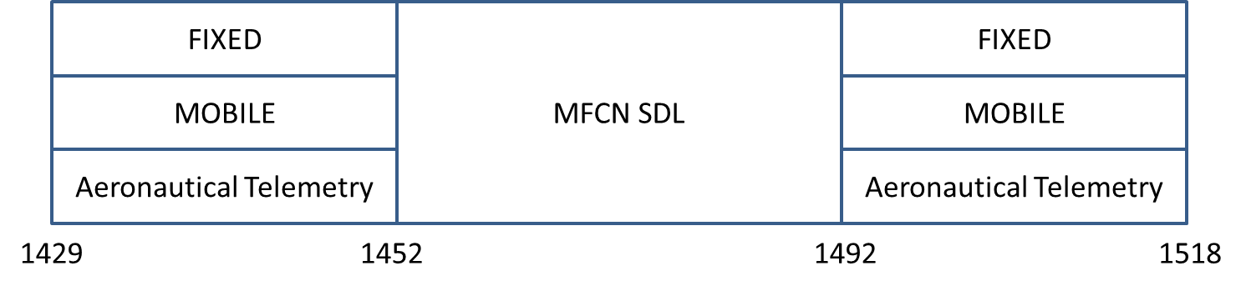
Figure 1: Services in bands adjacent to 1452-1492 MHz

Out-of-band compatibility scenarios
In line with the frequency usage shown in the Figure 1, the three following scenarios are considered in this Report:
- MFCN SDL in 1452-1492 MHz vs. Fixed service below 1452 MHz and above 1492 MHz;
- MFCN SDL in 1452-1492 MHz vs. Mobile service below 1452 MHz and above 1492 MHz;
- MFCN SDL in 1452-1492 MHz vs. Aeronautical Telemetry below 1452 MHz and above 1492 MHz.
The results of the studies are presented in Section 4.

Proposed Out-of-band (OoB) emissions for MFCN SDL operating in 1452-1492 MHz are derived from these compatibility studies and summarised in Section 5.

Fixed Service Characteristics
The Fixed Service operates with primary status in 1429-1452 MHz and in 1492-1518 MHz. Fixed services are mainly located in rural areas, with a typical antenna height of 20 m.
Table 4: Coordinated fixed links characteristics
Parameter | Value
Antenna Height | 20 m
Bandwidth | 1 MHz
Receiver noise level | -110 dBm/MHz
Target Interference to Noise Ratio | -6 dB
Blocking Response | BR1 = 25 dB  BR2-5 = 50 dB  BR>5 = 55 dB
Antenna (Option 1) | Type: Yagi  D = 0.5 m  G_{max}= 13 dBi  G₁= 1 dBi
Antenna (Option 2) | Type: Dish  D = 2 m  G_{max} = 30 dBi  G₁ = 14 dBi

Figure 2 shows the antenna radiation patterns for both antennas derived from Recommendation ITU-R F.1245 [9], corresponding to the antenna considered in ECC Report 121 [4].

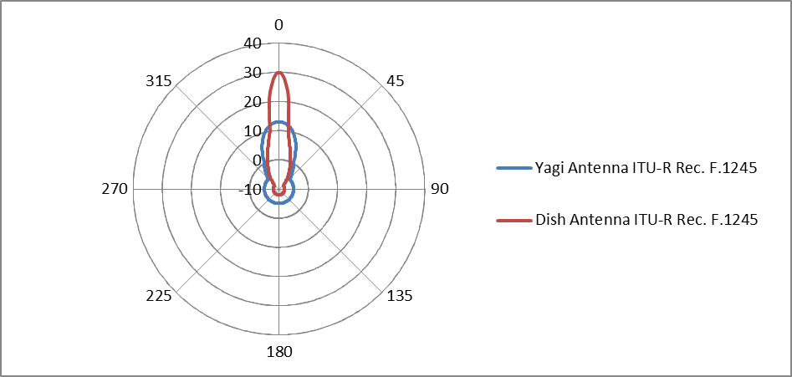
Figure 2: FS antenna patterns derived from ITU-R Rec. F. 1245

Table 5: Uncoordinated fixed links characteristics
Parameter | Value
Antenna Height | 20 m
Bandwidth | 1 MHz³
Receiver noise level | -110 dBm/MHz⁴
Target Interference to Noise Ratio | -20 dB
Blocking Response | BR1 = 25 dB  BR2-5 = 55 dB  BR>5 = 60 dB
Antenna | Type: Dish (mesh reflector)  D = 1.2 m  G_{max} = 20.5 dBi
Minimum distance to the MFCN BS | 250 m

According to the ITU-R Radio Regulations, the Fixed Service is provided between two specified points:
1.20 fixed service: A radiocommunication service between specified fixed points.
Furthermore, any new station in an adjacent band should ensure that existing stations are not interfered by the new station:
4.3 Any new assignment or any change of frequency or other basic characteristic of an existing assignment (see Appendix 4) shall be made in such a way as to avoid causing harmful interference to services rendered by stations using frequencies assigned in accordance with the Table of Frequency Allocations in this Chapter and the other provisions of these Regulations, the characteristics of which assignments are recorded in the Master International Frequency Register.
Therefore, new MFCN SDL deployment should ensure that they do not create interference to existing Fixed Links, which operate at specified fixed points. In such a scenario, it is possible to coordinate the deployment of new MFCN SDL Base Stations with existing Fixed Links station. Such coordination implies that a specific study, taking into account all actual field parameters and mitigation techniques would be conducted when MFCN SDL base station deployment is planned below a given ‘coordination distance’ from an existing Fixed Link station. In such a scenario, referred to as ‘coordinated fixed links’ in this report, the parameters adopted for studies are provided in Table 4.
However, Fixed Links may operate in some countries in an uncoordinated manner, which means that these links do not have specific operation locations. In those countries where this would be the case, MFCN SDL base stations in 1452-1492 MHz must not create harmful interference to any existing or future fixed links stations in adjacent band, under any deployment configuration (e.g. main beam to main beam). For such a scenario, referred to as ‘uncoordinated fixed links’ in this report, the parameters adopted for studies are provided in Table 5.

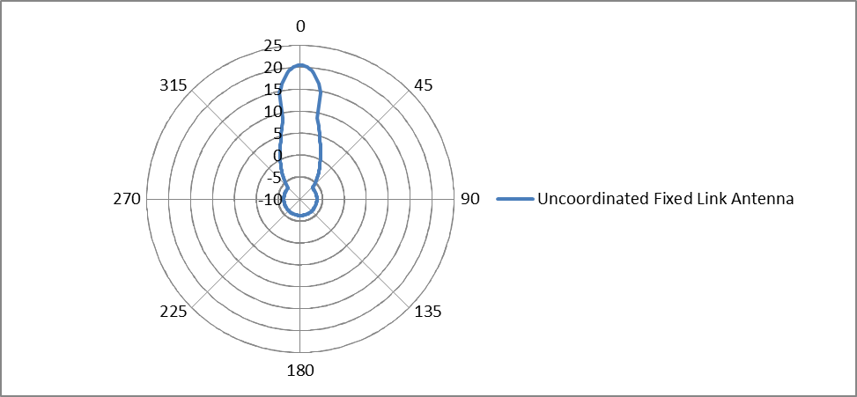
Figure 3: Antenna pattern for uncoordinated Fixed Links

Mobile Service
According to footnote EU15A of the European Common Allocation table, the use of the bands 1429-1452 MHz and 1492-1518 MHz by the mobile service is limited to tactical radio relay applications.
Table 6: Tactical Radio Relay (TRR)
Parameter | Value
Antenna Height | 10 m
Bandwidth | 1.5 MHz
Receiver noise level | -105 dBm/1.5MHz
Target Interference to Noise Ratio | 0 dB
Blocking Response | BR1 = 27 dB  BR2 = 45 dB  BR3 = 70 dB
Antenna | Gain = 21 dBi  Pattern: see below
Feeder Loss | 4 dB

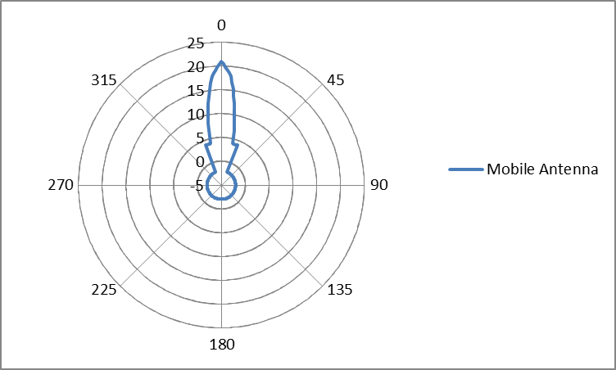
Figure 4: FS antenna patterns for Tactical Radio Relay, where Maximum Gain = 21 dBi

Aeronautical Telemetry characteristics
The deployment of aeronautical telemetry services is limited to some CEPT countries, in accordance with ITU Radio Regulation footnote 5.342. For the purpose of this Report, Aeronautical telemetry is limited to ground stations and considered appropriate parameters.

The characteristics in Table 7 are based on ECC Report 121 [4].
Table 7: Aeronautical Telemetry characteristics
Parameter | Value
Antenna Height | 50 m
Receiver noise level | -112 dBm/MHz
Protection criteria (I/N) | -3 dB
Antenna Gain | 41.2 dBi
Antenna Pattern | ITU-R M.1459
Elevation | 3 to 80 degrees

Figure 5: Aeronautical System Antenna Pattern given by Recommendation ITU-R M.1459

MFCN SDL characteristics
The proposed harmonised frequency arrangement is based on a block size of 5 MHz, resulting in the following 8 frequency blocks in 1452-1492 MHz (see Table 8). The channel width could be this block size or a multiple of it.

Table 8: Proposed harmonised frequency arrangement for MFCN SDL in 1452-1492 MHz
1452-1457 | 1457-1462 | 1462-1467 | 1467-1472 | 1472-1477 | 1477-1482 | 1482-1487 | 1487-1492
Downlink (base station transmit)
40 MHz (8 blocks of 5 MHz)

Table 9: Parameters for an MFCN SDL macro BS
Parameter | Value
In block e.i.r.p. | 68 dBm/5MHz
Out-of-block e.i.r.p. | 0 to +5 MHz from upper block edge: 16.3 dBm/5MHz  +5 to +10 MHz from upper block edge: 11 dBm/5MHz  0 to -5 MHz from lower block edge: 16.3 dBm/5MHz  -5 to -10 MHz from lower block edge: 11 dBm/5MHz  Remaining MFCN SDL frequencies: 9 dBm/5MHz
Antenna height | 45 m
Cell size (radius) | 8660 m
Horizontal antenna pattern | Omni directional
Vertical antenna pattern | 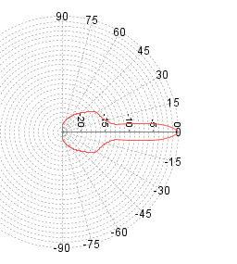  A down-tilt of 3° is assumed

compatibility studies

General considerations and target pathloss
The compatibility of fixed or nomadic stations with high gain antennas in adjacent bands can usually be ensured through a combination of separation distance, separation frequency, adequate coordination and good engineering practice. No technical solution can ensure coexistence under all circumstances.
The solution adopted to ensure coexistence will therefore vary depending on the scenario considered:
- For compatibility between MFCN SDL and coordinated Fixed Links, coordination would apply. A coordination distance is derived based on the generic parameters used for the studies.
- For those countries requesting compatibility between MFCN SDL and uncoordinated Fixed Links, MFCN SDL has to ensure general protection, independently from exact deployment configuration (e.g. separation distance, main beam to main beam scenario).
- For compatibility between MFCN SDL and Tactical Radio Relay, out of band emission levels are required as TRR are mobile systems. These out of band emissions are the basis for the proposed harmonized out of band emissions in the ECC Decision on MFCN SDL harmonisation in 1452-1492 MHz.
- Aeronautical telemetry systems and MFCN SDL will be deployed through coordination (frequency-territorial planning). A corresponding coordination distance to ensure co-existence between MFCN SDL and aeronautical telemetry stations in adjacent band is derived based on the generic parameters used for the studies.

MFCN SDL vs Fixed Services

Coordinated Fixed Links
For this approach it has been concluded to take the Out-of-Block values of the BEM also as Out-of-Band limits and to derive based on these assumed Out-of-Band limits the required coordination measures.

Identification of interference dominant factor
Table 10: Relative impact of out of band interference vs blocking, MFCN SDL vs Coordinated Fixed Links
Frequency considered | Out-of Band power | In-band power - BR | (In-band power – BR) - Out-of Band power
1492-1493 MHz | 9.3 dBm/MHz | 68+10xlog₁₀(1/5)-25 = 36 dBm | 26.7 dB
1493-1497 MHz | 9.3 dBm/MHz | 68-50 = 18 dBm | 8.7 dB
above 1497 MHz | 4.9 dBm/MHz | 68-55 = 13 dBm | 8.1 dB
1451-1452 MHz | 9.3 dBm/MHz | 68+10xlog₁₀(1/5)-25 = 36 dBm | 26.7 dB
1447-1451 MHz | 9.3 dBm/MHz | 68-50 = 18 dBm | 8.7 dB
below 1447 MHz | 4.9 dBm/MHz | 68-55 = 13 dBm | 8.1 dB

From Table 10 based on the assumptions listed above, it is clear that the dominant factor (for compatibility between coordinated Fixed Links and MFCN SDL Base Stations) is blocking, resulting from limited BR performance of the Fixed Link receiver.

MCL study
The coordination path loss can be defined as the path loss required between the MFCN SDL base station and the coordinated Fixed Link station in order to avoid interference when no coordination is in place. Under such coordination path loss, additional interference mitigation techniques should be adopted.
The coordination path loss can be derived as:
Coordination Path loss = 10 x log₁₀(10^(MFCN SDL in-band e.i.r.p. – FL BR)/10 + 10^(MFCN SDL OoB e.i.r.p.)/10)) - FL Receiver noise level - FL Target Interference to Noise Ratio + FL Antenna Gain
The coordination path loss is provided in Figure 6.

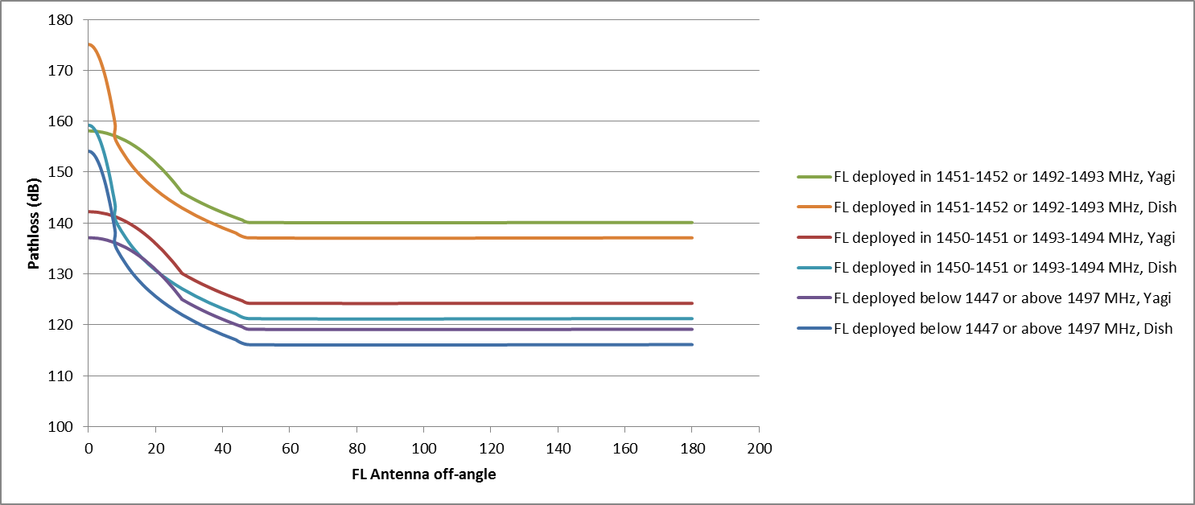
Figure 6: Path loss between MFCN SDL Base Station and Fixed Link Station
under which coordination is required
The MCL study indicates that avoiding Fixed Link deployment in 1451-1452 MHz and 1492-1493 MHz has a significant impact on the coordination pathloss, due to the large improvement of Fixed Link receiver selectivity from BR1 to BR2 (blocking remains the dominant interference factor even for BR2). Further Fixed Link deployment restrictions or MFCN SDL emission restrictions have limited impact on the results.
Finally, for MFCN SDL BSs/Fixed Links avoiding main beam to main beam scenarios, with Fixed Links deployment below 1451 MHz and above 1493 MHz, a coordination path loss of 130 dB, corresponding to a 8 km coordination distance, seems to be appropriate.

Uncoordinated Fixed Links

MCL study
For uncoordinated Fixed Links, the Fixed Link equipment, its position and its antenna alignment remain completely unknown. Therefore, the specific Out of Band emissions must ensure compatibility under the worst case scenario, i.e. main beam to main beam scenario with 250 m separation distance.
The e.i.r.p. emission limits are derived in Annex A3.1.
Taking into account the severe constraints in terms of in-band and out-of-band emissions limits that would be imposed on MFCN SDL to protect uncoordinated fixed links, it is proposed that those constraints would be considered as only applicable in those countries where such deployment is considered.

Study based on SEAMCAT simulations
An MFCN SDL system/network could be assumed as a system that will be deployed in a large area, for instance in the whole country. The system description of the MFCN SDL system provides a cell radius of 8.66 km which was used as maximum separation distance. The minimum distance is assumed as 250 m. It is also assumed that the operator of the uncoordinated fixed link is able to ensure that the antenna main beam of the system does not point with the maximum antenna gain to the antenna of the MFCN SDL BS.
The calculations were carried out in ANNEX 3: with SEAMCAT based on the methodology described in ANNEX 6: and the aforementioned parameters.
Table 11: Specific MFCN SDL Base station power limits for countries deploying uncoordinated Fixed Links in adjacent bands
Parameter | Value
Maximum OoB e.i.r.p. | -38.5 dBm/MHz
Maximum In-Band e.i.r.p.  1452-1457 MHz and 1487-1492 MHz | 11.8 dBm
Maximum In-Band e.i.r.p.  1457-1487 MHz | 20.2 dBm

MFCN SDL vs MOBILE SERVICES (TRR)

Compatibility study scenario
When studying the OoB emission requirements for SDL, it appears that the most appropriate case for the derivation of the MFCN SDL OoB emissions corresponds to a 3 MHz separation between the channel edges of the MFCN SDL and the TRR for two different reasons:
- The separation distances for a frequency separation lower than 3 MHz are very large compared to the MFCN SDL cell radius. This is further explained in Annex A4.2
- Below 3 MHz of separation, unwanted emissions from MFCN SDL are not the dominant interference factor. Blocking dominates the interference. This is further explained in Annex A4.1.
Therefore, the scenario studied thereafter will be MFCN SDL operating in 1452-1492 MHz and TRR operating below 1449 MHz or above 1495 MHz.

Criteria for derivation of out-of-band emissions
Under the scenario identified in section 4.3.1, MFCN SDL OoB will be derived to ensure that OoB emissions from SDL are not the dominant interference factor (blocking always remains the dominant interference factor). This corresponds to a situation where MFCN SDL OoB emissions are reduced to the point where further reduction would not improve the compatibility scenario.
The criteria for the study is that interference caused by OoB emissions is limited to 10 % of the interference power caused by blocking, which is equivalent to say that interference caused by OoB emissions remains 10 dB below the interference caused by blocking.

Studies and study results

MCL study
The separation path loss can be defined as the path loss required between the MFCN SDL base station and the TRR station in order to avoid interference. Under such separation path loss, additional interference mitigation techniques should be adopted.
The separation path loss can be derived as:
Separation Path loss = 10 x log₁₀(10^(MFCN SDL in-band e.i.r.p. – TRR BR)/10 + 10^(MFCN SDL OoB e.i.r.p. )/10)) - TRR Receiver noise level - TRR Target Interference to Noise Ratio + TRR Antenna Gain – Feeder Loss,
where MFCN SDL OoB e.i.r.p. is applied within the TRR receiver bandwidth (1.5 MHz).
The path loss required between the MFCN SDL base station and the TRR station in order to avoid interference is provided in Figure 7.

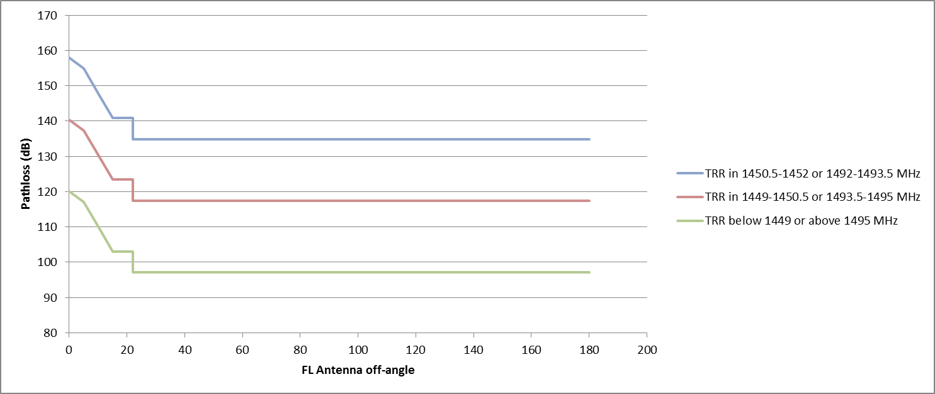
Figure 7: Path loss between MFCN SDL Base Station and TRR Station under which additional interference mitigation techniques are required
The adoption of OoB emission limits below 1449 MHz and above 1495 MHz ensured that blocking is always the dominant parameter and therefore an increase of the in-band power would have a direct effect on the coordination path loss. As such, MFCN SDL BS in-block e.i.r.p. should be restricted to 68 dBm, except for specific cases where co-existence with TRR in adjacent bands is not required.
The separation path loss is always less than the coordination path loss for T-DAB due to the lower in-band e.i.r.p. for MFCN SDL compared to T-DAB. In particular, assuming TRR are deployed below 1449 MHz or above 1495 MHz, a separation path loss of 120/97 dB is required for respectively main beam and back lobe of the TRR antenna. 120 dB corresponds to 16 km in free space path loss and less than 3 km for ITU-R Rec. P. 1546, 50 %. 97 dB corresponds to 1100 m for free space path loss.

Statistical and SEAMCAT study
Assuming that the additional isolation from Table 30 is met (i.e. assuming I_{total} ≈ I_{Out-of-band}), the impact of SDL BS networks on TRR receiver in rural environment is calculated, in term of probability of interference.

As a guidance of the studies, additional information is given, referring to deployments issues:
- minimum distance between SDL BS and TRR Rx when deploying the TRR devices, denoted d_{min}=1 km, specifically defined by the TRR devices,
- maximum distance between SDL BS and TRR Rx when deploying the TRR devices, denoted d_{max}=cell range, specifically defined by the size of the SDL networks (2h or R, see ANNEX 4.2.2).
Considering that Probability of an event A happens is denoted P(A),

We then have: P(Interference) ≈ P(Interference ML-ML)+P(Interference ML-SL)+P(Interference ML-BL).

We know that: P(ML-ML)=$\frac{Min(main_lobe(TRR),main_lobe(SDL))}{2π}$ ≈ 2.8 %
P(ML-SL)=$\frac{Min(side_lobe(TRR),side_lobe(SDL))}{2π}$ ≈ 9.4 %
P(ML-BL)=$\frac{Min(back_lobe(TRR),back_lobe(SDL))}{2π}$≈ 50 %
Moreover, as a first approximation, we can assume a linear decreasing of P(ML-ML) and P(ML-SL) with increasing distance d(TRR-SDL) and describe the possible behavior of the P(Interference) in the following figure:

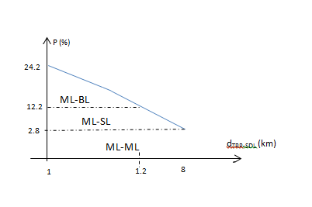
Figure 8: Probability that SDL BS interferes with TRR

By integration, we would obtain: Probability (Interference) = 8.6 %.
In addition, when running SEAMCAT with different settings, we refine the previous assumption on Probability (Interference) results:
Table 12: Probability of interference for different configurations
Interferer configuration | Random azimuth position  for SDL T_{x} | Fixed azimuth position  for SDL T_{x}
OFDMA Module | 6.5 % | 6.4 %
Generic Module | 8.8 % | 6.4 %

The statistical analysis shows that when TRR devices are considered under realistic deployment conditions (1-8 km away from MFCN SDL BS in Main Lobe-Main Lobe or Main Lobe-Side Lobe), with MFCN SDL OoB emission level of -16.8 dBm/MHz, there is a low probability that the TRR receiver is interfered (less than 8.6 %) by the MFCN SDL BS, when considering a frequency separation of two TRR channels (2 x 1.5 MHz = 3 MHz) between MFCN SDL BS and TRR receivers.
These results do not prevent the TRR devices from using a part or the whole of 3 MHz when appropriate TRR frequency and deployment planning is performed. For example, positioning TRR antenna back lobe to meet ML-BL configuration and add an obstacle between the BL of the TRR and the ML of the BS will reduce the path loss threshold as a consequence of the diffraction loss (20dB with appropriate height and distance from the TRR Receiver) so that d (TRR-SDL) = 6.5 km can be enabled with no TRR channel separation which ensures protection of these devices.

Proposed MFCN SDL in-band and OoB e.i.r.p. limits for protection of TRR
The studies performed in Section 4.3 ensure protection of TRR from MFCN SDL Base Station transmitting at 68 dBm. Depending on the bandwidth of the Base Stations, this corresponds to varying in-block e.i.r.p. requirements. Similarly to the recommendation provided by the ECC/DEC/(09)03 [10] , an administration may choose to specify an in-block e.i.r.p. limit for base stations. It should be noted that administrations may consider authorising higher in-block e.i.r.p. in specific circumstances, e.g. when compatibility with TRR is not required.
Additionally, it is proposed to adopt the MFCN SDL OoB e.i.r.p. limits defined in Table 13 for the protection of TRR.
Table 13: OoB e.i.r.p. limits for the MFCN SDL base station operating in the band 1452-1492 MHz for protection of TRR
Frequency range of  out-of-band emissions | Maximum mean  out-of-band e.i.r.p. | Measurement  Bandwidth
Below 1449 MHz | -20 dBm | 1 MHz
1449 -1452 MHz | 14 dBm | 3 MHz
1492 -1495 MHz | 14 dBm | 3 MHz
Above 1495 MHz | -20 dBm | 1 MHz

MFCN SDL vs telemetry

Limits of the study
As Blocking Response for Aeronautical Telemetry receivers is not available, the only effect taken into account is the effect of MFCN SDL out-of-band emissions. In the absence of BR values, it is not effective to impose general restrictions on the out-of-band emissions of MFCN SDL stations, as the main limitation may occur from the limited selectivity of aeronautical telemetry receivers.
Therefore, the appropriate approach is to derive a coordination distance under which interference mitigation from MFCN SDL into aeronautical telemetry will be required. The appropriate mitigation techniques can be assessed on a case by case basis.

MCL study
The coordination path loss can be defined as the path loss required between the MFCN SDL base station and the aeronautical telemetry station in order to avoid interference when no coordination is in place. Under such coordination path loss, additional interference mitigation techniques should be adopted.
The coordination path loss can be derived as:
Coordination Path Loss = MFCN SDL OoB e.i.r.p.- AeroT Receiver noise level - AeroT Target Interference to Noise Ratio + AeroT Antenna Gain
Under the worst case assumption, the uptilt of the aeronautical telemetry station is assumed equal to 3 degrees, i.e. the antenna gain is assumed to be equal to 25.5 dB.
Assuming MFCN SDL OoB emission limits derived in Section 4.3.4 , the coordination path loss is equal to 150 dB for protection of aeronautical telemetry stations deployed in 1449-1452 MHz and 1492-1495 MHz. This corresponds to a coordination distance up to 117 km for ITU-R Rec. P. 1546, for 10% of time and 50 % of locations.
Assuming MFCN SDL OoB emission limits derived in Section 4.3.4, the coordination path loss is equal to 121 dB for protection of aeronautical telemetry stations deployed below 1449 MHz or above 1495 MHz. This corresponds to a coordination distance up to 28 km for ITU-R Rec. P. 1546, for 10% of time and for 50 % of locations.

Conclusion

Recommendations for MFCN SDL deployment, including in-band and OOb emissions limits
Taking into account the compatibility studies, the following limits are proposed for the harmonised use of the band 1452-1492 MHz for MFCN SDL:
- The study is based on 68 dBm e.i.r.p in LTE system with 5 MHz channel plan
- Based on deployment requirements and on compatibility studies with Tactical Radio Relays, coordinated fixed links and/or aeronautical telemetry stations operating in adjacent bands, an administration could at national level restrict base stations in-band e.i.r.p. It should be noted that administrations may consider authorising in-block e.i.r.p other (i.e. higher) than 68 dBm dependent on specific circumstances. The recommended OoB emissions for the operation of MFCN SDL in 1452-1492 MHz are presented in the Table 14.
Table 14: OoB e.i.r.p. limits for the MFCN SDL base station operating in the band 1452-1492 MHz
Frequency range of  out-of-band emissions | Maximum mean  out-of-band e.i.r.p. | Measurement  Bandwidth
Below 1449 MHz | -20 dBm | 1 MHz
1449-1452 MHz | 14 dBm | 3 MHz
1492-1495 MHz | 14 dBm | 3 MHz
Above 1495 MHz | -20 dBm | 1 MHz
Compatibility between MFCN SDL and coordinated Fixed Links stations can be handled through coordination. Typical coordination distances are derived in the report.
Compatibility between MFCN SDL and Aeronautical Telemetry stations can be handled through coordination. Typical coordination distances are derived in the report.

specific in-band and Out-of-Band emissions Restrictions
For countries that may decide to pursue compatibility between MFCN SDL and uncoordinated Fixed Links, i.e. fixed links deployed in a fully un-coordinated manner in adjacent bands, the MFCN SDL in-band e.i.r.p. and OoB emissions restrictions in Table 15 and Table 16 can be adopted.
Table 15: MFCN SDL Base station in band e.i.r.p. limits for countries with uncoordinated Fixed Links in adjacent bands
Frequency range | Maximum mean e.i.r.p.
1452-1457 MHz | 11.8 dBm
1457-1487 MHz | 20.2 dBm
1487-1492 MHz | 11.8 dBm

Table 16: MFCN SDL Base station OoB e.i.r.p. limits for countries with uncoordinated Fixed Links in adjacent bands
Frequency range of  out-of-band emissions | Maximum mean  out-of-band e.i.r.p. | Measurement  Bandwidth
Below 1452 MHz | -38.5 dBm | 1 MHz
Above 1492 MHz | -38.5 dBm | 1 MHz

- Overview of studies performed in the ECC report 121
  - Out-of band compatibility in the frequency ranges 1429-1452 MHz and 1492-1518 MHz (examples of values are taken from the ECC Report 121)
Administration may need to consider the following when deploying MFCN SDL on their territory:
- To protect FS operating in the frequency range 1429-1452 MHz, the unwanted emissions defined in e.i.r.p of PWMS should not exceed -58 dBm in 200 kHz bandwidth;

- To protect FS operating in the band 1492-1518 MHz:
    - a separation distance of 15 km between the FS receiving station and the PWMS transmitter should be considered in a co-frequency situation;
    - MFCN SDL emissions at the frequency used by a FS receiver should not exceed -48dBm in 200 kHz for PWMS operating at a distance from the considered FS receiver lower than the separation distance (15 km).
- To protect ground stations in the Aeronautical Telemetry Service operating in the frequency range 1492-1535 MHz, separation distance of 28 km between aeronautical receivers and PWMS transmitter is required (see 5.342).
- 1494-1517.4 MHz, in this band the following restrictions are applicable:
  - To protect FS/Mobile/BSS operating below 1494 MHz, the unwanted emissions defined in e.i.r.p of PWMS in the frequency range 1479.5-1492 MHz MHz should not exceed -58 dBm in 600 kHz bandwidth
  - To protect Fixed/Mobile/MSS operating above 1518 MHz, the unwanted emissions defined in e.i.r.p of PWMS in the frequency range 1518 -1559 MHz should not exceed -48 dBm in 200 kHz bandwidth
  - IN-BAND COMPATIBILITY IN THE FREQUENCY RANGE 1452-1492 MHZ (EXAMPLES OF VALUES ARE TAKEN FROM THE ECC REPORT 121)
- 1479.5-1492 MHz, in this band the following restrictions are applicable:
    - to protect FS/BSS operating above 1479.5 MHz, the unwanted emissions defined in e.i.r.p of PWMS in the frequency range 1479.5-1492 MHz should not exceed -58 dBm in 600 kHz bandwidth.
Administration may need to consider the following when deploying MFCN SDL on their territory:
- To protect FS operating in the band 1452-1479 MHz:
  - a separation distance of 15 km between the FS receiving station and the PWMS transmitter should be considered in a co-frequency situation;
  - the PWMS emissions at the frequency used by a FS receiver should not exceed -48 dBm in 200 kHz for PWMS operating at a distance from the considered FS receiver lower than the separation distance (15 km);
- To protect stations in the Aeronautical Telemetry Service operating in the frequency range 1429-1492 MHz, separation distance of 36 km between aeronautical receivers and PWMS transmitter is required. In case of PWMS deployment on the territory of a neighbouring country this separation distance should not be less than 36 km to the national border (see 5.342 of Radio Regulations).

- MCL Analysis of coexistence between T-DAB in 1452-1492 MHz and other systems in adjacent bands
A Minimum Coupling Loss analysis of the coexistence between T-DAB and MFCN SDL is conducted in this Annex in order to derive the target path loss considered acceptable by the CEPT for the protection of Fixed Links and Tactical Radio Relays.
The parameters for the T-DAB stations are provided in the Table 17.
Table 17: T-DAB parameters for coexistence studies
Parameter | Value | Comment
e.i.r.p. | 70.25 dBm | Maastricht Special Arrangement Annex II, Section 5.3.4.  Reference power = 38.1 dBW
Bandwidth | 1.536 MHz | Maastricht Special Arrangement
Emission Mask |  | Maastricht Special Arrangement
Spurious Emissions | 70 dBc | ITU-R Rec. SM.329
Antenna height | 50 m | Maastricht Special Arrangement
Antenna Pattern | Omni-directional | Maastricht Special Arrangement

The integration of the T-DAB critical mask for intervals of 1MHz is provided in the Table 18
Table 18: Integration of T-DAB mask over 1MHz adjacent intervals
Frequency considered | e.i.r.p.
In-band e.i.r.p. | 68.4 dBm/MHz
[Fc+0.768 - Fc+1.768] | 31.1 dBm/MHz
[Fc+1.768 - Fc+2.768] | 8.7 dBm/MHz
[Fc+2.768 - Fc+3.768] | -2.5 dBm/MHz
[Fc+10 - Fc+11] | -1.6 dBm/MHz
[Fc-1.768 - Fc-0.768] | 31.1 dBm/MHz
[Fc-2.768 - Fc-1.768] | 8.7 dBm/MHz
[Fc-3.768 - Fc-2.768] | -2.5 dBm/MHz
[Fc-11 – Fc-10] | -1.6 dBm/MHz

The integration of the T-DAB critical mask for intervals of 1.5 MHz is provided in the Table 19.
Table 19: Integration of T-DAB mask over 1.5MHz adjacent intervals
Frequency considered | e.i.r.p.
In-band e.i.r.p. | 68.4 dBm/MHz
[Fc+0.768 - Fc+2.268] | 29.4 dBm/MHz
[Fc+2.268 - Fc+3.768] | -0.5 dBm/MHz
[Fc+3.768 - Fc+5.268] | -1.5 dBm/MHz
[Fc-2.268 - Fc-0.768] | 29.4 dBm/MHz
[Fc-3.768 - Fc-2.268] | -0.5 dBm/MHz
[Fc-5.268 - Fc-3.768] | -1.5 dBm/MHz

  - Results for T-DAB vs Coordinated Fixed Links
The assumptions from Table 4 are adopted in the section below.
    - Identification of interference dominant factor
Table 20: Relative impact of out of band interference vs blocking, T-DAB vs Coordinated Fixed Links
Frequency considered | Out-of Band power | In-band power - BR | (In-band power – BR) -  Out-of Band power
[Fc+0.768 - Fc+1.768] | 31.1 dBm/MHz | 43.4 dBm/MHz | 12.3 dB
[Fc+1.768 - Fc+2.768] | 8.7 dBm/MHz | 18.4 dBm/MHz | 9.7 dB
[Fc+2.768 - Fc+3.768] | -2.5 dBm/MHz | 18.4 dBm/MHz | 20.8 dB
[Fc+10 – Fc+11] | -1.6 dBm/MHz | 13.4 dBm/MHz | 15 dB
[Fc-1.768 - Fc-0.768] | 31.1 dBm/MHz | 43.4 dBm/MHz | 12.3 dB
[Fc-2.768 - Fc-1.768] | 8.7 dBm/MHz | 18.4 dBm/MHz | 9.7 dB
[Fc-3.768 - Fc-2.768] | -2.5 dBm/MHz | 18.4 dBm/MHz | 20.8 dB
[Fc-10 – Fc-11] | -1.6 dBm/MHz | 13.4 dBm/MHz | 15 dB

The critical interference factor is due to the limited BR of the fixed link receivers. In fact, the blocking is for any frequency 10 to 20 dB more constraining than the out-of-band emissions.
The blocking of fixed link receivers is the dominant interference factor.
    - Pathloss required to avoid interference
The pathloss required between the T-DAB station and the coordinated Fixed Link station in order to avoid interference is provided in Figure 9. Since Blocking is by far the dominant interference factor, frequency separations of 1 to 5 MHz do not improve the coexistence situation (since the BR does not improve until the 6th adjacent channel).

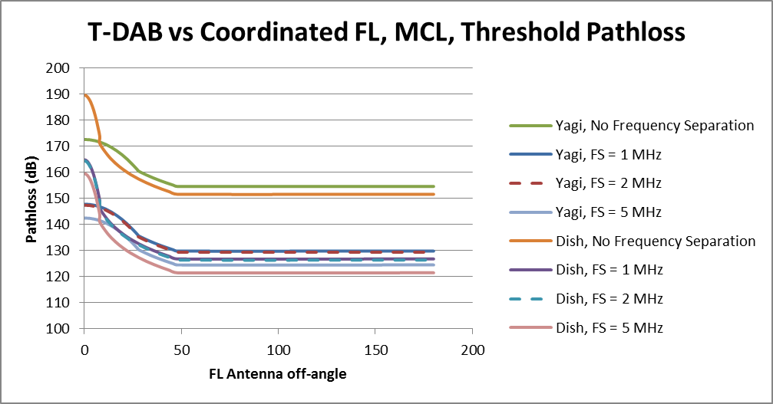
Figure 9: Threshold Pathloss for coexistence between T-DAB and Coordinated Fixed Link
    - Target Coordination Pathloss for SDL studies
For the SDL studies, taking a configuration with 1 MHz guard band and the case of a Yagi antenna with a 30 degree off-angle, a coordination pathloss of 135 dB should not be exceeded.
  - Results for T-DAB vs UNCoordinated Fixed Links
The assumptions from Table 5 are adopted in the section below.
    - Identification of interference dominant factor
Table 21: Relative impact of out of band interference vs blocking, T-DAB vs Coordinated Fixed Links
Frequency considered | Out-of Band power | In-band power - BR | (In-band power – BR) - Out-of Band power
[Fc+0.768 - Fc+1.768] | 31.1 dBm/MHz | 43.4 dBm/MHz | 12.3 dB
[Fc+1.768 - Fc+2.768] | 8.7 dBm/MHz | 13.4 dBm/MHz | 4.7 dB
[Fc+2.768 - Fc+3.768] | -2.5 dBm/MHz | 13.4 dBm/MHz | 15.8 dB
[Fc+10 – Fc+11] | -1.6 dBm/MHz | 8.4 dBm/MHz | 10 dB
[Fc-1.768 - Fc-0.768] | 31.1 dBm/MHz | 43.4 dBm/MHz | 12.3 dB
[Fc-2.768 - Fc-1.768] | 8.7 dBm/MHz | 13.4 dBm/MHz | 4.7 dB
[Fc-3.768 - Fc-2.768] | -2.5 dBm/MHz | 13.4 dBm/MHz | 15.8 dB
[Fc-10 – Fc-11] | -1.6 dBm/MHz | 8.4 dBm/MHz | 10 dB

The critical interference factor is due to the limited BR of the fixed link receivers. In fact, the blocking is for any frequency 5 to 16 dB more constraining than the out-of-band emissions.
The blocking of fixed link receivers is the dominant interference factor.
    - Pathloss required to avoid interference
The pathloss required between the T-DAB station and the uncoordinated Fixed Link station in order to avoid interference is provided in Figure 10. Since Blocking is by far the dominant interference factor, frequency separations of 1 to 5 MHz do not improve the coexistence situation (since the BR does not improve until the 6th adjacent channel).

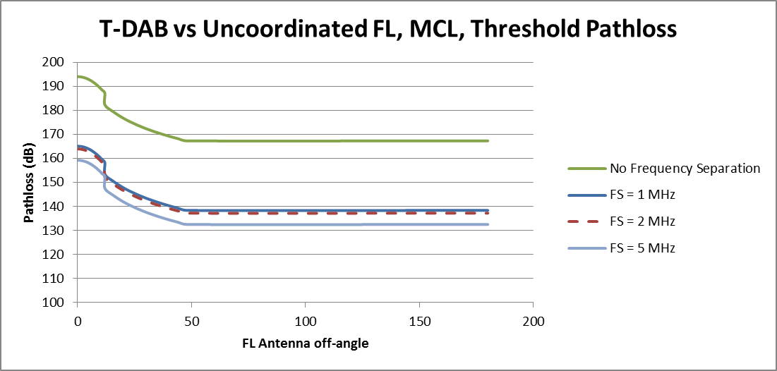
Figure 10: Threshold Pathloss for coexistence between T-DAB and Uncoordinated Fixed Link
The study indicates that pathloss of 194 dB is required for coexistence of T-DAB and uncoordinated Fixed Link in immediate frequency adjacency. Even with a large Frequency Separation, a pathloss superior to
160 dB is required for coexistence of T-DAB and uncoordinated Fixed Links.
  - RESULTS FOR T-DAB VS TACTICAL RADIO RELAYS
The assumptions from Table 6 are adopted in the section below.
    - Identification of interference dominant factor
Table 22: Relative impact of out of band interference vs blocking, T-DAB vs TRR
Frequency considered | Out-of Band power | In-band power - BR | (In-band power – BR) - Out-of Band power
[Fc+0.768 - Fc+2.268] | 29.4 dBm/MHz | 43.4 dBm/MHz | 14 dB
[Fc+2.268 - Fc+3.768] | -0.5 dBm/MHz | 18.4 dBm/MHz | 18.9 dB
[Fc+3.768 - Fc+5.268] | -1.5 dBm/MHz | -1.5 dBm/MHz | 0 dB
[Fc-2.268 - Fc-0.768] | 29.4 dBm/MHz | 43.4 dBm/MHz | 14 dB
[Fc-3.768 - Fc-2.268] | -0.5 dBm/MHz | 18.4 dBm/MHz | 18.9 dB
[Fc-5.268 - Fc-3.768] | -1.5 dBm/MHz | 1.5 dBm/MHz | 0 dB

The dominant factor is the blocking for frequency separation of 1.5 and 3 MHz. For frequency separation higher than 3 MHz, blocking and out-of-band emissions contribute equally to the risk of interference.
    - Pathloss required to avoid interference
The pathloss required between the T-DAB station and the TRR station in order to avoid interference is provided in Figure 11.

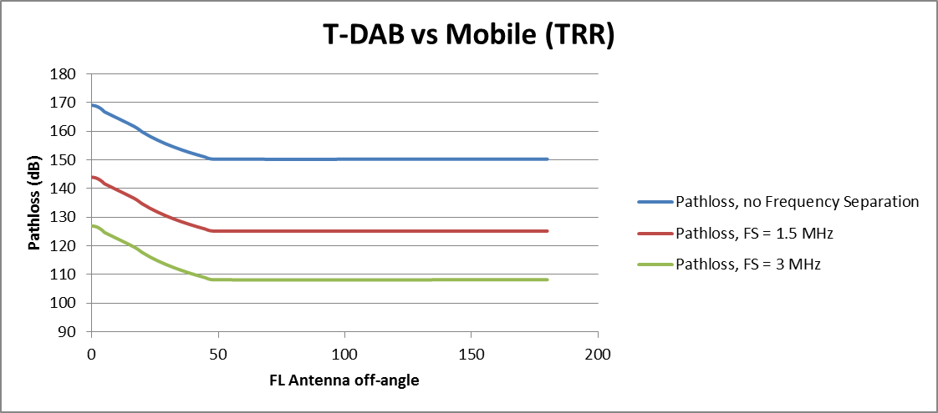
Figure 11: Threshold Pathloss for coexistence between T-DAB and Tactical Radio Relay
    - Reference Pathloss for SDL studies
For the SDL studies, taking a configuration with 3 MHz guardband and the case of an antenna with a 30 degree off-angle, the SDL should not create interference to TRR for a reference pathloss of 113.6 dB.
Therefore, the reference pathloss of 113.6 dB can be assumed for studies on the SDL base station out of band emissions.
  - RESULTS FOR T-DAB VS Aeronautical telemetry
The assumptions from Table 7 are adopted in the section below. In the absence of BR values for Aeronautical Telemetry systems, the analysis considers solely interference through out-of-band emissions but does not consider blocking.
    - Pathloss required to avoid interference
The pathloss required to avoid interference from T-DAB to Aeronautical Telemetry systems is provided in the Table 23.
Table 23: Coordination Pathloss, T-DAB vs Aeronautical Telemetry
Frequency considered | Coordination pathloss
[Fc+0.768 - Fc+1.768] | 171.7 dB
[Fc+1.768 - Fc+2.768] | 149.3 dB
[Fc+2.768 - Fc+3.768] | 138 dB
[Fc+10 – Fc+11] | 138 dB
[Fc-1.768 - Fc-0.768] | 171.7 dB
[Fc-2.768 - Fc-1.768] | 149.3 dB
[Fc-3.768 - Fc-2.768] | 138 dB
[Fc-10 – Fc-11] | 138 dB
    - Target Coordination Pathloss for SDL studies
For the SDL studies, taking a configuration with 3 MHz guardband, a coordination pathloss of 138 dB should not be exceeded.

- Uncoordinated Fixed Links studies
  - MCL study
    - Assumptions and study
For uncoordinated Fixed Links, the Fixed Link equipment, its position and its antenna alignment remain completely unknown. Therefore, the specific Out of Band emissions must ensure coexistence under the worst case scenario, i.e. main beam to main beam scenario with 250 m separation distance.
The MCL analysis provides a degree of freedom in accepting either blocking or out of band emission as the dominant interference factor. In the following, it is proposed to assume that blocking and out of band emission contribute equally to interference.
In such a scenario, the maximum MFCN SDL Base Station out of band e.i.r.p. can be derived as
Max MFCN SDL OoB e.i.r.p. = FL Receiver noise level + FL Target Interference to Noise Ratio - 3 dB - FL Antenna Gain + Pathloss (Free Space, 100 m),
where the factor 3 dB is resulting from the assumption of equal contribution from blocking and out of band interference.
Figure 12 provides the resulting maximum MFCN SDL Base Station out-of-band e.i.r.p. as a function of the Fixed Link antenna off angle.

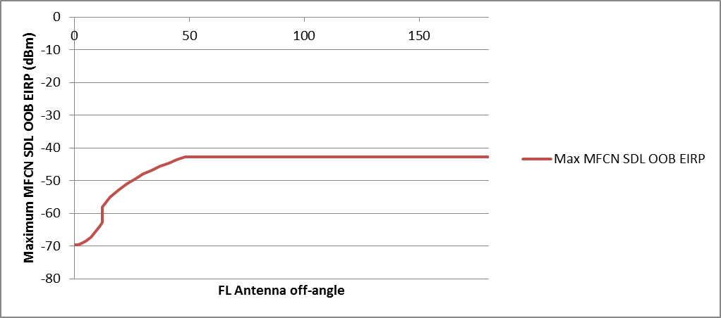
Figure 12: Maximum MFCN SDL Base Station Station out-of-band e.i.r.p. as a function of the Fixed Link antenna off angle, for MFCN SDL vs uncoordinated Fixed Link scenario
Since the worst case scenario has to be considered, the maximum MFCN SDL Base Station out of band e.i.r.p. has to be selected as -70 dBm/MHz.
Furthermore, the maximum MFCN SDL Base Station in-band e.i.r.p. can be derived as:
Max MFCN SDL in-band e.i.r.p. = FL Receiver noise level + FL Target Interference to Noise Ratio + BR –
3 dB + FL Antenna Gain – Pathloss (Free Space, 100 m),
where the factor 3 is resulting from the assumption of equal contribution from blocking and out of band interference.
Figure 13 provides the resulting maximum MFCN SDL Base Station in-band e.i.r.p. as a function of the Fixed Link antenna off angle.

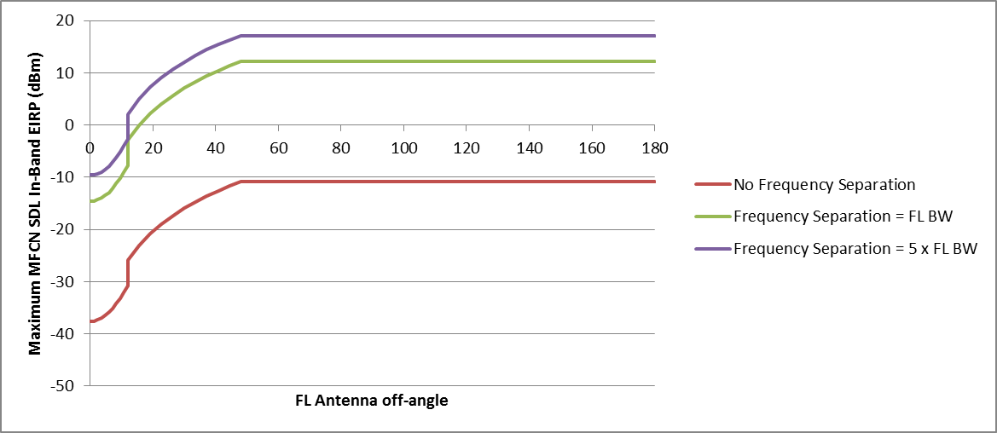
Figure 13: Maximum MFCN SDL Base Station in band e.i.r.p. as a function of
the Fixed Link antenna off angle, for various Frequency Separations,
for MFCN SDL vs uncoordinated Fixed Link scenario.
Since the worst case scenario has to be considered, the maximum MFCN SDL Base Station in band e.i.r.p. has to be selected as -38 dBm/MHz, -15 dBm/MHz and -10 dBm/MHz for respectively no Frequency Separation, a Frequency Separation equal to one bandwidth of the Fixed Link bandwidth and a Frequency Separation greater or equal to 5 times the Fixed Link bandwidth.
    - Resulting specific MFCN SDL e.i.r.p. limits
Taking into account the severe constraints in terms of in-band and out-of-band emissions limits that would be imposed on MFCN SDL to protect uncoordinated fixed links, it is proposed that those constraints would be considered as only applicable in the few specific countries where such deployment is considered.
Table 24: MCL analysis results for specific MFCN SDL Base station in band e.i.r.p. limits for countries deploying uncoordinated Fixed Links in adjacent bands
Frequency separation between  Fixed Links and MFCN SDL BS | Maximum mean in-band e.i.r.p. | Measurement  Bandwidth
No Frequency Separation | -38 dBm | MHz
Frequency Separation = 1 x Uncoordinated  Fixed Link bandwidth | -15 dBm | MHz
Frequency Separation = 2 x Uncoordinated  Fixed Link bandwidth | -10 dBm | MHz

Table 25: MCL analysis results for specific MFCN SDL Base station OoB e.i.r.p. limits out of the band 1452-1492 MHz for countries deploying uncoordinated Fixed Links in adjacent bands
Frequency range of  out-of-band emissions | Maximum mean  out-of-band e.i.r.p. | Measurement  Bandwidth
Below 1452 MHz | -70 dBm | MHz
Above 1492 MHz | -70 dBm | MHz

    - Discussion on specific MFCN SDL e.i.r.p. limits
The use of directional antennas above rooftop at any location pointing to any direction with low interference threshold results in extremely stringent requirements for systems in adjacent bands. Under such conditions, the band 1452-1492 MHz is practically unusable for any terrestrial system.
This result is compatible with the analysis of coexistence between uncoordinated Fixed Links and T-DAB systems, which indicate that pathloss of 191/161/156 dB would be required to avoid interference from a T-DAB station operating in 1452-1492 MHz and uncoordinated Fixed Links operating in adjacent bands with respectively no frequency separation, a frequency separation equal to 1 MHz, and Frequency Separations higher than 5 MHz. A pathloss of 191 dB corresponds to a separation distance of 56 000 km in Free Space and 90 km for Recommendation ITU-R P.1546 [11], for 50 % of time and 50 % of locations. A pathloss of 156 dB corresponds to a separation distance of 1000 km in Free Space and 27 km for Recommendation ITU-R Rec. P. 1546, for 50 % of time and 50 % of locations. This indicates that deployment of uncoordinated Fixed Links in a country is incompatible with the implementation of the Maastricht Special Arrangement for this country.
  - Study based on seamcat simulations
    - Antenna

The system uses as antenna a 1.2 m dish with a mesh reflector. This antenna type has a lower forward-back ratio as given in Recommendation ITU-R F.1245-2 [9]. Therefore, the max gain was corrected by -2.7 dB.

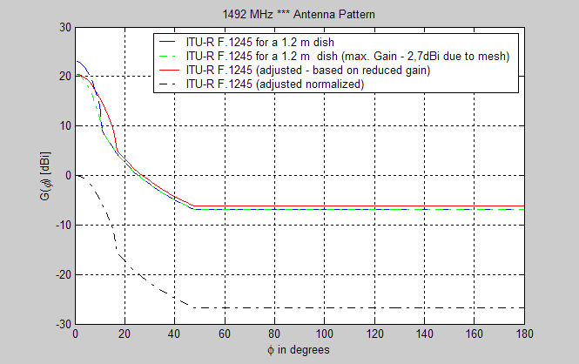
Figure 14: Antenna Pattern based on ITU-R F.1245-2 [9]

    - Geometric relationship of the scenario
An MFCN SDL system/network could be assumed as a system that will be deployed in a large area, for instance in the whole country. The system description of the MFCN SDL system provides a cell radius of 8.66 km which was used as maximum separation distance. The minimum distance is assumed as 250 m. It is also assumed that the uncoordinated fixed link is able to ensure that the antenna main beam of the system does not point with the maximum antenna gain to the antenna of the MFCN SDL BS.
The geometry is presented in the Figure 15 below.

MFCN SDL BS
Distance to compensate the maximum gain down to the side-lobe gain
Minimum distance
Maximum distance
Angle of first side-lobe
Victim system
Figure 15: Picture of the scenario

To enable SEAMCAT to perform the described behaviour of the victim system a post processing plug-in was used. The geometry, in this specific case is slightly different from the normal description of a scenario in SEAMCAT.
All interfering transmitters (MFCN SDL BS) are placed within the blue circle. After the calculation of all the snapshots, SEAMCAT deliver all the snapshots to the post processing plug-in. This plug-in creates an area within no interfering transmitter will be placed, this is the green circle. All transmitters in this area are taken away from the results (transmit power = -200 dBm).
The plug-in calculates the red marked (circle) distance as function of the maximum gain and the first side loop gain of the victim antenna. The interfering links located within the yellow area are modified in such a way that the victim antenna direction (angle between ILT and VLR) is randomly changed in the range between the side loop angles. This ensures that the victim antenna does not point with its maximum antenna gain to the interfering transmitter.
    - Results
The calculation was carried out with SEAMCAT based on the methodology described in ANNEX 6: and the aforementioned parameters. The allowed exceedance of the chosen limit is assumed as 1 %.

Table 26: SEAMCAT analysis results for specific MFCN SDL Base station e.i.r.p. limits for countries deploying uncoordinated Fixed Links in adjacent bands
 | I/N = -20 dB | I/N = -6 dB
Maximum OoB power | -38.5 dBm/MHz | -26.2 dBm/MHz
Maximum In-Band power  1452-1457MHz and 1487-1492 MHz | 11.8 dBm | 33.4 dBm
Maximum In-Band power  1457 – 1487 MHz | 20.2 dBm | 34 dBm

- Identification of compatibility scenario for MFCN SDL vs Mobile services (TRR) in adjacent band analysis
  - Considerations on interference dominant factor
Depending on the frequency range considered, the main interference could result from limited BR of the Tactical Radio Relay receiver or by the out-of-band emissions of the MFCN SDL Base Station transmitter.
Table 27: Relative impact of out of band interference vs blocking, MFCN SDL vs. Tactical Radio Relay
Frequency considered | Out-of Band power | In-band power - BR | (In-band power – BR) - Out-of Band power
1492-1493.5 | 9.3 dBm/MHz  11 dBm/1.5 MHz | 68+10xlog10(1.5/5)-27 = 36 dBm | 25 dB
1493.5-1495 | 9.3 dBm/MHz  11 dBm/1.5 MHz | 68-45 = 23 dBm | 12 dB
1495-1496.5 | 9.3 dBm/MHz  11 dBm/1.5 MHz | 68-70 = -2 dBm | -13 dB
1450.5 -1452 | 9.3 dBm/MHz  11 dBm/1.5 MHz | 68+10xlog10(1.5/5)-27 = 36 dBm | 25 dB
1449-1450.5 | 9.3 dBm/MHz  11 dBm/1.5 MHz | 68-45 = 23 dBm | 12 dB
1447.5-1449 | 9.3 dBm/MHz  11 dBm/1.5 MHz | 68-70 = -2 dBm | -13 dB

It is clear that the BR of the Tactical Radio Relay receiver (blocking) is the dominant factor for TRR equipment deployed in 1492-1495 MHz and 1449-1452 MHz. Conversely, out-of-band emissions are the dominant factor for TRR equipment deployed below 1449 MHz and above 1495 MHz.
The compatibility study aims at deriving an OoB emission level that will be applied generally in order to ensure that compatibility issues are restricted to a few extreme cases. Therefore, the analysis should focus on the scenarios where a modification of the MFCN SDL OoB emission improves the coexistence scenario. As it is unlikely that TRR equipment can significantly improve their BR, the analysis should focus on the scenario where TRR is deployed below 1449 MHz or above 1495 MHz.
  - Considerations on required separation distance
    - REQUIRED PROTECTION PATHLOSS AND SEPARATION DISTANCE
Emission restrictions are adopted to ensure coexistence between TRR and SDL applications when the appropriate pathloss between the interferer and the receiver is required. Additional mitigation techniques are required when such pathloss is not available.
In order to determine the target pathloss that is acceptable, the compatibility between SDL and Tactical Radio Relays requires to address InChannelTRR (from the Unwanted emissions) & Out-of-bandTRR interference (from the Unwanted emissions and Receiver Response) issues:
- InChannelTRR Interference:
Pathloss Threshold =OOBlock e.i.r.p.+Gr-Pfr-10log10(BTRR/BSDL)-Pthreshold
- Out-of-bandTRR Interference:
Pathloss Threshold =InBlock e.i.r.p.+Gr-Pfr-BRi-Pthreshold,

where:
- BRi: BR within the ith TRR adjacent channel
- BTRR : TRR bandwidth (MHz)
- BSDL: MFCN SDL bandwidth (MHz)
- Gr : TRR receiver antenna gain (dB)
- Pfr : TRR feeder loss
- P threshold: level or TRR threshold considered as a limit for MFCN SDL received signal (dBm)

In addition, the antenna positioning of SDL Base Station (BS) Tx and TRR Rx lead to:
- Main Lobe to Main Lobe (ML-ML)
- Main Lobe to Side Lobe (ML-SL)
- Main Lobe to Back Lobe (ML-BL) configurations.
Finally, MFCN SDL BS (Tx) and TRR (Rx) which are facing each other may be frequency adjacent (No Frequency separation from channel edge to channel edge) or have a frequency separation (1 TRR channel, 2 TRR channels).
These pathloss (see the figure below) ensure that MFCN SDL Base Stations will provide the required protection for TRR receiver. From them, separation distances are then derived assuming a Hata propagation model between the SDL interferer and the TRR Rx.
Table 28: Pathloss threshold & separation distance between MFCN SDL BSs and TRR Links
Scenario |  | Pathloss Threshold (dB) |  |  | Separation distance (km)
 |  | ML-ML | ML-SL | ML-BL | ML-ML | ML-SL | ML-BL
InBand_{TRR} | No Frequency separation | 133.1 | 130.1 | 110.1 | 37 | 33 | 5.2
InBand_{TRR} | 1 TRR channel frequency separation (1.5 MHz) | 133.1 | 130.1 | 110.1 | 37 | 33 | 5.2
InBand_{TRR} | 2 TRR channels frequency separation (3 MHz) | 133.1 | 130.1 | 110.1 | 37 | 33 | 5.2
Out-of-band _{TRR} | No Frequency separation | 157.8 | 154.8 | 134.8 | 78 | 71 | 34
Out-of-band _{TRR} | 1 TRR channel frequency separation (1.5 MHz) | 139.8 | 136.8 | 116.8 | 42 | 37 | 11.1
Out-of-band _{TRR} | 2 TRR channels frequency separation (3 MHz) | 120 | 117 | 97 | 16 | 11.4 | 1.2

    - Comparison between required protection and practical isolation
In order to compare the required separation distance (calculated in the previous step) to the practical distance between the SDL BS and the TRR Rx. the knowledge of the deployment parameters of SDL networks is needed, especially the cell radius and the inter-site distance.
Figure 16: Network layout and cell radius definition

Cell Radius = R
Cell Range = h = $\frac{√3}{2}$R
BS to BS distance = 2h

If TRR main lobe faces SDL BS main lobe, the maximum distance between TRR & SDL is equal to 2h.

As a result:
d_{max}(ML-ML)=13.9 km & d_{max}(ML-SL,BL)=8km.

From Table 24 and considering that total Interference I_{tot}=I_{Inband}+I_{Out-of-Band},

We have the following expression: d_{separation Itot} ≥ max (d_{separation Inband}, d_{separation Out-of-band}) .

The table below displays the comparison between d_{max} and d_{separation Itot}.
Table 29: Comparison between targeted and practical protections
Scenario | Configuration | d_{separation Itot} (km) | d_{max} (km)
No frequency separation | ML-ML | ≥ 78 | 13.9
No frequency separation | ML-(SL,BL) | ≥ 71 | 8
1 TRR channel frequency separation | ML-ML | ≥ 42 | 13.9
1 TRR channel frequency separation | ML-(SL,BL) | ≥ 37 | 8
2 TRR channel frequency separation | ML-ML | ≥ 37 | 13.9
2 TRR channel frequency separation | ML-(SL,BL) | ≥ 33 | 8

    - Choice of scenario that enables the compatibility between TRR Rx and SDL BS
From the previous table, the required additional isolation results bring to the following comments:

- No Frequency separation: According to the Table 1 and Table 3, Out-of-bandTRR Interference needs to be reduced through higher d_{Separation Blocking} (than 74 km) or higher BR1 (BR1=27+42 > 6.28 dB). However that is not practically feasible with SDL networks d_{max} up to 13.9 km.
- 1 TRR channel frequency separation (1.5 MHz): According to the Table 1 and Table 3, Out-of-band_{TRR} Interference needs to be reduced through higher d_{separation} (than 42 km) or higher BR₂ (BR2=45+23 > 68 dB) . However that is not practically feasible with SDL networks d_{max} up to 13.9 km.
- 2 TRR channels frequency separation (3 MHz): According to the Table 1 and Table 3, we notice that d_{separation Out-of-band} is lower than d_{max}, for some case (ML-BL). Morevorer InBand_{TRR} Interference is higher than Out-of-band_{TRR} Interference. That means we need to reduce InBand_{TRR} interference down to a value that is neglectible towards the Blocking:
- since reducing the Out-of-band_{TRR} Interference requires to increase the separation distance or BR_{i} , that would not be practically (or would be roughly) feasible with SDL networks.
- so that the Total interference would be similar to the Out-of-band_{TRR} Interferencethat meet the protection conditions of the receiver.
From these comments, it appears that additional isolation could be applied to the Unwanted component for the 2 TRR channels frequency separation (3 MHz) scenario, so that Unwanted Interference <<Blocking Interference.
If we consider the following criterion: I_{InBand} < 5 % I_{Out-of-band} , we derive an supplementary isolation: 13 dB to apply to I_{InBand} (that is OoB emission). From Table 24, we finally derive the total additional isolation for unwanted component in both cases:

Table 30: Results for OoB emission limits
Scenario: 2 TRR channels frequency separation  (3 MHz) | ML-ML | ML-(SL,BL)
Additional isolation (dB) | 133.1-120+13=26.1 | 13.1+13=26.1
OoB e.i.r.p. emission level (dBm/MHz)  at the band edge of the TRR receiver | 9.3-26.1.5=-16.8 | 9.3-26.1=-16.8

Conclusion: when considering the 2 TRR channels frequency separation (3 MHz), if OoB e.i.r.p. emission level at the band edge of the TRR receiver is ≤ -16.8 dBm/MHz, the compatibility between TRR and SDL devices could be insured since d_{separation}<d_{max.}

As, I_{total} ≈ I_{Out-of-band} , d_{separation} values hardly changed:

Table 31: Separation distances to avoid interferences
Scenario: 2 TRR channels frequency separation  (3 MHz) | Separation distance (km)
Scenario: 2 TRR channels frequency separation  (3 MHz) | ML-ML | ML-SL | ML-BL
Blocking | 16 | 11.4 | 1.2
I_{Total} | 16.2 | 11.7 | 1.2

It means that for:
- d(TRR,SDL) ≥ 16.2 km, there is no interference
- 16.2 km > d(TRR,SDL) ≥ 11.7km, there is interference only within ML-ML configuration
- 16.2 km ≥ d(TRR,SDL) ≥ 1.2 km, there is interference within ML-ML & ML-SL configurations.

- Fixed Links Blocking Response
  - Preliminary
The blocking parameters of a standard are specified for specific values testing parameters which do not always correspond to typical operational values. In particular, blocking protection ratio values in Fixed Link standards are specified for desensitization values (e.g. I/N=-6 dB) which may not correspond to the desired protection criteria (e.g. I/N=-20 dB for uncoordinated Fixed Links). It is therefore sometimes necessary to translate the Blocking Protection Ratio defined by the standard for a desensitization D_{STANDARD} into the desired Blocking parameter for another desensitization D_{TARGET}. This can only be achieved by deriving the Blocking Response of the receiver for a given frequency offset and assume that it remains constant for the target desensitization.
The analysis in Section A5.3 is conducted for a standard that provides a protection ratio.
  - Definitions
Abbreviation | Explanation
Blocking Level | Maximum power (Maximum I_{OOB}) of an interfering signal outside of the in-band, for a given frequency offset between the wanted signal and the interfering signal, given in dBm
Blocking Response | Receiver filter attenuation of signals outside of receiver’s channel/band, given in dB. It is derived by the following equation: Blocking Response = I_{IB} - I_{OOB}
C_{STANDARD} | Wanted signal level defined by the standard for the blocking specification
D | Desensitization of the receiver in the presence of an interfering signal, given in dB. It corresponds to the ‘noise rise’ due to the interfering signal and is derived by the following equation in dB: D = 10.log10[(10^(N/10) + 10^(I_{IB}/10))] - N
D_{STANDARD} | Desensitization defined by the standard for the blocking specification
D_{TARGET} | Target desensitization for a specific interference study
I_{IB} | I_{OOB} in-band equivalent interfering signal
I_{IB-STANDARD} | I_{OOB-STANDARD} equivalent in-band interfering signal
I_{IB-TARGET} | I_{OOB-TARGET} equivalent in-band interfering signal
I_{OOB} | Interfering signal at the RF input of a receiver, outside of the receiver’s bandwidth.
I_{OOB-STANDARD} | Allowed power of an interfering blocking signal as specified by the standard (for D_{STANDARD}).
I_{OOB-TARGET} | Allowed power of an interfering blocking signal for D_{TARGET}.
N | Noise floor in a given Bandwidth, given in dBm. N is derived from the following equation in dB: 10.log10(k.T.BW) + NF, where k = Boltzmann constant, T = 290 K, BW = Bandwidth, NF = Noise figure
SENSITIVITY | Minimum power of the wanted signal defined by the standard for appropriate reception in the absence of interference

  - When a protection ratio is given by the standards
This is the case for EN 302 217-2-2 V2.0.0.
In ETSI EN 302 217-2-2, Table A-7, the C_{STANDARD} - I_{OOB-STANDARD} is specified in dB for a desensitization D_{STANDARD} of 1 dB (see Annex A in ETSI EN 302 217-2-2).
- Co-channel Interference, [C/I]_{Linear} = C – I = 23 dB,
- First adjacent channel, [C/I]_{Linear} ²²= C – I = 0 dB,
- Second adjacent channel, [C/I]_{Linear} ²²= C – I = -25 dB.
These are the “blocking protection ratios”.
    - Example of derivation
Let’s consider for instance a FL with 1MHz BW and the first adjacent channel.
From the requirement on co-channel interference, ETSI EN 302 217-2-2 states that Sensitivity = -88 dBm.
Furthermore, C-I = 23 dB for RSL degradation of 1 dB (equivalent to I – N = -6 dB). This is equivalent to say that C-N = +23 - 6 dB = +17 dB. Therefore, N = -87 dBm -17 dB = -104 dBm
Consider the first adjacent channel:
C_{STANDARD} | = | SENSITIVITY + D_{STANDARD}
 | = | -88 dBm + 1 dB
 | = | -87 dBm
I_{OOB-STANDARD} | = | C_{STANDARD} - Blocking Protection Ratio
 | = | -87 dBm - (0 dB)
 | = | -87 dBm
Blocking Response | = | N + 10.log10[10^(D_{STANDARD}/10) -1] - I_{OOB-STANDARD}
 | = | -104 -6 - (-87)
 | = | -23 dB

A graphical representation of the derivation is provided in Figure 17.

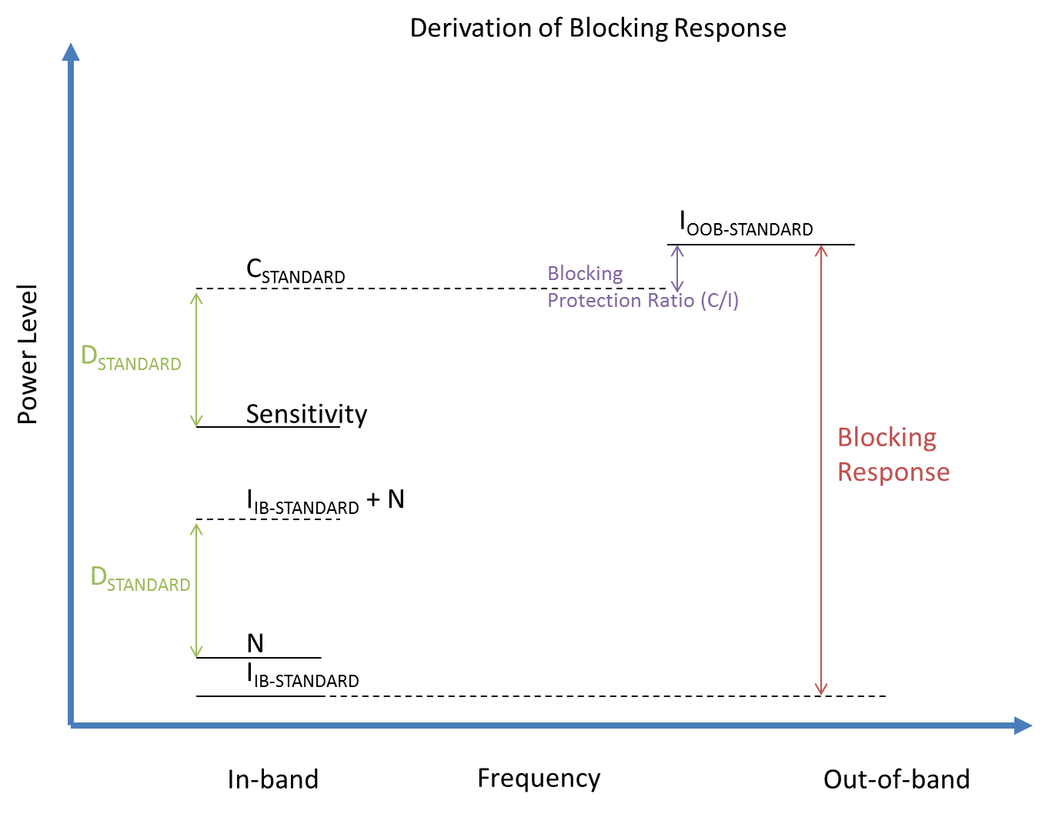
Figure 17: Derivation of the Blocking Response for standard providing a Blocking Protection Ratio
  - BR1 and BR2 Calculation based on [1]
The tests in Table A.7 of [1] for co-channel and adjacent channel interference sensitivity are considered. In all tests the bit error rate (BER) shall not exceed 10⁽⁻⁶⁾ for the parameters given in this table. This implies that the ratio of useful signal to interference is equal in all tests. In the tests, the received signal level is 1 dB above the reference sensitivity, i.e. hence,
with
; ;
where
denotes the ratio of signal to interference in the co-channel interference test and denotes the ratio of signal to interference in first adjacent channel interference test. This implies that:
A similar calculation for the second adjacent channel interference results in:
For class 4L equipment:
;
  - BR1 and BR2 Calculation based on [6]
The tests in Table 30 of for Adjacent and Non-Adjacent channel rejection are considered. In addition, we use the receiver SNR assumptions in Table 29 of [6]. In all tests the bit error rate (BER) shall not exceed 10⁽⁻⁶⁾ for the parameters given in Table 30. This implies that the ratio of useful signal to interference is equal in all tests. In the tests, the received signal level is 3 dB above the reference sensitivity, i.e. hence,
with
where denotes the ratio of signal to noise (SNR) in the reference channel and denotes the ratio of signal to interference in Adjacent channel rejection test. The test parameters result in the following relationships:
In Table 30 of [6], the tests are defined for 16-QAM-3/4 and 64-QAM-3/4. With the corresponding SNR from Table 29, we get following figures for BR1:
for 16-QAM and for 64-QAM
Similar calculations for the Non-Adjacent channel rejection result in:
for 16-QAM and for 64-QAM
  - BRn (n>2) estimation based on [7]
No test is defined in [1] and [6] which could be used for the calculation of BRn (n>2). The closest information for defining the "typical" BRn (n>2) for Fixed Radio Systems can be found in Annex F of [7] which defines a more realistic approach for the evaluation of receiver selectivity based on the specifications for blocking. In particular, Table F.4 presents a few examples which could be used for this purpose. The first row in this table is representative for Fixed Radio Systems with a channel size (CS) of 40 MHz, while the examples in the third and fourth rows of the table are representative of Fixed Radio Systems with a CS of 28 MHz. Irrespective of the CS of the Fixed Radio System considered, the BRn (n>2) is flat and depending on the CS, it is in the order of 67 dB to 74 dB. Therefore, by scaling the examples with respect to the CS, an average figure of 70 dB could be justified for the BRn (n>2) of the Fixed Radio Systems considered in this Report.
  - BRN (N>2) ESTIMATION
Fixed Links systems supporting 4QAM and 16QAM are deployed in the bands considered and are expected offer less performance in terms of BR capability than the examples in [3].
Therefore, the right values for the equipment under examination should be derived as follows:
- The asymptotic RX attenuation is basically derived from equation F.5 [3].
- The C/I co-channel is to be derived from Annex A of [1] and in average is 23 dB (4QAM systems), 30 dB (16 QAM systems)
- Blocking figures (CW interference) taken from in EN 301 390 [4] (generic standard for this purpose) is:
- Systems for CS ≤ 14 MHz, -20 dB for BRn (n = 3 …. 5)
-30 dB for BRn (n > 5)
- Systems CS >14 MHz -30 dB for BRn (n > 2) (not applicable to 1.5 GHz band)
Therefore, the BR results should be reduced to:
- BRn (n = 3, 4 and 5) 4QAM ~43 dB (but could be aligned to the 48 dB of BR2)
- BRn (n = 3, 4 and 5) 16QAM ~50 dB (but could be aligned to the 55 dB of BR2)
- BRn (n >5) 4QAM ~53 dB
- BRn (n > 5) 16QAM ~60 dB

- Using Seamcat for OOB calculations
  - General explanation
    - What is the OoB emission from the perspective of the interfered receiver?
Receivers do not know the terms wanted signal or unwanted emission in the OoB domain. All energy, collected by the receiver has an influence.
The wanted signal is the part of energy, needed to extract the information, known in terms of coding, signal shape, modulation and so on.
Unwanted emissions (including emissions in the OoB domain) are the part of the energy that has no additional effects to help the receiver to extract the needed information. Sometimes this part of energy (unwanted emissions) has a harmful impact to the decoding process. This energy is often radiated by another transmitter, not part of the link for the wanted connection.
These two parts are fully inside the bandwidth of the receiver and the receiver has no options to protect itself from the unwanted emissions.

P(f) [dB]
VLR (Blocking mask)
ILT (Emission mask)
VLT (Power)
f [MHz]
Received unwanted power [dB/MHz]

Figure 18: Wanted signal and Unwanted emissions
Following abbreviations are used in the annex: VLR (victim link receiver), ILT (interfering link transmitter), and VLT (victim link transmitter).

In order to define the unwanted emission power falling into the receiver bandwidth which will not be exceeding victim system protection requirements, one can consider the red shaded area as co-channel interference without any power outside the red (shaded) area.

P(f) [dB]
VLR (Blocking mask)
ILT (Emission mask)
VLT (Power)
f [MHz]
Figure 19: Simplification of coexistence analysis
The power, collected by the victim link receiver is in both cases the same, because the size of the red shaded area is in both cases the same. This approach has the advantage that the blocking effect is excluded.
    - Interference calculation made by SEAMCAT
After the calculation of all the snapshots, generated by SEAMCAT, the interference calculation could be done. The result is a percentage of exceedance of a given limit I/N, (N+I)/N, C/(I+N) and C/I, all this limits are mutually dependent. If all values are used correctly, the result in percentage of expedience is exactly the same for all criteria.
The resulting power received by the VLR is calculated for unwanted and blocking effects. For the unwanted effect the power received by the VLR falling in its bandwidth is calculated with equation:

$${iRSS}_{unwanted}=P+G_{e}+G_{r}-L$$

P = Transmit power of the ILT [dBm]
G_{e} = Antenna Gain of the ILT [dB]
G_{r} = Antenna Gain of the VLR [dB]
L = Path loss between ILT and VLR [dB]

A bandwidth correction is not done, if the receiver bandwidth is greater than or equal to the reference bandwidth of the ILT emission mask at a given frequency offset.

The values for the blocking mask are only relevant for the calculation of blocking.
SEAMCAT gives the option to investigate the influence of changing the radiated power of the ILT, based on the snapshots calculated and stored results (Calculation Mode: Translation). For this case the transmitter power is changed in a range and in a granularity given by the user.
  - Preparation of a Seamcat scenario
First of all the victim receiver must be defined as exact as possible, based on standards and if needed on some assumptions.
For this example a victim system with the parameters given in the table below was defined.

Table 32: Example of SEAMCAT Parameters for victim link receiver
Parameter | Unit | Value
Frequency | MHz | 1451.0
Noise Floor | dBm | -110
Sensitivity | dBm | -96.5
Bandwidth | kHz | 1000
I/N | dB | -20
Blocking mask  (for the calculation of iRSS_{unwanted} not needed | 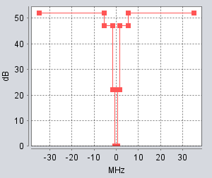

With the given parameters all interference criteria can be calculated as follows:

$${\left.\frac{C}{N+I}\right|}_{I=0dB}=\frac{C}{N}=Sensitivity - Noise Floor= 13.5 dB$$

Then we can calculate:

$$\frac{C}{I}=\frac{C}{N}+\left|\frac{I}{N}\right|= 33.5 dB$$

$$\frac{N+I}{N} =10∙log⁡\left({10}^{\frac{\left(\frac{I}{N}\right)}{10}}+1\right)= 0.04 dB$$

On the same frequency the substituted co-channel interferer is working. With the same bandwidth of 1 MHz, then the results are normalised to 1 MHz.
For the interfering transmitter (ILT) it is not necessary to have an exact value for the transmit power, because this value is changed in a range after the main calculation. The needed parameters are presented in the table below.
Table 33: Example of SEAMCAT Parameters for a interfering link transmitter
Parameter | Unit | Value
Frequency | MHz | 1451.0
Power | dBm | 0
Emissions mask | 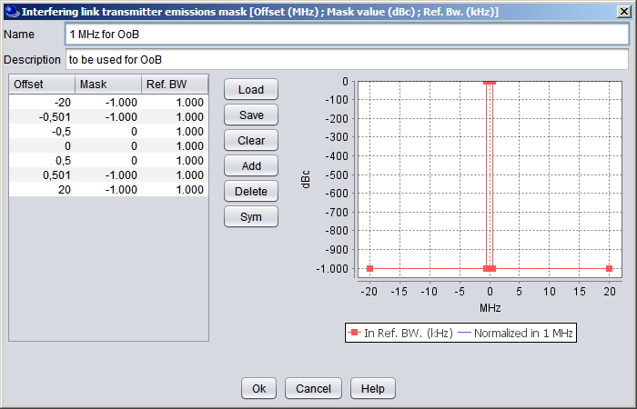

In this example scenario the VLR and the ILT are located in order to have a minimum protection distance of 250m and a maximum distance of 8.66 km these values could be correspond to typical distances in a real scenario. Free Space propagation Model without variation is used and both systems have an omnidirectional antenna.
The ILT is randomly placed in the area around the VLR.
The condition is fulfilled that received VLT power (dRSS) is constant and higher than the sensitivity of the VLR in order to take each snapshot into account in the calculation.
At each snapshot the ILT – VLR link is newly placed and the resulting power at the VLR is calculated.

  - What Seamcat calculates
The results are stored in the iRSS_{unwanted} vector and on the “Interference Calculations” panel, the user has the possibility to do some analyses of the results.

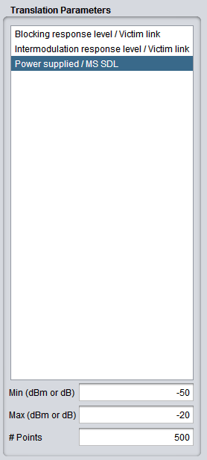
With the calculation mode “translation”, the user has the possibility to change the ILT power in a specific range and granularity.

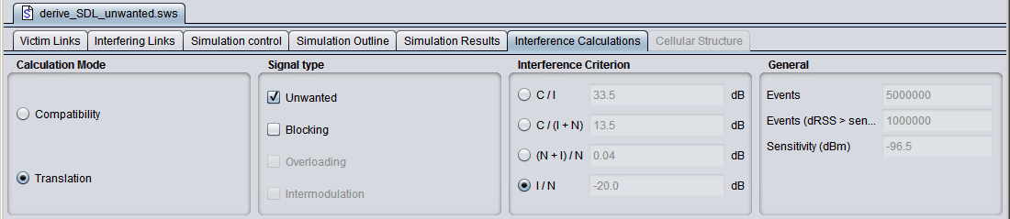
Then the user has the option to set the “Translation Parameters”.

If the user is calculating, for example, 10000 snapshots, each of them have one ILT – VLR link. In the unwanted vector (iRSS_{unwanted}) the resulting power at the VLR are stored for the initial parameters. These values are modified by the values given in range from min. to max. in “Translation Parameters”. For this example with a step size of 0.06 dB. For each step the new resulting percentage of exceedance is calculated and presented on a graph. For each step, the new power is given at the x-axis and the corresponding exceedance of the chosen limit at the y-axis.

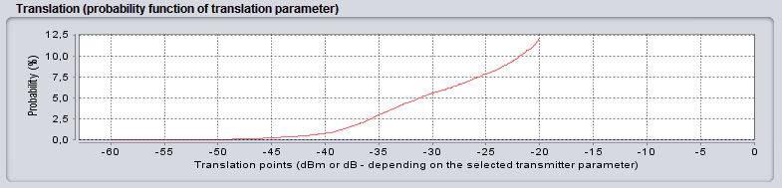

The user can now choose a percentage value that he is able to accept, for example 1%. Now, one is in the position to obtain the allowed power for 1% of exceedance from the graph below.

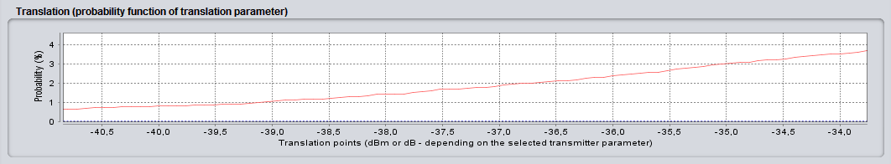

The result is the allowed OoB emission of -39 dBm/MHz e.i.r.p..

  - DISCUSSION
With SEAMCAT it is very easy to calculate the OoB emission limits for a new system if the parameters of the victim and the scenario are defined. The methodology was presented on a simple system and scenario, some additional things should be considered for a real study, for example the antenna pattern, placement of the victim and interfering links in the area, blocking mask parameters and others, if needed. This methodology is not a worst case situation, because the systems are not only placed on a minimum distance. If antenna pattern and directions are used, the random distribution allowing avoiding being in the direction of the other system with its maximum gain.
This is a more realistic situation than a calculation with the MCL methodology.

- List of references
- Maastricht, 2002 Special Arrangement on the CEPT Multi-lateral Meeting for the frequency band 1452-1479.5 MHz (MA02revCO07);
- ECC Decision (03)02 on the designation of the frequency band 1479.5 -1492 MHz for use by Satellite Digital Audio Broadcasting systems;
- ECC Report 188 on the future harmonised use of 1452-1492 MHz;
- ECC Report 121 on compatibility studies between professional wireless microphone systems (PWMS) and other services/systems in the bands 1452-1492 MHz, 1492-1530 MHz, 1533-1559 MHz also considering the services/systems in the adjacent bands (below 1452 MHz and above 1559 MHz);
- ETSI EN 302 217 V2.0.0 (2012-09), “Fixed Radio Systems; Characteristics and requirements for point-to-point equipment and antennas; Part 2-2: Digital systems operating in frequency bands where frequency co-ordination is applied; Harmonized EN covering the essential requirements of article 3.2 of the R&TTE Directive”.
- ETSI TS 102 177 V1.5.1 (2010-05), “HiperMAN; Physical (PHY) layer”.
- ETSI TR 101 854 V1.3.1 (2005-01), “Fixed Radio Systems; Point-to-point equipment; Derivation of receiver interference parameters useful for planning fixed service point-to-point systems operating different equipment classes and/or capacities”.
- ECC Decision (13)03 on the harmonised use of the frequency band 1452-1492 MHz for Mobile/Fixed Communications Networks Supplemental Downlink (MFCN SDL).
- Recommendation ITU-R F.1245 Mathematical model of average and related radiation patterns for line-of-sight point-to-point fixed wireless system antennas for use in certain coordination studies and interference assessment in the frequency range from 1 GHz to about 70 GHz
- ECC Decision (09)03 on harmonised conditions for Mobile/Fixed Communications Networks (MFCN)operating in the band 790-862 MHz
- Recommendation ITU-R P.1546 Method for point-to-area predictions for terrestrial services in the frequency range 30 MHz to 3 000 MHz

Fixed Links operating below 1452 or above 1492 MHz at specified fixed points
Fixed Links operating below 1452 or above 1492 MHz in an uncoordinated manner and not having specific operation locations
Rights of protection of services and international frequency co-ordination issues are covered by the relevant provisions of the Radio Regulations.
For the purpose of this Report, the e.i.r.p. is the total radiated power in any direction at a single location independent of any base station configuration.
The ECC has adopted on 8 November 2013 the ECC Decision (13)03 for use by Satellite Digital Audio Broadcasting systems [2].
Available in the band: 250 kHz to 3 MHz. Mostly used for BW ≥1 MHz. Source: ECC Report 121 and ITU-R Recommendation F. 758-5
ITU-R Recommendation F.1334 and ITU-R Recommendation F. 758-5
It should be noted that the FS protection criteria may be different from country to country.
Pattern from Recommendation ITU-R F.1245 [9], max gain is reduced by 2.7 dB
For coordination issues the provisions of the ITU RR 5.342 as well as of the Maastricht Special Arrangement 2002 as revised in Constanta 2007 should be applied.
Not taken into account in the derivation but useful for coordination.
Propagation model: ITU-R Rec P.1546 [11], for 50 % of time and 50% of locations
Including Blocking and Unwanted in the SEAMCAT tool
Without affecting the TRR link since it only impacts the back lobe of the TRR antenna beam
In order to avoid blocking of uncoordinated Fixed Links.
It should be noted that such criteria are usually only relevant when the application is effectively belonging to the fixed service. Some administrations may consider uncoordinated fixed links as fixed service, whereas other administrations may consider it as mobile service. For mobile service, the criteria may be different.
Corresponding to the 3dB aperture angle in the [-5°;5°] range for the TRR
Corresponding to the ]5°,22°[U]338°;355°[ range for the TRR
Corresponding to the [22°;338°] range for the TRR
Corresponds to the difference between out-of-band and in-band pathloss thresholds (see Table 28).
It does not preclude any interference issue. The next section (4) aims at assessing the impact of such conditions on interfering.
As I_{total} ≈I_{blocking} then d_{separation} ≈d_{separation Blocking}=(16;11.4;1.2) while d_{max}=(13.9;8;8).
It should be noted that the standard refers to C/Ia which is an equation in the linear domain, but specifies the value in dB, i.e. in the logarithmic domain.

