ECC Report 128

COMPATIBILITY STUDIES BETWEEN PSEUDOLITES AND SERVICES IN THE FREQUENCY BANDS
1164–1215, 1215–1300 and 1559–1610 MHz
Approved January 2009
Amended September 2012

Executive summary
Pseudolites (Pseudo satellites, PLs) are ground based radio transmitters that transmit a RNSS-like navigation signal. They are intended to be complementary to RNSS systems and transmit in the same frequency bands 1164-1215, 1215-1300 and 1559-1610 MHz as RNSS systems.
There are several other Radio Services and Radio Navigation Satellite Service itself that could be affected because of uncontrolled use of Pseudolites. Therefore it was decided to conduct compatibility studies between Pseudolites and services in the frequency bands 1164-1215, 1215-1300 and 1559-1610 MHz.
The purpose of this report is the study of the above mentioned co-existence and both indoor and outdoor pseudolites are covered. In sections 1 and 2 an introduction to pseudolites and definitions are given. Sections 3 overviews the pseudolites characteristics and section 4 explains the impact on non-participating RNSS receivers. In section 5 the impact of pseudolites to other radio services are provided and at last in section 6 some conclusions are drawn. More detailed information of the studies can be seen in relevant annexes of this report.
For information, the Excel workbook of the MCL calculations and the SEAMCAT files used for the calculations for the study are available in a zip-file at the www.ecodocdb.dk (ECO Documentation Area) next to this Report.
The main conclusions are presented also below:
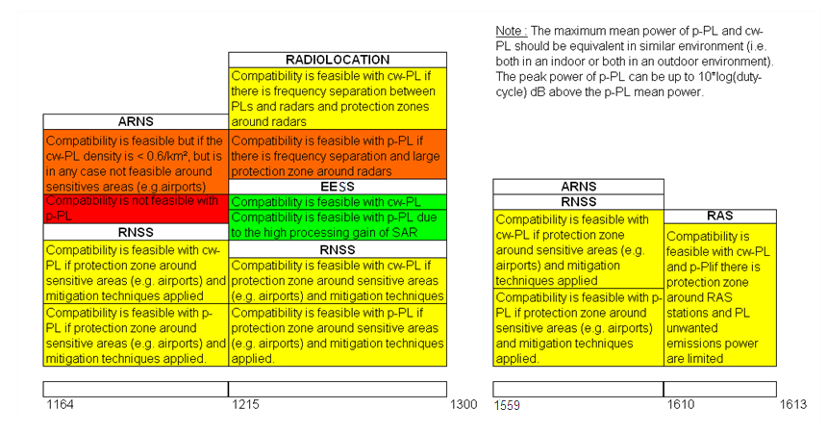

Note: In the Radio Regulations footnote 5.331 the band 1215-1300 MHz is also allocated to the radionavigation service on a primary basis in many CEPT countries.

TABLE OF CONTENTS

0 Executive summary 2
1 Introduction 6
2 Definitions 7
3 OVERVIEW AND CHARACTERISTICS OF PSEUDOLITES 8
3.1 Introduction 8
3.2 Application overview of pseudolites 8
3.3 Frequency band 9
3.4 The Near-Far problem 9
3.4.1 Frequency Offsets 10
3.4.2 Different PRN Codes 10
3.4.3 Signal Pulsing 10
3.4.3.1 RTCM SC-104 pulsing scheme 11
3.4.3.2 RTCA SC-159 pulsing scheme 11
3.4.3.3 Galileo pulsing schemes 11
3.5 Characteristics retained in the studies 11
4 Impact on non participating RNSS receivers 13
4.1 GNSS (Global Navigation Satellite Systems) RECEIVER characteristics 13
4.2 Mechanisms studied 13
4.2.1 Reception of non-expected PRN codes from the pseudolites 13
4.2.2 Near far effect 14
4.2.3 Noise level elevation 15
4.3 CW Pseudolite signal as an interferer in the 1559-1610 MHz band 15
4.3.1 Receiver tracking a satellite GNSS code from experimental pseudolite 16
4.3.2 Near-far effect 17
4.3.3 Noise level increase deterministic 18
4.3.4 Noise level increase using Statistical simulations conducted with SEAMCAT 19
4.3.5 Aggregated effect of pseudolites deployed in an indoor environment 20
4.3.5.1 Aeronautical case – maximum average PL density calculation 20
4.3.5.2 Noise elevation due to the multiple PL deployment in an airport 21
4.3.6 Analysis of the results for CW PLs operating in the 1559-1610 MHz band 24
4.3.6.1 Impact on RNSS receivers common to any method of PRN allocation (dedicated or non-dedicated) 24
4.3.6.2 In the case PLs don’t use dedicated PRN codes 24
4.4 CW Pseudolite signal as an interferer in the 1164-1215 MHz band 24
4.4.1 Receiver tracking satellite codes from pseudolites 24
4.4.2 Near-far effect 25
4.4.3 Noise level increase 26
4.4.4 Aggregated effect of pseudolites deployed in an indoor environment 27
4.4.4.1 Aeronautical case – maximum average PL density calculation 27
4.4.4.2 Noise elevation due to the multiple PL deployment in an airport 27
4.4.5 Analysis of the results for CW PLs operating in the 1164-1215 MHz band 28
4.4.5.1 Impact on RNSS receivers common to any method of PRN allocation (dedicated or non-dedicated) 28
4.4.5.2 In the case PLs don’t use dedicated PRN codes 28
4.5 CW Pseudolite signal as an interferer in the 1215-1300 MHz band 29
4.5.1 Receiver tracking satellite codes from pseudolites 29
4.5.2 Near-far effect 29
4.5.3 Noise level increase deterministic 30
4.5.4 Aggregated effect of pseudolites deployed in an indoor environment 30
4.5.4.1 Aeronautical case – maximum average PL density calculation 31
4.5.4.2 Noise elevation due to the multiple PL deployment in an airport 31
4.5.5 Analysis of the results for CW PLs operating in the 1215-1300 MHz band 32
4.5.5.1 Impact on RNSS receivers common to any method of PRN allocation (dedicated or non-dedicated) 32
4.5.5.2 In the case PLs don’t use dedicated PRN codes 32
4.6 Pulsed pseudolites 33
4.6.1 Aggregate interference effect of a network of pulsed pseudolites 35
4.6.1.1 Impact to non-aeronautical users in an outdoor environment 36
4.6.1.2 Impact on aeronautical receivers 38
4.6.2 Conclusions concerning pulsed pseudolites 38
5 Impact of pseudolites on other services 41
5.1 Aeronautical radio navigation Service (ARNS) 41
5.1.1 System overview of DME (ref. Federal Radionavigation Plan 1999) 41
5.1.2 Necessary technical parameters of the airborne DME receiver systems for the compatibility studies 41
5.1.3 Typical antenna pattern(s) of aircraft DME systems 42
5.1.4 Compatibility criteria 42
5.1.5 Results of studies 43
5.2 radio determination Service (rdS) 43
5.2.1 Overview of the Radio Determination Service (Recommendation ITU-R M.1463-1[11]) 43
5.2.2 Necessary technical parameters for the compatibility studies 44
5.2.3 Antenna pattern(s) of the RDS system 45
5.2.4 Compatibility criteria 45
5.2.5 Results of studies 45
5.3 earth exploration satellite service (eesS) 47
5.3.1 System overview of EESS (ref. Recommendation ITU-R RS.1166-3 [7]) 47
5.3.2 Necessary technical parameters for the compatibility studies (ref. Recommendation ITU-R RS.1347 [14]) 47
5.3.3 Typical antenna pattern(s) of the EESS system 47
5.3.4 Compatibility criteria (ref. Recommendation ITU-R RS.1166-3 [7]) 47
5.3.5 Results of studies 47
5.4 radio astronomy Service (RAS) 48
5.4.1 Single interferer case 51
5.4.2 Aggregation 52
5.4.3 Conclusions for the RAS 52
6 Conclusions 52
6.1 Band 1164-1215 MHz, RNSS 52
6.2 Band 1164-1215 MHz, ARNS 54
6.3 Band 1215-1300 MHz, RNSS 54
6.4 Band 1215-1300 MHz, RDS 56
6.5 Band 1215-1300 MHz, EESS 56
6.6 Band 1559-1610 MHz RNSS 57
6.7 RAS in the Adjacent Band 1610.6-1613.8 MHz 59
ANNEX 1: Comparison of measurement and composite loss model 60
ANNEX 2: IMPACT OF PSEUDOLITES ON ARNS 64
ANNEX 3: IMPACT OF PSEUDOLITES ON RDS 67
ANNEX 4: IMPACT OF PSEUDOLITES ON EESS 77
ANNEX 5: References 85

LIST OF ABBREVIATIONS

Abbreviation |  | Explanation
3GPP | 3rd Generation Partnership Project
A/D | Analog-to-Digital
AGC | Automatic Gain Control
ARNS | Aeronautical Radio Navigation Service
A-RNSS | Assisted RNSS
C/A | Coarse Acquisition
CEN | European Committee for Standardization
CENELEC | European Committee for Electrotechnical Standardization
CEPT | European Conference of Postal and Telecommunications Administrations
CW | Continuous Wave (radar)
DME | Distance Measuring Equipment
ECC | Electronic Communications Committee
EESS | Earth Exploration Satellite Service
e.i.r.p. | Effective Isotropic Radiated Power
ETSI | European Telecommunications Standards Institute
FDP | Fractional Degradation of Performance
GILT | Galileo Initiative for Local Technologies
GJU | Galileo Joint Undertaking
GNSS | Global Navigation Satellite Systems
GPS | Global Positioning System
JRC | Joint Research Center
LAAS | Local Area Augmentation System
LOS | Line of Sight
MCL | Minimum Coupling Loss
mEXPRESS | mobile in-EXhibition PRovision of Electronic Support Services
NLOS | Non Line of Sight
PFD | Power Flux Density
PL | Pseudolite (coined from "Pseudo (RNSS) Satellite)
PRN | Pseudo-Random Noise
RDS | Radio Determination Service
RLS | Radio Location System
RNSS | Radio Navigation Satellite Service (ITU)
SAR | Synthetic Aperture Radar
S/I | Signal to Interference Ratio
SIS | Signal in Space, i.e. transmissions from RNSS satellites
SNIR | Signal to Noise Plus Interference Ratio
VOR | VHF Omni-directional Range

Introduction
Pseudolites (Pseudo satellites, PLs) are ground based radio transmitters that transmit a RNSS-like navigation signal. It requires users to have modified RNSS-receivers to receive these signals. It is expected that these RNSS receivers have minor changes compared to today’s RNSS receivers and it is therefore possible to extend the satellite navigation technology to difficult environments like indoors with high accuracy and cost effectiveness.
Pseudolites are intended to be complementary to RNSS systems. To assure the best interoperability and compatibility with RNSS systems and to allow the technology to be used to its full potential, the frequency and regulatory issues need to be clarified.
The European Commission Committee 98/34 18th January 2007 Mandate addressed to CEN, CENELEC and ETSI is to Establish Space Industry Standards, which includes pseudolites.

Definitions
Term | Definition
Cold start | The RNSS receiver has no knowledge of at least one of the following with a precision good enough to determine which GNSS satellites are visible and which aren’t:  - Position  - Time  - Almanacs  As a consequence, every PRN is searched, and for each PRN, a full Code and Doppler search is made
Warm start (aided acquisition) | The RNSS receiver has a rough knowledge of position, and time, and knowledge of the almanacs, such that the receiver knows which the visible satellites are. As a consequence, the receiver will only search for the visible PRN, and there is only a limited number of Doppler bins to search, depending on the receiver clock quality wrt clock drift.
Hot start  Non participating RNSS receiver | Also called re-acquisition, or acquisition with PVT resolved. The receiver has resolved the PVT and the receiver clock drift with a high accuracy, and the receiver has knowledge of either the ephemerides or the almanacs. As a consequence, the receiver knows which are the visible satellites, and in which Doppler bin to search. The Doppler bin size and the number of code chips to search can be reduced so that the acquisition threshold is lowered and acquisition time is faster.  Hot start typically happens when 4 RNSS satellites are tracked and used to produce PVT and clock drift.  a RNSS receiver not designed to use pseudolite signals.
A-RNSS | Additional information is provided to the RNSS receiver by external means and allows an easiest acquisition by reducing the acquisition threshold.

OVERVIEW AND CHARACTERISTICS OF PSEUDOLITES

Introduction
Global Positioning System (GPS) providing Radio navigation Satellite Service has become commonplace among consumers and industrial users. The increasing importance of global positioning is highlighted by the decisions by the European Space Agency and the European Union to develop the Galileo and EGNOS systems. However, there are many difficult environments where positioning is needed, but where the current or planned global systems cannot provide the necessary accuracy or reliability due to degradation of visibility to the satellites. These environments include difficult geographic areas, urban canyons, large industrial facilities and indoor areas where consumers spend 95% of their time. Usable RNSS coverage is typically less than ~55% in urban areas and close to 0% indoors.
The lack of accurate and reliable GNSS signals in these environments makes it difficult to capture the most attractive benefits and business potential of positioning. Many new services would be made possible by extending the accuracy and coverage of global positioning to these difficult environments. Pseudolite technology is one possibility that can address these shortcomings by providing additional ranging signals and by improving geometry. To enable simultaneous reception of both satellite and pseudolite signals, interference issues must be carefully addressed.
Other methods of providing indoor location based positioning have been developed by the 3GPP community, whereby RNSS signals and supporting information to assist calculation of position are transmitted by the 3GPP networks - termed A-RNSS (Assisted-RNSS). Assisted RNSS technology uses the existing RNSS signals, without the need to provide additional terrestrial based RNSS like signals to aid positioning, and are targeted mainly for urban and (light) indoor situations, where coverage from the RNSS satellites is poor. A-RNSS receiver requires aiding information, which is provided through the 3GPP network transmissions, without this data they will not work well in environments where the satellites are significantly obscured. There are no additional RF transmissions from A-RNSS technology and therefore no compatibility issues to address. Pseudolites usage within the same indoor geographic areas as A-RNSS might, also require special consideration since A-RNSS might be a victim from the impact of pseudolites. These possible impacts are considered within this report. It is assumed in this report that A-RNSS will be used extensively by the mobile community for mass market access to location based services.

Application overview of pseudolites
Pseudolites are intended to improve the availability of positioning service in areas of challenging radio propagation such as indoors and, to a certain degree, urban canyons. RNSS satellites do not provide sufficient power flux density (PFD) to overcome major obstacles that attenuate the radio frequency wave front.
A wide variety of applications where pseudolite transmitters have been used in augmenting the GPS constellation have been exploited. Such applications can be:
- Machine control at mining sites
- Terrestrial deformation monitoring applications
- Positioning of goods and vehicles (also indoors)
- Improving signal coverage in cities with tall buildings
- Maritime applications e.g. Harbor.

A comprehensive summary of the pseudolite technology and applications can be found in e.g. Wang [1].
From the variety of applications three typical scenarios for PL-network architectures as shown can be derived, which form the basis for compatibility investigations:

Table 1: Generic Pseudolite scenarios
Scenario | Description | Service Area | e.i.r.p. | Remarks
A | Indoor | Building | Low (-50 dBm to -59 dBm) | PLs only  -50 dBm for the band 1559-1610MHz only-
B | Restricted propagation conditions | Urban canyon Several buildings | Low to high | PL and Signal in Space (SIS)
C | Combined reception over large Service Area | Airport services, Harbor | High (-30 to 11dBm) | PL and SIS

Frequency band
In this report, pseudolites are low power devices that operate co-frequency with the provision of RNSS signals from satellites in space (SIS). The primary allocations to RNSS are in the bands:
- 1164–1215 MHz (space-to-Earth)
- 1215–1300 MHz (space-to-Earth)
- 1559–1610 MHz (space-to-Earth)
- 5010–5030 MHz (space-to-Earth).

At the time the report was developed, there was no plan to use the band 5010-5030 MHz for pseudolites.
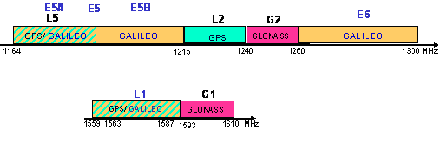
Figure 1: Frequency bands allocated to RNSS and their present use by RNSS-systems

The Near-Far problem
Because the RNSS satellites are far away and their antenna broadcast beam is shaped, the received RNSS signal power varies only slightly over the earth coverage (above 5° elevation angle). The PLs on the other hand are near-by and the PL received power varies with 20 log (R), where R is the range between the PL and the user’s receiving antenna. Thus, if the average PL received signal power is made to match that of the satellite at one range, it will dominate at another range while being too weak at yet another. The effect of this is that, unless carefully designed, the PL signal will act as a jammer to the satellite signals at short range and the PL signal will be too weak to be useful at long range.
The near-far problem highlights two major problems related to the pseudolite usage. First, the problem must be solved so that pseudolites can be utilized in practical applications. Secondly, any pseudolite signals must be carefully controlled so that receivers that are not part of the PL constellation are not disturbed or jammed by pseudolite signals.
In order to solve the near-far problem, three signal diversity options provide partial solutions – frequency offsets, optimization of the cross correlation between the codes and/or signal pulsing and/or waveform optimization. The use of all three options is possible.

Frequency Offsets
Frequency offsets can either be in-band or out-of-band. In-band offsets have the advantage that the same receiver front-end can be used, which minimizes inter-frequency biases when comparing PL measurements to satellite measurements. Out-of-band frequency offsets would usually require a different receiver front-end, which increases receiver cost and can create inter-frequency bias problems. However, this solution could eliminate PL interference to RNSS entirely and examples exist of bespoke PL systems proposing to use the 2.4GHz ISM band. Those are not considered in this report.

Different PRN Codes
The PL signal structure must be modified with respect to the SIS signal structure to minimize the interference to the RNSS signals. Using different PRN codes in a RNSS family of codes would minimize the impact on receiver design. For instance there are about 700 usable codes in the GPS C/A code family. There are also many usable wideband codes compatible with the GPS P-codes. Using a different code family should be avoided to minimize receiver design modifications. Longer codes or ones with higher chipping rates are desirable.
Typical mass market RNSS receivers will not be capable of interpreting pseudolite signals, unless these receivers are modified. For example, current GPS receivers (non-participating in the use of PL signals) use PRN codes 1-32 and this is designed into the software or firmware engines embedded into the GPS receiver chip sets. Indeed, current mass market GPS receivers rely on the published and agreed Signal Interface Standards of GPS. Redesigned software and firmware would need to be implemented to cater for any PL signals and be published and agreed as a standard.
However, the near-far problem cannot be solved using different PRN codes alone. There is not enough cross correlation margin between codes. If codes from the RNSS code family are used, the modification must also include provisions to minimize cross-correlation with the RNSS-codes.

Signal Pulsing
Signal pulsing is the most effective interference solution, using low-duty cycle, higher power pulses. This is because RNSS receivers are naturally robust against low-duty cycle pulsed interference. The PL signal only interferes the satellite signals when a pulse is present. The down side of low-duty cycle pulses is that PL signal reception is degraded by the square of the duty cycle, which dictates the PL peak power required for the desired radius of operation. Pulsing at low duty cycles is a necessity no matter what signal structure is chosen, unless larger frequency offsets are used.
However, because of the autocorrelation properties of the C/A code, very low-duty (less than 1%) cycles are not possible. The pulses must cover most of the code sequence during a reasonable receiver processing time interval. This becomes a problem when the number of PLs is increased: the aggregate duty cycle of pulsed signals grows and eventually causes harmful interference to non-participating receivers. Therefore the aggregate duty cycle of strong pulsed signals in a given area must be limited to protect non-participating receivers. Alternatively, it is possible to synchronize the pulses so that the aggregate duty cycle does not grow. The drawback of this solution is that the reception of the overlapping pulsed signals would be very difficult.
The aggregate duty cycle equals the sum of pulsed signals that are significantly stronger (peak power) than thermal noise level in the RNSS receiver. Only in this case the pulsed signals may saturate the receiver front-end. The interference caused by those pulsed signals that are weaker than this can be treated the same way as the interference caused by CW signals [5].
The interference caused by pseudolite signals below thermal noise level can be evaluated the same way as for CW signals (interference power level taken as the average power instead of peak power). In this case there are no saturation effects.

RTCM SC-104 pulsing scheme
The most commonly used pulsing scheme is the one defined by the RTCM-104 committee in 1986 [2]. This scheme defines 11 possible slots in a C/A code epoch. A pulse is transmitted in one of these slots during each epoch. As one C/A code epoch corresponds to 1023 chips during a period of 1 ms, each pulse transmission will be 93 chips or about 90.91 µs long. The active slots are defined by a fixed sequence which repeats every 200 ms, and as each 10th period two pulses are sent the average duty cycle sums up to 10%.
Most pseudolite work has been carried out using the RTCM-104 pulsing scheme. Some existing receivers are able to track the satellites and pseudolite signals simultaneously using this scheme. To reduce the average duty cycle the pulsing scheme can be modified by making the pulse lengths shorter and pulse duty cycles of 6-7% still provides reliable tracking by most existing receivers.

RTCA SC-159 pulsing scheme
The Special Committee SC-159 of RTCA proposed a pulsing scheme for the LAAS system in [3].
The pulse positions of RTCA are determined by the output of a shift register, which results in the pulses being more pseudo-randomly distributed compared to the RTCM scheme. The number of pulses within a given interval is therefore not constant. That means, for example, that more or less than one pulse can occur within the period of 1ms. Each pulse transmission will be 14 code chips, or about 13.69 µs long, and as the number of pulses in one second is 1997, the average pulse duty cycle can be derived as 2.733%.
The RTCA pulsing scheme causes difficulties for standard receivers. Most standard receivers have difficulties in acquiring such a signal, and once acquired the receivers tend to lose lock. These problems probably originate from the low duty cycle in combination with the long gaps between pulses. About 12% of the pulses are separated by a gap longer than 1ms and the longest gaps exceed 3ms.

Galileo pulsing schemes
Some research has been done on defining a pulsing scheme suitable for Galileo signals. In [4] several aspects of a new pulsing scheme are analyzed. However, more studies are needed before an optimal pulsing scheme for the Galileo signal can be defined.

Characteristics retained in the studies
It is assumed that following operational requirements have been established for PLs:
- all PLs in an area are controlled by the same entity.
- the PLs coverage for each scenario is limited to a maximum set radius
- that 1 to 6 PLs might be seen at any one location
- that the signals must be positively monitored.

The main technical parameters of the pseudolites used in this report are presented in table 2.
Table 2: Pseudolite parameters for the compatibility studies
Pseudolite system | Necessary bandwidth [MHz] | Tx power [dBm] | Duty cycle [%] | Additional losses,eg. indoor usage [dB] | Pseudolite antenna height [m] | Maximum antenna gain [dBi] | e.i.r.p. [dBm] (CW or during pulse) | Number of PLs | Usage area
Pseudolite; CW | 2- 10 | -70 | 100 | 0 | 10 | 11 | -59 | 4-6 | Outdoors
Pseudolite; CW | 2- 10 | -70/-61 ** | 100 | 8 dB * | 5-20 | 11 | -59/-50 ** | 6 | Indoors
Pseudolite; pulsed | 2- 10 | 0 | 7-10 | 0 | 10 | 11 | -30 to 11 | 1 | Outdoors
Pseudolite; pulsed | 2- 10 | 0 | 20-35 | 0 | 10 | 11 | -30 to 11 | 4-6 | Outdoors
* Indoor attenuation 8 dB taken from CEPT BWA buildings analysis report supporting ECC/DEC/(07)01 [17] for the band 1559-1610 MHz. Lower attenuation should be considered for RNSS bands with lower frequencies. It should also be noted that this figure cannot be assumed for all buildings, particularly if there are large apertures, windows etc.
** Limited to indoor pseudolites in the band 1559-1610 MHz.

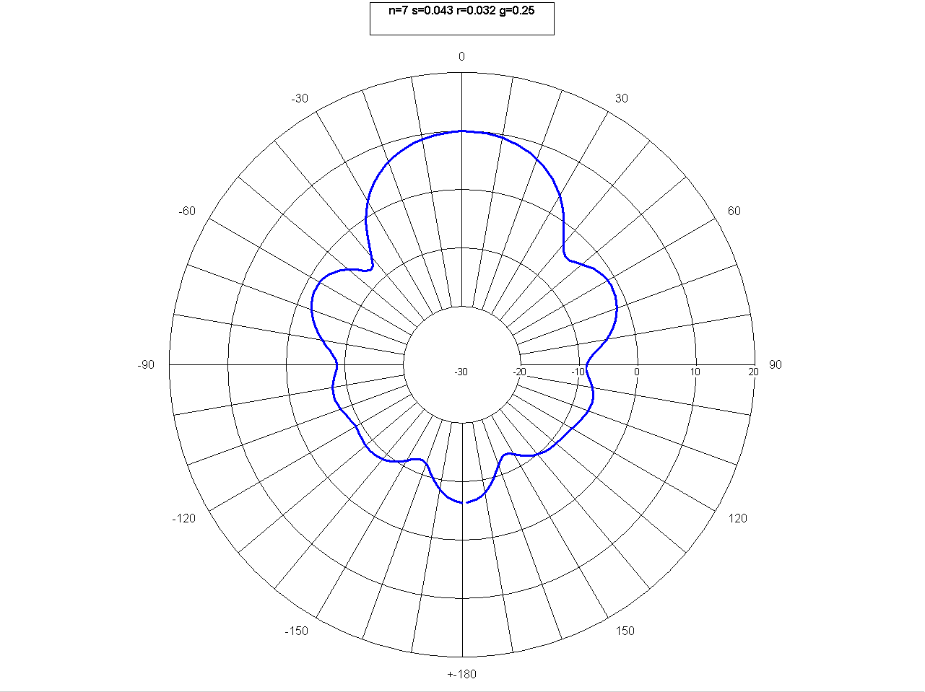

Figure 2: Typical horizontal antenna pattern of pseudolites

In this case a helix antenna is used and the vertical antenna pattern is symmetrical to the horizontal one.
When used indoors, the directional antenna can be tilted downwards such that at 0° elevation the gain will be reduced by 6dB
Other type of antenna (Omni directional) could be used.
Antenna optimization (shaping) should be made on a case by case study in order to reduce the e.i.r.p. in the upper hemisphere. e.i.r.p. towards several directions should be defined.

Impact on non participating RNSS receivers

GNSS (Global Navigation Satellite Systems) RECEIVER characteristics
Global Navigation Satellite Systems (GNSS) are navigation satellite systems that work under allocation of RNSS, and that provide positioning service with regional or global coverage. A GNSS allows small electronic receivers to determine their location (longitude, latitude, and altitude) within a few meters using time signals transmitted along a line of sight by radio from satellites.
When writing this report the GPS is the only fully operational GNSS. The GLONASS is a GNSS in a process of being restored to full operation. The European GALILEO positioning system is a next generation GNSS in the initial deployment phase, scheduled to be operational in 2015. There are also plans for other GNSSs in Asia. More detailed information on the RNSS systems may be found in relevant Recommendation ITU-R M series recommendations (e.g. Recommendation ITU-R M.1317 [9]).
The GPS and GALILEO systems are considered in this report.
Technical parameters as well as protection criteria may be found in the following ITU-R recommendations.
Table 3: Pseudolite parameters for the compatibility studies
Recommendation | Frequency band | Device | Title
M.1905 | 1164-1215 | User Rx | RNSS user receiver characteristics in 1164-1215 MHz band and their protection criteria.
M.1902 | 1215-1300 | User Rx | RNSS user receiver characteristics in 1215-1300 MHz band and their protection criteria.
M.1903 | 1559-1610 | User Rx | RNSS user receiver characteristics in 1559-1610 MHz band and their protection criteria.

Mechanisms studied
The non-participating receiver performance can be degraded in three different manners:
- the receiver receives PRN codes already allocated to another GNSS satellite which may degrade its performance
- the receiver is impacted (inter-correlation between codes) because of the near-far effect
- the receiver is saturated because of the increase in the noise level

Reception of non-expected PRN codes from the pseudolites
Reception of non-expected PRN codes from the pseudolites (i.e. satellite codes) is expected to be limited in time, from the cold start initialisation to the first fix if almanacs are present, and, if not, to the time when the almanacs have been decoded. However, this case is highly critical in terms of safety impact on non-participating receivers (especially aeronautical receivers).
If for example the PL transmits a PRN code of a visible satellite then any non-participating GNSS receiver may be caused to use this incorrect signal in its calculations. This particular case could occur when the pseudolites are designed to use codes from satellites on the other side of the earth and there is a failure of the pseudolites software management system. It is necessary to ensure that this event will never occur, with a set of measures to ensure this, including the implementation of a monitoring receiver outside the building that will constantly check that pseudolite transmit the correct PRN codes. This receiver may serve also for monitoring of disturbances potentially created by other systems in the RNSS band. The system will also have its internal monitoring functionalities and its processes for instantaneous execution of corrective actions.
Another example is the reception from a pseudolite of a PRN code used by a non-visible satellite. In that scenario, then any non-participating GNSS receiver may also be caused to use non expected data in its calculations:
- this is possible during a cold start if the received power is greater than the acquisition threshold,;
- this is less likely to happen when considering aided acquisition, but in any case the acquisition time may be increased
- this is unlikely to happen in case of acquisition with PVT (Position, Velocity and Time) resolved

However, if the PL uses dedicated codes, then it is impossible to cause a non-participating receiver to use the pseudolite transmitted data.
The consequences for a non-participating receiver for acquiring a PL signal equivalent to a non-visible satellite signal (same PRN code) are described below.
Some channels of the non-participating receivers are monopolized by the PLs signals and therefore, they are not available for acquiring and tracking useful signals. If several PLs are transmitting in the vicinity of the non-participating receiver, it may monopolize too many reception channels. Indeed, even if the non-participating receiver does not use the PL signal to determine its position, it may continue to track it in order to try demodulating its navigation message. In particular, during a cold start or aided acquisition, if the first signal acquired is a PL, the satellite signal acquisition will slow down.
In practice, a receiver often has 12 available reception channels for satellites among which 8 to 10 are generally used (at least 6 satellite signals are necessary to implement a Receiver Autonomous Integrity Monitoring (RAIM) function). Therefore, having 6 non-visible satellite codes used by PLs may leave only 6 reception channels for useful satellite signals which might have an impact on the RAIM function performance. This effect may not only exist during the acquisition mode. It may continue in the tracking mode even with PVT resolved. .
However, the usage of the measure performed with the PL signal in the navigation solution is almost impossible since some software checks exist at different levels in the receiver. In particular, the following measures can be taken:
- The PL navigation message has to be different from the satellite navigation message, and it must be guaranteed that the demodulation of the navigation signal will never give the parity bits supposed to validate the reading of the message.
- The health bits of the PL signal can be set as “not valid”
- No data bits are transmitted at all. Therefore, bit synchronization will not occur and the signal cannot be used by non-participating receiver for navigation purpose.

Finally, blocking of GNSS receiver channels by pseudolite signals may also result in a degradation of the Dilution Of Precision (DOP).
Therefore, in view of the unknown effect on all non-participating receiver designs associated with the use of non-visible satellite PRN codes by pseudolites, this method is not recommended for operational use. In other words, it is recommended that the pseudolites use different RNSS pseudorandom codes in their CDMA signal from those assigned to the provision of the other RNSS applications. It is assumed that a set of PRN can be found for these devices.

Near far effect
The near-far effect occurs when the PL signal level is significantly higher than the desired signal. It may lead to the acquisition and/or tracking of inter-correlation peaks.
This is possible if the following equation is valid:
C(PL) > Max(C(GNSS),acquisition_threshold(GNSS)) + Inter-correlation margin (– safety margin when required) (1)
- Open sky, RNSS signal is not attenuated and is much higher than the receiver acquisition threshold. RNSS signal power will be used in equation 1 above
- Low satellite visibility: the RNSS signal is attenuated and can be lower than the receiver attenuation threshold. In this case acquisition threshold must be used in equation 1.

In order to guarantee that a receiver will not track any false peak, it is recommended to consider an 18dB inter-correlation margin. This value is derived from the 21dB inter correlation margin for the C/A code minus a margin of 3 dB (some measurements even show that a margin of 4dB instead of 3dB is necessary). If other codes or waveforms are proposed this inter correlation margin should be revised.
In case of false acquisition and tracking due to the near-far effect occurs, its impact is similar to the effect described in previous sub-section.
This effect is usually significant at short distances, and in areas where the useful signal is attenuated, like indoors, A-RNSS or any GNSS applications tracking satellite signals at low elevation angles.
Accordingly, to calculate the near-far effect, it is relevant to consider the useful signal level. In open sky, a GNSS signal varies from -152dBW to -161dBW. However, when considering an indoor receiver or a satellite at low elevation angle, the useful signal can correspond to the minimum sensitivity of the receiver in aided acquisition mode.
It should be noted that currently, available commercial civilian GPS receivers can track signals arriving to the receiver's antenna with interfering RF power levels up to -120 dBm assuming an otherwise interference free environment. Therefore adjusting the PL transmission power so that the receiver signal level at the near boundary is –120 dBm would allow non-participating receivers to operate outside this boundary (one can at least assume that the area inside the near boundary is not accessible to the general public). For a receiver with a dynamic range of 21dB, the ratio of far boundary to the near boundary can be determined from the free-space propagation formula in this instance as:
(2)
which gives approximately 1:11 ratio.
Therefore, only relatively small areas may be covered by continuously transmitting pseudolites without causing interference to non-participating users. For example, if the PL antenna is installed so that it allows a near boundary at 10 m, the far boundary would be at 110 m distance from the PL. If a shaped gain antenna pattern is used, the general area where non-participating users would be jammed can be minimised, however in the direction of main antenna gain non-participating users would see an increase in the area being jammed. Therefore, overall the same area would be affected.

Noise level elevation
Even though PL signals will be spread spectrum, the PL PSD will increase the noise floor level, thus resulting in a degradation of the C/No equal to the noise floor elevation. If the PL signal is very strong, the C/No can decrease below the acquisition and/or tracking threshold and navigation will be denied.
It is necessary to evaluate the impact of several CW (Continuous Waves) pseudolites (PLs) transmitters on RNSS receivers. The aggregate effect is evaluated through an increase of the noise level.
The increase of noise level will affect the performance of the receiver depending on the level of signal received and its sensitivity.
One need to determine what density of pseudolites, for a given distance, would increase the noise level such that it prevents receiver to acquire or track satellite signals.

CW Pseudolite signal as an interferer in the 1559-1610 MHz band
It is important to note that the use of non-dedicated PRN code is addressed in this report but that this use corresponds to experimental purpose for a limited duration under specific regulation approval. The implementation of dedicated code for pseudolite is part of the modification of firmware expected from chipset manufacturer to meet mass market requirements

Receiver tracking a satellite GNSS code from experimental pseudolite
The results based on the worst case scenario are the following ones.
Table 4: Protection distances for worst case
Type of receiver | Operating mode | Protection distance  (PL e.i.r.p. max of -50dBm) | Protection distance  (PL e.i.r.p. max of -59dBm)
Aeronautical receiver | Cold start acquisition | 2021m | 717m
Aeronautical receiver | Aided acquisition | 2854m | 1013m
Assisted-RNSS | Aided acquisition | 1136m | 403m
Indoor receiver | Cold start acquisition | 1432m | 508m
Indoor receiver | Aided acquisition | 2022m | 717m
High precision receiver | Cold start acquisition | 1136m | 403m
High precision receiver | Aided acquisition | 1605m | 570m
General purpose receiver type 1 | Cold start acquisition | 1432m | 508m
General purpose receiver type 1 | Aided acquisition | 2022m | 717m
General purpose receiver type 2 | Cold start acquisition | 2001m | 710m
General purpose receiver type 2 | Aided acquisition | 2827m | 1003m

When considering that we in most cases have at least 8dB building losses (with the exception of indoor receivers) and a minimum C/N0 of 25dBHz in any operation mode other than the cold start acquisition, and a pseudolite antenna down-tilt to ensure a reduction of the PL e.i.r.p of at least 6dB above the horizon (i.e. 0° elevation), the results are improved (not for indoor receivers). They are presented below. However, they will not cover worst case scenarios presented above.

Table 5: Protection distances for more realistic case
Type of receiver | Operating mode | Protection distance  (PL e.i.r.p. max of -50dBm) | Protection distance  (PL e.i.r.p. max of -59dBm)
Aeronautical receiver | Cold start acquisition | 403m | 143m
Aeronautical receiver | Aided acquisition | 403m | 143m
Assisted-RNSS | Aided acquisition | 202m | 72m
Indoor receiver | Cold start acquisition | 1432m | 508m
Indoor receiver | Aided acquisition | 2022m | 717m
High precision receiver | Cold start acquisition | 227m | 80m
High precision receiver | Aided acquisition | 285m | 101m
General purpose receiver type 1 | Cold start acquisition | 285m | 101m
General purpose receiver type 1 | Aided acquisition | 359m | 127m
General purpose receiver type 2 | Cold start acquisition | 399m | 142m
General purpose receiver type 2 | Aided acquisition | 503m | 178m

Near-far effect
The results based on the worst case scenario are the following ones.
Table 6: Protection distances for worst case
Type of receiver | Operating mode | Protection distance (PL e.i.r.p. max of -50dBm) | Protection distance (PL e.i.r.p. max of -59dBm)
Aeronautical receiver | Open sky | 43m | 15m
Aeronautical receiver | Low satellite visibility | 359m | 128m
Assisted-RNSS | Low satellite visibility | 143m | 51m
Indoor receiver  High precision receiver | Low satellite visibility | 255m | 90m
Indoor receiver  High precision receiver | Open sky | 30m | 11m
General purpose receiver type 1 | Open sky | 43m | 15m
General purpose receiver type 1 | Low satellite visibility | 255m | 90m
General purpose receiver type 2 | Open sky | 43m | 15m
General purpose receiver type 2 | Low satellite visibility | 356m | 126m

When considering that we in most cases have at least 8dB building losses (with the exception of indoor receivers) and a minimum C/N0 of 25dBHz in any operation mode other than the cold start acquisition, and a pseudolite antenna down-tilt to ensure a reduction of the PL e.i.r.p. of at least 6dB above the horizon (i.e. 0° elevation), the results are improved (not for indoor receivers). They are presented below. However, they will not cover worst case scenarios presented above.

Table 7: Protection distances for more realistic case
Type of receiver | Operating mode | Protection distance (PL e.i.r.p. max of -50dBm) | Protection distance (PL e.i.r.p. max of -59dBm)
Aeronautical receiver | Open sky | 9m | 3m
Aeronautical receiver | Low satellite visibility | 51m | 18m
Assisted-RNSS | Low satellite visibility | 29m | 10m
Indoor receiver  High precision receiver | Low satellite visibility | 255m | 90m
Indoor receiver  High precision receiver | Open sky | 6m | 2m
General purpose receiver type 1 | Open sky | 9m | 3m
General purpose receiver type 1 | Low satellite visibility | 51m | 18m
General purpose receiver type 2 | Open sky | 9m | 3m
General purpose receiver type 2 | Low satellite visibility | 71m | 25m

Noise level increase deterministic
The results based on the worst case scenario are the following ones.
Table 8: Protection distances for worst case
Type of receiver | Operating mode | Protection distance (PL e.i.r.p. max of -50dBm) | Protection distance (PL e.i.r.p. max of -59dBm)
Aeronautical receiver | Acquisition | 50m | 18m
Aeronautical receiver | Tracking | 43m | 15m
Assisted-RNSS | Acquisition | 24m | 8m
Assisted-RNSS | Tracking | 24m | 8m
Indoor receiver | Acquisition | 54m | 19m
Indoor receiver | Tracking | 27m | 10m
High precision receiver | Acquisition | 36m | 13m
High precision receiver | Tracking | 36m | 13m
General purpose receiver type 1 | Acquisition | 27m | 10m
General purpose receiver type 1 | Tracking | 14m | 5m
General purpose receiver type 2 | Acquisition | 43m | 15m
General purpose receiver type 2 | Tracking | 21m | 8m

When considering that we always have at least 8dB building losses (with the exception of indoor receivers), the results are improved. They are presented below. However, they will not cover worst case scenarios presented above.
Table 9: Protection distances for most realistic case
Type of receiver | Operating mode | Protection distance (PL e.i.r.p. max of -50dBm) | Protection distance (PL e.i.r.p. max of -59dBm)
Aeronautical receiver | Acquisition | 20m | 7m
Aeronautical receiver | Tracking | 17m | 6m
Assisted-RNSS | Acquisition | 10m | 3m
Assisted-RNSS | Tracking | 10m | 3m
Indoor receiver | Acquisition | 54m | 19m
Indoor receiver | Tracking | 27m | 10m
High precision receiver | Acquisition | 14m | 5m
High precision receiver | Tracking | 14m | 5m
General purpose receiver type 1 | Acquisition | 11m | 4m
General purpose receiver type 1 | Tracking | 5m | 2m
General purpose receiver type 2 | Acquisition | 17m | 6m
General purpose receiver type 2 | Tracking | 9m | 3m

In order to assess the compatibility between the PL transmitter and a RNSS receiver (Galileo, GPS …), the generic methodology proposed in ITU-R Recommendation (see section 4.2.2) is used. However, for more detailed analysis, the SSC (Spectral Separation Coefficient) could also be used.
The SSC values are calculated by convolving the power spectral density of the PL signal and the power spectral density of the wanted RNSS signal, and:
(3)

Noise level increase using Statistical simulations conducted with SEAMCAT
The e.i.r.p. of the pseudolites was fixed to -50dBm and -59 dBm.
Two deployment situations are considered:
- antenna height of victim receiver is 2m and antenna height of Interfering transmitter is 10m;
- antenna height of victim receiver is 10m and antenna height of Interfering transmitter is 10m.

The separation distances between pseudolites and non-participating RNSS receivers are determined when interference criterion (see ITU References mentioned in Table 3) for RNSS is met.
Simulation results statistically show that interference situation depends on geographical position of victim receivers surrounded by interference transmitters.
Table 10: Minimum protection distance to ensure operation of non-participating receivers
Non-participating receiver system (operating frequency is 1575 MHz) | Maximum e.i.r.p. | Antenna height | Deployment scenario | Protection distance
RNSS (A-RNSS)  protection criteria for tracking mode is -146 dBW/MHz | CW PLs (e.i.r.p.  =-50 dBm) | Antenna height of VR 2m; IT is 10 m. | 4 active CW PLs placed in the 4 corners of the building compared to A-RNSS receiver; PLs receiver indoor and RNSS receiver outdoors; distance 2 PL transmitters placed in the corners (distance between 2 closest transmitters about 80 m), antenna heights 10m, activity factor 100%; | 20 m
 | CW PLs (e.i.r.p.  =-50 dBm) | Antenna height of VR 10m; IT is 10 m. |  | 40 m
 | CW PLs (e.i.r.p.  =-59 dBm) | Antenna height of VR 2m; IT is 10 m. |  | 1 m
 | CW PLs (e.i.r.p.  =-59 dBm) | Antenna height of VR 10m; IT is 10 m. |  | 10m
RNSS (High precision)  protection criteria for tracking mode is -147.4 dBW/MHz | CW PLs (e.i.r.p.  =-50 dBm) | Antenna height of VR 2m; IT is 10 m. | 4 active CW PLs placed in the 4 corners of the building compared to high precision receiver; PLs receiver indoor and RNSS receiver outdoors; distance 2 PL transmitters placed in the corners (distance between 2 closest transmitters about 80 m), activity factor 100 | 40 m
 | CW PLs (e.i.r.p.  =-50 dBm) | Antenna height of VR 10m; IT is 10 m. |  | 240 m
 | CW PLs (e.i.r.p.  =-59 dBm) | Antenna height of VR 2m; IT is 10 m. |  | 40 m
 | CW PLs (e.i.r.p.  =-59 dBm) | Antenna height of VR 10m; IT is 10 m. |  | 140 m
RNSS (general case)  acquisition mode  protection criteria for acquisition mode is -142 dBW/MHz | CW PLs (e.i.r.p.  =-50 dBm) | Antenna height of VR 2m; IT is 10 m. | 4 active CW PLs placed in the 4 corners of the building compared to general receiver; PLs receiver indoor and RNSS receiver outdoors; distance 2 PL transmitters placed in the corners (distance between 2 closest transmitters about 80 m), activity factor 100%; | 10 m
 | CW PLs (e.i.r.p.  =-50 dBm) | Antenna height of VR 10m; IT is 10 m. |  | 16 m
 | CW PLs (e.i.r.p.  =-59 dBm) | Antenna height of VR 2m; IT is 10 m. |  | 1 m
 | CW PLs (e.i.r.p.  =-59 dBm) | Antenna height of VR 10m; IT is 10 m. |  | 10m
RNSS (general case)  tracking mode  protection criteria for tracking mode is -136 dBW/MHz | CW PLs (e.i.r.p.  =-50 dBm) | Antenna height of VR 2m; IT is 10 m. | 4 active CW PLs placed in the 4 corners of the building compared to general receiver; PLs receiver indoor and RNSS receiver outdoors; distance 2 PL transmitters placed in the corners (distance between 2 closest transmitters about 80 m), activity factor 100%; | 2 m
 | CW PLs (e.i.r.p.  =-50 dBm) | Antenna height of VR 10m; IT is 10 m. |  | 5 m
 | CW PLs (e.i.r.p.  =-59 dBm) | Antenna height of VR 2m; IT is 10 m. |  | 1 m
 | CW PLs (e.i.r.p.  =-59 dBm) | Antenna height of VR 10m; IT is 10 m. |  | 0 m

Aggregated effect of pseudolites deployed in an indoor environment
The aggregate effect of pseudolites (PLs) corresponds to an increase of the noise level.
For the most sensitive aeronautical receivers, the protection criterion is -147.4dBW/MHz. If a 6dB safety margin is included and a single/ multiple interference entry factor of 10dB is considered (10% of the interference is allocated to pseudolites) then the protection criteria is -133.4dBm/MHz.
In order to assess this aggregate interference impact, the following hypotheses are made:
- All PLs are uniformly distributed on the ground, transmitting the maximum e.i.r.p. of -50dBm;
- The PL antenna pattern is in accordance with the Figure 2;
- A free space loss model is considered;
- An average building loss of 8dB is considered
- The closest PL is always at more than 350m.

Aeronautical case – maximum average PL density calculation
Results with a density of 0.3 PL/km²:
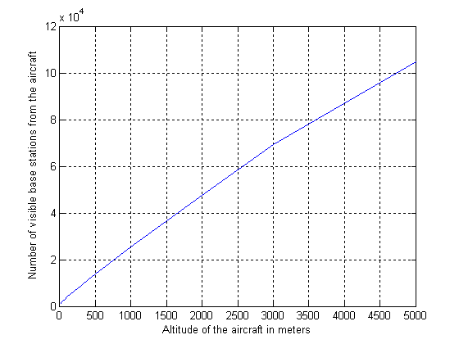 | 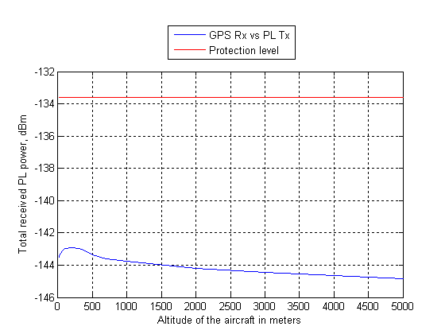
Figure 3: Number of visible PLs | Figure 4: Level of the aggregated interference

Results with a density of 2.5 PL/km²:
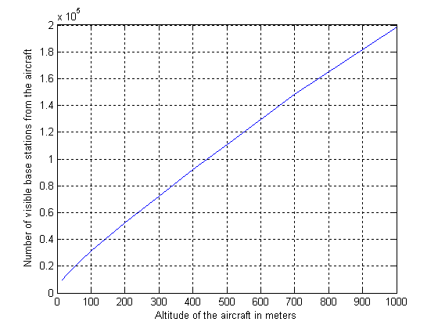 | 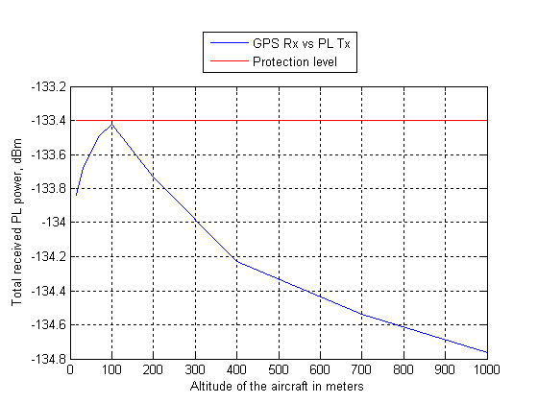
Figure 5: Number of visible PLs |  | Figure 6: Level of the aggregated interference
Results with a down tilt of the PL antennas of 30° (i.e. at least 6dB e.i.r.p. reduction above the horizon in comparison with the maximum e.i.r.p.). The density has been increased to 11.8 PL/km²:
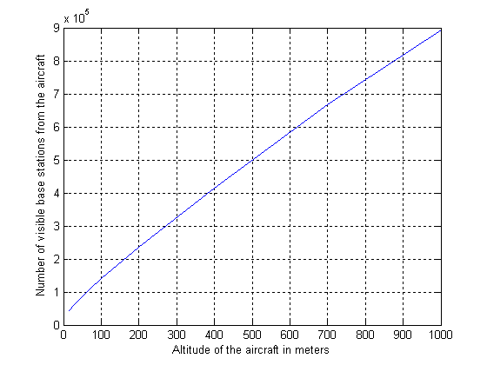 | 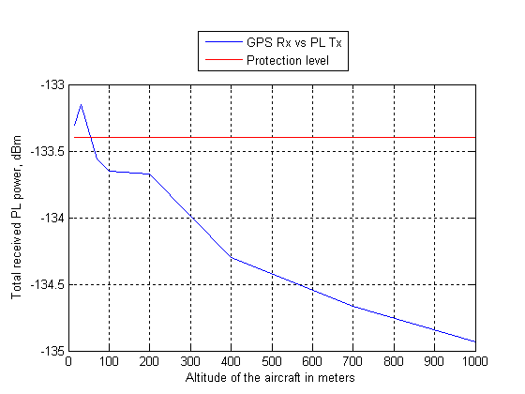
Figure 7: Number of visible PLs | Figure 8: Level of the aggregated interference

Noise elevation due to the multiple PL deployment in an airport
The aggregate effect of pseudolites (PLs) corresponds to an increase of the noise level.
For the most sensitive aeronautical receivers, the protection criterion is -147.4dBW/MHz. If a 6dB safety margin is included and a single/ multiple interference entry factor of 6dB is considered, then the protection criteria is -129.4dBm/MHz.
Note: The area in visibility from the aircraft is smaller than when the aircraft is flying, and therefore 25% of the interference is allocated to pseudolites.
In order to assess this aggregate interference impact, the following hypotheses are made:
- An example of possible PLs deployment in several airport terminals is proposed (see figures below). These deployments are only examples and therefore the reality may differs;
- A free space loss model is considered;

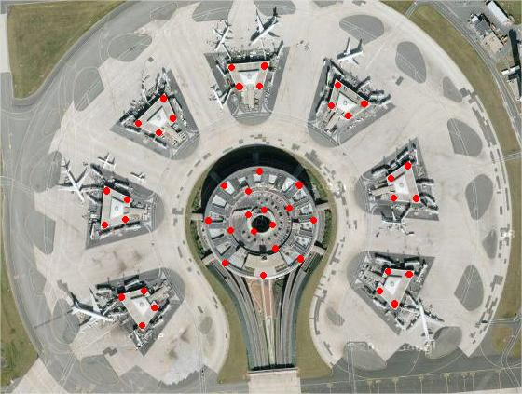 | 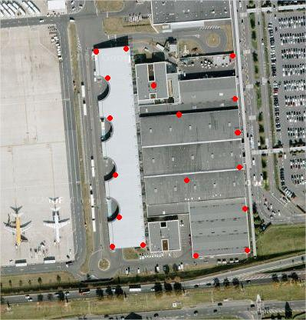
Figure 9: PL possible deployment 1 | Figure 10: PL possible deployment 2
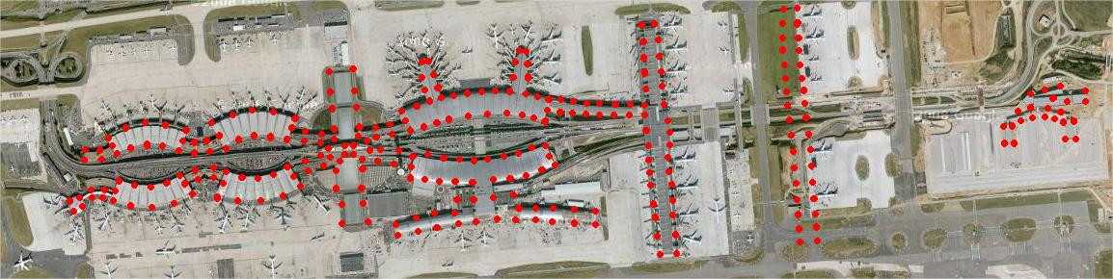
Figure 11: PL possible deployment 3

- Case 1: PLs transmit the maximum e.i.r.p. of -50dBm

The results presented in Figure 12 show that the aggregate noise level will be too high in the taxi area and even on runways of the airport if the maximum PL e.i.r.p. is -50dBm (in fact -53dBm/MHz in the simulation). Indeed, the noise level would be too high until a distance of:
- 600m to 1500m from any terminals if no site engineering is considered (no wall attenuation, antennas pointing towards apertures)
- around 200m from any terminal if we consider systematic site engineering (8dB wall attenuation, antennas pointing toward the ground and not toward any aperture)
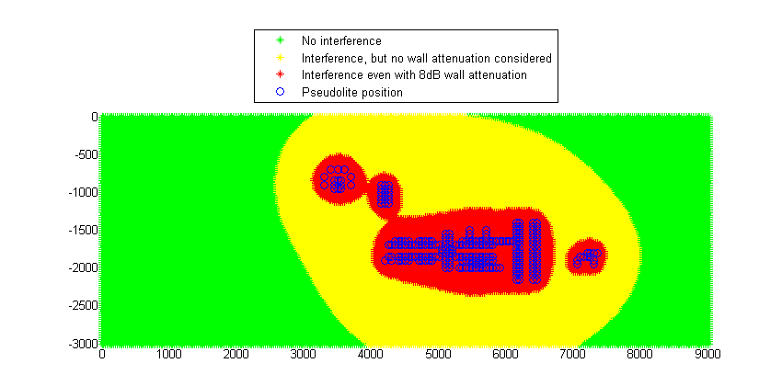
Figure 12: Aggregate noise level in an airport due to PL deployment in an airport (case 1)
- Case 2: PLs transmit the maximum e.i.r.p. of -59dBm

The results presented in Figure 13 show that the aggregate noise level can be too high in the taxi area of the airport if the maximum PL e.i.r.p. is -59dBm (in fact -62dBm/MHz in the simulation). Indeed, the noise level would be too high until a distance of 200m from any terminals if no site engineering is considered (no wall attenuation, antennas pointing towards apertures)
However, if systematic site engineering is considered (8dB wall attenuation, antennas pointing toward the ground and not toward any aperture) the maximum acceptable noise level should not be exceeded in taxi areas of the airport.
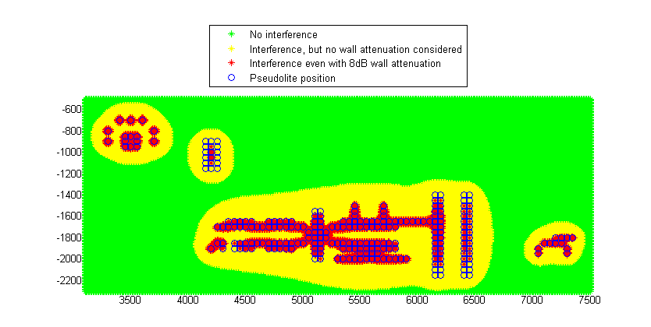
Figure 13: Aggregate noise level in an airport due to PL deployment in an airport (case 2)
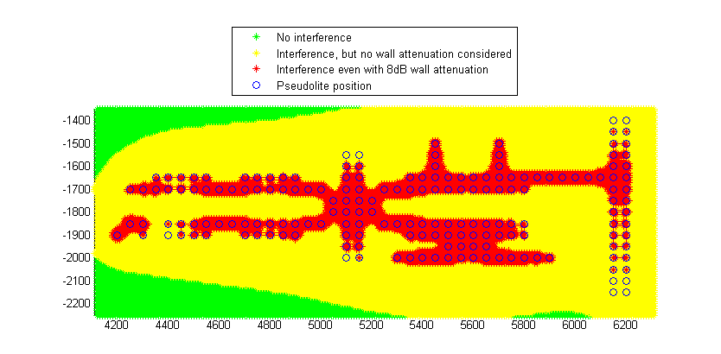
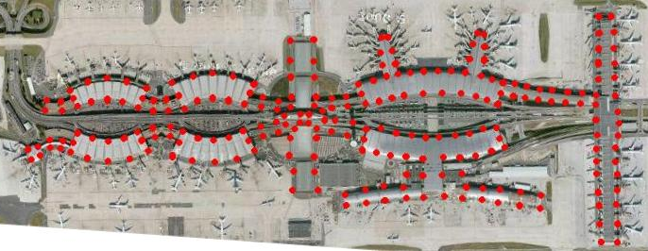
Figure 14: Aggregate noise level in an airport due to PL deployment in an airport (case 2)

Analysis of the results for CW PLs operating in the 1559-1610 MHz band

Impact on RNSS receivers common to any method of PRN allocation (dedicated or non-dedicated)
The main impacts of PLs are the near-far effect and the increase of the noise level.
- The noise level increase is not significant and should not create any difficulties for separation distances higher than 20 m if the PL e.i.r.p. is limited to -59dBm, and 50 m if the PL e.i.r.p. is increased to -50dBm. In the case where PLs would be deployed in airport areas, such separation distance (or equivalent attenuation) will have to be maintained with any aircraft or vehicles outside the building. The separation distance between any PL operating in light indoor environment (e.g. Terminal airport areas) and non-participating indoor GNSS receivers in the same building as the pseudolites will be 19m if the PL e.i.r.p. is limited to -59dBm and 54m if the PL e.i.r.p. is increased to -50dBm.
The studies of the aggregate effect of PL on aeronautical receivers show that in average, the PL density deployed in an indoor environment should be limited to 2.5 PL/km² if the e.i.r.p. is -50dBm and 11.8 PL/km² if the e.i.r.p. is limited to -56dBm (or if equivalent mitigation techniques are applied). In sensitive areas like airport, the studies show that the e.i.r.p. should be limited to -59dBm and mitigation techniques applied. Moreover, since the aggregated effect really depends on the real deployment conditions, case by case studies may be necessary.

- The near-far effect is more significant. The required separation distance varies from 15m to 128m if the PL e.i.r.p. is limited to -59dBm, and 43m to 359m if the PL e.i.r.p. is increased to -50dBm. A specific attention should be given to light indoor environment i.e. close to large apertures (doors, windows). Moreover, PL antennas should point to the ground. And finally, it will be necessary to limit the maximum PL e.i.r.p. to -59dBm in some sensitive areas (e.g. airport terminals…). In these conditions, the near-far effect would be reduced to the values given below. A separation distance between 51 and 255 m (or equivalent attenuation) should be maintained with any aircraft or vehicles outside the building in airport areas.

In the case PLs don’t use dedicated PRN codes
The main additional potential impact of PLs is the reception of unexpected PRN codes by the GNSS receivers
- The main concern is for cold start acquisition. In that case, the required separation distance varies from 400m to 700m if the PL e.i.r.p. is limited to -59dBm,
- Other potential impacts are the slow-down of the non-participating receivers. This effect will be more significant if the potential victim is close to the PL transmitter, but the maximum distance at which such phenomena could occur varies from 600m to 1300m if the PL e.i.r.p. is limited to -59dBm, and from 1,8km to 3.6km if the PL e.i.r.p. is increased to -50dBm.
- Finally, PL signals can monopolize some reception channels of non-participating receiver, even after the acquisition resolved. Therefore, non-participating receiver could have an insufficient number of available channels to receive satellite signals. It is recommended to limit the number of different non dedicated PL codes to 6, and in case of dedicated PL code to develop the associated receiver with an increased number of reception channels.

CW Pseudolite signal as an interferer in the 1164-1215 MHz band

Receiver tracking satellite codes from pseudolites
The results based on the worst case scenario are the following ones. The methodology used to derive these results is similar to the previous section on the impact of a pseudolite signal as an interferer in the 1559-1610 MHz band.
Table 11: Protection distances for worst case
Type of receiver | Operating mode | Protection distance (PL e.i.r.p. max of -59dBm)
Aeronautical receiver | Cold start acquisition | 1088m
Aeronautical receiver | Aided acquisition | 1537m
Indoor receiver | Cold start acquisition | 673m
Indoor receiver | Aided acquisition | 951m
High precision receiver | Cold start acquisition | 540m
High precision receiver | Aided acquisition | 763m
General purpose receiver | Cold start acquisition | 134m
General purpose receiver | Aided acquisition | 190m

When considering that we in most cases have at least 6dB building losses (with the exception of indoor receivers) and a minimum C/N0 of 25dBHz in any operation mode other than the cold start acquisition, and a pseudolite antenna down-tilt to ensure a reduction of the PL e.i.r.p. of at least 6dB above the horizon (i.e. 0° elevation), the results are improved (not for indoor receivers). They are presented below. However, they will not cover worst case scenarios presented above.
Table 12: Protection distances for more realistic case
Type of receiver | Operating mode | Protection distance (PL e.i.r.p. max of -59dBm)
Aeronautical receiver | Cold start acquisition | 273m
Aeronautical receiver | Aided acquisition | 273m
Indoor receiver | Cold start acquisition | 673m
Indoor receiver | Aided acquisition | 951m
High precision receiver | Cold start acquisition | 136m
High precision receiver | Aided acquisition | 171m
General purpose receiver | Cold start acquisition | 169m
General purpose receiver | Aided acquisition | 213m

Near-far effect
Table 13: Protection distances for worst case
Type of receiver | Operating mode | Protection distance (PL e.i.r.p. max of -59dBm)
Aeronautical receiver | Open sky | 20m
Aeronautical receiver | Low satellite visibility | 193m
Indoor receiver | Low satellite visibility | 120m
High precision receiver | Open sky | 14m
General purpose receiver | Open sky | 14m
General purpose receiver | Low satellite visibility | 120m

When considering that we in most cases have at least 6dB building losses (with the exception of indoor receivers) and a minimum C/N0 of 25dBHz in any operation mode other than the cold start acquisition, and a pseudolite antenna down-tilt to ensure a reduction of the PL e.i.r.p. of at least 6dB above the horizon (i.e. 0° elevation), the results are improved (not for indoor receivers). They are presented below. However, they will not cover worst case scenarios presented above.
Table 14: Protection distances for more realistic case
Type of receiver | Operating mode | Protection distance (PL e.i.r.p. max of -59dBm)
Aeronautical receiver | Open sky | 5m
Aeronautical receiver | Low satellite visibility | 34m
Indoor receiver | Low satellite visibility | 120m
High precision receiver | Open sky | 4m
General purpose receiver | Open sky | 4m
General purpose receiver | Low satellite visibility | 27m

Noise level increase
Table 15: Protection distances for worst case
Type of receiver | Operating mode | Protection distance (PL e.i.r.p. max of -59dBm)
Aeronautical receiver | Acquisition | 28m
Aeronautical receiver | Tracking | 18m
Indoor receiver | Acquisition | 45m
Indoor receiver | Tracking | 23m
High precision receiver | Acquisition | 17m
High precision receiver | Tracking | 17m
General purpose receiver | Acquisition | 14m
General purpose receiver | Tracking | 7m

When considering that we always have at least 6dB building losses (with the exception of indoor receivers), the results are improved. They are presented below. However, they will not cover worst case scenarios presented above.

Table 16: Protection distances for more realistic case
Type of receiver | Operating mode | Protection distance (PL e.i.r.p. max of -59dBm)
Aeronautical receiver | Acquisition | 14m
Aeronautical receiver | Tracking | 9m
Indoor receiver | Acquisition | 45m
Indoor receiver | Tracking | 23m
High precision receiver | Acquisition | 9m
High precision receiver | Tracking | 9m
General purpose receiver | Acquisition | 7m
General purpose receiver | Tracking | 4m

In order to assess the compatibility between the PL transmitter and a RNSS receiver (Galileo, GPS …), the generic methodology proposed in ITU-R Recommendation (see section 4.2.2.) is used. However, for more detailed analysis, the SSC (Spectral Separation Coefficient) could also be used. The SSC values are calculated by convolving the power spectral density of the PL signal and the power spectral density of the wanted RNSS signal, and:
(4)

Aggregated effect of pseudolites deployed in an indoor environment
The aggregate effect of pseudolites (PLs) corresponds to an increase of the noise level.
For the most sensitive aeronautical receivers, the protection criterion is -148.7dBW/MHz. If a 6dB safety margin is included and a single/ multiple interference entry factor of 10dB is considered (10% of the interference is allocated to pseudolites) then the protection criteria is -134.7dBm/MHz.
In order to assess this aggregate interference impact, the following hypotheses are made:
- All PLs are uniformly distributed on the ground, transmitting the maximum e.i.r.p. of -59dBm;
- The PL antenna pattern is in accordance with Figure 2;
- A free space loss model is considered;
- An average building loss of 6dB is considered
- The closest PL is always at more than 350m.

Aeronautical case – maximum average PL density calculation
According to the above hypothesis and with the same methodology used in the section dealing with the 1559-1610 MHz band, one can conclude that:
- the maximum average density of pseudolites should be 6 PL/km²;
- if a downtilt of the PL antennas of 30° is systematically applied (i.e. at least 6dB e.i.r.p. reduction above the horizon in comparison with the maximum e.i.r.p.), this density could be increased to 24 PL/km².

Noise elevation due to the multiple PL deployment in an airport
The aggregate effect of pseudolites (PLs) corresponds to an increase of the noise level.
For the most sensitive aeronautical receivers, the protection criterion is -148.7dBW/MHz. If a 6dB safety margin is included and a single/ multiple interference entry factor of 6dB is considered, then the protection criteria is -130.7dBm/MHz.
Note: The area in visibility from the aircraft is smaller than when the aircraft is flying, and therefore 25% of the interference is allocated to pseudolites
In order to assess this aggregate interference impact, the same hypotheses as in the section dealing with the 1559-1610 MHz band are made.
The results presented in Figure 13 show that the aggregate noise level can be too high in the taxi area of the airport if the maximum PL e.i.r.p. is -59dBm (in fact -62dBm/MHz in the simulation). Indeed, the noise level would be too high until a distance of 500m from any terminals if no site engineering is considered (no wall attenuation, antennas pointing towards apertures).
If systematic site engineering is considered (6dB wall attenuation, antennas pointing toward the ground and not toward any aperture) the maximum acceptable noise level would still be exceeded in some taxi areas of the airport and at aircraft parking stands.
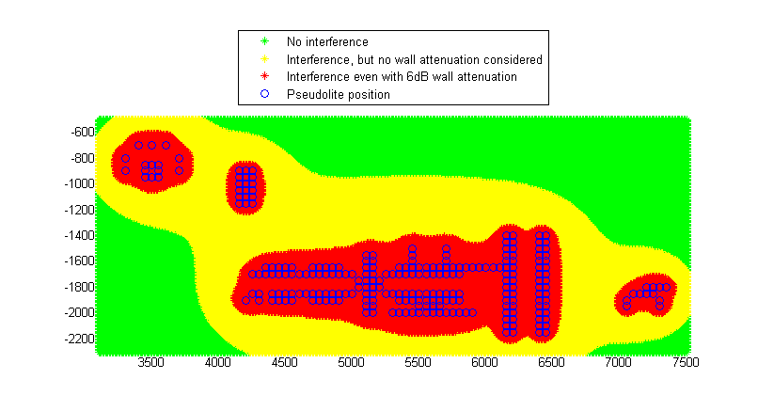
Figure 15: Aggregate noise level in an airport due to PL deployment in an airport (case 2)

Analysis of the results for CW PLs operating in the 1164-1215 MHz band

Impact on RNSS receivers common to any method of PRN allocation (dedicated or non-dedicated)
The main impacts of PLs are the near-far effect and the increase of the noise level.

- It is not envisaged to have higher e.i.r.p. than -59dBm. Therefore, the noise level increase is not significant and should not create any difficulties for separation distances higher than 30m. In case PLs would be deployed in airport areas, such separation distance (or equivalent attenuation) will have to be maintained with any aircraft or vehicles outside the building. However, the necessary separation distance between any PL operating in light indoor environment (e.g. Terminal airport areas) and non-participating indoor GNSS receivers in the same building as the pseudolites will be 45m.
The studies of the aggregate effect of PL on aeronautical receivers show that in average, the PL density deployed in an indoor environment should be limited to 6 PL/km² if the e.i.r.p. is -59dBm and 24 PL/km² if the e.i.r.p. is limited to -65dBm (or if equivalent mitigation techniques are applied).
In sensitive areas like airport, the studies show that mitigation techniques should be applied. Moreover, since the aggregated effect really depends on the real deployment conditions, case by case studies would be necessary.

- The near-far effect is more significant. The required separation distance varies from 20m to 190m if the PL e.i.r.p. is limited to -59dBm. A specific attention should be given to light indoor environment i.e. close to large apertures (doors, windows). Moreover, PL antennas should point to the ground. In these conditions, the near-far effect would be reduced to the values given below. A separation distance between up to 120m (or equivalent attenuation) should be maintained with any aircraft or vehicles outside the building in airport areas;

In the case PLs don’t use dedicated PRN codes
The main additional potential impact of PLs is the reception of unexpected PRN codes by the GNSS receivers
- The main concern is for cold start acquisition. In that case, the required separation distance varies from 140m to 1.1km if the PL e.i.r.p. is limited to -59dBm,
- Other potential impacts are the slow-down of the non-participating receivers. This effect will be more significant if the potential victim is close to the PL transmitter, but the maximum distance at which such phenomena could occur varies from 190m to 1.5km if the PL e.i.r.p. is limited to -59dBm.
- Finally, PL signals can monopolize some reception channels of non-participating receiver, even after the acquisition resolved. Therefore, non-participating receiver could have an insufficient number of available channels to receive satellite signals. It is recommended to limit the number of different non-dedicated PL codes to 6, and in case of dedicated PL code to develop the associated receiver with an increased number of reception channels.

CW Pseudolite signal as an interferer in the 1215-1300 MHz band

Receiver tracking satellite codes from pseudolites
The results based on the worst case scenario are the following ones. The methodology used to derive these results is similar to the previous section on the impact of a pseudolite signal as an interferer in the 1559-1610 MHz band.
Table 17: Protection distances for worst case
Type of receiver | Operating mode | Protection distance (PL e.i.r.p. max of -59dBm)
Aeronautical receiver | Cold start acquisition | 1043m
Aeronautical receiver | Aided acquisition | 1473m
Indoor receiver | Cold start acquisition | 652m
Indoor receiver | Aided acquisition | 921m
High precision receiver | Aided acquisition | 731m
General purpose receiver | Cold start acquisition | 652m
General purpose receiver | Aided acquisition | 921m

When considering that we in most cases have at least 7dB building losses (with the exception of indoor receivers) and a minimum C/N0 of 25dBHz in any operation mode other than the cold start acquisition, and a pseudolite antenna down-tilt to ensure a reduction of the PL e.i.r.p. of at least 6dB above the horizon (i.e. 0° elevation), the results are improved (not for indoor receivers). They are presented below. However, they will not cover worst case scenarios presented above.

Table 18: Protection distances for more realistic case
Type of receiver | Operating mode | Protection distance (PL e.i.r.p. max of -59dBm)
Aeronautical receiver | Cold start acquisition | 233m
Aeronautical receiver | Aided acquisition | 233m
Indoor receiver | Cold start acquisition | 652m
Indoor receiver | Aided acquisition | 921m
High precision receiver | Aided acquisition | 146m
General purpose receiver | Cold start acquisition | 146m
General purpose receiver | Aided acquisition | 184m

Near-far effect
Table 19: Protection distances for worst case
Type of receiver | Operating mode | Protection distance (PL e.i.r.p. max of -59dBm)
Aeronautical receiver | Open sky | 29m
Aeronautical receiver | Low satellite visibility | 185m
Indoor receiver | Low satellite visibility | 116m
High precision receiver | Open sky | 21m
General purpose receiver | Open sky | 29m
General purpose receiver | Low satellite visibility | 116m

When considering that we in most cases have at least 7dB building losses (with the exception of indoor receivers) and a minimum C/N0 of 25dBHz in any operation mode other than the cold start acquisition, and a pseudolite antenna down-tilt to ensure a reduction of the PL e.i.r.p. of at least 6dB above the horizon (i.e. 0° elevation), the results are improved (not for indoor receivers). They are presented below. However, they will not cover worst case scenarios presented above.
Table 20: Protection distances for more realistic case
Type of receiver | Operating mode | Protection distance (PL e.i.r.p. max of -59dBm)
Aeronautical receiver | Open sky | 7m
Aeronautical receiver | Low satellite visibility | 29m
Indoor receiver | Low satellite visibility | 116m
High precision receiver | Open sky | 5m
General purpose receiver | Open sky | 7m
General purpose receiver | Low satellite visibility | 23m

Noise level increase deterministic
Table 21: Protection distances for worst case
Type of receiver | Operating mode | Protection distance (PL e.i.r.p. max of -59dBm)
Aeronautical receiver | Acquisition | 19m
Aeronautical receiver | Tracking | 23m
Indoor receiver | Acquisition | 62m
Indoor receiver | Tracking | 31m
High precision receiver | Tracking | 12m
General purpose receiver | Acquisition | 17m
General purpose receiver | Tracking | 9m

When considering that we always have at least 7dB building losses (with the exception of indoor receivers), the results are improved. They are presented below. However, they will not cover worst case scenarios presented above.
Table 22: Protection distances for more realistic case
Type of receiver | Operating mode | Protection distance (PL e.i.r.p. max of -59dBm)
Aeronautical receiver | Acquisition | 9m
Aeronautical receiver | Tracking | 10m
Indoor receiver | Acquisition | 62m
Indoor receiver | Tracking | 31m
High precision receiver | Tracking | 7m
General purpose receiver | Acquisition | 8m
General purpose receiver | Tracking | 4m

In order to assess the compatibility between the PL transmitter and a RNSS receiver (Galileo, GPS …), the generic methodology proposed in ITU-R Recommendation (see section 4.2.2) is used. However, for more detailed analysis, the SSC (Spectral Separation Coefficient) could also be used.
The SSC values are calculated by convolving the power spectral density of the PL signal and the power spectral density of the wanted RNSS signal, and:
(5)

Aggregated effect of pseudolites deployed in an indoor environment
The aggregate effect of pseudolites (PLs) corresponds to an increase of the noise level.
For the most sensitive aeronautical receivers, the protection criterion is -147.5dBW/MHz. If a 6dB safety margin is included and a single/ multiple interference entry factor of 10dB is considered (10% of the interference is allocated to pseudolites) then the protection criteria is -133.5dBm/MHz.
In order to assess this aggregate interference impact, the following hypotheses are made:
- All PLs are uniformly distributed on the ground, transmitting the maximum e.i.r.p. of -59dBm;
- The PL antenna pattern is in accordance with Figure 2;
- A free space loss model is considered;
- An average building loss of 7dB is considered
- The closest PL is always at more than 350m.

Aeronautical case – maximum average PL density calculation
According to the above hypothesis and with the same methodology used in the section dealing with the 1559-1610 MHz band, one can conclude that:
- the maximum average density of pseudolites should be 12 PL/km²;
- if a downtilt of the PL antennas of 30° is systematically applied (i.e. at least 6dB e.i.r.p. reduction above the horizon in comparison with the maximum e.i.r.p.), this density could be increased to 48 PL/km².

Noise elevation due to the multiple PL deployment in an airport
The aggregate effect of pseudolites (PLs) corresponds to an increase of the noise level.
For the most sensitive aeronautical receivers, the protection criterion is -147.5dBW/MHz. If a 7dB safety margin is included and a single/ multiple interference entry factor of 6dB is considered, then the protection criteria is -129.5dBm/MHz.
Note: The area in visibility from the aircraft is smaller than when the aircraft is flying, and therefore 25% of the interference is allocated to pseudolites.
In order to assess this aggregate interference impact, the same hypotheses as in the section dealing with the 1559-1610 MHz band are made.
The results presented in Figure 13 show that the aggregate noise level can be too high in the taxi area of the airport if the maximum PL e.i.r.p. is -59dBm (in fact -62dBm/MHz in the simulation). Indeed, the noise level would be too high until a distance of 400 m from any terminals if no site engineering is considered (no wall attenuation, antennas pointing towards apertures)
If systematic site engineering is considered (7dB wall attenuation, antennas pointing toward the ground and not toward any aperture) the maximum acceptable noise level would still be exceeded in some few taxi areas of the airport and at aircraft parking stands.
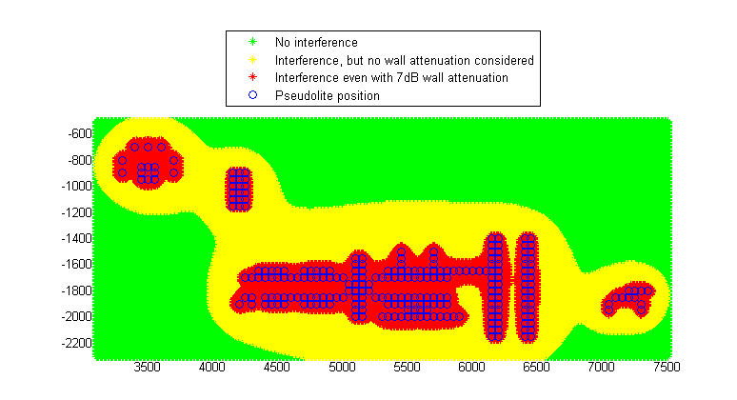
Figure 16: Aggregate noise level in an airport due to PL deployment in an airport (case 2)

Analysis of the results for CW PLs operating in the 1215-1300 MHz band

Impact on RNSS receivers common to any method of PRN allocation (dedicated or non-dedicated)
The main impacts of PLs are the near-far effect and the increase of the noise level.
- It is not envisaged to have higher e.i.r.p. than -59dBm. Therefore, the noise level increase is not significant and should not create any difficulties for separation distances higher than 23m. In case PLs would be deployed in airport areas, such separation distance (or equivalent attenuation) will have to be maintained with any aircraft or vehicles outside the building. However, the necessary separation distance between any PL operating in light indoor environment (e.g. Terminal airport areas) and non-participating indoor GNSS receivers in the same building as the pseudolites will be 60 m.
The studies of the aggregate effect of PL on aeronautical receivers show that in average, the PL density deployed in an indoor environment should be limited to 12 PL/km² if the e.i.r.p. is -59dBm and 48 PL/km² if the e.i.r.p. is limited to -65dBm (or if equivalent mitigation techniques are applied).
In sensitive areas like airport, the studies show that mitigation techniques should be applied. Moreover, since the aggregated effect really depends on the real deployment conditions, case by case studies may be necessary.

- The near-far effect is more significant. The required separation distance varies from 30 m to 185 m if the PL e.i.r.p. is limited to -59dBm. A specific attention should be given to light indoor environment i.e. close to large apertures (doors, windows). Moreover, PL antennas should point to the ground. In these conditions, the near-far effect would be reduced to the values given below. A separation distance between up to 120 m (or equivalent attenuation) should be maintained with any aircraft or vehicles outside the building in airport areas;

In the case PLs don’t use dedicated PRN codes
The main additional potential impact of PLs is the reception of unexpected PRN codes by the GNSS receivers
- The main concern is for cold start acquisition. In that case, the required separation distance varies from 650 m to 1.1 km if the PL e.i.r.p. is limited to -59dBm,
- Other potential impacts are the slow-down of the non-participating receivers. This effect will be more significant if the potential victim is close to the PL transmitter, but the maximum distance at which such phenomena could occur varies from 730 m to 1.5 km if the PL e.i.r.p. is limited to -59dBm.
- Finally, PL signals can monopolize some reception channels of non-participating receiver, even after the acquisition resolved. Therefore, non-participating receiver could have an insufficient number of available channels to receive satellite signals. It is recommended to limit the number of different non-dedicated PL codes to 6, and in case of dedicated PL code to develop the associated receiver with an increased number of reception channels.

Pulsed pseudolites
For the purpose of this ECC report, the European Commission Joint Research Center (JRC) has undertaken comprehensive analyses and tests involving pulsed pseudolites transmitting GPS like signals in the band 1559-1610 MHz, against non-participating GPS or GALILEO receivers. All details are given in the technical report “Impact of pseudolites signals on non-participating GNSS receivers” [5].
In the JRC report a two-part model of the impact of pseudolites on non-participating GNSS receivers have been developed. The two regions of applicability are:
- The small signal approximation when the pseudolite signal is below the noise floor.
- Saturation when the pseudolite saturates the receiver’s ADC.

In addition, a simple sigmoidal approximation has been proposed to interpolate between the two regions. The model has been verified using data collected from two commercial GPS receivers, a wide-band high-precision receiver (called Javad in the figures below) and a narrow-band commercial receiver (u-Blox in the figures below). The high-precision receiver was also capable of processing Galileo signals. The impact of the spectral separation between the pseudolite signal and the local replica in the receiver was clearly demonstrated by the fact that the Galileo signals suffered less SNR degradation then the GPS signals in the presence of a GPS pseudolite. In addition, the wide-band high-precision receiver suffered greater losses than the narrow-band commercial receiver, as predicted by the model.
Based on model parameters extracted from the experimental data, a number of case studies were considered. For each test case a minimum distance was computed, such that a non-participating receiver further away from the pseudolite than this minimum distance should experience average C/N0 losses less than a given threshold.
Figure 17 gives the separation distance that would be required between the pulsed pseudolite and the two receivers processing GPS signals in order to limit the C/N0 loss after the correlator to 1 dB, against the pseudolite duty cycle.
The transmit power should be understood as the mean transmit power. The peak transmit power (the power transmitted when the pseudolite is active) may be derived using the following formula:
$Pc=Pm-10\log\left(DC\right)$ (6)
where:
Pc : Peak power (dBm)
Pm : Mean power (dBm)
DC : Duty cycle

For example, a -50 dBm mean power with a 2% duty cycle is equivalent to a peak transmit power of -33 dBm.
$$⁡$$

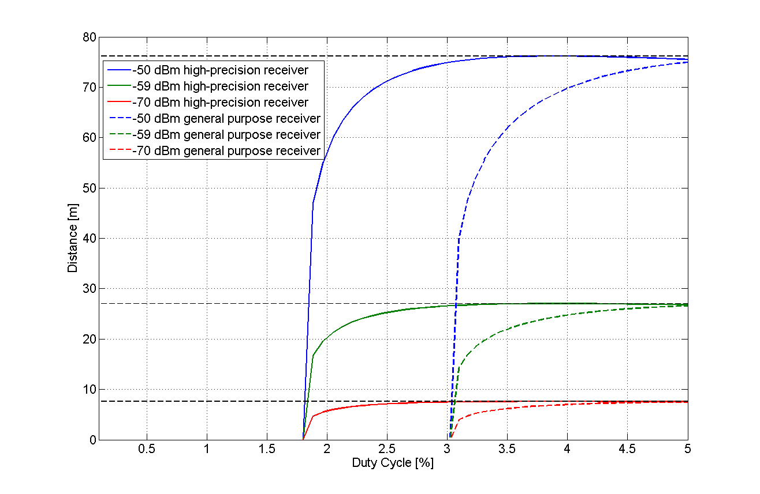
Figure 17: Separation distance vs pseudolite duty cycle for different mean powers and
for 2 GPS receivers
For the worst case considered, corresponding to an effective transmit power of -50 dBm and the high-precision GPS receiver, a minimum distance of ~ 75 m is required to ensure an induced SNR loss of less than 1 dB. This minimum distance can be reduced only by reducing either the transmit power, or the duty cycle or both. For example, keeping the effective transmit power constant for the simulated system the duty cycle would need to be reduced to less than 2% to bring the minimum distance below 30 m. On the other hand, if the effective transmit power was reduced to -59 dBm the corresponding minimum distance is at most ~ 28 m.
If a C/N0 loss of 3 dB is locally allowed (inside the defined area of coverage), the minimum distance for an effective transmit power of –50 dBm and the high-precision receiver decreases to less than 40 meters. For example, it was simulated for one system that a duty cycle of 6% could allow the non-participating receiver to be as close as possible without experiencing a loss greater than 3 dB.
Since the pseudolite is using dedicated PRN codes, these distances should be compared to the distances derived for the near-far effect for continuous wave receivers in Table 6, where a distance of 30 to 255 m was found, consistent with the 75 m found here for high duty cycles, The comparison is not straightforward as the C/N0 criterion may differ from one receiver to the other, and therefore from the criterion considered in previous sections.
However, it can be shown from this figure that:
- The use of a pulsing scheme allows for an increase of the pseudolite peak power.
- Figure 18 gives the separation distance that would be required between the pulsed pseudolite and the wideband Javad receiver processing a GALILEO signal in order to limit the C/N0 loss after the correlator to 1 dB, against the pseudolite duty cycle.

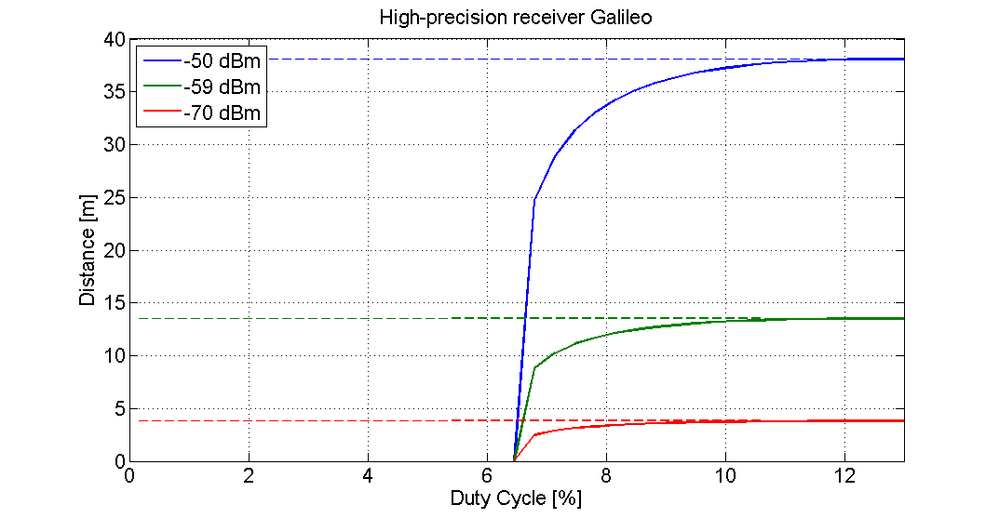
Figure 18: Separation distance vs pseudolite duty cycle for different mean powers and
for a GALILEO receiver

The conclusions are the same, although the signals are different between the pseudolite and the RNSS receiver, and therefore the SSC allows for a smaller separation distance.

Aggregate interference effect of a network of pulsed pseudolites
The aggregate duty cycle equals the sum of pulsed signals that are significantly stronger (peak power) than thermal noise level in the RNSS receiver. Only in this case the pulsed signals may saturate the receiver front-end. The interference caused by those pulsed signals that are weaker than this can be treated the same way as the interference caused by CW signals [5].
The interference caused by pseudolite signals below thermal noise level can be evaluated the same way as for CW signals (interference power level taken as the average power instead of peak power). In this case there are no saturation effects.
JRC report on the impact of pulsed pseudolites contains both theoretical and experimental results of the SNR loss caused by a pulsed pseudolite signal on a non-participating receiver [5]. Below simulation results of the SNR loss caused by a network of pulsed pseudolites, using the composite loss model presented in [5], are presented.

The loss for a single pseudolite signal is given by the maximum of small signal approximation L_{ss} and saturation loss L_{sat} :
$L_{pl}=\max_{}\left\{L_{ss},L_{sat}\right\}=L_{q}\max_{}\left(\frac{1}{1+L_{q}\frac{C_{p}}{N_{0}}dk_{a}};\frac{1-d}{1+k_{a}g(B,A_{g})\frac{d}{1-d}}\right)$ (7)
where:

L_{q} is the quantization loss, d is the pulse duty cycle and C_{p} is the pseudolite signal power during the pulse (i.e. peak power). In the following simulations, the quantization loss L_{q} is excluded from the results since it is due to the receiver signal processing and not the pseudolite interference.

The loss due to several pseudolite signals is calculated as follows:
- For each pseudolite signal, calculate the loss using both small signal approximation and saturation formula.
- If the saturation loss is selected, add the duty cycle of single pseudolite to the aggregate duty cycle d_{agg}
- If small signal loss is selected, add pseudolite signal power to the aggregate small signal power C_{p,agg}
The aggregate loss is then calculated as

$L_{pl,agg}=L_{ss,agg}∙L_{sat,agg}=\frac{1}{1+L_{q}\frac{C_{p,agg}}{N_{0}}dk_{a}}∙\frac{1-d_{agg}}{1+k_{a}g(B,A_{g})\frac{d_{agg}}{1-d_{agg}}}$ (8)

Impact to non-aeronautical users in an outdoor environment
For terrestrial users, the aggregate interference of 100 pseudolite transmitters arranged in a rectantular grid (10 x 10 pseudolites with 100 m separation distance between neighbours) was simulated. Simulation parameters are shown in Table 23.
Table 23: Simulation parameters
Parameter | Value | Comment
Pseudolite positions | (x,y) coordinates form a rectangular grid, both x and y go from 100 to 1000 with increments of 100  h = 5 | Assume height of 5 m for the transmitters
Transmit power | -33 dBm (peak power)  -46 dBm (mean power) | At distance of 120 m, the received (peak) power falls below noise level.  The signal could be received at slightly more than 130 m distance, with equivalent signal-to-noise density of 36 dBHz
Pulse duty cycle | 5 % | 5 % duty cycle allows signal tracking while not causing excessive interference
Antenna gain | 1 | For simplicity, assume isotropic antennas
Receiver position | (x,y) coordinates form a rectangular grid, both x and y go from 0 to 1100 with increments of 10  h = 0 | The receiver position grid covers the area inside the pseudolite transmitter network and extends beyond
Antenna gain | 1 | For simplicity, assume isotropic antennas
Tracking threshold for PL signal | 36 dBHz – 20log(d) | During the pulse, the signal-to-noise density must be 26 dB above 36 dBHz (d=0.05)
Number of ADC bits | 2 or 4
IF bandwidth | 2 MHz | L1 C/A signal
Sampling frequency | 5 MHz

- Two-bit receiver (B = 2).

The aggregate loss calculated for the 2-bit receiver is shown in Figure 19. The maximum loss, approximately 2.1 dB, is attained near the pseudolite transmitters.

Figure 19: Loss due to pseudolite interference when B=2
It is of interest to evaluate the number of pseudolite signals that could be received inside the area covered. The signal-to-noise density threshold for pulsed signal is obtained by multiplying the corresponding threshold for CW signal by the square of the duty cycle. This is valid for a receiver with no pulse gating i.e. no enhancement for tracking a pulsed signal. The results, calculated with a conservative threshold of 36 dBHz – 20*log(d), are shown in Figure 20. Inside the pseudolite grid, 4-7 signals are received. The maximum numbers are found in the areas between the transmitters.
Figure 20: Number of visible pseudolite signals when B=2
- Four-bit receiver (B = 4).

The loss for 4-bit receiver is shown in Figure 21. In this case the maximum loss is 2.9 dB. Outside the pseudolite transmitter grid, the loss is limited to 1 dB or less when the distance from the nearest transmitter is 60 meters or more. At 300 m distance the loss is less than 0.3 dB.
Figure 21: Loss due to pseudolite interference when B=4

Impact on aeronautical receivers
The results given for CW pseudolites are applicable to pulsed pseudolites when considering their aggregate impact on aeronautical RNSS receiver. In this case the mean power of pulsed pseudolite signal should be considered. The small signal approximation of the interference caused by a pulsed pseudolite is described in section 3.1. of [5].
It should also be noted that results given in section 4.3 to 4.5 include building losses in the propagation model and they are therefore applicable when pseudolites are deployed in an indoor environment. If pseudolites are deployed outside buildings, the density of pseudolites given in the above mentioned sections will have to be reduced to avoid an increase of interference in aeronautical RNSS receivers.

Conclusions concerning pulsed pseudolites
- A specific attention should be given to the use of pseudolites operating in outdoor environment:
- in the band 1164-1215 MHz, in the absence of mitigation techniques and assuming a mean EIRP of -59dBm and an SNR loss of 1 dB for any kind of non-aeronautical receiver / for high precision receiver, a separation distance of up to respectively 120m/96m can be necessary to ensure the protection of non-participating non-aeronautical receivers. In order to protect aeronautical receivers the PL mean EIRP should be reduced to -65dBm above 0°elevation. In order to reduce the potential interference level for lower separation distances or increase the mean on-axis e.i.r.p., the following measures could be taken:
- Optimization of the pseudolite signal
- To accept locally (inside the intended coverage area) an SNR loss of 3 dB
- in the band 1215-1300 MHz, in the absence of mitigation techniques and assuming a mean EIRP of -59dBm and an SNR loss of 1 dB for any kind of non-aeronautical receiver / for high precision receiver, a separation distance of up to respectively 116m/92m can be necessary to ensure the protection of non-participating non-aeronautical receivers. In order to protect aeronautical receivers the PL mean EIRP should be reduced to -65dBm above 0°elevation. In order to reduce the potential interference level for lower separation distances or increase the mean on-axis e.i.r.p., the following measures could be taken:
- Optimization of the pseudolite signal.
- To accept locally (inside the intended coverage area) an SNR loss of 3 dB.
- in the band 1559-1610 MHz, in the absence of mitigation techniques and assuming a mean EIRP of -50dBm and an SNR loss of 1 dB for any kind of non-aeronautical receiver / for high precision receiver / for the measured non-aeronautical receivers, a separation distance of up to respectively 255m/200m/77m can be necessary to ensure the protection of non-participating non-aeronautical receivers. In order to protect aeronautical receivers the PL mean EIRP should be reduced to -65dBm above 0°elevation. In order to reduce the potential interference level for lower separation distances or increase the mean on-axis e.i.r.p., the following measures could be taken:
- Optimization of the pseudolite signal ;
- To accept locally (inside the intended coverage area) an SNR loss of 3 dB.
- The peak power of pulsed pseudolites can be up to 10 log (duty cycle) above the mean power.
- The use of dedicated codes is recommended. Moreover, the use of longer codes will also improve the compatibility with non-participating receivers as well as the performance of participating receivers.
- The studies of the aggregate effect of PL on aeronautical receivers show that in average in:
  - L5 :,The PL density should be limited to 2 (6) PL/km² if the mean e.i.r.p. is -59dBm for outdoor (indoor) usage and 6 (24) PL/km² if the mean e.i.r.p. is limited to -65dBm (or if equivalent mitigation techniques are applied above 0 degree elevation angle) for outdoor (indoor) usage. It should be noted that these values correspond to average numbers, which may be exceeded locally, depending on the result of case by case studies on the impact of the pseudolite deployment on other RNSS users (in particular with safety of life applications).
  - L2 : The PL density should be limited to 2 (12) PL/km² if the mean e.i.r.p. is -59dBm for outdoor (indoor) usage and 10 (48) PL/km² if the mean e.i.r.p. is limited to -65dBm (or if equivalent mitigation techniques are applied above 0 degree elevation angle) for outdoor (indoor) usage. It should be noted that these values correspond to average numbers, which may be exceeded locally, depending on the result of case by case studies on the impact of the pseudolite deployment on other RNSS users (in particular with safety of life applications).
  - L1 : The PL density should be limited 4 (6) PL/km² if the mean e.i.r.p. is -59dBm for outdoor (indoor) usage and 18 (24) PL/km² if the mean e.i.r.p. is limited to -65dBm (or if equivalent mitigation techniques are applied above 0 degree elevation angle) for outdoor (indoor) usage. It should be noted that these values correspond to average numbers, which may be exceeded locally, depending on the result of case by case studies on the impact of the pseudolite deployment on other RNSS users (in particular with safety of life applications).
- In sensitive areas like around airport, the studies show that mitigation techniques (e.g. directional antennas) should be applied. Moreover, since the aggregated effect really depends on the real deployment conditions, case by case studies should also be necessary before any deployment.

Table 24: Aggregate effect of PL on aeronautical receivers
 | Bands | Technical Characteristics | Values
Indoor | L1  1559-1610 MHz | e.i.r.p. | -50dBm
Indoor | L1  1559-1610 MHz | Building Loss | 8dB
Indoor | L1  1559-1610 MHz | Max density | 2.5PL/km²
Indoor | L1  1559-1610 MHz | Max Density with max e.i.r.p. above 0° reduced by 6dB | 11.8PL/km²
Indoor | L2  1215-1300 MHz | e.i.r.p. | -59dBM
Indoor | L2  1215-1300 MHz | Building Loss | 7dB
Indoor | L2  1215-1300 MHz | Max density | 12 PL/km²
Indoor | L2  1215-1300 MHz | Max Density with max e.i.r.p. above 0° reduced by 6dB | 48PL/km²
Indoor | L5  1164-1215 MHz | e.i.r.p. | -59dBm
Indoor | L5  1164-1215 MHz | Building Loss | 6dB
Indoor | L5  1164-1215 MHz | Max density | 6PL/km²
Indoor | L5  1164-1215 MHz | Max Density with max e.i.r.p. above 0° reduced by 6dB | 24PL/km²
Outdoor | L1  1559-1610 MHz | e.i.r.p. | -59dBm
Outdoor | L1  1559-1610 MHz | Building Loss | 0dB
Outdoor | L1  1559-1610 MHz | Max density | 4PL/km²
Outdoor | L1  1559-1610 MHz | Max Density with max e.i.r.p. above 0° reduced by 6dB | 18PL/km²
Outdoor | L2  1215-1300 MHz | e.i.r.p. | -59dBm
Outdoor | L2  1215-1300 MHz | Building Loss | 0dB
Outdoor | L2  1215-1300 MHz | Max density | 2PL/km²
Outdoor | L2  1215-1300 MHz | Max Density with max e.i.r.p. above 0° reduced by 6dB | 10PL/km²
Outdoor | L5  1164-1215 MHz | e.i.r.p. | -59dBm
Outdoor | L5  1164-1215 MHz | Building Loss | 0dB
Outdoor | L5  1164-1215 MHz | Max density | 2PL/km²
Outdoor | L5  1164-1215 MHz | Max Density with max e.i.r.p. above 0° reduced by 6dB | 6PL/km²

Impact of pseudolites on other services

Aeronautical radio navigation Service (ARNS)

System overview of DME (ref. Federal Radionavigation Plan 1999)
Distance Measuring Equipment (DME) is a transponder-based radio navigation technology that measures distance by timing the propagation delay using radio signals. Aircrafts use DME to determine their distance from a land-based transponder by sending and receiving pulse pairs (interrogation). The ground stations are in many cases co-located with VORs (VHF Omni-directional Range) and in this configuration they may be sited at remote locations as well as on or near to airports. DME transponders are also used as part of landing systems at airports, although in this configuration they do not use the part of the frequency band shared with RNSS.
DME operates in 960-1027, 1033-1087 and 1093-1215 MHz sub-bands of the 960-1215 ARNS band. The RNSS band 1164-1215 MHz shares this part of the allocation band, where the DME receiver on aircraft receives the transponder replies. DME transponders may also use a local receiver to monitor and, in the event of malfunction, disable their transmitters.
The DME transponder transmissions can have a significant aggregate duty cycle affect if viewed from a high altitude. A ground based PL enabled receiver local to a DME transponder in the band 1164-1215 may see a maximum aggregate pulse environment of around 3%.

Necessary technical parameters of the airborne DME receiver systems for the compatibility studies
Table 25: Technical parameters of DME systems and pseudolite assumptions
Frequency [MHz] | Aircraft receiver height [m] | Maximum antenna gain towards terrestrial PL’s [dBi] | Noise figure [dB] | Number of PLs in the vicinity of the DME receiver | Compatibility criterion for pseudolites
1164-1215 | 100 | 4.5 | 3 | 4 to 5 | Aggregate pfd  -144.5 dBW/m²/MHz*
1164-1215 | 12192 | 4.5 | 3 | 100 or  1000 or 10000 | Aggregate pfd  -144.5 dBW/m²/MHz*
* Derived from the aggregated PFD in ITU-R Resolution 609 [15]

Typical antenna pattern(s) of aircraft DME systems
Table 26: Typical antenna pattern of aircraft DME system according to the
Recommendation ITU-R M.1642-1[13]
Elevation angle (°) | Antenna gain including  circular-to-linear polarization mismatch  G_{r}/G_{r, max} (dB) | Elevation angle | Antenna gain including  circular-to-linear polarization mismatch  G_{r}/G_{r, max} (dB) | Elevation angle | Antenna gain including  circular-to-linear polarization mismatch  G_{r}/G_{r, max} (dB)
–90 | –17.22 | 22 | –10.72 | 57 | –15.28
–80 | –14.04 | 23 | –10.81 | 58 | –15.49
–70 | –10.51 | 24 | –10.9 | 59 | –15.67
–60 | –8.84 | 25 | –10.98 | 60 | –15.82
–50 | –5.4 | 26 | –11.06 | 61 | –16.29
–40 | –3.13 | 27 | –11.14 | 62 | –16.74
–30 | –0.57 | 28 | –11.22 | 63 | –17.19
–20 | –1.08 | 29 | –11.29 | 64 | –17.63
–10 | 0 | 30 | –11.36 | 65 | –18.06
–5 | –1.21 | 31 | –11.45 | 66 | –18.48
–3 | –1.71 | 32 | –11.53 | 67 | –18.89
–2 | –1.95 | 33 | –11.6 | 68 | –19.29
–1 | –2.19 | 34 | –11.66 | 69 | –19.69
0 | –2.43 | 35 | –11.71 | 70 | –20.08
1 | –2.85 | 36 | –11.75 | 71 | –20.55
2 | –3.26 | 37 | –11.78 | 72 | –20.99
3 | –3.66 | 38 | –11.79 | 73 | –21.41
4 | –4.18 | 39 | –11.8 | 74 | –21.8
5 | –4.69 | 40 | –11.79 | 75 | –22.15
6 | –5.2 | 41 | –12.01 | 76 | –22.48
7 | –5.71 | 42 | –12.21 | 77 | –22.78
8 | –6.21 | 43 | –12.39 | 78 | –23.06
9 | –6.72 | 44 | –12.55 | 79 | –23.3
10 | –7.22 | 45 | –12.7 | 80 | –23.53
11 | –7.58 | 46 | –12.83 | 81 | –23.44
12 | –7.94 | 47 | –12.95 | 82 | –23.35
13 | –8.29 | 48 | –13.05 | 83 | –23.24
14 | –8.63 | 49 | –13.14 | 84 | –23.13
15 | –8.97 | 50 | –13.21 | 85 | –23.01
16 | –9.29 | 51 | –13.56 | 86 | –22.88
17 | –9.61 | 52 | –13.9 | 87 | –22.73
18 | –9.93 | 53 | –14.22 | 88 | –22.57
19 | –10.23 | 54 | –14.51 | 89 | –22.4
20 | –10.52 | 55 | –14.79 | 90 | –22.21
21 | –10.62 | 56 | –15.05

Compatibility criteria
According to the ITU-R Resolution 609 [15] the protection of the ARNS from harmful interference can be achieved if the value of the equivalent pfd (epfd) produced by all the space stations of all RNSS (space-to-Earth) systems in the 1164-1215 MHz band does not exceed the level of -121.5 dB(W/m²) in any 1 MHz band. Pseudolite transmissions are not included within this aggregate limit which corresponds to interference to noise ratio (I/N ≈ 0) of about zero in the DME receiver input.
Such a high interference level may be acceptable between two co-primary services but is not sufficient between pseudolites and ARNS. A suitable approach could be found from the Recommendation ITU-R F.1094 [10]. According to this recommendation 1% of all interference can be allocated to Secondary Services and other interference sources. If we apportion half of this 1% share to pseudolites we come to a value of 0.5 %, which corresponds to an I/N (long term interference) ratio of -23 dB.
The protection criterion retained is therefore an aggregate pfd of -144.5 dBW/m²/MHz.

Results of studies
Minimum Coupling Loss calculations show that continuously transmitting, low power (-70 dBm) pseudolite, either indoor or outdoor, does not interfere a DME receiver onboard aircraft provided that the distance between the pseudolite and the aircraft is more than 200 metres. The case is different when a high power (0 dBm), pulsing pseudolite is considered. In a worst case a single pulsing pseudolite may exceed the I/N of -23 dB interference threshold for a DME receiver flying at an altitude of 12000 meters, up to a 640 kilometres distance. It should also be noted that already a single pulsing PL causes a much higher PFD than -144.5 dBW/MHz/m² in the DME receiver.
In Table 27 the summary of MCL-calculations can be seen and more detailed calculations are available in Annex 2.
Table 27: PLs to ARNS separation distance calculated using MCL-method
Frequency Band | Intefering System | Victim Service and System | MCL Separation Distance | MCL Conclusions
1164-1215 MHz | CW PLs  (-70 dBm) | ARNS, DME rx | 200 metres | Interference probability low but not around airports
1164-1215 MHz | CW PLs indoor | ARNS, DME rx | 110 metres | Interference probability low but not around airports
1164-1215 MHz | pulsing PLs  (0 dBm) | ARNS, DME rx | 640 km | Interference probability very high
Note: Already a single pulsing PL can cause a PFD of more than -144,5 dBW/MHz/m^2 in a DME Rx

In statistical simulation about a 400 by 400 kilometres area is considered. Six pseudolites transmitted in one location and total density of transmitters was 0.0625 to 6.25 transmitters/km². The simulations concluded to an interference probability of 100 % for pulsed pseudolites and a risk of interference of CW pseudolites if their deployment is not very limited (density < 0.6 per km²). Thus, sharing and/or compatibility between continuously transmitting pseudolites and ARNS would not be simply feasible, and in particular around airports areas.
For more details, see ANNEX 3:.

radio determination Service (rdS)

Overview of the Radio Determination Service (Recommendation ITU-R M.1463-1[11])
The band 1215-1400 MHz is used by many different types of radars on fixed and transportable platforms. Radio determination functions performed in the band include long range search tracking and surveillance (e.g. for Air Traffic Control). Radar operating frequencies can be assumed to be uniformly spread throughout the band 1215-1400 MHz.
The radars operating in the 1215-1400 MHz band use a variety of modulations including continuous wave (CW) pulses, frequency modulated (chirped) pulses and phase coded pulses.
Cross-field, linear beam and solid state output devices are used in the final stages of the transmitters. The trend in new radar systems is toward linear beam and solid state output devices due to the requirement of Doppler signal processing. Also, the radars deploying solid state output devices have lower transmitter peak output power and higher pulsed duty cycles approaching 50% when operating on a single channel (a single channel may consist of three or four discrete frequencies in a 10 MHz bandwidth). There is also a trend towards frequency agile type radar systems which will suppress or reduce interference, although frequency agility may not be appropriate for all applications in all Administrations, e.g. for Air Traffic Control.
Typical transmitter RF emission bandwidths of radars operating in the 1215-1400 MHz band range from
0.5 to 2.5 MHz. Transmitter peak output powers range from 45 kW (76.5 dBm) for solid state transmitters up to 5 MW (97 dBm) for high power radars using klystrons.
The newer generation radar systems use digital signal processing after detection for range, azimuth and Doppler processing. Generally, included in the signal processing are techniques used to enhance the detection of desired targets and to produce target symbols on the display. The signal processing techniques used for the enhancement and identification of desired targets also provides some suppression of low-duty cycle interference, less than 5% that is asynchronous with the desired signal. Also, the signal processing in the newer generation radars using chirped and phase coded pulses produces a processing gain for the desired signal and may also provide suppression of undesired signals.
Some of the newer low-power solid state transmitters use high-duty cycle multiple receiver channel signal processing to enhance the desired signal returns. Some radar receivers have the capability to identify RF channels that have low undesired signals and command the transmitter to transmit on those RF channels.
A variety of types of antennas are used on radars operating in the 1215-1400 MHz band. Newer generation radars using reflector type antennas have multiple horns. Dual horns are used for transmit and receive antennas to improve detection in surface clutter. Also, multiple-horn stack-beam reflector antennas are used for three-dimensional radars. The multiple horn antennas will reduce the level of interference. Distributed phased array antennas are also used on some radars in the band 1215-1400 MHz. The distributed phase array antennas have transmit/receive modules mounted on the antenna. Also, radars using phased array antennas generally have lower side-lobe levels than reflector type antennas, and have a narrow scanning beam in elevation, or use the digital beam-forming principles.
Since the radars in the 1215-1400 MHz band perform search, track, and long range surveillance functions the antennas scan 360° in the horizontal plane. Horizontal, vertical and circular polarizations are used.

Necessary technical parameters for the compatibility studies
Table 28: Typical radar parameters for the compatibility studies
Radar | Frequency [MHz] | Noise bandwidth [MHz] | Noise figure [dB] | Vertical scan [deg.] | Radar antenna height [m] | Antenna maximum gain [dBi] | Antenna polarisation | Antenna beamwidth [deg.] | Protection criterion
S3 | 1215-1400 | 4,4 - 6,4 | 4,7 | -1 - +19 | 15 - 35 | 38,2 | horizontal | 3,2 | I/N = -6
S5 | 1215-1400 | 1,25 -0,625 | 2,6 | -6 - +20 | 15 - 35 | 38,5 | horizontal | 2,2 | I/N = -6

The radar antenna height does not appear in the ITU-R recommendations. Radar antennas are assumed to be above the local clutter. A typical antenna height of 15 to 35 m above the ground was assumed in the studies.

Antenna pattern(s) of the RDS system
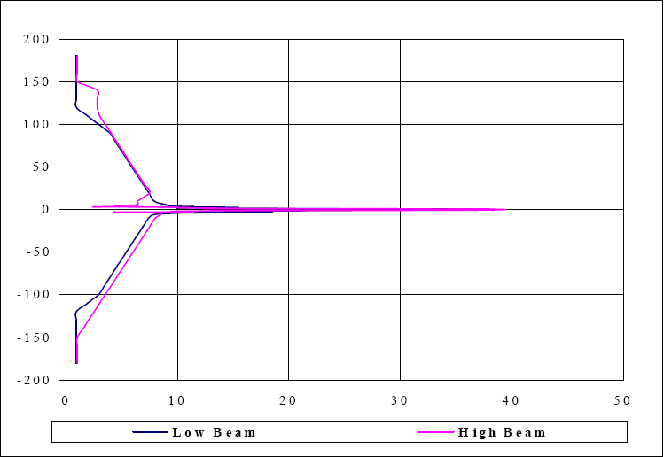
Figure 22: Typical horizontal antenna pattern of a primary radar
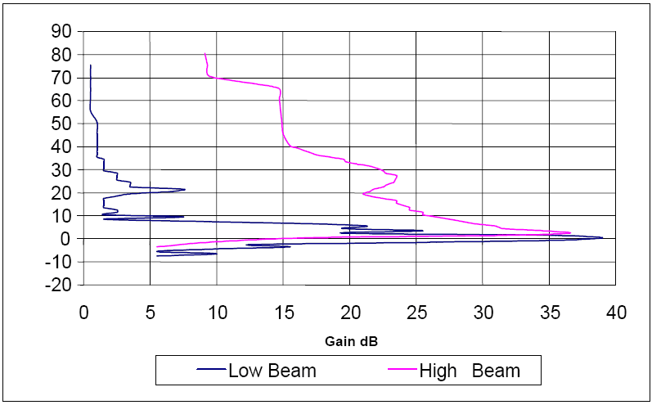
Figure 23: Vertical antenna pattern of a primary radar

Compatibility criteria
According to the Recommendation ITU-R M.1463-1 [11] considering c) and recommends 3 and 4, the radio determination service is a safety service as specified by No. 4.10 of the Radio Regulations (RR) and harmful interference to it cannot be accepted. In the case of continuous (non-pulsed) interference, an interfering signal power to radar receiver noise power level, I/N, of –6 dB should be used as the required protection level for the radio determination radars, and that this level represents the net protection level if multiple interferers are present.
The text in the overview of RDS section suggests that because of the signal processing techniques, radars can cope with low-duty cycle (less than 5%) asynchronous interference. However the duty cycle of a single PL is of the order of 7 - 10 % and the duty cycle of whole PL-system is of the order of 20 - 35 %. That is why it will be assumed in the first instance that the interference from pseudolite signals is continuous from the radar receiver point of view.
It should be noted that the compatibility analysis was performed without additional 6 dB aviation safety margin. The calculated separation distances would be doubled at short ranges if safety margin is applied.

Results of studies
Due to the high antenna gain and sensitivity of radars the separation distances calculated using MCL-method, are rather large already in the case of low power continuous wave pseudolites being about 450 meters in the radar antenna main beam. In the case of pulsing pseudolite the distance is unacceptably large, 75 kilometres (beyond the radio horison – the pseudolite is no longer in visibility from the radar) from the radar antenna main beam and about 13 kilometres from the antenna sidelobes.
The correlated SEAMCAT simulations in the next Table 29 show similarity to MCL-calculations if we take into account the small diffraction loss added to the MCL-results in pulsed PL case. The statistical SEAMCAT approaches show very high interference probabilities of the order of 30 - 90 %.
For more details see the Annex 3.
Table 29: PLs to RDS (radar) separation distance calculated using MCL-method
Frequency Band [MHz] | Intefering System | Victim Service and System | MCL Separation Distance | MCL Conclusions
1215-1300 | CW PLs  (-70 dBm) | RDS, radar rx, ant. Mainbeam | 450 metres | Interference probabability low
1215-1300 | CW PLs  (-70 dBm) | RDS, radar rx, ant. Sidelobe | 10 metres | Interference probability very low
1215-1300 | CW PLs indoor | RDS, radar rx, ant. Mainbeam | 200 metres | Interference probabability low
1215-1300 | CW PLs indoor | RDS, radar rx, ant. Sidelobe | 10 metres | Interference probability very low
1215-1300 | pulsing PLs  (0 dBm) | RDS, radar rx, ant. Mainbeam | 75 kilometres | Interference probability very high
1215-1300 | pulsing PLs  (0 dBm) | RDS, radar rx, ant. Sidelobe | 13 kilometres | Interference probability very high

Table 30: PLs to RDS (radar) summary of SEAMCAT simulation results
Frequency Band [MHz] | Intefering System | Victim Service and System | SEAMCAT models | SEAMCAT Conclusions
1215-1300 | CW PLs  (-70 dBm) | RDS S5 | Single PL correlated case; no distributions used; separation distance 0.45km; I/N criteria -6dB | Interference probability jumps to 1 on PLs Pwrlevel of -70 dBm, which is in line with the MCL case
1215-1300 | CW PLs  (-70 dBm) | RDS S5 | 6 PLs in RDS rx vicinity (density 0,003, activity factor 100%); I/N criteria -6dB | Interference probability 0.045%
1215-1300 | CW PLs  (-70 dBm) | RDS S5 | 6 PLs in RDS rx vicinity (density 0.1, protection distance 100m, activity factor 100%); I/N criteria -6dB | Interference probability 1.4%
1215-1300 | Pulsed PLs (0 dBm) | RDS S5 | Single pulsed PL correlated case; no distributions used; separation distance 75km; I/N criteria -6dB | Interference probability jumps to 1 on PLs Pwrlevel of ~-26 dBm, which is in line with the MCL case after the diffraction loss  (-26.6dBm) is taken into account
1215-1300 | Pulsed PLs (0 dBm) | RDS S5 | Single pulsed PL to radar S5, antenna height is 15m, activity factor 100%, protection distance 100m, density 0.003, I/N=-6dB | Interference probability 84%
1215-1300 | Pulsed PLs (0 dBm) | RDS S5 | Single pulsed PL to radar S5, antenna height 15 meters, activity factor 100%, protection distance 10km, density 0.0001, I/N= -6dB | Interference probability 7%

earth exploration satellite service (eesS)

System overview of EESS (ref. Recommendation ITU-R RS.1166-3 [7])
The ITU-R RR Article 5 [16] allocates the bands 1215-1240 and 1240-1300 MHz to active Earth Exploration-Satellite Service. The systems are called space borne active imaging radar sensors or Synthetic Aperture Radars (SARs).
SARs are used in space to typically produce radar image maps of the terrain below as the spacecraft motion creates a synthetic aperture over a typical aperture time of only 0.2-1.5 s.

Necessary technical parameters for the compatibility studies (ref. Recommendation ITU-R RS.1347 [14])
Table 31: Typical SAR parameters for the compatibility studies
System | Pulse bandwidth [MHz] | Maximum antenna gain [dBi] | Antenna orientation [deg. from nadir] | Antenna polarization | Orbital altitude [km] | Minimum desired signal * [dBm] | Noise level [dBm] * | Compatibility criterion
SAR 1 | 40 | 36.4 | 20 | linear, vertical/ horizontal | 400 | -156.5 | -97.7 | I/N = -6
SAR 2 | 15 | 33 | 35 | linear horizontal | 568 | No information | No information | I/N = -6
* Ref. Recommendation ITU-R RS.1166-3 [7]

Typical antenna pattern(s) of the EESS system
The EESS systems see the interference only from the antenna main beam. The maximum antenna gain is mentioned in the table. With this assumption the typical antenna pattern is not required.

Compatibility criteria (ref. Recommendation ITU-R RS.1166-3 [7])
The interference criterion for synthetic aperture radars is an interference-to-noise ratio (I/N) of –6 dB, which corresponds to a 10% performance degradation of the standard deviation of SAR pixel power. The radius of a SAR antenna footprint is 10 - 20 kilometers.

Results of studies
Here only the EESS satellite main beam case needs to be considered. According to the MCL-calculation a single high power, pulsing pseudolite does not interfere these EESS systems. However the criterion may be exceeded if many pulsing pseudolite systems transmit simultaneously in the EESS antenna main beam (about 20 x 20 km).
See Table 32 and Table 33 for more details.
Table 32: PLs to EESS separation distance calculated using MCL-method
Frequency Band [MHz] | Intefering System | Victim Service and System | MCL Separation Distance | MCL Conclusions
1215-1300 | pulsing PLs (0 dBm) | EESS active, SAR 1 | 425 kilometers | Interference probability very low
1215-1300 | pulsing PLs (0 dBm) | EESS active, SAR 2 | 693 kilometers | Interference probability very low

Table 33: PLs to EESS SAR1 and SAR2, summary of SEAMCAT simulation results
Frequency Band [MHz] | Intefering System | Victim Service and System | SEAMCAT models | SEAMCAT Conclusions
1215-1300 | pulsing PLs (0 dBm) | EESS SAR1 | Single pulsed PL in SAR1 rx vicinity, correlated case, separation distance 425km | Interference probability jumps to 1 on PLs Pwrlevel of 0dBm; in line with the MCL case
1215-1300 | pulsing PLs (0 dBm) | EESS SAR1 | Single pulse transmitting PL to SAR1; uniform distributions (PL transmitter density 0,0025 1/km2); Interference probability in 0.105% | Interference probability 0.1 %
1215-1300 | pulsing PLs (0 dBm) | EESS SAR1 | Six pulse transmitting PLs to SAR1; Uniform distributions (PL transmitter density 0.015 1/km2) | Interference probability 2.1 %
1215-1300 | pulsing PLs (0 dBm) | EESS SAR2 | Single pulsed PL in SAR2 rx vicinity, correlated case, separation distance 693 km | Interference probability jumps to 1 on PLs Pwrlevel of 0dBm; in line with the MCL case
1215-1300 | pulsing PLs (0 dBm) | EESS SAR2 | Single pulse transmitting PL to SAR2; Uniform distributions (PL transmitter density 0.0025 1/km2 | Interference probability 0 %
1215-1300 | pulsing PLs (0 dBm) | EESS SAR2 | Six pulse transmitting PLs to SAR2; Uniform distributions (PL transmitter density 0.015 1/km2) | Interference probability 0%

radio astronomy Service (RAS)
A separation distance between the pseudolite location and a radio astronomy station depending on the unwanted emission power of the pseudolite falling within the RAS band would be sufficient to protect the RAS station from detrimental interference.
Figure 24 shows the unwanted emission power spectral density vs the separation distance for a radio astronomy station located in France, assuming a flat terrain and a 0 dBi antenna gain for both the RAS station and the pseudolite (the pseudolite is assumed not to be pointed towards the RAS station). Recommendation ITU-R P.452-13 [12] was used with a time percentage of 2% to derive this figure.
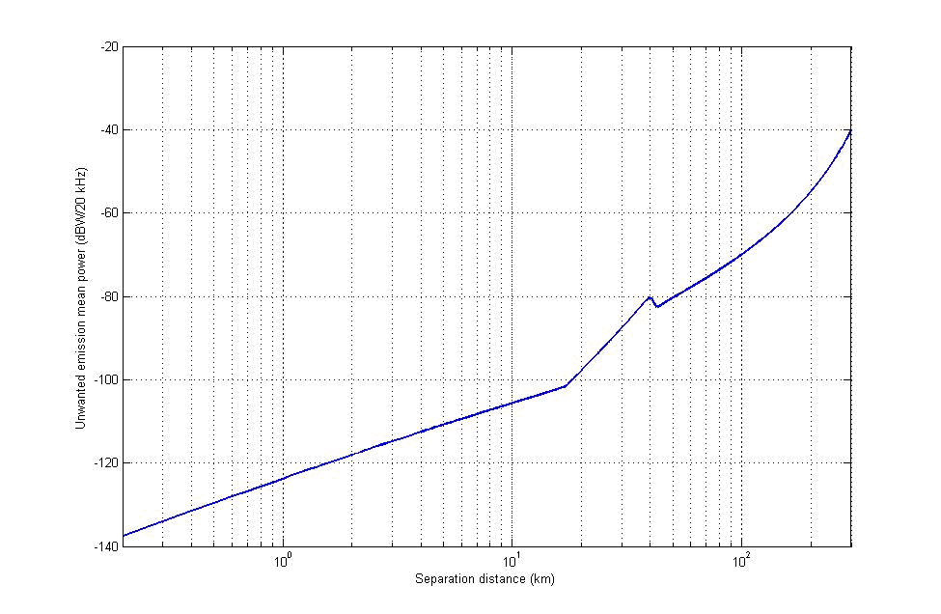
Figure 24: Unwanted emission power spectral density vs the separation distance for a radio astronomy station located in France
The peak emission power of pulsed pseudolites is 0dBm in 2 to 10MHz, associated with a duty cycle of 7 to 10%. The maximum mean power spectral density in the RNSS band is therefore -60dBW/20 kHz. As an example, assuming 30dB attenuation due to the waveform and a possible additional output filter, the unwanted mean emission power would be around -90dBW/20 kHz, leading to separation distances of around 25km.
This generic case may be considered as a worst case scenario since it does not take into account any terrain particularities. In practice, the separation distance should be calculated on a case by case basis using the actual terrain particularities existing around the radio astronomy station. The next Figure 25 and Figure 26 show the required unwanted emission mean power (in dBW/20 kHz) around the location of Nançay in France, taking into account the terrain elevation around the RAS station. Still assuming a 30 dB rejection for unwanted emissions, only the dark blue area around the RAS station would have to be avoided.
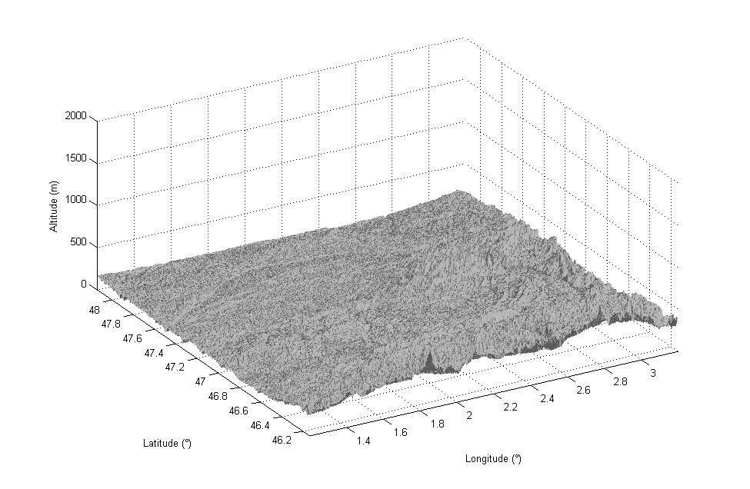
Figure 25 : Terrain elevation around the RAS station
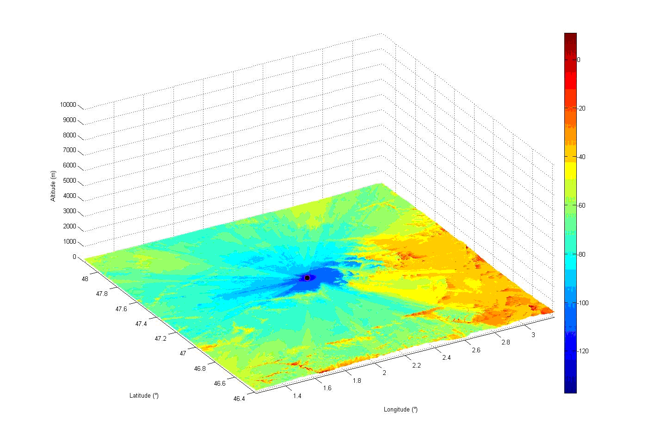
Figure 26: Required unwanted emission mean power (in dBW/20 kHz) around the location of Nançay in France, taking into account the terrain elevation around the RAS station

Single interferer case
Table 15 shows the results of a study to determine the minimum separation distance between an observatory of the RAS and a single interferer indoor PL of various types drawn from those currently proposed. The parameters varied for the PL are listed in the table. In addition for all cases the following were used :
  - Necessary BW: 2-10 MHz
  - PL antenna height: 20m
  - PL antenna gain: 0 dBi [assumption to correspond to an antenna orientated so as to point away from the observatory].

Each case has a calculation for additional building losses of 8 dB (from the CEPT BWA buildings analysis report) and 0 dB, the former corresponding to a normally mounted device inside a building and the latter to one mounted at an aperture of a building.
The detrimental threshold level for protection of the RAS (S_{H}) was taken from Recommendation ITU-R RA.769-2 [7] for spectroscopy in this band (S_{H} = -237 dB(Wm⁻²Hz⁻¹)) and a PL emitted spectral power flux density (S_{PL}) was calculated for each case in the appropriate bandwidth. Hence the total path attenuation needed (L_{prot}) for the system to deliver the required protection level was determined as follows:
L_{prot} = S_{H} – S_{PL} – G_{M} - G_{A} - G_{OOB} ₍₈₎
where:
- G_{M} = total of mitigating factors (e.g. duty cycle, building allowance, etc)
- G_{A} = antenna gain (0dBi)
- G_{OOB} = correction for OOB emissions into the RAS band (-30dB)
The minimum distance to provide the required path loss was then calculated based on equations in Recommendation ITU-R P.452-13 [12] (rural clutter assumed).
Table 34: Minimum separation distances for single interferers
Type | Tx Power (dBm) CW or during pulse | Duty cycle (%) | Building loss (dB) | Minimum separation distance (km) | Path Loss required for protection (dB)
CW | -61* | 100 | 8 | 0.023 | 63.9
CW | -70† | 100 | 8 | 0.008 | 54.9
CW | -61* | 100 | 0 | 0.058 | 71.9
CW | -70† | 100 | 0 | 0.021 | 62.9
Pulsed | 0§ | 7 | 8 | 8.7 | 113
Pulsed | 0§ | 35 | 8 | 21.2 | 120
Pulsed | 0§ | 7 | 0 | 23.0 | 121
Pulsed | 0§ | 35 | 0 | 32.4 | 128
* Corresponds to an into building e.i.r.p. of -50dBm
† Corresponds to an into building e.i.r.p. of -59dBm
§ Corresponds to an into building e.i.r.p. of 11dBm during a pulse.

It should be clearly noted that the minimum separation distances presented are calculated on the assumptions given, particularly that of an additional 30 dB of attenuation for emissions falling into the RAS band. This figure was proposed as a guideline for that achievable via waveform shaping and a possible additional filter on the transmitter output.
The minimum separation distance given should be considered to be for an observatory in relatively flat, open rural land such as Westerbork (NL), Nançay (FR) or Jodrell Bank (UK). Observatories located in areas with potentially significant terrain shielding (e.g. Effelsberg, (DE), or Onsala, (SE)) might achieve smaller separation distances commensurate with the actual path loss seen between the transmitter and the observatory.
Potential pulsed PL deployment at smaller distances from an observatory than those shown could be assessed using a commercial path loss prediction tool and an appropriate terrain & clutter database. This, together with reduction in transmitter pulse power, careful choice of physical location in the building, manipulation of the transmit antenna pattern in situ (additional shielding), reduction in duty cycle, etc. may allow deployment without interference to the observatory.
The minimum separation distances for CW PLs are so small as to be physically on the property of the observatory concerned and it is unlikely that a need for them would arise there. Given the assumptions and transmit powers stated, indoor CW PLs appear to pose little threat to the RAS.

Aggregation
A study on aggregate effects has yet to be completed. Any significant density of deployment of PLs around an observatory is likely to require a larger co-ordination zone.

Conclusions for the RAS
Based the assumptions made in the study, it is concluded:
For CW PLs
- Compatibility between CW PLs and the RAS is possible
For Pulsed PLs:
- Compatibility between pulsed PLs and the RAS is possible if there is an adequate separation distance between Pseudolites and a Radio Astronomy Station. A co-ordination zone of 33 km should be adopted around observatories of the RAS and deployment of pulsed PLs within this zone should be assessed on a case by case basis for non-interference. Terrain effects between the PL and observatory may facilitate deployment at reduced distances. This might be assessed using a path loss prediction tool with an appropriate terrain and clutter database. In addition, reduction in transmitter pulse power, careful choice of physical location, manipulation of the transmit antenna pattern in situ (additional shielding), reduction in duty cycle, etc. may also be used in combination to meet the requirements of Recommendation ITU-R RA.769-2 [8].

Conclusions

Band 1164-1215 MHz, RNSS
Radio Navigation Satellite Systems are spread spectrum systems. Because of the similarities between RNSS and PL systems, the RNSS receiver tolerates more or less the PL wideband interference depending on the nature and characteristics of the PL signal.
The RNSS receiver tolerates also to some extent pulsed interference. The RNSS receiver saturates during the interfering pulse, but after short recovery time can receive the slightly degraded satellite signals. However, the maximum acceptable pulse duty cycle for all pulsing pseudolites in the vicinity of RNSS receiver still has to be determined.
Compatibility between continuously transmitting pseudolites deployed in an indoor environment and RNSS is feasible under the following conditions:
- A specific attention should be given to the use of pseudolites operating in light indoor environment, i.e. close to large apertures (e.g. doors, windows,). In this case, in the absence of mitigation techniques and assuming an e.i.r.p. of -59dBm, a separation distance of up to 190m can be necessary to ensure the protection of non-participating receivers. In order to reduce the potential interference level for lower separation distances, the following measures could be taken:
    - Reduce the PL e.i.r.p. to -65dBm above 0°elevation;
    - Avoiding PL deployment close to large aperture or implementing additional attenuation with shielding material;
    - Reducing the PL maximum e.i.r.p.
    - Optimization of the pseudolite signal.

- The impact of PLs on outdoors non-participating receivers differs depending on the type of PRN codes that is used by the PLs (i.e. dedicated or non-dedicated codes). In the case non-dedicated PRN codes are used, this area of potential performance degradation is much larger than with dedicated codes and separation distances up to 1.5km are necessary to guarantee the integrity of non-participating receivers (those used for safety applications). The impact in this area is an increase of the Time-To-First-Fix of non-participating receivers in cold start.

In order to reduce the potential interference level for lower separation distances, the following measures could be taken:
    - Reduce the PL e.i.r.p. to -65dBm above 0°elevation;
    - Avoiding PL deployment close to large aperture or implementing additional attenuation with shielding material;
    - Reducing the PL maximum e.i.r.p.

In addition, in order to avoid non-participating receivers using the RNSS code allocated to other systems (i.e. satellites), it is recommended to broadcast on the PLs a modified navigation message to ensure that the signal source validity is identified.

Moreover, PL signals can monopolize some reception channels of non-participating receiver, even after the acquisition resolved. Therefore, non-participating receiver could have an insufficient number of available channels to receive satellite signals. It is recommended to limit the number of different non dedicated PL codes to 6, and in case of dedicated PL code to develop the associated receiver with an increased number of reception channels.

Finally, it is necessary to ensure that a failure of the software management system used to allocate the satellite PRN codes to the PLs will never occur. For use in any area where safety is an issue, this software must be proven to be using well known safety case assessment procedures.
Therefore, the use of non-dedicated code should only correspond to experimental purpose for a limited duration under specific regulation approval. The implementation of dedicated code for pseudolite is part of the modification of firmware expected from chipset manufacturer to meet mass market requirements. In view of the unknown effect to all non-participating receiver designs associated with the use of non visible satellite PRN codes by pseudolites, this method is not recommended for operational use.

- Using dedicated code will avoid the type of impact described in b) and is thus recommended as soon as possible (as soon as mass market chipsets are able to process such dedicated codes). Moreover, the use of longer codes will also improve the compatibility with non-participating receivers as well as the performance of participating receivers. In case of mass market deployment, the use of dedicated code is the solution to grant no interference described in b) with non-participating GPS receiver

- It is not possible to determine a reasonable separation distance (i.e. much lower than the building dimensions) between the pseudolites and a non-participating GNSS receiver located in the same building. Therefore, this kind of non-participating GNSS receiver cannot be protected.

- The studies of the aggregate effect of PL on aeronautical receivers show that in average, the PL density deployed in an indoor environment should be limited to 6 PL/km² if the e.i.r.p. is -59dBm and 24 PL/km² if the e.i.r.p. is limited to -65dBm (or if equivalent mitigation techniques are applied). It should be noted that these values correspond to average numbers, which may be exceeded locally, depending on the result of case by case studies on the impact of the pseudolite deployment on other RNSS users (in particular with safety of life applications).

In sensitive areas like airport, the studies show that mitigation techniques should be applied. Moreover, since the aggregated effect really depends on the real deployment conditions, case by case studies should also be necessary before any deployment.

Compatibility between pulse transmitting pseudolites and RNSS is feasible under the following conditions:

- A specific attention should be given to the use of pseudolites operating in outdoor environment. In this case, in the absence of mitigation techniques and assuming a mean e.i.r.p. of -59dBm and an SNR loss of 1 dB for any kind of non-aeronautical receiver / for high precision receiver, a separation distance of up to respectively 120m/96m can be necessary to ensure the protection of non-participating non-aeronautical receivers. In order to protect aeronautical receivers the PL mean e.i.r.p. should be reduced to -65dBm above 0°elevation. In order to reduce the potential interference level for lower separation distances or increase the mean on-axis e.i.r.p., the following measures could be taken:
    - Optimization of the pseudolite signal
    - To accept locally (inside the intended coverage area) an SNR loss of 3 dB.

- The peak power of pulsed pseudolites can be up to 10 log (duty cycle) above the mean power.

- The use of dedicated codes is recommended. Moreover, the use of longer codes will also improve the compatibility with non-participating receivers as well as the performance of participating receivers.

- The studies of the aggregate effect of PL on aeronautical receivers show that in average, the PL density should be limited to 2 (6) PL/km² if the mean e.i.r.p. is -59dBm for outdoor (indoor) usage and 6 (24) PL/km² if the mean e.i.r.p. is limited to -65dBm (or if equivalent mitigation techniques are applied above 0 degree elevation angle) for outdoor (indoor) usage. It should be noted that these values correspond to average numbers, which may be exceeded locally, depending on the result of case by case studies on the impact of the pseudolite deployment on other RNSS users (in particular with safety of life applications).

- In sensitive areas like around airport, the studies show that mitigation techniques should be applied. Moreover, since the aggregated effect really depends on the real deployment conditions, case by case studies should also be necessary before any deployment.

Band 1164-1215 MHz, ARNS
Aeronautical Radio Navigation Service (ARNS) is a safety related service and should be carefully protected from interference. The protection criterion is I/N = - 23 dB and does not include any relaxation for example as function of time (Fractional Degradation of Performance, FDP). The ARNS receivers are located on board aircraft on all altitudes up to 12000 meters and the radio propagation environment is already rather difficult.
An aggregated PFD limit of -144.5 dBW/m²/MHz to protect ARNS from RNSS was assumed.
Compatibility between continuously transmitting pseudolites and ARNS would not be easily feasible, and in particular around airports areas.
Compatibility between Pulse transmitting pseudolites and ARNS is not feasible.

Band 1215-1300 MHz, RNSS
Radio Navigation Satellite Systems are spread spectrum systems. Because of the similarities between RNSS and PL systems, the RNSS receiver tolerates more or less the PL wideband interference depending on the nature and characteristics of the PL signal.
The RNSS receiver tolerates also to some extent pulsed interference. The RNSS receiver saturates during the interfering pulse, but after short recovery time can receive the slightly degraded satellite signals. However, the maximum acceptable pulse duty cycle for all pulsing pseudolites in the vicinity of RNSS receiver still has to be determined.
Compatibility between continuously transmitting pseudolites deployed in an indoor environment and RNSS is feasible under the following conditions:
- A specific attention should be given to the use of pseudolites operating in light indoor environment, i.e. close to large apertures (e.g. doors, windows,…). In this case, in the absence of mitigation techniques, and assuming an e.i.r.p. of -59dBm, a separation distance of up to 185m can be necessary to ensure the protection of non-participating receivers. In order to reduce the potential interference level for lower separation distances, the following measures could be taken:
- Reduce the PL e.i.r.p. to -65dBm above 0°elevation
- Avoiding PL deployment close to large aperture or implementing additional attenuation with shielding material;
- Reducing the PL maximum e.i.r.p.
- Optimization of the pseudolite signal.

- In the case non-dedicated PRN codes are used, this area of potential performance degradation is much larger than with dedicated codes and separation distances up to 1.5km are necessary to guarantee the integrity of non-participating receivers (those used for safety applications). The impact in this area is an increase of the Time-To-First-Fix of non-participating receivers in cold start.

In order to reduce the potential interference level for lower separation distances, the following measures could be taken:
- Reduce the PL e.i.r.p. to -65dBm above 0° elevation;
- Avoiding PL deployment close to large aperture or implementing additional attenuation with shielding material;
- Reducing the PL maximum e.i.r.p.

In addition, in order to avoid non-participating receivers using the RNSS code allocated to other systems (i.e. satellites), it is recommended to broadcast on the PLs a modified navigation message to ensure that the signal source validity is identified.

Moreover, PL signals can monopolize some reception channels of non-participating receiver, even after the acquisition resolved. Therefore, non-participating receiver could have an insufficient number of available channels to receive satellite signals. It is recommended to limit the number of different non dedicated PL codes to 6, and in case of dedicated PL code to develop the associated receiver with an increased number of reception channels.

Finally, it is necessary to ensure that a failure of the software management system used to allocate the satellite PRN codes to the PLs will never occur. For use in any area where safety is an issue, this software must be proven to be using well known safety case assessment procedures.

Therefore, the use of non-dedicated code should only correspond to experimental purpose for a limited duration under specific regulation approval. The implementation of dedicated code for pseudolite is part of the modification of firmware expected from chipset manufacturer to meet mass market requirements.

In view of the unknown effect to all non-participating receiver designs associated with the use of non-visible satellite PRN codes by pseudolites, this method is not recommended for operational use.

- Using dedicated code will avoid the type of impact described in b) and is thus recommended as soon as possible (as soon as mass market chipsets are able to process such dedicated codes). Moreover, the use of longer codes will also improve the compatibility with non-participating receivers as well as the performance of participating receivers. In case of mass market deployment, the use of dedicated code is the solution to grant no interference described in b) with non-participating GPS receiver.

- It is not possible to determine a reasonable separation distance (i.e. much lower than the building dimensions) between the pseudolites and a non-participating GNSS receiver located in the same building. Therefore, this kind of non-participating GNSS receiver cannot be protected.

- The studies of the aggregate effect of PL on aeronautical receivers show that in average, the PL density should be limited to 12 PL/km² if the e.i.r.p. is -59dBm and 48 PL/km² if the e.i.r.p. is limited to -65dBm (or if equivalent mitigation techniques are applied). It should be noted that these values correspond to average numbers, which may be exceeded locally, depending on the result of case by case studies on the impact of the pseudolite deployment on other RNSS users (in particular with safety of life applications).
In sensitive areas like airport, the studies show that mitigation techniques should be applied. Moreover, since the aggregated effect really depends on the real deployment conditions, case by case studies should also be necessary before any deployment.

Compatibility between pulse transmitting Pseudolites and RNSS is feasible under the following conditions:

- A specific attention should be given to the use of pseudolites operating in outdoor environment. In this case, in the absence of mitigation techniques and assuming a mean e.i.r.p. of -59dBm and an SNR loss of 1 dB for any kind of non-aeronautical receiver / for high precision receiver, a separation distance of up to respectively 116m/92m can be necessary to ensure the protection of non-participating non-aeronautical receivers. In order to protect aeronautical receivers the PL mean of-axis e.i.r.p. should be reduced to -65dBm above 0°elevation. In order to reduce the potential interference level for lower separation distances or increase the mean on-axis e.i.r.p., the following measures could be taken:
    - Optimization of the pseudolite signal
    - To accept locally (inside the intended coverage area) an SNR loss of 3 dB.

- The peak power of pulsed pseudolites can be up to 10 log (duty cycle) above the mean power.

- The use of dedicated codes is recommended. Moreover, the use of longer codes will also improve the compatibility with non-participating receivers as well as the performance of participating receivers.

- The studies of the aggregate effect of PL on aeronautical receivers show that in average, the PL density should be limited to 2 (12) PL/km² if the mean e.i.r.p. is -59dBm for outdoor (indoor) usage and 10 (48) PL/km² if the mean e.i.r.p. is limited to -65dBm (or if equivalent mitigation techniques are applied above 0 degree elevation angle) for outdoor (indoor) usage. It should be noted that these values correspond to average numbers, which may be exceeded locally, depending on the result of case by case studies on the impact of the pseudolite deployment on other RNSS users (in particular with safety of life applications).

In sensitive areas like around airport, the studies show that mitigation techniques should be applied. Moreover, since the aggregated effect really depends on the real deployment conditions, case by case studies should also be necessary before any deployment.

Band 1215-1300 MHz, RDS
Radiodetermination Service (RDS) is a safety related service and should be carefully protected from interference. The protection criterion considered is I/N = - 6 dB to be met 100% of the time.
Due to the high antenna gain and sensitivity of radars the separation distances are rather large already in the case of continuously transmitting Pseudolites, becoming unacceptable in the case of pulse transmitting Pseudolites.
Compatibility between Pseudolites and Radio determination Service is possible if
- There is a frequency separation between Pseudolites and radars
or
- There is a separation distance between Pseudolites and radars.

It should be noted that the compatibility analysis was performed without additional 6 dB aviation safety margin. Use of safety margin does not change the conclusions.

Band 1215-1300 MHz, EESS
An EESS system scans the surface of the Earth with its antenna main beam. During scan the antenna footprint is about 20 km x 20 km area. One single pulse transmitting Pseudolite in the antenna footprint cannot cause interference to EESS systems. If the number of Pseudolites in the footprint increases aggregated average interference power level in the EESS receiver may be exceeded.
Compatibility between continuously transmitting Pseudolites and EESS is feasible.
Compatibility between pulse transmitting Pseudolites and EESS is also feasible due to the high processing gain of the SAR system.

Band 1559-1610 MHz RNSS
Radio Navigation Satellite Systems are spread spectrum systems. Because of the similarities between RNSS and PL systems, the RNSS receiver tolerates more or less the PL wideband interference depending on the nature and characteristics of the PL signal.
The RNSS receiver tolerates also to some extent pulsed interference. The RNSS receiver saturates during the interfering pulse, but after short recovery time can receive the slightly degraded satellite signals. However, the maximum acceptable pulse duty cycle for all pulsing pseudolites in the vicinity of RNSS receiver still has to be determined.
Compatibility between continuously transmitting pseudolites deployed in an indoor environment and RNSS is feasible under the following conditions:
- The increase of the PLs e.i.r.p. from -59dBm to -50dBm will create additional interference on outdoor non-participating receivers. A specific attention should be given to the use of pseudolites operating in light indoor environment, i.e. close to large apertures (e.g. doors, windows). In this case and in the absence of mitigation techniques, with a maximum PL e.i.r.p. of -50dBm, a separation distance of up to 350m can be necessary to ensure the protection of non-participating receivers. In order to reduce the potential interference level for lower separation distances, the following measures could be taken:
    - Reduce the maximum PL e.i.r.p. by 6dB above 0°elevation ;
    - Avoiding PL deployment close to large aperture or implementing additional attenuation with shielding material;
    - Reducing the PL maximum e.i.r.p.
    - Optimization of the pseudolite signal.

Under these conditions, and with a more typical receiver sensitivity of 25dBHz, a separation distance of between 18 m and 51 m (corresponding to PLs maximum e.i.r.p. of -59dBm and -50dBm respectively) will have to be maintained between any PL and outdoor non-participating receivers.

- In the case non-dedicated PRN codes are used, this area of potential performance degradation is much larger than with dedicated codes and separation distances of 1.1km to 2km are necessary to guarantee the integrity of non-participating receivers (those used for safety applications). The impact in this area is an increase of the Time-To-First-Fix of non-participating receivers in cold start.

In order to reduce the potential interference level for lower separation distances, the following measures could be taken:
    - Reduce the maximum PL e.i.r.p. by 6dB above 0°elevation .Avoiding PL deployment close to large aperture or implementing additional attenuation with shielding material;
    - Reducing the PL maximum e.i.r.p.

Under these conditions, and with a more typical receiver sensitivity of 25dBHz, a separation distance of between 143 m and 403 m (corresponding to PLs maximum e.i.r.p. of -59dBm and -50dBm respectively) will have to be maintained between any PL and outdoor non-participating receivers. In some sensitive areas like airports, a case-by-case interference analysis is recommended to evaluate the potential risk associated to a PL deployment proposal.

In addition, in order to avoid non-participating receivers using the RNSS code allocated to other systems (i.e. satellites), it is recommended to broadcast on the PLs a modified navigation message to ensure that the signal source validity is identified.

Moreover, PL signals can monopolize some reception channels of non-participating receiver, even after the acquisition resolved. Therefore, non-participating receiver could have an insufficient number of available channels to receive satellite signals. It is recommended to limit the number of different non dedicated PL codes to 6, and in case of dedicated PL code to develop the associated receiver with an increased number of reception channels.

Finally, it is necessary to ensure that a failure of the software management system used to allocate the satellite PRN codes to the PLs will never occur. For use in any area where safety is an issue, this software must be proven to be using well known safety case assessment procedures.

Therefore, the use of non-dedicated code should only correspond to experimental purpose for a limited duration under specific regulation approval. The implementation of dedicated code for pseudolite is part of the modification of firmware expected from chipset manufacturer to meet mass market requirements.

In view of the unknown effect to all non-participating receiver designs associated with the use of non-visible satellite PRN codes by pseudolites, this method is not recommended for operational use.

- Using dedicated code will avoid the type of impact described in b) and is thus recommended as soon as possible (as soon as mass market chipsets are able to process such dedicated codes). Moreover, the use of longer codes will also improve the compatibility with non-participating receivers as well as the performance of participating receivers. In case of mass market deployment, the use of dedicated code is the solution to grant no interference described in b) with non-participating GPS receiver.

- It is not possible to determine a reasonable separation distance (i.e. much lower than the building dimensions) between the pseudolites and a non-participating GNSS receiver located in the same building. Therefore, this kind of non-participating GNSS receiver cannot be protected.

- The studies of the aggregate effect of PL on aeronautical receivers show that in average, the PL density should be limited to 2.5 PL/km² if the e.i.r.p. is -50dBm and 11.8 PL/km² if the e.i.r.p. is limited to -59dBm (or if equivalent mitigation techniques are applied). It should be noted that these values correspond to average numbers, which may be exceeded locally, depending on the result of case by case studies on the impact of the pseudolite deployment on other RNSS users (in particular with safety of life applications).
In sensitive areas like airport, the studies show that the e.i.r.p. should be limited to -59dBm and mitigation techniques applied. Moreover, since the aggregated effect really depends on the real deployment conditions, case by case studies should also be necessary before any deployment.

Compatibility between pulse transmitting pseudolites and RNSS is feasible under the following conditions:

- A specific attention should be given to the use of pseudolites operating in outdoor environment. In this case, in the absence of mitigation techniques and assuming a mean e.i.r.p. of -50dBm and an SNR loss of 1dB for any kind of non-aeronautical receiver / for high precision receiver / for the measured non-aeronautical receivers, a separation distance of up to respectively 255m/200m/77m can be necessary to ensure the protection of non-participating non-aeronautical receivers. In order to protect aeronautical receivers the PL mean e.i.r.p. should be reduced to -65dBm above 0°elevation. In order to reduce the potential interference level for lower separation distances or increase the mean on-axis e.i.r.p., the following measures could be taken:
    - Optimization of the pseudolite signal
    - To accept locally (inside the intended coverage area) an SNR loss of 3 dB

- The peak power of pulsed pseudolites can be up to 10 log (duty cycle) above the mean power.
- The use of dedicated codes is recommended. Moreover, the use of longer codes will also improve the compatibility with non-participating receivers as well as the performance of participating receivers.
The studies of the aggregate effect of PL on aeronautical receivers show that in average, the PL density should be limited 4 (6) PL/km² if the mean e.i.r.p. is -59dBm for outdoor (indoor) usage and 18 (24) PL/km² if the mean e.i.r.p. is limited to -65dBm (or if equivalent mitigation techniques are applied above 0 degree elevation angle) for outdoor (indoor) usage. It should be noted that these values correspond to average numbers, which may be exceeded locally, depending on the result of case by case studies on the impact of the pseudolite deployment on other RNSS users (in particular with safety of life applications).
- In sensitive areas like around airport, the studies show that mitigation techniques should be applied. Moreover, since the aggregated effect really depends on the real deployment conditions, case by case studies should also be necessary before any deployment.

RAS in the Adjacent Band 1610.6-1613.8 MHz
Based the assumptions made in the study, it is concluded:
For CW PLs
- Compatibility between CW PLs and the RAS is possible
For Pulsed PLs:
- Compatibility between pulsed PLs and the RAS is possible if there is an adequate separation distance between pseudolites and a Radio Astronomy Station. A co-ordination zone of 33 km should be adopted around observatories of the RAS and deployment of pulsed PLs within this zone should be assessed on a case by case basis for non-interference. Terrain effects between the PL and observatory may facilitate deployment at reduced distances. This might be assessed using a path loss prediction tool with an appropriate terrain and clutter database. In addition, reduction in transmitter pulse power, careful choice of physical location, manipulation of the transmit antenna pattern in situ (additional shielding), reduction in duty cycle, etc. may also be used in combination to meet the requirements of Recommendation ITU-R RA.769 [8].

- Comparison of measurement and composite loss model
To test the validity of the composite loss model [5], two receivers were used to evaluate the loss induced by a pulsed pseudolite signal. The tests were performed in conducted mode using two GSG-L1 signal generators: one transmitting a continuous wave signal (simulating a satellite) and one transmitting a pulsed signal (simulating a pulsed pseudolite). The signal power for the CW signal was set so that the receiver under test showed a carrier-to-noise level of approximately 44 dBHz in the absence of the pulsed signal. The loss was then evaluated as the difference between carrier-to-noise values in the presence and absence of the pulsed pseudolite signal.
Two receivers, a high-precision NovAtel OEMV and a high sensitivity Fastrax IT03 were tested. For both receivers, three different duty cycle values were used and the power level of the pulsed signal was varied.
  - High precision receiver (NovAtel OEMV)
The results for NovAtel OEMV receiver are shown in the three figures below. In addition to the measured loss values (circles), the figures show the composite loss model for a 2-bit receiver. The composite loss model predicts the measured loss reasonably well, perhaps with the exception of a low duty cycle (4.3%) and high power level (effective pseudolite C/N0 > 90 dB-Hz).
Figure 27: Duty cycle 4.3%
Figure 28: Duty cycle 6.7%
Figure 29: Duty cycle 4.3%
  - General purpose receiver (Fastrax IT03)
The results for Fastrax IT03 receiver are shown in the following three figures. In addition to the measured loss values (circles), the figures show the composite loss model for a single-bit receiver. In this case the composite loss model predicts the measured loss otherwise well but underestimates the loss in the saturation region. For effective pseudolite C/N0 values above 75 dB-Hz, the measured loss seems to be between the values predicted by the composite model for single- and two-bit receivers
Figure 30: Duty cycle 9.4%
Figure 31: Duty cycle 6.7%
Figure 32: Duty cycle 4.3%

- IMPACT OF PSEUDOLITES ON ARNS

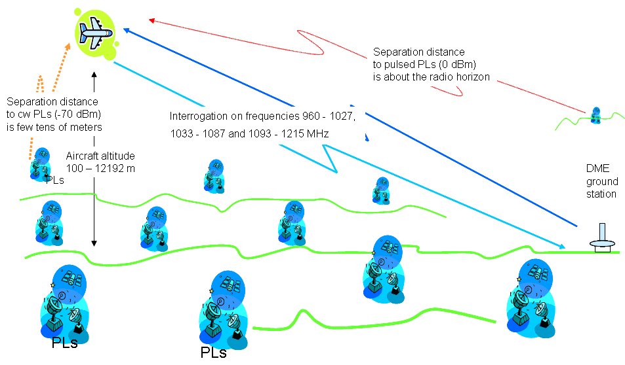
Figure 33: ARNS scenario
  - Introduction
Aeronautical Radio Navigation Service (ARNS) is a safety related service and should be carefully protected from interference and the protection criterion should be met 100% of the time. The impact of pseudolites on ARNS is evaluated considering a scenario depicted in the Figure above. First the separation distance required by a ARNS receiver operating in the presence of an unwanted pseudolite signal, and vice versa, is determined by the Minimum Coupling Loss (MCL) method for each considered system scenario. After the MCL calculations, statistical simulations are conducted in order to further investigate the interference probability between the two systems.
  - MCL calculations – Single entry case
The results of the Minimum Coupling Loss method present the isolation required between the interferer and victim in order to ensure interference free operation. The results are a worst case analysis, providing therefore a spectrally inefficient result for scenarios of a statistical nature.
Table 35: Pseudolites to ARNS interference calculation using the MCL method
Interfering system | Pseudolite / CW | Pseudolite indoor / CW | Pseudolite / Pulsed
Frequency [MHz] | 1176 | 1176 | 1176
Bandwidth [MHz] | 2 | 2 | 2
TX [dBm] | -70 | -70 | 0
additional attenuation. eg. indoor usage [dB] | 0 | 6 | 0
TX antenna height [m] | 10 | 10 | 10
TX antenna gain [dBi] toward the victim | 11 | 11 | 11
Separation distance [km] | 0.2 | 0.11 | 640
Free space loss [dB] | 75.4 | 69.4 | 145.9
RX antenna gain [dBi] toward the PL | 4.5 | 4.5 | 4.5
PFD the receiving site [dBW/MHz/m^2] | -144.55 | -144.55 | -145.05
PFD criterion [dBW/MHz/m^2] | -144.5 | -144.5 | -144.5
Interference risk (single entry) | Medium | Medium | Very high

As seen from the MCL results, the separation distances of the pulsing pseudolites are rather large reaching beyond the horizon. As for CW pseudolites, separation distances would impose coordination around airports.
  - Statistical simulations – Multiple entry case
The following simulations are performed in order to determine the statistical compatibility between the Pseudolite and Aeronautical Radio Navigation Service (ARNS) systems. First the consistency between the statistical scenario and the MCL calculations is checked by a simple correlated simulation case without any distributions. After this a full statistical approach is taken to describe a real life scenario as well as possible. The relevant simulation characteristics and parameters for the studied ARNS are presented in Table 36Error! Reference source not found.. Both the interfering PL and the victim ARNS system are assumed to operate in the same 1 176 MHz frequency.
The coverage area, seen by the DME receiver, is considered to be about a 400 times 400 square kilometres. In this area the number of Pseudolites is assumed to be 10000, 100000 or 1000000, corresponding to PL transmitter densities 0.0625, 0.625 and 6.25 respectively. The simulated duty cycle is 100% in the CW PL case and 10% in the pulsed PL case and the DME receiver (i.e. the aircraft altitude) is assumed to be either 100 or 12000 meters in the simulations.
Table 36: Statistical simulation scenario parameters for PL to ARNS (DME receivers)
SEAMCAT parameters | Victim: ARNS, DME receiver | Interfering System: CW or  Pulsed PLs
Frequency [MHz] | 1 176
Transmit power PTX [dBm] | - | -70 or 0
Bandwidth [MHz] | - | 2
Antenna azimuth [deg] | 0...360º uniform distribution | 0...360º uniform distribution
Antenna elevation [deg] | Depending on the relative position between any PL and the DME receiver; In accordance with Recommendation ITU-R M 1642-1[13] | Depending on the relative position between any PL and the DME receiver; In accordance with section 2.7
Antenna height [m] | 100...12 000 | 10
Maximum antenna gain [dBi] | 4,5 | 11 (Tx)
Interference criteria | Maximum PFD of -144.5dBW/MHz/m²
Minimum separation distance | 150m
Propagation model | Free Space and 6dB building loss for indoor PL
Interfering transmitters in DME coverage | - uniformly distributed PLs, density 0.0625 Tx/km²  - uniformly distributed PLs, density 0.625 Tx/km²  - uniformly distributed PLs, density 6.25 Tx/km²

The Distance Measuring Equipments (DMEs) are used in aircrafts to determine the distance to the land-based transponder. Since the interfered receiver is airborne, LOS propagation conditions between the interfered receiver and interfering PL transmitter are assumed. Thus, the Free Space Loss model is used in the simulations.
  - CW PLs to DME receivers operating in the band 1164-1215 MHz
In the following simulations both, the interfering PLs and the victim ARNS service are assumed to operate on the same 1176 MHz frequency. In the continuously transmitting (CW) indoor pseudolite scenario the interference probability is higher than in the aggregated scenario where the victim systems were RNSS applications. Indeed, with a pseudolite density of 6.26 per km², there is a risk of interference to a DME receiver (See Table 37).
When considering outdoor CW pseudolites, the PFD levels of Table 37 would have to be increased by 6dB.
Therefore, multiple indoor or outdoor CW pseudolites could interfere a DME receiver onboard aircraft if their deployment is not very limited (density < 0.6 per km²).
Table 37: PFD received at the aircraft in dBW/MHz/m² to be compared to
the protection criteria of -144dBW/MHz/m²
Aircraft height / Indoor PL density | 0.0625 PL/km² | 0.625 Pl/km² | 6.25 Pl/km²
100m | -153.7 | -149.3 | -139.3
12000m | -161.1 | -151.1 | -141.1

  - Pulsed PLs to DME receivers operating in the band 1164-1215 MHz
According the the MCL calculations, already a single pulsing PL can cause a PFD more than
-144.5 dBW/MHz/m² in the DME receiver at lower altitudes in very large areas. Therefore, this multiple entry analysis will just some indications of interference levels.
Table 38: PFD received at the aircraft in dBW/MHz/m² to be compared to
the protection criteria of -144dBW/MHz/m²
Aircraft height / Indoor PL density |  | 0.0625 PL/km² |  | 0.625 Pl/km² |  | 6.25 Pl/km²
 | 100m |  | -93.7 |  | -89.3 |  | -79.3
 | 12000m |  | -101.1 |  | -91.1 |  | -81.1
  - Multiple entry case conclusions
The Aeronautical Radio Navigation Service (ARNS) protection criterion is I/N=-23 dB, which should be met 100% of the time. In the simulated continuously transmitting (CW) Pseudolite scenario the interference probability is higher than in the aggregated scenario where the victim systems were RNSS applications. Indeed, multiple indoor or outdoor CW pseudolites could interfer a DME receiver onboard aircraft if their deployment is not very limited (density < 0.6 per km²). Thus, sharing and/or compatibility between continuously transmitting Pseudolites and ARNS would not simply feasible.
In the pulse transmitting Pseudolite cases the DME is interfered even in high altitudes. In the simulations the resulting interference probabilities are 100%. Thus, sharing and/or compatibility between pulse transmitting pseudolites and ARNS, DME receivers is not feasible.
- IMPACT OF PSEUDOLITES ON RDS
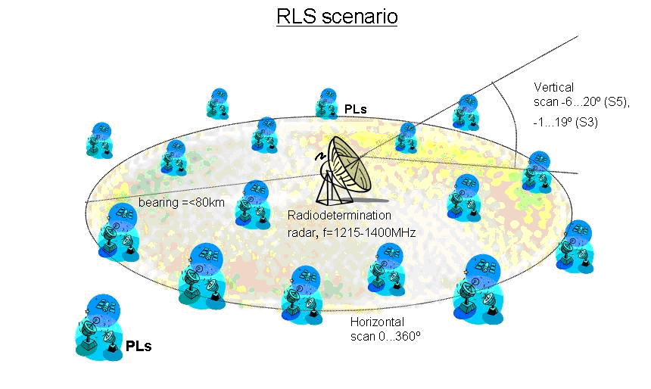
Figure 34 RLS scenario
  - Introduction
Radio Determination Service (RDS) is a safety related service and should be carefully protected from interference 100% of the time. The impact of Pseudolites on RDS radars is evaluated considering a scenario depicted in the Figure above. First the isolation i.e. the separation distance required by a RDS receiver operating in the presence of an unwanted Pseudolite signal, and vice versa, is determined by the Minimum Coupling Loss (MCL) method for each considered system scenario. After this statistical SEAMCAT simulations are conducted in order to further investigate the interference probability between the two systems.
  - MCL calculations
The Minimum Coupling Loss method calculates the isolation required between the interferer and victim in order to ensure interference free operation. The method provides a worst case analysis, which is a spectrally inefficient result for scenarios of a statistical nature. Therefore, the statistical approach is taken afterwards by SEAMCAT simulations.
The results of the calculated MCL separation distances between the interfering Pseudolite and the victim RDS system are presented in Table 39.
Table 39: PLs to RDS interference calculation using MCL method
 | Interfering system |  | PL / CW |  | PL / CW |  | PL / CW  Indoor |  | PL / CW)  Indoor |  | Pulsed PL |  | Pulsed PL
Frequency [MHz] |  | 1 227 |  | 1 227 |  | 1 227 |  | 1 227 |  | 1 227 |  | 1 227
Bandwidth [MHz] |  | 10 |  | 10 |  | 10 |  | 10 |  | 10 |  | 10
TX [dBm] |  | -70 |  | -70 |  | -70 |  | -70 |  | 0 |  | 0
Duty cycle [%] |  | NA |  | NA |  | NA |  | NA |  | NA |  | NA
Additional attenuation, eg. indoor usage |  | 0 |  | 0 |  | 8 |  | 8 |  | 0 |  | 0
Efective heigth of the TX antenna [m] |  | 10 |  | 10 |  | 10 |  | 10 |  | 10 |  | 10
TX antennagain [dBi] towards the victim |  | 11 |  | 11 |  | 11 |  | 11 |  | 11 |  | 11
Separation distance [km] |  | 0.45 |  | 0.01 |  | 0.2 |  | 0.01 |  | 75 |  | 13
Free Space loss [dB] |  | 87.2911 |  | 54.2269 |  | 80.2475 |  | 54.2269 |  | 131.7281 |  | 116.5058
Long term (20 %) diffraction loss [dB] |  | 0 |  | 0 |  | 0 |  | 0 |  | 26.6451 |  | 2.7727
PFD the receiving site [dBW/MHz/m^2) |  | -163.36 |  | -130.30 |  | -164.32 |  | -138.30 |  | -137.80 |  | -122.58
Victim Service and system |  | RL, S5 |  | RL, S5 |  | RL, S5 |  | RL, S5 |  | RL, S5 |  | RL, S5
Interfered signal level at Rx bw [dBm] |  | -111 |  | -111 |  | -111 |  | -111 |  | -111 |  | -111
Reference bandwidth [MHz] |  | 1.25 |  | 1.25 |  | 1.25 |  | 1.25 |  | 1.25 |  | 1.25
Rx noisefigure [dB] |  | 2.6 |  | 2.6 |  | 2.6 |  | 2.6 |  | 2.6 |  | 2.6
Rx antenna heigth [m] |  | 15 |  | 15 |  | 15 |  | 15 |  | 15 |  | 15
RX antenna gain towards inteference [dBi] |  | 38.5 |  | 0 |  | 38.5 |  | 0 |  | 38.5 |  | 0
Additional losses, eg. indoor usage |  | 0 |  | 0 |  | 0 |  | 0 |  | 0 |  | 0
Rx noise floor [dBm] |  | -110.4309 |  | -110.4309 |  | -110.4309 |  | -110.4309 |  | -110.4309 |  | -110.4309
TX/RX BW correction factor |  | -9.0309 |  | -9.0309 |  | -9.0309 |  | -9.0309 |  | -9.0309 |  | -9.0309
Interfering signal level at Rx bw [dBm] |  | -116.8220 |  | -122.2578 |  | -117.7784 |  | -130.2578 |  | -117.9041 |  | -117.3094
I/N at ref. bw |  | -6.3911 |  | -11.8269 |  | -7.3475 |  | -19.8269 |  | -7.4732 |  | -6.8785
Inteference criterion |  | I/N<-6  or -12 |  | I/N<-6  or -12 |  | I/N<-6  or -12 |  | I/N< -6  or -12 |  | I/N< -6  or -12 |  | I/N< -6  or -12
Comments |  | Radar antenna mainbeam |  | Radar antenna sidelobe |  | Radar antenna mainbeam |  | Radar antenna sidelobe |  | Radar antenna mainbeam |  | Radar antenna sidelobe
Inteference risk  (single entry) |  | Low |  | Very low |  | Low |  | Very low |  | Very high |  | Very high

The separation distances are rather large already in case of continuously transmitting pseudolites, becoming unacceptable in the case of pulse transmitting pseudolites. This is due to high e.i.r.p. of the pseudolites and high antenna gain and sensitivity of the radars. In the pulsed pseudolite cases, where the separation distance reaches beyond the horizon, the resulting diffraction loss needs to be taken into account when comparing the SEAMCAT simulation results to the MCL calculations.
The above distances would be more than doubled in case a narrow PL signal would be used (i.e. with a
2 MHz bandwidth).

  - SEAMCAT simulations
The SEAMCAT simulations are performed in order to determine the statistical compatibility between the pseudolite and Radio Determination Service (RDS) system radars. First the consistency between the SEAMCAT scenario and the MCL calculations is checked by a simple correlated simulation case without any distributions. After this a full statistical approach is taken to describe the real life scenario as well as possible.
The radar antenna height does not appear in the ITU-R recommendation, but it is assumed to be above the local clutter and a radar antenna height of 15 to 35 m above the ground is assumed in the simulations. pseudolites on the other hand may operate below the local clutter and, thus, the propagation path between the interfering pseudolite and victim radar antennas can be either LOS or NLOS. The simulations are conducted by using the Extended Hata (as implemented in SEAMCAT) as well as the Free Space Loss model (as implemented in SEAMCAT).
  - RDS radar S5 operating in the band 1215-1400 MHz
The relevant simulation characteristics and parameters for the studied RDS radars are presented in Table 40. Both the interfering PL and the victim radar are assumed to operate in the same 1227 MHz frequency. Besides the indoor loss no additional losses or margins (e.g. wall penetration, implementation margin, etc.) are considered. The number of actively transmitting pseudolites is 6.
Table 40: SEAMCAT simulation parameters for PL to RDS (radar S5)
SEAMCAT parameters |  | Victim: RDS, SS receiver |  | Interfering system: CW or Pulsed Pseudolites
 | Frequency [MHz] |  | 1 227
 | Transmit power P_{TX} [dBm] |  | - |  | -70 or 0
 | Noise floor [dBm] |  | -110,4
 | Bandwidth (pulse) [MHz] |  | 1.5 |  | 2 / 10
 | Antenna azimuth [deg] |  | 0...360º uniform distribution |  | 0...360º uniform distribution
 | Antenna elevation [deg] |  | -6...20º uniform distribution |  | 0º
 | Antenna height [m] |  | 15...35 (uniform distribution) |  | 10
 | Maximum antenna gain [dBi] |  | 38. |  | 11 (Tx)
 | Antenna orientation (deg, from nadir) |  | 20º
 | Minimum desired signal [dBm] |  | -156.5
 | Interference criteria |  | Interference-to Noise ratio, I/N=-6dB
 | Distance between  InterferingTx -Victim Rx |  | - MCL case: separation distance (see Table 39)  - Otherwise: uniform
 | Propagation model |  | - In MCL case and between SAR - PLs: Free Space  - Between PL Rx and Tx: Extended Hata, Suburban (below roof)  - both interfering PL and Victim outdoors
 | Interfering transmitters in radar coverage |  | - MCL case: Single transmitter  - Otherwise:  - Single transmitter case (density 0,0025 1/km²)  - 6 uniformly distributed PLs (density 0,015 1/km²)

It is indicated in the main document that, from the radar receiver point of view, the interference from the actively transmitting Pseudolites can be taken as continuous and therefore a 100% duty cycle is used in the simulations.
The used DME RDS receiver blocking response and PL transmitter emissions mask are presented in Figure 35 and Figure 36, respectively.
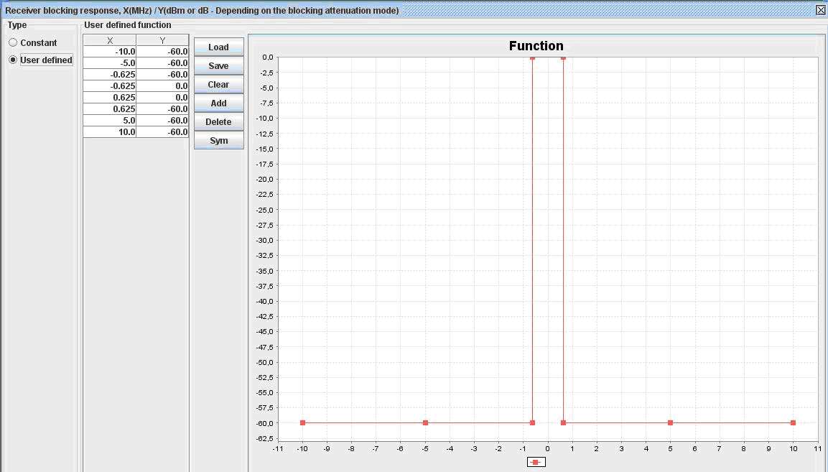
Figure 35: RDS, S5 receiver blocking response
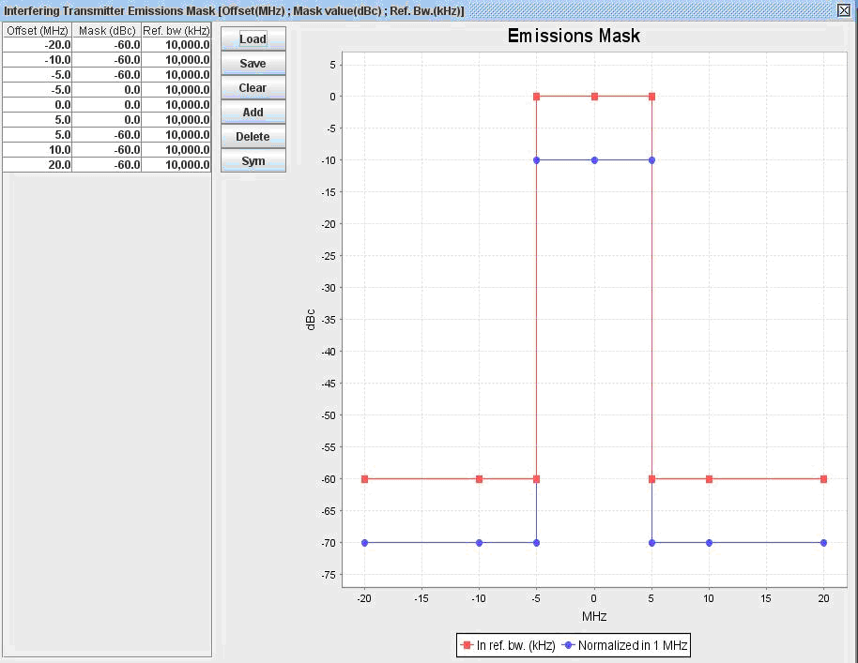
Figure 36: PL transmitter emissions mask
The results of the correlated MCL case are shown in Figure 37 for the continuously transmitting low power pseudolite and it can be seen that they are consistent with the MCL calculations.
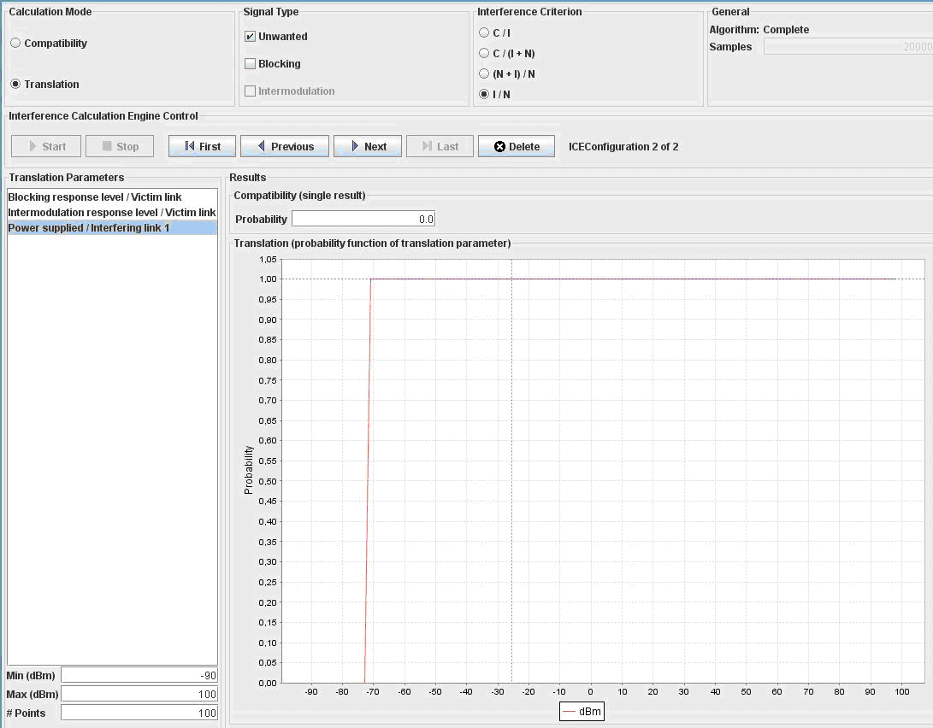
Figure 37: Correlated MCL case with single PL in RDS S5 receiver vicinity. I/N criteria is –6dB and separation distance 0.45km, antenna height is 15m (ref. RDS_PL to S5_cw_MCL.sws)
The pulsed Pseudolite case is shown in Figure 38. In the pulsed PL case the results are consistent with the MCL calculations after the diffraction loss 26.6 dB is taken into account.

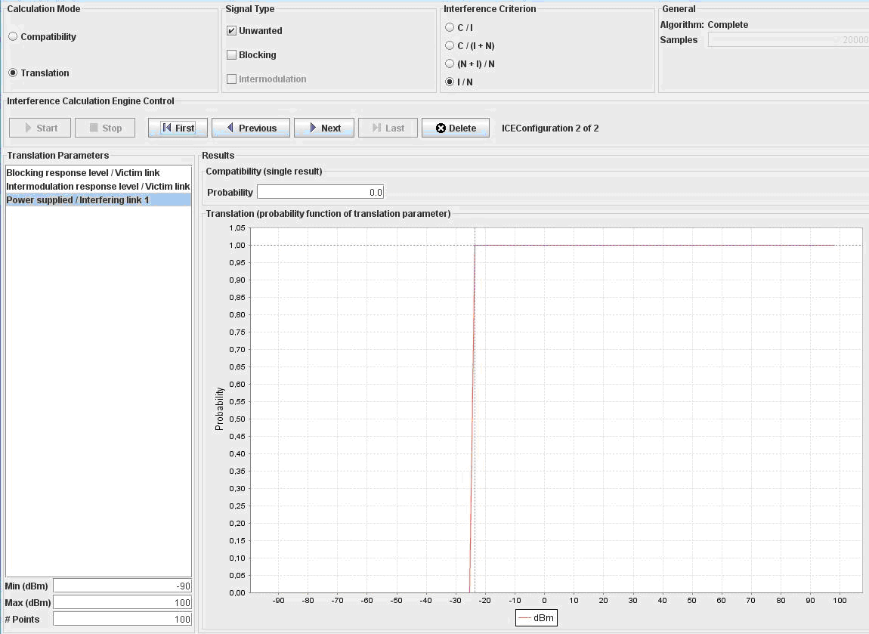
Figure 38: Correlated case with single pulsing PL in RDS S5 receiver vicinity. I/N criteria –6dB, separation distance 75km (ref. RDS_PL to S5_pulsed_MCL.sws)
In the statistical SEAMCAT simulations the interfering Pseudolites are assumed uniformly distributed in the simulation area. Since the e.i.r.p. levels of the continuously transmitting Pseudolites are low (-70dBm), the resulting interference probabilities in CW Pseudolite scenarios (Figure 39 and Figure 40) remain very low.

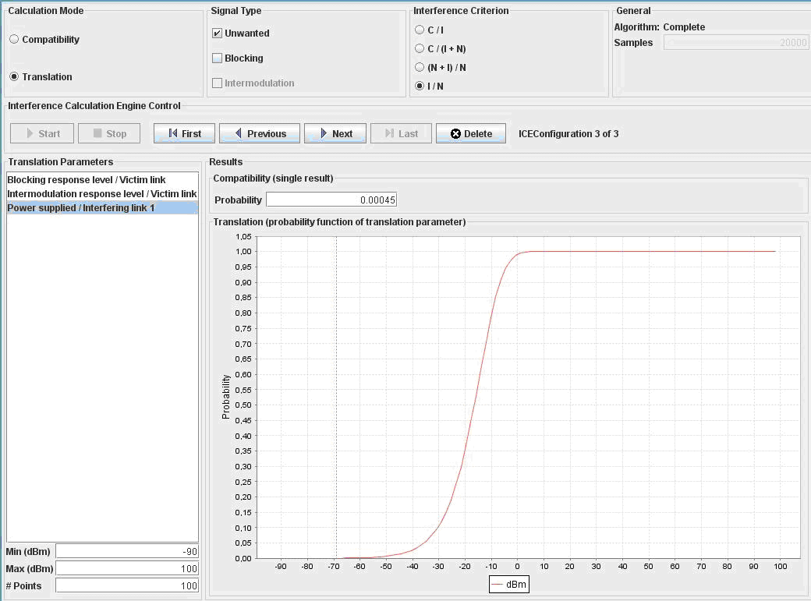
Figure 39: 6 CW PLs to radar S5, uniform distribution 0..360º, antenna elevation -6...20deg,
(PL density 0.003, activity factor 100%, protection distance 100m, Ext.Hata suburban).
The interference probability with I/N criteria -6dB is 0.045%
(RDS_PL to S5_cw_6PLs_pd100m_d0.003.sws)

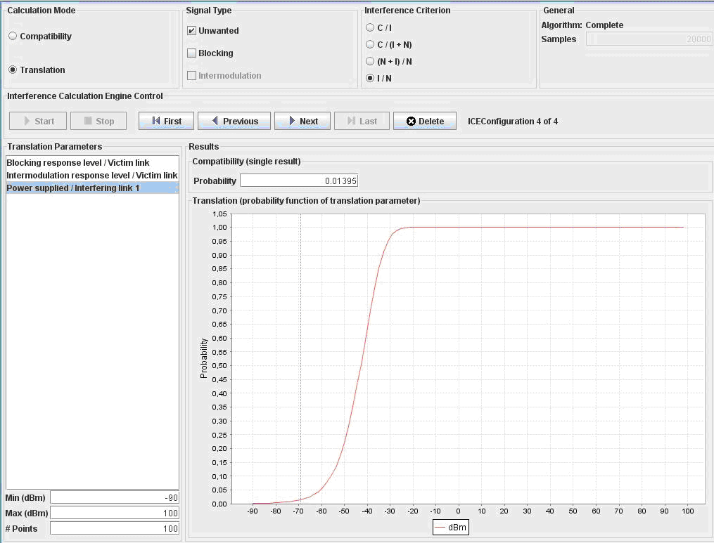
Figure 40: 6 CW PLs to radar S5, uniform distribution 0..360º, antenna elevation -6...20deg,
(PL density 0.1 1/km2, activity factor 100%, protection distance 100m, Ext.Hata suburban).
The interference probability with I/N criteria -6dB is 1.4%
(ref. RDS_PL to S5_cw_6PLs_pd100m_d0.1.sws)
In case of a pulsed Pseudolite to RDS radar receiver the transmit power of the interfering Pseudolite is high (0dBm) and if the operational conditions remain the same, the resulting interference probability becomes very high, Figure 41.

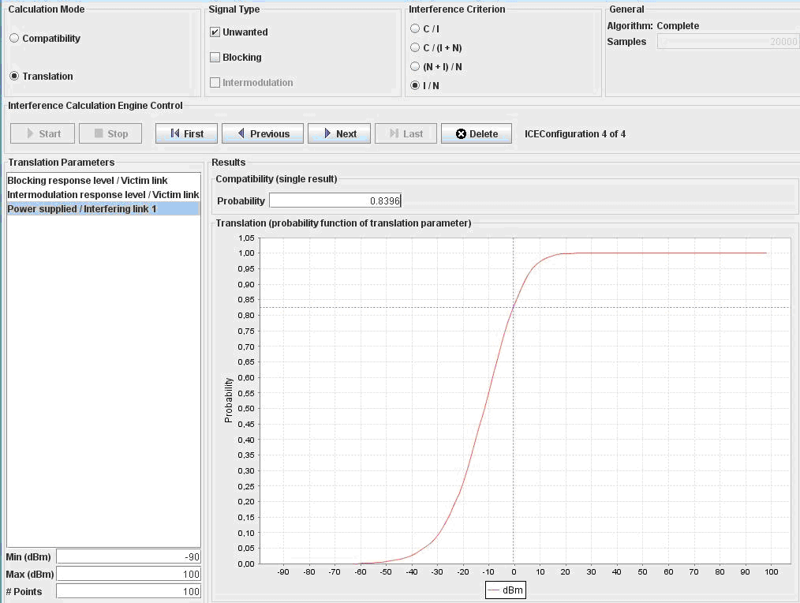
Figure 41: Single pulsed PL to radar S5, antenna height is 15m, activity factor 100%, protection distance 100m, density 0.003. The resulted interference probability with I/N criteria of -6dB is 84% (ref. RDS_PL to S5_pulsed_single_pd100_d0.003.sws)

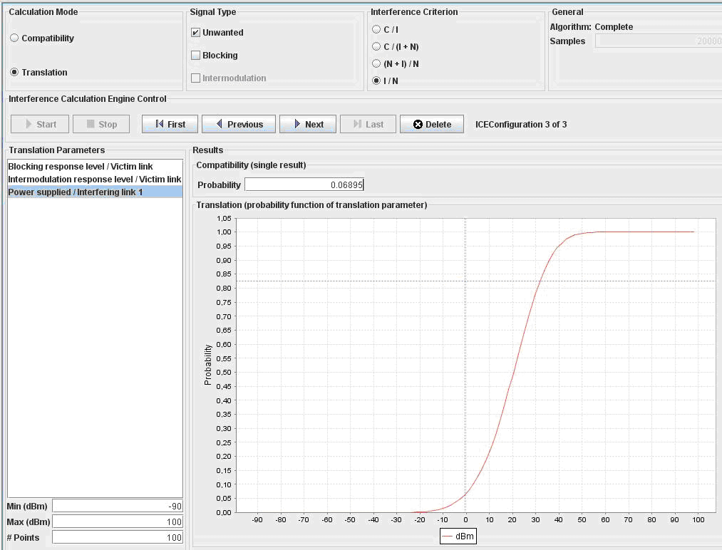
Figure 42: Single pulsed PL to radar S5, antenna height 15 meters, activity factor 100%, protection distance 10km, density 0.0001. The resulted interference probability with I/N criteria of -6dB is ~7% (ref. RDS_PL to S5_pulsed_single_pd10km_d0.0001.sws)
  - SEAMCAT Conclusions
Radiodetermination Service (RDS) is a safety related service and should be carefully protected from interference. The protection criterion considered is I/N =-6 dB is to be met 100% of the time. According to the obtained simulation results, the sharing and/or compatibility between continuously transmitting pseudolites and RDS is possible. In order to guarantee interference free operation, a frequency separation between pseudolites and radars or an adequate separation distance between the two systems must be implemented.
Between pulse transmitting pseudolites and RDS radars sharing/compatibility is feasible only if there is frequency separation or large protection zone around the radars.
- IMPACT OF PSEUDOLITES ON EESS
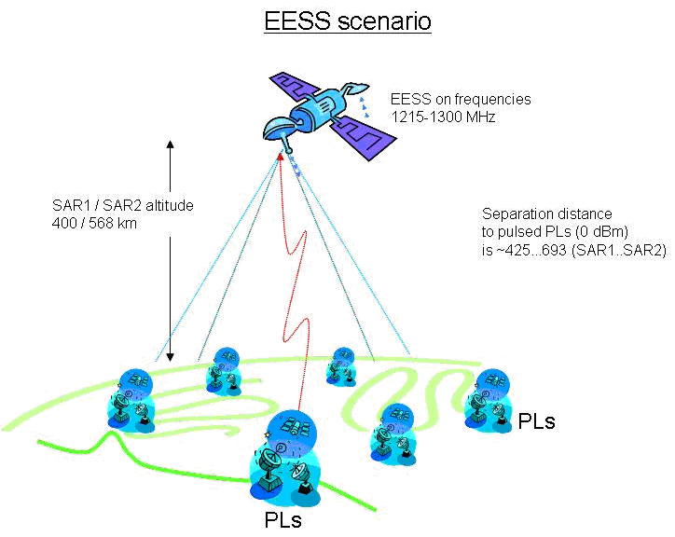
Figure 43. EESS scenario
  - Introduction
The impact of pseudolites on Earth Exploration-Satellite Service (EESS) systems is evaluated considering a simple scenario depicted in the Figure above. First the separation distance required by a space-borne SAR receiver is computed first by the Minimum Coupling Loss (MCL) and after this SEAMCAT-simulations are conducted in order to further investigate the interference probability between pseudolites and EESS radars.
  - MCL calculations
The required isolation between the interfering pseudolite and victim EESS SAR1 and SAR2 systems are calculated by the Minimum Coupling Loss method and the obtained results are presented in Table 41. The MCL method provides separation distances required in order to ensure interference free operation in the worst case scenario. These results are although spectrally inefficient for scenarios of a statistical nature and therefore, a more realistic approach is obtained by full statistical SEAMCAT simulations.

Table 41: Pseudolites to EESS, interference calculation using the MCL method
Interfering systems | Pseudolite pulsing | Pseudolite pulsing
Frequency, MHz | 1227 | 1227
Bandwidth, MHz | 10 | 10
TX, dBm | 0 | 0
Duty cycle, % | NA | NA
Additional attenuation, eg. indoor usage | 0 | 0
TX antenna height, m | 20 | 100
TX antenna gain, dBi towards the victim | 0 | 0
Separation distance, km | 425 | 693
Free Space loss, dB | 146.9 | 151.4
Long term (20 %) diffraction loss, dB | 0 | 0
PFD the receiving site, dBW/MHz/m²) | -163.7 | -168.1
Victim Service and System | EESS, SAR 1 | EESS, SAR 2
Interfered signal level at RF bw dBm | -90 | -90
Interfering signal level at RF bw dBm | -146.9 | -151.4
C/I at RF bandwidth | 56.9 | 61.4
RX bandwidth MHz | 40 | 15
Rx noise figure | 0. | 0.
Rx antenna height, m | 400000 | 568000
RX antenna gain dBi towards interference | 36. | 33
Rx noise floor, dBm | -97.7 | -102.3
TX/RX BW correction factor | 0 | 0
Interfering signal level, dBm | -110.946699 | -118.4
I/N, dB | -12.1 | -16.0
Compatibility criterion | I/N = -6 | I/N = -6
Interference risk (single entry) | Very low | Very low

Because of the long distance between the space-borne SAR receivers and ground-based PL transmitters, the continuous transmitting low power pseudolites do not cause interference to SAR receivers and compatibility evaluations are made to pulsed pseudolites.
  - SEAMCAT simulations
In the SEAMCAT simulations the statistical compatibility between the Pseudolite and EESS services is studied. The consistency between the SEAMCAT scenario and the MCL calculations is checked by a simple correlated simulation case without any distributions and after this a full statistical scenario is implemented.
The SAR receivers are space-borne, thus line-of-sight visibility between the interfering Pseudolite transmitter and the victim can be assumed. The selected propagation model for the simulations is the Free Space Loss model (as implemented in SEAMCAT). Between the pseudolite transmit and receive antennas the operational environment is assumed as non-LOS and the Extended Hata model (as implemented in SEAMCAT) is used.
The interference criteria for synthetic aperture radars is an interference-to-noise ratio (I/N) of –6 dB, which corresponds to a 10% performance degradation of the standard deviation of SAR pixel power. The EESS SAR radar scans the surface of the Earth with its antenna main beam when it sees the interference only from the main beam. Therefore, in these evaluations, only the main lobes of the Synthetic Aperture Radar, SAR1 or SAR2, are considered. The size of the antenna footprint is about 20 km x 20 km.
In the simulations both, the interfering PL and victim SAR receivers are assumed to operate on same 1 227 MHz frequency. The simulation parameters are gathered in Table 42.

Table 42: SEAMCAT simulation parameters for SAR receivers in the bands 1215-1240 MHz and 1240-1300MHz [Ref. Recommendation ITU-R RS.1347[14]], [*Ref. Recommendation ITU-R RS.1166-3[7]]
SEAMCAT parameters |  | Victim: EESS, SAR receiver |  | Interfering system: CW or Pulsed PLs
 |  | SAR1 | SAR2 | CW | Pulsed
 | Frequency [MHz] | 1 227
 | Transmit power P_{TX} [dBm] | - |  | -70 or 0
 | Noise level [dBm] | -97.7 | -102
 | Bandwidth (pulse) [MHz] | 40 | 15 | 2 or 10
 | Antenna azimuth [deg] | Polar angle 360º; uniform distribution |  | 0...360º uniform distribution
 | Antenna elevation [deg] | 0º |  | 0º
 | Antenna height [m] | 400 000 | 568 000 | 10
 | Maximum antenna gain [dBi] | 36,4 | 33 | 11 (Tx)
 | Antenna orientation (deg, from nadir) | 20º | 35º
 | Minimum desired signal [dBm] | -156.5 *
 | Interference criteria | Interference-to Noise ratio, I/N=-6dB
 | Distance between  InterferingTx -Victim Rx | - MCL case: separation distance (see Table 41)  - Otherwise: radar altitude (see. antenna height above)
 | Propagation model | - In MCL case and between SAR - PLs: Free Space  - Between PL Rx and Tx: Extended Hata, Suburban (below roof)  - both interfering PL and Victim outdoors
 | Interfering transmitters in SAR coverage | - MCL case: Single transmitter  - Otherwise:  - Single transmitter case (density 0,0025 1/km²)  - 6 uniformly distributed PLs (density 0,015 1/km²)

The used SAR1 and SAR2 receiver blocking responses and PL transmitter emissions mask are presented in Figure 44, Figure 45 and Figure 46, respectively.
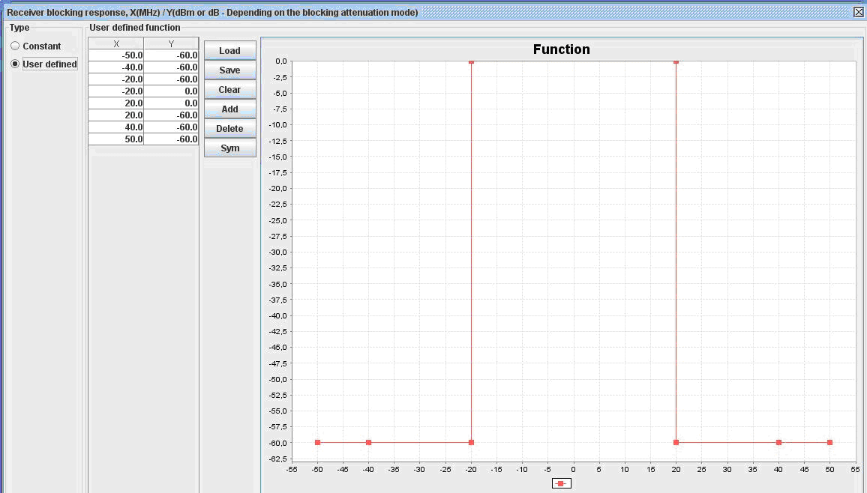
Figure 44: EESS, SAR1 receiver blocking response

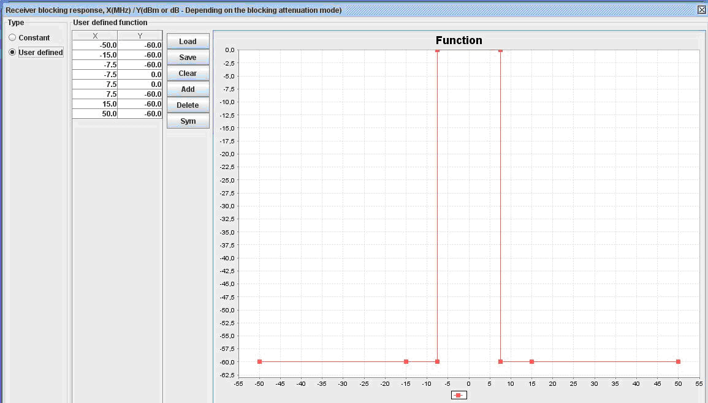
Figure 45: EESS, SAR2 receiver blocking response

Figure 46: PL transmitter emissions mask

EESS (space-to-Earth) SAR1 receivers operating in the band 1215-1300 MHz

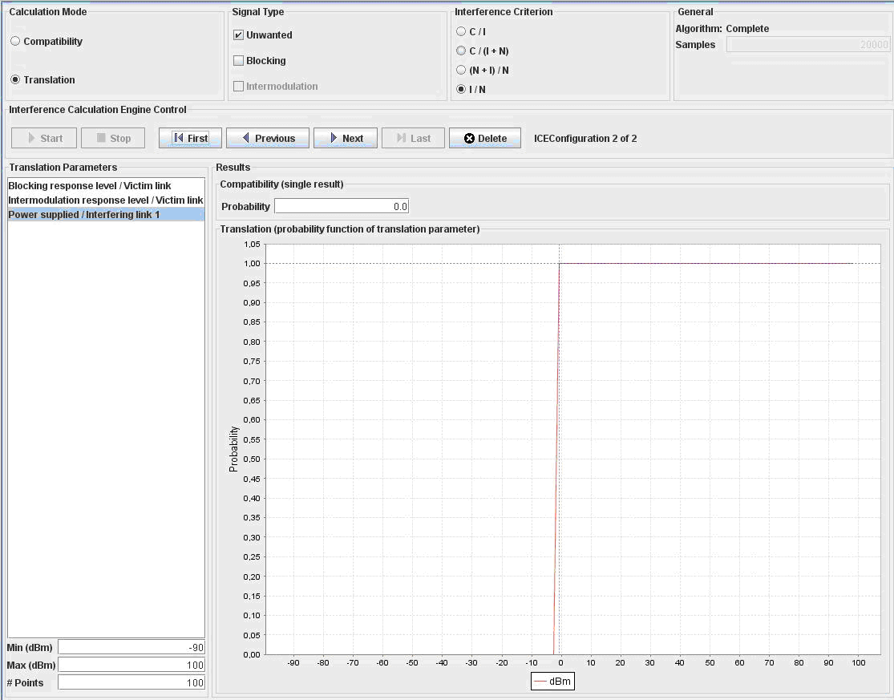
Figure 47: Pulsed PL to EESS, space-borne SAR1; Correlated case with
I/N criteria -6 dB and separation distance 425km.
(EESS_PL to SAR1_pulsed_MCL.sws)

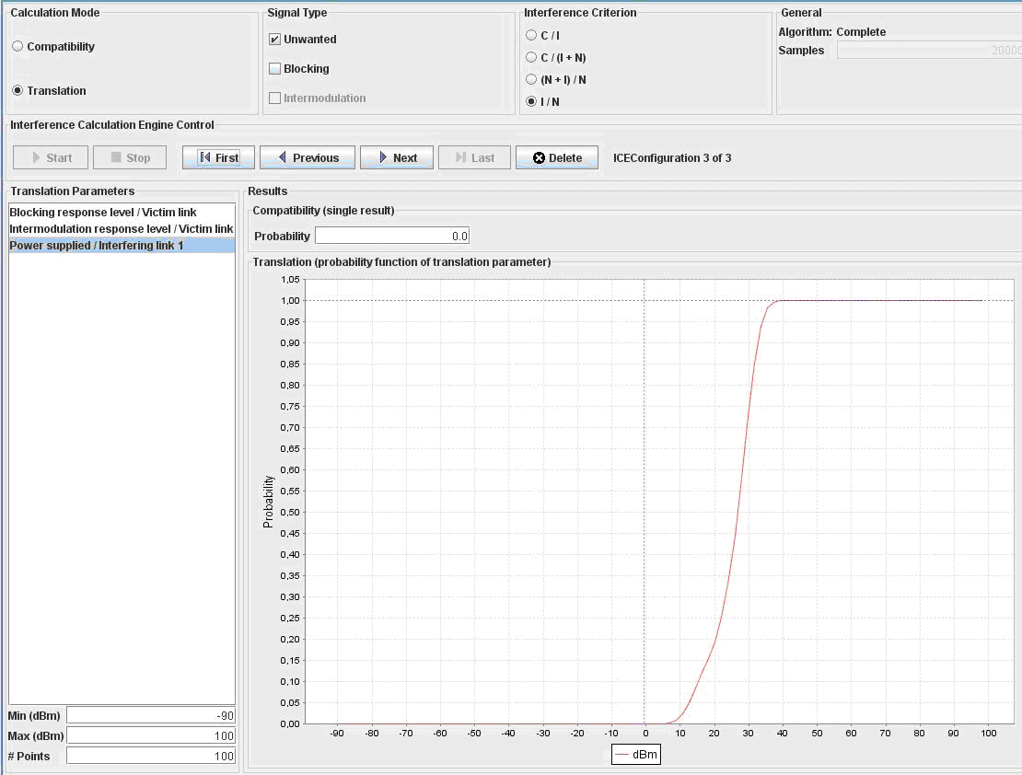
Figure 48: Single pulse transmitting PL to SAR1; uniform distributions
(PL transmitter density 0.0025 1/km²); Interference probability is 0.105%
(EESS_PL to SAR1_pulsed_single_d0.0025.sws)

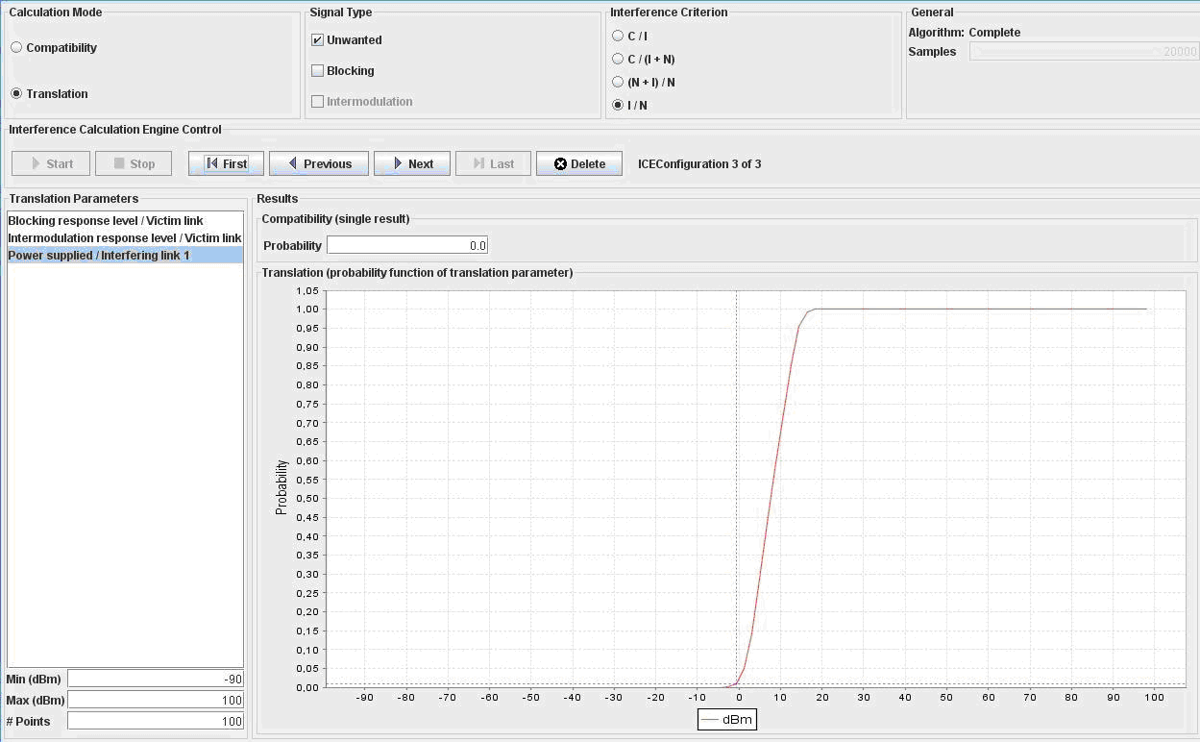
Figure 49: Six pulse transmitting PLs to SAR1; Uniform distributions
(PL transmitter density 0.015 1/km²); Interference probability is 2.14%
(EESS_PL to SAR1_pulsed_6tx_d0.015.sws)
Single pulse transmitting pseudolite in the SAR1 antenna footprint (PL density 0.0025 1/km²) does not cause interference to the EESS system (Figure 48). The situation is the same also in the six pulse transmitting pseudolites case (with higher PL density of 0.015 Tx/km²) in Figure 49. However, as the number of pseudolites in the radar footprint increases aggregated average interference power level in the EESS receiver may be exceeded.
EESS (space-to-Earth) SAR2 receivers operating in the band 1215-1300 MHz
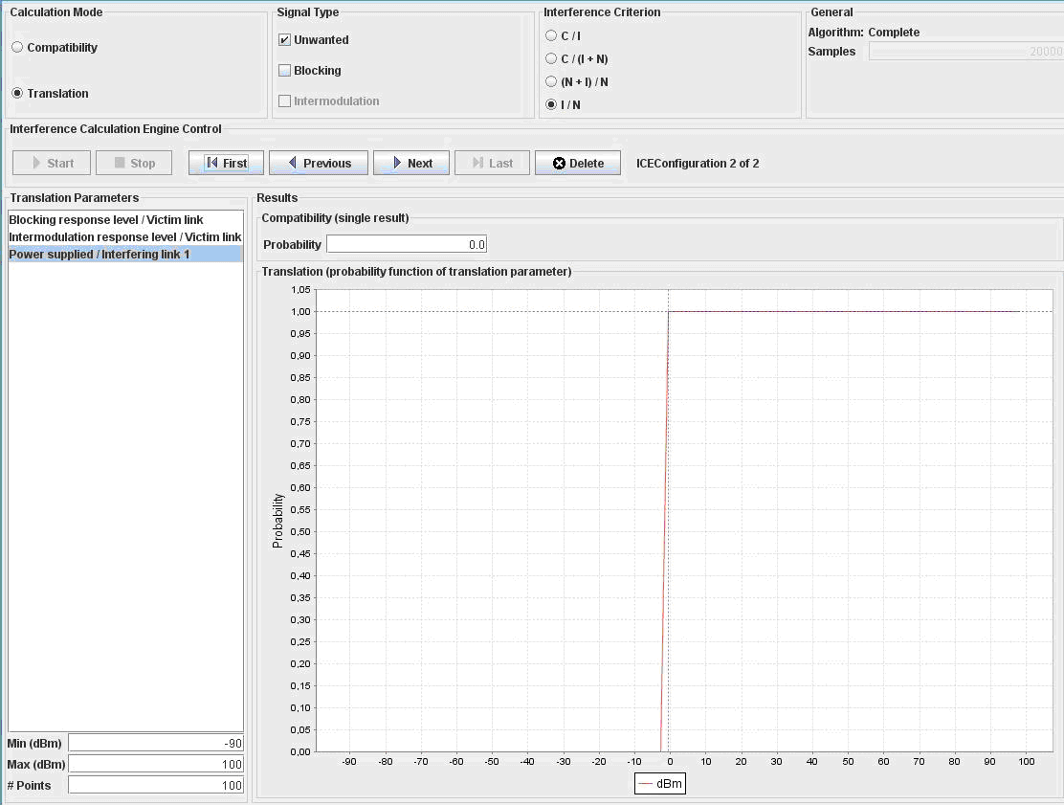
Figure 50: Pulsed PL to EESS, space-borne SAR2; Correlated case with I/N criteria -6 dB and separation distance 693km. (EESS_PL to SAR2_pulsed_MCL.sws)
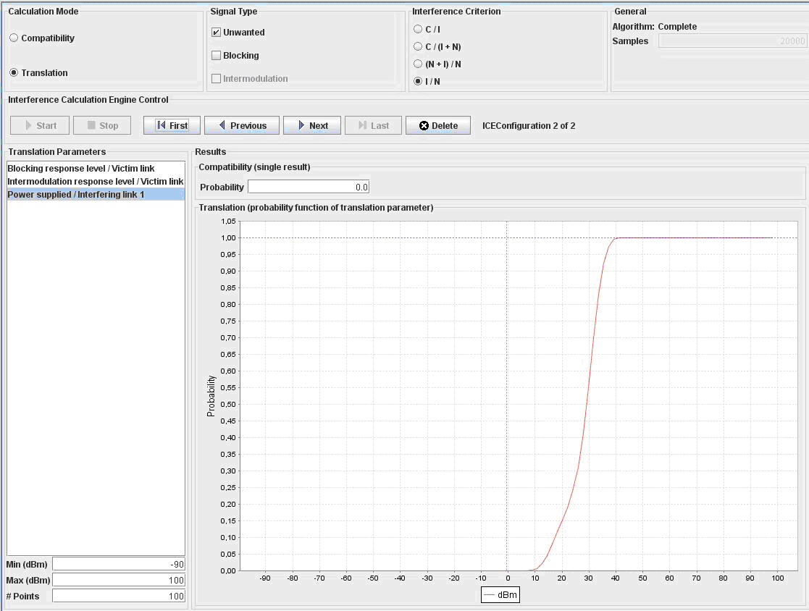
Figure 51: Single pulse transmitting PL to SAR2; Uniform distributions
(PL transmitter density 0.0025 1/km2); Interference probability 0%
(EESS_1PL to SAR2_single_pulsed_d0.0025.sws)

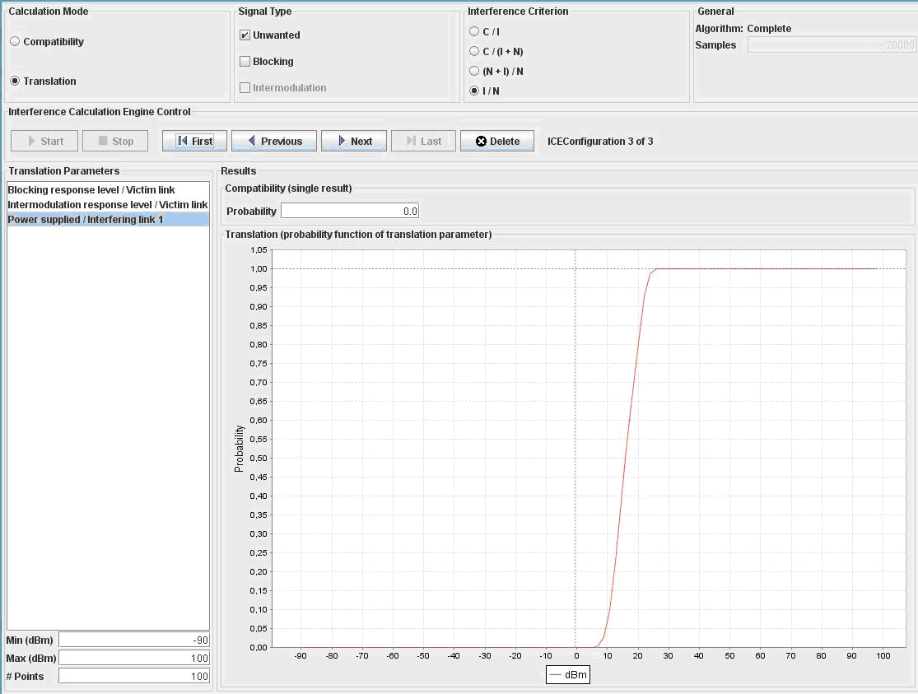
Figure 52: Six pulse transmitting PLs to SAR2; Uniform distributions
(PL transmitter density 0.015 1/km²); Interference probability is 0%
(EESS_PL to SAR2_6tx_pulsed_d0.015.sws)

Single pulse transmitting Pseudolite in the antenna footprint (density 0.0025 1/km²) does not cause interference to the EESS, SAR2 system (Figure 51) and neither do six pulse transmitting PLs (PL density 0.015 Tx/km²), Figure 52. However, when the number of Pseudolites in the radar footprint increases aggregated average interference power level in the EESS receiver may be exceeded.
  - SEAMCAT Conclusions (1215-1300 MHz)
Continuously transmitting pseudolites do not cause interference to synthetic aperture radars due to of the long distance between the space-borne SAR receivers and ground-based PL transmitters. The case is similar in case of pulse transmitting pseudolites. However, as the number of pulsed pseudolites in the footprint increases, the aggregated average interference power level in the EESS receiver may be exceeded.
Therefore it can be concluded that sharing and/or compatibility between continuously transmitting pseudolites and EESS SAR receivers is feasible. In the pulse transmitting pseudolite case sharing/combatibility is feasible if the aggregated average interference from all pseudolites in the surveillance radar antenna footprint (approximately 20km x 20km area) is limited.

- References
- Wang J., 2002: Pseudolite Applications in Positioning and Navigation: Progress and problems, Journal of Global Positioning Systems, 1(1):48-56.
- T. A. Stansell, Jr., "RTCM SC 104 Recommended Pseudolite Signal Specifications", Global Positioning System, Vol. III, Institute of Navigation, 1986
- RTCA/DO-246B, “GNSS based precision approach local area augmentation system (LAAS) signal-in-space interface control document (ICD)”, 2001.
- Abt, TL, F Soualle and S Martin; Optimal Pulsing Schemes for Galileo Pseudolite Signals. ION GNSS 2005.
- Impact of Pseudolite Signals on Non-Participating GNSS Receivers, JRC Scientific and Technical Reports, 2001. SE40(11)059 (1);
- A. J. Van Dierendonck, Pat Fenton, and Chris Hegarty, ”Proposed Airport Pseudolite Signal Specification for GPS Precision Approach Local Area Augmentation Systems”, in Proc. ION GPS 1997
- Recommendation ITU-R RS.1166-3 - EN-Performance and interference criteria for active spaceborne sensors
- Recommendation ITU-R RA.769-2 – Protection criteria used for radio astronomical measurements
- Recommendation ITU-R M.1317 - Considerations for sharing between systems of other services operating in bands allocated to the radionavigation-satellite and aeronautical radionavigation services and the global navigation satellite system (GLONASS-M)
- Recommendation ITU-R F.1094 Maximum allowable error performance and availability degradations to digital radio-relay systems arising from interference from emissions and radiations from other sources
- Recommendation ITU-R M.1463-1 - Characteristics of and protection criteria for radars operating in the radiodetermination service in the frequency band 1215-1400 MHz
- Recommendation ITU-R P.452-13 - Prediction procedure for the evaluation of microwave interference
between stations on the surface of the Earth at frequencies above about 0.7 GHz
- Recommendation ITU-R M 1642-1 - Methodology for assessing the maximum aggregate equivalent power flux-density at an aeronautical radionavigation service station from all radionavigation-satellite service systems operating in the 1 164-1 215 MHz band
- Recommendation ITU-R RS.1347 - Feasibility of sharing between radionavigation-satellite service receivers and the Earth exploration-satellite
- ITU-R Resolution 609 - Protection of aeronautical radionavigation service systems from the equivalent power flux-density produced by radionavigationsatellite service networks and systems in the 1164-1215 MHz frequency band
- The ITU-R RR Article 5 - Frequency Allocations
- ECC/DEC/(07)01 on specific Material Sensing devices using Ultra-Wideband (UWB) technology

