Technical study for co-existence between RMR in the 900 MHz range and other applications in adjacent bands
approved 21 May 2020
ECC Report 313
editorial update 2 February 2024

Executive summary
This Report studies the compatibility of Railway Mobile Radio (RMR) in the 900 MHz range with adjacent applications as part of the answer to the Mandate from the European Commission on FRMCS.
From that perspective, the studies show that the 900 MHz frequency range is feasible for RMR systems, under the condition that the RMR receivers fulfil some requirements more stringent than those currently specified by 3GPP for band 8; however without any proper mitigation measures, the reception of RMR cab-radio within the duplex gap of MFCN system may suffer interference from MFCN BS above 925 MHz.
Requirements on RMR BS:
Table 1: Requirements on GSM-R and FRMCS BS receiver characteristics
Parameter | Value
Level of the wanted signal | Sensitivity +3 dB
Maximum interfering signal in 870-874.4 MHz (Note 1) | -34 dBm
The antenna connector of the radio module is the reference point.
Note 1: These requirements cover both blocking and third-order intermodulation. It is up to ETSI to define a relevant interfering signal against which the conformity test will be performed. In this Report, the considered bandwidth of the interfering signal is 200 kHz wide.
Requirements on GSM-R cab-radio:
Table 2: Additional requirements on GSM-R cab-radio receiver characteristics
Parameter | Value
Level of the wanted signal | Sensitivity +3 dB
Maximum interfering signal in 916.1-918.9 MHz (Note 1) | -26 dBm
The antenna connector of the radio module is the reference point.
Note 1: These requirements cover both blocking and third-order intermodulation. It is up to ETSI to define a relevant interfering signal against which the conformity test will be performed. In this Report, the considered bandwidth of the RFID interfering signal is 400 kHz wide.
Improved GSM-R cab-radios as per ETSI TS 102 933-1 [7] are currently under deployment and are designed for the improved reception of GSM-R in the vicinity of intensive MFCN emissions above 925 MHz and are not designed to fulfil the requirements in the frequency range of 916.1-918.9 MHz. Administrations may further consider the protection of GSM-R if the requirements in Table 2 are not met.
GSM-R carrier at 919.6 MHz:
In some worst-case scenarios with low probability, the GSM-R cab-radio receiving at 919.6 MHz may face interference from 25 milliwatt SRD due to blocking. Taken into account the discontinuous transmission of SRD devices (“duty cycles”), no harmful interference issues are anticipated.
Requirements on FRMCS cab-radio:
Table 3: Requirements on FRMCS cab-radio receiver characteristics
Parameter | Value
Level of the wanted signal | Sensitivity +3 dB
Maximum interfering signal in 880-918.9 MHz (Note 1) | -26 dBm
Maximum CW interfering signal in 925.2-927 MHz | -13 dBm
Maximum CW interfering signal in 927-960 MHz | -10 dBm
Maximum 5 MHz LTE interfering signal (lowest carrier at 927.6 MHz) | -13 dBm
The antenna connector of the radio module is the reference point.
These requirements cover both blocking and third-order intermodulation.
Note 1: It is up to ETSI to define a relevant interfering signal against which the conformity test will be performed. In this Report, the considered bandwidth of the RFID interfering signal is 400 kHz wide.
It is considered that a spurious emission limit of -36 dBm/100 kHz from an RFID interrogator should be sufficient to ensure co-existence between RFID interrogators and RMR cab-radios in all cases.
The highest RFID interrogator channel is centred at 918.7 MHz, operating in 918.5-918.9 MHz. For FRMCS, the lowest possible RB starts around 919.6 MHz. The spurious level of -36 dBm/100 kHz is fulfilled from 919.7 MHz upwards.
No additional requirement is necessary to mitigate unwanted emissions from other SRD.
MFCN out-of-band emissions:
When in close vicinity to railway tracks, MFCN BS out-of-band emissions may cause interference to FRMCS cab-radio. In practice, to solve these cases, technical and/or operational measures could be used to ensure the coexistence of both MFCN and FRMCS in parallel.

TABLE OF CONTENTS

0 Executive summary 2
1 Introduction 7
2 Frequency use 8
3 RMR technical parameters 9
4 Co-existence between RMR cab-radio and MFCN in the 900 MHz range 11
4.1 Co-existence between RMR cab-radio and MFCN BS above 925 MHz 11
4.1.1 Blocking and intermodulation 11
4.1.2 Considerations on RMR minimum signal level 11
4.1.2.1 Derivation of the ACS value 11
4.1.3 Impact of MFCN BS unwanted emissions on FRMCS cab-radio 12
4.1.3.1 Assumptions on parameters 13
4.1.3.2 Antenna gain of the MFCN base station in the direction of the cab-radio 15
4.1.3.3 Propagation path loss 16
4.1.3.4 Interference calculation 17
4.1.3.5 Duration of the interference 18
4.1.3.6 Results 18
4.1.3.7 Conclusions 20
4.2 Co-existence between RMR cab-radio and MFCN aerial UE below 915 MHz 21
5 Co-existence between RMR cab-radio and SRD below 919.4 MHz 22
5.1 500 milliwatt SRD 22
5.1.1 500 milliwatt SRD NAP above rooftop 22
5.1.2 500 milliwatt NN at 5 m height 23
5.1.3 Receiver requirements for RMR cab-radio below 918.9 MHz 23
5.2 RFID 23
5.2.1 RFID indoor operation 26
5.3 Other 25 milliwatt SRD 26
5.4 Specific case of GSM-R operating at 919.6 MHz 27
5.5 Overall requirements on RMR cab-radio receiver characteristics with respect to SRD 28
5.6 SRD spurious emissions 28
5.6.1 RFID interrogators 28
6 Co-existence between RMR BS and SRD below 874.4 MHz 30
6.1 500 milliwatt SRD 30
6.1.1 Receiver requirements for RMR BS below 874.4 MHz 30
6.2 Impact from 500 milliWatt SRD spurious emissions 31
7 Conclusion 32
ANNEX 1: Protection criteria for GSM-R and FRMCS base stations and receivers 34
ANNEX 2: SRD technical parameters 38
ANNEX 3: Examples of loss observed between MFCN and GSM-R in the 900 MHz frequency range 43
ANNEX 4: List of references 45

LIST OF ABBREVIATIONS

Abbreviation | Explanation
3GPP | 3rd Generation Partnership Project
ACS | Adjacent Channel Selectivity
ACLR | Adjacent Channel Leakage Power Ratio
BCCH | Broadcast Control Channel
BS | Base Station
CEPT | European Conference of Postal and Telecommunications Administrations
CPICH | Common Pilot Channel
CSS | Chirp Spread Spectrum
CW | Continuous Wave
DC | Duty Cycle
DL | Downlink
EC | European Commission
ECC | Electronic Communications Committee
ETCS | European Train Control System
EDGE | Enhanced Data rates for GSM Evolution
e.i.r.p. | equivalent isotropic radiated power
EN | European Norm
ERM | Electromagnetic compatibility and Radio spectrum Matters
e.r.p. | effective radiated power
ETSI | European Telecommunications Standards Institute
E-UTRA | Evolved Universal Terrestrial Radio Access
FFR | Fractional Frequency Reuse
FRMCS | Future Railway Mobile Communication System
GSM-R | Global System for Mobile communications for Railway
ICI | Inter-Cell Interference
LTE | Long Term Evolution
MFCN | Mobile and Fixed Communication Networks
MSR | Multi-Standard Radio
NAP | Network Access Point
NBN | Narrow-Band Network
NF | Noise Figure
NN | Network Node
NR | New Radio
OOB | Out-Of-Band
RED | Radio Equipment Directive
RFID | Radio Frequency Identification
RMR | Railway Mobile Radio
RxQual | Reception Quality
SINR | Signal-to-Noise-Ratio
SNR | Signal-to-Interferer-plus-Noise-Ratio
SRD | Short Range Devices
TC RT | Technical Committee for Rail Telecommunications (ETSI)
TN | Terminal Node
TR | Technical Report
TRR | Tactical Radio Relay
TS | Technical Specification
UAS | Unmanned Aircraft System
UE | User Equipment
UIC | International Union of Railways
UL | Uplink
UNB | Ultra-Narrow Band
WBN | Wide-Band Network

Introduction
The present ECC Report is a technical study on Railway Mobile Radio (RMR) in the 874.4-880 MHz / 919.4-925 MHz band to answer the Mandate from the European Commission on the Future Railway Mobile Communication System (FRMCS). In accordance with the principle of technology and service neutrality, a variety of technologies could be deployed in the frequency band 874.4-880 MHz / 919.4-925 MHz. Hence, GSM-R in 874.4-876 MHz / 919.4-921 MHz is also considered in the studies.
The EC Decision (EU) 2018/1538 [2] harmonised the frequency bands and the related technical conditions for the availability and efficient use of spectrum by short-range devices within the 874-874.4 MHz and 915-919.4 MHz frequency bands.
The following cases are to be studied:
- Co-existence with MFCN:
Impact of MFCN BS above 925 MHz on RMR cab-radio in 919.4-925 MHz;
Impact of MFCN aerial UE below 915 MHz on RMR cab-radio in 919.4-925 MHz;
Requirements for additional filtering in RMR cab-radio.
- Co-existence with SRD:
Impact of 500 milliwatt networked SRD on RMR BS around 874.4 MHz;
Impact of RFID on RMR cab-radio around 919.4 MHz;
Impact of 500 milliwatt networked SRD on RMR cab-radio around 919.4 MHz;
Impact of networked wideband data transmission on RMR cab-radio around 919.4 MHz;
Impact of non-specific 25 milliwatt SRD on RMR cab-radio around 919.4 MHz;
Requirements for additional filtering in RMR cab-radio.
The adjacent channel compatibility studies between governmental systems (Unmanned Aircraft System and Tactical Radio Relay) and RMR was not studied in this Report. The intermodulation from MFCN BS above 925 MHz to FRMCS below 925 MHz was not studied in this Report.

Frequency use
This section is aimed at depicting the frequency range occupation under consideration in the 900 MHz range.
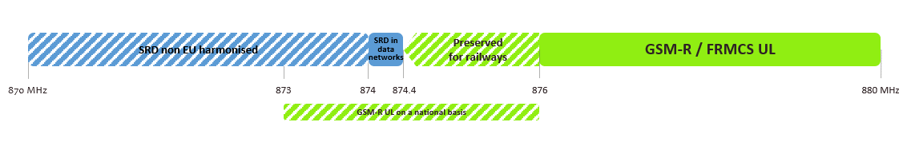
Figure 1: Band plan for 870-880 MHz
Figure 2: Band plan for 915-925 MHz
Notes:
- 500 milliwatt SRD in data networks are harmonised in 874-874.4 MHz in the Decision (EU) 2018/1538, while the band 870-874.4 MHz is listed in ERC Recommendation 70-03, annex 2 [3];
- 25 milliwatt non-specific SRD in data networks are harmonised in 917.4-919.4 MHz in the Decision (EU) 2018/1538, while the band 915-919.4 MHz is listed in ERC Recommendation 70-03, annex 2;
- Wideband data transmission devices in data networks (802.11ah on in the Figure 2) are harmonised in 917.4-919.4 MHz in the Decision (EU) 2018/1538, while the band 915.8-919.4 MHz is listed in ERC Recommendation 70-03, annex 3;
- The 874-874.4 MHz and 915-919.4 MHz frequency bands are harmonised at EU level for Short Range Devices under Decision (EU) 2018/1538 [2];
- A few countries in Europe are using this frequency band 873-876 MHz / 918-921 MHz on a national basis for GSM-R. In some CEPT countries, these bands are used by other governmental systems.

RMR technical parameters
Railway Mobile Radio (RMR) encompasses Global System for Mobile communications for Railway (GSM-R) and Future Railway Mobile Communication System (FRMCS), where GSM-R is a narrowband system based on GSM/GPRS/EDGE, and FRMCS is a wideband system based on LTE/NR.
All values not related to specifications are values provided by industry.
Table 4: BS characteristics
Parameter | Value | Reference
Frequency band | 874.4-880 MHz (UL) /  919.4-925 MHz (DL)
Antenna gain | 17 dBi | (typical value)
Feeder and coupling losses | 4 dB | (typical value)
Noise figure | 5 dB | Report ITU-R M.2039-3 [4]  Table 5 (interface no. 4)  Table 2 (interface no. 1)
Protection criterion | Desensitization = 1 dB | ANNEX 1:
Table 5: Cab-radio characteristics
Parameter | Value | Comment
Antenna | HUBER+SUHNER  1399.99.0121 | (Note 1)
Antenna height | 4 m
Maximum antenna gain | 5 dBi | Typically at 30° elevation  (see Figure 4)
HW losses | 3 dB (Note 2)
Noise figure | 5 dB | Data from cab-radio manufacturer
Protection criterion | Desensitization = 2.2 dB for GSM-R  Desensitization = 1.7 dB for FRMCS | ANNEX 1:
Note 1: In the horizontal plane, the cab-radio antenna pattern can be considered as omnidirectional. In the vertical plane, the cab-radio antenna pattern is in Fig 4
Note 2: It may be as high as 6 dB in some circumstances.
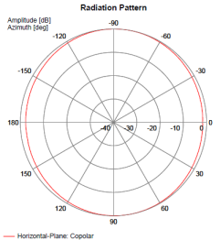
Figure 3: Cab-radio horizontal antenna pattern at 880 MHz

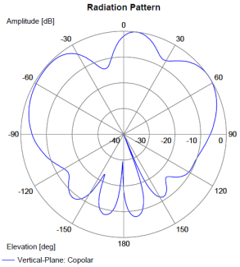
Figure 4: Cab-radio vertical antenna pattern at 880 MHz

Co-existence between RMR cab-radio and MFCN in the 900 MHz range
This section aims at determining the robustness required for the RMR cab-radio, i.e. the maximum interfering signal level from MFCN BS and MFCN “aerial UE” that a cab-radio must be able to face.

Co-existence between RMR cab-radio and MFCN BS above 925 MHz

Blocking and intermodulation
Based on UIC’s report O-8736 [6], where field measurements of emissions from UMTS BS and a potential increase of MFCN BS e.i.r.p. in the long term when moving to 10 MHz channels (as described in Report ITU-R M.2292-0, table 3 [5]) are documented, ETSI TS 102 933-1 v1.3.1 [7] onwards has specified an enhanced blocking / intermodulation threshold for GSM-R cab-radios so that they are able to cope with MFCN emissions above 925 MHz.
Table 6: GSM-R improved cab-radio receiver characteristics
Parameter | Value
Sensitivity | -104 dBm
Level of the wanted signal | -101 dBm  = Sensitivity +3 dB
Maximum CW interfering signal in 925.2-927 MHz | -13 dBm
Maximum CW interfering signal in 927-960 MHz | -10 dBm
Maximum 5 MHz LTE interfering signal (lowest carrier at 927.6 MHz) | -13 dBm
The antenna connector of the radio module is the reference point.
These requirements cover both blocking and third-order intermodulation.

These requirements remain valid and can be directly applied to FRMCS cab-radios except for the sensitivity levels which can be derived by the one defined in 3GPP 36.101 and 3GPP 38.101,

Considerations on RMR minimum signal level

Derivation of the ACS value
Interference resulting from selectivity of a radio receiver can be modelled by a power level, denoted $I_{R}$, degrading the signal over noise power ratio:

 | $$\frac{S}{NF+I_{R}}$$ | (1)
The interfering power within the receiver $I_{R}$ can be expressed as function of the interfering interference $I$ at the antenna connector:
 | $$I_{R}=\frac{I}{A}$$ | (2)
Where the selectivity “A” is the value of an intrinsic characteristic of the receiver that reflects its level of immunity to the interference. The selectivity can be derived from the Requirements on FRMCS cab-radio receiver characteristics as follows.
When operating at the receiver sensitivity, in a noisy environment, the signal to noise power ratio is given by:
 | $$\frac{S_{sensitivity}}{NF}={SNR}_{sensitivity}$$ | (3)
When operating under the conditions described by the requirement, the signal to noise power ratio is given by:
 | $$\frac{S_{sensitivity}×{10}^{3/10}}{NF+I/A}= {SNR}_{sensitivity}$$ | (4)
This equation represents a desensitisation of 3 dB when subject to a given interference power $I$ at the antenna connector.
By dividing the two expressions above, the following equation for A is obtained, expressed in dB scale:
 | $$A=I-NF-10×\log_{10}\left({10}^{\frac{3}{10}}-1\right)$$ | (5)
By application of the values proposed in Table 6 the following is obtained for a 5 MHz carrier:
 | $$A=89 dB$$ | (6)

With:
- $I=-13 dBm$;
- $F=$ 5 dB.

Impact of MFCN BS unwanted emissions on FRMCS cab-radio
In this study, a worst-case analysis is performed to compute the amount of the interference-to-Noise Ratio ($I-{N)}_{calculated}$ at the FRMCS cab-radio victim receiver caused by a MFCN base station in close vicinity. The FRMCS cab-radio is operating in 919.4-925 MHz and the MFCN base station interferer is operating in the channel above 925 MHz. In this study, distances from 0 m up to 1200 m are considered between the MFCN base station and the cab-radio victim receiver. The antenna gain of the MFCN base station in the direction of the train is accounted for by using the formulas from the Recommendation ITU-R F.1336-5 [19]. For the propagation model, describing the attenuation of the radio signal along the propagation path, the modified Hata model is used that is presented in the ERC Report 68. In this analysis, open area, suburban and urban environments are addressed.
The results of the study indicate that the ($I-{N)}_{target}=0 dB$ will be exceeded for quite some ranges of parameters. However, it should be noted that the study gives the results for a worst case in which the antenna beam of the MFCN interferer is pointing directly onto the rail tracks. Hence, it is assumed that the victim is situated inside of the main beam range in the azimuth plane. The interference situation will be improved accordingly in cases, where the victim is located in a side-lobe region but not inside of the main beam lobe of the interferer.

Assumptions on parameters
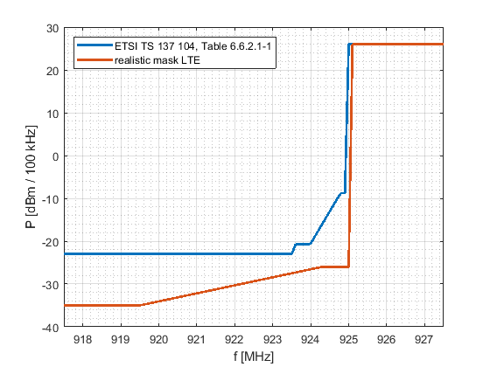
Figure 5: Sketch of the emission levels of the LTE transmit masks given by an ETSI TS 137 104 (blue curve) and a measurement report (red curve)
The realistic LTE mask is based on a real LTE base station currently in use where the unwanted emission suppression is better than the corresponding standard requires.
In this study, the limits for the unwanted emissions of an LTE MFCN base station given in the document ETSI TS 137 104 in Table 6.6.3.1-3 are considered [8] for a measurement bandwidth of 100 kHz (Table 7).
Table 7: LTE MFCN base station emission mask
Frequency offset of measurement filter centre frequency, f_{offset} | Minimum requirement per 100 kHz
0.015 MHz ≤ f_{offset} < 0.215 MHz | -8.78 dBm
0.215 MHz ≤ f_{offset} < 1.015 MHz | -8.78 dBm -15$∙\left(\frac{f_{offset}}{MHz}-0.215\right)$ dB
1.015 MHz ≤ f_{offset} < 1.5 MHz | -20.78 dBm
1.5 MHz ≤ f_{offset} ≤ 10 MHz | -23 dBm
For the inblock power of the MFCN base station, a value of P = 26 dBm/100 kHz is assumed.
It is further considered an expression for an LTE emission mask determined by measurements and given in the document referenced [24] (the measured emission mask was called "the realistic mask".) where the average over the measurements data reads as follows:
Table 8: Realistic LTE MFCN base station mask based on measurement
Frequency point (MHz) | Absolute level (dBm) per 100 kHz
917.5 | -35
919.5 | -35
924.3 | -26
925 | -26
925.1 | +26 (in-band power)
927.5 | +26 (in-band power)
This mask will also be referred as ”realistic mask” in the following, as actual LTE base stations usually reach a higher suppression of unwanted emissions than the standard requires. Further, the LTE signals used in the measurements were configured according to a test model representing the worst case for the victim because it occupies all the available resource blocks at maximum power. Based on practical experiences an LTE signal is pulsed and has high out-of-band emissions only during short times. referenced [24], section 3.4).
In this study, the following characteristics shown in Table 9 arewere assumed for the MFCN base station:
Table 9: LTE MFCN base station characteristics
 | Open area case | Urban/suburban cases
h_{basestation} | 45 m | 30 m
Downtilt $θ_{1 }$ | 3° | 10°
G₀ | 17 dBi | 15 dBi
Feeder Loss | 3 dB | 3 dB
For the cab-radio, a height of h_{cabradio} = 4 m is assumed.
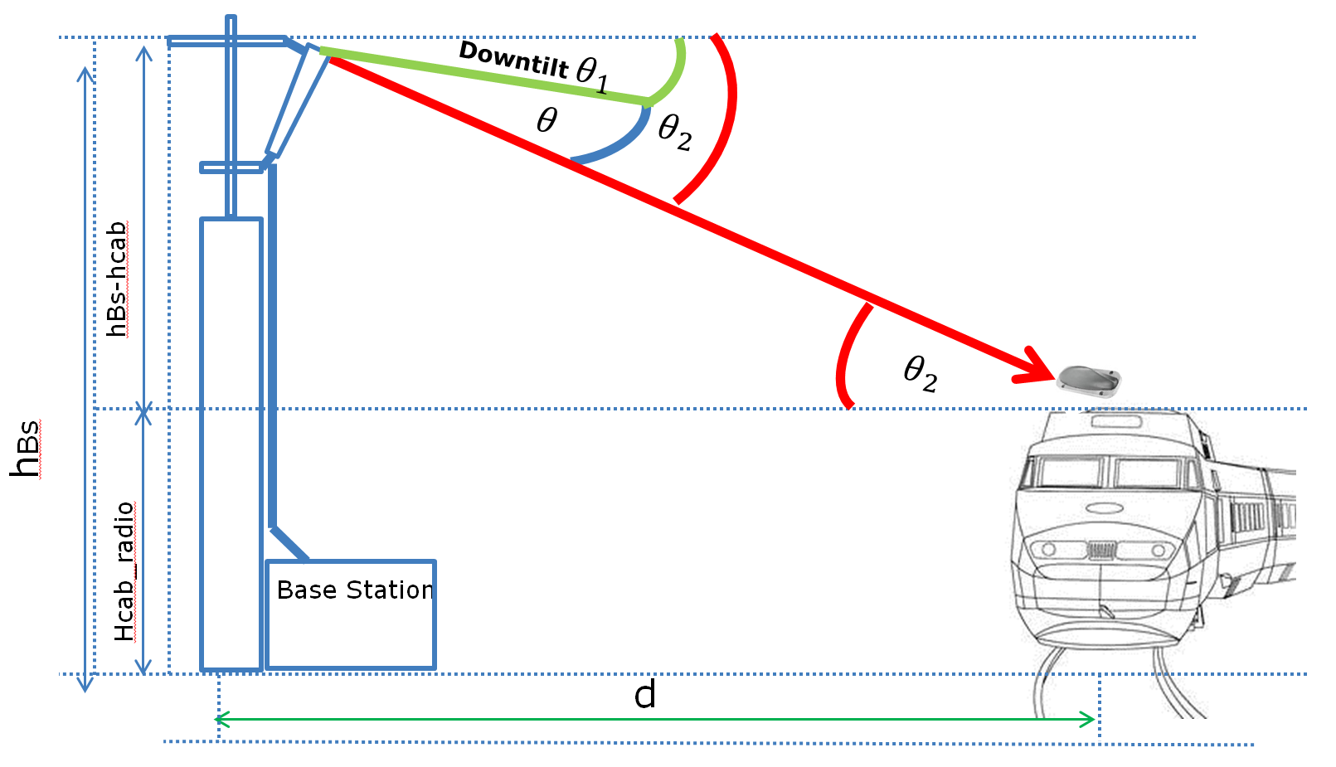
Figure 6: Illustration of the scenario
A scenario with distances ranging from d=0 m up to to d=1200 m between the MFCN base station is considered, and the train tracks at which the FRMCS cab-radio is located, as illustrated in the graphic above. The angle $θ$ is relevant to determine the deviation from the maximum antenna gain in the elevation plane for the MFCN base station.

Antenna gain of the MFCN base station in the direction of the cab-radio
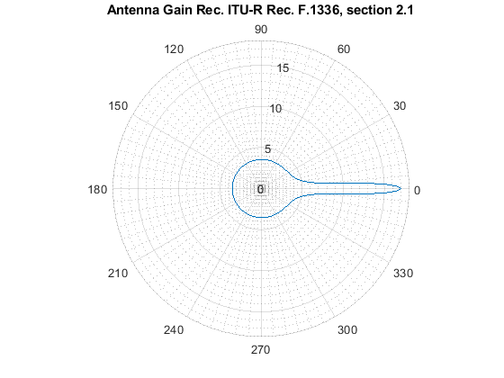
Figure 7: Plot of the formula for $G\left(θ\right)$ as given below
Source: Recommendation ITU-R F.1336, section 2.1 [19]
In order to describe the antenna pattern of the MFCN base station the ”peak side lobe pattern” given in the Recommendation ITU-R F.1336-5 [20], section 2.1, is used given by the following formula:
 | $$G\left(θ\right)=\left\{\begin{aligned}G_{0}-12{\left(\frac{θ}{θ_{3}}\right)}^{2} for 0 ≤\left|θ\right|<θ_{4} \\ G_{0}-12+10 log\left(k+1\right) for θ_{4} ≤\left|θ\right|<θ_{3} \\ G_{0}-12+10 log\left[{\left(\frac{\left|θ\right|}{θ_{3}}\right)}^{-1.5}+k\right] for θ_{3} ≤\left|θ\right|<90°\end{aligned}\right.$$ | (7)
With:
 | $$θ_{3}=5°$$  $θ_{4}$= $θ_{3}\sqrt{1-\frac{1}{1.2}log\left(k+1\right)}$ | (8)
Where:
- $G\left(θ\right):$ gain relative to an isotropic antenna (dBi);
- $G_{0}:$ maximum gain in the azimuth plane (dBi);
- $θ:$ elevation angle relative to the angle of the maximum gain (degrees) (-90° ≤$θ≤90°$);
- $θ_{3}:$ the 3 dB beamwidth in the elevation plane;
- $k$: parameter which accounts for increased side-lobe levels above what would be expected for an antenna with improved side-lobe performance. In the present case there is $k=0.7$.
Considering Figure 7, the angle $θ$ that is relevant to compute the reduction from the maximum value for the antenna gain G₀ reads as follows:
 | $$θ = θ_{2}-θ_{1}=\tan^{-1}\left(\frac{h_{basestation}-h_{cabradio}}{d}\right)-θ_{1}$$ | (9)
Where:
- $e_{1}$ is the downtilt of the antenna at the MFCN base station;
- $θ_{2}$ is the angle between the horizontal plane and the connection line between the MFCN base station and the cab-radio;
- With the above given formula for $G(θ)$, the antenna gain in the direction of the connection line between the MFCN base station and the cab-radio can be derived.
The results show that the maximum antenna gain $G_{0}$ is reduced by values ranging from $≈0$dB to -13.4 dB depending on the angle $θ$.

Propagation path loss
To compute the path loss of the radio signal propagating between the MFCN base station and the cab-radio, the modified Hata model is used which is described in the ERC Report 68 [29] on the page 21. In the evaluation, the frequency is set to f = 925 MHz.
For the parameter h_basestation, the cases of urban, suburban and open area environments have to be distinguished.
For distances d ≤ 40 m, the propagation loss is given by:
 | $$L_{pathloss}\left[dB\right]=32.45+20∙\log\left(f\right)+10∙{\log{(\left(d\left[km\right]\right)}}^{2}+\frac{{\left(h_{basestation}-h_{cabradio}\right)}^{2}}{{10}^{6}})$$ | (10)
For d≥ 100 m, the modified Hata model reads for the respective scenarios:
Urban case:
 | $$L_{pathloss,urban}\left[dB\right]=69.6+26.2∙\log\left(f\right)-13.82∙\log\left(h_{basestation,urban}\right)+\left(44.9-6.55∙\log\left(h_{basestation,urban}\right)\right)∙\log\left(d\left[km\right]\right)-a\left(h_{cabradio}\right)$$  $$a\left(h_{cabradio}\right)=\left(1.1∙\log\left(f\right)-0.7\right)∙h_{cabradio}-(1.56∙\log\left(f\right)-0.8)$$ | (11)
Suburban case:
 | $$L_{pathloss,suburban}\left[dB\right]=L_{urban}\left[dB\right]-2∙{\left(\log\left(\frac{f}{28}\right)\right)}^{2}-5.4$$ | (12)
Open area case:
 | $$L_{pathloss,freespacce}\left[dB\right]=32.45+20\log\left(f\right)+20 log⁡(d[km])$$ | (13)
In the open area case, the pathloss is given by the free space propagation model.
For the case of 40 m < d < 100 m, the path loss is interpolated by:
 | $$L_{pathloss}\left[dB\right]=L_{pathloss}\left(0.04\right)+\frac{\left(\log\left(d\left[km\right]\right)-\log\left(0.04\right)\right)}{\left(\log\left(0.1\right)-\log\left(0.04\right)\right)}∙\left(L_{pathloss}\left(0.1\right)-L_{pathloss}\left(0.04\right)\right)$$ | (14)
where for $L_{pathloss}\left(0.04\right), L_{pathloss}(0.1)$ the formulas for the respective cases of open area, suburban and urban environments have to be used. The graphic below figure illustrates the predictions of the propagation model. For example, for d = 100 m the path loss is 71.8 dB for the open area case, 75.2 dB for the suburban case and 85.3 dB for the urban case, so that the difference can amount up to 13.5 dB.
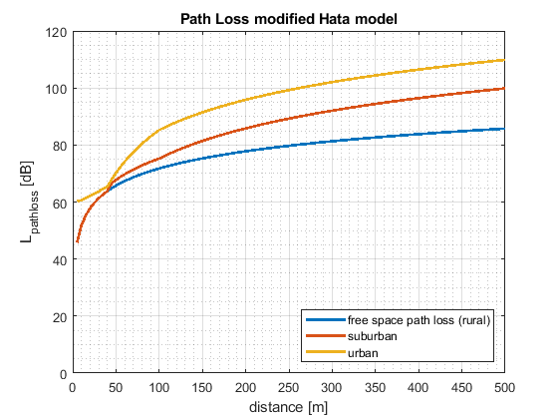
Figure 8: Propagation path loss predicted according to the modified Hata model

Interference calculation
In the present study, a worst-case analysis is performed. The following is computed:
 | $$I-N=P_{MFCN,transmitmask}+G{\left(θ\right)}_{MFCN,i}-L_{pathloss,i}-L_{feeder}-L_{MFCN_{feeder}}-N$$ | (15)
Where:
- i=urban, suburban, open area environments for the propagation model;
- $I:$ power levels received at the cab-radio;
- $N:$ noise power level at the receiver;
- $P_{MFCN,transmitmask}$: power levels from the transmit masks of the MFCN base station;
- $L_{feeder}=$3 dB feeder loss of the cab-radio;
- $L_{MFCN_feeder}=$3 dB feeder loss of the MFCN BS;
- $G{\left(θ\right)}_{MFCN,i}:$antenna gain as explained above for the respective scenarios i= urban, suburban, open area.
The results can be compared with a protection criterion as follows:
 | $$(I-{N)}_{target}=0 dB$$ | (16)
that corresponds to an allowed degradation margin of 3 dB for the cab-radio. For a bandwidth of 100 kHz and a noise figure for the cab-radio as NF = 5 dB, the noise level N in the expression can be computed as:
 | $$N\left[\frac{dBm}{100 kHz}\right]=-174\frac{dBm}{Hz}+10∙\log\left({10}^{5}\right)+NF= -119\frac{dBm}{100 kHz}$$ | (17)

Duration of the interference
In a scenario where the main beam of the MFCN base station is pointing onto the rail tracks orthogonally and where the azimuth halfpower beamwidth is assumed to be $Δφ=$62°, a train with the velocity vv will be situated inside of the main beam region for the respective time that can be computed as (see Figure 9):
 | $$t=\frac{b}{v}$$ | (18)
Where b is the length of track covered by BS antenna and given as $b=2d\tan{\frac{Δφ}{2}}$
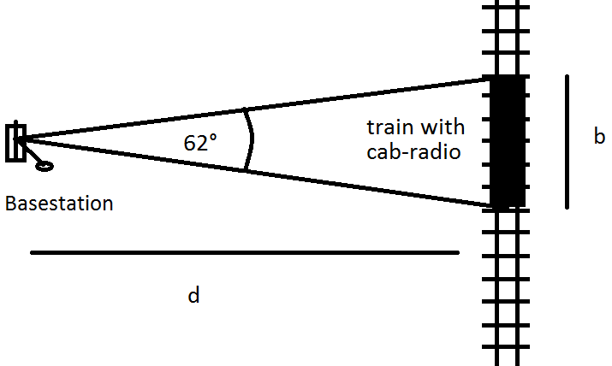
Figure 9: Scenario to determine the interference time t

Table 10: Interference time depending on distance and train speed
d (m) | t (sec) for v=80 km/h | t (sec) for v=150 km/h
100 | 5.4 | 2.9
250 | 13.5 | 7.2

Results
In the following, the results of the above described analysis are presented.
In Figure 10 and Figure 11 the amount of the interference is illustrated in terms of the $(I-{N)}_{calculated}$ in [dB] in dependence of the frequency range for the cases of d = 100 m and 250 m between the MFCN base station and the cab-radio victim receiver.
It should be noted that the study gives the results for the worst case in which the antenna beam of the MFCN interferer is pointing directly onto the rail tracks. In this scenario, the victim is situated inside of the main beam range in the azimuth plane. The interference situation will be improved accordingly in cases where the victim is located in a side-lobe region but not inside of the main beam lobe of the interferer. In this worst-case situation, the $(I-{N)}_{target}=0 dB$ will be exceeded for quite some ranges of parameters. Table 11 shows $(I-{N)}_{calculated}$at the frequency f = 922.5 MHz, the $(I-{N)}_{calculated}$ reads in [dB].
Table 11: Calculated Interference to Noise ratios at different environments
 |  | Standard mask  $$(I-{N)}_{calculated}$$ | Realistic mask  $$(I-{N)}_{calculated}$$
d = 100 m | Open area | 22.43 | 16.05
d = 100 m | Suburban | 20.07 | 13.69
d = 100 m | Urban | 10.05 | 3.67
d = 250 m | Open area | 16.74 | 10.37
d = 250 m | Suburban | 7.83 | 1.45
d = 250 m | Urban | -3.81 | -8.57
In Figure 12, the $(I-{N)}_{calculated}$ is illustrated for the power level per 100 kHz at f = 922.5 MHz as a function of the distance d between the interferer and the victim. In these graphics, the kinks are stemming from the distinction of cases in the formula for the antenna gain $G(θ)$ as described above in the second subsection of this study. In the formula for $G(θ)$, the angles $θ$ are varying with the distance d between the MFCN base station and the cab-radio.
Considering urban and suburban environments, the emissions according to the ETSI mask (named "standard mask" in Table 11) are reduced sufficiently after distances of around 250 m and 400 m, respectively. For the emission mask averaging the measurements results (named "realistic mask" in Table 11), the emissions can be reduced sufficiently after distances of around 200 m and 260 m, respectively. For the open area case, the situation is more critical. Nevertheless, it should be noticed that the propagation loss of the radio signal is given by the free space propagation model in the open area case, representing pessimistic interference conditions (excluding clutter effects).
The Figure 10 and Figure 11 show I-N caused by the MFCN interferer at the cab-radio victim receiver for distances of 100 m and 250 m between the MFCN base station and the victim receiver, for the emission mask according to ETSI TS 137 104 [22] and the emission mask determined by measurements, respectively.
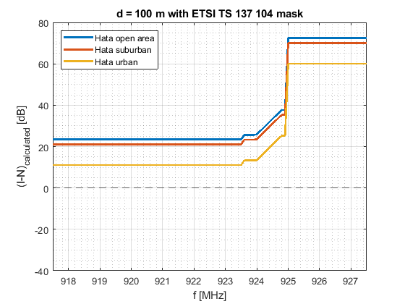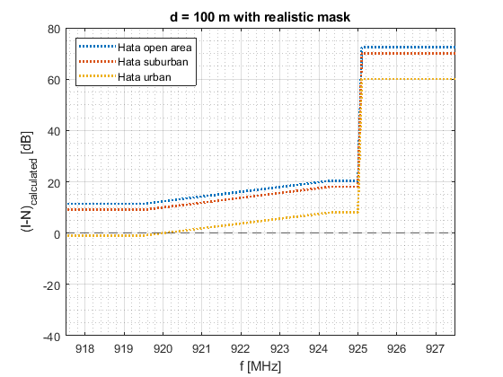
Figure 10: I-N caused by the MFCN interferer at the cab-radio victim receiver for a distance of 100 m between the MFCN base station and the victim receiver, for the emission mask according to ETSI TS 137 104 and the emission mask determined by measurements, respectively

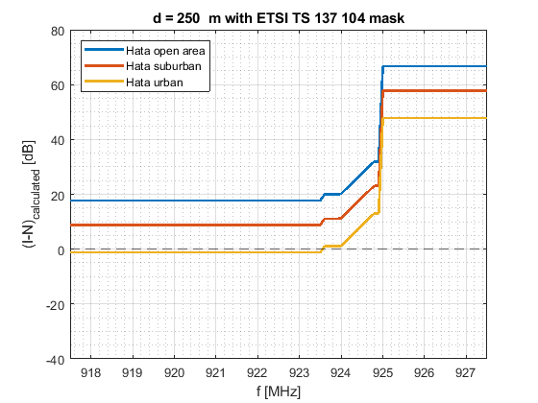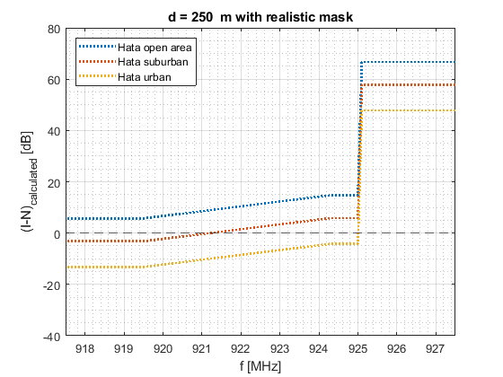
Figure 11: I-N caused by the MFCN interferer at the cab-radio victim receiver for a I-N caused by the MFCN interferer at the cab-radio victim receiver for distance of 250 m between the MFCN base station and the victim receiver, for the emission mask according to ETSI TS 137 104 and the emission mask determined by measurements, respectively
Figure 12 shows I-N caused by the MFCN interferer at the cab-radio victim receiver in dependence of the distance between the MFCN base station and the victim receiver at the frequency level f = 922.5 MHz, for the emission mask according to ETSI TS 137 104 and the emission mask determined by measurements, respectively.
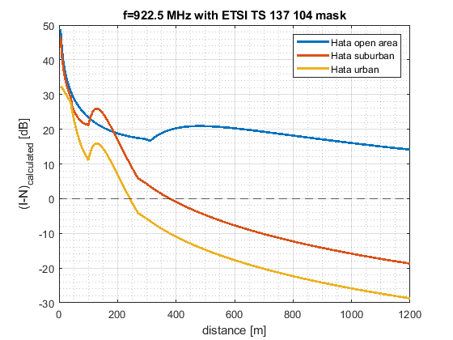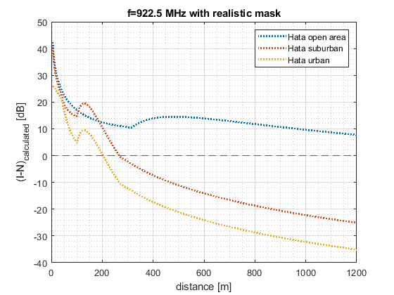
Figure 12: I-N caused by the MFCN interferer at the cab-radio victim receiver in dependence of the distance between the MFCN base station and the victim receiver at the frequency level f = 922.5 MHz, for the emission mask according to ETSI TS 137 104 and the emission mask determined by measurements, respectively
The results of I-N in Figure 12 for very short distances shows that without mitigation techniques, out-of-band emissions from MFCN BS may exceed the acceptable level of interference in RMR cab-radios in some worst cases.

Conclusions
The results of the study should be considered in the planning for the FRMCS system. Coordination and/or other mitigation techniques are required for co-existence between cab-radio and a MFCN BS close to railway track and operating on the channels adjacent to the FRMCS channel. The study gives the results for worst-case situations, where the MFCN base station operates in close vicinity (several hundreds of metres in open area) to the railway tracks and the main beam of the MFCN base station is hitting directly onto the railway tracks. The train movement on operational railway lines depends on timetables and the kind of railway services. The probability of a moving train staying in front of a MFCN base station is very low.

Co-existence between RMR cab-radio and MFCN aerial UE below 915 MHz
According to ECC Report 309 [15], the term “aerial UE” is equally applicable to unmanned aircraft (drone) and manned aircraft.
Aerial UE characteristics:
- Max. output power: 23 dBm;
- Antenna gain: 0 dBi (see ECC Report 309).
When assuming an MFCN aerial UE at 30 m separation distance from the cab-radio (expected to be the minimum exclusion zone from rail tracks), the maximum interfering power Max_I_{IB} that a cab-radio must be able to face at its antenna connector can be calculated from the following formula:
 | $$AerialUE_EIRP -L=Max_I_{IB}$$  $$L=PL-G_{cab-radio}+HWlosses$$ | (19)
Where:
- PL is the free space path loss;
- G_{cab-radio} is the cab-radio antenna gain of 5 dBi;
- HWlosses are 3 dB.:
 | $$Max_I_{IB}=23-61.2+5-3=-36.2 dBm$$ | (20)
As seen in ANNEX 1, the maximum acceptable desensitization for an FRMCS cab-radio (worst case compared to GSM-R) is 1.7 dB. Thus, the maximum MFCN aerial UE interfering signal below 915 MHz that an RMR cab-radio may face is -36.2 dBm for a desensitization of 1.7 dB. In order to be able to cope with MFCN aerial UE, the following receiver characteristics are required for RMR cab-radios are listed in Table 12.
Table 12: Requirements on RMR cab-radio receiver characteristics
Parameter | Value
Level of the wanted signal | Sensitivity +3 dB
Maximum 5 MHz LTE interfering signal in 880-915 MHz (Note 1) | -33 dBm (Note 2)
The antenna connector of the radio module is the reference point.
Note 1: This requirement covers both blocking and third-order intermodulation
Note 2: -36.2 dBm for a desensitization of 1.7 dB is equivalent to -33 dBm for a desensitization of 3 dB

These requirements are already fulfilled by GSM-R cab-radios specified in ETSI TS 102 933-1 [7] (≥ -12 dBm below 915 MHz for continuous wave signal).

Co-existence between RMR cab-radio and SRD below 919.4 MHz
This section aims at determining the robustness required for the RMR cab-radio, i.e. the maximum interfering signal level from SRD that a cab-radio must be able to face given that the spectrum should be used to maximum efficiency. Full technical characteristics of SRD considered in this Report are given in ANNEX 2.
ECC Report 200 [13] assessed the impact of SRD unwanted emissions on GSM-R terminals based on the assumptions available at that time; some parameters are not up to date (e.g. C/(N+I)), antenna height, propagation model, etc.) and FRMCS was not considered.

500 milliwatt SRD
In this study, worst-case scenarios (meaning not typical) for RMR cab-radios are considered where 500 milliwatt SRD are in close proximity to rail tracks, in direct line-of-sight and of the following types:
- Network Access Point (NAP) placed above rooftop;
- Network Node (NN) (outdoor relay nodes) placed at 5 m height.
Table 13: 500 milliwatt SRD characteristics
Parameter | Value | Comment
Upper channel | 918.5-918.9 MHz
Bandwidth | 1 kHz to 200 kHz
Maximum e.r.p. | 500 mW
Maximum e.i.r.p. | 29.1 dBm
Antenna height | NAP: 25 m *¹  NN: 5 m *² | *¹ valid for CSS and UNB  *² valid for NBN  (There are 2 other type of devices emitting at 500 mW SRD which are not considered in this section:  - NBN NAP at 7 m  - NBN TN at 1.5 m)

500 milliwatt SRD NAP above rooftop
For certain types of data networks, NAP are installed at the heights of up to 25 m; then the co-existence scenario for a 500 milliwatt SRD NAP is above rooftop. In other cases, NAP are installed at the heights of 7 m or 5 m, so which is below rooftop (see section 5.1.2). The worst-case scenario of a NAP at 25 m height is considered here and is similar to co-existence between MFCN BS (also above rooftop) and RMR cab-radio.
From Report ITU-R M.2292-0 [5] and ETSI TS 102 933-1 [7], the loss L between the MFCN BS EIRP and the maximum interfering power received at the cab-radio antenna connector Max_I_{IB} (defined for a desensitization of 3 dB) can be computed as follows:deduced.
 | $$MFCN_BS_EIRP -L=Max_I_{IB}$$ | (21)

 | $$L=MFCN_BS_EIRP-Max_I_{IB}=58-\left(-13\right)=71 dB$$ | (22)
The same loss is applied between the NAP e.i.r.p. and the interfering power received at the cab-radio antenna connector.
 | $$Max_I_{IB}=NAP_EIRP-CL=29.1-71=-41.9 dBm$$ | (23)
In order to cope with 500 milliwatt NAP above rooftop, the maximum interfering signal below 918.9 MHz for RMR cab-radios shall be -42 dBm for a desensitization of 3 dB.

500 milliwatt NN at 5 m height
The purpose of this section is to assess whether a maximum interfering level of -39 dBm is sufficient for RMR cab-radios to cope with 500 milliwatt NN at 5 m height.
When assuming 25 m separation distance, the loss L between the NN and the cab-radio can be described as follows:
 | $$L=PL-G_{cab-radio}+HWlosses$$ | (24)
where $G_{cab-radio}$ is assumed to be 0 dBi since the elevation angle from the cab-radio is close to 0°. HWlosses are 3 dB (see Table 5). The free space propagation model is used.:
 | $$PL=59.6 dB$$  $$L=59.6-0+3=62.6 dB$$ | (25)
The loss is 8.4 dB lower than the one related to the NAP above rooftop. Thus, in order to cope with 500 milliwatt NN below rooftop, the maximum interfering signal below 918.9 MHz for RMR cab-radios shall be -33.5 dBm (= -41.9 + 8.4) for a desensitization of 3 dB.
This section is also valid for NAP below rooftop.

Receiver requirements for RMR cab-radio below 918.9 MHz
In order to face a potential densification of 500 milliwatt SRD along rail tracks, a margin of 3 dB is added to the maximum interfering signal below 918.9 MHz for RMR cab-radios. Based on worst-case scenarios, the following receiver characteristics shown in Table 14 are thus required for RMR cab-radios.
Table 14: Requirements on RMR cab-radio receiver characteristics
Parameter | Value
Level of the wanted signal | Sensitivity +3 dB
Maximum interfering signal in 916.1-918.9 MHz (Note 1) | -30.5 dBm
The antenna connector of the radio module is the reference point.
Note 1: This requirement covers both blocking and third-order intermodulation.

RFID
When considering the impact of RFID interrogator on RMR cab-radio, three worst -case scenarios are studied (outdoor cases are considered here and indoor case in Section 5.2.1:
- an horizontal interrogator to scan containers from above the truck (1);
- a vertical interrogator facing the opposite direction of the rail tracks (2);
- a vertical interrogator facing the rail tracks (3).
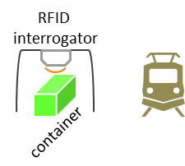 (1)
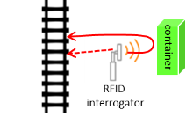 (2) | 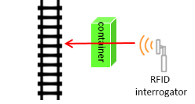 (3)
Figure 13: RFID outdoor scenarios
These scenarios reflect potential rare RFID use cases in private sidings connected to the main railway network, like in container storage areas, intermodal freight nodes, etc. These scenarios are rare worst cases, and the minimum separation distances in typical situation are likely to be larger than used in this study.

Table 15: RFID interrogator characteristics (heights and distances for different scenarios)
Parameter | Value
Frequency ranges | 916.1-916.5 MHz  917.3-917.7 MHz  918.5-918.9 MHz
Bandwidth | 400 kHz
Maximum e.r.p. | 4 W
Maximum e.i.r.p. | 38.2 dBm
Antenna | Laird™ PAV90209H
Antenna height | 4.5 m for (1)  2.4 m for (2) and (3) (Note 1)
Maximum antenna gain | 9 dBi
Front to back ratio | 18 dB
Ground distance from rail tracks | 25 m for (1) and (3)  20 m for (2) (Note 1)
Note 1: (1), (2) and (3) refer to scenarios
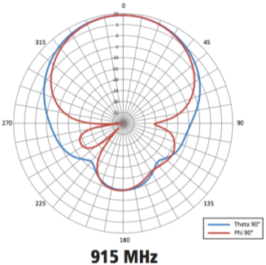
Figure 14: RFID interrogator antenna pattern
Theta = vertical plane / Phi = horizontal plane when the interrogator is placed vertically
The maximum interfering power Max_I_{IB} that a cab-radio must be able to face at its antenna connector can be calculated from the following formula:
 | $$RFID_EIRP -L=Max_I_{IB}$$  $$L=PL+D_{RFID}-G_{cab-radio}+HWlosses$$ | (26)
Where:
- PL is the free space path loss;
- D_{RFID} is the RFID antenna discrimination depending on the scenario considered;
G_{cab-radio} is the cab-radio antenna gain including the discrimination and depending on the scenario considered, and HW losses are 3 dB.
In scenario (1):  - PL = 59.6 dB;  - D_{RFID} = 35 dB;  - G_{cab-radio} = 0 dBi;  - L = 97.6 dB;  - Max_I_{IB} = -59.4 dBm. | In scenario (2), reflection on the container:  - PL = 58.5 dB with 2 m additional propagation distance towards/from the container (due to reflection);  - D_{RFID} = 6 dB to account for the reflection loss;  - G_{cab-radio} = 0 dBi;  - L = 67.5 dB;  - Max_I_{IB} = -29.3 dBm.
In scenario (2), backwards emissions:  - PL = 57.7 dB;  - D_{RFID} = 18 dB;  - G_{cab-radio} = 0 dBi;  - L = 78.7 dB;  - Max_I_{IB} = -40.5 dBm. | In scenario (3):  - PL = 59.6 dB;  - D_{RFID} = 0 dB;  - G_{cab-radio} = 0 dBi;  - L = 62.6 dB;  - Max_I_{IB} = -24.4 dBm.
As seen in ANNEX 1, the maximum acceptable desensitization for an FRMCS cab-radio (worst case compared to GSM-R) is 1.7 dB. Scenario (2) is used to define the maximum RFID interfering signal below 918.9 MHz that an RMR cab-radio may face, i.e. -29.3 dBm for a desensitization of 1.7 dB. In order to be able to cope with 4 W RFID interrogators in worst case situations, the following receiver characteristics are required for RMR cab-radios.
Table 16: Requirements on RMR cab-radio receiver characteristics
Parameter | Value
Level of the wanted signal | Sensitivity +3 dB
Maximum RFID interfering signal in  916.1-918.9 MHz (Note 1) | -26 dBm (Note 2)
The antenna connector of the radio module is the reference point.
Note 1: This requirement covers both blocking and third-order intermodulation.
Note 2: -29.3 dBm for a desensitization of 1.7 dB is equivalent to -26.1 dBm for a desensitization of 3 dB.

RFID indoor operation
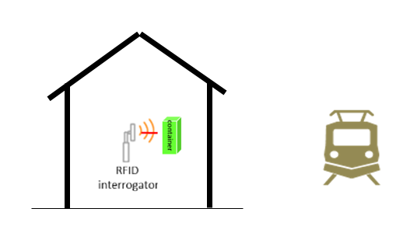
Figure 15: RFID indoor scenario (4)
In scenario (4), indoor operation:
- PL = 59.6 dB for 25 m ground distance;
- D_{RFID} = 0 dB;
- Wall loss = 7 dB in store / item tagging scenario (see A2.2);
- G_{cab-radio} = 0 dBi;
- L = 69.6 dB;
- Max_I_{IB} = -40.4 dBm with 27 dBm e.r.p. RFID interrogators in store / item tagging scenario (see A2.2).

As seen in ANNEX 1, the maximum acceptable desensitization for an FRMCS cab-radio (worst case compared to GSM-R) is 1.7 dB. For typical indoor operation, RMR cab-radios may face -42.6 dBm.

Other 25 milliwatt SRD
The loss L between the 25 milliwatt SRD and the cab-radio can be described as follows:
 | $$L=PL-G_{cab-radio}+HWlosses$$ | (27)
Where:
- PL is the path loss for 20 m separation distance (worst case);
$G_{cab-radio}$ is -5 dBi (below horizontal plane in Figure 4), HW losses are 3 dB (see Table 5). The 25 milliwatt SRD is considered outdoor while in most cases they are inside a building. The free space propagation model is used.
 | $$PL=57.7 dB$$  $$L=57.7-(-5)+3=65.7 dB$$ | (28)
The maximum interfering power received at the cab-radio antenna connector Max_I_{IB} can be deduced.
 | $$Max_I_{IB}=SRD_EIRP-L=16.1-65.7=-49.6 dBm$$ | (29)
As seen in ANNEX 1, the maximum acceptable desensitization for an FRMCS cab-radio (worst case compared to GSM-R) is 1.7 dB. Based on the table above, the maximum 25 milliwatt SRD interfering signal below 919.4 MHz that an RMR cab-radio may face is -49.6 dBm for a desensitization of 1.7 dB. In order to be able to cope with 25 milliwatt SRD, the following receiver characteristics are required for RMR cab-radios.
Table 17: Requirements on RMR cab-radio receiver characteristics
Parameter | Value
Level of the wanted signal | Sensitivity 3 dB
Maximum interfering signal in  918.9-919.4 MHz (Note 1) | -46 dBm (Note 2)
The antenna connector of the radio module is the reference point.
Note 1: This requirement covers both blocking and third-order intermodulation.
Note 2: -49.6 dBm for a desensitization of 1.7 dB is equivalent to -46.4 dBm for a desensitization of 3 dB.
This value could be relaxed by 17 dB with respect to SRD operating indoor. This would lead to a blocking level of -63 dBm, which is already fulfilled by both GSM-R and LTE/NR specifications. Considering:
- the elements above;
- that the requirement of a blocking level of -26 dBm below 918.9 MHz could lead to some additional filtering in 918.9-919.4 MHz;
it is considered not necessary to define a specific requirement on RMR receivers in 918.9-919.4 MHz.

Specific case of GSM-R operating at 919.6 MHz
The lowest GSM-R carrier within the band is centred at 919.6 MHz.
In GSM TS 05.05, table 6.3-1 in section 6.3 [9] protection ratios are specified in dB for a desensitization D_{STANDARD} of 20 dB (see section 6.1):
- Co-channel, [C/Ic]_{dB} = 9 dB;
- First adjacent channel, [C/I_{a1}]_{dB} = -9 dB.
The selectivity can be obtained by the following formula in dB:
 | $$S_{a1}=I_{a1}-I_{c}=\left[C/{I_{c}}\right]-\left[C/{I_{a1}}\right]=18 dB$$ | (30)
When considering a desentisation of 2.2 dB (see Annex 2) and a noise figure of 5 dB (see Table 5), the associated blocking level is -99.8 dBm.
The loss L between the SRD e.i.r.p. and the maximum interfering power received at the cab-radio antenna connector Max_I_{IB} is given by the following formulas.
 | $$L=SRD_EIRP-Max_I_{IB}$$ | (31)
where $SRD_EIRP$ is 16.1 dBm (25 milliwatt e.r.p.).
 | $$L=115.9 dB$$ | (32)
When the 25 milliwatt SRD operate indoor, an additional wall loss of 17 dB should be taken into account, giving a loss of 98.9 dB. The number of SRD in close proximity to rail tracks is supposed to be a low proportion.
In some worst-case scenarios in close proximity to the rail tracks, the GSM-R cab-radio receiving at 919.6 MHz may face harmful interference from 25 milliwatt SRD due to blocking. Considering the SRD duty cycles, a very low probability of occurrence can be assumed.

Overall requirements on RMR cab-radio receiver characteristics with respect to SRD
In order to be able to cope with SRD emissions below 919.4 MHz, the following receiver characteristics presented in Table 18 are required for RMR cab-radios.
Table 18: Requirements on RMR cab-radio receiver characteristics
Parameter | Value
Level of the wanted signal | Sensitivity +3 dB
Maximum interfering signal in  916.1-918.9 MHz (Note 1) | -26 dBm
The antenna connector of the radio module is the reference point.
Note 1: This requirement covers both blocking and third-order intermodulation. It is up to ETSI to define a relevant interfering signal against which the conformity test will be performed. In this Report, the considered bandwidth of the RFID interfering signal is 400 kHz wide.
Improved GSM-R cab-radios as per ETSI TS 102 933-1 [7] are currently under deployment and are designed for the improved reception of GSM-R in the vicinity of intensive MFCN emissions above 925 MHz and are not designed to fulfil the requirements in the frequency range of 916.1-918.9 MHz. Administrations may further consider the protection of GSM-R if the requirements in Table 18 are not met.
The above level is not met for emissions below 919.4 MHz.

SRD spurious emissions

RFID interrogators
When considering the worst case scenario (2) for RFID interrogator described in section 5.2, which gives a loss of 67.5 dB, and the maximum co-channel interfering power of -122.2 dBm/100kHz that can be accepted by an FRMCS cab-radio at its antenna connector (as seen in ANNEX 1) the maximum spurious emission level from an RFID interrogator would be -54.7 dBm/100kHz.
Currently, the ETSI EN 302 208 (Figure 6, page 19, version 3.1.1) [31 allows an unwanted emission level of:
- -36 dBm/kHz in 919.1-919.5 MHz (out-of-band);
- -46 dBm/kHz in 919.5-919.7 MHz (out-of-band);
- -36 dBm/100 kHz above 919.7 MHz (spurious).
It is assumed that the scenarios considered in section 5.2 correspond to a duty cycle of 2.5% (see ANNEX 2). It is considered that a spurious emission limit of -36 dBm/100 kHz from an RFID interrogator should be sufficient to ensure co-existence between RFID interrogators and RMR cab-radios in all cases, including those in private sidings.
The highest RFID interrogator channel is centred at 918.7 MHz, operating in 918.5-918.9 MHz. For FRMCS, the lowest possible RB starts around 919.6 MHz. The spurious level of -36 dBm/100 kHz is fulfilled from 919.7 MHz upwards.
    - Other SRD
3GPP-based systems are designed to deal with typical spurious emission levels as specified in ERC Recommendation 74-01 [20], noting that some specific more stringent requirements are defined within 3GPP for co-existence between BS and UE operating in different frequency bands.
It is thus considered that spurious emission levels defined in ERC Recommendation 74-01 are sufficient to ensure co-existence of SRD with RMR cab-radios.

Co-existence between RMR BS and SRD below 874.4 MHz
This chapter aims at determining the robustness required for the RMR BS, i.e. the maximum interfering signal level from SRD that a BS must be able to face. Full technical characteristics of SRD considered in this Report are given in ANNEX 2.

500 milliwatt SRD
When considering the characteristics of 500 milliwatt SRD in data networks and the various technologies possible, NAP in some cases are installed below rooftop and the worst case for RMR BS arises when NAP are installed above rooftop. Co-existence between 500 milliwatt NAP above rooftop and RMR BS is similar to coexistence between two MFCN BS (also above rooftop) belonging to two different operators. The technical characteristics are provided in section 5.1.
The maximum interfering power Max_I_{IB} that a cab-radio must be able to face at its antenna connector can be calculated from the following formula:
 | $$NAP_EIRP -L=Max_I_{IB}$$  $$L=PL+D_{Rail}-G_{Rail}$$ | (33)
where:
- PL is free space path loss for 100 m;
- D_{Rail} is the RMR BS antenna discrimination of 1 dB;
- G_{Rail} is the RMR BS antenna gain of 13 dB including the feeder and coupling losses.

 | $$Max_I_{IB}=NAP_EIRP-L=29.1-71.2-1+13=-30.1 dBm$$ | (34)
Compared to the above 100 m-based approach, the findings of ECC Report 318 [16], (section 4) indicate that the typical propagation loss RMR BS ↔ MFCN BS MCL is likely to be higher than free space propagation loss for 100 m. The 100 m-based MCL calculation approach considered between RMR and MFCN BS in the 900 MHz range, calculated that the MCL coupling loss was 57.2 dB and for the statistical approach an coupling loss value of 68 dB was determined which is a difference of around 10 dB. Therefore it was considered, for this report, and that an adjustment of 10 dB (Ladjust) should be added to take into account the actual statistical distribution of base stations and alignment with directional lobes.
Therefore the equations would become:
 | L=PL+Ladjust+DRail-GRail | (35)
and so:
 | MaxIIB=NAP_EIRP-L=29.1-71.2-10-1+13=-40.1 dBm. | (36)

Receiver requirements for RMR BS below 874.4 MHz
In order to cope with 500 milliwatt NAP above rooftop, the maximum interfering signal below 874.4 MHz for RMR BS shall needs to be 40 dBm for a desensitization of 1 dB.
Table 19: Requirements on GSM-R and FRMCS BS receiver characteristics
Parameter | Value
Level of the wanted signal | Sensitivity +3 dB
Maximum interfering signal in  870-874.4 MHz | -34 dBm
The antenna connector of the radio module is the reference point.
These requirements cover both blocking and third-order intermodulation. It is up to ETSI to define a relevant interfering signal against which the conformity test will be performed. In this Report, the considered bandwidth of the interfering signal is 200 kHz wide.

Impact from 500 milliWatt SRD spurious emissions
In this case, the situation is similar to two MFCN operators immediately adjacent to each other in frequency. Hence, as in 3GPP specifications, no specific requirement is needed on 500 milliwatt SRD operating below 874.4 MHz and ERC Recommendation 74-01 [20] should apply.

Conclusion
This Report studies the compatibility of Railway Mobile Radio (RMR) in the 900 MHz range with adjacent applications as part of the answer to the Mandate from the European Commission on FRMCS.
From that perspective, the studies show that the 900 MHz frequency range is feasible for RMR systems, under the condition that the RMR receivers fulfil some requirements more stringent than those currently specified by 3GPP for band 8; however without any proper mitigation measures, the reception of RMR cab-radio within the duplex gap of MFCN system may suffer interference from MFCN BS above 925 MHz.
Requirements on RMR BS:
Table 20: Requirements on GSM-R and FRMCS BS receiver characteristics
Parameter | Value
Level of the wanted signal | Sensitivity +3 dB
Maximum interfering signal in  870-874.4 MHz (Note 1) | -34 dBm
The antenna connector of the radio module is the reference point.
Note 1: These requirements cover both blocking and third-order intermodulation. It is up to ETSI to define a relevant interfering signal against which the conformity test will be performed. In this Report, the considered bandwidth of the interfering signal is 200 kHz wide.
Requirements on GSM-R cab-radio:
Table 21: Additional requirements on GSM-R cab-radio receiver characteristics
Parameter | Value
Level of the wanted signal | Sensitivity +3 dB
Maximum interfering signal in  916.1-918.9 MHz (Note 1) | -26 dBm
The antenna connector of the radio module is the reference point.
Note 1: These requirements cover both blocking and third-order intermodulation. It is up to ETSI to define a relevant interfering signal against which the conformity test will be performed. In this Report, the considered bandwidth of the RFID interfering signal is 400 kHz wide.
Improved GSM-R cab-radios as per ETSI TS 102 933-1 [7] are currently under deployment and are designed for the improved reception of GSM-R in the vicinity of intensive MFCN emissions above 925 MHz and are not designed to fulfil the requirements in the frequency range of 916.1-918.9 MHz. Administrations may further consider the protection of GSM-R if the requirements in Table 2 are not met.
GSM-R carrier at 919.6 MHz:
In some worst-case scenarios with low probability, the GSM-R cab-radio receiving at 919.6 MHz may face interference from 25 milliwatt SRD due to blocking. Taken into account the discontinuous transmission of SRD devices (“duty cycles”), no harmful interference issues are anticipated.
Requirements on FRMCS cab-radio:
Table 22: Requirements on FRMCS cab-radio receiver characteristics
Parameter | Value
Level of the wanted signal | Sensitivity +3 dB
Maximum interfering signal in  880-918.9 MHz (Note 1) | -26 dBm
Maximum CW interfering signal in  925.2-927 MHz | -13 dBm
Maximum CW interfering signal  in 927-960 MHz | -10 dBm
Maximum 5 MHz LTE interfering signal  (lowest carrier at 927.6 MHz) | -13 dBm
The antenna connector of the radio module is the reference point.
These requirements cover both blocking and third-order intermodulation.
Note 1: It is up to ETSI to define a relevant interfering signal against which the conformity test will be performed. In this Report, the considered bandwidth of the RFID interfering signal is 400 kHz wide.
It is considered that a spurious emission limit of -36 dBm/100 kHz from an RFID interrogator should be sufficient to ensure co-existence between RFID interrogators and RMR cab-radios in all cases.
The highest RFID interrogator channel is centred at 918.7 MHz, operating in 918.5-918.9 MHz. For FRMCS, the lowest possible RB starts around 919.6 MHz. The spurious level of -36 dBm/100 kHz is fulfilled from 919.7 MHz upwards.
No additional requirement is necessary to mitigate unwanted emissions from other SRD.
MFCN out-of-band emissions:
When in close vicinity to railway tracks, MFCN BS out-of-band emissions may cause interference to FRMCS cab-radio. In practice, to solve these cases, technical and/or operational measures could be used to ensure the coexistence of both MFCN and FRMCS in parallel.

- Protection criteria for GSM-R and FRMCS base stations and receivers
  - Introduction
Mobile and Fixed Communication Networks (MFCN) are confronted with three main interference mechanisms: unwanted emissions from other systems, blocking and intermodulation distortion. These effects result in receiver desensitisation, which is often used as criterion to evaluate performance degradation. In that regard, several ECC Reports involving MFCN have respectively considered 1 and 3 dB desensitisation as acceptable protection criterion for BS and MS, respectively. This is applicable for general public applications for which there is no stringent performance and/or availability requirement.
By contrast, GSM-R is a mission-critical system which provides railway voice services and carries ETCS (mission-critical data transmission for train control via CSD or IP) and whose particularities in terms of availability and interoperability must be duly taken into account. This will also be valid for FRMCS. In that regard, this annex aims at providing a suitable protection criterion in terms of “maximum allowable interference power” for both GSM-R/FRMCS BS and cab-radios which should also be made to be resilient and robust to interference.
  - Protection of GSM-R and FRMCS Base Stations
Experience has shown that 1 dB receiver desensitisation as protection criterion for GSM-R BS (similar to MFCN BS) is sufficient to meet the performance requirements associated with GSM-R.
GSM-R networks may implement EDGE for ETCS over IP or other data applications. As such, GSM-R can be considered as an IMT-2000 system, and Report ITU-R M.2039-3 [4], table 5 (interface No. 4) applies. This table gives a 5 dB noise figure for EDGE BS, which results in -116 dBm/200 kHz total noise power for a GSM-R BS.
The maximum allowable interference power must be 6 dB below the calculated noise floor for the desensitisation not to exceed 1 dB, and therefore amounts to -122 dBm/200 kHz.
The 5 dB noise figure value is also applicable to LTE/NR BS, see Report ITU-R M.2039-3, table 2 (interface No. 1). Hence the maximum allowable interference for an LTE/NR based FRMCS BS is -115 dBm/MHz.
  - Protection of GSM-R cab-radio
Experience has shown that 3 dB receiver desensitisation as protection criterion for MFCN UE is sufficient to meet the performance requirements associated with public mobile network operators. However, because of the criticality of GSM-R and of the high requirements on availability, this criterion is not seen as appropriate for GSM-R cab-radios.
    - Necessary C/(N+I) at the cab-radio receiver
GSM TS 05.05 [9] clause 6.3 specifies the co-channel “reference interference ratio”, which is C/I = 9 dB, for a desensitization of 20 dB and a given “reference interference performance” defined in Table 2. With such a desensitization, it appears C/(N+I) ≈ C/I.
The minimum performance that the GSM receiver must be able to achieve in this interference situation, i.e. C/(N+I) = 9 dB, is provided in the figure below, which is an extract of Table 2 of GSM TS 05.05.

Table 23: Specified performance level of GSM receivers [30]
GSM 850 and GSM 900
Type of channel |  | Propagation conditions
 |  | TU3  (no FH) | TU3  (ideal FH) | TU50  (no FH) | TU50  (ideal FH) | RA250  (no FH)
FACCH/H | (FER) | 22% | 6.7% | 6.7% | 6.7% | 5.7%
FACCH/F | (FER) | 22% | 3,4% | 9.5% | 3.4% | 3.5%
SDCCH | (FER) | 22% | 9% | 13% | 9% | 8%
RACH | (FER) | 15% | 15% | 16% | 16% | 13%
SCH | (FER) | 17% | 17% | 17% | 17% | 18%
TCH/F14.4 | (BER) | 10% | 3% | 4.5% | 3% | 3%
TCH/F9.6 & H4.8 | (BER) | 8% | 0.3% | 0.8% | 0.3% | 0.2%
TCH/F4.8 | (BER) | 3% | 10-4 | 10-4 | 10-4 | 10-4
TCH/F2.4 | (BER) | 3% | 10-5 | 10⁻⁴ | 10-5 | 10-5
TCH/H2.4 | (BER) | 4% | 10-4 | 2 10-4 | 10-4 | 10-4
TCH/FS | (FER) | 21α% | 3α% | 6α% | 3α% | 3α%
class Ib (RBER) |  | 2/α% | 0.2/α% | 0,4/α% | 0.2/α% | 0.2/α%
class II (RBER) |  | 4% | 8% | 8% | 8% | 8%
As one can see, for a full rate transport channel (TCH/FS), the Class II Residual Bit Error Rate (RBER), which is the BER after error correction, is 8% for all channel models, except in TU3 without FH (urban journey at 3 km/h) where it is 4%. This performance is rather poor and corresponds to a barely intelligible voice communication. As an illustration, the table below is an extract of GSM TS 05.08 [12] which shows the mapping between BER and voice quality in GSM downlink. From this below table, it can be deduced that a maximum of about 3% BER is necessary to provide an acceptable voice quality.
Table 24: BER to Voice Quality mapping in GSM downlink
RxQual | BER | Voice Quality
0 | BER < 0.2% | Very good
1 | 0.2% < BER < 0.4% | Good
2 | 0.4% < BER < 0.8% | Good
3 | 0.8% < BER < 1.6% | Quite good
4 | 1.6% < BER < 3.2% | Quite good
5 | 3.2% < BER < 6.4% | Poor
6 | 6.4% < BER < 12.8% | Poor
7 | 12.8% < BER | Very poor

Since GSM-R provides railway emergency calls, it cannot be operated with the performance level specified in Figure 16. Therefore, a protection criterion of C/(N+I) = 9 dB is not sufficient to meet the requirements associated with GSM-R.
Indeed, some sources in the literature indicate that a C/(N+I) = 12 dB needs to be considered as a design target:
- ECC Report 229 , table 4 [14];
- Considerations regarding a radio planning procedure for the GSM-R network covering the Bucuresti-Constanta railway corridor [17];
- GSM-R Radio Planning Guidelines [18].
Therefore, it is believed that C/(N+I) = 12 dB ensures good operation of GSM-R cab-radios, and this value will be retained in the following sections of this contribution when deriving the protection criterion for GSM-R cab-radio.
    - Minimum guaranteed wanted signal level
State-of-the-art cab-radio receivers have a typical noise figure of 5 dB (data from cab-radio manufacturer), and therefore the noise floor is -116 dBm/200 kHz (the same as in GSM-R BS receivers, see section A1.2).
Considering a necessary 12 dB C/(N+I), alongside with a 3 dB interference degradation margin, the minimum signal wanted signal level at the cab-radio antenna connector is -116 dBm + 12 dB + 3 dB = -101 dBm.
    - Intra-system interference
Like every mobile network, GSM-R must accept a certain level of intra-system interference coming from adjacent cells. ECC Report 229, table 4 [14] indicates that the intra-system interference is 20 dB on average below the wanted signal.
    - Maximum acceptable external interference level
The minimum wanted signal level of $-101dBm/200 kHz$ (see section A1.3.2) must be $12 dB$ above the total noise and interference power, which is thus $-113 dBm/200 kHz$. The thermal noise power is $-116 dBm/200 kHz$ (see section A1.3.2). The internal interference level is $20 dB$ below the wanted signal level, and therefore amounts to $-121 dBm/200 kHz$. From this, it can be deduced that the maximum level of external interference at the GSM-R cab-radio receiver is:
 | $$10×\log_{10}\left({10}^{-{113 dBm}/{10}}-{10}^{-{116 dBm}/{10}}-{10}^{-{121 dBm}/{10}}\right)= -117.7 dBm/200 kHz$$ | (37)
This maximum level of $-117.7dBm/200 kHz$ corresponds to a maximum desensitization of 2.2 dB acceptable at the GSM-R cab-radio antenna connector.
 | $$10×\log_{10}\left({10}^{-{116 dBm}/{10}}+{10}^{-{117.7 dBm}/{10}}\right)-\left(-116 dBm\right)=2.2 dB$$ | (38)
  - Protection of FRMCS cab-radio
The same methodology as described in the previsous sections can be applied to LTE/NR cab-radios.
Inter-cell interference (ICI) is an important limiting factor in LTE/NR networks or, more generally, in all technologies reusing the same frequencies within a limited geographical area. There are several measures that can be taken to reduce it, and a complete listing of all possibilities that could be used in FRMCS is beyond the scope of this report. The frequency reuse scheme assumed in this co-existence study is shown in the figure below. It is a very basic version of the so-called Fractional Frequency Reuse (FFR). It consists in configuring FRMCS BS in such a way that the antenna pointing towards the left can only use the first 25 RBs (numbered #1 to #25), and the antenna pointing towards the right, the 25 remaining RBs (numbered #26 to #50). In this way, ICI is limited to a single adjacent cell as shown below (for the sake of simplicity, radiations at the rear of antennas are not considered).

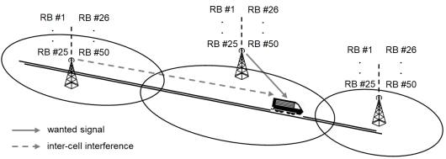
Figure 16: Assumed fractional frequency reuse scheme and inter-cell interference
As for GSM-R, it is likely that FRMCS requires a higher C/(N+I) than the one considered by 3GPP for MFCN.
This gives the following results:
- For a 1.4 MHz LTE carrier, the maximum level of external interference at the FRMCS cab-radio receiver is -112.2 dBm/MHz, corresponding to a maximum desensitization of 1.7 dB acceptable at the FRMCS cab-radio antenna connector;
- For a 5 MHz LTE carrier, the maximum level of external interference at the FRMCS cab-radio receiver is -111.3 dBm/MHz, corresponding to a maximum desensitization of 2.0 dB acceptable at the FRMCS cab-radio antenna connector.
Hence a protection criterion of -112.2 dBm/MHz (i.e. desensitization of 1.7 dB) is considered for the FRMCS cab-radio.
- SRD technical parameters
  - SRD in data networks
    - EU Commission Decision
Table 25: 500 milliwatt devices
Parameter | Value | Technology
Frequency bands | 874-874.4 MHz | all
Frequency bands | 916.1-916.5 MHz  917.3-917.7 MHz  918.5-918.9 MHz | all
Maximum power | 500 milliwatt e.r.p.  APC required (20 dB range) | all
Duty cycle | ≤ 10% for fixed NAP  ≤ 2.5% otherwise | all
Bandwidth | ≤ 200 kHz | all
Table 26: 25 milliwatt devices
Parameter | Value
Frequency band | 917.4-919.4 MHz
Maximum power | 25 milliwatt e.r.p.
Duty cycle | ≤ 1%
Bandwidth | ≤ 600 kHz  Typical: 200 kHz and 600 kHz
    - Indoor/outdoor deployment ratio for TN of data networks SRD
Table 27: Assumption about the indoor/outdoor ratio of TN
 | Indoor | Outdoor
Scenario 1 | 30% | 70%
Scenario 2 | 50% | 50%
Scenario 3 | 70% | 30%

    - NBN (mesh networks)
Table 28: NBN characteristicse
Parameter | NAP | NN  (relay) | TN  (terminal)
Bandwidth | 200 kHz
Antenna height | 7 m | 5 m | 1.5 m
Antenna pattern | omnidirectional
Maximum e.i.r.p. | 29 dBm
OOB emissions | ETSI EN 303 204 [24] and ETSI TR 102 886 [25]
Maximum duty cycle | 10% | 2.5% | 0.1%
Average duty cycle | 2.5% | 0.7% | 0.05%
Maximum density | 10/km² | 90/km² | 1900/km²
Average density | 5/km² | 45/km² | 950/km²
Outdoor/Indoor (%) | 100/0 | 100/0 | See Table 27
Regulatory Duty Cycle parameters are based on transmissions in any continuous one hour time interval. An NBN NN with a very much lower long-term average duty cycle may occasionally operate at up to 2.5% DC when measured over a given one hour interval. Assuming that all the devices (NAP, NN or TN) within a given square kilometre will be emitting at max. DC during the whole day is extremely pessimistic and even unrealistic.
    - CSS (spread spectrum one-hop networks)
Table 29: CSS characteristics
Parameter | NAP | TN
Bandwidth | 125 kHz (Note 1)
Antenna height | 25 m (outdoor)  1.5 m (indoor) | 1.5 m (indoor/  outdoor)
Antenna pattern | omnidirectional
Maximum e.i.r.p. | 29 dBm | 16 dBm
OOB emissions | ETSI TR 103 526 [26]
Maximum duty cycle | 10% | 1%
Typical duty cycle | 0.5% | 0.007%
Maximum density | 3.5/km² | 3000/km²
Typical density | 0.5/km² | 360/km²
Outdoor/Indoor (%) | 100% / 0% | See Table 27
It should be noted that in the proposed approach, NAP deployed with 16 dBm e.i.r.p or lower are proposed to be modelled as TN.
Note 1: One or two 250 kHz channels are also anticipated operated with an e.i.r.p of 16 dBm (NAP and TN).
Regulatory Duty Cycle parameters are based on transmissions in any continuous one hour time interval. A CSS TN with a very much lower long-term average duty cycle may occasionally operate at up to 1% DC when measured over a given one hour interval. Assuming that all the devices (NAP or TN) within a given square kilometre will be emitting at max. DC during the whole day is extremely pessimistic and even unrealistic.
    - UNB (ultra-narrowband one-hop networks)
Table 30: UNB characteristics
Parameter | NAP  Scenario #1 | NAP  Scenario #2 | TN
Bandwidth | 1 kHz | 1 kHz | 250 Hz
Antenna height | 25 m | 7 m | 1.5 m
Antenna pattern | Omnidirectional
Maximum e.i.r.p. | 29 dBm | 29 dBm | 16 dBm
OOB emissions  (Note 2) | ETSI TR 103 435 [27]
Maximum duty cycle  (Note 1) | 10% | 10% | 1%
Typical duty cycle  (Note 1) | 0.7% | 3% | 0.06%
Maximum density | 0.1/km² | 0.1/km² | 2000/km²
Typical density | 0.01/km² | 0.01/km² | 343/km²
Outdoor/Indoor (%) | 100% / 0% | 100% / 0% | See Table 27
Note 1: Regulatory Duty Cycle parameters are based on transmissions in any continuous one hour time interval. A UNB TN with a very much lower long-term average duty cycle may occasionally operate at up to 1% DC when measured over a given one hour interval. Assuming that all the devices (NAP or TN) within a given square kilometre will be emitting at max DC during the whole day is extremely pessimistic and even unrealistic.
In the table above the regulatory values for Max DC are indicated, along with Typical DC values reflecting long-term average behaviour.
Note 2: During the discussions at SE-24, it was revealed that the UL emission mask provided in ETSI TR 103 435 has shown to be inaccurate and is currently being reviewed by ERM TG28 as a matter of urgency.
  - RFID
The technical characteristics of RFID are shown in the tables below. The information contained in the tables is consistent with ECC Report 200 [13] and ETSI EN 302 208 v3.1.1 (2016-11)) [31], except where noted.
Table 31: RFID characteristics
Parameters | Interrogator - Fixed | Interrogator - Handheld | Tag
Frequency range | 916.1-916.5 MHz  917.3-917.7 MHz  918.5-918.9 MHz | 916.1-916.5 MHz  917.3-917.7 MHz  918.5-918.9 MHz | 915.5-919.5 MHz
Transmitter Power, dBm | 30.2 dBm | 27.0 dBm
Bandwidth | 400 kHz | 400 kHz | 1600 kHz (Note 1)
Tx antenna gain, dBi | 8.0 | 2.2
Tx radiated power (e.r.p.), dBm | 36 dBm (Note 2) | 27 dBm (Note 2) | -10 dBm
Maximum e.i.r.p., dBm | 38.2 | 29.2 | -7.8
Antenna height | TBD | TBD | TBD
Antenna pattern | (Note 3) | (Note 3)
OOB emissions | see Figure 6  in ETSI EN 302 208 [31] | see Figure 6  in ETSI EN 302 208 | see Figure 9  in ETSI EN 302 208
Note 1: The tag backscatter is contained in two sidebands 320 kHz wide at fc ±640 kHz.
Note 2: Since RFID is primarily an indoor application using passive tags which is equivalent to a semi-shielded environment, an average of 20 dBm e.r.p. is suggested for compatibility studies (see Annex 2.5 in ECC Report 200 [13] or ETSI TR 103 151, annex C.
Note 3: See Annex 2.5 in ECC Report 200 for typical antenna patterns for fixed (e.g. hotspot, industrial, etc) and handheld (e.g. retail store) applications.
Five scenarios are considered:
- “Hotspot”: multiple RFID interrogators in a hotspot such as a large warehouse/distribution centre (dense interrogator scenario);
- “Airport”: RFID readers on conveyors at airport terminals for baggage handling (e.g. a baggage handling hall in an airport terminal building. Such systems would be carefully designed and have to satisfy the requirements of the airport frequency management department);
- “Store”: a line of interrogators at the check-outs of a store (a row of check-out counters at a supermarket; due to shorter distances only 500 milliwatt e.r.p. is assumed);
- “Other”: a typical concentration of RFID interrogators in an outdoor environment (any other usage not specially defined);
- “Item tagging”: RFID in a store, i.e. an additional variation of the store scenario, in which individual items are tagged so that they may be identified.
Table 32: Parameters used for RFID as interferer
Parameters | RFID Use Scenarios
Parameters | Hotspot | Airport | Store/item  tagging | Industrial | Other  (Note 1)
ERP (dBm) | 36 | 36 | 27 | 24 | 36
Antenna Gain (dBi) | 8 | 8 | 2 | 8 | 8
Building Penetration Loss (Note 2) (dB) | 16 | 16 | 7 | 16 | (Note 1)
Density (per hotspot or per sq-km, Note 3) | 480 | 480 | 20 | 400 | 12
DC, per channel (%) | 2.5 | 2 | 12.5 | 50 | 1
Environment | Indoor | Indoor | Indoor | Indoor | Outdoor
Note 1: The most common “Other” RFID use scenario is RFID used for Automatic Vehicular Identification (AVI). For road tolling applications the antenna read zone is confined to a vehicle lane, and for parking lot and vehicular access applications the read zone is confined by using low transmit power. Therefore, 20 dBm is suggested for ERP in compatibility studies (combined transmit power and directional attenuation).
Note 2: The building penetration loss has been measured for indoor use scenarios and is shown in the table such that transmit power, antenna gain, and building loss result in an average of 20 dBm e.r.p. (see Annex 2.5 in ECC Report 200 [13] or Annex C of ETSI TR 103 151 [28]).
Note 3: The values in the table are taken directly from Annex 2.5 in ECC Report 200. Since the time of publication, the number of Hotspot and Airport scenarios has been limited due to several factors. While there may be some cases where the high densities may be observed, they are rare and limited to a small geographic area. To some extent the same case is also true for Industrial scenarios. The most common RFID use scenario found today is retail store/item tagging. For this scenario the values in the table may apply is the typical sense, however, for retail “hotpot” areas like shopping malls, the density of RFID interrogators can be greater than the amount shown in the table.
  - Wideband data transmission in data networks0
Table 33: WBN characteristics
Parameter | Value
Frequency band | 917.4-919.4 MHz
Maximum power | 25 milliwatt e.r.p.
Duty cycle | ≤ 10% for fixed NAP  ≤ 2.8% otherwise  polite spectrum access
Bandwidth | > 600 kHz  ≤ 1 MHz

- Examples of loss observed between MFCN and GSM-R in the 900 MHz frequency range
  - Context of measurements
In the context of GSM-R interference mitigation procedures, measurements of MFCN BS’s levels are performed by the railway operator (SNCF Réseau).
MFCN operators provide e.i.r.p. values Common Pilot Channel (CPICH) and Broadcast Control Channel (BCCH) respectively for 3G and 2G networks) of neighbouring sites.
Based on this information, losses (including TX antenna discrimination) have been derived.
The measurements are provided in Section 2, and the methodology includes the following:
- Measurement from MFCN sites that do and do not interfere are both reported. Hence the range of loss reported includes losses from both neighbouring and remote sites. It should be noted that only the minimum loss has been retained in the results;
- Measurements are not exhaustive as only a limited number (seven) of interference cases have been assessed. These cases have been selected randomly amongst all interference cases targeted by the mitigation procedure at the time of writing this contribution. It is therefore expected that lower values could exist;
- MCL could be even lower in locations where no interference has been reported yet;
- From the contributors’ point of view, the minimum observed value is relevant to derive minimum immunity performance;
- The measurements are performed in the 900 MHz band;
- The loss values have been derived with the following formula:
Loss (dB) = MFCN BS e.i.r.p. (dBm) – measured value (dBm);
- The loss values include TX antenna pattern discrimination (for MFCN);
- The antenna gain and losses for RX are compensated (RX gain = 0 dBi).

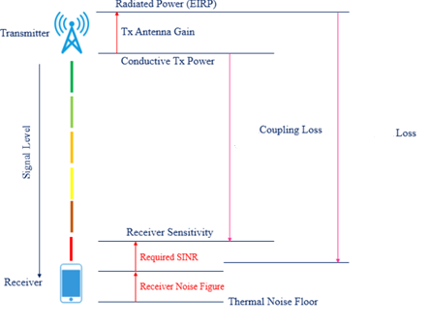
Figure 17: Assumed fractional frequency reuse scheme and inter-cell interference
Remark: No measurement exists for 1900 MHz, extrapolations could be done by taking into consideration additional propagation losses and specific antenna MFCN system (discrimination) for 1.9 GHz.
  - Measurement results
Table 34: Measurements results
 | Minimum loss (dB) |  | Number of samples
Case Name | 2G | 3G | 2G | 3G | Min. GSM-R level | Max. MFCN level 2G | Max. MFCN level 3G Commn Pilot Channel (CPICH Pilot), see Note 1
Conflans | 71.88 dB | 68.80 dB | 108 | 54 | -58 dBm | -15 dBm | -23 dBm
Jardin d'Eole | 75.80 dB | 72.70 dB | 138 | 68 | -64 dBm | -23 dBm | -26 dBm
Blanc Mesnil | 77.84 dB | 77.90 dB | 36 | 28 | -70 dBm | -21 dBm | -24 dBm
Courbevoie | 71.09 dB | 69.50 dB | 228 | 184 | -75 dBm | -13 dBm | -22 dBm
La Villette | 72.78 dB | 73.56 dB | 150 | 136 | -65 dBm | -17 dBm | -25 dBm
Nantes | 77.68 dB | 77.70 dB | 252 | 225 | -63 dBm | -16 dBm | -27 dBm
Strasbourg | 75.59 dB | 75.30 dB | 60 | 33 | -69 dBm | -19 dBm | -26 dBm
Note 1: It should be pointed out that 3G Pilot power is usually between 5% and 15% of the total Node B transmit power. Commonly, the Common Pilot Channel (CPICH) power is 10% of the typical total transmit power by a 3G BS. Based on this assumption, the measured power level of -22 dBm for a 3G pilot power corresponds to up to -12 dBm power level of total 3G BS power when both pilot and traffic channels are considered.

Table 35: Average, median and standard deviation of the minimum loss values
Parameter | Value
Average value (Note 1) | 74.17 dB
Median value (Note 1) | 74.43 dB
Standard deviation (Note 1) | 3.13 dB
Note 1: Values based on the minimum losses presented above
The maximum level received from MFCN (at the connector of the GSM-R antenna) over the seven cases considered is -13 dBm for 2G and -22 dBm for 3G (Pilot measurements). It is worth noting that about one fourth of the 2G transmitters of a MFCN network have higher e.i.r.p.se than the e.i.r.p. of the measured transmitter, hence this case is not the worst case.
The e.i.r.p. of future 900 MHz networks, based on e.g. 4G or 5G technologies is out of the scope of this contribution.
  - Summary
The minimum loss observed at the worst measurement location is around 69 dB at 900 MHz band between MFCN BS e.i.r.p. and antenna cab-radio including the discrimination from TX antenna patterns.
- List of references
- Directive 2014/53/EU of the European Parliament and of the Council of 16 April 2014 on the harmonisation of the laws of the Member States relating to the making available on the market of radio equipment and repealing Directive 1999/5/EC
- Commission Implementing Decision (EU) 2018/1538 of 11 October 2018 on the harmonisation of radio spectrum for use by short-range devices within the 874-876 and 915-921 MHz frequency bands
- ERC Recommendation 70-03 relating to the use of Short Range Devices, approved October 1997, latest amended June 2019
- Report ITU-R M.2039-3 (11/2014): “Characteristics of terrestrial IMT-2000 systems for frequency sharing/interference analyses”
- Report ITU-R M.2292-0 (12/2013): “Characteristics of terrestrial IMT-Advanced systems for frequency sharing/interference analyses”
- UIC O-8736: “Assessment report on GSM-R current and future radio environment”
- ETSI TS 102 933-1: “GSM-R improved receiver parameters; Part 1: Requirements for radio reception”
- ETSI TS 137 104: "E-UTRA, UTRA and GSM/EDGE; Multi-Standard Radio (MSR) Base Station (BS) radio transmission and reception”
- GSM TS 05.05: “GSM/EDGE; Radio transmission and reception”
- GSM TS 05.08: “GSM/EDGE; Radio subsystem link control”
- GSM TR 03.30: “GSM/EDGE Radio network planning aspects”
- GSM TR 05.50: “GSM/EDGE Background for Radio Frequency (RF) requirements”
- ECC Report 200: “Coexistence studies for proposed SRD and RFID applications in the frequency band 870-876 MHz and 915-921 MHz”, approved September 2013
- ECC Report 229: “Guidance for improving coexistence between GSM-R and MFCN in the 900 MHz band”, approved May 2015
- ECC Report 309: “Use of MFCN for the command & control and payload links of UAs within the current MFCN harmonised regulatory framework”, approved July 2020
- ECC Report 318: Compatibility between RMR and MFCN in the 900 MHz range, the 1900-1920 MHz band and the 2290-2300 MHz band, approved July 2020
- C. M. Alexandrescu, L.-M. Nemtoi: “Considerations regarding a radio planning procedure for the GSM-R network covering the Bucuresti – Constanta railway corridor”; Scientific Bulletin of University Politehnica of Bucharest, Series C, Vol. 73, Issue 3, 2011
- 3A-GSM-038: “GSM-R Radio Planning Guidelines", Jernbaneverket, February 2006
- Recommendation ITU-R F.1336-5: "Reference radiation patterns of omnidirectional, sectoral and other antennas for the fixed and mobile serviceservices for use in sharing studies in the frequency range from 400 MHz to about 70 GHz”
ETSI EN 302 208: "Radio Frequency Identification Equipment operating in the band 865 MHz to 868 MHz with power levels up to 2 W and in the band 915 MHz to 921 MHz with power levels up to 4 W; Harmonised Standard for access to radio spectrum"
- ERC Recommendation 74-01: "Unwanted emissions in the spurious domain", approved 1998
- Glazunov, Andres Alayon, Ying Wang, and Per Zetterberg: "Decorrelation distance characterization of long term fading of CW MIMO channels in urban multicell environment." 2005 18th International Conference on Applied Electromagnetics and Communications. IEEE, 2005
- ETSI TS 137 104: “Digital cellular telecommunications system (Phase 2+) (GSM); Universal Mobile Telecommunications System (UMTS); LTE; E-UTRA, UTRA and GSM/EDGE; Multi-Standard Radio (MSR) Base Station (BS) radio transmission and reception" (3GPP TS 37.104 version 15.4.0 Release 15)
- Bundesnetzagentur measurement report: "Compatibility measurements GSM/UMTS/LTE vs. GSM-R” version 3.0 issued 23/09/2013
- ETSI EN 303 204: ” Network Based Short Range Devices (SRD); Radio equipment to be used in the 870 MHz to 876 MHz frequency range with power levels ranging up to 500 mW; Harmonised Standard covering the essential requirements of article 3.2 of the Directive 2014/53/EU
- ETSI TR 102 886: ”Electromagnetic compatibility and Radio spectrum Matters (ERM); Technical characteristics of Smart Metering (SM) Short Range Devices (SRD) in the UHF Band; System Reference Document, SRDs, Spectrum Requirements for Smart Metering European access profile Protocol (PR-SMEP)
- ETSI TR 103 526: “System Reference document (SRdoc); Technical characteristics for Low Power Wide Area Networks Chirp Spread Spectrum (LPWAN-CSS) operating in the UHF spectrum below 1 GHz”
- ETSI TR 103 435: “System Reference document (SRdoc); Short Range Devices (SRD); Technical characteristics for Ultra Narrow Band (UNB) SRDs operating in the UHF spectrum below 1 GHz”
- ETSI TR 103 151: “Electromagnetic compatibility and Radio spectrum Matters (ERM); Tests on the immunity of Wind Profiler Radar to transmissions from RFID, ALDs and GSM”
- ERC Report 68: “Monte-Carlo Radio Simulation Methodology for the use in sharing and compatibility studies between different radio services or systems”, approved June 2002
- 3GPP TS 05.05 V8.20.0 (2005-11): “3rd Generation Partnership Project; Technical Specification Group GSM/EDGE Radio Access Network; Radio transmission and reception (Release 1999)
- ETSI EN 302 208: "Radio Frequency Identification Equipment operating in the band 865 MHz to 868 MHz with power levels up to 2 W and in the band 915 MHz to 921 MHz with power levels up to 4 W; Harmonised Standard for access to radio spectrum"

925.2 MHz is preferred (see also DEC(06)13), subject to a feasibility study. If it shows to be challenging, then 925.6 MHz would also be an acceptable value as TS 102933-1.
As of March 2020: Germany, Switzerland and Liechtenstein
925.2 MHz is preferred (see also DEC(06)13), subject to a feasibility study. If it shows to be challenging, then 925.6 MHz would also be an acceptable value as TS 102933-1.
ECC Report 309 determines separation distance needed to protect RMR cab-radio from aerial UE
58 dBm e.i.r.p. = 46 dBm output power + 15 dBi antenna gain – 3 dB feeder loss (Table 3 in Report ITU-R M.2292-0)
-13 dBm (ETSI TS 102 933-1)
-40 dBm for a desensitization of 1 dB is equivalent to -34 dBm for a desensitization of 3 dB.
925.2 MHz is preferred (see also DEC(06)13), subject to a feasibility study. If it shows to be challenging, then 925.6 MHz would also be an acceptable value as TS 102933-1.
The thermal noise equals $-174dBm/Hz$, which leads to $-174\frac{dBm}{Hz}+10*\log_{10}\left(200 kHz\right)= -121 dBm$ thermal noise for a $200 kHz$ GSM-R channel bandwidth, to which must be added the $5 dB$ noise figure.
This margin allows the receiver to face a desensitization due to internal and external interference (see GSM TR 03.30 Annex A [13] and GSM TR 05.50 clause H.3.3 [14]).
This accounts for both internal and external interference.
-101 dBm – 20 dB, see Section A2.3.3.
Harmonised frequency band as per Decision EU 2018/1538

