Cross-border coordination and synchronisation for Railway Mobile Radio (RMR) networks in the 1900-1910 MHz TDD frequency band
approved 16 June 2023
ECC Report 353

Executive summary
The purpose of this ECC Report is to support administrations in handling the cross-border coordination and synchronisation for Railway Mobile Radio (RMR) networks in the 1900-1910 MHz TDD band.
Based on ECC Decision (20)02 [8] and Commission Implementing Decision (EU) 2021/1730 [13], CEPT administrations and EU Member states shall designate and make available on a non-exclusive basis the unpaired frequency band 1900-1910 MHz for RMR, based on national demand.
The specifics of TDD networks demand that measures are taken to ensure efficient operation of all networks at a border location. ECC Report 216 [2] mentions: “When more than one TDD network operates in the same geographic area and in the same band, severe interference may impair network performance if the networks are uncoordinated, i.e. if some equipment is transmitting while other equipment is receiving in the same time-slots”. It also says that one way to eliminate those TDD-specific BS-BS and UE-UE interferences is “to synchronise base stations so that they roughly transmit and receive in the same time. More precisely, synchronised operation means that no simultaneous uplink and downlink occur between any pairs of cells which may interfere with each other in the same band”.
Synchronised and unsynchronised TDD operation have been assessed and addressed in various ECC deliverables for MFCN such as ECC Report 216 [2], ECC Report 296 [4] and ECC Report 331 [10] as well as ECC Recommendation (20)03 [7] and ECC Recommendation (15)01 [6]. Those studies have shown that synchronised operation is highly preferred, and that unsynchronised operation often leads to large separation distances and/or low field strength requirements. Synchronised operation requires stakeholders to agree on a common reference phase clock and on compatible frame structures, noting that the frame structure has an influence on various performance indicators, e.g.:
- the length of the frame has an impact on the latency;
- UL/DL ratio has an influence on spectrum efficiency depending on the local traffic pattern;
- size of guard period has an influence on both spectrum efficiency and maximum cell size.
In summary, synchronised TDD operation is generally encouraged as the most spectrum efficient way to use the given spectrum.
However, even though RMR relies on the same family of technologies than MFCN, railway operation differs significantly in various aspects, e.g.:
- linear topology rather than an area based topology;
- high reliability requirements;
- various traffic patterns depending on the local operational specificities;
- uplink/downlink- balanced or even uplink-dominated traffic patterns;
- one single infrastructure manager (IM) per country as opposed to several operators in MFCN bands;
- coverage requirements in the neighbouring countries for railway lines crossing the border.
Overall, from a railway operation perspective, the cross-border coordination should support the diversity of railway operational needs that exist at different border locations, ranging from parallel railway tracks to border crossing tracks with or without service continuity, different usage densities and 2- and 3-country border cases.
These specificities call for a framework that would:
- enable a high level of flexibility when all stakeholders agree on optimal parameters (possibly at the local level) as part of an RMR arrangement;
- ensure, in absence of an RMR arrangement, fairness and certainty with regards to TDD system parameters and deployment constraints nearby the border, under the conditions of synchronised operation.
In order to take those elements into account, the following framework is proposed for the cross-border coordination of TDD RMR networks in the 1900 MHz frequency band:
- A coordination trigger field strength (CTFS) value shall be defined based on the required isolation between a victim base station (BS) at the border and an unsynchronised base station on the other side of the border (see Annex 3). This is similar in spirit to the “DSB implementation zone” developed by CEPT and described in ECC Report 331 [10]. In order to effectively protect base stations on the other side of the border taking into account the reliability requirements of RMR, a field strength value of 0 dBµV/m/5 MHz @3 m (measured on the downlink part of the frame at the border) is proposed for this CTFS value;
- Base stations leading to a field strength at the border below the CTFS value are not in the scope of this framework and operators may therefore use any relevant TDD parameter or frame structure suitable to their local needs;
- For base stations creating a field strength at the border above the CTFS value, the following situations may occur:
  - By default, stakeholders shall use the reference parameters in Table 1, which enable synchronised co-channel operation at the border;
  - In the case of RMR arrangements between IMs, it would be possible to deviate from those reference parameters so that IMs may set optimal parameters suitable for their local needs and efficient use of the spectrum. Those RMR arrangements may be defined generically between two or more countries or only for specific local areas as relevant, and may enable some flexibility or alleviate some constraints such as different frame configurations or different field strength limits when crossing the border. Annex 2 describes a non-exhaustive toolbox that infrastructure managers may consider.

Table 1: Reference parameters for synchronised co-channel operation at a border
Parameter | Value
Reference phase / time clock | Aligned with UTC, properly monitored to ensure the local clock drift does not exceed +/- 1.5 µs in the event of a PRTC outage  (Informative note: GNSS (e.g. GPS) is an example of compliant clock)
Reference frame  (see Annex 4) | With Tc := 1/(480000*4096) seconds (Basic time unit for NR as defined in ETSI TS 138.211, section 4.1 [15]):  - Start-of-frame, aligned with the reference clock  - Downlink for 3371008*Tc  - Guard period for 280576*Tc  - Uplink for 2246656*Tc  - Downlink for 1685504*Tc  - Guard period for 280576*Tc  - Uplink for 1966080*Tc  - Downlink for 3371008*Tc  - Guard period for 280576*Tc  - Uplink for 2246656*Tc  - Downlink for 1685504*Tc  - Guard period for 280576*Tc  - Uplink for 1966080*Tc  - Back to start-of-frame  (Informative note: Those timings correspond to 5G NR configuration “DS_{a}US_{b}U DS_{a}US_{b}U” with a 15 kHz SCS and S(DL/GP/UL):=(S_{a} = 10:2:2, S_{b} = 12:2:0) and 5G NR configuration “DDDS₁UUDS₂UU DDDS₁UUDS₂UU” with a 30 kHz SCS and S(DL/GP/UL):=(S₁ = 6:4:4, S₂ = 10:4:0)).  Note: All SCS are acceptable as long as the frame complies with the above timings. Other frame configurations are also deemed compatible if they do not lead to any downlink/uplink overlap (e.g. if they implement a larger guard period).
Field strength at the border  (see Annex 3) | 65 dBµV/m/5 MHz @3 m at the border  47 dBµV/m/5 MHz @3 m at 6 km in the other country.  All field strengths shall be measured on the downlink part of the frame (otherwise any measurement made on the whole frame must then be scaled accordingly with the DL/UL ratio).

TABLE OF CONTENTS

0 Executive summary 2
1 Definitions 8
2 Introduction 9
3 Railway operation and interoperability in border areas 10
3.1 Introduction: cooperation between railways at the border 10
3.2 Diversity of railway operational environments 10
3.3 Railway operation in border areas 12
3.4 Migrating GSM-R to FRMCS and introducing FRMCS 13
4 Generalities on coexistence between TDD networks 15
4.1 Interference scenarios 15
4.2 Unsynchronised operation: isolation and separation distances for MFCN 15
4.3 Synchronised operation 16
4.4 Partially-synchronised operation 19
5 Proposed framework for administrations on RMR cross-border coordination in the 1900 MHz TDD band 20
5.1 Lessons learnt from MFCN 20
5.2 Main differences between MFCN and railways 20
5.3 Proposed toolbox 21
6 Conclusions 23
ANNEX 1: Typical railway deployment scenarios 26
ANNEX 2: Toolbox for infrastructure managers in RMR arrangements 31
ANNEX 3: SEAMCAT simulation and calculation of field strength limits 38
ANNEX 4: Timing details for the proposed reference frame 46
ANNEX 5: List of references 48

LIST OF ABBREVIATIONS

Abbreviation | Explanation
3GPP | 3rd Generation Partnership Project
5G NR | 5G New Radio
AAS | Active Antenna System
BEM | Block Edge Mask
BS | Base Station
BWA | Broadband Wireless Access
CCS-TSI | Control-Command and Signalling – Technical Specification for Interoperability
CEPT | European Conference of Postal and Telecommunications Administrations
CPE | Customer Premises Equipment
CQI | Channel Quality Indicator
CTFS | Coordination Trigger Field Strength
DL | Downlink
DNCA | Dual Network Coverage Area
DSB | Downlink Symbol Blanking
ECC | Electronic Communications Committee
eNB / eNodeB | evolved Node B
ETCS | European Train Control System
FDD | Frequency Division Duplex
FFR | Fractional Frequency Reuse
FRMCS | Future Railway Mobile Communication System
FWA | Fixed Wireless Access
gNB | gNodeB
GP | Guard Period
GSM-R | Global System for Mobile Communications – Railway
HARQ | Hybrid automatic repeat request
HCM | Harmonised Calculation Method
IM | Infrastructure Manager
iRSS | Interfering Received Signal Strength
LoS | Line of Sight
LTE | Long Term Evolution
MFCN | Mobile/Fixed Communication Network
MS | Mobile Station (equivalent to UE)
ppb | parts per billion
OFDM | Orthogonal Frequency-Division Multiplexing
PRTC | Primary Reference Time Clock
RB | Resource Block
RBC | Radio Block Centre
RF | Radio Frequency
RTD | Round Trip Delay
PTP | Precision Time Protocol
RMR | Railways Mobile Radio, encompasses GSM-R and its successor(s), including FRMCS
RTT | Round Trip Time
SCS | Sub Carrier Spacing
TAI | International Atomic Time
TDD | Time Division Duplex
UE | User Equipment (equivalent to MS)
UIC | Union International des Chemins de fer (International Union of Railways)
UL | Uplink
UMTS | Universal Mobile Telecommunications System
UTC | Coordinated Universal Time
WCDMA | Wideband Code Division Multiple Access
WiMAX | Worldwide Interoperability for Microwave Access

Definitions
Term | Definition
Arrangement | A plan agreed between parties (in the present Report RMR operators) covering a set of technical conditions that have the purpose of allowing optimised usage of the radio spectrum by each party for radio coverage across country borders and/or in a border area.  Such arrangements may have to be under administration review. In that case, it is anticipated that those arrangements shared with administrations would not have to systematically be formally approved by them. However, administrations may choose to do so on a case-by-case basis or depending on their national policy.
Agreement | A legally binding set of technical conditions that have been concluded between national administrations, with the purpose of avoiding interferences in areas across a national border, may contain permission to establish operator arrangements.
Cross-border coordination | Cross-border coordination based on Agreements concluded between administrations relates to the separation/isolation of networks located in neighbouring countries with the aim of avoiding mutual interference and providing a certain level of coverage in border areas. No coverage or operation across the border is foreseen.  Cross-border coordination based on Arrangements comprise common network planning in the border zone. For RMR this could be applied to increase coverage in the own border area or to create coverage of foreign territory to ensure service-provision across the border between countries (or between operator networks) i.e. cross-border cooperation.

Introduction
This ECC Report deals with cross-border coordination and synchronisation for Railway Mobile Radio (RMR) networks in the 1900-1910 MHz TDD band. Cross-border coordination for RMR in the 900 MHz band is covered by ECC Recommendation (05)08 (GSM-R) [17] and ECC Recommendation (08)02 (FRMCS) [18].
Based on ECC Decision (20)02 [8] and Commission Implementing Decision (EU) 2021/1730 [13], CEPT administrations and EU Member states shall designate and make available on a non-exclusive basis the unpaired frequency band 1900-1910 MHz for RMR, based on national demand.
In border areas the following radio-specific scenarios can be distinguished:
- RMR operators in adjacent countries have made arrangements that enable continuity of service for trains whilst crossing the border, and/or to allow optimal usage of the radio spectrum on non-border crossing tracks on either side of the border;
- There are no arrangements between RMR operators in adjacent countries, in which case only the agreements between the national administrations apply.
This Report addresses the specificities of using TDD networks in the above scenarios.
First it will address the railway specific usage, focusing on the diversity of railway operational environments and needs and outlining deployment options envisioned for FRMCS. After that it will explain the generalities related to coexistence between TDD networks. And it will end with a toolbox for administrations and railway operators (Infrastructure Managers – IMs) to be leveraged for the various RMR TDD border coordination scenarios.
When more than one TDD network operates in the same geographic area, severe interference may happen if the networks are uncoordinated, i.e. if some equipment is transmitting while another equipment is receiving in the same time-slots and in the same band (on the same channel or on adjacent channels) while having a poor isolation (e.g. due to geographical proximity).
One way to avoid all BS-BS and UE-UE interferences is to implement synchronised operation so that no simultaneous uplink and downlink transmission occur between any pairs of cells which may interfere with each other in the same band. The word “synchronisation” is often used in several other contexts (e.g. frequency synchronisation for FDD networks, BS-UE synchronisation, etc.), and this Report will focus on phase/time synchronisation in order to align downlink and uplink switching points in combination with coordinated uplink and downlink timeslots and/or coordinated Resource Blocks usage for interference-mitigation purposes.
Synchronised and unsynchronised TDD operation have been assessed and addressed in various ECC deliverables for MFCN such as ECC Report 216 [2], ECC Report 296 [4] and ECC Report 331 [10], ECC Recommendation (20)03 [7] and ECC Recommendation (15)01 [6]. Those studies have shown that synchronised operation is highly preferred.
Synchronised operation requires stakeholders to agree on a common reference phase clock (usually traceable to UTC with sufficient accuracy e.g. +/- 1.5 µs) and on compatible frame structures, noting that the frame structure has an influence on various performance indicators : e.g. the length of the frame has an impact on the latency, UL/DL ratio has an influence on spectrum efficiency depending on the local traffic pattern, size of guard period has an influence on both spectrum efficiency and maximum cell size, etc.
However, even though RMR relies on the same family of technologies than MFCN, railway operation differ significantly in various aspects (e.g. linear topology rather than an area based topology, uplink/downlink- balanced or even uplink-dominated traffic patterns, high reliability requirements, variable traffic patterns depending on the local operational specificities, one single infrastructure manager per country as opposed to several operators in MFCN bands, coverage requirements in the neighbouring countries for railway lines crossing the border, etc). Those specificities call for a framework that would both enable a deterministic configuration with synchronised operation at the border in order to avoid interferences or large exclusion zones when stakeholders do not agree on common parameters, and that would also enable a high level of flexibility and ensure railway inter-operability in the cross-border coordination when all stakeholders agree at the local level.

Railway operation and interoperability in border areas

Introduction: cooperation between railways at the border
Dedicated GSM-R railway radio communications networks are used throughout Europe to carry voice, railway signalling and operational rail data services. A European-wide infrastructure has been built from the early 2000s onwards whilst some railway infrastructure managers are still rolling out GSM-R networks. GSM-R enables cross-border radio communications for railway purposes, including service continuity across borders. It is included in the European railway legislative framework since 2001 as the only mandatory radio communication system, ensuring interoperability for operational voice communication and (ETCS) data implementations.
FRMCS-based radio applications will further increase railway interoperability and will contribute to the safety and full digitalisation of railway operation. These aspects of FRMCS, among others, have already been described in ECC Report 294 [16].

Diversity of railway operational environments
Railways, even within a country, are made of dissimilar environments, reflecting a range of operational needs. This diversity of environments includes single railway lines themselves (main, high speed, regional), stations and shunting yards in varying combinations in different geographical areas.
In border areas, different operational environments may exist on either side of the border. In addition to this, railway lines may be present that cross the border requiring service continuity for trains crossing that border. Annex 1 provides several examples showing this diversity of railway network environments at sample border locations.
Furthermore, different railway operational coexistence scenarios may exist at multiple different border areas between two neighbouring countries. See for example Figure 7, Figure 8 and Figure 9 related to different scenarios for an illustration of this aspect between France and Belgium.
This diversity of railway environments and their differing operational service needs will have to be supported by the RMR networks. Therefore, it is expected that the technical telecom characteristics of an infrastructure manager's RMR network will have to vary across geographic areas in order to serve the railway operational need. This results in the need for flexibility in the usage of the RMR radio spectrum, in particular when the underlying spectrum is operated in TDD mode.
In addition to the example railway network scenarios described in Annex 1, in the larger European context railway corridors have been defined (see Figure 1) where the smooth operation of trains should be ensured during their end-to-end journey. Within the EU countries this is governed by the so-called CCS-TSI [12] which defines the conditions that ensure interoperability for trains that operate in multiple countries.
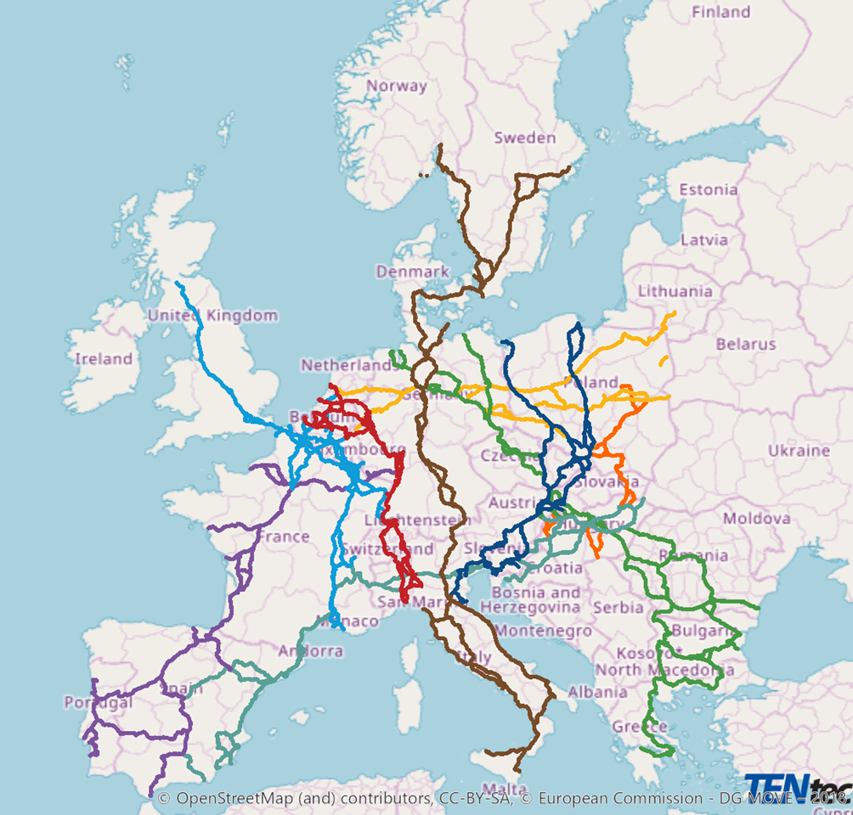
Figure 1: Rail freight corridors in Europe
In specific border areas, where railway lines are crossing the border, the neighbouring countries may have the same railway interoperability requirements, but for non-border crossing lines may have different needs due to their national operational constraints. In summary, railway telecom infrastructure must cope with a wide variety of railway operational scenarios.
It shall be noted that it is particularly challenging at this stage to provide detailed and accurate throughput requirements associated to the various operational scenarios. At the very least for the following reasons:
- timeline of introduction and evolution of the operational needs;
- service mix (railway interoperability services relevant to neighbouring RMR operators, railway operational requirements relevant to operational efficiency of a given RMR operator);
- specificities of the environment (leading to different user density, user needs, usage patterns).
Each of these would contribute to the throughput needs, in particular in border areas where two (or three) RMR operators are concerned. ECC Report 294 [16] gives some indication of expected traffic during and after the migration from GSM-R to FRMCS.
This implies that railways need the ability to adapt the railway telecom infrastructure to their local needs while balancing constraints of radio coexistence and economics of deployment. In the case of FRMCS 1900 MHz TDD implementations, this notably requires the ability to implement different TDD frame structures at different network locations.

Railway operation in border areas
As noted in the previous paragraph and illustrated in Annex 1, the railway services to be ensured at a border area include the local operational needs of the respective railways as well as, in many cases, border crossing rail operation. This is likely to result in different railway environments on either side of the border.
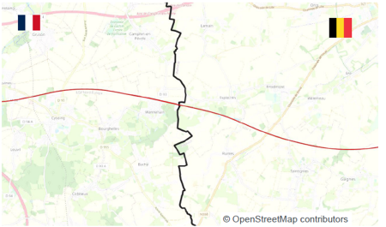 | 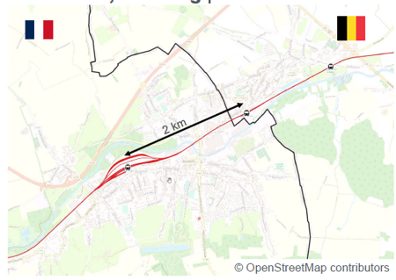 | 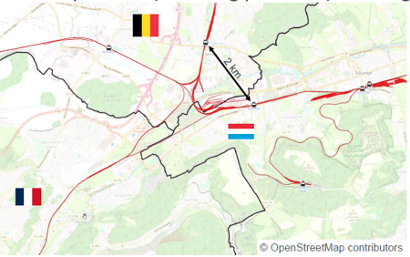
Figure 2: Examples of diversity of scenarios at the borders of France, Belgium and Luxembourg (see Annex I)

Cooperation at the border
At a railway operational level, border-crossing naturally implies coordination and cooperation between parties at the border (e.g. the geographical limit of responsibilities for the control of the trains by the dispatchers). At a railway telecom level, coordination and cooperation are consequently essential to a smooth operation of railway networks.
It is to be noted that technical reasons may require that railway border crossings between neighbouring countries are not always located at the national geographic border, depending on mutually agreed railway operating rules. This may necessitate extending the coverage of an RMR network into the territory of the neighbouring country.
As railways at the border have a business incentive for cooperation, quite dissimilar from the position of most MFCN, it is common to find various agreements between the involved railway infrastructure managers. For GSM-R networks, processes and procedures for cross-border railway operation are currently being managed via bilateral arrangements between the involved railway infrastructure managers. This may include both border crossings but also railway operation in pre-defined coordination areas parallel to or in the vicinity of the border.
In the current GSM-R networks, the allocated spectrum is shared at border areas. The network frequency planning is defined by close direct cooperation between the involved railway infrastructure managers. Railway IMs are exchanging relevant data when preferred frequencies (as per the HCM agreement [11]) defined for each country cannot be implemented (which is especially the case in dense border areas such as the Basel area). Although this cross-border coordination is a challenge for the radio network planning and rollout at border areas, this coordination process is running successfully since several years.
For the introduction of FRMCS, similar arrangements are anticipated. For TDD networks, this would notably include all necessary time and frame synchronisation information and other radio characteristics. Those arrangements will allow optimised usage of the radio spectrum by each railway infrastructure manager for radio coverage across country borders and/or in a border area reflecting their respective operational needs.

Service continuity
For cross-border railway operation, there is a need to extend RMR network coverage within the neighbouring country to assist service continuity related to network and application hand-over timing requirements.
The concept of (railway) "service continuity" at a border crossing means that a train service does not stop at the border (e.g. to change a locomotive) but rather that the train continues its journey without any hindrance. This has several implications for the RMR communication functions.
Where the rail track crosses the operational border between two RMR Networks, there is a segment of rail track where intentional overlapping radio coverage from both RMR networks is required to safeguard the rail border-crossing processes, i.e. to ensure service continuity. This results in a Dual Network Coverage Area (DNCA) for ETCS data transmission and in a switching zone for voice transmissions. Both are used according to mutually agreed railway operational rules. The fundamental background for the realisation of seamless border crossing for voice and data service functionalities has been established for the GSM-R domain by the UIC.
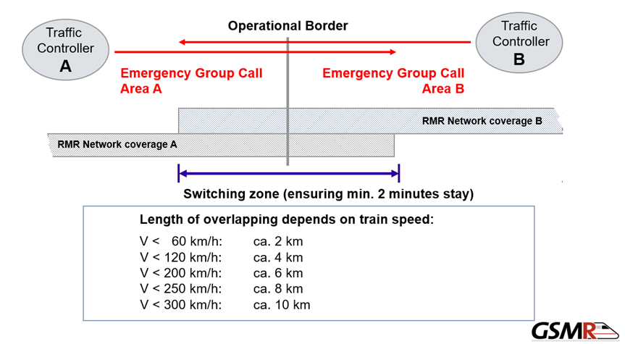
Figure 3: switching zones example between GSM-R networks
For the GSM-R ETCS case, a concept of Dual Network Coverage Area (similar to the switching zone described above) is required, where the DNCA will be larger than for the GSM-R voice case. This is due to the additionally required handover from the current Radio Block Centre (RBC) to the new RBC in the other network.
For FRMCS networks, a similar DNCA concept with overlapping coverage is anticipated.

Migrating GSM-R to FRMCS and introducing FRMCS
The migration from the existing GSM-R networks to FRMCS in border areas will depend on the national plans to replace the current GSM-R infrastructure and therefore on the timeline for deployment of both FRMCS trackside and on-board equipment. Between CEPT administrations and EU Member States a large variation is expected in the deployment timelines for FRMCS. This may lead to complications for the coordination of cross-border operation, for example due to uncertainties in the required traffic characteristics on either side of a border.
Especially in border areas with spectrum limitations associated with frequency coordination, some GSM-R network operators are already facing the problem of insufficient radio resources in the GSM-R band to support their operational needs. In such areas adding FRMCS in the 900 MHz band may prove challenging and FRMCS in the 1900 MHz band would be an essential enabler for the migration.
Prior to the introduction of FRMCS in border areas, at least the following subjects need to be addressed:
- Coordination areas need to be determined; the principles of existing GSM-R and FRMCS 900 MHz coordination areas and processes could be reused and adjusted / extended for TDD specificities as set out in section 4;
- Wherever possible, bilateral RMR arrangements shall be put in place to cover one or multiple coordination areas;
- Each RMR arrangement would cover all necessary technical details such as exchange of site data, radio parameters, propagation models and procedures and, for TDD networks, details on synchronisation, plus operational information (e.g. contact names…). If required by specific national administrations, the RMR arrangements may need their approval. In the absence of a specific RMR arrangement in a coordination area, regulatory conditions shall ensure fairness with regards to TDD system parameters and deployment constraints nearby the border, regardless of respective deployment timelines of FRMCS deployments on either side of the border.

Generalities on coexistence between TDD networks

Interference scenarios
Figure 4 illustrates the interference scenarios in case of simultaneous UL/DL transmissions: the green arrows represent the desired links, while the potential interference is represented by the yellow arrows. BS-MS interference happens in all cases (FDD and TDD), whether synchronised or not and is handled as part of the standards. MS-MS and BS-BS interference in unsynchronised and semi-synchronised TDD networks are within the scope of this Report.
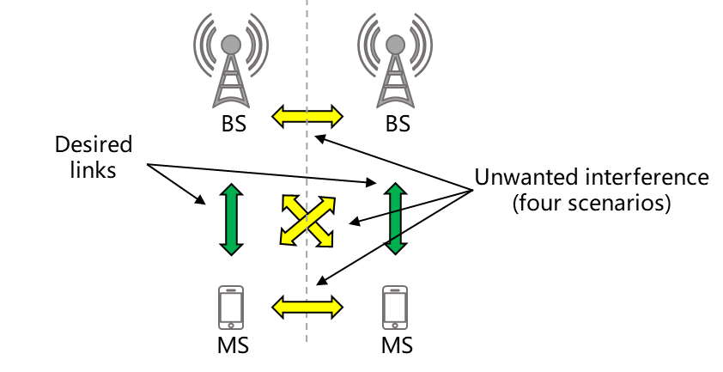
Figure 4: Interference scenarios in case of simultaneous UL/DL transmissions
In a generic context, the following technical approaches can be implemented to mitigate UE-UE and BS-BS interferences.
- Proper isolation (e.g. geographical separation, azimuth and tilt fine-tuning, etc.): this is partially discussed in ECC Report 296 [4] (3.5 GHz band), ECC Report 307 [5] (26 GHz band) and ECC Recommendation (15)01 [6];
- Synchronised operation (full or partial): this is discussed in ECC Report 216, ECC Report 296 [4], ECC Report 307 [5] and ECC Recommendation (15)01 [6]. With a few exceptions, this is also the baseline assumption from 3GPP standards (e.g. see 3GPP TR 37.801, section 6.1.2 [9]).

Unsynchronised operation: isolation and separation distances for MFCN
According to ECC Report 296 [4], "The studies show minimum distances required between unsynchronised Macro-cellular networks could be up to 60 km when operating co-channel and up to 14 km when operating in the adjacent channel without guard bands". Those studies have been done on the 3.5 GHz band with AAS.
ECC Report 331, section 1.2 [10] gives some context about what assumptions were behind various field strength used over time for unsynchronised operation. In particular, it states: “The previous field strength value for unsynchronised TDD in ERC Recommendation (01)01 [5] was 15 dBµV/m/(5 MHz) at 3 m. Then based on simulations for UMTS-TDD unsynchronised operation in 2 GHz band (1900-1920 MHz), a field strength value of 30 dBµV/m/(5 MHz) at 3 m was adopted for those systems in 2 GHz band (ERC Recommendation (01)01) and 2.6 GHz band (ECC Recommendation (11)05 [6]). This value was chosen with the assumption of uplink throughput loss of 50% and shared exclusion area at the borderline (noting that the alternative of considering preferential frequency blocks would also lead to a 50% UL and DL capacity loss). Then the field strength value of 32 dBµV/m/(5 MHz) at 3 m was used for non-AAS TDD wideband systems operating in 3.4-3.8 GHz band when ECC Recommendation (15)01 was developed in 2015 by adding 2 dB frequency scaling factor from 2.6 GHz to 3.6 GHz band. Therefore, such a value of 32 dBµV/m at 3 m assumes that there is no victim located at borderline. In the revision of ECC Recommendation (15)01 in 2019, simulations for both non-AAS and AAS wideband systems (LTE and 5G NR) were performed, the field strength value of 0 dBµV/m/(5 MHz) at 3 m was obtained based on an uplink throughput loss between 5% and 10%. This field strength value of 0 dBµV/m/(5 MHz) at 3 m can lead in practice to very large exclusion zones in cross-border areas. In order to facilitate the deployment of TDD MFCN in border areas, there is a need to study the field strength values with different more realistic deployment options and to analyse operational solutions for efficient usage of spectrum”.
ECC Report 331 [10] describes new simulations to address the case of unsynchronised systems involving AAS and DSB. These results including the required separation distances are set out in its Annex 2. In the case of DSB, it is assumed that victim systems can be located at the border, while in all other scenarios it is assumed that the required separation distance is shared between operators at the border.
The distances taken from ECC Report 331 are not directly applicable to FRMCS which is not foreseen to use AAS and which has different requirements in terms of reliability and acceptable data loss (in the case of Non-AAS to Non-AAS with stricter reliability requirements, it is expected that the distances would be significantly larger). However, those results illustrate the large separation distances that are required for any co-channel unsynchronised operation, and therefore the benefits of synchronised operation, and give a first order of magnitude of the size of the coordination zone (which is defined similarly to the DSB implementation zone in the MFCN domain). Following the publication of ECC Report 331, ECC Recommendation (15)01 [6] was amended with a field strength level of 14 dBµV/m/5 MHz at 3m at the border for the determination of the DSB implementation zone, noting it assumes a throughput loss up to 30% is deemed acceptable in border areas in the case of MFCN.
Additional simulations have been performed for this ECC Report in order to check the needed separation distances and field strength for the case of TDD RMR networks in 1900-1910 MHz. Those simulations were performed using SEAMCAT. With a 5% uplink throughput loss as a protection criteria, the resulting separation distance would be 77 km, which would lead to a field strength of 0 dBµV/m/5 MHz @3 m at that distance. Therefore, in order to effectively protect base stations on the other side of the border taking into account the reliability requirements of RMR, a coordination trigger field strength value of 0 dBµV/m/5MHz @3m (measured on the downlink part of the frame at the border) is proposed.

Synchronised operation

Definition
As described in ECC Report 216 [2] and ECC Report 296 [4], the word “synchronisation” is used in many different contexts with different meanings. For example, BS-UE synchronisation within the same network, frequency and phase synchronisation at the carrier level for demodulation purposes, frequency synchronisation for FDD networks like GSM, etc.
Frequency synchronisation, phase synchronisation and time synchronisation can be distinguished, as illustrated in Figure 5:
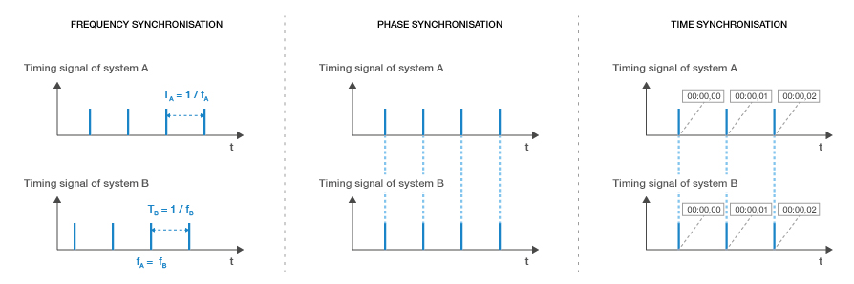
Figure 5: Illustration of Frequency-, Phase- and Time Synchronisation
Frequency synchronisation (also called "syntonisation") means equipment A and B get a common reference signal and evolve at the same rate within a given accuracy and stability but significant instants of the signal are not aligned in time.
Phase synchronisation means equipment A and B get a common reference signal and significant instants are aligned in time within a given accuracy and stability but are not necessarily traceable to a reference time clock such as UTC or TAI.
Time synchronisation means equipment A and B are phase-synchronised with a known traceable reference for timestamps (e.g., UTC, same reference for leap seconds, etc.).
Both FDD and TDD mobile networks usually require frequency synchronisation in order to implement seamless handovers. In addition to that, TDD networks require aligning UL/DL switching points between cells in overlapping coverage areas in order to avoid interferences and therefore require phase synchronisation. In practice, time synchronisation is generally implemented in order to ensure a common traceable reference clock. ECC Report 216 [2] describes various techniques to achieve this.
In the context of this Report and following previous ECC Reports such as ECC Report 216 [2], ECC Report 296 [4] and ECC Report 331 [10], ”synchronised operation” means that no simultaneous uplink and downlink transmission occurs between any pairs of cells which may interfere with each other in the same band. In order to deploy synchronised operation in a multi-operator context (including at the border), consensus needs to be reached on:
- a common phase clock reference (e.g., UTC/TAI) with proper accuracy requirement for the considered technology (e.g. +/- 1.5 µs), together with permanent monitoring of the agreed clock source and with a common definition of the “start of frame” (e.g. which may be defined as per 3GPP specifications, or defined as the start of the first downlink symbol);
- a compatible frame structure (including TDD UL/DL ratio, frame length and guard period) in order to avoid uplink/downlink overlapping (or only enable it in well-known and controlled portions of the frame in case of partial synchronisation).
This consensus should also clarify where synchronisation must apply and/or may not be required (e.g. geographical zones / isolated gNodeB and micro-BS may be excluded from the requirement…), and how to review the agreement in order to possibly update those parameters (such as the TDD UL/DL ratio).

Time source accuracy requirements
Table 2 provides the synchronisation requirements for 3GPP technologies including 5G NR in terms of frequency and phase accuracy.
Table 2: Frequency and phase synchronisation requirements for different 3GPP technologies
Technology | Parameter
Technology | Frequency accuracy relatively to the reference oscillator | Phase accuracy relatively to the reference clock
GSM, UMTS, WCDMA, LTE-FDD | 50 ppb | N/A
LTE-TDD | 50 ppb | ±1.5 μs (for cell radius ≤ 3 km)
LTE-TDD | 50 ppb | ±5 μs (for cell radius > 3 km)
5G NR | 50 ppb | ±1.5 μs

Frame structure
As explained above, configuring compatible frame structures means setting the duration of the frame, the TDD uplink/downlink ratio and guard period in order to align UL/DL switching points, so that the last transmitter stops before the first receiver starts, taking into account the propagation delay (e.g. in LoS non co-sited cases). Frame structures do not need to be exactly identical provided this condition is met.
Figure 6 provides an illustration for simultaneous and non-simultaneous UL/DL transmissions in TDD networks.
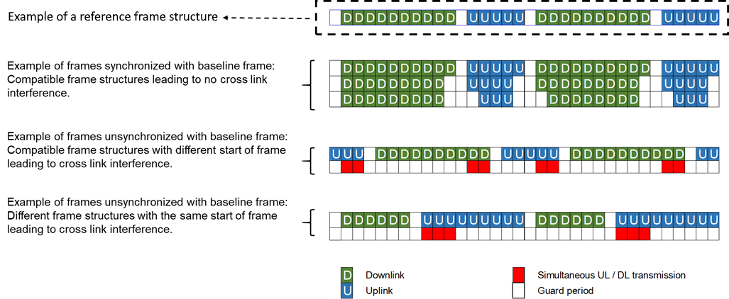
Figure 6: Examples of simultaneous and non-simultaneous UL/DL transmissions in TDD networks

Considerations on inter-operator arrangements
The benefits of synchronised operation have been clearly shown above (as well as the consequences of unsynchronised operation in terms of isolation or separation distances). However, as explained in ECC Report 296, section 3.2 [4], the frame structure selection has an impact on several aspects of network performance and spectrum utilisation efficiency, including:
- DL/UL traffic ratio: the frame structure determines a specific DL/UL ratio: the frame structure selection shall therefore carefully account for the expected traffic patterns;
- Round trip time (RTT) latency (the more frequent the DL/UL and UL/DL switching, the lower the RTT is). A short latency improves the channel estimation quality (CQI feedback) using TDD channel reciprocity properties and also enables fast HARQ retransmissions. More frequent switching therefore has a positive impact on spectrum efficiency in high mobility conditions. On the other hand, considering that guard periods (GP) are required at each DL/UL switch, more frequent switching increases the GP overhead that can have a negative impact on spectrum efficiency;
- Coverage: The guard period (GP) between downlink and uplink must be large enough to compensate the propagation delay for large cells (for coexistence with other cells in line of sight and with the furthest UE).
Therefore, it should be anticipated that multilateral arrangements may not be straightforward in some situations (see also ECC Report 216, section3.3 [2]). In particular: without any regulation, the operator who deploys first nearby the border would unilaterally decide a frame structure which may not be optimal for other stakeholders. Therefore, appropriate regulation should be made to avoid that kind of situation and ensure that all operators would always be equal regardless of their respective deployment timescales.

Partially-synchronised operation
When stakeholders – due to local specificities – mutually agree to use different frame structures at the border, various techniques (such as downlink symbol blanking and semi-synchronisation) may be implemented to mitigate interferences to some extent. Those may be part of the RMR arrangement and are described in Annex 2.

Proposed framework for administrations on RMR cross-border coordination in the 1900 MHz TDD band

Lessons learnt from MFCN
In a generic MFCN context, ECC Report 216 [2] already addressed the topic of inter-operator synchronisation and the shortcomings that might happen in some situations (see 3.3, in particular “lack of mutual incentive”, “unanimity required” and “sustainability of the synchronised arrangement”). More recently, ECC Report 296 [4] and ECC Report 331 [10] addressed the questions of separation distances and various mitigation techniques (including Downlink Symbol Blanking (DSB)) for unsynchronised operation in the 3.5 GHz frequency band, especially in the context of AAS where operator-specific filters are challenging to implement.
Among the key takeaway from MFCN, it could be noted that:
- Synchronised operation is highly desirable – even for adjacent-channel operation. Besides, when AAS are involved, the necessity for synchronised operation increases. When unsynchronised operation is considered, the required separation distances computed in the 3.5 GHz band are typically > 60 km in co-channel operation in order to avoid exceeding the protection criterion;
- Since inter-operator synchronisation requires a multilateral agreement, MFCN stakeholders may not always successfully agree on common parameters for synchronised operation (in particular because of those issues highlighted in ECC Report 216, section3.3 [2]). As a consequence, some administrations have implemented a default frame structure at the national level in order to facilitate synchronised operation between 5G operators and/or between 5G and BWA operators based on LTE/WiMAX technologies;
- No default frame structure has been defined at a European level, however, ECC Recommendation (20)03 [7] recommends two frames in order to restrict the combinatorial complexity of mitigation measures at the border and bring visibility to the industry for the implementation of Downlink Symbol Blanking;
- Various field strength levels for a limited set of TDD frame structures have been computed in ECC Report 331 [10]. In particular, the field strength for the DSB implementation zone defines the area where DSB may be implemented as a mitigation measure.

Main differences between MFCN and railways
- Railways have in most locations a business and operational incentive to coordinate, in particular when railway lines are crossing the border in order to ensure railway service continuity (e.g. ETCS level 2 and/or railway emergency calls);
- The location of the (operational) border between two different railway infrastructure managers generally follows railways’ operational needs and does not necessarily coincide with the geographical border of the two adjacent countries;
- Section 3.2 and Annex 1 highlighted that the operational requirements at the border may significantly differ from cross-border location to cross-border location;
- The frame structure is likely to be UL/DL balanced or even more uplink-oriented in a large number of situations;
- Coverage is sometimes needed on the other side of the border in order to ensure service continuity;
- While Downlink Symbol Blanking (DSB) theoretically enables the same benefits as synchronised operation in terms of radio coexistence with different frame structures at the expense of some downlink capacity loss, ECC Recommendation (20)03 [7] highlights that ”the availability of such feature will be fostered by a limited choice of frame structures” and defines two recommended frame structures for MFCN (named A and B) for which the impact of downlink symbol blanking on DL capacity is evaluated as 17.3%, while there is no similar framework for FRMCS in order to limit the combinatorial complexity and evaluate the capacity loss. In particular, the effect of DSB on downlink capacity loss may be larger in the case of RMR when the frame is originally configured with few downlink slots due to a traffic pattern mostly dominated by uplink.

Proposed toolbox
From previous sections, it can be summarised that:
- As mentioned in ECC Report 296 [4], “The chosen frame structure will contribute to the network performance (e.g., latency, spectral efficiency, throughput and coverage)” therefore operators naturally strive to keep as much flexibility as possible;
- Unsynchronised operation usually requires significant separation distances between different networks. Therefore, it is highly desirable to implement a framework that can guarantee that operators can deploy properly up to the borderline and ensure, in absence of an RMR arrangement, fairness with regards to TDD system parameters and deployment constraints nearby the border, under the conditions of synchronised operation;
- The exact capacity needs in UL and DL for FRMCS is not yet fully defined, however, it is foreseen that the needs could differ significantly depending on the situation (see section 3.2). Therefore it would be desirable to enable custom/local configurations in dedicated border areas as long as this is mutually agreeable by the stakeholders. This usually assumes that the stakeholders are able to implement a proper topological de-coupling of these border areas with the rest of their network;
- Coverage requirements in the neighbouring countries for railway lines crossing the border may also require agreement between parties on a custom field strength level. Therefore, it is highly desirable to enable a high level of flexibility when all stakeholders agree on optimal parameters (possibly at the local level) as part of an RMR arrangement. Considering that:
  - Such arrangements may be under administrations review. In that case it is anticipated that those arrangements shared with administrations would not have to systematically be formally approved by them. However, administrations may choose to do so on a case-by-case basis or depending on their national policy;
  - For those cases where the field strength would exceed the CTFS value on more than one border (e.g. in the case of a border area between more than two countries), those RMR arrangements will have to involve and be agreed by all parties in the relevant areas;
- A cross-border arrangement only needs to address those border areas where deployments may affect the other side of the border.
In order to take those elements into account, the following framework is proposed for the cross-border coordination of TDD RMR networks in the 1900 MHz frequency band:
- A coordination trigger field strength (CTFS) shall be defined based on the required isolation between a victim BS at the border and an unsynchronised base station on the other side of the border (see Annex 3). This is similar in spirit to the “DSB implementation zone” developed in CEPT and described in ECC Report 331 [10]. In order to effectively protect base stations on the other side of the border, taking into account the reliability requirements of RMR, a field strength value of 0 dBµV/m/5 MHz @3 m (measured on the downlink part of the frame at the border) is proposed for this CTFS value;
- Base stations leading to a field strength at the border below the CTFS value, are not in the scope of this framework and operators may therefore use any relevant TDD parameter or frame structure suitable to their local needs;
- For base stations creating a field strength at the border above the CTFS value, the following situations may occur:
      - By default, stakeholders shall use the reference parameters below, which enable synchronised co-channel operation at the border;
      - In the case of RMR arrangements between IMs, it would be possible to deviate from those reference parameters so that IMs may set optimal parameters suitable for their local needs and efficient use of the spectrum. Those RMR arrangements may be defined generically between two or more countries or only for specific local areas as relevant, and may enable some flexibility or alleviate some constraints such as different frame configurations or different field strength limits when crossing the border. Annex 2 describes a non-exhaustive toolbox that infrastructure managers may consider.
Table 3: Reference parameters for synchronised co-channel operation at a border
Parameter | Value
Reference phase / time clock | Aligned with UTC, properly monitored to ensure the local clock drift does not exceed +/- 1.5 µs in the event of a PRTC outage  (Informative note: GNSS (e.g. GPS) is an example of compliant clock)
Reference frame  (see Annex 4) | With Tc := 1/(480000*4096) seconds (Basic time unit for NR as defined in ETSI TS 138.211, section 4.1 [15]):  - Start-of-frame, aligned with the reference clock  - Downlink for 3371008*Tc  - Guard period for 280576*Tc  - Uplink for 2246656*Tc  - Downlink for 1685504*Tc  - Guard period for 280576*Tc  - Uplink for 1966080*Tc  - Downlink for 3371008*Tc  - Guard period for 280576*Tc  - Uplink for 2246656*Tc  - Downlink for 1685504*Tc  - Guard period for 280576*Tc  - Uplink for 1966080*Tc  - Back to start-of-frame  (Informative note: Those timings correspond to 5G NR configuration “DS_{a}US_{b}U DS_{a}US_{b}U” with a 15 kHz SCS and S(DL/GP/UL):=(S_{a} = 10:2:2, S_{b} = 12:2:0) and 5G NR configuration “DDDS₁UUDS₂UU DDDS₁UUDS₂UU” with a 30 kHz SCS and S(DL/GP/UL):=(S₁ = 6:4:4, S₂ = 10:4:0)).  Note: All SCS are acceptable as long as the frame complies with the above timings. Other frame configurations are also deemed compatible if they do not lead to any downlink/uplink overlap (e.g. if they implement a larger guard period).
Field strength at the border  (see Annex 3) | 65 dBµV/m/5 MHz @3 m at the border  47 dBµV/m/5 MHz @3 m at 6 km in the other country.  All field strengths shall be measured on the downlink part of the frame (otherwise any measurement made on the whole frame must then be scaled accordingly with the DL/UL ratio).

Conclusions
The purpose of this ECC Report is to support Administrations in handling the cross-border coordination and synchronisation for RMR networks in the 1900-1910 MHz TDD band.
Based on ECC Decision (20)02 [8] and Commission Implementing Decision (EU) 2021/1730 [13], CEPT administrations and EU Member states shall designate and make available on a non-exclusive basis the unpaired frequency band 1900-1910 MHz for Railway Mobile Radio, based on national demand.
The specifics of TDD networks demand that measures are taken to ensure efficient operation of all networks at a border location. ECC Report 216 [2] mentions: “When more than one TDD network operates in the same geographic area and in the same band, severe interference may impair network performance if the networks are uncoordinated, i.e. if some equipment is transmitting while other equipment is receiving in the same time-slots”. It also says that one way to eliminate those TDD-specific BS-BS and UE-UE interferences is “to synchronise base stations so that they roughly transmit and receive in the same time. More precisely, synchronised operation means that no simultaneous uplink and downlink occur between any pairs of cells which may interfere with each other in the same band”.
Synchronised and unsynchronised TDD operation have been assessed and addressed in various ECC deliverables for MFCN such as ECC Report 216 [2] , ECC Report 296 [4] and ECC Report 331 [10] as well as ECC Recommendation (20)03 [7] and ECC Recommendation (15)01 [6]. Those studies have shown that synchronised operation is highly preferred, and that unsynchronised operation often leads to large separation distances and/or low field strength requirements. Synchronised operation requires stakeholders to agree on a common reference phase clock and on compatible frame structures, noting that the frame structure has an influence on various performance indicators, e.g.:
- the length of the frame has an impact on the latency;
- UL/DL ratio has an influence on spectrum efficiency depending on the local traffic pattern;
- size of guard period has an influence on both spectrum efficiency and maximum cell size.
In summary, synchronised TDD operation is generally encouraged as the most spectrum efficient way to use the given spectrum.
However even though RMR relies on the same family of technologies than MFCN, railway operation differs significantly in various aspects, e.g.:
- linear topology rather than an area based topology;
- high reliability requirements;
- various traffic patterns depending on the local operational specificities;
- uplink/downlink- balanced or even uplink-dominated traffic patterns;
- one single infrastructure manager per country as opposed to several operators in MFCN bands;
- coverage requirements in the neighbouring countries for railway lines crossing the border.
Overall, from a railway operation perspective, the cross-border coordination should support the diversity of railway operational needs that exist at different border locations, ranging from parallel railway tracks to border crossing tracks with or without service continuity, different usage densities and 2- and 3-country border cases.
These specificities call for a framework that would:
- enable a high level of flexibility when all stakeholders agree on optimal parameters (possibly at the local level) as part of an RMR arrangement;
- ensure, in absence of an RMR arrangement, fairness and certainty with regards to TDD system parameters and deployment constraints nearby the border, under the conditions of synchronised operation.
In order to take those elements into account, the following framework is proposed for the cross border coordination of TDD RMR networks in the 1900 MHz frequency band:
- A coordination trigger field strength (CTFS) shall be defined based on the required isolation between a victim BS at the border and an unsynchronised base station on the other side of the border (see Annex 3). This is similar in spirit to the “DSB implementation zone” developed in CEPT and described in ECC Report 331 [10]. In order to effectively protect base stations on the other side of the border taking into account the reliability requirements of RMR, a field strength value of 0 dBµV/m/5 MHz @3 m (measured on the downlink part of the frame at the border) is proposed for this coordination threshold;
- Base stations leading to a field strength at the border below the coordination trigger threshold are not in the scope of this framework and operators may therefore use any relevant TDD parameter or frame structure suitable to their local needs;
- For base stations creating a field strength at the border above the coordination trigger threshold, the following situations may occur:
  - By default, stakeholders shall use the reference parameters in Table 4, which enable synchronised co-channel operation at the border;
  - In the case of RMR arrangements between IMs, it would be possible to deviate from those reference parameters so that IMs may set optimal parameters suitable for their local needs and efficient use of the spectrum. Those RMR arrangements may be defined generically between two or more countries or only for specific local areas as relevant, and may enable some flexibility or alleviate some constraints such as different frame configurations or different field strength limits when crossing the border. Annex 2 describes a non-exhaustive toolbox that infrastructure managers may consider.

Table 4: Reference parameters for synchronised co-channel operation at a border
Parameter | Value
Reference phase / time clock | Aligned with UTC, properly monitored to ensure the local clock drift does not exceed +/- 1.5 µs in the event of a PRTC outage  (Informative note: GNSS (e.g. GPS) is an example of compliant clock)
Reference frame  (see Annex 4) | With Tc := 1/(480000*4096) seconds (Basic time unit for NR as defined in ETSI TS 138.211, section 4.1 [15]):  - Start-of-frame, aligned with the reference clock  - Downlink for 3371008*Tc  - Guard period for 280576*Tc  - Uplink for 2246656*Tc  - Downlink for 1685504*Tc  - Guard period for 280576*Tc  - Uplink for 1966080*Tc  - Downlink for 3371008*Tc  - Guard period for 280576*Tc  - Uplink for 2246656*Tc  - Downlink for 1685504*Tc  - Guard period for 280576*Tc  - Uplink for 1966080*Tc  - Back to start-of-frame  (Informative note: Those timings correspond to 5G NR configuration “DS_{a}US_{b}U DS_{a}US_{b}U” with a 15 kHz SCS and S(DL/GP/UL):=(S_{a} = 10:2:2, S_{b} = 12:2:0) and 5G NR configuration “DDDS₁UUDS₂UU DDDS₁UUDS₂UU” with a 30 kHz SCS and S(DL/GP/UL):=(S₁ = 6:4:4, S₂ = 10:4:0)).  Note: All SCS are acceptable as long as the frame complies with the above timings. Other frame configurations are also deemed compatible if they do not lead to any downlink/uplink overlap (e.g. if they implement a larger guard period).
Field strength at the border (see Annex 3) | 65 dBµV/m/5 MHz @3 m at the border  47 dBµV/m/5 MHz @3 m at 6 km in the other country.  All field strengths shall be measured on the downlink part of the frame (otherwise any measurement made on the whole frame must then be scaled accordingly with the DL/UL ratio).
- Typical railway deployment scenarios
Railways, even within a country, are made of dissimilar environments, reflecting a range of operational needs. This diversity of environments includes railway lines themselves (main, high speed, regional), stations and shunting yards in varying combinations in different geographical areas. In border areas different operational environments may exist on either side of the border. In addition to this, railway lines may be present that cross the border requiring service continuity for trains crossing that border.
This annex provides several examples showing such diversity of railway network environments at sample border locations.
The examples also demonstrate that multiple border crossing cases may exist between neighbouring countries with differing railway network environments that would result in different requirements on the RMR networks in those areas.
- Area near Gruson (F): HSL line
For the area near Gruson (France), a border crossing with Belgium with a single high-speed line is shown in below. To support border crossing at high speed, a significant coverage overlap is necessary on both sides of the border (especially in case of ETCS level 2 use). It is expected that the traffic demand on either side of the border will be (almost) identical.
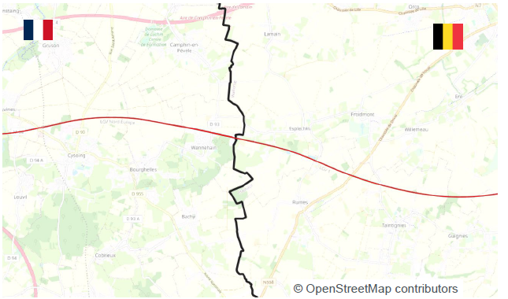
Figure 7: High speed line
- Jeumont (F) | Erquelinnes (BEL) area: station, shunting + station
In the French area near Jeumont, a station plus shunting area exists whereas on the Belgian side only a station is present. As the two stations belong to different railway infrastructure managers, the national railway operations and hence traffic needs are expected to differ. Furthermore, the French shunting yard will result in additional traffic for the French RMR network only. Overall, this potentially results in different uplink - downlink requirements.
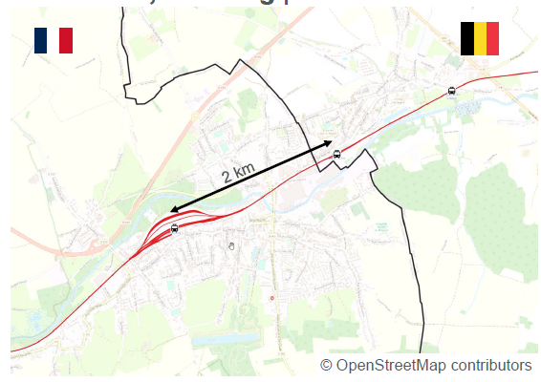
Figure 8: Station with and without shunting area
- Tourcoing (F) | Mouscron (BEL) area: station, shunting + station, shunting
In the border area between Mouscron (Belgium) and Tourcoing (France), in both countries a combination of a railway station plus shunting area exist, as well as a border crossing line. Due to differing national operating procedures and differing national train densities, the requirements on the RMR networks are expected to be different on either side of the border.
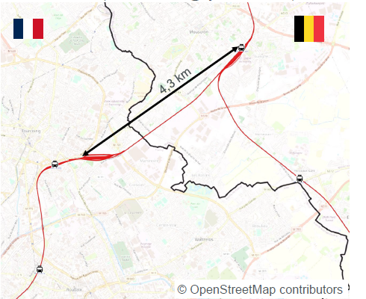
Figure 9: Two stations plus shunting
- Strasbourg (F) | Kehl (D) area: line, shunting + stations, shunting
The French-German border area near Strasbourg and Kehl shows a combination of large shunting areas on either side of the border, separated by the Rhine river, plus railways stations on the German side and a border crossing track. Apart from the potentially large differences between the French and German shunting operation traffic, also the presence of the river and other water areas will result in a difficult propagation environment leading to a tighter coupling between the two networks. Thus, the complication here is the expected differing needs for uplink - downlink traffic versus the higher probability of mutual interference.
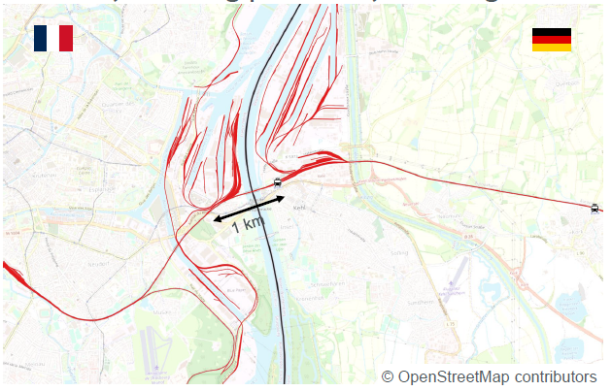
Figure 10: Multiple line, station and shunting combinations
- Longwy (F) | Aubange (BEL) | Rodange(LUX) area: line + stations, shunting + stations, shunting
In the area of Longwy (France), Aubange (Belgium) and Rodange (Luxembourg), the railway networks of these three countries show a combination of stations, shunting and national- border crossing tracks. Similar to the previous scenarios, the three RMR networks will have to support different traffic characteristics. The added difficulty of this scenario is that three networks need to jointly make appropriate use of the 1900-1910 MHz frequency band, possibly in combination with the 900 MHz band.
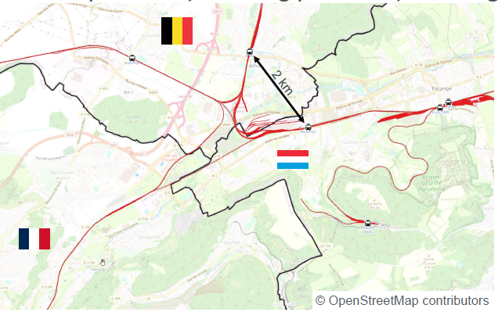
Figure 11: 3-country border area
- Basel area: Line + stations, shunting + stations, shunting
In the area near Basel (Switzerland) also the rail networks of France and Germany are present with national and border crossing tracks, shunting yards and stations, all within a rather limited geographical space. Different national railway procedures and processes, in combination with different national and border crossing rail traffic densities are expected to call for different RMR network requirements with differing uplink - downlink demands.
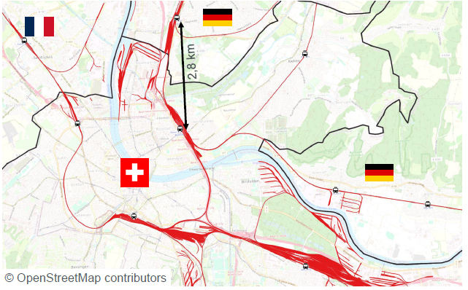
Figure 12: Complex 3-country border area
- Lauterbourg Region(F) | D area south of Karlsruhe: line + stations, line
The border area between Lauterbourg (France) and Germany is rather flat with patches of water. This results in a rather limited isolation between the French and German RMR networks. As on the German side several stations exist whereas on the French side the railway network is mainly a single line, it is anticipated that on the German side the uplink - downing demand will be quite different from that on the French side.
This scenario demonstrates that not only border crossing railway tracks will need to be considered for creating arrangements between railway infrastructure managers.
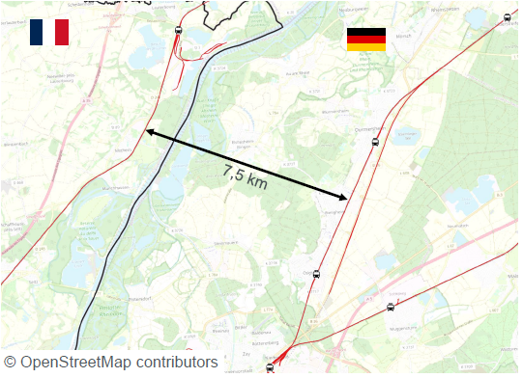
Figure 13: Limited network isolation
- Copenhagen (DNK) | Malmö (S) area: line + stations, line
Between Denmark and Sweden, the Øresund bridge carries both road and rail traffic. The cities of Copenhagen and Malmö on either side of that water crossing have their own stations and shunting areas as well as national railway lines. Thus, also here a different set of requirements on the RMR network and its uplink - downlink characteristics is anticipated. However, due to the presence of a large patch of water in between the two networks, only a limited isolation between the networks is expected, complicating their coexistence.
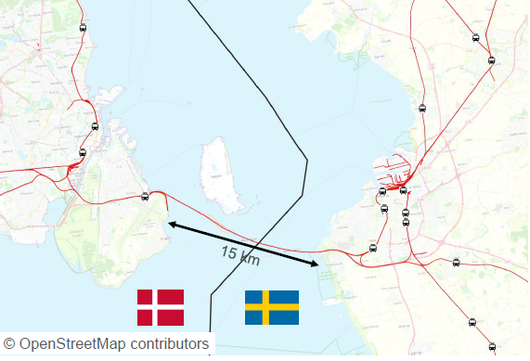
Figure 14: Border crossing over water
- Toolbox for infrastructure managers in RMR arrangements
- Partially-synchronised operation
When stakeholders – due to local specificities – mutually agree to use different frame structures at the border, various techniques (such as downlink symbol blanking and semi-synchronisation) may be implemented to mitigate interferences to some extent. Those solutions are described in this Annex.
- Semi-synchronised operation as defined in ECC Report 296
ECC Report 281 [3] provides the following definition: ”the semi-synchronised operation corresponds to the case where part of the frame is consistent with synchronised operation as described above, while the remaining portion of the frame is consistent with unsynchronised operation as described above. This requires the adoption of a frame structure for all TDD networks involved, including slots where the UL/DL direction is not specified, as well as synchronising the beginning of the frame across all networks”.
A very generic description of semi-synchronised operation is depicted in the below figure where Operator A and Operator B operate in co-channel at the border or adjacent channels in the same geographical area. The operators can designate portions of the frame to have synchronised fixed duplex direction, i.e. they are always DL or always UL. For the remainder of the slots, the operators may choose semi-static but different, or time-varying duplex directions.
Figure 15: Example of semi-synchronised operation
Semi-synchronised operation aims to find a balance between more flexibility (compared to synchronised operation) and some acceptable data-loss. The part of the frame with flexible UL/DL transmissions may suffer from BS-BS and UE-UE interference with respect to both leakage and blocking interference mechanisms. Therefore, the conditions where semi-synchronised operation may be considered acceptable with regard to the data-loss have to be carefully discussed and agreed between the stakeholders involved.
In a specific implementation of semi-synchronised operation, the control plane can be protected by ensuring that the control signals never belong to the flexible part of the frame. This is different from the case of unsynchronised operation where both control and data channels can be interfered leading to potentially larger loss (e.g. inability to decode the whole frame resulting in large throughput degradation).
Semi-synchronised operation between TDD networks requires the following agreements between operators:
- Time synchronisation – as in the case of synchronised operation;
- Partial frame alignment: the agreement shall define a default frame structure for synchronised operation (for which UL/DL directions are defined across the whole frame) and at the same time the part of the frame where each operator is allowed to reverse the default transmission direction.
Semi-synchronised operation can also be applied in case of coexistence between different technologies if the operators involved agree on a frame structure which could contain some flexible portions of the frame. A different degree of flexibility in the assignment of UL/ DL transmission directions to the different portion of the frame (e.g. in granularity, dynamic vs. static) and in the ability to protect control channels can be achieved by different features.
Benefits and challenges of semi-synchronised operation
Semi-synchronised operation allows for some degree of frame structure flexibility when compared with synchronised operation.
Just like synchronised operation, semi-synchronised operation requires operators to find an agreement with all other concerned operators in the frequency band and in the same area if they want to deploy without any other additional coexistence mitigation. An agreement between two operators in an RMR context, potentially using the same technology, is easier to achieve than an agreement between multiple operators, potentially using different technologies and potentially targeting different services.
Semi-synchronised operation introduces an upper limit to the BS-BS and MS-MS interference when compared with unsynchronised operation.
Operators may trade-off between frame flexibility and risk of interference. In some circumstances, semi-synchronised operation of BSs meeting the ECC baseline out of block limits (defined in ECC Report 296 [4] for the synchronised operation) will be possible in the same geographical areas without guard bands and operator-specific filters with an increase in lost packets that operators may consider acceptable. The applicability of the ECC baseline out of block limit is investigated in section 4.5.
Should operators agree to allow semi-synchronised operation based on the ECC baseline out of block power limit (waiving the requirement for ECC restricted baseline), then the part of the frame with flexible UL/DL transmissions may suffer from BS-BS and MS-MS interference with respect to both leakage and blocking interference mechanisms.
There are some 5G use cases that imply the deployment of MSs that are in fixed positions and close to each other (e.g. crowded stadiums, trains, busses, (home) CPEs in fixed wireless access (FWA) systems, fixed machinery/robots in factories). In such scenarios, the MS-MS interference might not be negligible anymore: no studies were performed with this respect in order to support semi-synchronised operation, and BSs may have to implement interference mitigation techniques. For example, in a scenario where a portion of the DL periods can be used for UL:
- Using zero forcing to create a null in the direction of the interference coming from the neighbour network operating in the adjacent band. It is currently unclear to what extent such techniques will be effective and what additional implementation costs would be involved;
- Limiting the UL transmission to part of the occupied bandwidth far from the edge of the operator block and using a robust modulation and coding scheme. The extent to which this would reduce spectral efficiency still needs to be determined.
In terms of market availability, some features needed to support some semi-synchronised operation scenarios are optional in 3GPP specifications. The latest updates on the status and future plans in 3GPP (Rel. 15 and Rel. 16) [9] on the unsynchronised and semi-synchronised operating modes are available in ECC Report 296, annex 9 [4].
- Downlink symbol blanking as defined in ECC Report 331
ECC Report 331 notes:
“The downlink symbol blanking (DSB) feature can be used to facilitate cross-border coordination between operators who decide to use two non-compatible frame structures while adopting a common phase clock reference.”
“DSB allows the base stations’ schedulers to switch off transmissions (“blanking”) of those downlink symbols (“blanked DL symbols”) of each network that correspond to simultaneous uplink reception or simultaneous gap symbols for the other network.”
While DSB enables the same benefits as synchronised operation in terms of radio coexistence with different frame structures at the expense of some downlink capacity loss, ECC Recommendation (20)03 [7] highlights that ”the availability of such feature will be fostered by a limited choice of frame structures” and defines two recommended frame structures for MFCN (named A and B). There is no similar framework for FRMCS in order to limit the combinatorial complexity and evaluate the capacity loss.
In the case of MFCN, the impact of downlink symbol blanking on DL capacity is evaluated as 17.3% when DSB is implemented by blanking both traffic and control channels at the granularity of OFDM symbols. It may be higher if the blanking is implemented at the granularity of a whole downlink slot. The impact of DSB for other frame structures would need to be assessed on a case-by-case basis, and in particular the effect of DSB on downlink capacity loss may be larger in the case of RMR when the frame is originally configured with few downlink slots due to a traffic pattern mostly dominated by uplink.
- 1900 MHz channel arrangements
As the RMR harmonised spectrum at 1900 MHz consists of only 10 MHz, the following channel arrangements are the most likely at the border.
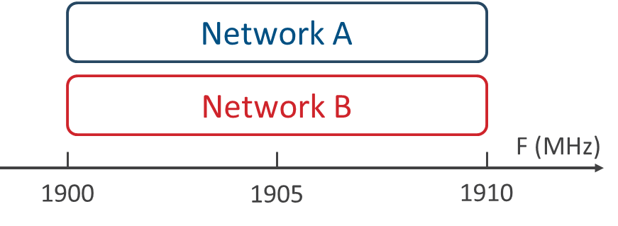  Co-channel deployment | 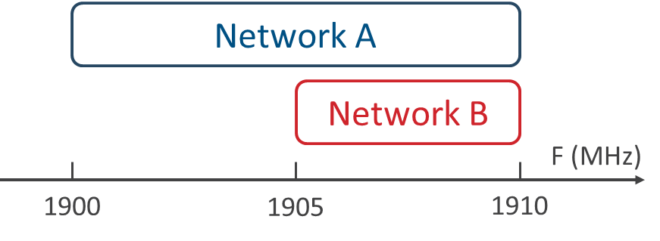  Partial channel overlap | 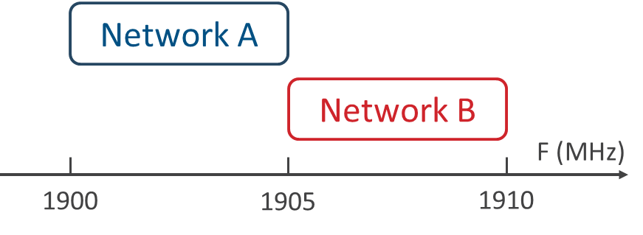  Adjacent channel deployment
Figure 16: Most likely 1900 MHz RMR channel arrangements at the border
Thanks to the business and technical incentive of RMR operators to collaborate and coordinate at the border, a variant of the co-channel deployment is also possible making use of Fractional Frequency Reuse (FFR). In this variant, RMR operators would operate on the full 10 MHz channel but would distribute the available Resource Blocks.
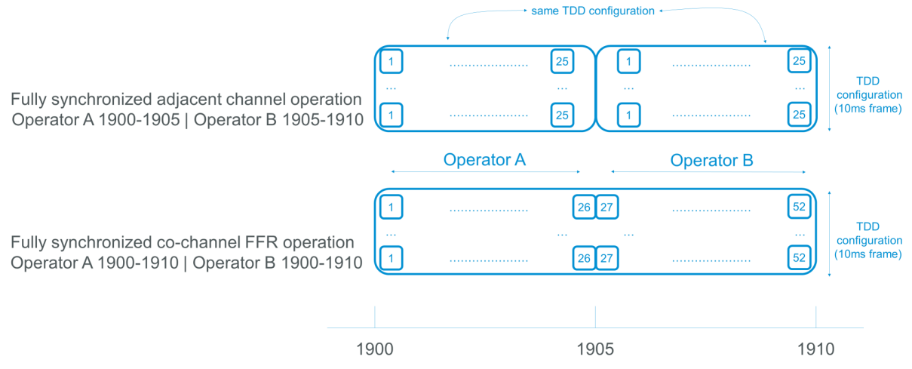
Figure 17: Adjacent channel and co-channel deployment variant with FFR usage
The co-channel variant would enable a more optimal spectrum usage (52 RBs to be shared between RMR operators vs 2 X 25 RBs in case of adjacent channel deployment, coexistence field strength levels similar to adjacent channel deployment, etc.) and simplify coordination and operation of the railway telecom network (no restriction to usage of the full 10 MHz channel within countries or at the border, enablement of coexistence scenarios including more than two RMR operators, etc.).
- About TDD cell size
The Guard Period (GP) is the time between downlink and uplink transmission. Its purpose is to avoid interference within a cell and ensure all UL transmissions from multiple UEs arrive at the same time at the eNB/gNB receiver. The GP is not required between uplink and downlink as the eNB/gNB is the only entity transmitting. The GP duration allows to compensate for propagation delays hence the longer the GP, the larger the cell can be.
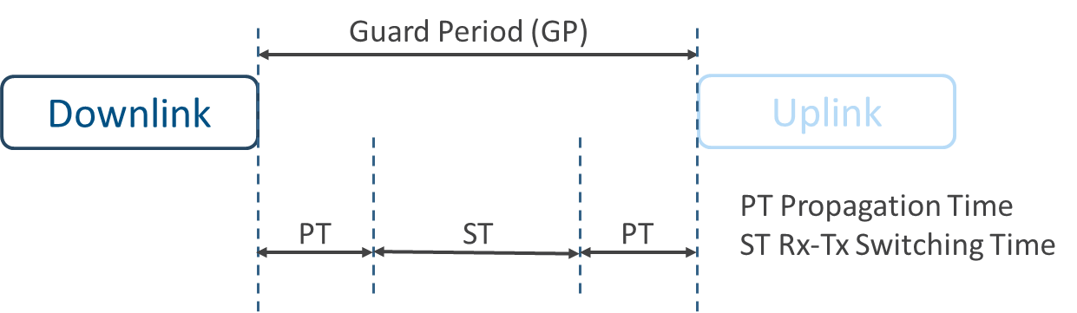
Figure 18: TDD DL/UL switching timers
In practice, the maximal cell radius can be determined based on the round trip delay (RTD) and the velocity at which RF signal travels (c = 3x10⁵ km/s). In equation form, this calculation takes the following form:
Figure 19: Formula to determine maximal TDD cell size to compensate propagation delay
$$Cell Size (km) = \frac{RTD}{2}=\frac{Time×Velocity}{2}=\frac{\frac{{symbols}_{GP}}{14}×300000}{\frac{SCS}{15}×1000×2}=\frac{{symbols}_{GP}}{SCS}×\frac{1125}{7}$$

This translates to the following maximum cell sizes for LTE (SCS = 15 kHz) and 5G NR (SCS = 15 or 30 kHz for a 10 MHz RMR carrier) when looking solely at the propagation delay. Compared to the inter-site distance currently followed at 900 MHz (which is roughly 8 km in rural areas although it varies between countries and railway lines characteristics), it is expected that the duration of the guard period does not represent a limiting factor once at least two symbols are used as a guard period.
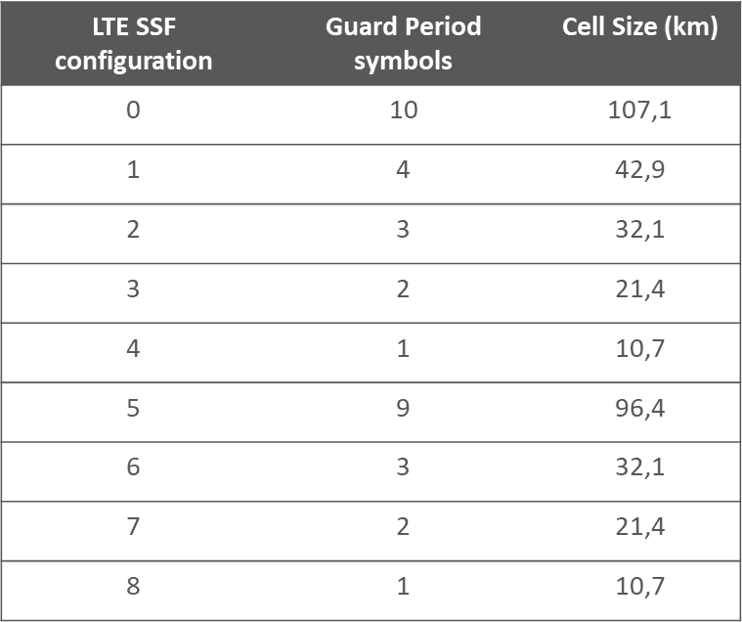 | 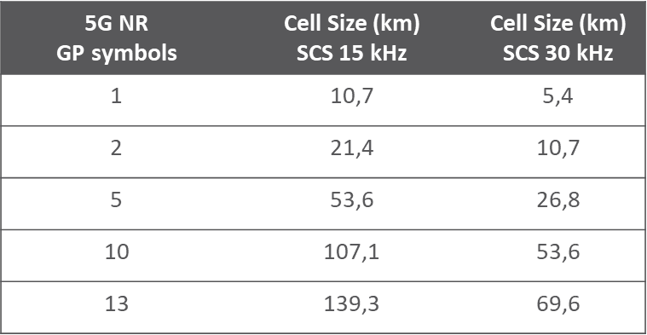
Figure 20: Maximal cell sizes induced by Guard Period duration for a LTE or 5G NR RMR carrier
Note: The Guard Period does not by itself determine the cell size, there are also other important parameters including the anticipated guaranteed target throughput in uplink or in downlink that may have more impact on the cell size.
- About topological connectivity in a two-band network
RMR networks are mostly curvilinear networks which means that this peculiar topology can be leveraged when tackling the possible need of different TDD frames inside a RMR network or between RMR networks. Figure 21 outlines two possible schemes, one assuming the use of solely the 1900 MHz band where the second one takes advantage of the two RMR harmonised frequency bands.
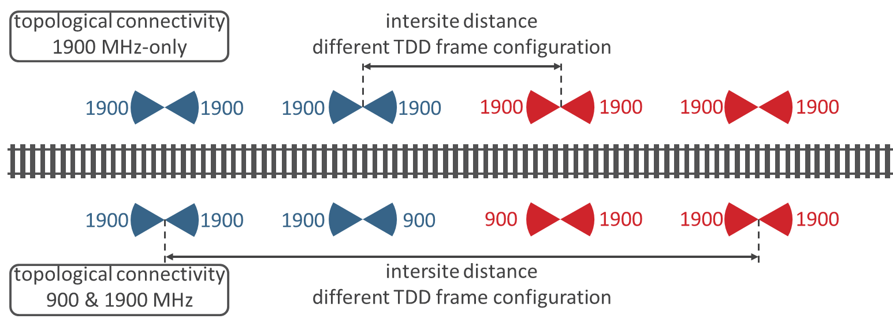
Figure 21: Topological connectivity schemes
This setup could be leveraged between RMR operators’ networks or within the network of a RMR operator wishing to adopt different TDD frame configurations.
- About TDD frame configurations
As outlined in section 3.2, railway operational environments vary significantly within a country and this diversity is echoed at the border where operational needs of the RMR operators sharing a border at a particular location may differ significantly.
- About coordination areas
GSM-R networks in border areas need to share the allocated 900 MHz GSM-R spectrum. Consequently, railway operators have established a procedure to mutually coordinate radio coverage on a case-by-case basis for each involved base station site. The coordination area is based on a threshold field strength level that is applied at either a country border in case of non-preferential frequency usage or at a certain distance within the neighbouring country when using preferential frequencies. Coordination on a site-by-site basis is only required when the respective threshold field strength is exceeded.
Similarly, the allocated RMR spectrum will have to be shared in border areas and a similar procedure would be required to accommodate coexistence between RMR 1900 MHz networks. The foreseen approach would be similar in spirit to the DSB implementation zone developed in CEPT and described in ECC Report 331 [10].
Assuming a field strength level at the border FS1 (0 dBµV/m / 5 MHz @3 m) associated to unsynchronised operation and a field strength level FS2 (65 dBµV/m / 5 MHz @3 m) associated to synchronised operation, the coordination areas for RMR 1900 MHz operation in border areas would be used as follows when it comes to coordination requirement induced on operator A with regard to neighbour country B:
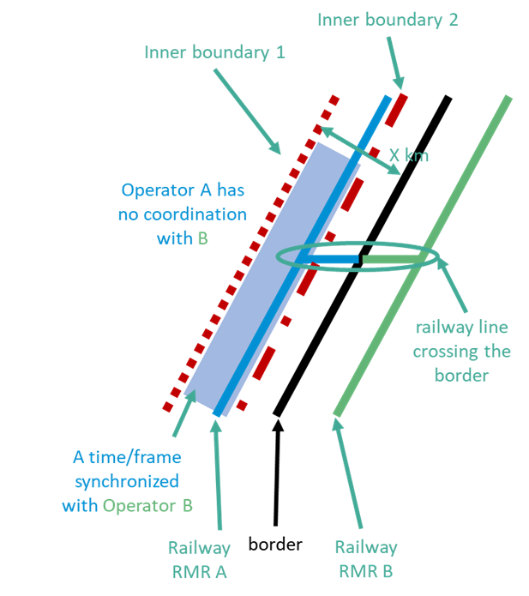
Figure 22: Coordination areas
- Boundaries:
  - Inner boundary 1: this boundary is defined at a distance from the border derived from unsynchronised operation threshold FS1 at the border line;
  - Inner boundary 2: this boundary is defined at a distance from the border derived from synchronised operation threshold FS2 at the border line.
- Usage of the boundaries:
  - Farther inside country A than this inner boundary 1 line, RMR operator A would not have to coordinate its sites with regard to RMR operator B;
  - Between inner boundary 1 and inner boundary 2, the two RMR operators would be expected to be time synchronised;
    - In absence of an RMR arrangement, the Fallback TDD frame configuration (see Table 1) shall be used;
    - In presence of an RMR arrangement, the TDD frame configurations shall be mutually agreed;
  - Between inner boundary 2 and the border:
    - If the predicted field strength level at the border line of the sites of RMR operator A is below FS2, the Fallback TDD frame configuration (see Table 1) shall be used in absence of an RMR arrangement;
    - If the predicted field strength level at the border line of the sites of RMR operator A is above FS2, an RMR arrangement is mandatory.
In an RMR context, the purpose of coordination areas is to identify the relevant RMR radio sites where detailed evaluations of the interference potential need to be performed. If a given RMR radio site falls under one of the scenarios where coordination is required, the exchange between RMR operators of the relevant radio system parameters as well of deployment plans is required. Elements that need to be considered are:
- CTFS value;
- All railway lines parallel to the border as well border crossing railway lines;
- Set of RMR services that need to be supported together with relevant system parameters;
- RMR capacity and coverage aspects;
- Terrain and topography.

- SEAMCAT simulation and calculation of field strength limits
When assessing the DSB implementation zone related to the required isolation for unsynchronised operation, ECC Report 331 [10] mentions “In the revision of ECC Recommendation (15)01 in 2019, simulations for both non-AAS and AAS wideband systems (LTE and 5G NR) were performed, the field strength value of 0 dBµV/m/(5 MHz) at 3 m was obtained based on an uplink throughput loss between 5 % and 10%”. Although this value was further relaxed to 14 dBµV/m /5 MHz @3 m in ECC Recommendation (15)01 [6] in order to reduce the DSB implementation zone under the assumption of higher throughput losses for MFCN (up to 30%), it is anticipated that in the case of RMR such a field strength limit of 0 dBµV/m/5 MHz @3 m could be required for the coexistence between a victim BS at the border and an unsynchronised BS on the other side of the border considering the reliability requirements.
It is also anticipated that field strengths from ECC Recommendations on cross-border coordination for MFCN in the 1800 MHz and 2100 MHz FDD frequency bands could be reused for synchronised operation in the 1900 MHz RMR TDD band, provided the field strength is measured on the downlink part of the frame (if the measurement is made on the average field strength of a whole frame, then the measured field strength ought to be scaled by (DL+UL)/UL, where DL and UL represent the durations of the downlink and uplink part of the frame respectively). Those deliverables for MFCN FDD recommend the field strength values of 65 dBµV/m/5 MHz @3 m at the border and 47 dBµV/m/5 MHz @3 m at 6 km in the other country.
The study undertaken aimed to check and confirm those values with new simulations, noting however that the SEAMCAT tool does not yet fully take into account the specificities of TDD and is also inherently more suited to area based deployments such as MFCN and less suited to linear topology-types of deployments such as RMR.
- Technical parameters of the simulation
Table 5: Specific Railway Simulation parameters
Parameter | Urban/suburban | Rural
Centre Frequency (MHz) | 1905
Channel bandwidth (MHz) | 10 (co-channel)**
Channel bandwidth (MHz) | 5 (adjacent channel)
Spectrum usage | TDD
BS Tx Power (W/10 MHz) | 40
BS Tx Power (dBm/10 MHz) | 46 (49)
BS Tx Power (dBm/5 MHz) | 46 / (43)
BS antenna height (m) | 25 | 35
Cell Range (m) | 600 | 4000
BS antenna gain (dBi) | A fixed antenna pattern with a typical gain up to 19 dBi
Additional Loss (dB) | 2 (0)
Antenna pattern | Recommendation ITU-R F.1336-4 rec 3 [14]
Gain (dBi) | 16
Horizontal 3dB beam (deg) | 65
Elevation additional offset (deg) | -3
Channel-model | SISO
UE (Cab-R) Tx Power (dBm) | 31 | 31
UE antenna gain (dBi) | 2 | 2
Data user bodyloss (dB) | 0
HO margin (dB) | 3.0
UE height (m) | 4.0 | 4.0
Rx height (m) | 3.0 | 3.0
UE Indoor/Outdoor percentage (%) | 0 / 100 | 0 / 100
Wall Loss for indoor UE (dB) | 20 | 15
Wall Loss for indoor UE (dB) standard deviation (dB) | 5 | 5
BS noise figure (dB) | 6
Noise inside receiver BS (dBm) | -98
UE noise figure (dB) | 8
Noise inside receiver UE (dBm) | -96
BS ACLR (dB) | 45
BS ACS (dB) | 30 dB (Calculated with -52 dBm ACS level and 5 dB noise figure)
BS ACS (dB) | 33 dB (Calculated with -52 dBm ACS level and 8 dB noise figure)
UE ACLR (dB) | 37
UE ACS (dB) | -
Network loading | 100% | 100%
Table 6: Propagation Model used in the simulation
Environment | Urban/Suburban | Rural
Propagation Model Intra-Networks
 | Recommendation ITU-R. P.1546: 50% location and 50% time | Recommendation ITU-R. P.1546: 50% location and 50% time
Propagation Model Interfering link
 | Recommendation ITU-R. P.1546: 50% location and 10% time
General environment around Rx | suburban | rural
General environment around Tx | suburban | rural
Representative Clutter height around Rx | not activated | not activated
Representative Clutter height around Tx | not activated | not activated
User specific standard deviation | 7 dB | 7 dB
A limited number of antennas are available in SEAMCAT. Therefore, the reference radiation pattern of the ITU-R F.1336-4 [14] (F series) antennas was used in this simulation. These antennas are designed for sharing studies related to mobile services.
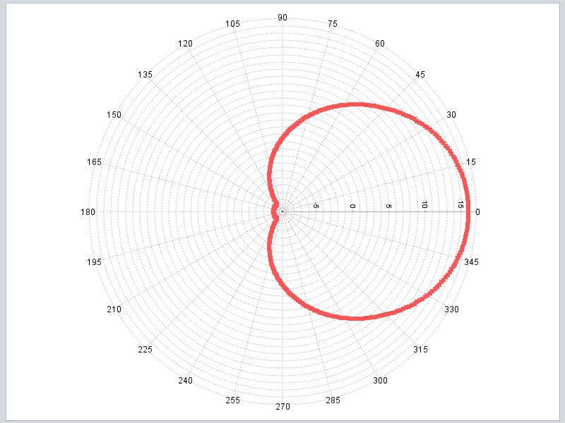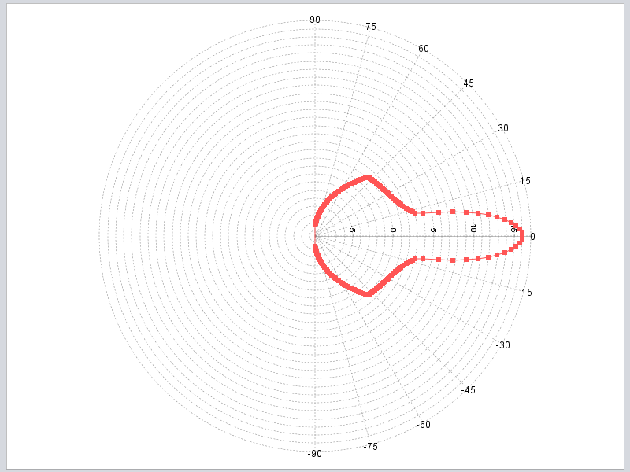
Figure 23: Antenna pattern horizontal- and vertical of ITU-R F.1336-4
- Simulation scenarios
The corresponding simulation scenarios were set up specifically for the railway case. The railway specific network layout is depicted in Figure 24 with highlighting of the so called reference cells (in short ref-cell) of network A and network B.
The following figure depicts a two network layout along the borderline, but the “network” is ghosted as it is not present in the Railway case. Only the ref-cells are highlighted. This means: These cells are the nearest cells to each other and constitute the worst case scenario assumed in this study.
Figure 24: Simulation scenario between two TDD networks (derived for Railway-Layout)
The distance d is from the network A reference cell site to the borderline, it is also the separation distance from the reference cell site of the network B to the borderline. Thus D=2*d is the distance between the ref-cells.
- Synchronised operation
In this case, Network A and B are in operation in co-channel with 10 MHz channel bandwidth, the co-channel interference from network A downlink to network B downlink is simulated.
10 MHz
10 MHz
A
B
Figure 25: Co-channel
The calculation in SEAMCAT has been done in (proposed) three steps:
Step 1: Determination of the C(I+N) at Railway track
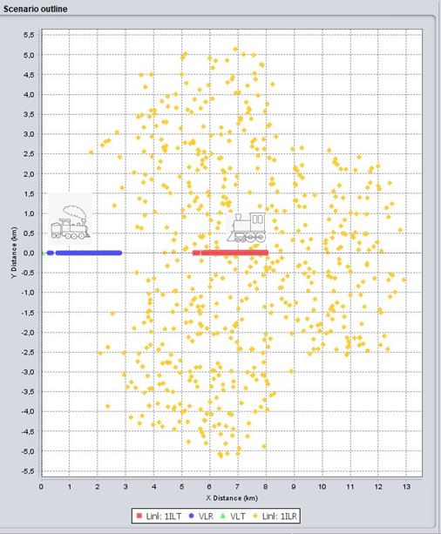
Figure 26: Example: VLT victim BS=A ILT Interfering BS=B VLR interfered track, ILR Cab’s of B (right)
C/(N+I) = 19.92 dB (VLT/(ILT+Noise) Median-value)
Step 2: Calculation of the DL throughput-loss (less than 5%)
Table 7: DL throughput loss
D (km) | iRSS_unwanted  (dBm) | Ref. Cell DL TP Loss | DL SINR (dB) Median  Ref-cell
6.0 | -77.45 | 4.568% | 14.33
3.96 | -81.95 | 4.748% | 14.64

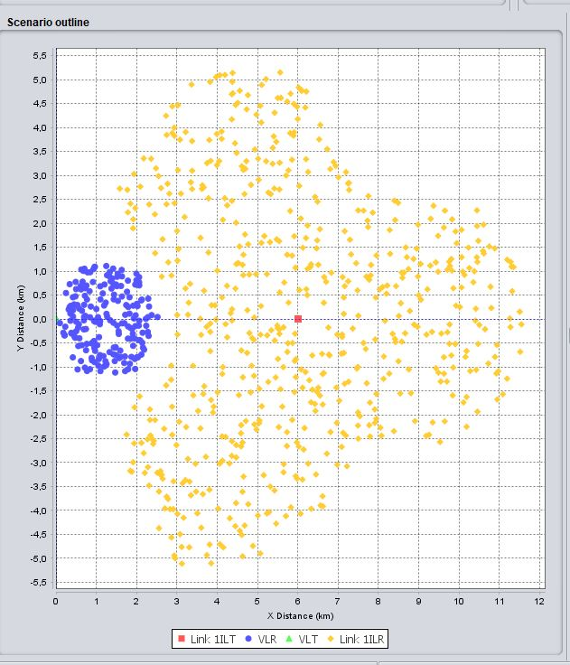
Figure 27: DL throughput-loss Synchronised – Railway scenario
The calculation was performed for rural and suburban environments with the cell radius 4 km and 0.6 km respectively (Table 8).
Step 3: Determine FS-Level at borderline (d=D/2)
Table 8: TDD 1900 synchronised – Derivation of the field strength-levels for different environments
Environment | d (km) | Pr (dBm/10 MHz) at 3 m | E (dBµV/m/10 MHz) at 3 m | E (dBµV/m/5 MHz) at 3 m
Suburban | 1.98 | -75.03 | 67.97 | 64.97
Rural | 3.0 | -73.44 | 69.56 | 66.56
ILT MAX e.i.r.p. = Derived for 65 dBm
Non interfered data throughput - synchronised
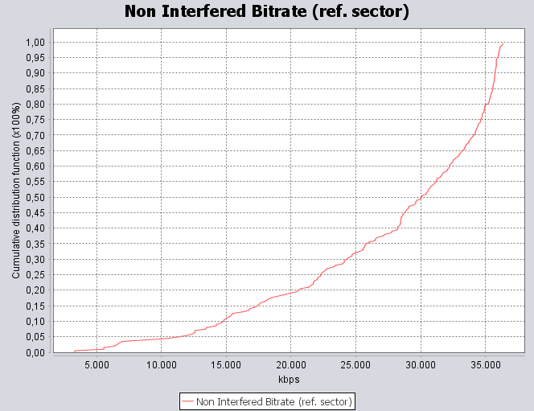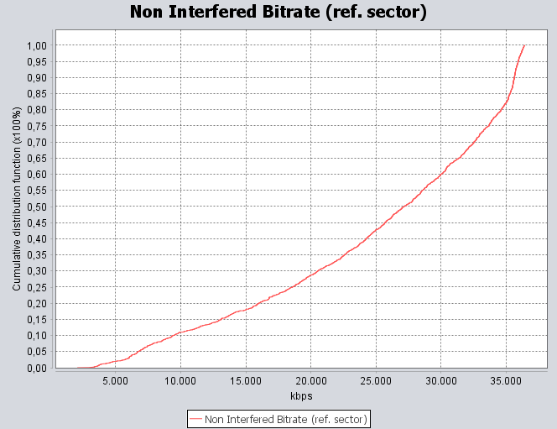
Figure 28: CDF DL data throughput – rural and suburban environments

Table 9: DL throughput per ref-cell for different environments
Environment | 95% likely | Median | 5% likely
Rural | 6.83 Mbit/s | 26.84.Mbit/s | 35.13 Mbit/s
Suburban | 7.96 Mbit/s | 27.57 Mbit/s | 35.04 Mbit/s
- Unsynchronised operation
In this case, the ref-cells of Network A and B are in co-channel operation with 10 MHz channel bandwidth, the co-channel interference from the ref-cell of network A downlink to the ref-cell of network B uplink in a rural environment is simulated.
Step 1: Calculate distance for UL throughput-loss (TP) < 5%: it can be seen that D=77 km
Table 10: UL throughput loss
D (km) | iRSS_unwanted(dBm) | Ref. Cell UL TP Loss | UL SINR (dB) Median Ref-cell
77 | -102.42 | 4.259% | 1.97
64 | -97.86 | 10% | 1.32
49 | -92.39 | 20% | 0.99
38.5 | -87.27 | 30% | 0.4
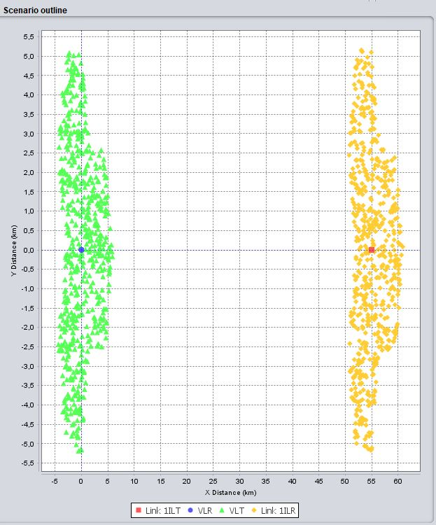
Figure 29: UL throughput-loss unsynchronised – Railway scenario
Step2: Determine FS-level at borderline
For the definition of the CTFS value, the distance D is assumed to be within one country and not shared across the border.
Table 11: TDD 1900 unsynchronised operation – Derivation of the field strength levels.
ILT MAX. e.i.r.p. = 65 dBm
D (km) | Pr (dBm/10 MHz) at 3 m | E (dBµV/m/10 MHz) at 3 m | E (dBµV/m/5 MHz) at 3 m
77 | -140 | 3 | 0
64 | -136.6 | 6.4 | 3.4
49 | -130.89 | 12.11 | 9.11
38.5 | -125.76 | 17.24 | 14.24
The calculated values in Table 11 are derived from
E =Pr + 20 log F + 77.2 | (1)
Where:
- E is the field strength (dBµV/m);
- Pr is the received power level (dBm);
- F is the frequency (MHz).
- Summary and Conclusion
In this railway specific SEAMCAT study, different threshold values could be derived for the FRMCS TDD 1900 operation modes, synchronised and unsynchronised. As SEAMCAT only works in the frequency domain, time domain specific effects are not possible to simulate.
Following the results, it is proposed to use for the max. e.i.r.p. BS-Power = 65 dBm the following thresholds at 3 m at the border:
Synchronised case: FS_{synchronised} = 65 dBµV/m/5 MHz
Unsynchronised case: FS_{unsynchronised} = 0 dBµV/m/5 MHz
- Timing details for the proposed reference frame
The proposed reference frame would be based on 5G NR configuration “DS_{a}US_{b}U DS_{a}US_{b}U” with a 15 kHz SCS and S(DL/GP/UL):=(S_{a} = 10:2:2, S_{b} = 12:2:0) OFDM symbols. In order to make it technology-neutral and independent from the SCS, it is desirable to express it in terms of timings rather than “D/S/U” slots and S(DL/GP/UL) OFDM symbols.
In order to have exact integer values, it is useful to express those timings in multiples of the basic time unit for NR, which is defined in ETSI TS 138.211, section 4.1 [15] as Tc := 1/(df_max*N_FFT_max) where df_max is the maximum inter-carrier spacing which is used in the largest SCS, and N_FFT_MAX is the largest FFT size which is used for the largest channel size, i.e. Tc = 1/(480000*4096) seconds ≈ 0.509 ns.
According to ETSI TS 138.211 [15]:
- One NR frame has a duration of 10 ms and is made of 10 subframes of 1 ms each;
- For the 15 kHz SCS, one subframe is equivalent to one slot. All following calculations will be based on this case, since all timings shall be equal regardless of the SCS. One slot always contains 14 OFDM symbols for a normal cyclic prefix;
- The duration of an OFDM symbol (without cyclic prefix) is 1/SCS = 1/15000 seconds = 131072*Tc;
  - For the 1st and 7th OFDM symbol within a slot, the cyclic prefix length is 10240*Tc, therefore the total “long” OFDM symbol duration is 141312*Tc;
  - For the 12 remaining OFDM symbols of a slot the cyclic prefix length is 9216*Tc, therefore the total “short” OFDM symbol duration is 140288*Tc.
- When considering a half-frame “DS_{a}US_{b}U”:
  - The downlink part is made of 1 “D” slots + 10 OFDM symbols for the downlink part of the “S_{a}” slot, i.e. 24 OFDM symbols in total, of which 4 are “long” and 20 are “short”. This leads to a total downlink duration of 3371008*Tc seconds;
  - The guard period in the middle of the “S_{a}” slot is made of 2 "short" OFDM symbols. This leads to a duration of 280576*Tc seconds;
  - The uplink part is made of 2 OFDM symbols for the uplink part of the “S_{a}” slot + 1 “U” slots, i.e. 16 OFDM symbols in total, of which 2 are “long” and 14 are “short”. This leads to a total uplink duration of 2246656*Tc seconds;
  - The next downlink part is made of 12 OFDM symbols for the downlink part of the “S_{b}” slot, of which 2 are “long” and 10 are “short”. This leads to a total downlink duration of 1685504*Tc seconds;
  - The guard period in the middle of the “S_{b}” slot is made of 2 "short" OFDM symbols. This leads to a duration of 280576*Tc seconds;
  - The uplink part is made of 0 OFDM symbols for the uplink part of the “S_{b}” slot + 1 “U” slots, i.e. 14 OFDM symbols in total, of which 2 are “long” and 12 are “short”. This leads to a total uplink duration of 1966080*Tc seconds;
  - It can be verified that the total duration of one half frame of (DL+GP+UL) is equivalent to 10 “long” + 60 “short” OFDM symbols, which is 9830400*Tc i.e. exactly 5 ms.
Those timings above for the half-frame have of course to be repeated twice in order to obtain a 10 ms frame. Therefore, the following timings are proposed for the reference frame:
With Tc := 1/(480000*4096) seconds (Basic time unit for NR as defined in ETSI TS 138.211, section 4.1 [15]):
- Start-of-frame, aligned with the reference clock
- Downlink for 3371008*Tc
- Guard period for 280576*Tc
- Uplink for 2246656*Tc
- Downlink for 1685504*Tc
- Guard period for 280576*Tc
- Uplink for 1966080*Tc
- Downlink for 3371008*Tc
- Guard period for 280576*Tc
- Uplink for 2246656*Tc
- Downlink for 1685504*Tc
- Guard period for 280576*Tc
- Uplink for 1966080*Tc
- Back to start-of-frame
Note: All SCS are acceptable as long as the frame complies with the above timings. Other frame configurations are also deemed compatible if they do not lead to any downlink/uplink overlap (e.g. if they implement a larger guard period).
- List of references

- ECC Report 203: “Least Restrictive Technical Conditions suitable for Mobile/Fixed Communication Networks (MFCN), including IMT, in the frequency bands 3400-3600 MHz and 3600-3800 MHz", approved November 2013
- ECC Report 216: “Practical guidance for TDD networks synchronisation”, approved August 2014
- ECC Report 281: “Analysis of the suitability of the regulatory technical conditions for 5G MFCN operation in the 3400-3800 MHz band”, approved July 2018
- ECC Report 296: “National synchronisation regulatory framework options in 3400-3800 MHz: a toolbox for coexistence of MFCNs in synchronised, unsynchronised and semi-synchronised operation in 3400-3800 MHz”, approved March 2019
- ECC Report 307: “Toolbox for the most appropriate synchronisation regulatory framework including coexistence of MFCN in 24.25-27.5 GHz in unsynchronised and semi-synchronised mode”, approved March 2020
- ECC Recommendation (15)01: “Cross-border coordination for mobile/fixed communications networks (MFCN) in the frequency bands: 694-790 MHz, 1452-1492 MHz, 3400-3800 MHz”, approved 10 June 2022
- ECC Recommendation (20)03: “Frame structures to facilitate cross-border coordination of TDD MFCN in the frequency band 3400-3800 MHz”, approved 23 October 2020
- ECC Decision (20)02: “Harmonised use of the paired frequency bands 874.4-880.0 MHz and 919.4-925.0 MHz and of the unpaired frequency band 1900-1910 MHz for Railway Mobile Radio (RMR)”, approved November 2020, updated June 2022
- 3GPP TR 37.801 (LTE3500): UMTS-LTE 3500 MHz Work Item Technical Report
- ECC Report 331: ”Efficient usage of the spectrum at the border of CEPT countries between TDD MFCN in the frequency band 3400-3800 MHz”, approved November 2021
- HCM Agreement http://www.hcm-agreement.eu
- CCS TSI: Commission Regulation (EU) 2016/919 of 27 May 2016 on the technical specification for interoperability relating to the ‘control-command and signalling’ subsystems of the rail system in the European Union
- Commission implementing Decision (EU) 2021/1730 of 28 September 2021 on the harmonised use of the paired frequency bands 874.4-880.0 MHz and 919.4-925.0 MHz and of the unpaired frequency band 1900-1910 MHz for Railway Mobile Radio
- Recommendation ITU-R F.1336-4: “Reference radiation patterns of omnidirectional, sectoral and other antennas for the fixed and mobile service for use in sharing studies in the frequency range from 400 MHz to about 70 GHz
- ETSI TS 138.211: “5G; NR; Physical channels and modulation”
- ECC Report 294: “Assessment of the spectrum needs for future railway mobile radio (RMR) communications”, approved February 2019
- ECC Recommendation (05)08: “Frequency planning and cross-border coordination between GSM Land Mobile Systems (GSM 900, GSM 1800, and GSM-R), approved February 2006, latest amended on 8 October 2021
- ECC Recommendation (08)02: “Cross-border coordination for Mobile/Fixed Communications Networks (MFCN) in the frequency bands 900 MHz and 1800 MHz excluding GSM vs. GSM systems, approved February 2008, latest amended October 2021
- Recommendation ITU-R. P.1546: “Method for point-to-area predictions for terrestrial services in the frequency range 30 MHz to 4 000 MHz”

Such a low field strength value may be challenging to check with in-field measurements. It is expected to be assessed using RF planning tools.
For those cases where the field strength would exceed the CTFS value on more than one border (e.g. in the case of a border area between more than two countries), those RMR arrangements will have to involve and be agreed by all parties in the relevant areas.
Due to the signal propagation delay, the proposed GP only ensures that synchronised operation is fully effective within a radius of 45 km of a BS. This is most of the time sufficient due to signal attenuation, however a larger GP may be needed in situations where exceptional propagation conditions could make a BS interfere with another BS located farther away than 85 km.
These values are taken from the ECC Recommendations on cross-border coordination for MFCN in the 1800 MHz and 2100 MHz frequency bands. It is assumed that the coordination field strength thresholds of these FDD bands correspond to the permissible field strength value for synchronised operation in the 1900 MHz TDD band. In addition these values have been confirmed by simulation.
https://ec.europa.eu/transport/infrastructure/tentec/tentec-portal/map/maps.html
https://uic.org/IMG/pdf/gsmr8300_fffs_at_bx-3.0.0.pdf
When losing the primary reference time clock (PRTC) equipment may continue operation for a period of time ("holdover period") that has to be agreed and which depends on the quality of the local oscillator in the BS and on the wireless network accuracy requirement. If the PRTC is lost for a duration longer than the holdover period, the system shall no longer be considered in synchronised operation and may start interfering other channels, and therefore proper action ought to be taken.
E.g. if UE-UE interference can be considered negligible compared to eNB-eNB interferences and the start of frame is properly synchronised, then the operator that has the smallest amount of downlink will not interfere with the other operator(s), and may therefore be considered as having a “compatible” frame structure with those others operators. The same rationale applies to the operator that has the highest amount of downlink if UE-UE interferences are dominant compared to eNB-eNB interferences.
Such a low threshold may be challenging to check with in-field measurements. It it is expected to be assessed using RF planning tools. However, performing such analysis exhaustively for all sites of a network can be a high workload for stakeholders whereas it is expected that a buffer zone of 77km on each side of the border should capture most of those sites that have to be coordinated, therefore stakeholders may restrict their calculations to sites within this buffer zone as a first approximation.
For those cases where the field strength would exceed the coordination threshold on more than one border (e.g. in the case of a border area between more than 2 countries), those RMR arrangements will have to involve and be agreed by all parties in the relevant areas.
Due to the signal propagation delay, the proposed GP only ensures that synchronised operation is fully effective within a radius of 45 km of a BS. This is most of the time sufficient due to signal attenuation, however a larger GP may be needed in situations where exceptional propagation conditions could make a BS interfere with another BS located farther away than 85km.
These values are taken from the ECC Recommendations on cross-border coordination for MFCN in the 1800 MHz and 2100 MHz frequency bands. It is assumed that the coordination field strength thresholds of these FDD bands correspond to the permissible field strength value for synchronised operation in the 1900 MHz TDD band. In addition these values have been confirmed by simulation.
Such a low field strength value may be challenging to check with in-field measurements. It is expected to be assessed using RF planning tools.
For those cases where the field strength would exceed the CTFS value on more than one border (e.g. in the case of a border area between more than two countries), those RMR arrangements will have to involve and be agreed by all parties in the relevant areas.
Due to the signal propagation delay, the proposed GP only ensures that synchronised operation is fully effective within a radius of 45 km of a BS. This is most of the time sufficient due to signal attenuation, however a larger GP may be needed in situations where exceptional propagation conditions could make a BS interfere with another BS located farther away than 85 km.
These values are taken from the ECC Recommendations on cross-border coordination for MFCN in the 1800 MHz and 2100 MHz frequency bands. It is assumed that the coordination field strength thresholds of these FDD bands correspond to the permissible field strength value for synchronised operation in the 1900 MHz TDD band. In addition these values have been confirmed by simulation.
With reference to the restricted baseline limits defined for AAS base stations, ECC Report 281 [2] states “For unsynchronised and semi-synchronised operations, if no geographic or indoor/outdoor separation is available, the restricted baseline limit must be respected. However, agreements at national level (including bilateral agreements among any pair of adjacent MNOs) may be concluded to allow the definition of a different BEM”. With this respect, ECC Report 281 refers to the possibility to account the information provided in this toolbox illustration.
SEAMCAT Nomenklatur: ILT Interference-link Transmitter, VLT Victim-link Transmitter, VLR Victim-link Receiver
iRSS = interference received signal strength
SINR = Signal to Interference plus noise ratio
Due to the signal propagation delay, the proposed GP only ensures that synchronised operation is fully effective within a radius of 45 km of a BS. This is most of the time sufficient due to signal attenuation, however a larger GP may be needed in situations where exceptional propagation conditions could make a BS interfere with another BS located farther away than 45 km.

