Radiodetermination equipment for ground based vehicular applications in 77-81 GHz
approved 3 February 2023
ECC Report 350

Executive summary
New operational parameters for automotive radars in the 77-81 GHz band are proposed to represent the evolution of the technology that has taken place. The studies carried out in this Report are based on the technical characteristics of radiodetermination equipment for ground based vehicular applications defined in the ETSI Technical Report TR 103 593 [2].
The envisaged frequency range is already in use by other services or applications in the in-band and the out-of-band domain. Other systems could be in operation on a national basis. The results of studies conducted in the framework of this Report are summarised below.

Sharing with RAS
The single-entry study leads to similar exclusion zones for both NOEMA and SRT, up to approximately 50 km.
Comparing the results of the aggregation study, no significant variations are found for the same location in different scenarios. The terrain seems to play an important role for the exclusion zone size, varying from a few kilometres (Effelsberg) up to almost 70 km (IRAM and Yebes).
It has to be noted that switching off automotive radars in potential exclusion zones has an impact on the reliability for safety relevant driver's assistance functions and autonomous driving. Other mitigation techniques than exclusion zones were not studied.

Sharing with Radiolocation
In 2020, information was provided that no military radiolocation systems are operated by NATO members in the band 77 to 81 GHz. Furthermore, there are no plans to introduce such systems.
There is no other applications of the Radiolocation Service using this band.

Sharing with Amateur Service
MCL calculations, taking into account the vertical delta between both automotive radar (AR) and Amateur Service antennas, reveal separation distances between 0 km and 35.7 km. The distance depends highly on transmission level and angular offset between the AR transmitter to the Amateur Radio receiver.
Due to the use of directive antennas the highlighted areas where interference could happen are relatively small. It has to be noted that interference in reality may have a low probability due to following reasons:
- A car/street has to be inside of the relatively small critical area;
- The cars antenna must be directed towards the Amateur Service antenna;
- LOS conditions between automotive radars and the Amateur Service receiver must apply;
- The more vertical separation between both antennas prevails the lower the impact will be;
- The setup of the Amateur Service system is such (e.g. LOS conditions between two Amateur Service stations) that probability of interference is low, but may be assessed case by case.
Aggregation was not taken into account.

SRD in the band
It has to be noted that SRDs have no status of being protected from interference from a regulatory point of view. However, the following information about coexistence with automotive radars is provided.
HD-GBSAR systems operating in the band 77-78 GHz avoid interference by implementing detect and avoid techniques.
Information about Security Scanners in the band 60-82 GHz, which may use the band in future, can be found in ECC Report 344 [40].

Compatibility with the Fixed Service
The compatibility between vehicle radars and FS has been studied based on a MCL approach. The unwanted emissions for the automotive radar in the bands 71-76 GHz and 81-86 GHz were limited to -30 dBm/MHz e.i.r.p. The highest required separation distance is 4.23 km where the I/N of -20 dB is exceeded at most by 2.5 dB when using a 50 dBi FS antenna gain. The separation distance becomes 2.12 km where the I/N of -20 dB is exceeded at most by 3 dB for an FS antenna gain of 43 dBi. There are limited cases where the radar can potentially cause interference to the fixed service receiver and highly depends on the relative orientation between the vehicular radar and FS Rx. This happens when the vehicle radars fall in the main lobe of the fixed service station. Due to the narrow beamwidth of the FS antenna, the minimum separation distance decreases if the interferer is not in the main lobe. The interference becomes negligible when the vehicular radars are beyond approximately 0.8 degrees in azimuth from the main beam of the FS Rx. These finding are inline also with the results obtained in the studies in Report ITU-R F.2394 [12].
On the topic of possible mitigation techniques, possible options to improve the compatibility between both adjacent services are:
- The avoidance of fixed service links pointed in the azimuth direction near to and parallel to roads;
- Minimise vehicular radar antenna radiation above the horizontal plane, since the goal is to prevent collision with other vehicles or obstacle;
- Use of vehicular radar antennas with higher gain and smaller beamwidths to minimise the occurrence of interference.

TABLE OF CONTENTS

0 Executive summary 2
0.1 Sharing with RAS 2
0.2 Sharing with Radiolocation 2
0.3 Sharing with Amateur Service 2
0.4 SRD in the band 2
0.5 Compatibility with the Fixed Service 3
1 Introduction 8
2 System description of ground based vehicular Radars in the 77-81 GHz Band 9
2.1 System description 9
2.2 Proposal for new system parameters 10
2.3 General System Parameters 11
2.3.1 Operating bandwidth 12
2.3.2 Unwanted Emissions 14
3 Existing Band usage 15
3.1 ECA Allocations Inband (77-81 GHz) 15
3.2 ECA Allocations out-of-band (69-77 GHz, 81-89 GHz) 16
4 Sharing studies 19
4.1 Sharing with the Radio Astronomy service 19
4.1.1 Use of the band by RAS and regulatory status 19
4.1.2 RAS protection criterion 19
4.1.3 Parameters used in this Report 19
4.1.4 Interference scenarios and methodologies 20
4.1.5 Conclusion 31
4.2 Sharing with the Radiolocation Service 32
4.3 Sharing with the Amateur Service 32
4.3.1 Methodology 32
4.3.2 Victim parameters 33
4.3.3 Operational scenario 34
4.3.4 Results 34
4.3.5 Conclusion 39
4.4 SRD operating in the band 39
5 Compatibility studies 40
5.1 Compatibility with the Fixed Service 40
5.1.1 MCL Methodology 40
5.1.2 Vehicular Radar Parameters 41
5.1.3 FS parameters 41
5.1.4 Results 42
5.1.5 Conclusion 50
6 Conclusions 51
6.1 Sharing with RAS 51
6.2 Sharing with Radiolocation 51
6.3 Sharing with Amateur Service 51
6.4 SRD in the band 51
6.5 Compatibility with the Fixed Service 51
ANNEX 1: DESCRIPTION OF FUTURE car TECHNOLOGY 53
ANNEX 2: Existing Studies for the relevant RAS Band 55
ANNEX 3: Applicability of using Recommendation ITU-R P.452-16 in the band 77-81 GHz 58
ANNEX 4: List of References 60

LIST OF ABBREVIATIONS

Abbreviation | Explanation
ACC | Automatic Cruise Control
AEB | Automatic Emergency Breaking
AMSL | Above mean sea level
APA | Automated Parking Assist
AR | Automotive Radar
BW | Bandwidth
CEPT | European Conference of Postal and Telecommunications Administrations
CLC | Corine Land Cover
CW | Continuous wave
DATV | Digital Amateur TV
e.i.r.p. | Equivalent isotropically radiated power
ECA | European Common Allocation
ECC | Electronic Communications Committee
EESS | Earth Exploration Satellite Service
EME | Earth-moon-earth
ETSI | European Telecommunications Standards Institute
FMCW | Frequency Modulated Continuous Wave
GBVR | Ground based vehicular radar
HZAP | Home Zone Automated Parking
LOS | Line-of-sight
LPR | Level Probing Radar
LRR | Long Range Radar
ITU | International Telecommunication Union
MCL | Minimum Coupling Loss
NLOS | Non Line-of-sight
OFDM | Orthogonal Frequency-Division Multiplexing
OOB | Out-of-band
OSM | OpenStreetMap
PSD | Power Spectral Density
RA | Radio Astronomy
RAS | Radio Astronomy Service
RF | Radio Frequency
RLOC | Radiolocation
RT | Radio Telescope
Rx | Receiver
SRR | Short Rang Radar
TLPR | Tank Level Probing Radar
TR | Technical Report (ETSI)
TTT | Transport and Traffic Telematics
Tx | Transmitter
UWB | Ultra Wide Band

Introduction
In 2004, ECC Decision (04)03 [1] was published. It identified the 77-81 GHz band as a long term solution for short- range radars. It also identified the maximum operational parameters as given in Table 1:
Table 1: Existing PSD and e.i.r.p. limits
 | Mean PSD - limit (e.i.r.p.) | Peak e.i.r.p. - limit
Single radar (including e.g. bumper attenuation) | -9 dBm/MHz | (not specified)
Single radar (standalone) | -3 dBm/MHz | 55 dBm
The European Commission harmonised the use of automotive Short Range radar equipment according to this decision in 2004 [5].
The regulation for the 79 GHz band is untouched since then, but RF technology and signal processing evolved that allows to develop 79 GHz automotive radar sensors that provide more functions and better RF performance than it was foreseen in 2004.
Since 2004, the demand for radar based driver assistance functions increased significantly and the number of radar equipped vehicles is increasing.
In addition, the performance of radar based driver assistance functions evolved. Radar based functions will also be a key technology for highly automated or autonomous driving vehicles [2].
The baseline for studies in this Report is the industry request ETSI TR 103 593 [2] which is expected to lead to regulatory action in Europe to increase safety at vehicle level. More detailed information can be found in ANNEX 1.
New operational parameters are proposed to represent the evolution of the technology that has taken place and to make Mid Range and Long Range Radars also possible in the range 77-81 GHz. The studies carried out in this Report are based on radiodetermination equipment for ground based vehicular applications technical characteristics defined in the ETSI TR 103 593 [2].

System description of ground based vehicular Radars in the 77-81 GHz Band

System description
To provide different functionalities for driving assistance and increased safety, more and more cars are equipped with different type of radars that are mounted at specific positions on board the vehicle as shown in Figure 1. Front and corner radars are used for applications requiring long and medium range such as automatic cruise control, lane keep, lane change assist, automatic emergency braking, etc.
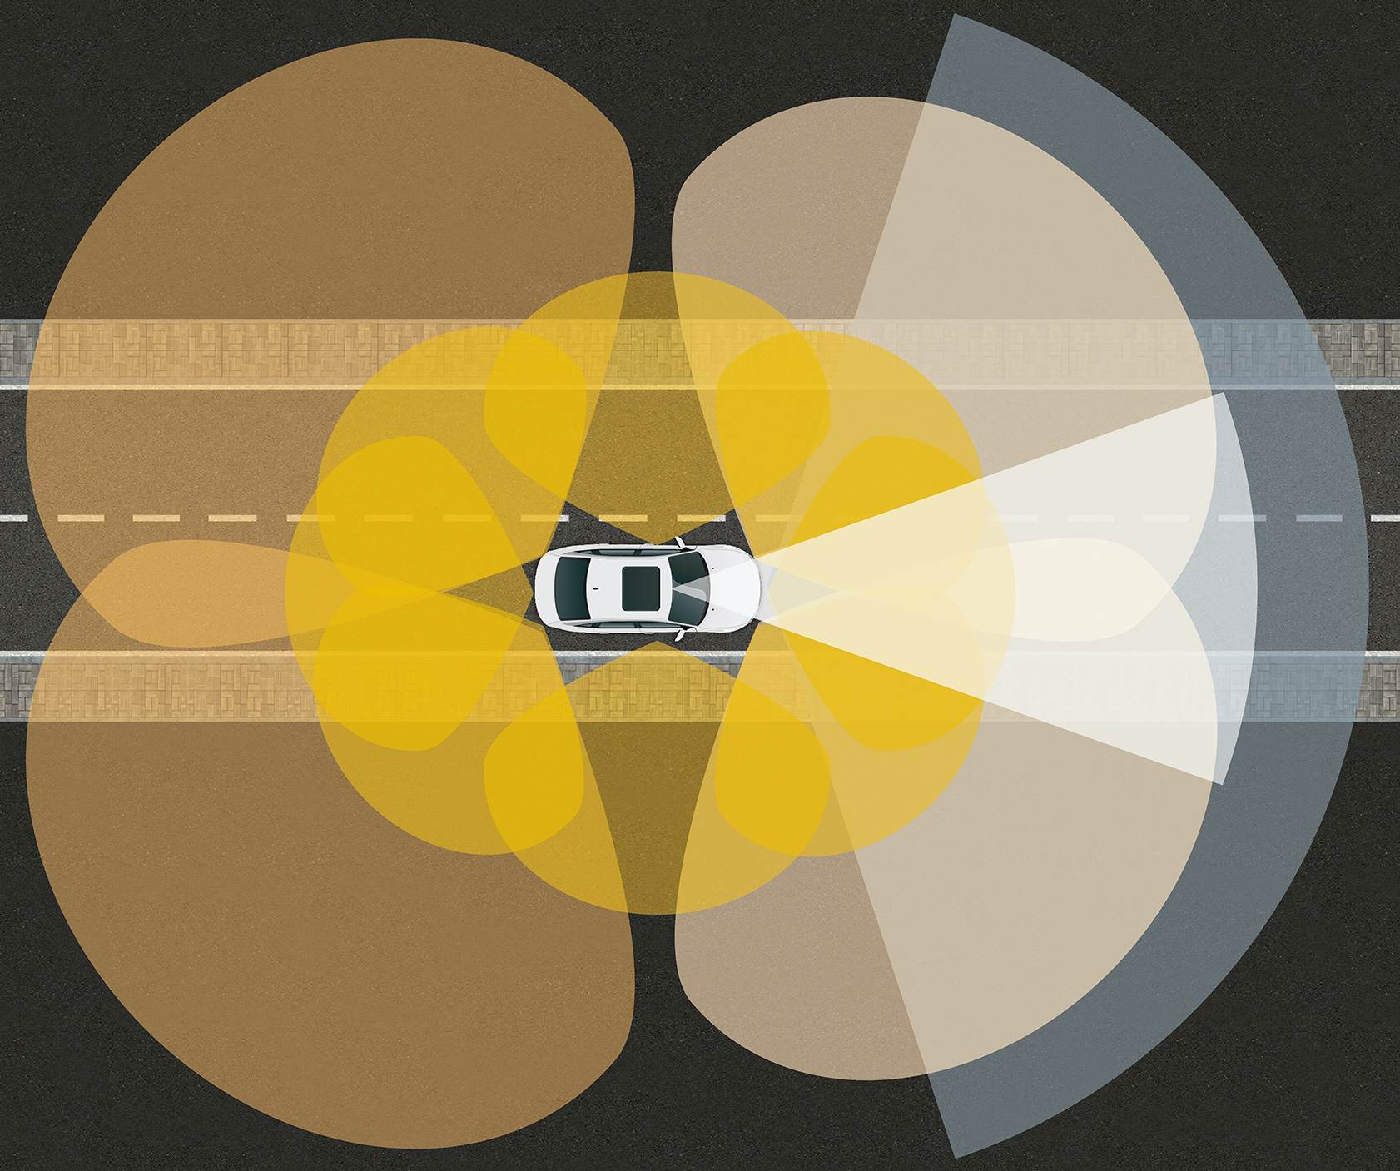
Figure 1: Example for the coverage range of radar sensors at one vehicle to achieve 360 degrees coverage
Future radar based applications providing the vehicle with higher degree of autonomy and enable automated driving require long, short and ultra-short-range radars for front, side and rear-view (see yellow areas in Figure 1), such that 360° sensing is enabled.
New high resolution vehicular radar sensors will besides the already implemented long-range functions allow to obtain a wide field of view (in azimuth) 360 degrees around the vehicle and allow to implement features like e.g. turn assist, intersection assistant, automated parking assistance or autonomous valet parking. A more comprehensive list of functions that depend on high-resolution radars is available in ETSI TR 103 593 [2].
To perform such features, the radars need to be capable to detect a wide range of objects such pedestrian, bicycles, vehicles, etc. Vehicular radar sensors that are capable of detecting small objects such as bicycles, pedestrians and children require an operating bandwidth with up to 4 GHz.
To offer that in as many cars as possible, it is required to extend radio resources and use lower-bandwidth radars also in the band 77-81 GHz and increase the maximum possible transmit power spectral density.
A listing of Advanced Driving Assistance Systems covering the related features & use cases can be found in Table 2. The key system elements including radar are provided.
The list does not claim to be complete and is therefore not restricted to the systems specified. Additional systems and applications may exist or will emerge based on evolving technology.
Table 2: Advanced Driving Assistance Systems
Advanced driver assistant Systems | Key System Elements
Adaptive Light Control | Matrix LED Lighting, Radar, Camera, Localisation
Forward Collision Warning | Radar, Camera
Automatic Emergency Braking | Radar, Camera, Braking Control
Automatic Cruise Control (ACC) | Radar, Camera, Braking Control
Enhanced Blind Spot Monitoring | Radar, Camera
Lane Change Assis | Front Camera, Corner Radar
Traffic Jam Assist | Camera, Radar, Corner Radar, LiDAR, Steering and/or Braking Control
Rear Cross Traffic Alert | Corner Radar, Rear Camera, UPA, SVS, Braking Control
Front Junction-Intersection Assist | Camera, Corner Radar, SVS, UPA, Braking Control
Highway Chauffeur | Front Radar(s), Camera, Driver Monitoring, Steering & Braking Control
Automatic Lane Chang | Camera, 360° Radar, Steering & Braking Control
Automated Parking Assist (APA) (Note 1) | UPA, SVS, Steering Control, Braking Control
Home Zone Automated Parking (HZAP) | Secure Connectivity, UPA, SVS, Radar, Steering & Braking Control
Valet Parking | Secure Connectivity, Camera, 360° Radar, UPA, LiDAR Steering & Braking Control
Highway Pilot | Secure Connectivity, Camera, 360° Radar, UPA, LiDAR, Driver Monitoring, Steering & Braking Control
Note 1: Ultrasonic-only or camera+ultrasonic-fusion automated parking systems
In ETSI TR 103 593, table 5 and annex A [2] additional information is provided for radar-based functions that could be implemented in a vehicle:
- The implementation of radar-based functions varies for each vehicle type and vehicle platform;
- In a vehicle certain radar-based functions are used and activated only in dedicated situations and are not activated while the vehicle is travelling on the road in normal traffic. For instance, for parking support functions (based on Ultra Short Range Radar) this function is activated only when the vehicle is in a specific situation such as a parking lot or parking garage at slow speed.

Proposal for new system parameters
ETSI TR 103 593, section 8, table 8 [2] provides the proposed maximum mean PSD (e.i.r.p.) and maximum mean e.i.r.p. limits for standalone vehicular radar sensors. These limits apply during Ton and do not include any consideration of car body losses.
Table 3: Proposed mean PSD (e.i.r.p.) and mean e.i.r.p. limits in the frequency range 77-81 GHz
Radar sensor category | Modulation Bandwidth | max. mean PSD e.i.r.p. (during Ton) | max. mean e.i.r.p. (during Ton)
Long Range Radar | Up to 1 GHz | 20 dBm/MHz | 40 dBm
Mid Range Radar | Up to 2 GHz | 7 dBm/MHz | 37 dBm
Short Range radar | Up to 4 GHz | -3 dBm/MHz | 30 dBm
Ultra Short Range Radar | Up to 4 GHz | -3 dBm/MHz | 30 dBm
RF loss of a cover above the radar sensor (for example a bumper fascia) is not included in the study, because such covers are not under control of the radar manufacturers [2]. Cover loss might only be considered as additional mitigation in the background.

General System Parameters
Technical parameters for vehicular radars operating in the frequency range 77-81 GHz are available in ETSI TR 103 593 [2] and Recommendation ITU-R M.2057 [8].
Table 4 provides general parameters extracted from [2] and [8] for vehicular radars operating in the 77-81 GHz band.
Table 4: General parameters of vehicular radars
Parameter | Value
Antenna height above road surface | 0.3-1 m  typical 0.5 m
Duty cycle | 30-50% [2]
Operating Bandwidth | Up to 4 GHz, depending on vehicle speed and scenario
Typical emission type | FMCW, Fast FMCW
Typical sweep time | FMCW: 10000-40000 µs  Fast FMCW: 10 -40 µs
Automotive radars may use analogue modulation schemes with linear chirps (see illustration in Figure 2). Chirp durations are in the order of 10 ms for slow chirps or in the order of 10 µs for fast chirps [2].
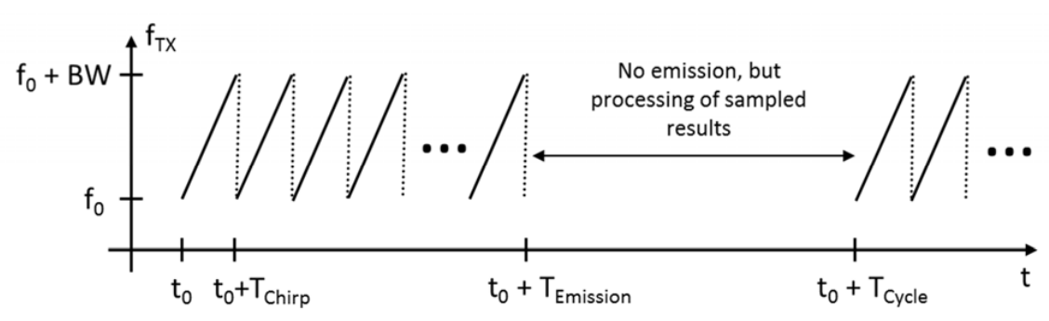
Figure 2: Illustration of analogue modulated radar transmit emission
Automotive radars may use digital modulation schemes, for example with phase modulation or OFDM (see illustration in Figure 3) [2].

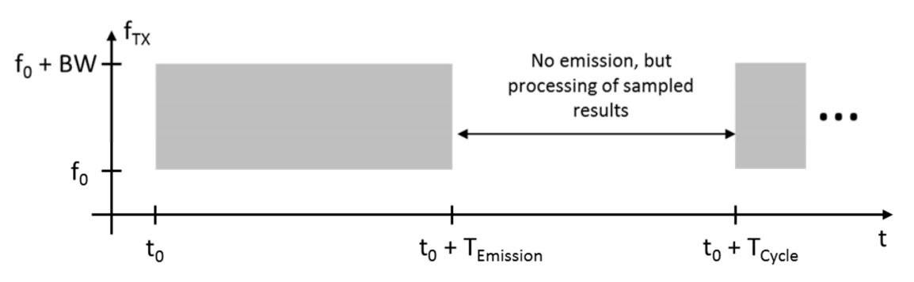
Figure 3: Illustration of digital modulated radar transmit emission
For both modulations the emission follows a periodic cycle to duration TCycle (in the order of 50 ms) which is subdivided into an active measurement interval of duration TEmission (in the order of 20 ms) and a processing of sampled results (duration TCycle - TEmission) [2].

Operating bandwidth
ETSI TR 103 593 section 7.1.1, table 5 [2] provides the context between the required bandwidth of a vehicular radar sensor and the traffic/ environment situation a vehicle is in.
It can be concluded that only in specific situations such as parking scenarios the sensor will use the full 4 GHz bandwidth. In these specific situations the vehicle moves only at low speed.
In driving scenarios on highway and standard roads the typical occupied BW is 1-1.5 GHz.
The operating bandwidth of the automotive radar signal is specified by the bandwidth in which -23 dB below the maximum of the radiated power is emitted or equivalent 99% of its radiated power.
ITU-R Recommendation M.2057, table 1 [8] provides the antenna gain assumptions to be used for the 4 types of vehicular radars (see Table 5).
Table 5: Antenna patterns for vehicular radars
Radar use case | Antenna gain (dBi) | Reference  Radar Type | Pattern
Long Range Radar | 30 | Radar A | 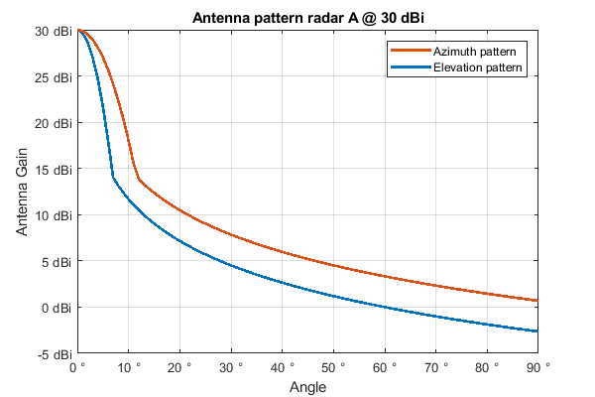
Mid Range Radar | 23 | Radar B | 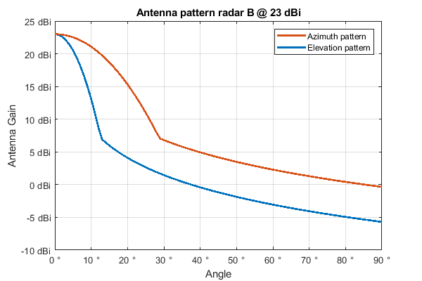
Short Range Radar | 23 | Radar C | 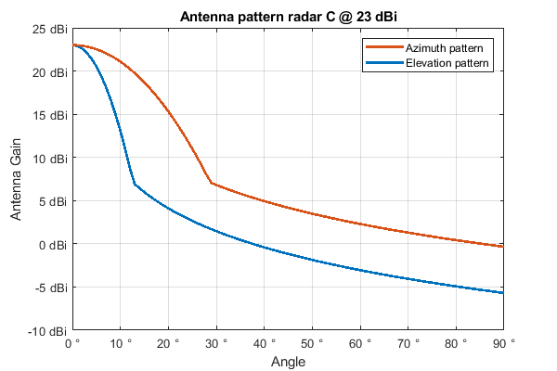
Ultra Short Range Radar | 23 | Radar E | 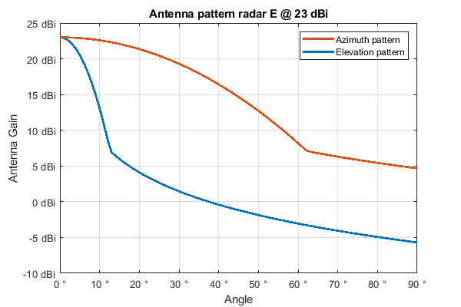

Unwanted Emissions
For compatibility studies with the FS, the unwanted emissions for the automotive radar in the bands 71-76 GHz and 81-86 GHz were limited to -30 dBm/MHz e.i.r.p.
Compatibility studies with AR in the 76-77 GHz were not done.

Existing Band usage
Given a bandwidth of 4 GHz centred at 79 GHz the in band frequencies are 77 GHz to 81 GHz and the out-of-band frequencies are 69 GHz to 77 GHz and 81 GHz to 89 GHz.
The envisaged frequency range is already in use by other allocations and applications in the in-band and the out-of-band domain. An overview of those is given in the following subsection using information from the ECA table, version April 2022 [4]. Other systems could be in operation on a national basis.
A simplified visualisation (for example MOBILE-SATELLITE is included in MOBILE) of the band in focus can be found in Figure 4. Additional information about the usage of frequency bands of applications can be found e.g. in ERC Recommendation 70-03 [50]. Other applications using the band in addition to the applications given in the ECA Table are for example HD-GBSAR (ECC Decision 21(02) [41]), Rotorcraft Radars in the band 76-77 GHz (ECC Decision(16)01 [42]). At the time of publication of this ECC Report Security Scanners (ECC Report 344 [40]) are under consideration to be allowed for use in the frequency range 60-82 GHz.
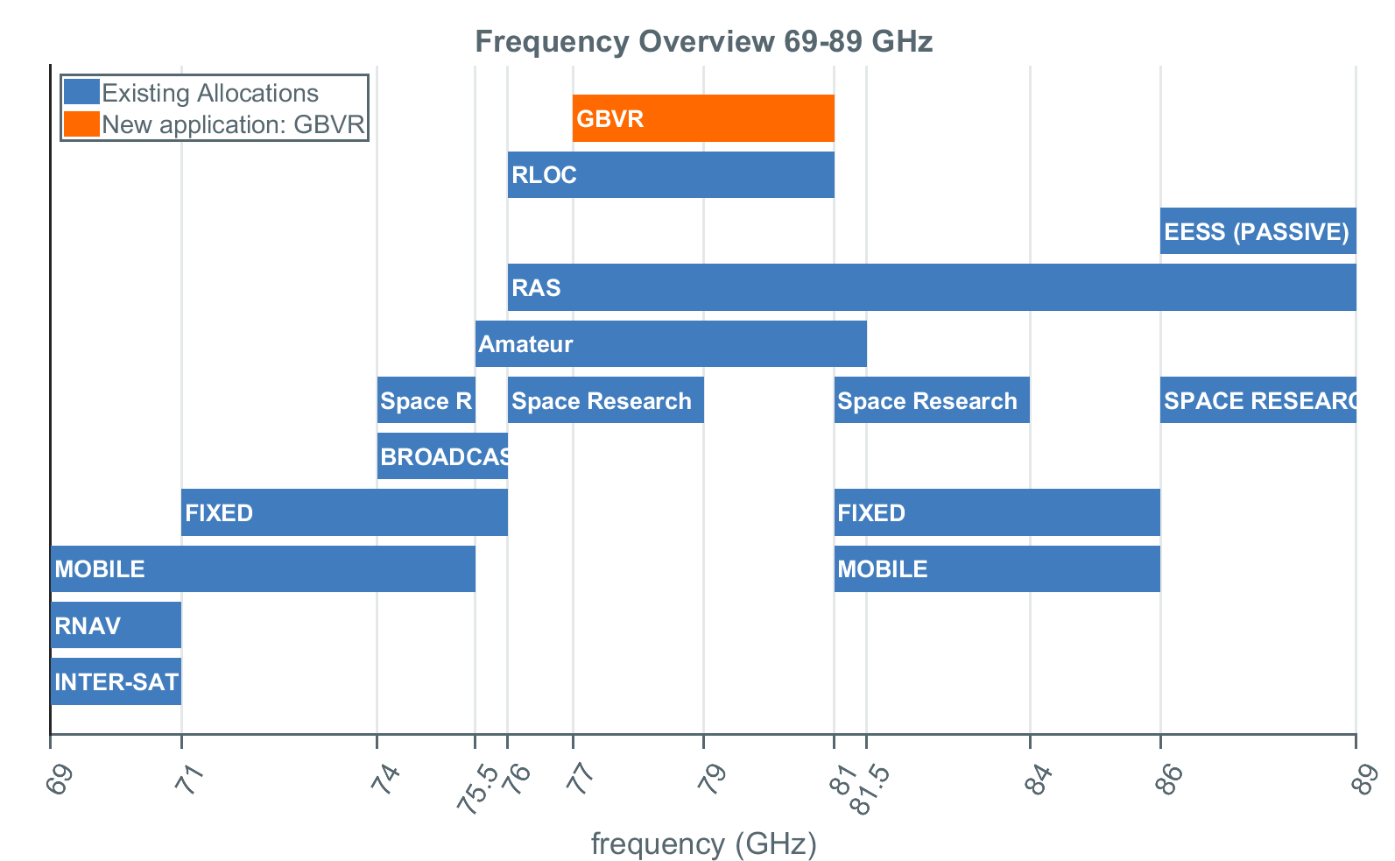
Figure 4: Simplified visualisation of the frequency band 69-89 GHz according to the ECA Table

ECA Allocations Inband (77-81 GHz)
Table 6 is an excerpt of the ECA Table [4] for the in band domain.
Table 6: Excerpt of the ECA Table for the in-band domain
Frequency Range | Allocations | Applications
76 GHz - 77.5 GHz | RADIO ASTRONOMY  RADIOLOCATION  Amateur  Amateur-Satellite  Space Research (space-to-Earth)  5.149 | Amateur  Amateur-satellite  Radio astronomy  Radiodetermination applications  Radiolocation (civil)  SRR  TTT
77.5 GHz - 78 GHz | AMATEUR  AMATEUR-SATELLITE  RADIOLOCATION 5.559B  Space Research (space-to-Earth)  5.149 | Amateur  Amateur-satellite  Radio astronomy  Radiodetermination applications  SRR
78 GHz - 79 GHz | Amateur  Amateur-Satellite  RADIOLOCATION  Radio Astronomy  Space Research (space-to-Earth)  5.149  5.560 | Amateur  Amateur-satellite  Radio astronomy  Radiodetermination applications  Radiolocation (civil)  SRR
79 GHz - 81 GHz | RADIO ASTRONOMY  RADIOLOCATION  Amateur  Amateur-Satellite  5.149 | Amateur  Amateur-satellite  Radio astronomy  Radiodetermination applications  Radiolocation (civil)  SRR
5.149: In making assignments to stations of other services to which the bands: 13 360-13 410 kHz, 25 550-25 670 kHz, 37.5-38.25 MHz, 73-74.6 MHz in Regions 1 and 3, 150.05-153 MHz in Region 1, 322-328.6 MHz, 406.1-410 MHz, 608-614 MHz in Regions 1 and 3, 1 330-1 400 MHz, 1 610.6-1 613.8 MHz, 1 660-1 670 MHz, 1 718.8-1 722.2 MHz, 2 655-2 690 MHz, 3 260-3 267 MHz, 3 332-3 339 MHz, 3 345.8-3 352.5 MHz, 4 825-4 835 MHz, 4 950-4 990 MHz, 4 990-5 000 MHz, 6 650-6 675.2 MHz, 10.6-10.68 GHz, 14.47-14.5 GHz, 22.01-22.21 GHz, 22.21-22.5 GHz, 22.81-22.86 GHz, 23.07-23.12 GHz, 31.2-31.3 GHz, 31.5-31.8 GHz in Regions 1 and 3, 36.43-36.5 GHz, 42.5-43.5 GHz, 48.94-49.04 GHz, 76-86 GHz, 92-94 GHz, 94.1-100 GHz, 102-109.5 GHz, 111.8-114.25 GHz, 128.33-128.59 GHz, 129.23-129.49 GHz, 130-134 GHz, 136-148.5 GHz, 151.5-158.5 GHz, 168.59-168.93 GHz, 171.11-171.45 GHz, 172.31-172.65 GHz, 173.52-173.85 GHz, 195.75-196.15 GHz, 209-226 GHz, 241-250 GHz, 252-275 GHz are allocated, administrations are urged to take all practicable steps to protect the radio astronomy service from harmful interference. Emissions from spaceborne or airborne stations can be particularly serious sources of interference to the radio astronomy service (see Nos. 4.5 and 4.6 and Article 29). (WRC-07)
5.559B: The use of the frequency band 77.5-78 GHz by the radiolocation service shall be limited to short-range radar for ground-based applications, including automotive radars. The technical characteristics of these radars are provided in the most recent version of Recommendation ITU-R M.2057. The provisions of No. 4.10 do not apply. (WRC-15)
5.560: In the band 78-79 GHz radars located on space stations may be operated on a primary basis in the Earth exploration-satellite service and in the space research service.

ECA Allocations out-of-band (69-77 GHz, 81-89 GHz)
Table 7 is an excerpt of the ECA Table [4] for the lower out-of-band domain.
Table 7: Excerpt of the ECA Table for the lower out-of-band domain
Frequency Range | Allocations | Applications
66 GHz - 71 GHz () | INTER-SATELLITE  MOBILE 5.553 5.558  MOBILE-SATELLITE  RADIONAVIGATION  RADIONAVIGATION-SATELLITE  5.554 | Wideband data transmission systems
71 GHz - 74 GHz | FIXED  FIXED-SATELLITE (SPACE-TO-EARTH)  MOBILE  MOBILE-SATELLITE (SPACE-TO-EARTH) | Fixed
74 GHz - 75.5 GHz | BROADCASTING  BROADCASTING-SATELLITE  FIXED  FIXED-SATELLITE (SPACE-TO-EARTH)  MOBILE  Space Research (space-to-Earth)  5.561 | Fixed  Radiodetermination applications  Space research
75.5 GHz - 76 GHz | BROADCASTING  BROADCASTING-SATELLITE  FIXED  FIXED-SATELLITE (SPACE-TO-EARTH)  Amateur  Amateur-Satellite  5.561 ECA35 | Amateur  Amateur-satellite  Fixed  Radiodetermination applications  Space research
76 GHz - 77.5 GHz | RADIO ASTRONOMY  RADIOLOCATION  Amateur  Amateur-Satellite  Space Research (space-to-Earth)  5.149 | Amateur  Amateur-satellite  Radio astronomy  Radiodetermination applications  Radiolocation (civil)  Railway applications  SRR  TTT
5.149: In making assignments to stations of other services to which the bands: 13 360-13 410 kHz, 25 550-25 670 kHz, 37.5-38.25 MHz, 73-74.6 MHz in Regions 1 and 3, 150.05-153 MHz in Region 1, 322-328.6 MHz, 406.1-410 MHz, 608-614 MHz in Regions 1 and 3, 1 330-1 400 MHz, 1 610.6-1 613.8 MHz, 1 660-1 670 MHz, 1 718.8-1 722.2 MHz, 2 655-2 690 MHz, 3 260-3 267 MHz, 3 332-3 339 MHz, 3 345.8-3 352.5 MHz, 4 825-4 835 MHz, 4 950-4 990 MHz, 4 990-5 000 MHz, 6 650-6 675.2 MHz, 10.6-10.68 GHz, 14.47-14.5 GHz, 22.01-22.21 GHz, 22.21-22.5 GHz, 22.81-22.86 GHz, 23.07-23.12 GHz, 31.2-31.3 GHz, 31.5-31.8 GHz in Regions 1 and 3, 36.43-36.5 GHz, 42.5-43.5 GHz, 48.94-49.04 GHz, 76-86 GHz, 92-94 GHz, 94.1-100 GHz, 102-109.5 GHz, 111.8-114.25 GHz, 128.33-128.59 GHz, 129.23-129.49 GHz, 130-134 GHz, 136-148.5 GHz, 151.5-158.5 GHz, 168.59-168.93 GHz, 171.11-171.45 GHz, 172.31-172.65 GHz, 173.52-173.85 GHz, 195.75-196.15 GHz, 209-226 GHz, 241-250 GHz, 252-275 GHz are allocated, administrations are urged to take all practicable steps to protect the radio astronomy service from harmful interference. Emissions from spaceborne or airborne stations can be particularly serious sources of interference to the radio astronomy service (see Nos. 4.5 and 4.6 and Article 29). (WRC-07)
5.553: In the bands 43.5-47 GHz and 66-71 GHz, stations in the land mobile service may be operated subject to not causing harmful interference to the space radiocommunication services to which these bands are allocated (see No. 5.43). (WRC-2000)
5.554: In the bands 43.5-47 GHz, 66-71 GHz, 95-100 GHz, 123-130 GHz, 191.8-200 GHz and 252-265 GHz, satellite links connecting land stations at specified fixed points are also authorized when used in conjunction with the mobile-satellite service or the radionavigation-satellite service. (WRC-2000)
5.558: In the bands 55.78-58.2 GHz, 59-64 GHz, 66-71 GHz, 122.25-123 GHz, 130-134 GHz, 167-174.8 GHz and 191.8-200 GHz, stations in the aeronautical mobile service may be operated subject to not causing harmful interference to the inter-satellite service (see No. 5.43). (WRC-2000)
5.561: In the band 74-76 GHz, stations in the fixed, mobile and broadcasting services shall not cause harmful interference to stations of the fixed-satellite service or stations of the broadcasting-satellite service operating in accordance with the decisions of the appropriate frequency assignment planning conference for the broadcasting-satellite service. (WRC-2000)
ECA35: In Europe the band is also allocated to the Amateur and Amateur-satellite services.
Table 8 is an excerpt of the ECA Table [4] for the upper out-of-band domain.
Table 8: Excerpt of the ECA Table for the upper out-of-band domain
Frequency Range | Allocations | Applications
81 GHz - 84 GHz | FIXED 5.338A  FIXED-SATELLITE (EARTH-TO-SPACE)  MOBILE  MOBILE-SATELLITE (EARTH-TO-SPACE)  RADIO ASTRONOMY  Space Research (space-to-Earth)  5.149  5.561A | Amateur  Amateur-satellite  Fixed  Radio astronomy  Radiodetermination applications
84 GHz - 86 GHz | FIXED 5.338A  FIXED-SATELLITE (EARTH-TO-SPACE)  MOBILE  RADIO ASTRONOMY  5.149 | Fixed  Radio astronomy  Radiodetermination applications
86 GHz - 92 GHz | EARTH EXPLORATION-SATELLITE (PASSIVE)  RADIO ASTRONOMY  SPACE RESEARCH (PASSIVE)  5.340 | Passive sensors (satellite)  Radio astronomy
5.149: In making assignments to stations of other services to which the bands: 13 360-13 410 kHz, 25 550-25 670 kHz, 37.5-38.25 MHz, 73-74.6 MHz in Regions 1 and 3, 150.05-153 MHz in Region 1, 322-328.6 MHz, 406.1-410 MHz, 608-614 MHz in Regions 1 and 3, 1 330-1 400 MHz, 1 610.6-1 613.8 MHz, 1 660-1 670 MHz, 1 718.8-1 722.2 MHz, 2 655-2 690 MHz, 3 260-3 267 MHz, 3 332-3 339 MHz, 3 345.8-3 352.5 MHz, 4 825-4 835 MHz, 4 950-4 990 MHz, 4 990-5 000 MHz, 6 650-6 675.2 MHz, 10.6-10.68 GHz, 14.47-14.5 GHz, 22.01-22.21 GHz, 22.21-22.5 GHz, 22.81-22.86 GHz, 23.07-23.12 GHz, 31.2-31.3 GHz, 31.5-31.8 GHz in Regions 1 and 3, 36.43-36.5 GHz, 42.5-43.5 GHz, 48.94-49.04 GHz, 76-86 GHz, 92-94 GHz, 94.1-100 GHz, 102-109.5 GHz, 111.8-114.25 GHz, 128.33-128.59 GHz, 129.23-129.49 GHz, 130-134 GHz, 136-148.5 GHz, 151.5-158.5 GHz, 168.59-168.93 GHz, 171.11-171.45 GHz, 172.31-172.65 GHz, 173.52-173.85 GHz, 195.75-196.15 GHz, 209-226 GHz, 241-250 GHz, 252-275 GHz are allocated, administrations are urged to take all practicable steps to protect the radio astronomy service from harmful interference. Emissions from spaceborne or airborne stations can be particularly serious sources of interference to the radio astronomy service (see Nos. 4.5 and 4.6 and Article 29). (WRC-07)
5.340: All emissions are prohibited in the following bands: 1 400-1 427 MHz, 2 690-2 700 MHz, except those provided for by No. 5.422, 10.68-10.7 GHz, except those provided for by No. 5.483, 15.35-15.4 GHz, except those provided for by No. 5.511, 23.6-24 GHz, 31.3-31.5 GHz, 31.5-31.8 GHz, in Region 2, 48.94-49.04 GHz, from airborne stations 50.2-50.4 GHz [see No. 5.340.1] , 52.6-54.25 GHz, 86-92 GHz, 100-102 GHz, 109.5-111.8 GHz, 114.25-116 GHz, 148.5-151.5 GHz, 164-167 GHz, 182-185 GHz, 190-191.8 GHz, 200-209 GHz, 226-231.5 GHz, 250-252 GHz. (WRC-03)
5.538A: In the frequency bands 1 350-1 400 MHz, 1 427-1 452 MHz, 22.55-23.55 GHz, 24.25-27.5 GHz, 30-31.3 GHz, 49.7‑50.2 GHz, 50.4-50.9 GHz, 51.4-52.4 GHz, 52.4-52.6 GHz, 81-86 GHz and 92-94 GHz, Res. 750 (Rev.WRC-19) applies. (WRC‑19)
5.561A: The 81-81.5 GHz band is also allocated to the amateur and amateur-satellite services on a secondary basis. (WRC-2000)

Sharing studies
Parameters of victim systems and methodologies have been reused from existing documentation within ECC and ITU. An overview of existing documentation is given in Annex 2.

Sharing with the Radio Astronomy service

Use of the band by RAS and regulatory status
Radio Astronomy Service (RAS) is allocated as a primary service in the 76 GHz to 77.5 GHz and 79 to 81 GHz frequency bands, while 77.5-78 GHz is allocated as secondary. Furthermore, the full frequency range (76-81 GHz) is addressed in the footnote RR No. 5.149 [37] because of the scientific interest in this frequency range. Important detections of molecules in the interstellar medium have been performed with first-class radio telescopes such as the 30 m radio telescope (IRAM Pico Veleta, Spain), the NOEMA interferometer (IRAM Plateau de Bure, France), the Onsala 20 m radio telescope (OSO, Sweden) and the 40 m radio telescope (IGN-Yebes Observatory, Spain) in the 76-81 GHz range.
Many large prebiotic molecules can be detected in this range, such as CH3OH, CH3C5N, and the long carbon chains (HC3N, HC9N, C3N, C5H, etc). Particularly important are some deuterated molecules (DNC, DC3N and mainly N2D+), where the N2D+ J=1-0 line at 77.1 GHz is the best tracer of pre-stellar condensations, particularly in the crucial phase in which stars are ready to be formed, but with the interstellar gas still being cold.
Another field of research in the frequency range of 76-81 GHz is the study of emission of galaxies, observed via the highly redshifted CO lines. The analysis of these lines is required to understand star formation inside galaxies.
According to footnote No. 5.149 of the Radio Regulations, administrations are urged to take all practicable steps to protect the RAS from harmful interference in the 76-86 GHz frequency band. The necessary protection levels are defined in Recommendation ITU-R RA.769-2 [16], whose Table 1 contains threshold levels for the so-called continuum observations (which apply here) for a range of example bands. As no value is provided in that Table for the particular frequency bands studied in this Report, the threshold values provided for 89 GHz are considered.

RAS protection criterion
In Recommendation ITU-R RA.769-2 the protection criterion for continuum observations in the relevant frequency range provides a value of -228 dB (W/m²/Hz), which was also used in existing studies. However, for this Report a power spectral density (PSD) limit is proposed to be calculated from the interference input power limit of -189 dBW which is also given in RA.769-2. This results for a 4 GHz Radar system in -195 dBm/MHz, for a 2 GHz Radar system in -192 dBm/MHz and for a 1 GHz radar system in -189 dBm/MHz.

Parameters used in this Report
For the single interferer study (see section 4.1.4.1), it is assumed that the device under test is a car equipped with a single radar Type A which belongs to the category of Long Range Radar (LRR).
For the aggregation study (see section 4.1.4.2) it is assumed that the device under test is a car equipped with several radar devices.
The technical parameters of a radar device are shown in 2.2. However, the transmitter antenna pattern has to be taken into account for cases where the RAS station is not located close to the boresight of the radar antenna.
The parameters for the radio astronomy station are defined in Recommendation ITU-R RA.769-2 [16] and are shown in Table 9. A list of RAS stations in Europe is included in Table 10.
Table 9: Radio astronomy station parameters
System Parameter | Value | Remarks
Integration time | 2000 s
Side lobe gain, Gr | 0 dBi | According to Recommendation ITU-R RA.769-2 [16], only side lobe receptions need to be considered
Duty cycle | 30 % | Percentage of time where the signal is active. It reduces the average power
Threshold interference level:  Recommended continuum power, Plim | -189 dBW | For continuum observations, extracted from Recommendation ITU-R RA.769-2 [16]
Antenna height, hrx | D/2 m | D is the diameter of the antenna. See column 5 of Table 10
Polarisation loss | 0 dB | RAS observations use both polarisations

Interference scenarios and methodologies
In the following, two different scenarios are considered. First, a single-entry worst-case study is performed, in which it is assumed that a car points (one of) its Radar system (type A) towards the RAS station. However, the number of cars in the area will usually be large, which increases the potential power received by the radio telescope significantly. At the same time, not all car Radars will transmit towards the telescope. Therefore, in a second more realistic scenario, a full simulation of a large number of cars is performed. This is based on a realistic road network and takes into account several possible mitigation effects from antenna directions and local clutter on the transmitter side.
The terrain around a radio telescope has an important impact on the study results, which is why, for both scenarios, the propagation model according to ITU-R Recommendation P.452-16 [13] is employed. For the aggregate case, the clutter losses are determined according to the model in P.452-16, as well, which is a correction to the propagation path loss taking into account the end point of the path, only. An explanation of the applicability of model P.452-16 in the frequency range 77-81 GHz is given in Annex 3.
According to Recommendation ITU-R RA.1513 [17], RAS has to accept a maximum data loss of 2%. Therefore, for the propagation model, a time-percent value of 2% is used throughout this section.
Two sites are studied in detail in the following: Plateau de Bure/NOEMA (France) and Sardinia/SRT (Italy), which lead to. 53 km (NOEMA) and 40 km (SRT). Comparing the results of the first three scenarios (A, 4B and A+4B) with the latter three scenarios (B, 4C and B+4B) very similar exclusion zone sizes are required. While the nominal maximum e.i.r.p. of the former is higher, the beam widths of the antennas in the latter compensate for the lower e.i.r.p. in the aggregation calculations. The spread of curves is due to the high number of possible configurations considered. Table 13 and Figure 20 show the summary of necessary exclusion zone sizes for the different radar configurations.
For the other sites only a summary of the results is provided in Table 13 and resulting images are provided attached to this Report. Terrain height profiles are based on Lidar data [18], except for those under Note 1 in Table 10, which are based on SRTM data [19]. Maido (France) and Raege (Portugal) were not studied in aggregate case due to the lack of data for the road maps.
Table 10: List of CEPT radio telescopes (RT) operating in the 77-81 GHz band
Observatory Name | Administration | Longitude I, Latitude (N) | Elevation (m AMSL) | Antenna Height (m) | Geographical characteristics
Plateau de Bure/ NOEMA | France | 05°54'28.5″  44°38'02" | 2553 | 8 | Isolated high mountain top in the Alps
Sardinia (SRT) | Italy | 09°14′42″  39°29′34″ | 600 | 32 | Partially shielded by surrounding mountains
Pico Veleta (IRAM-30 m) | Spain | -03°23'34"  37°03'58" | 2850 | 17 | Sierra Nevada Mountain
Onsala (note 1) | Sweden | 11°55'04"  57°23'35" | 18 | 10 | Waterside, forested. Located at 5 km from the closest urban area (Onsala)
Effelsberg | Germany | 06°53'01.0"  50°31'29.4" | 369 | 50 | Located in a valley in a mountainous area
Medicina (note 1) | Italy | 11°38'49"  44°31'15" | 28 | 16 | Flat plain near Bologna
Noto | Italy | 14°59'20.51"  36°52'33.78" | 90 | 16 | Partially shielded by surrounding mountains
Metsähovi (note 1) | Finland | 24°23'36"  60°13'05" | 80 | 7 | Flat populated countryside
BEST (note 1) | Hungary | 19°31'00"  47°54'00" | 240 | 9 | Forested mountainous area
Yebes | Spain | -03°05'13"  40°31'28.8" | 980 | 22 | Broad flat plain
Maido (note 2) | France | 55°23’01”  –21°04’46” | 2200 | 2 | Mountain top
RAEGE Santa María (note 2) | Portugal | -25°07′33.2″  36°59′7.1″ | 247 | 9 | Island in Azores archipelago
Note 1: Lidar Data are not freely available for these sites, therefore, SRTM data is used.
Note 2: Not studied in aggregate case due to the lack of data for the road maps.

Site-specific single-entry scenarios
In the single-entry scenario, only one transmitter is considered, which emits with maximum gain towards the RAS station. Considering only type A radars as transmitter with an average e.i.r.p. of 40 dBm and a duty cycle of 30%, the effective e.i.r.p. is 34.8 dBm. The difference between the transmitter (Tx) e.i.r.p., (Long Range Radar) and the RAS threshold (Table 9) is denoted as the minimum coupling loss (MCL). For the site-specific single-entry scenario, just one transmitter is assumed. The actual difference between the MCL and the determined path propagation loss (following the propagation model in Recommendation ITU P.452-16 [13]) is called the margin. A positive margin means that the received signal strength is below the RAS threshold from Recommendation ITU-R RA.769-2 and thus both applications are compatible with each other. A negative margin indicates a violation of the threshold levels. Therefore, the area enclosed by the zero-margin contour indicates the potential size of an exclusion zone.
In Figure 5 and Figure 6, the left panel shows the path loss map at 77 GHz, while the right panel shows the contour black line at which the margin is zero, thus it identifies the minimum separation distance for the specific site considering the terrain heights. The white circles show distances from the RAS stations in steps of 25 km. As explained above, for the single-entry worst-case study, no clutter attenuation is considered. Likewise, the maximum transmitter antenna gain is assumed.
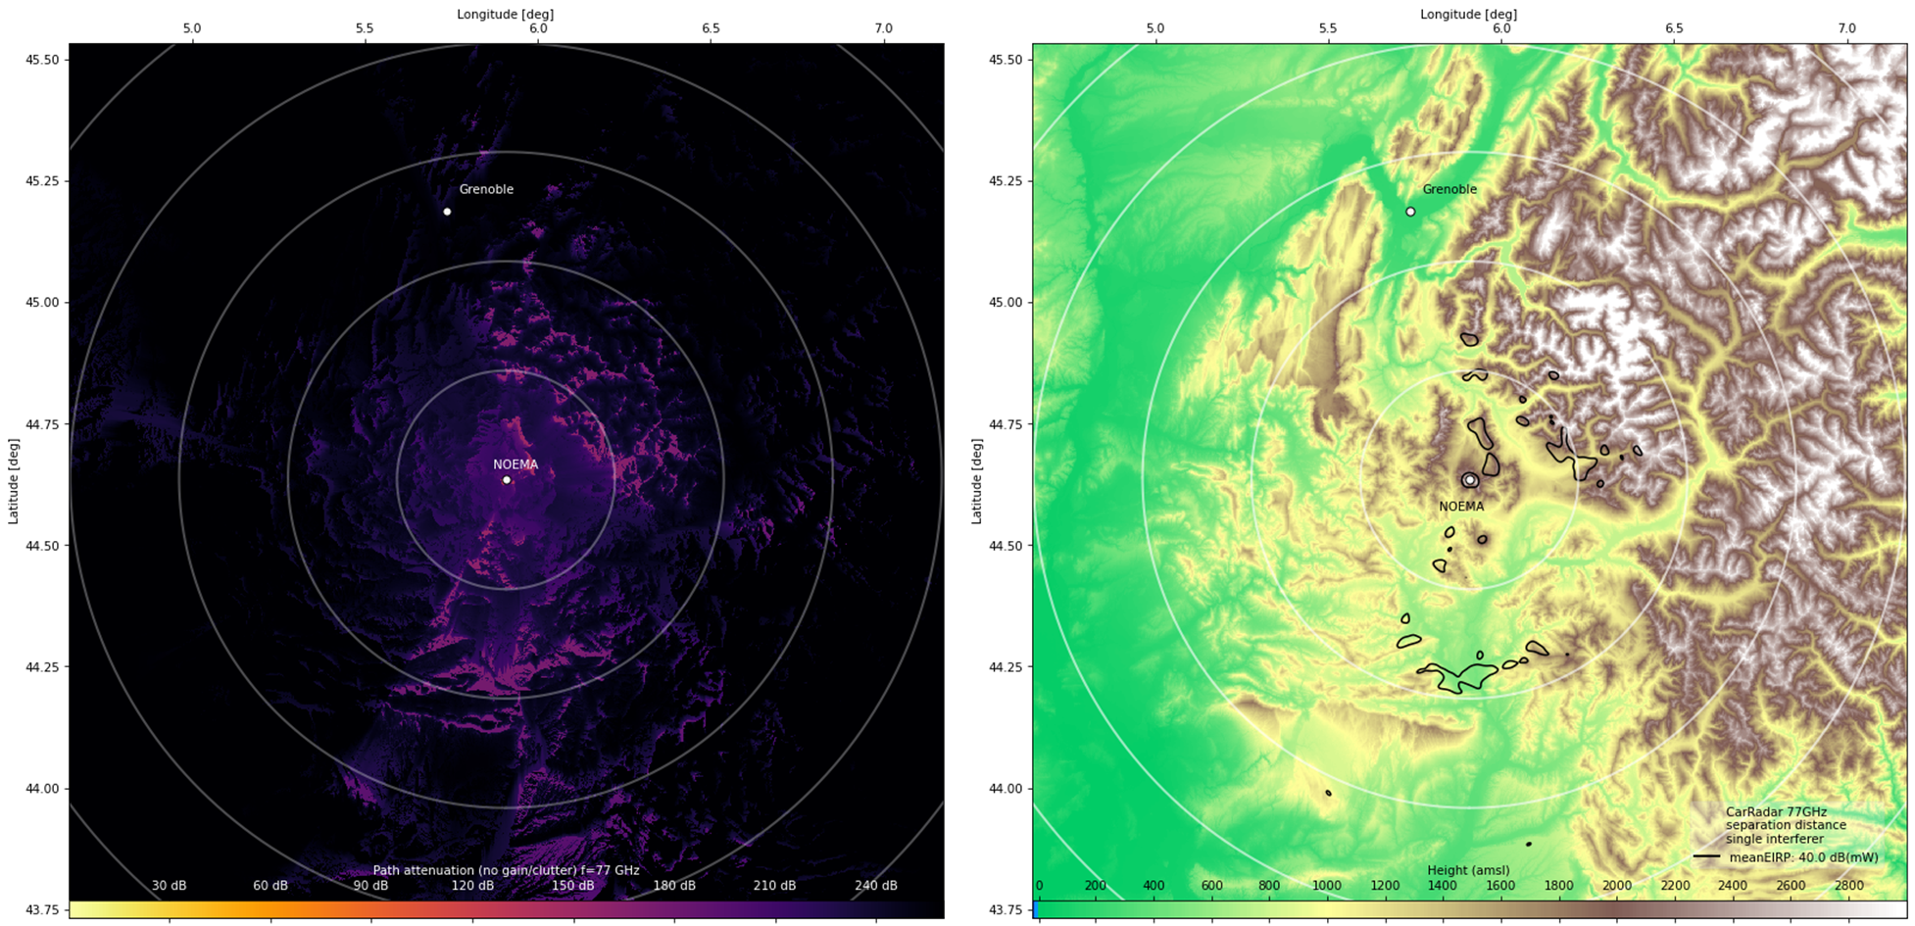
Figure 5: Attenuation map (left) and exclusion zone (right) for the single interference case for NOEMA
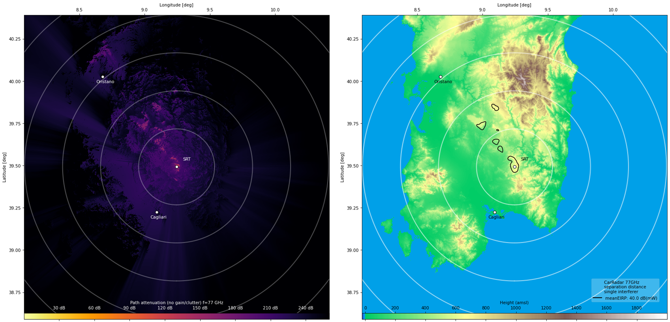
Figure 6: Attenuation map (left) and exclusion zone (right) for the single interference case for Sardinia (SRT)
In both cases, for SRT and NOEMA, the resulting exclusion zones are within a radius of less than 50 km and highly direction-dependent.

Site-specific aggregation scenarios
For the aggregation case, a more realistic scenario is assumed, where several vehicles are located randomly on the different roads around the radio telescopes following a statistical distribution (see Table 12).
To simulate a realistic distribution of vehicles, road map data from OpenStreetMap [20] (OSM) is utilised, which is available under Open Database License [21]. For each scenario, road map data within an area of 200x200 km2 were queried. OSM differentiates between various road types. Table 11 lists the total length of each type of road in the area for the two stations. For simplicity, all road types other than "primary", "secondary", "tertiary" and "residential" were subsumed into a category "other". Motorways and trunk roads are considered as primary roads. Figure 7 shows the average road length in certain distance bins (normalised to the area). When interpreting the numbers, one should consider that different types of roads will have very different traffic statistics. For example, the NOEMA station has more than 6000 km of primary roads on 200x200 km2 area.
Table 11: Total Road length per road type with 100 km radius centred around the RAS stations. OpenStreetMap contributors
Road Type | Total length of roads (per type) (km)
Road Type | NOEMA | SRT
Primary | 7805 | 3981
Secondary | 13000 | 4130
Tertiary | 21372 | 4858
Residential | 21404 | 9052
Other | 49776 | 10389
All | 113357 | 32410
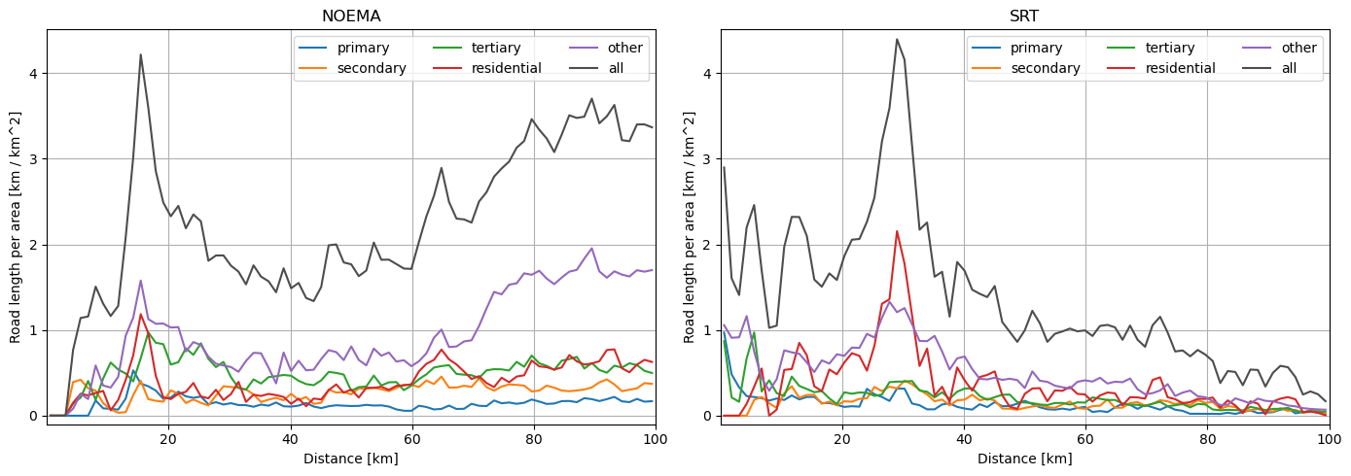
Figure 7: Road length per area per road type in distance bins around the RAS stations.
Based on OpenStreetMap
For an aggregation study, one can create samples of vehicles which follow the road distribution and also account for the different types of roads. To acknowledge the fact that traffic can be different during the day (and night) and also from day to day, the overall number of vehicles in such a sample can also be varied. In Table 12, the deployment parameters are summarised. For each of the road types, a normal distribution with a given mean and standard deviation was used to randomly sample the overall vehicle density for one realisation in the simulation (ECC Report 327, table 61 [49]). As the radar antenna directions play a role in the simulation, the motion vector of the car has to be considered, i.e. cars can usually travel in both directions of a road. In total, the simulation was repeated 100 times to have a fair number of realisations for statistical analyses, e.g. to estimate uncertainties. In each simulation run, vehicles were placed randomly onto the roads according to the desired density distributions. To account for the rather long integration time of 2000 s, which is the basis of the RAS thresholds (compare ITU-R RA.769 [16]), vehicular positions were sampled 200 times each (according to a time resolution of 10 s). The antenna pattern provided in Recommendation ITU-R M.2057 [8] is applied to determine the effective gain of the transmitter into the direction of the RAS station. The azimuthal (offset) angle with respect to the transmitter boresight can be directly computed from the motion vector of the car relative to the direction to the receiving RAS station. The motion vector was derived from the OSM road vectors. The roads are stored as polygons, i.e. the motion vector on a given road piece is entirely determined by the start and end point of the road piece (but can have the anti-parallel direction, of course). The elevation pattern is not purely geometric, as the actual propagation path could also be trans-horizon, in which case the path horizon elevation angle is the angle under which the local (radio) horizon appears. The elevation angles are determined according to the Recommendation ITU-R P.452 [13] model. Antenna patterns are shown in Table 5. Figure 8 and Figure 9 show a realisation of the simulations (the one with the highest overall vehicle density) for each station. The average car density is respectively 5.6 and 2.2 car/km2 for NOEMA and SRT station. In these maps, transparent lines show road data, while filled dots indicate the vehicle positions. RAS stations are marked with a black square, while grey circles indicate distances from the RAS station in steps of 25 km.
Table 12: Vehicle densities used for the simulation
Road type | Vehicle density (vehicles/km)
Primary | 3.6 ± 0.9
Secondary | 0.6 ± 0.15
Tertiary | 0.2 ± 0.05
Residential | 0.1 ± 0.025
Other | 0.1 ± 0.025

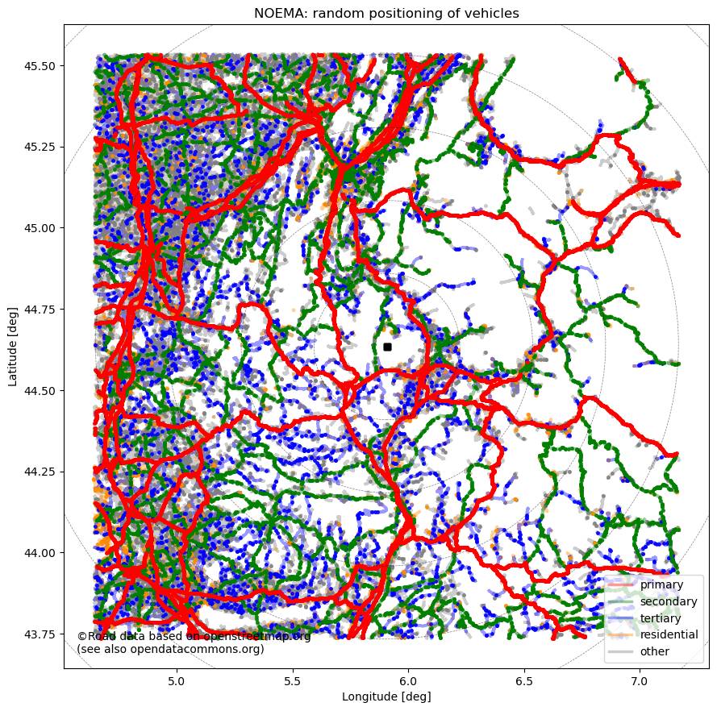
Figure 8: Random vehicle positions from the simulations around NOEMA station
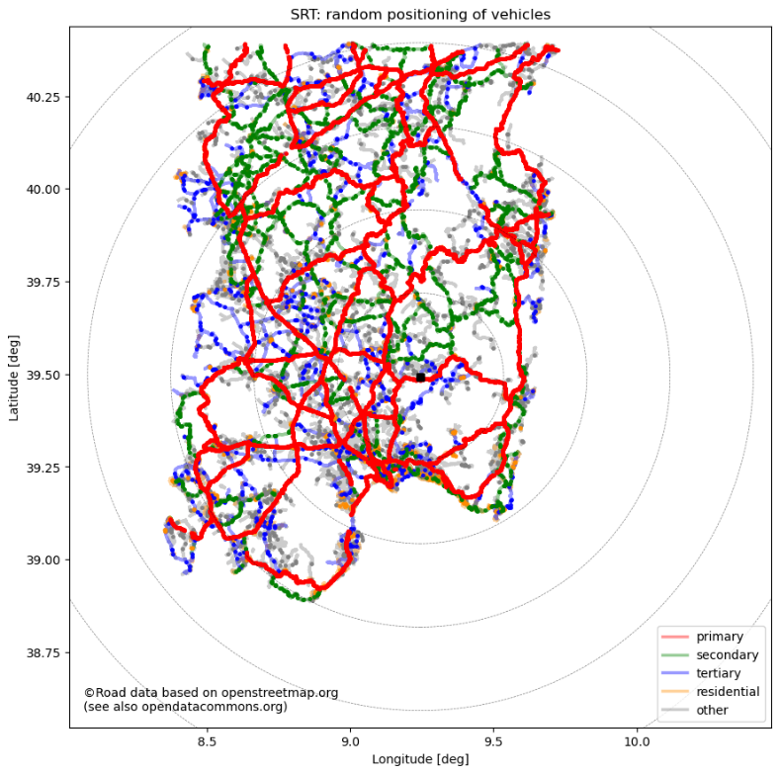
Figure 9: Random vehicle positions from the simulations around Sardinia (SRT) station
Based on the location of vehicles, one can then determine the propagation loss individually. Furthermore, Corine Land Cover (CLC) data [22] was queried to obtain the clutter type zones for each position. Based on the clutter type, the clutter loss model in Recommendation ITU-R P.452 [13], and a Tx height of 0.7 m, the clutter loss could be determined. Figure 10 and Figure 11 show the inferred clutter types around each station.
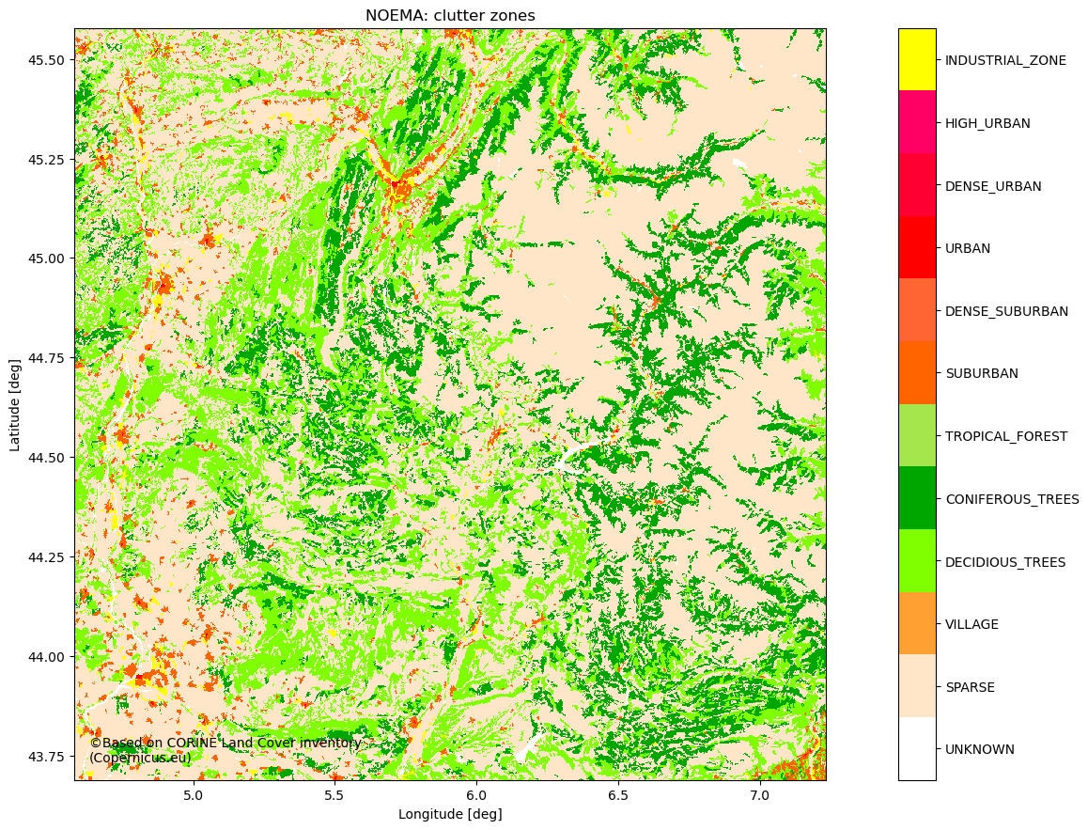
Figure 10: Clutter type zones around NOEMA station
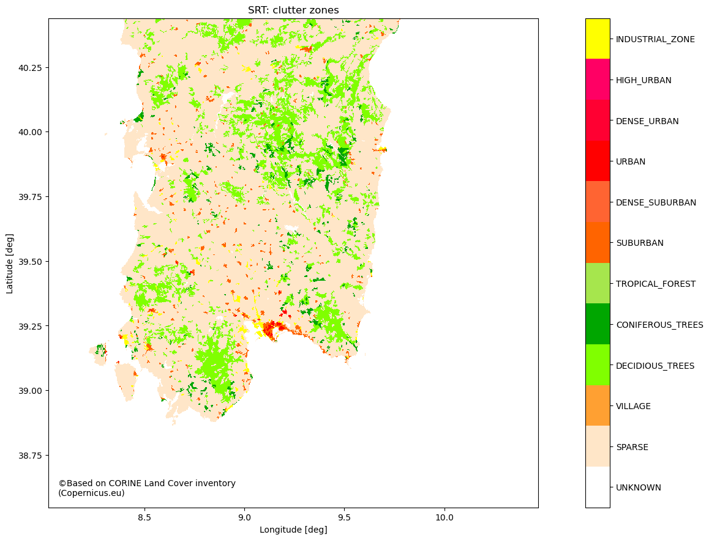
Figure 11: Clutter type zones around SRT station
In reality, each car will have several radars. To properly estimate the total contribution, multiple radars (six different cases) have been considered for each car. In particular, the following scenarios were assessed:
- Scenario A: 1 front radar, type A;
- Scenario 4B: 4 corner radars, type B;
- Scenario A+4B: 1 front radar, type A, and 4 corner radars, type B;
- Scenario B: 1 front radar, type B;
- Scenario 4C: 4 corner radars, type C;
- Scenario B+4C: 1 front radar, type B, and 4 corner radars, type C.
The other radar types considered in this Report have shorter range and will not significantly change the outcome. The resulting antenna patterns of the mixed scenarios, A+4B and B+4C, are shown from Figure 12 to Figure 15.
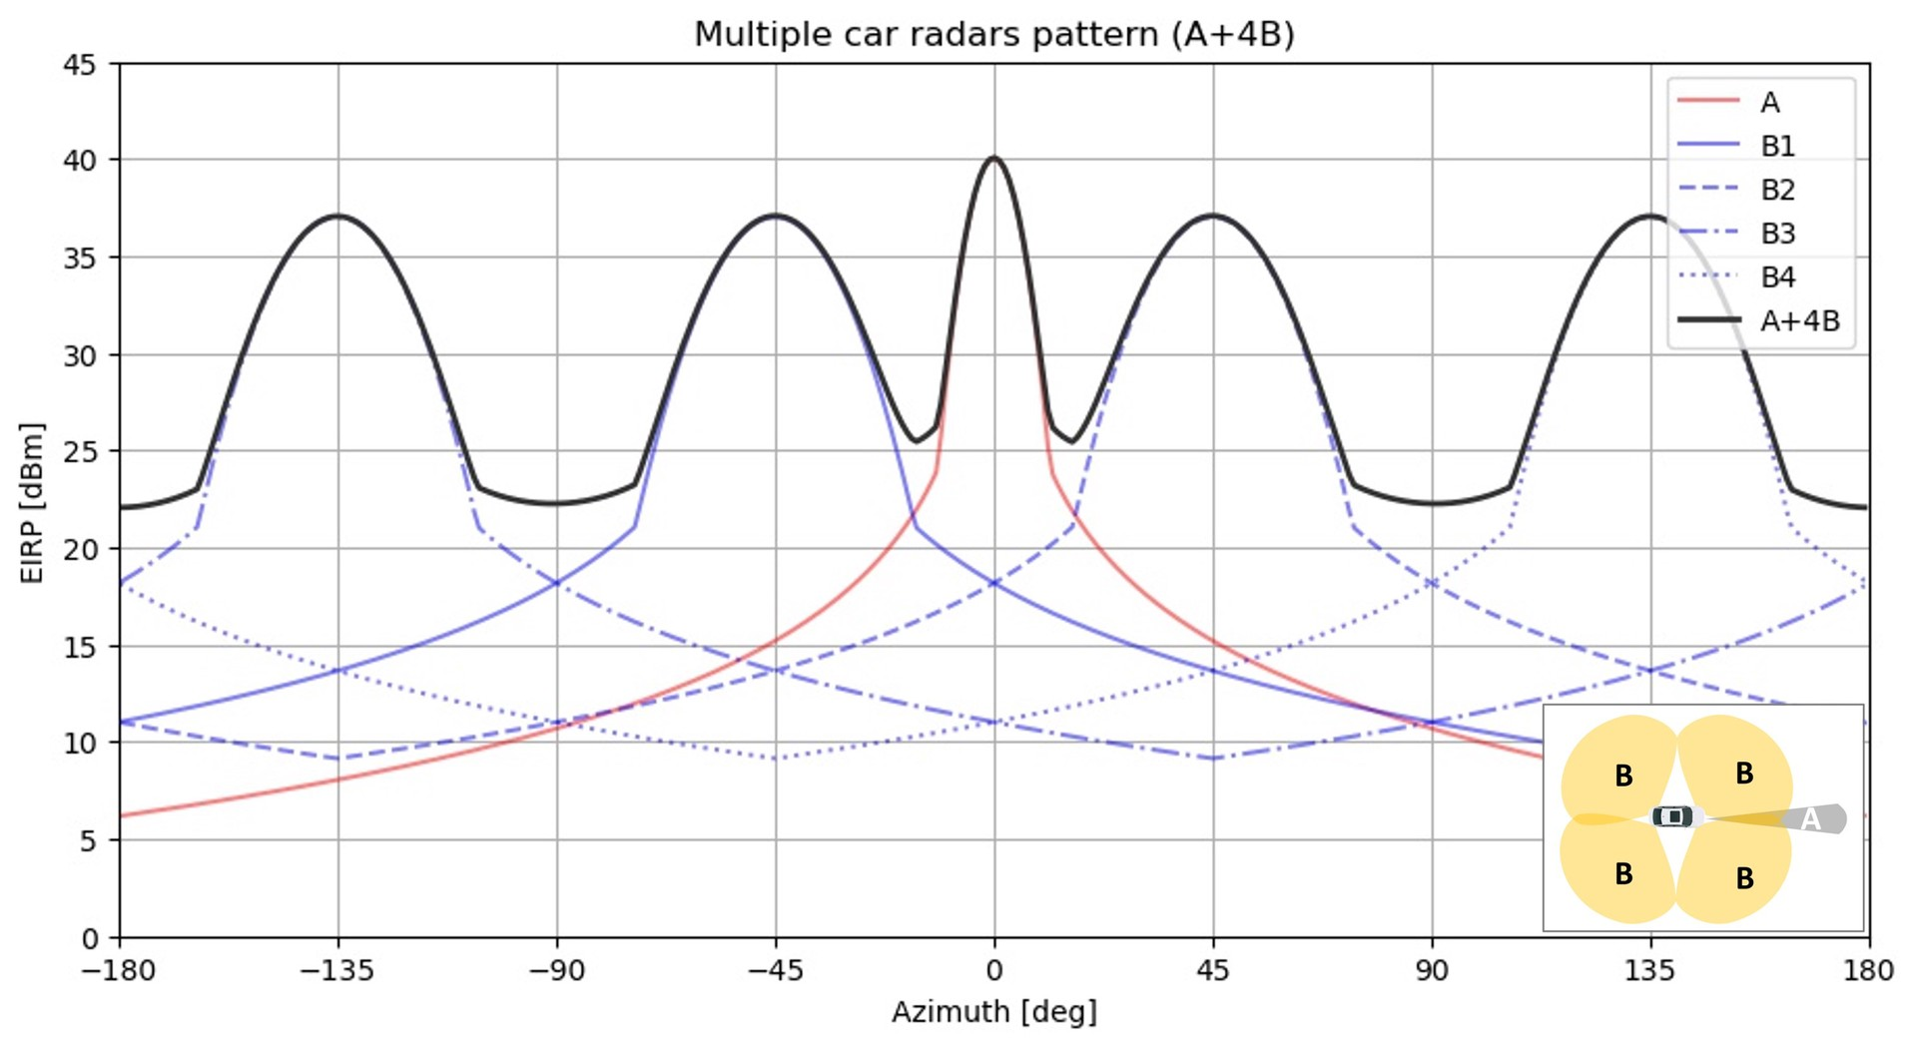
Figure 12: Antenna pattern of multiple radars, type A in the front direction and 4 type B in the corner directions at 0° elevation plane. Bottom right: top view of the radar distribution

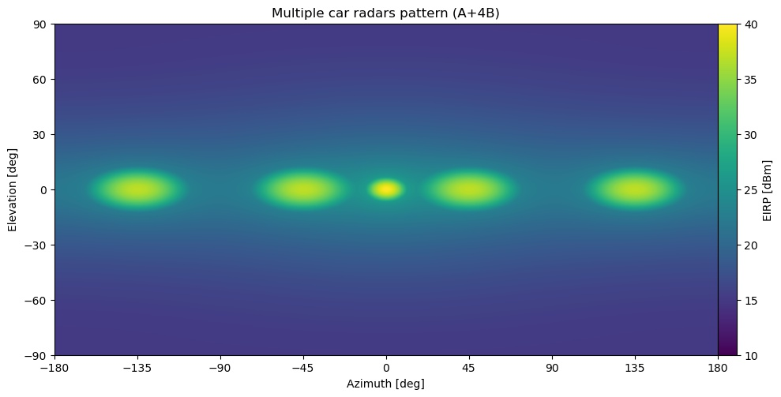
Figure 13: Antenna pattern of multiple radars, type A in the front direction and 4 type B in the corner directions displayed for both azimuthal and elevation planes
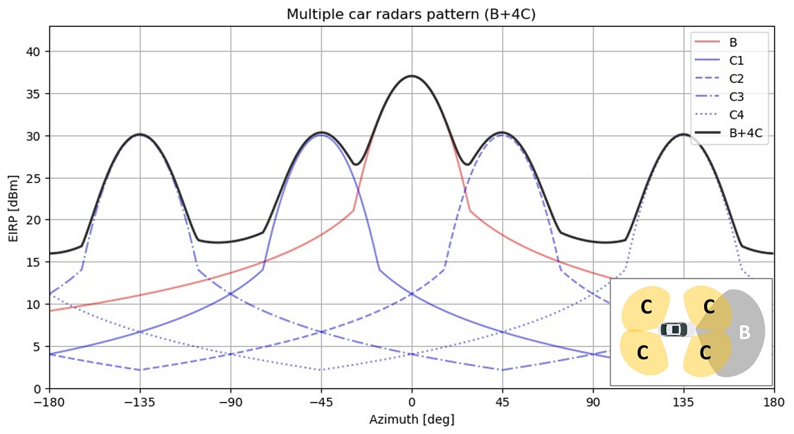
Figure 14: Antenna pattern of multiple radars, type B in the front direction and 4 type C in the corner directions at 0° elevation plane
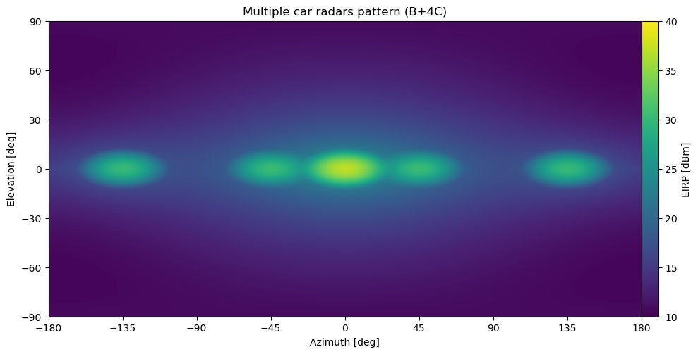
Figure 15: Antenna pattern of multiple radars, type B in the front direction and 4 type C in the corner directions displayed for both azimuthal and elevation planes
The aggregated received power at the RAS station can be determined for each simulation run (averaging the powers of all time steps). As this almost always exceeds the RAS thresholds, the aggregation was repeated for a number of hypothetical exclusion zones, in which no device would be active.
Results
The results are depicted from Figure 16 to Figure 19, which show the received power for the various exclusion zone radii for each iteration and the median for single radar (type A and type B) and multiple radars (4B, A+4B, 4C and B+4C). The exclusion zone radius actually required to comply with the RAS threshold is determined by the intersection of the median curve (black solid line) with the RAS threshold line (red dashed horizontal line).
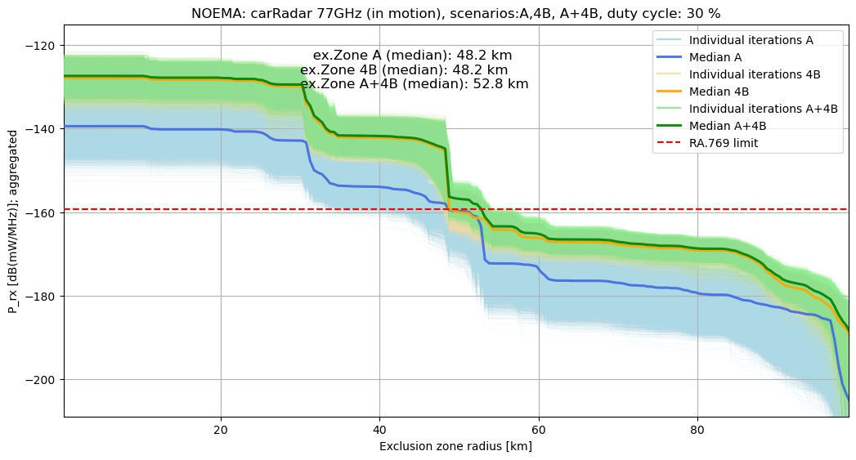
Figure 16: Results of the aggregation calculation of Automotive Radar (type A, type 4B, and type A+4B) in motion around NOEMA station

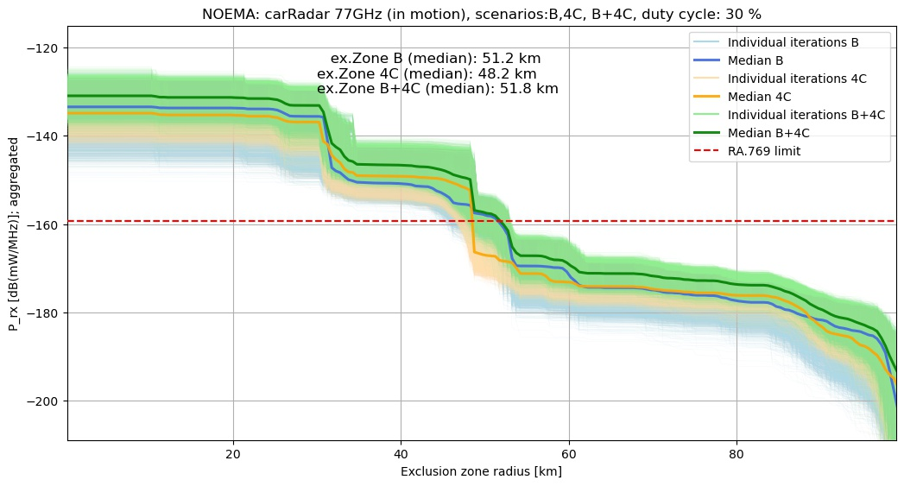
Figure 17: Results of the aggregation calculation of Automotive Radar (type B, type 4C and type B+4C) in motion around NOEMA station

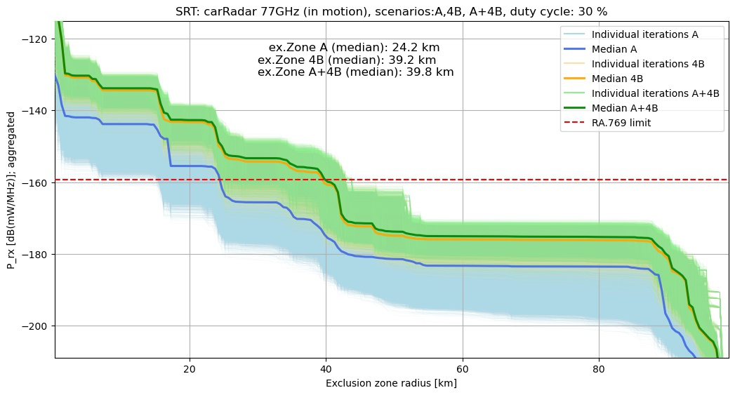
Figure 18: Results of the aggregation calculation of Automotive Radar (type A, type 4B, and type A+4B) in motion around SRT station
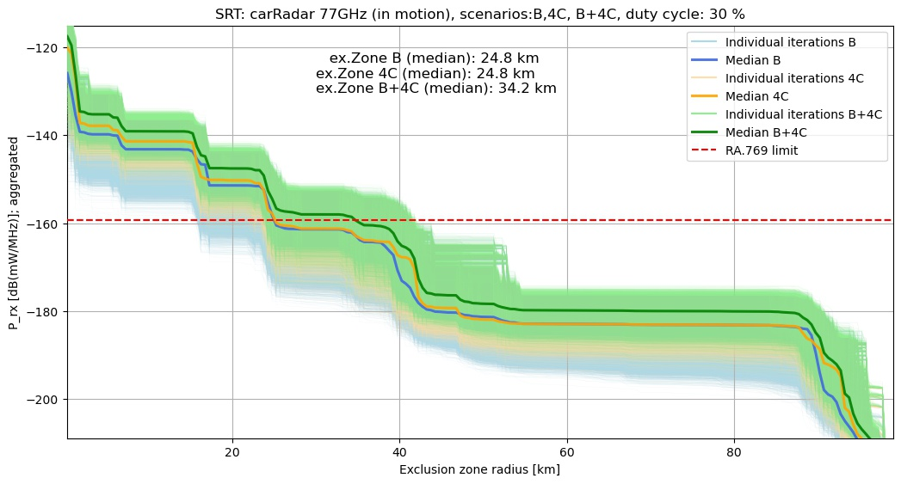
Figure 19: Results of the aggregation calculation of Automotive Radar
(type B, type 4C and type B+4C) in motion around SRT station
The results show a range of necessary exclusion zone sizes, depending on the radar configurations and environment of a site. For the type A car radar, compatibility with RAS is achieved with an exclusion zone size of 48 km for the NOEMA station and 24 km for the Sardinia station, respectively, while for the multiple radar (A+4B) case the necessary exclusion zone size increases up to 53 km (NOEMA) and 40 km (SRT). Comparing the results of the first three scenarios (A, 4B and A+4B) with the latter three scenarios (B, 4C and B+4B) very similar exclusion zone sizes are required. While the nominal maximum e.i.r.p. of the former is higher, the beam widths of the antennas in the latter compensate for the lower e.i.r.p. in the aggregation calculations. The spread of curves is due to the high number of possible configurations considered. Table 13 and Figure 20 show the summary of necessary exclusion zone sizes for the different radar configurations.
Table 13: Summary of the exclusion zone radius considering different radar configurations for the CEPT RT
 | Required exclusion zone sizes (km) for each scenario
Observatory Name | A | 4B | A+4B | B | 4C | B+4C
Plateau de Bure/NOEMA | 48.2 | 48.2 | 52.8 | 51.2 | 48.2 | 51.8
Sardinia (SRT) | 24.2 | 39.2 | 39.8 | 24.8 | 24.8 | 34.2
Pico Veleta (IRAM-30m) | 60.2 | 68.2 | 69.2 | 62.2 | 58.8 | 64.2
Onsala | 12.8 | 20.2 | 21.2 | 15.8 | 18.8 | 19.8
Effelsberg | 1.8 | 2.2 | 2.2 | 1.8 | 1.8 | 1.8
Medicina | 50.2 | 63.8 | 65.2 | 52.8 | 51.2 | 57.8
Noto | 13.2 | 26.8 | 27.8 | 13.8 | 14.8 | 18.8
Metsähovi | 5.8 | 14.2 | 15.2 | 6.2 | 14.2 | 14.2
BEST | 14.2 | 16.2 | 16.2 | 14.8 | 15.8 | 15.8
Yebes | 57.8 | 66.8 | 67.2 | 59.8 | 61.2 | 64.8
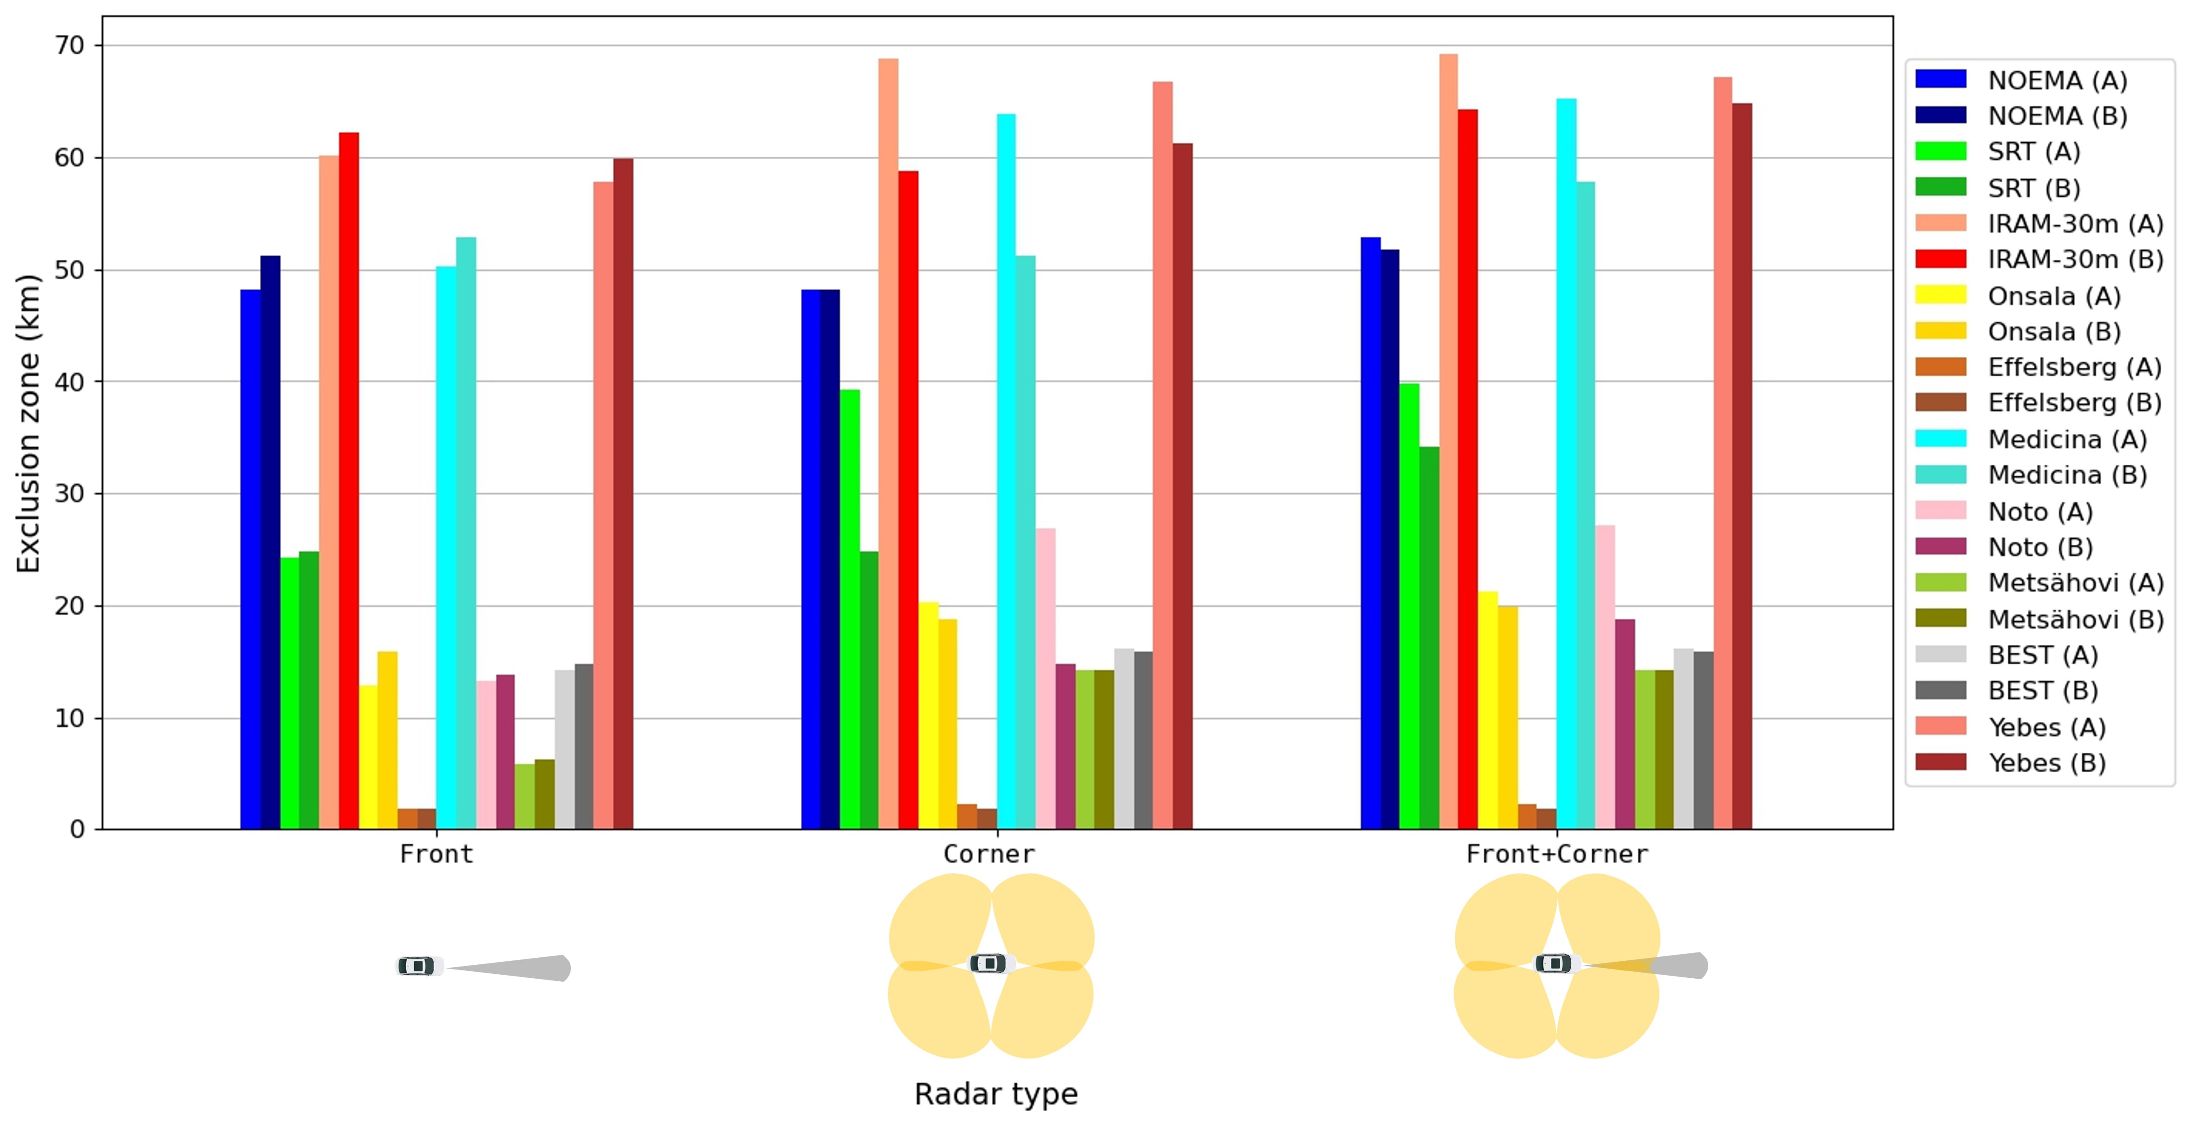
Figure 20: Summary of the exclusion zone radius considering different radar configurations for CEPT RAS stations (#1 refers to type A, 4B or A+4B and #2 refers to type B, 4C or B+4C)

Conclusion
The single-entry study leads to similar exclusion zones for both NOEMA and SRT, up to approximately 50 km.
Comparing the results of the aggregation study, no significant variations are found for the same location in different scenarios. The terrain seems to play an important role for the exclusion zone size, varying from a few kilometres (Effelsberg) up to almost 70 km (IRAM and Yebes) (see Table 13).

Sharing with the Radiolocation Service
In 2020, information was provided that no military radiolocation systems are operated by NATO members in the band 77 to 81 GHz. Furthermore, there are no plans to introduce such systems.
There is no other application of the Radiolocation Service using this band.

Sharing with the Amateur Service
The amateur and amateur-satellite services have secondary and primary allocations within the range of study between 75.5 and 81 GHz. Whilst past use has been inhibited by equipment availability, ongoing experimentation, high performance frequency sources and innovative adaptation of commercial chipsets has led to growth in activity which can be currently categorised as:
- Weak-signal reception of Narrowband (e.g. CW-Morse or voice) terrestrial operations in harmonised sub-bands (including over earth-moon-earth (EME) paths and through non-geostationary amateur satellite transponders);
- Growing use of wider bandwidth modes, such as Digital Amateur TV (DATV) and data links;
- Usage of fixed beacon transmitting stations for propagation research and equipment alignment.
In general, most amateur stations are currently portable low-power highly directional systems. In order to maximise Long Range communications, operation is often from elevated locations where they can achieve terrestrial line of sight contacts up to 50 km. Antennas operate at elevated angles for EME and satellite operations.

Methodology
In the following, single interferer MCL calculations were done for an area around an amateur service receiver which is placed at the position (0,0) and directed to the right. The impact of a single AR interferer (directed towards the Amateur Service antenna in the azimuth) is calculated on each point of the area taking into account the antenna patterns. A schematic view from the top is given in Figure 21.
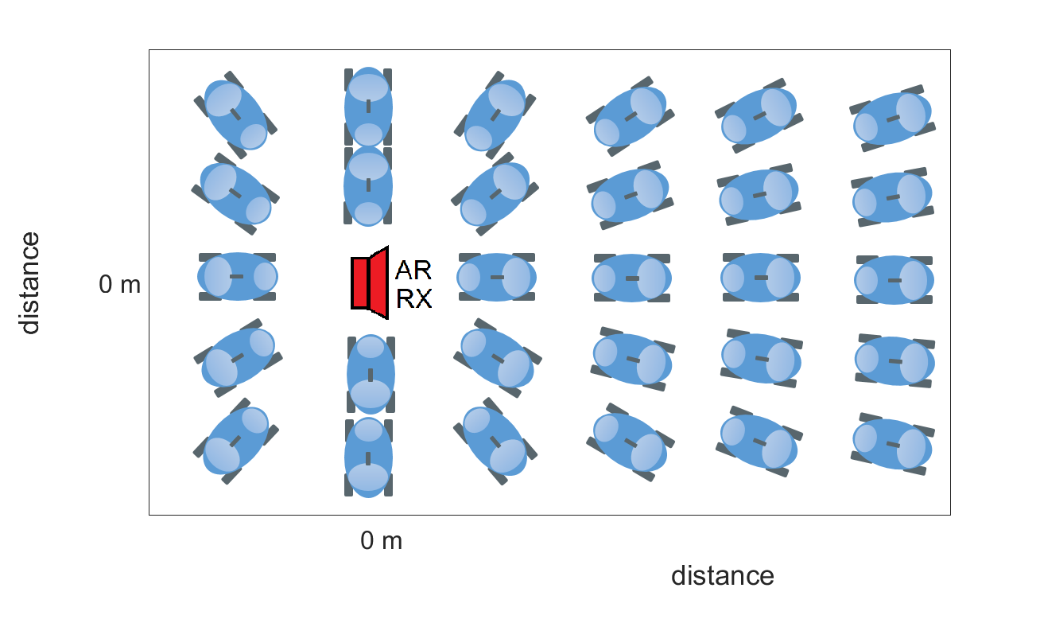
Figure 21: MCL top view
Both antennas are pointing to 0° in elevation. A schematic view from the side is given in Figure 22.
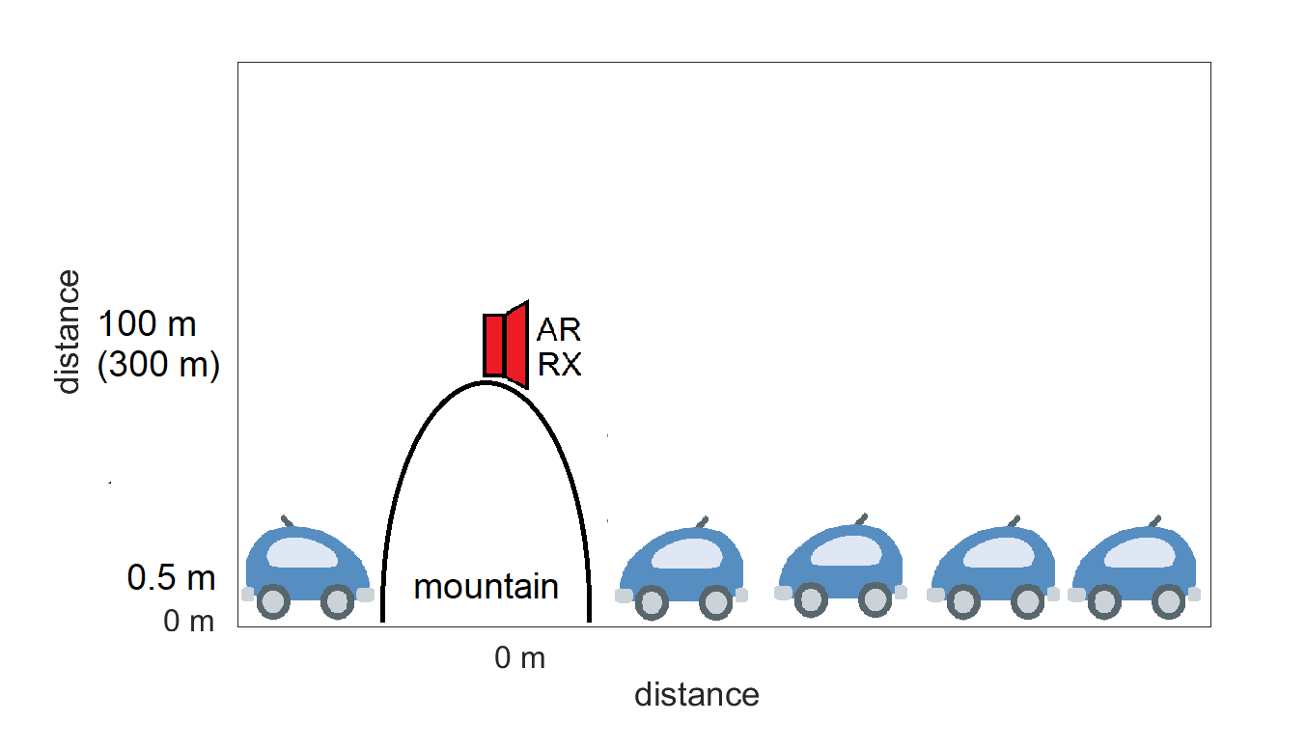
Figure 22: MCL side view
The impact of a single AR interferer is calculated on each point of the area. A red contour highlights the separation distance in each direction. The coloured areas highlight the amount to which the results lie above or below the criterion I/N =-6 dB. The parameters used and also the results are noted on the plots, respectively.
Peak radius results represent the maximum range of interference coming from the height level of the AR, when a constant ground level of 0 m is assumed. This is usually located in the main lobe direction.
Circle radius results represent the minimum range of interference coming from the height level of the AR, when a constant ground level of 0 m is assumed. This is usually located in the back lobe area.
Main beam to main beam results represent the MCL calculation, where no vertical geometry was considered.

Victim parameters
Recommendation ITU-R M.1732-2 [11] provides generic characteristics of stations operating in the amateur service for use in sharing studies. However, they are not very specific for the 75.5-81 GHz frequency range. This Report considers the appropriate amateur and amateur-satellite service characteristics as used in ECC Report 315 [6] and summarised in Table 14.
Terrestrial stations in the amateur and amateur-satellite services have identical technical characteristics, except for the (variable) positive elevation angle of the receiver antenna.

Table 14: Examples of Amateur and Amateur-Satellite Service characteristics in the band 75.5-81 GHz
Parameter | CW-Morse | SSB Voice | NBFM Voice | DATV
Receiver IF bandwidth (kHz) | 0.5 | 2.7 | 15 | 4000
Typical Feeder Loss (dB) | 1 | 1 | 1 | 1
Antenna gain (dBi) | 36–42  (typically: 40) | 36–42  (typically: 40) | 36–42  (typically: 40) | 36–42  (typically: 40)
Antenna polarisation | Horizontal, Vertical | Horizontal, Vertical | Horizontal, Vertical | Horizontal, Vertical
Receiver Noise Figure (dB) | 3–7  (typically 4) | 3–7  (typically 4) | 3–7  (typically 4) | 3–7  (typically 4)

Operational scenario
For terrestrial operations, amateur stations are usually tripod mounted around 2 to 5 m above ground and are rotatable in azimuth. The operating sites are usually in non-built up locations on high ground with uncluttered visibility. For EME and amateur satellite service activities the antennas will be capable of pointing skyward. Therefore, the height of the receivers will be assumed to be 100 m and 300 m, similar to ECC Report 315 [6].
Parameters of AR were taken from section 2.2.
The propagation model described in Recommendation ITU-R P.452-16 [13] was used to calculate the path loss. Propagation parameters were noted on each plot and were kept constant for all analyses.

Results

Automotive Radar Type ”A” @20 dBm/MHz
The worst-case geometry (main beam to main beam) for the Automotive Radar Type “A” would lead to a separation distance of 37675 m. This scenario is not considered as realistic.
Taking into account the vertical delta of 99.5 m and the respective antenna patterns, this distance was calculated to be 35700 m (see Figure 23).
Taking into account the vertical delta of 299.5 m and the respective antenna patterns, this distance was calculated to be 34100 m (see Figure 24).
In general, the critical area around the amateur radio receiver is limited to small angle around its azimuthal directivity.
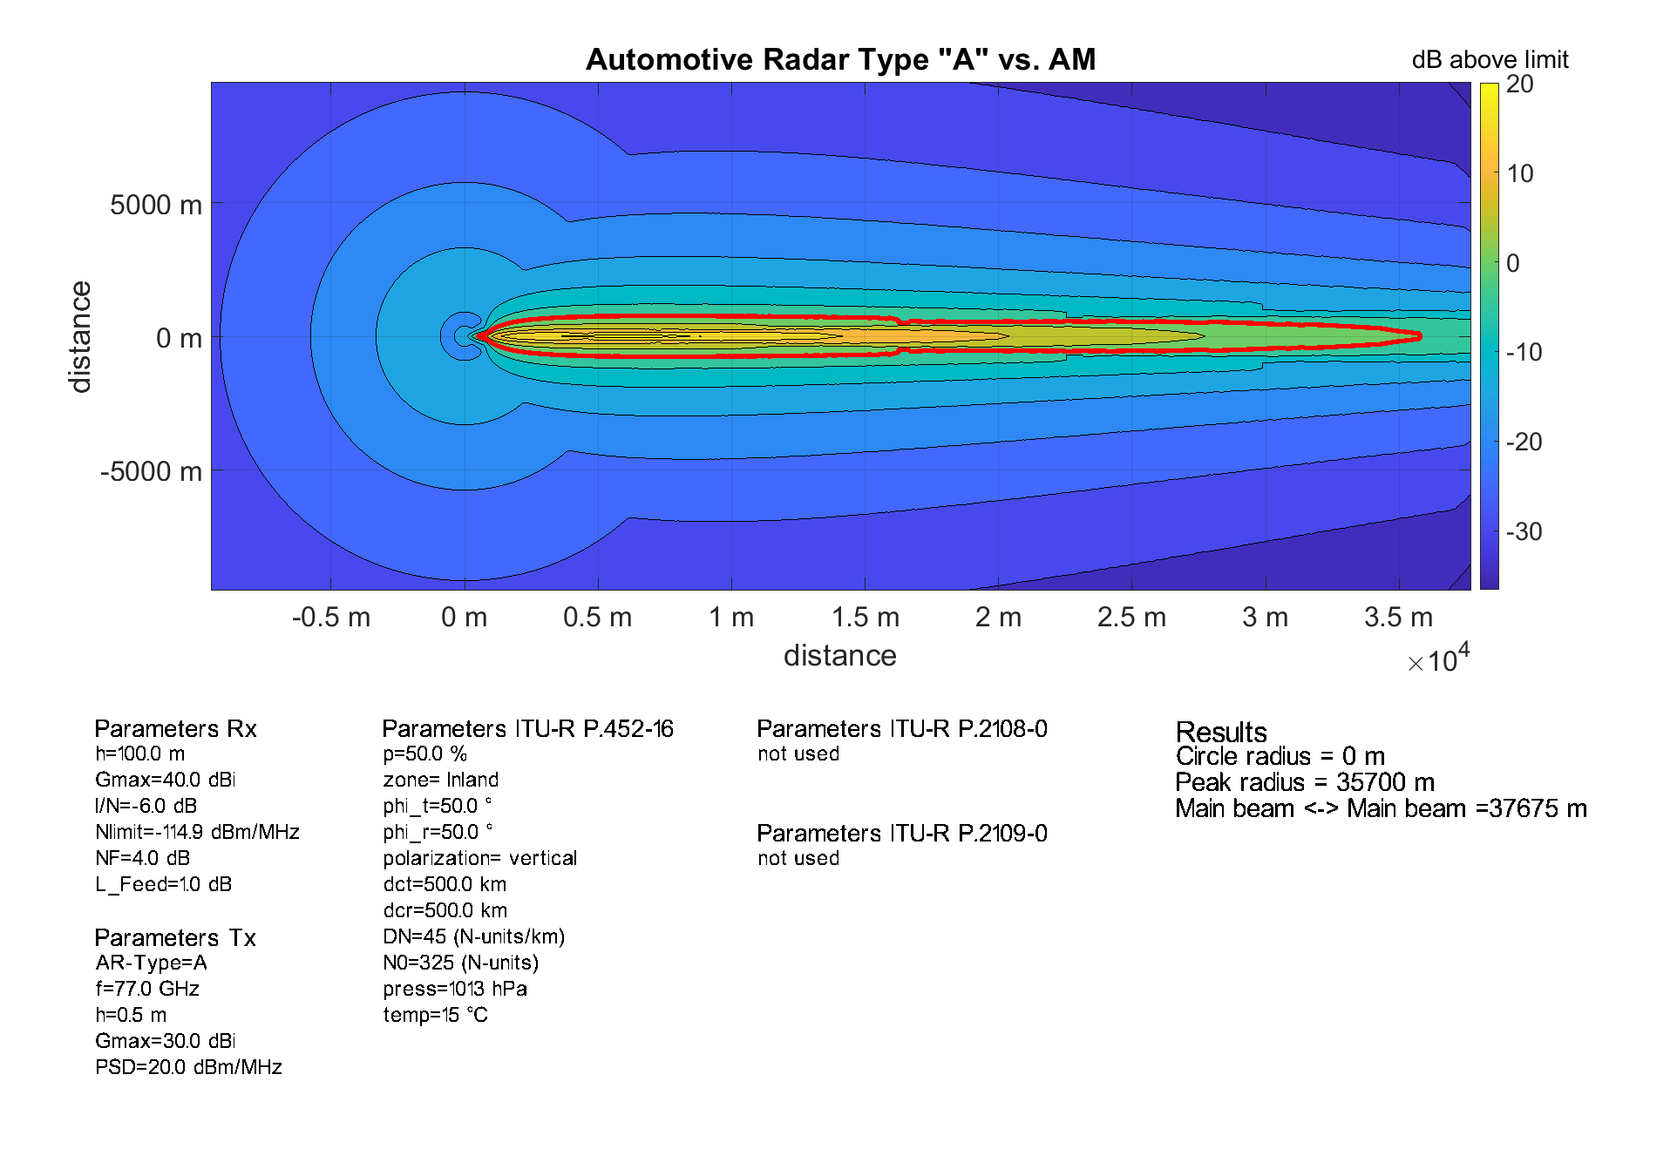
Figure 23: AR ”A” @20 dBm/MHz vs. Amateur Service @100 m
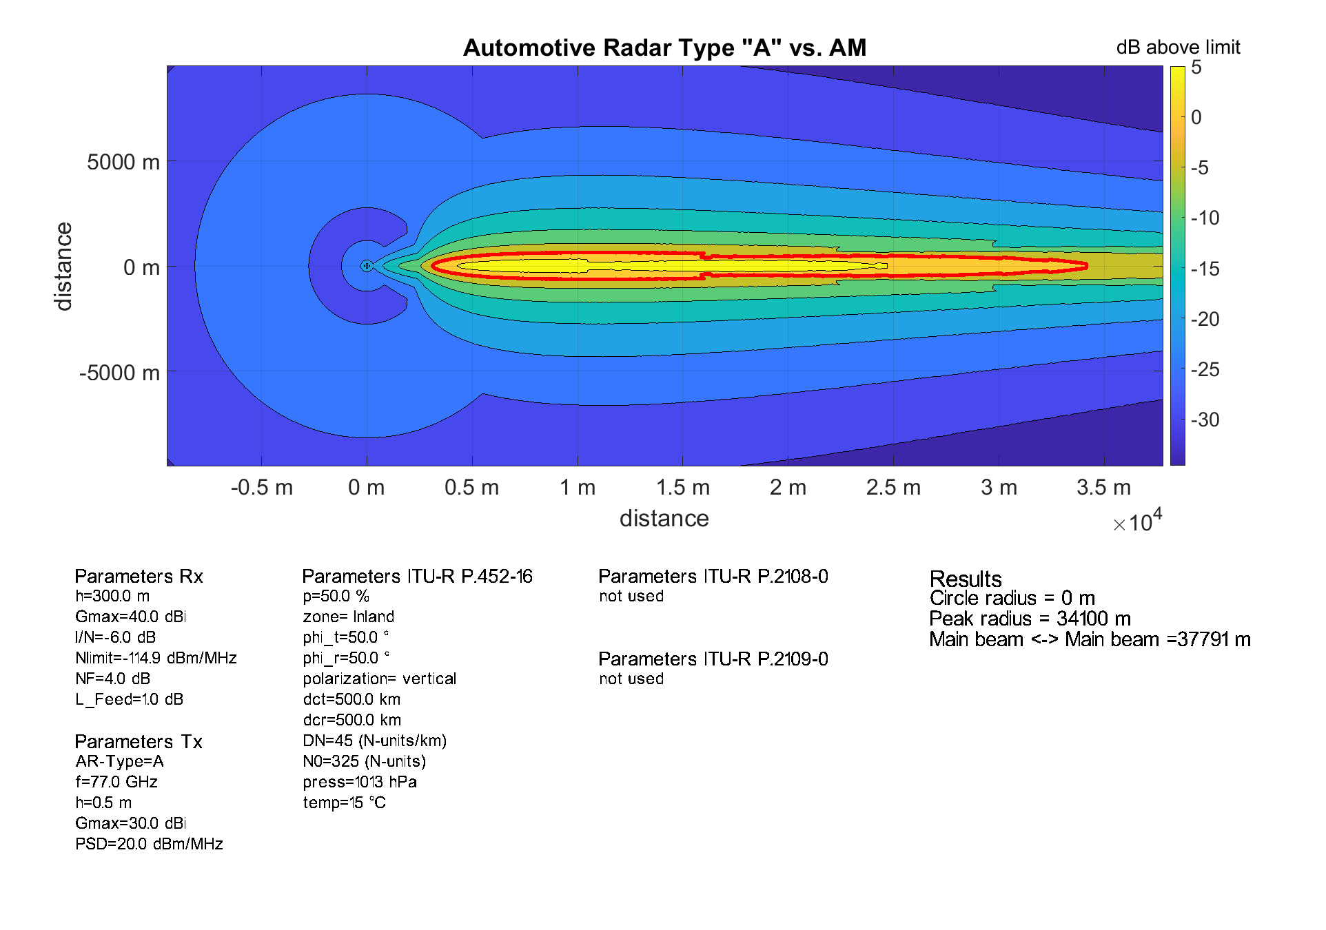
Figure 24: AR ”A” @20 dBm/MHz vs. Amateur Service @300 m

Automotive Radar Type ”B” @7 dBm/MHz
The worst-case geometry (main beam to main beam) for the Automotive Radar Type “B” would lead to a separation distance of 18401 m. This scenario is not considered as realistic.
Taking into account the vertical delta of 99.5 m and the respective antenna patterns, this distance was calculated to be 16700 m (see Figure 25).
Taking into account the vertical delta of 299.5 m and the respective antenna patterns, no separation distance would be needed (see Figure 26).
In general, the critical area around the Amateur Radio receiver is limited to small angle around its azimuthal directivity.
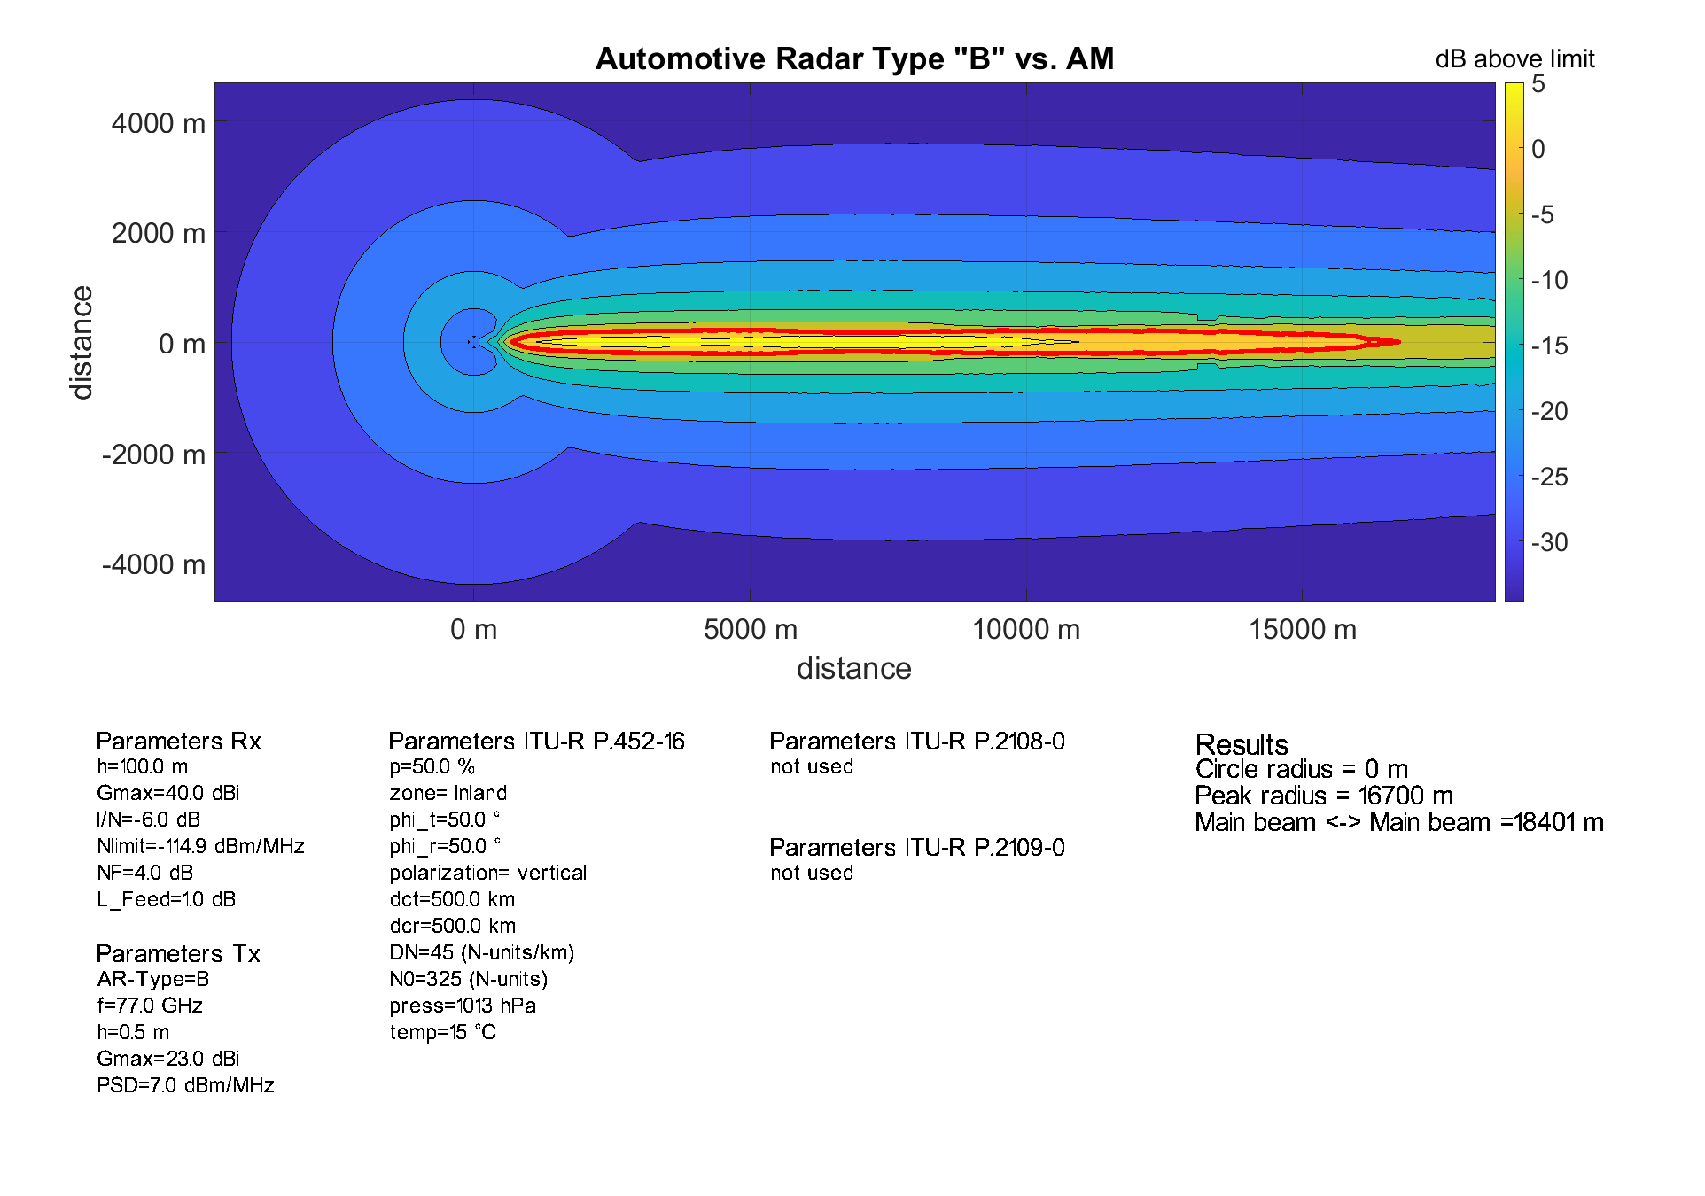
Figure 25: AR ”B” @7 dBm/MHz vs. Amateur Service @100 m
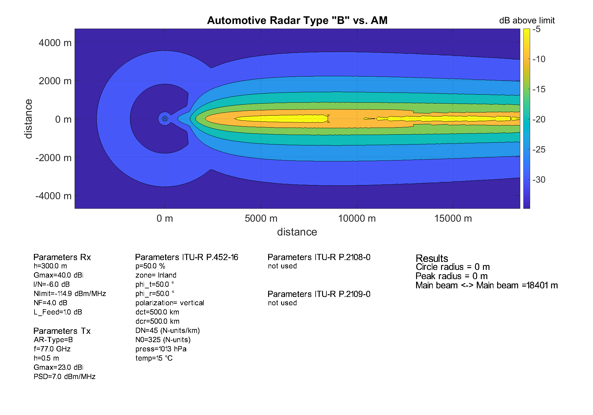
Figure 26: AR ”B” @7 dBm/MHz vs. Amateur Service @300 m

Automotive Radar Type ”C” @-3 dBm/MHz
The worst-case geometry (main beam to main beam) for the Automotive Radar Type “C” would lead to a separation distance of 8613 m. This scenario is not considered as realistic.
Taking into account the vertical delta of 99.5 m and the respective antenna patterns, no separation distance would be needed (see Figure 27).
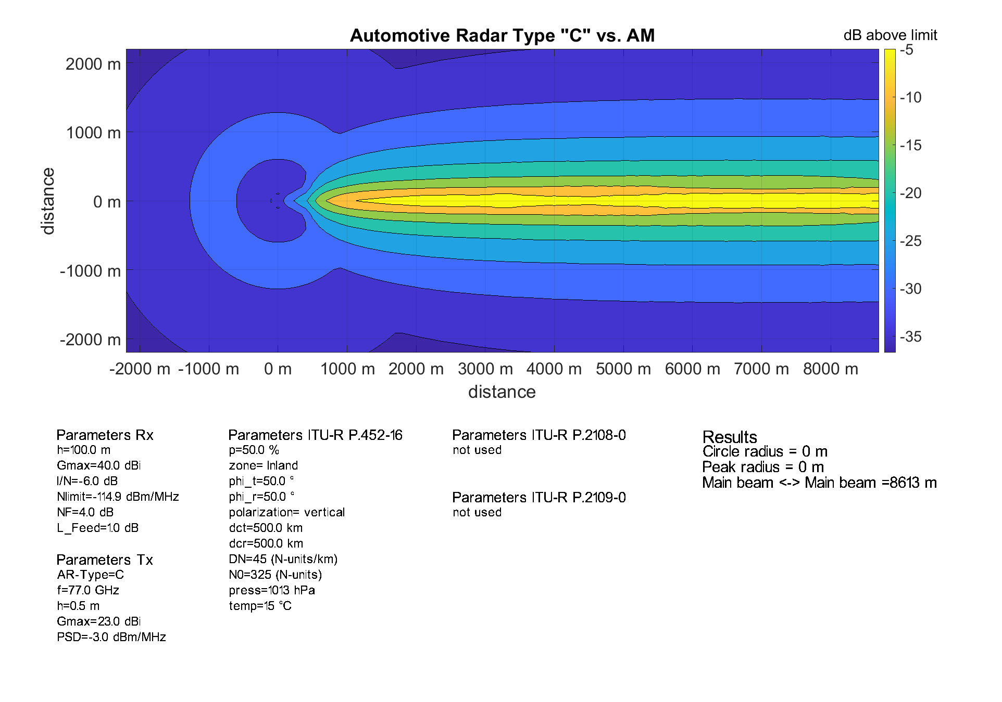
Figure 27: AR ”C” @-3 dBm/MHz vs. Amateur Service @100 m

Automotive Radar Type ”E” @-3 dBm/MHz
The worst-case geometry (main beam to main beam) for the Automotive Radar Type “E” would lead to a separation distance of 8613 m. This scenario is not considered as realistic.
Taking into account the vertical delta of 99.5 m and the respective antenna patterns, no separation distance would be needed (see Figure 28).

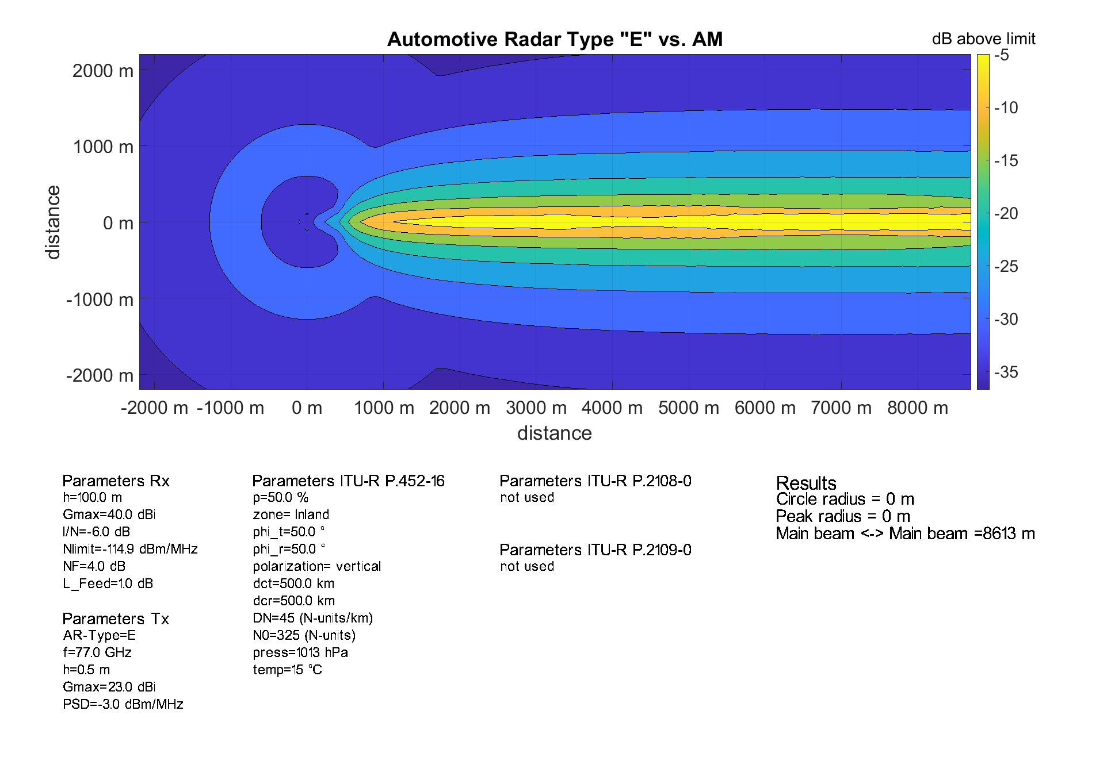
Figure 28: AR ”E” @-3 dBm/MHz vs. Amateur Service @100 m

Conclusion
MCL calculations, taking into account the vertical delta between both AR and Amateur Service antennas, reveal separation distances between 0 km and 35.7 km. The distance depends highly on the transmission level and angular offset between the AR transmitter to the Amateur Radio receiver.
Due to the use of directive antennas the highlighted areas where interference could happen are relatively small. It has to be noted that interference in reality may have a low probability due to following reasons:
- A car/street has to be inside of the relatively small critical area;
- The car´s antenna must be directed towards the Amateur Service antenna;
- LOS conditions between automotive radars and the Amateur Service receiver must apply;
- The more vertical separation between both antennas prevails the lower the impact will be;
- The setup of the Amateur Service system is such (e.g. LOS conditions between two Amateur Service stations) that probability of interference is low, but may be assessed case by case.
Aggregation was not taken into account.

SRD operating in the band
It has to be noted that SRDs have no status of being protected from interference from a regulatory point of view. However, the following information about coexistence with automotive radars is provided.
HD-GBSAR systems operating in the band 77-78 GHz avoid interference by implementing detect and avoid techniques.
Information about Security Scanners in the band 60-82 GHz, which may use the band in future, can be found in ECC Report 344 [40].

Compatibility studies

Compatibility with the Fixed Service

MCL Methodology

Propagation Model
This Report uses the same propagation model as used in Report ITU-R F.2394-0 [12]. This model is described in Recommendation ITU-R P.452 [13] to determine the propagation loss for the automotive radar system’s signal, using a smooth circular Earth and a time percentage of 50%.
Reflections and diffraction of an automotive radar signal off surrounding vehicles could potentially increase the interference received by an FS station. However, losses incurred from the reflection of this signal would result in the field strength of this reflected wave at the FS station to be less than the field strength of the wave emitted directly by the automotive radar mounted on the front of the reflecting vehicle (except only in high density traffic conditions where the direct signal of the preceding car is being shielded). Therefore, the overall effect of reflection and diffraction effects from surrounding vehicles are assumed to be negligible and will not be taken into account.

Interference scenario model
This Report considers only single-entry interference scenarios. Multiple entry interference scenarios can be considered in another study.
In practice, a vehicle can have any orientation in azimuth with respect to the FS Rx. For the elevation angles, to simplify the analysis, it is assumed that the radar emits towards the horizon and the FS Rx is also pointing towards the horizon, i.e. 0 elevation angles. The top view of the geometric model used to conduct the interference analysis in shown in Figure 29, which consists of an FS receiver and a radar emitter. The azimuth angles α and β are varied and the minimum separation distance is calculated for each pair of angles. The effective antenna gain for both the radar Tx and FS Rx is calculated for each case based on the geometry of the interference scenario. Note that although the radar is placed in the front of the vehicle in Figure 29, this is representative also for radars mounted on the side or in the back, but for simplicity reasons, the illustration shows the radar mounted in the front.
Figure 29: Interference scenario top view
Figure 30: Interference scenario side view

Vehicular Radar Parameters
Table 15 provides a summary of the parameters for vehicular radars used in the MCL study.
Table 15: Used Automotive Radar parameters
Sensor operation/Function | Antenna gain | OOB e.i.r.p. | Notation
Long Range Radar | 30 dBi | -30 dBm/MHz | A
Mid Range Radar | 23 dBi | -30 dBm/MHz | B
Short Range Radar | 23 dBi | -30 dBm/MHz | C
Ultra Short Range Radar | 23 dBi | -30 dBm/MHz | D
The height of the radar was considered to be 0.5 m above ground level and the elevation angle was 0 degrees assuming the car radar is pointing towards the horizon.

FS parameters
Table 16 summarises the parameters used for the FS in the MCL study taken from Recommendation ITU-R F.758-7 [15].
Table 16: Used FS parameters [15]
Parameter | Value
Carrier frequency | 81 GHz
FS Receiver noise power density typical | -106 dBm/MHz
FS Allowed Long-term interference to noise ratio (I/N) | -20 dB
Antenna height | 15 m
Antenna gain | 43 dBi and 50 dBi
Antenna elevation angle | 0 degrees
Antenna pattern | ITU-R F.699-8 [14]
Feeder/multiplex loss | 0 dB

Results
Calculations have been done for all four types of radars in Table 15 and two different FS antenna gains. First contour plots are shown with the minimum separation distance for different azimuth angles for the vehicular radar and the FS receiver. The upper limit represents the worst-case scenario. Second, specific scenarios for azimuth angles of 0 are shown for the vehicular radar and FS, respectively. Third, I/N curves are shown as a function of distance between the vehicular radar and FS receiver for specific scenarios for azimuth misalignment of 0 degrees between both antennas.

FS Antenna Gain 43 dBi
Figure 31: Long Range Radar A
Figure 32: Mid Range Radar B
Figure 33: Short Range Radar C
Figure 34: Ultra Short Range Radar D
Figure 35: Car radar azimuth β=0 degrees
Figure 36: FS azimuth $α=0$ degrees
Figure 37: Interference as function of distance for 0 degree misalignment in azimuth
(43 dBi FS antenna)
As can be seen in the figures above, all radars have the same maximum required separation distance, i.e. 2.12 km, to fulfil the protection criterion due to same emission level. However, due to the different antenna pattern of the radar, the required separation distance changes differently depending on the relative orientation in azimuth between the FS receiver and the vehicle radar. Long Range radars have a faster decay on the antenna gain, which results in narrower spot where interference is possible. Long Range radars have also a faster day in elevation compared to the other radar types, therefore the interference is lower when comparing the same azimuth orientation, c.f. Figure 32. Mid Range radars have the same results as short-range radars since they share the same antenna pattern. Whereas Ultra Short Range Radars having the broadest gain in azimuth, have also the broadest range for interference, c.f. Figure 30.
Figure 32 shows the interference to noise ratio for the worst-case scenario when the FS receiver and vehicle are aligned in azimuth. The highest I/N value is -17 dB, reached around 1 km, and the criterion of I/N<-20 dB is fulfilled before 0.65 km and after 2.12 km.

FS Antenna Gain 50 dBi
Figure 38: Long Range Radar A
Figure 39: Mid Range Radar B
Figure 40: Short Range Radar C
Figure 41: Ultra Short Range Radar D
Figure 42: Car radar azimuth $β=0$ degrees

Figure 43: FS azimuth $α=0$ degrees
Figure 44: Interference as function of distance for 0 degree misalignment in azimuth
(50 dBi FS antenna)
The results obtained for the 50 dBi FS antenna follow the same pattern as the ones for the 43 dBi antenna. The differences result in a narrower interference region with respect to azimuth alignment of the FS antenna and a higher separation distance due to the higher antenna gain.
Figure 41 shows the interference to noise ratio for the worst-case scenario when the FS receiver and vehicle are aligned in azimuth. The highest I/N value is -17.5 dB, reached around 2.3 km, and the criterion of I/N<-20 dB is fulfilled before 1.5 km and after 4.23 km.

Conclusion
The compatibility between vehicle radars and FS has been studied based on a MCL approach. The unwanted emissions for the automotive radar in the bands 71-76 GHz and 81-86 GHz were limited to -30 dBm/MHz e.i.r.p. The highest required separation distance is 4.23 km where the I/N of -20 dB is exceeded at most by 2.5 dB when using a 50 dBi FS antenna gain. The separation distance becomes 2.12 km where the I/N of -20 dB is exceeded at most by 3 dB for an FS antenna gain of 43 dBi. There are limited cases where the radar can potentially cause interference to the fixed service receiver and highly depends on the relative orientation between the vehicular radar and FS Rx. This happens when the vehicle radars fall in the main lobe of the fixed service station. Due to the narrow beamwidth of the FS antenna, the minimum separation distance decreases if the interferer is not in the main lobe. The interference becomes negligible when the vehicular radars are beyond approximately 0.8 degrees in azimuth from the main beam of the FS Rx. These finding are inline also with the results obtained in the studies in Report ITU-R F.2394 [12].
On the topic of possible mitigation techniques, possible options to improve the compatibility between both adjacent services are:
- The avoidance of fixed service links pointed in the azimuth direction near to and parallel to roads;
- Minimise vehicular radar antenna radiation above the horizontal plane, since the goal is to prevent collision with other vehicles or obstacle;
- Use of vehicular radar antennas with higher gain and smaller beamwidths to minimise the occurrence of interference.

Conclusions

Sharing with RAS
The single-entry study leads to similar exclusion zones for both NOEMA and SRT, up to approximately 50 km.
Comparing the results of the aggregation study, no significant variations are found for the same location in different scenarios. The terrain seems to play an important role for the exclusion zone size, varying from a few kilometres (Effelsberg) up to almost 80 km (IRAM and Yebes).
It has to be noted that switching off automotive radars in potential exclusion zones has an impact on the reliability for safety relevant driver's assistance functions and autonomous driving. Other mitigation techniques than exclusion zones were not studied.

Sharing with Radiolocation
In 2020, information was provided that no military radiolocation systems are operated by NATO members in the band 77 to 81 GHz. Furthermore, there are no plans to introduce such systems.
There is no other applications of the Radiolocation Service using this band.

Sharing with Amateur Service
MCL calculations, taking into account the vertical delta between both AR and Amateur Service antennas, reveal separation distances between 0 km and 35.7 km. The distance depends highly on transmission level and angular offset between the AR transmitter to the Amateur Radio receiver.
Due to the use of directive antennas the highlighted areas where interference could happen are relatively small. It has to be noted that interference in reality may have a low probability due to following reasons:
- A car/street has to be inside of the relatively small critical area;
- The cars antenna must be directed towards the Amateur Service antenna;
- LOS conditions between automotive radars and the Amateur Service receiver must apply;
- The more vertical separation between both antennas prevails the lower the impact will be;
- The setup of the Amateur Service system is such (e.g. LOS conditions between two Amateur Service stations) that probability of interference is low, but may be assessed case by case.
Aggregation was not taken into account.

SRD in the band
It has to be noted that SRDs have no status of being protected from interference from a regulatory point of view. However, the following information about coexistence with automotive radars is provided.
HD-GBSAR systems operating in the band 77-78 GHz avoid interference by implementing detect and avoid techniques.
Information about Security Scanners in the band 60-82 GHz, which may use the band in future, can be found in ECC Report 344 [40].

Compatibility with the Fixed Service
The compatibility between vehicle radars and FS has been studied based on a MCL approach. The unwanted emissions for the automotive radar in the bands 71-76 GHz and 81-86 GHz were limited to -30 dBm/MHz e.i.r.p. The highest required separation distance is 4.23 km where the I/N of -20 dB is exceeded at most by 2.5 dB when using a 50 dBi FS antenna gain. The separation distance becomes 2.12 km where the I/N of -20 dB is exceeded at most by 3 dB for an FS antenna gain of 43 dBi. There are limited cases where the radar can potentially cause interference to the fixed service receiver and highly depends on the relative orientation between the vehicular radar and FS Rx. This happens when the vehicle radars fall in the main lobe of the fixed service station. Due to the narrow beamwidth of the FS antenna, the minimum separation distance decreases if the interferer is not in the main lobe. The interference becomes negligible when the vehicular radars are beyond approximately 0.8 degrees in azimuth from the main beam of the FS Rx. These finding are inline also with the results obtained in the studies in Report ITU-R F.2394 [12].
On the topic of possible mitigation techniques, possible options to improve the compatibility between both adjacent services are:
- The avoidance of fixed service links pointed in the azimuth direction near to and parallel to roads;
- Minimise vehicular radar antenna radiation above the horizontal plane, since the goal is to prevent collision with other vehicles or obstacle;
- Use of vehicular radar antennas with higher gain and smaller beamwidths to minimise the occurrence of interference.

- DESCRIPTION OF FUTURE car TECHNOLOGY
Development roadmaps and regulatory requirements foresee further price/performance improvements of a single sensor allowing also new use cases and thus further improvement of road traffic safety.
In part the growth is motivated by governments setting mandatory requirements for car manufacturers to include features like AEB (Automatic Emergency Breaking), Pedestrian Detection (VRU-AEB), or product rating agencies like Euro NCAP assigning higher ratings if safety functions are available as optional or standard equipment (see [23], [24] and [25]).
The European Commission has issued a proposal [23] for the mandatory inclusion of multiple ADAS technologies. In [24], it is stated "The current proposal addresses the main problem of persistent high number of road accidents that in turn leads to a high number of fatalities and severe injuries and provides measures to increase safety at vehicle level so as to either avoid and lower the number of accidents or lower the severity of un-avoided accidents to limit the number of fatalities and severe injuries".
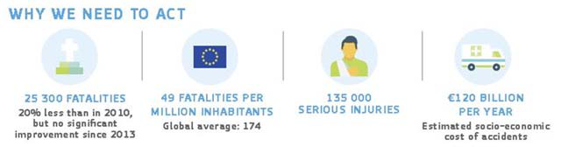
Figure 45: European Commission views on the need to address the main problem of persistent high number of road accidents
The European Commission [24] enforced that from 6 July 2022 on all new models introduced on the market should have several advanced safety features, such as:
- Advanced emergency braking;
- Alcohol interlock installation facilitation (cars, vans, trucks and buses);
- Drowsiness and attention detection (cars, vans, trucks and buses);
- Distraction recognition/prevention (cars, vans, trucks and buses);
- Event (accident) data recorder (cars and vans);
- Emergency stop signal (cars, vans, trucks and buses);
- Intelligent speed assistance (cars, vans, trucks and buses);
- Lane keeping assist (cars and vans);
- Reversing camera or detection system (cars, vans, trucks and buses).
Different countries and regions have already implemented safety functions and new evolved functions are planned. The regional NCAP organizations (e.g. Euro NCAP, US NCAP, etc.) have already developed their road maps for implementing new functions for the next period (see [35], [36] and [38]).
Through fusion of several vehicular perception sensors (e.g. camera, lidar and radar) a sensing performance is on the horizon, powerful enough for automated driving. By additionally using communication between vehicles or infrastructure the data set used by a car to decide on its next actions can be further improved.
The Society of Automotive Engineers (SAE) has defined five levels of autonomous driving. The relevant SAE standard SAE J3016TM that defines the levels of automated driving can be found in [43].
In Germany, currently series production cars up to level 3 are allowed to be used on the roads. Some manufacturers and groups of manufacturers are developing highly and fully automated vehicles (levels 4 and 5). End of 2018, the first robotic taxi service was started in Phoenix (Arizona).
Highly automated autonomous driving level 4 and fully automated cars of level 5 are expected to provide new forms and modes of transportation, changing the way mobility is provided.
In parallel, UNECE and ISO have worked and are working on detail regulations and test standards of assistance functions (see Table 17 and Table 18). Some of these functions can only be supported or provided by radar technology.
Table 17: Examples of UNECE requirements for current driver assistance systems
Regulation | Summary of Content
UNECE regulation 79 [27] | Dealing with vehicle steering, among others covering automatic steering during parking, automatic lane centering and automatic lane change.
UNECE regulation 131 [26] | Dealing with automatic emergency braking for busses and trucks.
UNECE regulation 151 [29] | Dealing with turn assist function for busses and trucks
UNECE regulation 152 [30] | Dealing with automatic emergency braking for passenger cars
Table 18: Examples of ISO standards for driver assistance systems
ISO standards | Summary of Content
ISO 15622:2018 [31] | Describes requirements and test for adaptive cruise control function
ISO17387:2008(E) [32] | Describes requirements and test for blind-spot detection and lane change assist functions
ISO 21202:2020 [33] | Describes requirements and test of partially automated lane change function
ISO 22078:2020 [34] | Describes requirements and test of emergency braking for bicyclists

- Existing Studies for the relevant RAS Band
This Annex includes information about existing studies in the relevant RAS band published in ECC and ITU.
ECC Report 056 (SRR 77-81 GHz) published 2004 [3]
Recommendation ITU-R RA.769 [18] was used to define the protection level to be -222 dBW/(m2·Hz) and the receiving antenna gain to be 0 dBi. Propagation models described in Recommendation ITU-R P.525 [44] and Recommendation ITU-R P.620 [46] were used.
A first study (Annex C, Section 6) was conducted to derive the maximum tolerable e.i.r.p. per SRR device from an aggregated scenario with a separation distance of 30 m to a RAS station.
A second study (Annex C, Section 7) was conducted to derive the separation distance to a RAS station assuming a mean e.i.r.p. power spectral density of -3 dBm/MHz for SRR.
ECC Report 139 (TLPR 75-85 GHz) published 2010 [38]
Recommendation ITU-R RA.769 [18] was used to define the protection level to be -208 dBW/(m2·Hz) and the receiving antenna gain to be 0 dBi. Propagation models described in Recommendation ITU-R P.525 [44].
A MCL study (Section 5.4.1) was conducted to derive the separation distance.
A Monte-Carlo study (Section 6.5) was conducted to derive the probability of interference varying the distance, the Tx antenna gain (random pointing), the activity and the power level.
Unwanted emissions were studied.
A list of relevant RAS stations is given in the Report.
ECC Report 222 (Helicopter Radars 76-79 GHz) published 2014 [7]
Recommendation ITU-R RA.769 was used to calculate the protection level to be -224 and -228 dBW/(m2·Hz) and to define the receiving antenna gain to be 0 dBi. The propagation model described in Recommendation ITU-R P.452 has been used with a time percentage of 50 %.
A MCL study (Section 4.2.2) was conducted to derive the critical separation distance.
The occurrence probability from take-off and landing has been determined in the critical areas to compare it against the maximum data loss value of 2 % (Section 4.2.5).
Unwanted emissions were studied.
A list of relevant RAS stations is given in the Report.
ECC Report 315 (HD-GBSAR 74-81 GHz) published 2020 [6]
Recommendation ITU-R RA.769 was used to calculate the protection level to be -228, -208 and -172 dBW/(m2·Hz) and to define the receiving antenna gain to be 0 dBi. The propagation model described in Recommendation ITU-R P.620 has been used.
A MCL study (Section 5.2.7) was conducted to derive the separation distance. An average Tx antenna was used in combination with an offset of 5° in elevation domain.
Unwanted emissions were studied.
A list of relevant RAS stations is given in the Report.

Report ITU-R RA.2457-0 (2019-06) 76-81 GHz [9]
Recommendation ITU-R RA.769 was used to calculate the protection level to be -228, -208 and -172 dBW/(m2·Hz) and to define the receiving antenna gain to be 0 dBi. An attenuation coefficient of 0.15 dB/km was used.
A MCL study (Section 4.2) was conducted to derive the separation distance. The propagation models described in Recommendation ITU-R P.525 [44], Recommendation ITU-R P.526 [45], and Recommendation ITU-R P.676 [47] have been used. Line-of-sight (LOS) and non-line-of-sight (NLOS) results were compared.
Site specific MCL (Section 5) studies were conducted to show critical areas taking into account terrain data. The Propagation model described in Recommendation ITU-R P.452 was used. Clutter losses other than terrain heights were not introduced.
LOS-measurements (Section 4.3 and Annex 3) with Rx antenna gains corresponding to the side lobes at two distances between RAS and SRR were undertaken to calculate a zone of avoidance. The propagation models described in Recommendation ITU-R P.525 [45] and Recommendation ITU-R P.676 have been used.
A list of relevant RAS stations is given in the Report.
Report ITU-R M.2322-0 (2014-11) 77.5-78 GHz [10]
Recommendation ITU-R RA.769 was used to calculate the protection level to be -228, -208 dBW/(m2·Hz) and to define the receiving antenna gain to be 0 dBi. The propagation models described in Recommendation ITU-R P.525 [44], Recommendation ITU-R P.526 [45], Recommendation ITU-R P.620 [46] and Recommendation ITU-R P.676 [47] have been used. Line-of-sight (LOS) and non-line-of-sight (NLOS) cases were considered. An attenuation coefficient of 0.358 dB/km was used.
A MCL study (Section 6.3.4.1) was conducted to derive the separation distance as a function of the density of SRR devices.
LOS-measurements (Section 6.3.4.2) with Rx antenna gains corresponding to the side lobes at two distances between RAS and SRR were undertaken to calculate a zone of avoidance. The propagation models described in Recommendation ITU-R P.525 and Recommendation ITU-R P.676 have been used.
A site specific MCL study (Section 6.3.4.3) was conducted to show critical areas taking into account terrain data.
A list of relevant RAS stations is given in the Report.
Table 19: Summary Table ECC
 | ECC Report 56 [3] | ECC Report 139 [38] | ECC Report 222 [7] | ECC Report 315 [6]
Year of Publication | 2004 | 2010 | 2014 | 2020
Frequency Band | 77-81 GHz | 75-85 GHz | 76-79 GHz | 74-81 GHz
Study type | MCL aggregation | MCL single entry, Monte-Carlo | MCL | MCL
RAS protection level | $$-222 \frac{dBW}{m²Hz}$$ | $$-208 \frac{dBW}{m²Hz}$$ | $$-228 \frac{dBW}{m²Hz}$$ | $$-228 \frac{dBW}{m²Hz}$$
RAS Antenna Gain | 0 dBi | 0 dBi | 0 dBi | 0 dBi
Propagation model | <45 km: P.525  >45 km: P.620 | P.525 | P.452 | P.620 “clear air mode”
Result 1 | Maximum e.i.r.p. as function of SRR density (no separation distance) | Separation distance (MCL) | Separation distance | Separation distance
Result 2 | Minimum separation distance as function of SRR density (no further e.i.r.p. restriction) | Probability of exceeding the protection level (Monte-Carlo) | Comparison of take-offs/landings with 2% criterion of time
Sections containing study results | Annex C / Section 6 & 7 | Section 5.4.1  Section 6.5 | Section 4.2.2  Section 4.2.5 | Section 5.2.7
Additional Information | - | list of 7 relevant RAS stations | list of 10 relevant RAS stations | list of 8 relevant RAS stations
Table 20: Summary Table ITU
 | Report ITU-R M.2322-0 [10] | Report ITU-R RA.2457-0 [9]
Year of Publication | 2014 | 2019
Frequency Band | 77.5-78 GHz | 76-81 GHz
Study type | MCL, Measurement | MCL, Measurement
RAS protection level | $$-228 \frac{dBW}{m²Hz}$$ | $$-228 \frac{dBW}{m²Hz}$$
RAS Antenna Gain | 0 dBi | 0 dBi
Propagation model | (I) P.525, P.526, P.676  (II) P.452 | (I) P.620, P.526  (II) P.525, P.526, P.676  (III) P.452
Gas coefficient | 0.358 dB/km | 0.15 dB/km
Result 1 | Separation distance (LOS/NLOS) | Separation distance (LOS/NLOS)  Minimum separation distance as function of SRR density (no further e.i.r.p. restriction)
Result 2 | Separation areas using terrain data  Separation distance based on measurements | Separation areas using terrain data  Separation distance based on measurements
Sections containing study results | Section 4.2  Section 4.3 & Annex 3  Section 5 | Section 6.3.4
Additional Information | List of 18 relevant RAS stations | List of 16 (7 of those are not using the band in 2019) relevant RAS stations
- Applicability of using Recommendation ITU-R P.452-16 in the band 77-81 GHz
This Annex includes information about the applicability of using Recommendation ITU-R P.452-16 [13] as propagation model in the band 77-81 GHz, although its applicable range is given with maximum 50 GHz. In the process of developing this ECC Report, the following comparison between different models was made.
  - Propagation model
For site specific calculations, path profiles have to be taken into account by the propagation model. Different models were compared, based on Recommendation ITU-R P.452-16 and Report ITU-R M.2322-0 [10]. The model used in Report ITU-R M.2322-0 combines Recommendation ITU-R P.525 [44] and Recommendation ITU-R P.526 [45], which are not restricted in frequency above 30 MHz. Section 4.5 “Method for a general terrestrial path” of P.526-15 was used. A time percentage of 2% was used. It could be observed that the major difference between the models came from the way clutter information was included.
  - Consideration of clutter loss
Site specific calculations, taking into account terrain heights, lack of nearby clutter information. Antennas are placed above the average surface height, which means that nearby clutter losses are disregarded. Two different ways of taking into account clutter losses are compared, e.g. due to a forest close to an antenna.
One way could be to place an additional obstacle into the terrain path between both antennas (plot b in Figure 47). Following attributes are proposed. The obstacle should have a height of 15 m (Recommendation ITU-R P.1812-5, table 2 [48]) and should be placed at a distance of about 25 m from the antenna, if the antenna is surrounded by a forest. This information could be obtained from Corine Land Cover maps like depicted in Figure 46. In Report ITU-R M.2322-0 [10], clutter heights were taken into account when diffraction was considered.
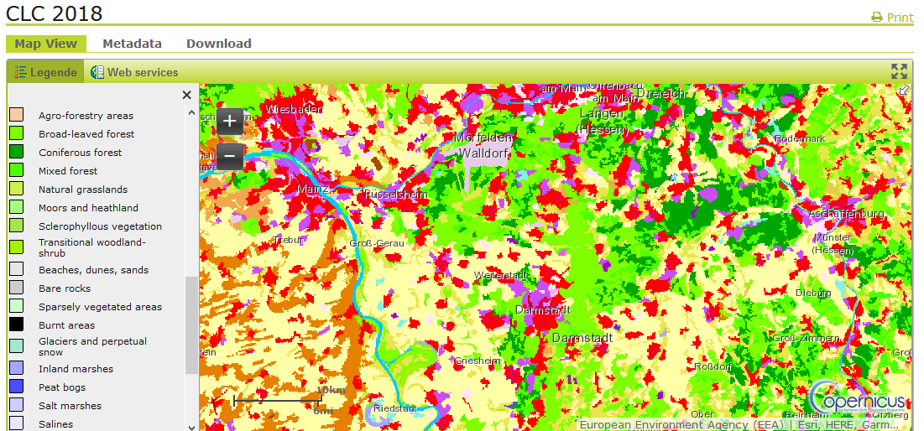
Figure 46: Example of CLC data
The other way to consider clutter losses is described in Recommendation ITU-R P.452-16 (plot c in Figure 47) and will be included in the comparison for the transmitter side. In this model, a wider range of clutter types is available.
In Figure 47, the aforementioned models are compared on a theoretical path with a length of 10 km. The blue curve shows the terrain height. Plots a, d, and e were calculated without taking into account clutter.
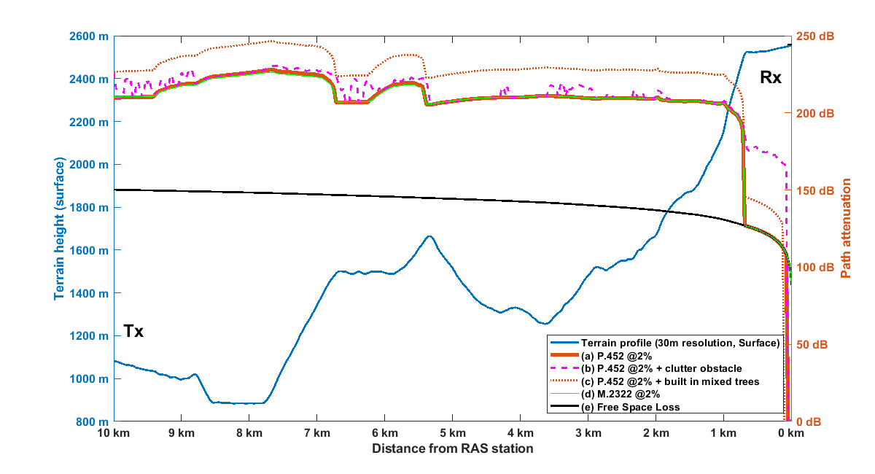
Figure 47: Comparison of path attenuation
Plot b shows that for close LOS conditions the additional loss due to an obstacle can be up to 50 dB, for other conditions the additional loss is up to 10 dB. There are many situations where no additional loss was calculated.
Plot c would give a constant value for additional path loss of about 20 dB for distances greater than 1 km from the receiver Rx. This model seems to be less deterministic, because the resulting terrain angles will be calculated in a statistical approach.
The model described in ITU-R M.2322 [10] without restriction of upper frequency is calculating quite similar values compared to the model ITU-R P.452 [13] without clutter. Therefore, even if model ITU-R P.452 is limited to 50 GHz, it is regarded as a model that can be used in this Report.

- List of References

- ECC Decision (04)03: “On the frequency band 77-81 GHz to be designated for the use of Automotive Short Range Radars”, approved March 2004
- ETSI TR 103 593 V1.1.1_0.1.5 (2020-02): "Short Range Devices; Transport and Traffic Telematics (TTT); Short. Range Radar equipment operating in the 77 GHz to 81 GHz"
- ECC Report 056: “Compatibility of automotive collision warning Short Range Radar operating at 79 GHz with radiocommunication services”, approved October2004
- ERC Report 25: “The European table of frequency allocations and applications in the frequency range 8.3 kHz to 3000 GHz”, approved June 1994, latest amended October 2021
- 2004/545/EC: Commission Decision of 8 July 2004 on the harmonisation of radio spectrum in the 79 GHz range for the use of automotive short-range radar equipment in the Community
- ECC Report 315: “Feasibility of spectrum sharing between High-Definition Ground Based Synthetic Aperture Radar (HD-GBSAR) application using 1 GHz bandwidth within 74-81 GHz and existing services and applications”, approved May2020
- ECC Report 222: “The impact of Surveillance Radar equipment operating in the 76 to 79 GHz range for helicopter application on radio systems”, approved September 2014
- Recommendation ITU-R M.2057-1 (01-2018): “Systems characteristics of automotive radars operating in the frequency band 76-81 GHz for intelligent transport systems applications
- Report ITU-R RA.2457-0 (06-2019): “Coexistence between the radio astronomy service and radiolocation service applications in the frequency band 76-81 GHz”
- Report ITU-R M.2322-0 (11-2014): “Systems characteristics and compatibility of automotive radars operating in the frequency band 77.5 78 GHz for sharing studies”
- Recommendation ITU-R M.1732-2 (01-2017): “Characteristics of systems operating in the amateur and amateur-satellite services for use in sharing studies”
- Report ITU-R F.2394-0 (11-2016): “Compatibility between point-to-point applications in the fixed service operating in the 71-76 GHz and 81-86 GHz bands and automotive radar applications in the radiolocation service operating in the 76-81 GHz bands”
- Recommendation ITU-R P.452-16 (07-2015): “Prediction procedure for the evaluation of interference between stations on the surface of the Earth at frequencies above about 0.1 GHz”
- Recommendation ITU-R F.699-8 (01-2018): “Reference radiation patterns for fixed wireless system antennas for use in coordination studies and interference assessment in the frequency range from 100 MHz to 86 GHz”
- Recommendation ITU-R F.758-7 (11-2019): “System parameters and considerations in the development of criteria for sharing or compatibility between digital fixed wireless systems in the fixed service and systems in other services and other sources of interference”
- Recommendation ITU-R RA.769-2 (05-2003): “Protection criteria used for radio astronomical measurements”
- Recommendation RA.1513-2 (03-2015): “Levels of data loss to radio astronomy observations and percentage-of-time criteria resulting from degradation by interference for frequency bands allocated to the radio astronomy service on a primary basis”
- Sources for the different RAS stations used in this Report, based on a compilation by Open Data Portal, Austria:
SRT, I: Regione Autonoma della Sardegna, Sardegna Geoportale: DTM 1 m and DTM 10 m https://www.sardegnageoportale.it/webgis2/sardegnamappe/?map=download_raster; License: Creative Commons Attribution 4.0 International (CC BY 4.0)
Plateau de Bure (NOEMA), F: Institut national de l’information géographique et forestière (IGN): RGE ALTI, DTM 5 m https://geoservices.ign.fr/documentation/diffusion/telechargement-donnees-libres.html https://geoservices.ign.fr/cgu-licences
Effelsberg, D: Land Nordrhein-Westfalen (2017), DTM 1 Meter & Landesamt für Vermessung und Geobasisinformation Rhineland-Palatinate: DTM 25 Meter (DGM25); License: Datenlizenz Deutschland Namensnennung 2.0
Noto, I: Regione Siciliana: MDT 2012-2013 2x2 ETRS89 (= DTM 2 m)
https://www.sitr.regione.sicilia.it/geoportale/mobile/search.html; License: Creative Commons Attribution 4.0 International (CC BY 4.0)
Yebes & Pico Veleta (IRAM 30-m), E: LiDAR-PNOA assigned by Instituto Geográfico Nacional (IGN): 1) DTM05, LIDAR 1st Coverage, download month 2019-11: DTM 5m, 2) DTM02, LIDAR 2nd Coverage, download month 2019-11: https://centrodedescargas.cnig.es/CentroDescargas/ /; License: Creative Commons Attribution 4.0 International (CC BY 4.0)
- T. G. Farr, P. A. Rosen, E. Caro, R. Crippen, R. Duren, S. Hensley, M. Kobrick, M. Paller, E. Rodriguez, L. Roth, D. Seal, S. Shaffer, J. Shimada, J. Umland, M. Werner, M. Oskin, D. Burbank and D. Alsdorf, “The Shuttle Radar Topography Mission:” Reviews of Geophysics, Vol. 45, 2007
- https://www.openstreetmap.org/
- https://opendatacommons.org/
- ©Corine Land Cover (CLC), https://www.copernicus.eu
- European Commission 2018/0145[COD]: "Proposal for a Regulation of the European Parliament and of the Council on type-approval requirements for motor vehicles and their trailers, and systems, components and separate technical units intended for such vehicles, as regards their general safety and the protection of vehicle occupants and vulnerable road users, amending Regulation (EU) 2018/… and repealing Regulations (EC) No 78/2009, (EC) No 79/2009 and (EC No 661/2009", (Text with EEA relevance) {SEC(2018)270 final} - {SWD(2018) 190 final} -{SWD(2018)191 final}
- European Commission: "Benefit and Feasibility of a Range of New Technologies and Unregulated Measures in the fields of Vehicle Occupant Safety and Protection of Vulnerable Road Users (March 2015)"
- Department Of Transportation, National Highway Traffic Safety Administration, [Docket No. NHTSA-2015-0119]: "New Car Assessment Program (NCAP)"
- SAE Levels of Driving Automation™ Refined for Clarity and International Audience, https://www.sae.org/blog/sae-j3016-update
- UNECE regulation 79: Uniform provisions concerning the approval of vehicles with regard to steering equipment, http://www.unece.org/fileadmin/DAM/trans/main/wp29/wp29regs/2018/R079r4e.pdf
- UNECE regulation 131: Uniform provisions concerning the approval of motor vehicles with regard to the Advanced Emergency Braking Systems (AEBS), https://www.unece.org/fileadmin/DAM/trans/main/wp29/wp29regs/2015/R131r1e.pdf
- UNECE regulation 151: Uniform provisions concerning the approval of motor vehicles with regard to the Blind Spot Information System for the Detection of Bicycles, https://unece.org/sites/default/files/2021-08/R151e.pdf
- UNECE regulation 152: Uniform provisions concerning the approval of motor vehicles with regard to the Advanced Emergency Braking System (AEBS) for M1 and N1 vehicles, https://www.unece.org/fileadmin/DAM/trans/main/wp29/wp29regs/2020/R152e.pdf
- ISO 15622:2018: Intelligent transport systems -- Adaptive cruise control systems -- Performance requirements and test procedures
- ISO 17387:2008(E): Intelligent transport systems -- Lane change decision aid systems (LCDAS) -- Performance requirements and test procedures
- ISO 21202:2020: Intelligent transport systems -- Partially Automated Lane Change Systems (PALS) -- Functional / operational requirements and test procedures
- ISO 22078:2020: Intelligent transport systems -- Bicyclist detection and collision mitigation systems (BDCMS) -- Performance requirements and test procedures
- Euro NCAP Roadmap 2025.
NOTE: Available at https://cdn.euroncap.com/media/30700/euroncap-roadmap-2025-v4.pdf.
- NHTSA Announces Coming Upgrades to New Car Assessment Program.
NOTE: Available at https://www.nhtsa.gov/press-releases/ncap-upgrades-coming
- Radio Regulations Edition 2020
- ECC Report 139: "Impact of Level Probing Radars (LPR), using Ultra-Wideband Technology on Radiocommunications Services", approved February 2010
- NHTSA Proposes Significant Updates to Five-Star Safety Ratings Program, https://www.nhtsa.gov/press-releases/five-star-safety-ratings-program-updates-proposed
- ECC Report 344: “Sharing and compatibility studies of Security Scanners (SScs) within frequency range 60-82 GHz”, approved October 2022
- ECC Decision 21(02): “On the harmonised frequency band 76-77 GHz, technical characteristics, exemption from individual licensing and free circulation and use of High Definition Ground Based Synthetic Aperture Radar (HD-GBSAR)”, approved November 2021, updated 1 July 2022
- ECC Decision(16)01: “On the harmonised frequency band 76-77 GHz, technical characteristics, exemption from individual licensing and free carriage and use of obstacle detection radars for rotorcraft use”, approved March 2016, corrected on 18 November 2016
- SAE J3016TM: "Automated driving levels", January 2019
NOTE: Available at https://www.sae.org/news/2019/01/sae-updates-j3016-automated-driving-graphic.
- Recommendation ITU-R P.525: " Calculation of free-space attenuation"
- Recommendation ITU-R P.526: "Propagation by diffraction"
- Recommendation ITU-R P.620: " Propagation data required for the evaluation of coordination distances in the frequency range 100 MHz to 105 GHz"
- Recommendation ITU-R P.676: " Attenuation by atmospheric gases and related effects"
- Recommendation ITU-R P.1812: "A path-specific propagation prediction method for point-to-area terrestrial services in the frequency range 30 MHz to 6 000 MHz"
- ECC Report 327: "Technical studies for the update of the Ultra Wide Band (UWB) regulatory framework in the band 6.0 GHz to 8.5 GHz", approved October 2021
- ERC Recommendation 70-03: “Relating to the use of Short Range Devices (SRD)”, approved October 1997,latest amended on 10 June 2022, editorial update on 14 October 2022

