Usage of aerial UE in 1.8 GHz, 2 GHz and 2.6 GHz frequency bands with MFCN AAS base stations
approved 18 November 2022
ECC Report 348

Executive summary
This Report addresses the usage of aerial UE in the 1.8 GHz, 2 GHz and 2.6 GHz MFCN harmonised frequency bands with AAS base stations (BS) operating according to the ECC framework in those bands (see relevant ECC Decisions). This Report complements ECC Report 309 [4] by analysing the possible additional risk of interference created by AAS BS on adjacent systems when serving aerial UE or by aerial UE communicating with AAS BS. Potential MFCN intra-network interference is not covered by this Report. This Report also assesses any impact from MFCN technologies (LTE, 5G NR) serving aerial UE.
Due to the current state of the technology, usage of AAS BS is not foreseen in the 700 MHz, 800 MHz or 900 MHz MFCN harmonised frequency bands. In consequence, those MFCN harmonised bands have not been considered in this Report.
MFCN AAS BS serving aerial UE may offer a different interference scenario compared to serving UE that are located on the ground, and hence are relevant to systems indicated in Table 1.
The conclusions of the analysis are summarised in Table 1:
Table 1: Frequency bands where aerial UE connected to AAS MFCN BS in 1.8 GHz, 2 GHz and 2.6 GHz and associated required regulatory measures (in addition to those identified by ECC Report 309)
Aerial UE frequency band  (MHz) | MFCN BS AAS  Frequency band  (MHz) | Additional regulatory measure required  (in addition to those identified by  ECC Report 309) | Victim system (on receiver on board flying platform)
1710-1785 | 1805-1880 | None | None
1920-1980 | 2110-2170 | None | Satellite MSS 1980-2010 MHz
1920-1980 | 2110-2170 | None | Satellite services 2025-2110 MHz
1920-1980 | 2110-2170 | None | MSS/CGC 2170-2200 MHz  (MSS airborne receiver, airborne CGC receiver)
2500-2570  2570-2620 | 2620-2690  2570-2620 | (see hereafter) | None
At 2.6 GHz, adjacent applications: RAS and radars (ATC, military and Meteo) refer only to ground receivers. The usage of MFCN by aerial UE when AAS BS are deployed requires similar mitigation measures in the 2.6 GHz frequency band to those already identified in ECC Report 309 which are taken into consideration in the current harmonised MFCN framework based on CEPT Report 72 [5] and ECC Report 308 [6].

TABLE OF CONTENTS

0 Executive summary 2
1 Introduction 5
2 Main assumptions 6
3 Technologies (LTE, 5G NR) comparison 7
4 1.8 GHz Band 8
4.1 Frequency Arrangement 8
4.2 Compatibility Discussions 8
4.3 Summary 8
5 2 GHz Band 9
5.1 Frequency Arrangement 9
5.2 Compatibility Discussions 9
5.3 Summary 9
6 2.6 GHz Band 10
6.1 Frequency Arrangement 10
6.2 Compatibility Discussions 10
6.3 Summary 10
7 Conclusion 11
ANNEX 1: Impact of AAS BS serving Aerial UE in the 2110-2170 MHz on Satellite Services operating in 2025-2110 MHz (Earth-to-Space) 12
ANNEX 2: List of References 26

LIST OF ABBREVIATIONS

Abbreviation | Explanation
3GPP | 3rd Generation Partnership Project
5G NR | 3GPP 5th Generation mobile networks New Radio
AAS | Active Antenna System
ACLR | Adjacent Channel Leakage Power Ratio
ATC | Air Traffic Control
BS | Base Station
CEPT | European Conference of Postal and Telecommunications Administrations
CGC | Complementary Ground Component (see ECC Decision (06)09 [7] for the definition)
DECT | Digital Enhanced Cordless Telephony
ECC | Electronic Communications Committee
LTE | Long Term Evolution
MFCN | Mobile Fixed Communication Network
MSS | Mobile-Satellite Service
NR | New Radio
OOBE | Out-of-Band Emissions
RAS | Radio Astronomy Service
UE | User Equipment

Introduction
This Report addresses the usage of aerial UE in the 1.8 GHz, 2 GHz and 2.6 GHz frequency bands: with AAS base stations (BS) operating according to the ECC framework in those bands (see relevant ECC Decisions). This Report complements ECC Report 309 [4] by analysing the possible risk of interference created by AAS BS on adjacent systems when serving aerial UE or by aerial UE communicating with AAS BS. Potential MFCN intra-network interference is not covered by this Report. This Report assesses also the impact from MFCN technologies (LTE, 5G NR) serving aerial UE.
This Report includes a relevant section for each of the addressed frequency bands: 1.8 GHz, 2 GHz and 2.6 GHz. The performed technical studies are included in Annex 1 of this Report.
Due to the current state of technology, AAS is not foreseen in the 700 MHz, 800 MHz and 900 MHz MFCN harmonised frequency bands and therefore these MFCN harmonised bands have not been considered in this Report.

Main assumptions
The studies in ECC Report 309 [4] were focused on non-AAS BS, except those on 3.4-3.8 GHz where the AAS BS case has been addressed.
According to ECC Report 309: "The intention is to use already existing MFCN BS, which are typically deployed to provide effective coverage at ground level. At this stage, mobile operators do not intend to develop specific network planning to respond to these new aerial uses. Due to this, coexistence studies are mostly required for Uplink, due to the elevated position of aerial UE. No specific studies are required in the Downlink for non-AAS BS, since the emission characteristics are not modified. Studies in the Downlink would only be required for the case of AAS BS, where beam steering may lead to beam pointing above the horizon and may modify the emission characteristics." In consequence, this ECC Report 348 has analysed and studied impact of AAS BS pointing above the horizon.
The AAS feature optimises the effective transmission power of the aerial UE due to higher gain created by the BS towards the transmitting UE together with the power control feature. The aerial UE transmits lower power when connecting to an AAS BS compared to a connection with a non-AAS BS.
In addition to the assumptions used in ECC Report 309, this Report also considers the case where some AAS BS could create a beam pointing towards a direction above the horizon to serve aerial UE, even though that due to the vertical scan angle limitations in current AAS BS deployment scenarios the main beam may not be able to follow aerial UE in the sky. As a result, there is no reason for victim receivers located on the ground and operating in adjacent bands to face additional interference, either due to the AAS BS transmission mask (OOBE or spurious domain), or their own selectivity.
In this case, the received level of interference is assumed to be lower than the level of interference created by AAS BS serving on-ground UE.
Studies have been carried out to assess whether additional interference may be generated to victim receivers not on the ground but on board a flying platform.
This Report assesses for each band the relevant case where the victim receiver is not on the ground and in case of modifications of above assumptions of ECC Report 309.
This Report assumes that aerial UE are non-AAS.

Technologies (LTE, 5G NR) comparison
The technical conditions for LTE aerial UE have been studied in ECC Report 309 [4] for protecting adjacent band radio systems, which are defined as:
- OOB emission limit for aerial UE
or
- No-fly zone for aerial UE.
The difference between LTE UE and 5G NR UE stems from a different channel occupancy rate for some channel bandwidths, as shown in Table 2 below (CEPT Report 81 [8]).
Table 2: LTE and 5G NR channel bandwidth and occupied channel bandwidth
Technology | LTE UE  (ETSI TS 136.101 [9]) | 5G NR UE  (ETSI TS 138.101 [10])
Channel bandwidth (MHz) | 5, 10, 15, 20 | 5, 10, 15, 20, 25, 30
Occupied channel bandwidth (MHz) | 4.5, 9, 13.5, 18 | 4.5, 9.36, 14.22, 19.08, 23.94, 28.8
The commonality between LTE UE and 5G NR UE transmitter characteristics are summarised in Table 3.
- LTE UE and 5G NR UE have the same maximum transmit power
- LTE UE and 5G NR UE have the transmit power dynamic range
- LTE UE and 5G NR UE have the same ACLR (Adjacent Channel Leakage Power Ratio)
Table 3: Commonality between LTE UE and 5G NR UE
Technology | LTE UE  (ETSI TS 136.101 [9]) | 5G NR UE  (ETSI TS 138.101 [10])
Maximum transmit power (dBm/channel) (Class 3) | 23 | 23
UE transmit power dynamic range for 5, 10, 15, 20 MHz channel | 63 dB (from 23 dBm to -40 dBm) | 63 dB (from 23 dBm to -40 dBm)
ACLR (For Tx Power Class 3) (dB) | 30 | 30
Even though there is a slight difference of channel occupancy rate between LTE UE and 5G NR UE, they have the same in-band and adjacent band transmitter characteristics.
Consequently, it can be concluded that the technical conditions such as no-transmit zone or OOBE limits based on the studies from the ECC Report 309 are valid for both LTE and 5G NR aerial UE.
Moreover, since characteristics and usage of AAS are similar for both LTE and 5G NR base stations, it can also be deduced from a purely technology perspective that the possible risk of interference from AAS BS to adjacent systems when operating with aerial UE will be the same for both LTE and 5G NR technologies used for MFCN.
In consequence, when defining the regulatory measures applicable for aerial UE usage in relevant harmonised MFCN bands, there is no need to differentiate between LTE and 5G NR. Relevant analysis shall only focus on non-AAS and AAS MFCN issues.

1.8 GHz Band

Frequency Arrangement
The following figure illustrates the current frequency arrangement in the 1.8 GHz band:

Figure 1: Frequency arrangement in the 1.8 GHz band

Compatibility Discussions
The BS transmission in 1805-1880 MHz with AAS features is permitted by the revised ECC Decision (06)13 [1]. This Decision and the associated report (ECC Report 297 [11]) identify specific restrictions and mitigation measures to ensure coexistence with systems operating in adjacent bands.
For the 1.8 GHz frequency band, all adjacent applications only use ground receivers: MetSat (space-to-Earth), radio microphones, fixed services and DECT.
In line with the main assumptions (section 3) for this band, the use of MFCN AAS BS to serve aerial UE does not lead to additional interference cases to be studied.

Summary
The usage of MFCN by aerial UE where AAS BS are deployed does not require additional mitigation measures in the 1.8 GHz band other than those (if any) already identified in ECC Report 309 [4].

2 GHz Band

Frequency Arrangement
The following figure illustrates the current frequency arrangement in the 2 GHz band:

Figure 2: Frequency arrangement in the 2 GHz band

Compatibility Discussions
The BS transmission in 2110-2170 MHz with AAS antenna is permitted by the revised ECC Decision (06)01 [2]. This Decision and the associated Report (ECC Report 298 [12]) identify specific restrictions and specific mitigation measures to ensure coexistence with systems operating in adjacent bands.
For the 2 GHz frequency band, the cases relating to victim receivers not on the ground are the following:
- MSS in 1980-2010 MHz (Earth-to-space): As there is at least 100 MHz frequency separation from MFCN downlink (starting above 2110 MHz) and the satellite MSS receiver bands (ending at 2010 MHz), there is no risk that the emission levels (in the spurious domain, i.e. not higher than -30 dBm/MHz) from AAS BS would cause any interference to MSS receivers;
- Satellite services operating in 2025-2110 MHz (Earth-to-space) with space station receiver;
- MSS/CGC in 2170-2200 MHz: the MSS airborne receiver (space-to-Earth) as well as the airborne CGC receiver (CGC downlink) may be interfered by MFCN AAS BS transmissions.

Summary
The conclusions of this Report confirm the following:
- No additional protection measure is identified with satellite services operating in 2025-2110 MHz (Earth-to-space) (Annex 1);
The use of AAS BS for the coverage of aerial UE does not cause more interference than the current use of non-AAS BS covering terrestrial UE. The coverage of aerial UE in addition to the current coverage of terrestrial UE by AAS BS does not change the current interference environment and would not cause additional interference to satellite receivers;
- No additional protection measure is identified with MSS/CGC in 2170-2200 MHz.

2.6 GHz Band

Frequency Arrangement
Figure 3 illustrates the current frequency arrangement in the 2.6 GHz band.
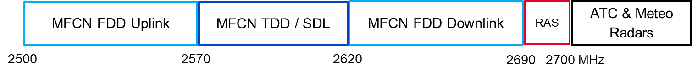
Figure 3: Frequency arrangement in the 2.6 GHz band

Compatibility Discussions
The BS transmission in 2620-2690 MHz with AAS is permitted by the revised ECC Decision (05)05 [3]. This Decision and the associated report (ECC Report 308 [5]) identify specific restrictions and mitigation measures to ensure coexistence with systems operating in adjacent bands.
For the 2.6 GHz frequency band, the adjacent applications RAS and radars (ATC, military and Meteo) only use ground receivers.
Therefore, for this band the usage of MFCN AAS BS to serve aerial UE under the additional regulatory measures required according to ECC Report 308 [6] does not lead to additional interference cases to be studied.
In particular, according to ECC Report 308, the following analysis/conclusions are noted:
- Concerning radars, when AAS is not pointing towards such stations, AAS is not expected to cause more interference than non-AAS BS;
- Concerning RAS sites (2690-2700 MHz), an additional baseline at 2690-2700 MHz is implemented for AAS FDD base stations including one to reduce the size of the coordination zone with radio astronomy sites.

Summary
The use of MFCN by aerial UE when AAS BS are deployed requires mitigation measures in the 2.6 GHz band similar to those already identified in ECC Report 309 [4] which are taken into consideration by the current harmonised MFCN framework based on CEPT Report 72 [5] and ECC Report 308 [6].
Operational conditions refer to no-transmit zones or alternative measures (e.g. additional filtering) to protect radars above 2700 MHz, where appropriate, and no-transmit zones around RAS sites operating in 2690-2700 MHz.
When establishing these no-transmit zones, in particular to RAS sites, administrations shall also consider the coordination zones with radio astronomy sites already implemented according to ECC Decision (05)05 [3] (based on CEPT Report 72 and ECC Report 308).

Conclusion
This Report addresses the usage of aerial UE in 1.8 GHz, 2 GHz and 2.6 GHz MFCN harmonised frequency bands with AAS base stations (BS) operating according to the ECC framework in those bands (see relevant ECC Decisions). This Report complements ECC Report 309 [4] by analysing possible additional risk of interference created by AAS BS on adjacent systems when serving aerial UE or by aerial UE communicating with AAS BS. Potential MFCN intra-network interference is not covered by this Report. This Report also assesses any impact from MFCN technologies (LTE, 5G NR) serving aerial UE.
Due to the current state of the technology, usage of AAS BS is not foreseen in the 700 MHz, 800 MHz, 900 MHz MFCN harmonised frequency bands. Consequently, those MFCN harmonised bands have not been considered in this Report.
MFCN AAS BS serving aerial UE may offer a different interference scenario compared to serving UE that are located on the ground, and hence are relevant to systems indicated in the following table.
The conclusions of the analysis are summarised in the following table:
Table 4: Frequency bands where aerial UE connected to AAS MFCN BS in 1.8 GHz, 2 GHz and 2.6 GHz and associated required regulatory measures (in addition to those identified by ECC Report 309)
Aerial UE frequency band  (MHz) | MFCN BS AAS  Frequency band  (MHz) | Additional regulatory measure required  (in addition to those identified by  ECC Report 309) | Victim system (on receiver on board flying platform)
1710-1785 | 1805-1880 | None | None
1920-1980 | 2110-2170 | None | Satellite MSS 1980-2010 MHz
1920-1980 | 2110-2170 | None | Satellite services 2025-2110 MHz
1920-1980 | 2110-2170 | None | MSS /CGC 2170-2200 MHz  (MSS airborne receiver, airborne CGC receiver)
2500-2570  2570-2620 | 2620-2690  2570-2620 | (see hereafter) | None
At 2.6 GHz, adjacent applications: RAS and radars (ATC, military and Meteo) refer only to ground receivers. The usage of MFCN by aerial UE when AAS BS are deployed requires similar mitigation measures in the 2.6 GHz frequency band to those already identified in ECC Report 309 which are taken into consideration in the current harmonised MFCN framework based on CEPT Report 72 [5] and ECC Report 308 [6].

- Impact of AAS BS serving Aerial UE in the 2110-2170 MHz on Satellite Services operating in 2025-2110 MHz (Earth-to-Space)
  - Introduction
The analysis in this section presents a study to estimate the evolution of the interference environment in the case where AAS BS, currently used for terrestrial UE coverage, were also used to provide service to aerial UE. The result of this potential use-case is then compared to the current use of AAS and non-AAS BS serving only ground users.
This study follows a similar methodology than the one used in the former ECC Report 298 [12]. The analysis is performed regarding the co-channel interference generated by either 4G or 5G networks even if the considered systems are operating in adjacent bands (see section 6.1). As standard 4G/5G AAS and non-AAS base stations have similar specifications in the out-of-band domain, it is understood that the comparison of the impacts created by any type of considered base stations (AAS or non-AAS and serving or not aerial UE) in the MFCN band will lead to similar conclusions as the comparison of their impacts in the adjacent band used by satellite services.
  - study Characterisitics
    - AAS and non AAS BS transmitter characteristics
The following characteristics have been extracted from Table 9 of Annex 4.4 to the WP5D chairman's report 5D/716 [13]:
Table 5: Beamforming antenna characteristics for IMT in 1710-4990 MHz
 |  | Rural macro | Suburban macro | Urban macro
1 | Base station antenna characteristics
1.1 | Antenna pattern | Refer to the extended AAS model in Table A of Annex 3
1.2 | Element gain (dBi) (Note 1) | 6.4 | 6.4 | 6.4
1.3 | Horizontal/vertical 3 dB beam width of single element (degree) | 90º for H  65º for V | 90º for H  65º for V | 90º for H  65º for V
1.4 | Horizontal/vertical front-to-back ratio (dB) | 30 for both H/V | 30 for both H/V | 30 for both H/V
1.5 | Antenna polarisation | Linear ±45º | Linear ±45º | Linear ±45º
1.6 | Antenna array configuration (Row × Column) (Note 2) | 4 × 8 elements | 4 × 8 elements | 4 × 8 elements
1.7 | Horizontal/Vertical radiating element/sub-array spacing, dh /dv | 0.5 of wavelength for H, 2.1 of wavelength for V | 0.5 of wavelength for H, 2.1 of wavelength for V | 0.5 of wavelength for H, 2.1 of wavelength for V
1.7a | Number of element rows in sub-array, Msub | 3 | 3 | 3
1.7b | Vertical radiating element spacing in sub-array, dv,sub | 0.7 of wavelength of V | 0.7 of wavelength of V | 0.7 of wavelength of V
1.7c | Pre-set sub-array down-tilt, θsubtilt (degrees) | 3 | 3 | 3
1.8 | Array Ohmic loss (dB) (Note 1) | 2 | 2 | 2
1.9 | Conducted power (before Ohmic loss) per antenna element/sub-array (dBm) (Note 5, 6) | 28 | 28 | 28
1.10 | Base station horizontal coverage range (degrees) | ±60 | ±60 | ±60
1.11 | Base station vertical coverage range (degrees) (Notes 3, 4, 7) | 90-100 | 90-100 | 90-100
1.12 | Mechanical downtilt (degrees) (Note 4) | 3 | 6 | 6
1.13 | Maximum base station output power/sector (e.i.r.p.) (dBm) | 72.28 | 72.28 | 72.28
Note 1: The element gain in row 1.2 includes the loss given in row 1.8 and is per polarization. This means that this parameter in row 1.8 is not needed for the calculation of the BS composite antenna gain and e.i.r.p.
Note 2: For the small/micro cell case, 8 × 8 means there are 8 vertical and 8 horizontal radiating elements. For the extended AAS model case, 4 × 8 means there are 4 vertical and 8 horizontal radiating sub-arrays.
Note 3: The vertical coverage range is given in global coordinate system, i.e. 90° being at the horizon.
Note 4: The vertical coverage range in row 1.11 includes the mechanical downtilt given in row 1.12.
Note 5: The conducted power per element assumes 8 × 8 × 2 elements for the micro/small cell case, and 4 x 8 x 2 sub-arrays for the macro case (i.e. power per H/V polarised element).
Note 6: In sharing studies, the transmit power calculated using row 1.9 is applied to the typical channel bandwidth given in Table 5-1 and 6-1 respectively for the corresponding frequency bands.
Note 7: In sharing studies, the UE that are below the base station vertical coverage range can be considered to be served by the “lower” bound of the electrical beam, i.e. beam steered towards the max. coverage angle. A minimum BS-UE distance along the ground of 35 m should be used for urban/suburban and rural macro environments, 5 m for micro/outdoor small cell, and 2 m for indoor small cell/urban scenarios.
Similarly, Table 5-1 of Annex 4.4 to the WP5D Chairman's Report 5D/716 provides the list of deployment assumptions to consider for both AAS and non AAS BS in the 2-3 GHz band.
Table 6: Deployment-related parameters for bands between 1 and 3 GHz
 | Rural macro | Urban/suburban macro
Base station characteristics/Cell structure
Cell radius/Deployment density (for bands between 2 and 3 GHz)  (Report ITU-R M.2292 [17]) | > 2 km  (typical value to be used in sharing studies 4 km) | 0.2-0.8 km urban / 0.4-2.5 km suburban (typical value to be used in sharing studies for urban macro 0.4 km and for suburban macro 0.8 km)
Antenna height  (Report ITU-R M.2292) | 30 m | 20 m urban / 25 m suburban (2-3 GHz)
Sectorization | 3 sectors | 3 sectors
Non-AAS BS downtilt  (Report ITU-R M.2292)  (Note 1) | 3 degrees | 10 degrees urban/6 degrees suburban
Frequency reuse | 1 | 1
Non-AAS BS antenna pattern (Note 1) | Recommendation ITU-R F.1336 (recommends 3.1) [14]  ka = 0.7  kp = 0.7  kh = 0.7  kv = 0.3  Horizontal 3 dB beamwidth: 65 degrees  Vertical 3 dB beamwidth: determined from the horizontal beamwidth by equations in Recommendation ITU-R F.1336.  Vertical beamwidths of actual antennas may also be used when available.
Non-AAS BS antenna polarisation (Note 1) | Linear/±45 degrees | Linear/±45 degrees
Indoor base station deployment | n.a. | n.a.
Indoor base station penetration loss | n.a. | n.a.
Below rooftop base station antenna deployment (Report ITU-R M.2292) | 0% | Urban: 30% (1-2 GHz), 50% (2-3 GHz)  Suburban: 0%
Non-AAS BS feeder loss (Note 1) | 3 dB | 3 dB
Typical channel bandwidth | 10 MHz | 10 MHz
Maximum Non-AAS BS output power (in 10 or 20 MHz) (Report ITU-R M.2292) (Note 1) | 46 dBm | 46 dBm
Maximum Non-AAS BS antenna gain (Report ITU-R M.2292) (Note 1) | 18 dBi | 16 dBi
Maximum Non-AAS BS output power/sector (e.i.r.p.) (Note 1) | 61 dBm | 59 dBm
Network loading factor (base station load probability X%) (see annex 4.4 of [13] and Recommendation ITU-R M.2101 Annex 1, section 3.4.1 and 6 [15]) | 20%, 50% | 20%, 50%
Average Non-AAS BS power/sector (e.i.r.p.) taking into account activity factor (Note 1) | Use Recommendation ITU-R M.2101 (see section 3.4 of [13]) | Use Recommendation ITU-R M.2101 (see section 3.4 of [13])
TDD/FDD | Depending on band | Depending on band
BS TDD activity factor | 75% | 75%
Note 1: This parameter is only applicable for non-AAS base stations. Antenna characteristics for AAS base stations (for frequency bands above 1 710 MHz) are provided in Table 5.
ECC Report 298 [12] also puts forward a list of assumptions to model large area deployment in the form of an average cell radius distance of 6.8 km. When looking at the resulting number of BS in the ECC Report 298 study summary, one can understand this 6.8 km as the average radius of BS deployment, meaning that the BS are deployed with a distance of 6.8x2 = 13.6 km separating each one of them on average, for the case of a disk cell shape. In this study, both the Ra/Rb and the ECC Report 298 approaches will be considered, and their results compared.
As described in the introduction, the aim of the study is to compare the evolution of the interference environment in the case where currently used AAS BS were to provide service to aerial UE. In order to simulate this scenario where AAS BS provide service to both terrestrial and aerial UE, it is assumed in this study that the repartition of the UE would be: 67% terrestrial UE and 33% aerial UE.
    - Satellite receiver characteristics
Similar to the previous section, the characteristics of the satellite receiver are based on ECC Report 298 [12]. The study therefore considers a satellite receiver at an altitude of 250 km.
According to section 4.2 of Annex 1 to Recommendation ITU-R SA.1154 [16], the satellite receiver gain could be considered as quasi omnidirectional: "The average gain of a quasi omnidirectional antenna is around 0 dBi with gain minima exceeding occasionally –6 dBi ". For this study, a 0 dBi gain was assumed in all directions for the satellite receiving antenna.
  - Analysis steps and results
- Step 1: Consider 1 satellite 250 km (worst case) above (90° elevation) an MFCN central cell (tri-sector).
- Step 2: Divide the satellite visibility coverage (Elevation >=0°) into elemental grid cells with a step of 0.1° in latitude and 0.1° in longitude. Calculate the elementary surface linked to each grid cell. The result is dependent on the elementary surface latitude as shown in the following figures. The figure on the left is for a satellite receiver at longitude 0° and latitude 0° and is the standard case considered for the rest of the study presented below. The figure on the right shows a projection of the satellite footprint and elementary cell surfaces for a satellite at longitude 5° and latitude 45° (covering part of Europe).
Satellite @ (Lat, Long) = (0°, 0°) | Satellite @ (Lat, Long) = (45°, 5°)
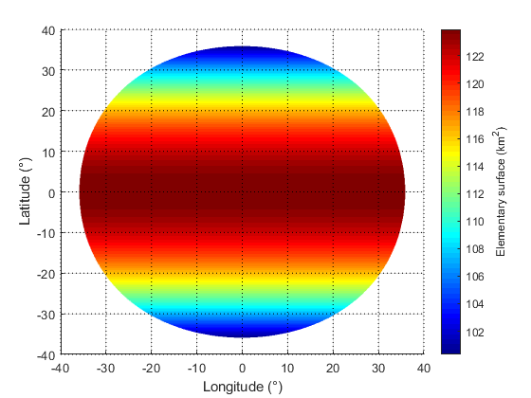 | 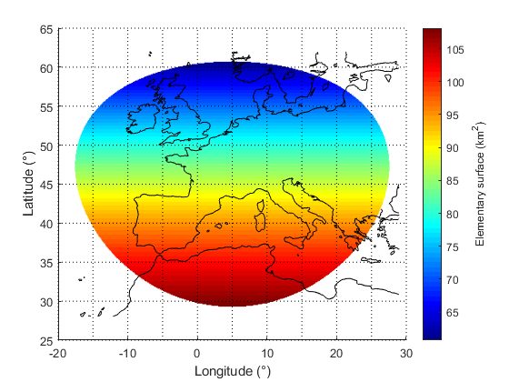
Figure 4: Elementary surface for longitude 0°, latitude 0° (left), and longitude 5°, latitude 45 (right)
- Step 3: Calculate the number of BS per grid cell.
  - Step 3.1: Use the Ra/Rb methodology
As mentioned in the deployment-related parameters table in section A1.2.1 above, the cell radius is defined in Report ITU-R M.2292 [17] as the distance (A) in Figure 5:
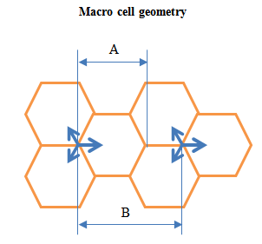
Figure 5: Macro cell geometry
Based on this definition, one can calculate the density of AAS BS sectors in the various deployment environments using the following formula:
$$Ds=1/A_{s}$$ | (1)
With $A_{s}$ the area covered by one BS sector (corresponding to a regular hexagon) defined as follows:
$$A_{s}=\frac{3\sqrt{3}}{2}{\left(\frac{cell_radius}{2}\right)}^{2}$$ | (2)
Table 7 provides the corresponding AAS BS sector density per square km:
Table 7: AAS BS sector density per square km
Deployment environment | Cell radius in km | Sectoral AAS BS density, Ds per square km
Urban | 0.4 | 9.62 BS/km²
Suburban | 0.8 | 2.4056 BS/km²
Since this study assumes a deployment of AAS BS over the entire visibility of the satellite receiver, it is proposed to implement the Ra/Rb methodology to calculate the total number of BS to be considered in the study.
The Rb factor is independent of frequency as it relates to the ratio of built areas over total area. The following values proposed to be used in this study are based on option 1 of Table 11 (6-8 GHz band) of the Annex 4.4 to the WP5D chairman's report [13]:
Table 8: Values of Rb
Parameter | Value
Rb (depending on the area under study) | 5% (area < 200000 km2)  2% (200000 - 1000000 km2)  1% (area > 1000000 km2)
Given that the total area of visibility for a satellite at 250 km is equal to about 9.64 million square km, the 1% Rb value is assumed for BS deployment in this area.
No Ra factors were provided for the 1-3 GHz frequency band in the Annex 4.4 to the WP5D chairman's report. However, for this study a Ra factor of 80% is assumed to be representative for the suburban/urban deployment case.
The total number of BS for each element surface in the satellite visibility can then be calculated using the following formula:
$$N_{Tot_BS}= \sum_{i=1}^{M}{S_{area}}∙D_{s_BS_i}∙R_{a_i}∙R_{b}$$ | (3)
With:
- $N_{Tot_BS}$: the total number of BS in a given elemental surface, corresponding to the sum of suburban and urban IMT deployment;
- $S_{area}$: the elemental surface area within the satellite visibility area;
- $D_{s_BS_i}$: the BS deployment density for the different deployment environment i, in this case suburban and urban (values presented in table above);
- $R_{a_i}$: the Ra factor for the different deployment environment i, in this case the Ra factor is assumed to be 80% for both suburban and urban deployments;
- $R_{b}$: ratio of built areas to total area of region in study, defined in the table above.
With $Surface_{i}$ the i-th elemental surface defined in step 2 within the satellite visibility. Figure 6 shows the number of BS per elemental surface ($N_{BS_{i}}$) over the satellite visibility area for the suburban, urban and finally combined deployment environment cases.
Suburban BS deployment per elemental surface | Urban BS deployment per elemental surface
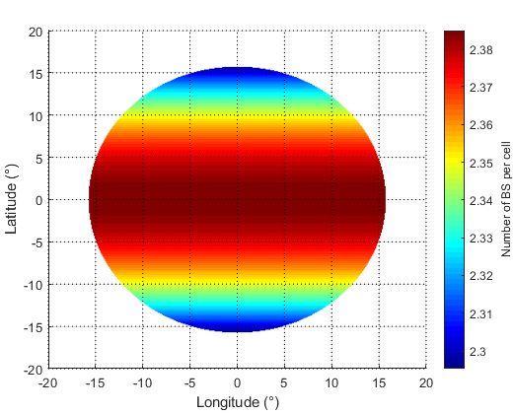 | 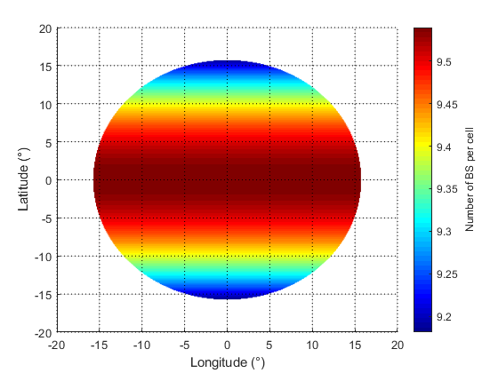
Total BS deployment considered in the study (sum of the row above)
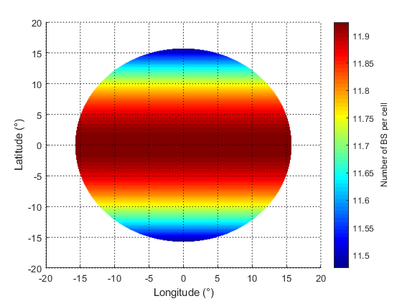
Figure 6: Number of BS per elemental surface
When summing the number of BS deployed in the elemental surfaces over the area footprint, the total number of BS deployed in the satellite visibility area equates to about 927241 BS. One can note that when applying the above formula to the entire satellite visibility instead to each elemental cells, the total number of BS amounts to 927697. This is linked to the accuracy based on the elemental surface cell spacing of 0.1 degree steps in latitude and longitude. There is only about 0.05% between these two numbers showing that the 0.1 degree cell step is granular enough for this study.
  - Step 3.2: Use the ECC Report 298 [12] methodology
One can compare the result of the above step 3.1 to the total number of BS calculated in ECC Report 298. ECC Report 298 assumes an average BS intersite distance of 6.8 x 2 = 13.6 km. The average area per BS is therefore calculated as follows:
$$A_{grid}=π{r_{grid}}^{2}=147.3 km^{2}$$ | (4)
With.
- $A_{grid}$ the MFCN average intersite area;
- $r_{grid}$the average MFCN intersite radius (=6.8 km as per ECC Report 298).
Using these assumptions, ECC Report 298 approximated the number of MFCN sites within the visibility footprint of a satellite at 250 km altitude to 66700 MFCN sites. One can obtain this number by simply dividing the total area by the above average intersite area $A_{grid}.$ Taking into account the tri-sector assumption, this amounts to about 200 100 BS.
This same methodology can be adapted to calculate the average BS per elementary surface cell. The elementary surfaces can be divided by $A_{grid}$ surface and the output multiplied by 3 to take into account the tri-sector assumption. Figure 7 provides the result of this calculation:
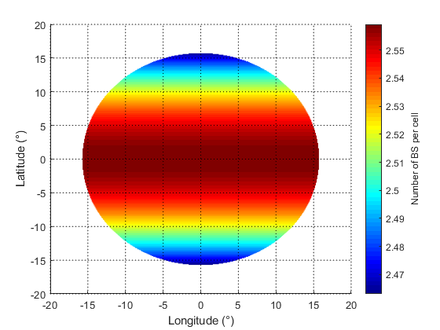
Figure 7: Average BS per elementary surface cell
When summing the number of BS deployed in the elemental surfaces over the area footprint, the total number of BS deployed in the satellite visibility area equates to about 199 002 BS. There is therefore a factor 4.6 between the two deployment methodologies presented above. The ratio of suburban BS versus urban BS within each cell is derived from the Ra/Rb methodology and is applied to the other deployment methodology presented in ECC Report 298 [12].
In order to compare these results with concrete examples, one can look at national deployments in the band. When looking at the French national deployment, there are 17000 sites or 51000 BS over the territory of 643801 square km. When extrapolating that number to the total satellite visibility of 9.64 million square km, this amounts to about 764000 BS which falls between the total BS numbers calculated following the two methods presented above. Of course, this extrapolation is not necessarily representative as there most likely will be some expanses of water within the satellite visibility as well as variation of deployment density from country to country.
- Step 4: Calculate the elevation angle from the ground towards the satellite receiver for each elementary surface.
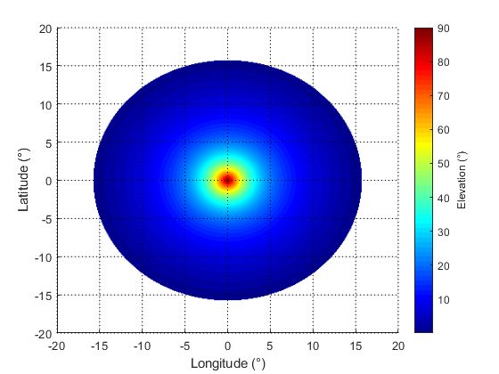
Figure 8: Elevation angle towards the satellite
- Step 5: Calculate propagation losses. Only free space loss was considered for this study and the result is presented in Figure 9:
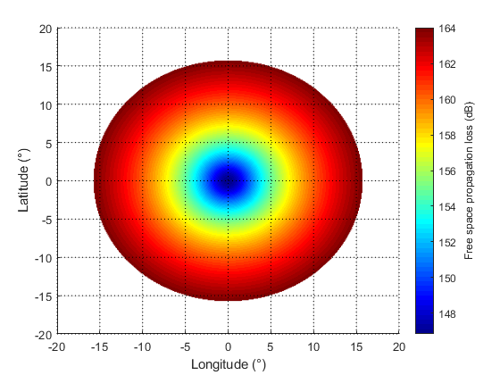
Figure 9: Free space propagation loss
- Step 6: Calculate the average AAS BS antenna gain as a function of the elevation angle (towards the satellite). To calculate the average gain, this study assumes the following scheme of BS use and deployment:
  - BS serving UE on the ground within a cell radius of 800 m (suburban) or 400 m (urban). This deployment is assumed to represent 67% of the BS usage.
Deploying uniformly UE over the area of coverage from the BS, the CDF of elevation can be determined for suburban and urban deployment cases. It is important to note that the BS vertical coverage range is limited to 90-100° for the suburban and urban deployment cases, equivalent to a limitation of elevation from 0° (horizon) to -10° (under the horizon). Therefore, for all UE deployments seen at elevation angles lower than -10°, the elevation angle of the BS to cover these UE will be set to -10° and the UE will be covered with the BS side-lobes. Similarly, if an aerial UE is seen at an elevation greater than 0°, the BS is assumed to be pointing at an elevation of 0° and would be covering this aerial UE with its side lobes.
The resulting elevation CDFs are presented below noting that the range of elevation is limited to the 10° range as explained above and are applicable for both AAS and non AAS BS. The difference in suburban and urban deployment comes from the difference of the cell radius and the BS antenna height. This explains that the elevation for the suburban case (cell radius of 0.8 km) is contained between 1.8° and 10° and for the urban case between 2.6° to 10° (cell radius of 0.4 km).
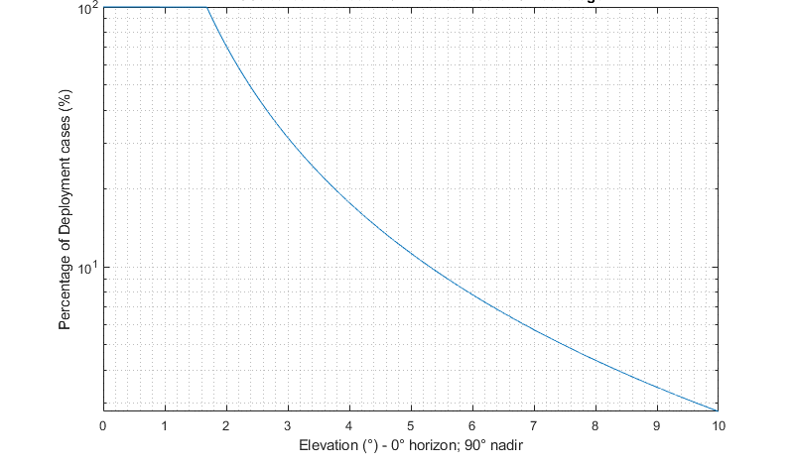
Figure 10: Suburban BS elevation CCDF
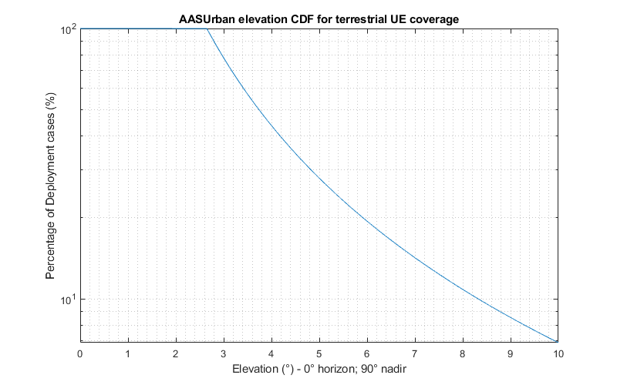
Figure 11: Urban BS elevation CCDF
These plotted elevation CDFs are a contribution of the BS mechanical tilt and electrical tilt. Assuming a mechanical tilt of 6°, the BS electrical tilt CDF can be derived from the previous elevation distribution by a simple translation of 6°.
  - BS serving aerial UE in visibility. This deployment is assumed to represent either 6.7% or 33% of the BS usage.
The aim of this study is to see whether the current BS deployments serving terrestrial UE can be used to serve aerial UE. As such, the same vertical coverage range of 90-100° is considered for this case. This means that since the elevation of the BS main beam will not exceed 0°, the aerial UE will always perceive the side-lobe of the BS. Therefore, all BS covering aerial UE are assumed to be pointing at 0° elevation in the direction of the aerial UE. The altitude of the aerial UE is therefore irrelevant as it will always be seen from the BS at elevations above the horizon. The proposed density for aerial UE 6.7% has been extracted from ECC Report 309 (Annex 13) [4] and represents an average case taking into consideration that a significant high number of cells may not be used to provide aerial coverage at max. payload (33%). Since the simulation area for this study is hugely larger (tens of thousands of cells) than the one considered in ECC Report 309 (61 cells), it is expected that the aerial UE payload, if uniformly distributed over this larger area, would be lower than 6.7% because it is understood that there may be likely large sub-areas with no aerial UE operation. This assumption (6.7%) is then considered as conservative when applied to such a large area. Results for the maximum payload (33%) of the aerial UE scenario are provided for information in this Report although it remains unrealistic for so many cells.
One can then generate a randomised distribution of IMT BS following the elevation distributions (taking into account the electrical tilts and mechanical antenna tilts) explained above with their associated weighting: 67% of ground UE and 33% of Aerial UE or 93.3% of ground UE and 6.7% of Ground UE.
The average gain considering the two deployment cases (terrestrial and aerial UE coverage) can then be calculated by implementing the Recommendation ITU-R F.1336 [14] for non AAS BS and the antenna pattern as defined in Table A of Annex 3 contained in Annex 4.4 to the WP5D chairman's report [13] for AAS BS operating in the range 1710-4990 MHz. The minimum gain for the AAS BS was set to -30 dBi as it is assumed that lower levels are not necessarily representative. The following average gain versus elevation was generated based on the assumptions presented above. In other words, the average gain in a specific elevation direction was taken for 100000 BS deployment cases and averaged (70000 cases where the BS is serving terrestrial UE and 30000 cases where the BS is serving aerial UE). The left side of the figures considers a suburban deployment while the right ride considers an urban deployment for the terrestrial UE. Only the AAS are assumed to be providing service to the aerial UE.
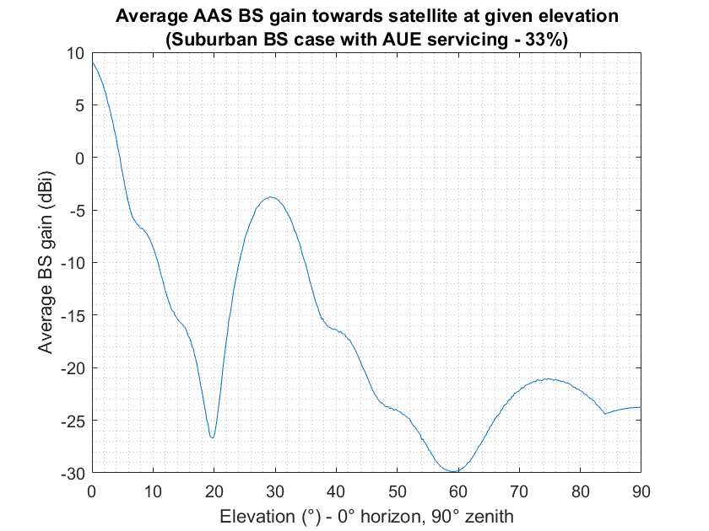 | 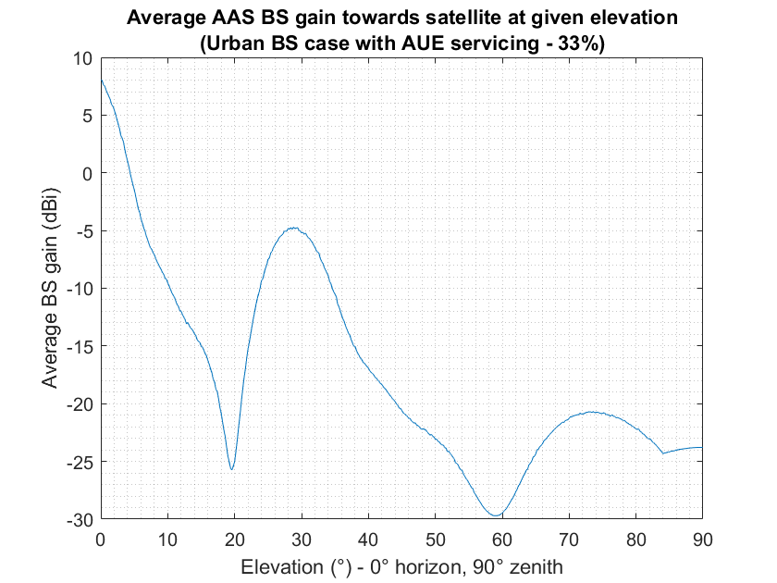
Figure 12: AAS BS average gain for terrestrial and aerial UE servicing (33% aerial UE payload)
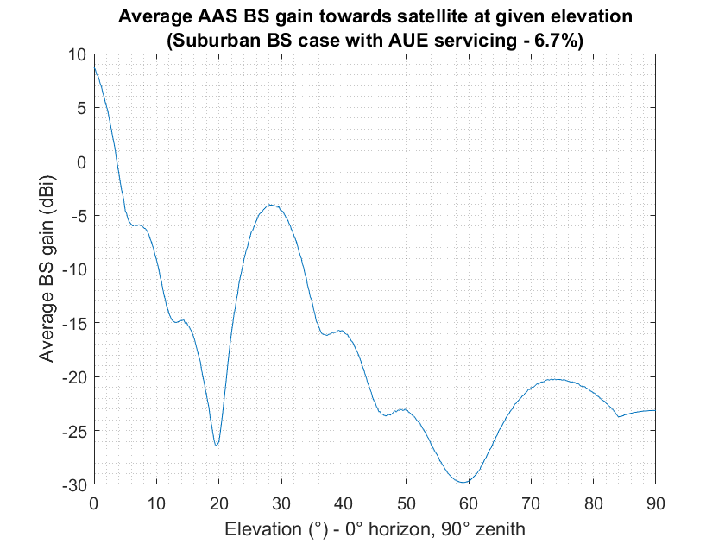 | 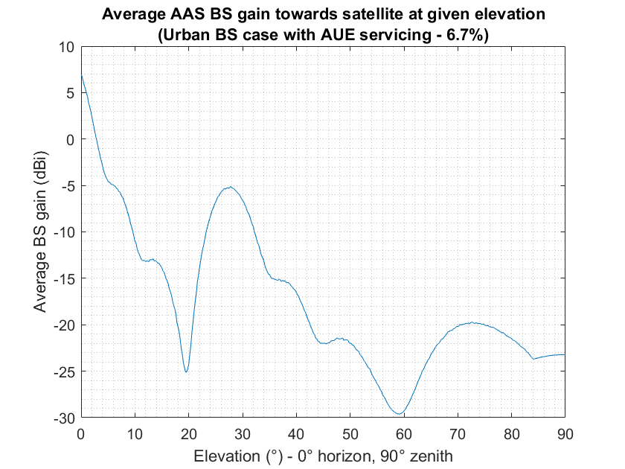
Figure 13: AAS BS average gain for terrestrial and aerial UE servicing (6.7% aerial UE payload)
The above average gain distributions consider 6.7 or 33% of the served UE being aerial UE. For the two considered densities, one can note that these AAS beamforming antennas present side lobes with higher gains on average and that the gain does not decrease monotonously.
In order to quantify the impact of servicing aerial UE, this study will also calculate the impact of MFCN AAS and non-AAS BS deployment servicing only terrestrial UE. The following average BS gains were calculated using the same methodology as above but this time considering all 100000 BS deployment cases to be serving terrestrial UE.

AAS BS average gain for terrestrial servicing only
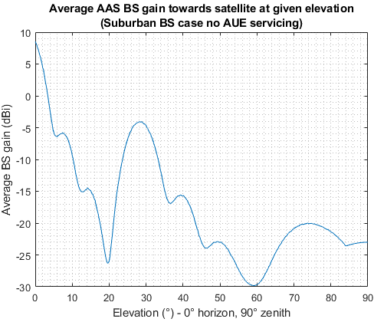 | 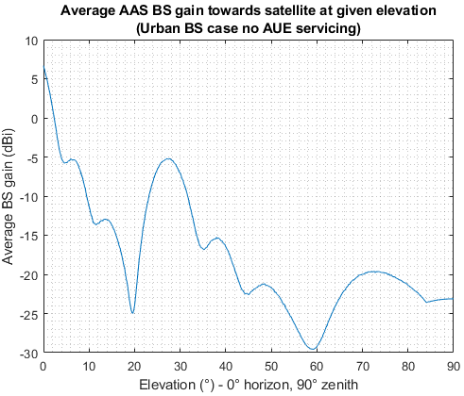
Non AAS BS average gain for terrestrial servicing only
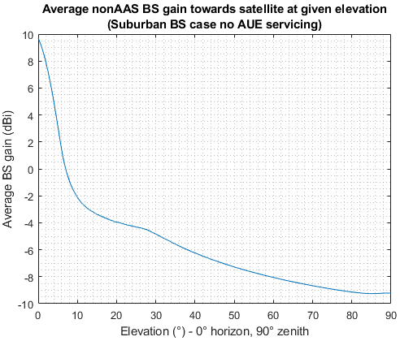 | 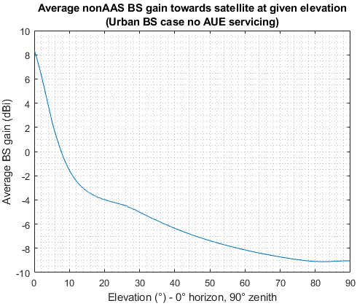
Figure 14: AAS and non-AAS BS average gain for terrestrial UE servicing only
Step 6: Compute the interference level from each elemental cell, considering the number of BS deployed in each cell and making distinction between suburban and urban deployments. The following formula were used to calculate the interference per cell:
$${I_{sub}}_{i} = PSD + G_{BS_{sub}→SAT}\left(el_{i}\right)+ 10∙\log_{10}\left(N_{B{S_{sub}}_{i}}∙NLF\right) + G_{SAT_{i}} - {FSL}_{i} -P_{L}$$  $${I_{urb}}_{i} = PSD + G_{BS_{urb}→SAT}(el_{i}) + 10∙\log_{10}\left(N_{B{S_{urb}}_{i}}∙NLF\right) + G_{SAT_{i}} - {FSL}_{i} -P_{L}$$  $$I_{i} =10∙ \log_{10}\left({10}^{{{I_{sub}}_{i}}/{10}}+{10}^{{{I_{urb}}_{i}}/{10}}\right)$$ | (5)
With:
- ${I_{sub/urb}}_{i}$ the interference from suburban/urban AAS in the cell;
- $I_{i}$ the total interference of cell i in dBW/Hz;
- $PSD$: Power spectral density of the BS in dBW/Hz;
- $G_{BS→SAT}(el_{i})$ the average BS gain of cell i towards the satellite receiver seen at the elevation $el_{i}$;
- $N_{B{S_{sub/urb}}_{i}}$ the number of BS (suburban or urban) for cell i;
- $G_{SAT_{i}}$the gain of the satellite receiver towards cell i, taken here as 0 dBi since assumed to be an isotropic antenna;
- ${FSL}_{i}$ the free space loss from cell i in dB (step 4);
- $P_{L}$ additional losses (3dB feeder loss for the non AAS case, the polarisation loss of AAS antennas are included in the element gain);
- $NLF$ the network loading factor (20% assumed)
The left columns provide the results for the deployment methodology following ECC Report 298 (total of 199100 BS deployed) and the right column follows the Ra/Rb methodology (total of 927241 BS deployed).
Table 9: Deployment methodology comparison
Deployment Methodology: ECC Report 298 [12] (step 3.2) results | Deployment Methodology: Ra/Rb (step 3.1) results
AAS BS (both suburban and urban deployment) with aerial UE coverage (33% aerial UE payload)
I_{agg} = -168,18 dBW/Hz | I_{agg} = -161.49 dBW/Hz
AAS BS (both suburban and urban deployment) with aerial UE coverage (6.7% aerial UE payload )
I_{agg} = -170.02 dBW/Hz | I_{agg} = -163.34 dBW/Hz
AAS BS (both suburban and urban deployment) without aerial UE coverage
I_{agg} = -170.65 dBW/Hz | I_{agg} = -163.96 dBW/Hz
Non AAS BS without aerial coverage
I_{agg} = -168.76 dBW/Hz | I_{agg} = -162.07 dBW/Hz
To take into account the possible clutter attenuation between every active BS antenna and the satellite, the following input parameters and assumptions were taken:
- Height of the base station: 20 m (Urban environment);
- Shielding building height: 25 m. This is based on the Recommendation ITU-R P.452 [18] nominal height for dense urban environment and was taken for this urban case as it is above the 20 m height of the urban BS;
- Frequency: 2.110 GHz;
- Elevation angle: elevation of the corresponding urban BS towards the satellite receiver as calculated above;
- Percentage of location: randomised following a uniform distribution between 0 and 100%;
- Clutter applied to all urban BS;
- No clutter attenuation considered for the suburban case as the considered antenna height (25 m) is above the building heights indicated by Recommendation ITU-R P.452 for suburban (9 metres) and dense suburban (12 metres) environments-
The following aggregate interference results are obtained when applying the clutter model as defined in Document 3K/178 Annex 6 and Annex 1 Section 3.3 [19] to the above calculation:

Table 10: Aggregate interference results with clutter loss
Aggregate interference with clutter loss considerations (dBW/Hz)
 | Deployment methodology: ECC Report 298 | Deployment methodology: Ra/Rb
AAS with aerial UE (33% aerial UE payload) | -173.7 | -167.0
AAS with aerial UE(6.7% aerial UE payload) | -174.8 | -168.2
AAS without aerial UE | -175.3 | -168.6
non AAS without aerial UE | -175.2 | -167.1
One can note that:
  - The choice of deployment methodology leads to a difference of 6-7 dB regardless of the other parameters (BS configuration, aerial UE service or not, clutter attenuation or not).
  - The AAS BS serving ground-based UE generates less interferences (in the range of 0 to 1.5 dB) than non-AAS BS serving ground-based UE.
  - When serving aerial UE and for a reasonable density of aerial UE (i.e. 6.7%), AAS BS generate limited additional interference (up to 0.5 dB) compared to when serving only ground-based UE.
  - Conclusion
The results in the tables above show that the coverage of aerial UE by AAS BS in addition to their current coverage of terrestrial UE causes a slight increase of co-channel interference of about 0.5 dB, considering a reasonable aerial UE density, compared to the AAS BS deployments covering only terrestrial UE.
Moreover, the use of AAS BS for the coverage of aerial UE does not cause more co-channel interference than the current use of non-AAS BS covering terrestrial UE.
Thus, considering the similar behaviour of AAS and non-AAS base stations in the out-of-band domain, the coverage of aerial UE in addition to the current coverage of terrestrial UE by AAS BS does not change the current interference environment and would not cause additional interference to satellite receivers.
- List of References
- ECC Decision (06)13: “Harmonised technical conditions for mobile/fixed communications networks (MFCN) including terrestrial IMT systems, other than GSM and EC-GSM IoT, in the bands 880-915/925-960 MHz and 1710-1785/1805-1880 MHz”, approved December 2006, latest amended March 2022
- ECC Decision (06)01: “The harmonised utilisation of the bands1920-1980 MHz and 2110-2170 MHz for mobile/fixed communications networks (MFCN) including terrestrial IMT”, approved March 2006, latest amended on 8 March 2019.
- ECC Decision (05)05: “Harmonised utilisation of spectrum for Mobile/Fixed Communications Networks (MFCN) operating within the band 2500-2690 MHz”, approved March 2005, latest corrected March 2022
- ECC Report 309: “Analysis of the usage of aerial UE for communication in current MFCN harmonised bands”, approved July 2020
- CEPT Report 72: “Report from CEPT to the European Commission in response to the Mandate
“to review the harmonised technical conditions for certain EU-harmonised frequency bands and to develop least restrictive harmonised technical conditions suitable for next-generation (5G) terrestrial wireless systems”
Report A: Review of technical conditions in the paired terrestrial 2 GHz and the 2.6 GHz frequency bands, and the usage feasibility of the 900 MHz and 1800 MHz frequency bands”, approved July 2019
- ECC Report 308: “Analysis of the suitability and update of the regulatory technical conditions for 5G MFCN and AAS operation in the 2500-2690 MHz band”, approved March 2020
- ECC Decision (06)09: “The designation of the bands 1980-2010 MHz and 2170-2200 MHz for use by systems in the Mobile-Satellite Service including those supplemented by a Complementary Ground Component (CGC)”, approved December 2006, amended 5 September 2007
- CEPT Report 81: “Report from CEPT to the European Commission in response to
Task 1 of the Mandate “Study and assess conditions to operate 5G non-AAS connectivity for MCA in the 1800 MHz (1710-1785 MHz and 1805-1880 MHz) frequency band” and
Task 2 of the Mandate “Study and assess whether, and under what conditions, the usage of an NCU in MCA operations could be made optional””, approved November 2021
- ETSI TS 136.101: “LTE; Evolved Universal Terrestrial Radio Access (E-UTRA); User Equipment (UE) radio transmission and reception (3GPP TS 36.101 version 15.5.0 Release 15)”
- ETSI TS 138.101: “5G NR; User Equipment (UE) radio transmission and reception; Part 4: Performance requirements (3GPP TS 38.101-4 version 15.7.0 Release 15)”
- ECC Report 297: “Analysis of the suitability and update of the regulatory technical conditions for 5G MFCN and AAS operation in the 900 MHz and 1800 MHz bands”, approved March 2019
- ECC Report 298: “Analysis of the suitability and update of the regulatory technical conditions for 5G MFCN and AAS operation in the 1920-1980 MHz and 2110-2170 MHz band”, approved March 2019
- ITU-R Document 5D/716: “Report on the 38th meeting of Working Party 5D”, e-Meeting, 7-18 June 2021
- Recommendation ITU-R F.1336: “Reference radiation patterns of omnidirectional, sectoral and other antennas for the fixed and mobile service for use in sharing studies in the frequency range from 400 MHz to about 70 GHz”
- Recommendation ITU-R M.2101: “Modelling and simulation of IMT networks and systems for use in sharing and compatibility studies”
- Recommendation ITU-R SA.1154: “Provisions to protect the space research (SR), space operations (SO) and Earth exploration-satellite services (EESS) and to facilitate sharing with the mobile service in the 2 025-2 110 MHz and 2 200-2 290 MHz bands”
- Report ITU-R M.2292: “Characteristics of terrestrial IMT-Advanced systems for frequency sharing/interference analyses”
- Recommendation ITU-R P.452: “Prediction procedure for the evaluation of interference between stations on the surface of the Earth at frequencies above about 0.1 GHz”
- ITU-R Document 3K/178: “Report on the meeting of Working Party 3K”, e-Meeting, 21 June - 1 July 2021

ECC Decision (06)13 [1], ECC Decision (06)01 [2] and ECC Decision (05)05 [3]
1800 MHz (1710-1785 and 1805-1880 MHz): ECC Decision (06)13 [1]; 2 GHz(1920-1980 MHz and 2110-2170 MHz): ECC Decision (06)01 [2]; 2.6 GHz (2500-2690 MHz)):ECC Decision (05)05 [3]
No-fly zones from ECC Report 309 are referred to as no-transmit zones in this Report.
ECC Decision (06)13 [1], ECC Decision(06)01 [2] and ECC Decision (05)05 [3]

