Unwanted emissions of common radio systems: measurements and use in sharing/compatibility studies
approved 29 April 2016
ECC Report 249
amended 28 January 2022

Executive summary
The existing regulation of unwanted emissions for digital application were first updated or first developed about 15 years ago, and digital technologies have considerably changed since then. All the present regulatory instruments (Recommendation ITU-R SM.1541 [1], ERC Recommendation 74-01 [2], Recommendation ITU-R SM.329 [3], Recommendation SM 1539 [5] and others) have been developed in the period from around 1996 to 2004 when digital radio systems were already predominant over analogue ones. Measurements of a limited number of equipment samples of digital systems as well as also of analogue systems were done in order to analyse the difference in performance of both types of equipment. This Report has a focus on exploring and analysing digital systems and their characteristics but analogue transmitter measurements are attached in Annex A3.2 for comparison.
The scope of this Report is:
- To compare the measured characteristics of a limited number of equipment samples with the existing regulatory limits in order:
To explore the current definitions of the limits used for the OoB and spurious domains given in ITU-R Recommendations and ETSI standards;
To compare the "safety-net" worst case characteristics of OoB emissions in Recommendation ITU-R SM.1541 [1] and the measurements of the equipment samples;
To compare spurious domains emissions in ERC Recommendation 74-01 [2] Recommendation ITU-R SM.329 Category B and the measurements of the equipment samples;
- To characterise the unwanted emissions of various digital modulation technologies of broadband communication systems. It considers the boundary between the out-of-band (OoB) and spurious; domains as well as the levels of unwanted emissions in a set of measurements on equipment samples;
- To develop possible concepts to better characterise the unwanted emissions of broadband systems using digital technology to enable a more efficient use of the radio spectrum in adjacent bands.
The characteristics of unwanted emissions of different technologies, the definitions and limits for out-of-band emissions and spurious emissions are explored in this Report by evaluating measurements on a limited number of equipment samples.
This Report addresses both the OoB and spurious domains with particular focus on narrowband and broadband systems digital systems. Digital transmitters in comparison to analogue ones have no spikes. The boundary between the out-of-band and spurious domain on either side of the centre frequency is generally defined as 250% of the necessary bandwidth according to Annex 1 to Appendix 3 of the ITU Radio Regulations [4]. However, more specific definitions may be applicable, for example in some IMT systems based on a variable channel bandwidth where the boundary is presently specified in section 2.6 of Recommendation ITU-R M. 2070 [32] for base stations as 10 MHz beyond the operating band edge.
Recommendations ITU-R SM.1541 [1] and SM.1539 [5] already contain boundary flexibility provisions in particular for very narrow and very wide band applications. Therefore, possible ways forward include the possibility to reconsider the 250% rule and/or to act on a case-by-case basis in order to identify the most suitable boundary between the OoB and spurious domains.
While Annex 1 to Appendix 3 of the Radio Regulations [4] and Recommendation ITU-R SM.1539 [5] define a boundary lower than 250 % for wideband systems, it is also recommended that revision of the boundary for systems with very wide bandwidths should be considered, as the current limits may not be optimal. This may have implications for sharing/compatibility studies, for example those on future high capacity systems in frequencies above 60 GHz.
In this Report, measurements are provided on a limited number of equipment samples of different radio technologies. It is observed that the measured emissions are typically lower than the limits in recommendations and ETSI standards by a significant margin of several tens of dBs in the spurious domain, except for the harmonic frequencies. This finding has an important implication for sharing and compatibility studies which are typically based on the assumption that equipment would only just meet the limits set out in standards.
However, this needs to be justified statistically because the measurements have been made for a limited set of conditions (both environmentally and configured parameters) and on a very limited number of equipment samples.
Two questions are raised:
- Should sharing/compatibility studies be based on typical performance of unwanted emissions rather than the limits?
- Should those limits/levels in bands adjacent to the operating one (and boundary between the OoB and spurious domains) be redefined or be re-considered on a case-by-case basis to better reflect actual performance of equipment, and therefore allow for increased opportunities for sharing/compatibility and more efficient use of spectrum in the future?
In relation to Question 1, in order to improve the accuracy of sharing/compatibility studies, four ways forward to incorporate unwanted emissions in sharing/compatibility studies are proposed:
- Revise assumptions to reflect typical performance of the equipment based on measurements rather than limits;
- Perform a wider range of measurements specific to the study;
- Incorporate typical performance of the equipment in a statistical manner;
- Consider results of studies based on measurements as sensitivity analysis for comparison with results based on limits.
Any changes to the levels used in sharing studies would need to be based on reflecting actual performance taking into account both existing and future equipment considerations as well as the various conditions equipment would operate in.
It is proposed that all of these options are considered in order to evaluate any improvements of the accuracy of sharing/compatibility studies, when assessing potential new uses of spectrum. This could lead to improvement in the efficient use of the spectrum.
In relation to Question 2, to better reflect the performance observed for the equipment samples considered in this Report, the following options for changes to limits have been considered:
- Adjustment of the level of unwanted emissions in the out-of-band domain;
- Adjustment of the level of unwanted emissions in the spurious domain;
- Revised definition of the level of unwanted emissions in the spurious domain, e.g. on a statistical basis.
Any changes to limits of unwanted emissions would need to be based on reflecting actual performance and/or the legal requirements of the relevant European Directives. The measurements in Section 4 raise questions about whether the related ETSI Harmonised Standards are according to the state of the art. It needs to be continuously investigated if limits are realistic in terms of "good engineering practice" and "state of the art". The factual information in this Report has therefore a certain "expiration date".
It is not intended to put additional restrictions or modify limits which could have an impact on the cost of all the equipment considered in the coexistence scenario.
There are several challenges with all of these approaches, including:
- Equipment may not be available for measurement, especially when a suitable frequency band has not yet been defined;
- The measured equipment may be representative for that on the market at a certain point in time but not afterwards.
It is recommended further study should be undertaken to assess the potential advantages and disadvantages of each approach.
This Report was updated in January 2022 to include new measurements of DTT transmitters (see section 4.3.2 and section 5.1.3). The remainder of the content and conclusions remains unchanged from the original version published in April 2016.

TABLE OF CONTENTS

0 Executive summary 2
1 Introduction 10
1.1 Unwanted emissions 10
1.2 boundary between OOB and spurious domain 11
1.2.1 The 250% rule 11
1.2.2 Exceptions to the 250% rule 11
1.3 specification of unwanted emission limits 11
1.3.1 Out-of-Band Limits 11
1.3.2 Spurious Domain Limits 12
1.4 Implications of boundary Between the OoB and Spurious domains and limits of unwanted emissions for efficient use of the spectrum 12
2 Definitions 14
3 Application of limits in Recommendations and standards 15
3.1 Overview of how unwanted emission limits (both OoB and spurious) are defined in common standards and recommendations 15
3.2 Spurious emissions in IMT standards 15
4 Measurements on the performance of common digital systems 17
4.1 General 17
4.2 DAB / DAB+ 17
4.2.1 Out-of-band emissions 17
4.2.2 Spurious emissions 18
4.3 DVB-T 20
4.3.1 Laboratory measurements 20
4.3.2 Field measurements, where the DTT transmitter is in operation 22
4.4 LTE800 Base stations 33
4.4.1 Out-of-band emissions 34
4.4.2 Spurious emissions 34
4.5 LTE800 User Equipment 36
4.5.1 Out-of-band emissions 36
4.5.2 Spurious emissions 37
4.5.3 Harmonic emissions 38
4.6 LTE 2300 User equipment 40
4.7 GSM900 Base station 41
4.7.1 Out-of-band emissions 42
4.7.2 Spurious emissions 42
4.8 DECT 44
4.8.1 Out-of-band emissions 44
4.8.2 Spurious emissions 45
4.9 UMTS 2100 base stations 46
4.9.1 Out-of band emissions 47
4.9.2 Spurious emissions 48
4.10 RLAN devices in the 2.4 GHz band 49
4.10.1 Out-of-band emissions 49
4.10.2 Spurious emissions 50
4.11 WIMAX 3.6 GHz UE 50
4.11.1 Spurious emissions 51
4.12 25 GHz Point-to-Point Links 51
4.12.1 Out-of-band emissions 52
4.12.2 Spurious emissions 53
5 Possibilities for improving the way unwanted emissions are described and used in sharing/compatibility studies 55
5.1 Filtered and unfiltered systems 55
5.1.1 DAB 55
5.1.2 LTE800 Base station 56
5.1.3 DTT RF channel filters 56
5.2 Transient emissions in pulsed digital systems 63
5.3 Narrowband and wideband unwanted emissions 65
5.4 unwanted emission levels for digital and analogue systems 66
5.5 Boundary between OoB and spurious domain 66
6 Analysis and possible alternative ways to specify limits 67
6.1 Relation between measurements and specified limits for digital equipment 67
6.2 possibile changes to limits or boundaries 68
6.2.1 Revision of the existing boundary between the OoB and spurious domain 68
6.2.2 Adjustment of the unwanted emission limits in the out-of-band domain 68
6.2.3 Adjustment of the unwanted emission limits in the spurious domain 69
6.2.4 Revised definition of unwanted emission limits in the spurious domain on a statistical basis 69
6.3 Challenges in revising the limits 69
7 Unwanted emissions in sharing studies 70
7.1 Current usage of unwanted emissions in sharing/compatibility studies 70
7.2 Alternative options for sharing/compatibility studies 70
7.2.1 Revise assumptions to reflect typical performance of the equipment based on measurements rather than limits 71
7.2.2 Perform measurements on a large sample of transmitters specific to the study 71
7.2.3 Incorporate typical performance of the equipment in a statistical manner; 71
7.2.4 Consider results based on measurements sensitivity analysis for comparison with results based on limits. 71
8 Conclusions 72
ANNEX 1: Measurement process and setup 74
ANNEX 2: OOB boundary definitions in IMT standards 78
ANNEX 3: Additional Measurements 82
ANNEX 4: List of Reference 102

LIST OF ABBREVIATIONS

Abbreviation | Explanation
3GPP | 3rd Generation Partnership Project
ACLR | Adjacent Channel Leakage Ratio
AM | Amplitude Modulation
BCCH | Broadcast Control Channel
BS | Base Station
BW | Bandwidth
CEPT | European Conference of Postal and Telecommunications Administrations
CQPSK | Complementary Quadrature Phase Shift Keying
D/A | Digital to Analogue
DAB | Digital Audio Broadcasting
DECT | Digital Enhanced Cordless Telecommunications
DSP | Digital Signal Processor
DSSS | Direct-Sequence Spread Spectrum
DTT | Digital Terrestrial Television
DVB-T | Digital Video Broadcasting – Terrestrial
ECC | Electronic Communications Committee
ERC | European Radiocommunications Committee
e.i.r.p. | Equivalent Isotropically Radiated Power
e.r.p. | Effective Radiated Power
ETSI | European Telecommunications Standards Institute
E-UTRA | Evolved Universal Terrestrial Radio Access
FDD | Frequency Division Duplex
FM | Frequency Modulation
FS | Fixed Service
FSK | Frequency Shift Keying
GMSK | Gaussian Minimum Shift Keying
GSM | Global System for Mobile Communications
G-TEM | Gigahertz Transverse Electromagnetic
HF | High Frequency
IEEE | Institute of Electrical and Electronics Engineers
IMF | Image Frequency
IMT | International Mobile Telecommunications
ITU | International Telecommunication Union
ITU-R | International Telecommunication Union - Radiocommunication Sector
I/Q | In-phase/Quadrature
LTE | Long Term Evolution
MSR | Multi Standard Radio
OFDM | Orthogonal Frequency-Division Multiplexing
OoB | Out-of-Band
PCS | Personal Communications System
PEP | Peak Envelope Power
PSD | Power Spectral Density
PMR | Private Mobile Radio
QAM | Quadrature Amplitude Modulation
QPSK | Quadrature Phase Shift Keying
RAT | Radio Access Technology
RB | Resource Block
RF | Radio Frequency
RLAN | Radio Local Area Network
RMS | Root Mean Square
RR | ITU Radio Regulations
Rx | Receiver
SC-FDMA | Single Carrier Frequency Division Multiple Access
SE | Spurious Emissions
SEAMCAT | Spectrum Engineering Advanced Monte Carlo Analysis Tool
SEM | Spectrum Emission Mask
SRD | Short Range Devices
SSB | Single-Sideband Modulation
TDD | Time Division Duplex
TDMA | Time Division Multiple Access
TETRA | Terrestrial Trunked Radio
TFES | TC MSG / TC ERM Task Force for the production of Harmonised Standards under the R&TTE Directive for the IMT family
TV | Television
Tx | Transmitter
UE | User Equipment
UHF | Ultra High Frequency
UMTS | Universal Mobile Telecommunications System
UTRA | Universal Terrestrial Radio Access
VHF | Very High Frequency
W-CDMA | Wideband Code Division Multiple Access
WiMAX | Worldwide Interoperability for Microwave Access
WLAN | Wireless Local Area Network
WRC | World Radio Conference

Introduction
The existing regulation of unwanted emissions for digital application were first updated or first developed about 15 years ago, and digital technologies have considerably changed since then. All the present regulatory instruments (Recommendation ITU-R SM.1541 [1] ERC Recommendation 74-01[2], Recommendation ITU-R SM.329 [3], Recommendation SM 1539 [5] and others) have been developed in the period from about 1996 to 2004 when digital systems were already predominant over analogue ones. Measurements of a limited number of equipment samples of digital systems as well as of analogue systems were done in order to analyse the difference in performance of both types of equipment. Although this Report has a focus on exploring and analysing digital systems and their characteristics, analogue transmitter measurements are attached in Annex A3.2 for comparison.
Scope
The scope of this Report is to compare the measured characteristics of a limited number of equipment samples with the existing regulatory limits in order:
To explore the current definitions of the limits used for the OoB and spurious domains given in ITU-R Recommendations and ETSI standards;
- To compare the "safety-net" worst case characteristics of OoB emissions in Recommendation ITU-R SM.1541 [1] and the measurements of the equipment samples;
To compare spurious domains emissions in ERC Recommendation 74-01 [2], Recommendation ITU-R SM.329 Category B and the measurements of the equipment samples;
- To characterise the unwanted emissions of various digital modulation technologies of broadband communication systems. It considers the boundary between the out-of-band (OoB) and spurious domains as well as the levels of unwanted emissions in a set of measurements on equipment samples;
- To develop possible concepts to better characterise the unwanted emissions of broadband systems using digital technology to enable a more efficient use of the radio spectrum in adjacent bands.
Measurements on several types of equipment have been performed in order to review the characterisation of the unwanted emissions to achieve a more efficient use of the spectrum in the long term. The review includes considerations on the out-of-band and spurious domains as well as the boundary between them, taking into account the development of technology.
This Report provides examples and analysis of measurements of unwanted emissions of a limited number of equipment samples, including both digital and analogue technologies (see Annex 3). Measurement results are presented in section 4, and are compared with the existing regulatory limits and analysed in section 5.
Consideration on alternative ways to specify limits, and the challenges associated with revising the existing limits are presented in section 6. The implications of the measurement results on sharing/compatibility studies are presented in section 7.

Unwanted emissions
Unwanted emissions in a radio system are emissions which occur outside of a transmitter's necessary bandwidth, which can cause interference to other systems. According to the definition in the Radio Regulations 1.146 [4], unwanted emissions are classified as either out-of-band (OoB) or spurious emissions. Definitions of OoB and spurious domains are provided in section 2.
While analogue technologies can cause unwanted emissions typically in the form of spikes due to harmonics of carrier and subcarriers, local oscillator leakage or mixing products, new digital broadband technologies have different properties, e.g. spikes in the spectrum are typically limited to local oscillator leakage or some mixing products, but most of the unwanted emissions (harmonics and intermodulation products) can be quite broadband due to wideband digital modulations. Therefore, consideration should be given to whether the current characterisation of unwanted emissions continues to be adequate, or if there should be a need for a more detailed characterisation to enable more efficient spectrum usage in the future. For example, the unwanted emissions could be characterised by two different limits, one for narrow frequency domain spikes like local oscillator leakages and one for the generic noise floor or reference baseline level for broadband unwanted emissions, which would be significantly lower when measured over a much wider bandwidth.

boundary between OOB and spurious domain

The 250% rule
According to Annex 1 of Appendix 3 of the Radio Regulations, the boundary between the OoB and spurious domain is generally defined as 250% of the necessary bandwidth from the centre frequency, apart from specifically identified cases of emissions with very narrow and very wide necessary bandwidth.
It should be noted that this definition does not necessarily apply to all systems in practice. Measurements have shown that in some cases unwanted emissions due to intermodulation and switching show up at offsets less than 250% of the occupied bandwidth (Figure 19, section 4.5.1). However, the introduction of the "OoB domain" and "spurious domain" concepts, introduced and defined in Radio Regulations 1.146A and 1.146B by WRC 2003, solved the ambiguity and gave certainty to which limit (OoB or spurious) shall apply to any unwanted emission, independently from its "theoretical pertinence".

Exceptions to the 250% rule
Some IMT systems, such as UMTS and LTE base stations, use a different definition for the boundary between the OoB and spurious domains - in this case it is defined as 10 MHz outside the operating band (i.e. the entire downlink band), for any channel bandwidth (Section 2.6 of Recommendation ITU-R M. 2070 [32]).
According to the Radio Regulations (Appendix 3, Table 1) and Recommendation ITU-R SM.1539 [5], the 250% rule does not apply to systems in the very wideband case. For these special cases, more stringent boundaries apply. For example, the boundary for systems with bandwidths greater than 50 MHz at frequencies between 1 and 3 GHz is 1.5 times the necessary bandwidth plus 50 MHz. These same references define more relaxed boundaries for systems with very narrow bandwidths. For example, the boundary for systems with bandwidths smaller than 100 kHz at frequencies between 1 and 3 GHz is more than 2.5 times the necessary bandwidth.
Situations where additional guidelines are required, situations where the boundary is not defined in terms of necessary bandwidth as well as particular service types and bands are also dealt with in Recommendation ITU-R SM.1539.
The specification of the boundary between the OoB and spurious domains in IMT standards is explored in further detail in Annex 2.

specification of unwanted emission limits

Out-of-Band Limits
Recommendation ITU-R SM.1541 [1] gives a number of generic limits (sometimes called "safety net limits") for unwanted emissions in the out-of-band domain for a range of services (i.e. ideally enveloping all relevant technologies). Therefore, these are not generally intended to be used as regulatory limits "unless tighter limits are not otherwise required to protect specific applications (e.g. in areas having a high radiocommunications density)". Therefore, limits in Recommendation SM.1541 are defined on the basis of "services" rather than "systems"; rationale for this choice is that, while technical standards have quick evolution and may manage the technology evolution with the support/cooperation of local/regional regulatory organisations, ITU-R worldwide recommendations are not capable to offer such timely adaptation.
In addition, unwanted emissions limits for many modern IMT digital cellular systems have been included in ITU-R M series recommendations:
- Recommendation ITU-R M.1580 “Generic unwanted emission characteristics of base stations using the terrestrial radio interfaces of IMT-2000” [30];
- Recommendation ITU-R M.1581 “Generic unwanted emission characteristics of mobile stations using the terrestrial radio interfaces of IMT-2000” [31];
- Recommendation ITU-R M.2070 “Generic unwanted emission characteristics of base stations using the terrestrial radio interfaces of IMT-Advanced” [32];
- Recommendation ITU-R M.2071 “Generic unwanted emission characteristics of mobile stations using the terrestrial radio interfaces of IMT-Advanced” [15].
These recommendations have not been considered in the measurements contained in this Report.
Moreover, limits for many modern digital systems are not included, e.g. Short Range Devices (SRD), Personal Communication Systems (PCS). Out-of-band limits for these systems are specified in the relevant ETSI standards.
We should also consider that, while spurious emissions, in particular far from the centre frequency of the emission, are far less predictable in position and level, OoB emissions mask in many of those system standards, particularly those for "licensed applications" (fixed and mobile applications) are specifically designed as trade-off between optimisation of adjacent channels operation and maximisation of industrial margins for mass production. Such masks have already been used for defining further regulatory limits in term of Block-Edge Masks (BEM) in several block assignment regulations.

Spurious Domain Limits
Limits for unwanted emissions in the spurious domain are specified in Recommendation ITU-R SM.329 [3] and in ERC Recommendation 74-01 [2].
The specification of limits is explored in further detail in section 3.

Implications of boundary Between the OoB and Spurious domains and limits of unwanted emissions for efficient use of the spectrum
As there are an increasing number of different services obtaining new allocations in the same frequency ranges, the compatibility between systems in adjacent frequency bands is becoming more challenging. Therefore, it is important to have an appropriate model for the unwanted emissions (both OoB and spurious domains) for the specific need of sharing (when requiring band segmentation) and compatibility studies. Recommendation ITU-R SM.1540 [33] already set the minimum requirement that "the necessary bandwidth, and preferably the overall occupied bandwidth, of any emission should be maintained completely within the band allocated to the service in question, including any offsets such as Doppler shift or frequency tolerances".
Assumptions for unwanted emissions used in sharing/compatibility studies tend to be based on the regulatory limits (i.e. worst case equipment). If typical equipment is found to outperform these regulatory limits by a significant margin in practice, then the results of sharing/compatibility studies may not allow for the most efficient use of the spectrum.
This raises 2 questions:
- Should sharing/compatibility studies be based on typical performance of unwanted emissions rather than the limits?
- Should those limits/levels in bands adjacent to the operating one (and boundary between the OoB and spurious domains) be redefined or be re-considered on a case-by-case basis to better reflect actual performance of equipment, and therefore allow for increased opportunities for sharing/compatibility and more efficient use of the spectrum in future?
Furthermore, with the increasing development of technologies using wider bandwidths (e.g. wideband systems of several GHz in the millimetre wave bands) there could be limitations on the potential for sharing/compatibility with systems in adjacent bands if the existing definitions of the boundary and limits for spurious emissions are applied.
On the other hand, save for a few exceptions, sharing and compatibility studies are made over "typically worse" scenarios, often requiring aggregation of a "typical" population of interfering systems. Therefore, the "probabilistic" approach is already implicit in any study and using the "worst case" for unwanted emissions appears too overcautious.
It should also be considered that compatibility studies are not usually conducted for bands other than the adjacent allocated ones and there are no known practical examples of compatibility problems (at least from point of view of terrestrial services other than high power radars) in bands other than adjacent one or the second harmonic range; only for Radio Astronomy the impact should always be considered. This means that when spurious emission limits are concerned a different level of attention should be given depending on the frequency range.

Definitions

Term1 | Definition
Emission (1.138) | Radiation produced, or the production of radiation, by a radio transmitting station.
Out-of-band emission (1.144) | Emission on a frequency or frequencies immediately outside the necessary bandwidth which results from the modulation process, but excluding spurious emissions.
Spurious emission (1.145) | Emission on a frequency or frequencies which are outside the necessary bandwidth and the level of which may be reduced without affecting the corresponding transmission of information. Spurious emissions include harmonic emissions, parasitic emissions, intermodulation products and frequency conversion products, but exclude out-of-band emissions.
Unwanted emissions (1.146) | Consist of spurious emissions and out-of-band emissions.
Out-of-band domain (of an emission) (1.146A) | The frequency range, immediately outside the necessary bandwidth but excluding the spurious domain, in which out-of-band emissions generally predominate. Out-of-band emissions, defined based on their source, occur in the out-of-band domain and, to a lesser extent, in the spurious domain. Spurious emissions likewise may occur in the out-of-band domain as well as in the spurious domain. (WRC-03).
Spurious domain (of an emission) (1.146B) | The frequency range beyond the out-of-band domain in which spurious emissions generally predominate. (WRC-03).
Necessary bandwidth (1.152) | For a given class of emission (RR 1.139), the width of the frequency band which is just sufficient to ensure the transmission of information at the rate and with the quality required under specified conditions.
Occupied bandwidth (1.153) | The width of a frequency band such that, below the lower and above the upper frequency limits, the mean powers emitted are each equal to a specified percentage β/2 of the total mean power of a given emission.  Unless otherwise specified in an ITU-R Recommendation for the appropriate class of emission, the value of β /2 should be taken as 0.5%.
Frequency assignment (1.18) | Assignment (of a radio frequency or radio frequency channel): authorization given by an administration for a radio station to use a radio frequency or radio frequency channel under specified conditions.
Conducted power | Power of wanted and/or unwanted emissions measured at the transmitter output or antenna feed.
Radiated power | Power of wanted and/or unwanted emissions radiated from the transmitting antenna. This power is determined through calculation based on field strength measurement off air and the formula for free space attenuation.
1 Numbers in brackets refer to paragraph numbers in the ITU Radio Regulations [4]

Application of limits in Recommendations and standards

Overview of how unwanted emission limits (both OoB and spurious) are defined in common standards and recommendations
The limits of unwanted emissions are important parameters in the standardisation of radio systems and for the estimation of the sharing/compatibility between different radio systems operating in adjacent or the same frequency ranges. Unwanted emissions are classified into two domains the Out-of-Band (Recommendation ITU-R SM.1541 [1]) and spurious domains (ERC Recommendation74-01 [2] and Recommendation ITU-R SM.329 [3]). According to Annex 1 of Appendix 3 of the Radio Regulations [4], the boundary between these domains usually lies at 250% of the necessary bandwidth from the centre frequency.
Recommendation ITU-R SM.1541 generally describes the maximum OoB emissions as a spectrum mask. The 0 dB reference is either the total power of the signal which is equal to the power of the unmodulated carrier (dBc) or the maximum power spectral density (dBsd) within the necessary bandwidth recorded with a certain reference bandwidth. Generally, for analogue systems a dBc reference and for digital systems a dB or dBsd reference is regarded as most suitable. Therefore, the limiting mask can directly be compared with the measured power spectral density of the signal, after a necessary bandwidth correction (if applicable). The relative level of the unwanted emissions is independent of the transmitter power.
Since the shape of practical OoB masks strongly depends on the particular system, Recommendation ITU-R SM.1541 only specifies generic ("safety net") OoB domain emission limits for a number of most common radio services to be only used for the definition of more detailed limits for specific systems. Applicable standards and service-specific Recommendations should also be consulted.
Recommendation ITU-R SM.1541 describes two different approaches to determine conformance with OoB domain emission limits:
- The integrated power in an adjacent band or channel (Annex 1, Section 1 of Recommendation ITU-R SM. 1541);
- Comparison of the measured power spectral density with an OoB spectrum mask (annex 1, Section 2 of Recommendation ITU-R SM. 1541.
The Recommendation already considers distinguishing between noise-like and line spectra in the OoB domain and the possible need of different limits for both, see Note 1 in annex 1, Section 2.3 of Recommendation ITU-R SM. 1541.
Regarding the impact on sharing/compatibility studies, it should be pointed out that both transmit power and unwanted emissions (OoB and spurious) are usually defined as conducted emissions, but the radiated power (in-band and out-of-band) can be calculated for use in the studies. The combination of radiated unwanted emissions and the victim antenna discrimination is what actually affects the coexistence.
On the other hand, defining limits at the antenna port fits with the "statistical" background of compatibility studies due to the fact that higher gain antennas emit relatively higher levels of unwanted emissions, but over a very limited volume around the boresight angle; whereas lower gain sectorised or omnidirectional antennas emit lower levels, but over a larger (or the whole) volume. In addition, considering that the victim antenna also needs to be taken into account and, in compatibility studies, the interfering and victim antennas are often of a very different kind, defining limits at the antenna port has been considered appropriate.
However, modern applications (e.g. SRDs, and mobile terminals) are designed with integral antennas, which characteristics are not easily known and measurable, the opportunity of having the option of e.i.r.p. limitation of unwanted emissions should be considered. It should be noted that some ETSI standards already foresee option for radiated test.

Spurious emissions in IMT standards
ETSI EN 301 908 [6] defines the boundary between OoB and spurious emissions for different IMT technologies. For some IMT technologies those limits follow the requirements of ERC Recommendation 74-01 [2] (or the category B limits specified in Recommendation ITU-R SM.329 [3]) and in other cases more stringent requirements apply, which therefore allow more efficient use of spectrum in adjacent bands.
For UMTS, LTE and MSR base stations (EN 301 908-3 [7], EN 301 908-14 [9] and EN 301 908-18 [10]) the boundary is defined as 10 MHz away from the downlink operating band edge for channel bandwidths larger or equal to 5 MHz. For large channel bandwidths close to the band edge, the spurious domain boundary is less than 250%.
This is shown in Figure 1 for E-UTRA band 7 (2.6 GHz), where df is equal to 10 MHz.
The overview of spurious emissions in IMT standards is provided in ANNEX 2 (OoB boundary definitions in IMT standards).

Figure 1: Out-of-band and spurious domain for E-UTRA band 7 (df = 10 MHz)

Measurements on the performance of common digital systems

General
This section shows the results of measurements of unwanted emissions (both OoB and spurious domain) from typical digital systems. The measurements are based on a limited number of equipment samples which may not necessarily be representative of the wider population of equipment.
For immediate comparison, the relevant limits are also included in the figures with the measurements as either spectrum masks or horizontal limit lines. Where limits are defined as absolute power levels, they are recalculated into relative values using the same reference power level on the transmitted carrier as for the measured spectra. Where limits are defined as power spectral density in bandwidths other than the measurement bandwidth, the measured spectra are converted to the reference bandwidth using a sliding integration window. For easier comparison with the measured spectrum, the OoB limit lines are drawn from 0 MHz offset from the centre frequency as a reference line indicating the relative in-band power spectral density.
Each test includes the reference OoB limit (e.g. spectrum mask) taken from the relevant standard. When available, also the "safety-net" limit in Recommendation ITU-R SM.1541 [1] for the service concerned is included for comparison with the limits.
It should be noted that the measurement sensitivity (measurement setup noise floor) may be different in the different plots and is not always exactly known. Therefore, the measured spectra sometimes seem to end in a (nearly) horizontal gradient which is in fact the noise floor of the measurement equipment and not unwanted emissions coming from the transmitter. This is especially true for transmitters having a filter at the output, which limits the unwanted emissions in order to meet certain system requirements (e. g. protecting the corresponding receive band). Such systems almost never have any measurable emissions for larger offsets in the spurious domain. Please note that in some figures the notation "receiver noise" should be read as "spectrum analyser noise floor".
Further measurements of the same or additional systems are presented in ANNEX 3. This Annex also contains measurements for some analogue transmitters to highlight the differences in the typical characteristics of unwanted emissions between analogue and digital systems.
For explanations of when peak and average cases of spectrum masks are to be used see A1.4.

DAB / DAB+
This OFDM system is one of the possible digital successors of the analogue sound broadcasting system. The relevant RF parameters are equal for DAB and DAB+ systems:
- Encoding: OFDM with 1736 active carriers;
- Modulation: DQPSK;
- Transmitter bandwidth: 1.536 MHz;
- Transmitter power: 780 W = 28.9 dBW (Tx output), 10 kW (e.r.p.);
- Tx output filter: yes;
- OoB domain ends at: 3.84 MHz (250% of necessary bandwidth).

Out-of-band emissions
In Figure 2, measurements of a DAB+ transmitter are shown with the relevant limits.
The out-of-band radiated signal spectrum in any 4 kHz band shall be constrained by one of the masks defined in the GE-06 Special Agreement [11] (Fig. 3-2 and the associated Table 3-10 thereof). The centre frequency of the transmitter was 174.928 MHz which is the lowest block in the VHF band. Therefore, the most critical mask was used as a reference for the measurements of the lower sideband.
The measurements were made at the antenna port of the transmitter with a resolution bandwidth of 3 kHz. The spectrum mask from GE-06 has an original reference bandwidth of 4 kHz. It was converted into a spectrum mask in 3 kHz; the resulting spectrum mask is shown in Figure 2.
For information, the relevant limit for spurious emissions from ERC Recommendation 74-01 [2] is also shown in Figure 2.

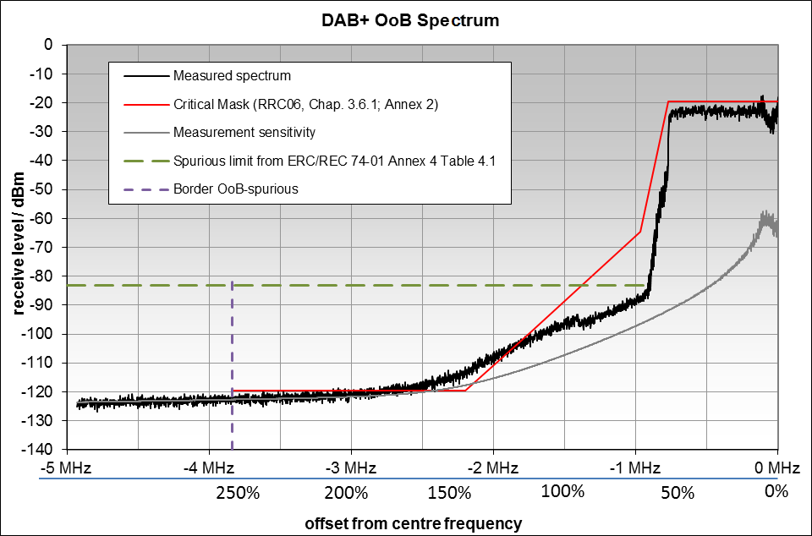
Figure 2: OoB measurements from a DAB+ transmitter
Because the measured levels of spectral emissions at offsets greater than 2.5 MHz are very close to the sensitivity level of the measurement equipment, it can only be said that the actual levels of OoB emissions greater than this offset are lower than the critical mask (most stringent) from the GE-06 Special Agreement [11]. However, due to the limited dynamic range of the measurements, it was not possible to determine by how much the emissions from the transmitter were below the critical mask. The actual sensitivity of the system used in the measurement was between -115 and -120 dBm at the frequency offset of 2.2 MHz.
Observation from Figure 2:
- One can see that the critical mask is violated around 2.2 MHz offset, but it is difficult to judge the reason why the mask is violated because of the sensitivity limitation of the measurement equipment.

Spurious emissions
As mentioned above, DAB/DAB+ transmitters always have output filters to limit unwanted emissions. Measurements on several DAB transmitters in Germany have shown that unwanted emissions in the spurious domain for high frequency offsets from the centre frequency as well as harmonic emissions above the noise floor of the measurement system could not be detected.
Figure 3 shows measurements of spurious emissions from a DAB transmitter with the relevant regulatory limits.
Comparison with regulatory limits:
- Recommendation ITU-R SM.329 [3] does not contain specific spurious emission limits for DAB in Category B (Europe). Therefore, the limit for Category A "all services except those services quoted below" is used for comparison;
- The measurement was performed at the antenna port of a DAB transmitter with 780 W output power (10 kW e.r.p.). The spurious emission limit from Category A "all services except those services quoted below" of Recommendation ITU-R SM.329 in 100 kHz is 70 dBc. Since Figure 3 is normalised to the in-band signal level measured in 100 kHz bandwidth, this limit was converted to a relative attenuation of 70 dBc - 10*log10(1536/100) = 58.2 dBc. ERC Recommendation74-01, Annex 4, Table 4.1 [2] specifies a limit of 75 dBc for transmitters between 8 and 800 W output power, with a reference bandwidth of 100 kHz. This leads to an in-channel power spectral density in 100 kHz, the limit would be at 75 dBc -10*log10(1536/100) = 63.2 dBc;
- ETSI EN 302 077-1, table 4.3 [12] defines a relative limit of 126 dBc in a 4 kHz reference bandwidth for mean transmitter output power between 25 and 1000 W. Because Figure 3 is normalised to the in-band signal level measured in 100 kHz bandwidth, this limit converts to a relative attenuation of 126 dBc - 10*log10(1536/4) = 100.2 dBc.
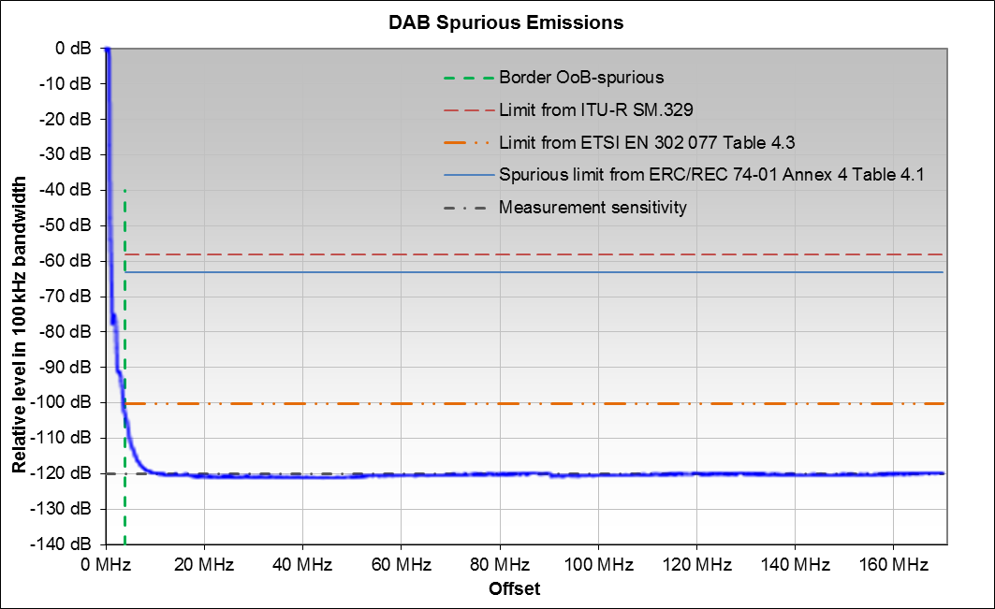
Figure 3: Spurious emissions from a DAB transmitter (shown in blue line)
Observations from Figure 2 and Figure 3:
- The relative suppression of spurious emissions with respect to the carrier power near the OOB boundary is approximately 100 dB (see also Figure 2 for offsets below -3.84 MHz);
- The spurious emissions from filtered DAB/DAB+ transmitters at offsets from the centre frequency above about 10 MHz, and harmonic emissions are below the measurement sensitivity and more than 57 dB below the limits from ERC Recommendation 74-01 [2];
- The OoB mask reaches the spurious emission limit from ERC Recommendation 74-01 at offsets of around 1.4 MHz or 90% of the signal bandwidth (see Figure 2).

DVB-T
This is the digital terrestrial television system used in Europe. In order to protect adjacent channels and/or radiocommunication services, the OoB limits from Recommendation ITU-R SM.1541 [1] were regarded as insufficient. Therefore, more stringent limits were defined in the GE-06 agreement as well as in ETSI Harmonised Standards. To meet these requirements, DVB-T transmitters always have to be fitted with band-limiting filters after the final amplification stage.
In this section, two set of measurements are presented:
- Laboratory measurements carried out on a single DVB-T transmitter;
- In situ measurements carried out on twenty-six (14 low power and 12 high power) DVB-T transmitters.

Laboratory measurements
The parameters of the measured DVB-T system are:
- Encoding: 8 k OFDM with 6817 active carriers;
- Modulation: 64 QAM;
- Bandwidth: 7.61 MHz;
- Transmitter power: 1 kW (Tx output), 10 kW e.r.p;
- Tx output filter: yes;
- OoB domain ends at: 20 MHz (see Recommendation ITU-R SM.1541, annex 6, section2.2.1 [1]);
- Measurement BW: 7.5 kHz.

For additional explanations, see also A1.4.

Out-of-band emissions
The measurements were carried out at the antenna feed with a measurement bandwidth of 7.5 kHz and are presented in Figure 4 with a reference bandwidth of 4 kHz. The measured levels are normalised to the in-band power spectral density in a 4 kHz bandwidth. Recommendation ITU-R SM.1541 [1] specifies relative limits for the whole OoB range. To protect radiocommunication services in adjacent bands, the output filter of the measured transmitter was designed to meet the most stringent mask of GE-06, Chapter 3.6, Table 3-11 [11] for sensitive cases. It should be noted that in most cases the non-critical RR06 spectrum mask is applied.
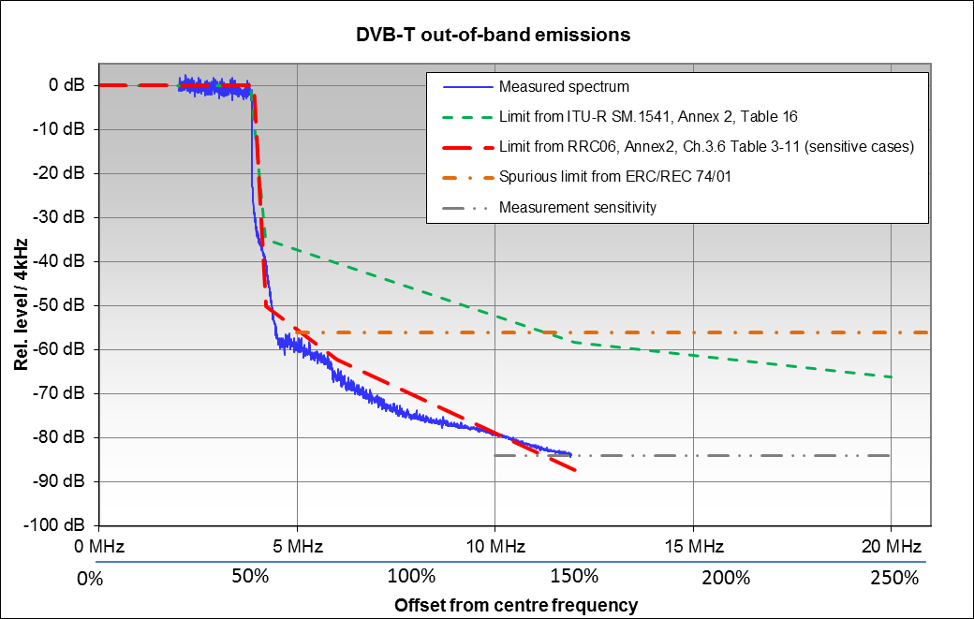
Figure 4: OoB measurements of DVB-T transmitters
Observation for Figure 4:
- The OoB emissions could only be measured down to the level of the breakpoint of the mask from GE-06 at 12 MHz. OoB emissions for higher frequency offsets are below this most stringent mask but could not be quantified due to the limited measurement sensitivity (measurement setup noise floor).

Spurious emissions
Comparison with regulatory limits:
- The GE-06 agreement does not contain any spurious emission limits;
- Since Recommendation ITU-R SM.329 [3] does not contain specific values for DVB-T, the general Category A limits for 'broadcast television' transmitters may be taken. A limit of 46 dB + 10*log10(P/W) or 60 dBc is specified, whichever is less stringent, but without exceeding 12 mW (10.8 dBm). For transmitters with more than 50 W output power, the attenuation of 60 dBc in 100 kHz bandwidth is relevant; for transmitters above 12 kW, the required attenuation is 19 dB + 10*log10(P/W);
- ERC Recommendation 74-01 [2] Table 4.1 specifies a spurious limit of -16 dBm in 100 kHz bandwidth for a transmitter with 1 kW mean output power at the antenna port;
In our case, with the output power of 59 dBm in 8 MHz bandwidth, this limit leads to a relative attenuation of 59 dBm -10*log10(8000/100) -(-16 dBm) = 56 dB. This limit is shown in Figure 4 4 for comparison;
- The relevant ETSI standard, EN 302 296 [13], specifies spurious limits that are more stringent than the ones from Recommendation ITU-R SM.329 [3]. As an example, for transmitter output powers of more than 1 kW, the limit in this ETSI standard is -36 dBm in 100 kHz bandwidth (400–790MHz and 862–1000 MHz), resulting in a relative attenuation of more than 96 dBc.
As mentioned above, DVB-T transmitters always have output filters to meet the requirements of the GE-06 agreement [11]. The most critical point is the offset of 12 MHz where the lowest OoB level has to be reached. At the boundary between the OoB and spurious domains at 20 MHz, the output filter further reduces unwanted emissions well below any limit. As a consequence, no spurious emissions or harmonics can be expected that are above the measurement sensitivity. Measurements in Germany by BNetzA have shown that the spectral density of DVB-T unwanted emissions in the spurious domain are attenuated by more than 100 dB, relative to the in-band reference power spectral density in the same bandwidth.
Observations from Figure 4:
- Due to the filtering required, the unwanted emission level even at the beginning of the spurious domain (20 MHz offset) is below the measurement sensitivity and at least 30 dB below the limit from Table 4.1 of ERC Recommendation 74-01;
- The OoB mask from GE-06 reaches the spurious emission limit of Table 4.1 of ERC Recommendation 74-01 already at frequency offsets of 5 MHz or 62% of the signal bandwidth.

Field measurements, where the DTT transmitter is in operation
This section presents various examples of out-of-band (OoB) and spurious emission (SE) levels measured at the output of real-life DVB-T transmitters (including channel filters/multiplexers) in France. These measurements were carried out at seven different DTT sites (3 high power and 4 low power) housing approximately 30 DTT transmitters.
This section also describes the measurement setup used and compares the results of measurements with the limits defined in ETSI Harmonised Standards.
The main characteristics of the measured DTT transmitters are:
- Encoding: 8k OFDM with 6048 active carriers;
- Modulation: 64 QAM;
- Bandwidth: 7.61 MHz;
- Transmitter power: 4 W-3.7 kW (Tx output);
- Centre frequency: 482-778 MHz;
- Tx output filter: yes;
- OoB domain ends at: 20 MHz (see Recommendation ITU-R SM.1541, annex 6, section 2.2.1 [1]);
- Measurement BW: 3 kHz.

Measurement of DTT transmitters out-of-band emissions
Measurements have been carried out at seven different DTT sites (3 high power and 4 low power transmission sites) aiming at evaluating the out-of-band emission levels and adjacent channel leakage ratio (ACLR) of real-life DVB-T transmitters in France.
In principle, to keep the use of the spectrum optimal, the DTT transmitter output is filtered:
- in the case of primary networks, by an 8th order cavity filter if the first adjacent channels are used, and by a 6th order cavity filter otherwise;
- in the case of secondary networks, by a 6th order filter if the first adjacent channels are used, and by a 3rd order filter otherwise.
Due to the lack of a measurement probe at the output of the channel filters all the measurements have been carried out at the multiplexer output (DTT antenna input) by means of a measurement probe, a spectrum analyser and various band-pass, low-pass and high-pass filters. In case of high power transmitters, a band-pass filter has been inserted between the multiplexer output and the spectrum analyser input in order to minimise the cumulative power of the transmitted DTT signals (multiplexes) and prevent overloading of the spectrum analyser. However, despite the filtering, it was not possible to measure the DTT signal OOBE over the whole OoB domain (DTT fc±20 MHz) due to the noise floor of the spectrum analyser as shown in Figure 5 and Figure 6.
Note that all the signal spectrum measurements were carried out with a spectrum analyser with the following parameters: RBW=VBW=3 kHz; Detector=RMS; Frequency range= fc (DTT)±20 MHz.
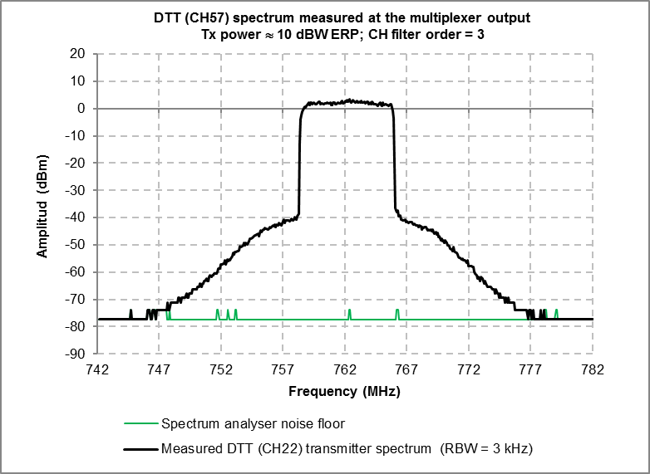
Figure 5: Spectrum of a low power DVB-T transmitter

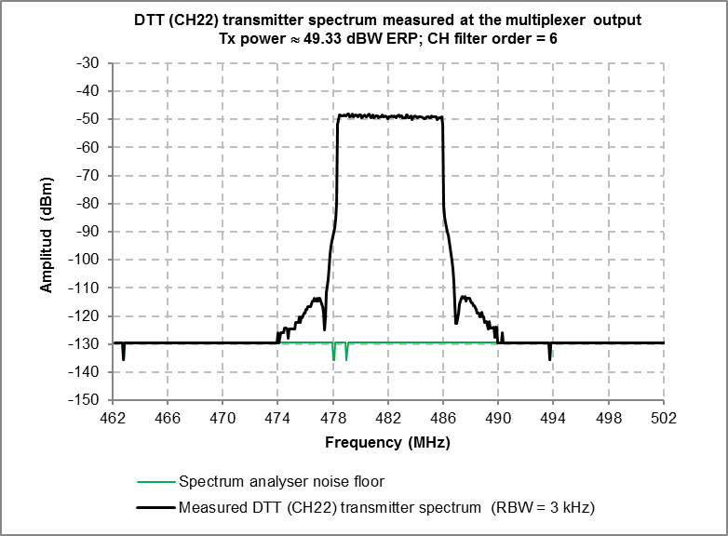
Figure 6: Spectrum of a high power DVB-T transmitter
Under such conditions it was not possible to measure the ACLR of DTT transmitters. This problem was resolved by the following method:
- Step 1: The spectrum of the DTT signal S(f) in the range of fc±20 MHz at the input of the multiplexer (output of the transmitter) is measured and recorded;
- Step 2: The spectrum of the DTT signal Sref(f) at the multiplexer output is measured and recorded;
- Step 3: The frequency response of several DTT channel filters H(f) representative of those used in the real-life DTT networks is measured and recorded;
- Step 4: The spectrum of the DTT signal at the multiplexer output is calculated by applying the recorded frequency response of the channel filter to the recorded spectrum of the DTT signal at Step 1: S’(f)=S(f)+H(f). The validity of the obtained spectrum is checked by comparing it to that measured at Step 2 (see Figure 7);
- Step 5: The ACLR of the DTT signal at the output of the DTT channel filter is calculated by integrating its OoB emissions over the 1st and 2nd adjacent channels (see section 4.3.2.1).
Comparison of a DTT transmitter signal Sref(f), measured in the field at the multiplexer output, with S’(f) obtained by applying a recorded frequency response of a 3-poles DTT channel filter to the DTT signal measured at the multiplexer input is depicted in Figure 7. The slight difference between the two spectrums can be explained by the slight difference between the frequency responses of the channel filter used on the radio site and that used for the calculations. As shown in Figure 7, the method used permits to circumvent the difficulty caused the noise floor of the spectrum analyser and estimates quite accurately the transmitter spectrum at the multiplexer output.
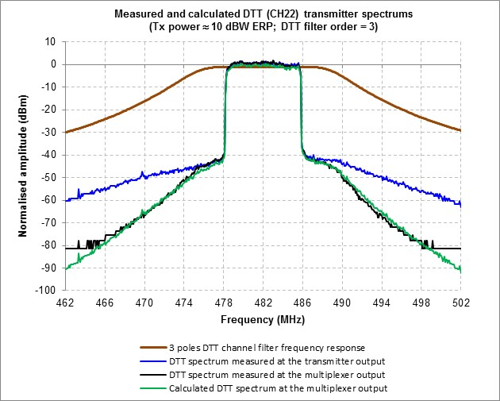
Figure 7: Comparison of the measured and calculated DTT (Ch22) Transmitter spectrum
The emissions off 14 different real-life low power and 12 different real-life high power DTT transmitters have been measured at the multiplexer input (before the channel filter). This is aimed at calculating the emissions in the OoB domain as well as the ACLR at the output of the DTT channel filter/multiplexer using the method described above. The measured emissions are depicted in Figure 8 and Figure 9.
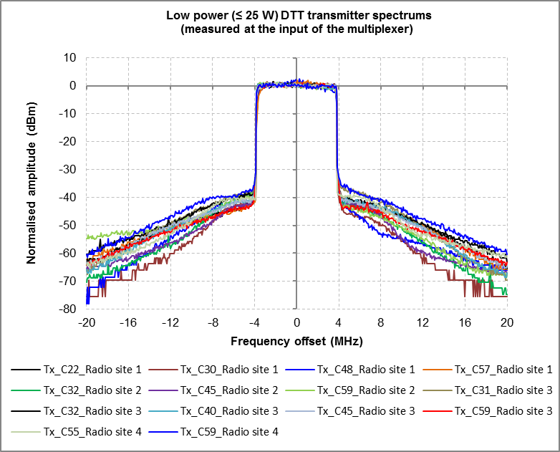
Figure 8: Low power DTT transmitters output emissions measured at the multiplexer input
(before the channel filter)

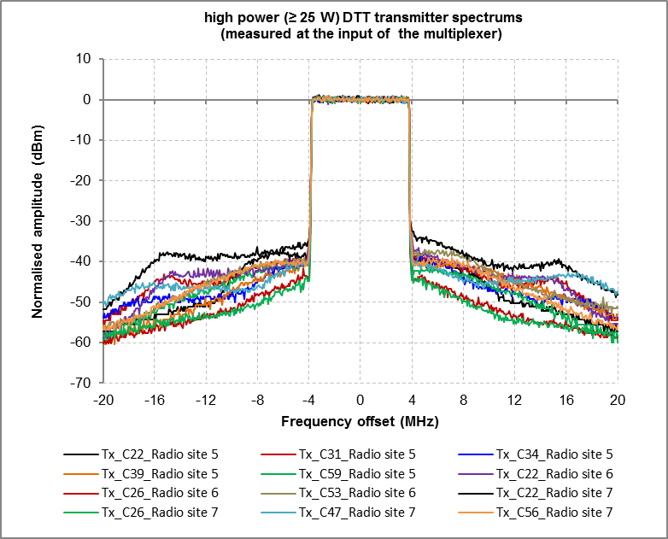
Figure 9: High power DTT transmitters output emissions measured at the multiplexer input
(before the channel filter)
The spectrum of the DTT transmitter output signal (fc±20 MHz) at the channel filter/multiplexer output has been calculated by applying the recorded frequency response of the channel filter to the spectrum of the DTT signal measured at the transmitter output. The low power DTT transmitters output signals have been filtered by 3-pole filters F1, F2, F3 and by 6-pole filters F6 and F7 respectively. While the high power DTT transmitters output signals have been filtered by 6-pole filters F1 and F3 respectively (see Figure 10 and Figure 11).
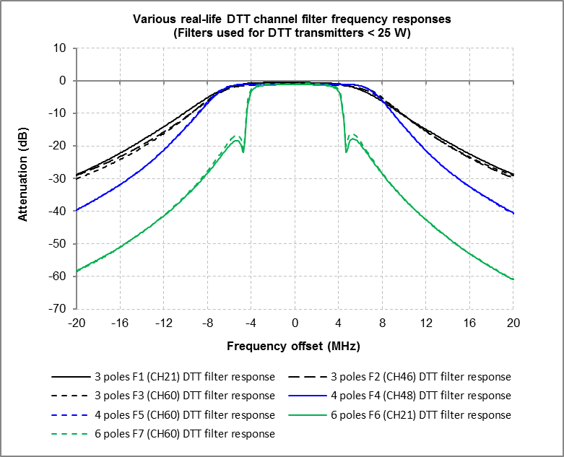
Figure 10: Actual DTT channel filters used for low power transmitters (< 25 W)

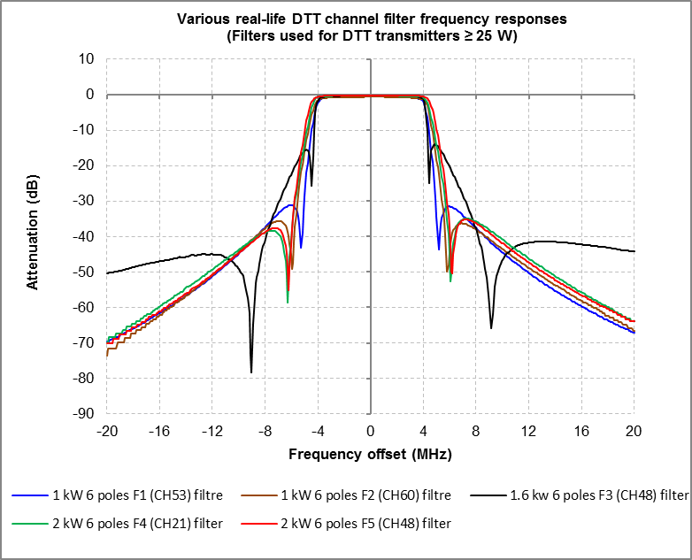
Figure 11: Actual DTT channel filters used for high power transmitters (≥ 25 W)
The results of the calculations based on in field measurements and their comparison with the limits defined in ETSI Harmonised Standards are presented in the following section.

ACLR values of low power DTT transmitters (P ≤ 25 W) using a 3-poles channel filter
Note that as underlined in section 4.3.2.1, low power 3-pole channel filters are used in the case of secondary networks when the first adjacent channels are not used.
Emissions of the 14 low power DTT transmitters (P ≤25 W) calculated at the output of a 3-pole channel filter are depicted in Figure 12.
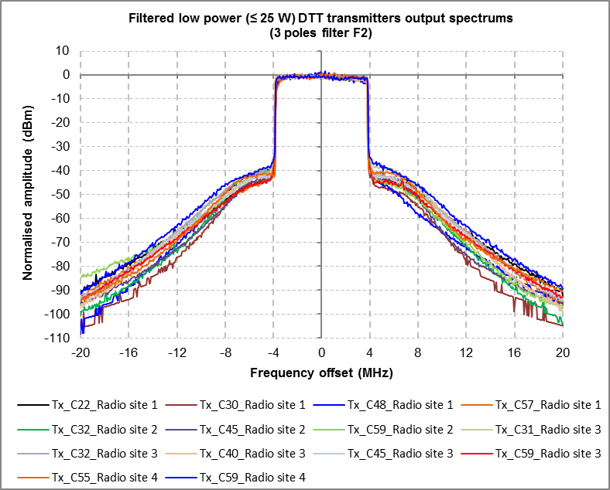
Figure 12: Low power DTT transmitters’ spectrum calculated at the output of a 3-pole channel filter
The ACLR values of the low power DTT transmitter have been calculated from the transmitters’ OoB emissions by integrating them over the 1st and 2nd adjacent channels. In Table 1, the ACLRs obtained are compared with the non-critical ACLR defined for DTT transmitters in ETSI EN 302 296 [13] (least restrictive limits).
Table 1: DTT transmitter (4 W < P ≤ 25 W) ACLR values calculated from 14 different real-life transmitters’ output signals filtered by using 3 different real-life 3-pole channel filters
(ACLR defined/calculated in 8 MHz)
Filter type | Required non-critical ACLR limit  1st adjacent channel | Calculated worst / best ACLR (dB)  1st adjacent channel | Required ACLR non-critical limit  2nd adjacent channel | Calculated worst / best ACLR (dB)  2nd adjacent channel
3-pole F1 | 42 | 42.4 / 47.3 | 64 | 68.9 / 82.9
3-pole F2 | 42 | 41.7 / 47.3 | 64 | 69.8 / 83.9
3-pole F3 | 42 | 41.3 / 47.1 | 64 | 70.6 / 84.6
The above results show that the ACLR values of the measured low power DTT transmitters using a 3-pole channel filter are:
- on average slightly better (higher) than the 1st adjacent channel non-critical ACLR limit defined in ETSI EN 302 296;
- 5-10 dB better than the 2nd adjacent channel non-critical ACLR limit defined in ETSI EN 302 296.

OoB emission levels and ACLR values of low power DTT transmitters (P ≤ 25 W) using a 6-pole channel filter
Note that as underlined in section 4.3.2.1, low power 6-pole channel filters are used in the case of secondary networks when the first adjacent channels are used.
Emissions of the 14 low power DTT transmitters (P ≤ 25 W) calculated at the output of a 6-pole channel filter and their comparison with the low power non-critical and critical masks defined in ETSI EN 302 296 [13]¨are depicted in Figure 13.
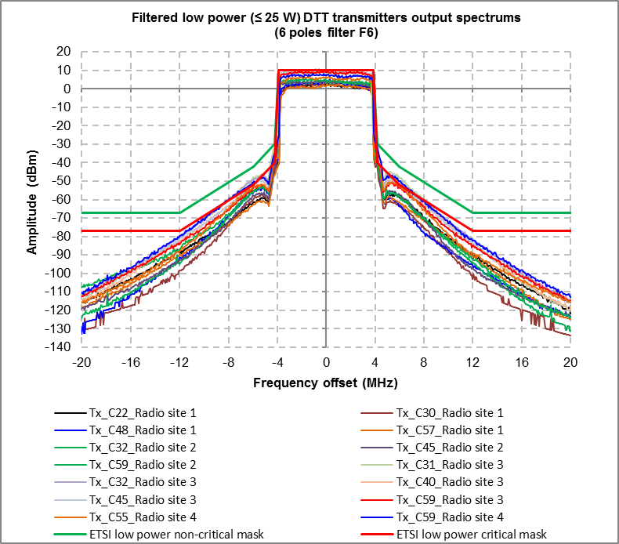
Figure 13: Low power DTT transmitters spectrum calculated at the output of a 6-pole channel filter
The ACLR values of the low power DTT transmitter have been calculated from the filtered transmitters’ OoB emissions by integrating them over the 1st and 2nd adjacent channels. In Table 2, the ACLRs obtained are compared with the minimum required critical ACLR defined in ETSI EN 302 296.
Table 2: DTT transmitter (4 W < P ≤ 25 W) ACLR values calculated from 14 different transmitters output signals filtered by using 2 different real-life 6-pole channel filters (ACLR defined/calculated in 8 MHz)
Filter type | Required critical ACLR limit  1st adjacent channel | Calculated worst / best ACLR (dB)  1st adjacent channel | Required critical ACLR limit  2nd adjacent channel | Calculated worst / best ACLR (dB)  2nd adjacent channel
6-pole F6 | 55 | 51.7 / 58.3 | 77 | 96 / 110
6-pole F7 | 55 | 51.2 / 57.4 | 77 | 96.3 / 110.3
Figure 13 shows that the OoB emission levels of the measured low power DTT transmitters using a 6-pole channel filter are:
- 10 dB better (lower) than the non-critical mask defined in ETSI EN 302 296 in the 1st adjacent channel and about 10-40 dB better in the 2nd adjacent channel;
- on average slightly better than the critical mask defined in ETSI EN 302 296 in the 1st adjacent channel and some dBs to 30 dB better at the beginning and the end of the 2nd adjacent channel respectively.
While Table 2 shows that the ACLR values of the measured low power DTT transmitters using a 6-pole channel filter are:
- on average close to the 1st adjacent channel critical ACLR limit defined in ETSI EN 302 296;
- 19-33 dB higher than the 2nd adjacent channel critical ACLR limit defined in ETSI EN 302 296.

OoB emission levels and ACLR of high power DTT transmitters (P > 25 W) using a 6-pole channel filter
Note that as underlined in section 4.3.2.1, high power 6-pole channel filters are used in the case of primary networks when the first adjacent channels are not used.
Emissions of the 12 high power DTT transmitters (P > 25 W) calculated at the output of two 6-pole channel filters and their comparison with the high power non-critical and critical masks defined in ETSI EN 302 296 [13] are depicted in Figure 14 and Figure 15.
The ACLR values of the high power DTT transmitter have been calculated from the filtered transmitters OoB emissions by integrating them over the 1st and 2nd adjacent channels. In Table 2, the ACLRs obtained are compared with the minimum required critical ACLR defined in ETSI EN 302 296.
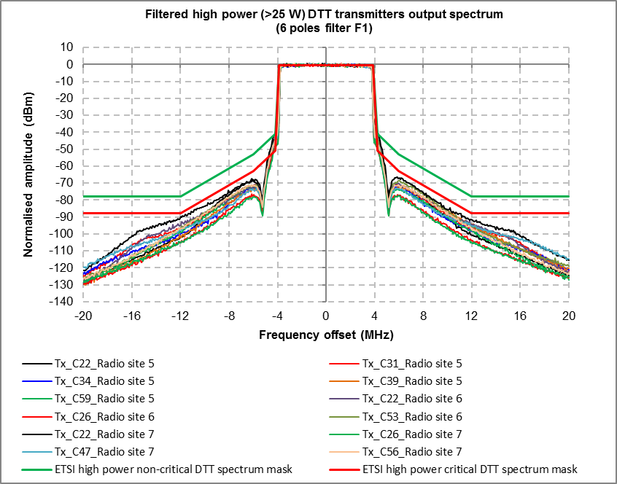
Figure 14: High power DTT transmitters spectrum calculated at the output of a 6-pole channel filter

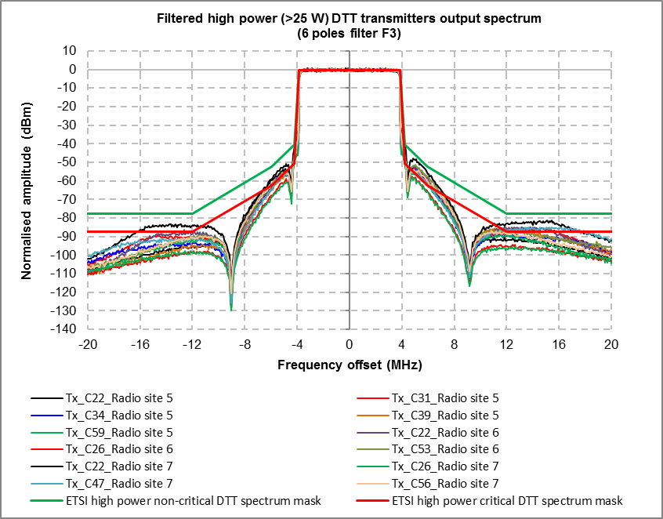
Figure 15: High power DTT transmitters spectrum calculated at the output of a 6-pole channel filter

Table 3: DTT transmitter (P >25 W) ACLR values calculated from 12 different transmitters output signals filtered by using 2 different real-life 6-pole channel filters(ACLR defined/calculated in 8 MHz)
Filter type | Required critical ACLR limit  1st adjacent channel | Calculated worst / best ACLR (dB)  1st adjacent channel | Required critical ACLR limit  2nd adjacent channel | Calculated worst / best ACLR (dB)  2nd adjacent channel
6-pole F1 | 61 | 50.9 / 60.2 | 87 | 96.8 / 111.5
6-pole F3 | 61 | 50.9 / 60.1 | 87 | 83.8 / 97.8
Figure 14 shows that the OoB emission levels of the measured high power DTT transmitters using a 6-pole channel filter F1 are:
- 10 dB better (lower) than the non-critical mask defined in ETSI EN 302 296 in the 1st adjacent channel and about 10-40 dB better in the 2nd adjacent channel;
- slightly better than the critical mask defined in ETSI EN 302 296 in the 1st adjacent channel, except at about ± 4.2 MHz frequency offset where they are slightly worse (higher), and some dBs to 30 dB better at the beginning and the end of the 2nd adjacent channel respectively.
However, as shown in Figure 15, the OoB emission levels of some of the measured high power DTT transmitters using a 6-pole channel filter F3 are in conformity with the non-critical mask defined in ETSI EN 302 296 in the 1st adjacent 2nd adjacent channels, but not with the critical mask.
Table 3 shows that the ACLR values of the measured high power DTT transmitters using a 6-pole channel filter are:
- on average slightly worse (lower) than the 1st adjacent channel critical ACLR limit defined in ETSI EN 302 296;
- 9-34 dB better (higher) than the 2nd adjacent channel critical ACLR limit defined in ETSI EN 302 296 when channel filter F1 is used, and on average 7 dB better when channel filter F3 is used.

Measurement of DTT transmitters spurious emission levels
Measurements were carried out at three different high power DTT radio sites aiming at evaluating the spurious emission (SE) levels of real-life DVB-T transmitters in France. The transmitter power of these radio sites were 3.7 kW, 1,7 kW and 0.24 kW respectively.
The DTT multiplexer output was fed, via a coupling device (measurement probe) and a high-pass filter, into a spectrum analyser having a high dynamic range (noise floor = -106 dBm/(100 kHz)). Various low-pass and high-pass filters were used to filter the transmitted DTT signals (multiplexes) to minimise their cumulative power and to prevent the overloading of the spectrum analyser.
Measurement results show that, due to the high measurement probe attenuation at the multiplexer output, the spurious emission levels below -50 dBm/(100 kHz) can hardly be measured despite the very high dynamic range of the existing spectrum analysers.
The results of the measurements are summarised below:
- Band 10-470 MHz: no spurious emissions due to DTT transmitters were identified;
- Band 790-862 MHz: no spurious emissions due to DTT transmitters were identified;
- Maximum spurious emission levels due to DTT transmitters measured above 862 MHz are presented in Table 4.
Table 4: Measured DTT transmitters (P >25 W) spurious emission levels
Radio Site | Frequency (MHz) | Measured SE level at spectrum analyser input (dBm) (Note 1) | Probe att (dB) | Ext att (dB) (Note 2) | Actual SE level (dBm) | Remarks
No. 5 (Tx power ≈ 3.7 kW) | 906.26 | -96.04 | 52 | 2 | -42.04 | RNE CH39  RBW=100 kHz/VBW=3 kHz
No. 5 (Tx power ≈ 3.7 kW) | 965.67 | -108.26 | 52 | 2 | -54.26 | R2H (Note 3) CH22  RBW=VBW=3 kHz
No. 5 (Tx power ≈ 3.7 kW) | 965.67 | -93.33 | 52 | 2 | -39.33 | R2H CH22  RBW=100 kHz/VBW=3 kHz
No. 5 (Tx power ≈ 3.7 kW) | 1659.54 | -79.85 | 47 | 2 | -30.85 | R3H CH31  RBW=100 kHz/VBW=3 kHz
No. 6 (Tx power ≈ 1.9 kW) | 963.53 | -111.48 | 51.8 | 2 | -57.68 | R2H CH22  RBW=VBW=3 kHz
No. 6 (Tx power ≈ 1.9 kW) | 963.53 | -96.33 | 51.8 | 2 | -42.53 | R2H CH22  RBW=100 kHz/VBW=3 kHz
No. 6 (Tx power ≈ 1.9 kW) | 982.77 | -97.97 | 51.6 | 2 | -44.26 | R2H CH23  RBW=100 kHz/VBW=3 kHz
No. 6 (Tx power ≈ 1.9 kW) | 1537.88 | -90.76 | 38.3 | 2 | -50.46 | R3H CH26  RBW=100 kHz/VBW=3 kHz
No. 7 (Tx power ≈ 0.24 kW) | 990.44 | -105.38 | 45.6 | 2 | -57.78 | R2H CH23  RBW=VBW=3 kHz
No. 7 (Tx power ≈ 0.24 kW) | 990.44 | -90.19 | 45.6 | 2 | -42.59 | R2H CH23  RBW=100 kHz/VBW=3 kHz
No. 7 (Tx power ≈ 0.24 kW) | 2317.86 | -88.18 | 38.3 | 2 | -47.88 | R4H CH34  RBW=100 kHz/VBW=3 kHz
Note 1: For all the measurements: Detector: RMS; Trace: Max Hold; spectrum analyser noise floor = -106 dBm/100 kHz (RBW = 100 kHz / VBW = 3 kHz)
Note 2: Low-pass/High-pass filter + cable attenuation
Note 3: Residual harmonic emissions
The comparison of the above limits with the limits defined in ETSI EN 302 296 [13] and ERC Recommendation 74-01 [2] is depicted in Figure 16.
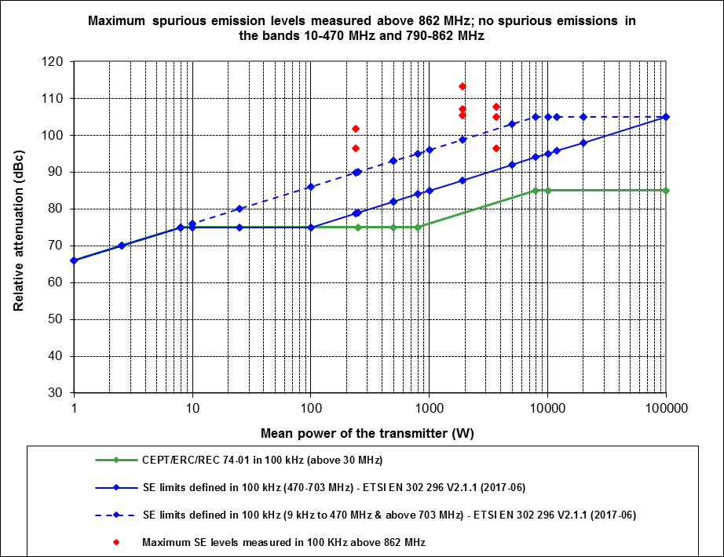
Figure 16: High power DTT transmitters spurious emission levels
The above results show that the spurious emission levels of the measured high power DTT transmitters using a 6-pole channel filter are, except in one case, lower than the spurious emission limits defined in ETSI EN 302 296.

Conclusion on DTT field measurements
The results of the field measurements where the DTT transmitter is in operation show that:
- The OoB emission levels of the measured low power (P ≤ 25 W) and high power (P > 25 W) DTT transmitters using a 6-pole channel filter are:
10 dB better (lower) than the non-critical mask defined in ETSI EN 302 296 [13] in the 1st adjacent channel and about 10-40 dB better in the 2nd adjacent channel;
on average slightly better than the critical mask defined in ETSI EN 302 296 in the 1st adjacent channel, and some dBs to 30 dB better at the beginning and the end of the 2nd adjacent channel respectively, with the exception of some high power transmitters using channel filter F3.
- The ACLR values of the measured low power (P ≤ 25 W) DTT transmitters using a 3 or 6-pole channel filter are:
on average close to or slightly better (higher) than the 1st adjacent channel critical ACLR limit defined in ETSI EN 302 296;
5-10 dB better than the 2nd adjacent channel non-critical ACLR limit and 19-33 dB better than the 2nd adjacent channel critical ACLR limit defined in ETSI EN 302 296.
- The ACLR values of the measured high power (P > 25 W) DTT transmitters using a 6-pole channel filter are:
on average slightly worse (lower) than the 1st adjacent channel critical ACLR limit defined in ETSI EN 302 296;
9-34 dB better (higher) than the 2nd adjacent channel critical ACLR limit defined in ETSI EN 302 296 when channel filter F1 is used, and on average 7 dB better when channel filter F3 is used.
- The spurious emission levels of the measured high power DTT transmitters using a 6-pole channel filter are, except in one case, lower than the spurious emission limits defined in ETSI EN 302 296 [13] (no spurious emissions due to DTT transmitters were identified in the bands 10-470 MHz and 790-862 MHz).
In conclusion, the OoB emission and ACLR levels of DTT transmitters are significantly better than the non-critical limits defined in ETSI EN 302 296. They are on average slightly better than the critical limits defined in the 1st adjacent channel and better than those defined in the 2nd adjacent channel.

LTE800 Base stations
The 4th generation of the mobile communication standard (LTE) is currently being introduced by many network providers. 3GPP TS 36.211 [35] allows many RF parameters to be flexible, including the RF bandwidth. Measurements were performed on several LTE800 base stations from different manufacturers. The key RF parameters of the measured base stations are:
- Frequency range: 796 MHz for Tx1 and Tx2, 816 MHz for Tx3;
- Modulation: OFDM;
- Bandwidth: 10 MHz;
- Transmitter power: 46 dBm (40 W) Tx output, 60.5 dBm (1122 W) e.i.r.p.;
- Tx output filter: None for transmitter 1 and 3, transmitter 2 has an additional external filter in order to comply with DVB-T protection requirements (in practice the lower side band of Tx2 was measured, and the result was mirrored at the centre frequency to the upper sideband to allow direct comparison with the result from Tx1 and Tx3 in one graph );
- OoB domain ends at: for Tx1 at 35 MHz, for Tx2 and Tx3 at 15 MHz offset from the centre frequency (see section 3.2).

Although no external output filters were applied for Tx1 and Tx3, they have internal filters to limit the spurious emissions outside the allocated downlink band in order to protect their own receivers in the uplink band (832 to 862 MHz).
The measurements are based on a limited number of equipment samples, and worst case performance may considerably deviate from the results shown due to the inherent dynamic nature of the 3GPP LTE systems. Also, the specific resource block configuration during the measurements was not always known.

Out-of-band emissions
The system transmits in bursts of different length and bandwidth, depending on base station configuration and traffic. The measurements were done while the base stations were in a test mode using all available resource blocks and thereby stimulating the maximum sideband emissions. Measurement bandwidths were between 30 and 100 kHz. The transmitter output power of all three LTE base stations was 40 W = 16 dBW = 46 dBm. The radiated power was 60.5 dBm.
Since Recommendation ITU-R SM.1541 [1] does not contain any information for OoB limits for this kind of application, the masks from ETSI EN 301 908-14, table 4.2.2.2.3-3 [9] are shown for comparison.
The levels of both measured values and limits were converted into a bandwidth of 30 kHz and normalised.
Values to the right from the black dashed line show technical limitations due to the receiver noise.
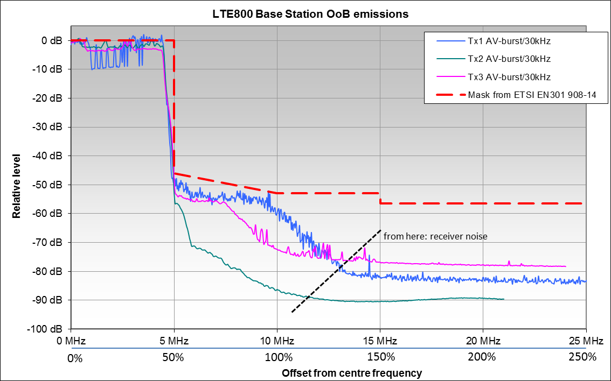
Figure 17: OoB emissions from LTE800 base stations
Observation from Figure 17:
- Even if no external filters are applied (see Tx1 and Tx3), the OoB emissions beyond an offset of approximately 15 MHz (150% channel width) are already suppressed by 80 dB, or 20 dB below the limit (see also Figure 36, upper sideband);
- However, it is noted that Tx1 only just meets the mask at lower offsets (<10 MHz) and this may change if the measurement time was increased.

Spurious emissions
Since Recommendation ITU-R SM.329 [3] (Cat. B) does not contain specific values for Broadband Wireless Access systems below 1 GHz, the general Category B limit for land mobile service of -36 dBm in 100 kHz bandwidth was taken for comparison.
The relevant ETSI standard EN 301 908 section 4.2.4.2.1 [6] and Table 2.1 of ERC Recommendation 74-01 [2] also specify a spurious limit of -36 dBm in 100 kHz bandwidth, measured conducted at the transmitter output. This limit has to be referenced to a total in-band power of 40 W = 46 dBm in 10 MHz, which corresponds to an in-band power spectral density of 46 dBm - 10log10(10000/100) = 26 dBm in 100 kHz bandwidth. The resulting relative attenuation of spurious emissions is then 26 dBm - (-36 dBm) = 62 dB.
As seen in the OoB measurements, the level of emissions in Figure 17 is already below the sensitivity of the measurement system at the boundary of the spurious domain. Because all LTE base stations have at least internal filters to protect their own receive bands, no spurious emissions could be detected at any further frequency offsets.
Figure 18 below shows conducted measurements at the transmitter output of an LTE base station, operating at 796 MHz. The base station has been configured to transmit with maximum power, although not all resource blocks have been allocated to the user data. The operational mode when the base station transmits at maximum power and all resource blocks are allocated to user data can stipulate a higher level of unwanted emissions and can be referred to as 'worst case'.
Considering the principles described in section 3.2, the spurious domain starts at an offset of 15 MHz, depicted by the red dashed line in Figure 18 below.
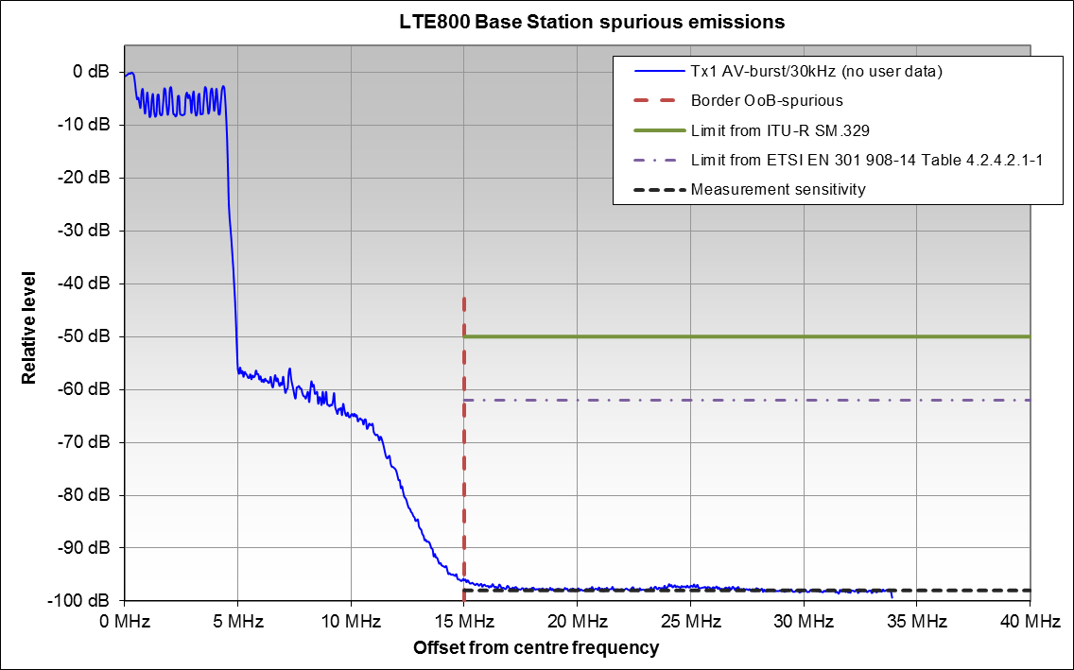
Figure 18: Emissions from an LTE800 base station
Observations:
- Modulated signals already disappear below measurement sensitivity at around 15 MHz offset (150% bandwidth);
- The spurious emission levels are at least 40 dB below the limits of Category B for land mobile service in Recommendation ITU-R SM.329 [3],Table 2.1 of ERC Recommendation 74-01 [2] and ETSI EN 301 908-14 [9] due to the output filters applied;
- Although the station was not operated in "worst case" mode, it can be seen that the output filter has most effect at offsets above 12 MHz, although the spurious domain begins at 25 MHz offset.

LTE800 User Equipment
User equipment (UE) for LTE800 may be modems installed in houses with internal or external antennas, or smart phones. During active connections, the UE always transmits a control channel with a bandwidth of 180 kHz. The scheduler in the base station assigns an additional part of the channel width at certain times to the mobile in order to transmit user data. This results in a constantly changing bandwidth of the UE signal, depending on the traffic situation. In addition, power control constantly adjusts the output power of the UE in a way that the signal is just receivable at the base station.
Measurements were performed using several LTE800 UEs from different manufacturers. It is acknowledged that ideally a statistically representative number of equipment samples/reference designs should be analysed in order to derive statistical models for the performance of mobile devices deployed in practice. For practical reasons, the measurements are based on a limited number of equipment samples and worst case performance may considerably deviate from the results shown due to the inherent dynamicity of the 3GPP LTE systems. For example, the LTE configuration used (i.e., the number of resource blocks, where are resource blocks located in time/frequency, etc.) is not always specified. Even a "full load" where the UE transmits on all possible resource blocks with maximum power, does not necessarily result in the maximum unwanted emissions, which is the reason why in ETSI standards used for conformance tests the equipment has to be operated in a number of different configurations, none of which may produce unwanted emissions above the limit. However, the measurement results may provide valuable data for sharing and compatibility studies.
The key RF parameters of the measured UEs are:
- Frequency range: 832 MHz - 862 MHz;
- Modulation: SC-FDMA;
- Bandwidth: 180 kHz to 10 MHz;
- OoB domain ends at: 20 MHz offset from the centre frequency (see ETSI EN 301 908-13, Table
4.2.4.1.2-1) [8]
- Transmitter power: up to 23 dBm (200 mW) e.i.r.p. ;
- Tx output filter: None.

Although no external output filters were applied, there is some internal filtering to limit the spurious emissions outside the allocated uplink band in order to protect their own receivers operating in the band 791 to 821 MHz, or adjacent services.
Since only the FDD mode is of interest in this frequency range, TDD operation has not been investigated.

Out-of-band emissions
Measurements on four different LTE800 UEs are published in [14]. The report notes the measurements were recorded as RMS power in a 10 kHz resolution bandwidth, with each UE set to transmit at maximum power (23 dBm) and using 16 QAM modulation which was the maximum modulation order supported by all the devices under test. This ensured maximum levels of unwanted emissions. Since ITU-R Recommendation SM.1541 [1] does not contain any information for OoB limits for this kind of application; the masks from ETSI EN 301 908-13, Table 4.2.3.1.2-1 [8] are shown in Figure 19 for comparison. Note that this standard also defines the OoB boundary for 10 MHz LTE signals to be at 20 MHz offset which is equal to 200% of the channel bandwidth.
The levels of both measured values and limits were converted into a bandwidth of 10 kHz and normalised.
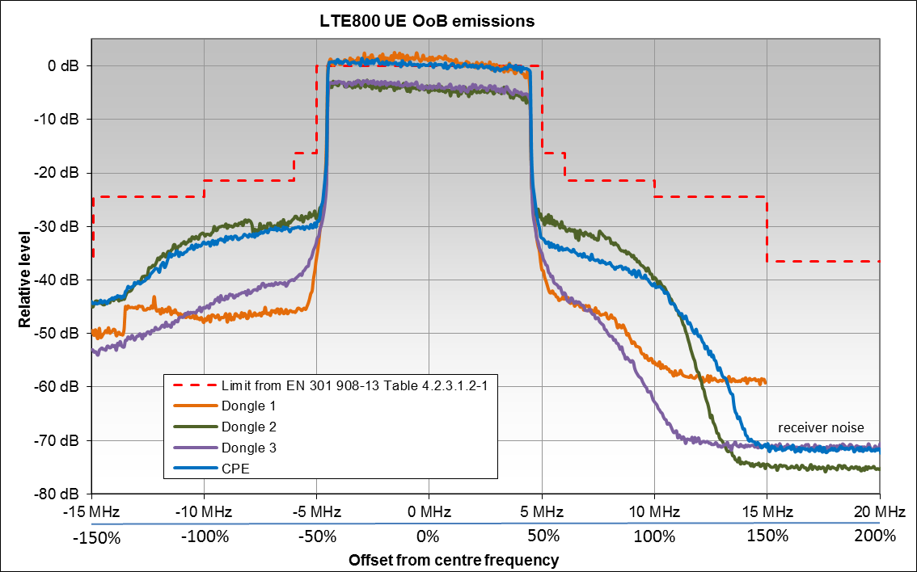

Figure 19: OoB measurements of four LTE800 UEs
Observations from Figure 19:
- The results show that all UEs outperform the OoB emission mask to varying degrees.
- All tested UEs demonstrated asymmetric emissions, with higher suppression above 862 MHz. This suggests the presence of (internal) filtering to address co-existence issues with systems in adjacent frequency bands.
Further OoB measurements of LTE800 UEs can be found in A3.1.1 and A3.1.2.

Spurious emissions
- Recommendations ITU-R SM.329 [3] (Category B, land mobile service), Table 2.1 of ERC Recommendation 74-01 [2] and the relevant ETSI standard EN 301 908-13 (Table 4.2.4.1.2-2) [8] specify a spurious emissions limit of -36 dBm in 100 kHz reference bandwidth (measured conducted at the transmitter output). This limit has to be referenced to a total in-band power of 200 mW = 23 dBm in 10 MHz, which corresponds to an in-band spectral density of 23 dBm - 10log10(10000/100) = 3 dBm in 100 kHz bandwidth. The resulting relative attenuation of spurious emissions is then 3 dBm - (-36 dBm) = 39 dB.
- Note that ETSI EN 301 908-13 defines the OoB boundary for 10 MHz LTE signals to be at 20 MHz offset which is equal to 200% of the channel bandwidth (see Table 4.2.4.1.2-1 thereof).
Figure 20 shows measurements of two LTE800 UEs operating on 857 MHz in the offset range near the OoB boundary.
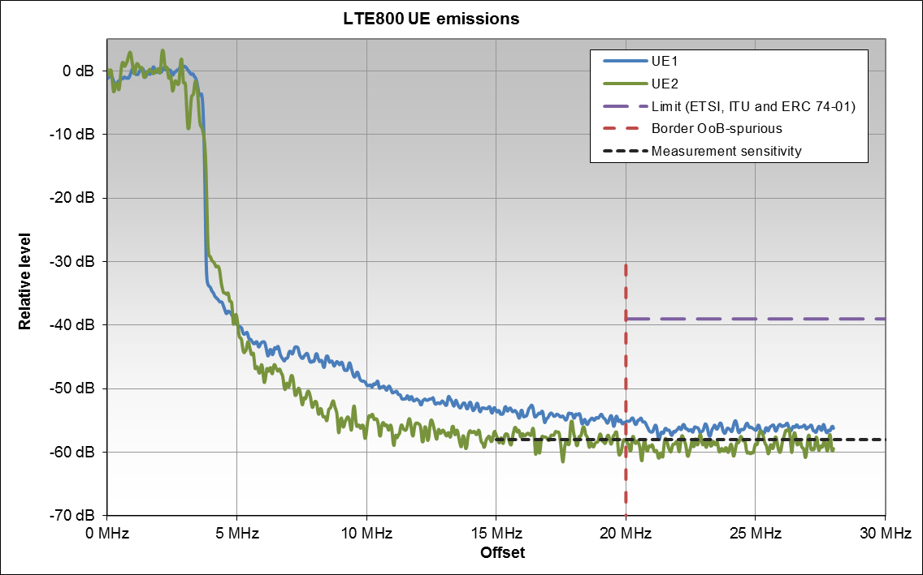
Figure 20: Emissions from two LTE800 UEs
Observations:
- It can be seen from Figure 20 that both UEs outperform the limits from Table 2.1 of ERC Recommendation 74-01 [2] by at least 20 dB in this configuration. The actual spurious emissions are lower than shown because of the limitation by the available measurement sensitivity;
- The fact that the UEs operated at the highest LTE800 channel where spurious emissions are further suppressed to protect adjacent services results in very high suppression of the spurious emissions, even below the measurement sensitivity. By examining the lower sidebands in Figure 20, it can be seen that at the OoB boundary and even inside the LTE800 band, the spurious emissions are considerably lower than the limits.

Harmonic emissions
Unwanted emissions at the second harmonic frequency of commercially available LTE800 UE have been measured as it falls within the receiver bandwidth of a radionavigation satellite service band. Because these unwanted emissions are always above 1 GHz, the limits from Cat. B, land mobile service of Recommendation ITU-R SM.329. Table 2.1 of ERC Recommendation 74-01 and ETSI EN 301 908-13 [8] of -30 dBm in 1 MHz reference bandwidth apply. Recommendation ITU-R M.2071 [15], applicable to IMT-Advanced UEs, also specifies the same limit. The total radiated power measured was 27 dBm in 10 MHz which results in an in-channel spectral density of 17 dBm/MHz. The required suppression of the harmonic frequencies would therefore be 17 dBm/MHz -(-30 dBm) = 47 dB.
The transmitter frequency was 858 MHz. Measurements have been performed radiated in a laboratory setup with a measurement bandwidth of 100 kHz. Figure 21 and Figure 22 show the measured in-band signal and its second harmonic.
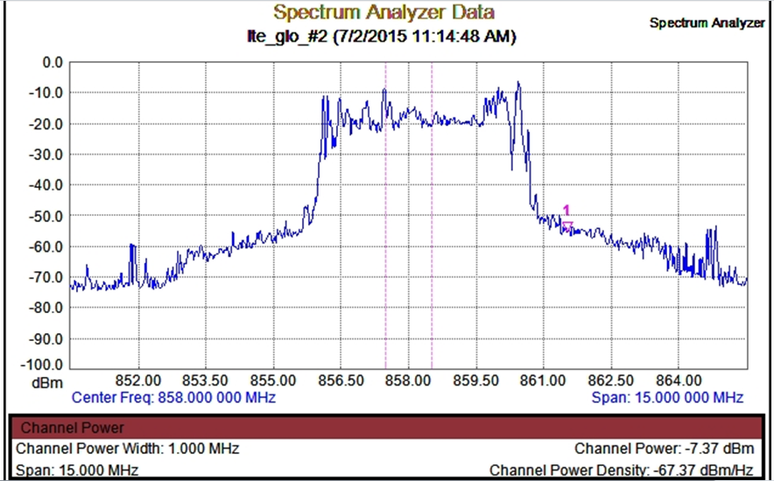
Figure 21: In-band emission from an LTE800 UE

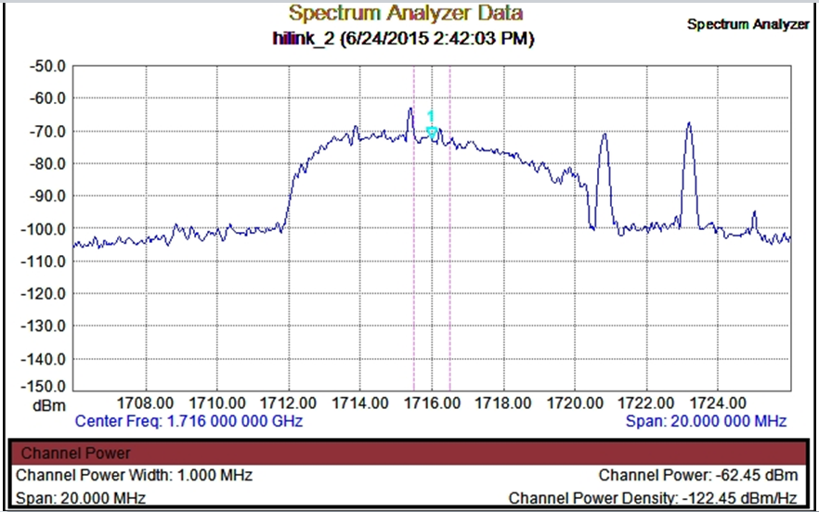
Figure 22: Emission from an LTE800 UE at the second harmonic frequency
The link budget for these measurements was as follows in Table 5.
Table 5: Link budget
Parameter | Main emission | Second harmonic emission
Frequency | 858 MHz | 1716 MHz
Measured Power | - 7.35 dBm/MHz | -62.45 dBm/MHz
Antenna gain | 7.8 dB | 7.5 dB
Cable attenuation | 1.2 dB | 1.5 dB
Free space attenuation | 31.2 dB | 37.14 dB
Radiated power | 17.23 dBm/MHz | -31.31 dBm/MHz
The suppression of the second harmonic for the measured UE is estimated as
17.23 dBm/MHz -(-31.31 dBm/MHz) = 48.54 dB.
Observation:
- The unwanted emission of the measured UE at the second harmonic frequency is approximately 1.5 dB below the limit.

LTE 2300 User equipment
In some European countries, LTE is also used in the 2.3 GHz range. The system is principally the same as LTE800 with the exception that typically channels are 20 MHz wide. The relevant RF parameters are:
- Frequency range: 2300 MHz - 2400 MHz;
- Modulation: SC-FDMA;
- Bandwidth: 180 kHz to 20 MHz;
- Transmitter power: Up to 23 dBm (200 mW) Tx output and e.i.r.p.
- Tx output filter: None;
- OoB domain ends at: 35 MHz offset from the centre frequency (see ETSI EN 301 908-13, table 4.2.4.1.2-1) [8].
Figure 23 below shows the results of lab measurements on the unwanted emissions of 2 different LTE UEs operating in a 20 MHz channel of the 2.3 GHz LTE TDD band from 2370-2390 MHz. Measurements were recorded as RMS power in a 10 kHz resolution bandwidth, with each UE set to transmit at maximum power (23 dBm) and using 16 QAM modulation.
For reasons similar to those discussed in section 4.5, the measurements are based on two equipment samples and worst-case performance may considerably deviate from the results shown due to the inherent dynamic behaviour of the 3GPP LTE systems. Also, the LTE configuration used (i.e., the number of resource blocks, where are resource blocks located in time/frequency, etc.) is not always specified.
The graph in Figure 23 is normalised to the in-channel power spectral density in a 10 kHz bandwidth.
Recommendation ITU-R SM.1541 [1] does not contain OoB emission limits for this system, therefore the spectrum mask from the relevant standard, ETSI EN 301 908-13 (Table 4.2.3.1.2-1), converted into a 10 kHz bandwidth and compared to the in-channel power spectral density, is shown in Figure 23.
The relevant ETSI standard EN 301 908-13 (Table 4.2.4.1.2-2), Recommendation ITU-R SM.329 (Cat. B for land mobile systems) [3] and Table 2.1 of ERC Recommendation 74-01 [2] provide a spurious emissions limit of -30 dBm in 1 MHz bandwidth. Since this value applies to the transmitter output, the regulatory limit has to be referenced to a total in-band power of 200 mW = 23 dBm in 20 MHz, which corresponds to an in-band spectral density of 23 dBm - 10log10(20/1) = 10 dBm in 1 MHz bandwidth. The resulting relative attenuation of spurious emissions is then 10 dBm -(-30 dBm) = 40 dB.
Note that ETSI EN 301 908-13 [8] (Table 4.2.4.1.2-1) defines the OoB boundary for 20 MHz LTE signals to be at 35 MHz offset which is equal to 175% of the channel bandwidth
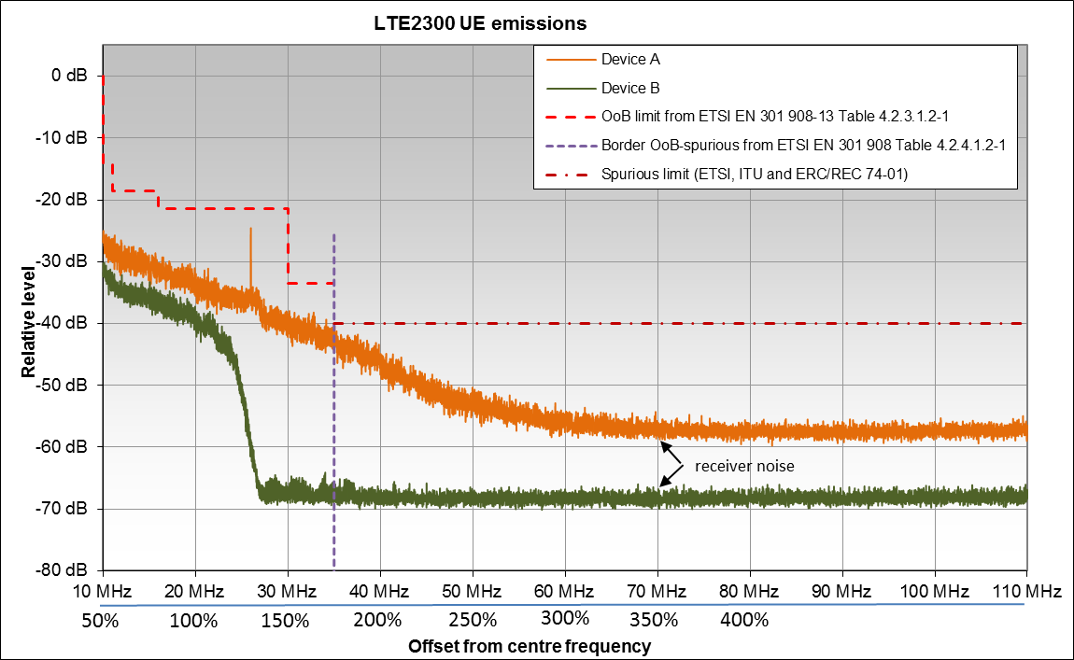
Figure 23: Unwanted emission measurements of 2 LTE 2.3 GHz UEs
(RMS power, resolution bandwidth = 10 kHz)
Observations from Figure 23:
- There is a noticeable difference in the measured emission profile between the 2 devices. Device A has a linear roll-off with the exception of a spike within the OoB domain, and only just meets the spurious emission limit immediately beyond the boundary. Device B shows significantly better performance, with much sharper roll-off in the OoB domain;
- The spurious emissions for higher frequency offsets outperform the limit by as much as 30 dB. It should be noted however that measurements in the spurious domain are limited by the dynamic range of the measurement equipment. The unwanted emissions from the devices could therefore be even lower than shown in Figure 23.

GSM900 Base station
The relevant RF parameters of the GSM900 base stations are:
- Frequency range: 925 MHz - 960 MHz;
- Modulation: GMSK;
- Occupied Bandwidth: 250 kHz;
- Channel spacing: 200 kHz;
- OoB domain ends at: 500 kHz offset from the centre frequency
(250% rule, using channel spacing (Note 1));
- Transmitter power: up to 46 dBm Tx output (typical);
- Tx output filter: None.
Note 1: 500 kHz offset to the start of the spurious domain has typically been used in compatibility studies. In GSM specifications ETSI EN 302 408 V8.0.1 [36] section 4.3.3.1 and EN 301 502 V12.1.1 [37] section 4.2.5.1.3 and Table 4.2.5.1, the spurious emissions are defined starting 1.8 MHz from the carrier centre inside a transmit band and from 2 MHz offset from the band edge outside the transmit band.
Although no external output filters are applied, the transmitters usually have some internal filtering to limit unwanted emissions in adjacent bands and to protect their own uplink receiver band (880-915 MHz).

Out-of-band emissions
Recommendation ITU-R SM.1541 [1] does not contain specific OoB limits for GSM. The relevant standard ETSI TS 145 005 [16] does not separate requirements for OoB and spurious emissions. However, section 4.2.1 "Spectrum due to modulation and wide band noise" thereof defines a spectrum mask in section 4.2.1.3, table in a2 that may be used as a reference. This reference mask is presented in Figure 24 as a red line.
The measured base station was set to the lowest possible operating channel (#975), which corresponds to a downlink centre frequency of 925.2 MHz. The spectrum analyser was set to a 30 kHz resolution bandwidth, using a RMS detector and displaying a max-hold trace.
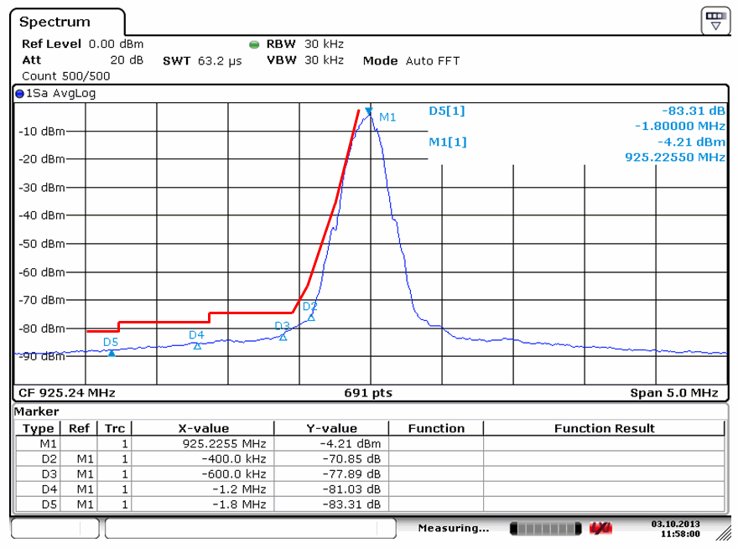
Figure 24: Measurement result of GSM900 base station test
Observations:
- Over the full range the level of unwanted emissions is below the ETSI limit and particularly at 400 kHz offset outperforms the emission mask by approximately 10 dB.

Spurious emissions
The measurements were done at the transmitter output of a common GSM base station on the so-called “C1” frequency (930.6 MHz) carrying the broadcast channel (BCCH). Although GSM is a TDMA system and normally transmits in bursts, the C1 frequency is continuously transmitted with full power. Therefore, external triggering was not necessary to measure the RMS level.
ERC Recommendation 74-01 [2] and Recommendation ITU-R SM.329 [3] specify a spurious emission limit of -36 dBm in 100 kHz bandwidth for Category B, land mobile systems, base stations. In this case the transmitter output power was 42 dBm in a 200 kHz channel bandwidth, therefore this limit will correspond to a relative attenuation of the spurious emissions of 42 dBm - (-36 dBm + 10*log10(200/100)) = 75 dB. The in-channel receive level of the measured base station was +20 dBm in 30 kHz measurement bandwidth which corresponds to +25 dBm in a 100 kHz reference bandwidth. The limit from Recommendation ITU-R SM.329 and ERC Recommendation 74-01 is therefore at +25dBm – 75 dB = -50 dBm in the diagram.
ETSI TS 145 005 [16] has rather complicated limits for spurious emissions, specified separately inside and outside the assigned GSM band. However, the resulting values are much more stringent than the general values from the ITU Recommendation. The upper band edge of the GSM downlink band is 960 MHz. With a transmit frequency of the measured base station of 930.6 MHz, the boundary is at an offset of 29.4 MHz.
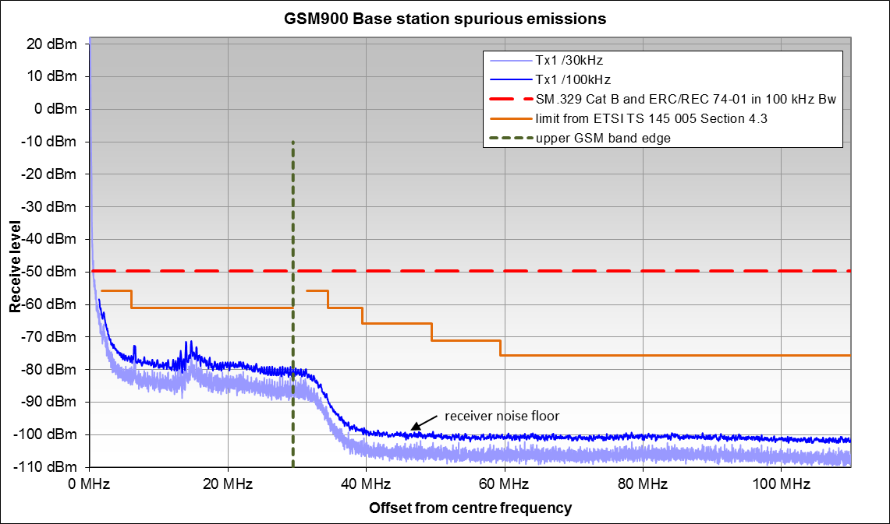
Figure 25: GSM900 spurious emissions (upper frequency range)
Observations:
- The actual spurious emissions above an offset of 40 MHz could be even lower than shown in the figure due to the limited sensitivity limitation of the measurement receiver.
- Outside the assigned GSM band, the spurious limit for Category B, land mobile systems, base stations of Recommendation ITU-R SM.329 and ERC Recommendation 74-01 is outperformed by at least 30 dB.
- Especially outside the assigned GSM band, the level of unwanted emissions is more than 25 dB below the ETSI limit in [16] because of the internal filtering to protect adjacent services.
The 2nd harmonic could not be seen above the noise floor of the measurement receiver which means that it was below -100 dBm (receiving equipment level in 100 kHz), corresponding to less than -90 dBm (transmit level in 100 kHz bandwidth). Emissions were measured but not recorded above the 2nd harmonic, because already no emissions were found above the noise floor above 110 MHz offset.

DECT
The Digital Enhanced Cordless Telecommunications standard is commonly used by many personal communication systems. It is a TDMA system, so both fixed and portable parts transmit in bursts. The parameters of the measured systems are:
- Tx frequency: 1897.344 MHz;
- Modulation: 2-FSK;
- Radiated power: 250 mW = 24 dBm (average burst);
- Occupied bandwidth: 1.15 MHz;
- Spurious domain starts at: 2.875 MHz offset;
- Burst duration: 90 µs or 368 µs;
- Burst repetition: 10 ms;
- Measurement bandwidth: 100 kHz.

The measurements were performed radiated (off air) because the equipment usually has no external antenna connectors. The measured levels are RMS during the bursts only (average-burst level). External triggering was used to synchronise the measurement with the transmitted bursts (see ANNEX 1 for a description of the measurement setup).

Out-of-band emissions
Two DECT handsets of different manufacturers were measured with a resolution bandwidth of 100 kHz. The resulting OoB spectra are shown as "Tx1 AV-burst/100kHz" and "Tx2 AV-burst/100kHz".
Recommendation ITU-R SM.1541 [1] does not contain an annex specifying limits for DECT OoB emissions, therefore the mask was taken from the applicable standard ETSI EN 300 175-2 [17] (§ 5.5.1 Table 1) was taken as a reference. The OoB limits are defined in power levels over the whole channel bandwidth for both the 0 dB reference and the OoB emissions, so no bandwidth conversion was required. To have a direct comparison with the limits, the measured spectral densities were integrated over a bandwidth of 1.15 MHz for the used channel and adjacent channel. The results are shown as horizontal lines ("Tx1 channel power" and "Tx2 channel power"). The level axis of the figure is normalised to the 0 dB reference line of the total in-channel power. See the further explanation regarding DECT terminology in A2.3.
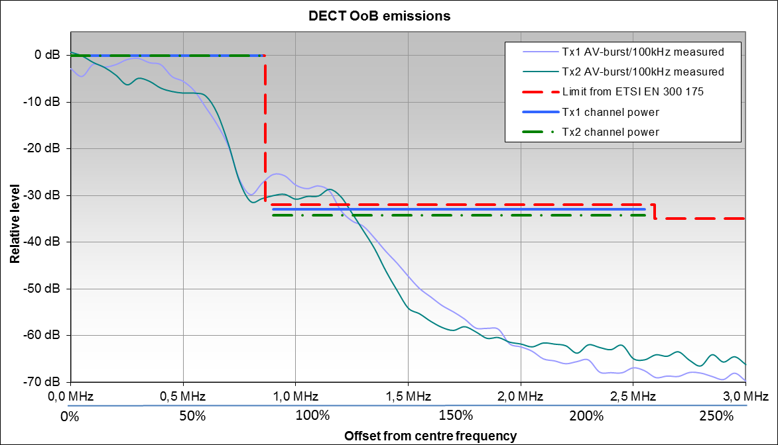
Figure 26: DECT OoB emissions (upper frequency range)
Observations from Figure 26:
- It can be seen that the OoB levels of both measured DECT devices do not in the offset range around 1 MHz fulfil the requirements from the ETSI standard [17];
- As only modulation-related emissions can be seen in the OoB domain, it can be assumed that all DECT devices will have almost the same OoB spectrum in which case it seems that there is a considerable margin to lower the OoB emissions limit , especially in the range of the neighbouring channel with 2 MHz offset.

Spurious emissions
For the DECT service, Recommendation ITU-R SM.329 (Cat B [3], land mobile service) and ERC Recommendation 74-01 [2] specify a spurious emission limit of -30 dBm in a 1 MHz reference bandwidth. With a transmitted power of 24 dBm, this limit corresponds to a relative attenuation of the spurious emissions of 24 dBm - (-30 dBm) = 54 dB.
The equivalent measured in-channel receive level in 1 MHz was -12 dBm. The level axis in Figure 27 can therefore be converted to reflect radiated power in 1 MHz bandwidth by adding 36 dB to account for the losses in the set-up. In Figure 27, the line for the necessary suppression of spurious emissions of 54 dB lies at -12 dBm - 54 dB = -66 dBm.
Section 5.5.4 of ETSI EN 300 175-2 [17] specifies a spurious emissions limit of 1 µW = -30 dBm above the designated DECT band. . The reference bandwidths for this level are between 30 kHz and 3 MHz, resulting in a decreasing limit when referenced to the 1 MHz bandwidth of Figure 27. The measured devices were forced to a transmit frequency of 1897.344 MHz which is the highest DECT channel in Europe. The designated DECT band ends at 1900 MHz which corresponds to an offset of 2.656 MHz.
Because DECT devices transmit in bursts, the unwanted emissions were only measured during a burst, using a triggered spectrum analyser. For details on the measurement setup (see A1.3).
A floating window was applied on the levels measured in 100 kHz to integrate the levels to the reference bandwidth of 1 MHz. The resulting spectrum lines shown in dark blue and dark green have to be compared to the limits in Figure 27.
To compare the measured levels with the limit from the ETSI standard [17] that is defined as a peak power level, a reduction of 13 dB was applied in the calculation of the limit in Figure 27 to account for the difference between average and peak levels for noise-like signals.
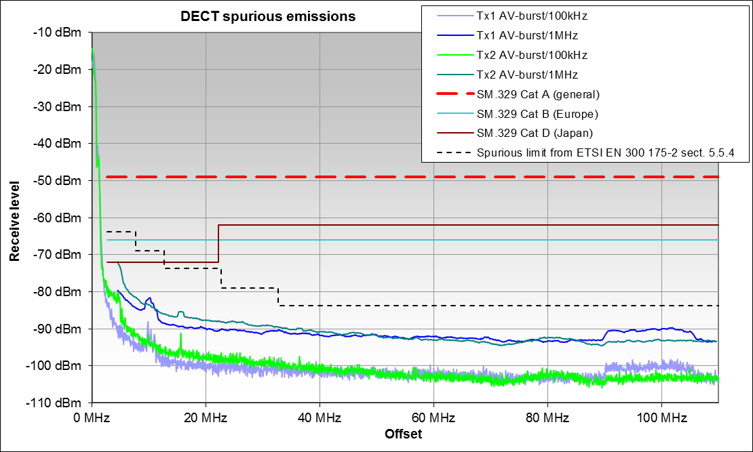
Figure 27: DECT spurious emissions (upper frequency range)
The harmonics were measured separately with the results given in Table 6:
Table 6: Harmonic levels of measured DECT base stations
 | Tx1 |  |  | Tx2
 | frequency | level/1MHz | attenuation | frequency | level/1MHz | Attenuation
Fundamental | 1881.6 MHz | -6.0 dBm | 0.0 dBc | 1890.4 MHz | -8.0 dBm | 0.0 dBc
2nd harmonic | 3763.2 MHz | -80.0 dBm | 74.0 dBc | 3780.8 MHz | -77.0 dBm | 69.0 dBc
3rd harmonic | 5644.8 MHz | -79.0 dBm | 73.0 dBc | 5671.2 MHz | -85.0 dBm | 77.0 dBc
4th harmonic | 7526.4 MHz | < -88 dBm | > 82 dBc | 7561.6 MHz | < -88 dBm | > 80 dBc
Observations from Figure 26 and Figure 27:
- The results show that the spurious emission limits of Recommendation ITU-R SM.329 [3] and ERC Recommendation 74-01 [2] are met with a large margin. For higher offsets, the spurious emissions are typically 30 dB below this limit;
- As with the other digital systems, the most critical offset is at the boundary between the OoB and spurious domain where Tx1 meets the requirements of Cat. B with a margin of 5 dB;
- The spurious emission limits from ETSI EN 300 175-2 [17] are met with a margin of typically 10 dB;
- All harmonic emissions of the measured devices are well below the spurious emission limits.

UMTS 2100 base stations
This 3G cellular mobile system uses W-CDMA spread spectrum technique to manage multiple accesses. It is widely used in Europe and worldwide as the successor to GSM. The parameters of the UMTS system are:
- Frequency range: 2110-2170 MHz (FDD downlink Band I);
- Modulation: QPSK;
- Bandwidth: 5 MHz (channel);
- Tx external filter: none;
- Spurious domain starts at: 12.5 MHz offset (250% rule).
Although no additional filtering was applied at the transmitter output, some internal filtering must be assumed to protect the base station's own receive band and possibly also adjacent services.

Out-of band emissions
The following measurements of OoB emissions were conducted at the transmitter output. The relevant RF parameters of the measured station were:
- Tx frequency: 2152 MHz (centre);
- Tx power: 3 W / 35 dBm (RMS at transmitter output);
- Measurement bandwidth: 4 kHz.
The measured spectrum in Figure 28 shows relative levels in dB normalised to the maximum power spectral density in the measurement bandwidth of 4 kHz.
Recommendation ITU-R SM.1541 [1] does not provide limits for W-CDMA systems. Therefore, the limits defined in ETSI TS 125 104 [17], Chapter 6.6.2.1, Table 6.5 are shown. Because they are given in reference bandwidths between 30 kHz and 1 MHz, the limit in the following figure has been derived after bandwidth correction and normalised to the measured in-channel power spectral density.
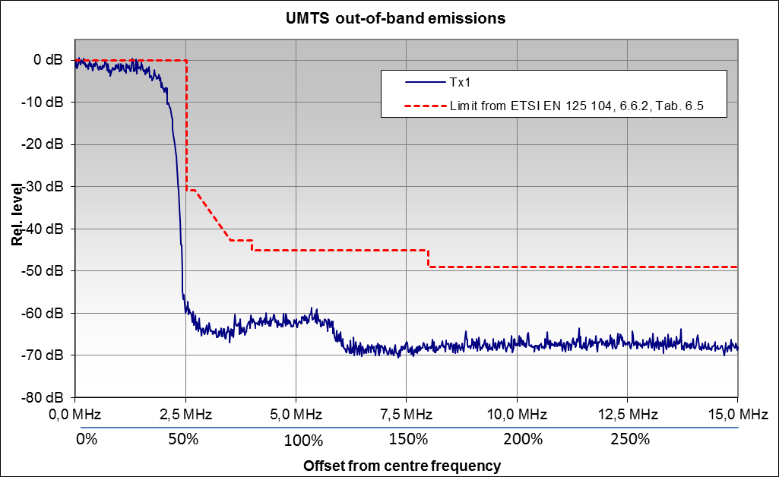
Figure 28: OoB emissions from a UMTS base station
Observations:
- The results show that the limit from the relevant ETSI standard [18] is easily met. In fact, the OoB emissions are at least 15 dB below the mask;
- The unwanted emissions due to modulation already disappear in the broadband noise from the amplifier at offsets around 125% of the channel width.

Spurious emissions
Recommendation ITU-R SM.329 [3] Cat B (Europe) for Land mobile service (base stations), Table 6.9 of ETSI TS 125 104 [18] and Table 2.1 of ERC Recommendation 74-01 [2] specify a maximum spurious emissions level of -30 dBm/MHz. Section 6.6.3 of the ETSI standard [18] defines the applicability of the spurious emissions limit for offsets more than 12.5 MHz below the first carrier frequency used in the UMTS band or more than 12.5 MHz above the last carrier frequency used.
Figure 29 shows a radiated measurement of a UMTS base station operating on the highest channel in the UMTS band I. The relevant RF parameters are:
- Tx frequency: 2167.2 MHz (centre frequency);
- Tx power: 32 W / 45.1 dBm (RMS at transmitter output);
- Bandwidth: 5 MHz (channel);
- Measurement bandwidth: 30 kHz.
In Figure 29, the levels are normalised to the in-channel power spectral density in 30 kHz bandwidth. The limit of -30 dBm is defined in a 1 MHz bandwidth. The conversion to the UMTS bandwidth of 5 MHz is 10*log10(5) = 7 dB. With this correction and normalisation to in-channel power spectral density, the limit is shown at -30 dBm - (45.1 dBm-7 dB) = -68 dB in the figure.
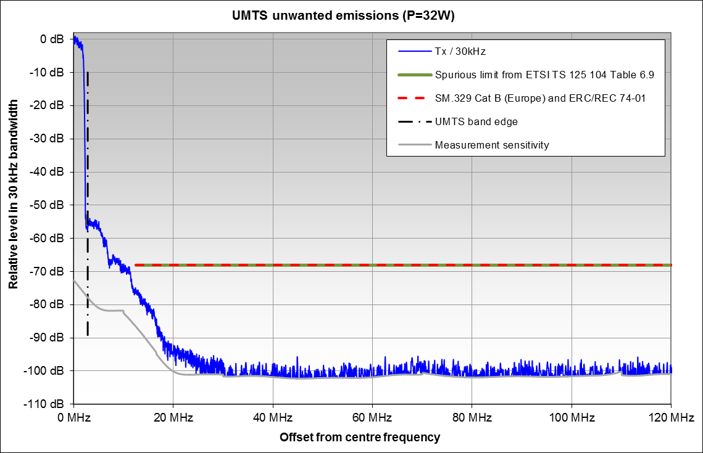
Figure 29: Spurious emissions from a UMTS base station
Observations from Figure 29:
- Although transmitting on the highest channel and thereby presenting the most critical case for complying with spurious emission limits, the measured station outperforms these limits by approximately 10 dB even at the start of the spurious domain;
- For offsets higher than 20 MHz, the limits are outperformed by at least 30 dB. The actual spurious emissions for these offsets are even lower than shown. The limitation is the measurement sensitivity.

Further measurements of UMTS base stations are available in A3.1.4.

RLAN devices in the 2.4 GHz band
RLAN or WLAN devices are used in large numbers all over the world. The service conforms to the IEEE 802.11 standard [28]. Depending on the variant of this standard, a frequency in the ranges around 2.4 GHz or 5.6 GHz is used. The parameters are:
- Modulation: QPSK or OFDM;
- Max. radiated power: 100 mW = 20 dBm (average burst);
- Bandwidth: around 16 MHz;
- OoB domain ends at: 40 MHz offset (250% rule);
- Burst duration: variable, depending on traffic, example: 100 µs;
- Burst repetition: variable, depending on traffic, example 100 ms.

Out-of-band emissions
Measurements were made on three different WLAN devices:
- Tx1: RLAN access point, operating in 802.11g mode (OFDM), measured radiated;
- Tx2: RLAN router, operating in 802.11b mode (DSSS), measured at the Tx output;
- Tx3: Smartphone with RLAN capability, operating in 802.11b mode (DSSS), measured radiated.
Since Recommendation ITU-R SM.1541 [1] does not contain an annex specifying limits for SRD OoB emissions, the mask was taken from the applicable Standard ETSI EN 300 328 V1.9.1 [19], Section 4.3.2.8.3. The definition of the OoB emission limits outside the allocated band depend on the occupied bandwidth which was 16.5 MHz for Tx1 and 15 MHz for Tx2 and Tx3. During the measurement, all three transmitters were operating on the highest channel in the band with a centre frequency of 2472 MHz. The limit from the band edge (2480 MHz) and 2480 + OBW is -10 dBm/MHz and between 2480 + OBW and 2480 + 2*OBW it is -20 dBm/MHz (see an illustration of this phenomenon in Figure 30).
The levels in Figure 30 show relative values in dB and are normalised so that 0 dB corresponds to the maximum in-channel power spectral density in the measurement bandwidth of 300 kHz. The limits are also normalised to 300 kHz bandwidth to allow a direct comparison.
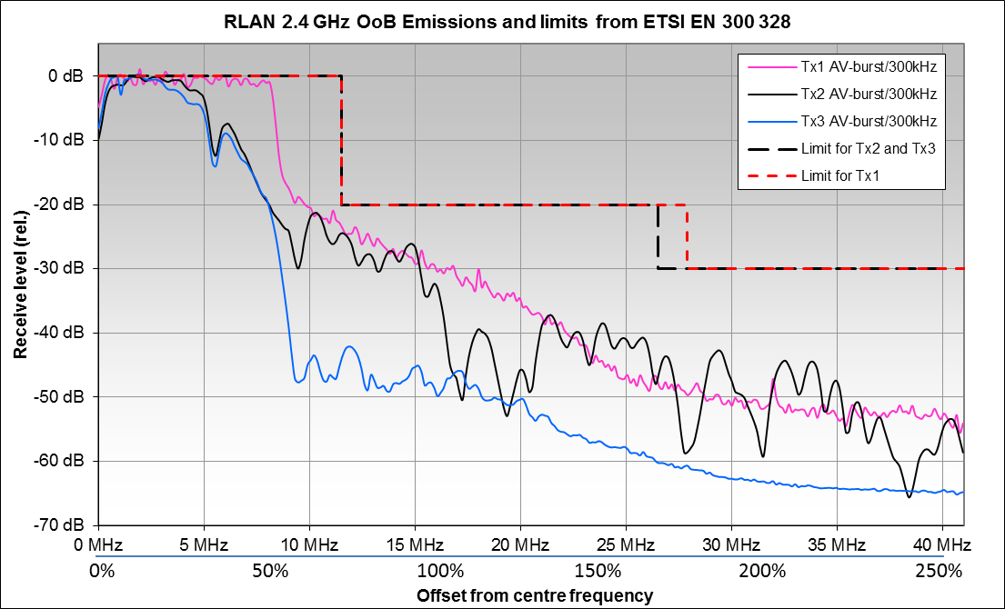
Figure 30: RLAN OoB emissions
Observations:
- All three measured devices meet the OoB limits from ETSI EN 300 328 [19]. At 250% offset, the OoB emissions are typically more than 20 dB below the limit.

Spurious emissions
For RLAN systems, Table 2.1, reference number 2.1.2 of ERC Recommendation 74-01 [2] and Recommendation ITU-R SM.329 [3] specify a spurious emissions limit of -30 dBm in a 1 MHz bandwidth for Europe (Cat B).

ETSI EN 300 328, section 4.3.1.10.3, table 1 specifies a spurious emission level for transmitters of wideband emissions of-30 dBm in 1 MHz for the frequency range 1 GHz to 12,75 GHz.

The measurements were made on the same three RLAN devices as OoB emission measurements in Figure 30, and with a measurement bandwidth of 300 kHz. For direct comparison with the limits, a floating 1 MHz integration window was applied to convert the measured values into the reference bandwidth of 1 MHz. Since Figure 31 is normalised to the total in-channel power of 20 dBm, the limit of -30 dBm from Recommendation ITU-R SM.329 and ETSI EN 300 328 corresponds to a relative level of -50 dB.

The levels shown in the graph can directly be converted into radiated levels in a 1 MHz bandwidth by adding 20 dB.

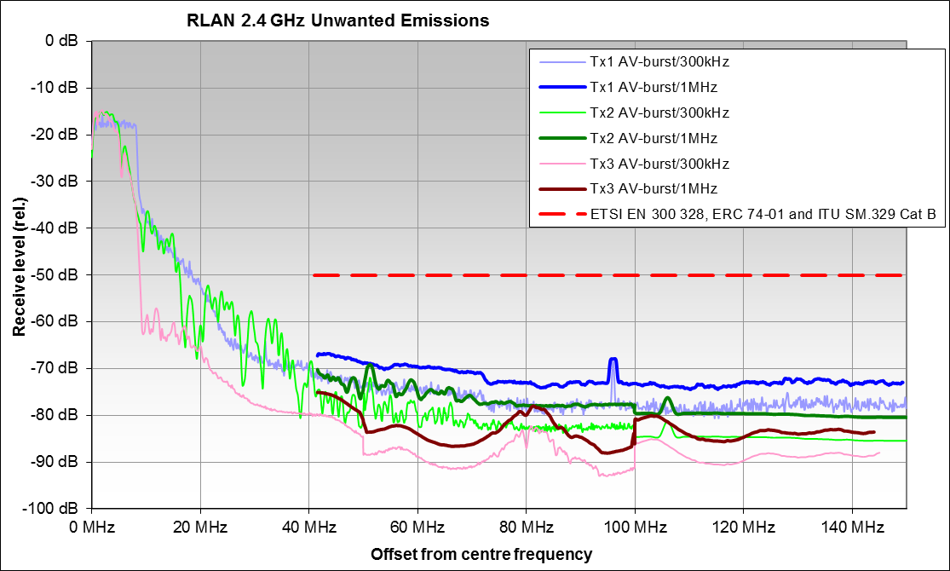
Figure 31: RLAN spurious emissions
Observations:
- Even the more stringent limits from Recommendation ITU-R SM.329 [3] are met with a margin of typically 20 to 30 dB.

WIMAX 3.6 GHz UE
WiMAX is a system for broadband wireless access. The respective WiMAX band has the following RF characteristics:
- Frequency range: 3600-3800 MHz;
- Modulation: OFDM;
- Bandwidth: 10 MHz (channel).

Spurious emissions
The spurious emission limit for UE/BS in the land mobile service in accordance with Table 2.1 of ERC Recommendation 74-01 [2] is -30 dBm/MHz. The same limit is defined in Recommendation ITU-R SM.329 [3] for frequencies above 1 GHz. Section 4.2.4 of EN 301 908-21 [29] defines the transmitter spurious emission limits for OFDMA TDD WMAN (Mobile WiMAX) FDD User Equipment.
Figure 32 shows a spurious emission measurement of a production line of WiMAX terminals in the adjacent radar band, conducted directly at the transmitter output. The following RF parameters are relevant for this measurement:
- Tx frequency: 3620 MHz (lowest usable uplink channel);
- Tx power: 27 dBm / 500 mW (transmitter output);
- Tx external filter: none;
- Spurious domain starts at: 25 MHz offset (250% rule);
- Measurement bandwidth: 1 MHz.
Although no additional filtering was applied at the transmitter output, some internal filtering must be assumed to protect the own downlink receive band and adjacent services.
Because the measurement and reference bandwidth are equal, no bandwidth conversion is required.
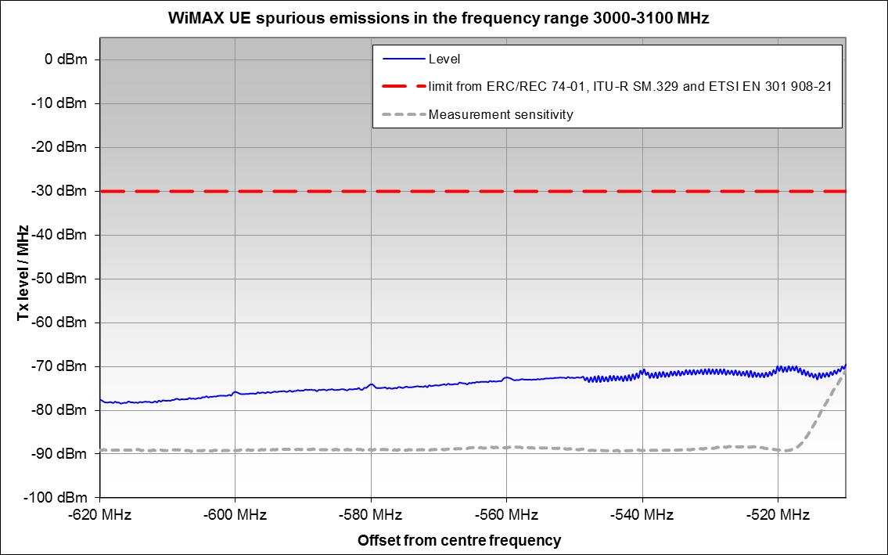
Figure 32: UE 3.6 GHz WiMAX - Emissions in radar frequency band
Observations:
- Although the measurement covers only a small frequency range at a very high offset, it can be seen that the limits are outperformed with a margin of at least 40 dB;
- Even at very high frequency offsets, the level of the spurious emissions is frequency-dependent and tends to fall with higher offsets.

25 GHz Point-to-Point Links
These point-to-point systems are commonly used to connect base stations of the public mobile service (e.g. GSM, UMTS, LTE). Depending on the required data rate, different bandwidths up to 50 MHz are assigned. The common characteristics for this equipment are e.g.:
- Frequency range: 25.1-26.5 GHz;
- Modulation: QPSK or QAM;
- Bandwidth: 3.5 MHz - 50 MHz (channel);
- Tx power: -10 dBm - 24 dBm (transmitter output).

Although no external filters are applied, internal filtering can be assumed to protect the own receiver for the signal from the opposite link station.

Out-of-band emissions
Figure 33 shows a conducted measurement of unwanted emissions from a 25 GHz Point-to-Point link device. The relevant RF parameters are:
- Centre frequency: 25.157 GHz;
- Modulation: 64 QAM;
- Bandwidth: 40 MHz (channel);
- Tx power: 17 dBm (transmitter output);
- Tx external filter: none;
- Measurement bandwidth: 300 kHz.
The levels in Figure 33 are normalised to the maximum in-channel power spectral density in a 300 kHz bandwidth. The generic FS OoB emission limits are taken from ITU-R SM.1541-5, Annex 12 [1] and the specific limits for this system from the section 4.2.4.2.1 of ETSI EN 302 217-2-2 [20] and converted into relative levels in 300 kHz.
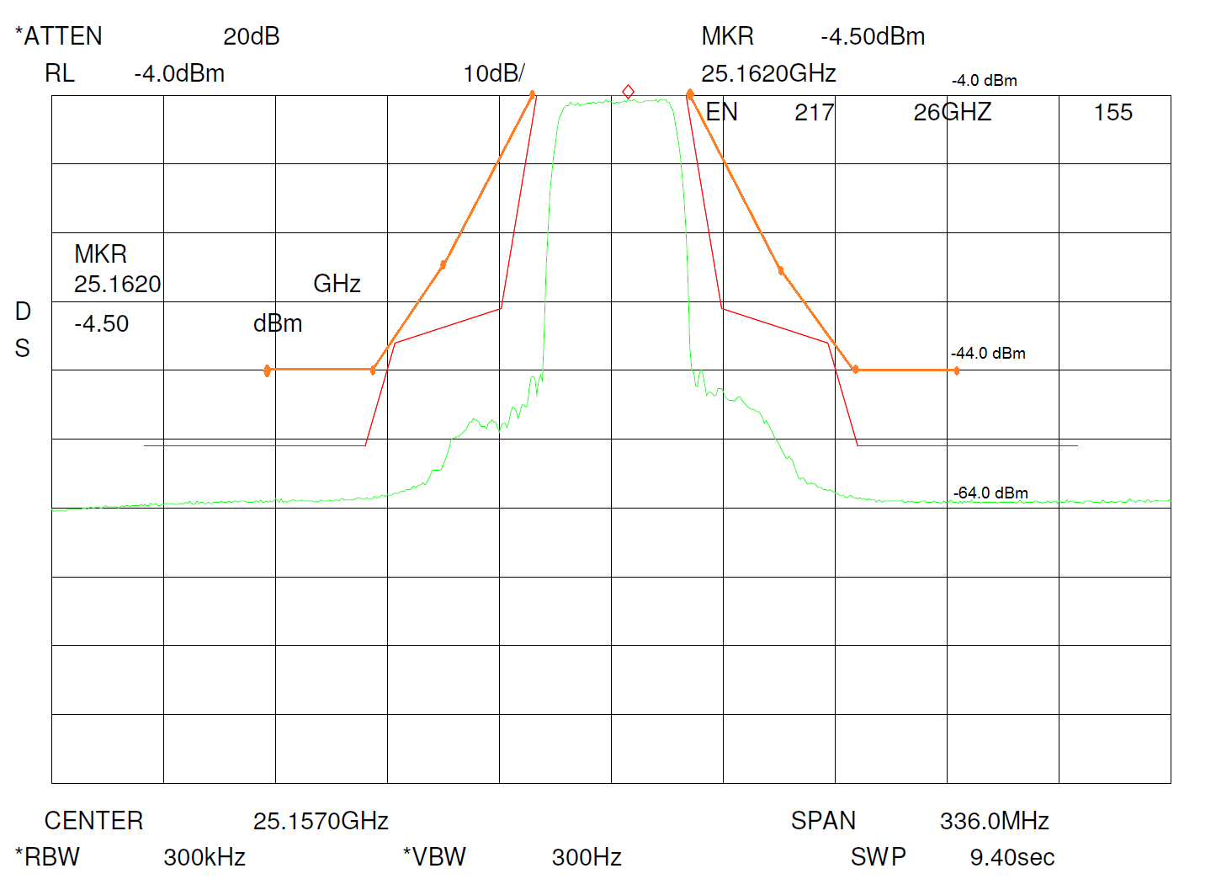
250%
-100%
100%
0%
-250%
Receiver noise

Figure 33: 25 GHz Point-to-Point link unwanted emissions
The measurements for offsets of more than ±75 MHz are limited by the sensitivity of the receiver. In fact, the unwanted emissions in these offset ranges are even higher than shown.
Observations from Figure 33:
- The OoB generic FS safety net emission limits from Annex 12 of Recommendation ITU-R SM.1541 [1] are met with a margin of about 20 dB;
- The specific limit from the section 4.2.4.2.1ETSI EN 302 217-2-2 [20] is met with a margin of at least 10 dB.
Section A3.1.5 contains additional measurements from other point-to-point link devices with different bandwidths. Regarding OoB emission characteristics and levels, these additional measurements show the same trend as the results presented in Figure 33.

Spurious emissions
The limit for spurious emissions in ERC Recommendation 74-01 [2] as well as in Recommendation ITU-R SM.329 [3] (Cat B / Europe) is -30 dBm/MHz.
For the spurious emission limits, the relevant standard, ETSI EN 301 390 [21] also refers in its section 4.1.1 to the limits given in ERC Recommendation 74-01.
Spurious emission measurements have been performed on a number of point-to-point devices in the 25 GHz range with different channel bandwidths. The following figure shows a typical example of the spurious emissions at the start of the spurious range which is usually most critical, up to 40 GHz. The same device as for the OoB domain above is presented. The measurement bandwidth was 1 MHz. The 0 dB level reference is the in-channel power spectral density in 1 MHz.
Figure 34: 25 GHz Point to Point link spurious emissions
Observations:
- The spurious emission limit is met with a margin of more than 20 dB.
Spurious measurements of the same equipment for other frequency ranges (e.g. 28 GHz, 32 GHz, 38 GHz in the measured range from 25.157 GHz to 40 GHz) have additionally shown that for wider frequency offsets the levels are even lower as physically expected.
Section A3.1.5 contains additional measurements from other point-to-point link devices with different bandwidths. Regarding OoB emission characteristics and levels, the remaining measurements show the same trend as the result presented in Figure 34.

Possibilities for improving the way unwanted emissions are described and used in sharing/compatibility studies
The measurements in section 4 have shown that, apart from the power level, the characteristics of unwanted emissions of digital systems may be significantly different from the current limits for unwanted emissions in ERC Recommendation. 74-01 [2] and the relevant ETSI standards. The following sub-sections highlight some of the differences that may provide possibilities for improving the way unwanted emissions are described and used in sharing/compatibility studies.

Filtered and unfiltered systems
National and international frequency management often requires high suppression of unwanted emissions when allocating a frequency band for a specific service in order to prevent harmful interference to neighbouring radio services. In most cases these requirements can only be met if some sort of additional, physical filtering is applied in or after the final stage of the transmitter. In cases where such filters are deployed, the level of the unwanted emissions in the spurious domain is strongly frequency-dependant. In addition, their absolute level is often so low that it cannot be measured. In this case, the spurious emissions cannot cause harmful interference to other radiocommunication services and may therefore be neglected in compatibility/sharing studies.
Some examples of systems that always apply filters at the transmitter output are LTE base stations (see section 5.1.2), DAB (see section 5.1.1), and DVB-T (see section 5.1.3).

DAB
Figure 35 shows the measured unwanted emissions from a DAB transmitter directly at the transmitter output and after the additional filter at the antenna feed.
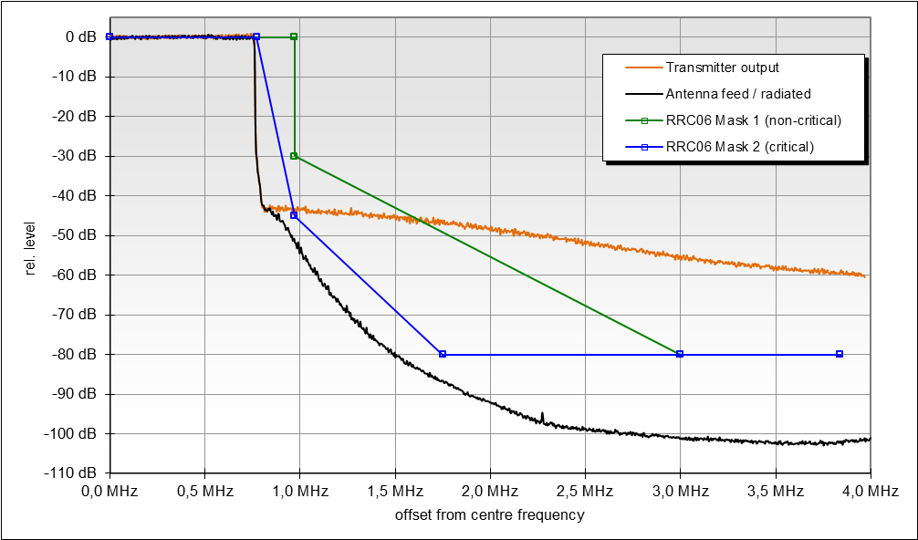
From here: receiver noise
Figure 35: DAB unwanted emissions in the OOB domain

Observations from Figure 35:
- The unfiltered spectrum cannot meet the GE-06 Mask 1 (non-critical) and GE-06 Mask 2 (critical), which are the OoB emission masks required in Europe;
- The filtered spectrum suppresses the unwanted emissions significantly even in the OoB domain;
- The unwanted emissions in the spurious domain are not measurable and are actually even lower than the noise level shown in Figure 35.

LTE800 Base station
The requirements to supress emissions in adjacent bands may lead to 'asymmetrical' OoB emissions because filters have to be applied to suppress emissions in only the lower or the upper adjacent frequency band.
Figure 36 shows OoB emissions from two different LTE800 base stations, both operating on the lowest LTE channel (796 MHz). The upper half comes from a transmitter in idle mode (Tx1), therefore the in-band power of the subcarriers are lower than from Tx2.
It can be seen that the OoB emissions close to the wanted channel are much lower in the lower sideband because a steep filter has to be applied in order to protect the immediately adjacent DVB-T band.
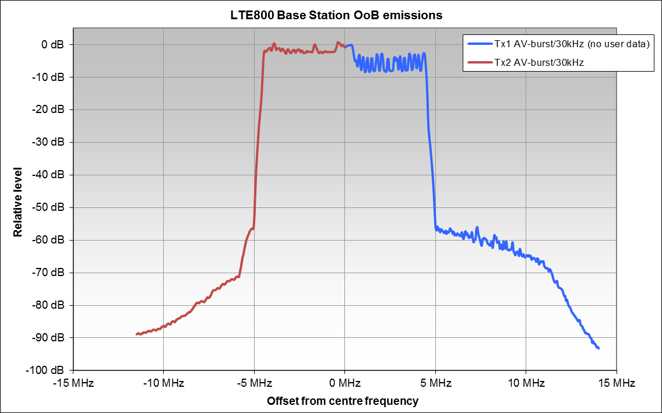
Figure 36: 'Asymmetrical' OoB spectra from an LTE800 Base Station

DTT RF channel filters
This section presents the results of the measurements carried out on DTT channel filters designed for the UHF TV band. The objective is to explain their behaviour and to evaluate their impact on the occurrence of spurious emissions at the output of the RF combiner feeding the TV transmitter antenna. Note that in this study only medium power (25 W ≤ P_{max}<5 kW) and one low power (P_{max}<25 W) DTT channel filters have been considered. The behaviour of cross-coupled high power channel filters may be different.
The information can help to verify the relevance of the currently used method to define the boundary between the out-of-band and spurious domains, which is the frequency separated from the centre frequency of the emission by 250% of the necessary bandwidth of the emission.
RF channel filters are the main building blocks of RF combiners. Their main objective is to keep the out-of-band emissions and spurious emissions (SE) levels of the TV signals to be transmitted low enough permitting to combine them through the RF combiner, which composed of several bandpass combiners, and to transmit them on the same antenna.
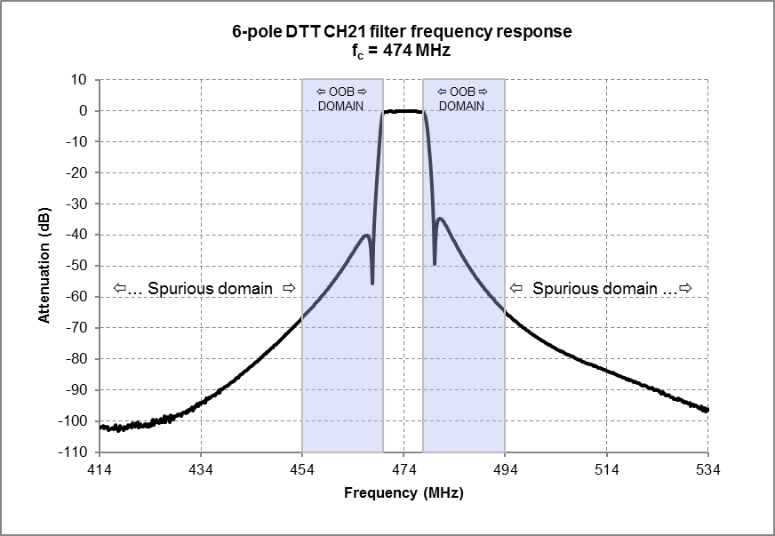
Figure 37: 6-pole DTT Ch21 filter frequency response - 414-534 MHz
Figure 37 shows the frequency response of an RF channel filter in the out-of-band (OOB) domain as well as in a small part of the spurious domain.
By observing Figure 37, the filter centre frequency (474 MHz) being the reference frequency, one can conclude that the channel filter attenuates any emission by more than:
- 60 dB beyond the frequency offset of ±20 MHz;
- 95 dB beyond the frequency offset of ±60 MHz.
Unfortunately, the second conclusion is wrong as shown in Figure 38.
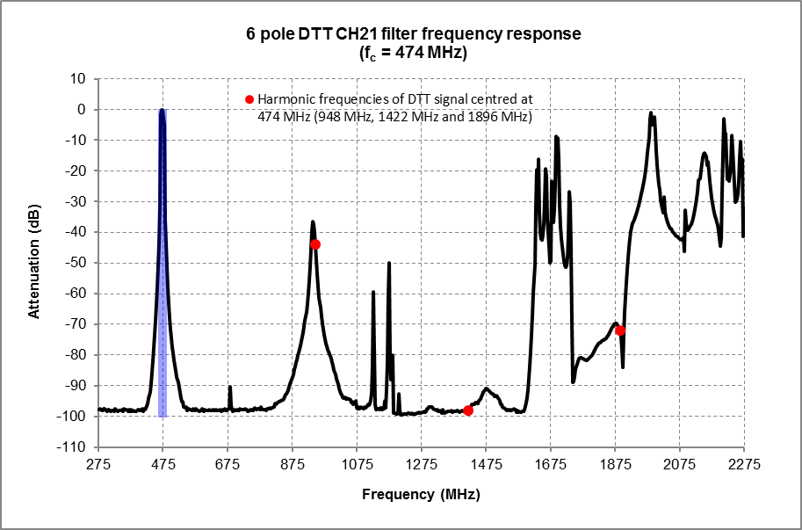
Figure 38: 6-pole DTT Ch21 filter frequency response - 275-2275 MHz
Figure 38 shows the frequency response of the same RF channel filter over a wider frequency range. In this figure, we note a strong decrease of the filter attenuation for some frequencies above 875 MHz. There is no unique commonly accepted name for this phenomenon. It is often called in relation to filters:
- harmonic behaviour or harmonics attenuation - which may be confusing;
- re-entrant modes - highlights the physical effect of the resonator itself, but does not take into account couplings;
- higher order modes - used synonymously to re-entrant modes.
In this section, for the sake of simplicity, this phenomenon is referred to as “high frequency leakages” of a filter.

High frequency leakages of TV channel filters
TV channel filters are usually cavity filters based on coaxial resonators (rectangular cavity, cylindrical cavity or coaxial cavity resonators). A well-constructed cavity filter is capable of high selectivity even under a power load of several megawatts.
The HF leakages of channel filters are the main cause of the occurrence of high-level spurious emissions at the output of RF combiners. The reason for the HF leakages lies in the physics of the resonators and coupling elements which constitute the filter.
There are at least three main causes of HF leakages of a cavity filter:
- Usually, the coaxial resonators used in cavity filters have a length of λ/4 (quarter-wave coaxial resonators). Consequently, in theory, at frequencies of n*(4*c/λ) (where, n = 2, 3, 4, ,N) passbands occur where the resonators have their higher order modes;
- Cavity resonances where the outer conductor of the resonator acts as a waveguide resonator with fundamental frequencies and harmonics depending on the size in x-, y- and z-direction;
- Coupling itself (metallic loops or capacitive elements which feature a line length going from one resonator chamber to the next) that can also start to resonate with frequencies depending on their length.
The HF leakage phenomenon is even more complicated because other parasitic effects also have an impact on the occurrence of HF leakages of a filter. Consequently, it is difficult to accurately determine by theory the HF leakage frequencies and attenuation of a channel filter. This can be understood by observing Figure 39.
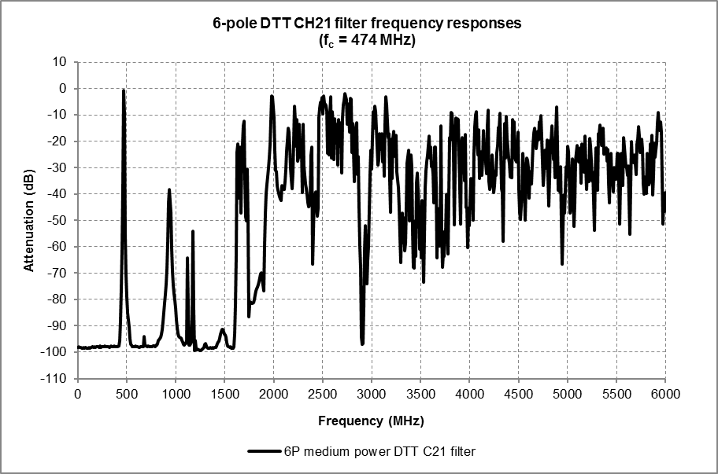
Figure 39: 6-pole DTT Ch21 filter frequency response - 0-6 GHz
Note that:
- compared to the centre frequency of the filter, the higher the frequency, the higher the HF leakage;
- the HF leakages of cavity filters are closer to the passband for filters with higher power rating. For smaller sized (lower power) filters they are shifted to higher frequencies because cavity footprint and coupling resonances are smaller and therefore the unwanted frequencies are shifted up (see Figure 40). The mechanical length of the resonator for smaller filters (λ/4) is usually also reduced by capacitively loading the resonator which also shifts the higher order modes of the resonator itself to higher frequencies.
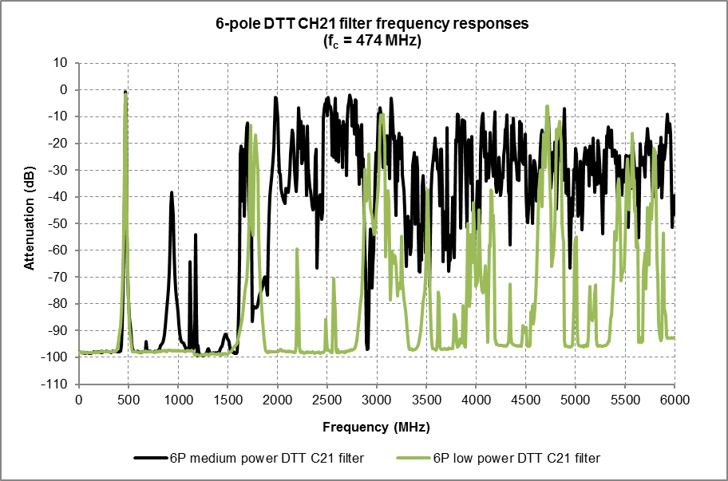
Figure 40: Comparison of low and medium power 6-pole DTT Ch21 filter frequency responses –
0-6 GHz

Impact of high frequency leakages of TV channel filters on the occurrence of the spurious emissions at the RF combiner output
Figure 41 and Figure 42 show the spectrum of a DTT (Ch21) signal measured before the channel filter at the output of a low power DTT repeater (0.1 W).
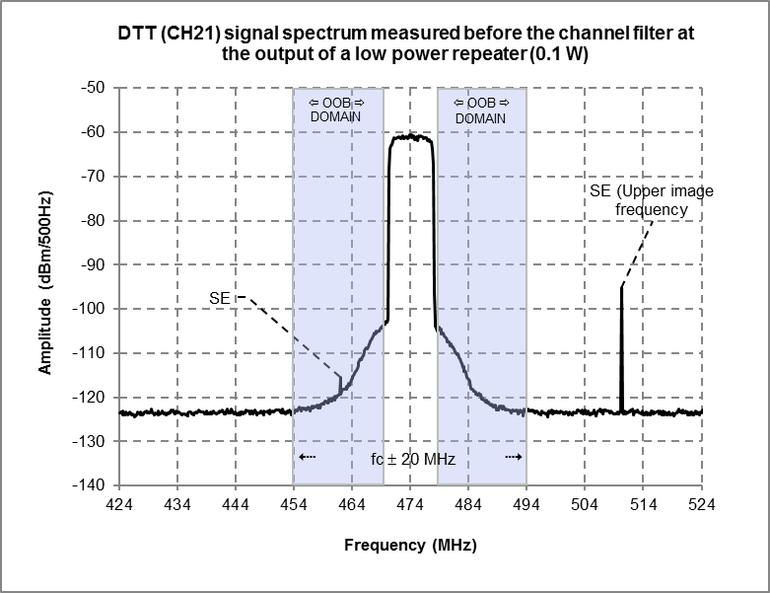
Figure 41: DTT Ch21 signal spectrum at the output of a low power repeater - 424-524 MHz

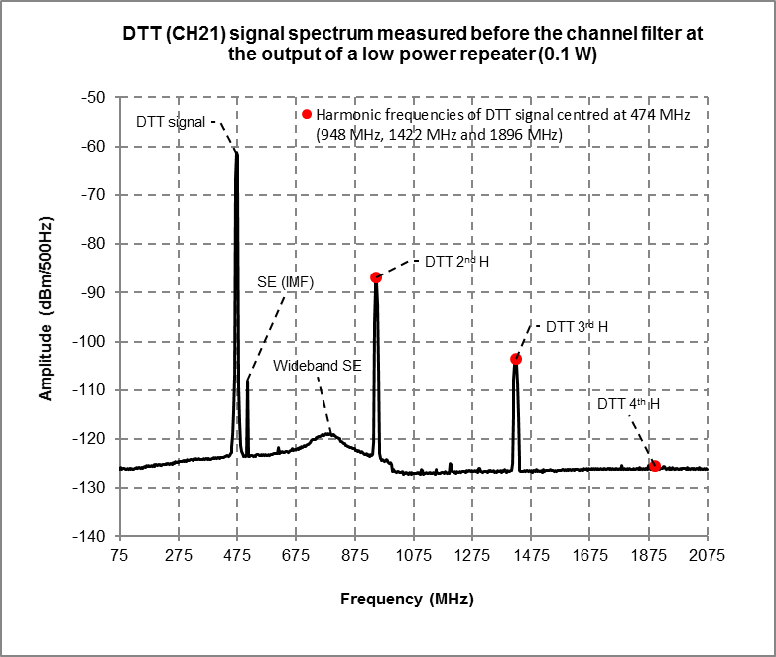
Figure 42: DTT Ch21 signal spectrum at the output of a low power repeater - 75-2075 MHz
In this example, the signal before the channel filter at the output of the repeater is composed of:
- the DTT signal to be transmitted centred at f1=474 MHz;
- the following spurious emissions (SE):
the upper image frequency (IMF) of the internal mixer of the repeater centred at f2=474+fIF=510 MHz (fIF=36 MHz);
wideband SE centred at f3=782 MHz;
the second and third harmonics of the DTT signal, centred at f4=948 MHz and f5=1422 MHz respectively;
some other low level SE.
Note that there is also a low level SE in the OoB domain as shown in Figure 41. This is not surprising, because OoB emissions occur in the OoB domain and, to a lesser extent, in the spurious domain. Spurious emissions likewise may occur in the OoB domain as well as in the spurious domain. Nevertheless, OoB emissions should generally predominate in the OoB domain, while SE should generally predominate in the spurious domain.
Clearly, despite its low power, the DTT repeater output signal cannot be directly emitted (without a channel filter) via the DTT transmitter antenna due to its undesired high-level spurious emissions. Figure 43 shows the spectrum of the signal before and after the channel filter presented in Figure 37 and Figure 38.
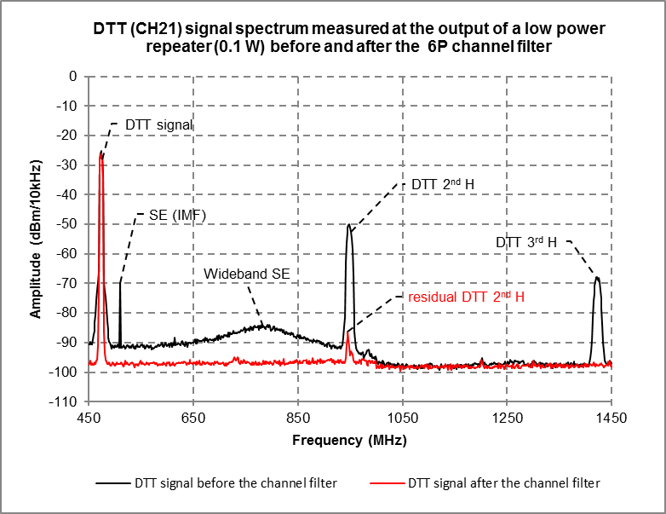
Figure 43: DTT Ch21 signal spectrum before and after a 6-pole channel filter
At the output of the channel filter, one can easily note the residual second harmonic of the DTT signal, despite a full suppression of the image frequency (IMF), wideband SE and the third harmonic of the DTT signal by the channel filter. The reason for this residual signal is the HF leakage of the channel filter at 948 MHz (2* 474 MHz) as shown in Figure 38. At this frequency, the second harmonic of the DTT signal is only attenuated by about 44 dB (average attenuation measured in 8 MHz), while the other cited spurious emissions are attenuated by about 95 dB or more.
Usually, SE levels are measured at the output of the channel filter or combiner. If the measurement is carried out in laboratory, the channel filter used shall be representative of the multiplexer or filter existing in operational conditions and viewed by the transmitted output when installed (see ETSI EN 302 296 [13]).
Figure 44 and Figure 45 show the spectrum of a DTT (Ch22) signal measured before the channel filter at the output of a medium power DTT transmitter (≈ 2 kW).
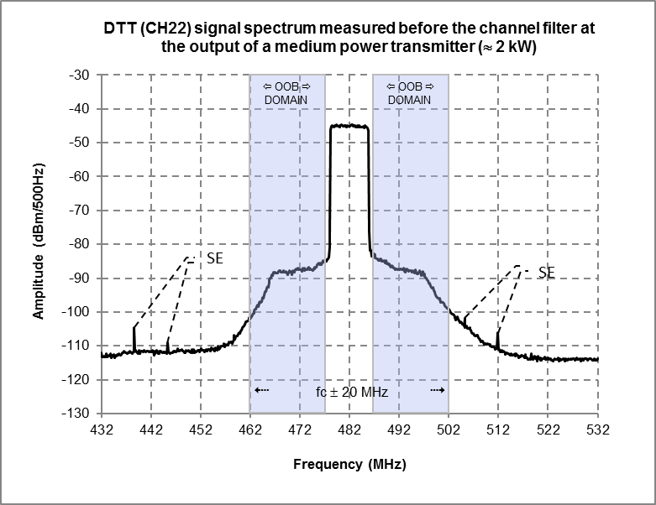
Figure 44: DTT Ch22 signal spectrum before the channel filter - 432-532 MHz

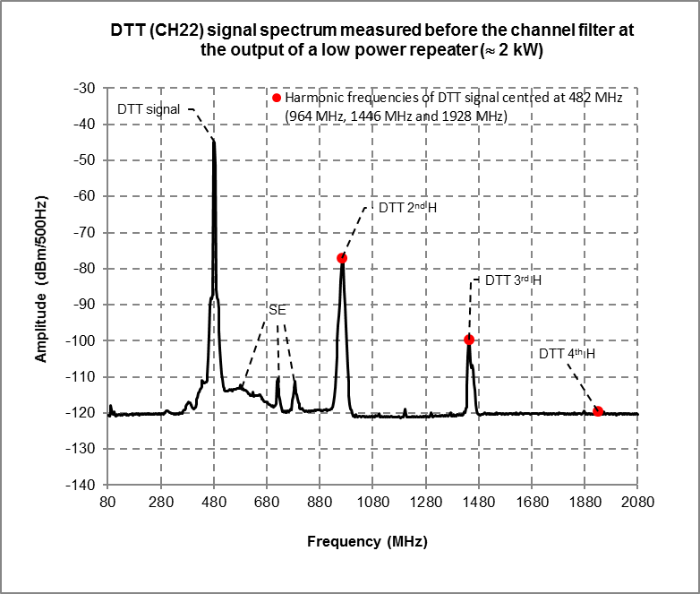
Figure 45: DTT Ch22 signal spectrum before the channel filter - 80-2080 MHz
In this example, the signal before the channel filter at the output of the transmitter is composed of:
- the DTT signal to be transmitted centred at f1=482 MHz;
- the following spurious emissions (SE):
wideband SE centred at f2=578 MHz, f3=720 MHz and f4=787 MHz;
the second and third harmonics of the DTT signal, centred at f5=964 MHz and f6=1446 MHz respectively;
some other low level SE.
Note that there are some low level SE close to the OoB domain as shown in Figure 44. The further they are from the boundary between OoB and spurious domains, the more they predominate.

Comments
In light of the measurement results, we can note that for medium and low power DTT transmitters:
- at the DTT transmitter output, before the channel filter, the boundary between the out-of-band and the spurious domains based on the 250% rule seems appropriate;
- at the DTT channel filter/combiner output it may be difficult to identify the boundary between the out-of-band and the spurious domains, because the SE of the DTT signal are strongly attenuated (60 dB or more) by the DTT channel filter up to 870 MHz. It is practically not possible to measure them below this frequency. This is in line with the results of the SE measurements presented in section 4.3.2;
- the HF leakages of DTT channel filters are the main cause of the occurrence of high-level spurious emissions at the output of RF channel filters/combiners for frequencies higher than 870 MHz. The reason for the HF leakages lies in the physics of the resonators, the coupling elements which constitute the filter and other parasitic effects.

Conclusion
Measurements carried out on real-life DTT transmitters (including channel filters/multiplexers) show that in most cases their performance is superior of that defined in the existing harmonised standards and recommendations.

Transient emissions in pulsed digital systems
Many TDMA systems produce so-called “transient” unwanted emissions. These are emissions that occur only for very short times during the switching on and off of the transmitter at the beginning and end of each burst. The same effect occurs in some OFDM systems during the changes of the transmitted symbols. Internal design of some TDMA systems also cause the final stage of the transmitter (power amplifier) to stay on continuously, while the bursts, including the on- and off-timing, are generated by the DSP in the baseband.
As a result, there are three different shapes of the unwanted emissions:
- Broadband amplifier noise that is continuously present;
- Modulation dependant sideband emissions, present only during the burst;
- Transient emissions, present only during power ramping or symbol changes.
Figure 46 shows the OoB emissions recorded during a 10 ms frame of an LTE800 base station in all of the above-mentioned phases.
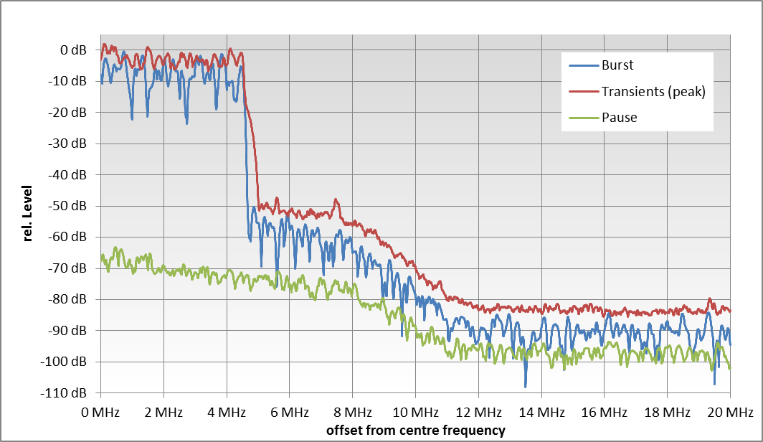
Figure 46: LTE800 BS: OoB emissions at different times
This example gives rise to the discussion whether one limit is enough to realistically represent the interference potential of a pulsed digital system, especially in the OoB domain. It may be more appropriate to specify two limits: one being a flat peak value that is not to be exceeded at any time, and another limit that may be exceeded for a certain, small percentage of time to account for the transient emissions. However, a general measurement method for this which is "bulletproof" would be very difficult to devise (see further discussion in section 6.2.4).
Figure 47 shows the operation of an LTE800 UE device with a high time resolution. Only one resource block is allocated, so the used bandwidth is only 180 kHz. However, every 71 µs the transmitted symbol and the modulation of all used subcarriers change.
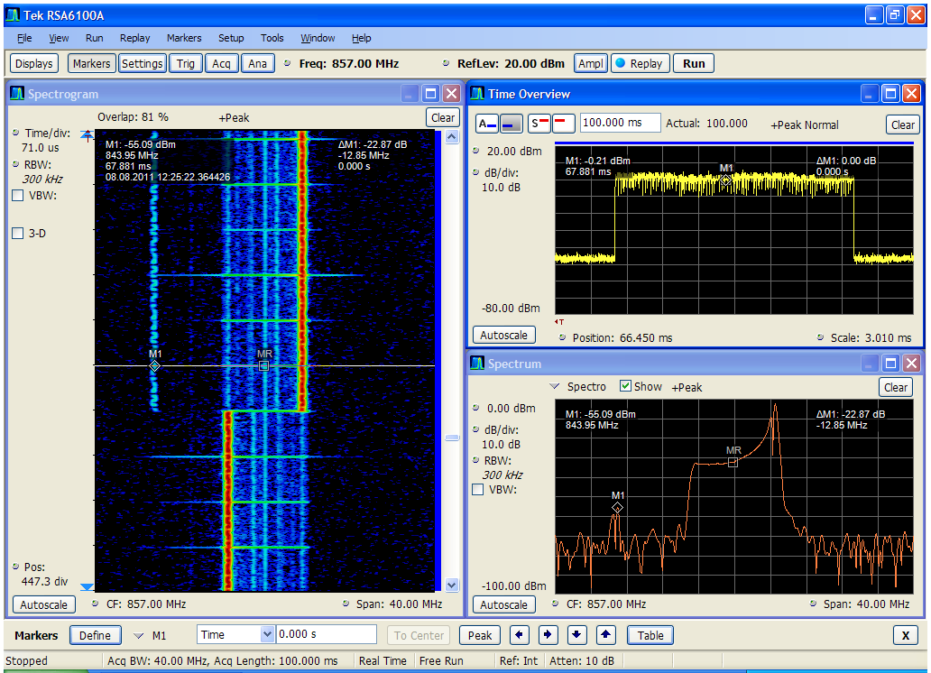
Figure 47: Spectrum, power versus time and momentary spectrum at the time marked with a line (with points M1 and MR) in the spectrogram of a randomly selected LTE800 UE, high time resolution
Observation from Figure 47:
- The OoB emission level rises significantly during the symbol changes (the red circle marks one symbol change);
- When the OoB emissions are measured as peak levels, the resulting sideband spectrum will look like during the time of symbol changes. However, as seen in the spectrogram, these worst case emissions occur only for very short time ("transients") and possibly have a different interference potential than if they were present continuously.

Narrowband and wideband unwanted emissions
All output stages of transmitter amplifiers produce a certain amount of noise which can be seen as wideband unwanted emissions both in the OoB and spurious domain. In addition to that, analogue transmitters often produce narrowband emissions on single, distinct frequencies in the spurious domain that originate from the RF generation inside the transmitter with various mixing stages and intermediate frequencies. These "peaks" often have significantly higher levels than the wideband noise. Figure 48 shows a typical example of this performance with two different PMR transmitters:
Figure 48: Land Mobile spurious emissions from two different PMR transmitters
(upper frequency range)
This measurement is discussed in more detail in Section A3.2.2.2.
Another typical example of this behaviour is Radar systems as presented in Section A3.2.3.
These peaks may be only single, unmodulated carriers. Their level will not change when measured with different bandwidths. Therefore, unwanted levels measured in a narrow bandwidth cannot simply be converted into a reference bandwidth of 100 kHz. In Figure 48, the unwanted spectra measured with 10 kHz (light blue and light magenta) had to be converted into the reference bandwidth of 100 kHz by applying a sliding integration window (dark blue and brown).
It can be seen that this conversion raises the wideband noise levels by about 10 dB whereas the level of the peaks remain nearly the same.
Modern transmitters of digital systems always generate the RF spectrum digitally in the so-called "baseband". After D/A conversion, the two baseband components are directly shifted into the RF frequency range by applying I/Q modulation. As a result, no distinct peaks occur in the spurious domain. All of the measurements presented in this document show that the spurious emissions are only wideband in nature. This is the main reason why the spurious emission levels of the measured digital systems are often far below the limits of Recommendation ITU-R SM.329 [3] and ERC Recommendation 74-01 [2] that accounted for the peaks of analogue systems. One advantage of this behaviour is that the spurious emissions of digital systems can usually be converted into different bandwidths by a constant correction of 10*log10(BW1/BW2).

unwanted emission levels for digital and analogue systems
While in many analogue systems the actual spectrum emission and its bandwidth depends on the state of the modulating signal, the spectrum emission from most digital systems is typically noise-like and constant in shape and bandwidth.
The measurements in Figure 4, Figure 17, Figure 19, Figure 25, Figure 28, Figure 30 and Figure 33 have shown that the specific OoB emission masks defined in the relevant ETSI standards and especially the generic "safety net" limits given in the masks of Recommendation ITU-R SM.1541 [1] are sometimes outperformed. It has to be noted, however, that these limits apply for each piece of equipment. Therefore, a margin between typical performance and limit is needed to account for production variations. In sharing/compatibility studies, however, it may be more realistic to use typical performance instead of mandatory limits. It should be further noted that in some cases (e.g. Figure 26) the limits are only met marginally.
Due to the different characteristics of unwanted emissions from digital vs. analogue systems, the limits of Recommendation ITU-R SM.329 [3] and ERC Recommendation 74-01 [2] in the spurious domain are typically outperformed in the measurements in Figure 3, Figure 4, Figure 18, Figure 20, Figure 23, Figure 25, Figure 29, Figure 31, Figure 32, Figure 34 by a significant margin of several tens of dB, except for the harmonic frequencies Figure 22. The large difference between typical performance and the limit is generally not needed by digital systems, especially when output filters have to be applied to meet stringent requirements in the OoB domain.
The measurements (Figure 3, Figure 18, Figure 20, Figure 23, Figure 25, Figure 29, Figure 33), have shown that the unwanted emission level in the spurious domain is not constant over frequency as assumed in Recommendation ITU-R SM.329 [3] and the relevant ETSI standards, especially when output filters are applied. With increasing frequency offset, the spurious emission levels continuously decrease. Filtered transmitters generally have no measurable spurious emissions at offsets of more than about 4 times the signal bandwidth, and sometimes already at the 250% boundary. However, spurious response of filter attenuation is generally expected in the frequency ranges near the harmonics of the centre frequency.
Even unfiltered transmitters show a frequency dependency of the spurious emissions. An exception may be a peak at harmonics (see LTE800 UE in Section 4.5.3) showing an example of unwanted emissions of the measured UE at the second harmonic frequency but even there the peak is 1.5 dB below the limit of REC/ERC 74-01 Figure 22).

Boundary between OoB and spurious domain
With the exception of some public mobile systems (3GPP standards), in general, the boundary between OoB and spurious domain is defined at 250% of the signal bandwidth (necessary bandwidth Bn). For broadband systems, the Radio Regulations [4] (Appendix 3) defines a tighter boundary of 1.5*Bn. However, this formula often applies only to systems with wider bandwidth than actually used in the band. Examples are:
- Between 30 MHz and 1 GHz, the boundary at 1.5 Bn applies only to Bn > 10 MHz. Typical applications like TETRA, DAB, DVB-T, GSM, UMTS and LTE have smaller bandwidths;
- Between 1 GHz and 3 GHz, the reduced boundary applies only to Bn > 50 MHz. Almost all systems in this range including GSM, UMTS, DECT, LTE and RLAN have smaller bandwidths.
As a result, for all measured systems, the boundary is at 250% of the signal bandwidth, with exceptions in the public mobile bands where the boundary is often defined relative to the edges of the designated band (see ANNEX 2).
However, the measurements have shown that the modulation based unwanted emissions, especially for wideband systems, often end at offsets well below 250% of the bandwidth. This is especially true for base stations of filtered systems such as DAB (see Figure 35), DVB-T (see Figure 4), and GSM/UMTS/LTE (see Figure 24, Figure 25 for GSM, Figure 28 for UMTS and Figure 17, Figure 18 for LTE800 Base stations, Figure 20 for LTE800 UEs).

Analysis and possible alternative ways to specify limits

Relation between measurements and specified limits for digital equipment
Regarding the out-of-band domain limits, the measurements have shown that the limits specified in ETSI standards are generally the relevant limits particularly tailored to the specific application; ITU-R SM.1541 [1] (containing only the "safety-net" limits which are mainly only based on services) consequently shows a large margin as expected.
In the measurements presented in Section 4, equipment typically outperforms the relevant ETSI standards, ERC Recommendation 74-01 [2] and Recommendation ITU-R SM. 329 [3] for unwanted emissions, particularly in the spurious domain, except at harmonic frequencies (Figure 22). This raises the question of whether to take action related to the relevant existing limits. Possibilities include a case-by-case reconsideration and/or a redefinition of the limits.
Unwanted emission limits in the spurious domain in harmonised standards and product specifications are to a large extent based on limits in ERC Recommendation 74-01 and Recommendation ITU-R SM. 329 but they may have stricter limits to facilitate certain performance of a specific piece of equipment in operation, and/or to enable co-existence between similar systems in order to efficiently use the spectrum within the band assigned to that system. The limits in ERC Recommendation74-01 and Recommendation ITU-R SM. 329 are developed with a broader view through compatibility/sharing studies with other systems in order to facilitate efficient use of the spectrum both within and across frequency bands.
In this way, the limits in harmonised standards and product standards are also used to verify equipment conformance through testing. Those test requirements are in many cases taken directly from recommendations such as ERC Recommendation 74-01.
A prerequisite for the conformance testing set-up and procedures is that they should represent the operating range of the equipment from all aspects and thereby span the "space" of different operating parameters as far as possible. From this point of view, the scenario "simulated” during conformance testing is a worst-case scenario.
This means that when designing mobile and base station equipment, the RF requirements, including spurious emission limits, must be met in the following conditions:
- Operation across the full output power range, including maximum transmit power;
- With different sets of physical channels transmitted and varying resource block allocations within a carrier, including the maximum number of resource blocks;
- With different configurations of carrier(s) and carrier combinations (in case of multi-carrier transmitters). Specific multicarrier "test configurations” are defined for the most difficult combinations and power settings, including both wideband transmissions and high PSD transmission;
- Operation with a single RAT as well as with different combinations of RATs, in case of multi-RAT transmitters. Specific "test configurations” are defined for the most difficult combinations and power settings;
- Operation in varying environmental conditions, including temperature, vibration, pressure etc. The temperature range is for example specified as -10 C to +55 C.

Extra margins are also added by design engineers to allow for aging, varying component batches, test margins, etc. Overall, mobile and base station equipment testing is performed across a number of worst-case conditions, where it is unlikely that all of them will occur simultaneously, but the equipment under test will be demonstrated to have emissions below the recommended limits under those worst case conditions.
Measured values on the other hand are selected samples of a piece of equipment in operation. The conformance testing scenario is thus very different from a field measurement under typical operating conditions. In such a field scenario, the equipment will operate quite far from the worst case testing conditions for most operating parameters exemplified in the list above, giving spurious emissions that are considerably below e.g. the limits recommended in ERC Recommendation 74-01 .
The implication is that measurements of spurious emissions under typical operating conditions, which appear to be far below the recommended limits at least for the limited number of equipment samples considered in this Report, are not in themselves an indicator that the limits can be made tighter without implications for the base station and mobile equipment. The equipment must always comply with the recommended limits under the worst case conditions, as is demonstrated in conformance testing. Tighter recommended limits will therefore mean tighter conformance testing conditions, with the corresponding implementation impact.
The measurements demonstrating spurious emission below the limits under typical conditions are however a strong indicator that co-existence analysis should in many cases not be based on specified emission limits, since they only show what the potential worst-case emissions are. Using estimates of typical emission levels in co-existence analysis can give more realistic conclusions about co-existence.
Revision of the limits to make them more stringent could arguably lead to improvements in efficient use of the spectrum due to increased opportunities for sharing. However it should be noted that it may be challenging to revise the existing boundaries and limits which have been in use for many years. Alternatives include a case-by-case analysis and specific modifications if required by a given use case.
It is acknowledged that modifications of limits must rely on worst case measurements - the dynamicity of equipment behaviour depends on the applied radio access technology. While 3GPP LTE, for example, exhibits a highly dynamic behaviour where random working points may substantially deviate from worst case characteristics specified in approval tests, other systems may show smaller variations due to their inherent designs.

possibile changes to limits or boundaries
Four possible alternative ways to revise limits or boundaries are considered here. Each of these could be achieved through a change of rules, and/or a case-by-case consideration:
- Revision of the existing boundary between the out-of-band and spurious domain;
- Adjustment of the limits of unwanted emissions in the out-of-band domain;
- Adjustment of the limits of unwanted emissions in the spurious domain;
- Revised definition of limits of unwanted emissions in the spurious domain on a statistical basis.
The options above are not exclusive; any combination of these options could be considered. Each of these options is explored in detail in the following sections.

Revision of the existing boundary between the OoB and spurious domain
A general modification would involve revising the definition of the 250% rule as set out in the Radio Regulations [4] (Appendix 3, Annex 1). Recommends 2.3 of Recommendation ITU-R SM. 329 [3] already acknowledges that "this frequency separation [boundary] may be dependent on the type of modulation used, the maximum bit rate in the case of digital modulation, the type of transmitter, and frequency coordination factors". For specific digital systems the 250% figure could be decreased to a lower percentage of the bandwidth, to account for the fact that the spurious domain is shown by measurements in section 4 on some common digital systems to start at lower offsets in practice. Equivalent adjustments would be required to the wideband and narrowband cases specified in Recommendation ITU-R SM.1539 [5]. This would be particularly pertinent for future wideband systems (>1 GHz bandwidth) in millimetre wave bands.

Adjustment of the unwanted emission limits in the out-of-band domain
A general modification would involve adjusting the existing specific limits in the out-of-band domain as currently specified in relevant standards. Revision of generic limits in Recommendation ITU-R SM.1541 [1] might also be considered; however, the "safety-net" scope of such limits already implies that those limits are in general inappropriate for detailed sharing/compatibility studies whenever more specific limits are available from the specific system standards/regulations, and any revision would not improve this situation.

Adjustment of the unwanted emission limits in the spurious domain
A general modification would involve adjusting the existing unwanted emission limits in the spurious domain as currently specified in Recommendation ITU-R SM.329 [3] and in ERC Recommendation 74-01 [2].
As a majority of the measured equipment samples in Section 4 are shown to out-perform these limits by a significant margin, tightening these limits may lead to improvements in sharing/compatibility opportunities for any systems which are within the neighbouring spurious domain of the interfering system.

Revised definition of unwanted emission limits in the spurious domain on a statistical basis
This option is based on the random nature of spurious emissions which are expected to occur either only as "spikes" on certain frequencies (which may be difficult to define), and may also be transient in nature, only occurring as random bursts in the time domain. A general modification would require changing the existing limits specified in Recommendation ITU-R SM.329 and in ERC Recommendation 74-01 to account for this random nature on a statistical basis. Alternatives include the possibility to reconsider the rule on a case-by-case basis.
For example, the existing limits could be kept, complemented with an additional limit that would need to be met for a certain percentage of time or frequencies. This option could allow for improvements in sharing opportunities.
It will be necessary to understand the actual length during which high levels of spurious emissions are present. If 1% of time means that about one hour every 4 days, this will have a very different impact compared to 1 ms out of 100 ms. The interfered with system may have a mechanism to repair affected data, if the interference was only very small, i.e. of the order of ms, not seconds. It needs to be understood whether the effects causing higher levels of spurious emissions can be specified for a certain percentage of time regardless of the environmental conditions (e.g. temperature as required by the Radio Equipment Directive [34]). It is questionable if the statistics of all systems could be captured in one general method.

Challenges in revising the limits
As noted above, many of the possible changes explored above could introduce benefits in terms of improved opportunities for sharing within bands and compatibility with neighbouring bands.
In general, however, these options would require changes to several ITU-R recommendations and possibly also to the Radio Regulations [4]. This would be a non-trivial and lengthy process. The generic rules or the specific rules (case-by-case basis) could be reconsidered. The specific levels in ETSI Harmonised Standards could be reconsidered.
Additionally, any changes would only apply to equipment not yet placed on the market; therefore benefits to sharing/compatibility with existing systems may be limited.
The limits in specifications considered here, including those endorsed from regulation, are used for legal conformance to the Radio Equipment Directive [34]. One challenge that needs more study is how any changes would affect the conformance testing and indirectly the product implementation, in terms of overall market impact for reaching new conformance limits.

Unwanted emissions in sharing studies

Current usage of unwanted emissions in sharing/compatibility studies
Unwanted emissions are a fundamental parameter in studies to determine the potential interference between systems operating in adjacent bands, and therefore it is crucial that they are specified as accurately as possible. Pessimistic assumptions (i.e. assumed unwanted emissions higher than reality) can overestimate the impact of interference and limit options for sharing in adjacent bands, whereas optimistic assumptions (i.e. assumed unwanted emissions lower than reality) can underestimate the impact of interference and therefore lead to real impacts in future.
Currently in the majority of compatibility/sharing studies the default assumption is to assume unwanted emissions (in both out-of-band and spurious domain) are equal to the relevant limits (e.g. from current ETSI standards, relevant ITU-R/ECC Recommendations or ECC Decisions). This approach is often favoured where the actual characteristics of equipment are not known - i.e. where measurements of typical equipment are not available, and in order to capture the worst case scenario, since all equipment must meet the limits.
However, as this is a worst case assumption it is very likely to overestimate the impact of interference in compatibility/sharing studies. Therefore it is worth reviewing the measurement results in section 4 to determine if any improvements could be made to standard assumptions. At the same time, it is acknowledged that there may be different requirements for sharing and compatibility studies versus definitions of spectrum emission masks in ETSI standards and ITU-R Recommendations, The measurements presented in section 4 show that the measured equipment generally outperforms the ETSI standards by a significant margin based on the conditions and RF parameters used in the test. If these results were used to redefine the assumptions used in compatibility/sharing studies - so that unwanted emissions were based on the measured performance of typical equipment rather than the worst case scenario of the limits, then the results of studies could be made more accurate. There would therefore be clear benefits as opportunities for compatibility/sharing between systems would be increased. This would not increase the risk of interference to systems in adjacent bands, provided that the measurements are representative of the wider population of transmitters within the band and the actual conditions for use. It would also need to be seen if the actual impact to a potential victim can co-exist with the use of values of unwanted emissions much lower than those in the relevant ETSI Harmonised Standards, considering the degree of potential risk that equipment with higher unwanted emissions would affect the victim.
It should be noted that the measurements contained in this Report are based on a small sample of transmitters, and therefore they cannot be guaranteed to be representative of the wider population.

Alternative options for sharing/compatibility studies
Compatibility studies are always made in the reception band of the interfered systems. Taking into account this fact, four possible ways to incorporate the results of unwanted emitted power measurements in sharing/compatibility studies are considered here:
- Revise assumptions to reflect typical performance of the equipment based on measurements rather than limits;
- Perform a wider range of measurements specific to the study;
- Incorporate typical performance of the equipment in a statistical manner;
Consider results of studies based on measurements as sensitivity analysis for comparison with results based on limits.
The options above are not exclusive and assume actual samples of equipment are available. There is also a risk that equipment with less desirable properties is chosen. In order not to close the door for future improvement, in case better equipment enters the market, measurements could be be revised and parameters used for compatibility studies adjusted accordingly. Some combinations of these options could be considered. Each of these options is explored in detail in the following sections.

Revise assumptions to reflect typical performance of the equipment based on measurements rather than limits
This option would involve using the relevant measurement results for a representative transmitter in order to give a more realistic view of the unwanted emissions. As noted above, the drawback of this option is that it cannot guarantee that the wider population of transmitters, or future designs, would not exceed the assumed level. Additionally, there may not be equipment available for measurement if the equipment does not yet have a frequency band assigned. Therefore, assumptions may need to be reviewed regularly (e.g. every 5 years or in case of big technological changes in the market).

Perform measurements on a large sample of transmitters specific to the study
The problem above of obtaining a truly representative transmitter could be mitigated by measuring a large sample of transmitters relevant to the specific systems and frequency offsets under study. This would give greater certainty that the measured emissions would be representative of the wider population of transmitters at a specific time. Selecting a suitable value for use in analysis would depend on the spread of results. If there is little variation between results, then either the mean or maximum result could be used. If there is a wide variation in results, such as in Figure 30 in section 4, then it may be more appropriate to use the maximum result (i.e. the transmitter with the worst/highest unwanted emissions). Alternatively the spread of results could be used as a statistical distribution, as part of the method explored below. Depending on the spread of results a certain minimum number of different transmitters need to be measured to reach some confidence level.
However, there may not be equipment available for measurement if the equipment does not yet have a frequency band assigned. In this case equipment available in other bands could be used to assess unwanted emissions.

Incorporate typical performance of the equipment in a statistical manner
Many compatibility/sharing studies (particularly Monte Carlo analysis) make use of statistical distributions to capture the variations in certain factors (i.e. equipment density, distribution of power, etc.). Unwanted emissions are typically considered as fixed values in most studies based on recommended or values in ETSI standards. To achieve a representative result, it is also necessary to include weighting factors for each measured transmitter. Despite a large number of transmitters available on the market, it may be dominated by a few devices. The choice of distribution and their time performance would depend on the measurement results and the aim of the study. Some examples are considered below:
- The spread in performance between different transmitters found in measurements (e.g. Figure 32 in section 4) leading to statistical distributions of the unwanted emission level by considering the majority of typical equipment for one application and taking into account the actual distribution of different devices in practice;
- The variation between measured values and the limits in ITU-R Recommendations and ETSI standards - in order to capture both the worst case and the typical performance;
- Spurious domain "spikes" - for cases where spikes are found to occur in the spurious domain (e.g. Figure 48 in section 5), e.g. on specific frequencies or at specific points in time. The probability of these occurrences can be defined as a distribution. This is similar to the proposed option for revised limits on a statistical basis, as outlined in section 6.2.4.

Consider results based on measurements sensitivity analysis for comparison with results based on limits
For studies where it is preferable to focus on the worst case based on the limits for unwanted emissions, measurement results can be used to generate an alternative set of assumptions for use in a sensitivity analysis. This will show the overall impact of unwanted emissions on the results, e.g. to demonstrate if interference is dominated by the unwanted emissions from the transmitter, or by the selectivity of the receiver.

Conclusions
In this Report, the characteristics of unwanted emissions of different technologies has been explored. The definitions and limits for out-of-band emissions and spurious emissions have been explored, and the performance of a limited number of equipment samples has been measured and analysed. The boundary between the out-of-band and spurious domain on either side of the centre frequency is generally defined as 250% of the necessary bandwidth according to Annex 1 to Appendix 3 of the ITU Radio Regulations [4]. However, more specific definitions may be applicable, for example in some IMT systems based on a variable channel bandwidth where the boundary is presently specified in section 2.6 of Recommendation ITU-R M. 2070 [32] for base stations as 10 MHz beyond the operating band edge.
Possible ways forward include the possibility to reconsider the 250% rule and/or to act on a case-by-case basis in order to identify the most suitable boundary between the OoB and spurious domains.
While Annex 1 to Appendix 3 of the Radio Regulations [4] and Recommendation ITU-R SM.1539 [5] define a boundary lower than 250% for wideband systems, it is also recommended that revision of the boundary for systems with very wide bandwidths should be considered, as the current limits may not be optimal. This may have implications for sharing/compatibility studies, for example those on future high capacity systems in frequencies above 60 GHz.
In this Report, measurements are provided on a limited number of equipment samples of different radio technologies. It is observed that the measured emissions are typically lower than the limits in recommendations and ETSI standards by a significant margin of several tens of dBs in the spurious domain, except for the harmonic frequencies. This finding has an important implication for sharing and compatibility studies which are typically based on the assumption that equipment would only just meet the limits set out in standards.
However, this needs to be justified statistically because the measurements have been made for a limited set of conditions (both environmentally and configured parameters) and on a very limited number of equipment samples.
Two questions are raised:
- Should sharing/compatibility studies be based on typical performance of unwanted emissions rather than the limits?
- Should those limits/levels in bands adjacent to the operating one (and boundary between the OoB and spurious domains) be redefined or be re-considered on a case-by-case basis to better reflect actual performance of equipment, and therefore allow for increased opportunities for sharing/compatibility and more efficient use of spectrum in future?
In relation to Question 1, in order to improve the accuracy of sharing/compatibility studies, four ways forward to incorporate unwanted emissions in sharing/compatibility studies are proposed:
- Revise assumptions to reflect typical performance of the equipment based on measurements rather than limits;
- Perform a wider range of measurements specific to the study;
- Incorporate typical performance of the equipment in a statistical manner;
- Consider results of studies based on measurements as sensitivity analysis for comparison with results based on limits.
Any changes to the levels used in sharing studies would need to be based on reflecting actual performance taking into account both existing and future equipment considerations as well as the various conditions equipment would operate in.
It is proposed that all of these options are considered in order to evaluate any improvements of the accuracy of sharing/compatibility studies, when assessing potential new uses of spectrum. This could lead to improvement in the efficient use of the spectrum.
In relation to Question 2, to better reflect the performance observed for the equipment samples considered in this Report, the following options for changes to limits have been considered.
- Adjustment of the level of unwanted emissions in the out-of-band domain;
- Adjustment of the level of unwanted emissions in the spurious domain;
- Revised definition of the level of unwanted emissions in the spurious domain, e.g. on a statistical basis.
Any changes to limits of unwanted emissions would need to be based on reflecting actual performance and/or the legal requirements of the relevant European Directives. The measurements in section 4 raise questions about whether the related ETSI Harmonised Standards are according to the state of the art. It needs to be continuously investigated if limits are realistic in terms of "good engineering practice" and "state of the art". The factual information in this Report has therefore a certain "expiration date".
It is not intended to put additional restrictions or modify limits which could have an impact on the cost of all the equipment considered in the coexistence scenario.
There are several challenges with all of these approaches, including:
- Equipment may not be available for measurement, especially when a suitable frequency band has not yet been defined;
- The measured equipment may be representative for that on the market at a certain point in time but not afterwards.
It is recommended further study should be undertaken to assess the potential advantages and disadvantages of each approach.
This Report was updated in January 2022 to include new measurements of DTT transmitters (see section 4.3.2 and section 5.1.3). The remainder of the content and conclusions remains unchanged from the original version published in April 2016.

- Measurement process and setup
This annex shows typical setups for the measurement of OoB and spurious emissions. Which setup is to be used depends on the required dynamic range of the result and on whether the emission is pulsed or continuous.
For conducted measurements of transmitters not requiring a return path, the signal is derived directly from the transmitter output, after suitable attenuation (dummy load) or from a measurement output (if provided). In case external output filtering is applied, the measurement point is after the filter.
For conducted measurements of transmitters requiring a return path to operate and not having a measurement output, the signal is taken from the output of a directional coupler that is inserted into the transmit path. A major disadvantage of this method is that the signal to be measured is attenuated by the directional coupler (typically 20 dB) which limits the detection level of unwanted emissions especially for devices with very low power. Some systems allow access to the transmit line before the Rx/Tx splitter which is then the preferred measurement point.
Those transmitters that do not have an antenna port have to be measured radiated, preferably in a G-TEM cell with known RF properties.
For radiated measurements of bigger transmitters, the signal is taken from a measurement antenna. In this case the most critical issue is to gather as much RF energy as possible, and that the frequency range of interest is free of emissions from other transmitters. Both issues can be addressed by using an antenna with high directivity (and therefore high gain) pointing directly into the transmit antenna at the shortest distance possible.
  - Setup Type 1
If the required dynamic range is not higher than the difference between the maximum level that the measurement receiver can handle without being overloaded and its own noise level, the simplest setup can be used for continuous signals:

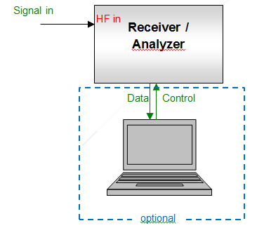
Figure 49: Principle measurement setup Type 1

  - Setup Type 2
This setup can be used for continuous signals when the required dynamic range of the result exceeds the capabilities of the measurement receiver/analyser.
To enhance the dynamic range of the measurement receiver/analyser, the wanted signal has to be suppressed by a (tuneable) filter. First, the filtered spectrum on the wanted channel/frequency as well as in the OoB or spurious domain is measured and recorded. In a second measurement, using the same receiver/analyser settings, the attenuation (frequency response) of the filter is measured and recorded. Then, using a software tool (e. g. Microsoft Excel), both curves are added to retain the original spectrum of the signal. The measurement is most efficient if controlled by a computer.
Depending on the application, frequency and bandwidth of the signal under test, a band pass filter or a band stop filter may be used. For spurious emissions, a band stop filter tuned to the wanted frequency is preferred as it allows measuring the whole spurious range at once. For OoB measurements, band pass filters tuned to the frequency range of the Out-of-band domain to be measured, could also be used.
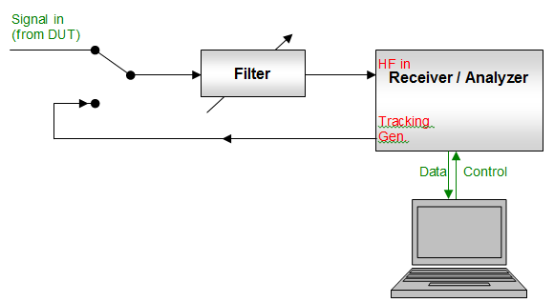
Figure 50: Principle measurement setup Type 2
  - Setup Type 3
For TDMA systems that transmit in bursts, the limits usually apply to the times where the transmitter is on. Unless the peak level is specifically mentioned in the relevant Recommendation, the average burst level has to be measured which is the RMS level during the burst only. This is done by externally triggering the measurement receiver to the burst start and adjusting the measurement time to match the burst length. The trigger is derived from a second spectrum analyser, operated in zero span mode and tuned to the wanted frequency.
The measurement process is identical to the setup Type 2.
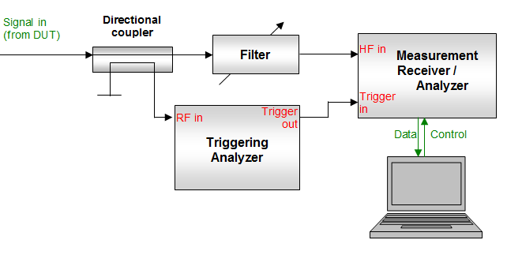
Figure 51: Setup Type 3 for measurements of TDMA systems
Data processing
The measurement bandwidth is always chosen to be equal to, or smaller than, the reference bandwidth stated in the relevant recommendation or standard. Especially in the vicinity of peak spurious emissions and in the OoB domain close to the wanted frequency, it is necessary to use a narrow measurement bandwidth because otherwise the measured spectrum would be unduly widened, leading to an overestimation of the unwanted level.
The signal levels (or spectral densities) taken in the selected measurement bandwidth are linearly converted to the corresponding levels or power densities in the reference bandwidths using the formula:
with
- PrefBW = signal level in reference bandwidth;
- PmeasBW = signal level in measurement bandwidth;
- refBW = reference bandwidth;
- measBW = measurement bandwidth.

  - Peak and average CASES of spectrum masks
With fixed limits for unwanted emissions that are not to be exceeded at any time, it would be necessary to measure the emissions with a peak detector. The 0 dB reference for OoB spectrum masks, however, is in most cases the total in-channel power or a power flux density in a given reference bandwidth, both of which are RMS values.
For analogue victim receivers the interference potential of an unwanted emission is mainly dependant on its peak level, while it is the RMS level that determines the interference potential to a digital receiver. This has been proven by various measurements for compatibility studies.
In digital systems, nearly all the unwanted emissions as well as the wanted emission are noise-like, which means that there is usually a fixed difference (crest factor) between RMS and peak level of about 13 dB. For these systems it would be possible to define either RMS or peak limits because the other corresponding level could be calculated. Exceptions include spikes due to harmonics or mixing products.
It may, however, be useful to consider systems on a case-by-case basis and to define both OoB/spurious levels and the 0 dB reference level on the same basis (either both in RMS or both in peak) and adapted to the specific case because this would enable direct comparison of a measured spectrum with a given mask. Figure 52 shows an example (DVB-T OoB emissions) where the OoB limits of the mask are always defined in peak levels. Mask 1 is the peak spectral density in 4 kHz reference bandwidth. This mask can directly be compared with the measured OoB spectrum. For Mask 2, however, the 0 dB reference level is the RMS power in 4 kHz. In this case there is a difference of approximately 13 dB between measured in-channel spectral density and the 0 dB reference of the Mask.
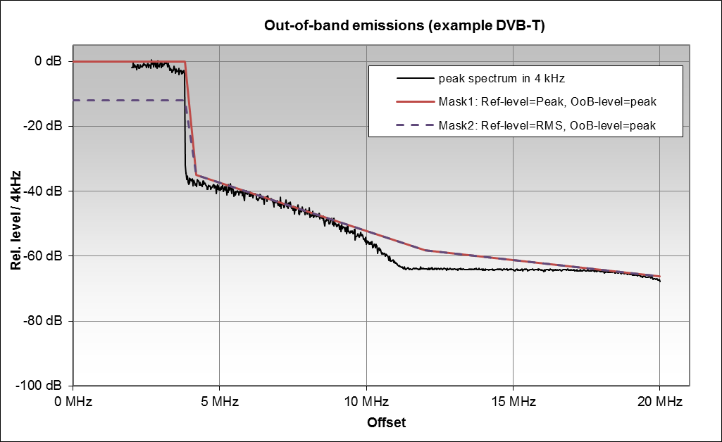
Figure 52: Different mask definitions - an example (DVB-T OoB emissions)
In many cases, the reference level for a spectrum mask is the power of the unmodulated carrier. In digital systems, the carrier is never unmodulated and can therefore not be measured directly. Instead, the total in-channel power of the modulated signal can be measured RMS as this is equal to the power of an unmodulated carrier. However, the reference bandwidth for this measurement has to be the occupied bandwidth of the signal which may be different from the reference bandwidth for the unwanted emissions. In these cases, a spectrum mask compared with a measured spectrum has no in-channel reference line. In the example in Figure 52, the horizontal line between 0 MHz and 4 MHz offset would be missing, and the 0 dB reference level would be shifted by the difference resulting from the bandwidth correction (in case of DVB-T: 10*log10(8 MHz/4 kHz)=23 dB).
- OOB boundary definitions in IMT standards
Examples below show differences in defining the OoB boundary in different IMT standards:
  - Theoretical explanation for more stringent limits for IMT systems
When UMTS (UTRA) was first specified by 3GPP as an IMT-2000 system in 1998-2000, spurious emission limits and the boundary between spurious and out-of-band domain were fundamentally based on the international recommendations ERC Recommendation 74-01 [2] and Recommendation ITU-R SM.329 [3]. For requirements applicable in Europe, Category B limits were used, which are identical in these two recommendations.
Later in the development of IMT in 2005 to 2006, when new frequency bands were added and the LTE (E-UTRA) standard was included as a new wideband radio access technology, there was a need to update the way the limits were applied for base stations in particular. This was all done in close co-operation between 3GPP, ETSI and ECC. The final agreement for how to apply the limits is summarised in a liaison statement response to 3GPP and ETSI from ECC [24].
- The boundary between the out-of-band and spurious domain for base stations is fundamentally based on a 5 MHz channel bandwidth, placing it at 12.5 MHz from the carrier centre (10 MHz from the carrier “edge”). This 10 MHz assumption originates from the UMTS 5 MHz carrier and is in 3GPP also applied for LTE BS transmissions, where the carrier bandwidth may be 10, 15 or 20 MHz. Note that this is not the case for LTE UEs (terminals), where the 250% rule is applied also for larger carrier bandwidths.
- The limits inside the operating band for a UMTS or LTE BS are based on a reduced measurement bandwidth close to the carrier, as outlined in the recommendations (see Annex 2 of ERC Recommendation 74-01 [2]). This reduction is in the 3GPP specifications interpreted as a relaxed limit of -15 dBm/MHz. While the recommendations allow for this reduction in a frequency range up to 10 times the necessary bandwidth, it was agreed that the relaxed limit could be applied in the complete transmitter operating band, plus within 10 MHz on each side of the operating band.
The agreement above on the spurious emission limits is based on the following:
The limits are in line with the limits used in ERC and ECC compatibility studies;
There is no impact on in-band sharing between different IMT technologies;
The limits are fair between operators and give mutual advantages, regardless of the technology deployed, the carrier bandwidth, the number of carriers or the position of the operator’s licence block.

Figure 53: UTRA Category B spurious emission limits for a single 5 MHz
carrier in two example carrier positions. The dotted red line shows the relevant limits from
ERC Recommendation 74-01 [2] and Recommendation ITU-R SM.329 [3]
The agreed limits were implemented for both UMTS and LTE at that time. With the agreement, the limits become homogenous over the operating band, independent of the placement of the carrier(s), carrier bandwidth, the width of the operating band and the number of carriers. This is shown in the figure above for a single 5 MHz carrier at the centre and at one of the edges of the operating band respectively.
  - Wideband, multicarrier and Multi-RAT transmissions
When LTE (E-UTRA) was developed, the focus was first on single-carrier transmission with flexible channel bandwidth (1.4 to 20 MHz). It was however quite early made clear that BS transmitters with multiple carriers would be deployed, especially when a "Multi-Standard Radio" or MSR standard was developed. With such a standard, it would be possible to use a more generic multicarrier transmitter capable of transmitting not only LTE, but also UMTS and GSM, and also enabling simultaneous transmission for different Radio Access Technologies (RAT). Such a development also supports migration between RATs within a spectrum block and facilitates technology neutrality. The importance of multicarrier transmission has later been stressed further with the addition to the standard of Carrier Aggregation for higher transmission bandwidths.
MSR Base Stations can be deployed in a number of scenarios with different RAT combinations. Some example scenarios are given in Figure 54, where the green carriers are UTRA, the blue carriers are E-UTRA and the orange narrowband carriers are GSM. From an implementation point-of-view, there is very little difference between the four scenarios in Figure 54. Also from an interference point-of-view when looking at the adjacent channels, there is no difference between the scenarios. There is fundamentally no reason why the frequency ranges for the out-of-band and spurious domains should be any different between the scenarios. This is however the case when following the first published version of ERC Recommendation 74-01 [2], since the necessary bandwidth would only be based on a single carrier.
Figure 54: Four example scenarios with multicarrier/multi-RAT transmissions
It was thus noted that the existing recommendations for spurious emissions in ERC Recommendation 74-01 [2] at that time did not give proper guidance for such multicarrier transmissions and mobile services were excluded. An activity was initiated to update the recommendation on spurious emissions and to provide guidance for multicarrier and multi-RAT transmitters, in particular for base stations, but also for mobile stations.
After several meetings and extensive liaison during 2008-2011 between ECC and ETSI, an update was agreed that was incorporated in the latest version of ERC Recommendation 74-01 [2] (see section 3 of Annex 2 of ERC Recommendation 74-01) and also in the updated version of ECC Recommendation (02)05 [22] (see section 5 thereof). The updates concerned mainly how the necessary bandwidth is calculated for such a multicarrier/multi-RAT transmitter and how the boundary between out-of-band and spurious domain is determined, with the following elements:
- The transmitter bandwidth is used as the necessary bandwidth for determining the limit between the out-of-band and spurious domain, and it is defined as the width of the frequency band covering the envelope of the transmitted carriers.
- Particular guidance is given for wideband transmitters, with reference to Recommendation ITU-R SM.1539 [5].
- Rules are made applicable for both contiguous and non-contiguous transmissions within a frequency block.
The current UMTS and LTE specifications for base and mobile stations are fully in line with the updated version of ERC Recommendation [2]. The boundary between out-of-band and spurious domains is in fact for many cases set closer to the edge of the transmitted carriers than what is provided for in ERC Recommendation 74-01.
  - DECT Terminology
DECT unwanted emissions are defined in DECT standards EN 301 406 [23] and EN 300 175-2 [17] for the native DECT band: "Unwanted RF power radiation" is defined in section 5.5 of EN 300 175-2 [17]. The emissions due to modulation and transmitter transient are defined and tested over DECT channels within the designated DECT band. "Spurious emissions when allocated a transmit channel" are defined in section 5.5.4 of EN 300 175-2. It is understood that the spurious emissions are tested beyond the DECT band edge.
Recommendation ITU-R SM.1541 [1] defines limits in the OoB domain, which is named the “2 MHz exclusion zone” in DECT terminology. This is illustrated in the Figure 55:

Figure 55: Clarification on DECT OoB and spurious emissions terminology

DECT equipment does not exceed the limits in EN 300 175-2 at the lower band edge (1880 MHz) where the lowest DECT carrier is 1.792 MHz away, and at the higher band edge (1900 MHz) where the highest DECT carrier is 2.656 MHz away from the band edge. When checking the values in the diagram in Figure 55 at these offsets, it can be noted that the values at these offsets are well below the limits.

- Additional Measurements
  - Digital Systems
    - LTE800 UE Out-of-band emissions (source: Germany)
The following measurements have mainly been made to investigate how much the level of OoB emissions depends on the actual state of the UE, especially on the bandwidth. For this campaign, two LTE modems of different manufacturers have been measured as follows.
The terminal was operated using one antenna path only. A fixed attenuator was placed in the antenna path to force the terminal’s power control to the maximum output power – which also maximises the unwanted emissions. A large data file was transmitted using the maximum speed and RF bandwidth available. It was ensured that the terminal was the only one linked to the serving base station at that moment.
While UE1 was operated in a network without limitation of the maximum bandwidth, the provider of the network for UE2 has defined a maximum upload speed for one unit of 2 Mbit/s. This results in a spectrum with constant bandwidth (2.52 MHz from 14 Resource Blocks), but changing position inside the usable 10 MHz channel.
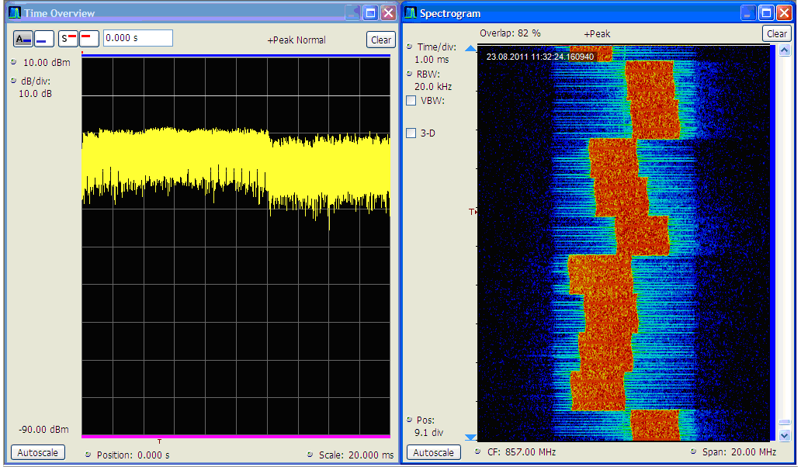
Figure 56: Power versus time and spectrogram for signal UE2
The relevant RF parameters from this measurement are:
- LTE uplink Band: 832-862 MHz;
- UE centre frequency: 857 MHz;
- Bandwidth: 10 MHz (channel);
- Tx power: 200 mW = 23 dBm (Tx output and e.i.r.p.);
- Tx output filter: no;
- Measurement bandwidth: 100 kHz;
- OoB domain ends at: 20 MHz offset (see ETSI EN 301 908-13 [8] Table 4.2.4.1.2-1) = 200% BW.
Although no external output filter is applied, internal filtering can be assumed at least to protect the own receiver in the downlink band (796-816 MHz).
The measurements were done conducted by extracting the UE signal from the path to the antenna with a directional coupler.
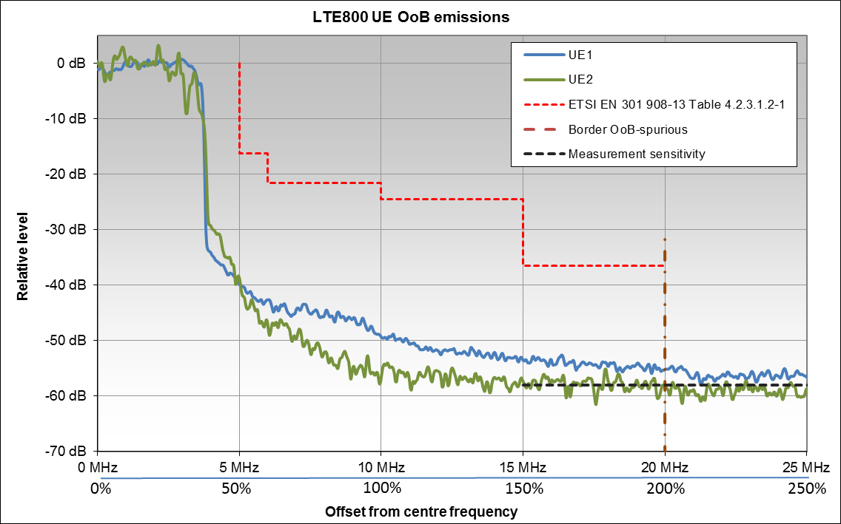
Figure 57: LTE800 UE OoB emissions
Observations:
- The OoB limits from ETSI EN 301-908 [6] are out-performed with a margin of about 20 dB;
- The level of OoB emissions are to a certain extent depending on the bandwidth of the UE emission, although the examples above do certainly not present the highest difference possible.
To further explore the dependency of OoB emissions on the momentary bandwidth used by the UE, the following figure shows a recording of a randomly selected device in a typical LTE environment with changing data rates. The observation bandwidth is 40 MHz, the acquisition time is 100 ms (10 radio frames). The yellow spectrum shows the peak-hold spectrum over that time, while the orange spectrum shows the momentary spectrum at the time instant marked with a line in the spectrogram. The resolution bandwidth was set to match one resource block (180 kHz).
The spectrogram below (left side) presents the transmission over time where all the resource blocks are used for the first 1/3 of the transmission, while in the remaining 2/3 of the time only a few resource blocks are transmitted.
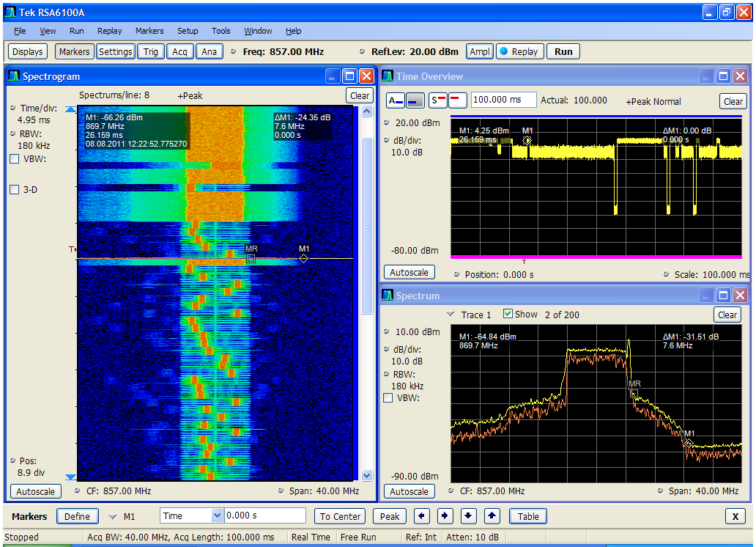
Figure 58: Example of Out-of-Band emissions of a randomly selected LTE terminal.
Spectrogram (left), power vs. time (upper right) and spectrum
(yellow: whole acquisition time; orange: time instant marked with a line in the spectrogram)
Observations:
- The figure clearly shows the correlation between the resource block allocations in the in-band (i.e. useful signal’s part) and the OoB-emissions: The wider the bandwidth the higher the level of OoB emissions on a particular OoB frequency;
- The shoulder attenuation (difference between spectral density inside and immediately outside the used bandwidth) is constant (about 40 dB).
    - LTE800 UE
      - OoB Measurements from France
In order to quantify the UE unwanted emissions at different transmit power levels, 4 LTE800 smartphones from different vendors with different chipsets inside were selected and measured in a laboratory. The laboratory tests were performed conducted following the test procedure defined in ETSI TS 136 521-1 [25] (LTE UE radio test specification).
The relevant RF parameters for the measurement are:
- LTE uplink band: 832-862 MHz;
- UE centre frequency: 837 MHz;
- Bandwidth: 10 MHz (channel);
- Max. Tx power: 200 mW = 23 dBm (Tx output and e.i.r.p.);
- Tx output filter: no;
- Measurement bandwidth: 9 MHz channel filter.
LTE UE unwanted emissions (both OoB emissions and spurious emissions) were measured with 50 RBs (full channel bandwidth occupation) and 12 RBs (partial channel occupation). The characteristics of the unwanted emissions for the 4 tested UEs were quite similar. The results for the UE #4 are plotted in Figure 59 and Figure 60. The line mark-ups represent the total RMS power inside the neighbouring channels.
Figure 59: Measured UE#4 OOB Emissions (QPSK modulation, 50 RBs)

Figure 60: Measured UE#4 OoB Emissions (QPSK modulation, 12 RBs)
Observations:
- UE unwanted emissions levels are lower than the minimum requirement defined in the specification;
- The measured results do not show a clear interruption at the point between OoB domain and spurious emissions domain, as defined in the standards;
- When UE Tx power is reduced by x dB, UE OoB levels decrease by more than x dB.
An analytic equation is not realistic since the spurious emissions are derived from the emissions of the various RF components (e.g. power amplifiers, local oscillators...) that may be part of a transmission chain. Therefore it does not seem adequate to establish a theory regarding this issue.
As described in Report ITU-R M.2292 [26] these unwanted emission limits are the upper limits from ETSI specifications for laboratory testing with maximum transmitting power. It is assumed that when the in-band transmitting power is reduced by x dB through power control, the unwanted emission levels would also reduce by x dB. According to the above measurements this seems not to be realistic.
      - OoB measurements from the European Commission’s Joint Research Centre
Conducted measurements of four different LTE800 UEs (UE1 to UE4) have been performed in a frequency range of 50 MHz around the used channel. The relevant RF parameters for this measurement are:
The relevant RF parameters for the measurement are:
- LTE uplink Band: 832-862 MHz;
- UE centre frequency: 837 MHz;
- Bandwidth: 10 MHz (channel);
- Max. Tx power: 200 mW = 23 dBm (Tx output and e.i.r.p.);
- Tx output filter: no;
- Measurement bandwidth: 1 kHz.
In the following figure, the results have been converted into a reference bandwidth of 1 MHz. The attenuation in the measurement setup has been compensated, so that the level axis shows transmitter power in 1 MHz.
The measurement sensitivity (noise floor of the spectrum analyser) was -91 dBm/MHz, so unwanted emissions higher than -55 dBm/MHz would be visible.
The limit line for the OoB spectrum mask has been taken from ETSI EN 301 908-13 [8]. The same standard defines the boundary to the spurious domain at ΔfOOB > 15 MHz which in the case of the lower sideband is 822 MHz. The limit for spurious emissions is -30 dBm/MHz.

Figure 61: Comparison of LTE UE emissions (807-857 MHz, Bandwidth = 1 MHz)
vs. LTE spectrum emission mask (ETSI, 2013)
Observations:
- UE unwanted emissions levels are significantly lower than the minimum requirement defined in the specification;
- No spurious emissions close to the OoB boundary (between 807 and 817 MHz) are visible which means the spurious level in the most critical offset range (-25 MHz < ΔfOOB < -15 MHz) is at least 22 dB below the limit.
    - LTE2600 base stations (source: Ofcom UK)
The spurious emissions of a LTE2600 base station in the upper sideband has been measured with the following relevant RF parameters:
- LTE2600 downlink band: 2620-2690 MHz;
- Tx frequency: 2670 MHz (centre frequency of the highest downlink channel);
- Channel bandwidth: 20 MHz;
- Tx power: 20 W / 43.2 dBm (RMS at transmitter output);
- Tx external filter: none;
- Measurement bandwidth: 1 MHz;
The spurious limit in ITU-R SM.329 (Cat B) [3] and in ETSI EN 301 908-14 [9] (Table 4.2.4.3.1-1) is at
-30 dBm/MHz. The ETSI standard defines the beginning of the spurious domain at 20 MHz outside the boundary of the allocated band which is in this case at 2690 MHz + 20 MHz = 2710 MHz or an offset to the centre frequency of 30 MHz.
The following figure shows direct levels at the transmitter output in 1 MHz bandwidth, so no conversion of the limit line is necessary.
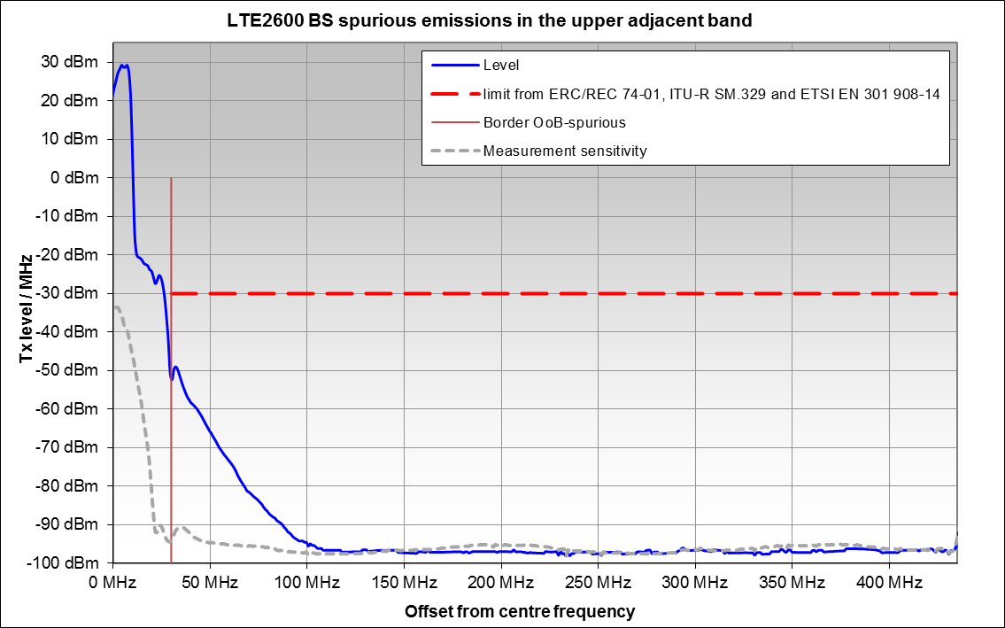
Figure 62: LTE2600 BS spurious emissions (Bandwidth = 1 MHz)
Observations:
- The spurious emission levels are significantly lower than the minimum requirement defined in the specification. Even at the critical boundary between OoB and spurious emissions the limits are out-performed by 20 dB;
- Due to the built-in filtering, the spurious emissions for large frequency offsets (>100 MHz) are at least 65 dB below the limit;
- The actual spurious emissions for frequency offsets above 120 MHz are even lower than shown, because of the limitation of the measurement sensitivity.
    - UMTS2100 base stations
The following figure shows a conducted measurement of a UMTS base station. The relevant RF parameters are:
- Tx frequency: 2152 MHz (centre);
- Tx power: 3 W / 35 dBm (RMS at transmitter output);
- Tx external filter: none;
- Measurement bandwidth: 30 kHz.
For Europe (Cat B), ITU-R SM.329 [3] specifies the limit for broadband wireless access systems such as UMTS of -30 dBm in 1 MHz bandwidth. With 35 dBm total power of the transmitter, this relates to a required attenuation of 65 dBc. The output power of the UMTS station of 35 dBm corresponds to the measured in-channel level of 20 dBm Therefore the regulatory limit on Figure 63 corresponds to
20 dBm – 65 dBc = -45 dBm in 1 MHz.
A floating integration window of 1 MHz was applied to convert the levels measured in 30 kHz bandwidth into reference bandwidth of 1 MHz. The level axis in Figure 63 can be converted to directly reflect radiated power in 1 MHz bandwidth by adding 15 dB.
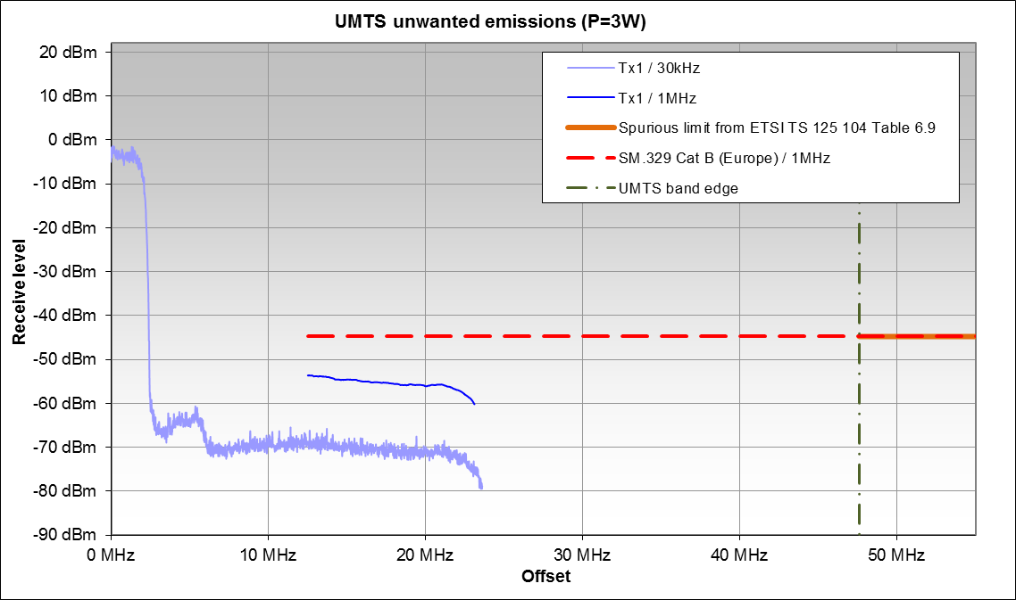
Figure 63: UMTS spurious emissions (upper frequency range)
Observations:
- At the beginning of the spurious domain according to Recommendation ITU-R SM.329 [3], the limit is met with a margin of 10 dB. However, the falling spectral levels towards the right end of the measured curve already show that the spurious levels lower considerably at higher frequency offsets, due to internal filtering;
- Although no measurement data exists for frequency ranges outside the allocated UMTS band (offsets above 44.6 MHz), it may be assumed that the limit from the relevant ETSI standard is easily met. In practice, the internal filtering will result in no measurable spurious emissions in this range. More critical situations would be if the UMTS station would be operated on the highest channel, close to the band edge.
    - 25 GHz Point-to-point links
For the OoB domain, Recommendation ITU-R SM.1541, annex 12 [1] defines relevant generic FS limits for this system. The relevant ETSI standard is EN 302 217 [20] which also defines specific OoB spectrum masks.
The spurious limit in Recommendation ITU-R SM.329 is -30 dBm/MHz.
The following section contains additional OoB measurements for point-to-point links from three different devices operating with three different bandwidths. The relevant RF parameters are stated separately for each device.

      - Device A
- Centre Frequency : 25138.750 MHz;
- Channel Spacing : 3.5 MHz;
- Data Rate : 2x2 Mbit/s;
- Modulation : CQPSK;
- Output Power : 24 dBm;
- Measurement bandwidth: 30 kHz;
- Reference spectral density: 4 dBm in 30 kHz bandwidth = -11 dBW/MHz.
The spurious emission limit from ITU-R SM.329 [3] of -30 dBm/MHz would convert to -45 dBm in the measurement bandwidth of 30 kHz.
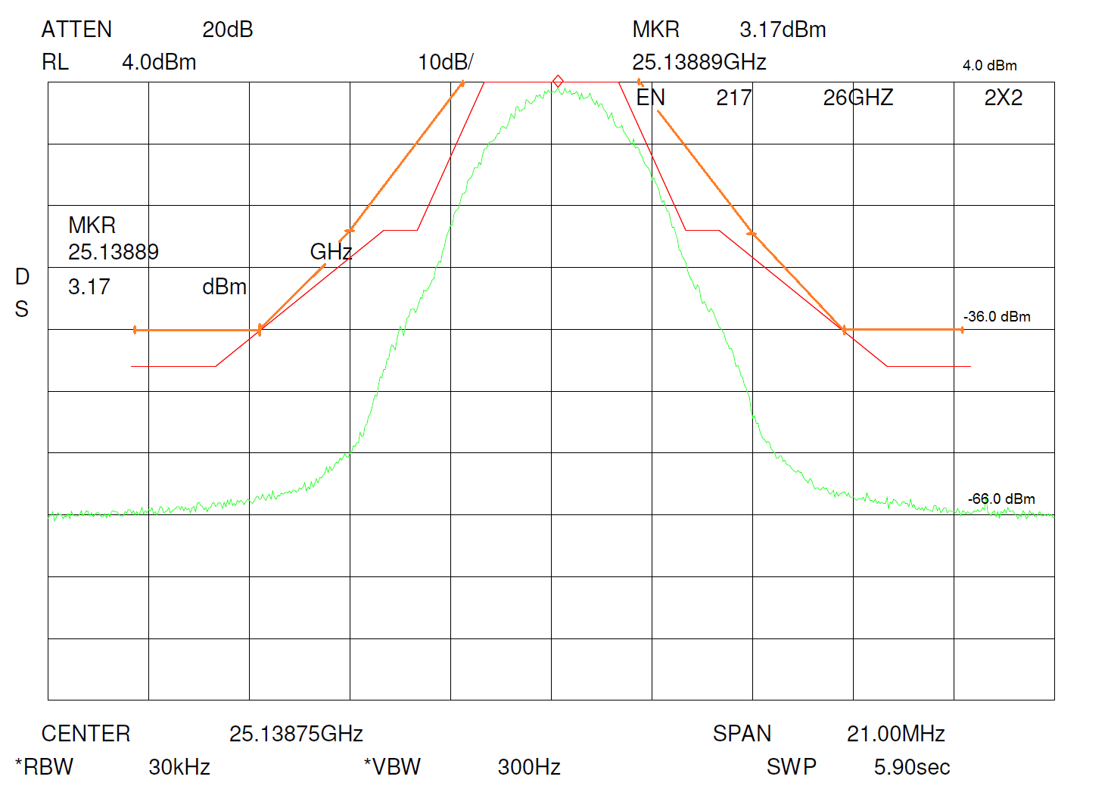
Receiver noise
Figure 64: 25 GHz Point to Point link unwanted emissions - Device A
Observations:
- The OoB emission levels are between 15 and 35 dB lower than the generic FS limit from ITU-R SM.1541 [1], and between 5 and 30 dB lower than the specific limit from ETSI EN 302 217 [20];
- The spurious emissions at the boundary to the OoB domain are at least 21 dB below the limit from ITU-R SM.329;
- The above spectrum is peculiar of a specific CPM/TFM modulation family. Details of this technique are in Recommendation ITU-R SM.328 [38] annex 6 § 2). This format, particularly good with respect to 3rd IM products, could be used only for low modulation index (2-4 max). Therefore, it is not suitable for modern adaptive modulation systems that universally use QAM formats dynamically variable from 2 to 2048 states.
      - Device B
- Centre Frequency: 25140.5 MHz;
- Channel Spacing: 7 MHz;
- Data Rate: 10x2 Mbit/s;
- Modulation: 16 QAM;
- Output Power: 20 dBm;
- Measurement bandwidth: 30 kHz;
- Reference spectral density: -3.5 dBm in 30 kHz bandwidth = -18 dBW/MHz.
The spurious emission limit from ITU-R SM.329 [3] of -30 dBm/MHz corresponds to -45 dBm in the measurement bandwidth of 30 kHz.
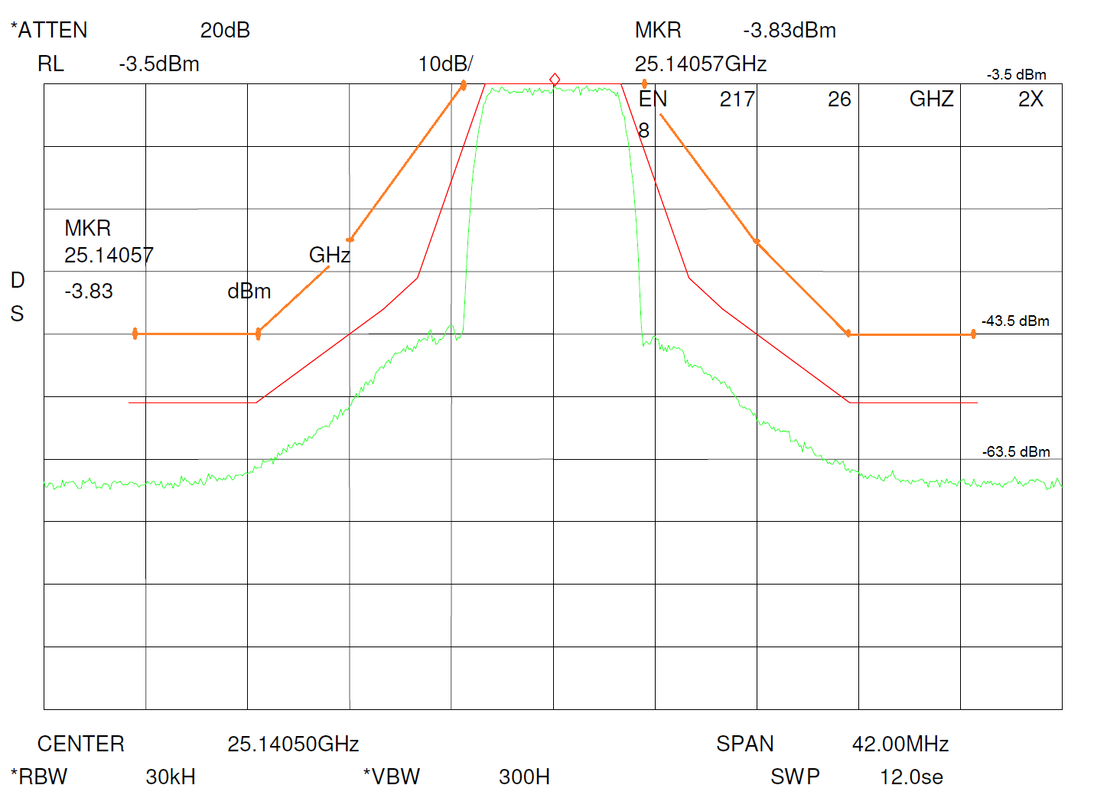
Receiver noise
Figure 65: 25 GHz Point to Point link unwanted emissions - Device B
Observations:
- The OoB emission levels are between 22 and 40 dB lower than the generic FS limit from ITU-R SM.1541 [1], and typically 10 dB lower than the specific limit from ETSI EN 302 217 [20];
- The spurious emissions at the boundary to the OoB domain are at least 21 dB below the limit from ITU-R SM.329.
      - Device D
- Centre Frequency : 25144.000 MHz;
- Channel Spacing : 14 MHz;
- Data Rate : 35x2 Mbit/s;
- Modulation : 128 QAM;
- Output Power : +20 dBm;
- Measurement bandwidth: 100 kHz;
- Reference spectral density: -1.5 dBm in 100 kHz bandwidth = -21.5 dBW/MHz.
The spurious emission limit from Recommendation ITU-R SM.329 [3] of -30 dBm/MHz corresponds to
-40 dBm in the measurement bandwidth of 100 kHz.
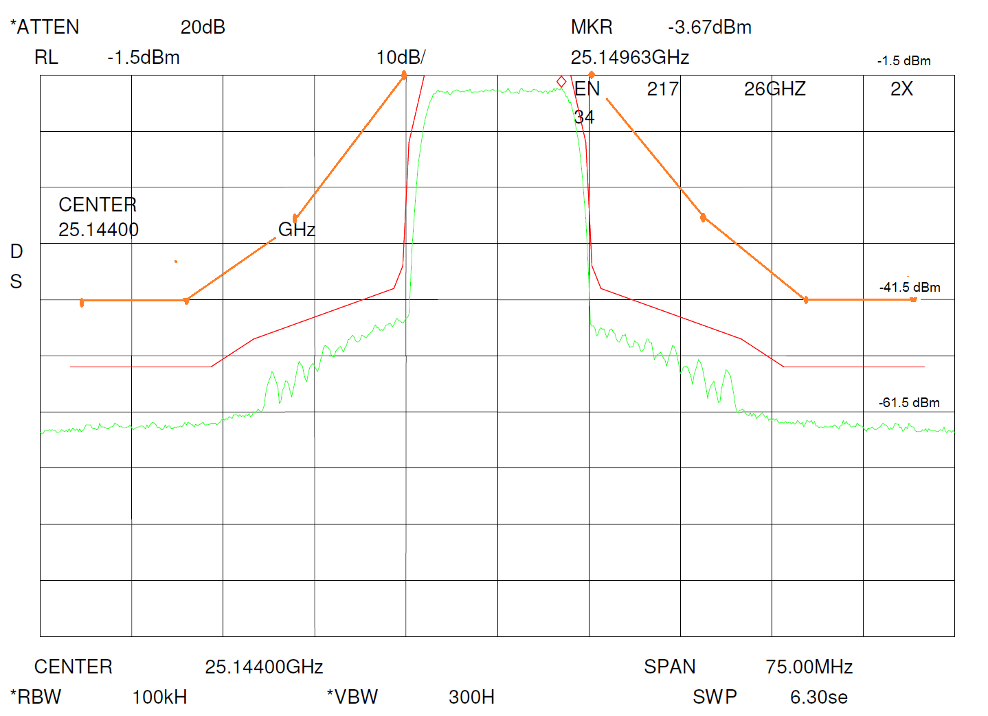
Receiver noise
Figure 66: 25 GHz Point to Point link unwanted emissions - Device D
Observations:
- The OoB emission levels are between 22 and 45 dB lower than the generic FS limit from Recommendation ITU-R SM.1541 [1], and typically 10 dB lower than the specific limit from ETSI EN 302 217 [20];
- The spurious emissions at the boundary to the OoB domain are at least 23 dB below the limit from Recommendation ITU-R SM.329.
  - Analogue Systems
    - FM broadcast
The generic broadcasting service limits for analogue sound broadcasting system are covered in Annex 7 of Recommendation ITU-R SM.1541 [1]. The relevant RF parameters are:
- Modulation: FM;
- Deviation: 75 kHz (for coloured noise of Tx3); 63 kHz
(for normal programme content at Tx1, Tx2, Tx4);
- Max. bandwidth: 180 kHz;
- Channelling: 200 kHz;
- Tx output filter: no;
- OoB domain ends at: 500 kHz (see Recommendation ITU-R SM.1541 Annex 7, § 1 [1]).

When several FM broadcast transmitters are operated at the same site, or even at the same antenna, they are usually fitted with band pass filters after the final output stage. However, when standing alone, they may be operated without such a filter. To assess the worst performance for this service, the transmitters were measured conducted at the output (i.e. before any filter).
      - Out-of-band emissions
For this system, Recommendation ITU-R SM.1541 recommends using the channel bandwidth for the determination of the OoB boundaries although the actual maximum occupied bandwidth is slightly less. The reference bandwidth for the spectrum mask is 1 kHz. The measurements were made at the antenna port of transmitters of various power classes with 1 kHz measurement bandwidth. The measured spectral densities are normalized to the 0 dB reference of the spectrum mask.
It should be noted that the conversion of the 0 dB reference for the spectrum mask given in Annex 7, Table 20 of Recommendation ITU-R SM.1541 from 200 kHz to 1 kHz assumes an evenly spread spectral density over the whole 200 kHz channel width. Therefore, the in-channel points of the mask when referenced to 1 kHz bandwidth lies at -23 dB. Actual broadcasting transmitters, however, do not occupy the whole 200 kHz channel evenly. Consequently, the spectral density measured in 1 kHz bandwidth is usually only approximately 17 dB below the total power measured in 200 kHz bandwidth. Therefore, the measured spectral density in the figure below exceeds the mask inside the used channel by as much as 5 dB.
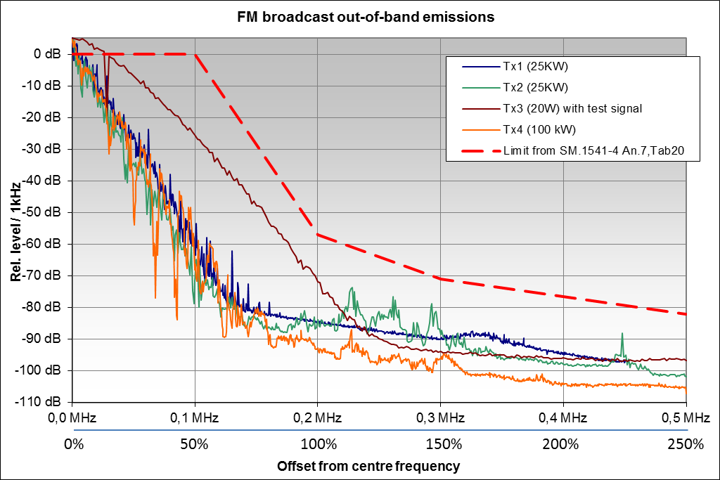
Figure 67: OoB measurements from four different FM broadcast transmitters
All spectral components in the above Figure originate from the transmitters. The measurement sensitivity was well below -110 dB.
Observations:
- The OoB limits are met by all transmitters measured.
- When operated with normal programme material (Tx1, Tx2 and Tx4), the spectra are much narrower and the OoB emissions caused by modulation much lower than when transmitting a test signal (Tx3 with coloured stereo noise according to Recommendation ITU-R BS.559). The coloured noise signal was used for comparison purposes as it occupies maximum available bandwidth.
      - Spurious emissions
The key RF parameters of the measured analogue sound broadcasting systems are the same as in the section dealing with OoB emissions above.
Measurements were done at the transmitter output of three broadcast transmitters of different power classes without additional output filtering applied. Because the spurious limits in Recommendation ITU-R SM.329 [3] are dependent on the transmit power, each measurement is shown in its own graph to allow comparison of the spectrum with the relevant limit.
The measurement bandwidth was 1 kHz for Tx1 and Tx2, and 10 kHz for Tx3. The direct results are shown in light blue. Because the limits are given in a reference bandwidth of 100 kHz, a floating window of 100 kHz was applied to convert the measured spectral density into the reference bandwidth of 100 kHz. The converted spurious levels are shown in dark blue.
All spurious emissions shown in the following figures originate from the transmitters and are above the system sensitivity.
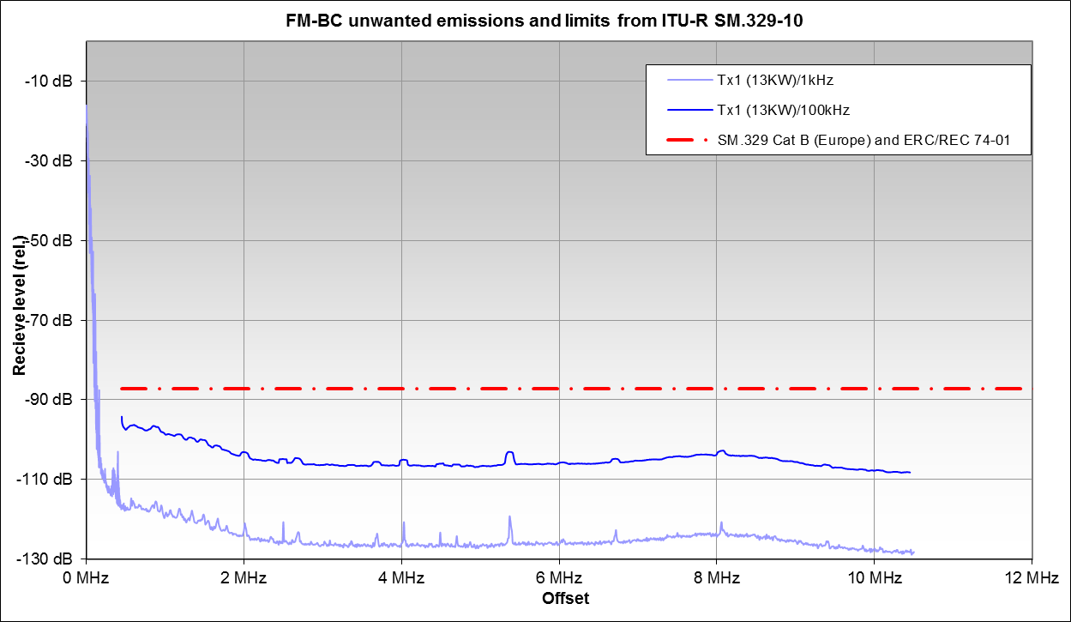
Figure 68: Spurious emissions of a 13 kW FM broadcast transmitter (upper frequency range)
Since the transmitter output power was 13 kW = 71 dBm, the level axis of Figure 68 can be converted to reflect directly the spurious levels in dBm (in 100 kHz BW) by adding 71 dB.
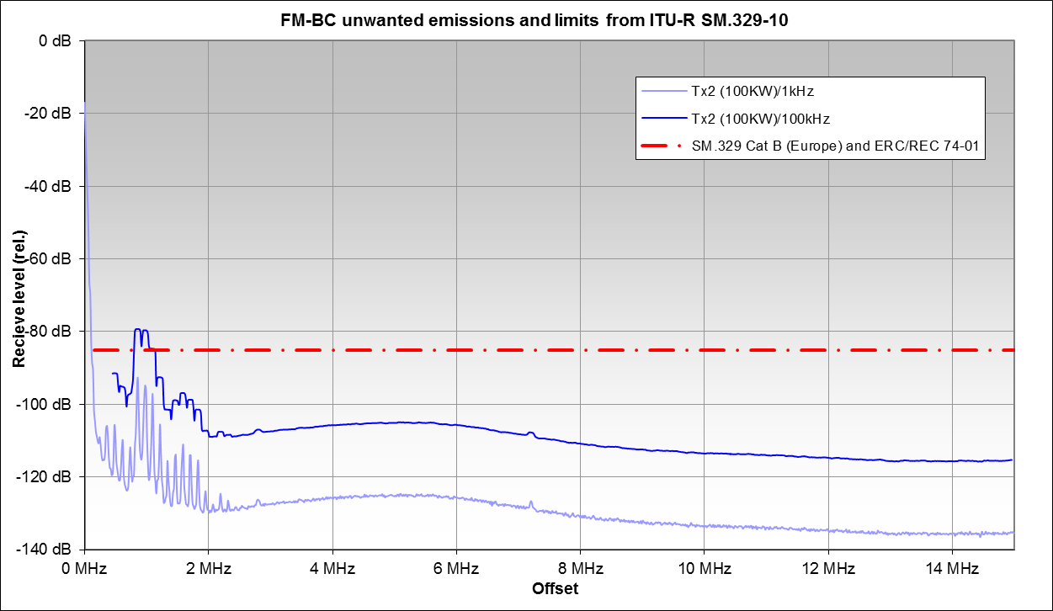
Figure 69: Spurious emissions of a 100 kW FM broadcast transmitter (upper frequency range)
Since the transmitter output power was 100 kW = 80 dBm, the level axis of Figure 69 can be converted to directly reflect the spurious levels in dBm (in 100 kHz BW) by adding 80 dB.
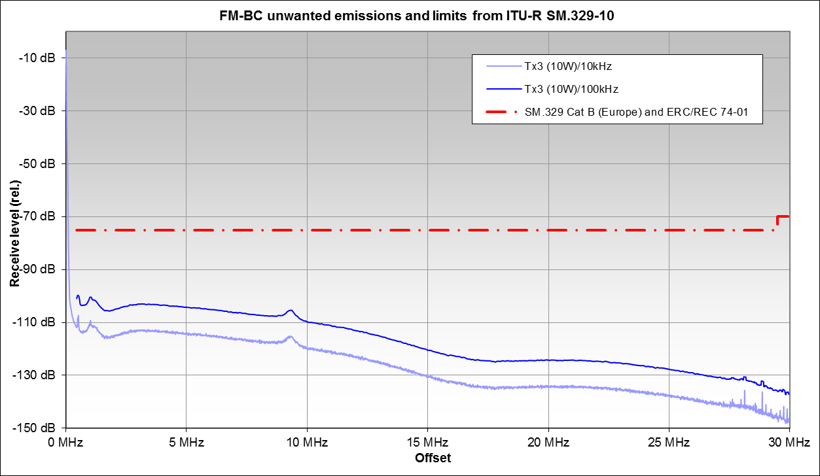
Figure 70: Spurious emissions of a 10 W FM broadcast transmitter (upper frequency range)
Since the transmitter output power was 10 W = 40 dBm, the level axis of Figure 70 can be converted to directly reflect the spurious levels in dBm (in 100 kHz BW) by adding 40 dB.
The harmonics were measured at the transmitter output of Tx3 separately with the following results:
Table 7: Harmonic levels of a 10W FM broadcast transmitter
Harmonic | Tx3 (10W)
 | Frequency | Level/100 kHz | Attenuation/100kHz
Fundamental | 100 MHz | 18.5 dBm
2nd harmonic | 200 MHz | -54.0 dBm | 72.5 dBc
3rd harmonic | 300 MHz | -91.0 dBm | 109.5 dBc
4th harmonic | 400 MHz | -77.0 dBm | 95.5 dBc
5th harmonic | 500 MHz | -97.0 dBm | 115.5 dBc
6th harmonic | 600 MHz | < -110 dBm | >128.5 dBc
7th harmonic | 700 MHz | < -110 dBm | >128.5 dBc
8th harmonic | 800 MHz | < -110 dBm | >128.5 dBc
9th harmonic | 900 MHz | < -110 dBm | >128.5 dBc
10th harmonic | 1000 MHz | < -110 dBm | >128.5 dBc
Note: The most restrictive limit in Recommendation ITU-R SM.329 [3] (Category B) corresponds to an attenuation of 77 dBc.

Observations:
- The spurious limits are met by all transmitters measured. Except for Tx2 at offsets around 1 MHz, the spurious emissions are typically between 10 and 20 dB below the limits;
- As mentioned above, all measured transmitters did not have output filters. It should be noted, however, that FM broadcast transmitters are often fitted with band pass output filters that virtually cut off all spurious emissions. This is especially the case at nearly all sites where more than one transmitter (or frequency) is operated.
    - Land mobile service (PMR)
Measurements were performed on the following units:
- mobile transceiver used for public safety communication (4 m, voice);
- mobile transceiver used for company radio networks;
- transceiver used as a relay station (2 m).
All three measured units can be used as fixed or mobile installations.
The key RF parameters are:
Modulation: FM
Max. output power for all three transmitters: 10 W = 40 dBm
(Occupied) bandwidth for all three transmitters: 10 kHz
Tx output filter: yes
Spurious domain starts at: 62.5 kHz offset
(in accordance with Recommendation ITU-R SM.1539, table 2 [5]) for 25 kHz channels.
The deployment of output filters depends on the individual system. In case it is a full duplex system, the device also has a receiver which has to be protected from unwanted emissions of its own transmitter. However, these filters are not necessarily band pass filters, they can also be low pass, high pass or band stop filters. In case of half-duplex or simplex systems, the transceivers may be operated without filter.
All three measured units were designed for full duplex operation, so it can be assumed that some kind of filter is implemented to protect the receive band. The measurements were made at the transmitter output to achieve maximum dynamic range and sensitivity.
      - Out-of-band emissions
Measurements of both sides from the centre frequency have shown that the curves of the OoB emissions are symmetrical to the wanted frequency.
Recommendation ITU-R SM.1541 [1] does not provide general limits for all land mobile services. Instead, examples are given only for 5 kHz bandwidth with SSB modulation, 6.5, 12.5 and 30 kHz bandwidth for AM/FM modulated systems. The channel spacing for the systems measured is 20 kHz. Although no example from the Recommendation exactly fits, the figure shows the relative limit lines for the 12.5 kHz spacing case in comparison with the measured spectra. This example was chosen because limits for OoB emissions for 12.5 kHz spacing are more stringent compared to 30 kHz spacing.
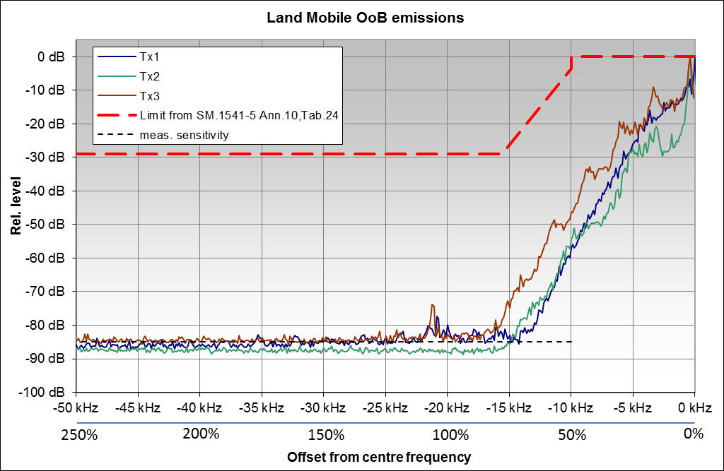
Figure 71: OoB emissions from Land Mobile stations
Observations:
- The generic mobile service OoB limits from Recommendation ITU-R SM.1541-5 [1] seem very generous for the land mobile service;
- The OoB limits are met by all transmitters measured. The OoB emissions of all three transmitters are at least 55 dB below the limit from Recommendation ITU-R SM.1541;
- The OoB emissions related to the modulation already disappear in the noise of the measurement system at frequency offsets around 75% of the channel bandwidth. Beyond an offset of 100% of the channel bandwidth, no unwanted emissions could be measured.
      - Spurious emissions
Measurements were performed on the transceivers Tx1 and Tx2 used for the OoB measurements and are presented in Figure 48. According to Recommendation ITU-R SM.1539, Table 2 [5], the spurious domain starts at 62.5 kHz offset.
The measurements were made at the transmitter output to achieve maximum dynamic range and sensitivity. The actual measurement bandwidth was 10 kHz; the results are shown in the light colour in Figure 48. A floating integration window of 100 kHz was then applied to convert results into reference bandwidth of 100 kHz; the results are shown in the dark colour in Figure 48. These curves should be compared to the limit lines.
The output power of both stations was 10W = 40 dBm. This corresponds to an in-channel receive level of 19 dBm. The level axis in Figure 48 can therefore be converted to directly reflect radiated power in 100 kHz bandwidth by adding 21 dB.
The harmonics were measured separately with the following results:
Table 8: Harmonic levels of measured Land Mobile stations at transmitter output
Harmonic | Tx1 |  |  | Tx2
Harmonic | Frequency | Receive level  /100 kHz | Attenuation  /100 kHz | Frequency | Receive level  /100 kHz | Attenuation  /100 kHz
Fundamental | 85.175 MHz | 19.0 dBm | 0 dB | 156.025 MHz | 19.0 dBm | 0 dB
2nd harmonic | 170.350 MHz | -96.0 dBm | 115 dB | 312.050 MHz | -71.0 dBm | 90 dB
3rd harmonic: | 255.525 MHz | -68.0 dBm | 87 dB | 468.075 MHz | -69.0 dBm | 88 dB
4th harmonic: | 340.700 MHz | -81.0 dBm | 100 dB | 624.100 MHz | -62.0 dBm | 81 dB
5th harmonic: | 425.875 MHz | -80.0 dBm | 99 dB | 780.125 MHz | -59.0 dBm | 78 dB
6th harmonic: | 511.050 MHz | -78.0 dBm | 97 dB | 936.150 MHz | -73.0 dBm | 92 dB
7th  harmonic | 596.225 MHz | -102.0 dBm | 121 dB | 1092.175 MHz | -67.0 dBm | 86 dB
8th harmonic: | 681.400 MHz | -132.0 dBm | 151 dB | 1248.200 MHz | -70.0 dBm | 89 dB
9th harmonic: | 766.575 MHz | -132.0 dBm | 151 dB | 1404.225 MHz | -77.0 dBm | 96 dB
10th harmonic: | 851.750 MHz | -132.0 dBm | 151 dB | 1560.250 MHz | -80.0 dBm | 99 dB
For information: The most restrictive limit in Recommendation ITU-R SM.329 [3] (Cat B) corresponds to an attenuation of 76 dBc.
In addition to the conducted measurement at the transmitter output, the harmonics of Tx2 and an additional Tx3 were also measured radiated (off-air) as field strength or power flux density:
Table 9: Harmonic levels of measured Land Mobile stations at Tx output and off-air
Harmonic | Frequency | Tx2 (attenuation) |  | Tx3 (attenuation)
Harmonic |  | Tx-output | Off air | Tx-output | Off air
Fundamental | 156.025 MHz | 0 dB | 0.0 dB | 0 dB | 0.0 dB
2nd harmonic | 312.050 MHz | 90 dB | 80.3 dB | 23 dB | 86.3 dB
3rd harmonic | 468.075 MHz | 88 dB | 57.8 dB | 85 dB | 75.8 dB
4th harmonic | 624.100 MHz | 81 dB | 75.4 dB | 104 dB | 93.4 dB
5th harmonic | 780.125 MHz | 78 dB | 80.0 dB | 125 dB | 97.0 dB
6th harmonic | 936.150 MHz | 92 dB |  | 136 dB
7th harmonic | 1092.175 MHz | 86 dB | 76.2 dB | 151 dB | > 84 dB
8th harmonic | 1248.200 MHz | 89 dB | 87.0 dB | 151 dB | > 84 dB
Observations:
- The spurious limits from Recommendation ITU-R SM.329 [3] are met by both transmitters, except for one distinct frequency around 6 MHz offset where Tx2 exceeds the limit for Europe;
- Using the limit of the spurious domain as a continuous spectral power results in an overestimation of the possible impact of these emissions. Further investigations are needed in order to develop a general algorithm in terms of probability of occurrence of the peaks.
    - Radiodetermination
      - Spurious emissions
This section shows example of civil air traffic control radar operating in the 2.7 GHz band (taken from ECC Report 174 [27]).
For the spurious level, the limit from ERC Recommendation 74-01 [2] was taken which is at -60 dBc, measured in 1 MHz bandwidth. The start of the spurious domain is wherever the OoB level meets the spurious level.
The unwanted emission limit for this type of radar in accordance with Table 5.1 of ERC Recommendation 74-01 [2] is -60 dBc (marked red). A few spikes are close to the limit. The noise floor is about 40 dB below.

Figure 73: Civil Air traffic Control radar #1
Apart from a very low wideband noise level, the spurious emissions of the measured radars show distinct peaks at the harmonic frequencies that are typical for many analogue systems.
- List of References
- Recommendation ITU-R SM.1541: “Unwanted emissions in the out-of-band domain”
- ERC Recommendation 74-01: “Unwanted emissions in the spurious domain”, approved 1998, amended January 2011
- Recommendation ITU-R SM.329: “Unwanted emissions in the spurious domain”
- ITU Radio Regulations, Edition of 2012
- Recommendation ITU-R SM.1539: “Variation of the boundary between the out-of-band and spurious domains required for the application of Recommendations ITU-R SM.1541 and ITU-R SM.329”
- ETSI EN 301 908: “IMT cellular networks; Harmonized EN covering the essential requirements of article 3.2 of the R&TTE Directive”
- ETSI EN 301 908-3 (V7.1.1): “IMT cellular networks; Harmonized EN covering the essential requirements of article 3.2 of the R&TTE Directive; Part 3: CDMA Direct Spread (UTRA FDD) Base Stations (BS)”
- ETSI EN 301 908-13 (V7.1.1, 2015-12): “IMT cellular networks; Harmonised EN covering the essential requirements of article 3.2 of the R&TTE Directive; Part 13: Evolved Universal Terrestrial Radio Access (E-UTRA) User Equipment (UE)”
- ETSI EN 301 908-14 (V7.1.1): “IMT cellular networks; Harmonised EN covering the essential requirements of article 3.2 of the R&TTE Directive; Part 14: Evolved Universal Terrestrial Radio Access (E-UTRA) Base Stations (BS)”
- ETSI EN 301 908-18 (V7.1.1): “IMT cellular networks; Harmonized EN covering the essential requirements of article 3.2 of the R&TTE Directive; Part 18: E-UTRA, UTRA and GSM/EDGE Multi-Standard Radio (MSR) Base Station (BS)”
- Geneva 06 (GE-06) Agreement: “Regional Agreement Relating to the planning of the digital terrestrial broadcasting service in Region 1 (parts of Region 1 situated to the west of meridian 170° E and to the north of parallel 40 S, except the territory of Mongolia) and in the Islamic Republic of Iran, in the frequency bands 174 230 MHz and 470-862 MHz” (http://www.itu.int/pub/R-ACT-RRC.14-2006/en)
- ETSI EN 302 077 (V1.1.1): “Electromagnetic compatibility and Radio spectrum Matters (ERM);Transmitting equipment for the Terrestrial - Digital Audio Broadcasting (T-DAB) service;
Part 1: Technical characteristics and test methods”
- ETSI EN 302 296 (V2.2.0): “Electromagnetic compatibility and Radio spectrum Matters (ERM);Transmitting equipment for the digital television broadcast service, Terrestrial (DVB-T)”
- LTE User Equipment: “Coexistence with 862-870 MHz”, Ofcom, September 2012: https://www.ofcom.org.uk/__data/assets/pdf_file/0023/55922/lte-coexistence.pdf
- Recommendation ITU-R M.2071: “Generic unwanted emission characteristics of mobile stations using the terrestrial radio interfaces of IMT-Advanced”
- ETSI Technical Specification TS 145 005 (V13.0.0, 2016-01): “Digital cellular telecommunications system (Phase 2+); Radio transmission and reception (3GPP TS 45.005 version 13.0.0 Release 13”
- ETSI EN 300 175-2 (V2.6.1, 2015-07): “Digital Enhanced Cordless Telecommunications (DECT). Common Interface (CI); Part 2: Physical Layer (PHL)”
- ETSI Technical Specification TS 125 104: “Universal Mobile Telecommunications System (UMTS); Base Station (BS) radio transmission and reception (FDD)”
- ETSI EN 300 328 (V1.9.1): “Electromagnetic compatibility and Radio spectrum Matters (ERM); Wideband transmission systems; Data transmission equipment operating in the 2.4 GHz ISM band and using wide band modulation techniques; Harmonized EN covering the essential requirements of article 3.2 of the R&TTE Directive”
- ETSI EN 302 217-2-2 (V2.0.0): “Fixed Radio Systems; Characteristics and requirements for point-to-point equipment and antennas”
- ETSI EN 301 390 (V1.3.1): “Fixed Radio Systems; Point-to-point and Multipoint Systems; Unwanted emissions in the spurious domain and receiver immunity limits at equipment/antenna port of Digital Fixed Radio Systems”
- ECC Recommendation (02)05: “Unwanted emissions”, approved March 2012
- ETSI EN 301 406 (V1.5.1): “Digital Enhanced Cordless Telecommunications (DECT); Harmonized EN for Digital Enhanced Cordless Telecommunications (DECT) covering the essential requirements under article 3.2 of the R&TTE Directive; Generic radio”
- Liaison Statement from ECC PT1 to ETSI ERM RM and ERM/MSG TFES on ”IMT 2000/UTRA Category B spurious emission limits”, Doc ECC PT1(06)184 Annex 12
- ETSI Technical Specification TS 136 521: “LTE; Evolved Universal Terrestrial Radio Access (E-UTRA); User Equipment (UE) conformance specification; Radio transmission and reception”
- Report ITU-R M.2292: “Characteristics of terrestrial IMT-Advanced systems for frequency sharing/interference analyses”
- ECC Report 174: “Compatibility between the mobile service in the band 2500-2690 MHz and the radiodetermination service in the band 2700-2900 MHz”, approved April 2012
- IEEE 802.11-2012: “IEEE Standard for Information technology--Telecommunications and information exchange between systems Local and metropolitan area networks--Specific requirements Part 11: Wireless LAN Medium Access Control (MAC) and Physical Layer (PHY) Specifications”
- ETSI EN 301 908-21 (V5.2.1): “IMT cellular networks; Harmonized EN covering the essential requirements of article 3.2 of the R&TTE Directive; Part 21: OFDMA TDD WMAN (Mobile WiMAX) FDD User Equipment (UE)”
- Recommendation ITU-R M.1580: “Generic unwanted emission characteristics of base stations using the terrestrial radio interfaces of IMT-2000”;
- Recommendation ITU-R M.1581: “Generic unwanted emission characteristics of mobile stations using the terrestrial radio interfaces of IMT-2000”
- Recommendation ITU-R M.2070-0: “Generic unwanted emission characteristics of base stations using the terrestrial radio interfaces of IMT-Advanced”
- Recommendation ITU-R SM.1540: “Unwanted emissions in the out-of-band domain falling into adjacent allocated bands”
- Directive 2014/53/EU of the European Parliament and of the Council of 16 April 2014 on the harmonisation of the laws of the Member States relating to the making available on the market of radio equipment and repealing Directive 1999/5/EC
- 3GPP TS 36.211 (V13.1.0): “Evolved Universal Terrestrial Radio Access (E-UTRA); Physical channels and modulation”
- ETSI EN 302 408 (V8.0.1): “Digital cellular telecommunications system (Phase 2+); GSM Cordless Telephony System (CTS), Phase 1; CTS-FP Radio subsystem”
- ETSI EN 301 502 (V12.1.1): “Global System for Mobile communications (GSM); Harmonized EN for Base Station Equipment covering the essential requirements of article 3.2 of the R&TTE Directive”
- Recommendation ITU-R SM.328: “Spectra and bandwidth of emissions”

While most of the industry now use digital modulation techniques, analogue modulation is still used in some areas and requires a higher unwanted emission limit.
The measurements settings used are the same as those used for conformance testing, except for the LTE measurements.
Annex 1 to Appendix 3 of the Radio Regulations [4] “Some systems specify unwanted emissions relative to channel bandwidth, or channel spacing. These may be used as a substitute for the necessary bandwidth in Table 1, provided they are found in ITU-R Recommendations”
Recital 10 of the Radio Equipment Directive 2014/53/EU [34] states: "…unwanted radio waves emissions generated by the transmitter (e.g. in adjacent channels) with a potential negative impact on the goals of radio spectrum policy should be limited to such a level that, according to the state of the art, harmful interference is avoided". Essential Requirements. Article 3 (2) states: “Radio equipment shall be so constructed that it both effectively uses and supports the efficient use of radio spectrum in order to avoid harmful interference”.
While most of the industry now use digital modulation techniques, analogue modulation is still used in some areas and requires a higher unwanted emission limit.
Since the difference between DAB and DAB+ lies only in the digital coding, the same transmitters are used for both standards resulting in the same typical unwanted emissions.
Note: the "worst case" resource block allocation for LTE in terms of out-of-band and spurious emissions cannot be easily identified. In practice, this "worst case" configuration differs from a "full load" configuration with all available resource blocks being allocated in both the Base Station and User Equipment case. The reasons are as follows: In LTE there are very flexible resource block (RB) allocations possible, which can range from 1 to 100 for a single carrier. The positions of these resource blocks can also vary from 0 to 99, so that there are thousands of combinations. In case of carrier aggregation these thousands of combinations for the first carrier can be combined with the combinations of the second carrier resulting in even more combinations. While full allocation is in some cases the worst case as it results in a quite wide signal, there are also other cases where a medium number of resource blocks can result in higher OoB emissions. One other case is transmissions of a single resource block, since single RB transmissions have a very high power spectral density. Therefore intermodulation products between the transmitted resource block, the carrier frequency, and the image frequency can fall into the OoB frequency range and have significant amplitudes close to the limit. In carrier aggregation it is even possible that there is a single RB on each of the carriers. Then intermodulation products between the carriers falling out of band can be quite high, therefore in that case power reduction is required to fulfill the OoB and spurious emissions limits.
This is an empirically derived figure. It applies to noise-like signals when measured with a peak and with an RMS detector.
The measurements settings used are the same as those used for conformance testing, except for the LTE measurements.
Recital 10 of the Radio Equipment Directive 2014/53/EU [34] states: "…unwanted radio waves emissions generated by the transmitter (e.g. in adjacent channels) with a potential negative impact on the goals of radio spectrum policy should be limited to such a level that, according to the state of the art, harmful interference is avoided". Essential Requirements. Article 3 (2) states: “Radio equipment shall be so constructed that it both effectively uses and supports the efficient use of radio spectrum in order to avoid harmful interference”.

