ERC Recommendation 12-03

Harmonised radio frequency channel arrangements for digital terrestrial fixed systems operating in the band 17.7-19.7 GHz
Approved 1996
Amended 29 May 2019

ERC recommendation 12-03 of 1996 on HARMONISED RADIO FREQUENCY CHANNEL ARRANGEMENTS FOR DIGITAL TERRESTRIAL FIXED SYSTEMS OPERATING IN THE BAND 17.7-19.7 GHz, amended 29 may 2019
“The European Conference of Postal and Telecommunications Administrations,
considering
- that CEPT should develop radio frequency channel arrangements in consultation with organisations developing standards for radio systems, in order to make the most effective use of the spectrum available;
- that compatibility between systems of different capacities should be assured;
- that for low capacity digital systems there exist many links among CEPT countries using various arrangements according to recommends 6 of Recommendation ITU-R F. 595;
- the main deployment is foreseen by the majority of CEPT Administrations for medium and high capacity digital systems;

noting
- that Article 5 of the Radio Regulations allocates in Region 1 the band 17.7-19.7 GHz on equal primary basis to the Fixed, Fixed-Satellite and Mobile services;
- that radio frequency channel arrangements have been recommended by ITU-R for medium and high capacity digital systems in the 17.7-19.7 GHz band;
- that, when very high capacity links are required, it may be achieved by using wider channel bandwidth;

recommends
- that for medium and high capacity digital systems, CEPT Administrations should follow the recommended radio frequency channel arrangements for the band 17.7-19.7 GHz (ANNEX 1:);
- that for low capacity digital systems channel frequency arrangements may be accommodated, on a national basis, within any of the high capacity channels or guard bands;
- that CEPT administrations may consider merging any two adjacent 110 MHz channels recommended in ANNEX 1 to create one 220 MHz channel, with its centre frequency between the merged channels. To assist cross border co-ordination, administrations may refer to the channel identifiers described in ANNEX 2.”
Note:
Please check the Office documentation database https://www.ecodocdb.dk for the up to date position on the implementation of this and other ECC Recommendations.

- channel arrangements for the band 17.7-19.7 GHz
Let
F₀ be the centre frequency (MHz) of the 17.70 - 19.70 GHz band (F₀ =18700 MHz),
F_{N} be the centre frequency (MHz) of a radio frequency channel in the lower half of the band,
F_{N}’ be the centre frequency of a radio frequency channel in the upper half of the band,

then the frequencies (MHz) of individual channels are expressed by the following relationships:
- Co-channel arrangement (see Figure 1)
- For systems with a carrier spacing of 110 MHz:
lower half of the band: | F_{N} = F₀ - 1000 + 110 n
upper half of the band: | F_{N}’ = F₀ + 10 + 110 n | where n = 1, … 8
- For systems with a carrier spacing of 55 MHz:
lower half of the band: | F_{N} = F₀ - 1000 + 55 n
upper half of the band: | F_{N}’ = F₀ + 10 + 55 n | where n = 1, … 17
- For systems with a carrier spacing of 27.5 MHz:
lower half of the band: | F_{N} = F₀ - 1000 + 27.5 n
upper half of the band: | F_{N}’ = F₀ + 10 + 27.5 n | where n = 1, … 35
- For systems with a carrier spacing of 13.75 MHz:
lower half of the band: |  | F_{N} = F₀ - 1000 + 13.75 n
 | upper half of the band: | F_{N}’ = F₀ + 10 + 13.75 n | where n = 1, … 70

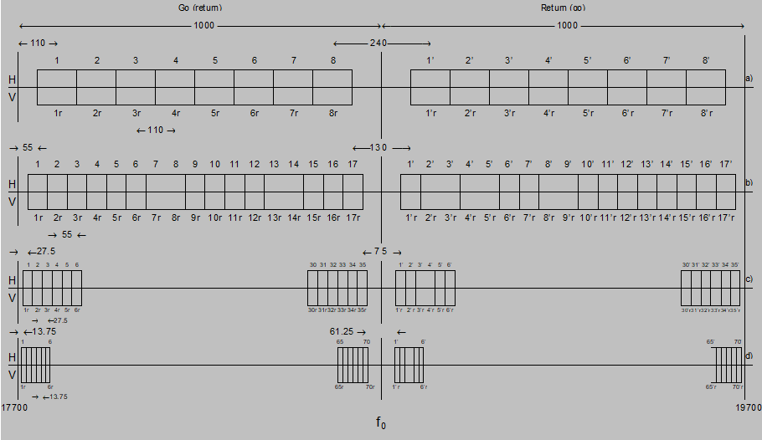
Figure 1: Radio frequency channel arrangement for digital-relay systems operating in the
17.7-19.7 GHz band
(Co-channel arrangement)
(All frequencies are in MHz)

- Channel Arrangement and identifiers for 220 MHz channels by merging 110 MHz channels
The 220 MHz channels (ref. recommends 3) can be identified by using the following numbering:

Let
F₀ be the reference frequency of 18700 MHz;
F_{N} be the centre frequency (MHz) of a radio frequency channel in the lower half of the band;
F_{N}’ be the centre frequency (MHz) of a radio frequency channel in the upper half of the band;
Duplex spacing = 1010 MHz,
Centre gap = 130 MHz

then the frequencies of individual channels are expressed by the following relationships:

Lower half of band: F_{N} = (F₀ - 945 + 110n) MHz
Upper half of band: F_{N}’ = (F₀ + 65 + 110n) MHz where: n = 1, 2, 3, …. 7

It is to be noted that the numbering is just for identification of the channelling. It should also be noted that two consecutive channel numbers cannot be used on the same physical link due to channels overlap. See figures below for channel arrangement example with identifiers.

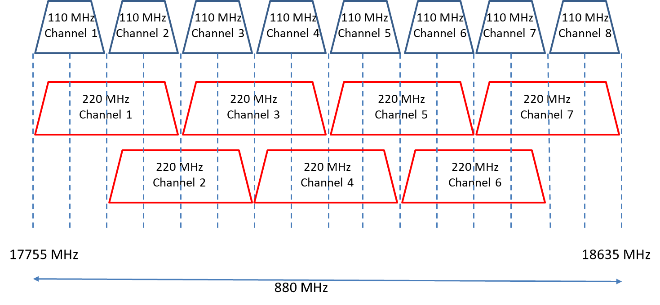
Figure 2: Channel arrangement and identifiers with channel width of 220 MHz (lower half of band)

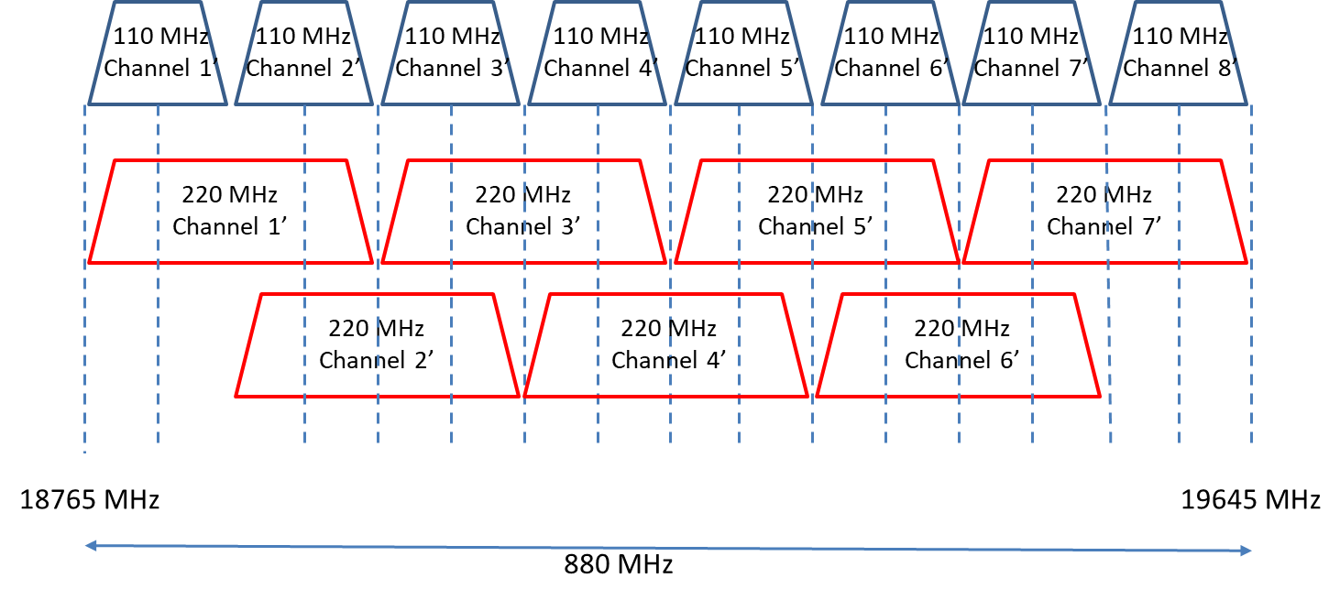
Figure 3: Channel arrangement and identifiers with channel width of 220 MHz (upper half of band)

