Compatibility between RMR and MFCN in the 900 MHz range, the 1900-1920 MHz band and the 2290-2300 MHz band
approved 3 July 2020
ECC Report 318

Executive summary
This ECC Report studies the compatibility of Railway Mobile Radio (RMR) with Mobile and Fixed Communication Networks (MFCN) as part of the answer to the mandate from the European Commission on FRMCS [1]. This includes a BEM for RMR BS in 874.4-880 MHz/919.4-925 MHz in order to coexist with MFCN BS and the impact of FRMCS high-power UE on MFCN BS in three frequency bands: 874.4-880 MHz/919.4-925 MHz, 1900-1910 MHz and 2290-2300 MHz.
The following cases are studied:
- Compatibility of RMR with MFCN in the 900 MHz range;
Impact of RMR BS in 919.4-925 MHz on MFCN BS receiving below 915 MHz;
Impact of FRMCS high-power UE in 874.4-880 MHz on MFCN BS receiving above 880 MHz.
- Compatibility of FRMCS in part of 1900-1920 MHz with MFCN;
Impact of FRMCS BS on MFCN BS receiving above 1920 MHz;
Impact of FRMCS high-power UE on MFCN BS receiving above 1920 MHz.
- Compatibility of FRMCS in 2290-2400 MHz with MFCN;
Suitability of existing BEM as per ECC Decision (14)02 [2];
Impact of FRMCS high-power UE on adjacent MFCN BS.
The impact of possible interference from FRMCS BS and the high-power cab radio operating in the 900 MHz, 1900 MHz and 2290 MHz band on the MFCN UEs has not been analysed in this Report.
Only non-AAS FRMCS and non-AAS MFCN systems have been considered. Additional studies should be performed in case AAS systems are considered for FRMCS in the 1900-1910 MHz band. The protection of MFCN 5G/NR with AAS BS above 1920 MHz was not studied in this Report. Further analysis of the interference impact of FRMCS on MFCN AAS systems may be required.
As described in CEPT Report 19 [3], the BEM is developed on the basis that detailed coordination and cooperation agreements would not be required to be in place prior to network deployment. The BEM for the transmitter emissions would not avoid all interference that might arise in certain deployment scenarios, including for some configurations at shared base station sites or between nearby base station sites. In these situations, mobile network operators and RMR operators of both systems may have to coordinate, and the use of additional interference mitigation techniques might be considered.

BEM derivation at 900 MHz
In order to derive a BEM for RMR BS, a reference MCL has to be defined. For this purpose, two MCL calculation approaches have been considered: one based on 100 m separation distance between BS and one based on statistics relying on existing GSM-R and MFCN deployment data in France, Germany and Sweden. The statistical approach appears to be of particular relevance when the two systems under study exhibit significant differences in their deployment patterns, notably as a result of different coverage targets. In particular, railway coverage is largely focused along railway tracks and railway premises following curvilinear geometries whereas public networks focus on optimised area-based coverage of population concentrations. In some countries, MFCN BS along some railway tracks provide in-train coverage and these sites are considered in the statistical calculations.
The 100 m based MCL calculation leads to a reference MCL of 57.2 dB. The statistical calculation leads to a reference MCL of 68 dB. This reference coupling loss predicts that less than 7% of RMR sectors might face an MFCN neighbouring sector with less than 68 dB coupling loss. In practice, the number of RMR sectors is expected to be lower, considering that simulations have only taken EPM-73 propagation model into account, without any clutter, digital terrain model or building layer. Additionally, the statistical analysis shows that most occurrences of low coupling loss are located in urban areas whereas in practical terms the coupling loss is expected to be higher in most cases due to building and clutter losses. Solving the interference issue for the limited remaining cases not covered by the BEM should be addressed at national level when interference occurs. No additional mitigation due to the RMR activity factor has been taken into account in this Report.
The BEM based on the 57.2 dB reference MCL from the 100 m approach are provided in Table 14 for GSM-R BS and in Table 16 for FRMCS BS. Those BEM limits are expected to be overly stringent for efficient RMR spectrum usage since the specificities of RMR deployments would make the 100 m reference scenario occur in rare cases. As a consequence, the statistical approach is assumed to allow uncoordinated deployments whilst ensuring a suitably low occurrence probability of worse cases where the coexistence objective is exceeded. These remaining interference cases should be solved at national level.
The BEM based on the statistical approach are provided in Table 15 for GSM-R BS and in Table 17 for FRMCS BS. These BEM are expected to enable deployments based on existing GSM-R sites in several scenarios. There are situations where it might still be desirable to enable a higher RMR BS e.i.r.p. as long as no MFCN BS would be desensitised by more than 1 dB. When the RMR operator wishes to operate an RMR BS with a higher e.i.r.p., they can use a given formula with respect to each MFCN BS in the vicinity of the RMR radio site (see section 4.1.4), as part of a national coordination procedure.

BEM derivation at 1900 MHz
This report looks at LRTC for operation of FRMCS in 1900-1910 MHz. The 100 metre MCL calculation approach and the statistical approach, assuming a MFCN BS selectivity as per CEPT Report 39 [4], result in LRTC requiring in-block e.i.r.p. limit for FRMCS BS of 40.7 dBm/10 MHz and 50.7 dBm/10 MHz respectively. However, the report also considers the operation of FRMCS in that band with macro coverage. This requires an in-block e.i.r.p. of 65 dBm/10 MHz for FRMCS BS and leads to a BEM as specified in Table 20. It may result in interference to some MFCN BS located near an FRMCS radio site.
With the current level of selectivity of MFCN base stations, those LRTC for FRMCS may result in interference to some MFCN base stations located near FRMCS BS sites. One way of addressing this interference is to coordinate FRMCS and MFCN deployments. However, this means that RMR operators may not be able to use 65 dBm at certain locations. If 65 dBm e.i.r.p. uncoordinated FRMCS base stations is desired, then these MFCN BS may need to be adapted when an FRMCS BS is rolled out in its proximity, so that it does not suffer interference from FRMCS.
Additional mitigation techniques need to be implemented on a case-by-case basis, such as adjustments of antenna directivity, azimuth, tilt, or improve the selectivity of the MFCN BS in the vicinity of the railway tracks. Table 23 shows this enhanced selectivity.
The technical feasibility for receiver selectivity enhancement for MFCN AAS BS may not be achievable due to design constraints. These high selectivity requirements might hinder the migration of MFCN networks to 5G/NR with AAS BS, however studies need to be carried out.
In order to ensure that the MFCN operators have enough time to adapt the relevant radio sites, the RMR operator is required to perform an early notification procedure in advance of the rollout of a new FRMCS BS.
The impact of possible interference from FRMCS BS and the high-power cab radio operating in the 1900 MHz band on the MFCN UEs has not been analysed in this Report.

BEM derivation at 2290 MHz
The BEM specified in Annex 2 of ECC Decision (14)02 [2] are considered valid in the case of FRMCS BS operating in 2290-2300 MHz. Conversely, LSA would not apply to FRMCS due to its permanent nature in terms of location, operation and availability requirements.
Moreover, the issue of TDD cross-network synchronisation arises since FRMCS in the 2290-2300 MHz band falls within the in-band blocking domain of LTE band #40. Both unsynchronised operation and synchronised operation raise specific concerns, the former with regards to filtering or separation distances, and the latter with regards to its performance impact (latency, UL/DL ratio, cell range, etc.).

High-power cab-radio
For both 900 MHz and 1900 MHz bands, Monte Carlo studies based on SEAMCAT have been conducted and show that the interference from FRMCS cab-radio of 31 dBm output power to MFCN uplink is acceptable when uplink power-control is implemented and activated and with unwanted emissions as described in Annex 10.
Annex 9 provides a worst-case analysis based on an MCL calculation for the case without FRMCS cab-radio uplink power control. It concludes that this could result in harmful interferences unless unwanted emissions from cab-radio would be reduced to -53 dBm/MHz in the 880-915 MHz and 1920-1980 MHz frequency ranges.
FRMCS cab-radios shall therefore implement and activate uplink power control in the 900 MHz and 1900 MHz band. FRMCS high-power cab-radios are not permitted to operate without uplink power control.
Coexistence between MFCN in 2300-2400 MHz band and FRMCS high-power cab-radios in 2290-2300 MHz band has not been covered in this study.

TABLE OF CONTENTS

0 Executive summary 2
0.1 BEM derivation at 900 MHz 2
0.2 BEM derivation at 1900 MHz 3
0.3 BEM derivation at 2290 MHz 3
0.4 High-power cab-radio 4
1 Introduction 9
2 Technical parameters and scenarios 10
2.1 RMR technical parameters 10
2.1.1 Generic RMR technical parameters 10
2.1.2 GSM-R technical parameters 11
2.1.3 LTE/NR FRMCS technical parameters 12
2.2 MFCN technical parameters 13
2.2.1 LTE/NR technical parameters 13
2.2.2 Duplexer filtering in 915-925 MHz 15
2.2.3 Consolidated selectivity including the duplexer effect 16
2.3 Scenarios 18
2.3.1 BS to BS interference 18
2.3.2 High-power cab-radio to BS interference 18
2.4 BS to BS Propagation model 18
3 Methodologies 20
3.1 BEM methodology 20
3.2 Method #1: 100 m based MCL calculation approach 21
3.2.1 MCL calculation 21
3.3 Method #1bis: 100 m based MCL calculation approach with horizontal discrimination 22
3.4 Method #2: Statistical approach 24
3.4.1 Inputs for the statistical approach 24
3.4.1.1 Basic input data – geometrical characteristics 24
3.4.1.2 Additional input data – antenna characteristics 24
3.4.1.3 Additional input data – digital terrain model 25
3.4.1.4 Additional input data – rural/suburban/urban geographical classification 25
3.4.2 High-level, methodology description 25
3.4.3 Determination of the coexistence scenarios 26
3.4.3.1 Determination of the sites to be studied for a given aggressor system 26
3.4.3.2 Determination of the antenna to antenna coexistence scenarios 27
3.4.4 Determination of the antenna to antenna coupling 29
3.4.5 Additional considerations 30
3.4.5.1 Considerations on antenna models 30
3.4.5.2 Considerations on propagation models 31
4 Compatibility of RMR with MFCN in the 900 MHz range 33
4.1 Impact of RMR BS in 919.4-925 MHz on MFCN BS receiving below 915 MHz 33
4.1.1 MCL at 900 MHz 33
4.1.1.1 Method #1: 100 m based MCL calculation approach 33
4.1.1.2 Method #2: Statistical approach 33
4.1.2 Possible LRTC for GSM-R BS 36
4.1.2.1 Method #1: 100 m based MCL calculation approach 36
4.1.2.2 Method #2: Statistical approach 37
4.1.3 Possible LRTC for wideband RMR BS (FRMCS) 38
4.1.3.1 Method #1: 100 m based BEM approach 38
4.1.3.2 Method #2: Statistical approach 39
4.1.4 Maximum RMR signal level at MFCN BS location 40
4.1.5 Summary 41
4.2 Feasibility of FRMCS high-power cab-radio in 874.4-880 MHz 41
4.2.1 Monte Carlo simulation and MCL analysis 41
5 Compatibility of FRMCS in 1900-1910 MHz with MFCN 42
5.1 Impact of FRMCS BS in 1900-1910 MHz on MFCN BS receiving above 1920 MHz 42
5.1.1 MCL at 1900 MHz 42
5.1.1.1 Method #1: 100 m based MCL calculation approach 42
5.1.1.2 Method #2: Statistical approach 42
5.1.2 Possible LRTC for wideband RMR BS (FRMCS) based on MFCN BS selectivity as per CEPT Report 39 43
5.1.2.1 Method #1: 100 m based MCL calculation approach 43
5.1.2.2 Method #2: Statistical approach 44
5.1.3 Possible LRTC for wideband RMR BS without in-block restriction subject to changes to MFCN BS selectivity 44
5.1.3.1 Desired LRTC for wideband RMR BS 44
5.1.3.2 Changes induced by the 100 m based MCL calculation approach 44
5.1.3.3 Changes induced by the statistical approach 45
5.1.3.4 Further assessment of induced changes based on statistics 45
5.1.4 Summary 46
5.2 Feasibility of FRMCS high-power cab-radio in 1900-1910 MHz 46
5.2.1 Monte Carlo simulation and MCL analysis 47
6 Compatibility of FRMCS in 2290-2300 MHz with MFCN 48
6.1 Suitability of existing BEM as per ECC Decision (14)02 48
6.2 Feasibility of FRMCS high-power cab-radio in 2290-2300 MHz 50
7 Conclusions 51
7.1 BEM derivation at 900 MHz 51
7.2 BEM derivation at 1900 MHz 52
7.3 BEM derivation at 2290 MHz 52
7.4 High-power cab-radio 52
ANNEX 1: Consideration on the location of the victim MFCN channel 53
ANNEX 2: Inputs for the statistical approach – ANFR’s study 56
ANNEX 3: Statistical approach – France data 74
ANNEX 4: Statistical approach – Sweden data 80
ANNEX 5: German study of RMR-MFCN coexistence in railway environment 84
ANNEX 6: FRMCS-MFCN Interference configuration at 900 MHz – Bordeaux study 98
ANNEX 7: Analysis of separation distance between FRMCS BS and MFCN BS at 900 MHz 111
ANNEX 8: Additional receiver filtering for MFCN BS 116
ANNEX 9: Uplink MCL calculation 117
ANNEX 10: Uplink simulations of the impact of FRMCS cab-radio on MFCN BS 118
ANNEX 11: List of References 120

LIST OF ABBREVIATIONS

Abbreviation | Explanation
3GPP | 3rd Generation Partnership Project
ACLR | Adjacent Channel Leakage power Ratio
ACS | Adjacent Channel Selectivity
AGL | Above Ground Level
ASL | Above Sea Level
BEM | Block Edge Mask
BS | Base Station
CDF | Cumulative Distribution Function
CEPT | European Conference of Postal and Telecommunications Administrations
CL | Coupling loss
DL | Downlink
DTM | Digital Terrain Model
EC | European Commission
ECC | Electronic Communications Committee
ECO | European Communications Office
EDGE | Enhanced Data rates for GSM Evolution
E-GSM | Extended GSM (880-915 MHz / 925-960 MHz)
EIRENE | European Integrated Railway Radio Enhanced Network
e.i.r.p. | equivalent isotropic radiated power
EPM | Empirical Propagation Model (e.g. EPM-73)
ETCS | European Train Control System
ETSI | European Telecommunications Standards Institute
E-UTRA | Evolved Universal Terrestrial Radio Access
FDD | Frequency Division Duplex
FRMCS | Future Railway Mobile Communication System
GSM | Global System for Mobile communications
GSM-R | GSM for Railway
HS | Harmonised Standard
LRTC | Least Restrictive Technical Conditions
LSA | Licensed Shared Access
LTE | Long Term Evolution
MCL | Minimum Coupling Loss
MFCN | Mobile and Fixed Communication Networks
MFCN 900 | Mobile and Fixed Communication Network operating in 900 MHz band
MFCN 915 | Mobile and Fixed Communication Network operating in the 915 MHz band
MIMO | Multiple Input Multiple Output
MSR | Multi-Standard Radio
NDA | Non-Disclosure Agreement
NR | New Radio
OOB | Out-of-Band
PL | Path Loss
PPDR | Public Protection Disaster Relief
RB | Resource Block
REC | Railway Emergency Call
RF | Radio Frequency
RMR | Railway Mobile Radio
RRU | Remote Radio Unit
SEAMCAT | Spectrum Engineering Advanced Monte Carlo Analysis Tool
SQL | Structured Query Language
TDD | Time Division Duplex
TR | Technical Report
TS | Technical Specification
UE | User Equipment
UL | Uplink
UMTS | Universal Mobile Telecommunications System
VHF | Very High Frequency
WAPECS | Wireless Access Policy for Electronic Communications Services

Introduction
This ECC Report studies the compatibility of Railway Mobile Radio (RMR) with Mobile and Fixed Communication Networks (MFCN) as part of the answer to the Mandate from the European Commission on Future Railway Mobile Communication System (FRMCS) [1].
The following cases are studied:
- Compatibility of RMR with MFCN in the 900 MHz range;
Impact of RMR BS in 919.4-925 MHz on MFCN BS receiving below 915 MHz;
Impact of FRMCS high-power UE in 874.4-880 MHz on MFCN BS receiving above 880 MHz.
- Compatibility of FRMCS in part of 1900-1920 MHz with MFCN;
Impact of FRMCS BS on MFCN BS receiving above 1920 MHz;
Impact of FRMCS high-power UE on MFCN BS receiving above 1920 MHz.
- Compatibility of FRMCS in 2290-2400 MHz with MFCN;
Suitability of existing BEM as per ECC Decision (14)02 [2];
Impact of FRMCS high-power UE on adjacent MFCN BS.
The impact of possible interference from FRMCS BS and the high-power cab-radio on the MFCN UEs operating in the 900 MHz band has not been analysed in this Report.
The impact of possible interference between FRMCS and PPDR in 1900-1910 MHz band has not been studied in this Report.
With regards to the 900 MHz range, the EC Mandate limits the studies to the 874.4-880 MHz / 919.4-925 MHz frequency band and indicates that simultaneous operation of GSM-R and its successor during the migration period within the whole 5.6 MHz duplex should be made possible. Further, CEPT plans to give flexibility to railways to roll out GSM-R and FRMCS carriers anywhere in the 874.4-880 MHz / 919.4-925 MHz band, including in-band scenario and/or adjacent channel arrangement.
The EC Mandate also lists the 1900-1920 MHz frequency band as a band to be investigated. This is in line with ECC Report 294 [5] which concludes that “access to complementary spectrum, e.g. 10 MHz in 1900-1920 MHz, is a prerequisite for many countries in order to manage the migration with dual networks operating in parallel” and that “after the migration, the complementary band(s) will still be required in order to cover railway’s long-term needs (including critical sensing/video), border and hotspot areas”. In that band, only the successor to GSM-R is foreseen.
Based on the EC Mandate also the band 2290-2400 MHz has been investigated as an alternative to the 1900-1920 MHz frequency band for the successor of GSM-R. However, no detailed analysis has been performed for this band as for the 900 MHz range and the 1900 MHz range.
Due to the expected increase in critical railway communication demands because of the growth of passenger and freight transport, reduction of greenhouse gas emissions, further implementation of European Train Control System (ETCS) and the expected automation of railways, the successor to GSM-R is essential.
This Report also investigates the feasibility of an FRMCS cab-radio having an output power of up to 31 dBm, noting that current GSM-R cab-radios can already transmit up to 39 dBm output power without UL power control in the 900 MHz range.

Technical parameters and scenarios

RMR technical parameters
All values not related to specifications are typical values provided by the industry.
In this Report, only non-AAS FRMCS systems have been considered. Additional studies should be performed in case AAS systems are considered for FRMCS deployments.

Generic RMR technical parameters
Table 1: RMR BS characteristics
Parameter | Value | Comment
Antenna | Recommendation ITU-R F.1336-5 [6],  ‘recommends 3.1.1’ for peak side lobes  k_{p} = 0.7 – k_{h} = 0.7 – k_{υ} = 0.3
3 dB opening angle  in the azimuth plane | 65°
3 dB opening angle  in the elevation plane | 8.5° | KATHREIN 80010305v02
Tilt | -2°
Feeder and coupling losses | 4 dB
Table 2: RMR cab-radio characteristics
Parameter | Value | Comment
Antenna | HUBER+SUHNER 1399.99.0121 | Note 1
Antenna height | 4m
Maximum antenna gain | 5 dBi | At 30° elevation
HW losses | 3 dB
Polarisation | Vertical
Note 1: In the horizontal plane, the cab-radio antenna pattern can be considered as omnidirectional. In the vertical plane, the cab-radio antenna pattern is as follows.

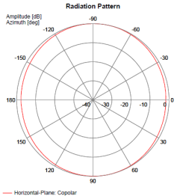
Figure 1: Cab-radio horizontal antenna pattern at 880 MHz

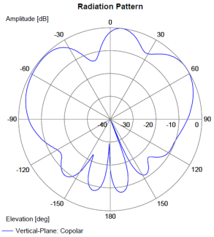
Figure 2: Cab-radio vertical antenna pattern at 880 MHz

GSM-R technical parameters
This set of parameters are applicable to the frequency band 874.4-880 MHz (UL)/919.4-925 MHz (DL).
Table 3: GSM-R BS characteristics
Parameter | Value  900 MHz range | Reference
Channel spacing and bandwidth | 200 kHz | ETSI TS 145 005 [7]  ETSI TS 102 932 [8]
Maximum antenna gain | 17 dBi
Table 4: GSM-R 8W cab-radio characteristics
Parameter | Value  900 MHz range | Reference
Channel spacing and bandwidth | 200 kHz | ETSI TS 145 005 [7]  ETSI TS 102 932 [8]
Maximum output power | 39 dBm without UL power control | ETSI TS 145 005 [7]
Maximum e.i.r.p. | 41 dBm without UL power control

LTE/NR FRMCS technical parameters
This set of parameters is applicable to the frequency bands 874.4-880 MHz (UL)/919.4-925 MHz (DL) and 1900-1910 MHz.
Table 5: LTE/NR FRMCS BS characteristics
Parameter | FRMCS BS  900 MHz range | FRMCS BS  1900 MHz range | Reference
Channel bandwidth | LTE: 1.4 or 5 MHz  NR: 5 MHz | 10 MHz | ETSI TS 137 104 [9]
Channel bandwidth | NR: 5.6 MHz |  | Note
Occupied bandwidth | LTE: 1.08 or 4.5 MHz  NR: 4.5 MHz | 9 MHz | ETSI TS 137 104 [9]
Occupied bandwidth | NR: 5.04 MHz |  | Note
Maximum antenna gain | 17 dBi | 18 dBi
ACLR | 45 dB | 45 dB | ETSI TS 137 104 [9]
Note: The 5.6 MHz channel bandwidth is considering a transmission bandwidth of 28 RB between 919.6725 and 924.7125 MHz, reflecting a possible 5.6 MHz NR channel. This is understood to be compatible with NR lower layers, subject to additional standardisation work, as necessary, to confirm and further specify this.
For FRMCS BS, the spectrum emission mask considered is specified at the antenna connector in ETSI TS 137 104 [9] Tables 6.6.2.2-1 and 6.6.2.2-2 for the 900 MHz range and in Table 6.6.2.1-1 for the 1900 MHz range.
Table 6: LTE/NR FRMCS high-power cab-radio characteristics
Parameter | FRMCS BS  900 MHz range | FRMCS BS  1900 MHz range |  | Reference
Channel bandwidth | LTE: 1.4 or 5 MHz  NR: 5 MHz | 10 MHz | ETSI TS 136 101 [10]  ETSI TS 138 101-1 [11]
Channel bandwidth | NR: 5.6 MHz |  | Note
Occupied bandwidth | LTE: 1.08 or 4.5 MHz  NR: 4.5 MHz | LTE: 9 MHz  NR: 9.36 MHz | ETSI TS 136 101 [10]  ETSI TS 138 101-1 [11]
Occupied bandwidth | NR: 5.04 MHz |  | Note
Maximum output power | 31 dBm with UL power control |  | Railway industry’s request
Maximum e.i.r.p. | 33 dBm with UL power control
ACLR | 37 dB |  | ETSI TS 136 101 [10]  Power Class 1
Note: The 5.6 MHz channel bandwidth is considering a transmission bandwidth of 28 RB between 919.6725 and 924.7125 MHz, reflecting a possible 5.6 MHz NR channel. This is understood to be compatible with NR lower layers, subject to additional standardisation work, as necessary, to confirm and further specify this.

MFCN technical parameters

LTE/NR technical parameters
Since both UMTS (or occasionally LTE) and GSM are simultaneously operated in the 900 MHz range band, Multi-Standard Radio base stations (MSR BS) as per ETSI TS 137 104 [9] are taken as working assumption in this Report. For MFCN BS operating in the 2 GHz band, CEPT Report 39, table 6 [4] is taken as working assumption for the selectivity in the 1900-1920 MHz band.
In addition, in the 1900-1920 MHz band, FRMCS is only considered in 1900-1910 MHz where the MFCN BS blocking level is better.
In this Report, only non-AAS MFCN systems have been considered. Additional studies should be performed in case AAS systems are considered for MFCN deployments.
Table 7: MFCN BS characteristics
Parameter | MFCN BS  in 910-915 MHz |  | MFCN BS  in 1920-1930 MHz | Reference
Channel bandwidth |  | 5 MHz | 10 MHz
Occupied bandwidth |  | 4.5 MHz | 4.5 MHz | Fixed reference channel of 25 RB, see section 7.2 in:  ETSI TS 136 104 [12]  ETSI TS 138 104 [13]
Antenna |  | Recommendation ITU-R F.1336-5 [6],  ‘recommends 3.1.1’ for peak side lobes  k_{p} = 0.7 – k_{h} = 0.7 – k_{υ} = 0.3
3 dB opening angle in the azimuth plane |  | 65° | 65° | Report ITU-R M.2292-0 [14]
Maximum antenna gain |  | Rural: 18 dBi  Suburban &  Urban: 15 dBi * | 18 dBi * | Report ITU-R M.2292-0  See also ECC Reports 82 [15] and 96 [16] for rural antenna gain at 900 MHz
Polarisation |  | linear +45°/-45° | linear +45°/-45° | Report ITU-R M.2292-0 [14]
Tilt |  | Rural &  Suburban:  -3° *  Urban: -6° | Rural: -3° *  Suburban: -6°  Urban: -10°
Feeder loss |  | 3 dB |  | Report ITU-R M.2292-0 [14]
Noise figure |  | 5 dB |  | 3GPP TR 36.824 [17]  Report ITU-R M.2292-0 [14]
Reference sensitivity |  | LTE: -101.5 dBm  NR: -101.7 dBm |  | ETSI TS 136 104 [12]  ETSI TS 138 104 [13]  (section 7.2)
3GPP desensitisation |  | 6 dB |  | ETSI TS 137 104 [9]
Associated  blocking level |  | -49 dBm | not used | Table 7.4.2-1, in the first  adjacent 5 MHz
 |  | -40 dBm (Note A) | not used | Table 7.4.1-1, beyond
Selectivity |  | 48.7 dB | not used | in the first adjacent 5 MHz⁹
 |  | 57.7 dB | 61.24 dB  in 1910-1915 MHz  71.24 dB  in 1905-1910 MHz  84.24 dB  in 1900-1905 MHz | beyond¹⁰  See CEPT Report 39, Table 6 (Note B) [4]
Target desensitisation |  | 1 dB
* values used in the 100 m based BEM approach, as well as in the statistical approach when no field data is available.
Note A: Beyond the first adjacent 5 MHz, the blocking level specified by ETSI in TS 137 104 v15.3.0 [9] onwards for NR-based MFCN BS is -43 dBm, which is a 3 dB degradation compared to -40 dBm for UMTS/LTE. However, it is considered that new NR BS have to fit into the existing radio environment to comply with the efficient use of spectrum. Hence only the -40 dBm blocking level is considered in this Report.
Note B: Typical values for FDD BS total receiver selectivity (including RF selectivity and duplex filter attenuation) provided by one manufacturer and derived from measurements
Table 8: MFCN UE characteristics
Parameter | MFCN UE  in 910-915 MHz | MFCN UE  in 1920-1930 MHz | Reference
Channel bandwidth | 5 MHz | 10 MHz
Occupied bandwidth | 4.5 MHz | 9 MHz
Antenna gain | -3 dBi |  | Report ITU-R M.2292-0 [14]
Noise figure | 9 dB |  | 3GPP TR 36.824 [17]  Report ITU-R M.2292-0 [14]
Reference sensitivity | -97 dBm | -96.8 dBm | ETSI TS 136 101 [10]  ETSI TS 138 101-1 [11]

Duplexer filtering in 915-925 MHz
RMR BS are within the duplex gap of the E-GSM band, i.e. 915-925 MHz. Therefore, the effect of the MFCN BS duplexer in terms of filtering should be taken into account. An additional filtering of 80 dB/(6 MHz) from 918 MHz to 924 MHz is considered.
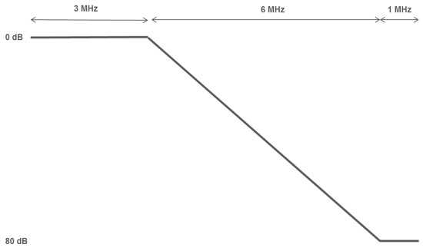
Figure 3: Duplex filter considered in 915-925 MHz
When combining the selectivity and the duplexer filtering, the reception mask to be considered in the studies for an MFCN MSR BS operating in the channel 910-915 MHz is as follows. For the purpose of this study, the wideband blocking level requirement has been shifted down to 919.6 MHz (instead of 920 MHz). The assumed shift is only valid for this Report; it cannot be reused for the 900 MHz band in another context nor extended to another MFCN operating band.
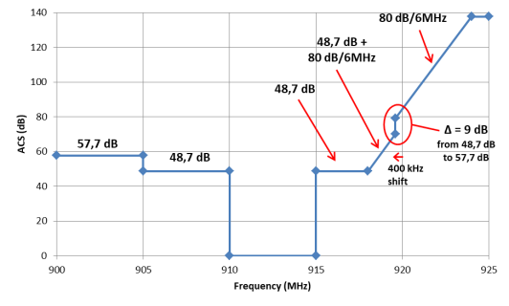
Figure 4: MFCN BS receiver mask, including duplexer effect above 915 MHz

Consolidated selectivity including the duplexer effect
The following methodology is applied to determine the consolidated blocking level of an MFCN BS, taking into account the duplexer filtering. This was already described in ECC Report 162 [18].
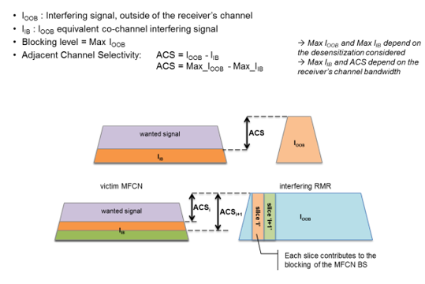
Figure 5: Methodology to determine blocking levels of an MFCN BS
 | $$I_{slice}=I_{OOB}+10\log_{10}\left(\frac{0.18}{BW}\right)$$ | (1)

 | $$ACS_{i}=ACS_@918MHz+\left(f_{i}-918\right)×\left(80/6\right)$$ | (2)

 | $$I_{IB}=10\log_{10}\left(\sum_{i}{{10}^{\frac{I_{slice}-ACS_{i}}{10}} }\right)$$ | (3)

 | $$\sum_{i}{{10}^{\frac{I_{slice}-ACS_{i}}{10}} }={10}^{\frac{I_{slice}}{10}}×\sum_{i}{{10}^{\frac{-ACS_{i}}{10}} }$$ | (4)

 | $$I_{IB}=I_{slice}+10\log_{10}\left(\sum_{i}{{10}^{\frac{-ACS_{i}}{10}} }\right)$$ | (5)
- $I_{slice}$ in dBm/(180 kHz);
- $I_{OOB}$ in dBm/channel.

 | $${ACS}_{global}=-10\log_{10}\left(\sum_{i}{{10}^{\frac{-ACS_{i}}{10}} }\right)-10\log_{10}\left(\frac{0.18}{BW}\right)$$ | (6)

From that method, the MFCN BS selectivity can be calculated.
Table 9: 900 MHz MFCN BS selectivity including the duplexer effect
Interferer | Centre frequency | Selectivity value
1.4 MHz LTE in 919.5-920.9 MHz | 920.2 MHz | 85.3 dB
1.4 MHz LTE | N/A | slope of 80 dB/(6 MHz)
1.4 MHz LTE in 921.0-922.4 MHz | 921.7 MHz | 105.3 dB
5 MHz LTE/NR in 919.4-924.4 MHz | 921.9 MHz | 91.2 dB
5 MHz LTE/NR in 919.5-924.5 MHz | 922.0 MHz | 92.5 dB
5 MHz LTE/NR in 919.6-924.6 MHz | 922.1 MHz | 93.8 dB
5 MHz LTE/NR in 919.7-924.7 MHz | 922.2 MHz | 95.2 dB
5 MHz LTE/NR in 919.8-924.8 MHz | 922.3 MHz | 96.5 dB
5 MHz LTE/NR in 919.9-924.9 MHz | 922.4 MHz | 97.8 dB
5 MHz LTE/NR in 920-925 MHz | 922.5 MHz | 99.2 dB
5.6 MHz NR in 919.4-925 MHz (Note) | 922.2 MHz | 92 dB
Note: The 5.6 MHz channel bandwidth is considering a transmission bandwidth of 28 RB between 919.6725 and 924.7125 MHz, reflecting a possible 5.6 MHz NR channel. This is understood to be compatible with NR lower layers, subject to additional standardisation work, as necessary, to confirm and further specify this.
CEPT noted that to avoid the narrowband blocking effect of the wideband system receivers by the adjacent NB systems, a 200 kHz frequency separation is required between the NB system channel edge and the WB system channel edge. A frequency separation of 200 kHz or more is also needed between channel edges of different NB systems. This will be further addressed by regulatory measures at the national level, consistently with the relevant FRMCS and MFCN harmonised technical and regulatory conditions.
Table 10: 2 GHz MFCN BS selectivity including the duplexer effect
Interferer | Centre frequency | Selectivity value
10 MHz LTE/NR in 1900-1910 MHz | 1905 MHz | 74 dB (CEPT Report 39 [4])

Scenarios

BS to BS interference
Scenario: impact of an RMR BS transmitting in 919.4-925 MHz on an MFCN BS receiving below 915 MHz
Type: above rooftops
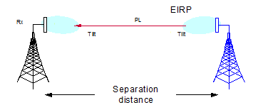
Figure 6: RMR BS to MFCN BS interference scenario

High-power cab-radio to BS interference
Scenario: impact of a cab-radio with an output power of 31 dBm and UL power control transmitting in 874.4-880 MHz on an MFCN BS receiving above 880 MHz

BS to BS Propagation model
In this Report, an adaptation of the EPM-73 propagation model [19] is used. EPM-73 is a LoS model applicable to “above rooftops” scenarios, to the frequency range 40 MHz to 10 GHz and for distances higher than 500 m. Below 100 m, the free space propagation model is considered. Between 100 m and 500 m, a linear slope between the two models is assumed.
EPM-73 considers two break points. The lower one is d₁ defined in kilometres as follows:
 | d₁ = 1.1×h₁×h₂×f/3.47×10⁵ | (7)
where h₁ and h₂ are the BS antenna heights in metres and f is the frequency in MHz.
Table 11: EPM-73’s first break point calculation
 | Urban | Rural
h₁ (RMR) | 20 m | 35 m
h₂ (MFCN) | 30 m | 45 m
d₁ at 920 MHz | 1.75 km | 4.6 km
d₁ at 1900 MHz | 3.6 km | 9.5 km
The distances considered between RMR BS and MFCN BS are in both cases, urban and rural, lower than d₁. Thus, the following formula applies for the path loss.
At 920 MHz:
 | $$d≤0.1 km{PL}_{920MHz}\left(d,f\right)={PL}_{freespace}\left(d,f\right) \\ 0.1 km<d≤0.5 km{PL}_{920MHz}\left(d,f\right)={PL}_{freespace}\left(d,f\right)+\left[\frac{d_{km} - 0.1}{0.4}\right]×2.5 \\ 0.5 km<d{PL}_{920MHz}\left(d,f\right)={PL}_{freespace}\left(d,f\right)+2.5$$ | (8)
At 1900 MHz14:
 | $$d≤0.1 km{PL}_{1900MHz}\left(d,f\right)={PL}_{freespace}\left(d,f\right) \\ 0.1 km<d≤0.5 km{PL}_{1900MHz}\left(d,f\right)={PL}_{freespace}\left(d,f\right)+\left[\frac{d_{km} - 0.1}{0.4}\right]×3.2 \\ 0.5 km<d{PL}_{1900MHz}\left(d,f\right)={PL}_{freespace}\left(d,f\right)+3.2$$ | (9)
Where:
 | $${PL}_{freespace}\left(d,f\right)=32.4+20\log_{10}\left(f_{MHz}\right)+20\log_{10}\left(d_{km}\right)$$ | (10)

Methodologies

BEM methodology
The least restrictive technical conditions (LRTC) derived for RMR BS are in the form of a block-edge mask (BEM). As explained in CEPT Report 19, annex IV [1], the BEM represents the minimum technical conditions necessary to control the level of interference from a transmitter into adjacent receivers, in this case from RMR BS into MFCN BS. It is developed on the basis that detailed coordination and cooperation agreements would not be required to be in place prior to network deployment. The BEM for the transmitter emissions would not avoid all interference that might arise in certain deployment scenarios, including for some configurations at shared base station sites or between nearby base station sites. In these situations, mobile network operators and railway operators may have to coordinate, and the use of additional interference mitigation techniques might be considered such as external receiver filtering.
The RMR BS BEM enables RMR deployment that does not rely on detailed coordination and cooperation arrangements between MFCN and RMR in neighbouring frequencies. The different components of a BEM are illustrated in the figure below.
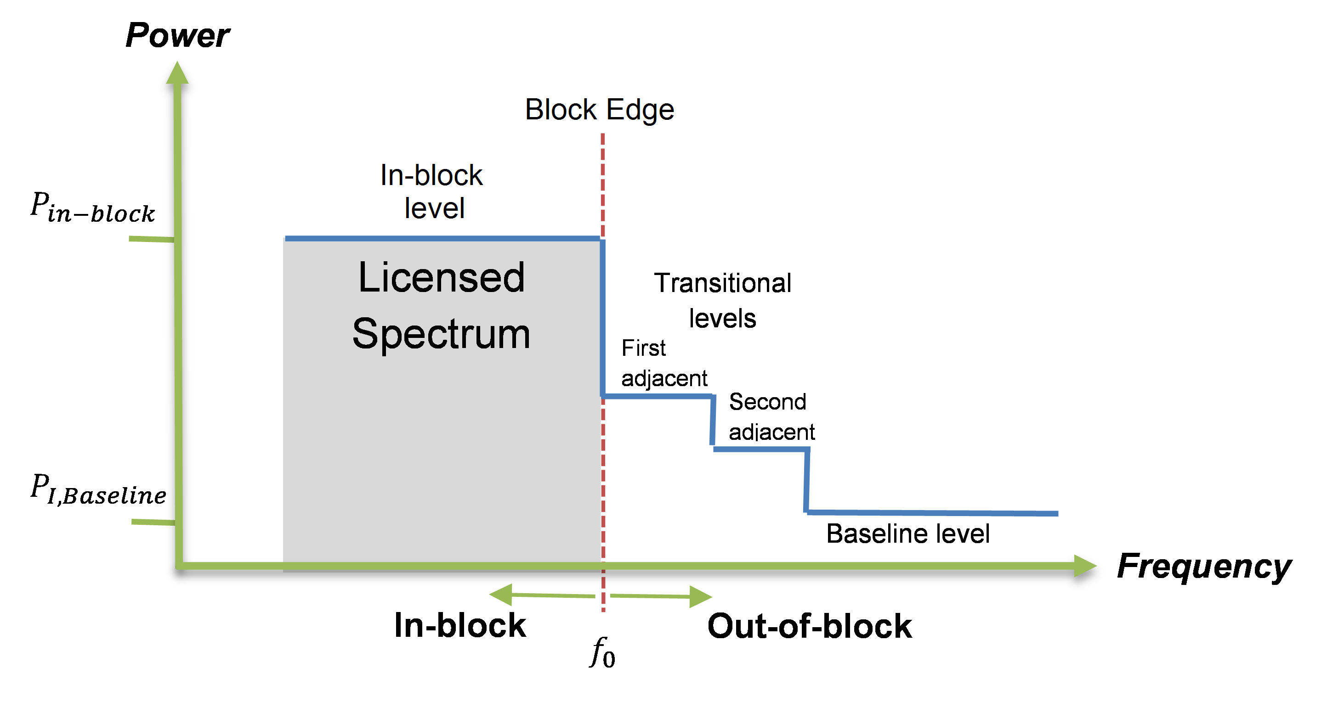
Figure 7: BEM illustration, example
The methodology for the BEM calculation is described hereafter.
The total permitted interference:
 | $$I_{IB}=N+10\log_{10}\left({10}^{\frac{D}{10}}-1\right)$$ | (11)
Where:
- I_{IB} is the total permitted interference at the antenna connector in dBm;
- D is the acceptable degradation in receiver sensitivity, or desensitization, in dB;
- N is the receiver thermal noise power in dBm.
The permitted in-block power:
This can be calculated from the total permitted interference power while knowing the interference power generated by the interferer outside its wanted channel.
 | $$I_{IB}=10\log_{10}\left[{10}^{\frac{{TxI}_{inblock}-CL-S_{inblock}}{10}}+\sum_{i}{{10}^{\frac{{TxI}_{OOBi}-CL-S_{OOBi}}{10}}}+{10}^{\frac{{TxI}_{spurious}-CL}{10}}\right]$$ | (12)
Where:
- TxI_{inblock} is the interferer in-block e.i.r.p. in dBm,
- TxI_{OOBi} is the interferer out-of-band e.i.r.p. in dBm (corresponding to the transitional levels),
- TxI_{spurious} is the interferer spurious e.i.r.p. in dBm falling in the victim wanted channel (corresponding to the baseline level),
- CL = MCL + G_{Rail} in dB,
- S_{inblock} is the victim selectivity in dB related to the in-block emissions from the interferer;
- S_{OOBi} is the victim selectivity in dB related to the out-of-band emissions from the interferer.
The transitional levels is calculated as Min {integration of the spectrum emission mask + G_{Rail} ; TxI_{inblock} – ACLR}. The baseline level fulfils the following formula:
 | $${TxI}_{spurious}-CL<I_{IB}$$ | (13)
Two approaches are used to determine the BEM for RMR BS:
- 100 m based MCL calculation approach without any horizontal discrimination;
- “statistical approach”, which is a refinement of the previous approach, providing a distribution of theoretical coupling losses based on existing locations, azimuths and altitudes of RMR and MFCN antennas.

Method #1: 100 m based MCL calculation approach
While aiming for spectrum efficiency and enabling RMR rollout in the 900 and 1900 MHz frequency ranges, protection of the existing and the future MFCN systems operating in the adjacent bands against harmful interference must be ensured. The methodology described below aims to provide the calculation of the Minimum Coupling Loss (MCL) which is a key parameter in the determination of the block-edge mask (BEM) for the operation of RMR base stations. It is assumed that these values would ensure coexistence for these two systems, under uncoordinated deployment, without considering them to be collocated. The approach used for the present MCL calculations is based on the BS-BS interference scenario, where the distance between an interferer and victim BS is 100 m, as shown in Annex 7.

MCL calculation
The MCL calculation is as follows:
 | $$MCL={PL}_{\left(f,d\right)}- G_{Rail}-G_{MFCN}+D_{Rail}+D_{MFCN}$$ | (14)
Where:
- ${PL}_{\left(f,d\right)}$ is the free space pathloss between the two base stations under consideration, operating in frequency $f$ with separation distance $d$.;
- $D_{Rail}$ is the RMR antenna vertical discrimination;
- $D_{MFCN}$ is the MFCN antenna vertical discrimination;
- $G_{Rail}$ is the RMR antenna gain (including feeder and coupling losses);
- $G_{MFCN}$ is the MFCN antenna gain (including feeder loss). No horizontal discrimination is taken into account.
The following MCL calculation is based on the technical parameters listed in sections 2.1 and 2.2.
Table 12: MCL calculation
RMR range | 919.4-925 MHz | 1900-1910 MHz | Reference
f | 920 MHz | 1905 MHz
d | 100 m | 100 m
RMR-MFCN height difference | 10 m | 10 m | typical (Note 1)
PL | 71.7 dB | 78.0 dB
G_{Rail} | 13 dBi | 14 dBi
G_{MFCN} | 12 dBi | 15 dBi
D_{Rail} | 10 dB | 11.5 dB | Recommendation ITU-R F.1336-5 [6] (Note 1)
D_{MFCN} | 0.5 dB | 2.5 dB | Recommendation ITU-R F.1336-5 [6] (Note 1)
MCL | 57.2 dB | 63 dB | (Note 1)
Note: If a 5 m height difference is assumed between RMR and MFCN antennas, D_{Rail} is 4 dB and DMFCN is 0 dB leading to an MCL of 50.7 dB at 920 MHz and 53 dB at 1905 MHz. Depending on the antenna height difference, a lower MCL may be achieved further away than 100 m.

Method #1bis: 100 m based MCL calculation approach with horizontal discrimination
Here is an example of how the antenna discrimination in the horizontal plane was calculated for the GSM-R BS in the urban scenario. It has been assumed that the GSM-R BS is near the railway track and the antenna points directly along the track, and not straight-forward towards a 900 MHz MFCN cellular-site. The minimum required distance between MFCN BS and RMR BS is assumed to be 100 meters, i.e. when the horizontal angle from RMR antenna beam to MFCN BS is 90 degrees. A discrimination of at least 8 dB from the GSM-R antenna can be obtained compared to the 100 m LoS. In the table below, it can be observed that the minimum discrimination is obtained between 35 and 40 degree angle towards the tracks. If the distance between RMR and MFCN base stations is increased from the minimum 100 metres, the gain is still 8 dB since the minimum angle becomes independent of absolute distance as long as simplified LoS path loss is used.
Existing antenna data has been considered when calculating the antenna discrimination for MFCN and RMR.
Figure 8: Path loss compensated with GSM-R horizontal beam offset
Assumptions/approximations:
- GSM-R site points along railway;
- Railway curve radius >> 100 m;
- 900 MHz MFCN cellular site may point towards GSM-R;
- 65 deg RMR antenna, KATHREIN 80010305V02 (-2 deg pattern at 902 MHz);
- Resolution: 5 deg.
Table 13: Path loss compensated with GSM-R horizontal beam offset
Horizontal angle rail to cellular site [deg] | Site distance [m] | Free space  loss [dB] | Gain reduction GSM-R ant due to azimuth offset [dB] | Path loss compensated with hor. beam offset [dB]
5 | 1147 | 92.9 | 0.08 | 93.0
10 | 576 | 86.9 | 0.3 | 87.2
15 | 386 | 83.5 | 0.66 | 84.1
20 | 292 | 81.0 | 1.15 | 82.2
25 | 237 | 79.2 | 1.79 | 81.0
30 | 200 | 77.7 | 2.55 | 80.3
35 | 174 | 76.5 | 3.41 | 80.0
40 | 156 | 75.6 | 4.44 | 80.0
45 | 141 | 74.7 | 5.57 | 80.3
50 | 131 | 74.0 | 6.79 | 80.8
55 | 122 | 73.5 | 8.13 | 81.6
60 | 115 | 73.0 | 9.55 | 82.5
65 | 110 | 72.6 | 11.09 | 83.7
70 | 106 | 72.3 | 12.73 | 85.0
75 | 104 | 72.0 | 14.39 | 86.4
80 | 102 | 71.9 | 16.1 | 88.0
85 | 100 | 71.8 | 17.91 | 89.7
90 | 100 | 71.7 | 19.68 | 91.4
Minimum difference between compensated path loss and 100 m free space path loss [dB]:
 | $$min\left({PL}_{Compensated horizontal beam offset}\right)-{PL}_{100-m} ≅8 dB$$ | (15)
Based on this model and assuming a 5 m height difference between RMR and MFCN BS, when taking into account the antenna discrimination in the horizontal plane, the MCL calculated in Table 12 can be increased by 8 dB.

Method #2: Statistical approach
Two MCL calculation approaches have been considered: one based on 100 m separation distance between BS and one based on statistics relying on existing GSM-R and MFCN deployment data in France, Germany and Sweden. This section describes the latter.
The spirit of the “statistical approach” is to use field data as close as possible to the existing deployment of the two systems under consideration in order to infer realistic coexistence conditions (such as distance between the two systems, horizontal and vertical discriminations between respective antenna systems, specific geometric configurations) for subsequent technical studies and notably to derive distributions of realistic coupling situations between systems.
Such a method appears of particular relevance when the two systems under study exhibit significant differences in their deployment patterns, notably as a result of different coverage targets. In particular, railway coverage is largely focused along railway tracks and railway premises following curvilinear geometries whereas public networks focus on optimised area-based coverage of population concentrations.
While homogeneous systems (such as two MFCN networks) aimed at covering similar areas (such as populations concentrations) may need to be studied with conditions, such as 100 m separation distance, representative of the homogeneity and density of their deployment, studies of heterogeneous systems (such as RMR and MFCN networks) would benefit from using more realistic coexistence conditions. This would more faithfully reflect field conditions and also enable prevention of overly restrictive coexistence conditions that could lead to inefficiencies of spectrum usage and of economical deployment of RMR system.

Inputs for the statistical approach

Basic input data – geometrical characteristics
For the coexistence of heterogeneous wireless systems deployed over wide geographical areas, the following data allows to determine realistic coexistence conditions between the systems:
- Geographical locations of the emission/reception points described by longitudes and latitudes and ideally complemented by site altitudes;
- Spatial orientations and geometric characteristics of the antennas described notably by antenna height above ground level (AGL), antenna azimuthal direction, elevation angle of the main lobe to the horizontal plane.
The aforementioned information allows for the calculation of key coexistence characteristics useful in the coexistence studies, notably the inter-site distance, the geographical bearings from one site to another as well as the elevation angles from an antenna emitting point to the antenna receiving point on the other site. From these characteristics can then be further inferred propagation path loss and antenna-to-antenna horizontal and vertical discriminations.
It shall be noted that the absence of site altitudes can be compensated by assuming a “flat-earth” model, albeit with some loss of accuracy in the output of the statistical approach.

Additional input data – antenna characteristics
The statistical approach requires the determination of the relative antenna gain in the direction of a far-field object, based on an antenna radiation pattern model (which can be resulting from tabulated data available from antenna suppliers or from reference radiation patterns formulas such as the ones available in Recommendation ITU-R F.1336 [6]), and the horizontal and vertical angular discrimination between the antenna boresight and the far-field object.
When available, specific antenna type and make can be used in order to calculate realistic relative gains in the direction of the far-field object. If not available, antenna characteristics (antenna gain, 3 dB beamwidth in the azimuth plane, 3 dB beamwidth in the elevation plane) deemed representative of the systems under study may be used, albeit with some loss of accuracy in the output of the statistical approach.

Additional input data – digital terrain model
The statistical approach requires the determination of the path loss between the receiver and the transmitter. The path loss can be derived through multiple methods, such as the use of a theoretical propagation model like the modified EPM-73 model described in section 2.4, which uses the distance and frequency of operation as inputs, or more sophisticated approaches such as the use of a radio planning tool that would take into account the clutter and terrain variations on the transmission path.
To simplify the complexity of the statistical study, it is proposed to use where possible a Digital Terrain Model to derive absolute altitude over sea level (ASL) for the transmitting and receiving antennas. Wherever available, more sophisticated approaches could certainly be used to achieve a greater accuracy in the output of the statistical approach.
Depending on the nature of the systems under study, European datasets like the EU-DEM (European Union - Digital Elevation Model) produced by European Environment Agency members and cooperating countries may prove useful. In the particular case of the RMR ↔ MFCN coexistence study, its geographic accuracy of 25 m (as per information published by EEA for the December 2017 version) may probably be sufficient in most cases.

Additional input data – rural/suburban/urban geographical classification
CEPT studies and in general coexistence studies refer at times to rural/suburban/urban scenarios where some of the assumptions may vary, notably antenna altitude above ground level (AGL), antenna tilts as well as antenna characteristics (e.g. gain, horizontal/vertical half-power beam width, opening angles). Ideally, the availability of a geodataset providing rural/suburban/urban geographical classification shall be ensured to more accurately reflect the aforementioned assumptions.
When not available, for systems for which the technical parameters identified in sections 2.1 and 2.2 differ according to a rural/suburban/urban classification, assumptions from one of the environment may be used, at the expense of some accuracy in the output of the statistical approach.

High-level, methodology description
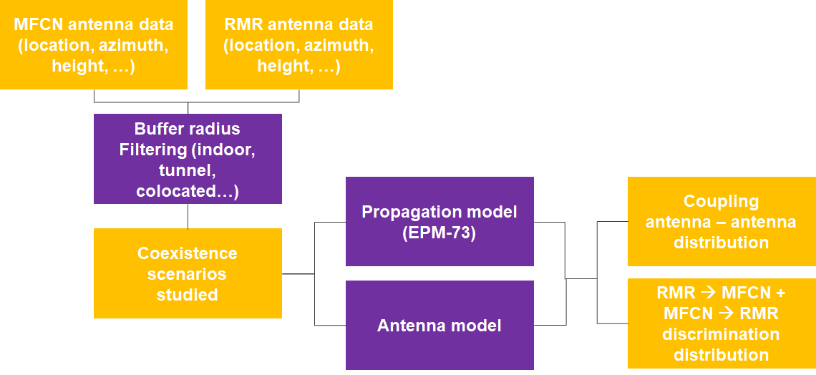
Figure 9: High-level perspective of the “statistical approach”

In essence:
- Determination of the coexistence scenarios: the geographical data and associated site characteristics are processed to determine a set of RMR ↔ MFCN coexistence scenarios to be further studied.
  - Choice of a buffer: not all possible coexistence scenarios need to be studied (such as the case of two sites that would be distant by an order of magnitude significantly larger than relevant for the study). Determining a suitable distance buffer around the interfering site appears a pragmatic solution to that question, allowing to simplify subsequent calculations by focusing the studies on the subset of possible coexistence scenarios for which the victim site is within the buffer.
  - Depending on the nature of the heterogeneous systems, cases of co-location or cases where one of the sites is underground and the other is overground can be excluded from subsequent studies as resulting from coordination or being outside of scope.
- Determination of the antenna to antenna coupling: for a set of coexistence scenarios between two antennas, the geographical data, the geometry of coexistence (distance, bearing and elevation angles site to site), the antenna characteristics (gain, horizontal and vertical half power beamwidth), the channel characteristics (channel bandwidth, channel location and the filtering of the victim) are processed to derive the antenna to antenna coupling
- Statistical output: several metrics can be derived from the set of coexistence scenarios, such as CDF of coupling, CDF of combined antenna discrimination (RMR MFCN & MFCN RMR). These metrics can then be used to choose an MCL value representative of realistic deployment and coexistence conditions.

Determination of the coexistence scenarios
Depending on the datasets made available, a prior step of determination of the coexistence scenarios may need to be undertaken. As an example, the French spectrum agency makes available through different channels (notably the “Cartoradio” website) a dataset of radio transmitters on a national basis, containing data on the French MFCN operators but also on the French RMR radio network. On the basis of such a national dataset, not all possible coexistence scenarios need necessarily be studied, such as the case of two sites that would be distant by an order of magnitude significantly larger than relevant for the study - e.g. on the opposite side of the country. A pragmatic solution to that question is to simplify subsequent calculations by focusing the studies on the subset of possible coexistence scenarios for which the victim site is within the buffer.

Determination of the sites to be studied for a given aggressor system
The following picture provides an illustration of two RMR sites (labelled “R”) with their individual antennas (represented by arrows) in a RMR-typical bi-sectorial configuration covering the tracks with eight MFCN sites (labelled “M”) in their vicinity, also with their respective antennas in a MFCN-typical tri-sectorial configuration. A buffer of a certain radius has been extended around respectively RMR sites #1 and #2. MFCN sites #1, #2, #5 and #6 fall inside the buffer drawn around RMR site #1 and the coexistence conditions between the antennas of these sites and the antennas of RMR site #1 will be studied. MFCN sites #3, #4, #6, #7 and #8 fall inside the buffer drawn around RMR site #2 and the coexistence conditions between the antennas of these sites and the antennas of RMR site #2 will be studied.
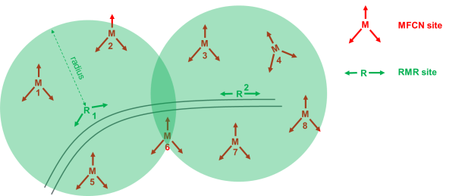
Figure 10: Example of study area with two RMR sites and 8 MFCN sites
It shall be noted that looking at coexistence scenarios in a statistical manner, a site like MFCN site #6 on the Figure 10 may need to be considered twice as its coexistence conditions with RMR site #1 may largely differ from its coexistence conditions with RMR site #2, notably due to the respective geometric dispositions of the sites and their antenna azimuthal orientations.
A further important thing to note is that sites per se do not interfere with each other but antennas do. In the case of Figure 10, it has been noted above that in the case of RMR site #1, the coexistence conditions between the antennas of the MFCN sites #1, #2, #5 and #6 on the one hand and the antennas of RMR site #1 can be studied. In total, this corresponds thus to a total of 12 MFCN antennas and two RMR antennas, leading to a potential 24 possible coexistence scenarios between an MFCN antenna and an RMR antenna within that buffer.
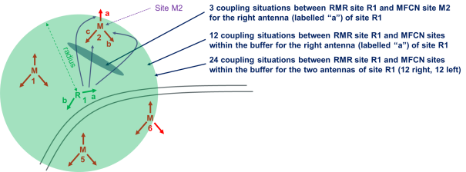
Figure 11: 24 possible coexistence scenarios between RMR site #1 and MFCN sites #1, #2, #5 and #6

Determination of the antenna to antenna coexistence scenarios
The respective orientation of the RMR and MFCN antennas within those 24 possible coexistence scenarios largely differ: in some scenarios, such as the coexistence of antenna “b” of site R1 and antenna “a” of site M2 in Figure 11, the two antennas may point in totally opposite directions leading to a low probability of interference between them.
Several strategies can be undertaken to select coexistence scenarios deemed relevant for inclusion in the population which will be subject to the statistical analysis. It shall nevertheless be noted that any filtering of some of the coexistence scenarios within a buffer introduces some amount of bias in terms of the statistical distribution (as compared to the unfiltered population deemed representative of a fully uncoordinated approach) and thus on how inferred statistical outputs (such as the CDF of coupling situations) shall be interpreted.
In practice, three basic approaches can be identified:
- Unfiltered approach: for respective antennas within a buffer, no further selection is made. In the case of Figure 11, this essentially translates into considering all 24 coexistence scenarios;
- “Half-plane” approach: for respective antennas within a buffer, only the antennas for which the other antenna is in the half-space defined by the plane normal to the direction of the antenna are considered (see top part of Figure 12). In the particular case of the bottom part of Figure 12, out of the three possible coexistence scenarios between the antenna labelled “a” of site R1 and site M2, only R1a-M2b and R1a-M2c would be considered in the distribution while the coexistence scenario between R1a and M2a would be discarded. This essentially leads to discarding scenarios with low possibilities of interference while preventing over-representation in the distribution of the worst cases.
- Worst-case approach: out of the possible coexistence scenarios within a buffer, only the worst coupling scenario is retained while all the other coexistence situations are discarded. This bears the risk of over-representing in the distribution “lone” cases of bad geometric circumstances (such as combination of a small distance and limited discrimination between antennas) at the expense of a larger number of coexistence scenarios where geometric circumstances would otherwise lead to low interference between systems: taking only the worst case situations in the distributions may thus lead to the adoption of potentially over-restrictive technical conditions for a large number of sites where, in field deployment, a better coexistence strategy could have been to take special measures (antenna adjustments in azimuth and tilt, more directive antennas…) for these “lone” cases.
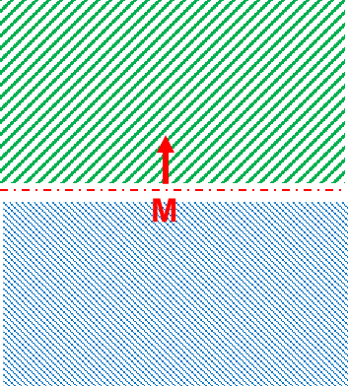
Green stripes: half-plane considered
Blue stripes: half-plane discarded
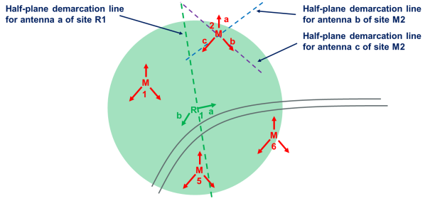
Figure 12: Half-plane approach
It should be further noted that the buffer-based approach may also lead to situations where the aggressor system may have no victim systems in the buffer due to the difference in coverage strategies between the respective systems. This is notably exemplified in the RMR – MFCN coexistence studies by the fact that Annex 3 and Annex 4 indicate that some 27% of RMR sites in France have no non-collocated MFCN 900 MHz neighbour within 1 km in France (the figure rises to 50.8% if focusing solely on MFCN915) and some 57.1% of RMR sites in Sweden have no non-collocated MFCN915 neighbours within 1 km. As such, and especially in the case where only the worst-case approach as described above would be taken, it would be of particular importance to either consider the heavy selection bias that the distribution reflects when adopting the BEM or to find a way to reflect in the distribution the RMR sites that have no neighbour. As an example, it could be beneficial for those RMR sites without neighbours within the buffer to find the nearest neighbour site within the MFCN dataset irrespective of the buffer distance and to consider in the distribution the worst-case situation between the antennas of the RMR site and the antennas of the identified nearest MFCN neighbour.

Determination of the antenna to antenna coupling
Once a selection of coexistence scenarios has been done as described in the previous section, the next step is to calculate the coupling loss between the respective systems using the following formula:
 | $$MCL={PL}_{\left(f,d\right)}- G_{Rail}-G_{MFCN}+D_{Rail}+D_{MFCN}$$ | (16)
Where:
- ${PL}_{\left(f,d\right)}$ is the pathloss between the two base stations under consideration calculated as per the modified EPM-73 model (see section 2.4), operating in frequency $f$ with separation distance $d$.
- $D_{Rail}$ is the RMR antenna discrimination (vertical and horizontal);
- $D_{MFCN}$ is the MFCN antenna discrimination (vertical and horizontal); $G_{Rail}$ is the RMR antenna gain (including feeder and coupling losses); $G_{MFCN}$. The antenna discrimination can be determined by using the horizontal and vertical discrimination angles in the antenna radiation pattern model.
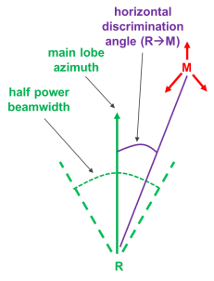 | 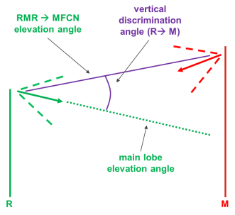
Figure 13: Horizontal and vertical antenna discriminations
The path loss itself shall be calculated at the lowest applicable frequency for the band under study as this would lead to the lowest path loss. In the specific case of the RMR-MFCN coexistence at 900 MHz, that lowest applicable frequency would be 919.4 MHz. For distance calculation it is proposed to use the Haversine formula.

Additional considerations

Considerations on antenna models
Sections 2.1 and 2.2 identify the use of Recommendation ITU-R F.1336 [6] model to determine the gain of the RMR and the MFCN antennas respectively according to the horizontal and vertical discrimination angles. Recommendation ITU-R F.1336 provides a reference radiation pattern model and, as such, determines an envelope as compared to measurements performed over real antennas. Kathrein Antennas model 80010305v02 has been identified as representative of RMR antennas and Kathrein Antennas model 80010767 has been identified as representative of MFCN antennas (in the urban case).
The following pictures provide, in the azimuth and elevation planes, for the 900 MHz frequency band, a visual comparison for Kathrein antennas 80010305v02 and 80010767 between the measured gains (as available in MSI format) and the computed gains resulting from the Recommendation ITU-R F.1336 model for sectorised antennas and the model described in Ericsson Research’s paper “Downtilted Base Station Antennas – A Simulation Model Proposal and Impact on HSPA and LTE Performance” [20]. It shall be noted that the calculations made for the Recommendation ITU-R F.1336 model have been made with the following parameters: kp = 0.7 – kh = 0.7 – kυ = 0.3. For the calculations made for the Ericsson Research model, the relevant parameters have been inferred from the manufacturer’s datasheet (such as Front-to-Back ratio and so forth).

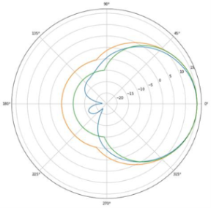 | 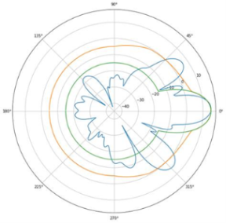
Figure 14: Comparison of MSI (blue), Ericsson Research (green) and F.1336 (orange) models for Kathrein antenna 80010767
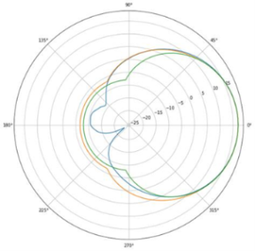 | 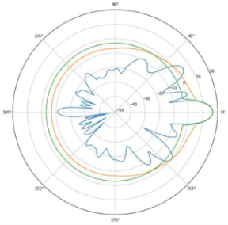
Figure 15: Comparison of MSI (blue), Ericsson Research (green) and F.1336 (orange) models for Kathrein antenna 80010305
It can be observed that in the elevation plane, both models are faithful to the main lobe.
In the case of the Ericsson Research model, it appears to be a "tighter fit" overall to the measured radiation pattern, at the exception of some secondary lobes in the elevation plane.
In the case of the Recommendation ITU-R F.1336 model applied with the aforementioned parameters, it appears to be modelling a more "optimistic" gain as compared to the measured radiation pattern and generally also "contains" the strong secondary lobes. It may however over-estimate the antenna gain in the elevation plane when just outside of the main lobe.
It should thus be understood when considering the statistical outputs that the Recommendation ITU-R F.1336 model may under-estimate the coupling between the RMR and MFCN antennas by several dBs depending on the particular geometric configuration of the two systems.

Considerations on propagation models
As mentioned in section 3.4.1.3, the use of the modified EPM-73 identified in section 2.4 along with the absolute ASL altitudes already yields a fairly realistic appreciation of the expected propagation loss between two sites. That being said, in urban environment where significant buildings may obstruct the signal propagation or in rural hilly environment where a hill could separate the two sites, the EPM-73 + ASL DTM model may underestimate the propagation loss. The following picture is an example of such a situation (visualised with the help of Google EarthTM) where the presence of a building higher than the MFCN site location (at the top of the image) would certainly imply a propagation loss between the sites significantly higher than envisioned by the EPM-73 + ASL DTM model.
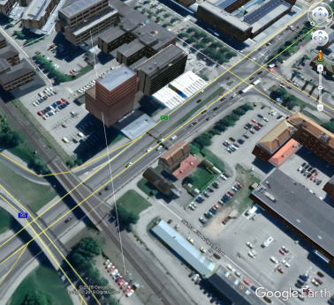
Figure 16: Example of building obstruction between a RMR and a MFCN site in Sweden

Compatibility of RMR with MFCN in the 900 MHz range

Impact of RMR BS in 919.4-925 MHz on MFCN BS receiving below 915 MHz
In the 900 MHz frequency band (MFCN 900) MFCN BS are receiving in the range 880-915 MHz. The band is typically allocated between three to four MFCN operators per country.
Annex 2 studies sensitivity to RMR interference for the highest channel in MFCN 900 UL (the channel just below 915 MHz) and the channels below it. Annex 2 finds that the highest channel in the MFCN 900 UL is the most sensitive to RMR interference (as compared to the channels below it) and thus concludes that the BEM aimed at protecting the highest channel in the MFCN 900 UL against RMR interference will offer better protection to the channels below it.
The present section thus focuses on studying the impact of RMR BS in 919.4-925 MHz on MFCN BS receiving in the channel just below 915 MHz (the highest channel in MFCN 900 UL) and operating LTE or MSR in LTE or NR.

MCL at 900 MHz

Method #1: 100 m based MCL calculation approach
As calculated in section 3.2.1, the MCL to be considered between RMR and MFCN BS in the 900 MHz range with this method would be 57.2 dB. Taking into account the horizontal discrimination would lead to a higher MCL value.
Note: 10 m antenna height difference between MFCN and RMR base stations.
Annex 7 contains information from statistics that show the validity of the 100 m based MCL approach.

Method #2: Statistical approach
Annexes 2 to 6 contain the results obtained by applying the statistical approach:
- Annex 2 France study 1
- Annex 3 France study 2
- Annex 4 Sweden study
- Annex 5 Germany study
- Annex 6 Bordeaux area study
The following pictures provide a Cumulative Distribution Function for the coupling loss between RMR (based on existing GSM-R sites for 900 MHz and assumed RMR sites for 1900 MHz) and MFCN antennas respectively for France, Sweden and Germany, some of them with three different curves to account for the different statistical population filtering approaches outlined in section 3.4.3.2.
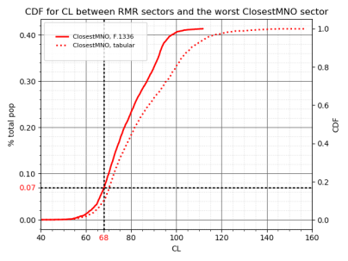
Figure 17: CDF of the coupling loss between GSM-R sectors and the worst MFCN sector
(France Study 1)
(only the public mobile network operating the closest to 915 MHz is considered)
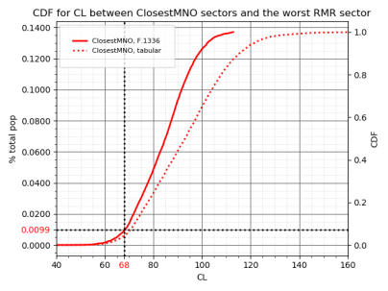
Figure 18: CDF of the coupling loss between MFCN sectors and the worst GSM-R sector
(France Study 1)
(only the public mobile network operating the closest to 915 MHz is considered)
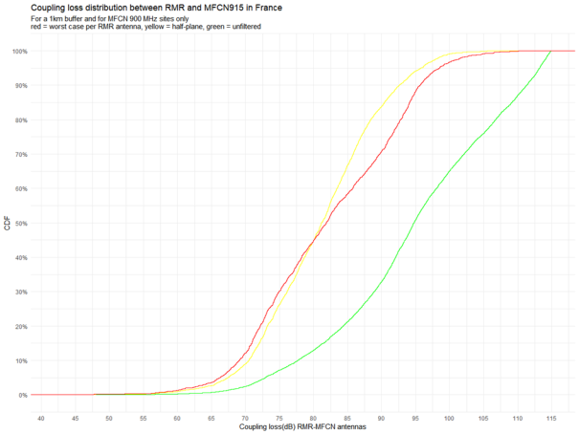
Figure 19: CDF for coupling loss between RMR and MFCN915 in France

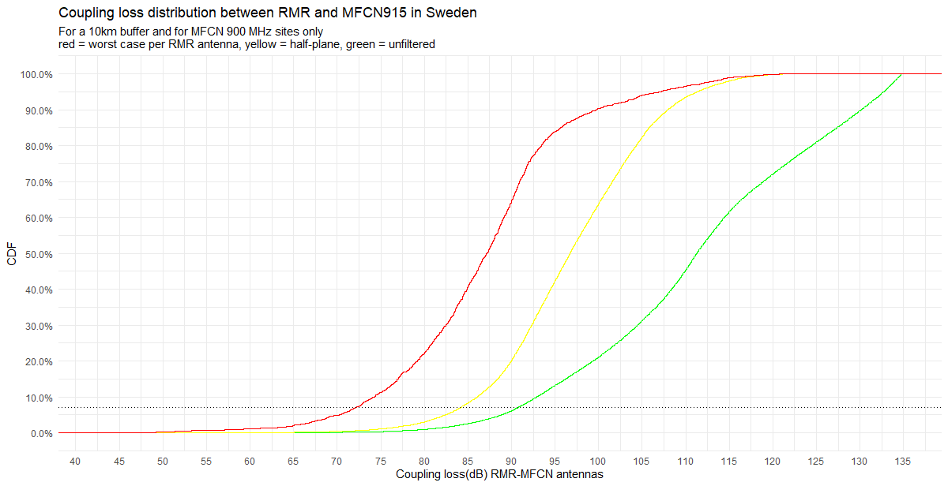
Figure 20: CDF for coupling loss between RMR and MFCN915 in Sweden
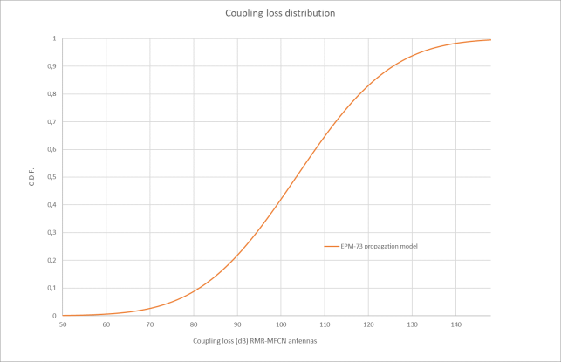
Figure 21: CDF for coupling loss between RMR and MFCN in Germany
In order to select an MCL value, the following criterion has been selected: 7% of GSM-R sectors would have at least one MFCN neighbouring sector (from the operator the closest in frequency to the GSM-R lower band edge) with a coupling loss lower than that MCL value. This threshold of 7% is a compromise value between efficient use of RMR and reasonable protection of the incumbent, taking into account possible densification. Based on the mentioned criterion and on the figures above related to statistics from France, the MCL value to be considered between RMR and MFCN BS in the 900 MHz range is 68 dB. According to the CDF for France in Figure 18, up to 1% of MFCN sectors of the closest MNO in frequency would potentially be affected. It is however probable that the real number of cases will be lower considering that simulations have been assessing worst cases e.g. without taking into account a digital terrain model, clutter layer or building layer, and therefore there would be a suitably low occurrence probability of worse cases where the coexistence objective is exceeded. No additional mitigation due to the RMR activity factor has been taken into account in this Report. The remaining interference cases are supposed to be solved by a coordination process at national level.

Possible LRTC for GSM-R BS

Method #1: 100 m based MCL calculation approach
The following table provides the maximum in-block e.i.r.p. for a GSM-R BS in the 900 MHz range based on the MCL associated with a 100 m distance without horizontal discrimination. It is noted that GSM is not subject to the BEM concept due to its narrowband nature compared to UMTS/LTE/NR. Operation of GSM-R BS with higher e.i.r.p. is also possible based on national coordination. Existing GSM-R transmitters (GSM-R BS) are exempt from this new requirement.
Table 14: 100 m based LRTC for GSM-R BS
GSM-R carrier | Max. e.i.r.p.
918.2 MHz | 13.2 dBm | Note 1
918.4 MHz | 15.9 dBm | Note 1
918.6 MHz | 18.6 dBm | Note 1
918.8 MHz | 21.2 dBm | Note 1
919.0 MHz | 23.9 dBm | Note 1
919.2 MHz | 26.6 dBm | Note 1
919.4 MHz | 29.2 dBm | Note 1
919.6 MHz | 40.9 dBm
919.8 MHz | 43.6 dBm
920.0 MHz | 46.2 dBm
920.2 MHz | 48.9 dBm
920.4 MHz | 51.6 dBm
920.6 MHz | 54.2 dBm
920.8 MHz | 56.9 dBm
921.0 MHz | 59.6 dBm
921.2 MHz | 62.2 dBm | Note 2
Note 1: May be used on a national basis
Note 2: There is no e.i.r.p. restriction on GSM-R BS operating in the harmonised frequency band 921-925 MHz. The maximum e.i.r.p. for the GSM-R channel centred at 921.2 MHz is given for information only.

Method #2: Statistical approach
The following table provides the maximum in-block e.i.r.p. for a GSM-R BS in the 900 MHz range based on the 68 dB MCL associated with the statistical approach. It is noted that GSM is not subject to the BEM concept due to its narrowband nature compared to UMTS/LTE/NR. Operation of GSM-R BS with higher e.i.r.p. is also possible based on national coordination. Existing GSM-R transmitters (GSM-R BS) are exempt from this new requirement.
Table 15: LRTC for GSM-R BS based on statistics
GSM-R carrier | Max. e.i.r.p.
918.2 MHz | 24.1 dBm | Note 1
918.4 MHz | 26.7 dBm
918.6 MHz | 29.4 dBm
918.8 MHz | 32.1 dBm
919.0 MHz | 34.7 dBm
919.2 MHz | 37.4 dBm
919.4 MHz | 40.1 dBm
919.6 MHz | 51.7 dBm
919.8 MHz | 54.4 dBm
920.0 MHz | 57.1 dBm
920.2 MHz | 59.7 dBm
920.4 MHz | 62.4 dBm
920.6 MHz | 65.1 dBm
920.8 MHz | 67.7 dBm
921.0 MHz | 70.4 dBm
921.2 MHz | 73.1 dBm | Note 2
Note 1: May be used on a national basis
Note 2: There is no e.i.r.p. restriction on GSM-R BS operating in the harmonised frequency band 921-925 MHz. The maximum e.i.r.p. for the GSM-R channel centred at 921.2 MHz is given for information only.

Possible LRTC for wideband RMR BS (FRMCS)

Method #1: 100 m based BEM approach
The following table provides the maximum in-block and baseline e.i.r.p. for an FRMCS BS in the 900 MHz range based on the MCL associated with a 100 m distance without horizontal discrimination, while taking into account its out-of-band and spurious emissions.
Similarly to the baseline level in the UL band defined in ECC Decision (09)03 [21] and ECC Decision (15)01 [22], a baseline level of -49 dBm/5 MHz is considered over the UL band 880-915 MHz.
Operation of FRMCS BS with higher e.i.r.p. is also possible based on national coordination.
Table 16: 100 m based LRTC for wideband RMR BS
RMR carrier | In-block e.i.r.p. | Out-of-band  emissions | Baseline e.i.r.p.  in 880-915 MHz
1.4 MHz LTE in 919.5-920.9 MHz | 45.1 dBm/1.4 MHz | as per TS 137 104 Tables 6.6.2.2-1 and 6.6.2.2-2 | -49 dBm/5 MHz
1.4 MHz LTE in… | slope of 80 dB/6 MHz | as per TS 137 104 Tables 6.6.2.2-1 and 6.6.2.2-2 | -49 dBm/5 MHz
1.4 MHz LTE in 921.0-922.4 MHz | 65.1 dBm/1.4 MHz | as per TS 137 104 Tables 6.6.2.2-1 and 6.6.2.2-2 | -49 dBm/5 MHz
5 MHz LTE/NR in 919.4-924.4 MHz | 51.0 dBm/5 MHz | as per TS 137 104 Tables 6.6.2.2-1 and 6.6.2.2-2 | -49 dBm/5 MHz
5 MHz LTE/NR in 919.5-924.5 MHz | 52.4 dBm/5 MHz | as per TS 137 104 Tables 6.6.2.2-1 and 6.6.2.2-2 | -49 dBm/5 MHz
5 MHz LTE/NR in 919.6-924.6 MHz | 53.7 dBm/5 MHz | as per TS 137 104 Tables 6.6.2.2-1 and 6.6.2.2-2 | -49 dBm/5 MHz
5 MHz LTE/NR in 919.7-924.7 MHz | 55.0 dBm/5 MHz | as per TS 137 104 Tables 6.6.2.2-1 and 6.6.2.2-2 | -49 dBm/5 MHz
5 MHz LTE/NR in 919.8-924.8 MHz | 56.4 dBm/5 MHz | as per TS 137 104 Tables 6.6.2.2-1 and 6.6.2.2-2 | -49 dBm/5 MHz
5 MHz LTE/NR in 919.9-924.9 MHz | 57.7 dBm/5 MHz | as per TS 137 104 Tables 6.6.2.2-1 and 6.6.2.2-2 | -49 dBm/5 MHz
5 MHz LTE/NR in 920-925 MHz | 59.0 dBm/5 MHz | as per TS 137 104 Tables 6.6.2.2-1 and 6.6.2.2-2 | -49 dBm/5 MHz
5.6 MHz NR in 919.4-925 MHz (Note) | 51.3 dBm/5.6 MHz | Assumed to be consistent with 1.4 MHz and 5 MHz channels | Assumed to be  -49 dBm/5 MHz
Note: The 5.6 MHz channel bandwidth is considering a transmission bandwidth of 28 RB between 919.6725 and 924.7125 MHz, reflecting a possible 5.6 MHz NR channel. This is understood to be compatible with NR lower layers, subject to additional standardisation work, as necessary, to confirm and further specify this.
As expected, the in-block e.i.r.p. follows the duplexer slope of 80 dB/6 MHz.
CEPT noted that to avoid the narrowband blocking effect of the wideband system receivers by the adjacent NB systems, a 200 kHz frequency separation is required between the NB system channel edge and the WB system channel edge. A frequency separation of 200 kHz or more is also needed between channel edges of different NB systems. This issue will be further addressed at the national level, consistently with the relevant FRMCS and MFCN harmonised technical and regulatory conditions.

Method #2: Statistical approach
The following table provides the maximum in-block and baseline e.i.r.p. for an FRMCS BS in the 900 MHz range based on the 68 dB MCL associated with the statistical approach, while taking into account its out-of-band and spurious emissions.
Operation of FRMCS BS with higher e.i.r.p. is also possible based on national coordination.
Table 17: LRTC for wideband RMR BS based on statistics
RMR carrier | In-block e.i.r.p. | Out-of-band  emissions | Baseline e.i.r.p.  in 880-915 MHz
1.4 MHz LTE in 919.5-920.9 MHz | 55.9 dBm/1.4 MHz | as per TS 137 104, tables 6.6.2.2-1 and 6.6.2.2-2 [9] | -49 dBm/5 MHz
1.4 MHz LTE in… | slope of 80 dB/6 MHz | as per TS 137 104, tables 6.6.2.2-1 and 6.6.2.2-2 [9] | -49 dBm/5 MHz
1.4 MHz LTE in 921.0-922.4 MHz | 75.9 dBm/1.4 MHz | as per TS 137 104, tables 6.6.2.2-1 and 6.6.2.2-2 [9] | -49 dBm/5 MHz
5 MHz LTE/NR in 919.4-924.4 MHz | 61.8 dBm/5 MHz | as per TS 137 104, tables 6.6.2.2-1 and 6.6.2.2-2 [9] | -49 dBm/5 MHz
5 MHz LTE/NR in 919.5-924.5 MHz | 63.2 dBm/5 MHz | as per TS 137 104, tables 6.6.2.2-1 and 6.6.2.2-2 [9] | -49 dBm/5 MHz
5 MHz LTE/NR in 919.6-924.6 MHz | 64.5 dBm/5 MHz | as per TS 137 104, tables 6.6.2.2-1 and 6.6.2.2-2 [9] | -49 dBm/5 MHz
5 MHz LTE/NR in 919.7-924.7 MHz | 65.8 dBm/5 MHz | as per TS 137 104, tables 6.6.2.2-1 and 6.6.2.2-2 [9] | -49 dBm/5 MHz
5 MHz LTE/NR in 919.8-924.8 MHz | 67.2 dBm/5 MHz | as per TS 137 104, tables 6.6.2.2-1 and 6.6.2.2-2 [9] | -49 dBm/5 MHz
5 MHz LTE/NR in 919.9-924.9 MHz | 68.5 dBm/5 MHz | as per TS 137 104, tables 6.6.2.2-1 and 6.6.2.2-2 [9] | -49 dBm/5 MHz
5 MHz LTE/NR in 920-925 MHz | 69.8 dBm/5 MHz | as per TS 137 104, tables 6.6.2.2-1 and 6.6.2.2-2 [9] | -49 dBm/5 MHz
5.6 MHz NR in 919.4-925 MHz (Note) | 62.1 dBm/5.6 MHz | Assumed to be consistent with 1.4 MHz and 5 MHz channels | Assumed to be  -49 dBm/5 MHz
Note: The 5.6 MHz channel bandwidth is considering a transmission bandwidth of 28 RB between 919.6725 and 924.7125 MHz, reflecting a possible 5.6 MHz NR channel. This is understood to be compatible with NR lower layers, subject to additional standardisation work, as necessary, to confirm and further specify this.
As expected, the in-block e.i.r.p. follows the duplexer slope of 80 dB/6 MHz.
CEPT noted that to avoid the narrowband blocking effect of the wideband system receivers by the adjacent NB systems, a 200 kHz frequency separation is required between the NB system channel edge and the WB system channel edge. A frequency separation of 200 kHz or more is also needed between channel edges of different NB systems. This issue will be further addressed at the national level, consistently with the relevant FRMCS and MFCN harmonised technical and regulatory conditions.

Maximum RMR signal level at MFCN BS location
Operation of RMR BS with e.i.r.p. levels higher than those in Table 14-Table 17 is also possible based on national coordination.
It should be decided on national level how to coordinate between RMR and MFCN. The following procedure provides a possibility as an example.
When the RMR operator wishes to operate an RMR BS with a higher e.i.r.p. they can use the following formula to coordinate with each MFCN BS within a given radius around the RMR radio site:
 | $${TxI}_{inblock}≤ N-6+ACIR+CL$$ | (17)

 | $$ACIR=10\log_{10}\left(\frac{1}{\frac{1}{S_{inblock}}+\frac{1}{α}}\right)$$ | (18)

 | $$CL=PL+D_{Rail}+D_{MFCN}-G_{Rail}-G_{MFCN}$$ | (19)
where:
- ${TxI}_{inblock}$ is the RMR BS in-block e.i.r.p.;
- $I_{IB}$ is the total permitted interference at the antenna connector for a noise figure of 5 dB for MFCN BS .;
- $S_{inblock}$ is the MFCN BS selectivity (given in Table 9 of this ECC Report) dependent on the edge-to-edge frequency offset between the MFCN and RMR carriers
- $α$ accounts for RMR BS out-of-band and spurious emissions;
$α=2 dB$ for a baseline level of -49 dBm/5 MHz below 915 MHz;
$α=1 dB$ for a baseline level of -85 dBm/100 kHz below 915 MHz (Table 6.6.1.2.1-1 for self-protection*).
- $PL$ is the path loss specific to the propagation environment and ground occupancy;
- $D_{Rail}$ is the RMR antenna discrimination, noting that having more directive antennas or adjusting tilt and azimuth may ease coexistence;
- $D_{MFCN}$ is the MFCN antenna discrimination;
- $G_{MFCN}$ is the MFCN antenna gain (including feeder loss);
* in 3GPP TS 37.104: -98 dBm/(100 kHz) + 13 dBi antenna gain
The RMR BS in-block e.i.r.p. may be increased while fulfilling this coexistence criterion thanks to adjustments of antenna directivity, azimuth, tilt, etc.
All the required elements related to the neighbouring MFCN sites (coordinates, antenna height, azimuth, tilt, antenna reference, frequency carrier, etc.) should be made available to the railway operator either by the national administration or the mobile network operators (if required through an NDA).

Summary
The 100 m based approach leads to a 57.2 dB reference MCL. The statistical approach leads to a 68 dB reference MCL. The BEM based on the 57.2 dB reference MCL from the 100 m approach are provided in Table 14 for GSM-R BS and in Table 16 for FRMCS BS. Those BEM limits are expected to be overly stringent for efficient RMR spectrum usage since the specificities of RMR deployments would make the 100 m reference scenario occur in rare cases. As a consequence, the statistical approach is assumed to allow uncoordinated deployments whilst ensuring a suitably low occurrence probability of worse cases where the coexistence objective is exceeded. These remaining interference cases should be solved at national level.
The BEM based on the statistical approach are provided in Table 15 for GSM-R BS and in Table 17 for FRMCS BS. These BEM are expected to enable deployments based on existing GSM-R sites in several scenarios. There are situations where it might still be desirable to enable a higher RMR BS e.i.r.p. as long as no MFCN BS would be desensitised by more than 1 dB. When the railway operator wishes to operate an RMR BS with a higher e.i.r.p., they can use a given formula with respect to each MFCN BS in the vicinity of the RMR radio site (see section 4.1.4), as part of a national coordination procedure.

Feasibility of FRMCS high-power cab-radio in 874.4-880 MHz

Monte Carlo simulation and MCL analysis
For the 900 MHz band, the conclusion is as follows:
- Monte Carlo studies based on SEAMCAT have been conducted and are documented in Annex 10. The simulation results show that the interference from FRMCS cab-radio of 31 dBm output power to MFCN uplink is acceptable when uplink power-control is implemented and activated and with unwanted emissions as described in Annex 10;
- Annex 9 provides a worst-case analysis based on a MCL calculation for the case without FRMCS cab-radio uplink power control and concludes that this would result in harmful interferences unless unwanted emissions from cab-radio would be reduced to -53 dBm/MHz in the frequency range 880-915 MHz.
- FRMCS cab-radios shall therefore implement and activate uplink power control in the 900 MHz band. FRMCS high-power cab-radios are not permitted to operate without uplink power control.

Compatibility of FRMCS in 1900-1910 MHz with MFCN
In this Report, FRMCS is only considered in 1900-1910 MHz where the MFCN BS blocking level is better.

Impact of FRMCS BS in 1900-1910 MHz on MFCN BS receiving above 1920 MHz

MCL at 1900 MHz

Method #1: 100 m based MCL calculation approach
As calculated in section 3.2.1, the MCL to be considered between RMR and MFCN BS in the 1900 MHz range with this method would be 63 dB. Taking into account, the horizontal discrimination would lead to a higher MCL value.
Note: 10m antenna height difference between MFCN and RMR base stations.

Method #2: Statistical approach
In the case of the study at 1900 MHz, pseudo-RMR sites were inserted midway of two successive RMR sites when distant of more than 5 km in non-urban areas. This is not perfect (it could be further improved by using a shapefile), yet is expected to reasonably simulate a possible densification of RMR sites in this frequency band. This adds 670 sites (1340 sectors) to the RMR population. MFCN and RMR antenna gains are both 18 dBi.
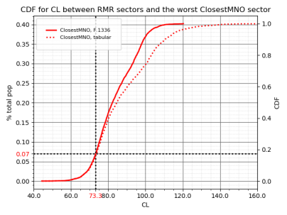
Figure 22: cdf of the coupling loss between RMR sectors and the worst MFCN sector (France)
(only the public mobile network operating the closest to 915 MHz is considered)
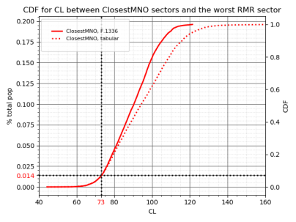
Figure 23: cdf of the coupling loss between MFCN sectors and the worst RMR sector (France)
(only the public mobile network operating the closest to 915 MHz is considered)
In order to select an MCL value, the following criterion has been selected: 7% of RMR sectors would have at least one MFCN neighbouring sector (from the operator the closest in frequency to the RMR lower band edge) with a coupling loss lower than that MCL value. The threshold of 7% has been chosen as a compromise value between efficient use of RMR and protecting the incumbent. Based on this criterion and on the figures above; the MCL value to be considered between RMR and MFCN BS in the 1900 MHz range is 73 dB.

Possible LRTC for wideband RMR BS (FRMCS) based on MFCN BS selectivity as per CEPT Report 39

Method #1: 100 m based MCL calculation approach
The following table provides the maximum in-block and baseline e.i.r.p. for an FRMCS BS in the 1900 MHz range based on the MCL associated with a 100 m distance without horizontal discrimination, while taking into account its out-of-band and spurious emissions.
Similarly to the baseline level in the UL band defined in ECC Decision (05)05 [23] for non-AAS BS, a baseline level of -41 dBm/(5 MHz) is considered over the UL band 1920-1980 MHz.
Table 18: 100 m based LRTC for wideband RMR BS,
considering MFCN BS selectivity as per CEPT Report 39 [4]
RMR carrier | In-block e.i.r.p. | Out-of-band  emissions | Baseline e.i.r.p.  in 1920-1980 MHz
10 MHz LTE/NR in 1900-1910 MHz | 40.7 dBm/(10 MHz) | as per TS 137 104 Table 6.6.2.1-1 | -41 dBm/(5 MHz)

Method #2: Statistical approach
The following table provides the maximum in-block and baseline e.i.r.p. for an FRMCS BS in the 1900 MHz range based on the 73 dB MCL associated with the statistical approach, while taking into account its out-of-band and spurious emissions.
With respect to the baseline level, it is proposed to apply the 5 dB difference between the MCL values associated with the statistical approach between the 900 MHz band and the 1900 MHz as well as the 1 dB difference between the RMR BS antenna gains, resulting in a baseline level of -43 dBm/(5 MHz).
Table 19: LRTC for wideband RMR BS based on statistics,
considering MFCN BS selectivity as per CEPT Report 39 [4]
RMR carrier | In-block e.i.r.p. | Out-of-band  emissions | Baseline e.i.r.p.in 1920-1980 MHz
10 MHz LTE/NR in 1900-1910 MHz | 50.7 dBm/(10 MHz) | as per TS 137 104 Table 6.6.2.1-1 [9] | -43 dBm/(5 MHz)

Possible LRTC for wideband RMR BS without in-block restriction subject to changes to MFCN BS selectivity

Desired LRTC for wideband RMR BS
This report considers the operation of FRMCS with macro coverage. This requires 65 dBm/(10 MHz) e.i.r.p. for FRMCS BS. The following table provides the desired LRTC for an FRMCS BS in the 1900 MHz range, while taking into account its out-of-band and spurious emissions.
Table 20: LRTC for wideband RMR BS,
considering enhanced MFCN BS selectivity
RMR carrier | In-block e.i.r.p. | Out-of-band  emissions | Baseline e.i.r.p.  in 1920-1980 MHz
10 MHz LTE/NR in 1900-1910 MHz | 65 dBm/(10 MHz) | as per TS 137 104 Table 6.6.2.1-1 [9] | -43 dBm/(5 MHz)
Note: In case an in-block e.i.r.p. higher than 65 dBm/10 MHz is desired by an administration, it is assumed that appropriate interference mitigation or coordination are put in place.
With the current level of selectivity of MFCN base stations, those LRTC for FRMCS may result in interference to some MFCN base stations located near FRMCS BS sites. One way of addressing this interference is to coordinate FRMCS and MFCN deployments. However, this means that RMR operators may not be able to use 65 dBm at certain locations. If 65 dBm e.i.r.p. uncoordinated FRMCS base stations is desired, then these MFCN BS may need to be adapted when an FRMCS BS is rolled out in its proximity, so that it does not suffer interference from FRMCS.
Additional mitigation techniques need to be implemented on a case-by-case basis, such as adjustments of antenna directivity, azimuth, tilt, or improve the selectivity of the MFCN BS in the vicinity of the railway tracks. Table 23 shows this enhanced selectivity.

Changes induced by the 100 m based MCL calculation approach
Based on section 5.1.2.1, in order to enable an in-block e.i.r.p. of 65 dBm/(10 MHz) for FRMCS BS, the MFCN BS selectivity would need to be 98.3 dB (assuming an MCL of 63 dB measured at the antenna connector.
Table 21: MFCN BS selectivity increase
RMR carrier | MFCN BS selectivity increase
RMR carrier | compared to  CEPT Report 39 [4] | compared to  TS 137 104 [9]
10 MHz LTE/NR in 1900-1910 MHz | 24.3 dB | 40.6 dB

Changes induced by the statistical approach
Based on section 5.1.2.2, in order to enable an in-block e.i.r.p. of 65 dBm/(10 MHz) for FRMCS BS, the MFCN BS selectivity would need to be 88.3 dB (assuming an MCL of 73 dB measured at the antenna connector).
Table 22: MFCN BS selectivity increase
RMR carrier | MFCN BS selectivity increase
RMR carrier | compared to  CEPT Report 39 [4] | compared to  TS 137 104 [9]
10 MHz LTE/NR in 1900-1910 MHz | 14.3 dB | 30.6 dB

Further assessment of induced changes based on statistics
The figure below provides the CDF of coupling loss between RMR sectors and the worst sector from the MNO operating immediately above 1920 MHz, excluding sites in dense urban areas. Compared to section 5.1.1.2, the threshold at 7% has shifted from 73 dB to 81 dB, which means an increase of 8 dB of the CL at 7% threshold.
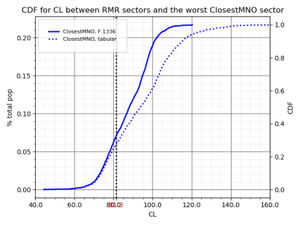
Figure 24: CDF of the coupling loss between RMR sectors and the worst MFCN sector
in non-urban areas (France)
(only the public mobile network operating the closest to 915 MHz is considered)
Hence, in non-urban areas, the selectivity on MFCN BS operating above 1920 MHz would need to be 80.3 dB in order to enable an in-block e.i.r.p. of 65 dBm/(10 MHz) for FRMCS BS.
In urban areas, the coupling loss is expected to be higher than calculated, e.g. due to ground occupancy and other factors (as shown at 920 MHz in Annex 3).
As a conclusion, the enhanced selectivity below 1910 MHz on MFCN BS operating above 1920 MHz would need to be 80 dB assuming an MCL of 81 dB measured at the antenna connector for non-urban areas.
Table 23: MFCN BS selectivity increase
RMR carrier | MFCN BS selectivity increase
RMR carrier | compared to  CEPT Report 39 [4] | compared to  TS 137 104 [9]
10 MHz LTE/NR in 1900-1910 MHz | 6 dB | 22.5 dB
In BSs operating with passive antenna systems, additional filtering can be achieved either natively in new radio units or by adding external filter to existing radio units. However, this presents the following challenges:
- There will be a possible reduction in the range in the uplink;
- An external filter increases complexity at the BS.
In BSs operating with active antenna systems the following challenges exist:
- Additional external filter is not feasible for active antenna systems;
- High selectivity requirements may not be achievable due to design constraints. These high selectivity requirements might hinder the migration of MFCN network to 5G/NR with AAS BS, however studies need to be carried out.
Considerations on challenges associated with additional receiver filtering for MFCN BS are provided in Annex 8.

Summary
The 100 metre MCL calculation approach and the statistical approach, assuming a MFCN BS selectivity as per CEPT Report 39 [4], result in LRTC requiring in-block e.i.r.p. limit for FRMCS BS of 40.7 dBm/(10 MHz) and 50.7 dBm/(10 MHz) respectively. However, the report also considers the operation of FRMCS in that band with macro coverage. This requires an in-block e.i.r.p. of 65 dBm/(10 MHz) for FRMCS BS and leads to a BEM as specified in Table 20. It may result in interference to some MFCN BS located near an FRMCS radio site.
With the current level of selectivity of MFCN base stations, those LRTC for FRMCS may result in interference to some MFCN base stations located near FRMCS BS sites. One way of addressing this interference is to coordinate FRMCS and MFCN deployments. However, this means that RMR operators may not be able to use 65 dBm at certain locations. If 65 dBm e.i.r.p. uncoordinated FRMCS base stations is desired, then these MFCN BS may need to be adapted when an FRMCS BS is rolled out in its proximity, so that it does not suffer interference from FRMCS.

Feasibility of FRMCS high-power cab-radio in 1900-1910 MHz
FRMCS is only considered below 1915 MHz due to the lower MFCN BS blocking level for an interferer in 1915-1920 MHz. Finally, it has been decided to develop technical parameters only for the band 1900-1910 MHz.

Monte Carlo simulation and MCL analysis
Monte Carlo studies based on SEAMCAT have been conducted and are documented in Annex 10. The simulation results show that the interference from FRMCS cab-radio of 31 dBm output power to MFCN uplink is acceptable when uplink power-control is implemented and activated and with unwanted emissions as described in Annex 10.
Annex 9 provides a worst-case analysis based on an MCL calculation for the case without FRMCS cab-radio uplink power control and concludes that this would result in harmful interferences unless unwanted emissions from cab-radio would be reduced to -53 dBm/MHz in the frequency range 1920-1980 MHz.
FRMCS cab-radios shall therefore implement and activate uplink power control in the 1900 MHz band. FRMCS high-power cab-radios are not permitted to operate without uplink power control.

Compatibility of FRMCS in 2290-2300 MHz with MFCN

Suitability of existing BEM as per ECC Decision (14)02
The BEM specified in Annex 2 of ECC Decision (14)02 [2] are considered valid in the case of FRMCS BS operating in 2290-2300 MHz. Conversely, LSA would not apply to FRMCS due to its permanent nature in terms of location, operation and availability requirements.
According to the answers to the CEPT questionnaire on the 2290-2400 MHz range, at least 15 CEPT countries out of 42 with a rail network have or plan to have MFCN in the 2300-2400 MHz band. In these countries, the issue of TDD cross-network synchronisation arises. These can be predominately mitigated with the following approaches (see ECC Reports 216 [24] and 296 [25]).
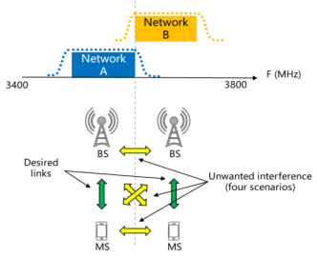 | 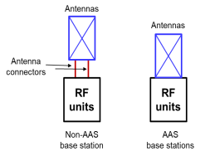
Figure 25: TDD cross-network synchronisation
- Inter-operator synchronisation means operation of two or more different time division duplex (TDD) networks, where simultaneous uplink (UL) and downlink (DL) transmissions do not occur, that is at any given moment in time either all networks transmit in downlink or all networks transmit in uplink. This requires the alignment of all DL and UL transmissions for all TDD networks involved as well as synchronising the beginning of the frame across all networks. Technical specifications currently assume synchronised operation.
- Unsynchronised operation with custom filters and guard bands: in order to deal with simultaneous UL/DL transmissions, more stringent limits have to be defined. In the present case, it means additional filtering below 2300 MHz for MFCN which is not included in the ECC baseline out of block power limit. In addition, FRMCS would also have to do similar filtering above 2300 MHz. From the existing case of the 3.5 GHz band which is already assessed in ECC Reports 203 [26] and 281 [27], it is assumed that the implementation of the ECC restricted baseline limit would imply operator-specific filters. These filters are challenging to implement cost effectively in the case of AAS BS with currently available technologies as described in Figure 25, and would also require significant inter-operator guard bands. Based on currently available AAS BS technology, it is therefore assumed that AAS equipment will only implement filters designed to comply with the ECC baseline out of block power limit with 3GPP band boundaries.
- Unsynchronised operation with separation distances: From ECC Report 296 on the 3.5 GHz band, these could be up to 60 km when co-channel and up to 14 km when operating in the adjacent channel. From recent contributions on ECC Recommendation (15)01 [29], a coordination threshold of 0 dBµV/m / 5 MHz is being considered in case of unsynchronised co-channel operation at the border.
Synchronised operation requires a multilateral agreement between all TDD licensees (MFCN and RMR) in the same coverage area / region on parameters defined in ECC Report 216 §3.3, most notably:
- A common reference clock with a proper accuracy (e.g. UTC +/- 1.5 µs). There are several ways to comply with this and GNSS is currently the main one as described in ECC Report 216.
- A compatible frame structure (which determines a specific DL/UL transmission ratio) and frame length, which contribute to the network performance (e.g. latency, spectral efficiency, throughput and coverage). Compatible frame structure may also introduce new operational constraints and additional costs: for instance, inter-operator synchronisation may lead to a less flexible DL/UL ratio selection, resulting in suboptimal spectrum utilisation for an individual operator (see ECC Report 216, section 3.3). Agreements on synchronised operation between operators will be simplified when operators adopt the same technology and target the same type of services with the associated desired user plane latency and performance targets.
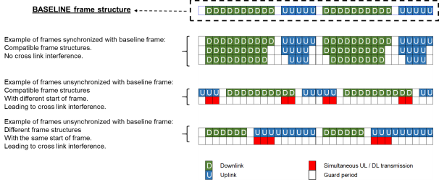
Figure 26: TDD frame structure synchronisation
In the case of FRMCS in the 2290-2300 MHz band, which falls within the in-block blocking domain of the 2300- 2400 MHz band, this raises specific concerns:
- From FRMCS perspective, it is unclear whether specific latency constraints will be mandated;
- It is foreseen that the required frame for FRMCS would be more UL-centric contrary to MFCN which are DL-centric. Synchronisation between MFCN and FRMCS would imply a significant suboptimal loss of capacity either from MFCN or from FRMCS (or both);
- Implementing synchronised operation between different technologies, when feasible, often implies suboptimal configurations. In this case of LTE/NR coexistence, the latency penalty is assessed in ECC Report 296.
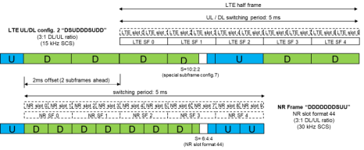
Figure 27: TDD LTE/NR frame structure synchronisation
In summary, the results on previous CEPT studies in the 2.3 GHz band as well as other MFCN bands indicate several technical challenges to enable unsynchronised operation together with MFCN TDD networks in the 2.3 GHz band. The required geographical protection distances between unsynchronised base stations are expected to be so large that this is not considered to be a realistic option for RMR deployment. The possible implications of a synchronised operation between RMR and MFCN (which also include sharing the same up- and downlink frame structure) is outside the scope of this Report.

Feasibility of FRMCS high-power cab-radio in 2290-2300 MHz
In the course of the studies, it was decided to not further look into the range 2300-2400 MHz. This was concluded from the results gained in a CEPT questionnaire.
With respect to blocking phenomenon, the feasibility of FRMCS high-power cab-radios (in terms of coexistence with MFCN) depends on its density of usage, so that MFCN adjacent in frequency face an acceptable throughput loss. This is for further study.
With regard to out-of-band emissions, this issue has not been covered in this Report. Additional studies should be performed in case the usage of this frequency range becomes of interest for FRMCS.

Conclusions
This ECC Report studies the compatibility of Railway Mobile Radio (RMR) with Mobile/Fixed Communication Networks (MFCN) as part of the answer to the Mandate from the European Commission on FRMCS. This includes a BEM for RMR BS in 874.4-880 MHz/919.4-925 MHz in order to coexist with MFCN BS and the impact of FRMCS high-power UE on MFCN BS in three frequency bands: 874.4-880 MHz / 919.4-925 MHz, 1900-1910 MHz and 2290-2300 MHz. Only non-AAS FRMCS and non-AAS MFCN systems have been considered. Additional studies should be performed in case AAS systems are considered for FRMCS in the 1900-1910 MHz band. The protection of MFCN 5G/NR with AAS BS above 1920 MHz was not studied in this Report. Further analysis of the interference impact of FRMCS on MFCN AAS systems may be required.
As described in CEPT Report 19 [3], the BEM is developed on the basis that detailed coordination and cooperation agreements would not be required to be in place prior to network deployment. The BEM for the transmitter emissions would not avoid all interference that might arise in certain deployment scenarios, including for some configurations at shared base station sites or between nearby base station sites. In these situations, mobile network operators and RMR operators of both systems may have to coordinate, and the use of additional interference mitigation techniques might be considered.

BEM derivation at 900 MHz
In order to derive a BEM for RMR BS, a reference MCL has to be defined. For this purpose, two MCL calculation approaches have been considered: one based on 100 m separation distance between BS and one based on statistics relying on existing GSM-R and MFCN deployment data in France, Germany and Sweden. The statistical approach appears to be of particular relevance when the two systems under study exhibit significant differences in their deployment patterns, notably as a result of different coverage targets. In particular, railway coverage is largely focused along railway tracks and railway premises following curvilinear geometries whereas public networks focus on optimised area-based coverage of population concentrations. In some countries, MFCN BS along some railway tracks provide in-train coverage and these sites are considered in the statistical calculations.
The 100 m based MCL calculation leads to a reference MCL of 57.2 dB. The statistical calculation leads to a reference MCL of 68 dB. This reference coupling loss predicts that less than 7% of RMR sectors might face an MFCN neighbouring sector with less than 68 dB coupling loss. In practice, the number of RMR sectors is expected to be lower, considering that simulations have only taken the EPM-73 propagation model into account, without any clutter, digital terrain model or building layer. Additionally, the statistical analysis shows that most occurrences of low coupling loss are located in urban areas whereas in practical terms the coupling loss is expected to be higher in most cases due to building and clutter losses. Solving the interference issue for the limited remaining cases not covered by the BEM should be addressed at national level when interference occurs. No additional mitigation due to the RMR activity factor has been taken into account in this Report.
The BEM based on the 57.2 dB reference MCL from the 100 m approach are provided in Table 14 for GSM-R BS and in Table 16 for FRMCS BS. Those BEM limits are expected to be overly stringent for efficient RMR spectrum usage since the specificities of RMR deployments would make the 100 m reference scenario occur in rare cases. As a consequence, the statistical approach is assumed to allow uncoordinated deployments whilst ensuring a suitably low occurrence probability of worse cases where the coexistence objective is exceeded. These remaining interference cases should be solved at national level.
The BEM based on the statistical approach are provided in Table 15 for GSM-R BS and in Table 17 for FRMCS BS. These BEM are expected to enable deployments based on existing GSM-R sites in several scenarios. There are situations where it might still be desirable to enable a higher RMR BS e.i.r.p. as long as no MFCN BS would be desensitised by more than 1 dB. When the RMR operator wishes to operate an RMR BS with a higher e.i.r.p., they can use a given formula with respect to each MFCN BS in the vicinity of the RMR radio site (see section 4.1.4), as part of a national coordination procedure.

BEM derivation at 1900 MHz
This report looks at LRTC for operation of FRMCS in 1900-1910 MHz. The 100 metre MCL calculation approach and the statistical approach, assuming a MFCN BS selectivity as per CEPT Report 39 [4], result in LRTC requiring in-block e.i.r.p. limit for FRMCS BS of 40.7 dBm/(10 MHz) and 50.7 dBm/(10 MHz) respectively. However, the report also considers the operation of FRMCS in that band with macro coverage. This requires an in-block e.i.r.p. of 65 dBm/(10 MHz) for FRMCS BS and leads to a BEM as specified in Table 20. It may result in interference to some MFCN BS located near an FRMCS radio site.
With the current level of selectivity of MFCN base stations, those LRTC for FRMCS may result in interference to some MFCN base stations located near FRMCS BS sites. One way of addressing this interference is to coordinate FRMCS and MFCN deployments. However, this means that RMR operators may not be able to use 65 dBm at certain locations. If 65 dBm e.i.r.p. uncoordinated FRMCS base stations is desired, then these MFCN BS may need to be adapted when an FRMCS BS is rolled out in its proximity, so that it does not suffer interference from FRMCS.
Additional mitigation techniques need to be implemented on a case-by-case basis, such as adjustments of antenna directivity, azimuth, tilt, or improve the selectivity of the MFCN BS in the vicinity of the railway tracks. Table 23 shows this enhanced selectivity.
The technical feasibility for receiver selectivity enhancement for MFCN AAS BS may not be achievable due to design constraints. These high selectivity requirements might hinder the migration of MFCN networks to 5G/NR with AAS BS, however studies need to be carried out.
In order to ensure that the MFCN operators have enough time to adapt the relevant radio sites, the RMR operator is required to perform an early notification procedure in advance of the rollout of a new FRMCS BS.
The impact of possible interference from FRMCS BS and the high-power cab-radio operating in the 1900 MHz band on the MFCN UEs has not been analysed in this Report.

BEM derivation at 2290 MHz
The BEM specified in Annex 2 of ECC Decision (14)02 [2] are considered valid in the case of FRMCS BS operating in 2290-2300 MHz. Conversely, LSA would not apply to FRMCS due to its permanent nature in terms of location, operation and availability requirements.
Moreover, the issue of TDD cross-network synchronisation arises since FRMCS in the 2290-2300 MHz band falls within the in-band blocking domain of LTE band #40. Both unsynchronised operation and synchronised operation raise specific concerns, the former with regards to filtering or separation distances, and the latter with regards to its performance impact (latency, UL/DL ratio, cell range, etc.).

High-power cab-radio
For both 900 MHz and 1900 MHz bands, Monte Carlo studies based on SEAMCAT have been conducted and show that the interference from FRMCS cab-radio of 31 dBm output power to MFCN uplink is acceptable when uplink power-control is implemented and activated and with unwanted emissions as described in Annex 10.
Annex 9 provides a worst-case analysis based on an MCL calculation for the case without FRMCS cab-radio uplink power control. It concludes that this could result in harmful interferences unless unwanted emissions from cab-radio would be reduced to -53 dBm/MHz in the 880-915 MHz and 1920-1980 MHz frequency ranges.
FRMCS cab-radios shall therefore implement and activate uplink power control in the 900 MHz and 1900 MHz band. FRMCS high-power cab radios are not permitted to operate without uplink power control.
Coexistence between MFCN in 2300-2400 MHz band and FRMCS high-power cab-radios in 2290-2300 MHz band has not been covered in this study.
- Consideration on the location of the victim MFCN channel
In CEPT countries, the MFCN 900 band is split between multiple MFCN operators (typically between three and four per country). The present section evaluates the sensitivity of MFCN system to RMR interference depending on the location of the MFCN allocated channel within the MFCN 900 band uplink and depending on the wireless standard operated by the MFCN operator in its channel.
  - Introduction
Several MFCN operators are sharing the MFCN 900 band in all countries in Europe. It is therefore useful to evaluate if studies for RMR interference onto base stations operating below 915 MHz should include all MFCN channels or shall focus on the highest channel in the MFCN 900 band.
To facilitate this evaluation, the frequency plan for the MFCN 900 band and its duplex gap is represented in the figure below. In this picture, several operators are sharing the E-GSM band, MFCN#1 is the operator using the highest channel in band 8 and MFCN#2 is the operator using the second to highest channel in the MFCN 900 band.
Figure 28: RMR vs. MFCN frequency plan
The evaluation in this annex studies the sensitivity of the position of the MFCN channel within the band (i.e. which channel is more sensitive to RMR interference than the other) to interference from RMR systems operating in 919.4-925 MHz. The evaluation is performed in two separate sub-sections:
- MFCN operator using a wideband standard, either in UMTS, LTE or 5GNR standard with MSR or standard-dedicated base stations;
- MFCN operator using the GSM standard, either with MSR, Multi-carrier or GSM legacy base stations.
The evaluation considers the situation in which the MFCN operating the highest channel in the MFCN 900 band spectrum is allocated a 5 MHz channel bandwidth. This is the smallest channel awarded to a public operator in Europe, and this is considered to be the worst case scenario for the MFCN#2 since it offers the lowest guard band toward RMR systems.
  - MFCN using wideband standards such as UMTS, LTE or NR
When based on LTE in 900 MHz range, FRMCS can be deployed with 1.4 MHz, 3 MHz or 5 MHz channel bandwidth. The smallest difference between channel bandwidth and RF occupied bandwidth occurs for 3 MHz channel bandwidth with 300 kHz difference (i.e. 0.15 MHz guard band on each side). Therefore, the smallest offset of a FRMCS RB centre frequency to the upper edge of the MFCN 900 band UL band is:
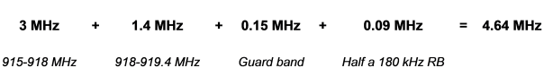
This means that in practice, in this worst case condition, only 3 RB of the FRMCS channel have an offset lower than 5 MHz toward upper edge of UL band.
Robustness to interferers is specified through blocking specification. When considering frequency offset possibility, two specifications are applicable to the situation under investigation: narrowband and general blocking. Performances as specified for LTE and MSR systems are listed in the following table.
Table 24: Summary of blocking parameters for MFCN base stations
Several important properties can be identified in this table:
- All systems are more robust to signals over 5 MHz edge-to-edge offset from useful channel;
- Difference is 9 dB for LTE, and MSR systems used for LTE;
- Difference for MSR used for NR is 6 dB;
- MSR used for GSM is more robust than for LTE or NR.
As a consequence, studying the impact and determining LRTCs based on the MFCN#1 using LTE or NR in the highest part of MFCN 900 band guarantees that other systems will be less impacted:
- MFCN#2 systems using the second to highest channel in the MFCN 900 band;
- MSR systems used for GSM.
  - MFCN using only GSM standard
The performances to be considered are from ETSI TS 145 005 [7]. Two variants of equipment can be considered:
- Legacy GSM base station;
- Multi-Carrier GSM base station.
Base Stations blocking performances can be summarised as follows.
Table 25: Blocking parameters summary applicable to GSM only BS
(extract from ETSI TS 145 005)
From this table, one can note that the specified blocker levels for GSM, whether legacy or multi-carrier base stations, have a much higher RF power than blocker levels considered in LTE and MSR systems. For offsets higher than 3 MHz, the lowest difference is 27 dB. This guarantees that FRMCS levels deemed acceptable for LTE systems and MSR (both LTE or NR) will have no impact on a GSM only base station (whether legacy or Multi-Carrier).
  - Conclusion
The analysis documented in the present contribution shows that the sensitivity of MFCN to RMR emissions depends on the position of the sub band inside the MFCN 900 band and depends on the standard of the MFCN system:
- MFCN systems using GSM standards (MSR, Multi-carrier or GSM legacy) have higher robustness to RMR emissions;
- MFCN using LTE or MSR in LTE or NR mode operating in the second to highest channel have a better robustness to RMR emissions than similar MFCN system using the highest channel in the MFCN 900 band (i.e. just below 915 MHz);
- It is thus concluded that the study of the impact of RMR base stations operating in 919.4-925 MHz onto MFCN systems operating below 915 MHz shall focus on the highest MFCN channel below 915 MHz and on MFCN operating LTE or MSR in LTE or NR.

- Inputs for the statistical approach – ANFR’s study
  - Data source and contents
The dataset comes from an ANFR internal database. Some of these elements are already provided as open-data on cartoradio.fr and on data.gouv.fr. For the purpose of this study, the following information is used (shown here as SQL DDL):

CREATE TABLE sectors (
id INTEGER PRIMARY KEY AUTOINCREMENT,
sectorid INTEGER,
comsis INTEGER, -- one for each site, allows to group sectors per sites
h FLOAT, -- antenna height
alt INTEGER, -- altitude (as per a digital terrain model)
freq FLOAT, -- center frequency
tilt INTEGER, -- tilt of the antenna (usually negative number)
azh INTEGER, -- azimuth of the antenna
pow FLOAT, -- e.i.r.p. in dBm
INSEE VARCHAR (5),
lat FLOAT, -- latitude, converted from DMS i.e. accuracy is one arc-second
lon FLOAT, -- longitude, converted from DMS i.e. accuracy is one arc-second
tech VARCHAR (10), -- technology (UMTS 900, GSM R, etc.)
op VARCHAR (4) -- operator (SFR, Orange, Bouygues, Free, RMR)
);
In the few cases where an information element is missing (e.g. tilt value at “NULL”), the reference default value is chosen (e.g. -3° for MFCN, -2° for RMR for the tilt).
  - High level description of the dataset
Table 26: Dataset
Population | Number | Query
RMR antennas | 7497 | select count(*) from sectors where freq>921 and freq<925
RMR sites | 3631 | select count(*) from (select comsis from sectors where freq>921 and freq<925 group by comsis)
MFCN antennas | 392770 | select count(*) from sectors where freq>925 and freq<960
MFCN sites | 45772 | select count(*) from (select comsis from sectors where freq>925 and freq<960 group by comsis)
MFCN915 antennas | 113075 | select count(*) from sectors where freq>950 and freq<960
MFCN915 sites | 21337 | select count(*) from (select comsis from sectors where freq>950 and freq<960 group by comsis)
These numbers reflect the whole population in the datasets (before any buffer or filtering is applied).
The figure below provides a CDF of the current GSM-R e.i.r.p.: two curves are based on the latest SNCF data (including e.i.r.p. below 1 W) and one curve is based on ANFR internal database.
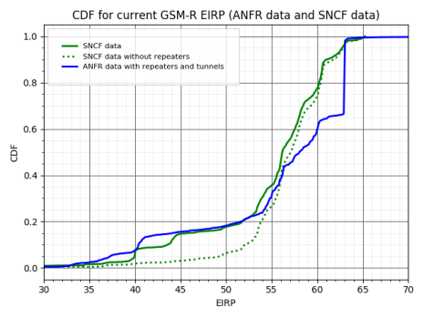
Figure 29: cdf of e.i.r.p. for current GSM-R sites in France

Table 27: Proportion of the sites operating at least at a given EIRP
e.i.r.p. (dBm) | 66 | 63 | 60 | 57 | 45
ANFR data | 45 (0 %) | 143 (1 %) | 2669 (35 %) | 3643 (48 %) | 5608 (74 %)
SNCF data | 0 (0 %) | 208 (3 %) | 1270 (19 %) | 2558 (38 %) | 5128 (77 %)
  - Antennas
The following reference antennas were used:
- For RMR: Kathrein 80010305v02, and F.1336 [6] with (65° HPBWh, 8.5° HPBWv, 17 dBi Gain);
- For MFCN: Kathrein 80010767, and F.1336 with (65° HPBWh, 15° HPBWv, 15 dBi Gain).
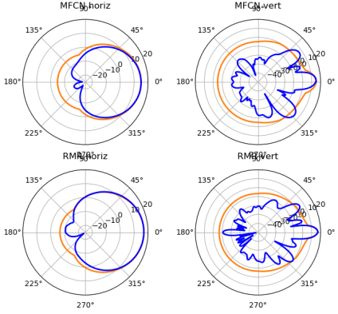
Figure 30: Reference antennas
Then it is possible to perform computations on couples of sectors (S1,S2), using angles (θ,ϕ) properly computed from azimuths/tilts and the respective bearings. A new table “dsectors” is generated as the result of the computation between all pairs of sectors in the database that are distant from less than 1 or 5 km. For each couple (sector1 (RMR), sector2 (MFCN)), it stores information about the computation of:
- distance, horizontal bearing and vertical angle between sites hosting those sectors (taking into account their respective height and altitude);
- relative gains with real/tabular antenna patterns and with F.1336 antenna patterns (taking into account the horizontal/vertical angles of sectors with regard to the direction towards the other sector);
- coupling loss (with tabular and F.1336 antenna patterns) taking into account the relative gains in the other sector’s direction:
 | $$CL\left(S1,S2\right)=\underset{EPM73}{\underbrace{PL\left(d\right)}}-G_{RMR}(θ_{1},φ_{1})+L_{RMR}-G_{MFCN}(θ_{2},φ_{2})+L_{MFCN}$$ | (20)
- the allowed e.i.r.p. on S1 to avoid desensitisation by more than 1 dB on S2 is computed as:
 | $${EIRP}_{RMR}\left(S1,S2\right)=\underset{I_{OOB}}{\underbrace{N_{BW}+{\left(\frac{I}{N}\right)}_{D=1dB}+S_{f_{c},BW}}}+CL\left(S1,S2\right)+{(G}_{RMR_max}-L_{RMR})$$ | (21)
  - Results
A few remarks on the CDF generated:
- The CDF are computed from the whole population of couples of sectors. When an RMR site has no MFCN neighbour in its vicinity, it is not included in the table. This is compensated by scaling the CDF with the size of the population. Computations have been done for 1 km and 5 km buffer zones;
- Making aggregates (group by clause in SQL) can lead to differences depending on the considered population. For example, if the minimum of the coupling losses between one RMR antenna and all its MFCN neighbours is considered, having a population from all MFCN operators may lead to a different CDF compared to a scenario with only one MFCN operator;
- The result is expected to be conservative for several reasons, e.g. no digital terrain model is used (which leads to significant differences in areas with urban canyons such as Paris). This is explored in the last section of this annex.
    - CDF on MCL
First subsection shows statistics on raw coupling losses (for information). Next figures are then derived when grouping data by {RMR, MFCN} sectors respectively and picking the minimum of the MCL value for each group. For each of them:
- Left vertical graduation shows the percentage of sectors with regards to the total population; for example, many RMR sites have no MFCN neighbour within a 1 km buffer zone;
- Right vertical graduation shows the percentage with regards of the population in the dataset for CDF;
- All figures are based on ANFR internal database. In all figures, continuous lines are with F.1336 model while dashed lines are computed with real antenna pattern. They exhibit that F.1336 leads to pessimistic results compared to tabular antenna patterns.
For CDF of CL between RMR sectors and the worst MFCN sector from the operator closest in frequency to the RMR channel (noted “ClosestMNO”), a threshold has been set at 7% of the CDF i.e. the CL value X represents the value so that 7% of RMR sectors would have at least one MFCN neighbour with a CL less than X dB, and therefore 93% of RMR sectors would have no MFCN neighbour less than X dB. The threshold of 7% has been chosen as a compromise value between 5% and 10%.
      - CDF of raw CL between couples of sectors at 920 MHz
The figure on the left shows the CDF of the coupling losses between RMR and MFCN antennas within a buffer of 1 km. Figure on the right shows the scatter plot of coupling losses vs distance up to 5 km (with F.1336 [6] antenna pattern, whose minimum gain is still quite high).
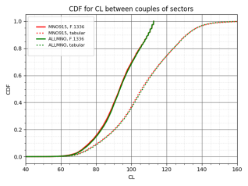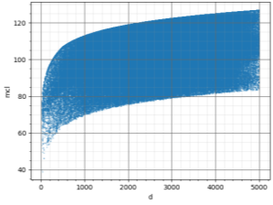
Figure 31: Left - cdf of CL between RMR antennas and MFCN antennas within 1 km; Right - CL losses between RMR antennas and MFCN antennas for MFCN sites within 5 km as a function of distance
CDF of the MCL between pairs of {RMR, MFCN} sectors:
- 90 % of the links have a CL > 76 dB;
- No significant difference between “MNO915” and “AllMNO” scenarios;
- For a defined distance, there is more than 40 dB of variation between the worst case and the best case (which itself is bounded by the F.1336 [6] formula while a tabular formula would allow it to grow to higher values).
      - CL between RMR sectors and the worst MFCN sector at 920 MHz
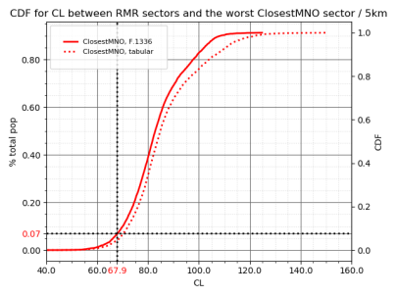
Figure 32: cdf for CL between RMR sectors and the worst ClosestMNO sector
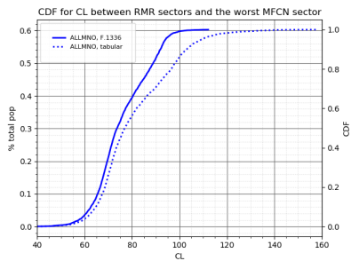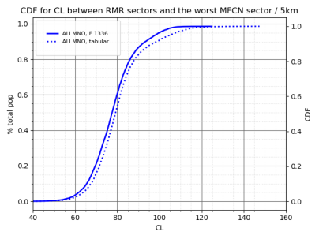
Figure 33: cdf for CL between RMR sectors and the worst MFCN sector

      - CL between MFCN sectors and the worst RMR sector at 920 MHz
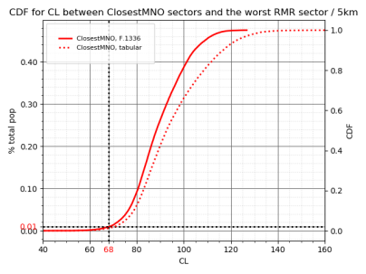
Figure 34: cdf for CL between ClosestMNO sectors and the worst RMR sector
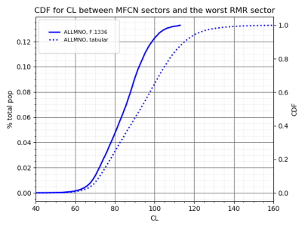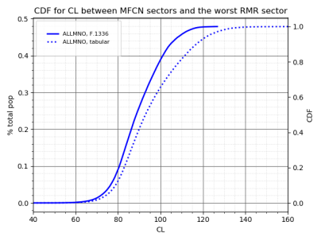
Figure 35: cdf for CL between MFCN sectors and the worst RMR sector
      - Further assumption for the 1900 MHz range
In the case of the study at 1900 MHz, pseudo-RMR sites were inserted between RMR sites distant from more than 5 km in non-urban areas with their 2 closest neighbours (using a classification from 1 to 4 from INSEE for determining dense/urban/suburban/rural areas, and excluding all cities with a value of 1 in this classification. In the following figure, existing RMR sites are in red and pseudo-RMR sites are in green). This is not perfect (it could be further improved by using a shapefile), yet expected to reasonably simulate a possible densification of RMR sites in this frequency band. This adds 670 sites (1340 sectors) to the RMR population. MFCN and RMR antenna gains are both 18 dBi.
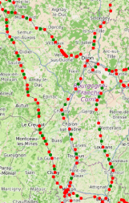
Figure 36: Simulated densification of RMR 900 MHz sites to model 1900 MHz RMR coverage
(red: existing sites, green: infill sites)
      - CL between RMR sectors and the worst MFCN sector at 1900 MHz
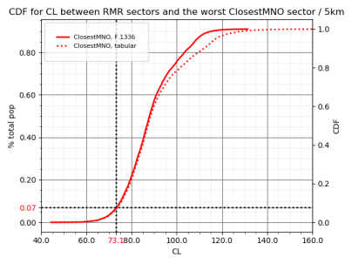
Figure 37: cdf for CL between RMR sectors and the worst ClosestMNO sector
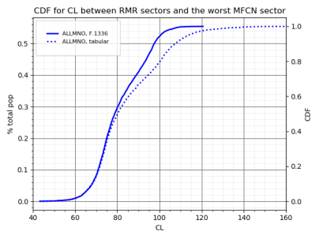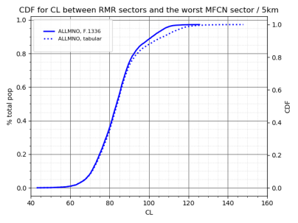
Figure 38: cdf for CL between RMR sectors and the worst MFCN sector
      - CL between MFCN sectors and the worst RMR sector at 1900 MHz
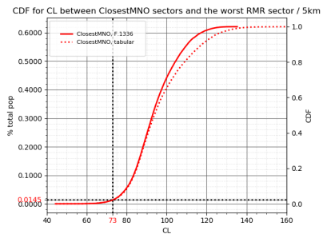
Figure 39: cdf for CL between ClosestMNO sectors and the worst RMR sector
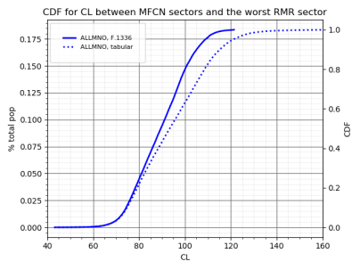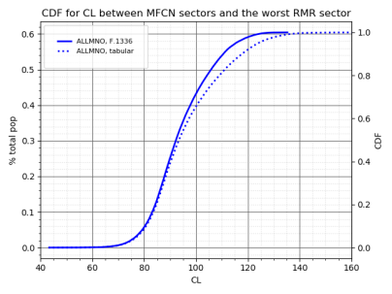
Figure 40: cdf for CL between MFCN sectors and the worst RMR sector
      - Observations
It can be observed that:
- 40% of RMR sectors have no MFCN neighbour in the 1 km buffer zone, and 55% of RMR sectors have no MNO915 neighbour in the buffer zone;
- Conversely, less than 14% of the MFCN sector population has a RMR sector within a 1 km buffer zone.
- Increasing the buffer zone from 1 km to 5 km does not change significantly the CDF for low MCL (most sectors distant from more than 1 km have a high coupling loss);
- At 900 MHz, 7% of RMR sectors have (at least) one neighbour with a CL <= 68 dB and therefore 93% of RMR sites with a MFCN neighbour in the buffer zone have no situation with a CL <= 68 dB;
- At 1900 MHz, 7% of RMR sectors have (at least) one neighbour with a CL <= 73 dB.
      - Sensitivity analysis on buffer size
From the results above, it has already been observed that increasing the buffer size from 1 km to 5 km does not change significantly the CDF for low CL values (which is consistent with the fact that sites far away are more likely to exhibit a higher coupling loss). It mechanically increases the population size (including the number of sites that are likely to face desensitisation by more than 1 dB if e.i.r.p. was identical to GSM-R), however the average desensitisation is typically low and rarely achieves high values, and this has to be balanced with the lack of a digital terrain model in this study (i.e. the theoretical path loss from the propagation model is more likely to be underevaluated considering hills, trees, buildings, etc.).
    - Sensitivity analysis on location / population density
      - Location of sites with MCL <= 68 dB at 920 MHz
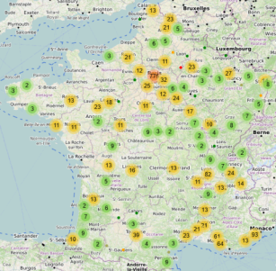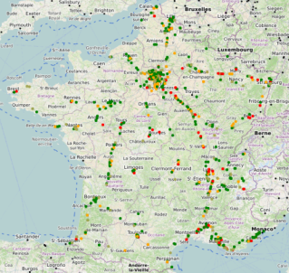
Figure 41: Location of sites with MCL <= 68 dB at 920 MHz
The maps above show the location of the MFCN sectors that have an RMR neighbour with MCL less than 68 dB (on the left map, they are grouped with clustering. On the right map, dots have a colour that depends on how much lower the MCL is compared to the reference value of 68 dB: e.g. all green points have an MCL that is between 65 and 68 dB).
It can be observed that most of the MFCN sites that would face a neighbour with less than 68 dB MCL are located in the (wide) metropolitan areas of Lille, Paris, Lyon, Marseille and Nice. Those are mostly urban areas where EPM-73 propagation model may be overly pessimistic. The same observation can be made for the location of MFCN sites experiencing a possible future RMR neighbour at 1900 MHz with coupling loss less than 73 dB.

      - Location of sites with MCL <= 73 dB at 1900 MHz
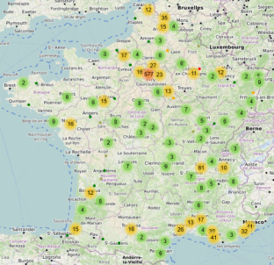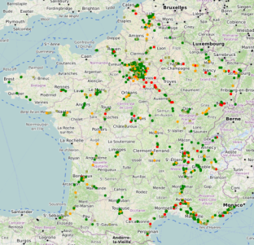
Figure 42: Location of sites with MCL <= 73 dB at 1900 MHz
      - Compared CDF of coupling loss in urban areas vs. other areas at 1900 MHz
Every city and village in France has an ID called “INSEE code”. There is an available classification of the average density of population within each city based on its INSEE code (which is less accurate than a real density estimation around each RMR/MFCN site based on latitude/longitude, yet it gives a rough estimate of whether the site is located in urban/suburban/rural area). This has been integrated in our dataset in the field “dclass” (1= dense urban area. 4=rural area).
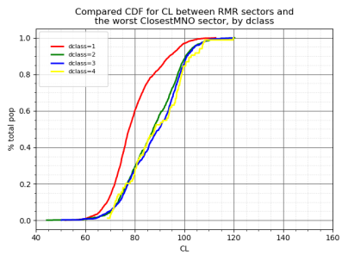
Figure 43: Compared CDF for CL between RMR sectors and the worst ClosestMNO sector
This figure shows how much the CDF differentiate for CL between RMR sectors and the worst closest (in frequency) MFCN network in a 1 km buffer zone, depending on the area classification of the RMR sector (urban/suburban/average/rural). It appears clearly that the dense urban area (dclass=1) have a significantly different CL CDF, which is reflected by the more frequent occurrence of sites close to each other.
The next figure shows the CDF of CL between RMR sectors and the worst sector from the closest MNO in frequency at 1900 MHz, excluding sites in dense urban areas. Compared to section A2.4.1.5, the threshold at 7% has shifted from 73 dB to 81 dB.
Figure 44: CDF for CL between RMR sectors and the worst ClosestMNO sector
      - Excess loss over free space in urban areas
A simulation has been performed using ATDI ICS Telecom, assessing the path loss between GSM-R and MFCN sites inside the city of Paris. The output value “Excess loss over free space (dB)” gives the following CDF and statistics at 900 MHz
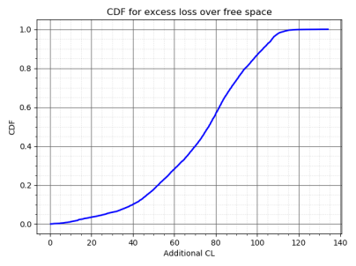 | 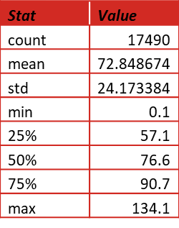
Figure 45: cdf for excess loss over free space
This simulation is imperfect for several reasons:
- Only MFCN victims with panel antennas were considered (i.e. microcells with different antenna types were ignored);
- Values less than 0 dBµV/m are ignored, which can bias the statistics (most probably eliminating very high path losses);
- Sites located in tunnel are not simulated as such (i.e. some sites show a lower path loss than in reality);
- The buffer zone for simulations around RMR sites is 1 km. P.452-14 10% is used. Kathrein 80011877 is used for all panel antennas (RMR and MFCN). For Yagi, Amphenol 747830 is used;
- No “group by” clause is applied i.e. this CDF should be considered with the same care as the raw CDF in section A2.4.1.1.
However despite those imperfections, this suggests quite clearly that the EPM-73 model may not be representative of the much stronger path loss in urban areas with high losses due to buildings (EPM-73 has at most 2.5 dB higher than free space at 900 MHz and 3.2 dB higher than free space at 1900 MHz).
    - Statistics on e.i.r.p.
The following tables show the number and percentage of RMR sectors and sites that could not use a target e.i.r.p. without coordination and of MFCN sectors and sites that could be affected by more than 1 dB desensitisation. The computation is done both for a 1.4 MHz FRMCS carrier starting at 919.5 MHz and for a for 5 MHz carrier centred at 922.5 MHz. The percentages shown are versus the total population (see section A2.2 above). When performing the computation, the buffer zone around RMR sites is set to 1 km, excluding sites that are located in tunnels.
The statistics related to the “AllMNO scenario” take into account the increase of the MFCN BS selectivity when the edge-to-edge offset from the interferer is greater than 5 MHz.
Only the blocking phenomenon is taken into account in the following tables; the effect of RMR unwanted emissions is excluded. FRMCS and GSM-R BS share the same radio sites.
The first column “Current GSM-R” provides statistics when FRMCS BS have the same e.i.r.p. as GSM-R BS. The other columns assume that all FRMCS BS have an e.i.r.p. equal to the title value.
Table 28: Group by sectors, 1.4 MHz FRMCS carrier
 |  | Current GSM-R | 63 | 60 | 57 | 45
AllMNO F.1336 | RMR  MNO | 1075 (16.63 %)  2713 (1.27 %) | 1879 (29.06 %)  5093 (2.38 %) | 1382 (21.37 %)  2987 (1.39 %) | 857 (13.25 %)  1570 (0.73 %) | 81 (1.25 %)  117 (0.05 %)
AllMNO tabular | RMR  MNO | 844 (13.05 %)  1748 (0.82 %) | 1518 (23.48 %)  3302 (1.54 %) | 1038 (16.05 %)  1865 (0.87 %) | 604 (9.34 %)  975 (0.45 %) | 49 (0.76 %)  70 (0.03 %)
ClosestMNO F.1336 | RMR  MNO | 508 (7.86 %)  668 (1.29 %) | 956 (14.79 %)  1301 (2.51 %) | 648 (10.02 %)  753 (1.45 %) | 384 (5.94 %)  424 (0.82 %) | 22 (0.34 %)  21 (0.04 %)
ClosestMNO tabular | RMR  MNO | 356 (5.51 %)  418 (0.81 %) | 708 (10.95 %)  847 (1.63 %) | 433 (6.70 %)  480 (0.93 %) | 239 (3.70 %)  274 (0.53 %) | 12 (0.19 %)  11 (0.02 %)
Table 29: Group by sectors, 5 MHz FRMCS carrier
 |  | Current GSM-R | 63 | 60 | 57 | 45
AllMNO F.1336 | RMR  MNO | 106 (1.64 %)  193 (0.09 %) | 183 (2.83 %)  272 (0.13 %) | 102 (1.58 %)  161 (0.08 %) | 46 (0.71 %)  68 (0.03 %) | 3 (0.05 %)  6 (0.00 %)
AllMNO tabular | RMR  MNO | 72 (1.11 %)  112 (0.05 %) | 126 (1.95 %)  181 (0.08 %) | 68 (1.05 %)  95 (0.04 %) | 36 (0.56 %)  48 (0.02 %) | 3 (0.05 %)  4 (0.00 %)
ClosestMNO F.1336 | RMR  MNO | 36 (0.56 %)  46 (0.09 %) | 65 (1.01 %)  70 (0.14 %) | 36 (0.56 %)  37 (0.07 %) | 11 (0.17 %)  11 (0.02 %) | 2 (0.03 %)  2 (0.00 %)
ClosestMNO tabular | RMR  MNO | 23 (0.36 %)  28 (0.05 %) | 44 (0.68 %)  45 (0.09 %) | 20 (0.31 %)  19 (0.04 %) | 8 (0.12 %)  8 (0.02 %) | 1 (0.02 %)  1 (0.00 %)
Table 30: Group by sites, 1.4 MHz FRMCS carrier
 |  | Current GSM-R | 63 | 60 | 57 | 45
AllMNO F.1336 | RMR  MNO | 808 (23.93 %)  1567 (3.58 %) | 1325 (39.25 %)  2634 (6.02 %) | 1027 (30.42 %)  1670 (3.82 %) | 666 (19.73 %)  900 (2.06 %) | 75 (2.22 %)  79 (0.18 %)
AllMNO tabular | RMR  MNO | 689 (20.41 %)  1152 (2.63 %) | 1150 (34.06 %)  1970 (4.51 %) | 828 (24.53 %)  1146 (2.62 %) | 496 (14.69 %)  598 (1.37 %) | 46 (1.36 %)  50 (0.11 %)
ClosestMNO F.1336 | RMR  MNO | 407 (12.06 %)  528 (2.70 %) | 692 (20.50 %)  894 (4.57 %) | 485 (14.37 %)  550 (2.81 %) | 305 (9.03 %)  300 (1.53 %) | 20 (0.59 %)  20 (0.10 %)
ClosestMNO tabular | RMR  MNO | 304 (9.00 %)  358 (1.83 %) | 552 (16.35 %)  641 (3.27 %) | 358 (10.60 %)  361 (1.84 %) | 207 (6.13 %)  202 (1.03 %) | 11 (0.33 %)  11 (0.06 %)
Table 31: Group by sites, 5 MHz FRMCS carrier
 |  | Current GSM-R | 63 | 60 | 57 | 45
AllMNO F.1336 | RMR  MNO | 99 (2.93 %)  120 (0.27 %) | 171 (5.07 %)  173 (0.40 %) | 96 (2.84 %)  99 (0.23 %) | 44 (1.30 %)  48 (0.11 %) | 3 (0.09 %)  3 (0.01 %)
AllMNO tabular | RMR  MNO | 66 (1.95 %)  82 (0.19 %) | 118 (3.50 %)  120 (0.27 %) | 64 (1.90 %)  68 (0.16 %) | 34 (1.01 %)  37 (0.08 %) | 3 (0.09 %)  3 (0.01 %)
ClosestMNO F.1336 | RMR  MNO | 33 (0.98 %)  37 (0.19 %) | 59 (1.75 %)  57 (0.29 %) | 31 (0.92 %)  30 (0.15 %) | 11 (0.33 %)  11 (0.06 %) | 2 (0.06 %)  2 (0.01 %)
ClosestMNO tabular | RMR  MNO | 21 (0.62 %)  25 (0.13 %) | 40 (1.18 %)  39 (0.20 %) | 19 (0.56 %)  19 (0.10 %) | 8 (0.24 %)  8 (0.04 %) | 1 (0.03 %)  1 (0.01 %)

- Statistical approach – France data
  - DATA SOURCE AND CONTENTS
The study is based on a dataset sourced from the cartoradio.fr website on the 1st of April 2019 with data managed by the French spectrum agency “Agence nationale des fréquences” (ANFR).
The dataset notably contains data on:
- RMR base stations
Their geographical coordinates (EPSG:4326 – WGS84);
The height and azimuth of the antennas.
- MFCN base stations, notably the French MFCN operator occupying the spectrum below 915 MHz:
Their geographical coordinates (EPSG:4326 – WGS 84);
The height and azimuth of the antennas;
The frequency band.
Note: the “cartoradio” data does not contain antenna tilt information. Due to the lack of a rural/suburban/urban classification shapefile (see 3.4.1.4), the current version of the study assumes a 2° downtilt for both RMR and MFCN antennas.
  - HIGH-LEVEL DESCRIPTION OF THE TWO POPULATIONS
    - The RMR network
Table 32: RMR network
Parameter | Count
Sites | 2350
Antennas | 4752
    - The MFCN network (900 MHz)
Table 33: MFCN network (900 MHz)
Parameter | All operators | MFCN915
Sites | 7254 | 2937
Antennas | 26240 | 8207
    - A note on antenna azimuths distributions between RMR and MFCN
The following figures depict the distribution of antenna azimuths for RMR and MFCN915 900 MHz antennas respectively. Where the RMR antenna azimuth distribution does not show a clear pattern, the MFCN915 900 MHz antenna azimuths exhibit a clear bias towards 0°, 120° and 240°. This appears to be consistent with other MFCN operators except for one which has a 30° rotated pattern (30°, 150°`and 270°).
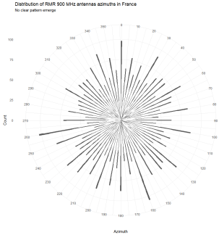 | 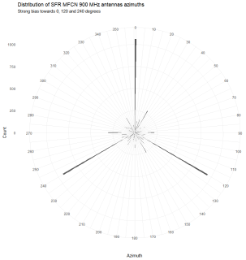
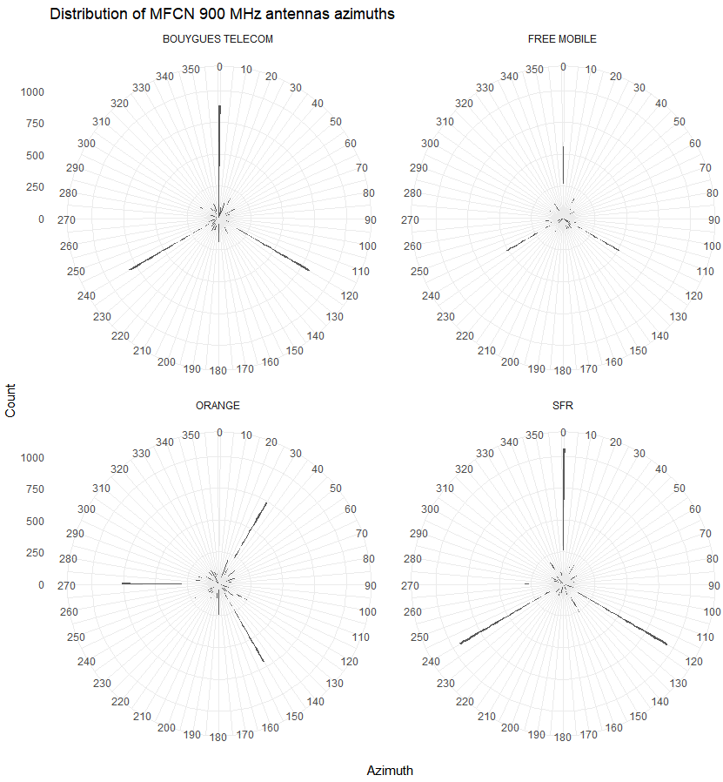
Figure 46: Distribution of antenna azimuths for RMR and MFCN915 900 MHz antennas
  - Distribution of the sites before calculating coupling
After filtering of sites based on a 600 m threshold and leaving out co-located or underground sites, the sites remaining can be summarised as follows:
Table 34: 600 m buffer
600 m buffer | 900 MHz  All MFCN |  | MFCN915
System | Count | Proportion | Count | Proportion
RMR | 1067 | 45.4% | 623 | 26.5%
MFCN | 2042 | 28.1% | 779 | 26.5%

Hence one can notice that about a quarter of the RMR sites are within 600 m from a MFCN base station operating in the spectrum just below 915 MHz and less than half are within 600 m from a MFCN 900 MHz base station. Less than a third of the MFCN 900 MHz sites are within 600 m from an RMR site and only about a quarter for the MFCN915 operator.
When performing the same analysis with a 1 km buffer for 900 MHz sites, the figures are as follows:
Table 35: 1 km buffer
1 km buffer | 900 MHz  All MFCN |  | MFCN915
System | Count | Proportion | Count | Proportion
RMR | 1716 | 73.0% | 1156 | 49.2%
MFCN | 4665 | 64.3% | 1832 | 62.4%

One can see that even with a larger buffer (1 km instead of 600 m), a large proportion of RMR sites (almost 50%) have no neighbouring MFCN base station operating in the spectrum just below 915 MHz.
  - Elevation calculations
In the current version of the study, the altitude of the RMR and of the MFCN sites was supplied by SNCF on the basis of their Digital Terrain Model. As such, the elevation angle between an RMR antenna and a MFCN antenna (and the reverse) are calculated based on the actual ASL altitudes of the respective antennas.
Note: in hilly terrain and at long distances, the model still may underestimate the effect of irregular terrain on signal propagation. Similarly, in dense areas, it is likely that houses and buildings would also result in attenuation of the signal. In general, it is the authors’ belief that the chosen propagation model is rather conservative as compared to real life conditions.
  - Horizontal and vertical discrimination
The characteristics of the antenna used are that of Kathrein K80010305 antenna for RMR sites and Kathrein K80010767. This modelling of the antenna is perceived as being somewhat pessimistic (for example, railways notably use on occasion more directive antennas).
  - Outcome
    - Cumulative Distribution Functions
MFCN915 is the most sensitive to RMR interference. The following CDF presents the coupling loss distribution between RMR and MFCN915 sites in France.
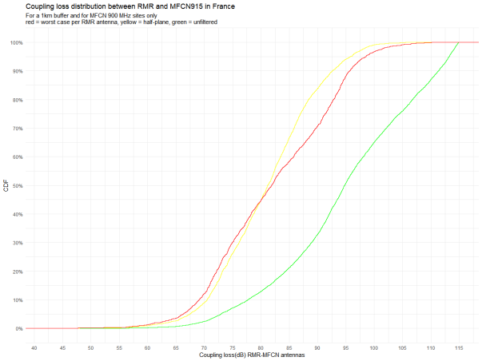
Figure 47: Coupling loss distribution between RMR and MFCN915 sites in France
The following CDFs present the coupling loss distribution between RMR and the other operators in France. A 9 dB indicative correction is provided to account for the lesser sensitivity to interference of channels below the highest MFCN channel in the MFCN 900 band to help with the comparison.
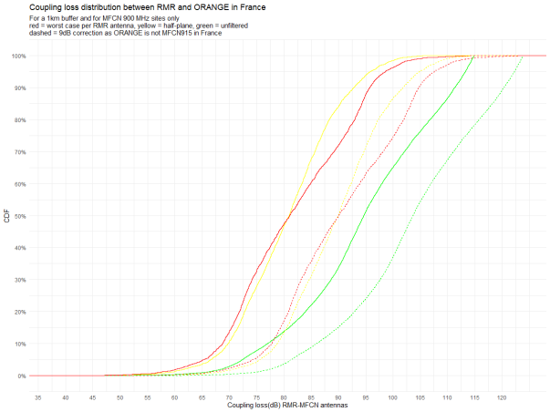
Figure 48: Coupling loss distribution between RMR and ORANGE in France
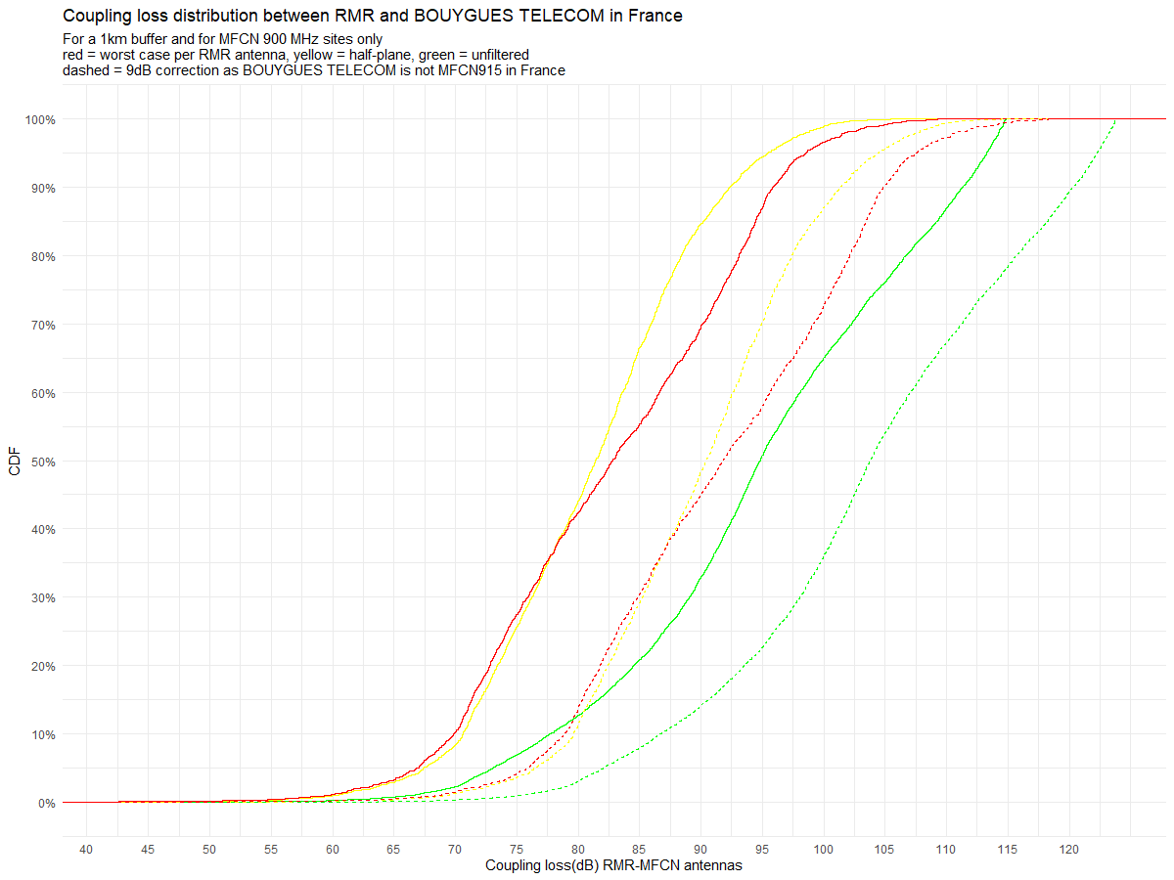
Figure 49: Coupling loss distribution between RMR and BOUYGES TELECOM in France
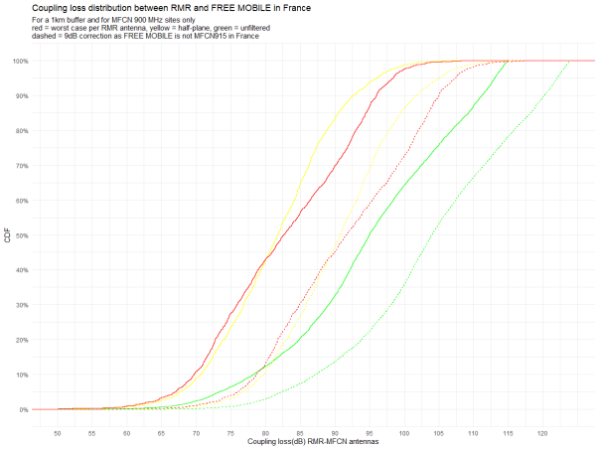
Figure 50: Coupling loss distribution between RMR and FREE MOBILE in France
    - Scatter plots
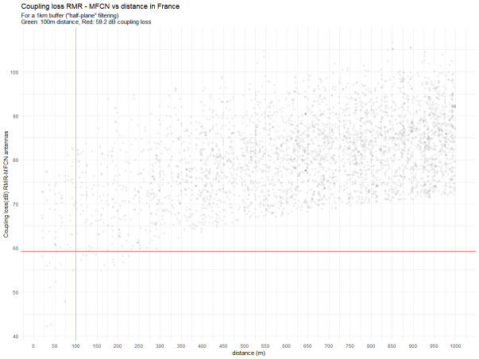
Figure 51: Coupling loss RMR-MFCN vs distance in France

- Statistical approach – Sweden data
  - DATA SOURCE AND CONTENTS
The study is based on a dataset provided by Trafikverket containing data on:
- RMR base stations from Trafikverket, including notably:
Their geographical coordinates (EPSG:3847 – SWEREF99 / RT90 2.5 gon V);
The height, azimuth, tilt and type of the antennas;
The altitude of the site.
- MFCN base stations operated by the Swedish MFCN operator occupying the spectrum below 915 MHz (in practice, the subset of the MFCN sites that are in proximity of the railways sites), including notably:
Their geographical coordinates (EPSG:4326 – WGS 84);
The height, azimuth, tilt and type of the antennas;
The system deployed, i.e. GSM, UMTS or LTE;
The frequency band used on a per antenna basis.
  - HIGH-LEVEL DESCRIPTION OF THE TWO POPULATIONS
    - The RMR network
Table 36: RMR network
Parameter | Count
Sites | 1371
Antennas | 2296
    - The MFCN network (subset 10km from the track)
Table 37: MFCN network
Technology | All bands | 900 MHz
MFCN sites | 9596 | 4448
… with GSM / UMTS / LTE | 4185 | 0
… with only GSM | 377 | 299
… with only UMTS | 3867 | 3
… with only LTE | 570 | 0
… with GSM / LTE | 254 | 0
… with GSM / UMTS | 156 | 4146
… with UMTS / LTE | 187 | 0
The above table features the MFCN sites across all bands present in the dataset (GSM900, GSM1800, LTE800, LTE1800, LTE2600, UMT900, UMTS2100) and the second column presents the number of sites featuring at least one 900 MHz system. The present study focuses on RMR-MFCN coexistence for the 900 MHz band.
    - A note on antenna azimuths distributions between RMR and MFCN
The following figures depict the distribution of antenna azimuths for RMR and MFCN915 900 MHz antennas respectively. Where the RMR antenna azimuth distribution does not show a clear pattern, the MFCN915 900MHz antenna azimuths exhibit a clear bias towards 0°, 120° and 240°.
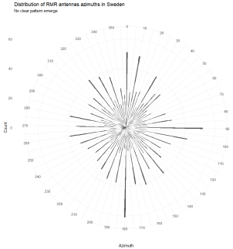 | 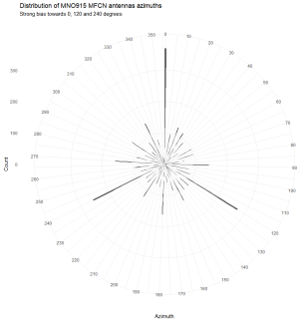
Figure 52: Distribution of antenna azimuths for RMR and MFCN915 900 MHz antennas
  - Distribution of the sites before calculating coupling
After filtering of sites based on a 600 m threshold and leaving out co-located or underground sites, the sites remaining can be summarised as follows:
Table 38: 600 m buffer
600 m buffer | All bands |  | 900 MHz
System | Count | Proportion | Count | Proportion
RMR | 619 | 45% | 455 | 33.2%
MFCN | 1756 | 18.3% | 529 | 05.5%
Hence one can notice than less than a third of the RMR sites are within 600 m from a MFCN base station operating in the spectrum just below 915 MHz. Less than one in five of the MFCN sites within the dataset are within 600 m from a RMR site and about one in twenty if considering only the ones that use the 900 MHz frequency band.
When performing the same analysis with a 1 km buffer for 900 MHz sites, the figures are as follows:
Table 39: 1 km buffer
1 km buffer | 900 MHz
System | Count | Proportion
RMR | 592 | 42.9%
MFCN | 857 | 08.9%
One can see that even with a larger buffer (1 km instead of 600 m), a large proportion of RMR sites (almost 60%) have no neighbouring MFCN base station operating in the spectrum just below 915 MHz.
  - Elevation calculations
In the current version of the study, the altitude of the respective RMR sites was supplied by Trafikverket and the altitudes for the MFCN sites were taken from Trafikverket’s Digital Terrain Model for the location of the MFCN site. As such, the elevation angle between a RMR antenna and a MFCN antenna (and the reverse) are calculated based on the actual ASL altitudes of the respective antennas.
Note: in hilly terrain and at long distances, the model still may underestimate the effect of irregular terrain on signal propagation. Similarly, in dense areas, it is likely that houses and buildings would also result in attenuation of the signal. In general, it is the authors’ belief that the chosen propagation model is rather conservative as compared to real life conditions.
The following picture is an example of such situation (visualised with the help of Google EarthTM) where the presence of a building higher than the MFCN site location (at the top of the image) would certainly imply a propagation loss between the sites significantly higher than envisioned by the EPM-73 + ASL DTM model.
Figure 53: Example of building obstruction between a RMR and a MFCN site in Sweden
  - Horizontal and vertical discrimination
The characteristics of the antenna used are in majority that of Kathrein K80010305 antenna for RMR sites and Kathrein K80010767. In practice, where the dataset allowed to identify the use of an omnidirectional antenna on the RMR side, the formulas from Recommendation ITU-R F.1336 has been used, taking into account the characteristics of the Kathrein antenna model (K736347 or K736349) (notably gain and vertical half power beam width opening angle).
This modelling of the antenna is perceived as being somewhat pessimistic (for example, railways notably use on occasion more directive antennas and the sites where omnidirectional antennas are currently used for GSM-R would probably use directive antennas for FRMCS).
  - Outcome
    - Cumulative Distribution Functions
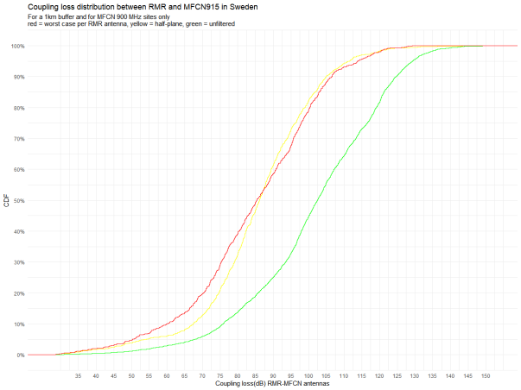
Figure 54: Coupling loss distribution between RMR and MFCN915 in Sweden
    - Scatter plots
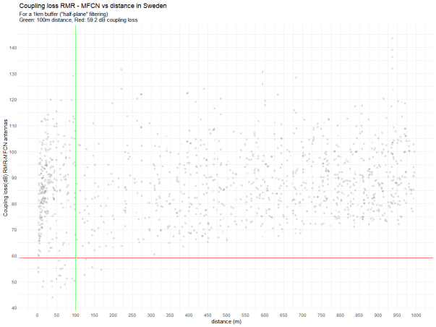
Figure 55: Coupling loss RMR-MFCN vs distance in Sweden
- German study of RMR-MFCN coexistence in railway environment
  - Railway mobile radio
DB Netz AG is the railway infrastructure manager of Deutsche Bahn AG and is responsible for the approximately 33000 km rail network, including all operational necessary installations. An average of 40,000 trains are using DB Netz AG’s infrastructure per day. The main task is to make available a high–quality, high-availability, and non-discriminatory railway infrastructure to around 420 Railway Undertakings. The GSM-R radio network is in operation since 2004.
GSM-R-based services and applications do contribute to the overall safety of railway operation. Therefore, highest quality for GSM-R voice and data communication with low interference and high speech quality is needed.
The key figures for the German RMR (GSM-R) network are:
- DB Netz AG is using 2 x 7 MHz in the 873-880 MHz (uplink)/918-925 MHz (downlink) band for the GSM-R radio network;
- The GSM-R deployment in Germany is designed to meet the EIRENE specifications [30];.
- The GSM-R cell radius is in the range of a few hundred meters to several kilometres;
- GSM-R applications and services with dedicated antennas, no in train coverage for GSM-R;
- Current GSM-R radio BTS configurations typically use one or two GSM-R RF carriers per radio cell. In dense areas, up to 4 GSM-R RF carriers per radio cell are used today;
- Covered track length: ca. 29500 km;
- Dedicated GSM-R tunnel coverage, mainly in metropolitan areas and on high-speed lines with a total length of more than 500km;
- ca. 3900 GSM-R radio sites.
The nationwide radio coverage for the current GSM-R radio network is shown in the following figure.
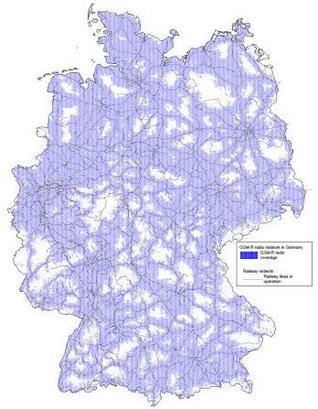
Figure 56: RMR (GSM-R) radio network in Germany
The GSM-R radio network of DB Netz AG is used today for mission-critical voice and data services. The European Train Control System (ETCS) requires high-availability GSM-R data services at all times. Voice services are important, including features such as the Railway Emergency Call (REC), and it is notable that the special features built in to GSM-R are a prerequisite for the safe railway operation.
Spectrum demand for GSM-R continues to grow:
- The railway passenger and freight traffic are expected to be doubled within 10 to 15 years.
- Further ETCS implementations (e.g. in accordance with the European Deployment Plan and on national level).
- The migration of voice and partly data services from analogue to digital – particularly in shunting areas where voice is partly still supported by legacy analogue VHF radio networks –is still ongoing.
- Transit railway traffic and a strong growth in passenger traffic are increasing the pressure to enhance efficiency.
DB Netz AG is in an ongoing nationwide reinvest programme for all GSM-R base stations since 2015. The programme involves the total length of ca. 30,000 km of the German railway network with GSM-R radio coverage. The new base station technology was tested and is being rolled out since summer 2018 in first test areas under railway-operational conditions. After finalising the nationwide reinvest programme, every GSM-R base station will be able to use the full range of 2x7 MHz GSM-R spectrum.
Regarding the end of support for GSM-R – planned by 2030 onwards – and the future railway spectrum demand, the first studies for a successor to GSM-R, named Future Rail Mobile Communications System (FRMCS) has been started. As a result, the evaluation of a new spectrum introduction for new services, e.g. automation of train operation, has already been started. The FRMCS may serve over a period extending from ca. 2025 to ca. 2050 [5]. The definition of migration strategies from GSM-R to FRMCS with their associated impacts in terms of traffic analysis and frequency spectrum requirements are ongoing. In order to be able to smoothly introduce new RMR services while preserving the support for existing radio services within the existing planning and economic framework, it is necessary to reuse the existing GSM-R radio infrastructure for FRMCS at 900 MHz.
  - National operator agreement in the 900 MHz frequency band
As recommended in ECC Report 229 (Guidance for improving coexistence between GSM-R and MFCN in the 900 MHz band) [31], DB Netz AG in cooperation with MNOs/MFCN and BNetzA has successfully established a national coordination and cooperation process between MNOs/MFCN and GSM-R network operation. The whole 2x7 MHz GSM-R spectrum is covered by the national coordination and cooperation process. A soft coordination of all 900 MHz radio sites takes place in a buffered area of up to 2075 m around operational railway lines. Therefore, the number of MNO/MFCN interferences at GSM-R mobile stations has been significantly reduced since 2017.
The key figures for the National Operator Agreement are:
- national operator arrangement for 900 MHz agreed by all German radio network operators and in operation since 2017;
- fast interference evaluation by exchanging antenna data between operators in the rail environment;
- cooperation between GSM-R RF Planning and MFCN;
- GSM-R RF planning guideline for site sharing;
- monitoring of interferences issues;
- quick assessment of interference through antenna data exchange;
- transparent decisions through agreed assessment procedures (e.g. frequency coordination);
- pre-assigned and fixed frequencies prevent interferences;
- for the current nationwide GSM-R deployments in the railway environment, no interference issues at MFCN base stations have been reported to date.
  - Data source and contents
The study from DB Netz AG is based on existing antenna data from national operator agreement. Considering current nationwide deployments of MFCN systems in the railway environment, this section evaluates consequences of proximity between MFCN and RMR systems. After the antenna data sets have been prepared, an evaluation of coexistence schemes between existing public GSM900 and LTE900 cellular on one side and GSM-R systems on the other side is performed. Only railway lines in operation with GSM-R in a 2D view are considered (Effects due to tunnels have not been taken into account).
RMR base stations from DB Netz AG are specified by:
- Geographical coordinates (WGS84);
- The height, azimuth, gain, tilt and type of the antennas;
- The altitude of the site.
MFCN base stations operated by the three German MFCN operators at 900 MHz are specified by:
- Their geographical coordinates (WGS84);
- The altitude of the site;
- The height, azimuth, tilt of the antennas;
- The nominal type of the antennas (HCM Antenna Radiation Pattern);
- Indoor or outdoor;
- Radio system deployed, i.e. GSM900 or LTE900.
The deployment environment of the RMR and MFCN base stations has been categorised as “dense”, “agriculture (rural)” or “forest (rural)” by using spatial data.
The used spatial data, including the appropriate metadata, is provided free of charge for these purposes by the Federal Agency for Cartography and Geodesy (Bundesamt für Kartographie und Geodäsie, BKG). The free spatial data of the BKG and INSPIRE-conform spatial data are available free of charge for download. The CORINE Land Cover 10 ha (CLC10) data set offers a description of the landscape in vector format under the nomenclature of the CLC classes, which reflect land cover, on the one hand, but also involve aspects of land use, on the other. CLC10 is based on the land cover model Germany 2012 (LBM-DE2012) with its detailed segmentation into land cover (LB) and land use (LN) at the minimum value of 1 ha. Unique CLC classes are derived from the combinations of LB and LN (“CLC2012”). These data will subsequently be generalised for CLC10 to a value of 10 ha.
    - RMR network in Germany
Only railway lines in operation with GSM-R are considered and the GSM-R RF planning complies with current German regulatory requirements. BNetzA in Germany are in charge to monitor compliance with international agreements. Frequency coordination is based on the HCM agreement and plays an important role in the frequency assignment and authorisation process. The HCM agreement aims to prevent harmful interference and optimizes the use of resources in border areas. Frequency coordination process also takes high field strengths and national radio monitoring sites into account. Nominal antenna patterns are part of the Frequency Authorisation Process, also for GSM-R.
In October 2018, the actual GSM-R frequency assignment and authorisation process has successfully completed for
- ca. 3900 GSM-R radio sites;
- ca. 4300 GSM-R radio cells;
- ca. 9800 GSM-R antenna data records (per antenna and frequency).
The amount of antenna data records is corresponding with the number of used radio frequencies (GSM-R radio frequency carriers with 200 kHz channel raster) and the antenna configuration. The actual GSM-R standard antenna configuration, the so-called quasi-omni radio cell (splitting the RF power from one BTS to two or more antennas and forming one GSM-R radio cell on the air interface), is shown in following figure:
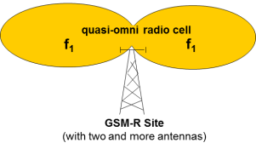
Figure 57: RMR (GSM-R) standard antenna configuration
    - MFCN networks at 900 MHz
Filtering out the indoor usage from existing antenna data records from the national operator agreement, the amount of MFCN antenna data records in the railway environment by March 2019 is ca. 100000. This includes all actual nationwide deployments of GSM900 and LTE900 radio systems records in the railway environment after finalizing the frequency authorization process with BNetzA.
  - Methodology
This study focuses on RMR-MFCN coexistence for the 900 MHz frequency band and was performed by proceeding to the following steps. Based on the national operator agreement 900 MHz, relevant antenna data records of existing RMR and MFCN antenna installations have been evaluated. Antenna data records have been processed in which geographical coordinates in latitudes and longitudes of RMR and MFCN antennas in the rail environment in Germany were found. The data sets also included radiation characteristics, height above sea level and ground and elevation angle of the antennas.
MFCN antennas were used in the rail environment from 50 m up to 600 m to the RMR antennas. The spatial decoupling of the RMR to the MFCN was done via SQL. In the first approach the distances have been determined with simplified assumptions for the large amount of data records (> 1 billion). The formula for the determination of the distances, in order to each MFCN antenna to the nearest RMR antenna with the condition of d < 850m. After assignment, an ID was created for each individual file of an individual MFCN which could be used to assign the dedicated antenna pairs from MCFN to RMR. In the second method, the exact distances of the antenna pairs were determined by using dedicated coding in MATLAB®. With the Antenna Toolbox of MATLAB®, the RMR<->MFCN distance could be determined exactly with the WGS-84 model.
As a final result for the further data analysing, a paired antenna data set was created. For every single MFCN antenna, the closest RMR antenna has been assigned.
Further data processing in GIS (MapInfo Professional®): Assignment of each RMR and MFCN base station to an environment category based on the intersection with the landscape in vector format by BKG.
    - Studied railway area
Regarding the nationwide separation distance of RMR<->MFCN@900MHz, a 600 m buffer for the further precourse has been used.
The following figure shows the studied railway environment (600 m buffer around the existing GSM-R radio sites) in Germany.
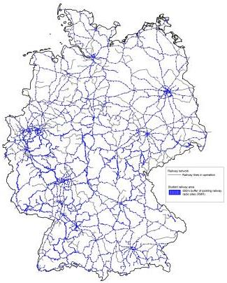
Figure 58: Analysed railway area (blue)
The choice of the 600 m buffer at 900 MHz was essentially derived from the 67 dB MCL assumption in 3GPP TR 45.050, worst case antenna parameter and multiple interference margins. This corresponds under the free space propagation model to 250 m. In order to be conservative, the buffer to consider potential interference situations was extended to 600 m.
The following table shows that with the 600 m filter, the category “dense environment” for MFCN is the most represented one:
Table 40: Deployment environment of current radio sites within 600 m buffer of RMR
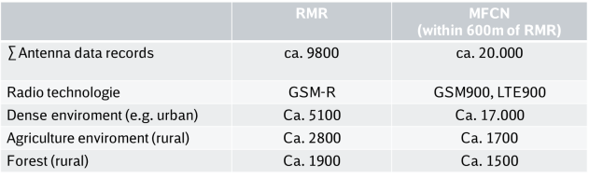
This table shows significant differences between the deployed radio networks studied. In dense environments (e.g. urban, sub-urban, industrial…) 85% of MFCN antennas within the 600 m buffer of RMR sites are located. Ca. 45% of the RMR antennas can be found in rural environments. It can be noted that for comparing RMR and MFCN deployment environments, significantly differences become apparent.
    - Comparison of antenna properties
In the studied railway area of 600 m around existing RMR sites in Germany, significant differences in the comparison of RMR and MFCN antenna properties were evident.
The following pictures show typical examples of RMR and MFCN antenna installations on cell towers in the railway environment. Being cellular networks, RMR and MFCN make use of radio cells on towers to provide wireless communication to mobile stations who are in the vicinity of these radio cells. Cell towers and antennas are usually placed during a specific cell planning process so that they can cover the area of interest.
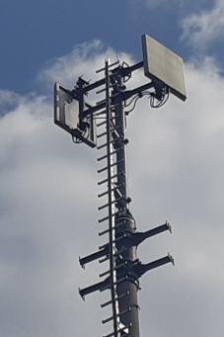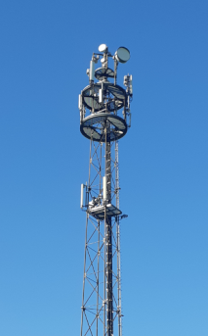
Figure 59: Typical RMR (left) and MFCN (right) antenna installations
Radio signal propagation in railway environment is affected by many factors such as reflection, multi-path transmission, obstructions, vegetation scattering and diffraction. For that reason, antenna height, antenna gain and antenna radiation patterns have to be chosen individually during the cell planning process, as well the azimuth of the antenna. In contrast to MFCN radio networks, the RMR network has only one coverage objective: the railway lines in the immediate vicinity.
The RMR coverage objective is particularly evident when analysing the nationwide distribution of RMR antenna azimuth (see figure below).
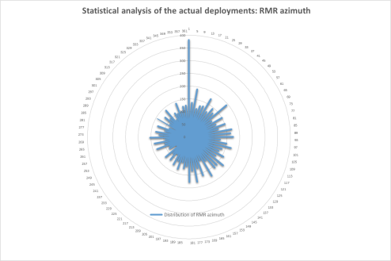
Figure 60: Statistical analysis of RMR azimuth
When analysing the nationwide distribution of MFCN antenna parameters in the railway environment, the MFCN antenna azimuths show a strong bias towards 0$°$, 120$°$ and 240$°$.
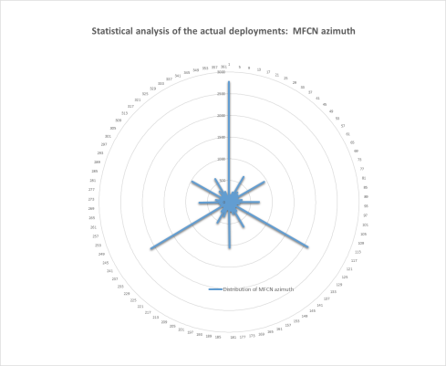
Figure 61: Statistical analysis of MFCN azimuth
Differences are also evident in the analysis of the nationwide distribution of RMR and MFCN antenna heights in the studied railway environment (600 m buffer around the existing GSM-R radio sites, as shown in the figure below).
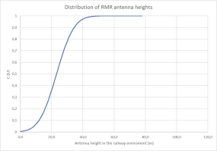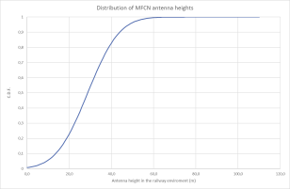
Figure 62: Statistical analysis of RMR and MFCN antenna heights
    - Propagation model for path loss determination
An adaptation of the EPM-73 propagation model is used for this study. EPM-73 is a LoS model applicable to “above rooftops” scenarios, to the frequency range 40 MHz to 10 GHz and for distances higher than 500 m. Below 100 m, the free space propagation model is considered. Between 100 m and 500 m, a linear slope between the two models is assumed.
The path loss (PL) itself is calculated with using the 920 MHz frequency to consider MFCN base stations receiving in the 900 MHz frequency range.
 | $$d≤0.1 km{PL}_{920MHz}\left(d,f\right)={PL}_{freespace}\left(d,f\right) \\ 0.1 km<d≤0.5 km{PL}_{920MHz}\left(d,f\right)={PL}_{freespace}\left(d,f\right)+\left[\frac{d_{km} - 0.1}{0.4}\right]×2.5 \\ 0.5 km<d{PL}_{920MHz}\left(d,f\right)={PL}_{freespace}\left(d,f\right)+2.5$$ | (22)
  - Evaluation of nationwide coexistence between RMR and MFCN
In order to get a reliable view on the distribution of coupling loss of RMR-MFCN in Germany, the following steps and assumptions were carried out:
- Discarding all MFCN antenna data records above 600 m (=> more than sufficient coupling loss);
- Discarding all MFCN antenna data records below 50 m (=> Co-Location/site sharing);
- Determination of real antenna height (above Mean Sea Level);
- Creation of RMR MFCN antenna pairings in the immediate vicinity;
- Determination of ∆ ɸ RMR-MFCN (rel. azimuth of RMR<->MFCN antennas facing each other).
A typical scenario of an uncoordinated deployment of MFCN and RMR antennas in the national railway environment is shown in the following figure.
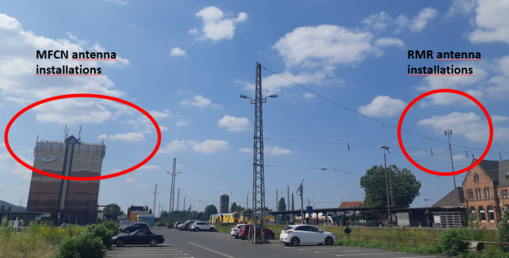
Figure 63: Typical scenario of RMR and MFCN antenna installations
For the evaluation of the RMR and MFCN coexistence in the railway environment, antenna pairs related to close proximity are considered. To determine the discriminations of the antenna pairs, the attenuation was determined by using the shortest difference of the angles between the antenna pairs RMR and MFCN and the respective radiation characteristics. Subsequently, ∆h and the relevant distances (d) were also considered. Using the function txsite() in MATLAB®, an antenna position of RMR or MFCN could be defined and used to represent as the variables for the angle() function.
    - Antenna types
The exact MNO antenna type is not part of the national operator agreement, only the so called HCM pattern is available. The HCM patterns or envelopes are a generalised picture of the existing irregular radiation pattern of a radio antenna. An assumption had to be made for the MFCN antenna type, since no specific data were available regarding the type and gain of the antennas. With the RMR antennas, empirical data were available regarding the most frequently occurring antenna types.
The following assumptions were made:
- For all MFCN antennas, the antenna type 80010305V02 was used as the only antenna type.
- For all RMR antennas, the typical antenna type SPA920/25/18/0/DS was used.
See also A7.7 for the relevant antenna data sheets.
    - Best-practice approach
For the further proceeding, a best-practice approach has been selected with the following assumptions
- No consideration of tunnels and bridges (2D only);
- Calculations of path loss with exact distances;
- Assumption of antenna types.
The mixed path loss calculation based on an adaptation of the EPM-73 propagation model:
 | $$d≤0.1 km{PL}_{920MHz}\left(d,f\right)={PL}_{freespace}\left(d,f\right) \\ 0.1 km<d≤0.5 km{PL}_{920MHz}\left(d,f\right)={PL}_{freespace}\left(d,f\right)+\left[\frac{d_{km} - 0.1}{0.4}\right]×2.5 \\ 0.5 km<d{PL}_{920MHz}\left(d,f\right)={PL}_{freespace}\left(d,f\right)+2.5$$ | (23)
The corresponding coupling loss is calculated using the following formula for each antenna data record:
 | $${CL}_{ant data record}=PathLoss_{\left(EPM-73 propagation model\right)}-G_{rail}-G_{MFCN}+D_{hor }+D_{ver}$$ | (24)
Where:
- G_{rail} is the antenna gain for the railways system, adjusted for feeder & coupler losses for the so called quasi-omni antenna configuration (-6 dB);
- G_{MFCN} is the antenna gain for the MFCN system, adjusted for feeder losses (-3 dB);
- D_{hor} is the discrimination in the horizontal direction;
- D_{ver} is the discrimination in the vertical direction (∆h);
- The path loss itself is calculated with using 920 MHz as a frequency.
The essential part for the determination of the corresponding coupling loss was thus carried by the azimuth angles.
    - Distribution of distance of the studied 900 MHz MFCN antennas
The following figure shows the nationwide distribution of 900 MHz MFCN antenna within 600 m RMR buffer in the German railway environment (Coordinated colocations and indoor 900 MHz sites have been filtered out):
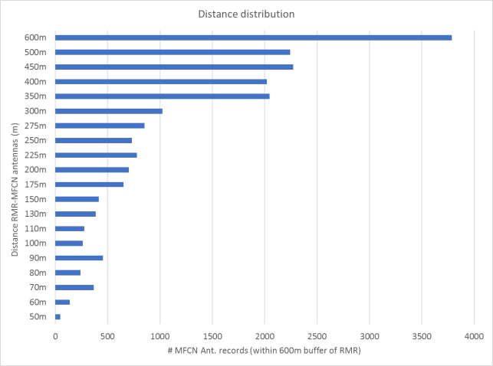
Figure 64: Nationwide distance distribution RMR<-> MFCN@900MHz
    - Nationwide distribution of coupling loss
The following figure shows the nationwide distribution of the coexistence data for the RMR-MFCN antenna distances up to 600 m and the estimated RMR-MFCN coupling loss, filtering out coordinated colocations and indoor 900 MHz sites.
Figure 65: Nationwide coupling loss distribution RMR<-> MFCN@900MHz
  - Conclusion
Reliable view on the distribution of coupling loss of RMR-MFCN@900MHz uncoordinated antenna deployments in Germany:
- The relevant scenarios of RMR-MFCN@900MHz BS interference are identified and a best practice approach is applied;
- Only by assuming a single antenna type for all MFCN sites and using the typical RMR antenna, the large amounts of antenna data sets could be processed;
- In all environments for the 600 m buffer (2D), the estimated 10% quantile of the coupling loss distribution is more than 80 dB;
- Less than 2% of RMR-MFCN@900MHz antenna pairings studied have a coupling loss of 67 dB or less;
- MFCN@915 MHz antenna pairs: Intersection of corresponding coupling losses less than 67 dB and distances of less than 100 m results in the total number of 15 corresponding radio sites in the national railway environment;
- Error analysis: strong influence of the relevant coordinates;
- Further inaccuracies are possible, additional path loss due to the real railway environment (e.g. stations, tunnels, bridges…) is not taken into account;
- Additional coupling loss in dense environments are very likely;
- Co-Location/site sharing excluded;
- Only MFCN antenna data records considered => because of planned usage and legacy data records, no exact figures for operating radio sites can be provided.
From the evidence outlined in the previous section, statistical data from nationwide field deployments in 900 MHz in Germany would lead to the conclusion that the use of a MCL greater than 70 dB for the railway environment is acceptable.
DB Netz AG strongly recommends national operator agreements to prevent an uncoordinated deployment of different radio systems in the rail environment, especially for distances less of 100 m around RMR sites.
  - Appendix
Figure 66: Datasheet for typical antenna used by RMR in Germany
Figure 67: Datasheet for the antenna type used to model MFCN antennas

- FRMCS-MFCN Interference configuration at 900 MHz – Bordeaux study
The present section focuses on the study of the RMR-MFCN interference configuration in the Bordeaux area.
The interference configuration to be considered at 900 MHz is between a MFCN uplink at 915 MHz (therefore MFCN BS as a victim) and a FRMCS downlink around 920 MHz (therefore a FRMCS BS transmitting as the interferer).
Because FRMCS sites are the same as the existing GSM-R sites for economic reasons and to ensure radio compatibility with the GSM-R, sites are known and their radio engineering is unlikely to change circa 2500 in France, covering approximately 16000 km of rail lines.
MFCN networks operated at 900 MHz are known and are not likely to change significantly around railways. There may be densification to better cover the tracks, but by selecting the Bordeaux case area where at least one MNO is already covering the rail network adequately, it is expected that most interference situations will already have been explored.
  - Case study presentation – the Bordeaux region
The Bordeaux area has been chosen for this case study, as it represents a sufficiently wide area with a mix of major city urban and rural area and a complex enough railway structure within the city and area.
Railway coverage is provided by a network of 59 antennas on 28 sites (3 tri-sector and 25 bi-sector sites). MFCN coverage at 900 MHz is ensured by 2385 antennas from about 795 MFCN sites (some are double counted because of site sharing).
A map of the area with the railway GSM-R network sites is shown in the figure below.
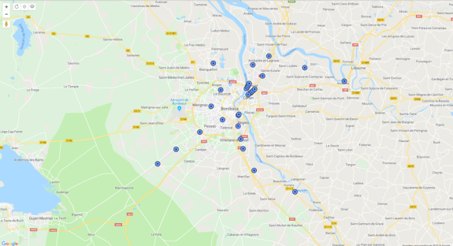
Figure 68: Map of the Bordeaux area with the GSM-R network sites
    - BEM separation distance at 900 MHz
Out of the 28 GSM-R sites, 3 (10%) have MFCN services collocated on them.
Those collocated situations are excluded.
Then, for each existing GSM-R site, the neighbourhood within 800 m has been determined with four categories:
- The closest BS from the MNO operating immediately below 915 MHz (MNO915);
- The closest MFCN BS operating in 880-915 MHz (any MNO) – there are 24 of them.
- The neighbouring BS from MNO915 (closest and other neighbours)
The neighbouring MFCN BS operating in 880-915 MHz (any MNO) – there are 62 of them.
The two next figures show the associated Cumulative Distribution Function.
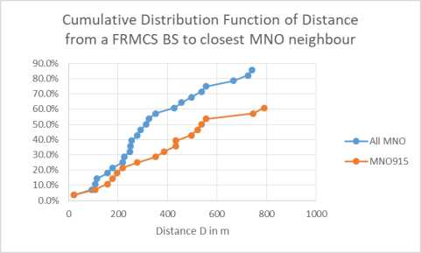
Figure 69: Closest neighbour distance- cumulative distribution function
The curve in the figure above allows to determine, for a given separation distance D, the % of GSM-R sites for which the closest MFCN neighbour is closer or equal to this separation distance. For example with a separation distance of 400 m: the closest MNO915 site is less or equal than 400 m in 30% of the FRMCS sites, and the closest MNO site is less or equal than 400 m in 60% of the FRMCS sites.
The next figure shows the distribution of distances between GSM-R sites and MFCN sites, not limiting to the closest neighbours (but still biased by neighbours less than 800 m). The distribution for MNO915 remains similar to the one in Figure 68.
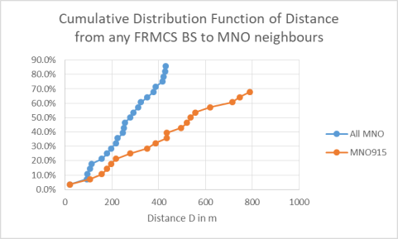
Figure 70: Neighbours at less than 800 m - cdf
Those statistic can serve to assess the % of GSM-R sites for which the introduction of FRMCS would require coordination if the BEM minimal separation is D. The following table provides the detailed data for shorter distances.
Table 41: Distribution of distance to neighbours (m)
MNO915 | All MNO | MNO915 | All MNO
Percentage | closest | closest | all neighbours | all neighbours
3.6% | 21 | 21 | 21 | 21
7.1% | 107 | 95 | 107 | 92
10.7% | 157 | 107 | 157 | 95
14.3% | 179 | 114 | 179 | 107
17.9% | 197 | 157 | 197 | 114
21.4% | 218 | 179 | 218 | 157
25.0% | 278 | 218 | 278 | 179
It appears for instance that if the BEM is calculated with minimal separation distance of 100 m, some additional coordination could be required in approximately 7% of the cases in order to protect MNO915 (data point highlighted in yellow, and next sample) and 14% of the cases if all MNOs need to be considered (data point highlighted in blue) .
    - Interference configurations
      - Horizontal plane
The horizontal geometry for one FRMCS BS interfering with one MFCN BS is given in the following picture:
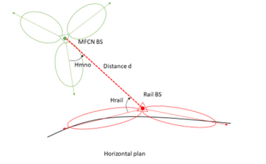
Figure 71: Bird view of interference configuration between a FRMCS BS and a MFCN BS
(horizontal plane)
Distance d and the azimuth Az from Rail BS to MFCN BS are determined based on BS coordinates:
- Hrail (deg) is determined by the difference between the Az and the FRMCS antenna azimuth;
- Hmno (deg) is determined by the difference between (180-Az) and the MFCN antenna azimuth.
      - Vertical plane
The vertical geometry for one FRMCS BS interfering with one MFCN BS is given in the figure below. It must be understood this is an exaggerated presentation, not at scale, so that elevation angles are clearly visible on the figure. In reality, terrain and height differences would be less marked and tilt values would be smaller, so elevation angles would be much smaller.
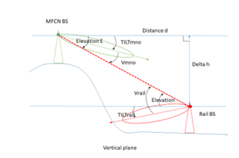
Figure 72: Sideview of interference configuration between an FRMCS BS and an MFCN BS
(vertical plane)
Distance d is same as above.
Delta h is determined based on the antennas height above ground data and the ground altitude for MFCN and FRMCS BS approximated through a DEM (digital elevation model):
 | $$Elevation E\left(°\right)=\tan^{-1}\left(h/d\right)*180/π$$ | (25)

 | $$V_{rail}\left(°\right)=E+TILT_{rail}$$ | (26)

 | $$V_{mno}\left(°\right)=E+TILT_{mno}$$ | (27)

Except for very small distance d and high delta h, h/d is small and E(deg) is approximately proportional to h/d.
Therefore the vertical discrimination V decreases with distance, with an asymptotic limit which is determined by the effect of the two tilts at the horizon. The figure below shows a simplified calculation of the vertical discrimination as a function of distance, for two altitude differentials (both antennas are supposed to have 3° tilt and 8.5° half power vertical beam width).
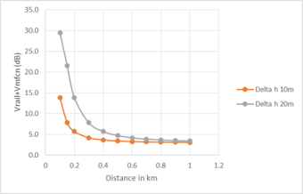
Figure 73: Simplified calculation of the vertical discrimination as a function of distance
The antenna discriminations Hrail+Vrail (respectively Hmno+Vmno) combine the effects of the horizontal and vertical RMR diagrams (respectively MFCN diagram) in the direction of the opposite base station. They are calculated using the Recommendation ITU-R F.1336-5 model [6].
    - Pathloss at 900 MHz
For distances up to 100 m, the free space loss is used:
 | $$PL_{freespace}\left(d,f\right)=32.4+20\log_{10}\left(f_{MHz}\right)+20\log_{10}\left(d_{km}\right)$$ | (28)

For distances beyond 100 m, the following model is therefore used:
 | $$0.1 km<d≤0.5 km{PL}_{920MHz}\left(d,f\right)={PL}_{freespace}\left(d,f\right)+\left[\frac{d_{km} - 0.1}{0.4}\right]×2.5 \\ 0.5 km<d{PL}_{920MHz}\left(d,f\right)={PL}_{freespace}\left(d,f\right)+2.5$$ | (29)
This is in line with the modified EPM-73 model identified in section 2.4.
    - Coupling loss
The coupling loss CL between the Rail BS and the MFCN BS is defined in relation to the path loss (PL), the antenna gains G_{rail} and G_{mno} and the horizontal and vertical discriminations.
 | $$CL=PL-G_{rail}+H_{rail}+H_{MNO}+V_{rail}+V_{MNO}$$ | (30)
This definition does not take into account any filtering effect from the MFCN BS duplexer.
Therefore, coupling loss is the sum of:
- path loss, which increases with distance;
- horizontal discrimination which tends to be high as shown in previous contribution but can fluctuate;
- and vertical discrimination, which diminishes with distance and is sensitive to variations in height at short distance
For a sample of Rail and MFCN BS, the coupling loss between each FRMCS antenna of each FRMCS site and each MFCN antenna of each MFCN sites can be calculated.
    - Application to the case study
For each FRMCS antenna of a given site in the Bordeaux area, the CL with all the MFCN antennas for all the neighbours within the area has been calculated.
The calculations are made by a mix of modelling, through assumed system parameters, and real life data.
    - System parameters
It is assumed that all FRMCS sites use the same kind of antenna with the same tilt.
For MFCN sites, different tilt values are used depending on the local environment (INSEE density code from 1 –dense to 4 very sparse). The value used for a specific environment is the average found in the non-public data base, as provided by ANFR.
Apart from those parameters, all other parameters for individual sites (location, altitude at ground level) and individual antennas (azimuth, height above ground) are taken from the actual sites.
    - Worst case beyond 100 m
Taking into account both horizontal and vertical discrimination, it has been found that the worst configuration for sites beyond 100 m (and of all sites with only one exception) was the following: the FRMCS site, close to the railway as usual, would be interfering with a MNO915 base station on the top of a building distant from 434 m. This configuration can be visualised in the figure below, marked with the yellow line. In this configuration, the altitudes of rail and MFCN antennas are almost identical and they are far away so there is limited vertical discrimination (2.0 dB for rail and 1.1 for MFCN). Horizontal discrimination is also small, as the rail antenna is pointing in a direction of the rail line which is curved towards the MFCN site, and in the general direction of the MFCN sector: antenna offset is 22° for rail (discrimination 1.2 dB) and 17° for MFCN (discrimination 0.8 dB).
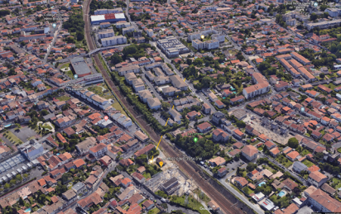
Figure 74: Worst-case interference configuration in Bordeaux area
    - Distribution of coupling loss
It is then possible to find the distribution of the CL, especially the lowest values, either when all MNOs are considered, or for a specific MNO network (identified as MNO915, MNO905, MNO900, MNO890 based on the upper limit of their uplink assignments).
Table 42: Lowest CL values
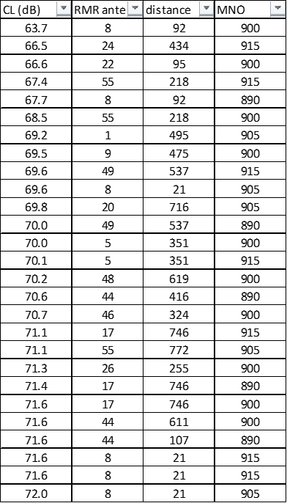,
All other interference cases have a coupling loss higher than 72 dB.
It must be noted that for CL values lower than 72 dB, only relatively close neighbours matter, i.e. those which are less than 800 m.
From the table above, it can be seen that restrictions on RMR based on a MCL of 58.2 dB, after correction of 1 dB as Grail is now taken as 13 dB instead of 12 dB) would be overly restrictive in 100% of the configurations in the case study area.
Table 43: Cumulative occurrence of lowest CL (dB) in relation to the number of FRMCS sites (28)
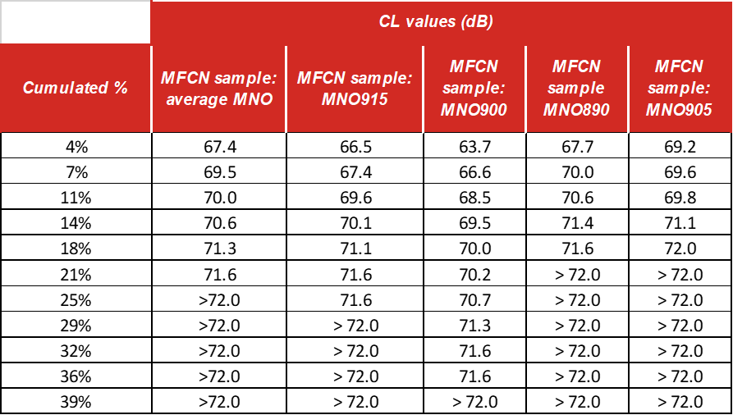
The table above gives the statistics, based on the 28 FRMCS sites, of the minimal coupling loss with the antennas of a given MNO.
The percentage in this table are established in relation to the total number of FRMCS sites (in this case study 28) to allow to get an insight on the number of low CL occurrences that would arise from a population of FRMCS sites.
For instance, for MNO915, it reads like this:
- no situation where the coupling is less than 66.5 dB;
- 1 situation (4%) where the coupling is 66.5 dB, and probability of 96% that the coupling is > 66.5 dB;
- 66.6<= Coupling <= 71.6 dB in 7 cases or 25%.
For protection the MNO network closest in frequency (MNO915) is the most exposed. However, other networks can also be taken into account to provide more samples of interference configurations. Therefore, a column "average MNO” is determined assuming the 4 MNO networks are independent from each other and from rail network, and that each provide relevant interference configuration samples (which would be the equivalent of a sample of RMR sites 4 times as large).
From interpolation in the table above it can be expected that an MCL of 68.5 dB could be exceeded for 95% of the RMR sites, with a worst-case error in the range of 4.8 dB for the remaining 5%.

Table 44: Cumulative occurrences of lowest CL, after excluding interference situations less than 100 m
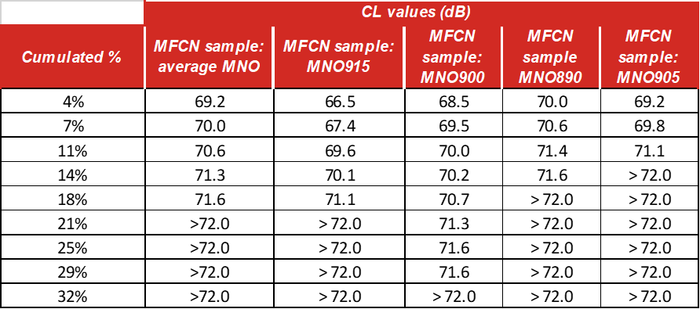
The table above reads very similarly to the previous one. It is indicative of the distribution of CL considering that coordination with sites less than 100 m has been performed.
From interpolation in the table above, it can be expected that assuming coordination with sites less than 100 m away, a value of MCL of 69.6 could be exceeded for 95% of the RMR sites, with a worst case error in the range of 3 dB for the remaining 5%.
  - Conclusion
From this case study, it can be noted:
- Restrictions on RMR based on a MCL of 58.2 dB would be overly restrictive in 100% of the configurations in the case study area;
- Without coordination, a MCL of 68.5 dB could be exceeded for 95% of the RMR sites, with a worst case error in the range of 4.8 dB for the remaining 5%;
- Assuming coordination with sites less than 100 m away, a value of MCL of 69.6 could be exceeded for 95% of the RMR sites, with a worst case error in the range of 3 dB for the remaining 5%.

  - Appendix 1
Table 45: Distance (m) to closest neighbour (excluding neighbours co-located or >800 m)
 |  | Sample All MNO, non-co-sited, less than 800 m
GSM-R site | GSM-R antenna index | closest, excluding co-located | second closest | third closest | fourth closest | fifth closest | sixth closest | seventh closest
1026736 | 7-8 | 21 | 92
1207600 | 22-23 | 95
1391953 | 44-45 | 107 | 416 | 430 | 513 | 611
1332868 | 32-33 | 114 | 197 | 634 | 755
1334394 | 36-37 | 157 | 629 | 773
1391951 | 42-43 | 179 | 378 | 420 | 583 | 727 | 743
1404722 | 55-56 | 218 | 772
1332870 | 34-35 | 225 | 386 | 578
1332864 | 28-29 | 247 | 587
1133676 | 13-14 | 251
1292508 | 26-27 | 255 | 420
1082746 | 9-10 | 278 | 475 | 684
1292506 | 24-25 | 291 | 434 | 497 | 620
1332866 | 30-31 | 313 | 434 | 538 | 608
1392007 | 46-47 | 324 | 521 | 787
1012447 | 5-6 | 351
854383 | 1-2 | 427 | 495
1205429 | 17-18 | 457 | 746
1334396 | 38-39 | 496 | 776
1404063 | 48-49-50 | 537 | 619 | 714
1205431 | 19-20-21 | 556 | 716 | 790
1773336 | 57-58-59 | 666
1404565 | 53-54 | 724 | 790
1107523 | 11-12 | 742
1404558 | 51-52 | 812
1334452 | 40-41
854413 | 3-4
1205425 | 15-16
Table 46: Distance (m) to closest neighbour (excluding neighbours co-located or >800 m)
 |  | MNO915, non-co-sited, less than 800 m
GSM-R site | GSM-R antenna index | closest, excluding co-located | second closest | third closest | fourth closest
1026736 | 7-8 | 21
1391953 | 44-45 | 107
1334394 | 36-37 | 157
1391951 | 42-43 | 179
1332868 | 32-33 | 197
1404722 | 55-56 | 218
1082746 | 9-10 | 278
1012447 | 5-6 | 351
1332870 | 34-35 | 386
1292506 | 24-25 | 434 | 620
1332866 | 30-31 | 434
1334396 | 38-39 | 496
1392007 | 46-47 | 521 | 787
1404063 | 48-49-50 | 537 | 714
1205431 | 19-20-21 | 556
1205429 | 17-18 | 746
1404565 | 53-54 | 790
1404558 | 51-52
1332864 | 28-29
1334452 | 40-41
1107523 | 11-12
1292508 | 26-27
1773336 | 57-58-59
854413 | 3-4
1207600 | 22-23
1205425 | 15-16
1133676 | 13-14
854383 | 1-2
  - Appendix 2: reference system parameters
The reference case study is made with the parameters listed in the table below
Table 47: Reference system parameters used in the study
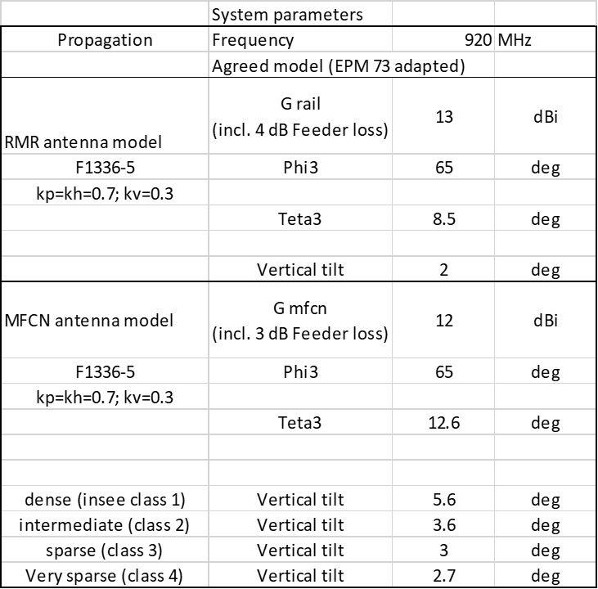

- Analysis of separation distance between FRMCS BS and MFCN BS at 900 MHz
This annex presents the analysis of the separation distance for the calculation of MCL between FRMCS BS and MFCN BS at 900 MHz based on GSM-R and MFCN sites in Paris region and Paris-Marseille railway track.
  - Paris city
In France, there are 4 MFCN networks in 900 MHz band. In Paris city, there are in total 85 GSM-R sites, of which 16 are outdoor GSM-R sites, others are in the tunnels or indoor. The 16 outdoor GSM-R radio sites and the radio sites of the 4 MFCN networks are illustrated in Figure 74. The CDF of the separation distances between the GSM-R BS and one MFCN networks is given in Figure 75.
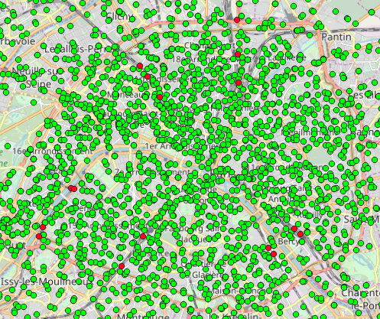
Figure 75: 900 MHz radio sites of 4 MFCN networks (green dots) and GSM-R sites (red dots)
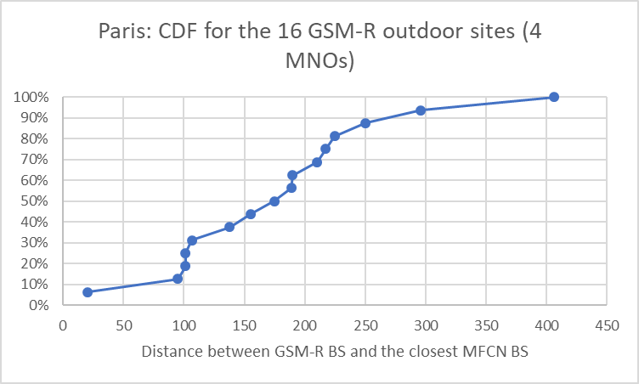
Figure 76: cdf of the distance between GSM-R BS and the closest BS from 4 MFCN networks
The 16 outdoor GSM-R radio sites and the radio sites of one of the 4 MFCN networks are illustrated in Figure 76. The CDF of the separation distances between the GSM-R BS and the nearest BS of one of the 4 MFCN networks is given in Figure 77.
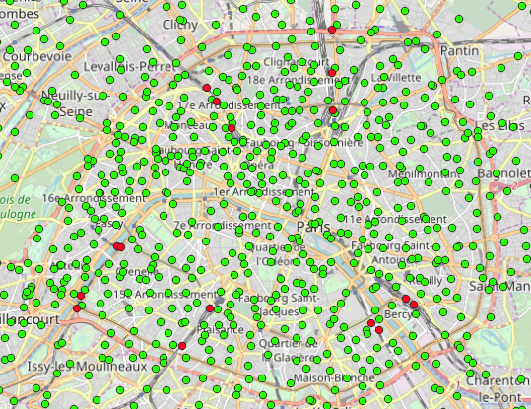
Figure 77: One 900 MHz MFCN radio sites (green dots) and GSM-R sites (red dots)
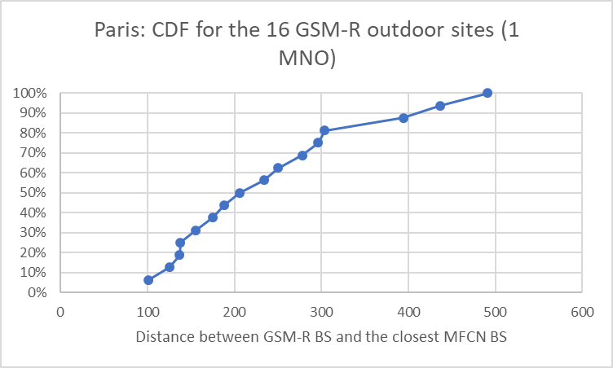
Figure 78: cdf of the distance between GSM-R BS and the closest BS of one of the 4 MFCN networks
  - Paris region (Île-de-France)
There are 236 outdoor GSM-R BS in Paris region (“Ile-de-France”). Some of them are collocated with an MFCN BS.
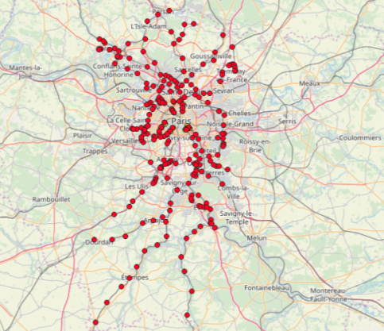
Figure 79: GSM-R radio sites in Paris region
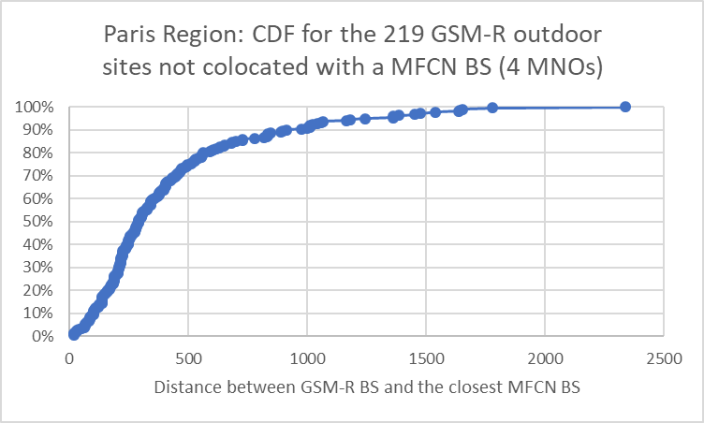
Figure 80: cdf of the distance between GSM-R BS and the closest BS from 4 MFCN networks
The figure above shows that 10% of GSM-R sites have a MFCN BS closer than 100 m (the lowest separation distance is 20 m).
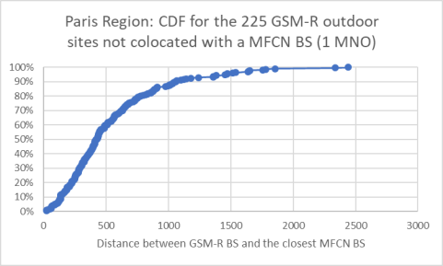
Figure 81: cdf of the distance between GSM-R BS and the closest BS of one of the 4 MFCN networks
The figure above shows that 5% of GSM-R sites have a MFCN BS of the selected 1 MFCN closer than 100 m (the lowest separation distance is 20 m).
  - Paris-Marseille railway track
Along the railway track, there are special in-train coverage design, each MFCN operator has deployed radio sites along the railway track to provide in-train coverage.
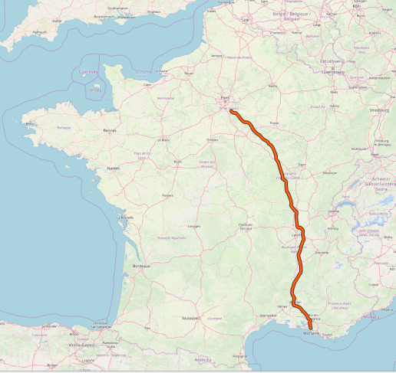
Figure 82: Railway track Paris-Marseille (~700 km)
Along the railway track Paris-Marseille of about 700 km, there are in total 194 GSM-R sites. The number of MFCN radio sites along the railway track are different between different MFCN networks. The distances between the GSM-R sites and the closest MFCN network (One of the 4 MFCN networks) radio sites along railway track are calculated and analysed. The CDF of the distances between the GSM-R sites and the closest MFCN network radio sites from one MFCN network along railway track Paris-Marseille is plotted in the next figure.
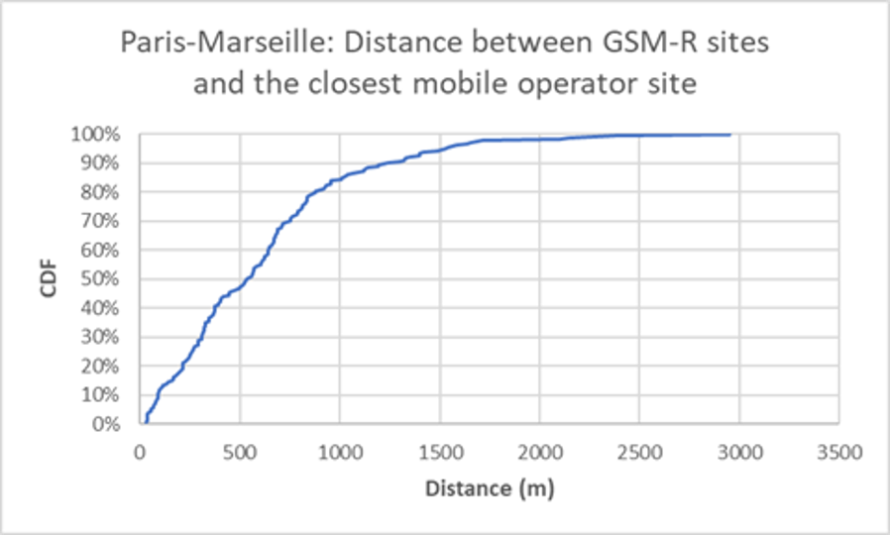
Figure 83: cdf of the distance between GSM-R BS and one MFCN BS along railway track Paris-Marseille
The figure above shows that 10% of GSM-R sites have a MFCN BS (one MFCN) closer than 88 m along railway track Paris-Marseille.
- Additional receiver filtering for MFCN BS
Additional filtering can be achieved either natively in new and renewed radio units or by adding external filter to existing radio units operating with passive antenna systems.
External filters for radio units operating with passive antenna systems
It is possible to design and produce external filters but several challenges arise.
An additional external filter between the antenna and the RRU increases the complexity by introducing a new box that requires additional connections and cabling. There will be more attenuation in the wanted uplink channel, resulting in an increase of the coupling loss and possibly a reduction in range in the uplink.
Few sites today operate single band single Tx/Rx antennas. Modern passive antenna systems are complex: a single non-AAS antenna integrates multiple bands and supports multiple Tx/Rx channels. As a result, the number of ports at the antenna could be as high as 30, with some of them being supported by cluster connectors that serve up to four ports. Introducing external filters for band #1 selectivity in this setting would be difficult: for instance, an antenna with MIMO technology may have four connectors, for frequency bands above 1 GHz, would require four external filters with equal transfer function in order to avoid imbalance between the RX ports at the RRU.
Additional filtering above what is specified by 3GPP is usually integrated in the radio units and not installed as an external unit at the antenna port.
Additional filtering for active antenna systems
By design, additional external filter is not feasible for active antenna systems. Active antenna systems include the RF stages in the antenna unit itself. Size and weight are key considerations for the design of these antennas. High selectivity requirements may only be achievable by using cavity filters, which may imply that volume and weight of the antenna unit increase to the extent that in practice it may not be feasible to integrate these components in an active antenna unit.
- Uplink MCL calculation
This Annex contains an MCL analysis of the impact of FRMCS UE on MFCN receiver that illustrates possible worst-case interferences when power-control is not implemented on the cab-radio side.
  - 900 MHz band
Under the assumption of no uplink power control by the FRMCS cab-radio, MCL calculation is used to estimate the interference from FRMCS cab-radio unwanted emission level to MFCN BS and Cab-radio. In ECC Report 313 [33], the cab-radio blocking level was defined as -13 dBm for LTE 5 MHz interferer under condition of I=N with MFCN BS transmit power of 49 dBm:
- The MCL = 49 - (-13) = 62 dB;
- The protection threshold for MFCN BS receiver is I/N=-6 dB, for a 5 MHz channel bandwidth;
- With a MFCN BS noise figure of 5 dB;
- N = -102 dB;
- I= N-6 = -102 - 6 = -108 dBm.

The required unwanted emission level for cab-radio = -108 + 62 = -46 dBm/(5 MHz) or -53 dBm/MHz in in the frequency range 880-915 MHz.
  - 1900 MHz band
Under the assumption of no uplink power control by the FRMCS cab-radio, MCL calculation is used to estimate the interference from FRMCS cab-radio unwanted emission level to MFCN BS and Cab-radio. In ECC Report 314 [34], the cab-radio blocking level was defined as -13 dBm for LTE 5 MHz interferer under condition of I=N with MFCN BS transmit power of 49 dBm.
- The MCL = 49 - (-13) = 62 dB;
- The protection threshold for MFCN BS receiver is I/N=-6 dB, for a 10 MHz channel bandwidth;
- With a MFCN BS noise figure of 5 dB;
- N = -99 dB;
- I = N - 6 = -99 - 6 = -105 dBm.

The required unwanted emission level for FRMCS cab-radio = -105 + 62 = -43dBm/(10 MHz) or -53dBm/MHz in the frequency range 1920-1980 MHz.
  - summary
In case FRMCS cab-radio power control is not implemented or not activated, the worst case MCL calculation show 900 MHz band FRMCS cab-radio would create harmful interference to MFCN uplink, in order to protect 900 MHz band MFCN uplink, the FRMCS cab-radio unwanted emission level should be reduced to -53 dBm/MHz in the frequency range 880-915 MHz.
In case FRMCS cab-radio power control is not implemented or not activated, the worst case MCL calculation show 1900 MHz band FRMCS cab-radio would create harmful interference to MFCN uplink, in order to protect 2 GHz band MFCN uplink, the FRMCS cab-radio unwanted emission level should be reduced to -53 dBm/MHz in the frequency range 1920-1980 MHz.
The occurrence of these worst-case assumptions for calculation has not been assessed with deployment data in this study. No additional mitigation due to the RMR activity factor has been taken into account in this calculation (e.g. see ECC Report 313 [33], section 4.1.3.5).

- Uplink simulations of the impact of FRMCS cab-radio on MFCN BS
  - Introduction
This annex analyses by means of simulations the impact of FRMCS cab-radios with 31 dBm output power (33 dBm e.i.r.p.) in the 900 MHz and 1900 MHz bands on MFCN BS.
The simulation scenario is illustrated in the figure below. The FRMCS BS is located close to the rail track. MFCN BS (a tri-sector site) is located at a separation distance D=100m from the rail track, and the inter-site distance between FRMCS BS is 10 km at 900 MHz and 8 km at 1900 MHz. Such a scenario may not be representative of common widespread situations (with regards to both the distance between MFCN BS and the track, and the inter-site distance). It is taken here as a worst case.
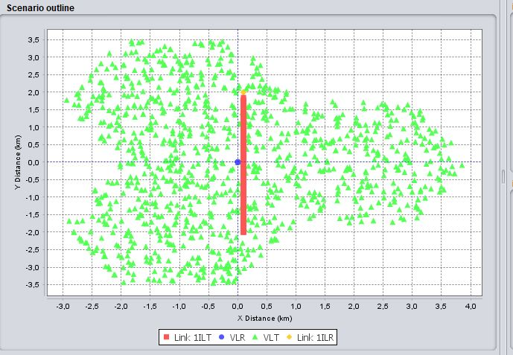
Figure 84: Simulation scenario
One observation is that power control has a significant impact on the simulation results. At the time of writing and with regards to the predictable path taken by trains as well as the power control granularity and measurement accuracy allowed by LTE and NR, it is believed that a 3 dB step for the uplink power control is an appropriate value, together with a threshold value of -101.5 dBm as suggested by ECO. The location of the FRMCS UE on the track has also an influence on the power control: in this simulation, it is assumed to be uniformly distributed.
Other parameters are as described in the body of the report and in the attached SEAMCAT workspaces. The following mask has been used to take into account an ACLR of 37 dB in the first adjacent channel, and then align with the LTE SEM defined in 3GPP 36.101, table 6.6.2.1.1-1.
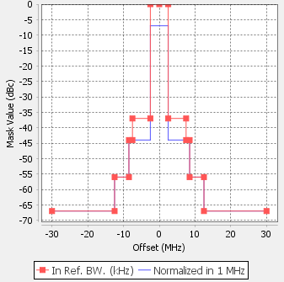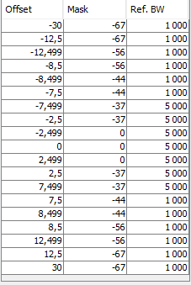
Figure 85: SEAMCAT mask used for the RMR 900 MHz 31 dBm UE simulation
  - Simulation results
The simulation results are given in the table below. It should be noted that the iRSSunwanted, iRSSblocking, and the MFCN BS throughput loss are the average over the three sectors of the tri-sector site. Both simulations assume 37 dBc ACLR as mandated by the 3GPP specifications for power class 1 UE.
Table 48: Simulation results
31 dBm UE at | Average (iRSSunwanted) | Average (iRSSblocking) | MFCN BS Throughput loss (Trisector site)
900 MHz | -132.53 dBm | -138.11 dBm | 3.5%
1900 MHz | -143.18 dBm | 138.39 dBm | 0.6%
  - SUMMARY
- For both bands, with an efficient UL power control, the blocking effect is not the limiting factor where the FRMCS cab-radio unwanted emission level is the limiting factor. This is consistent with the observation at 900 MHz where GSM-R cab-radios can already transmit up to 39 dBm (output power) without UL power control in 873-880 MHz while no harmful interference case has been reported so far on MFCN BS.
- In both bands, a 31 dBm FRMCS UE is feasible. An ACLR of 37 dB together with other standard limits from 3GPP provides appropriate protection to MFCN BS.
The occurrence of these assumptions related to SEAMCAT simulations (e.g. 100 m separation between the MFCN BS and the railway track, azimuth of the MFCN BS towards the track, the use of 3 dB power control step for LTE) has not been assessed with deployment data in this study. No additional mitigation due to the RMR activity factor has been taken into account in this calculation (e.g. see ECC Report 313 section 4.1.3.5 [33]).
- List of References
- EC Mandate to CEPT on spectrum for the future railway mobile communications system, July 2018
- ECC Decision (14)02: “Harmonised technical and regulatory conditions for the use of the band 2300-2400 MHz for MFCN”, approved June 2014
- CEPT Report 19: “Report from CEPT to the European Commission in response to the Mandate to develop least restrictive technical conditions for frequency bands addressed in the context of WAPECS”, approved October 2018
- CEPT Report 39: “Report from CEPT to the European Commission in response to the Mandate to develop least restrictive technical conditions for 2 GHz bands”, approved June 2010
- ECC Report 294: “Assessment of the spectrum needs for future railway mobile radio (RMR) communications”, approved February 2019
- Recommendation ITU-R F.1336-5: “Reference radiation patterns of omnidirectional, sectoral and other antennas for the fixed and mobile services for use in sharing studies in the frequency range from 400 MHz to about 70 GHz”
- ETSI TS 145 005 V14.7.0 (2020-04): “Digital cellular telecommunications system (Phase 2+) (GSM); GSM/EDGE Radio transmission and reception”
- ETSI TS 102 932-1 v1.1.1 (2011-11): “ER-GSM frequencies; Part 1: ER-GSM additional radio aspects”
- ETSI TS 137 104 V14.6.0 (2018-01): “Digital cellular telecommunications system (Phase 2+) (GSM); Universal Mobile Telecommunications System (UMTS); E-UTRA, UTRA and GSM/EDGE; Multi-Standard Radio (MSR) Base Station (BS) radio transmission and reception”
- ETSI TS 136 101 v12.24.0 (2020-02): “LTE; Evolved Universal Terrestrial Radio Access (E-UTRA); User Equipment (UE) radio transmission and reception”
- ETSI TS 138 101-1 V15.9.0 (2020-04): “5G; NR; User Equipment (UE) radio transmission and reception; Part 1: Range 1 Standalone”
- ETSI TS 136 104 V14.9.0 (2019-05): “LTE; Evolved Universal Terrestrial Radio Access (E-UTRA); Base Station (BS) radio transmission and reception”
- ETSI TS 138 104 V15.9.0 (2020-04): “5G; NR; Base Station (BS) radio transmission and reception”
- Report ITU-R M.2292-0: “Characteristics of terrestrial IMT-Advanced systems for frequency sharing/interference analyses”
- ECC Report 82: “Compatibility study for UMTS operating within the GSM 900 and GSM 1800 frequency bands”, approved June 2006
- ECC Report 96: “Compatibility between UMTS 900/1800 and systems operating in adjacent bands” , approved April 2007
- 3GPP TR 36.824: “E-UTRA; LTE coverage enhancements”
- ECC Report 162: “Practical mechanism to improve the compatibility between GSM-R and public mobile networks and guidance on practical coordination” , approved May 2011
- An Empirical Propagation Model (EPM-73), M. N. Lustgarten and J. A. Madison, IEEE: “Transactions on Electromagnetic Compatibility, Vol. EMC-19”, NO. 3, August 1977
- “Downtilted Base Station Antennas - A Simulation Model Proposal and Impact on HSPA and LTE Performance”; Fredrik Gunnarsson, Martin N Johansson, Anders Furuskär, Magnus Lundevall, Arne Simonsson, Claes Tidestav, Mats Blomgren; Ericsson Research, Ericsson AB; in Vehicular Technology Conference, 1988, IEEE 38th
- ECC Decision (09)03: “Harmonised conditions for MFCN operating in the band 790 - 862 MHz”, approved October 2009
- ECC Decision (15)01: “Harmonised technical conditions for MFCN in the band 694-790 MHz including a paired frequency arrangement (Frequency Division Duplex 2x30 MHz) and an optional unpaired frequency arrangement (Supplemental Downlink)”, approved March 2015
- ECC Decision (05)05: “Harmonised utilization of spectrum for MFCN operating within the band 2500-2690 MHz”, amended July 2019
- ECC Report 216: “Practical guidance for TDD networks synchronisation”, approved August 2014
- ECC Report 296: “National synchronization regulatory framework options in 3400-3800 MHz: a toolbox for coexistence of MFCNs in synchronised, unsynchronised and semi-synchronised operation in 3400-3800 MHz”, approved
- ECC Report 203: “Least Restrictive Technical Conditions suitable for MFCN, including IMT, in the frequency bands 3400-3600 MHz and 3600-3800 MHz”, approved November 2013
- ECC Report 281: Analysis of the suitability of the regulatory technical conditions for 5G MFCN operation in the 3400-3800 MHz band”, approved July 2018
- Report ITU-R M.2374: “Coexistence of two TDD networks in the 2300-2400 MHz band”
- ECC Recommendation (15)01 “Cross-border coordination for MFCN in the frequency bands: 694-790 MHz, 1452-1492 MHz, 3400-3600 MHz and 3600-3800 MHz”, amended February 2020
- EIRENE SRS v16.0.0: “System Requirements Specification”
- ECC Report 229: “Guidance for improving coexistence between GSM-R and MFCN in the 900 MHz band” , approved May 2015
- Recommendation ITU-R P.525: “Calculation of free-space attenuation”
- ECC Report 313: “Technical study for co-existence between RMR in the 900 MHz range and other applications in adjacent bands”, approved May 2020
- ECC Report 314: “Co-existence between Future Railway Mobile Communication System (FRMCS) in the frequency range 1900-1920 MHz and other applications in adjacent bands” , approved May 2020

Simulations in Annex 4 for the case of Paris show that the effect of the building, terrain and clutter layer can be very significant
Adjustments of antenna directivity, azimuth, tilt may not be sufficient to solve all interferences cases. MFCN BS with improved selectivity would avoid the need for national coordination (see section 5.1.3)
The band 1900-1910 MHz is licensed in the United Kingdom to provide enhanced mobile communications for the emergency services (PPDR).
It may be as high as 6 dB in some circumstances.
GSM-R is also used in some European countries on a national basis in the 873-876 / 918-921 MHz bands
33 dBm when using 8-PSK modulation.
UL power control is not used in the field, even if specified by 3GPP.
For a Power Class 3 UE, ACLR is 30 dB.
in 915-920 MHz for an MFCN receiving in 910-915 MHz / in 1915-1920 MHz for an MFCN BS receiving in 1920-1930 MHz
in 920-925 MHz for an MFCN receiving in 910-915 MHz / in 1900-1915 MHz for an MFCN BS receiving in 1920-1930 MHz
Some manufacturers were of the view that a -43 dBm blocking level should be considered to reflect LTE single RAT BS as per EN 301 908-14, NR single RAT as per EN 301 908-24 (awaiting publication).
Some manufacturers were of the view that the typical selectivity figures used for MFCN BS in CEPT Report 39 [2] and reused here are average values that do not reflect performance from all MFCN 2 GHz products or different operating conditions (aging, temperature, etc.). Receiver selectivity S_{tot} considered the combined effect from the receiver front-end selectivity and filter attenuation of typical existing hardware for the 2 GHz band (including a filter mismatch margin, but excluding margins for production spread, temperature drift and aging). Following the recent requirements trend from the market, the last 10 years brought a number of improvements to MFC BS in terms of in-band performance/functionality (like mMIMO), reduced equipment size and weight and more integration to meet deployment constraints. All these improvements add more constraints to the filter design compared to 10 years ago. Thus, while more recent MFCN BS still meet the relevant ETSI HS requirements, the filter might not offer as much margin compared to ETSI HS limits as the specific typical value considered before in CEPT Report 39 (2010) [2]. Therefore, consideration of typical values from CEPT Report 39 might lead to situation where MFCN BS in the field would be degraded due to RMR operation although they are 100% compliant to ETSI HS and to relevant ECC Decisions relating to MFCN deployment in the 2 GHz band.
This is not a typical value of antenna height in Europe.
Beyond 500 m, the additional loss compared to free space has been revised so that its value is relevant for distances between 500 m and 3 km and for frequencies around 920 MHz and 1900 MHz.
identified thanks to INSEE’s (French National Institute of Statistics and Economic Studies) classification
= -45 dBm/MHz + 10×log10(5) + 20×log10(1900/2620)
Adjustments of antenna directivity, azimuth, tilt may not be sufficient to solve all interferences cases
One of the factors that may lead to a higher CL in urban areas is that MFCN BS deployment around rail areas is restricted
N.B. Report ITU-R M.2374 [27] assesses the specific case of the 2.3 GHz band and mentions values such as "2.4 to 5 km. However, it also mentions that "The isolation requirement calculation has not taken into account effects due to propagation environment, antenna characteristics, antenna arrangements, additional RF filtering etc."
N.B. backup systems and possible shutdown of the transmissions should be considered if the reference clock is lost for a duration that exceeds the defined holdover period of the base station (which depends on the quality of the local oscillator)
For example the guard period between downlink-uplink has an impact on the cell range and also on the “synchronised area” (sites beyond a certain distance that would face exceptional propagation conditions could interfere with each other despite being synchronised, because the end of the downlink would clash with the beginning of the uplink of the other station). This is mostly an issue in co-channel operation, i.e. mostly at the border. The guard period also has an impact on spectrum efficiency
FM56(19)026rev1
Simulations in Annex 4 for the case of Paris show that the effect of the building, terrain and clutter layer can be very significant
Adjustments of antenna directivity, azimuth, tilt may not be sufficient to solve all interferences cases
Notice that it makes no sense to compute any threshold at 7% on this figure, as the size of the populations are not identical
The MFCN data is a subset of the MFCN sites that is within 10km from the track.
https://fahrweg.dbnetze.com/fahrweg-en/customers/network_statement/infrastructure_register/principles-1394986
Operator agreements require authorisation from regulatory authorities
© GeoBasis-DE / BKG 2013; see also http://www.bkg.bund.de
To prevent wireless telecommunication systems (in the frequency range from 29.7 MHz to 43.5 GHz) from harmful interference in border areas, 17 European countries signed the HCM agreement to coordinate their frequency allocations http://www.hcm-agreement.eu
To determine the distances via Matlab©, the vdist()-function, which matched the latitudes and longitudes of the relevant antennas.

