Co-existence between Future Railway Mobile Communication System (FRMCS) in the frequency range 1900-1920 MHz and other applications in adjacent bands
ECC Report 314
approved 21 May 2020

Executive summary
This ECC Report is a technical study for the feasibility of introducing the Future Railway Mobile Communication System (FRMCS) in the frequency band 1900-1920 MHz. FRMCS is gradually replacing GSM-R for mission-critical train-to-ground communications in the coming years. This work is in line with the EC Mandate on FRMCS.
Two adjacent band systems have been considered: Mobile/Fixed Communication Networks (MFCN) in the uplink band 1920-1980 MHz, and DECT in 1880-1900 MHz. The co-existence issue between these systems and FRMCS is simulated in different railway segments: high-speed lines, low-density lines and high-density lines. It should be noted that the band 1880-1920 MHz for potential Unmanned Aircraft System (UAS) use is subject to a separate ECC Report under development; this potential use is not studied in this Report. The band 1900-1910 MHz is licensed in the United Kingdom to provide enhanced mobile communications for the emergency services (PPDR); this co-frequency use is also not studied in this Report.
When assessing the feasibility of deploying FRMCS in the lower 10 MHz (1900-1910 MHz) using either 4G LTE or 5G NR as Radio Access Technology (RAT), the following results are obtained:
With MFCN above 1920 MHz:
- The main mechanism by which MFCN UEs interfere with FRMCS cab-radios is the unwanted emissions falling into the FRMCS channel;
- FRMCS cab-radios would not face downlink throughput degradation, even when the train is passing by a terminal in close proximity to the rail track, which is the configuration resulting in the maximum of desensitisation;
- The impact of FRMCS on MFCN base stations is addressed in ECC Report 318 [55].
With DECT below 1900 MHz:
- Impact of DECT on FRMCS cab-radio: When crossing heavily populated areas where the density of DECT devices is highest, FRMCS cab-radios would not face a downlink throughput degradation. The desensitisation of the FRMCS cab-radio is generally negligible, apart from exceptional cases where it can reach up to 10 dB for a few seconds, noting that in these situations the wanted signal remains 30 dB above the interference level;
- Impact of FRMCS cab-radio on DECT:
  - In the first analysis, when assuming free space propagation with building entry loss, separation distance from FRMCS cab-radios is in the range of 5.5-9 m for residential indoor DECT devices ensuring their operation free from harmful interference in channels F5 to F9, and in the range of 16-31 m for enterprise indoor DECT devices ensuring their operation free from harmful interference in all channels from F0. In the second analysis for the indoor scenario where the FRMCS cab-radio interferes with DECT systems, the protection distance range is from 1.5 m to 6.7 m, depending on the choice for the building entry loss from 13 dB to 20 dB;
  - In the first analysis, for outdoor DECT devices in the context of PMSE, separation distance from FRMCS cab-radio is 165 m assuming free space propagation, and 57 m assuming Hata urban propagation. In the second analysis, the FRMCS cab-radio interferes with DECT systems for the outdoor case if the protection distances is smaller than 30 m;
- Impact of FRMCS BS on DECT:
  - In the first analysis, when assuming free space propagation with building entry loss, typical separation distance from FRMCS BS is in the range of 34-57 m for residential indoor DECT devices ensuring their operation free from harmful interference in channels F5 to F9, and in the range of 95-162 m for enterprise indoor DECT devices ensuring their operation free from harmful interference in all channels from F0. In the second analysis, if DECT systems are interfered by the FRMCS base station, the protection distance range is from 42 m to 187 m, depending on the propagation model (free-space, Extended Hata) and building entry loss;
  - In the first analysis, for outdoor DECT devices in the context of PMSE, separation distance from FRMCS BS is 950 m assuming free space propagation, and 89 m assuming Hata urban propagation. Where the area of DECT operation is in the main lobe of the FRMCS BS antenna, the separation distance may increase beyond 1 km assuming free space propagation. The ground clutter has not considered between DECT and FRMCS. The second analysis shows, that in the outdoor scenario where the FRMCS base station interferes with DECT systems, the protection distances vary from 73 m to 840 m - depending on the propagation model (free-space, Extended Hata);
- Coexistence between FRMCS and outdoor DECT in the context of PMSE (stadiums, sporting events, amusement parks, street parades, etc.) may be facilitated by the presence of walls (e.g. in stadiums) that provide further attenuation to and from DECT devices, FRMCS BS directive antennas pointing to rail tracks, and the body loss when considering large numbers of people. This would reduce the probability of harmful interference on DECT devices;
- In the second analysis, the required protection distances are derived from MCL calculations, considering a worst case scenario where the dynamic channel selection of DECT systems is not possible, since all the adjacent channels are occupied (see the description in the measurement report in the ANNEX 4: of this Report). Where the DECT usage density is low, the Dynamic Channel Selection (DCS) algorithm implemented in DECT would then allow the communication to use one of the DECT channels that do not experience interference;
- The measurement campaign in ANNEX 3: shows, that in case of a 10 MHz wide LTE-TDD signal as interferer, in the co-channel interference scenario where all DECT downlink timeslots are free, the DECT communication link is not interrupted. When DECT frequency / timeslot hopping is disabled, the carrier-to-interference protection ratio is in the range of -32 dB down to -50 dB for a 8 MHz centre frequency offset between DECT and FRMCS;
- It should be noted that DECT is a licence-exempt system and there is no record of locations. Additionally, many PMSE type high-density activities will be of a temporary nature.
Requirements on FRMCS receivers:
The protection of FRMCS cab-radios against MFCN BS emissions in the frequency band 1805-1880 MHz and against aerial UEs in 1920-1980 MHz requires the following receiver characteristics:
Table 1: Requirements on FRMCS cab-radio receiver characteristics
Parameter | Value
Level of the wanted signal | sensitivity + 3 dB
Maximum 5 MHz LTE interfering signal in 1805-1880 MHz | -13 dBm
Maximum 5 MHz LTE interfering signal in 1920-1980 MHz | -39 dBm
Note 1: The antenna connector of the radio module is the reference point.
Note 2: These requirements cover both blocking and third-order intermodulation.
Depending on the feasibility of the introduction of governmental UAS in 1880-1920 MHz, FRMCS and governmental UAS may need to coexist and it would be up to the ETSI to define, based on Table 15, a maximum 5 MHz LTE interfering signal level in 1880-1890 MHz when a governmental UAS is in use not in the immediate vicinity of the rail tracks but close enough to cause harmful interference.
With respect to the protection of FRMCS BS against MFCN BS emissions in the frequency band 1805-1880 MHz, the following blocking level is recommended.
Table 2: Requirements on FRMCS BS receiver characteristics
Parameter | Value
Level of the wanted signal | sensitivity + 3 dB
Maximum 5 MHz LTE interfering signal in 1805-1880 MHz | -20 dBm
The antenna connector of the BS receiver is the reference point.
These requirements cover both blocking and third-order intermodulation.

TABLE OF CONTENTS

0 Executive summary 2
1 Introduction 9
1.1 Railway Mobile Radio 9
1.2 Evolving needs of RMR 9
1.3 EC Mandate on FRMCS 10
1.4 Scope of this report 10
2 FRMCS in 1900-1920 MHz 12
2.1 General description 12
2.2 Radio access technology to implement FRMCS 13
2.2.1 FRMCS using 4G LTE 13
2.2.2 FRMCS using 5G NR 13
2.2.3 Comparison between 4G LTE and 5G NR-based FRMCS 14
2.3 System parameters 15
2.4 Deployment-related parameters 17
2.5 Considered scenarios 22
2.6 FRMCS modelling in co-existence studies 24
3 Adjacent band systems 30
3.1 MFCN in band 1 uplink 30
3.1.1 Regulatory framework 30
3.1.2 LTE 2100 as representative system 30
3.1.3 System parameters of LTE 2100 31
3.1.4 Deployment-related parameters of LTE 2100 32
3.2 DECT in the core band 1880-1900 32
3.2.1 General description and regulatory aspects 32
3.2.2 System parameters 33
3.2.3 Deployment-related parameters 35
4 Co-existence between FRMCS and MFCN 37
4.1 Interference mechanisms 37
4.1.1 Unwanted emissions falling into the FRMCS band 38
4.1.2 Blocking caused by other effects than intermodulation 38
4.1.3 Receiver intermodulation 39
4.1.4 Dominating interference mechanism 40
4.2 Studied interference cases 41
4.2.1 High-speed scenario 42
4.2.2 Low-density scenario 44
4.2.3 High-density scenario 46
4.3 Results and Conclusion 48
5 Additional requirements on FRMCS receivers 50
5.1 MFCN Base Stations in 1805-1880 MHz 50
5.1.1 FRMCS cab-radio receivers 50
5.1.2 FRMCS BS receivers 50
5.2 Aerial UE in 1920-1980 MHz 51
5.2.1 Aerial UEs characteristics 51
5.2.2 Requirements on FRMCS cab-radios 51
5.3 Governmental UAS in 1880-1920 MHz 52
5.3.1 Governmental UAS technical parameters 52
5.3.2 Requirements on FRMCS cab-radios 52
6 Co-existence between FRMCS and DECT 54
6.1 Impact of DECT on FRMCS downlink 54
6.1.1 Interference mechanisms 54
6.1.2 Interference in the time domain 57
6.1.3 Methodology and example of an interference situation 58
6.1.4 Results and conclusion 60
6.2 Impact of FRMCS on DECT 63
6.2.1 Review of CEPT Report 39 63
6.2.2 Interference mechanisms 63
6.2.3 Residential case 66
6.2.4 Indoor enterprise case 69
6.2.5 Professional wireless outdoor intercom applications 70
6.2.6 Summary of the studies about the impact of FRMCS on DECT 70
6.3 Impact of FRMCS on DECT based on BNetzA measurement campaign 71
6.3.1 Introduction 71
6.3.2 Scenario DECT-systems interfered by FRMCS-Systems 72
6.3.3 System parameter 72
6.3.4 Propagation model 73
6.3.5 MCL analysis 73
6.3.6 Summary Results 75
6.3.7 Conclusions 77
7 Conclusions 78
ANNEX 1: Propagation model 81
ANNEX 2: Achievable downlink throughput without external interference 82
ANNEX 3: DECT widened usages 84
ANNEX 4: Measurements of the compatibility of DECT and LTE systems 88
ANNEX 5: List of references 98

LIST OF ABBREVIATIONS

Abbreviation | Explanation
3GPP | 3rd Generation Partnership Project
ACIR | Adjacent Channel Interference Ratio
ACLR | Adjacent Channel Leakage Ratio
ACS | Adjacent Channel Selectivity
AN | Added Noise
BEM | Block Edge Mask
BLER | Block Error Rate
BS | Base Station
BTS | Base Transceiver Station
BWP | Bandwidth Part
CDF | Cumulative Distribution Function
CEPT | European Conference of Postal and Telecommunications Administrations
CW | Continuous Wave
DCS | Dynamic Channel Selection
DECT | Digital Enhanced Cordless Telecommunications
EARFCN | E-UTRA Absolute Radio Frequency Channel Number
EC | European Commission
ECC | Electronic Communications Committee
e.i.r.p. | effective isotropic radiated power
eMBB | enhanced Mobile Broadband
ERC | European Radiocommunications Committee
ETSI | European Telecommunications Standards Institute
ETU | Extended Typical Urban
E-UTRA | Evolved UMTS Terrestrial Radio Access
FDD | Frequency Division Duplex
FFR | Fractional Frequency Reuse
FR | Frequency Range
FRC | Fixed Reference Channel
FRMCS | Future Railway Mobile Communication System
FRP | Fixed Radio Part
FSPL | Free Space Path Loss
GFSK | Gaussian Frequency Shift Keying
GSM-R | Global System for Mobile Communications – Railway
HPBW | Half-Power Beamwidth
ICI | Inter-Cell Interference
IIP3 | Third-order Input Intercept Point
INR | Interference to Noise Ratio
IoT | Internet of Things
ISD | Inter-Site Distance
ISI | Inter-Symbol Interference
ITU-R | International Telecommunication Union - Radiocommunication Sector
LOS | Line Of Sight
LRTC | Least Restrictive Technical Conditions
LTE | Long-Term Evolution
MCS | Modulation and Coding Scheme
MFCN | Mobile/Fixed Communications Networks
mMIMO | massive Multiple Input Multiple Output
mMTC | massive Machine-Type Communication
NF | Noise Figure
NR | New Radio
OBUE | Operating Band Unwanted Emissions
OFDMA | Orthogonal Frequency Division Multiple Access
PP | Portable Part
PMSE | Program Making and Special Events
PSD | Power Spectral Density
PSTN | Public Switched Telephone Network
QPSK | Quadrature Phase-Shift Keying
RAT | Radio Access Technology
RB | Resource Block
RMR | Railway Mobile Radio
RSl | Reference Sensitivity Level
SCS | Subcarrier Spacing
SEM | Spectrum Emission Mask
SINR | Signal-to-Interference-plus-Noise Ratio
SRdoc | System Reference Document
TBS | Transport Block Size
TC RT | Technical Committee Railway Telecommunications
TDD | Time Division Duplex
TDMA | Time Division Multiple Access
TM | Transmission Mode
TS | Technical Specification
UAS | Unmanned Aircraft System
UE | User Equipment
UIC | International Union of Railways
UL/DL | Uplink/Downlink
UMTS | Universal Mobile Telecommunications System
uRLLC | Ultra-Reliable and Low-latency Communications
WLL | Wireless Local Loop

Introduction

Railway Mobile Radio
Railway Mobile Radio (RMR) is a generic term used within the railway industry to designate a system capable of providing duplex communication services between a train and a terrestrial ground network. RMR allows for various types of data traffic, ranging from voice calls performed by the train driver to data exchange including signalling information, thus ensuring optimal separation distances between trains. In that regard, RMR is essential for train movements and safety and is de facto considered a mission-critical part of railway networks.
In 1994, the International Union of Railways (UIC) has identified the Global System for Mobile Communications - Railways (GSM-R) as a suitable technology to meet the RMR reliability and performance requirements. This system has ever since found wide acceptance in Europe and most railway undertakings companies have now adopted it to cover their network (at least partially). GSM-R has now equipped more than 100000 km of rail lines, and it is still being rolled out in many European countries.
With the aim of fostering railway interoperability (i.e. the smooth and uninterrupted operation of trains over the European rail network), the European Commission (EC) has a wide interest in harmonising frequency bands for RMR. EC Decision 1999/569/EC [2] and Electronic Communications Committee (ECC) Decision (02)05 [3] designate at European level the 876-880 MHz and 921-925 MHz frequency bands for GSM-R uplink (UL) (train-to-ground) and downlink (DL) (ground-to-train), respectively.

Evolving needs of RMR
The needs of railways in terms of communication have been evolving in the last years, and this has required the design of a new RMR system capable of supporting higher data rates, as well as emerging applications like for example the transmission of video streams. Moreover, GSM is being progressively shut down by telecom operators, which has led the 3rd Generation Partnership Project (3GPP) to gradually reduce the maintenance efforts of the standard. GSM-R will therefore most likely have become obsolete by 2030, which reinforces even more the need for a successor.
In 2012, the UIC has launched a project called Future Railway Mobile Communication System (FRMCS), which aims to find a new Radio Access Technology (RAT) for RMR. Possible candidates are 4G Long Term Evolution (LTE) or 5G New Radio (NR), both being commercial technologies developed at 3GPP. The UIC schedule anticipates the first FRMCS trial around 2022, a parallel operation of GSM-R and FRMCS until 2035, and a complete shutdown of GSM-R after 2035. FRMCS is planned to be operated until around 2050.
Railways currently use the 876-880 MHz / 921-925 MHz band as the harmonised spectrum for GSM-R at CEPT and EU levels. The band 873-876 MHz / 918-921 MHz is not harmonised for GSM-R within CEPT, but it is used for GSM-R on a national basis by some CEPT countries. Existing GSM-R is an application within the primary mobile service and needs to be protected. In addition, as specified in Article 3 of Commission Implementing Decision 2018/1538, EU Member States shall refrain from introducing new uses in the 874.4-876 MHz and 919.4-921 MHz sub-bands until harmonised conditions for their use are adopted under Decision 676/2002/EC [52].
Noting that having the possibility to reuse as much as possible the current radio network infrastructure (sites) would save costs and reduce operational burden, the spectrum in 874.4-880 MHz / 919.4-925 MHz is the preferred band for a harmonised solution for the successor to GSM-R for the migration and beyond. This is also recognised in the EC Mandate to CEPT on FRMCS [7]. This scenario includes use of 4G/5G as well as in-band and/or adjacent channel arrangement of GSM-R and FRMCS in the whole 2x5.6 MHz.
In dense railway networks, border areas and high density areas, the capacity brought by adding 2x1.6 MHz of spectrum is not enough during the migration. The conclusion is that access to complementary spectrum, e.g. 10 MHz in 1900-1920 MHz, is a prerequisite for many countries in order to manage the migration with dual networks operating in parallel. The frequency band 1900-1920 MHz, or parts of it, is currently licensed to mobile operators in many CEPT countries. After the migration, the complementary band(s) will still be required in order to cover railway’s long-term needs (including critical sensing/video), border and hotspot areas.

EC Mandate on FRMCS
At CEPT level, the work related to the introduction of FRMCS was triggered by the mandate RSCOM18-05 rev.3 Final [1] issued by the EC, that contains inter alia the following tasks:
- Task 1: ”Assess the spectrum needs for mission critical operation of FRMCS in terms of required amount of spectrum and frequency ranges.”
- Task 2: ”Based on the results of task 1, assess the technical feasibility for operating the successor system in the 874.4-880 MHz / 919.4-925 MHz frequency band while ensuring simultaneous operation of GSM-R and the successor system in these bands during a migration period.”;
- Task 3: ”Based on the results of task 1, assess the technical feasibility for operating the successor system (FRMCS) in part of the 1900-1920 MHz frequency band in addition to the band mentioned in task 2 while taking into account the specific requirements of the railway system and ensuring co-existence with adjacent use.”
ECC Report 294 [5] has processed task 1, and the following conclusion has been drawn:
”[...] the spectrum in 874.4-880 MHz / 919.4-925 MHz is the preferred band for a harmonised solution for the successor to GSM-R for the migration and beyond. [...] In dense railway networks, border areas and high density areas, the capacity brought by adding 2x1.6 MHz of spectrum is not enough during the migration. The conclusion is that access to complementary spectrum, e.g. 10 MHz in 1900-1920 MHz, is a prerequisite for many countries in order to manage the migration with dual networks operating in parallel.”

Scope of this report
This Report deals specifically with the task 3 of the EC Mandate on FRMCS [1], and considers the possibility of introducing a 10 MHz TDD channel in the 1900-1910 MHz band using either 4G LTE or 5G NR technology.
In this scenario, FRMCS would be adjacent to Mobile/Fixed Communications Networks (MFCN), which operate in the 1920-1980 MHz / 2110-2170 MHz paired band, and to Digital Cordless Enhanced Telecommunications (DECT), which operate in the 1880-1900 MHz band.
In November 2012, when revising ECC Decision (06)01 [6], CEPT withdrew the harmonisation of the 1900-1920 MHz unpaired band noting that the anticipated market for TDD UMTS had materialised only in few countries.
The Figure 1 below presents the different interference situations addressed in this Report.

1880 MHz
1900 MHz
1920 MHz
1910 MHz
1980 MHz
FRMCS UL
FRMCS DL
DECT
MFCN UL
Figure 1: interference scenarios addressed
Note that the impact study of adjacent systems on FRMCS is limited to the downlink. Indeed, experience has shown since the introduction of GSM-R in the 900 MHz band that interferences occur at the on-board equipment rather than at the base stations.
Further, the impact of FRMCS UL and DL on MFCN BS is studied in ECC Report 318 [55].

FRMCS in 1900-1920 MHz

General description
The architecture of FRMCS is shown in Figure 2 below. It has a structure quite similar to that one of a GSM-R network: radio sites are regularly placed along the rail track, and each site hosts a single sector base station covering a unique radio cell. Handover from one cell to the next is performed when signal strengths from both cells become equal to each other within the handover margin. If there is no obstacle, this occurs at an equal distance from both radio sites.
FRMCS is based on 4G LTE or 5G NR. Both technologies use the same carrier in each radio cell, which is equivalent to a reuse factor of 1. Therefore, all cells interfere with one another. For the sake of simplicity, this Report considers that most inter-cell interference is generated by the two adjacent cells, as shown in Figure 2.
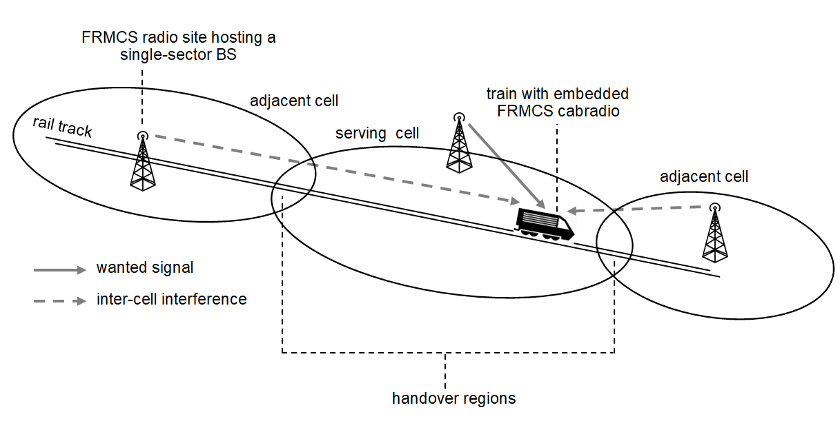
Figure 2: FRMCS architecture
As illustrated in Figure 3 below, an FRMCS radio site comprises a single base station, which is connected to a pair of antennas through a feeder line, a splitter and a pair of jumpers. Antennas are most of the time installed on top of a tower, but they can also be mounted on a building wall in urban areas. On-board equipment is composed of a single antenna installed on the roof of the train, a feeder line, and a so-called FRMCS cab-radio, which is integrated into the driver’s dashboard.
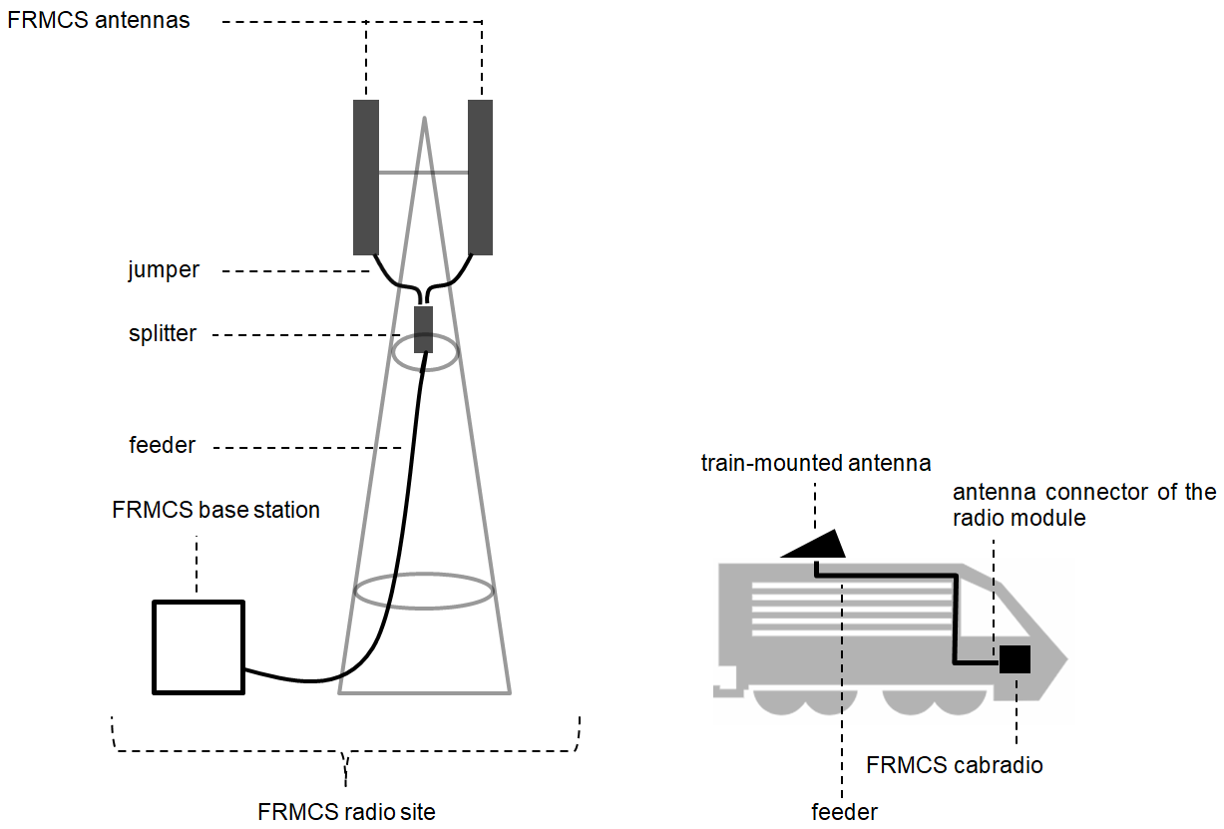
Figure 3: FRMCS radio site and on-board equipment

Radio access technology to implement FRMCS

FRMCS using 4G LTE
4G LTE technical specifications are defined in the documents 3GPP TS 36.101 [7] and 3GPP TS 36.104 [8] for User Equipment (UE) and Base Stations (BS), respectively. In this Report, it is assumed that FRMCS equipment that will be placed on the market would comply with these technical specifications, without any additional requirement.
In the case where FRMCS is implemented using 4G LTE RAT, it will use the Evolved UMTS Terrestrial Radio Access (E-UTRA) TDD operating band n°33 (see 3GPP TS 36.101, table 5.5-1), which spans over the 1900-1920 MHz frequency range. The 10 MHz E-UTRA carrier will be centred at 1905 MHz, i.e. the E-UTRA Absolute Radio Frequency Channel Number (EARFCN) is 36050 (see 3GPP TS 36.101, section 5.7.3 (“Carrier frequency and EARFCN”)).

FRMCS using 5G NR
Technical specifications for UE and BS are to be found in 3GPP TS 38.101 [9] and TS 38.104 [10], respectively. As in the case of 4G LTE, FRMCS equipment is not assumed to exhibit better characteristics than defined in these documents.
The 1900-1920 MHz frequency band was originally introduced for UMTS TDD (see 3GPP TS 25.101 [11] clause 5.2 (“Frequency bands”)). It was also included in the LTE specification as operating band n°33 (see 3GPP TS 36.101, table 5.5-1). However, as already stated in section 1.3, it was never used by any European operator, and therefore, it does not appear in the list of currently defined NR operating bands (see 3GPP TS 38.101, table 5.2-1). However, in the case FRMCS would adopt NR technology, the 1900-1920 MHz frequency range should be included as band n°33 in the list of NR operating bands.
The 10 MHz NR carrier centred at 1905 MHz is uniquely identified by NR-EARFCN = 381000 (see 3GPP TS 38.101 [9], section 5.4.2.3 (“Channel raster entries for each operating band”)).
5G NR is a new technology that builds upon 4G LTE, and therefore shares many characteristics with this latter, in particular regarding the modulation, spectrum access, scheduling mechanism, and so on. However, it also includes many new features that are not all needed in the context of FRMCS:
- 5G NR has a great variety of deployment scenarios, ranging from enhanced Mobile Broadband (eMBB), to massive Machine-type Communication (mMTC) and Ultra-Reliable and Low-Latency Communications (URLLC). Of those three usage scenarios, eMBB appears to be the most relevant but not being the only relevant for FRMCS;
- 5G NR allows for flexible numerology. It means that the Subcarrier Spacing (SCS) is no longer set at 15 kHz like in 4G LTE, but it can take one of the following values: 15, 30, 60, 120 or 240 kHz. The length of the Cyclic Prefix (CP), which is inserted at the beginning of every data symbol in 4G LTE and 5G NR, proportionally decreases as the SCS gets larger. The selection of the optimal SCS is based on whether the limiting factor in the particular deployment is the phase noise, or the delay spread. Phase noise is mostly observed at higher frequency bands (typically within the Frequency Range (FR) 2) and results from the mixing of interferers with the signal of local oscillators in the receiver chain. Delay spread is caused by multipath effects and generates Inter-Symbol Interference (ISI). It is mostly encountered in deployments using lower frequency bands, which is the case of FRMCS. A longer CP is thus needed in FRMCS to reduce ISI, which implies using the smallest possible SCS of 15 kHz. However, 30 kHz SCS may be used to address low latency scenarios in FRMCS;
- Unlike 4G LTE where the largest possible carrier bandwidth is 20 MHz, 5G NR can implement carriers with up 100 MHz bandwidth. The power consumption of a UE that would permanently receive on such a wide channel increases dramatically. In order to cope with this problem, 5G NR allows for the splitting of this carrier in different parts called Bandwidth Parts (BWP), where each BWP uses its own numerology (i.e. its own SCS). This feature is known as “bandwidth adaptation”. During bursty traffic periods, the whole carrier is used, and the rest of the time, only a small part of it. This feature is not relevant for FRMCS because it implements a 10 MHz carrier for which the separation in BWPs is not believed to be useful. Moreover, unlike battery-powered handheld devices, FRMCS on-board equipment is not subject to power-consumption constraints.

Comparison between 4G LTE and 5G NR-based FRMCS
Considering the similarities between 4G LTE and 5G NR technologies, the detailed technical study is addressing only a single technology for FRMCS: 4G LTE RAT. In that regard, the results can be generalised to 5G NR, at least when studying compatibility with other systems.

FRMCS as interferer
FRMCS base stations using a 10 MHz carrier centred at 1905 MHz have exactly the same unwanted emission limits, whether they use 4G LTE or 5G NR technology. The applicable requirement in terms of Operating Band Unwanted Emissions (OBUE) are to be found in 3GPP TS 36.104 [8], table 6.6.3.2.1-6 (Category B, Option 1) or Table 6.6.3.2.2-1 (Category B, Option 2) for LTE. These two tables correspond to Table 6.6.4.2.2.1-2 (Category B, Option 1) and Table 6.6.4.2.2.2-1 (category B, Option 2) in 3GPP TS 38.104 [10] for 5G NR. The boundary between out of-band region and spurious emissions region is the same for both technologies : 10 MHz below the lowest (i.e. 1890 MHz) to 10 MHz above the highest frequency (i.e. 1920 MHz) of the operating band (see 3GPP TS 36.104 [8], table 6.6.3.1-1 for LTE and 3GPP TS 38.104, table 6.5.2.2-1 for 5G NR.) The spurious emission limit is not technology specific: its value is fixed at -30 dBm/1 MHz by ERC Recommendation 74-01 [12], annex 2, table 6 (land mobile service, maritime mobile service and short range devices requirements).
4G LTE or 5G NR FRMCS on-board equipment must comply with the same Spectrum Emission Mask (SEM), which is provided in 3GPP TS 36.101 [7], table 6.6.2.1.1-1 for LTE and 3GPP TS 38.101 [9], Table 6.5.2.2-1 for NR. The spurious emission limit below 1885 MHz and above 1925 MHz is the same as for BS (i.e. -30 dBm/1 MHz).
Unwanted emissions are not the only mechanism by which FRMCS base stations and on-board equipment can interfere with other systems in adjacent bands: blocking and intermodulation also need to be considered. These two effects depend fundamentally on the structure of the interfering signal in terms of Power Spectral Density (PSD). As seen in section 2.2.2, a 10 MHz NR carrier used in FRMCS would most likely be configured with 15 kHz SCS, and therefore comprise 624 regularly spaced subcarriers (There are 52 Resource Blocks (RB) in a 10 MHz carrier when SCS = 15 kHz, see 3GPP TS 38.101, table 5.3.2.-1, and each RB comprises 12 subcarriers, independently of the SCS). The signal structure is almost the same as for a 10 MHz LTE carrier, whose occupied bandwidth is slightly smaller because it has only 50 RBs (see 3GPP TS 36.101, table 5.6-1), which results in 600 subcarriers.

FRMCS as interfered-with system
In 4G LTE and 5G NR, receiver requirements are given in terms of Reference Sensitivity Level (RSL) Adjacent Channel Selectivity (ACS), in-band blocking, out-of-band blocking and intermodulation characteristics. In each of these test cases, a wanted signal called Fixed Reference Channel (FRC) is introduced into the receiver, together with one or more interferers (except in the RSL test case, where there is no interferer). The test consists of checking that the FRC is still able to provide 95% of its maximum throughput in the presence of this/these interferer(s).
Fixed Reference Channel: In 4G LTE, the FRC for 10 MHz channel bandwidth in TDD mode has the following characteristics : all 50 Resource Blocks are allocated, the TDD configuration is such that 5 subframes per radio frame are assigned to the downlink, the modulation is Quadrature Phase-Shift Keying (QPSK) and the code rate is 1/3 (see 3GPP TS 36.101 [7], annex A.3.2 table A.3.2-2). This corresponds exactly to the FRC used in 5G NR for SCS = 15 kHz (see 3GPP TS 38.101, annex A.3.2, table A.3.2-2).
Reference Sensitivity Level: The RSL for 10 MHz bandwidth in operating band n°33 is -97 dBm in LTE (see 3GPP TS 36.101, table 7.3.1-1). In 5G NR, although the operating band “n33” is not defined, the RSL for band n39 (1880-1920 MHz) when using 10 MHz channel bandwidth together with 15 kHz SCS is -96.8 dBm (see 3GPP TS 38.101, table 7.3.2-1).
ACS, in-band-blocking, out-of-band blocking and intermodulation characteristics: In both technologies, the interferer used to check ACS, in-band/out-of-band blocking resistance and third order intermodulation rejection, is a 5 MHz modulated carrier with full Resource Blocks allocation (of the same technology as the victim signal), except for out-of-band blocking, where the interferer is an unmodulated carrier. In both technologies, the interferer power level, the frequency spacing to the wanted signal and the allowed receiver desensitisation are the same, which results in the same specified performance level.

System parameters
This section gathers the technical parameters of FRMCS that are not specific to any particular deployment scenario. As explained in section 2.2.3, these parameters are based on the assumption that FRMCS uses 4G LTE RAT and the results can be applied to 5G NR networks.

Table 3: FRMCS system parameters
Parameter | Value
Operating band | E-UTRA TDD operating band n°33 | Note 1
Carrier centre frequency | 1905 MHz | Note 1
Channel bandwidth | 10 MHz | Note 1
TDD configuration | frame configuration 0  special subframe configuration 6 | Note 2
Maximum number of Resource Blocks | 50 | Note 3
Occupied bandwidth | 9 MHz | Note 4
FRMCS BS
Maximum output power per antenna connector | 46 dBm | Note 5
Unwanted emissions | Given in 3GPP TS 36.104 [8], table 6.6.3.2.1-6 (OBUE for Category B Option 1 BS) and table 6.6.4.2.1-1 (spurious emissions) | Note 6
FRMCS on-board equipment
Maximum output power per antenna connector | 31 dBm | Note 7
Unwanted emissions | Given by 3GPP TS 36.101 [7], table 6.6.2.1.1-1 (SEM) and table 6.6.3.1-2 (spurious emissions)
Noise Figure (NF) | 5 dB | Note 8
Noise floor per Resource Block | -116.4 dBm | Note 9
Third-order intermodulation intercept point (IIP3) | -20.6 dBm | Note 10
Note 1: See section 2.2.1.
Note 2: LTE allows for eight different TDD configurations (see 3GPP TS 36.211 [13], table 4.2-2). The choice of the optimal configuration is based on the network load repartition between the uplink and the downlink. ECC Report 294 [5], section 3.3 and 3.4 indicate that in the case of FRMCS, significantly more data (including critical video traffic) has to be transmitted from the train to the ground infrastructure, than in the other direction. Therefore, frame configuration 0 has be assumed in this Report, for which the uplink/downlink ratio is 3 (6 uplink subframes and 2 downlink subframes per frame). Configuration 6 would also be possible. The frame structure for TDD configuration 0 is |D|S|U|U|U|D|S|U|U|U|, where D denotes a downlink, U an uplink, and S a special subframe.
Special subframes are used to make the transition between downlink and uplink transmission periods. In the Normal Cyclic Prefix Mode, special subframes comprise 14 OFDM symbols. In particular, configuration 6 has 9 downlink symbols, followed by a 3 symbols guard period, and 2 uplink symbols.
Note 3: The maximum useable number of Resource Blocks in the carrier is known as “transmission bandwidth configuration”. This figure is provided for each channel bandwidth in 3GPP TS 36.101 [7], table 5.6-1.
Note 4: As explained in section 2.2.3.1, there are 600 subcarriers in a 10 MHz E-UTRA channel and the SCS is 15 kHz, so that the occupied bandwidth is 15 kHz x 600 = 9 MHz.
Note 5: This is the power measured per antenna connector, before any feeder, splitter and jumper loss (see Figure 3), in the case where all Resource Blocks (RBs) are allocated (the power per RB is constant because no downlink power control is supported in LTE). This value may not be constant over the whole FRMCS network, depending upon the circumstances. For instance, in cities where the Inter-Site Distance (ISD) is smaller, a lower output power at base stations can reduce ICI, while maintaining the same coverage requirements. However, this generic value was reported by infrastructure managers and considered as representative of real deployments envisaged for FRMCS. Moreover, it was used in previous ECC reports involving GSM-R, for example ECC Report 200 [14], and ECC Report 162 [15].
Note 6: As explained in footnote 18, there are two possible OBUE limits for Category B BS. Option 1 was chosen because it is less stringent than Option 2 and therefore represents a worst case assumption for co-existence studies with other systems in adjacent bands.
Note 7: The FRMCS on-board transmitter requires a maximum transmit power of 31 dBm to meet the FRMCS performance objectives, and therefore they are referred to as Power Class 1 in 3GPP specifications. However, only commercial UEs (referred to as Power Class 3 in 3GPP specifications) are allowed to operate in E-UTRA band n°33 (see 3GPP TS 36.101 [7], table 6.2.2-1). It is thus assumed that TS 36.101 will need to be updated accordingly to allow Power Class 1 equipment to operate in E-UTRA band n°33.
Moreover, FRMCS cab-radios will implement uplink power control, but this was not taken into consideration in this Report.
Note 8: Typical value provided by cab-radio manufacturers for state-of-the-art equipment. This is about 4 dB better than the noise figure that could be determined from the RSL test case in TS 36.101 [7].
Note 9: The internal noise of the receiver when considering a single 180 kHz RB and a 5 dB noise figure is given by equation 5 in Recommendation ITU-R SM.575: $-174 \frac{dBm}{Hz}+10\log_{10}\left({180 kHz}/{1 Hz}\right)+5 dB= -116.4 dBm$.
Note 10: The receiver Third-Order Input Intercept Point (IIP3) associated to a 10 MHz E-UTRA channel is computed by following the methodology described in section 21.4.7 in “LTE, the UMTS Long Term Evolution” [16].
In the intermodulation test case in 3GPP TS 36.101, according to Table 7.8.1.1-1, the useful signal power is 6 dB above the RSL, i.e. at -91 dBm (the RSL in E-UTRA band n°33 for a 10 MHz channel is -97 dBm, according to 3GPP TS 36.101, table 7.3.1-1). The FRC signal being QPSK modulated with a code rate of 1⁄3 (see section 2.2.3.2), the minimum Signal-to-Interference-plus-Noise-Ratio (SINR) needed by the FRC to meet 95% of its maximum throughput is -1 dB, and an implementation margin of 2.5 dB must also be included to account for the difference in SINR requirement between theory and practicable implementation (see “LTE, the UMTS Long Term Evolution” section 21.4.4.1). Therefore, the elevated noise floor (i.e. the thermal noise plus the intermodulation product) in this test case is around: -91 dBm - (-1 dB + 2.5 dB) = -92.5 dBm. The allowed desensitisation being 6 dB, the intermodulation product is -1.25 dB below the elevated noise floor (if ${(N+I)}/N=6 dB$ then $I/{(N+I)}=10\log_{10}\left(1-{10}^{-0.1\left({N+I}/N\right)}\right)=10\log_{10}\left(1-{10}^{-0.6}\right)=1.25 dB$). As a 5 MHz E-UTRA combined with a CW signal are used to generate the intermodulation product, whereas the useful signal is 10 MHz, a factor of 3 dB has to be considered. Therefore, the intermodulation product has a power of: -92.5 dBm - 1.25 dB - 3 dB = -96.75 dBm. The two signals generating the intermodulation have both -46 dBm power, so that the IIP3 equals $\frac{-\left(96.75\right)+3⋅*\left(-46\right)}{2}=-20.6 dBm$ (two signals of equal power $P$ generate a third order intermodulation product with $3P-2{IIP}_{3}$ power, see Recommendation ITU-R SM.1134 [18] for further details about the computation of third-order intermodulation products).

Deployment-related parameters
The present section provides a list of possible deployment-related parameters that could be encountered in a typical FRMCS network that will be taken as a basis later in this Report.
Table 4: FRMCS deployment-related parameters
Parameter | Value
FRMCS radio sites | Same sites as for GSM-R coverage | Note 1
Frequency reuse scheme | See Figure 4 | Note 2
Parameters of FRMCS BS
Feeder loss | 4 dB | Note 3
Antenna height, azimuth and tilt | Two antennas per FRMCS site (see Figure 3). Same height, azimuth and tilt as already deployed antennas for GSM-R coverage | Note 1, Note 4
Antenna type | Passive sectoral panel antennas | Note 5
Transmit diversity gain | 3 dB | Note 6
Antenna pattern | Recommendation ITU-R F.1336-5 [19], section 3.1.1 or 3.1.2 with improved side-lobe efficiency: $k_{p}=0.7; k_{a}=0.7$; $k_{h}=0.7$; $k_{v}=0.3$ | Note 7
Antenna pattern parameters | Peak gain = 18 dBi / Horizontal Half-Power Beamwidth (HPBW) = 65° / Vertical HPBW = 8.5° | Note 8
Parameters of on-board equipment
Hardware losses | 3 dB | Note 9
Antenna pattern | HUBER+SUHNER 1399.99.0121  See Figure 6 to Figure 7 below | Note 10
Antenna height above the rail track | 4 m
Note 1: It is assumed that FRMCS BS will be co-located with GSM-R Base Transceiver Stations (BTS) in the same radio sites. This allows for reusing the existing infrastructure, which ultimately reduces the network deployment costs. In that regard, either bi-band antennas will be used to support GSM-R and FRMCS, or single-band antennas placed on top of each other: see for example Figure 11 in the study by UIC about the co-existence between GSM-R and FRMCS: Doc. FM56(17) 041Annex1 [20]. However, FRMCS in the 1900-1920 MHz frequency range experiences increased propagation losses of about 6 dB with respect to GSM-R, and therefore complementary sites might be needed. In this Report, for the sake of simplicity, no further densification was assumed.
Note 2: ICI is an important limiting factor in LTE networks or, more generally, in all technologies reusing the same frequencies within a limited geographical area. There are several measures that can be taken to reduce it, and a complete listing of all possibilities that could be used in FRMCS is beyond the scope of this Report. The frequency reuse scheme assumed in this co-existence study is shown in Figure 4 below. It is a very basic version of the so-called Fractional Frequency Reuse (FFR). It consists in configuring FRMCS BS in such a way that the antenna pointing towards the left can only use the first 25 Resource Blocks (RBs) (numbered #1 to #25), and the antenna pointing towards the right, the 25 remaining RBs (numbered #26 to #50). In this way, ICI is limited to a single adjacent cell as shown in Figure 4. (for the sake of simplicity, radiations at the rear of antennas are not considered
Note 3: This figure has been provided by infrastructure managers and accounts for the feeder, splitter and jumper losses (see Figure 3).
Note 4: The height, azimuth and tilt of antennas used for FRMCS deployment are obviously the same as used for GSM-R antennas: this is clear if a bi-band solution is adopted, and it remains true if separate antennas are installed, because the radio coverage issues do not depend on the system considered.
Note 5: Beamforming techniques are implemented in the most modern MFCN BS to direct independent beams towards different users, and thus increase the overall network performance. It requires using Advanced Antenna Systems (AAS) with a large number of steerable ports having each its own transceiver unit. A substantial part of the BS electronics is therefore moved directly to the top of tower, which requires a site update to support much wider and heavier antenna systems. There are two reasons why this is not feasible in the case of FRMCS: firstly bi-band antennas may be used to support GSM-R in the 900 MHz together with FRMCS in the 1900 MHz frequency range and, secondly, existing GSM-R sites have not been designed for supporting AAS. The site update would imply a considerable charge for infrastructure managers. Therefore, passive antenna systems have been taken as a basis in this Report Additional studies should be performed to understand the impact of AAS systems in case these are considered for FRMCS deployments at later stages.
Note 6: The possible Transmission Modes (TM) in LTE are defined in 3GPP TS 36.213 [21], table 7.2.3-0. Some of them implement transmit diversity (TM 2) and others spatial multiplexing (TM 4, TM5). The effort of FRMCS being focussed on reliability rather than performance, it is believed that only transmit diversity will be implemented, and that TM2 will be used. Moreover, it is assumed that only two connectors will be available for FRMCS 1900 on a single panel, because dual-band antennas may be used to support GSM-R as well. Hence 3 dB diversity gain in the downlink (the typical train-mounted antenna model presented in Note 10 has only one usable antenna port per frequency band and therefore no receive diversity can be envisaged).
Note 7: Recommendation ITU-R F.1336 [19], section 3.1.1 related to the peak side-lobe pattern is used to evaluate the impact of FRMCS BS on neighbouring systems, i.e. in section 0 of this Report, whilst section 3.1.2 related to the average side-lobe pattern is used to compute the useful signal strength received by an on-board receiver.
Note 8: These parameters have been reported by infrastructure managers and reflect the characteristics of antennas currently used for GSM-R linear coverage.
Note 9: By contrast with commercial UEs, FRMCS receivers have a distributed architecture: the rooftop antenna can be at a distance from the radio module and therefore additional losses have to be considered. As explained in document SE7(19)209 [22] this figure may vary between 0 and 6 dB depending upon circumstances. 3 dB was taken as a basis in this Report.
Note 10: This typical train-mounted single-port antenna was documented in document SE7(19)209. It can be used for 2G/3G/4G cellular bands. The peak gain as well as the radiation pattern depend on the frequency band at which the antenna is used. Figure 5 below shows the three-dimensional radiation pattern that was measured at f = 1900 MHz with a ground plane below the antenna, which is supposed to reproduce the electromagnetic effect of the roof of the train. There are three main lobes: one on each side of the antenna and one at the rear. Figure 4 further shows the orientation of the antenna with respect to the three axes. The peak gain is around 6.6 dBi and is obtained for an elevation angle of about 24°. below shows the two-dimensional radiation pattern in the horizontal plane for an elevation angle of 25

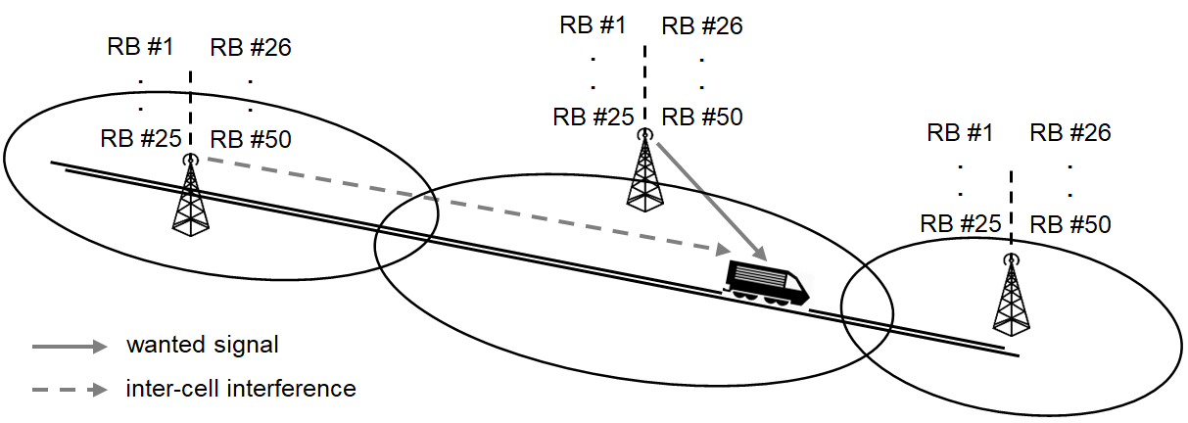
Figure 4: Assumed frequency reuse scheme and Inter-Cell Interference

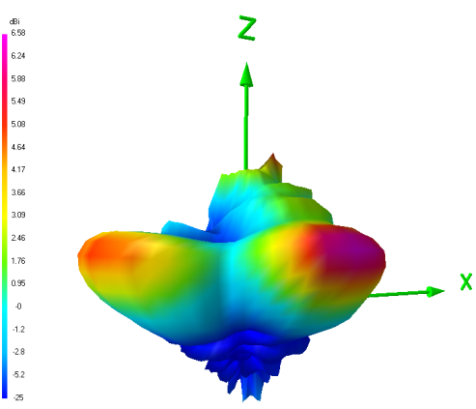
Figure 5: Train-mounted 3D radiation pattern at $f=1900 MHz$
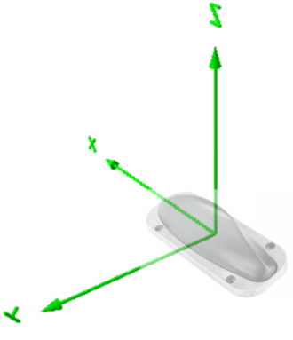
Figure 6: Orientation of the considered antenna

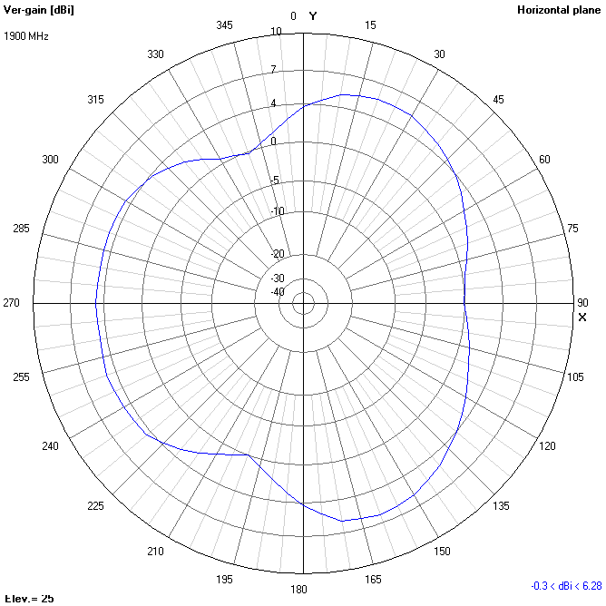
Figure 7: Horizontal radiation pattern of the train-mounted antenna at an elevation angle of 25° at f=1900 MHz

Considered scenarios
Three different environments are usually considered when deploying any mobile network: rural, urban, and suburban area. Each environment has its own specificities in terms of users’ density and mobility, propagation characteristics, and so on, that must be considered in co-existence and sharing studies with other services.
In the case of FRMCS, the same approach has been adopted: following the railway segmentation description contained in ECC Report 294 [5], three so-called railway segments have been defined and studied separately: high-speed lines, low-density lines, and high-density lines, whose respective characteristics are shown in Table 5 below. The average speed indicated for each type of segment is a best guess that may be underestimated or exceeded in some parts of the European railway network. The number of trains per radio cell is taken from ECC Report 294, Table 5 .
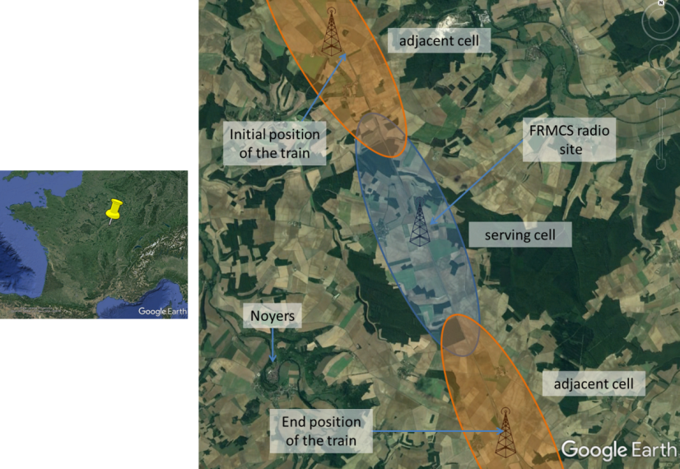
Figure 8: Representative example of a high-speed line (Paris-Lyon)
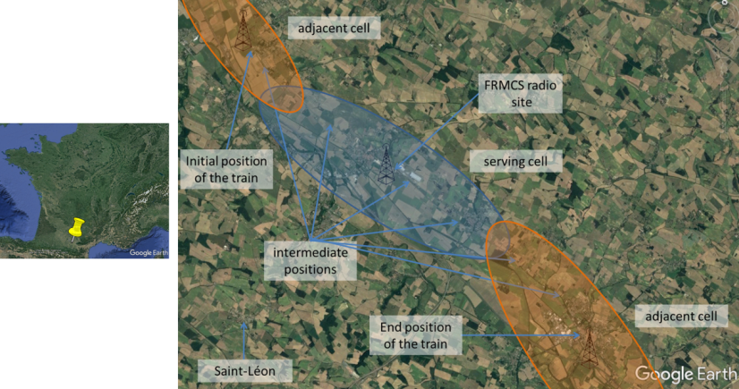
Figure 9: Representative example of a low-density line (Bordeaux-Toulouse)
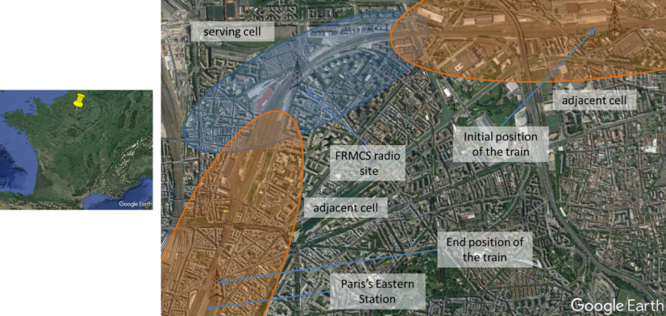
Figure 10: Representative example of a high-density line (Paris’s Eastern station in Paris city centre)
A representative example of each kind of segment has also been chosen in the French railway network and shown in Figure 8 to Figure 10 above. In each of these examples, three cells are considered: the serving cell in which the performances will be evaluated, together with the two adjacent cells that generate ICI. As explained in Table 4 note 1, the FRMCS sites are assumed to be the same as already installed GSM-R sites. The cell ranges and handover areas are shown for illustrative purposes only. Actual ranges will be determined in section 4 and 6, where the useful signal strength will be computed in each of the three scenarios. As further explained in section 2.6, these examples will serve as a basis throughout this Report to assess co-existence between FRMCS and neighbouring systems.
Table 5: Characteristics of the three railway segments
Railway environment | Corresponding MFCN environment | Average train speed | Number of trains per cell | Example
High-speed | Macro rural | 300 km/h | 4 | see Figure 8
Low-density | Macro rural | 100 km/h | 3 | see Figure 9
High-density | Macro urban | 50 km/h | 5 | see Figure 10

FRMCS modelling in co-existence studies
In this Report, the impact of adjacent band systems on the FRMCS downlink in terms of performance degradation has been assessed using the general methodology set out in Recommendation ITU-R M.2101 [23], section 3.4.1, which is applicable to IMT-Advanced and IMT-2020 cellular systems. However, the specificities of FRMCS with respect to public networks (in particular regarding the UE mobility) also have to be considered. Therefore, the different steps are outlined below and explained in detail further down in this section:

for scenario ∈ {high-speed, low-density, high-density}
for i = 1 to number of runs (Note 1)
- position FRMCS base stations as shown in section 2.5 and install two panel antennas per FRMCS site with the characteristics described in Table 4 (Note 2).

- position interferers (step 1).
for j = 1 to number of successive train positions considered in the serving cell (Note 3)
- Compute the useful signal strength (step 2).

- Compute the noise floor N (step 3).

- Compute the inter-cell interference $I_{Intra}$ generated by one of the two adjacent cells (step 4).

- Compute the external interference level $I_{ext}$, depending upon the interferer(s) considered (step 5).

- Compute and store the SINR value at the considered position of the train (step 6).
end
- Store the SINR values measured at each successive position of the train
end

- Display the Cumulative Distribution Function (CDF) of all SINR values and compare with the CDF without external interference.
end

Note 1:
The computation time depends on the number of runs, and therefore this parameter should be chosen with care. Interference to the FRMCS downlink is always dominated by a single interferer, which is typically the closest to the train, and thus aggregation effects only play a minor role. In the case of DECT, the density of devices to consider is so high (see Table 9) that the situation does not significantly change from a run to another, i.e. when “re-deploying” all the devices. Therefore, a single run has been considered, and was assumed to be sufficient in this case. When assessing the effect of MFCN, the number of devices (see Table 7) is such that 10 runs were found to be sufficient to capture the worst case where an LTE UE happens to be very close to the track. This represents a good compromise between the computational effort and the accuracy of the results.
Note 2: BS in public cellular networks are not active 100% of the time. Recommendation ITU-R M.2101 [23] takes this fact into consideration by introducing a so-called “load factor”, which represents the percentage of active BS over the simulation area that effectively transmit data to the connected UEs. The FRMCS traffic on the contrary is not bursty, but rather steady because signalling information has to be continuously exchanged between the trains and the ground infrastructure. Therefore, it is considered that all FRMCS BS are active (or equivalently the load factor is 100%).
Note 3: This factor is also a main driver of the overall computation time. In the MFCN study in section 4, 1000 successive positions of the train are considered, whilst in the DECT study in section 6 where much many more interferers are involved, 100 positions are considered.

Step 1 :
Whether in the case of LTE UEs or DECT devices, interferers are randomly spread over the simulation area. Some of them will be deployed in outdoors whilst others will be inside buildings. In this case, they can be placed on any floor of this building including the basement but excluding the roof, where they would be considered to be outdoor.

Step 2 and step 4 :
The maximum BS output power indicated in Table 3 ($P_{BS}^{max}$ = 46 dBm) is equally shared among the N trains in the cell (the value of N in each scenario is provided in Table 5). The so-called “power per train” (from now onwards denoted by $P_{BS}^{train}$) is calculated with the formula (5) in Recommendation ITU-R M.2101 [23]:

 | $$P_{BS}^{train}=P_{BS}^{max}-10\log_{10}\left(N\right)$$ | (3)

In order to compute the wanted signal C and the signal $I_{intra}$ from an adjacent cell that is responsible for ICI, the following power levels are introduced, and further illustrated in Figure 12 below.

$$C_{serving,1}$$ | Wanted signal mean power when the train is in the first half of the serving cell. This signal occupies ${50}/N$ Resource Blocks (RBs) among RB #1 to RB #25.
$$C_{serving,2}$$ | Wanted signal mean power when the train is in the second half of the serving cell. This signal occupies ${50}/N$ RBs among RB #26 to RB #50.
$$I_{adj,1}$$ | ICI mean power when the train is in the first half of the serving cell. This signal originates from the second adjacent cell and occupies the same RBs as $C_{serving,1}$.
$$I_{adj,2}$$ | ICI mean power when the train is in the second half of the serving cell. This signal originates from the first adjacent cell and occupies the same RBs as $C_{serving,2}$..

These power levels are determined by using the formula (8) in Recommendation ITU-R M.2101 [23]. For example, in the first part of the serving cell:

 | $$C_{serving,1}= P_{BS}^{train}-FL+G_{BS}^{train}+TxDivGain-{PL}_{BS}^{train}+G_{train}^{BS}-HL$$  $$I_{adj,1}= P_{BS}^{train}-FL+G_{BS}^{train} '+TxDivGain-{PL}_{BS}^{train} '+G_{train}^{BS}'-HL$$ | (4)
Where:
- $FL=4 dB$ | Intrinsic feeder/splitter/jumper loss in FRMCS BS (see Table 4);
- $G_{BS}^{train}$ | Gain of the antenna pointing towards the left at the serving BS, in the direction of the train (Note 1);
- $G_{BS}^{train} '$ | Gain of the antenna pointing towards the left at the base station in the second adjacent cell, in the direction of the train (Note 1);
- $G_{train}^{BS}$ | Gain of the train-mounted antenna in the direction of the serving BS (Note 2);
- $G_{train}^{BS}'$ | Gain of the train-mounted antenna in the direction of the BS in the second adjacent cell (Note 2);
- ${PL}_{BS}^{train}$ | Path loss between the serving BS and the train (Note 3);
- ${PL}_{BS}^{train} '$ | Path loss between the BS in the second adjacent cell and the train (Note 3);
- $TxDivGain=3 dB$ | Transmit diversity gain at FRMCS BS (see Table 4):
- $HL=3 dB$ | Hardware loss in FRMCS cab-radios (see Table 4).

Note 1: | The gain at the BS sectoral antenna is computed using the pattern provided in Table 4 and the methodology in Recommendation ITU-R F.1336 [19].
Note 2: | The gain at the train-mounted antenna is computed using the pattern provided in Table 4 and illustrated in Figure 5 to Figure 7.
Note 3: | The path loss is computed using the method presented in ANNEX 1.

As an illustration, the power levels $C_{serving,1}$, $C_{serving,2}$, $I_{adj,1}$ and $I_{adj,2}$ are shown in the particular case of the high-speed scenario in Figure 12 below. On the abscissa, the time in seconds is shown, based on the assumption that the train is at its initial position (see Figure 8) at t=0 and considering that its average speed is 300 km/h (see Table 5). The handover procedures occur when $C_{serving,1} ≈ I_{adj,2}$ (before this point, the useful signal was $I_{adj,2}$) and when $C_{serving,2} ≈ I_{adj,1}$ (after this point, the useful signal becomes $I_{adj,1}$). Therefore, the train stays in the serving cell for about 82s. It is interesting to note that the first handover procedure where the train enters the serving cell does not occur in the middle of the distance between the FRMCS sites. This is due to the particular geographical configuration, and to the fact that the train-mounted antenna has a lower gain towards the back than towards the front (see for example Figure 7).
Figure 13 below further shows the evolution of C (which is equal to $C_{serving,1}$ when the train is in the first half of the cell, and to $C_{serving,2}$ in the second half) and $I_{intra}$ (which is equal to $I_{adj,1}$ when the train is in the first half of the cell, and $I_{adj,2}$ in the second half). The apparent drop in signal strength when the train passes by the FRMCS site, and switches from one antenna to the other, is assumed to be mitigated in real deployments by an intra-site handover procedure. As shown in Figure 13, the SINR due to internal interference is 14 dB and 10 dB at the handover points. Note that ECC Report 229 [24], table 4 indicates an average value of 20 dB in GSM-R networks, that “may be lower at cell edge”.

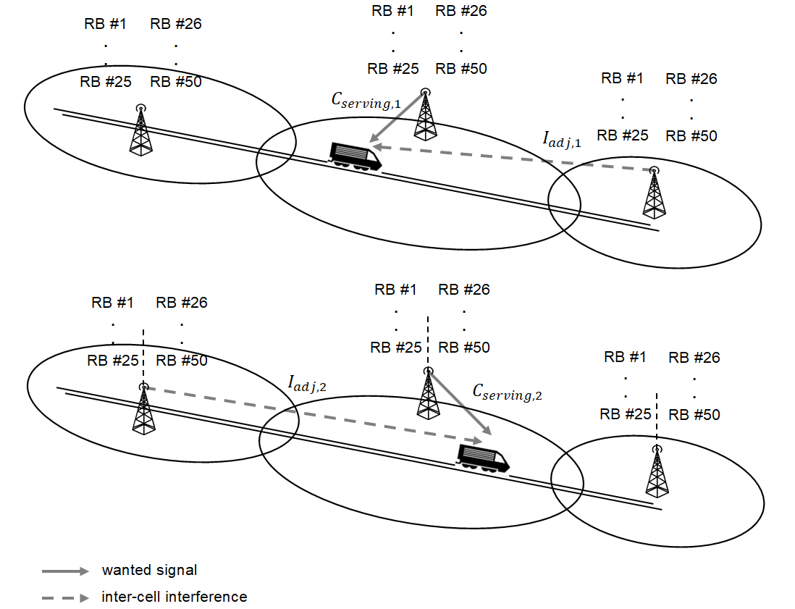
Figure 11: Wanted signal and ICI at the FRMCS cab-radio

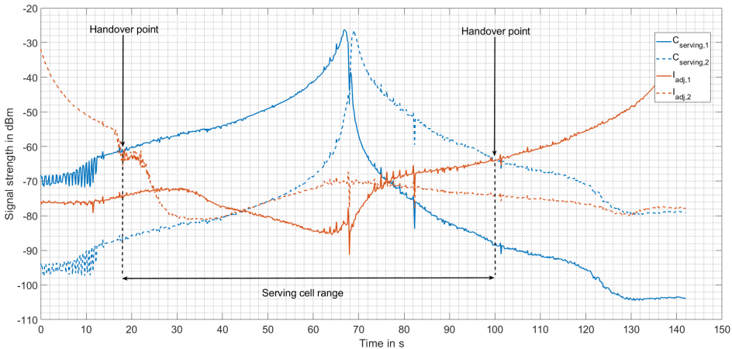
Figure 12: Power levels in the high-speed scenario
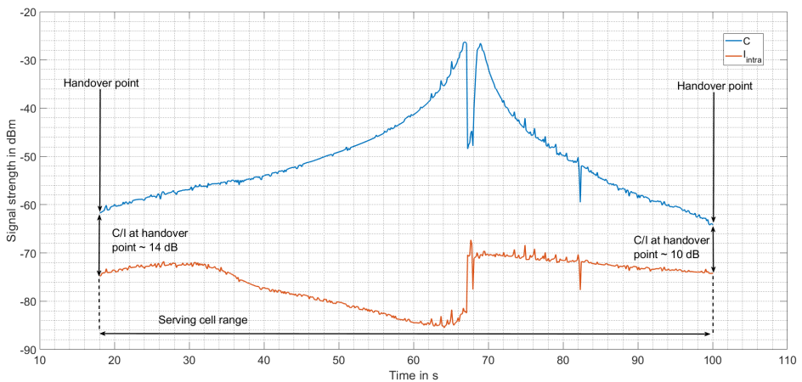
Figure 13: Wanted signal and ICI in the high-speed scenario
Step 3:
The noise floor in FRMCS on-board receivers has been computed using formula (11) in Recommendation ITU-R M.2101 [23]: $N= -174 {dBm}/{Hz}+10\log_{10}\left(180 kHz*number of used RBs\right)+Noise figure$. The noise figure of FRMCS cab-radios has been assumed to be 5 dB (see Table 3), and the average number of RBs per train depends on the train density indicated in Table 5. For example, in the high-speed scenario, there are 50 RBs (see Table 3) to share amongst 4 trains on average. The noise floor is then: $N= -174 {dBm}/{Hz}+10\log_{10}\left(180 kHz*{50 RBs}/{4 trains}\right)+5 dB= -105.5 dBm$. Following the same methodology, the noise floor in the low-density and in the high-density scenario is evaluated at -104.2 dBm and -106.4 dBm, respectively.

Step 5:
$I_{ext}$ is computed as the aggregation of the contribution of all interferers (which are alternatively LTE UEs in section 4 and DECT devices in section 6.1). In addition, as stated in Recommendation ITU-R M.2101 [23]:
”The Adjacent Channel Interference Ratio (ACIR) value should be calculated based on per UE allocated number of resource blocks”.
Therefore, the number of Resource Blocks (RBs) per train in each scenario (which can be determined from Table 5) has been duly considered in the calculation of $I_{ext}$.
Step 6:
The overall interference power is computed using formula (12) in Recommendation ITU-R M.2101: $I= I_{intra}+I_{ext}+N$, and thus: SINR = C – I.

Adjacent band systems

MFCN in band 1 uplink

Regulatory framework
The 1920-1980 MHz / 2110-2170 MHz paired frequency range is a multi-system operating band that can be used by all wideband technologies developed at 3GPP: it is referred to as band I in the UMTS specification (see 3GPP TS 25.101 [11], table 5.0), band n°1 in LTE (see 3GPP TS 36.101 [7], table 5.5-1) and band n1 in 5G NR (see 3GPP TS 38.101 [9],table 5.2-1).
This frequency range has been harmonised at CEPT level by ECC Decision (06)01 [6], whose first version (approved in 2006) allowed for the deployment of UMTS and LTE in the FDD mode, and using passive sectoral antenna systems in BS. The band has been extensively used by European mobile operators ever since. A second version of the decision has been approved in 2019, which makes it possible to introduce the 5G NR in the band, as well as base stations using AAS, by adapting the necessary Least Restrictive Technical Conditions (LRTC), including the Block Edge Mask (BEM).
The study contained in this report does not consider any guard band between the lower edge at 1920 MHz and the first MFCN block (the first version of ECC Decision (06)01 contained a 300 kHz guard band at the lower and upper edges of the frequency range, and therefore the first block started at 1920.3 MHz).

LTE 2100 as representative system
Among the three MFCN systems that may be deployed in 1920-1980 MHz (see section 3.1.1), it is believed that LTE implementing a 20 MHz channel centred at 1930 MHz (from now onwards referred to as LTE 2100) is a worst case assumption for the co-existence with FRMCS. The main reasons for this approach are:
- Whether in the case of 4G LTE or 5G NR, it is a general rule that the unwanted emissions limits are more relaxed as the carrier bandwidth gets larger (see for example TS 36.101 [7], table 6.6.2.1.1-1 and TS 38.101 [9], table 6.5.2.2-1);
- According to TS 38.101, table 5.3.5-1, the largest possible channel bandwidth for 5G NR in the 1900-1920 MHz frequency range is 20 MHz. The unwanted emissions limits of a 4G LTE UE and a 5G NR UE are the same, as already pointed out in section 2.2.3.1. In addition, section 4.1.3 concludes that the main mechanism by which UE interfere with FRMCS is the unwanted emissions falling into the FRMCS receiver bandwidth (neither the blocking nor the intermodulation). Therefore, there is no need to consider the exact structure of the interferer signal, and it makes no difference whether this signal is LTE or NR;
- The unwanted emissions limits of an UMTS UE using a carrier centred at 1922.4 MHz are given in 3GPP TS 25.101 [11], table 6.10, and shown in Figure 14 below, together with the limits of an LTE UE using a 20 MHz carrier centred at 1930 MHz, that are provided in 3GPP TS 36.101, table 6.6.2.1.1-1. Except for very small offsets from the lower edge of the operating band, the limits are more stringent for UMTS, and therefore LTE represents a worst case for FRMCS. In addition, UMTS is being progressively shut down by mobile operators, and the complete replacement would most likely be effective around 2025 (expected date for the first FRMCS rollout, see section 1.2).
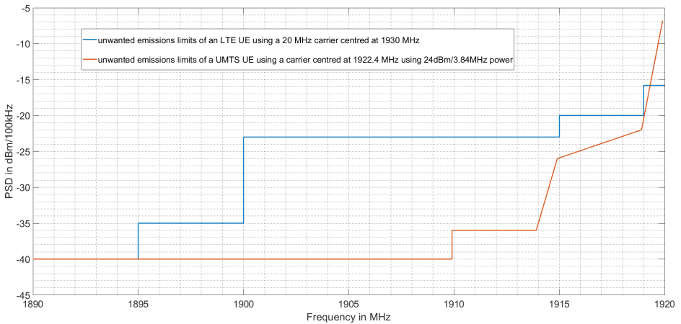
Figure 14: Comparison between UMTS and LTE unwanted emissions

System parameters of LTE 2100
Table 6 is based on the considerations presented in section 3.1.2, and summarises the system parameters of LTE 2100 uplink that is used in the co-existence study with FRMCS.
Table 6: LTE 2100 uplink system parameters
Parameter | Value
Operating band | E-UTRA FDD operating band n°1 | Note 1
Carrier centre frequency | 1930 MHz | Note 1
Channel bandwidth | 20 MHz | Note 1
Maximum number of RBs | 100 | See Table 3, Note 3
Occupied bandwidth | 18 MHz | See Table 3, Note 4
Parameters of LTE UEs
Maximum output power | 23 dBm | Note 2
Unwanted emissions | Given by TS 36.101 [7],Table 6.6.2.1.1-1 (SEM) and Table 6.6.3.1-2 (spurious emissions)
Note 1: See section 3.1.2.
Note 2: As per 3GPP TS 36.101[7], table 6.2.2-1, Power Class 3 equipment only is allowed to operate in the operating band n°1, with a maximum output power of 23 dBm. This is in line with Report ITU-R M.2292 [27], TABLE 4, which is about the characteristics of terrestrial IMT-Advanced systems for sharing and interference analyses.

Deployment-related parameters of LTE 2100
The following table summarises the deployment-related parameters of LTE 2100 uplink in the particular context of FRMCS: for example, the number of UEs to consider is specific to the simulation areas considered in section 2.5.
Table 7: LTE 2100 deployment-related parameters
Parameter | value
Parameters of LTE UEs
Antenna pattern | isotropic with -3 dBi gain in all directions |  |  | Note 1 | Note 2
Body loss | 4 dB |  |  | Note 1 | Note 3
Antenna height above ground | 1.5 m |  |  | Note 1 | Note 4
 | high-speed scenario | low-density scenario | high-density scenario | Note 1
Building entry loss | 15 dB |  | 20 dB | Note 1 | Note 5
Active users in buildings | 51 | 97 | 76 | Note 1 | Note 5  Note 6
Active users in open area | 51 | 97 | 32 | Note 1 | Note 5  Note 6
Note 1: Set of values taken from Report ITU-R M.2292 [27], table 3 (“Deployment-related parameters for bands between 1 and 3 GHz”).
Note 2: Current LTE user’s devices transmitting in the 1920-1980 MHz frequency range contain 2 or 4 antennas and, for this kind of equipment, the radiation pattern has been described in Report ITU-R M.2292 Table 3 (i.e. -3 dBi gain in all directions).
ECC Decision (06)01 [6] allows for the use of AAS in the 1920-1980 MHz / 2110-2170 MHz duplex band, but it also clearly states that “AAS in the 2GHz frequency band only apply to base stations”. This is further acknowledged in the executive summary of ECC Report 298 [28]: “The introduction of AAS systems will be only on the BS side as it is not foreseen for the UE side.” This is easily understandable because the size and spacing between antennas in a mMIMO system both get larger as frequencies get lower, which makes the integration into a portable device difficult. Therefore, no AAS is envisaged for future LTE user’s devices in the 1920-1980 MHz band, and Report ITU-R M.2292 is assumed to remain applicable.
Note 3: This value takes into account the various losses that occur when the user is holding the device or placing it against his head.
Note 4: For an outdoor UE, this height is counted from the “natural ground” level, whilst for a UE within a building, this height is counted from the “artificial” floor on which the UE is standing.
Note 5: The high-speed and low-density scenarios are assumed to belong to a macro rural, and the high-density scenario, to a macro urban environment (see Table 5)
Note 6: The number of UEs in each scenario has been determined using the density estimation provided in Report ITU-R M.2292, according to which 0.17 UEs/km² and 3 UEs/km² must be considered per 5 MHz frequency block, in a macro rural and macro urban environment, respectively.
The simulation areas shown in Figure 8 (high-speed), Figure 9 (low-density) and Figure 10 (high-density) are about 150 km², 285 km², and 9 km², respectively. Therefore, using the high-density scenario as an example, the number of UEs in open area is: 3 UEs/km² * 9 km² * 30% (percentage of UEs within buildings) * 4 frequency blocks ~ 32.

DECT in the core band 1880-1900

General description and regulatory aspects
The standard for Digital Enhanced Cordless Telecommunications (DECT) was developed at the European Telecommunications Standards Institute (ETSI) in the early 1990s, and a first version was released in 1992. DECT is a radio technology, which provides intra-building or campus connectivity, or access to an external network like the Public Switched Telephone Network (PSTN). Voice as well as data are supported. Since then DECT has widened to other usages as detailed below (see also Annex 2).
The technical specification for DECT is provided in ETSI EN 300 175-2 [29], whilst the presumption of conformity to the Radio Equipment Directive (RED) 2014/53/EU [30] can be obtained using ETSI EN 301 406 [31]. Given the significant number of co-existence studies realised at CEPT level, that involve DECT technology, ETSI has also published report ETSI TR 103 089 [32] which gathers necessary parameters. Extensive use of this latter document will be made throughout this Report.
DECT has become a world-wide success ever since its standardisation, and its acceptance increases every year: in 2010 the market share for the residential and enterprise systems was 82% and 65% respectively. This is due to the availability of the common frequency band 1880-1900 MHz that has been harmonised in Europe for unlicensed used by ERC Decision (94)03 [33] and Council Directive 91/287/EEC [34].
The infrastructure for DECT communications comprises one or several BS called Fixed Radio Parts (FRP), which communicate with one or several handsets called Portable Parts (PP). Main applications of DECT technology can be distinguished:
- The private residential systems, which represent the well-known cordless phones inside a house, which have become the norm for fixed telephony over the last decade. Usually there is only one PP communicating with one FRP (hence a unique cell), which also serves as a battery charger for the PP. This represents the main application in residential and densely populated areas;
- The private enterprise systems, where several FRPs are installed within the premises of an enterprise, a hospital, a school, a call centre, etc. (usually on the walls of corridors as Wi-Fi access points);
- The Wireless Local Loop (WLL) which is used by some operators in Eastern Europe to replace the wired local loop when the deployment of a fixed infrastructure (copper wires or optical fibre) to the subscriber’s home is not practically feasible;
- The Internet of Things, which includes smart city, smart home, etc. with ultra-low latency planned in the future;
- Professional audio PMSE for wireless microphones or speakers covering a permanent or temporary installation such as theatres or outdoor events (stadium, music festival, etc.).
In other than residential scenarios, the DECT may in some cases operate with full capacity, thus occupying all channels.

System parameters
Table 8 summarises the system parameters of DECT devices. These parameters are taken from the specification ETSI EN 300 175-2 [29], or from previous ECC Reports involving DECT technology. The specification does not make distinction between FRPs and PPs; so they are treated similarly in this Report.
DECT mobile devices can connect on the fly to the best fixed-point signal. In the cases where the fixed-point may be on a different floor which may lead to lower received signal, this could lead to received power level of -79 dBm, about 15 dB lower than the -65 dBm reference value defined in ETSI TR 103 089.

Table 8: DECT system parameters
Parameter | Value
Operating band | 1880-1900 MHz | Note 1
Channelisation | 10 equally spaced RF channels numbered DECT carrier F0 to F9, that are respectively centred at 1897.344 MHz – 1.728 * i  (i = 0 corresponds to F0 and i = 9 corresponds to F9). | Note 2
Duplex mode | TDMA | Note 3
Access mechanism | DCS | Note 4
Occupied bandwidth | 1.152 MHz | Note 5
Maximum output power | 24 dBm | Note 6
SEM | Given in ETSI EN 300 175-2 [29] subclause 5.5.1 (“Emissions due to modulation”) and 5.5.4 (“Spurious emissions when allocated a transmit channel”) | Note 7
Noise floor | -103 dBm/channel | Note 8
IIP3 | -20.5 dBm | Note 9
Note 1: 1880-1900 MHz is the core frequency band for DECT, and it has been harmonised in Europe. However, other bands may be used in some other countries (for example in America), depending upon the local regulatory framework. Refer to ETSI EN 300 175-2 [29] subclause 4.1.1 (“Nominal position of RF carriers”) for further details.
Note 2: See ETSI EN 300 175-2 subclause 4.1.1 (“Nominal position of RF carriers”).
Note 3: In the time domain, the frame duration is 10 ms. Each frame is divided into two 5ms half-frames, where the first one is reserved for the downlink (Fixed Radio Part to Portable Part) and the second one for the uplink (Portable Part to Fixed Radio Part). Each half-frame is further divided into 12 time slots. A communication occupies exactly a pair of slots separated by 5 ms (i.e. one slot for the downlink and one slot for the uplink), that repeat periodically.
If several Portable Parts have to be served at the same time by the same Fixed Radio Part, the latter can switch between the channels but can only use a single channel in a given slot. This principle is illustrated in Figure 15.
Note 4: All DECT devices must be able to operate on the 10 RF channels (though not at the same time). A communication is always initiated by the PP. Before connecting to the FRP, it listens to all 10 channels and selects the one that is least interfered, i.e. on which the least power from other DECT communications or other systems is received: this process is known as Dynamic Channel Selection (DCS). During the communication, both the PP and the FRP keep on scanning all channels and possibly switch to a less interfered one without losing the communication.
Note 5: The carrier spacing is 1.728 MHz (see Note 1). However, there is not definite information about the exact occupied bandwidth. ETSI TR 103 089 [32] indicates in Annex B.1 that “the transmit bandwidth is about 1 MHz”. ECC Report 96 [35] Table 4-2 (“Main DECT system parameters”) provides a value of 1.152 MHz, which has been retained in this Report.
Note 6: Mean power measured at the antenna connector (see ETSI EN 300 175-2 [29] subclause 5.3.1.1 (“PP and FRP with an integral antenna”).
Note 7: Subclause 5.5.1 requires a minimum ACLR in adjacent DECT channels.
Note 8: See ETSI TR 103 089, annex B.4.
Note 9: The specified IIP3 of a DECT device has been calculated from the intermodulation test in ETSI EN 300 175-2, section 6.6 (“Receiver intermodulation performance”), where the intermodulation product is generated by a modulated DECT carrier and a CW signal having each -48 dBm power. The authorised desensitisation is 3 dB, so that the intermodulation product equals the noise floor, i.e. -103 dBm (see Note 8). Therefore IIP3=(3*(-48)+103)/2=-20.5 dBm (see Table 3; Note 10 for more details about the computation of intermodulation products).

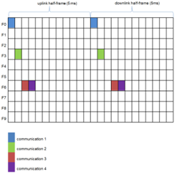
Figure 15: Illustration of DECT multiplexing principle

Deployment-related parameters
Table 9: DECT deployment-related parameters
Parameter | Value
Maximum range | The distance between the FRP and the PP will be denoted by d. It ranges from 1 to 50 meters |  |  |  | Note 1
Rx power 1 | -65 dBm |  |  |  | Note 2
Required protection criterion | $${\left(C/{N+I}\right)}_{min}=21 dB$$ |  |  |  | Note 3
Antenna pattern | Isotropic with 0 dBi gain in all directions |  |  |  | Note 4
Antenna height above ground | 1.5 m |  |  |  | Note 5
 | High-speed scenario | Low-density scenario |  | High-density scenario
Building entry loss | 15 dB |  |  | 20 dB | Note 6
Number of active FRP-PP pairs considered | 1050 |  | 3990 | 3465 | Note 7
Note 1: The maximum range of DECT devices will be used in this report to estimate the minimum signal strength at the receiver under realistic conditions of use. An exact value cannot be found in the related specification documents, nor in previous ECC reports. However, datasheets of modern DECT equipment give an order of magnitude of 50 m.
Note 2: : -65 dBm is the received power level computed at 50 m using the propagation model provided in TR 103 089 [29] Annex B.4 This propagation model can be used in both residential and enterprise scenarios. -65 dBm is also reached for outdoor systems considering free space loss model and distance of 350 m. TR 103 089 is the application of Recommendation ITU-R P.1238 [52] for office without floor separation between the FRP and the PP (at least one FRP per floor in professional use).
Note 3: “I” is understood here as in-band interference power. This figure was taken from ETSI TR 103 089 [32],subclause 6.2.1 (“Noise floor and carrier to interference ratio in a typical fading environment”) and includes a 10 dB fading margin.
Note 4: For residential and enterprise deployment scenarios, the antenna gain of DECT devices can be assumed to be 0 dBi. This value has been retained in all previous ECC reports involving DECT: ERC Report 31 [36], ERC Report 65 [37] , ERC Report 100 [38], ECC Report 96 [35], ECC Report 146 [39], CEPT Report 39 [40] and CEPT Report 41 [41]. See also ETSI TR 103 089, annex A for further details.
Note 5: DECT devices are used in the same way that LTE UEs and therefore the antenna height above the ground is assumed to be the same (see Table 7, note 4).
Note 6: Report ITU-R M.2292-0
Note 7: The number of active FRP-PP pairs to consider in each scenario is based on a traffic estimation provided in ETSI TR 101 310 [42], section6.1 (“Residential application”), where the data is given in terms of Erlangs per square kilometre. 1 Erlang corresponds to a duplex communication between an FRP and a PP and, for the sake of simplicity, it is assumed in this report that a single pair cannot generate more than 1 Erlang of traffic (this means that there is only one PP connected per FRP, which represents the majority of cases in private deployments). ETSI TR 101 310 further differentiates between “villa areas” (to which belong the high-speed and low-density scenarios) and “densely populated areas” (to which belong the high-density scenario).
According to ETSI TR 101 310, each household generates between 50 mE and 70 mE of speech traffic during the busy hour, and it is also stated that these figures must be doubled to include data traffic as well. Taking a conservative approach, we will therefore assume that each household generates 2x70 mE = 0.14 E of speech and data traffic.
According to ETSI TR 101 310, there can be 500 to 1000 households per square kilometre in villa areas. The upper value is kept here as a conservative assumption. The high-speed scenario involves a 150 km² area (see Table 7, note 6), but only 5% of this area is effectively populated. The total traffic is therefore: $1000\frac{households}{km^{2}}*5\% (populated area)*150 km^{2}*0.14 \frac{E}{household}=1050 E$, that converts itself to 1050 FRP-PP pairs. In the low-density scenario, the effectively populated area has been estimated at around 10% of the 285 km² simulation area (see Note 6 in Table 7). Therefore, the traffic is: $1000\frac{households}{km^{2}}*10 \% \left(populated area\right)*285 km^{2}*0.14 =3990 E$.

According to TR 101 310, in the most densely populated areas, the number of households per square kilometre is estimated at 2000 to 4000, depending on whether the average number of building storeys is 4 or 8. The high-density scenario involves 5.5 storeys buildings on average, so that the household density is $5.5 storeys*$ $\frac{2000 households}{km²*4 storeys}=2750 households/km²$. The simulation area is 9 km² (see Note 6 in Table 7) and it can be considered 100% populated, so that the traffic is: $2750 \frac{households}{km^{2}}*9 km^{2}*0.14 \frac{E}{household}=3465 E$.

Co-existence between FRMCS and MFCN

Interference mechanisms
As already stated in ECC Report 229 [24] about the co-existence between GSM-R and MFCN, there are three main interference mechanisms by which a 20 MHz E-UTRA signal can disturb the FRMCS cab-radio: unwanted emissions falling into the FRMCS band, receiver intermodulation, and blocking effects. As shown in Figure 16 below, each of these effects introduces a so-called Added Noise (AN) into the receiver bandwidth.
In the case of the unwanted emissions and blocking effects, which are dB per dB mechanisms, the AN is proportional to the power P of the interferer (measured at the FRMCS receiver input). Therefore, the AN can be described using the two coefficients A and C shown in Figure 16 below. However, products that originate from the intermodulation of two signals are a 3 dB/dB mechanism. When intermodulation distortion is generated by a wideband E-UTRA carrier, the added noise comes from the intermodulation of several subcarriers, not only two, and therefore two unknown coefficients, x and B are introduced (see Figure 16).
In this section, the three interference mechanisms will be described and studied separately, and the coefficients A, B, C and x will be calculated, based on the simplifying assumption that the FRMCS cab-radio operates on the 50 RBs that constitute the FRMCS channel (see Table 3).
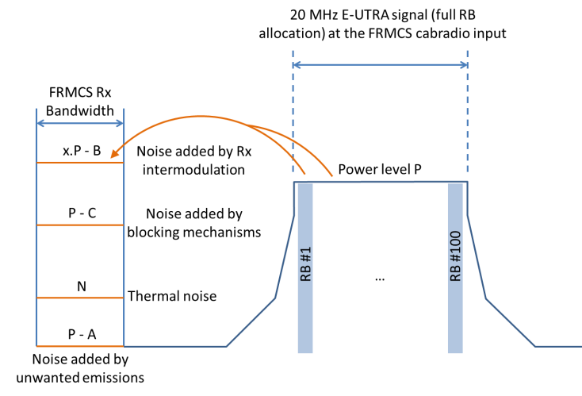
Figure 16: Interference of FRMCS cab-radios through unwanted emissions,
blocking mechanisms and receiver intermodulation

Unwanted emissions falling into the FRMCS band
The maximum output power of an LTE UE is 23 dBm (see Table 6), and the PSD of its unwanted emissions in the 1900-1910 MHz FRMCS receiver band equals -23 dBm/100 kHz (see Table 6 and Figure 14) at UE transmitting at its maximum power. When entering the FRMCS receiver, i.e. after having incurred the coupling loss CL (which encompasses the antenna gains, the path loss, etc.), the power P is therefore 23 dBm – CL, and the PSD in the FRMCS receiver bandwidth is -23 dBm-CL/100 kHz. The integrated power of these unwanted emissions over the 9 MHz FRMCS receiver bandwidth is therefore: $-23 dBm-CL+10\log_{10}\left(\frac{9 MHz}{100 kHz}\right)=-3.5 dBm-CL$. Therefore, the coefficient A in Figure 16 equals the difference between these two power levels, and thus: A = ( 23 dBm – CL ) - ( - 3.5 dBm – CL ) = 26.5 dB, when UE is transmitting at its maximum power, it should be noted that UE has a dynamic power control, its transmit power varies from 23 dBm to -40 dBm.

Blocking caused by other effects than intermodulation
As explained in ECC Report 229 [24], section 2.1:
“Blocking is a phenomenon that can be caused by either insufficient selectivity (filter discrimination), saturation of the front-end (LNA and/or mixer) or reciprocal mixing (with local oscillator phase noise)”.
The “selectivity” mentioned here must either be understood as the Radio Frequency (RF) selectivity provided by the band-pass filter in the first stage of the receiver chain, or the Intermediate Frequency (IF) selectivity in the next stage. Reciprocal mixing is caused by the imperfection of the Local Oscillator (LO) component that down converts RF to IF signals.
Blocking mechanisms (excluding intermodulation distortion) caused by the presence of a 20 MHz E-UTRA interferer centred at 1930 MHz are covered by the in-band blocking test (case 2) of TS 36.101 [7], subclause 7.6.1.1, whose setup has been illustrated in Figure 17 below.

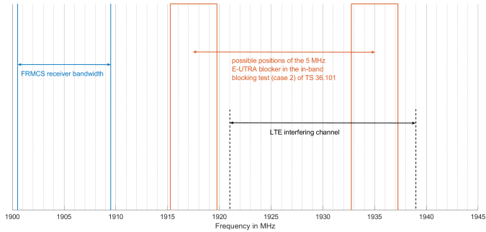
Figure 17: In-band blocking test case for FRMCS on-board equipment
In this test case, the FRC has 10 MHz bandwidth (full RB allocation) and the 5 MHz E-UTRA interferer can be placed at different positions ranging from 1917.5 MHz to 1925 MHz. Intermodulation distortion is excluded from this test case, because even when the interferer is centred at 1917.5 MHz, the lowest IP3 is centred at 1910 MHz, which is outside of the receiver bandwidth. As all RBs are allocated to the FRC, the thermal noise (based on 5 dB noise figure, see Table 3) is $-174\frac{dBm}{Hz}+10\log_{10}\left(\frac{9 MHz}{1 Hz}\right)+5 dB= -99.4 dBm$. The authorised desensitisation being 6 dB, the elevated noise floor may rise up to -93.4 dBm, and the in-band interference power generated by blocking effects to $10\log_{10}\left({10}^{-0.1*93.4}-{10}^{-0.1*99.4}\right)\left({10}^{-0.1*93.4}-{10}^{-0.1*99.4}\right)=-94.7 dBm$. The interferer having -44 dBm power, the “rejection factor” is estimated at: -44 dBm - (-94.7 dBm) = 50.7 dB.
The possible positions of the 5 MHz interferer in the in-band blocking test case 2 cover almost the whole bandwidth of the 20 MHz E-UTRA interferer, and therefore the rejection factor for this signal is assumed to remain unchanged. As a conclusion, C = 50.7 dB.

Receiver intermodulation
Intermodulation products generated by a single wideband signal is a well-known interference mechanism in GSM-R networks, which has been described in UIC document 0-8736-2.0 [43] in paragraph 1.2:
“Blocking of wideband (UMTS, LTE) signals: in a system with non-linearities, single or multiple wideband signals create multiple intermodulation products due to the multiplicity of frequency components within the UMTS or LTE carrier. [...] this effect is already existing for a single wideband carrier [...]”.
A 20 MHz E-UTRA carrier is composed of 1200 subcarriers that are equally spaced by 15 kHz. These subcarriers enter the FRMCS receiver at the same time and generate a number of intermodulation products in the receiver bandwidth. If we consider that each subcarrier has approximately 15 kHz bandwidth, then all products have three times this bandwidth, i.e. 45 kHz. These products have different centre frequencies, depending upon the position of the two subcarriers in the E-UTRA signal that generate them, but in the end they add up and this results in a gradual noise rise in the FRMCS receiver.
Figure 18 below illustrates this phenomenon by showing the effect of a -30 dBm E-UTRA signal with 20 MHz bandwidth and full RB allocation. The curve was obtained by calculating and summing the intermodulation products generated by the non-linearities of the FRMCS cab-radio, based on the IIP3 value determined in Table 3, note 10. The y-axis shows the power measured in 1 MHz bandwidth, therefore $-30 dBm+10\log_{10}\left(\frac{1 MHz}{18 MHz}\right)=-42.6 dBm/1MHz$ is measured when the filter is centred on the interferer. When the filter is centred on frequencies that are sufficiently “far away” from the interferer, a power level of $-174\frac{dBm}{Hz}+10\log_{10}\left(\frac{1 MHz}{1 Hz}\right)+5dB=-109 dBm/1MHz$ is measured, which corresponds to the thermal noise floor, assuming a 5 dB noise figure as per Table 3.
The two subcarriers in the E-UTRA signal with the lowest and highest frequencies are centred at 1921.015 MHz and 1938.985 MHz, respectively, so that the intermodulation product with the lowest frequency is centred at 2 x 1921.015 – 1938.985 = 1903.045 MHz. This can be observed in Figure 18.
The measured power grows as the filter gets closer to the interferer, because more and more intermodulation products superimpose with one another. This results in the step-like noise rise observed in Figure 18. The integration over the entire FRMCS receiver bandwidth results in an Added Noise (AN) of -94.5 dBm.
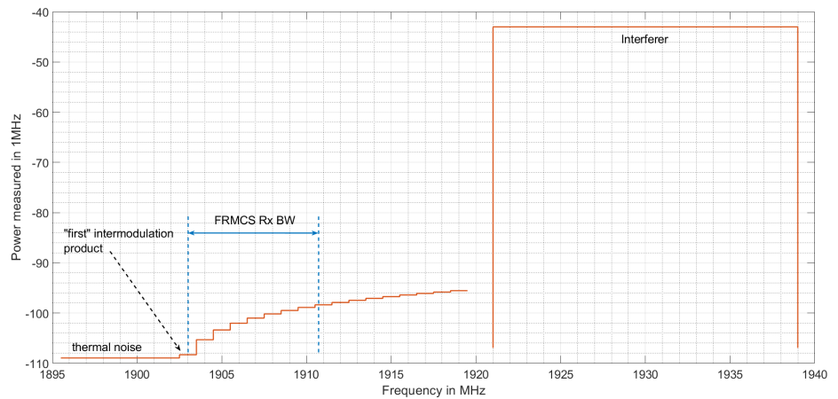
Figure 18: Noise rise is the FRMCS receiver caused by intermodulation effects
This calculation can be repeated for different power levels P of the E-UTRA interferer, which results in the graph shown in Figure 19 below. One can see that there is a linear relationship between the interferer power and the Added Noise (AN) in the FRMCS receiver bandwidth, with an offset of -4.5 dB.
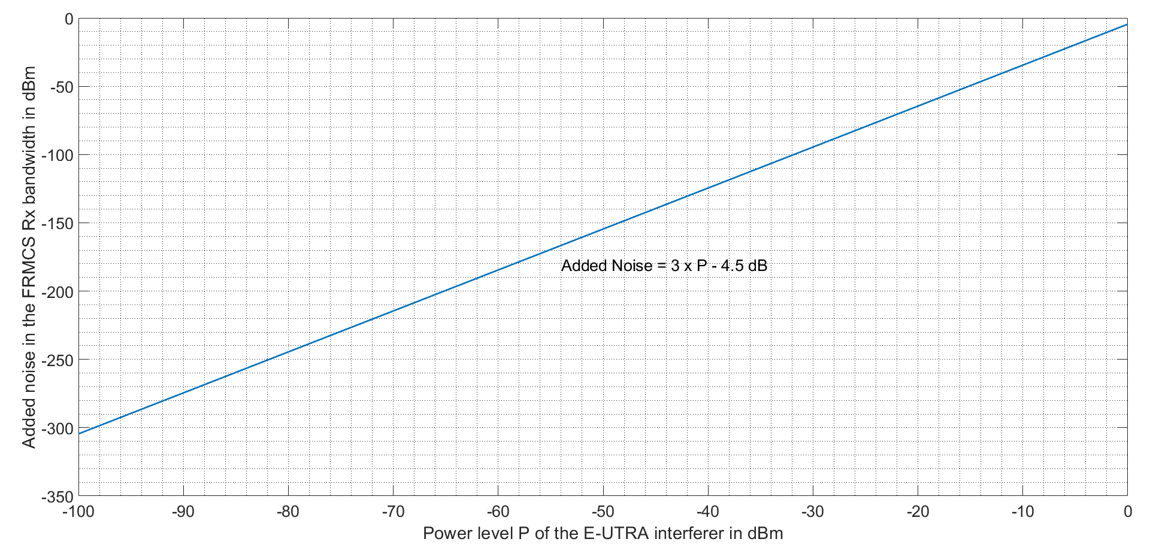
Figure 19: Noise rise in the FRMCS receiver caused by intermodulation
as a function of the interferer power
Therefore, the two coefficients x and B introduced in Figure 16 can be estimated at: x = 3 and B = 4.5 dB.

Dominating interference mechanism
Using the results obtained in sections 4.1.1, 4.1.2 and 4.1.3, Figure 20 below shows the Added Noise (AN) by unwanted emissions, intermodulation distortion and blocking mechanisms, as a function of the power P of the 20 MHz E-UTRA interferer measured at the FRMCS cab-radio input. The thermal noise at -99.4 dBm (see section 4.1.2) has also been drawn in the figure, and it is assumed not to change as P increases (i.e. no saturation of the receiver chain is considered).
As can be seen in the figure, blocking mechanisms are always dominated by unwanted emissions, irrespective of the power P (there is a constant difference of 20.2 dB between them). The receiver desensitisation occurs when the Added Noise (AN) is less than 10 dB below the thermal noise, i.e. when P = -84 dBm, and in this case desensitisation is mainly caused by unwanted emissions. Interference is only driven by intermodulation distortion for strong MFCN signals (more than around -11 dBm power).
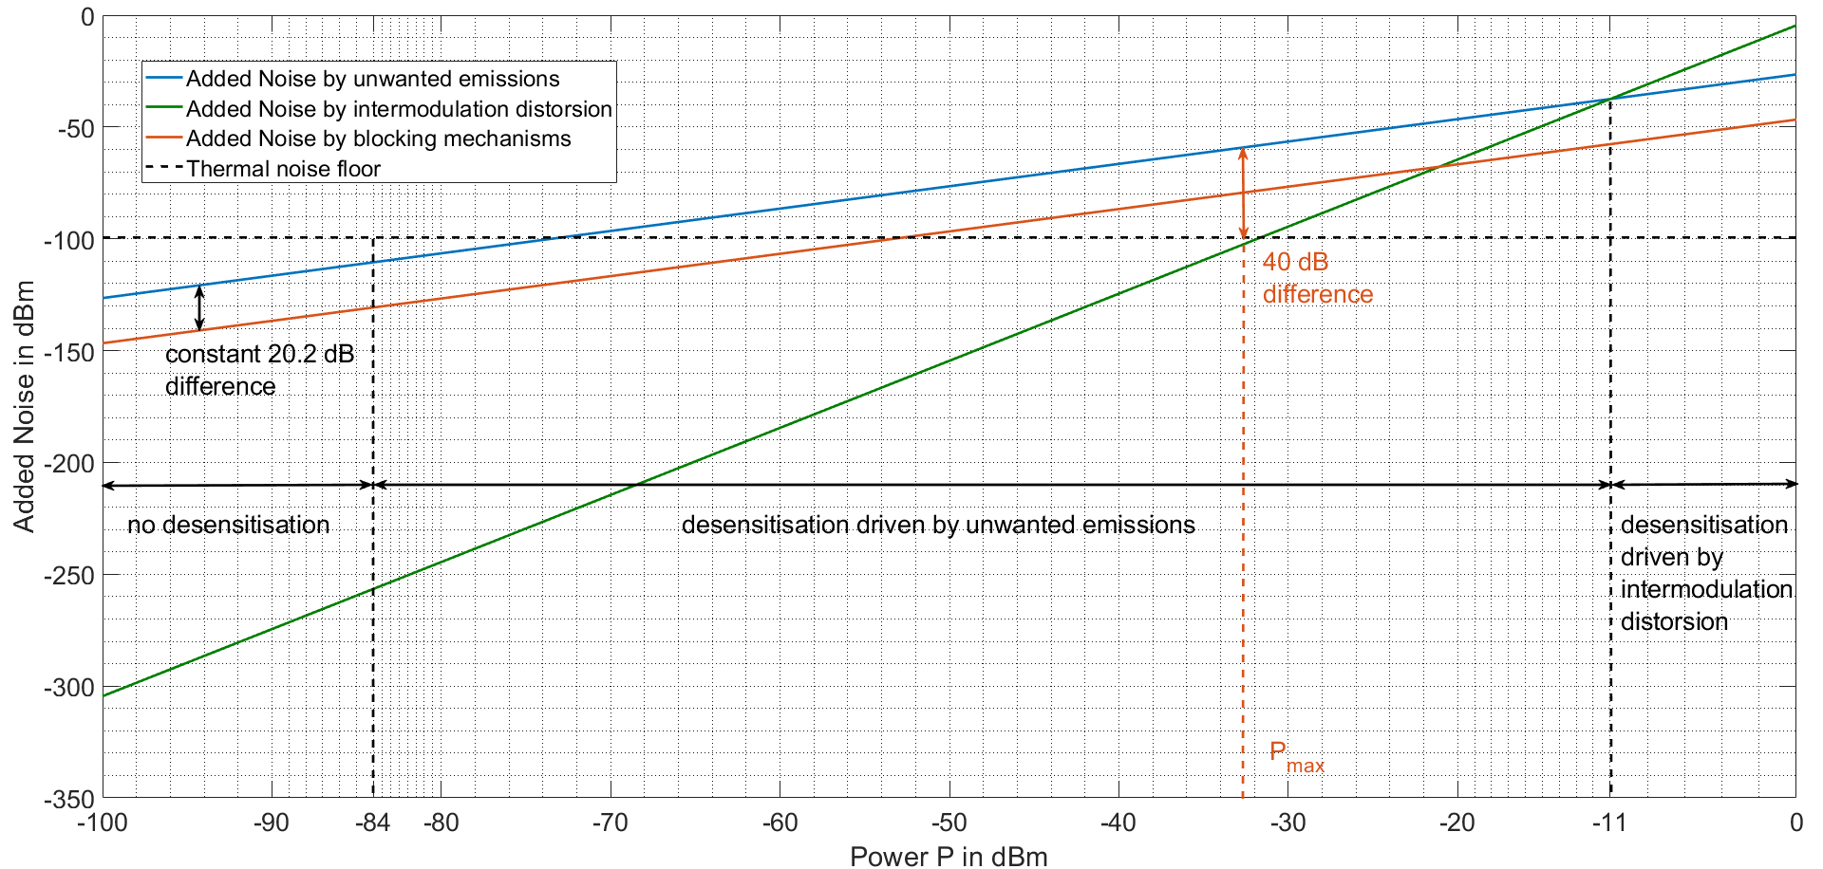
Figure 20: Comparison of unwanted emissions, blocking mechanisms and intermodulation distortion at the FRMCS cab-radio
The maximum power $P_{max}$ that can be “ ”expected” at the FRMCS cab-radio receiver input is computed by envisaging the worst case scenario where an LTE UE is transmitting at its maximum output power level ($P_{max}^{UE}=23 dBm$, see Table 6), and is standing in the main beam of the train-mounted antenna, at a distance of 5 m. In this case, $P_{max}$ is given by the following formula:
 | $$P_{max}= P_{max}^{UE}+G_{UE}^{train}-BL-PL+G_{train}^{UE}-HL$$ | (21)
Where:
- $G_{UE}^{train}=-3 dBi$ | UE antenna gain in the direction of the train (see Table 6);
- $BL=4 dB$ | Body loss at the UE side (see Table 6);
- $PL=52 dB$ | FSPL for a 1900 MHz wave at a distance of 5 m (the formula is still applicable for such a short separation distance, because the receiver is in the far-field region of the transmitter);
- $G_{train}^{UE}=6.6 dBi$ | Peak gain of the train-mounted antenna (see Table 4, note 10);
- $HL=3 dB$ | Hardware loss at the cab-radio side (see Table 4).
It results in $P_{max}= -32.4 dBm$. As can be seen in Figure 20, even for such a high power level, there is still a 40 dB difference between Added Noise (AN) by unwanted emissions and AN by intermodulation distortion.
It can be concluded from this section that the dominant mechanism by which LTE UE interfere with cab-radios are the unwanted emissions falling into the FRMCS receiving bandwidth.

Studied interference cases
In this section, a single run of each scenario is shown and analysed in detail. Particular attention is paid to the relative position of the interferers with respect to the train, and to the resulting impact on the FRMCS receiver. More specifically, the following key values will be measured at the FRMCS cab-radio receiver input: the wanted signal C, which is provided by the FRMCS site in the middle of the serving cell, the inter-cell interference $I_{intra}$ caused by the two adjacent cells, the thermal noise floor N (which is related to the number of allocated RBs and therefore depends on the considered scenario), the external interference $I_{ext}$ produced by the LTE UEs randomly positioned in the simulation area, and the resulting SINR.

High-speed scenario
Figure 24 and Figure 25 below show the evolution of C, $I_{intra}$, $I_{ext}$, N and SINR as the train passes through the serving cell. It can be noted that all of these variables exhibit relatively smooth variations, which can be explained by the fact that there are almost no buildings surrounding the rail track, and therefore no shadowing effects. As already explained in section 2.6, the first handover point where the train enters the serving cell is relatively far away from the FRMCS site, whilst whereas the second handover point where it leaves the cell is approximately at the middle of the distance to the next FRMCS site.
As can be seen in Figure 24, $I_{ext}$ is always at least 10 dB below the thermal noise floor, which means that the cab-radio is not desensitised by more than 0.4 dB because of external interferences, except at two points: the first at t=52 s where I/$I_{ext}$ = - 6 dB (which is equivalent to 1 dB desensitisation), and the second at t=95 s, where I/$I_{ext}$ = 0 dB (which results in 3 dB desensitisation).
Figure 22 below shows the simulation area, together with the exact range of the serving cell (based on the computation of C) and the position of the two UEs in open area causing important receiver desensitisation at t=52 s and t=95 s. Figure 23 takes a closer look at the exact position of these UEs: as can be seen, the first interferer is 380 m away from the rail track, whilst whereas the second one is only 225 m away. This difference is in distance results in $20\log_{10}\left(\frac{380 m}{225 m}\right)$ = 4.5 dB difference in path loss, which is also the reason why I/$I_{ext}$ values differ by 6 dB (other effects, like for example the path loss and the antenna gain, may explain this difference). No further interference case is noticed in the serving cell, even towards the end of the simulation were the train passes by a small village where a significant number of indoor UEs in buildings are present.
The SINR varies between about 55 dB in proximity of the FRMCS radio site, to 10 dB (which is reached its at cell edge). When comparing $I_{intra}$ with $I_{ext}$, it is clear that the SINR and therefore the overall system performance, is mainly driven by ICI rather than external interference.
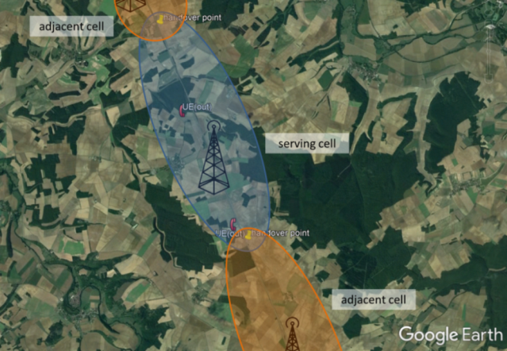
Figure 22: Simulation area and location of the interferers in the high-speed scenario
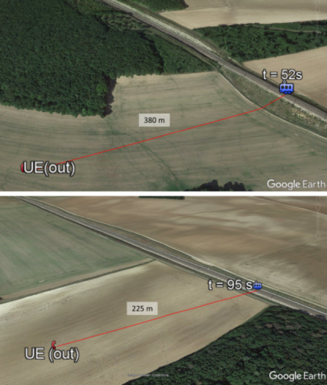
Figure 23: Location of the critical interferers in the high-speed scenario
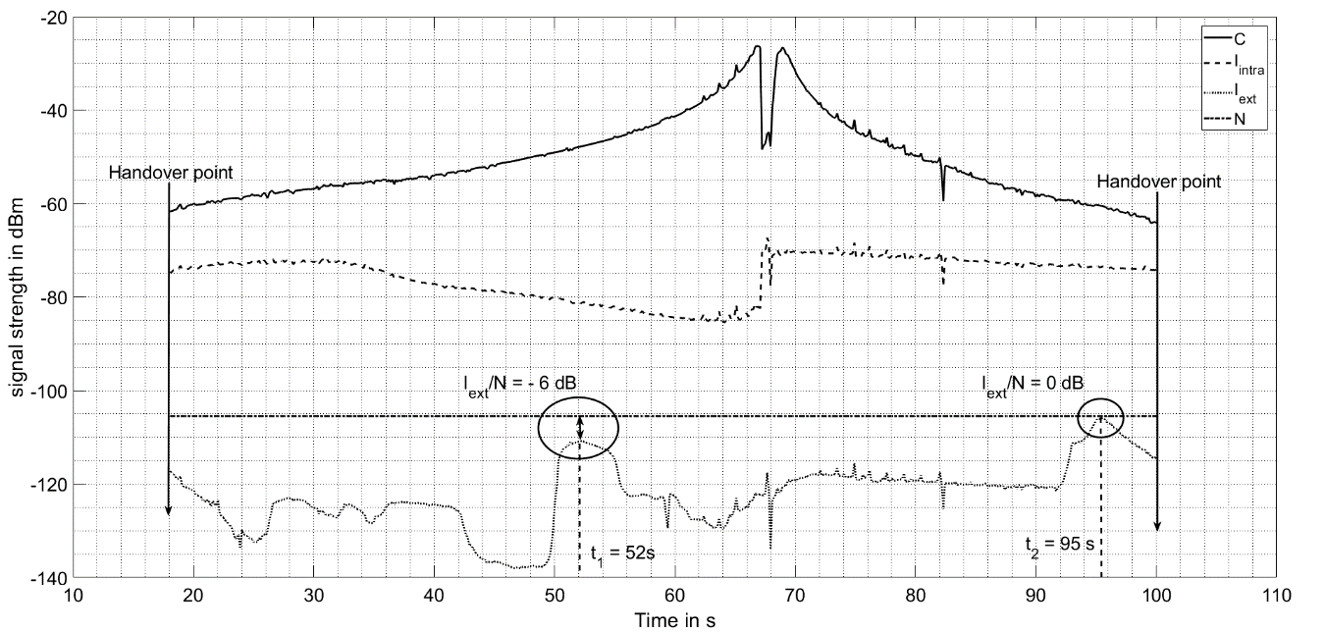
Figure 24: Evolution of the wanted and the interfering signals in the high-speed scenario
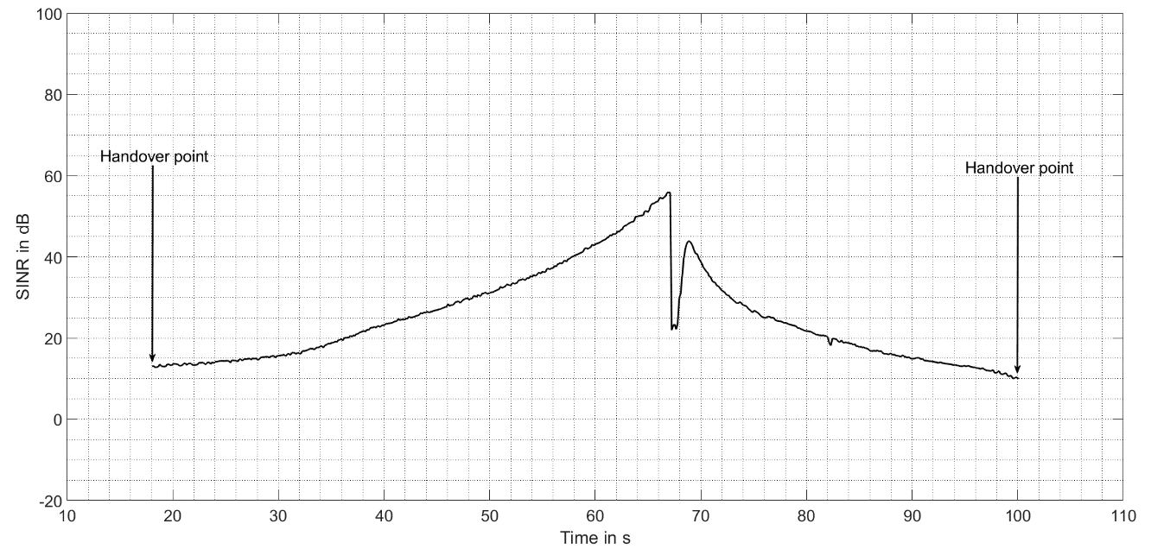
Figure 25: Evolution of the SINR in the high-speed scenario

Low-density scenario
Figure 27 and Figure 28 below show the evolution of the variables C, $I_{intra}$, $I_{ext}$, N and SINR over the serving cell. First of all, one can note a sudden drop in the wanted signal strength that takes place shortly after the train passes by the FRMCS site, i.e. at around t=280 s, followed by subsequent fluctuations that last all the way to the handover point. This can be explained by two simultaneous mechanisms represented in Figure 26 below.
The train is entering an important turn at t=280 s, which causes depointing with the antenna of the FRMCS site providing the useful signal;
After t=280 s, there are several buildings in the path between the BS and the train, as this latter is entering the turn. These fluctuations can cause ping-pong effects (during short intervals, the signal strength received from the next cell becomes stronger than from the serving cell, which may trigger erroneous handover procedures). However, this effect is assumed to be properly mitigated in practice, for example using timers (a handover procedure is only triggered when the signal received from the next cell exceeds the signal in the serving cell for a sufficient amount of time).
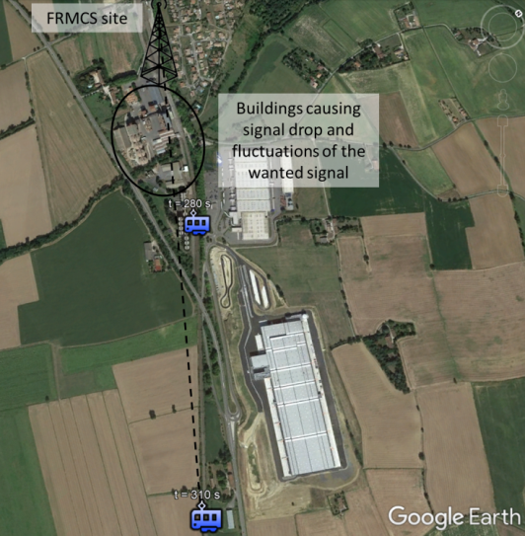
Figure 26: Illustration of the wanted signal fluctuation in the low-density scenario
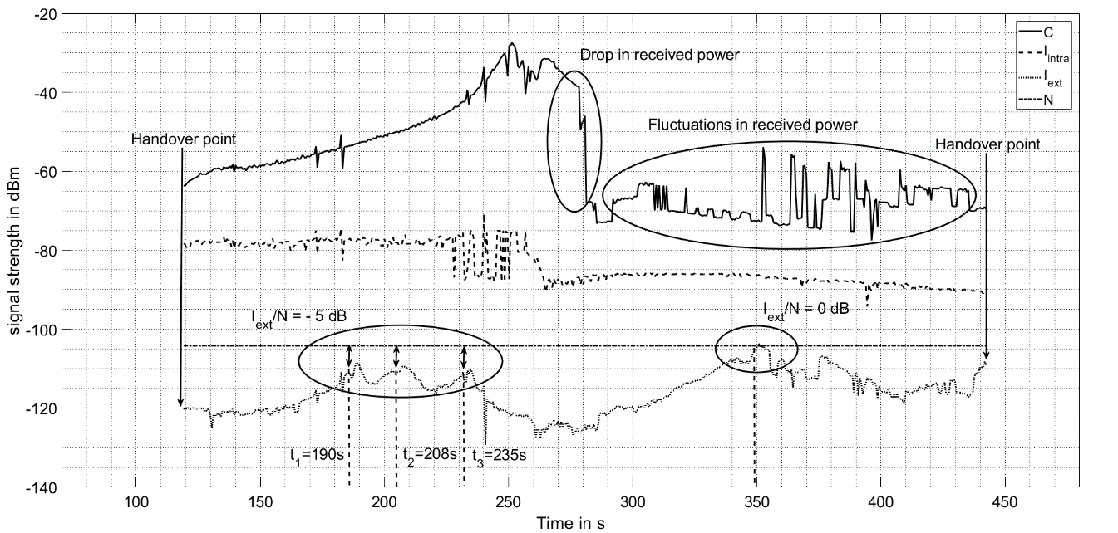
Figure 27: Evolution of the wanted and the interfering signals in the low-density scenario
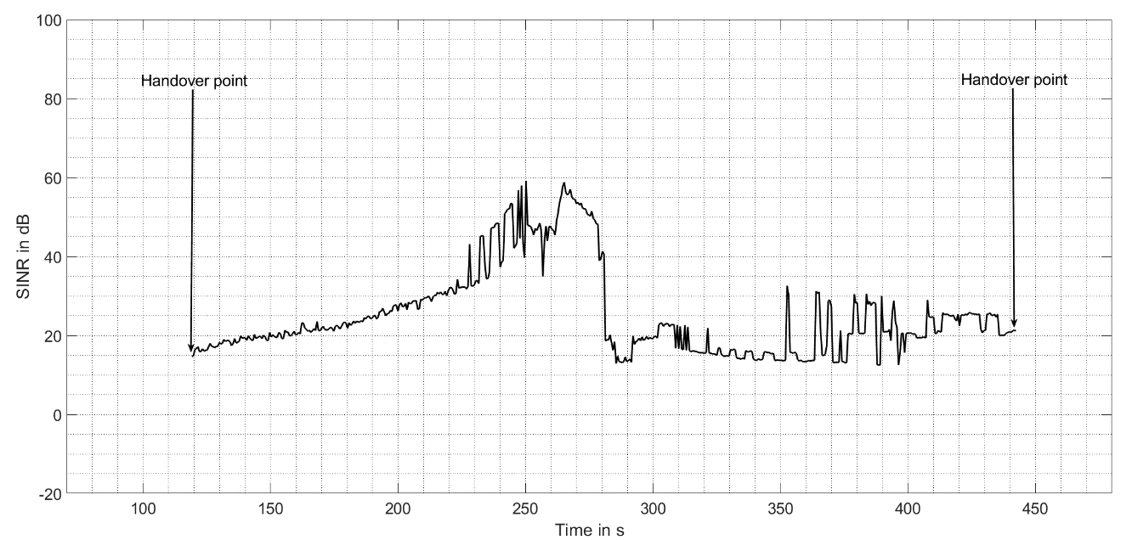
Figure 28: Evolution of the SINR in the low-density scenario
As can be seen in Figure 27, the intra-system interference level is relatively stable over time, and is 20-30 dB in the first half, and about 10 dB in the second half, below the wanted signal strength. Two interference cases can be noted in this simulation: the first one occurs between 190 s and 235 s, and is caused by the presence of 3 LTE UEs, each being inside a building close to the rail track. The exact situation is shown in Figure 29 below. The second interference situation happens at t=350 s and is caused by a UE in open area, for which the configuration is very similar to this encountered in the high-speed scenario (see section 4.2.1), and therefore it has not been shown here. The SINR remains above 10 dB, even during interference periods, and reaches its minimum in the vicinity of the FRMCS site, where the useful signal drops as explained above.
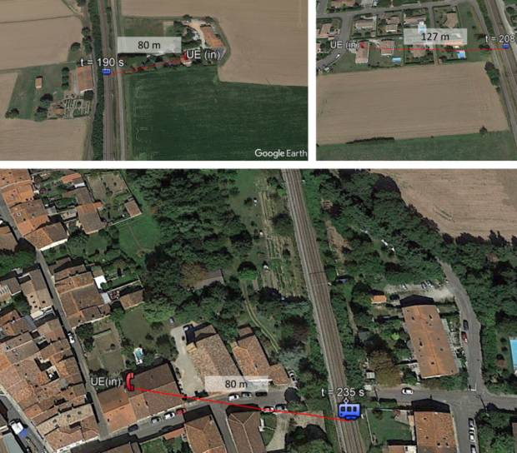
Figure 29: Location of the critical interferers in the low-density scenario

High-density scenario
The evolution of C, $I_{intra}$, $I_{ext}, N$ and SINR in the high-density scenario is shown in Figure 30 and Figure 31 below. The first point to note is that the wanted signal does not experience the significant fluctuations recorded in the low-density scenario. This is due to the fact that the rail track is very wide in this scenario (see Figure 10), and therefore the train is almost continuously in LOS of the FRMCS BS.
Moreover, the intra-system interference is at least 40 dB below the wanted signal level: indeed, as the train is in a relatively sharp turn (at a reduced speed of 50 km/h, see Table 5), there is an important depointing with the antennas of the FRMCS sites in adjacent cells, which results in a ”natural protection” again ICI. The SINR is very stable over time and does not fall below 40 dB, even at the handover points.
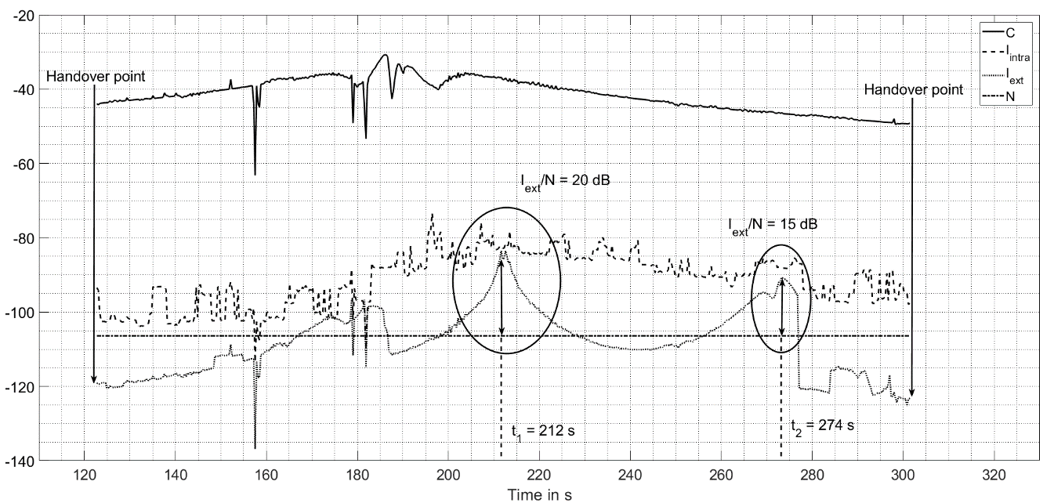
Figure 30: Evolution of the wanted and the interfering signals in the high-density scenario
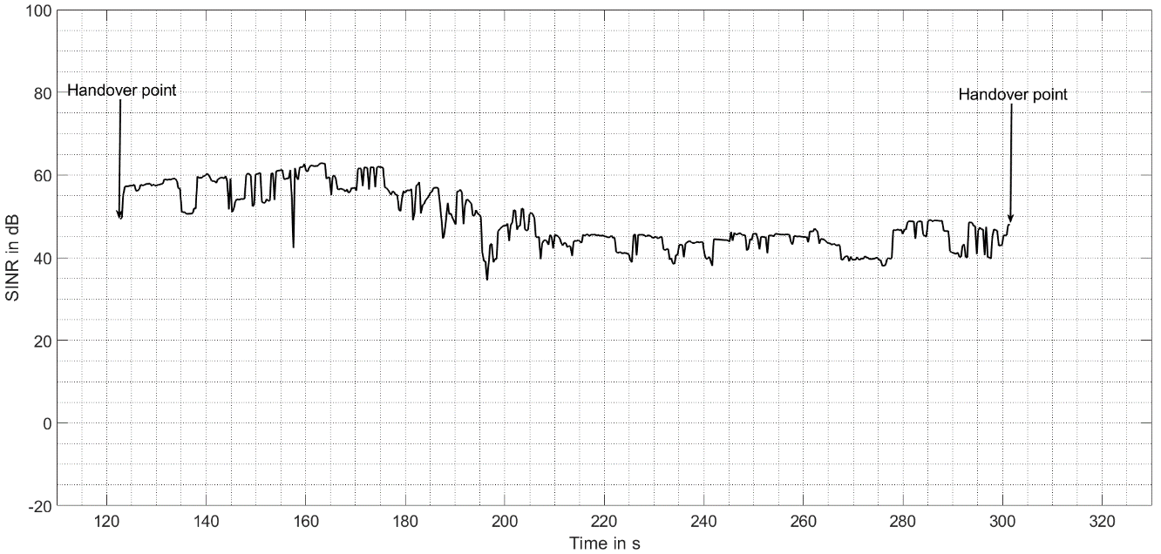
Figure 31: Evolution of the SINR in the high-density scenario
There are two main interference situations, that occur at t=212 s and t=274 s, where the Interference to Noise Ratio (INR) is 20 dB and 15 dB, respectively (which corresponds to a desensitisation of about the same value).
The first situation it is caused by a UE in open area (see Figure 30 below) which is directly on an adjacent rail track. This could for example belong to a member of the maintenance staff, or to a user in another train (in which case additional attenuation due to the train body should be considered, which was not the case here). The receiver is desensitised for about 10 s, until the train gets sufficiently far away from the UE. The second situation is shown in Figure 33 and is caused by a UE in a small street parallel to the track. At t=274 s, this UE is in LOS of the train and the desensitisation reaches about 15 dB as can be seen in Figure 30. From t=277 s onwards, there is a building between the train and the UE, which attenuates the signal transmitted by this latter, and this results in the sharp drop in external interference power level.
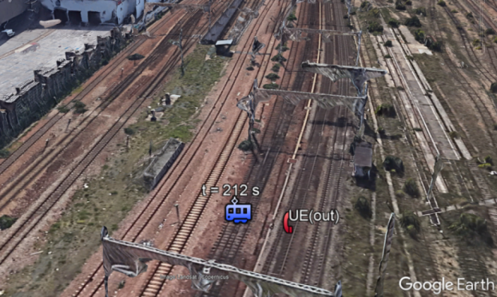
Figure 32: First interference situation in the high-density scenario
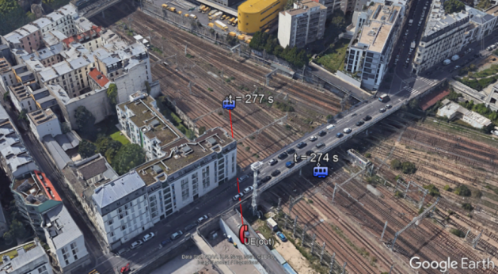
Figure 33: Second interference situation in the high-density scenario

Results and Conclusion
The following conclusions can be drawn from the co-existence study between MFCN and FRMCS downlink:
- Section 4.1 has shown that the main mechanism by which LTE UEs interfere with FRMCS cab-radios is the unwanted emissions falling into the FRMCS bandwidth. Other effects such as blocking and intermodulation distortion generally do not play a significant role. Therefore, there is no need to improve receiver performance of FRMCS cab-radios beyond the minimum requirements of 3GPP specifications;
- Desensitisation of the FRMCS cab-radio receiver may be noticed in the case where the train passes by a UE, that transmits with full power, in open area and in the vicinity of the rail track: see for example the high-density scenario in section 4.2.3, where the desensitisation can reach up to 20 dB. In the high-density scenario where the train speed is the lowest (about 50 km/h, see Table 5), the receiver desensitisation can last for about 30 s if no building or obstacle ”protects” the train from interference. In the other scenarios (high-speed and low-density), desensitisation generally does not exceed 5 s;
- On the one hand, rail tracks are generally not closer than 10 m to the surrounding buildings, and thus there is a minimum separation distance between the train and indoor UEs (which is not the case for UEs in open area). On the other hand, walls provide an additional attenuation considered of at least 15 dB (see Table 7), and therefore co-existence between FRMCS and UEs transmitting inside buildings is not critical: see for example the low-density scenario in section 4.2.2, where the FRMCS receiver is not desensitised by more than 1 dB when passing very close by buildings in which UEs are transmitting;
- The simulation methodology described in section 2.6 has shown that the SINR CDF presented in Figure 12 does not change when applying MFCN interference, except in the high-density scenario, where the degradation of the SINR value exceeded 95% of the time is however less than 0.5 dB (see Figure 34 below). This is due to the fact that interferences generated by LTE UEs are on average below the intra-system interference level (when applying the basic frequency reuse scheme explained in section 2.4), which has been noticed in all scenarios.
The conclusion is that if the FRMCS infrastructure reuses the existing GSM-R radio sites, and if the output power per antenna connector at the FRMCS base stations is the same as for GSM-R (up to 46 dBm per antenna connector which results in 63 dBm), then there is no performance degradation of the FRMCS downlink due to the MFCN interference, and the throughput values calculated can still be attained.

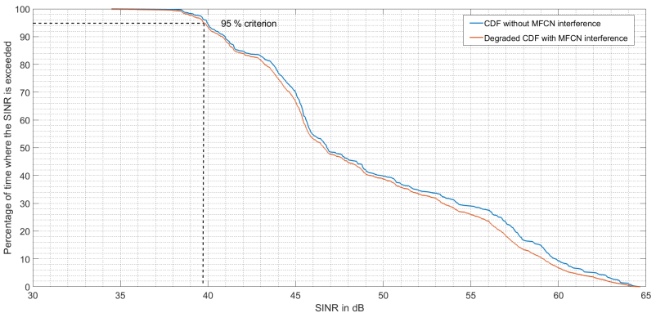
Figure 34: SINR CDF with and without MFCN interference in the high-density scenario

Additional requirements on FRMCS receivers
This section aims at determining the robustness required for the FRMCS cab-radio and BS, i.e. the maximum interfering signal level from MFCN BS, MFCN aerial UE and governmental UAS that FRMCS receivers must be able to deal with.

MFCN Base Stations in 1805-1880 MHz

FRMCS cab-radio receivers
As RMR cab-radios receiving in the frequency band 919.4-925 MHz need to filter emissions from MFCN BS transmitting above 925 MHz, FRMCS cab-radios receiving in 1900-1910 MHz need to filter emissions from MFCN BS in 1805-1880 MHz (i.e. in the 3GPP operating band #3).
According to 3GPP TS 36.101, [7] Table 7.6.2.1-2 and 3GPP TS 38.101-1[9], table 7.6.3-2, the blocking level of -15 dBm for an authorised desensitisation of 6 dB is only reached 85 MHz away for from the channel edge. Hence, it is necessary to define some specific requirements on FRMCS cab-radios receiving in the band 1900-1910 MHz with regard to MFCN BS emissions in the band 1805-1880 MHz.
It is expected that the levels from MFCN BS present at FRMCS cab-radios at 1900 MHz from MFCN BS are comparable to those present at 925 MHz. Thus, similar characteristics as in ETSI TS 102 933-1 [53] are required (see Table 10).
Table 10: Requirements on FRMCS cab-radio receiver characteristics
Parameter | Value
Level of the wanted signal | sensitivity + 3 dB
Maximum 5 MHz LTE interfering signal in 1805-1880 MHZ | -13 dBm
The antenna connector of the radio module is the reference point.
Note 2: This requirement covers both blocking and 3rd-order intermodulation.

FRMCS BS receivers
FRMCS BS will operate in the band 1900-1910 MHz, which is only 20 MHz away from MFCN BS operating in the band 1805-1880 MHz.
3GPP TS 36.104 [8] Table 7.6.1.1-1 and TS 38.104 [10] Table 7.5.2-1 specify an out-of-band blocking level of -15 dBm for a CW interfering signal 20 MHz away from the channel edge and for an authorized desensitization of 6 dB. This requirement remains valid and can be applied to FRMCS BS, except that the interfering signal below 1880 MHz to be considered should be LTE-based.
Table 11: Requirements on FRMCS BS receiver characteristic
Parameter | Value
Level of the wanted signal | sensitivity + 3 dB
Maximum 5 MHz LTE interfering signal in 1805-1880 MHz | -20 dBm
The antenna connector of the radio module is the reference point.
This requirement covers both blocking and 3rd-order intermodulation.

Aerial UE in 1920-1980 MHz
According to ECC Report 309 [56], the term “aerial UE” is equally applicable to unmanned aircraft (drone) and manned aircraft.
Section 4 has shown that ground UEs transmitting in the frequency band 1920-1980 MHz are not expected to significantly harm the operation of FRMCS cab-radios. However, band 1 is expected to be used for aerial UEs, in which no body loss or antenna gain reduction occur. Therefore, FRMCS cab-radios need additional protection against this kind of UEs, in the form of a more stringent blocking level. The goal of this section is to compute this new blocking level.

Aerial UEs characteristics
Aerial UEs have the same characteristics as ground UEs (see Table 6 and Table 7), with the exception that no body loss is assumed and they use an isotropic antenna with 0 dBi gain in all directions (see ECC Report 309).

Requirements on FRMCS cab-radios
When assuming an MFCN aerial UE at e.g. 30 m separation distance from the cab-radio (expected to be the minimum exclusion zone from rail tracks), the maximum interfering power P that a cab-radio must be able to deal with at its antenna connector can be calculated from the following formula:
,
 | $$P= P_{out}-PL+G_{cab-radio}-HWlosses$$ | (5)
Where:
- $P_{out}=23 dBm$ is the maximum e.i.r.p. of an aerial UE;
- $PL=67.6 dB$ is the path loss between the aerial UE and the FRMCS cab-radio antenna when assuming free-space propagation conditions;
- $G_{cab-radio}=6.6 dBi$ is the peak gain of the FRMCS antenna in this frequency band (see Figure 5);
- $HWlosses=3dB$ is the hardware loss of the FRMCS embedded receiver (see Table 4).
Hence, $P= -41 dBm$, which should be the blocking level for a 5 MHz or wider LTE signal, and for a desensitisation of 2 dB, which is the maximum acceptable desensitisation for an FRMCS cab-radio (see ECC Report 313 [54]). The corresponding blocking level for 3 dB desensitisation can be computed from the following formula, and equals $-38.7 dBm≈-39 dBm$.

 | $$B_{2}=B_{1}+10*\log_{10}\left(\frac{{10}^{{D_{2}}/{10}}-1}{{10}^{{D_{1}}/{10}}-1}\right)$$ | (6)
where $B_{1}$and $B_{2}$ are the blocking levels for a desensitisation of $D_{1}$ and $D_{2}$, respectively.
Table 12: Requirements on FRMCS cab-radio receiver characteristics
Parameter | Value
Level of the wanted signal | sensitivity + 3 dB
Maximum 5 MHz LTE interfering signal in 1920-1980 MHz | -39 dBm
The antenna connector of the radio module is the reference point.
This requirement covers both blocking and 3rd-order intermodulation

Governmental UAS in 1880-1920 MHz

Governmental UAS technical parameters
Table 13: Governmental UAS characteristics
Parameter | Value | Comment
Bandwidth | 5 or 10 MHz
Maximum output power | 30 dBm | long range ($\sim 10 km)$
Antenna gain | 5 dBi | long range ($\sim 10 km)$
For UAS usage, the 1880-1920 MHz band will be split in channels of 5 MHz or 10 MHz. Up to 3 UAS may be used at the same time in the same geographical area. Overall, UAS usage is very limited in time and space. Thus, the risk of causing harmful interference to an FRMCS cab-radio is expected to be rather low in practice.
In this section, it is assumed that only 1 drone at a time may fly in the vicinity of rail tracks and that this drone operates below 1890 MHz in order to provide enough frequency space to reach the filtering level required. This is expected to be feasible in terms of operational rules set up by governmental UAS users.

Requirements on FRMCS cab-radios
The maximum interfering power P that an FRMCS cab-radio must be able to deal with at its antenna connector can be calculated from the following formula:
 | $$P= P_{out}+G_{UAV}-PL+G_{cab-radio}-HWlosses$$ | (6)
Where:
- $P_{out}=30 dBm$is the maximum output power (see Table 14), $G_{UAV}=5 dBi$ is the peak gain at the UAS antenna (see Table 14), PL is the path loss between the UAV and the FRMCS antenna;
- $G_{cab-radio}=6.6 dBi$ is the peak gain of the FRMCS antenna in this frequency band (see Figure 5);
- $HWlosses=3 dB$ is the hardware loss of the FRMCS embedded receiver (see Table 4).
This blocking level should be acceptable for 2 dB desensitisation. The maximum interfering power $P$ is calculated for different separation distances and converted for 3 dB desensitisation in the below table (using the conversion formula in the previous section). Co-channel compatibility between UAS and FRMCS is not studied in this report.
The table below ensures the robustness of FRMCS cab-radio receiver against governmental UAS operating in 1890-1900 MHz or in 1910-1920 MHz, depending on the technical feasibility of such filtering in the cab-radio receiver. The impact of UAS out-of-band emissions on FRMCS is yet to be assessed.

Table 14: Requirements on FRMCS cab-radio receiver characteristics
Distance | PL | Blocking level for 2 dB desensitisation | Blocking level for 3 dB desensitisation
30 m | 67.5 dB | -28.9 dBm | -26.6 dBm
100 m | 78.0 dB | -39.4 dBm | -37.1 dBm
300 m | 87.5 dB | -48.9 dBm | -46.6 dBm
500 m | 92.0 dB | -53.4 dBm | -51.1 dBm
700 m | 94.9 dB | -56.3 dBm | -54 dBm
The antenna connector of the radio module is the reference point.
This requirement covers both blocking and 3rd-order intermodulation.

Co-existence between FRMCS and DECT

Impact of DECT on FRMCS downlink

Interference mechanisms

Unwanted emissions and blocking effects
The SEM of DECT devices is specified in EN 300 175-2 [29], table 1 in terms of maximum emitted power in adjacent channels. For any DECT carrier, the power in the first adjacent channel (measured at the antenna connector) should be less than -8 dBm, in the second adjacent channel, less than -30 dBm, in the third adjacent channel, less than -41 dBm, and in any other channel, less than -44 dBm. It has to be noted that these power levels are measured over 1 MHz bandwidth, which is slightly less than the occupied bandwidth of a DECT carrier (1.152 MHz according to Table 8).
The ACLR indicated in Table 16 for a particular DECT carrier is the difference between the carrier power, which is 24 dBm according to Table 8, and the power level obtained by integrating the unwanted emissions of this carrier in the FRMCS bandwidth. The calculations have been detailed below the table.
The blocking rejection factor indicated in Table 16 is obtained from the ACS or the in-band blocking test case of TS 36.101 [7]. It equals the difference in dB between the interferer power and the additional noise power that is found in the FRMCS receiver bandwidth because of the presence of this interferer.
The so-called “”conversion factor” combines the effect of unwanted emissions and blocking mechanisms. It is computed using following formula:
 | $$Conversion factor \left(dB\right)= -10log10\left({10}^{-\frac{ACLR\left(dB\right)}{10}-}+{10}^{-\frac{blocking rejection factor\left(dB\right)}{10}}\right)$$ | (8)

Table 16: ACLR and blocking rejection of DECT carriers
DECT carrier | F0 |  | F1 | F2 | F3 | F4 |  | F5 | F6 | F7 | F8 | F9
ACLR (dB) | 51.2 (Note 1) | 51.4 (Note 2) |  | 58.5 (Note 3)
Blocking rejection factor (dB) | 33 (Note 4) |  |  | 38.7 (Note 5) |  |  | 50.7 (Note 6)
Conversion factor (dB) | 32.9 |  |  |  |  |  | 50
Note 1: As shown in Figure 35 below, DECT carrier F0 has its second, third, up to its seventh adjacent channel completely or partially inside the FRMCS receiver bandwidth. The SEM provided in ETSI EN 300 175-2 [29] has been extrapolated between measurement intervals as illustrated in Figure 35. The 9 MHz FRMCS receiver bandwidth can be divided into three intervals whose bandwidths are respectively 1.528 MHz, 1.728 MHz, and 5.744 MHz, over which the PSD is -30 dBm/MHz, -41 dBm/MHz, and -44 dBm/MHz. Therefore, the integrated power in each of these intervals is -28.2 dBm/1.528 MHz, -38.6 dBm/ 1.728 MHz and -36.4 dBm/5.744 MHz. The total power in the FRMCS channel is then -27.2 dBm/9 MHz and the ACLR is 24 dBm - ( - 27.2 dBm) = 51.2 dB.
Note 2: As shown in Figure 36 below, DECT carrier F1 has its third up to its eighth adjacent channel that completely of partially overlap with the FRMCS receiver bandwidth. The methodology to compute the ACLR is the same as for DECT carrier F0 (see Note 1).
Note 3: As shown in Figure 37 below, the unwanted emissions of DECT carriers F2 up to F9 have a flat PSD of -44 dBm/MHz over the whole FRMCS receiver bandwidth. Therefore, the ACLR is simply $24 dBm-\left(-44 dBm+10*\log_{10}\left({9 MHz}/{1 MHz}\right)\right)=58.5 dB$.
Note 4: As shown in Figure 38 below, DECT carriers F0 and F1 are covered by the ACS test in TS 36.101 [7], table 7.5.1-1), whereby the blocking rejection factor of a 5 MHz E-UTRA carrier in the adjacent channel is 33 dB. The blocking rejection factor of DECT carriers F0 and F1 will therefore be taken equal to 33 dB, even though it is probably more than that. Indeed, the ACS test case of TS 36.101 uses a modulated E-UTRA carrier which does not only adds noise in the receiver bandwidth by blocking mechanisms, but also by intermodulation distortion (see section 4.1.3 for further details). This is not the case of a DECT carrier, which does not use multiple subcarriers but GFSK modulation.
Note 5: Figure 38 below shows that DECT carriers F2 to F4 are mostly covered by the case 1 of the in-band blocking test in TS 36 101 (see Table 7.6.1.1-1 and Table 7.6.1.1-2). In this test case, the blocker is a 5 MHz E-UTRA carrier with - 56 dBm power. The FRC has 10 MHz bandwidth with full RB allocation, and therefore the noise floor (based on a 5 dB noise figure according to Table 3) is $-174\frac{dBm}{Hz}+10\log_{10}\left(9 MHz\right)+5 dB=-99.4 dBm$. The authorised desensitisation being 6 dB, the interference level can reach up to
$10\log_{10}\left({10}^{{-99.4 dBm +6 dB}/{10}}- {10}^{-{99.4 dBm}/{10}}\right)=- 94.7 dBm$ and therefore the blocking rejection factor is - 56 dBm - ( - 94.7 dBm) = 38.7 dB$.$
Note 6: DECT carriers F5 to F8 are covered by the case 2 of the in-band blocking test of TS 36.101, whereby the blocking rejection factor is 50.7 dB. The methodology to compute this figure is the same as in Note 4. F9 is also considered to be covered by this test, because the out-of-band blocking evaluation in TS 36.101 uses a CW signal as interferer, and therefore it seems inappropriate to evaluate the effect of a wideband DECT carrier.

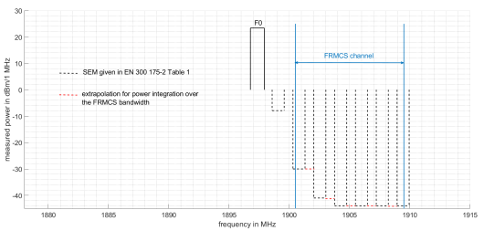
Figure 35: Unwanted emissions of DECT carrier F0 in the FRMCS receiver bandwidth
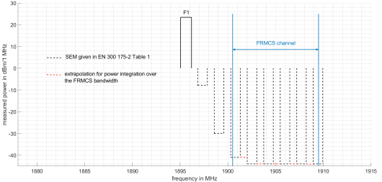
Figure 36: Unwanted emissions of DECT carrier F1 in the FRMCS receiver bandwidth
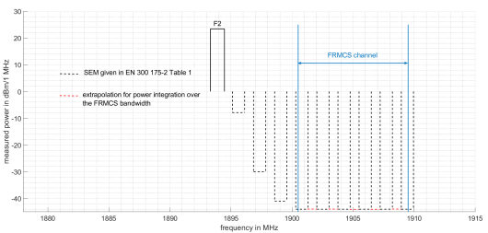
Figure 37: Unwanted emissions of DECT carrier F2 in the FRMCS receiver bandwidth
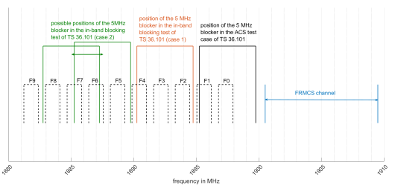
Figure 38: Applicable blocking test cases of TS 36.101 [7] for blocking by DECT carriers

Intermodulation distortion
The analysis presented in section 4.1 has shown that, when assessing the effect of an OFDMA modulated carrier on an FRMCS on-board receiver, intermodulation distortion is negligible when compared to unwanted emissions. This is due to the fact that the signal components generating intermodulation products are orthogonal subcarriers that have low power. This does not hold true for DECT carriers, that can have high power when reaching the FRMCS receiver, and thus generate strong intermodulation products.
The methodology used to compute the in-band interference power generated in the FRMCS receiver bandwidth because of intermodulation distortion is described below:
- An FRMCS receiver that operates in an environment with many DECT devices receives a great number of interferers that are all centred at one of the ten possible carrier frequencies F0 to F9 given in Table 8.
- For the sake of simplicity, interferers having the same centre frequency are added in terms of power at the FRMCS receiver input, which results in ten regularly spaced interferers, as shown in Figure 39 below. This however leads to an overestimation of intermodulation distortion.
- Intermodulation products are generated by specific pairs of DECT carriers. For example, as shown in Figure 39 below, the carriers F3 and F7 generate a 3.456 MHz bandwidth intermodulation product centred at 1899.072 MHz. This product has 0.3 MHz overlap with the FRMCS receiver bandwidth. If $P_{3}$ and $P_{7}$ respectively denote the power in dBm of the carriers F3 and F7, then the resulting interference power is $(2*P_{3}+P_{7}-2*{IIP}_{3})+10*\log_{10}\left(\frac{0.3 MHz}{3.456 MHz}\right)$, where ${IIP}_{3}=-20.6 dBm$ denotes the intercept point of the FRMCS receiver (see Table 4). If for example $P_{3}=P_{7}=-50 dBm$, then the power received by the FRMCS on-board equipment is $\left(3*\left(-50 dBm\right)-2*\left(-20.6 dBm\right)\right)+10*\log_{10}\left(\frac{0.3 MHz}{3.456 MHz}\right)= -119.4 dBm$.
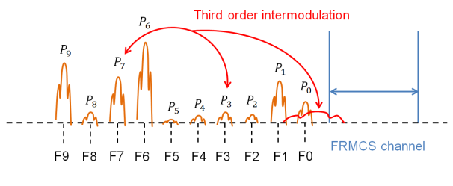
Figure 39: Intermodulation of DECT carriers in the FRMCS receiver bandwidth

Interference in the time domain
In order not to overestimate interference problems between DECT and FRMCS downlink, the access mechanism of each system in the time domain must be carefully accounted for. As already seen, both technologies implement 10 ms frames in the time domain: LTE frames are further divided into 10 subframes and the periods that are dedicated to downlink and uplink depend on the chosen TDD configuration: configuration 0 has taken as a basis in this Report (see Table 3, note 2). DECT frames are composed of two half-frames (one is reserved for downlink, and the other for uplink transmission), that are further divided into 12 slots. A DECT communication between an FRP and a PP occupies exactly a pair of slots in the time domain that repeat with a periodicity of 10 ms.
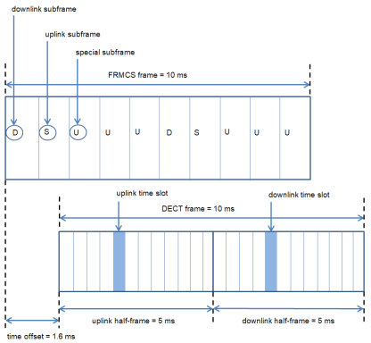
Figure 40: Example of time offset between DECT and FRMCS frames
Therefore, a DECT communication does not necessarily overlap in the time domain with FRMCS downlink: it depends on the initial offset between DECT and FRMCS frames. Figure 40 above shows for example that, if this offset is 1.6 ms and if the DECT communication occupies the fifth slot in the half-subframe, then there is no interference with FRMCS downlink (the uplink case is not studied in this report).
It is concluded that only a fraction of the DECT devices deployed in each scenario will effectively interfere with FRMCS downlink. For the sake of simplicity, it has been considered that, if an FRMCS downlink subframe partially overlaps with a DECT slot, it is however interfered for its entire duration.

Methodology and example of an interference situation
As in section 4, the interference of the on-board FRMCS receiver caused by DECT communications will be examined individually in each of the three scenarios shown in section 2.5, following the methodology outlined in section 2.6 and summarised below:
- There is only one run per scenario (see Note 1 in section 2.6);
- In each scenario, DECT devices will be deployed in pairs (the number of pairs being considered is given in Table 9). Each pair comprises an FRP which communicates with a PP using two slots per frame as illustrated in Figure 40. The channel used is drawn with equal probability among the 10 possible carriers F0 to F9, and the offset with the FRMCS frames, between 0 and 10 ms. All pairs are deployed inside a building at a random height, just as indoor UEs in section 4 (step 1);
- The positioning of FRMCS base stations, the computation of C and $I_{intra}$ (step 2 and 4), as well as the noise floor N (step 3) have already been explained in section 2.6;
- The calculation of $I_{external }$and SINR at each position of the train (step 5 and 6) is quite different from that which has been performed in section 4 for MFCN interference, because, as shown in section 6.1.2, the time dimension also has to be considered. At any particular position of the train, $I_{external }$and SINR are averaged over an entire FRMCS frame that would be transmitted at this position.
The method of computation is shown using the example presented in Figure 41 below. There are two DECT pairs. The first uses carrier F5 and the second F4. The signal produced by the first pair has a power $P_{1}=-30 dBm$ when reaching the FRMCS receiver input, whilst the signal produced by the second pair has power $P_{2}=-50 dBm$. Both signals disturb the FRMCS receiver through their unwanted emissions and blocking effects, but not through third-order intermodulation distortion. As represented in Figure 41, the time offset of DECT frames is such that both FRMCS downlink subframes are interfered.
In the first subframe, the interference power generated by the DECT pairs 1 and 2 in the receiver bandwidth are respectively $P_{1}-50 dB= -80 dBm$ and $P_{2}-38.7 dB= -88.7 dBm$. The total interference power in this subframe is therefore -79.4 dBm. The interference situation is the same is the second downlink subframe, which is due to the 5 ms time periodicity of the TDD configuration 0 for FRMCS. Therefore, $I_{external}=-79.4 dBm$, and assuming that the wanted signal strength is C = -50 dBm, SINR = -50 - (-79.4) = 29.4 dB.
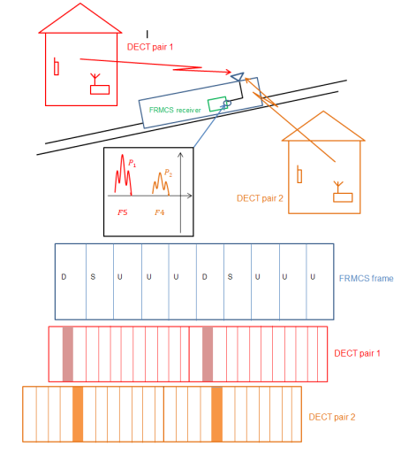
Figure 41: Interference situation between an FRMCS cab-radio and DECT devices

Results and conclusion
Figure 42, Figure 44 and Figure 46 below respectively show the temporal variation of C, $I_{intra}$, $I_{ext}$, N and SINR at the cab-radio receiver input in the high-speed, the low-density and the high-density scenario, respectively. $C,$ $I_{intra}$ and N are computed following the methodology outlined in section 2.6.
- In the high-speed scenario, the receiver is never desensitised by more than 1 dB, except near the first handover point, where the train passes through a small village in which several DECT devices are being operated, where the INR reaches up to 10 dB (see Figure 43 below). Even in this situation, the SINR is not affected as the wanted signal is still 30 dB above the interference level. When the train passes by a small village at t=75 s, the INR is less than -15 dB and therefore the receiver is not desensitised;
- In the low-density scenario, the receiver is desensitised by 10 dB when driving through the city shown in Figure 45 below. The situation is quite comparable to the preceding scenario and, in the same way, this loss in sensitivity does not result in a degradation in SINR, which is still above 20 dB;
- In the high-density scenario, where the number of buildings, and hence the density of DECT devices is the highest, the receiver is constantly desensitised by about 0.4 dB (which corresponds to INR = -10 dB), but never by more than 3 dB. This difference with the two previous scenarios can be explained by the higher Building Entry Loss (BEL) value that is assumed in urban environment (see Table 9).
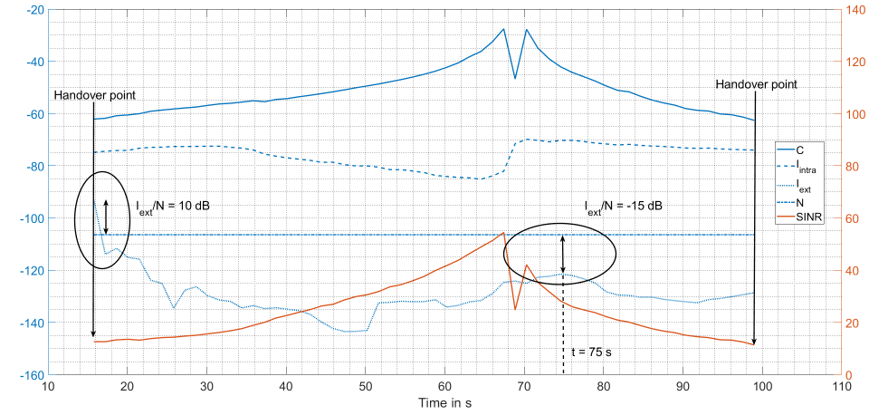
Figure 42: Evolution of the wanted and the interfering signals in the high-speed scenario
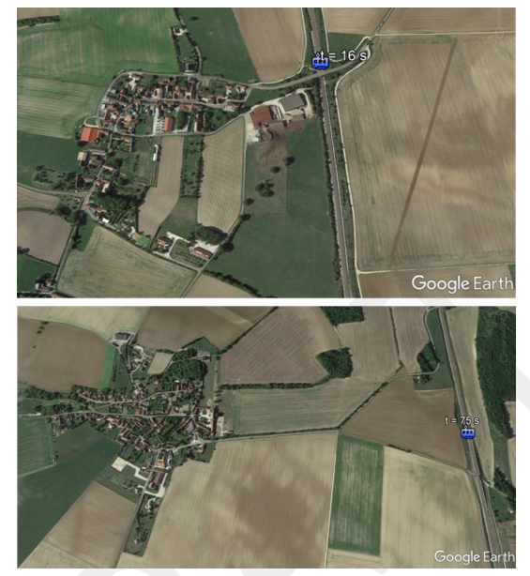
Figure 43: Interference situations in the high-speed scenario
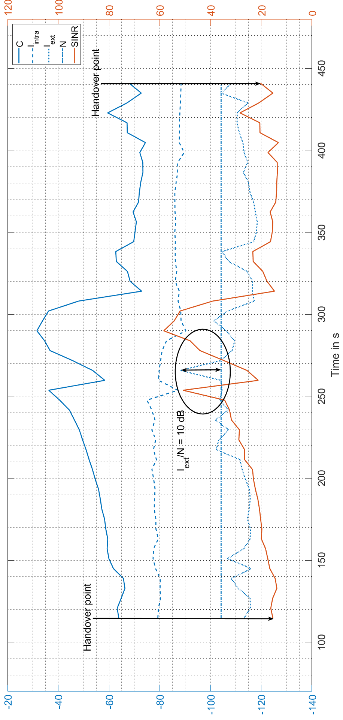
Figure 44: Evolution of the wanted and the interfering signals in the low-density scenario

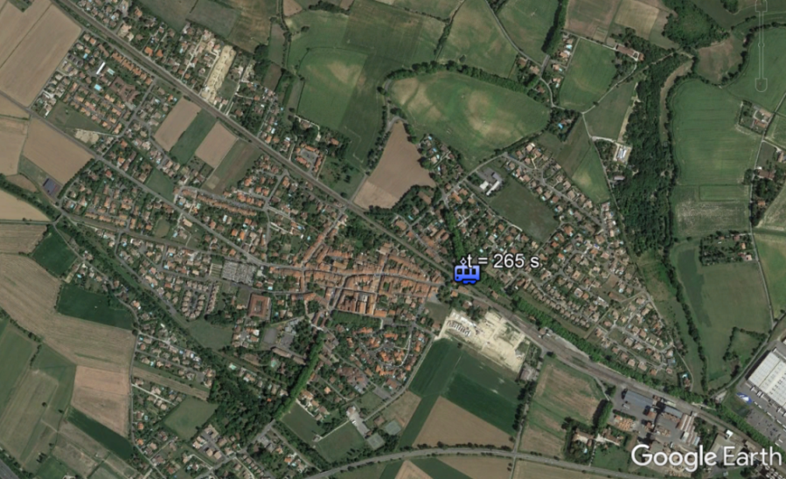
Figure 45: Interference situation in the low-density scenario
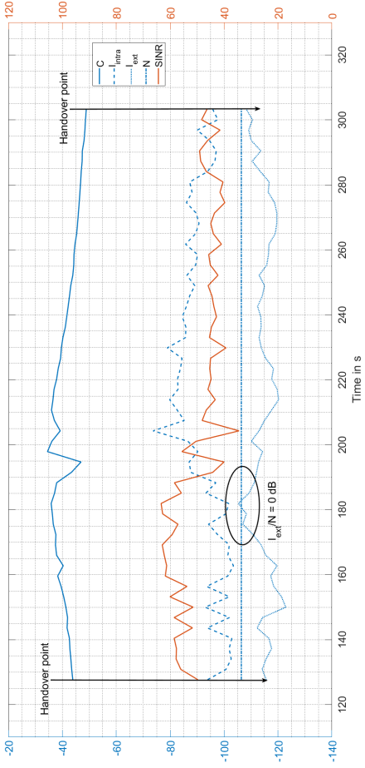
Figure 46: Evolution of the wanted and the interfering signals in the high-density scenario
As a conclusion, when passing through densely populated urban areas, the FRMCS cab-radio is constantly desensitised by the emissions of DECT devices. However, this desensitisation is most of the time limited to not more than 0.4 dB (see the high-density scenario) but can briefly reach a maximum of 10 dB in some cases (see the high-speed and low-density scenarios).
However, when 46 dBm per antenna connector are used at FRMCS BS (which is a working assumption of this study, see Table 3), this loss of sensitivity has no effect on the SINR, even when it occurs near the handover point (see the high-speed scenario), and therefore is not accompanied by a degradation of the throughput. The throughput targeted can thus be attained even when FRMCS is operating in areas with a high density of active DECT devices.

Impact of FRMCS on DECT

Review of CEPT Report 39
In this section, Annex 3 of CEPT Report 39 [40] is examined in order to see which results can be reused in the impact assessment of FRMCS (uplink and downlink) on DECT. The latter report determines, inter alia, the necessary technical conditions in which UMTS TDD (or any other broadband technology using a 5 MHz channel, for example LTE or WiMAX) can be deployed in the 1900 – 1905 MHz frequency range. Annex 3 focuses on an indoor UE that emits towards the outdoor BS to which it is connected, hence possibly leading to an interference situation with DECT equipment operating in the same building.
One conclusion of Annex 3 in CEPT Report 39 is that co-existence between an indoor UE and a DECT device operating in the same building is possible thanks to the DCS algorithm (see Table 8, note 4 for further details), which prevents the DECT device from using carriers on which interference is detected, hence introducing some kind of “flexible guard band” with the channel in 1900-1905 MHz used by the UE.
However, there are several reasons why this result of CEPT Report 39 Annex 3 cannot be generalised to the interference generated by FRMCS on-board transmitters or BS:
- Unwanted emissions of the UE are based on a 5 MHz channel, although FRMCS uses 10 MHz, in which case specified limits are less stringent (see 3GPP TS 36.101 [7], table 6.6.2.1.1-1);
- The UE operates indoors and uses 23 dBm output power, although an FRMCS cab-radio always operates outdoors and uses 31 dBm. FRMCS BS are deployed outdoors as well and use 46 dBm per antenna connector (see Table 3);
- No antenna gain is assumed at the UE side, whereas FRMCS train-mounted antennas and BS respectively have 6.6 dBi and 18 dBi peak gain (see Table 4).
Therefore, a specific co-existence study has been conducted in this report: sections 6.2.3 and 0 respectively assess the impact of FRMCS cab-radios and BS on DECT equipment operating indoors.
One result in CEPT Report 39 [40] can nevertheless be reused: the DCS algorithm in DECT has been primarily designed to detect interferences caused by other DECT communications. Therefore, it works even better when the interferer uses a “DECT-like” transmission scheme in the time domain. This is the case of FRMCS BS that emit a 1 ms subframe every 5 ms (see Table 3, note 2).

Interference mechanisms
The ACLR values indicated in Table 17 below are computed as the difference between the maximum output power of FRMCS cab-radios and BS (31 dBm and 46 dBm, respectively, see Table 3), and the integration of their unwanted emissions (given in Table 3 and further represented in Figure 47 below) over each DECT channel.
There are two subclauses in ETSI EN 300 175-2 [29] that can be applied to evaluate blocking mechanisms: either subclause 6.4 (“Radio receiver interference performance”), which uses DECT signals as interferers, or subclause 6.5 (“Radio receiver blocking”), which uses unmodulated carriers. When the interferer is a 10 MHz wideband FRMCS signal, subclause 6.4 is obviously best suited.
The blocking conversion factor in adjacent DECT channels has been calculated from subclause 6.4 in ETSI TR 103 089 [32], annex B.2, table B.1. It is evaluated at 24 dB in the first adjacent channel, 45 dB in the second, and 51 dB in any other channel. ACS values provided in Table 17 are obtained by integrating these values over the FRMCS carrier for each DECT channel.
The overall conversion factor is obtained by applying the same formula as in section 6.1.1.1.

Table 17: ACLR and blocking rejection of an FRMCS carrier
DECT channel |  | F0 | F1 | F2 | F3 | F4 | F5 | F6 | F7 | F8 | F9
ACLR (dB) | cab-radio | 40.4  (Note 1) |  | 43.4 |  | 43.9 (Note 2) | 55.4 |  | 56.3 | 60.4
ACLR (dB) | BS | 43.1 (Note 3) | 45.5 | 46.4 |  | 47 | 72.4
Blocking rejection factor (dB) | cab-radio | 49.3  (Note 4) | 51 (Note 5)
Blocking rejection factor (dB) | BS | 49.3  (Note 4)
Conversion factor (dB) | cab-radio | 39.3 | 40 | 42.7 |  | 43.1 | 49.7 |  | 49.9 | 50.5
Conversion factor (dB) | BS | 42.2 | 42.4 | 45.1 |  | 45.5 | 51
Note 1: The PSD in DECT channels F0 and F1 is -20 dBm/100 kHz (see Figure 47 below). Therefore the integrated power in each of these channels is $-20 dBm+10*\log_{10}\left(\frac{1.152 MHz}{100 kHz}\right)=-9.4 dBm$ and thus: ACLR = 31 dBm - ( - 9.4 dBm ) = 40.4 dB.
Note 2: The integration over DECT channel F4 must be made in two steps: firstly from 1889.856 MHz to 1890 MHz, where the PSD is -35 dBm/100 kHz, and secondly from 1890 MHz to 1891.008 MHz, where the PSD is -23 dBm/100 kHz (see Figure 47 below). The integrated power in these two intervals is respectively -33.4 dBm and -13 dBm. Therefore, the total power in this channel is -12.9 dBm, and thus: ACLR = 31 dBm - ( - 12.9 dBm ) = 43.9 dB.
Note 3: The power emitted by the FRMCS BS in DECT channel F0 is obtained by integrating the unwanted emissions in the linear domain. The ACLR indicated is the table is the result of the following calculation: $46 dBm-10*\log_{10}\left(\int_{f_{1}}^{f_{2}}{{10}^{\frac{-7-\frac{7}{5}f}{10}}}df\right)$ where $f_{1}=1896.768 MHz$ and $f_{2}=1897.92 MHz$ respectively denote the lower and the upper edge of DECT carrier F0.
Note 4: DECT carrier F0 has its second up to its seventh adjacent channels in the FRMCS receiver bandwidth (see Figure 35). The same extrapolation than in section 6.1.1 is made to compute the average blocking rejection factor over the FRMCS bandwidth. On this basis, the blocking rejection equals 24 dB from 1900.5 MHz to 1901.952 MHz, 45 dB from 1901.952 MHz to 1903.68 MHz and 51 dB from 1903.68 MHz to 1909.5 MHz. This results in:
$10\log_{10}\left(\frac{\left(1901.952-1900.5\right) MHz*{10}^{{24 dB}/{10}}+\left(1903.68-1901.952\right) MHz*{10}^{{45 dB}/{10}}+\left(1909.5-1903.68\right) MHz*{10}^{{51 dB}/{10}}}{9 MHz}\right)=49.3 dB$.

Note 5: DECT carrier F1 has its third up to its eighth adjacent channels in the FRMCS receiver bandwidth (see Figure 36). Using the methodology explained in the Note 4, it results in an average of 51 dB.

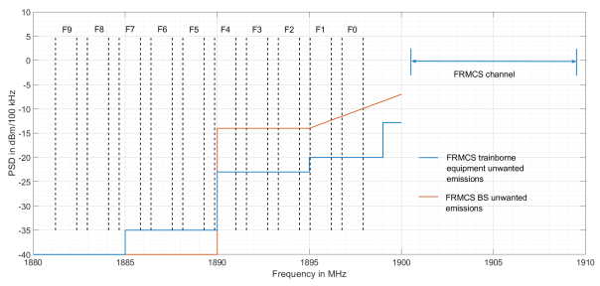
Figure 47: Unwanted emissions of FRMCS BS and on-board equipment in DECT channels
FRMCS signals are OFDMA modulated, and therefore are composed of several equally spaced subcarriers. When entering DECT devices, intermodulation distortion may happen due to the non-linearity of the receivers. This effect has been assessed using the same methodology as in section 4.1.3, by replacing the 20 MHz E-UTRA interferer by a 10 MHz FRMCS carrier, and considering in the same way full RB allocation. The -20.5 dBm third-order intercept point of a DECT receiver has been taken as a basis for the calculation (see Table 8).
The results are presented separately in Figure 48 for interference by FRMCS cab-radios and in Figure 49 for BS. The power of the FRMCS signal measured at the DECT receiver input is shown on the x-axis, and on the y-axis, the in-band power measured in each of the ten DECT channels. Therefore, when the FRMCS signal has very low power, -103 dBm are measured, which corresponds to the specified internal noise of a DECT receiver (see Table 8).
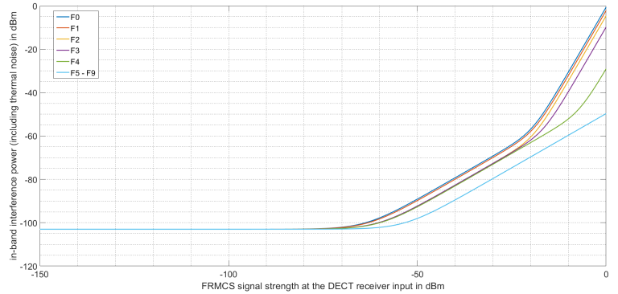
Figure 48: Interference of DECT channels by FRMCS on-board equipment
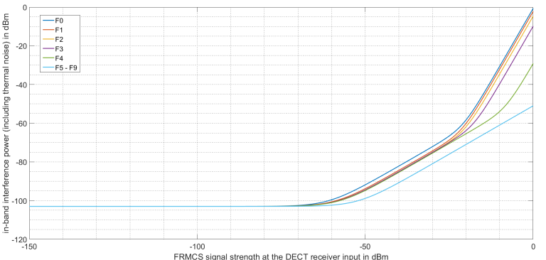
Figure 49: Interference of DECT channels by FRMCS BS
As one can see, interference is mostly driven by unwanted emissions and blocking effects when the FRMCS signal power is less than about -20 dBm, and by intermodulation distortion for higher power levels. Moreover, intermodulation distortion only has an impact on DECT carriers F0 to F4. This can be understood by calculating the centre frequency of the ”lowest” intermodulation product generated by a 10 MHz FRMCS carrier centred at 1905 MHz, which is approximately 1891.5 MHz i.e. in the middle of DECT channel F4.

Residential case
This section considers the case where the DECT received power is -65 dBm.

Interference with FRMCS cab-radios
The interference generated by an FRMCS cab-radio on a pair of DECT devices is assessed in the worst case configuration shown in Figure 50 below, where the train passes as close as 5 m by a residential building in which a PP and an FRP are communicating with each other. This situation is commonly encountered in densely populated areas (see for example the high-density scenario in section 2.5).
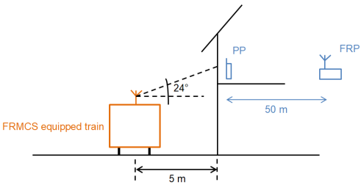
Figure 50: Worst-case configuration for the interference
of a DECT communication by an FRMCs cab-radio
The worst case in terms of relative positioning of the train and the DECT devices is also considered: firstly, the PP is 50 m away from the FRP, which is the maximum range (see Table 9). In this configuration, using the path loss model provided in Table 9, the useful signal strength measured at the PP is -65 dBm. Secondly, the elevation and azimuth angles at the train-mounted antenna in the direction of the DECT equipment are such that the antenna gain is maximal i.e. 6.6 dBi (see Table 4). This gain value being reached at around 24° elevation, the distance between the antenna and the wall is approximately 5.5 m, and the FSPL including a 20 dB building entry loss is 72.8 dB. Therefore, the power of the FRMCS signal at the PP receiver input is -38.2 dBm. The time domain has not been considered here: all DECT slots are assumed to collide with FRMCS uplink subframes.
The in-band interference power in each of the DECT channels is calculated by using the curve shown in Figure 48, as well as the SINR. The results are presented in Table 18 below. The minimum required SINR for a DECT communication is 21 dB according to Table 9, which means that only 5 DECT carriers (F5 – F9) are usable. In the case where the communication is initiated at the exact moment when the train passes by the building, the PP would therefore select the less interfered channel among F5 – F9. In the case where the PP and the FRP are already performing a communication using either one of F0 – F4, there is a possibility that the communication switches to another channel among F5 - F9. In both cases, the communication is not blocked because there are at least half of the channels available where the SINR is sufficient to ensure error-free transmission including a fading margin.
The example presented here shows that FRMCS cab-radios do not interfere with DECT devices operating in buildings.
Table 18: SINR in the DECT channels
DECT channel | F0 | F1 | F2 | F3 | F4 | F5 | F6 | F7 | F8 | F9
In-band interference power (dBm) | -76 (Note 1) |  | -80 |  |  | -86
SINR (dB) | 11 (Note 2) |  | 15 |  |  | 21
Note 1: According to the Figure 48, the in-band interference power (including thermal noise) in the DECT carrier F0 is -76 dBm when the FRMCS signal has -38.2 dBm power.
Note 2: The useful signal power at the PP receiver input is -65 dBm and the in-band interference power (including the thermal noise) is -76 dBm, which results in 11 dB SINR.

When considering a 15 dB building entry loss, the distance is increased from 5.5 m to 9 m.

Interference with FRMCS base stations
In this section, the possible impact of an FRMCS radio site on DECT devices operating in its proximity is examined using the Minimum Separation Distance approach (MSD). The following assumptions are taken and further illustrated in Figure 51 below:
- The FRMCS BS uses two sectoral antennas with the parameters provided in Table 3 and Table 4. In particular, the output power per antenna connector is P = 46 dBm, the feeder loss is FL = 4 dB, the pattern of each antenna is given by Recommendation ITU-R F.1336 -5 [19], section 3.1.1 (”peak side-lobe pattern”) (peak antenna gain = 18 dBi, $k_{p}=0.7; k_{a}=0.7$; $k_{h}=0.7$; $k_{v}=0.3$, horizontal HPBW = 65° and vertical HPBW = 8.5°). There is a diversity gain of TxDiv = 3 dB at each antenna, and no downtilt is applied;
- A pair of DECT devices are communicating with each other inside a building at the same height as the antennas of the FRMCS radio site. The distance between the FRP and the PP is at its maximum of 50 m, so that the useful signal power at the PP is - 65 dBm (see footnote 84);
- Signals generated by the FRMCS BS experience 20 dB BEL when entering the building in which the DECT pair is operating, which is the typical value assumed in urban environment (see Table 9).
The communication between the PP and the FRP is considered blocked if none of the ten DECT channels has more than 21 dB SINR. In other words, the maximum permitted in-band interference power is -65 dBm - 21 dB = -86 dBm. Therefore, using Figure 49, the maximum power of the FRMCS signal at the PP receiver input is -42 dBm (an FRMCS signal having -42 dBm power at the PP receiver input generates -86 dBm in-band interference power in DECT channels F5 – F9, mostly through unwanted emissions).
If the building is in front of an FRMCS antenna, the gain is G = 18 dBi, and therefore the Minimum Coupling Loss (MCL) is given by:
 | $$P-FL+G+TxDiv-MCL-BEL=-42 dB$$ | (8)
Where:
- MCL = 85 dB;
MSD = 225 m (using free space propagation loss formula in Recommendation ITU-R P.525 [44]).
If the building has 90° offset in the azimuth plane with an FRMCS antenna, the gain is G = 1.6 dBi, and therefore the Minimum Coupling Loss (MCL) is given by:
 | $$P-FL+G+TxDiv-MCL-BEL=-42 dB$$ | (9)
Where:
- MCL = 68.6 dB;
- MSD = 34 m (using free space propagation loss formula in Recommendation ITU-R P.525 [44]).
As a conclusion, DECT devices operated in buildings facing an FRMCS radio site (i.e. in the main lobe of one of the two antennas) at a distance of less than 99 m may experience blocking. This situation is quite rare because FRMCS antennas point in the direction of the rail track. In the more common case where the building is ”on the side of the site”, this separation distance falls down to 34 m.
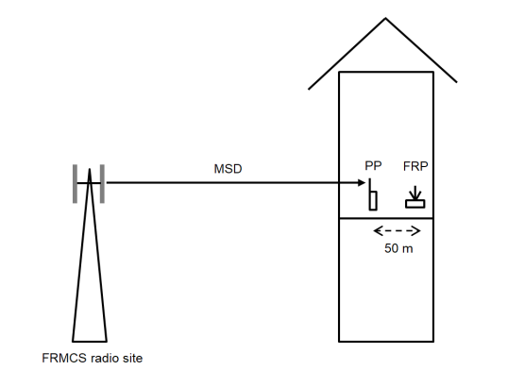
Figure 51: Configuration for interference of DECT devices by an FRMCS BS
When considering a 15 dB building entry loss, the requested attenuation is 90 dB (85 dB + 5 dB) in the main lobe corresponding to a distance about 380 m and the distance in the side lobes is 57 m.

Indoor enterprise case
In this case, all DECT channels should remain free of interference. Based on the existing results and using the Figures 48 and 49 (or the conversion factors), it is possible to derive the corresponding additional attenuation needed and then, the corresponding distances.
This section considers the case where the DECT received power is -65 dBm.

Interference with FRMCS cab-radios
Using Figure 50, it can be seen that that to protect F0, an additional 10.5 dB margin with respect to F5 should be considered. This would lead to a distance of about 16 m with a 20 dB building entry loss.
When considering a 15 dB building entry loss, the distance is 31 m.

Interference with FRMCS base stations
Using Figure 51, it can be seen that that to protect F0, an additional 9 dB margin with respect to F5 should be considered. This would lead to distances of about 630 m in the main beam case and 95 m in the side lobe case, with a 20 dB building entry loss.
When considering a 15 dB building entry loss, the distance is about 1.1 km in the main lobe and 162 m in the side lobes.
However, the free space propagation model may not provide accurate results for distances as great as 1.1 km in urban or suburban environments since the terrain clutter is considered between DECT and FRMCS base stations.

Professional wireless outdoor intercom applications
Based on the results above and considering the attenuation of 20 dB for building entry loss considered in this Report, it is possible to derive the corresponding distances. The Rx level of -65 dBm is achieved at 350 m assuming the free space model (see Recommendation ITU-R P.525-3 [44]).

Interference with FRMCS cab-radios
This leads to a distance of about 165 m with free space propagation model.
With urban Hata propagation model with 1.5 m and 30 m antenna heights, this distance is decreased to 57 m.

Interference with FRMCS base stations
This leads to distances of about 6.3 km in the main beam case and about 950 m in the side lobe case with free space propagation model.
However, the free-space propagation model may not provide accurate results for distances as great as 6 km in urban or suburban environments since the terrain clutter is not considered between DECT and FRMCS base stations.
With urban Hata propagation model with 1.5 m and 30 m antenna heights, these distances are respectively decreased to 226 m and 89 m.

Additional considerations
When used as intercom solution in the context of PMSE, DECT devices may in some cases be operated outdoor. Examples of outdoor applications from the DECT community are events with a large public: referee communications in stadiums, sporting events, street parade, amusement parks. In that case, coexistence with FRMCS may be facilitated by:
- the presence of walls (e.g. in stadiums), which provide an attenuation of the signals to and from DECT devices;
- that the BS for FRMCS would point in the direction of the rail tracks;
- the body loss, in particular when considering large numbers of people, would further reduce the probability of interference between DECT and railway radiocommunications.
Outdoor calculations with free space propagation do not consider the clutter in particular for urban and suburban scenarios.

Summary of the studies about the impact of FRMCS on DECT
The following table provides a summary of the results for the indoor scenarios.
Table 19: Summary of the results – indoor scenarios (free space propagation)
Scenario | Distance (m)  20 to 15 dB building attenuation  Rx power of -65 dBm | Comment
Residential indoor – FRMCS BS main beam | 225 to 380 m | DECT channels F5 to F9 free from interference
Residential indoor – FRMCS BS side lobes | 34 to 57 m
Residential indoor – FRMCS Cab-radio | 5.5 to 9 m
Enterprise indoor - FRMCS BS main beam | 630 m to 1.1 km | DECT channels F0 to F9 free from interference
Enterprise – indoor - FRMCS BS side lobes | 95 to 162 m
Enterprise indoor – FRMCS Cab-radio | 16 to 31 m
The following table provides a summary of the results for the outdoor scenarios.
Table 20: Summary of the results – professional wireless outdoor applications
Scenario | Distance free space | Distance Hata urban
FRMCS BS main beam | 6.3 km | 226 m
FRMCS BS side lobes | 950 m | 89 m
FRMCS Cab-radio | 165 m | 57 m
When used as intercom solution in the context of PMSE, DECT devices will in some cases be operated outdoor. Examples of outdoor applications from the DECT community are events with a large public: referee communications in stadiums, sporting events, street parade, amusement parks. In that case, coexistence with FRMCS may be facilitated by:
- the presence of walls (e.g. in stadiums), which provide an attenuation of the signals to and from the DECT devices;
- that the BS for FRMCS would point in the direction of the rail tracks;
- the body loss, in particular when considering large numbers of people, would further reduce the probability of interference between DECT and railway radiocommunications.

Impact of FRMCS on DECT based on BNetzA measurement campaign

Introduction
This document describes the calculations of minimum protection distances in a worst case scenario between the FRMCS base station or cab-radio and the DECT base stations and mobiles. The parameters Sensitivity=C and protection ratio=C-I were the results derived in the measurement campaign from BNetzA given in the annex 4 of this Report. For the protection ratio, the highest value from the measurement was used, unless another value was explicitly stated in the Tables. Therefore, the DECT parameters are those of the systems tested in the measurement campaign. All the other parameter, i.e. power, antenna gain, feeder loss, are as defined in the ECC Report 314. The detailed antenna pattern is not included, instead, the maximum values of the antenna gains (main beams) were used.

Scenario DECT-systems interfered by FRMCS-Systems

DECT
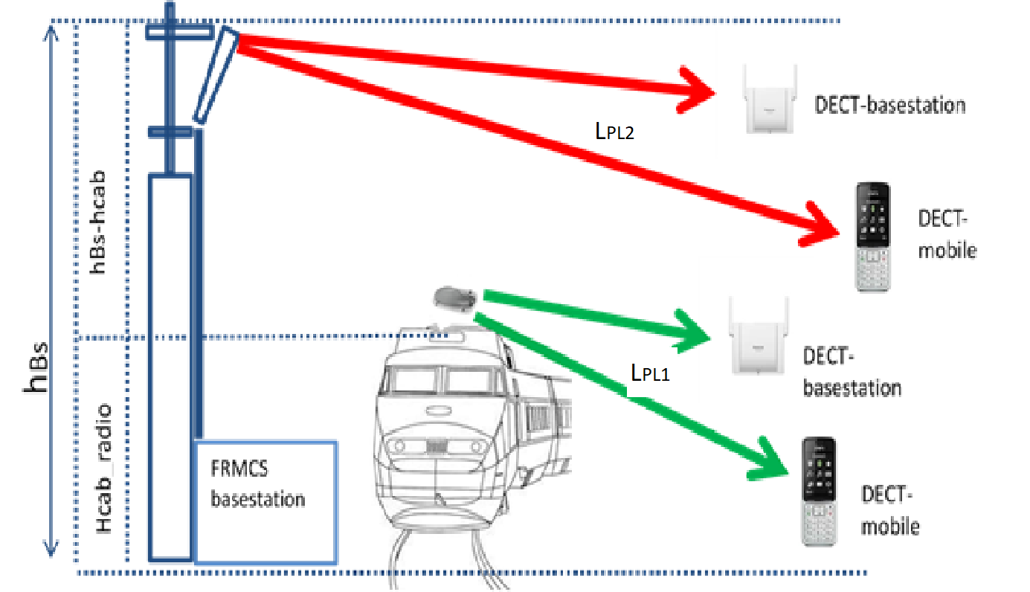
Figure 1: Scenario FRMCS basestation / cabradio interfere DECT basestation / mobile
In the scenario, the FRMCS base station and cab-radio are considered as the interferer to the DECT base station and mobile station.

System parameter
Table 20: Input parameter
Parameter | Unit | Value | Reference
Sensitivity DECT mobile ($C_{DECT,mobile}$) | dBm | -74 | Measurement, see Annex 4.3.1
Sensitivity DECT base station ($C_{DECT,basestation})$ | dBm | -75 | Measurement, see Annex 4.3.1
$$P_{FRMCS,basestation}$$ | dBm/MHz | 46/10 | ECC Report 314, Table 3
$$P_{FRMCS,cabradio}$$ | dBm/MHz | 31/10 | ECC Report 314, Table 3
$$Antenna height, FRMCS basestation$$ | m | 30
$$Antenna height, FRMCS cabradio$$ | m | 4 | ECC Report 314, Table 4
$$Antenna gain FRMCS basestation$$  $$G_{FRMCS,basestation}$$ | dB | 18 | ECC Report 314, Table 4
$$Feeder Loss FRMCS basestation$$  ($L_{feeder,basestation,})$ | dB | 4 | ECC Report 314, Table 4
$$Antenna gain FRMCS cabradio$$  $$G_{FRMCS,cabradio}$$ | dB | 6 | ECC Report 314, Figure 6
$$Feeder Loss FRMCS cabradio$$  ($L_{feeder,cabradio,})$ | dB | 3 | ECC Report 314, Table 4
In this table, the system parameters are collected that are used in the following calculations. The DECT parameters are those of the systems tested in the measurement campaign. All the other parameters, i.e. power, antenna gain, feeder loss, are as defined in the ECC Report 314.

Propagation model

Free-Space Attenuation and extended Hata model
The free-space propagation is a fundamental reference for radio-engineering. The basic calculation of the free-space attenuation is provided in Recommendation ITU-R P.525. The basic transmission loss is referred to free-space attenuation between isotropic antennas and is a function of the frequency and the distance between the isotropic antennas.
 | $$L_{fs}=32.45+20\log_{10}\left(d/{km}\right)+20\log_{10}\left(f/{MHz}\right)$$ | (7)

 | $$d/{km}={10}^{\left(L_{fs}-32,45-20\log_{10}\left(f/{MHz}\right)\right)/20}$$ | (8)
Noting that the free-space attenuation is independent of the antenna heights and is depending only on the frequency and direct radio path considered, i.e. no multi-path propagation is addressed.

Extented Hata model
The Extented Hata propagation model from SEAMCAT was used for the distances calculation.

Recommendation ITU-R P.2109 on building entry loss
This Recommendation provides a method for estimating building entry loss at frequencies between about 80 MHz and 100 GHz. The method is not site-specific, and is primarily intended for use in sharing and compatibility studies. This is a rather new Recommendation, adopted in 2017.
The penetration loss at 1900 MHz is about 13 dB for traditional houses and 28 dB for thermally efficient houses. The chosen value is 13 dB

MCL analysis
The interference on DECT base station / mobile in outdoor case is determined with MCL methodology for a worst-case scenario. The basic transmission loss (Path Loss) $L_{PL1}$ , $L_{PL2}$can be determined by
 | $$L_{PL1}= P_{FRMCS,cabradio}+G_{FRMCS,cabradio}-L_{feeder,cabradio}-I_{DECT,basestation}$$ | (12)

 | $$L_{PL1}= P_{FRMCS,cabradio}{ + G}_{FRMCS,cabradio}-L_{feeder,cabradio}-I_{DECT,mobile}$$ | (13)

 | $$L_{PL2}= P_{FRMCS,basestation}+G_{FRMCS,basestation}-L_{feeder,basestation}-I_{DECT,basestation}$$  $$L_{PL2}= P_{FRMCS,basestation}+G_{FRMCS,basestation}-L_{feeder,basestation}-I_{DECT,mobile}$$ | (14)

 | The interference criteria${ I}_{DECT,basestation,mobile}$ is calculated by  $$I_{DECT,basestation}=C_{DECT,basestation}-{\left(C-I\right)}_{basestation}$$  $$I_{DECT,mobile}=C_{DECT,mobile}-{\left(C-I\right)}_{mobile}$$ | (15)
The power for FRMCS base stations $P_{FRMCS,basestation}$and mobile stations $P_{FRMCS,cabradio}$per bandwidth for a DECT channel (1.152 MHz) is defined by:
 | $$\frac{P_{FRMCS,basestation}}{1.152 MHz}=\frac{P_{FRMCS,basestation}}{9 MHz}-10\log_{10}\left(\frac{9 MHz}{1.152 MHz}\right)$$  $$\frac{P_{FRMCS,cabradio}}{1.152 MHz}=\frac{P_{FRMCS,cabradio}}{9 MHz}-10\log_{10}\left(\frac{9 MHz}{1.152 MHz}\right)$$ | (16)
Where:
- $L_{PLx}=Basic transmission loss \left(Path Loss\right)in dB;$
- $P_{FRMCS,cabradio}=Transmitted power FRMCS cabradio in dBm$;
- $P_{FRMCS,basestation}=Transmitted power FRMCS basestation in dBm$;
- $I_{DECT,basestation}=Interference criteria DECT basestation in dBm;$
- $I_{DECT,mobile}=Interference criteria DECT mobile station in dBm$;
- $C_{DECT,basestation}=Sensitivity DECT basestation in dBm$;
- $C_{DECT,mobile}=Sensitivity DECT mobile in dBm$;
- $G_{FRMCS,basestation}=Antenna gain FRMCS basestation$;
- $L_{feeder,basestation}=Feeder Loss FRMCS basestation$;
- $G_{FRMCS,cabradio}=Antenna gain FRMCS cabradio;$
- $L_{feeder,cabradio}=Feeder Loss FRMCS cabradio$.

Summary Results
Table 21: Summary of the results – worst-case outdoor scenarios with Rx power of -74 dBm
Scenario Outdoor | Distances [m] for DECT mobile station with Rx power of  -74 dBm | Distances [m] for DECT base station with Rx power of  -75 dBm | Propagation Model
FRMCS cab-radio interfere to DECT (main beam) | 15 | 30 | ITU-R P.525
FRMCS Base station interfere to DECT (main beam) | 420 | 839 | ITU-R P.525
FRMCS Base station interfere to DECT  (main beam) | 73 to 240 | 88 to 356 | Extended Hata (urban)
FRMCS Base station interfere to DECT  (main beam) | 116 to 420 | 172 to 786 | Extended Hata (suburban)
FRMCS Base station interfere to DECT  (main beam) | 420 | 640 to 840 | Extended Hata (rural)
FRMCS cab-radio interfere to DECT  (main beam): C-I=-50.5 dB (mobile 4); C-I=-48.5 dB (base station 4) | 3.3 | 4.7 | ITU-R P.525
FRMCS Base station interfere to DECT  (main beam): C-I=-50.5 dB (mobile 4); C-I=-48.5 dB (base station 4) | 94 | 133 | ITU-R P.525

Table 22: Summary of the results – typical outdoor scenarios with Rx power of -65 dBm
Scenario Outdoor | Distances [m] for DECT mobile station with Rx power of  -65 dBm | Distances [m] for DECT base station with Rx power of  -65 dBm | Propagation Model
FRMCS cab-radio interfere to DECT (main beam) | 5 | 9 | ITU-R P.525
FRMCS Base station interfere to DECT (main beam) | 149 | 265 | ITU-R P.525
FRMCS cab-radio interfere to DECT  (main beam): C-I=-50.5 dB (mobile 4); C-I=-48.5 dB (base station 4) | 1.2 | 1.5 | ITU-R P.525
FRMCS Base station interfere to DECT  (main beam): C-I=-50.5 dB (mobile 4); C-I=-48.5 dB (base station 4) | 33.4 | 42 | ITU-R P.525

Table 23: Summary of the results – worst case indoor scenarios with Rx power of -74 dBm
Scenario Indoor | Building entry loss  P.2109 | Distances [m] for DECT mobile station with Rx power of -74 dBm | Distances [m] for DECT base station with Rx power of  -75 dBm | Propagation Model
FRMCS cab-radio interfere to DECT (main beam) | 13 | 3.3 | 6.7 | ITU-R P.525
FRMCS Base station interfere to DECT (main beam) | 13 | 94 | 187 | ITU-R P.525
FRMCS Base station interfere to DECT (main beam) | 13 | 48 to 92 | 58 to 152 | Extended Hata (urban)
FRMCS Base station interfere to DECT (main beam) | 13 | 55 to 92 | 77 to 187 | Extended Hata (suburban)
FRMCS Base station interfere to DECT (main beam) | 13 | 90 to 92 | 185 to 187 | Extended Hata (rural)
FRMCS cab-radio interfere to DECT (main beam) | 15 | 2.7 | 5.3 | ITU-R P.525
FRMCS Base station interfere to DECT (main beam) | 15 | 75 | 149 | ITU-R P.525
FRMCS cab-radio interfere to DECT (main beam) | 20 | 1.5 | 3 | ITU-R P.525
FRMCS Base station interfere to DECT (main beam) | 20 | 42 | 84 | ITU-R P.525
Table 24: Summary of the results – typical indoor scenarios with Rx power of -65 dBm
Scenario Indoor | Building entry loss  P.2109 | Distances [m] for DECT mobile station with Rx power of  -65 dBm | Distances [m] for DECT base station with Rx power of  -65 dBm | Propagation Model
FRMCS cab-radio interfere to DECT (main beam) | 13 | 1.2 | 2.1 | ITU-R P.525
FRMCS Base station interfere to DECT (main beam) | 13 | 33.4 | 59.4 | ITU-R P.525
FRMCS cab-radio interfere to DECT (main beam) | 15 | 0.9 | 1.7 | ITU-R P.525
FRMCS Base station interfere to DECT (main beam) | 15 | 26.5 | 47.2 | ITU-R P.525
FRMCS cab-radio interfere to DECT (main beam) | 20 | 0.5 | 0.9 | ITU-R P.525
FRMCS Base station interfere to DECT (main beam) | 20 | 14.9 | 26.5 | ITU-R P.525

Conclusions
The required protection distances are derived considering a worst case scenario where the dynamic channel selection of DECT systems is not possible since all the adjacent channels are occupied.
The results give protection distances for the worst case outdoor scenario with free space propagation model where the FRMCS cab-radio interferes with DECT systems (received power level = -74 dBm) are up to 30 m. But for a typical outdoor scenario with received power level = -65 dBm the protection distances are up to 9 m.
In the worst case outdoor scenario where the FRMCS base station interferes with DECT systems the protection distances varies from 73 m to 840 m - depending on the propagation model (free-space, Extended Hata). However, for typical outdoor scenario (received power level = -65 dBm) with free space propagation model the protection distances are as far as 59 m.
For the worst case indoor scenario where the FRMCS cab-radio interferes with DECT systems, the protection distance range is from 1.5 m to 6.7 m. This depends on the choice for the building entry loss from 13 dB to 20 dB. Unlike to typical indoor scenario the protection distance will be reduced to 2.1 m.
If DECT systems are interfered by the FRMCS base-station the protection distance is from 42 m to 187 m for the worst-case indoor scenario, depending on the propagation model (free-space, Extended Hata) and building entry loss. In contrast to typical indoor scenario with free-space propagation model the distances are from 15 m to 59 m depending on the building entry loss.
It should be noted that those results on protection distances are based on measurements of protection ratio (see ANNEX 4:), which may not be representative for all type of DECT devices.

Conclusions
This ECC Report is a technical study for the feasibility of introducing the Future Railway Mobile Communication System (FRMCS) in the frequency band 1900-1920 MHz. FRMCS is gradually replacing GSM-R for mission-critical train-to-ground communications in the coming years. This work is in line with the EC Mandate on FRMCS.
Two adjacent band systems have been considered: Mobile/Fixed Communication Networks (MFCN) in the uplink band 1920-1980 MHz, and DECT in 1880-1900 MHz. The co-existence issue between these systems and FRMCS is simulated in different railway segments: high-speed lines, low-density lines and high-density lines. It should be noted that the band 1880-1920 MHz for potential Unmanned Aircraft System (UAS) use is subject to a separate ECC Report under development; this potential use is not studied in this Report. The band 1900-1910 MHz is licensed in the United Kingdom to provide enhanced mobile communications for the emergency services (PPDR); this co-frequency use is also not studied in this Report.
When assessing the feasibility of deploying FRMCS in the lower 10 MHz (1900-1910 MHz) using either 4G LTE or 5G NR as Radio Access Technology (RAT), the following results are obtained:
With MFCN above 1920 MHz:
- The main mechanism by which MFCN UEs interfere with FRMCS cab-radios is the unwanted emissions falling into the FRMCS channel;
- FRMCS cab-radios would not face downlink throughput degradation, even when the train is passing by a terminal in close proximity to the rail track, which is the configuration resulting in the maximum of desensitisation;
- The impact of FRMCS on MFCN base stations is addressed in ECC Report 318 [55].
With DECT below 1900 MHz:
- Impact of DECT on FRMCS cab-radio: When crossing heavily populated areas where the density of DECT devices is highest, FRMCS cab-radios would not face a downlink throughput degradation. The desensitisation of the FRMCS cab-radio is generally negligible, apart from exceptional cases where it can reach up to 10 dB for a few seconds, noting that in these situations the wanted signal remains 30 dB above the interference level;
- Impact of FRMCS cab-radio on DECT:
In the first analysis, when assuming free space propagation with building entry loss, separation distance from FRMCS cab-radios is in the range of 5.5-9 m for residential indoor DECT devices ensuring their operation free from harmful interference in channels F5 to F9, and in the range of 16-31 m for enterprise indoor DECT devices ensuring their operation free from harmful interference in all channels from F0. In the second analysis for the indoor scenario where the FRMCS cab-radio interferes with DECT systems, the protection distance range is from 1.5 m to 6.7 m, depending on the choice for the building entry loss from 13 dB to 20 dB;
In the first analysis, for outdoor DECT devices in the context of PMSE, separation distance from FRMCS cab-radio is 165 m assuming free space propagation, and 57 m assuming Hata urban propagation. In the second analysis, the FRMCS cab-radio interferes with DECT systems for the outdoor case if the protection distances is smaller than 30 m;
- Impact of FRMCS BS on DECT:
In the first analysis, when assuming free space propagation with building entry loss, typical separation distance from FRMCS BS is in the range of 34-57 m for residential indoor DECT devices ensuring their operation free from harmful interference in channels F5 to F9, and in the range of 95-162 m for enterprise indoor DECT devices ensuring their operation free from harmful interference in all channels from F0. In the second analysis, if DECT systems are interfered by the FRMCS base station, the protection distance range is from 42 m to 187 m, depending on the propagation model (free-space, Extended Hata) and building entry loss;
In the first analysis, for outdoor DECT devices in the context of PMSE, separation distance from FRMCS BS is 950 m assuming free space propagation, and 89 m assuming Hata urban propagation. Where the area of DECT operation is in the main lobe of the FRMCS BS antenna, the separation distance may increase beyond 1 km assuming free space propagation. The ground clutter has not considered between DECT and FRMCS. The second analysis shows that in the outdoor scenario where the FRMCS base station interferes with DECT systems the protection distances vary from 73 m to 840 m - depending on the propagation model (free-space, Extended Hata);
- Coexistence between FRMCS and outdoor DECT in the context of PMSE (stadiums, sporting events, amusement parks, street parades, etc.) may be facilitated by the presence of walls (e.g. in stadiums) that provide further attenuation to and from DECT devices, FRMCS BS directive antennas pointing to rail tracks, and the body loss when considering large numbers of people. This would reduce the probability of harmful interference on DECT devices;
In the second analysis, the required protection distances are derived from MCL calculations, considering a worst case scenario where the dynamic channel selection of DECT systems is not possible, since all the adjacent channels are occupied (see the description in the measurement report in the ANNEX 4: of this Report);
- Where the DECT usage density is low, the Dynamic Channel Selection (DCS) algorithm implemented in DECT would then allow the communication to use one of the DECT channels that do not experience interference;
- The measurement campaign in ANNEX 3: shows, that in case of a 10 MHz wide LTE-TDD signal as interferer, in the co-channel interference scenario where all DECT downlink timeslots are free, the DECT communication link is not interrupted. When DECT frequency / timeslot hopping is disabled, the carrier-to-interference protection ratio is in the range of -32 dB down to -50 dB for a 8 MHz centre frequency offset between DECT and FRMCS;
- It should be noted that DECT is a licence-exempt system and there is no record of locations. Additionally, many PMSE type high-density activities will be of a temporary nature.
Requirements on FRMCS receivers:
The protection of FRMCS cab-radios against MFCN BS emissions in the frequency band 1805-1880 MHz and against aerial UEs in 1920-1980 MHz requires the following receiver characteristics:
Table 25: Requirements on FRMCS cab-radio receiver characteristics
Parameter | Value
Level of the wanted signal | sensitivity + 3 dB
Maximum 5 MHz LTE interfering signal in 1805-1880 MHz | -13 dBm
Maximum 5 MHz LTE interfering signal in 1920-1980 MHz | -39 dBm
The antenna connector of the radio module is the reference point.
These requirements cover both blocking and third-order intermodulation.
Depending on the feasibility of the introduction of governmental UAS in 1880-1920 MHz, FRMCS and governmental UAS may need to coexist and it would be up to the ETSI to define, based on Table 15, a maximum 5 MHz LTE interfering signal level in 1880-1890 MHz when a governmental UAS is in use not in the immediate vicinity of the rail tracks but close enough to cause harmful interference.
With respect to the protection of FRMCS BS against MFCN BS emissions in the frequency band 1805-1880 MHz, the following blocking level is recommended:
Table 26: Requirements on FRMCS BS receiver characteristics
Parameter | Value
Level of the wanted signal | sensitivity + 3 dB
Maximum 5 MHz LTE interfering signal in 1805-1880 MHz | -20 dBm
The antenna connector of the BS receiver is the reference point.
These requirements cover both blocking and third-order intermodulation.

- Propagation model
Most of the propagation models commonly used in CEPT and ITU-R co-existence studies are based on statistical approaches: for example, the Okumura-Hata model has been elaborated following a set of measurement campaigns in densely populated areas in Japan. These semi-empirical models provide good results when the distance between the transmitter and the receiver is sufficiently large to average out the effect of individual buildings and other obstacles. However, in very specific cases, especially for short distances, the particularities of the configuration are disregarded by such models, which can ultimately lead to a poor evaluation of the path loss.
The scenarios studied in this Report involve distances that generally do not exceed a few kilometres, but can reach down to a few meters in some cases (for example when calculating the wanted signal received by the cab-radio from the FRMCS site in the serving cell). For such short distances, the only relevant propagation effect is the diffraction, and therefore predicting the path loss requires knowing the exact position of all obstacles in the path between the transmitter and the receiver. This can be achieved by using a national terrain and buildings database: in France they are both provided by the ”Institut National de l’Information Géographique et Forestière” (IGN), with a precision of 5 m (1 m is also possible but it increases significantly the computation time and provides a level of accuracy that is not necessarily needed for the purposes of this Report).
Once the path profile between the transmitter and the receiver is determined, the Bullington single knife edge diffraction model is applied. The advantage of this model is its simplicity: it basically reduces the path profile to a single equivalent obstacle and ignores all others. Therefore, it tends to underestimate the diffraction loss which is acceptable in this report because it overestimates the impact of interferers on the FRMCS cab-radio.
The principle of the model is thoroughly described in “Diffraction Loss Prediction of Multiple Edges Using Bullington Method with Neural Network in Mountainous Areas” [45], and further illustrated in Figure 52 below. The length of the straight line between the transmitter (Tx) and the receiver (Rx) is denoted by d. The equivalent obstacle has a height h above this straight line, which is determined by drawing the lines from the transmitter and receiver to the highest point that they ”see” in the direction of each other. Let d1/d2 respectively denote the distance between Tx/Rx and the top of this equivalent obstacle. The diffraction loss is given by the following formula, where λ denotes the wavelength:
 | $$L_{diff }=6.9+20\log_{10}\left(\sqrt{{\left(v-0.1\right)}^{2}+1}+v-0.1\right), if v≥-0.78 (L_{diff }=0 otherwise)$$  $$v=h\sqrt{\frac{2}{λ}\left(\frac{1}{d_{1}}+\frac{1}{d_{2}}\right)}$$ | (16)
The path overall propagation loss results from the addition of $L_{diff }$, and the Free Space Path Loss (FSPL), which is provided in Recommendation ITU-R P.525 [44] (formula 4).
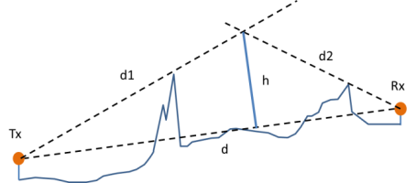
Figure 52: Determination of the equivalent obstacle in the Bullington diffraction model
- Achievable downlink throughput without external interference
In this paragraph, the minimum throughput of the FRMCS downlink is determined, based on the system and deployment-related parameters presented in section 2.3 and 2.4. No external interference is considered, so that the only limitation is the ICI generated by adjacent cells. The figure below shows the CDF of the SINR variable in each of the three scenarios. For example, in the high-speed case, the minimum SINR is about 10 dB, and it is attained at the second handover point (see Figure 13). The maximum SINR of 60 dB is measured when the train is passing by the FRMCS site in the centre of the serving cell.
In each scenario, the SINR value exceeded 95% of the time has also been shown, and equals 13 dB, 14 dB and 40 dB in the high-speed, the low-density and the high-density scenario, respectively. 95% has been chosen to keep this study consistent with the EIRENE specifications [25] for GSM-R, which requires a minimum signal strength at the train antenna that must be exceeded 95% of the time.
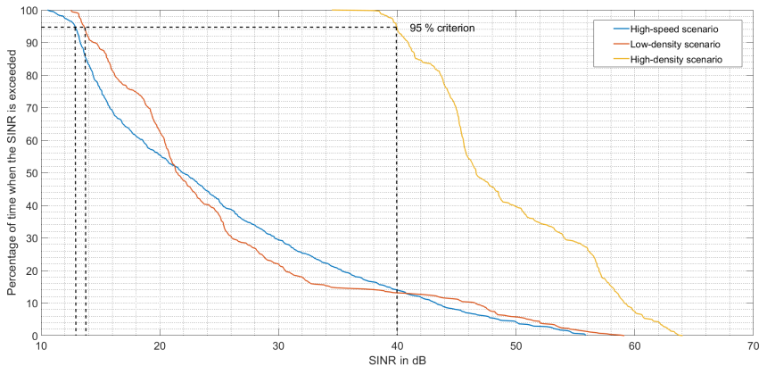
Figure 53: CDF of the SINR in the three scenarios without external interference
The standard methodology that has been used to compute the achievable throughput is described in the following steps:
- In LTE, the link adaptation algorithm dynamically selects the best possible Modulation And Coding Scheme (MCS) to maintain the BLock Error Rate (BLER) below 10%. A higher MCS offers higher spectral efficiency, but also requires higher SINR to support it. The paper ”LTE Physical Layer Performance Analysis” [45] provides the mapping between BLER and SNR for different channel models, and in particular for the Extended Typical Urban model (ETU), with maximum 70 Hz Doppler shift (see the figure below). As can be read from this figure, the maximum MCS index that keeps the BLER below 10% is 19, 20 and 28 in the high-speed, the low-density and the high-density scenario, respectively;
- The MCS index is mapped to the so-called Transport Block Size (TBS) index according to 3GPP TS 36.213 [21], table 7.1.7.1-1. It is 17, 18 and 26 in the high-speed, the low-density, and the high-density scenario, respectively;
- The average number of RBs allocated per train is computed based on the train densities given in Table 5. In the high-speed scenario, it equals 50/4 = 13, in the low-density, 50/3 = 17, and in the high-density, 50/5 = 10;
- The number of allocated RBs, together with the TBS index, are used to compute the Transport Block Size (TBS), which is the number of payload bits transported in a 1 ms subframe. The mapping is given in 3GPP TS [21], table 7.1.7.2.1-1. In the high-speed, TBS = 4776 bits, in the low-density, TBS = 6712 bits, and in the high-density scenario, TBS = 7480 bits, which results in throughput values of 4.776 Mbps, 6.712 Mbps and 7.480 Mbps. Indeed, a single transmission MIMO chain is considered for FRMCS downlink (see Table 4, note 6);
- The throughput values computed in the last step must be corrected by the factor $r_{dl}$, which reflects the proportion of time reserved for downlink traffic. This variable can be computed from the TDD frame and subframe configurations. In the case of FRMCS, the frame configuration is 3, and the special subframe configuration is 6 (see Table 3), and therefore: $r_{dl}=\frac{2}{10}+\frac{2}{10}*\frac{9}{14}=\frac{23}{70}$. This finally results in the throughput estimations provided below.
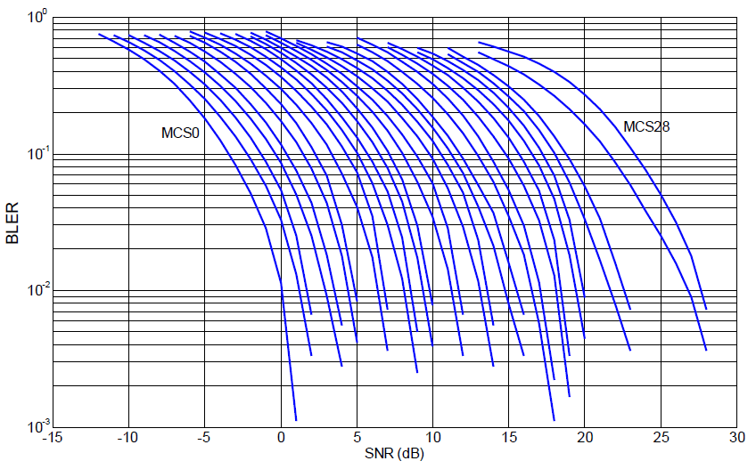
Figure 55: Mapping between SNR and BLER for different MCS indexes
in LTE downlink (ETU70 channel model)

Table 27: Throughput values exceeded 95% of the time in each scenario
Railway environment | Throughput
High-speed | 1.6 Mbps
Low-density | 2.2 Mbps
High-density | 2.5 Mbps

- DECT widened usages
  - Introduction
A rapidly growing number of private and public companies whose business utilizes professional and enterprise voice applications have been deploying DECT based systems for many years due to their reliability and quality of service, this includes:
- industrial manufacturing plants;
- R&D facilities;
- large commercial office buildings;
- conference centres;
- prisons;
- power stations;
- schools;
- university campuses;
- hospital;
- hotels;
- ships;
- airports;
- …
  - Professional high user density applications
The operator independent nature of the DECT band, DECT's ability to self-configure and its ability to support a large number and/or density of concurrent live audio streams, has also made DECT the technology of choice for Call Centre, Intercom and Conferencing systems where quality and reliability of communication is essential for very high densities of users. This unique capability has also attracted the attention of the broader Integrated System, Unified Communication and PMSE (Program Making and Special Events) industries where DECT is increasingly used in many mission-critical applications like 'Talk-back' structured intercom for Broadcasters, (which previously used 470-862 MHz channels) Translation Systems, Assistive Listening systems (for the hard of hearing) wireless performance microphones, wireless loudspeakers and headphones.
The density of users supported by these professional DECT systems can be expressed in the following ways.
- User Density Per Installation (Live = Rx + Tx streaming // Connected = Rx + Tx control/data only)
Concurrent Live Users per deployed system - without frequency re-use: can exceed 60 - all within a radius of 15 metres - or around one DECT radio per 10 square metres. Within one conference room, the density can exceed one radio per 2 square metres.
Concurrent Live Users per deployed system - with frequency re-use: is unlimited but single installations of >100 live users is not uncommon, with several hundred registered users. Within a call centre, the density can be as high as one radio per 5 square metres.
Connected Users: the number of connected users can far exceed the number of live users above - the 'connected' state meaning that users' equipment that is not Transmit-streaming, may be receiving broadcast audio or data and continues to exchange control data with base stations. The number of connected users can be measured in many 100s per installation (presentation/debating hall scenario).
- Access Point Density Per Installation
The distribution of access points and base stations in an installation adds to the above density of active DECT radios. In Enterprise and Conferencing installations, the density is typically around one DECT radio per 20-30 square metres with the density of base stations in call centres as high as one per 5 square metres (doubling the density of live user radios).
c) Spectrum Occupancy within an operating system's range
DECT spectrum occupancy can exceed 80% (> 160 of 200 available channels - the practical limit of a fully managed high QoS DECT spectrum) when full use of DECT's Dynamic Channel Allocation (see the section on DECT Technology and its highly efficient use of the DECT Spectrum) and synchronised accessed points is deployed. It is crucial to note that this extraordinarily high spectrum occupancy is only possible when the DECT spectrum is ONLY occupied by DECT radios (that adhere to DECT regulations). This extremely effective co-existence of DECT radios in the DECT spectrum is the main foundational property of the DECT technology that provides its claim of interference-free communication and very high Quality-of-Service (QoS) that has enabled the various use-cases described above.
Conclusion: in these high-density deployments, a very careful survey of the spectrum is carried out beforehand and typically steps are taken to design the installation to get the maximum throughput (number of voice channels) whilst maintaining very high QoS. Any new higher-power interferer that does not adhere to the DECT band's regulations would immediately render these high-density systems unusable.
  - Wireless outdoor applications
In all these scenario’s whilst voice is usually the prime requirement data is often in use varying from medical information of the patient to battery life of outside broadcast cameras.
The density of users supported by wireless intercom systems using DECT systems depends on the event and can expressed in the following ways.
- Sport stadium
Density:
- On the day of a sport event, more than 50 beltpacks are simultaneously in use.
- Before, during and after a concert up to 100 beltpacks are simultaneously in use and fill the spectrum completely around the stage/field area.
- Outdoor sport events
Outdoor sport events are normally time limited. Wireless communication systems are essential especially for broadcast services to coordinate all workers during setup and camera operators and artists during production. Wide working range is necessary to cover areas of e.g. a downhill racing mountain.
Multiple DECT systems operate side by side when an international event is broadcast by multiple stations. 10 to 20 access points are installed across the track and especially in the finish area.
Density:
- Before, during and after the sport event 50 to 100 users/beltpacks are simultaneously in use. These systems are widely spread across the complete track and finish area, the DECT spectrum is approx. 50% in use at various times.
- Motorsport events
Normally one operator provides a fully controlled multi-cell handover system with up to approx. 40 access points for all users. Up to 250 beltpack users work simultaneously in the pit lane area.
Density:
- Up to approx. 250 DECT beltpacks are simultaneously in use and fill the spectrum completely in the pit lane area multiple times.
- Music festivals
In these venues multiple unsynchronised multi-cell handover intercom systems are built-up by different parties to do their daily professional requirements. Approx. 15 Base Stations work in parallel. Very often 150 beltpack users work simultaneously across the event area and beyond. These users use 100% of the spectrum. As the frequencies are in use multiple times the working range of the beltpacks are already decreased in some areas. Sometimes microcells need to be installed to increase the coverage of beltpacks.
Density:
- Before, during and after the concert 100 beltpacks and more are simultaneously in use and fill the spectrum completely around the stage.
- Amusement parks
In parks like Disneyland, enterprise solutions have sometimes more than 60 access points and up to 250 live users/beltpacks across the park. Access points installed every 15 to 30 meters and frequencies re-used multiple times during high user density shows/parade.
Density:
- Every day 50 to 250 Beltpacks are in use. Especially during high user density shows/parade the spectrum is 50 to 80% in use.
  - Considerations on DECT radio planning
It should be noted that DECT is an unlicensed system, and there is no record of locations, in addition many PMSE type activities will be of a temporary nature.
Standard working range of Wireless Intercom Solutions:
Wireless intercom devices can operate in a distance of up to 350 meters radius in free line of sight. To increase live user density, this operation range can be adjusted by reducing the power settings.
Access Point Density in Outdoor Events:
Current wireless intercom enterprise deployments without frequency re-use can exceed 60 access points (e.g. Disneyland). These access points operate in a radius of up to 50 meters. The access point density can increase to 10 access points within 50 meters radius when up to 100 user needs support in one radio area.
Current wireless intercom enterprise deployments with frequency re-use support up to 250 simultaneous live users. Within a high-density area like a pit lane access points are installed every 5 to 10 meters to support this amount of users.
Spectrum Occupancy within an operating system's range
DECT spectrum occupancy can exceed 100% in some cases. This happens when operation range is reduced due to re-using of frequencies and as long as the carrier to interferer ratio is maintained and no interference is guaranteed. To guarantee a reliable communication this is only possible with an exact deployment and user position plan. Additional all DECT systems needs a common synchronisation and no interference in the air.
  - How DECT uses the spectrum
Dynamic Channel Allocation (DCA):
One main characteristic of DECT is the instant DCA (live with an active call/connection). DECT in Europe has 10 carriers available on a 20 MHz bandwidth (1880-1900 MHz). Each carrier is divided in frames of 24 full-slot time slots (12 in one direction and 12 in the other direction for symmetric duplex services). A DECT access channel is defined by a carrier frequency and a time slot. If for example, 10 DECT carriers are allocated, as in the frequency band 1880-1900 MHz, a total of 120 full-slot duplex access channels will be provided. Conferencing or Intercom Systems can deploy asymmetric frame structures to make the most efficient use of available spectrum.
During a live connection, the DECT traffic channel selection is made by the user equipment's radio. The radio's 'channel manager' continually scans all available time slots for interference and will collaborate through a 'back-channel' with the connected base station or access point, if and when a switch to a clearer time slot is necessary to maintain or improve quality of service (QoS). During this switch to an improved time-slot both 'old' and 'new' slots will be temporarily be active, to ensure a continuous and seamless connection. This ability (which is not for example native to technologies employing Fixed Channel Allocation (FCA) mechanisms - such as UHF systems that don't have a 'back-channel') is what makes DECT very attractive to microphone manufacturers who traditionally have used UHF technology where pre-scanning before every connection set-up is required and where typically, interference can (even after pre-scanning) still impact QoS. This DCA is a pro-active interference-avoidance mechanism that also compares favourably with the more reactive adaptive frequency-hopping FHSS wireless technologies such as Bluetooth that have a much poorer co-existence performance.
In summary, with DCA, so long as different applications and different operators are 'playing by the DECT rules', they can dynamically and efficiently share the same spectrum resource without prior distribution of channels to specific services or base stations.
Multi-cell / redundancy:
When multiple overlapping base stations or access points are deployed, the user equipment's radio can also keep track of the strongest detected signal from available base stations, and with a similar mechanism to DCA, can switch with seamless 'hand-off' from one base station to another. Cellular technologies such as GSM were designed with a very similar capability, but the typical physical DECT cell spacing can be small enough to provide very high densities of users with very high QoS.
Frequency re-use:
Many large-scale or high-density DECT systems can deploy very large numbers of user equipment by frequency re-use techniques. Just one example is call centre headset systems, that dynamically control the 'size' of the active DECT cell depending on the needs of the active connection. This is achieved by dynamically controlling (reducing) the RF power of both the user equipment's radio and the base station, thus 'shrinking' the cell size to the minimum required to maintain good QoS. Thus, in a large and high density installation, the carriers and timeslots of the DECT frequencies can be utilised many times over. It is important to note that in this very low-power state, call centre headsets (as mentioned - some of which are being used for emergency services) would be especially vulnerable to a non-DECT high-power interferer.
It is also important to note here that the above features and techniques deployed in any DECT systems which facilitate large numbers and high densities of users, were designed for DECT operation and coexistence of users within one DECT system and between independent DECT compliant systems. They were never designed to handle arbitrary adjacent band (or worse in-band) interference by other technologies and applications.

- Measurements of the compatibility of DECT and LTE systems
  - Introduction
This Annex provides a measurement report investigating the compatibility between DECT and LTE systems. The background for the studies is that in connection with the implementation of FRMCS, the former GSM-R systems will be replaced by a new system based on LTE-R. The frequency band in favour is LTE band 33, namely 1900-1920 MHz (duplex mode: TDD), right next to the DECT band at 1880-1900 MHz. The introduction of a guard band is not under consideration. This Report provides measurement results to support ongoing compatibility studies.
The DECT system is able to recognise and mitigate interferences by changing its channel and / or its time slot that is considered available. The DECT system uses a range of 20 MHz separated into 10 channels with 24 time slots for the up- and downlinks, where the highest channel (DECT channel F0) at 1897.344 MHz is the closest one to the intended LTE application. For the measurements, the DECT radios were forced to the highest channel, to disable that mitigation path.
The measurements deal with both TDD an FDD mode.
The measurements try to answer the following worst case scenario: in an open-plane office in the range of the DECT supply range of about 300 m without any mechanical obstructions there could be the case that all of the frequency and time slots are occupied. If an LTE system – e.g. on a train passing by – is in close vicinity, then the number of possible slots might be reduced due to the interference of up to all time slots on at least the uppermost DECT frequency. For that, the measurements lead to the required protection ratios.
  - Radio system particulars and parameters
    - DECT
For the measurements, the wanted DECT signal was generated by the use of a pair of DECT terminals: a specific base station belongs to a specific handheld. The antenna port of the DECT is usually not available without a modification of the Device under test (DUT). For that, the DUT was operated in a shielded, aAnechoic chamber. This allowed the isolated measurement of the specific DUT and supressed unwanted crosstalk and reception path beyond the intended one (the antenna placed in the chamber, bearing the measured signal scenario).
Devices in the DECT coordinate themselves to mitigate interferences by other DECT terminals or non-DECT-signals by changing the working frequency and timeslot. At least the frequency range was fixed for measurements by the use of a blocking signal. The concept is sketched in Figure 56: the DECT radio inside of the anechoic chamber was fed with an FM-carrier. The carriers frequency deviation and the frequency of the modulating tone was chosen in such a way that there was no opportunity the DECT radios to get a free radio resource outside of DECT channel 0. The level of the blocking signal was set as low as needed to mark the channel 1-9 as “interfered”, while avoiding a degradation of channel 0.

frequency/
DECT- channel
9
8
7
6
5
4
3
2
1
0
interfering
signal
DECT-
Wanted channel
DECT- Blocker
Figure 56: frequency occupancy during the measurements

Additionally, the corresponding real-time spectrum is shown below in Figure 57. The diagram’s colours indicate the chance that the power on that frequency appears: the darker the colour, the less that frequency is occupied by the level indicated on the y-axis in terms of time.
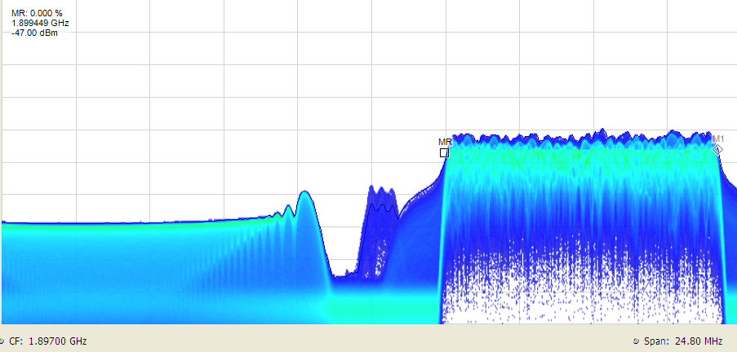
LTE-signal
DECT
DECT Blocker
Figure 57: Realtime spectrum in the frequency range of 1900 MHz during the measurements
    - LTE
A measurement signal generator generated the interfering LTE-signals. Two signals types are used: an LTE-TDD uplink signal, and an LTE-FDD downlink signal. Please note that the generator only creates one link direction; a second generator was not available at the time of measurement. Nonetheless, it is arguable what level settings for the LTE-connection counterpart signal shall be assumed.
      - LTE-TDD
According to the signal parameters sketched in section 2.3 Table 3 1900-1920 MHz the signal was configured as follows:
- Frame configuration: 0;
- Special sub-frame configuration: 6;
- RF-Bandwidth: 10 MHz.
This setting schedules most to the available timeslots to the uplink terminals. All available (uplink) slots were filled with dummy data (16-QAM). The schedule for one radio frame is shown in Figure 58.

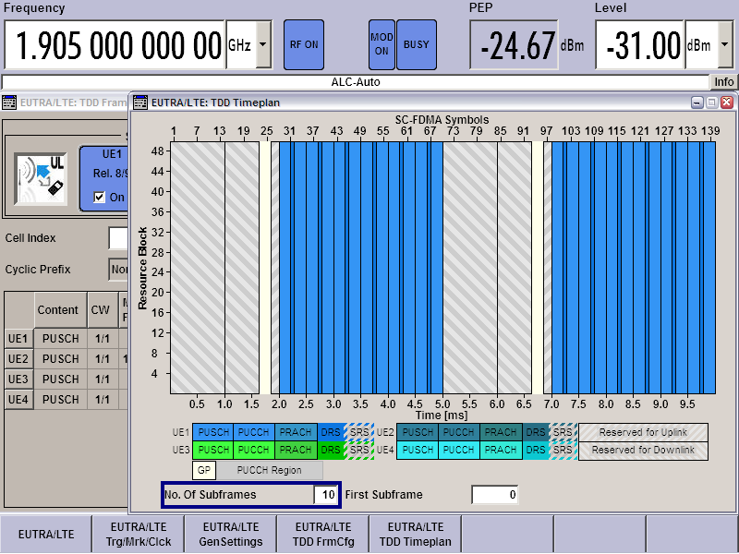
Figure 58: Time plan of the LTE-TDD interfering (uplink) signal
The corresponding RF-scenario is shown in Figure 59 below. The left window shows the spectrogram, while the “time overview” (upper right) shows the power across 20 MHz bandwidth over time. The spectrum traces (lower right) show in yellow the LTE-signal, in orange a DECT burst.
From the spectrogram, one can see that there is plenty of “free” time for positioning the DECT signal, although the uplink uses all available radio resources. Effort has been taken interrupt the DECT link by not only increasing of the LTE’s signal power, also the LTE signal was shifted in time to coincide with the DECT bursts. No one should be surprised that the DECT connection started to move to another, free timeslot. During that (very short) period, some audio packets were hard to understand by ear, before the connection’s quality was recovered. Although the interferer’s power was 60 dB above the DECT signal, it has not been possible to drop the connection (one the same frequency).
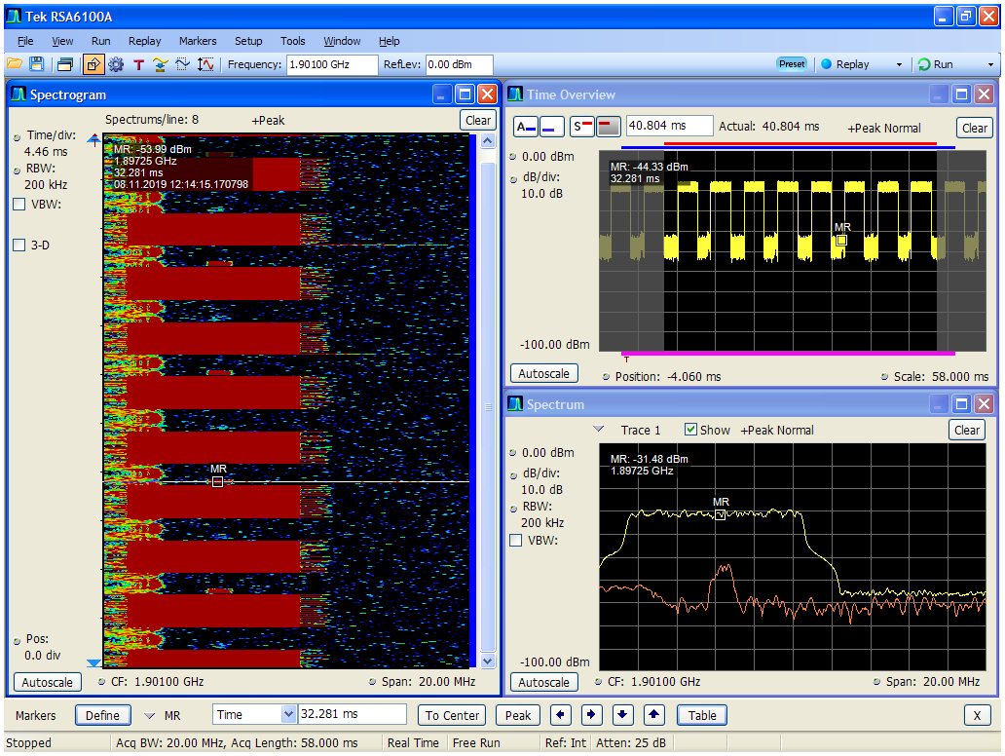
DECT blocker
DECT Mobile
LTE TDD Slots
DECT fixed
DECT LTE TDD SlotsMobileDECT fixed
Figure 59: LTE-TDD signal (white) on the same channel as DECT (blue)
      - LTE-FDD
Since the measurements with LTE-TDD lead to no results, it was decided to continue with an FDD signal. A completely filled downlink signal was used; the PDSCH was filled with dummy data, 16-QAM modulated. With that, the spectrum was filled for 100% of time up to the point where the DECT-devices had not been able any more to find a usable channel / timeslot. The occupied bandwidth was set to 10 MHz.
An example can be seen in Figure 60. While the spectrum view (lower right) illustrates the power relation between the DECT and LTE signal at that moment, the spectrogram (left hand side; the latest time is on the bottom of the screen) shows the superstition of both signals on the same centre frequency. The irregularities in the course of time for the DECT bursts are due to the variation of the LTE-power.
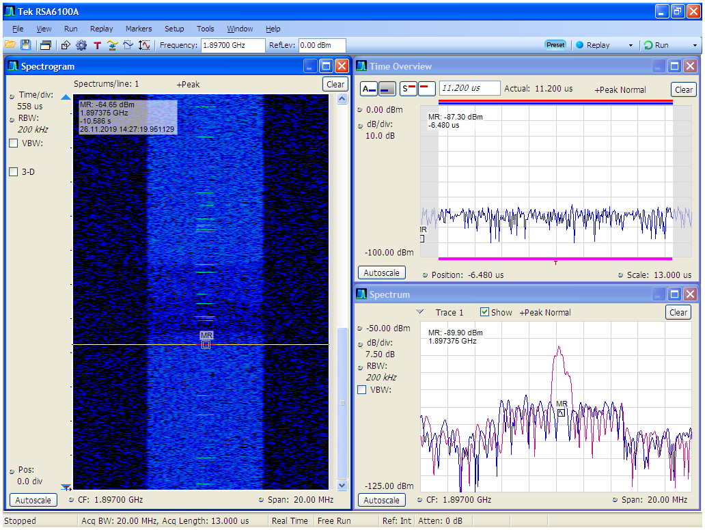
Figure 60: LTE-FDD and DECT in the co-channel case
  - Measurements
    - Set-up and procedure
Two types of setups are needed: one, where the mobile DECT device is the DUT, and a different one where the DECT base station is the DUT.
Figure 61 shows the setup when a mobile device is to be interfered. The base station is coupled via a directional antenna in short distance to the base. The blocker signal is inserted via a directional coupler. An variable attenuation is used to adjust the levels in such a way that an un-interfered connection to the mobile station is possible.
Figure 62 shows the setup when a base station is to be interfered. Using the variable Attenuation, the levels were adjusted in such a way that the connection to the mobile station is possible without interference.
The protection ratios are based on the signal’s RMS-levels measured over the full bandwidth.
Due to a limited amount of time, no investigation regarding the relation of LTE’s Out-of-Band emissions to the protection ratios was done. Nonetheless, the LTE-signals used confirm at least the respective in-band requirements.
Figure 61: Measurement setup for testing a mobile device (dashed green line = anechoic chamber)

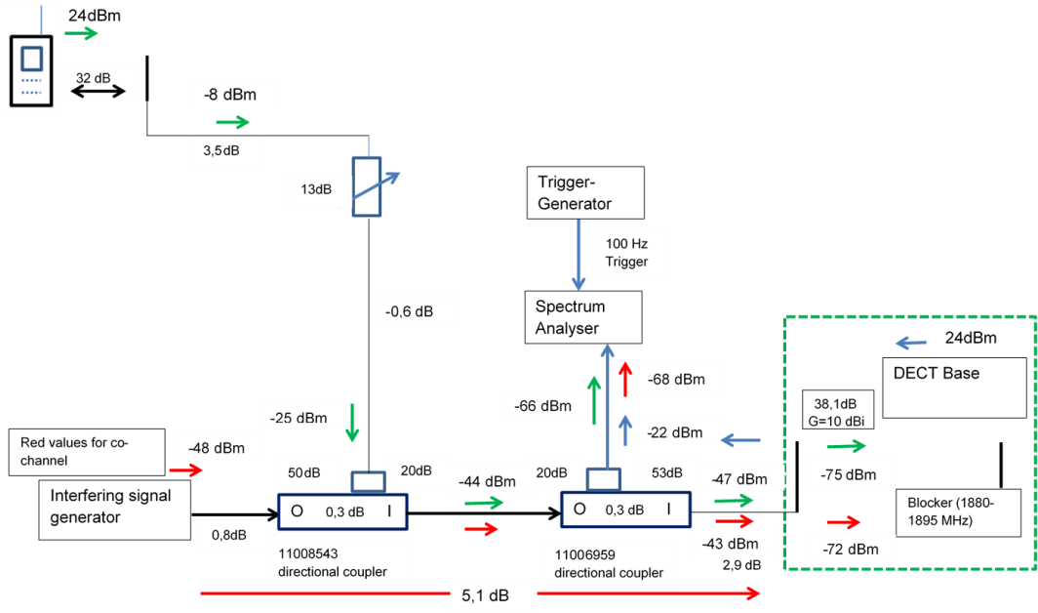
Figure 62: Measurement setup for testing a base station (dashed green line = anechoic chamber)
    - Interference criteria
For the measurements, the level of the interfering LTE signal was set. Then, a connection between the DECT devices was set up by calling into the system from an outside telephone. The interference level was adjusted until that connection failed.
It has been noted that the most critical situation – where the least interference level is needed – is the situation of the call setup. Typically, one needs roughly 6 dB more interference power to interrupt an connection than to establish an connection.
The interference criterion applied is the failure of setting up a call (the handheld does not react if paged by the base and vice versa).
Sometimes the measurements had to be repeated to obtain stable results. The interference level was considered to be “stable” if five subsequent call setups failed.
  - Measurement results
The measured protection ratios are given in the following figures, grouped by the type of tested device (either mobile handset or fixed base station). If a complete set (mobile and base station) was measured, then the ordering number of mobile and base station coincide (Mobile 1 belongs to base 1 and so on).
The frequency arrangement is always given relative to DECT-channel 0 (1897.344 MHz). Additionally, a dashed black line marks the frequency offset where an LTE-carrier (bandwidth: 10 MHz) with the least possible frequency separation from DECT could be positioned.
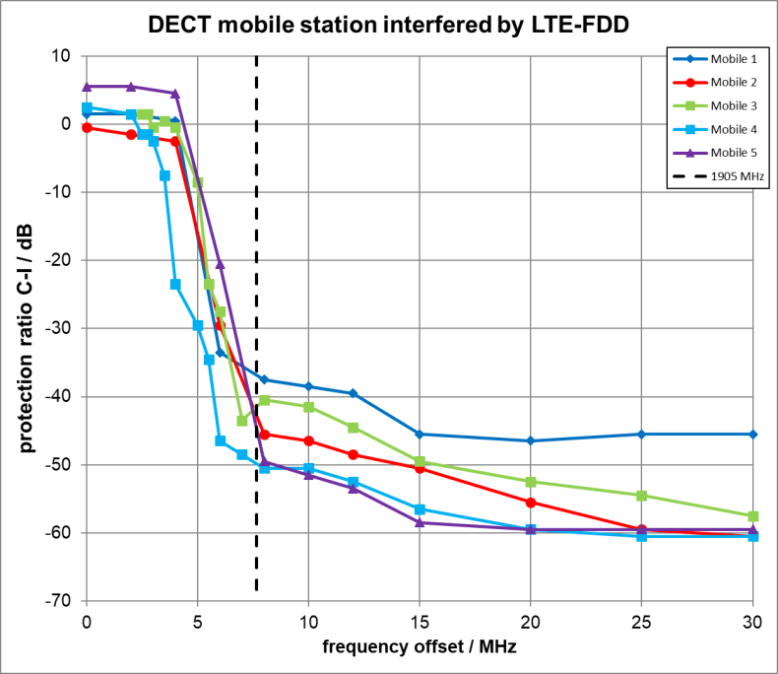
Figure 63: Protection ratios for DECT mobile stations interfered by an LTE-FDD signal (relative frequencies)

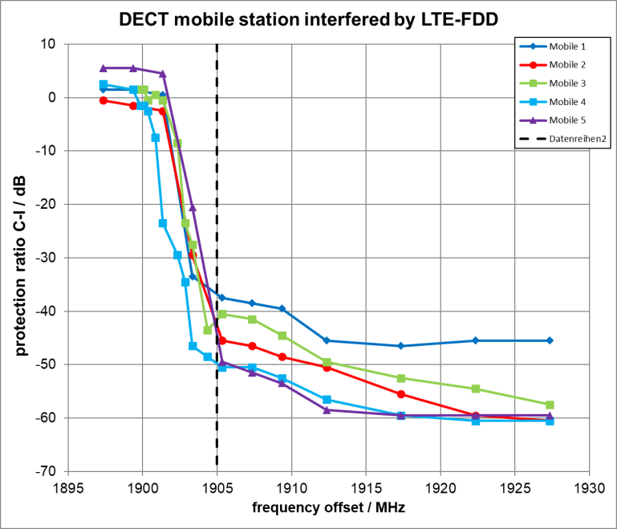
Figure 64: Protection ratios for DECT mobile stations interfered by an LTE-FDD signal
(absolute frequencies)
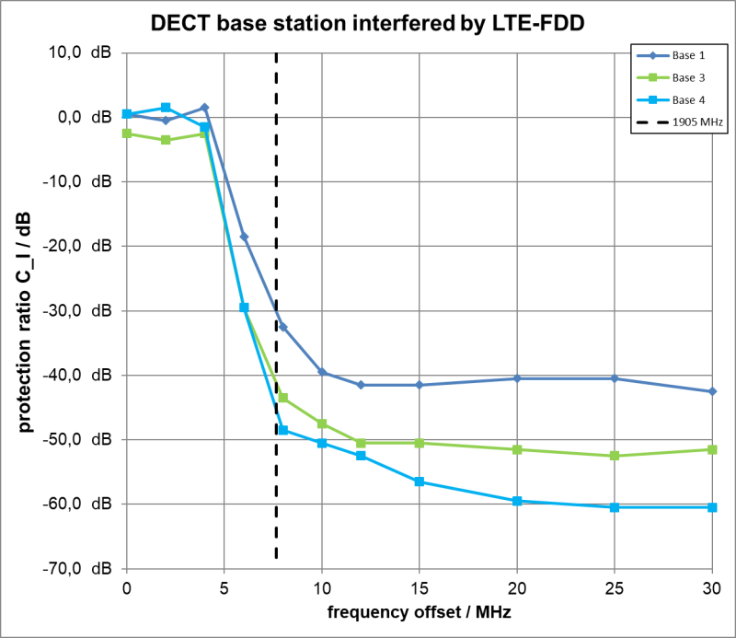
Figure 65: Protection ratios for DECT base stations interfered by an LTE-FDD signal

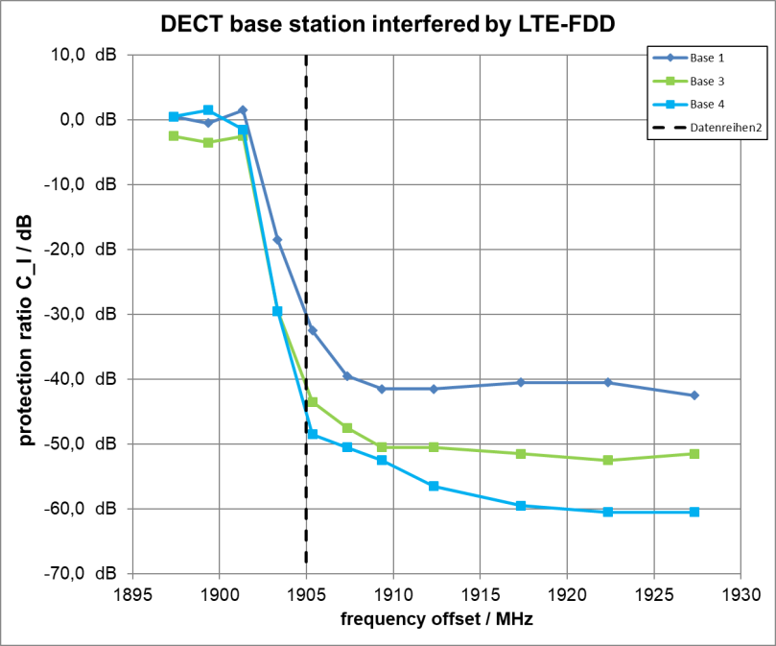
Figure 65: Protection ratios for DECT base stations interfered by an LTE-FDD signal
The results indicate that the DECT communication is quite robust, even if the interference mitigation techniques (frequency and timeslot hopping) already employed by DECT are disabled.
Table 28: Measured protection ratios
LTE-Freq.  Absolute  (MHz) | LTE-Freq.  Relative  (MHz) | Mobile 1  (dB) | Mobile 2  (dB) | Mobile 3  (dB) | Mobile 4  (dB) | Mobile 5  (dB) | Base 1  (dB) | Base 3 (dB) | Base 4  (dB)
1897.344 | 0.00 | 1.5 | -0.5 | 2.5 | 2.5 | 5.5 | 0.5 | -2.5 | 0.5
1899.344 | 2.00 | 1.5 | -1.5 | 1.5 | 1.5 | 5.5 | -0.5 | -3.5 | 1.5
1899.844 | 2.50 |  |  | 1.5 | -1.5
1900.094 | 2.75 |  |  | 1.5 | -1.5
1900.344 | 3.00 |  |  | -0.5 | -2.5
1900.844 | 3.50 |  |  | 0.5 | -7.5
1901.344 | 4.00 | 0.5 | -2.5 | -0.5 | -23.5 | 4.5 | 1.5 | -2.5 | -1.5
1902.344 | 5.00 |  |  | -8.5 | -29.5
1902.844 | 5.50 |  |  | -23.5 | -34.5
1903.344 | 6.00 | -33.5 | -29.5 | -27.5 | -46.5 | -20.5 | -18.5 | -29.5 | -29.5
1904.344 | 7.00 |  |  | -43.5 | -48.5
1905.344 | 8.00 | -37.5 | -45.5 | -40.5 | -50.5 | -49.5 | -32.5 | -43.5 | -48.5
1907.344 | 10.00 | -38.5 | -46.5 | -41.5 | -50.5 | -51.5 | -39.5 | -47.5 | -50.5
1909.344 | 12.00 | -39.5 | -48.5 | -44.5 | -52.5 | -53.5 | -41.5 | -50.5 | -52.5
1912.344 | 15.00 | -45.5 | -50.5 | -49.5 | -56.5 | -58.5 | -41s.5 | -50.,5 | -56.5
1917.344 | 20.00 | -46.5 | -55.5 | -52.5 | -59.5 | -59.5 | -40.5 | -51.5 | -59.5
1922.344 | 25.00 | -45.5 | -59.5 | -54..5 | -60. | -59.5 | -40. | -52,5 | -60.5
1927.344 | 30.00 | -45.5 | -60.5 | -57.5 | -60.5 | -59.5 | -42.5 | -51.5 | -60.
  - Conclusions
Measurements have been conducted regarding the co-existence of LTE in the frequency range of 1900-1920 MHz with DECT systems below 1900 MHz. For this purpose, five mobile and three fixed DECT stations were tested. The aim was to evaluate the protection ratio “carrier-to-interference ratio” (C-I=10log10(c/i)) for different kind of DECT-stations (base stations, mobile stations). For the interference criterion, the call setup of the DECT system is used. It is detected that the call setup is more critical than the link interruption, because the carrier-to-interference ratio C-I for the call setup is 6 dB below the C-I for the link interruption.
Further conclusions:
- The DECT system is designed as an intelligent system able to switch to free channels for the time and frequency range to avoid interferences. It is concluded that for the case of a 10 MHz wide LTE-TDD signal as interferer in the co-channel interference scenario where all the DECT downlink timeslots are free, the DECT connection stays free of any disturbances;
An LTE-FDD downlink signal has been used to cause a situation to disable the interference mitigation technique (frequency/ timeslot hopping) of DECT. When the LTE-FDD (downlink) signal (10 MHz wide) has an offset of 6 MHz (1903.344 MHz) from the DECT-channel 0 (1897.344 MHz), the carrier-to-interference ratio ranges from C-I = -18 dB down to -33 dB. In case where the offset is 8 MHz (1905.344 MHz) away from DECT-channel 0 (1897.344 MHz), the C-I ranges from C-I= -32 dB down to -50 dB;
- It should be noted that measurements were performed for a limited set of DECT devices (5 mobiles and 3 base stations);
- In a typical outdoor short-term use case scenario (e.g. a live concert), all channels are in use (a typical scenario would feature 10 belt packs per base station and 10 base stations in one radio area). The measurements performed are not representative of such deployment, which presents a dynamically changing S/N ratio as users are moving within the range. In this scenario, there are no other interference-free channels available.
Since the type of the RMR signal is not yet defined, it is not clear if the assumption for the RMR system in this annex is fully representative of the signal to be deployed.
- List of references

- RSCOM 18-05 rev. 3: “Final Mandate to CEPT on spectrum for the future railway mobile communication system”
- Commission Decision of 28 July 1999 on the basic parameters for the command-and-control and signalling subsystem relating to the trans-European high-speed rail system (1999/569/EC)
- ECC Decision (02)05: “The designation and availability of frequency bands for railway purposes in the 876-880 MHz and 921-925 MHz frequency bands”
- ETSI TR 103 333 v1.1.1 (2017-02): “System Reference document (SRdoc); GSM-R networks evolution”
- ECC Report 294: “Assessment of the spectrum needs for future railway communications”
- ECC Decision (06)01: “The harmonised utilisation of the bands 1920-1980 MHz and 2110-2170 MHz for mobile/fixed communications networks (MFCN) including terrestrial IMT systems”
- 3GPP TS 36.101 V16.0.0 (2018-12): “Evolved Universal Terrestrial Radio Access (E-UTRA); User Equipment (UE) radio transmission and reception (Release 15)”
- 3GPP 36.104 V15.4.0 (2018-10): “LTE; Evolved Universal Terrestrial Radio Access (E-UTRA); Base Station (BS) radio transmission and reception (Release 15)”
- 3GPP TS 38.101-1 V15.3.0: “5G; NR; User Equipment (UE) radio transmission and reception; Part 1: Range 1 Standalone”
- 3GPP TS 38.104 V15.2.0 (2018-07): “5G; NR; Base Station (BS) radio transmission and reception”
- 3GPP TS 25.101 V15.2.0: “Universal Mobile telecommunications Systems(UMTS); User Equipment (UE) radio transmission and reception (Release 15)”
- ERC Recommendation 74-01: “Unwanted emissions in the spurious domain”
- 3GPP TS 36.211 V13.10.0 (2018-07): “LTE; Evolved Universal Terrestrial Radio Access (E-UTRA); Physical channels and modulation (Release 13)”
- ECC Report 200: “Co-existence studies for proposed SRD and RFID applications in the frequency bands 870-876 MHz and 915-921 MHz”
- ECC Report 162: “Practical mechanism to improve the compatibility between GSM-R and public mobile networks and guidance on practical coordination”
- Recommendation ITU-R SM.575-2 (10/2013): “Protection of fixed monitoring stations against interference from nearby or strong transmitters”
- S. Stefania, T. Issam and B. Matthew: “LTE, the UMTS Long Term Evolution, From Theory To Practice” published at Wiley
- Recommendation ITU-R SM.1134-1: “Intermodulation interference calculations in the land-mobile service”
- Recommendation ITU-R F.1336-5 (01/2019): “Reference radiation patterns of omnidirectional, sectoral and other antennas for the fixed and mobile services for use in sharing studies in the frequency range from 400 MHz to about 70 GHz”
- Document No. 0-8789: “FRMCS coexistence with GSM-R in the UIC/E-UIC band”
- 3GPP TS 36.213 V11.13.0 (2017-10): “LTE; Evolved Universal Terrestrial Radio Access (E-UTRA); Physical layer procedures (Release 11)”
- Document SE7(19)209: “FRMCS deployment parameters to be used in SE7 studies”
- Recommendation ITU-R M.2101 (02/2017): “Modelling and simulation of IMT networks and systems for use in sharing and compatibility studies”
- ECC Report 229: “Guidance for improving coexistence between GSM-R and MFCN in the 900 MHz band”
- EIRENE SRS v16.0.0: “System Requirements Specification”
- W.-B. y. a. M. Souryal: “LTE Physical Layer Performance Analysis”
- Report ITU-R M.2292-0 (12/2013): “Characteristics of terrestrial IMT-Advanced systems for frequency sharing/interference issues”
- ECC Report 298: “Analysis of the suitability and update of the regulatory technical conditions for 5G MFCN and AAS operation in the 1900-1980 MHz and 2110-2170 band”
- ETSI EN 300 175-2 V2.7.1 (2017-11): “Digital Enhanced Cordless Telecommunications (DECT); Common Interface (CI); Part 2: Physical Layer”
- Directive 2014/53/EU of the European Parliament and the Council of 16 April 2014 on the harmonisation of the laws of the Member States relating to the making available on the market of radio equipment and repealing Directive 1999/5/EC
- ETSI EN 301 406 V2.2.2 (2016-09): “Digital Enhanced Cordless Telecommunications (DECT); Harmonised Standard covering the essential requirements of article 3.2 of the directive 2014/53/EU”
- ETSI TR 103 089 V1.1.1 (2013-01): “Digital Enhanced Cordless Telecommunications (DECT); DECT properties and radio parameters relevant for studies on compatibility with cellular technologies operating on frequency blocks adjacent to the DECT frequency band”
- ERC Decision (94)03: “the frequency band to be designated for the coordinated introduction of the Digital European Cordless Telecommunications system”, October 1994
- Council Directive of 3 June 1991 on the frequency band to be designated for the coordinated introduction of digital European cordless telecommunications (DECT) into the Community 91/287/EEC
- ECC Report 96: “Compatibility between UMTS 900/1800 and systems operating in adjacent bands”
- ERC Report 31: “Compatibility between DECT and DCS1800”
- ERC Report 65: “Adjacent band compatibility between UMTS and other services in the 2 GHz band”
- ERC Report 100: “Compatibility between certain radiocommunications systems operating in adjacent bands - Evaluation of DECT / GSM 1800 compatibility”
- ECC Report 146: “Compatibility between GSM MCBTS and other services (TRR, RSN/PRMG, HC-SDMA, GSM-R, DME, MIDS, DECT) operating in the 900 and 1800 MHz frequency bands”
- CEPT Report 39: “Report from CEPT to the European Commission in response to the Mandate to develop least restrictive technical conditions for 2 GHz bands”
- CEPT Report 41: “Report from CEPT to the European Commission in response to Task 2 of the Mandate to CEPT on 900/1800 MHz bands - "Compatibility between LTE and WiMAX operating within the bands 880-915 MHz / 925-960 MHz"”
- ETSI TR 101 310 V1.2.1 (2004-04): “Digital Enhanced Cordless Telecommunications (DECT); Traffic capacity and spectrum requirements for multi-system and multi-service DECT applications co-existing in a common frequency band”
- Document UIC 0-8736-2.0: “Assessment report on GSM-R current and future radio environment”
- Recommendation ITU-R P.525-3 (09/2016): “Calculation of free-space attenuation”
- H. U. Department of Electronics and Computer Engineering: “Diffraction Loss Prediction of Multiple Edges Using Bullington Method with Neural Network in Mountainous Areas” published at Hindawi / International Journal of Antennas and Propagation, 2018
- 3GPP TR 36.824 V11.0.0 (2012-16): “Evolved Universal Terrestrial Radio Access (E-UTRA); LTE coverage enhancements (Release 11)”
- 3GPP TR 36.942 V15.0.0 (2018-07) LTE: “Evolved Universal Terrestrial radio Access (E-UTRA); Radio Frequency (RF) system scenarios (Release 15)”
- UIC: “GSM-R Procurement & Implementation Guide”, March 2009
- 3GPP TS 25.102 V15.0.0 (2018-10): “Universal Mobile Telecommunications System (UMTS); User Equipment (UE) radio transmission and reception (TDD)”
- Recommendation ITU-R SM.329-12 (09/12): “Unwanted emissions in the spurious domain”
- “Work plan to answer the EC Mandate on FRMCS”
- Decision No 676/2002/EC of the European Parliament and of the Council of 7 March 2002 on a regulatory framework for radio spectrum policy in the European Community (Radio Spectrum Decision)
- ETSI TS 102 933-1: “Railway Telecommunications (RT); GSM-R improved receiver parameters; Part 1: Requirements for radio reception”
- ECC Report 313: “Coexistence between RMR in the 900 MHz range and other applications in adjacent bands”
- ECC Report 318: “Compatibility between RMR and MFCN in the 900 MHz range, the 1900-1920 MHz band and the 2290-2300 MHz band”
- ECC Report 309: “Use of MFCN for the command & control and payload links of UAs within the current MFCN harmonised regulatory framework”
- Recommendation ITU-R P.1238-10: “Propagation data and prediction methods for the planning of indoor radiocommunication systems and radio local area networks in the frequency range 300 MHz to 450 GHz”

To determine the interference effect from FRMCS systems on DECT systems, calculations of protection distances were carried out based on two different approaches: - first analysis: Influence of FRMCS systems on DECT systems based on technical specifications from ETSI, for details see section 6.2.6. - second analysis: Influence of FRMCS systems on DECT systems based on laboratory measurements using two different DECT receiver power to estimate its sensitivity level (lowest value reflected in the executive summary), for details see section 6.3.6.
Source : UIC.
Source : ETSI TR 103 333 [4].
The period when GSM-R and FRMCS will be operated simultaneously is referred to as ”migration phase”. It is essential for interoperability that railway networks have both systems running in parallel during this phase, and that trains are able switch from one system to the other.
as for NB-IoT.
Note that the harmonised solution for EU Member states differs from the request made in ETSI TR 103 333 [4] because it is limited to 2 x 5 MHz.
Another configuration (not considered in this Report) is possible, where each radio site hosts two base stations covering each a single cell. However, this implementation leads to more handovers procedures (both intra-site and inter-site handovers), which in the end decreases the overall system performance.
The situation is different in a GSM-R network, where 19 usable frequency channels are available (the first channel is centred at 876.2 MHz, the last at 879.8 MHz, and the channel spacing is 200 kHz). Each cell typically requires two or three channels depending upon the density of trains, which leads to a 7 cell repeat pattern (5 cells with 3 channels and 2 cells with 2 channels), which significantly reduces inter-cell interference. (see GSM-R Procurement & Implementation Guide [48] for more details about frequency planning in GSM-R networks)
There are two types of terminal stations in GSM-R (and therefore in the future system): handheld devices and cab-radios. Only the latter is considered in this Report.
: Possible carrier bandwidths in this operating band range from 5 MHz to 20 MHz (see 3GPP TS 36.101 [8] Table, 5.6.1-1).
Possible carrier bandwidths in NR band n39 range from 5 to 40 MHz (see 3GPP TS 38.101 [10] Table 5.3.5-1).
This is currently the only widely encountered use case of 4G LTE.
This use case refers to the connectivity for large numbers of low-cost and low-energy devices in the context of Internet of Things (IoT).
This includes for example real-time control of industrial processes, intelligent transport systems, and so on.
Frequency separation between subcarriers in an OFDM signal.
This is even truer that FRMCS cannot make use of beamforming techniques to reduce multipath effects (see Table 2, Note 5).
Using the same SCS as in LTE makes sense because LTE was originally designed for outdoor coverage using sub-3GHz frequencies, which is typically the case of FRMCS.
Category B limits are based on limits adopted in Europe and used by some other countries (see Recommendation ITU-R SM.329 [51] clause 3.3 (“Limits of spurious domain emissions”)).
Option 1 and 2 may be applied for category B Base Station. Option 2 may be applied regionally and is more stringent than Option 1.
The difference in Free space Path Loss (FSPL) between a 900 MHz and a 1900 MHz wave is given by: $20{\log_{10}\left({1900 MHz}/{900 MHz}\right)}_{}\sim 6.5 dB$ (see ANNEX 1 for further details about the free-space propagation model).
There is clearly a trade-off between the number of sites installed and the overall network performance, because increasing the number of sites implies more handover procedures. In addition, the position of GSM-R (and later FRMCS) sites is not only driven by coverage requirements (smaller cells allow for a more precise localisation of the trains in the network).
Beamforming is not tied to a specific technology: in that regard, it can be used in 4G LTE as well as 5G NR networks.
Hence the name massive Multiple Input Multiple Output (mMIMO).
This is even truer in the case of the 1900 MHz band. mMIMO is therefore rather used for higher frequency deployments, for instance 5G NR networks using mm-waves (also called FR2 in 3GPP specifications).
Also called MIMO schemes.
These environments are defined in Recommendation ITU-R M.2101 [24] §[23], section 2.2 (“Deployment scenarios”).
referring to the density of trains.
A detailed description of these railway segments is provided in ECC Report 294[5] §, section 3 (“Assessment of the spectrum needs”).
For instance, in high-speed lines, ECC Report 294[5] indicates a train density of 0.5 per km, together with an ISD of 8 km, which results in 4 trains per cell (typically two in each direction).
ECC Report 294[5] assumes a constant ISD of 8 km for each railway segment. This may be too large in high-density lines, where GSM-R (and future FRMCS) radio sites can be less than one kilometre away from each other.
Generic term used at ITU-R to designate 4G mobile systems including LTE-Advanced.
Generic term used at ITU-R to designate 5G mobile systems including NR and DECT-2020.
Given the size of the simulation area in each scenario (see Section 2.5), the case where two interferers are exactly at the same position can be considered very unlikely to happen.
This power is measured at the base station antenna connector and corresponds to $P_{BS}^{UE}$ in Recommendation ITU-R M.2101 [24].
All power levels are measured at the cab-radio antenna connector.
The exact period of time during which the train is attached to the serving cell depends on the chosen handover margin, which is ultimately left to the implementation, and therefore was not considered here.
The first version of ECC Decision (06)01 [6] also harmonised the 1900-1920 MHz unpaired frequency range for UMTS and LTE in the TDD mode. However, as explained in section 1.3, no operator has used this band so far, and therefore it was removed from ECC Decision (06)01, when revised and updated.
AAS is not tied to a specific technology and can be used for LTE or 5G NR.
The related technical studies have been documented in ECC Report 298 [29]..
20 MHz is the maximum channel bandwidth in LTE without carrier aggregation. This assumption implies that the closest operator to the lower edge of the operating band has been allocated 20 MHz of contiguous spectrum used for LTE only, which is rather rare in practice. According to the Halberd Bastion radiofrequency consulting group, most operators have 10 MHz contiguous spectrum in operating band n°1. However, two countries (Estonia and Finland) were found where one operator has 20 MHz adjacent to the band edge at 1920 MHz.
i.e. EARFCN = 18100 (see 3GPP TS 36.101 [8] table 5.7.3-1).
without carrier aggregation.
The UMTS standard implements a 100 kHz guard band with respect to the lower edge of Operating Band I, and therefore, the lowest carrier frequency in this band is 1922.4 MHz (see 3GPP TS 25.101 [11], table 5.1). This is also noted in ECC Decision (06)01[6]: “UMTS carriers need to be offset 100 kHz from the centre of the blocks defined in the new band plan [...]”.
This value takes account of the fact that integral antennas installed in user’s devices can exhibit some directivity properties, but the direction of maximum gain is not predictable as the UE is moving.
ETSI Technical Committee (TC) DECT.
source : ETSI TR 103 089 [33].
This figure comes from the French National Statistics Office (INSEE), which has established a precise mapping of the population density on French territory.
Source: IGN buildings database.
Blocking mechanisms often encompass receiver intermodulation as well, as it is difficult to isolate the effects in practice.
As its name suggests, the AN excludes the internal noise of the receiver.
The power of the AN increases by 1 dB when the interferer power increases by 1 dB.
The power of the third-order intermodulation product increases by 3 dB when each of the two interferer generating this product increases by 1 dB.
This is based on the assumption that the shape of the signal in the frequency domain does not change when travelling from the UE antenna connector to the FRMCS receiver input, or, in other words, that the channel transfer function is flat over the considered frequency range.
There are 100 RBs, and each RB is composed of 12 subcarriers.
This makes the assumption that the bandwidth of the subcarriers equals the SCS.
Two signals B1 and B2, that are respectively centred at f1 and f2 such that f1 < f2 generate an product centred at 2f1 – f2 which has a bandwidth of 2B1+B2 (the second IP at 2f2-f1 has a bandwidth of 2B2+B1).
Power level measured at the FRMCS cab-radio input.
$Desensitisation=10\log_{10}\left(1+{10}^{\frac{I/N}{10}}\right)$
As shown in Figure 24, the frequency reuse scheme implies a constant desensitisation of at least 20 dB due to ICI. However, the mitigation of ICI is left to the implementation and outside of the scope of this report.
: The total number of UEs considered in this scenario is 102 (51 inside a building and 51 in open area, see Table 6), but only two have been represented in Figure 22 for readability reasons.
e.i.r.p.= Maximum output power at antenna connector – Feeder Loss + Peak Antenna Gain + Tx Diversity gain. All values are provided in Table 1 and Table 2.
-15 dBm for a desensitization of 6 dB is equivalent to -19.8 dBm for a desensitization of 3 dB.
They are not strictly speaking "adjacent channels", because they do not belong to the 1880-1900 MHz core operating band of DECT.
(1897.344 + 3 * 1.728 - 0.5) - 1900.5
(1897.344 + 4 * 1.728 - 0.5) - (1897.344 + 3 * 1.728 - 0.5)
1909.5 - (1897.344 + 4 * 1.728 - 0.5)
$-30 dBm+10* \log_{10}\left({1.528 MHz}/{1MHz}\right)$
$-41 dBm+10*\log_{10}\left({1.728 MHz}/{1 MHz}\right)$
$-44 dBmdBm+10*\log_{10}\left({5.744 MHz}/{1 MHz}\right)$
$10\log_{10}\left({10}^{-{28.2 dBm}/{10}}+ {10}^{-{38.6 dBm}/{10}}{+10}^{-{36.4 dBm}/{10}}\right)$
The total power of the carrier being spread over all subcarriers.
3 * 1.152 MHz
2 * (1897.344 – 3 * 1.728) - (1897.344 – 7 * 1.728)
(1899.072 + 3.456/2) – 1900.5
Indeed, the intermodulation product is centred at 2 * (1897.344 – 4 * 1.728) - (1897.344 – 5 * 1.728) = 1892.16 MHz, and therefore does not overlap with the FRMCS receiver bandwidth.
As it uses DECT carrier F5, the conversion factor is 50 dB (see Table 9).
As it uses DECT carrier F4, the conversion factor is 38.7 dB (see Table 9).
$10\log_{10}\left({10}^{\frac{-80 dBm}{10}}+ {10}^{\frac{-88.7 dBm}{10}}\right)$ This no longer holds true if another TDD configuration is chosen for FRMCS.
This no longer holds true if another TDD configuration is chosen for FRMCS.
1897.344 – 4 * 1.728 - ( 1.152 ⁄ 2 ) MHz, the occupied bandwidth being 1.152 MHz (see Table 8).
1897.344 – 4 * 1.728 + ( 1.152 ⁄ 2 ) MHz.
$-35 dBm+10\log_{10}\left(\frac{1890 MHz - 1889.856 MHz}{100 kHz}\right)$
$-23 dBm+10\log_{10}\left(\frac{1891.008 MHz - 1890 MHz}{100 kHz}\right)$
$10\log_{10}\left({10}^{{-13 dBm}/{10}}+{10}^{{-33.4 dBm}/{10}}\right)$
(2 * 1900.5 - 1909.5) MHz
$24 dBm-\left(38+30\log_{10}\left(50m\right)\right) dB$
$\frac{5 m}{cos\left(24°\right)}$
$32.45 dB+20*\log_{10}\left(1900 MHz\right)+20*\log_{10}\left(\frac{5.5 m}{1 km}\right)+20 dB$ (formula 4 in Report ITU-R P.525 [44]).
31 dBm (output power) - 3 dB (hardware loss) + 6.6 dBi (antenna gain) - 72.8 dB (path loss)
To determine the interference effect from FRMCS systems on DECT systems, calculations of protection distances were carried out based on two different approaches: - first analysis: Influence of FRMCS systems on DECT systems based on technical specifications from ETSI, for details see section 6.2.6. - second analysis: Influence of FRMCS systems on DECT systems based on laboratory measurements using two different DECT receiver power to estimate its sensitivity level (lowest value reflected in the executive summary), for details see section 6.3.6.

