Measuring and evaluating Mobile Internet Access Service Quality (Mobile IASQ)
approved 27 May 2020
ECC Report 312

Executive summary
Publicly available, adequate, easily comparable, and up to date information on Mobile IASQ helps consumers to confidently make well-informed choices when selecting from numerous Mobile IAS offers available on the market. This information is also useful to other stakeholders including relevant public authorities and competing service providers.
ECC Report 195 provides information on best practices for monitoring the quality of retail IAS and the Report was followed by ECC Recommendation (15)03 which recommended a harmonised minimum set of parameters and measurement methods to achieve this goal so that end-users could be provided with easily comparable information to inform their decision.
ECC Recommendation (15)03 was amended in November 2018 to take account of EU Regulation 2015/2120 and the scope of the Recommendation was limited to retail IAS provided by fixed networks and/or wireless access services provided at a fixed location.
This Report now focuses on Mobile IASQ and its purpose is to describe and summarise the different approaches to measuring and evaluating mobile IASQ. The Report is based on the results of a questionnaire circulated to CEPT administrations and several country-specific examples are provided for information.
The Report concludes that:
- Many CEPT countries measure and evaluate parameters on Mobile IASQ based on national legislation or regulations which go beyond the requirements mandated for EU/EEA countries in EU Regulation 2015/2120, i.e. advertised and maximum download/upload speeds. For example, minimum/guaranteed transmission speed is a requirement in some countries in addition to the required information on maximum and advertised speeds;
- In addition to monitoring the transmission speed, the responses to the questionnaire revealed that many countries are also measuring and evaluating other Mobile IASQ parameters (e.g. delay, delay variation, mobile coverage, etc.);
- Most respondents to the questionnaire stated that their respective NRAs are involved in Mobile IASQ monitoring and that these monitoring activities are mainly based on NRA measurements, ISP measurements and periodic reports from ISPs;
- Various mobile IASQ measurement and evaluation methods are used in CEPT countries including drive tests, measurements at different fixed locations, long term measurements, crowd-sourcing and theoretical throughput calculation methods. The following observations have been made based on the different methods analysed in this Report:
Drive testing methods enable the collection of reliable information about actual Mobile IASQ over a wide geographic area within a relatively short time period;
Long-term measurements provide information on speeds and other Mobile IASQ parameters and obtain information on how they can change over time at certain geographical points. This could be used for evaluating Mobile IASQ stability and capability in the long term. Long-term metrics could also be used for objective measurement-based complaints resolution;
Crowdsourcing methods involve the use of mobile apps and desktop apps together and the collected data from all the locations can then be processed. Crowdsourcing has the advantage of providing many measurements covering a wide geographic area that provides information on measurements taken at different points in time;
Theoretical throughput calculation methods could be used for evaluating expected transmission speeds for any location using theoretical projections from calculations. One of the advantages of theoretical calculation over measurements, is that it allows for the estimation of throughput coverage across the country and this could help administrations for executing geographical estimations of Mobile IAS availability as required by the EECC. Preliminary findings demonstrate that, due to constantly changing network load, theoretical calculation methods may have the potential to provide a more suitable approach for estimating the maximum available throughput rather than predicting the throughput actually experienced by end user.
It should be noted that this Report is limited to measuring and evaluating technical Mobile IASQ parameters. It does not discuss the administrative Mobile IASQ parameters, such as the number of end-user complaints or SIM card activation time etc., which could also be used for evaluation of Mobile IASQ.

TABLE OF CONTENTS

0 Executive summary 2
1 Introduction 6
2 Topic description and policy objectives 7
3 Definition of parameters for Mobile IASQ 8
3.1 Definitions included in ECC Report 195 8
3.2 Definitions based on BEREC Guidelines 8
3.2.1 Estimated maximum speed 8
3.2.2 Advertised speed 8
4 Approaches in CEPT Countries regarding Mobile IASQ measurements and evaluation 9
4.1 Responsibility and information for the monitoring of mobile IASQ 9
4.2 Type of activities for mobile IASQ monitoring 10
4.3 The legislative framework and regulations for mobile IASQ monitoring 10
4.4 Parameters for mobile IASQ evaluation 11
4.5 Information about Mobile IASQ for publication 13
5 Measurement Approaches 14
5.1 Drive testing 14
5.2 Long-term measurements 14
5.3 Measurements at different fixed locations 14
5.4 Crowd sourcing 14
5.5 Measurement interfaces and general measurement architecture 14
5.5.1 Mobile Apps 14
5.5.2 Mobile web Apps 15
5.5.3 Desktop web Apps 15
6 Measurements in practice 16
6.1 Crowdsourcing measurements 16
6.1.1 Luxembourg 16
6.1.2 Slovenia 17
6.2 Long-term measurements - Latvia 21
6.3 Measurements at different fixed locations - Latvia 22
6.4 Drive tests - Lithuania 23
6.5 Throughput Calculation Method - Lithuania 24
6.5.1 Throughput calculation principles 25
6.5.2 Simulation methodology 30
6.5.3 Calculation results 32
7 Conclusions 36
ANNEX 1: RESPONSES TO A QUESTIONNAIRE ON Provision of Comparable Information on Mobile IASQ 37
A.1.1 INTRODUCTION 37
A.1.2 RESPONSE TO THE QUESTIONNAIRE 37
A.1.3 DETAILED ANSWERS 37
ANNEX 2: List of References 47

LIST OF ABBREVIATIONS

Abbreviation | Explanation
BEREC | Body of European Regulators for Electronic Communications
CEPT | European Conference of Postal and Telecommunications Administrations
ECC | Electronic Communications Committee
E.I.R.P | Equivalent Isotropically Radiated Power
ETSI | European Telecommunications Standards Institute
EU | European Union
IAS | (Retail) Internet Access Service
IASQ | Internet Access Service Quality
IP | Internet Protocol
ISP | Internet Service Provider
IXP | Internet exchange point
LTE | Long Term Evolution
MIMO | Multiple-Input and Multiple-Output
NRA | National Regulatory Authority
NCA | National Competent Authority - Another national authority, other than the NRA, with responsibility for IASQ. The term NRA is used in this document and can be assumed to mean NCA if applicable.
SINR | Signal to Interference and Noise Ratio
QoS | Quality of Service
QoE | Quality of Experience
3G | Third generation of mobile technology
4G | Fourth generation of mobile technology

Introduction
Publicly available, adequate, easily comparable, and up to date information on Mobile IASQ helps consumers to confidently make well-informed choices when selecting from numerous Mobile IAS offers available on the market. This information is also useful to other stakeholders including relevant public authorities and competing service providers. The availability of this type of information has the potential to contribute to an overall positive experience for the end user during the selection process and to inform improvements to Mobile broadband availability and quality.
ECC Report 195 [4] provides information on best practices for monitoring the quality of retail IAS and the Report was followed by ECC Recommendation (15)03 [1] which recommended a harmonised minimum set of parameters and measurement methods to achieve this goal so that end users could be provided with easily comparable information to inform their decision.
ECC Recommendation (15)03 was amended in November 2018 to take account of EU Regulation 2015/2120, and the scope of the Recommendation was limited to retail IAS provided by fixed networks and/or wireless access services provided at a fixed location. This Report now focuses on Mobile IASQ and its purpose is to describe and summarise the different approaches to measuring and evaluating mobile IASQ.
In recent years, Mobile ISPs and NRAs have established their own methods and tools to measure, evaluate and present Mobile IASQ-related information but it is common practice that, even within the same country, different Mobile ISPs measure, evaluate and present information about their services in different ways. While information on Mobile IASQ is important in order to ensure the possibility for end users to compare different Mobile IAS offers by different ISPs there is no formal common approach among NRAs on which Mobile IASQ parameters to measure and how to evaluate and present the results of those measurements in order to promote transparency on this subject.
The overall aim of this Report is to provide NRAs with information on measuring and evaluating Mobile IASQ using certain IASQ parameters, including IASQ parameters set in EU Regulation 2015/2120 [2], in order to allow end users to make more objective choices of ISP and the type of IAS which is not only based on price but also on the performance of the connection. For that purpose, the report describes and summarises the practices and experiences of NRAs dealing with issues associated with Mobile IASQ. The Report is based on the results of a questionnaire circulated to CEPT administrations and several country-specific examples are provided for information.
The report is limited to technical Mobile IASQ parameters. It does not discuss the administrative Mobile IASQ parameters, such as the number of end user complaints or SIM card activation time etc., which could also be used for evaluation of Mobile IASQ.
Chapter 2 discusses the topic description and policy objectives related to the evaluation of Mobile IASQ.
Chapter 3 lists the most relevant quality parameters and definitions for Mobile IAS.
Chapter 4 is based on the responses to a questionnaire which summarises the different approaches in CEPT countries regarding Mobile IASQ measurements and evaluation.
Chapter 5 provides information on measurement approaches and describes a general measurement architecture for Mobile IASQ.
Chapter 6 provides country-specific examples of Mobile IASQ evaluation based on 4G mobile networks coverage calculations.
Chapter 7 provides the conclusions of the Report.

Topic description and policy objectives
Mobile IAS technologies deployment and use, and further development of 5G microcell access technologies, implies that such technologies are and will be widely used as broadband technologies. There is no doubt that end-user access to the Internet via mobile networks is becoming significantly important when compared to other Internet access methods.
In the preambles to EU Regulation 2015/2120 [2] and Directive (EU) 2018/1972 [3] the importance of adequate IAS for growth of the digital economy is emphasised and the relevant articles set out requirements for the provision of information on IASQ. Article 4 of EU Regulation 2015/2120 sets out requirements for ISPs to provide information on IASQ.
In particular, providers of Mobile IAS shall ensure that any contract which includes IAS specifies inter-alia the following:
"a clear and comprehensible explanation as to how any volume limitation, speed and other quality of service parameters may in practice have an impact on Internet access services, and in particular on the use of content, applications and services;
a clear and comprehensible explanation of the estimated maximum and advertised download and upload speed of the Internet access services on mobile networks, and how significant deviations from the respective advertised download and upload speeds could impact the exercise of the end-users’ rights".
Providers of Mobile IAS are also required to publish the abovementioned information.
Article 5 of Regulation (EU) 2015/2120 obliges EU Member State NRAs, or other competent authorities to closely monitor and ensure compliance with Article 4 including monitoring of general IASQ.
Article 22 of Directive (EU) 2018/1972 requires NRAs and/or other competent authorities to conduct a geographical survey of the reach of electronic communications networks capable of delivering broadband. Articles 84-86 of Directive (EU) 2018/1972 specifies rights and obligations related to quality, availability and affordability of IAS.
Therefore, CEPT countries have been measuring and evaluating Mobile IASQ using their own approaches. As a result of the availability of various deliverables from international and European standardisation organisations, these approaches are often similar but do differ from country to country.

Definition of parameters for Mobile IASQ

Definitions included in ECC Report 195
Definitions of QoS parameters, which could be considered for IAS, are included in ECC Report 195 [4] ETSI and ITU deliverables, namely ETSI EG 202 057, ETSI TS 102 250, ETSI EG 203 165, ETSI EG 202 765, ITU-T Recommendations Y.1540 and Y.1541, Y.1545.1 establish and define a number of user-related QoS parameters which are described and referenced in ECC Report 195.

Definitions based on BEREC Guidelines
BEREC’s Guidelines on the Implementation by National Regulators of European Net Neutrality Rules [5] specifies the speeds of an IAS in mobile networks that need to be provided.

Estimated maximum speed
The estimated maximum speed for a Mobile IAS should be specified so that the end user can understand the realistically achievable maximum speed for their subscription in different locations under realistic usage conditions. The estimated maximum speed could be specified separately for different network technologies that affect the maximum speed available for an end user. End users should be able to understand that they may not be able to reach the maximum speed if their mobile terminal does not support the speed. Estimated maximum download and upload speeds could be made available in a geographical manner providing Mobile IAS coverage maps with estimated/measured speed values of network coverage in all locations.

Advertised speed
The advertised speed for a Mobile IAS offer should reflect the speed which the ISP is realistically able to deliver to end users. Although the transparency requirements regarding IAS speed are less detailed for Mobile IAS than for Fixed IAS, the advertised speed should enable end users to make informed choices, for example, so they are able to evaluate the value of the advertised speed vis-à-vis the actual performance of the IAS. Significant factors that limit the speeds achieved by end users should be specified. NRAs could set requirements in accordance with Article 5(1) in Regulation (EU) 2015/2120 on how speeds defined in the contract relate to advertised speeds, for example that the advertised speed for an IAS as specified in a contract should not exceed the estimated maximum speed as defined in the same contract.

Approaches in CEPT Countries regarding Mobile IASQ measurements and evaluation
This chapter is based on a summary of the responses to a questionnaire to CEPT administrations on the provision of comparable information on Mobile IASQ which was circulated from June until October 2018. Responses from 15 CEPT administrations were received. The full results of the questionnaire are available in Annex 1 of this Report.

Responsibility and information for the monitoring of mobile IASQ
13 from 15 respondents (87% of respondents) to the questionnaire stated that the NRA is responsible for the monitoring of Mobile IASQ in their respective countries as shown in Figure 1 below:
Figure 1: Is NRA responsible for the monitoring of Mobile IASQ?
Figure 2 below shows that more than half of the respondents answered that the Mobile IAS providers provide publicly available information about their Mobile IASQ beyond the information required by Regulation (EU) 2015/2120 (i.e. more than maximum and normally available speeds):
Figure 2: Do mobile IAS providers provide publicly available information about their mobile IASQ beyond the information required by Regulation (EU) 2015/2120?
Over half of the responses to this question demonstrate that the basis for the provision of this additional information is either voluntary or required by national regulations. It should be noted that Regulation (EU) 2015/2120 does not apply to all CEPT countries, only EU and EEA Member States.

Type of activities for mobile IASQ monitoring
The typical activities for Mobile IASQ monitoring are:
- QoS measurements performed by NRAs or other responsible authorities;
- QoS measurements performed by Mobile IAS providers;
- Periodic reports from Mobile IAS providers to NRAs or other responsible authorities;
- Other, e.g. checking of publicly available information on mobile providers websites by NRA.
From the responses to the questionnaire, the majority of respondents answered that NRAs or other responsible authorities monitor Mobile IASQ using their own measurements as shown in Figure 3 below:
Figure 3: What kind of activities are implemented for mobile IAS QoS monitoring?

The legislative framework and regulations for mobile IASQ monitoring
The principles on Mobile IASQ measurements and basic requirements are defined in Regulation (EU) 2015/2120. According to this regulation, mobile IAS providers are required to provide publicly available estimated maximum and advertised speeds.
From the responses to the questionnaire, it is clear that national legislative acts and NRA regulations are widely used for setting requirements for the mobile IASQ in addition to Regulation (EU) 2015/2120 as shown in Figure 4 below:
Figure 4: The legislative framework for mobile IASQ monitoring is based on
The majority of respondents have based their QoS monitoring requirements on national legislation and regulations. The following additional specific requirements or explanations are also included in national level legislation [Figure 5]:
Figure 5: If the QoS monitoring is based on Regulation (EU) 2015/2120 are there any additional specific requirements or explanations included in national level legislation?

Parameters for mobile IASQ evaluation
From the responses to the questionnaire, the following parameters for Mobile IASQ are measured and evaluated as shown in Figure 6 below:
- Radio coverage;
- Transmission speed;
- Delay;
- Delay variation;
- Packet loss ratio.

Figure 6: What parameters for Mobile IASQ are measured and evaluated?
Mobile IAS transmission speeds are measured and evaluated using the following parameters and illustrated in Figure 7 below:
- Minimum/ guaranteed;
- Average/ mean;
- Normally available;
- Maximum.

Figure 7: What kind of mobile internet access transmission speed is measured and evaluated?

Information about Mobile IASQ for publication
From the responses to the questionnaire, the information about Mobile IASQ is published in the following ways:
In individual end-user agreements;
On operators’ websites;
On NRA’s website.

Figure 8: Information for mobile IAS quality is available?

Measurement Approaches

Drive testing
Drive testing is a method used by a by a few NRAs and mobile ISPs in Europe to measure and evaluate coverage, capacity and IASQ of mobile networks. With this approach, the NRA uses a vehicle equipped with mobile network air interface equipment to measure and evaluate a broad set of mobile network parameters including coverage and transmission speed in a specified geographical area at a given time period. Outcome of such drive tests usually is a map representing mobile IASQ tests results in chosen territories, for example transition speeds achieved during driving on roads or in streets. Mobile network air interface equipment (measuring terminal equipment) could be also portable, allowing to perform tests in pedestrian areas or in public areas/buildings/public transport which are accessible on foot only. Drive testing method enables to get information about actual mobile IAS quality in many locations within relatively short time period.

Long-term measurements
Long-term metrics provide IASQ assessments during a given period, thus reflecting the dynamics of changes in IAS download speeds and/or other parameter values at a particular location. Serial measurements generally describe the stability of the IASQ and the change in quality indicators, including download/ upload speeds, depending on the traffic intensity at different times, e.g. during peak versus off-peak times, weekdays versus weekends, holidays etc. Measurement locations typically cover different population density areas, mobile broadband network technologies provided e.g. 3G/4G and all active mobile operators in certain area.

Measurements at different fixed locations
IAS quality measurements at different fixed locations reflect the availability of the Internet service and its quality indicators in specific locations, indicating the actual performance of the mobile electronic communications network at that current time. Aggregated measurement results report the service coverage of different mobile technology generations connectivity technologies, and the overall availability of the Internet service. The measurement locations should cover all of the assessed country or region's territory and the number of measurement locations might be related with population density and more measurement points chooses on crowded areas.

Crowd sourcing
Crowdsourcing method uses mobile apps and desktop apps together and processes the data from all the locations. This method allows evaluation of realistic scenarios where the tests are performed by a variety of end-user devices, locations, quality of internet service, mobile coverage etc. Based on huge amounts of technical data (time, location, speed, signal delay, jitter, type of the device, operating system etc.) gathered in the database it makes possible to identify the real behaviour of operator's networks in various geographical areas, at different day times. Crowdsourcing-based measurements can also be an instrument to collect information about commonly used software on end-user devices and for analysis of the end-user behaviour. Crowdsourcing method allows measurements and large-scale studies at low cost.

Measurement interfaces and general measurement architecture
Types of the mobile IASQ measurement Apps:

Mobile Apps
A mobile application for IASQ measurements is a software application designed to run on a mobile device such as a smartphone or tablet. Apps are generally downloaded from application distribution platforms, which are operated by the owner of the mobile operating system, such as the App Store (iOS), Google Play Store or specific measurement software developer.

Mobile web Apps
Mobile Web applications for IAS quality measurements refer to applications with responsible design for mobile devices that require only a Web browser to be installed on the device. Mobile Web applications differ from mobile apps, in that they use Web technologies and are not limited to the platform for deployment.

Desktop web Apps
Desktop Web applications for IAS quality measurements refer to applications for desktop computer devices that require only a Web browser to be installed on the device, sometimes the web browser plugins e.g. Java or XTML5 might be required.
The network quality measurement architecture is illustrated in Figure 9 below:
Figure 9: The typical types of mobile internet QoS measurement apps and network segments covered by assessment

Measurements in practice

Crowdsourcing measurements

Luxembourg
The NRA in Luxembourg is using a custom-built measuring tool called checkmynet.lu, which is available for end users to perform measurements of all types of IAS. The tool has the possibility to measure not only the performance but also the quality of the different broadband networks.
Regarding the measurements on mobile networks, more than 90% of the measurements have been made on 4G networks. Therefore, the NRA concluded that most end users have terminals which are compatible with 4G networks and that the 4G network is available in practically all locations where end users used checkmynet.lu to perform measurements.
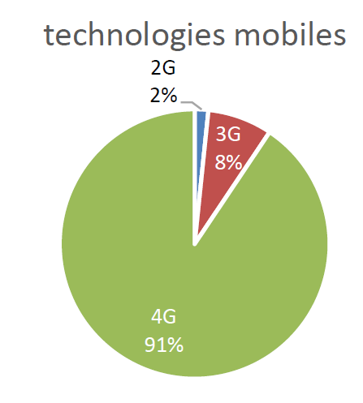
Figure 10: Compatability of end-user terminals with different mobile technologies
The map represents geographically the different measurements made on the mobile networks. To clarify we have three different physical mobile networks in Luxembourg. The measurement tool « checkmynet.lu » permits to show all the measures on a map with a colour code, which reflects the quality of the measurement. For 2018 the following colour-codings were applied:
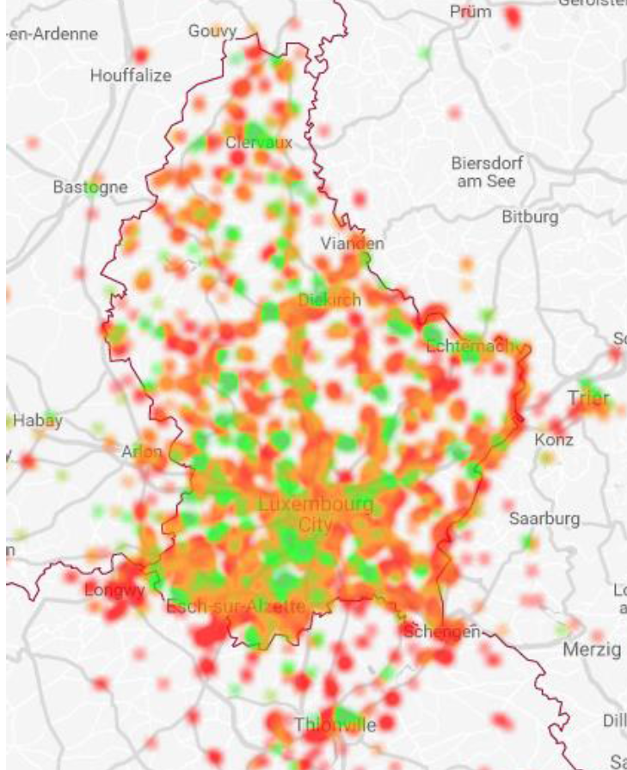 | Color-coding: | Mobile
 | Red | <20 Mbit/s
 | Orange | 20-50 Mbit/s
 | Green | >50 Mbit/s
Figure 11: Quality measurements recorded using checkmynet.lu for 2018
The average download speed is above 40 Mbit/s, so we can note that this speed is still far away from the advertised speeds, which are as high as 225 Mbit/s. Regarding the 4G+ technology, a few measures did come close to the 200 Mbit/s mark.
One special function of the tool is the possibility for the end user to indicate if they are in a building or outside. Or course, the tool itself cannot verify if this information is correct but the results of measurements which are claimed to be taken inside buildings are weaker than the outside measurements.
Measurement results taken using checkmynet.lu provide other useful information on IAS such as opened and blocked ports, whether VoIP is permitted etc. During the period under investigation, no such limitations appeared.

Slovenia
The Slovenian NRA, AKOS, uses a custom-built measuring tool called AKOS Test Net, which is available for end users to perform measurements for all types of IAS, using fixed and mobile terminals over various technologies (2G, 3G, 4G, LAN, WLAN). The tool provides the possibility to measure performance and quality parameters of broadband networks. AKOS Test Net is available as an application to mobile end users and can be downloaded free of charge for iOS and Android operation systems.
Regarding the number of measurements made to date, almost 90% have been made via fixed technologies - WLAN (21%) and LAN (68%). Of the mobile measurements the vast majority was made on 4G networks (91%). Therefore, the NRA concluded that most end users have terminals which are compatible with 4G networks and that the 4G network is available in practically all locations where end users used the AKOS Test Net tool.
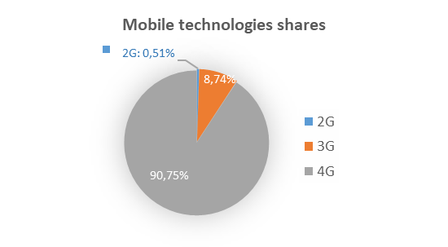
Figure 12: Mobile technologies’ shares performing crowdsourcing quality test
The map below (Figure 13) represents geographically the measurements made on the mobile networks of all mobile operators in Slovenia. The green colour shows speeds over 10 Mbit/s, the yellow colour between 2 and 10 Mbit/s and the red colour under 2 Mbit/s. The measurements shown on the map were made in the last year. The map shows that in practically all locations where end users used the AKOS Test Net tool the speeds over 10 Mbit/s were measured which allows the assumption the measurements were mostly made by 4G (LTE) technology.
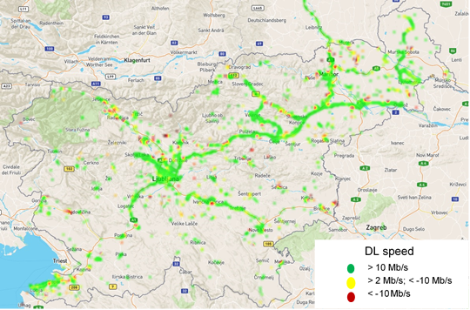
Figure 13: Mobile download speed measurements using AKOS Test Net in the past year
The measurement results can be presented in various ways as heat maps, points, region, community and settlement averages. The following picture (Figure 14) shows the point map of the delay measurements in the city of Maribor. Every dot means a measurement, by clicking on it the measured quality data are shown. The green colour means delay lower than 25 ms, the yellow colour between 25 ms and 75 ms and the red colour for delays bigger than 75 ms.
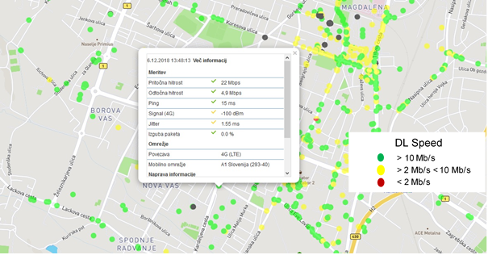
Figure 14: Measurements presented as point map

Figure 15 below presents the mobile download speeds in months from 1 June – 30 September 2019. Most maximum DL speeds is between 80 and 120 Mbit/s with some higher measurements of over 150 Mbit/s. The orange line represents the daily average speeds which are mostly between 25 and 40 Mbit/s.
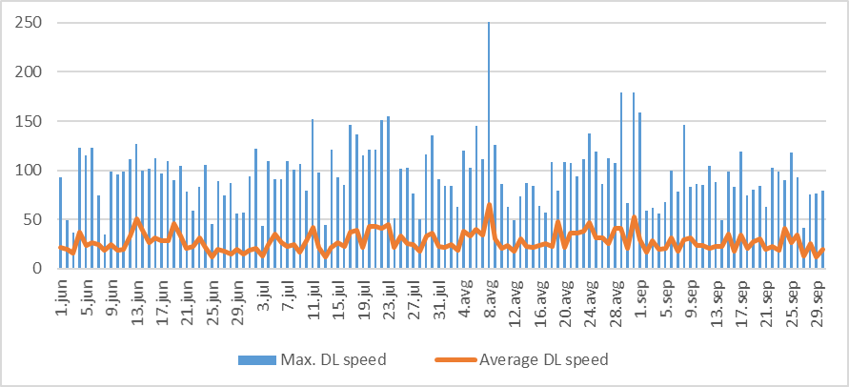
Figure 15: Max. and average mobile download speed AKOS Test Net results
Figure 16 below presents the mobile upload speeds in months from 1 June – 30 September 2019. The majority of maximum speeds is between 22 and 45 Mbit/s with some higher measurements of over 100 Mbit/s. The orange line represents the daily average speeds which are mostly between 12 and 20 Mbit/s.

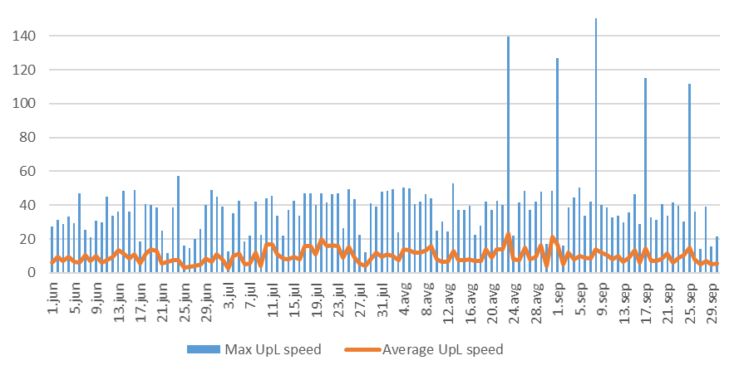
Figure 16: Max. and average mobile upload speed AKOS Test Net results
The delay measurements presented on the map on Figure 17 below show the delays lower than 25 ms in almost any part of the country.
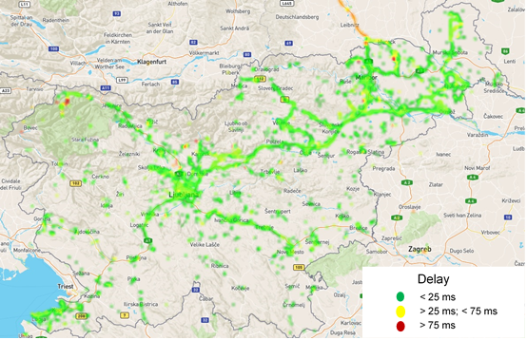
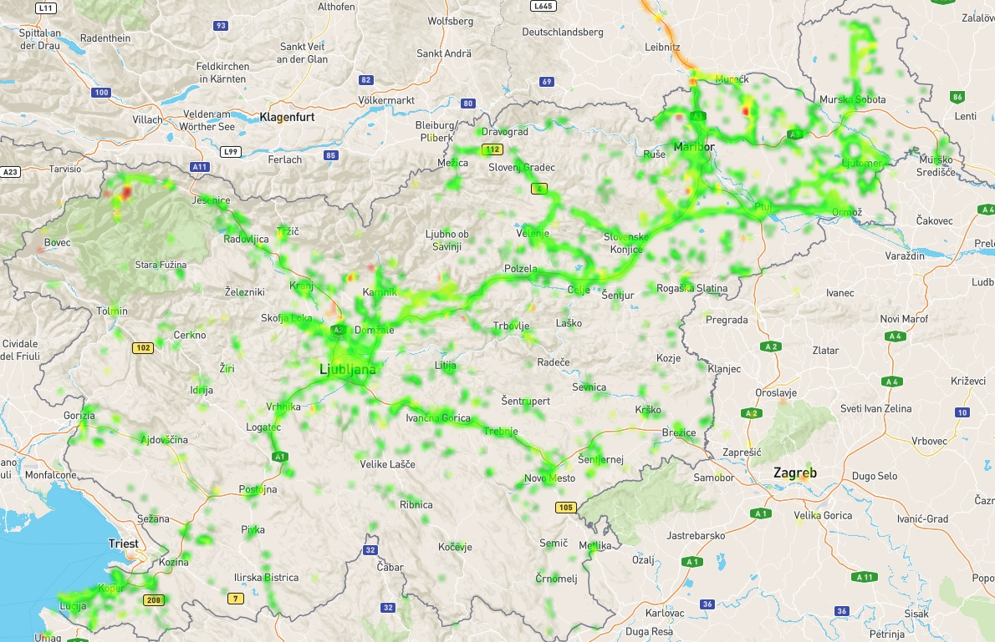
Figure 17: Mobile delay measurements AKOS Test Net results
LTE signal power was set into three groups: less than -111 dBm, between -111 and -90 dBm and higher than -90 dBm and is presented on the map below (Figure 18).
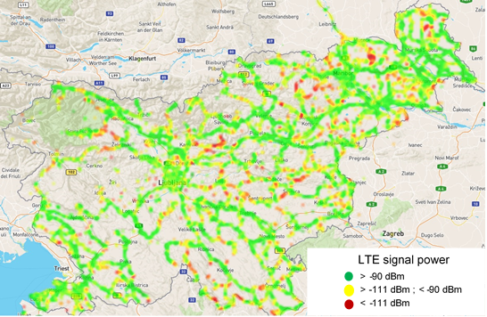
Figure 18: LTE signal power measurements AKOS Test Net results
The picture below (Figure 19) shows a single measurement of LTE signal power in a rural area. It also shows the advantage of LTE + technology where even at very low signal levels (-116 dBm) there was 66 Mbit/s download speed achieved, at a very good signal quality (t.i. 0,0% packet loss). Therefore, low signal levels do not necessarily mean bad service, because of LTE’s possibility to aggregate signal carriers. Of course, if the area not free of signal reflections and external disturbances it is probable that this would result in some packet loss, and consequently, reduced the transition speed.
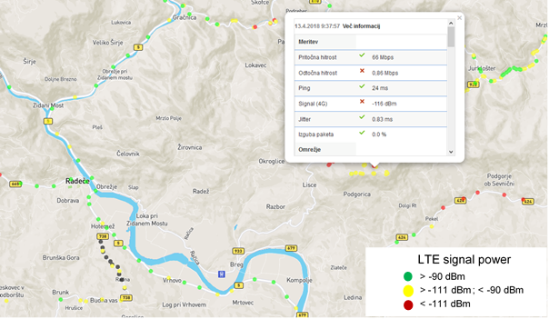
Figure 19: Example of a single LTE signal power measurement
There were 7.4% measurements made by roaming end users. Some of these were made by foreign end users roaming on Slovenian networks while others were made by Slovenian end users using the AKOS Test Net tool while roaming abroad. They achieved average values of 15.8 Mbit/s download speed, 6.7 Mbit/s upload speed and 188ms delay which is inferior to the quality experienced by domestic end users. This is understandable as the connection had to pass through their home network and then through the home network's roaming partners before finally reaching one of the AKOS Test Net measurement servers in Slovenia. Domestic mobile operators have much more optimised networks and interconnections to offer faster and much more agile services to domestic mobile end users.

Long-term measurements - Latvia
The NRA in Latvia is using their measurement tool, iTEST, for the long term measurements provided in all mobile ISPs' networks. The measurement results are available on the NRA's website as interactive infographics with the possibility to choose different variations and layouts of speed hour-by-hour. Also, the average, achieved maximum and minimum values are indicated. Figure 20 below provides an example for one mobile ISP access speed variations measured during a single day:
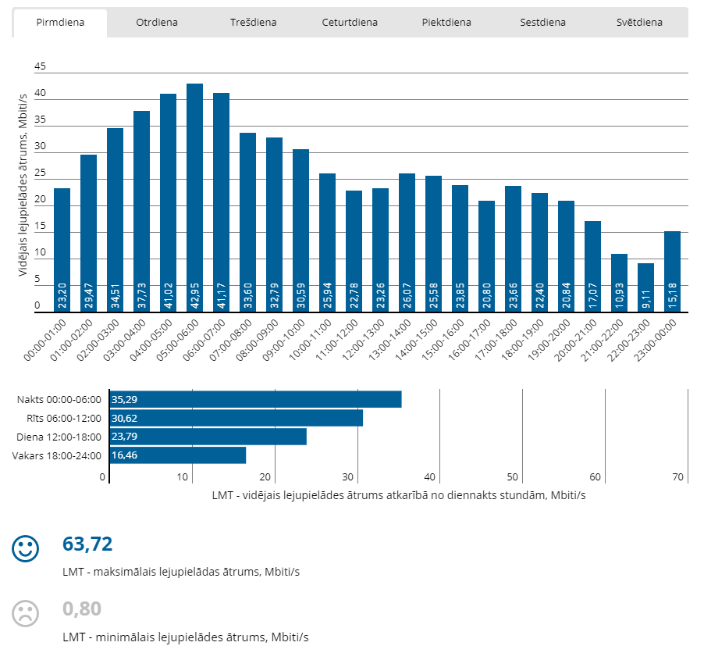
Figure 20: Example measurements taken for a single ISP on a given day

Measurements at different fixed locations - Latvia
iTEST is available for use by the NRA, end users and ISPs. The measurement results gathered by the NRA are published in annual IASQ reports and information on mobile broadband speeds is available in a geographical map. An example for one mobile ISP access speed measurement results for the year 2018 are provided below:
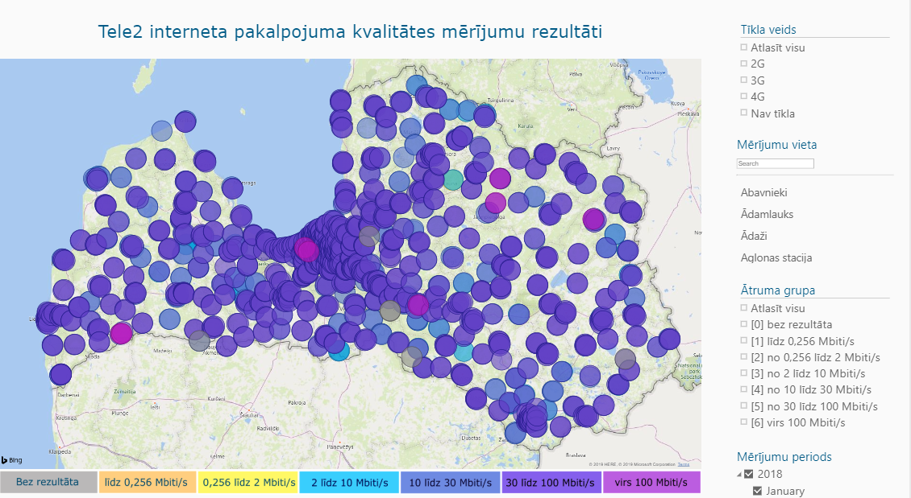
Figure 21: Example measurements taken for a single ISP for year ending 2018

Drive tests - Lithuania
The Lithuanian NRA has been using drive testing to obtain information about mobile IASQ of Lithuanian-based mobile ISPs. The measurement methodology and equipment enable the NRA to perform simultaneous tests for all 4 ISPs at any geographical location. Measurement equipment is installed in a vehicle for drive tests on roads or on streets in towns (see Figure 22), or in backpack for mobile IASQ evaluation on railways.
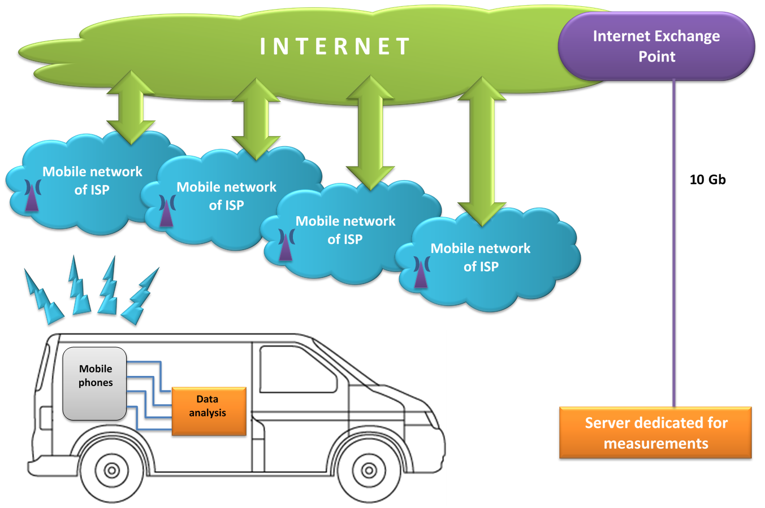
Figure 22: Drive tests on roads and in towns scheme
The number and intensity of measurements is based on the population density of a given area. For example, tests are performed every 200 m in towns and 1km on roads or railways. Measurement results are publicly provided on the NRA's website where anyone can check and compare mobile IASQ measurements at any geographical point where measurements have been performed. The website also contains a tool provides information on any mobile ISP download speed average values within a specific territory/town of Lithuania (see Figures 23 and 24).
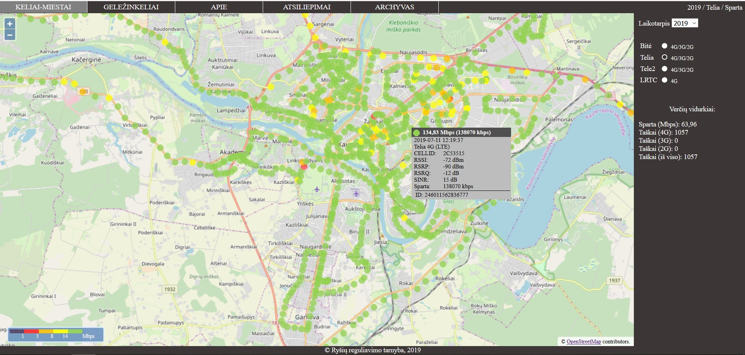
Figure 23: Example of drive tests performed in town results

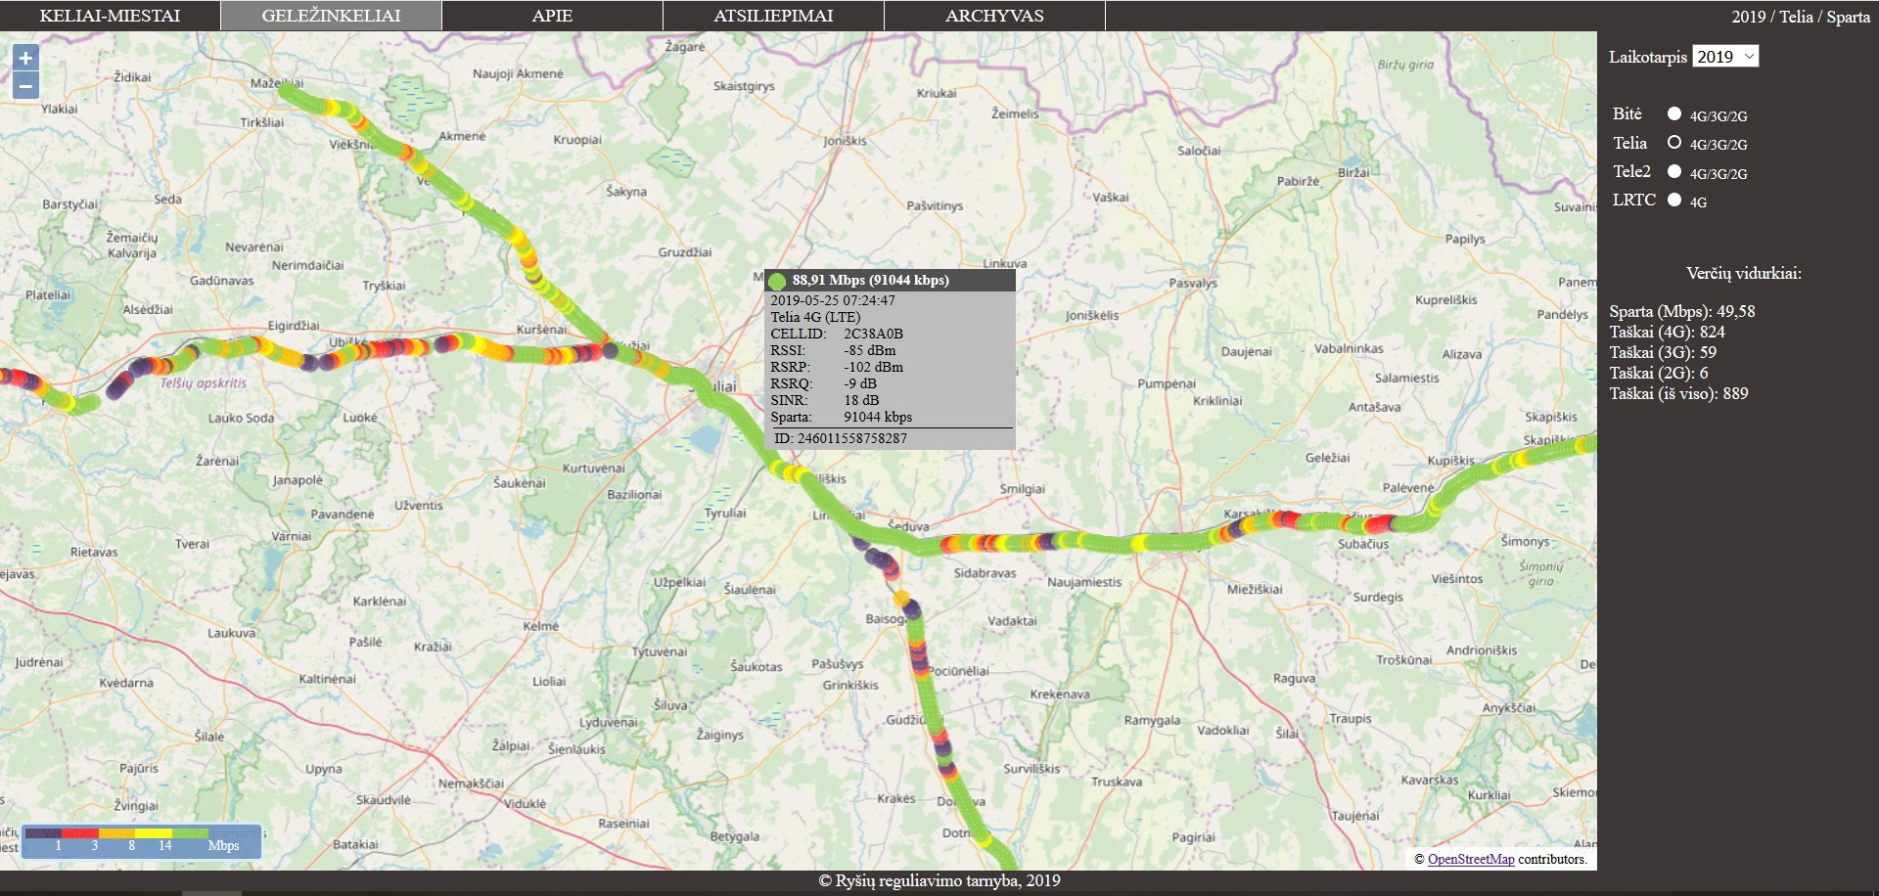
Figure 24: Example of drive tests performed on railways results
The Lithuanian NRA typically performs tests at up to 15,000 different locations of Lithuania over a one-year period. It also publishes annual reports based on these drive tests results. Annual reports provide aggregated/statistical values of download speeds measured over one year.

Throughput Calculation Method - Lithuania
Information about mobile IASQ could be collected and provided to end users using approaches/methods previously described in this chapter. These approaches provide reliable and evidence-based information about actual mobile IASQ measurements taken at particular places and times but are practically limited to providing information only for a specific area e.g. specific area within the country.
To obtain information about mobile IASQ download speeds at any place within a specific territory at outdoor conditions, the Lithuanian NRA has been conducting a pilot project on applying a new approach described as the "throughput theoretical calculation method".
The purpose of this theoretical calculation method is to obtain a download speed map on 4G/LTE networks in a specific area (e.g. Country, region, city, etc.) based on simulation results. To achieve this, the first thing needed is a mandatory set of primary components including:
- Specific software which has throughput calculation capabilities. There are various products currently available on the market which are used by the mobile operators and NRAs for radio planning, network optimisation and spectrum engineering tasks;
- Files that contain the territory’s digital elevation data. A digital terrain map can have different resolutions (pixel size) from high (e.g. 5 m) to low (e.g. 100 m). A higher grid step can provide more accurate simulation results, but it will take more time to run the calculations. For optimal modelling it is recommended to use at least a 50 m resolution map;
- Clutter data is highly useful because it can be used to evaluate the obstacles on the ground (buildings, vegetation, forest etc.) that affect radio propagation between the transmitter and receiver;
- Technical parameters of the LTE network base stations. The Lithuanian NRA obtained this information during the registration process of base stations. The required information and parameters are:
base station location (x, y coordinates);
operating frequency;
channel bandwidth;
power (e.i.r.p.);
antenna height;
antenna pattern;
azimuth;
electrical and mechanical tilt;
MIMO configuration.
- A tuned-up radio wave propagation model that is adapted individually according to terrain and clutter characteristics of the specific territory. Terrain characteristics may vary from country to country e.g. some may have more mountainous areas, while others can have more flatlands. The same applies to the clutter. Cities may have different building heights; forests can be predominantly deciduous or coniferous with trees of varying height and density. The appropriate propagation model is important in coverage calculation. To increase prediction accuracy the model should be tuned according to real field strength data obtained during drive test measurements in various clutter environments. The purpose of this process is to find the most suitable attenuation co-efficient and height diffraction factor for each clutter layer so that the calculated signal level is as accurate as possible for measurements.

Throughput calculation principles
In this sub-section, the basic principles that affect capacity and throughput in the data channel are provided. The throughput calculation method relies on Shannon's Theorem which gives an upper bound to the capacity of a link as a function of the spectrum resources, number of antennas and signal quality:

$$C≈B∙n∙\log_{2}{(1+SINR)}$$

Where:
- $C$ is the capacity/throughput, bps;
- $B$ channel bandwidth, Hz;
- $n$ number of antennas;
- $SINR$ signal to interference and noise ratio (linear scale).
Table 1 below shows possible LTE channel bandwidths defined in the 3GPP standard [6]. Here a resource block (RB) represents the smallest unit of resources that can be allocated to a user. The bandwidth of one resource block is 180 kHz. The wider the bandwidth is, the more RBs that can be allocated to a user and the higher the throughput that can be achieved.
Table 1: LTE channel bandwidths
Bandwidth, MHz | 1.4 | 3 | 5 | 10 | 15 | 20
Number of RB | 6 | 15 | 25 | 50 | 75 | 100
LTE channels have a carrier bandwidth limit of 20 MHz. This limit can be improved upon using carrier aggregation which achieves an increased network capacity by combining multiple carriers of various bandwidths to improve uplink and downlink transmission speeds. Carrier aggregation is described in further detail in sub-section 6.5.1.3 below.

MIMO
Another way to increase the capacity and throughput of the LTE network is through the deployment of multiple antenna technologies, such as MIMO (Multiple-Input Multiple-Output). MIMO systems use more than one transmission antenna (Tx) to send a signal on the same frequency to more than one receiver antenna (Rx) (Figure 25). MIMO also facilitates improved station coverage.

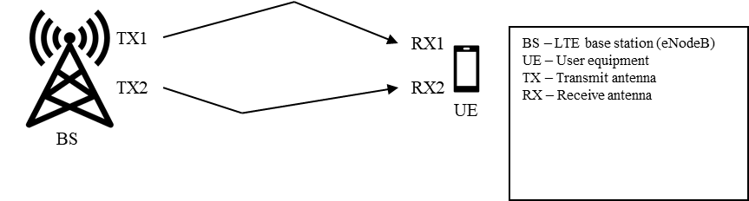
Figure 25: Multiple paths from BS to UE in MIMO 2x2 mode
MIMO systems can be grouped into four categories according to the number of antennas in the transmitter and the receiver:
- SISO – Single-Input Single-Output system (1 Tx antenna, 1 Rx antenna);
- SIMO – Single-Input Multiple-Output system (1 Tx antenna, NR>1 Rx antennas);
- MISO – Multiple-Input Single-Output system – NT>1 Tx antennas, 1 Rx antenna);
- MIMO – Multiple-Input Multiple-Output system – NT>1 Tx antennas, NR>1 Rx antennas).
In addition to the antenna configurations, there are two types of MIMO with respect to how data is transmitted across the given channel. When there are multiple antennas in a system different propagation paths will exist. In order to improve the system reliability, coverage and cell edge throughput, we can choose to send the same data across the different propagation (spatial) paths. This is called spatial diversity or Tx diversity. Tx diversity sends multiple copies through multiple transmit antennas, to improve the reliability of the data reception. Generally, this approach is used when the SINR is poor (at the cell edge) as illustrated in Figure 26 below:
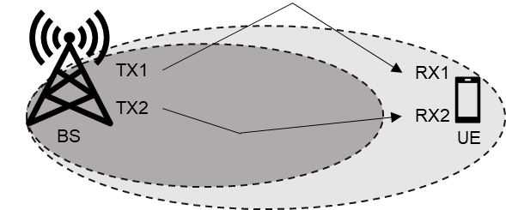
Figure 26: Tx diversity (2x2)
However, when SINR is high, additional throughput gains are minimal, and there is little benefit from further boosting SINR (see Figure 27 below).
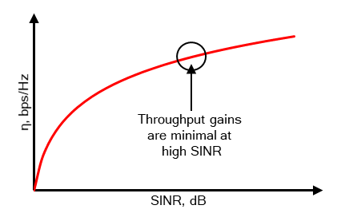
Figure 27: Spectral efficiency


To achieve an increase in throughput when SINR is already very high, LTE uses a MIMO technique called spatial multiplexing. In spatial multiplexing, each Tx sends a different data stream to multiple Rx (Figure 28 below). These data streams are then reconstructed separately by the UE. Generally, spatial multiplexing transmission mode is used when the SINR measured is high (typically when the UE is close to the station).
BS
UE
TX1
TX2
RX1
RX2

Figure 28: Spatial multiplexing (2x2)
In this throughput calculation method, LTE adaptive antenna switching (AAS) mode is used. It means that software will automatically select the best transmission mode (Tx diversity or spatial multiplexing) for a given UE giving the best SINR performances.

SINR
The main principle of this throughput calculation method is based on signal to interference and noise ratio (SINR) calculation on each point of the terrain. SINR is also a measure of signal quality, like RSRQ, but it is not defined in the 3GPP specifications but by the UE vendor. SINR on the traffic channel of LTE stations is computed from the wanted received power of the serving cell, the total interference power from other cells and the noise floor of a receiver:
$$SINR=\frac{S_{wanted}}{I_{other}+N}$$
Table 2 shows UE receiver noise floor (kTBF) values for the various LTE bandwidths. Here are the parameters used for the calculation:
- $k$ Boltzmann’s constant ($\text{1.38×}{\text{10}}^{\text{-23}}\text{J/K}$);
- $T$ temperature (290 K);
- $B$ bandwidth;
- $F$ noise figure of UE receiver (9 dB);
- $P_{loc}$ location probability (85%);
- $σ$ standard deviation (5.5);
- $SFM$ slow fading margin (5.7 dB).
Table 2: UE receiver noise floor (modified for 85% location probability)
Bandwidth, MHz | 1.4 | 3 | 5 | 10 | 15 | 20
kTBF, dBm | -99 | -95 | -93 | -90 | -88 | -87
These noise floor values are modified by slow fading margin (SFM) with a location probability of 85%.

Carrier Aggregation
Carrier aggregation (CA) is important, because it is one of the key features of the LTE network, which enables the support of wider bandwidth signals, increased bitrate and improved network performance. Each aggregated carrier is referred to as a component carrier (CC). LTE CA is a technique used to combine two or more (up to five) CCs across the available spectrum, hence the maximum aggregated bandwidth can reach up to 100 MHz. Figure 18 illustrates an example of CA with three different CCs. In this example two carriers with bandwidth of 20 MHz and one carrier with a bandwidth of 10 MHz are present. If the bandwidth of all three carriers is combined, 50 MHz in total is made available, thereby increasing throughput to 375 Mbit/s.
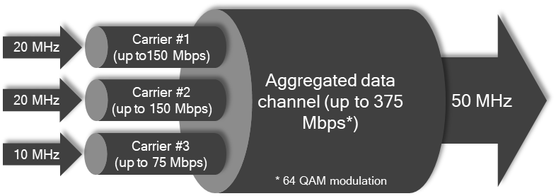
Figure 29: CA example with three CCs
However, in order to take advantage full three carrier aggregation, the user’s device must support this functionality and it must be near the base station as shown in Figure 29 where all three CCs can only be used for the black phone in green area. The yellow phone is not within the coverage area of the green CC, so here we can aggregate only two channels. Meanwhile, aggregation is not possible for furthest user because there is no coverage of transmitters working on higher frequencies.
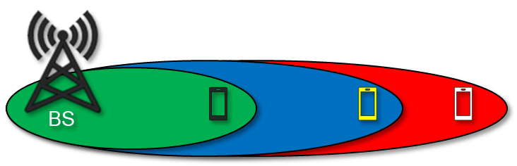
Figure 30: Taking advantage of three carrier aggregation
CA can be performed in the same operating frequency band (so-called intra-band contiguous or intra band non-contiguous) or it can be inter-band, in which case the CCs belong to different frequency bands, offering more flexible use of the spectrum.
For LTE, a CC used in data transmission is also a server cell. A server cell can provide control information and functions such as mobility, radio resources control and connection maintenance. The serving cell is referred to as a Primary Cell (PCell). The carrier corresponding to the primary cell is the Primary Component Carrier (PCC) for both downlink and uplink and may vary depending on radio conditions. Since only one CC is identified as primary, other CCs are identified as secondary cells (SCells), which are used to increase the bandwidth in LTE devices. The carrier corresponding to the secondary cell is the Secondary Component Carrier (SCC).
Table 3 below represents frequency bands in Lithuania which can be used to provide services, based on LTE technology, under licenses issued to mobile operators.
Table 3: LTE frequency bands in Lithuania
LTE Band | E-UTRA Operating Band | Uplink (UL) operating band  BS receive  UE transmit  FUL_low – FUL_high |  |  | Downlink (DL) operating band  BS transmit  UE receive  FDL_low – FDL_high |  |  | Duplex Mode
LTE 800 | 20 | 832 MHz | – | 862 MHz | 791 MHz | – | 821 MHz | FDD
LTE 900 | 8 | 880 MHz | – | 915 MHz | 925 MHz | – | 960 MHz | FDD
LTE 1800 | 3 | 1710 MHz | – | 1785 MHz | 1805 MHz | – | 1880 MHz | FDD
LTE 2100 | 1 | 1920 MHz | – | 1980 MHz | 2110 MHz | – | 2170 MHz | FDD
LTE 2300 | 40 | 2310 MHz | – | 2390 MHz | 2310 MHz | – | 2390 MHz | TDD
LTE 2600 | 7 | 2500 MHz | – | 2570 MHz | 2620 MHz | – | 2690 MHz | FDD

Receiver gain
Radio frequency signal attenuation that is caused by the human body is typically considered in sharing studies and various simulations with mobile client devices. A fixed receiver gain value of -3 dB is applied in throughput calculation method.

Network load (cell load)
All users need to share commonly available radio resources because they are limited. This means that the more resources a single user consumes, the less will remain for other users. So, the bitrate strongly depends on number of users who are connected to the network and on the traffic that they have generated. This is called network load or traffic load on the network. Network load is defined as percentage of used resource blocks (RB):
All users need to share commonly available radio resources because they are limited. This means that the more resources a single user consumes, the less will remain for other users. So, the bitrate strongly depends on number of users who are connected to the network and on the traffic that they have generated. This is called network load or traffic load on the network. Network load is defined as percentage of used resource blocks (RB):

$$Network load=\frac{Used RB}{All available RB}$$

Every cell in the network has its own network load. When calculating network throughput, it becomes difficult to choose network load values because they are not constant and change over time, depending on the time of day, user habits, population density and so on. Also, not every operator may want to provide network load values, because they can be treated as sensitive and confidential. To simplify calculations, the network load will be assumed to be evenly distributed across all network cells.
A network with the load around 5% to 10% is considered as an unloaded network, while a network load higher than 80% can be considered as a heavy loaded network. This throughput calculation method considers two network load models: 10% and 50%. The first model allows to evaluate mobile operator’s network capabilities to download data. In other words, it predicts maximum speed which can be achieved. As usually network without any users does not exist, we need to use more loaded network model in calculations to have more realistic scenario. For this, a model with 50% network load is used. The purpose of this model is to predict user’s bitrate in his daily service usage.

Simulation methodology
The basic structure of the simulation is as follows:

Data setup
The first step is to create a network of base stations of mobile operators in the computation program. Then set all the required technical parameters (coordinates, frequency, bandwidth, power, antenna height, pattern, tilt, azimuth, MIMO mode). This simulation method uses adaptive antenna switching (AAS) mode.
The second step is to define LTE channel power allocation percentages of the station. Default percentages for MIMO 2x2 mode are shown in Table 4 below:
Table 4: Power channel settings for MIMO 2x2 mode
Bandwidth, MHz | Reference signal, % | PDSCH, % | PDCCH, % | PBCH, % | PSS, % | SSS, % | Total, %
1.4 | 9.524 | 80.238 | 4.762 | 2.619 | 1.429 | 1.429 | 100
3 | 9.524 | 83.524 | 4.762 | 1.048 | 0.571 | 0.571 | 100
5 | 9.524 | 84.4 | 4.762 | 0.629 | 0.343 | 0.343 | 100
10 | 9.524 | 85.057 | 4.762 | 0.314 | 0.171 | 0.171 | 100
15 | 9.524 | 85.276 | 4.762 | 0.21 | 0.114 | 0.114 | 100
20 | 9.524 | 85.386 | 4.762 | 0.157 | 0.086 | 0.086 | 100
Reference signal % represents the percentage of power dedicated to the pilot channel:
- PDSCH % (Physical Downlink Shared Channel) represents the percentage of power dedicated to the traffic channels;
- PDCCH % (Physical Downlink Control Channel) represents the percentage of power dedicated to the control channels;
- PBCH % (Physical Broadcast Channel) represents the percentage of power dedicated to the broadcast channels;
- PSS % (Primary Synchronisation Signal) and SSS % (Secondary Synchronisation Signal) represents the percentages of power dedicated to the synchronisation channels.
As all traffic to the end user is transmitted through the PDSCH channel, its power allocation percentage indicates how many RBs are dedicated for user data (see Table 5 below). All remaining RBs are considered as LTE system overhead.
Table 5: Usable RB’s distribution
Bandwidth, MHz | 1.4 | 3 | 5 | 10 | 15 | 20
RB | 6 | 15 | 25 | 50 | 75 | 100
PDSCH, % | 80.238 | 83.524 | 84.4 | 85.057 | 85.276 | 85.386
RB for user traffic | 4 | 12 | 21 | 42 | 63 | 85
The primary goal is to calculate SINR and throughput on traffic (PDSCH) channel. In order to evaluate network load influence, default PDSCH values must be modified. Reduced PDSCH values based on network load percentage are given in Table 6. All other LTE channel power allocation percentages are same as in Table 4.
Table 6: PDSCH settings for different network load
Network load | Bandwidth. MHz | 1.4 | 3 | 5 | 10 | 15 | 20
 | RB | 6 | 15 | 25 | 50 | 75 | 100
10% load | PDSCH, % | 72.214 | 75.172 | 75.96 | 76.55 | 76.748 | 76.847
10% load | RB for user traffic | 4 | 11 | 18 | 38 | 57 | 76
50% load | PDSCH, % | 40.119 | 41.762 | 42.2 | 42.5285 | 42.638 | 42.693
50% load | RB for user traffic | 2 | 6 | 10 | 21 | 31 | 42
The third step is to define which stations need to be considered in the carrier aggregation process. To achieve this, cells of a base station with the lowest available frequency must be set as a reference (pilot) station. Also, stations to be aggregated must have the same unique group code (GC) as the reference station. If the base station uses only one LTE frequency, there is no need to define the group code, but it still needs to be set as the reference station. Some examples of different base station configurations are given in Figure 31 below:
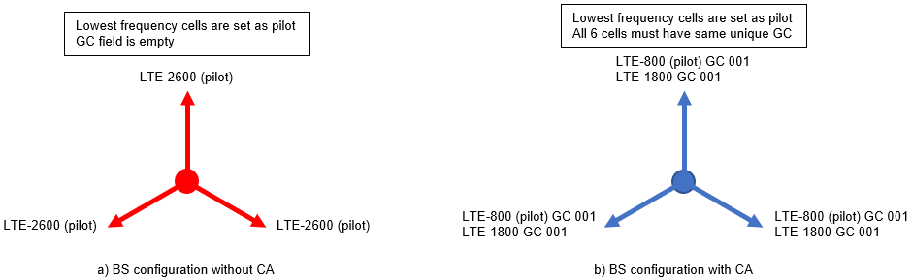
Figure 31: Examples of base station configurations

Coverage calculation
Once all LTE base station parameters are set, coverage calculations are performed. The Lithuanian NRA uses 15 m resolution digital terrain map (DTM) data with 14 clutter categories shown in Table 7 below. To speed up simulation time the DTM resampling factor of 4 is used. This means that cartographic resolution for simulations is reduced to 60 m.
Table 7: Clutter layers
Clutter name | Clutter height, m
Rural | 0
Water | 0
Forest < 0.3 | 20
Forest 0.4 - 0.6 | 10
Forest 0.4 - 0.6 | 20
Forest 0.4 - 0.6 | 30
Forest 0.4 - 0.6 | 40
Forest 0.7 - 1 | 10
Forest 0.7 - 1 | 20
Forest 0.7 - 1 | 30
Forest 0.7 - 1 | 40
Low-rise buildings | 7
High-rise buildings | 9
High-rise buildings | 15
The forest layer is divided into 9 categories according to tree density and average height. The simulations are performed using the deterministic propagation model ITU-R R.525-2 [6], which incorporates the Deygout 94 diffraction geometry and fine integration method for sub-path attenuation. This propagation model is tuned-up according to drive test measurements for three LTE bands (LTE-800, LTE-1800 and LTE-2600). As a result, additional attenuation and diffraction factors are applied for forests and buildings with ground occupancy layers for each LTE band. The field strength is calculated at a height of 1.5 m for the receiving antenna. The calculation distance around base stations is limited to 35 km.

Throughput calculation
After calculating coverage, throughput calculations are performed. At this stage it is possible to determine implementation losses to spectrum efficiency (due to coding rate, overheads) and the maximum possible bits/s according to the maximum modulation order that can be used. Nowadays, most LTE network elements and user equipment can support 256QAM modulation, which gives maximum 8 bits/s. Based on a 3GPP technical report [7] implementation losses are set to 0.6.
The pilot channels are used to build an LTE RSRP (Reference Signal Received Power) map where the best server can be identified on each point of the terrain. The SINR is then computed on a given best server point. Finally, SINR values are converted to throughput map according to Shannon formula. All the stations with the same group code as the best server and covering the same point will be aggregated for traffic calculation.
Computation time depends on the number of base stations, area size, calculation distance and data resolution. For example, it took 8 weeks for the Lithuanian NRA to carry out the calculations using 6000 stations, 35 km calculation distance and map with a resolution of 15 m. So, for countries with a large area computation may take a long time. In such case, lower map data resolution or/and computing distance could be used by sacrificing accuracy.

Calculation results
The LTE throughput maps of one of the Lithuanian operators based on the calculation results, considering network load of 10% and 50%, are depicted in Figures 32 and 33 respectively. Displayed throughput intervals are set into four groups: 10-30 Mbit/s, 30-100 Mbit/s, 100-150 Mbit/s and more than 150 Mbit/s. These thresholds can be changed according to needs. It is clear from the maps that the more loaded network, the smaller area where certain speed can be achieved.
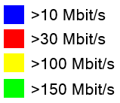
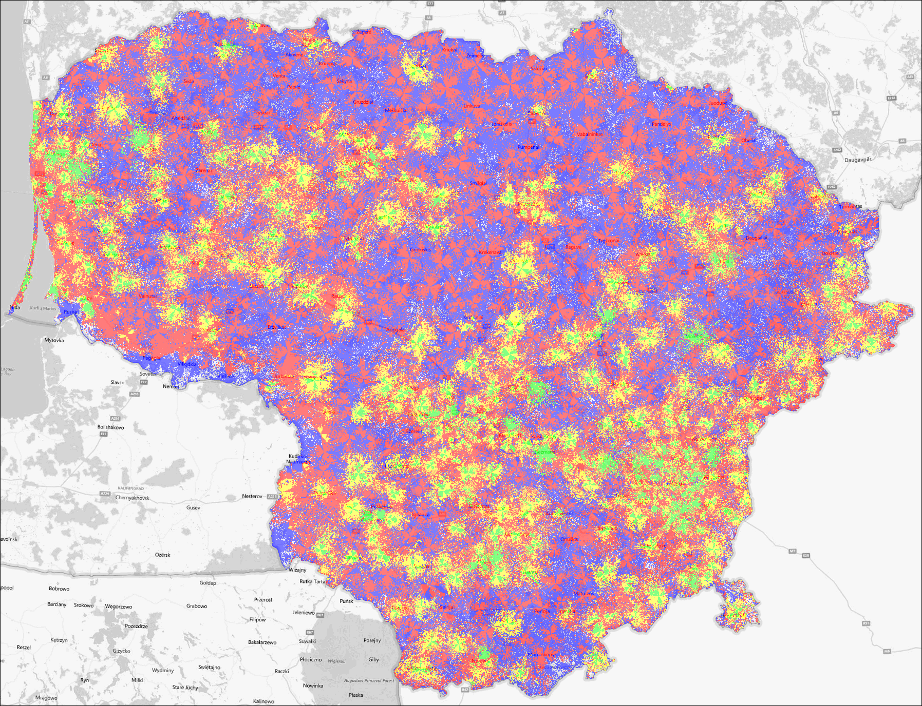
Figure 33: LTE throughput map (network load 10%)
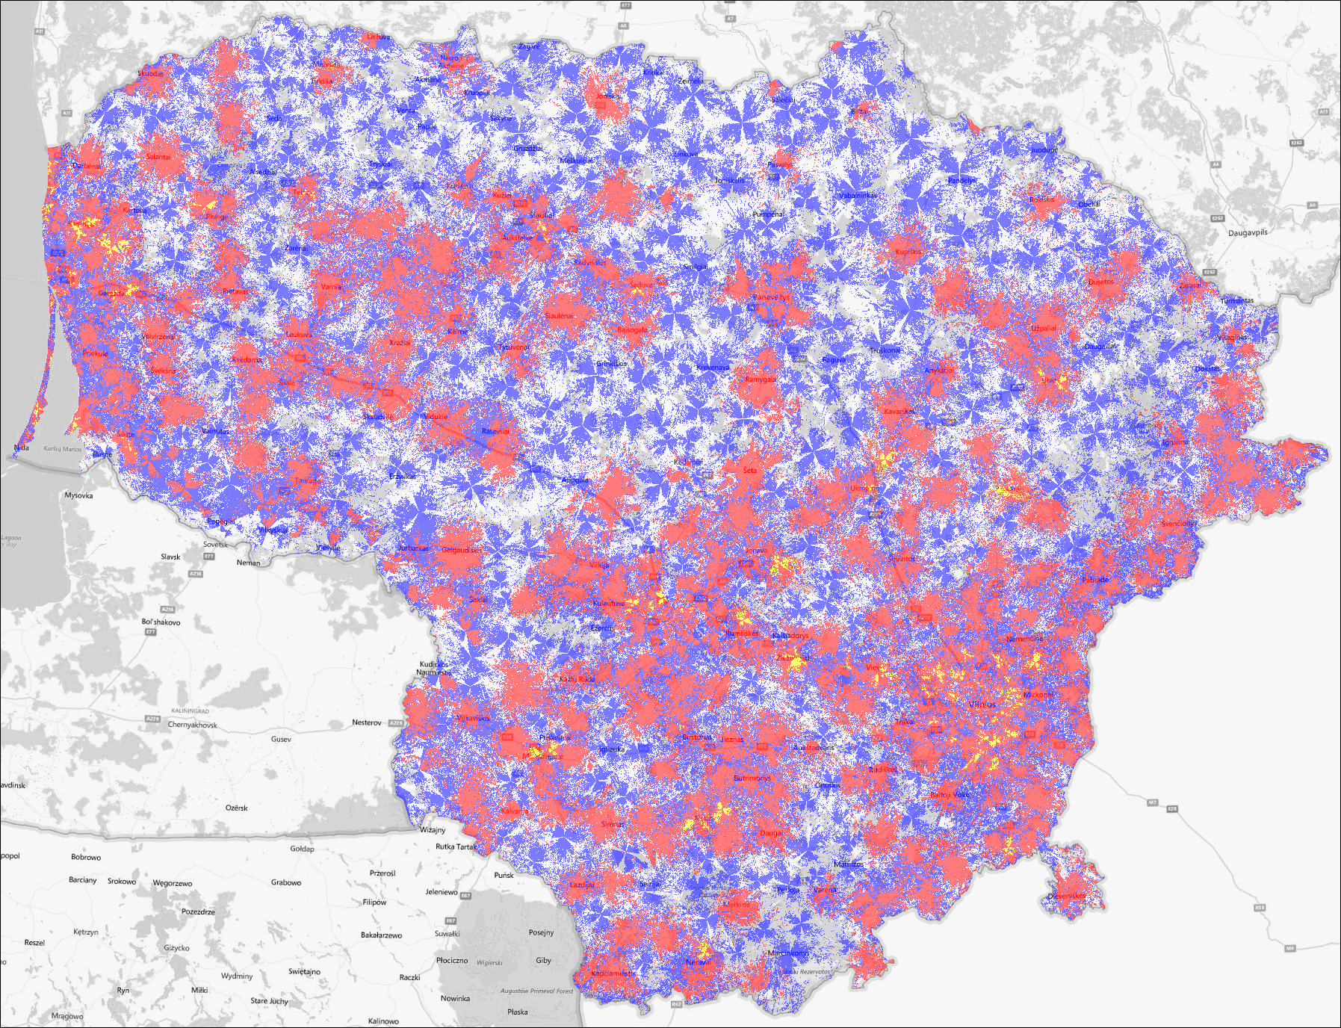
Figure 34: LTE throughput map (network load 50%)
One of advantages of theoretical throughput calculation over measurements, is that here it is possible to estimate throughput coverage within whole country area or any administrative unit. The coverage of the Lithuanian territory for different network load scenarios is presented in Table 8.
Table 8: LTE throughput coverage in Lithuania
Throughput | Network load 10% | Network load 50%
> 10 Mbit/s | 97.5% | 69.3%
> 30 Mbit/s | 61.4% | 27.4%
> 100 Mbit/s | 20.3% | 0.5%
> 150 Mbit/s | 4.9% | 0%
In the following, the calculations for two network load cases are compared with the measurements to see what correlation is between them. Usually this comparison is difficult to make because the measurements are done on a real/live network, where each station’s network load is different, unknown and varies in real time. Meanwhile, the computations cannot reflect to the real time situation on the network and we use a constant traffic load parameter throughout the network. However, certain trends can be seen in the urban and rural environments.
The situation in the city is shown in Figure 35. The coloured dots represent measurements’ points, which were obtained during drive tests. These points are put on throughput prediction map. From comparison we can see that colours corresponding to the bitrate are more or less in line with the calculation results on 50% network load model. Such tendencies are expected, as there are more residents in cities who use mobile internet.
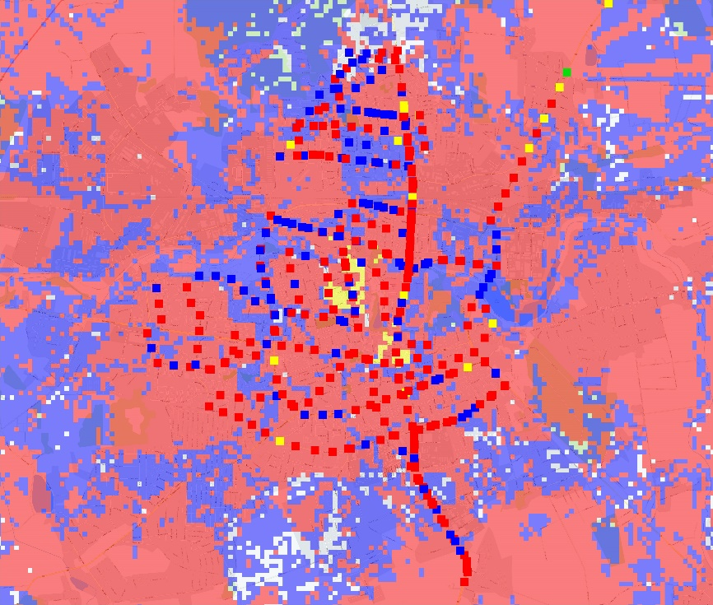
Figure 35: Calculations and measurements in the city (network load 50%)
At the same time, tendencies often differ in rural areas (Figure 36). The measured throughput here was more in line with theoretical calculations with 10% network load more often.
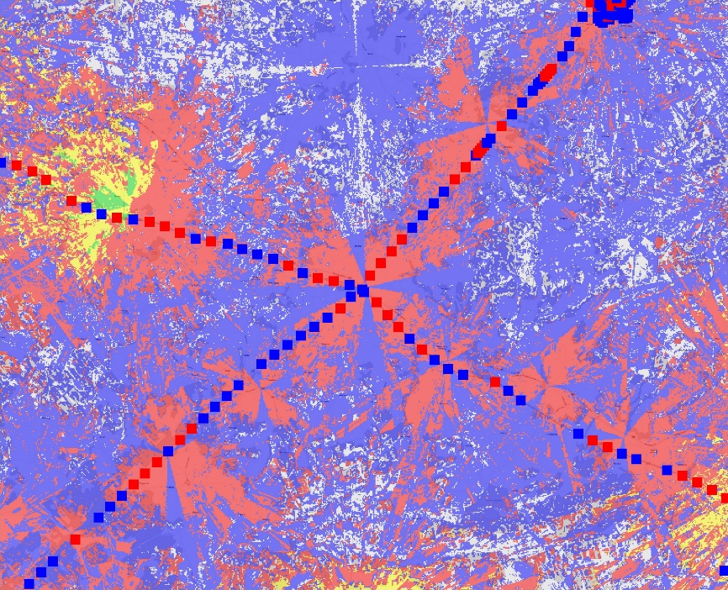
Figure 36: Calculations and measurements in the countryside (network load 10%)

Conclusions
Many CEPT countries measure and evaluate parameters on mobile IASQ based on national legislation or regulations which go beyond the requirements mandated for EU/EEA countries in EU Regulation 2015/2120, i.e. advertised and maximum download/upload speeds. For example, minimum/guaranteed transmission speed is a requirement in some countries in addition to the required information on maximum and advertised speeds.
In addition to monitoring the transmission speed, the responses to the questionnaire revealed that many countries are also measuring and evaluating other Mobile IASQ parameters e.g. delay, delay variation, mobile coverage, etc.
The majority of respondents (13 of 15) to the questionnaire stated that their respective NRAs are involved in Mobile IASQ monitoring and that these monitoring activities are mainly based on NRA measurements, ISP measurements and periodic reports from ISPs.
Various mobile IASQ measurement and evaluation methods are used in CEPT countries including drive tests, measurements at different fixed locations, long term measurements, crowd-sourcing and theoretical throughput calculation methods. The following observations have been made based on the different methods analysed in this Report:
- Drive testing methods enable the collection of reliable information about actual Mobile IASQ over a wide geographic area within a relatively short time period.
- Long-term measurements provide information on speeds and other Mobile IASQ parameters and obtain information on how they can change over time at certain geographical points. This could be used for evaluating Mobile IASQ stability and capability in the long term. Long term metrics could also be used for objective measurement-based complaints resolution.
- Crowdsourcing methods involve the use of mobile apps and desktop apps together and the collected data from all the locations can then be processed. Crowdsourcing has the advantage of providing many measurements covering a wide geographic area that provides information on measurements taken at different points in time.
- Theoretical throughput calculation methods could be used for evaluating expected transmission speeds for any location using theoretical projections from calculations. One of the advantages of theoretical calculation over measurements, is that it allows for the estimation of throughput coverage across the country and this could help administrations for executing geographical estimations of Mobile IAS availability as required by the EECC. Preliminary findings demonstrate that, due to constantly changing network load, theoretical calculation methods may have the potential to provide a more suitable approach for estimating the maximum available throughput rather than predicting the throughput actually experienced by end user.

- RESPONSES TO A QUESTIONNAIRE ON Provision of Comparable Information on Mobile IASQ

A.1.1 INTRODUCTION
Publicly available, adequate, easily comparable, and up to date information on Mobile IASQ helps consumers to confidently make well-informed choices when selecting from numerous Internet Access offers available on the market. The availability of this type of information has the potential to contribute to ensuring an overall positive experience for the end user during the selection process and this factor is very important in the broader context of broadband promotion particularly for extremely fast evolution on mobile networks.

A.1.2 RESPONSE TO THE QUESTIONNAIRE
A questionnaire on the provision of comparable information Mobile IASQ was sent to CEPT administrations on 18th of June 2018 with submission date for the responses by 31st of October 2018. The following 15 administrations have replied: Greece, Russian Federation, Austria, Bulgaria, Latvia, Malta, Lithuania, Germany, Croatia, Czech Republic, Montenegro, Switzerland, Slovenia, Spain and Portugal.

A.1.3 DETAILED ANSWERS
Question 1: Do mobile IAS providers in your country provide publicly available information about their mobile IAS quality beyond the information required by Regulation (EU) 2015/2120? (i.e. more than maximum and normally available speeds).
Austria | Yes. Additionally, classes in case of congestion (in German "Nutzungsklassen") are provided by all mobile operators. These classes define the bandwidth split among subscribers in case of mobile cell congestion.
Bulgaria | Yes. Mobile IASP provide more information on their web sites in the FAQ section where they have tips about the efficient usage of the data, as well the average traffic which an application could use (some examples are given).
Croatia | No
Czech Republic | Yes. ISPs provide to customers beyond the requirements of Regulation (EU) 2015/2120, information also about the minimum offered and the minimum guaranteed level of service quality.
Germany | n/a
Greece | No
Latvia | Yes. Mobile IAS providers provide average values of such parameters as latency, jitter and packet loss ratio as well as percentage of availability of service.
Lithuania | Yes. One mobile ISP provides a geographic map where provides expected/evaluated achievable download speeds at any location.
Malta | No
Montenegro | Yes. Based on the Rulebook on the Quality of Electronic Communication Services operators also measured unsuccessful data transmission ratio and delay.
Portugal | No
Russian Federation | Yes
Slovenia | No
Spain | Yes. IAS providers with an internet mobile service annual billing over 20 million euros must measure data transmission speed achieved. This speed is measured according to the ETSI EG 202 057 guides since at least year 2007.
Switzerland | No

Question 2: If Yes to Question 1, what is the basis for the provision of this additional information?
Austria | It is provided on a voluntary basis.
Bulgaria | It is provided on a voluntary basis.
Croatia | n/a
Czech Republic | There is an obligation to provide it. Remarks: The obligation is imposed in § 63, Par. 1, letter c) of Act No. 127/2005 Coll., on Electronic Communications (hereinafter AoEC), which represents the implementation of Article 20 (2) (b) Directive 2002/22 / EC of the European Parliament and of the Council on Universal Service.
Germany | n/a
Greece | n/a
Latvia | There is an obligation to provide it.
Lithuania | It is provided on a voluntary basis.
Malta | n/a
Montenegro | There is an obligation to provide it. Remarks: In accordance with the Rulebook on the Quality of Electronic Communication Services.
Portugal | n/a
Russian Federation | It is provided on a voluntary basis.
Slovenia | n/a
Spain | There is an obligation to provide it. Remarks: The obligation is included in this legal order: "Orden IET/1090/2014, de 16 de junio, por la que se regulan las condiciones relativas a la calidad de servicio en la prestación de los servicios de comunicaciones electrónicas"
Switzerland | n/a

Question 3: Is your institution (NRA) responsible for the monitoring of mobile internet access service quality?
Austria | Yes
Bulgaria | Yes
Croatia | Yes
Czech Republic | Yes. Remarks: The authorization of the Czech Telecommunication Office (hereinafter CTO) to monitor the quality of mobile Internet access services and the enforcement of directly enforceable Regulation (EU) 2015/2120 is, in addition to Article 5 (1) of this Regulation, also enshrined in § 113, Par. 1, 2 AoEC. However, given that the parameters of the quality of the mobile IAS were not set by CTO on the basis of the authorization stipulated in Article 5 (1) of the Regulation, the CTO shall carry out measurements only when checking the fulfilment of the frequency allocation conditions for LTE networks in which the CTO established the development criteria of these networks, i.e. the observance of the specified signal coverage and the download speed, as well as during resolution of the customer's complainants on the quality of the services.
Germany | Yes
Greece | Yes
Latvia | Yes
Lithuania | Yes
Malta | Yes
Montenegro | Yes
Portugal | Yes. Remarks: ANACOM conducts (notably within the scope of its responsibilities on the protection of rights and interests of consumers) periodical drive-tests on GSM/UMTS/LTE mobile communication systems. based on which it publishes reports with the outcome of the evaluation of the quality of mobile voice and data services and of the network coverage. The studies are conducted using technical parameters to represent quality perception from a user perspective. The services covered are mobile narrowband voice. SMS and mobile broadband (previous reports available at https://www.anacom.pt/render.jsp?categoryId=293535&languageId=1). These studies include therefore information on mobile Internet access service quality. The methodology of the previous studies was recently revised. Please refer to https://www.anacom.pt/render.jsp?contentId=1413944&languageId=1 for information on the methodology that will be used in the next studies. Please note. however. that. although GSM/UMTS Rights of Use have some generic provisions on QoS (such as admission time to service. degree of availability. among others). there are not specific Internet access service thresholds. for instance, for download/upload speeds. Furthermore. regarding Internet access service in general (including also in mobile accesses) ANACOM provides also a quality monitoring tool (NET.mede. available at https://netmede.pt/). on speed and other QoS parameters. which allow users to voluntarily run their own tests. and based on which ANACOM provides aggregated information stemming from the tests realized by users. on a crowdsourcing basis. (see remarks in the next question).
Russian Federation | No
Slovenia | Yes
Spain | Yes
Switzerland | No

Question 4: If Yes to Question 3, what kind of activities are implemented for mobile IAS quality monitoring:
Austria | QoS measurements performed by NRA, periodic reports from mobile IAS provider.
Bulgaria | QoS measurements performed by mobile IAS provider, periodic reports from mobile IAS provider.
Croatia | QoS measurements performed by NRA, periodic reports from mobile IAS provider.
Czech Republic | QoS measurements performed by NRA, periodic reports from mobile IAS provider. Remarks: Performed measurement of services is carried out under the conditions and the extent specified in the note to question 3. They are further collected periodic statistical reports by providers. Relevant are information on the network infrastructure, the number of active SIM used for mobile Internet access by the subscribers, the number of active SIMs used to access the Internet for M2M communication, the number of Internet access in CDMA, UMTS / LTE, and information on the volume of data transferred by customers in 3G and 4G networks.
Germany | Other: QoS measurements performed by end-users (crowd-sourced approach).
Greece | QoS measurements performed by NRA.
Latvia | QoS measurements performed by NRA, QoS measurements performed by mobile IAS provider, periodic reports from mobile IAS provider.
Lithuania | QoS measurements performed by NRA.
Malta | Other: The MCA has recently published a consultation paper proposing a framework which outlines how mobile QoS is to be measured and reported by the IAS providers. https://mca.org.mt/consultations-decisions/quality-service-framework-mobile-electronic-communication-services-%E2%80%93-public
Montenegro | QoS measurements performed by NRA, periodic reports from mobile IAS provider.
Portugal | QoS measurements performed by NRA. Other: Other - QoS tests ran by users. based on a quality monitoring tool (NET.mede). See also the previous answer. The methodology of the previous studies was recently revised. Please refer to https://www.anacom.pt/render.jsp?contentId=1413944 for information on the methodology that will be used in the next studies. Please note. however. that. although GSM/UMTS Rights of Use have some generic provisions on QoS (such as admission time to service. degree of availability. among others). there are not specific Internet access service thresholds. for instance, for download/upload speeds. Furthermore. regarding Internet access service in general (including also in mobile accesses) ANACOM provides also a quality monitoring tool (NET.mede. available at https://netmede.pt/). on speed and other QoS parameters. which allow users to voluntarily run their own tests. and based on which ANACOM provides aggregated information stemming from the tests realized by users. on a crowdsourcing basis.
Russian Federation | n/a
Slovenia | QoS measurements performed by NRA, QoS measurements performed by mobile IAS provider.
Spain | QoS measurements performed by mobile IAS provider. Remarks: Enforced IAS providers have developed a measuring system based on fixed probes and must audit the measuring system and procedures once a year. The resulting audit report is sent to the SEAD. This is so since at least year 2007.
Switzerland | n/a

Question 5: The legislative framework for mobile IAS QoS monitoring is based on:
Austria | National legislative acts, Regulation (EU) 2015/2120 for open internet access.
Bulgaria | National legislative acts.
Croatia | National legislative acts, NRA regulations/decisions.
Czech Republic | National legislative acts, NRA regulations/decisions Remarks: The national regulation contained in the AoEC can be applied exclusively to the cases of measurement performed to verify compliance with the quality of the mobile Internet access service agreed in the contract between the providers and the customers in addressing the customers' complaints about the quality of the services provided. The CTO's decision is applied exclusively to the measurements made when CTO checking compliance with the frequency assignment conditions for LTE. (both of which are described in detail in the Note to Question 3).
Germany | NRA regulations/decisions, Regulation (EU) 2015/2120 for open internet access.
Greece | National legislative acts, NRA regulations/decisions.
Latvia | National legislative acts, NRA regulations/decisions, Regulation (EU) 2015/2120 for open internet access.
Lithuania | Regulation (EU) 2015/2120 for open internet access.
Malta | Other: The proposed framework is built on powered granted to the Authority through the Telecom framework (Art 22 of the USD) and the Net Neutrality regulation.
Montenegro | NRA regulations/decisions.
Portugal | National legislative acts. Remarks: ANACOM statutes (Decree-Law no. 39/2015 of 16 March). (https://www.anacom.pt/render.jsp?contentId=1351851)
Russian Federation | Other
Slovenia | National legislative acts, NRA regulations/decisions.
Spain | National legislative acts. Remarks: The obligation is included in this legal order: "Orden IET/1090/2014, de 16 de junio, por la que se regulan las condiciones relativas a la calidad de servicio en la prestación de los servicios de comunicaciones electrónicas".
Switzerland | Other. Remarks: No legal basis.

Question 6: What parameters for mobile internet access are measured and evaluated:
Austria | Transmission speed, delay, radio coverage; other: Additionally, if supported by the client: signal strength, quality tests for voice over IP, unmodified content, web page, transparent connection, DNS, TCP and UDP ports. Refer to https://www.rtr.at/en/tk/netztestfaq_allgemein_0400.
Bulgaria | Transmission speed, delay, delay variation; Remarks: Measurements are performed by mobile IAS provider.
Croatia | Transmission speed, delay, packet loss ratio, radio coverage.
Czech Republic | Transmission speed, radio coverage. Remarks: They are regularly measured only parameters in regard observance of the frequency assignment conditions for LTE as set out in the notes to questions 3 and 5. Other parameters are measured only in cases where it requires resolution of customer's complaints, and only in situations where a simple measurement to verify the transmission speed negotiated in the contract is not sufficient for the correct assessment of the quality of the service provided and for determining the nature of the problem to which the complaint is directed.
Germany | Transmission speed, delay.
Greece | Transmission speed, radio coverage. Other: success ratio.
Latvia | Transmission speed, delay, delay variation, packet loss ratio.
Lithuania | Transmission speed, radio coverage.
Malta | Other: These parameters are still in PROPOSAL stage however measurements related to upload/download speed, latency, video quality are among the proposed parameters. It is proposed that drive test will be used to collect data and hence geo-space information will be included with the data collected, service coverage can be mapped out.
Montenegro | Transmission speed, delay, delay variation, packet loss ratio.
Portugal | Transmission speed. delay. delay variation. packet loss ratio. radio coverage. Remarks: The drive-tests on GSM/UMTS/LTE mobile communication systems. include measurements on radio coverage. transmission speed. delay. webpage transfer time. completed data session rate and others on video quality (for further details please see ANACOM’s decision on the methodology - https://www.anacom.pt/render.jsp?contentId=1413944). The quality monitoring tool NET.mede. available to users. provides measurements on transmission speed. delay. jitter. packet loss and webpage transfer time.
Russian Federation | Transmission speed, delay, radio coverage.
Slovenia | Transmission speed, delay, delay variation, packet loss ratio, radio coverage.
Spain | Transmission speed. Remarks: IAS providers provide information about mobile data transmission speed achieved measured in accordance with the ETSI EG 202 057 guides.
Switzerland | n/a

Question 7: What kind of mobile internet access transmission speed is measured and evaluated:
Austria | Other: The RTR-NetTest (in German: RTR-Netztest) is a crowd sourced solution which gives end-users the ability to run end to end tests on their Internet connection between their user equipment (e.g. smartphone, tablet, computer etc.) and the testservers in Internet and gather information in this respect. Please refer to https://www.rtr.at/en/tk/netztestmethodik for the test specification of the RTR-Nettest.
Bulgaria | Maximum transmission speed, minimum/ guaranteed transmission speed.
Croatia | Maximum transmission speed.
Czech Republic | Normally available transmission speed. Remarks: When CTO addressing the customer's complaint of the on the quality of the services, the actually achieved speed and its deviations are measured. The actual speed and its deviations are measured when CTO check the frequency allocation conditions for LTE networks.
Germany | Maximum transmission speed. Remarks: According to Regulation (EU) 2015/2120 it is the estimated maximum speed.
Greece | Average/mean transmission speed.
Latvia | Average/mean transmission speed, normally available transmission speed, maximum transmission speed, minimum/ guaranteed transmission speed.
Lithuania | Average/mean transmission speed.
Malta | Other: It is proposed that mobile QoS parameters will be measured through drive test campaigns and hence will be the normally available speed in general. However, the data collected can provide information about the maximum and minimum speeds available. This information could be then bench-marked against that stated by the operator including the advertised speed.
Montenegro | Average/mean transmission speed, maximum transmission speed, minimum/guaranteed transmission speed.
Portugal | Maximum transmission speed. Remarks: Both tests (drive-tests on GSM/UMTS/LTE mobile communication systems. as well as NET.mede tests) assess the maximum speed provided by the network at the moment of the test.
Russian Federation | Average/mean transmission speed.
Slovenia | Average/mean transmission speed, maximum transmission speed, minimum/ guaranteed transmission speed; other: The measured speeds are the actual speeds available at the time of measurement. The other kinds of speeds are calculated out of measured values.
Spain | Average/mean transmission speed. Other: Enforced mobile IAS providers have developed a measuring system based on fixed probes. These fixed probes may not be used in mobility and measure mobile data transmission speed achieved at least three times per hour 365 days a year. Every three months percentile 95, percentile 5 and mean transmission speed is calculated based on the results obtained from the fixed probes.
Switzerland | n/a

Question 8: If the QoS monitoring is based on Regulation (EU) 2015/2120 for open internet are there any additional specific requirements or explanations included in national level legislation?
Austria | n/a
Bulgaria | Penalties for service providers in case of violation of the Regulation (EU) 2015/2120.
Croatia | No additional requirements specified.
Czech Republic | No additional requirements specified, penalties for service providers in case of violation of the Regulation (EU) 2015/2120, Compensation for end-user if QoS level is not achieved (e.g. agreement may be terminated on the initiative of the end-user without any penalty, subscription fee is not applied for the time when the end-user received the service of poor quality, granting of discounts or other benefits for the end-user). Remarks: The AoEC regulates only the obligation to state the minimum offered and the minimum guaranteed level of service in the mobile IAS contract and in its published proposal by the easily accessible way - Section 63 Par. 1, letter c). Violation of Regulation (EU) 2015/2012 can be punished according Czech law. An offense against the law is committed by ISP which does not provide access to the open Internet, does not ensure that the customer's contract contains information required by the Regulation, or does not establish transparent, simple and effective procedures for dealing with end-user complaints. Pursuant to Paragraph 64 (12) of the AoEC, the ISPs are obliged to reduce the price accordingly if the service could only be used in part or it could not be used at all for a defect on the part of the ISPs.
Germany | Requirements for QoS indicators/ parameters, penalties for service providers in case of violation of the Regulation (EU) 2015/2120.
Greece | Requirements for QoS indicators/ parameters.
Latvia | Requirements for QoS indicators/ parameters, minimum/ guaranteed QoS level, penalties for service providers in case of violation of the Regulation (EU) 2015/2120, Compensation for end-user if QoS level is not achieved (e.g. agreement may be terminated on the initiative of the end-user without any penalty, subscription fee is not applied for the time when the end-user received the service of poor quality, granting of discounts or other benefits for the end-user).
Lithuania | Compensation for end-user if QoS level is not achieved (e.g. agreement may be terminated on the initiative of the end-user without any penalty, subscription fee is not applied for the time when the end-user received the service of poor quality, granting of discounts or other benefits for the end-user).
Malta | Requirements for QoS indicators/ parameters. Remarks: The response listed in this question refers to the proposal laid down in its consultation paper. MNOs will be required to measure and publish information additional to that specified in the Net neutrality regulation. MNOs will be required to measure latency, and video streaming quality.
Montenegro | No additional requirements specified.
Portugal | n/a
Russian Federation | Other
Slovenia | Requirements for QoS indicators/ parameters, Compensation for end-user if QoS level is not achieved (e.g. agreement may be terminated on the initiative of the end-user without any penalty, subscription fee is not applied for the time when the end-user received the service of poor quality, granting of discounts or other benefits for the end-user) Remarks: The measurement method for the end-users is prescribed by the general legislation act for QoS.
Spain | n/a
Switzerland | n/a

Question 9: Information for mobile IAS quality is available on:
Austria | On operators’ websites, in individual end-user agreement.
Bulgaria | On operators’ websites. Remarks: Individual end-user agreements contain the maximum/advertised and minimum speed.
Croatia | On NRA’s website.
Czech Republic | On operators’ websites, in individual end-user agreement. Remarks: The draft of mobile IAS contract must be accessible in ISPs shops and also with a manner allowing remote access.
Germany | Other: specific website (https://breitbandmessung.de).
Greece | On operators’ websites, on NRA’s website.
Latvia | On operators’ websites, on NRA’s website, in individual end-user agreement.
Lithuania | On operators’ websites, in individual end-user agreement.
Malta | Not available. Remarks: Information on mobile IAS quality is not yet published (except for estimated speeds) but the proposed framework will require operators to measure and publish their QoS information on their website, provide QoS data to the Authority and to dependent mobile service providers. The Authority may also carry out its measurements and publish its own results.
Montenegro | On operators’ websites, on NRA’s website.
Portugal | On operators’ websites. Remarks: ANACOM publishes periodically. on its website. reports with the outcome of the evaluation of the quality of mobile voice and data services and of the network coverage. based on the drive tests it run (https://www.anacom.pt/render.jsp?categoryId=293535). ANACOM provides also. on the website of its quality monitoring tool NET.mede. aggregated information stemming from the tests realized by users. on a crowdsourcing basis (https://netmede.pt/estatisticas).
Russian Federation | On operators’ websites, in individual end-user agreement.
Slovenia | On operators’ websites, on NRA’s website. Remarks: Coverage with the signal is presented as coloured map, based on the measured speeds. Link to the NRA's webpage: https://www.akostest.net/sl/map
Spain | On operators’ websites, on NRA’s website.
Switzerland | n/a

- List of References

- ECC Recommendation (15)03 of 23 April 2015 on provision of Comparable Information on Fixed Retail Internet Access Service Quality, amended on 28 November 2018
- Regulation (EU) 2015/2120 of the European Parliament and of the Council of 25 November 2015 laying down measures concerning open Internet access and amending Directive 2002/22/EC on universal service and users’ rights relating to electronic communications networks and services and Regulation (EU) No 531/2012 on roaming on public mobile communications networks within the Union (Text with EEA relevance)
- Directive (EU) 2018/1972 of the European Parliament and of the Council of 11 December 2018 establishing the European Electronic Communications Code (Recast)Text with EEA relevance
- ECC Report 195: “Minimum Set of Quality of Service Parameters and Measurement Methods for Retail Internet Access Services”, April 2013
- BoR (16) 127: “BEREC Guidelines on the Implementation by National Regulators of European Net Neutrality Rules”, August 2016
- ITU-R Recommendation P.525-4: “Calculation of free-space attenuation”, August 2019.
- 3GPP TS 36.101 V16.2.0: “Evolved Universal Terrestrial Radio Access (E-UTRA); User Equipment (UE) radio transmission and reception, Table 5.6-1”, June 2019

http://www.atdi.com/, https://www.forsk.com/

