Analysis of the suitability and update of the regulatory technical conditions for 5G MFCN and AAS operation in the 2500-2690 MHz band
approved 6 March 2020
ECC Report 308

Executive summary
The development of this Report was triggered in March 2018 by the need to assess the technical conditions in ECC Decision (05)05 [1] to enable a timely introduction of 5G and AAS, while maintaining adequate protection of other services and applications and to adapt them accordingly. This ECC Report recalled the current harmonised technical conditions defined for the 2500-2690 MHz band in the ECC Decision (05)05 approved in March 2005 and amended in July 2015 and studies their suitability for 5G. The 5G terminal characteristics defined in TS 38.101-1 for the MFCN bands 2500-2690 MHz [4] are similar to LTE terminal characteristics. The introduction of AAS systems will only be effective on the base station side as it is not foreseen for the user equipment. The findings in this Report and recommended updates of the existing ECC Decision (05)05 include:
- BS unrestricted BEM for AAS with TRP;
- BS restricted BEM in-block power for AAS with TRP;
- In-band coexistence between FDD and TDD AAS and non-AAS;
- Measures for the coexistence with other services; radar above 2700 MHz [6]
There is possibility of higher interference for AAS compared to existing non-AAS for sectors pointing towards such other services stations for frequencies close to the upper edge of the DL band where the beam is still more likely to be beamformed. When AAS is not pointing towards such other services stations (i.e. outside ±60 degree of AAS antenna boresight), AAS is not expected to cause more interference than non-AAS BSs.
- Measures for the coexistence with other services; RAS (2690-2700 MHz) [5]
An additional baseline has been developed at 2690-2700 MHz for AAS FDD base stations to reduce the size of the coordination zone with radio astronomy sites where considered necessary by the concerned administration. The feasibility of implementation of wide area outdoor AAS base stations in the highest two 5 MHz blocks taking into account the additional baseline limit may require evolution of filtering capabilities for AAS. However, these two upper blocks would remain usable for BS with lower power.
However, additional measures may be needed on a national basis in order to protect the RAS. Depending on the size of the necessary coordination zone to protect RAS cross border co-ordination may also be necessary.
This Report concludes on the need to update regulatory framework to support the introduction of 5G in the 2500-2690 MHz band and recommends an updated framework. CEPT concluded that there is no need to update current band plan for 2500-2690 MHz in ECC Decision (05)05. The recommended framework in this report is fully in line with the July 2019 revision of ECC Dec (05)05 and CEPT Report 72.
When considering 5G usage, the analysis confirms that the current BEM remains applicable for non-AAS and the need for a new BEM for AAS in order to ensure coexistence intra-band and with adjacent services. It is noted that the spurious domain for the base station in this frequency band starts 10 MHz from the band edge and that the corresponding limits are defined in current ERC Recommendation 74-01 [7] (i.e. -30 dBm/MHz, which was assumed in this Report).
Identification of required amendments to the existing framework for the 2500-2690 MHz frequency band are defined in section 5.

TABLE OF CONTENTS

0 Executive summary 2
1 Introduction 7
2 Existing Regulatory framework for MFCN systems 8
2.1 Existing Band plan 8
2.2 Existing technical conditions – BEM requirements 8
2.2.1 Unrestricted BEM for base stations 9
2.2.2 Restricted BEM for base stations 10
2.2.3 Restricted BEM for base stations with restrictions on antenna placement 11
2.2.4 Existing non-AAS unrestricted Block Edge Mask relation to 3GPP Spectrum Emission Mask 11
2.2.5 Restricted BEM for non-AAS BS relation to 3GPP pico BS 12
2.2.6 Existing restricted BEM for non-AAS BS with restrictions on antenna placement and NR/AAS 12
2.2.7 Limits for terminal stations 12
3 Suitability of the current technical framework for 5G 13
3.1 Suitability for non-aas MFCN Base stations 13
3.2 Suitability for AAS MFCN base stations 13
4 Adjacent band coexistence for AAS/non-AAS 2600 MHz MFCN band and RAS/radar 14
4.1 Spectrum situation 14
4.2 In-band coexistence 14
4.3 Adjacent band coexistence 15
4.4 Parameters and scenarios for the relative AAS/non-AAS compatibility study 16
4.5 Technical summary 17
5 Recommended updates to the Regulatory Framework 20
5.1 Recommended Band plan 20
5.2 Applicable technical conditions 20
5.2.1 Unrestricted BEM for BS 20
5.2.2 TDD unsynchronised operation 27
5.2.3 Restricted BEM for BS 27
5.2.4 Restricted BEM for BS with restrictions on antenna placement 28
5.2.5 Limits at 2690-2700 MHz for FDD AAS base station 28
5.2.6 Limits for terminal stations 29
6 Conclusions 31
ANNEX 1: AAS (LTE/NR) coexistence study between FDD and TDD networks within 2500-2690 MHz 32
A1.1 Simulation scenarios 32
A1.2 Simulation Parameters 32
A1.3 Simulation Results 34
A1.4 Conclusions 37
ANNEX 2: Parameters for the interference study in the 2600 MHz MFCN band between non-AAS and AAS and adjacent services above 2690 MHz (RAS and radar) 38
A2.1 LTE/NR parameters 38
A2.2 non-AAS and AAS parameters 39
A2.3 Ras and radar parameters 41
A2.4 Other parameters 42
A2.5 Appendix A: Additional info from ECC Report 174 44
A2.6 Appendix B: Additional info from ECC Report 281 46
A2.7 Appendix C: operating band unwanted emission limits/mask (UEM) 48
ANNEX 3: STUDY #1 for AAS/non-AAS 2600 MHz MFCN band and RAS/radar 50
A3.1 Comparison of MFCN 5G unwanted emissions impact 50
A3.2 MFCN parameters 50
A3.3 Calculations 58
A3.4 Impact on separation distances 62
A3.5 Conclusions 63
A3.6 Appendix 1 to Study #1 64
ANNEX 4: STUDY #2 for AAS/non-AAS 2600 MHz MFCN band and RAS/radar 66
A4.1 LTE/NR AAS/non-AAS parameters 66
A4.2 Simulation results for radar 66
A4.3 RAS 72
A4.4 For macro cellular BS sectors (rural/suburban/urban) NOT pointing in the direction of a radar or RAS station within ±60° from the boresight of the antenna 83
A4.5 appendix – figures 83
ANNEX 5: STUDY #3 for AAS/non-AAS 2600 MHz MFCN band and RAS/radar 85
A5.1 AAS (LTE/NR) Coexistence with Meteorological Radars in 2600 MHz: simulation scenarios and assumptions 85
A5.2 AAS (LTE/NR) Coexistence with Meteorological Radars in 2600 MHz: further analyses 91
A5.3 CONSIDERATIONS REGARDING AAS (LTE/NR) COEXISTENCE WITH RAS 97
ANNEX 6: STUDY #4 Compatibility between non-AAS and AAS MFCN in 2600 MHz and RAS in 2690-2700 MHz 99
A6.1 Introduction 99
A6.2 Study parameters 99
A6.3 Single-interferer case studies 109
A6.4 Summary and conclusions 127
ANNEX 7: STUDY #5 Protection of Radioastronomy service from adjacent emission of 2.6 GHz MFCN using AAS 129
A7.1 Introduction 129
A7.2 Characteristics of Radioastronomy service in 2.6 GHz 129
A7.3 Characteristics of MFCN in 2.6 GHz using AAS 129
A7.4 Methodology 131
A7.5 Results of TVG 132
A7.6 Results for different radioastronomy sites 132
A7.7 Conclusion 134
ANNEX 8: List of References 135

LIST OF ABBREVIATIONS

Abbreviation | Explanation
3GPP | 3rd Generation Partnership Project
AAS | Active Antenna Systems
ACLR | Adjacent Channel Leakage Ratio
ATPC | Automatic Transmitter Power Control
BEM | Block Edge Mask
BS | Base Station
CEPT | European Conference of Postal and Telecommunications Administrations
DL | Downlink
EC | European Commission
ECC | Electronic Communications Committee
e.i.r.p. | Equivalent Isotropic Radiated Power
E-UTRA | Evolved Universal Terrestrial Radio Access
FDD | Frequency Division Duplex
IMT | International Mobile Telecommunications
iRSS | interfering Received Signal Strength
LOS | Line Of Sight
ISD | Inter-Site Distance
LTE | Long Term Evolution
LRTC | Least Restrictive Technical Conditions
MC | Monte Carlo
MCL | Minimum Coupling Loss
MFCN | Mobile/Fixed Communications Network
MS | Mobile Service
MSR | Multi-Standard Radio
NLOS | Non Line of Sight
Non-AAS | Non-Active Antenna Systems
NR | New Radio
OOB | Out of Band
OOBE | Out of Band Emissions
OTA | Over The Air
RAN | Radio Access Network
RAS | Radio Astronomy Service
SDL | Supplemental Downlink
SEM | Spectrum Emission Mask
TRP | Total Radiated Power
TSG | Technical Specification Group
UE | User Equipment
UEM | Unwanted Emission Mask
UL | Uplink
UTRA | Universal Terrestrial Radio Access
WAPECS | Wireless Access Policy for Electronic Communications Services

Introduction
This Report analyses the necessary changes in the existing ECC Decision (05)05 for the 2600 MHz frequency band in order to introduce 5G, namely New Radio (NR) and Active Antenna Systems (AAS). The analysis is based on existing reports for non-AAS:
- CEPT Report 19 with FDD/ TDD coexistence in the band [2];
- ECC Report 45 [5] and ECC Report 174 [6] compatibility to Radio Astronomy Service (RAS) and radar for frequencies above 2690 MHz .
New studies/simulations for AAS with respect to non-AAS within the band coexistence and to adjacent services, RAS and radar, are done. The analysis assumes that the current technical conditions will also remain as part of the regulatory framework to ensure that current and future deployments of non-AAS MFCN will not be impacted. As a result, this ECC Report gives the least restrictive technical condition for the introduction of 5G and updated Block Edge Masks (BEMs).

Existing Regulatory framework for MFCN systems

Existing Band plan
ECC Decision (05)05 (amended in July 2015) includes in its Annex 1 a harmonised spectrum scheme for MFCN in band 2500-2690 MHz [1]:
- The frequency band 2500-2570 MHz is paired with 2620-2690 MHz for FDD operation with the mobile transmit within the lower band and base station transmit within the upper band;
- Administrations may assign the frequency band 2570-2620 MHz either for TDD or for Supplemental Downlink. Any guard bands required to ensure adjacent band compatibility at 2570 MHz and 2620 MHz boundaries will be decided on a national basis and taken within the band 2570-2620 MHz;
- Assigned blocks shall be in multiple of 5.0 MHz;
- The MFCN channelling arrangements blocks in the band 2500-2690 MHz are depicted in Figure 1.
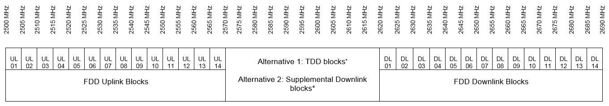
*Any guard bands required to ensure adjacent band compatibility at 2570 MHz and 2620 MHz boundaries will be decided on a national basis and taken within the band 2570-2620 MHz.
Figure 1: Existing MFCN channelling arrangements blocks in the band 2500-2690 MHz [1]

Existing technical conditions – BEM requirements
The existing harmonised technical conditions are given in ECC Decision (05)05 (amended July 2015) in Annex 2: “Least restrictive technical conditions for MFCN in the frequency band 2500-2690 MHz”.
They are expressed in the form of Block Edge Masks (BEMs) based on CEPT Report 19 and ECC Report 131 where the different elements are defined as below:
Table 1: MFCN BS BEM elements
BEM Element | Definition
In-block | Block for which the BEM is derived.
Baseline | Spectrum used for TDD and FDD UL, DL and SDL, except from the operator block in question and corresponding transitional regions.
Transitional region | For FDD DL blocks, the transitional region applies 0 to 5 MHz below and above the block assigned to the operator. For TDD blocks, the transitional region applies 0 to 5 MHz below and above the block assigned to the operator. Transitional regions do not apply to TDD blocks allocated to other operators, unless networks are synchronised. The transitional regions do not apply below 2570 MHz or above 2690 MHz.
Guard bands | Any guard bands required to ensure adjacent band compatibility at 2570 MHz and 2620 MHz boundaries will be decided on a national basis and taken within the band 2570-2620 MHz.
CEPT administrations should ensure that network operators are free to enter into bilateral or multilateral agreements to develop less stringent technical parameters and, if agreed among all affected parties, these less stringent technical parameters may be used.
Equipment operating in this band may also make use of equivalent isotropically radiated power (e.i.r.p.) limits for non-AAS or TRP for AAS other than those set out below provided that appropriate mitigation techniques are applied which comply with Radio Equipment Directive 2014/53/EU (RED) [36] and which offer at least an equivalent level of protection to that provided by these technical parameters.
In general, and unless stated otherwise, the BEM levels correspond to the power radiated by the relevant device irrespective of the number of transmit antennas, except for the case of non-AAS MFCN base station transition requirements which are specified per antenna.
In the case of unsynchronised TDD networks and adjacent TDD and FDD UL blocks, the compliance of two adjacent operators with the BEM requirements may be achieved by introducing frequency separation (e.g. through the authorisation process at national level) between the block edges of both operators.
Another option may be for CEPT administrations to introduce restricted spectrum block. Operators would then be required to limit the power used in the upper or lower part of their assigned spectrum, to limit the interference due to the selectivity of the adjacent operator’s receiver.
It should also be noted that a 5 MHz TDD block (2615-2620 MHz) immediately adjacent to a FDD DL block may suffer an increased risk of interference due to the emissions from the FDD DL. This may however for instance be mitigated by a TDD BS receiver antenna with lower gain or by placing the TDD BS receiver antenna at lower height. Administrations should also be aware of the above and therefore treat it appropriately when they award spectrum.
In the case of downlink only operation in the 2615-2620 MHz that is adjacent to FDD downlink there is no reason to treat it differently from the remaining blocks in 2570-2615 MHz.
Where small cells have specifically been considered within the existing framework these include various cell types including in-building cells (that may typically operate at up to 20 dBm e.i.r.p. in residential scenarios and up to 24 dBm e.i.r.p. in enterprises) and outdoor cells that may typically operate at up to 40 dBm e.i.r.p.

Unrestricted BEM for base stations
The BEM for an unrestricted spectrum block is built up by combining Table 2, Table 3 and Table 4 in such a way that the limit for each frequency is given by the higher value out of the baseline requirements and the block specific requirements:
Table 2: BS In-block e.i.r.p. power limit
BEM element | Frequency range | Power limit, e.i.r.p.
In-block | Block assigned to the operator | +61 dBm/5 MHz  CEPT administrations can relax this limit to 68 dBm/5 MHz for specific deployments e.g. in areas of low population density provided that this does not significantly increase the risk of terminal station receiver blocking

Table 3: BS Baseline requirement (for non-AAS)
BEM element | Frequency range | Maximum mean e.i.r.p.
Baseline | FDD DL blocks (including SDL blocks), TDD blocks synchronised with the interfering TDD block (note 2)), or used for downlink only operation. It further applies to 2615-2620 MHz. | +4 dBm/MHz (note 1)
Baseline | Frequencies in the band 2500-2690 MHz not covered by the definition in the row above. | -45 dBm/MHz
Note 1: The BS baseline BEM elements calculated for protection of spectrum used for downlink transmissions is based on the assumption that the emissions come from a Macro BS. It should be noted that small cells may be deployed at lower heights and thus closer to UEs which can result in higher levels of interference if the above power limits are used.
Note 2: Synchronised operation in the context of this Decision means operation of TDD in two different systems, where no simultaneous UL reception and DL transmissions occurs.
Table 4: BS Transitional region power limits (for non-AAS)
BEM element | Frequency range | Maximum mean e.i.r.p.
Transitional region | -5 to 0 MHz offset from lower block edge | +16 dBm/ 5 MHz (Note 1))
Transitional region | 0 to 5 MHz offset from upper block edge | +16 dBm/ 5 MHz (Note 1)
Note 1: In Table 4, the BS transitional region BEM elements are based on the assumption that the emissions come from a Macro BS. It should be noted that small cells may be deployed at lower heights and thus closer to UEs which can result in higher levels of interference if the above power limits are used. For such cases, administrations could establish lower maximum mean e.i.r.p. on a national level.

Restricted BEM for base stations
The BEM for a restricted spectrum block is built up by combining Table 3 and Table 5 in such a way that the limit for each frequency is given by the higher value out of the baseline requirements and the block specific requirements.
The restricted blocks are 2570-2575 MHz (except in UL mode operation in that block) and any 5 MHz block between unsynchronised TDD networks.
Table 5: BS In-block power limit for restricted spectrum blocks (for non-AAS)
BEM element | Frequency range | Power limit, e.i.r.p.
In-block | Restricted Block spectrum | +25 dBm/ 5 MHz (Note 1)
Note 1: It is noted that in some deployment scenarios this in-block power limit may not guarantee interference free UL operation in adjacent channels, although this would typically be mitigated by building penetration loss and/or difference in antenna height. Other mitigation methods may also be applied.

Restricted BEM for base stations with restrictions on antenna placement
In cases where antennas are placed indoors or where the antenna height is below a certain height, a CEPT administration may use alternative parameters in line with Table 6, provided that at geographical borders to other countries Table 3 applies and that Table 5 remains valid nationwide.
It should be noted that restricted power use along with additional restrictions on the placement of antennas (such as being indoor or under a certain height) is applicable even if the channel bandwidth of the restricted power use is more than 5 MHz.
Table 6: BS BEM for restricted spectrum blocks with restrictions on antenna placement (for non-AAS)
BEM element | Frequency range | Maximum mean e.i.r.p
Baseline | Start of the band (2500 MHz) to -5 MHz (lower edge) | -22 dBm/MHz
Transitional region | -5 to 0 MHz offset from lower block edge | -6 dBm/ 5 MHz
Transitional region | 0 to 5 MHz offset from upper block edge | -6 dBm/ 5 MHz
Baseline | +5 MHz (upper edge) to end of band (2690 MHz) | -22 dBm/MHz

Existing non-AAS unrestricted Block Edge Mask relation to 3GPP Spectrum Emission Mask
The existing unrestricted BEM mask "transitional region power limits" are related to 3GPP Spectrum Emission Mask (SEM) for macro BSs. The BEM for the 2600 MHz band was partly developed on the 3GPP UTRA SEM mask [9] which is also reflected in the TS 37.104 MSR Unwanted Emission Mask [7] and the CEPT/study in reference [2] for a technology neutral BEM. Using 17 dBi antenna gain, the equivalent 3GPP macro SEM value for non-AAS as defined in TS 37.104 shows the relation.
Table 7: ECC limits for unrestricted BEM and the 3GPP UEM
From TS 37.104 Table 6.6.2.1-1:  Wide Area operating band UEM for BC1 and BC3 |  |  |  | Comparison between 3GPP and ECC limits for unrestricted BEM
Frequency offset (MHz) | 3GPP UEM | Average Tx power | Units | 3GPP:  Tx Power  (dBm/5 MHz) |  | 3GPP:  e.i.r.p. | ECC  e.i.r.p.
0-0.2 | -14 | -14.0 | dBm/(30 kHz) | 8.2 | -0.7 | +16.3 dBm/(5 MHz) | +16 dBm/(5 MHz)
0.2-1 | -14 to -26 | -18.5 | dBm/(30 kHz) | 3.7 | -0.7 | +16.3 dBm/(5 MHz) | +16 dBm/(5 MHz)
1-5 | -13 | -13.0 | dBm/MHz | -6.0 | -0.7 | +16.3 dBm/(5 MHz) | +16 dBm/(5 MHz)
5-10 | -13 | -13.0 | dBm/MHz | -6.0 | -6.0 | +4 dBm/MHz | +4 dBm/MHz
10-15 | -15 | -15.0 | dBm/MHz | -8.0 | -8.0 | +2 dBm/MHz

Restricted BEM for non-AAS BS relation to 3GPP pico BS
For the restricted BEM the derivation of the in-block power can be found in CEPT Report 19 [2]. Pico BSs with Tx conducted power of 21 dBm and a 3 dBi antenna gain and a 1 dB conversion factor (3.84-5 MHz) are used for the restricted BEM. The power is based on terminal station receiver blocking.

Existing restricted BEM for non-AAS BS with restrictions on antenna placement and NR/AAS
The existing non-AAS values also apply for 5G NR for non-AAS operation. For Indoor AAS BSs or AAS BS with restrictions on antenna placement, alternative measures compared to Table 3 may be required on a case by case basis and on a national basis.

Limits for terminal stations
Table 8: In-block power limits for terminal stations
BEM element | Maximum mean power (including Automatic Transmitter Power Control (ATPC) range)
In-block | 31 dBm/ 5 MHz (TRP)
In-block | 35 dBm/ 5 MHz (e.i.r.p.)
NB: e.i.r.p. should be used for fixed or installed terminal stations and the TRP should be used for the mobile or nomadic terminal stations. TRP is a measure of how much power the antenna actually radiates. The TRP is defined as the integral of the power transmitted in different directions over the entire radiation sphere.

Suitability of the current technical framework for 5G

Suitability for non-aas MFCN Base stations
The term non-AAS refers to MFCN base station transmitters which are manufactured and supplied separately from the antenna systems. For non-AAS MFCN BS, including 5G, the antenna connector would most likely be connected to a passive antenna array, meaning that the resulting antenna gain is fairly invariant (between different implementations and between wanted and unwanted signals). Given the passive nature of the antenna array, setting requirements for non-AAS MFCN BS in terms of e.i.r.p. is appropriate.
Non-AAS MFCN base stations comply with existing LRTC in ECC Decision (05)05 [1], given that those requirements were derived from the analysis of the sum of the radiated powers across multiple antenna connectors. Furthermore, non-AAS MFCN BS keep the same unwanted emissions requirements as the ones given in 3GPP TS 37.104 [7] (unrestricted BEM) and TS 25.104 [9] (restricted BEM) which were used as basis for deriving existing limits in ECC Decision (05)05.
Based on the need to avoid disrupting the usage rights that have been already assigned for non-AAS MFCN in the 2500-2690 MHz range, it is proposed to maintain the existing out-of-block BEM e.i.r.p. limits as specified in ECC Decision (05)05.

Suitability for AAS MFCN base stations
AAS is one of the key features for 5G NR and LTE evolution products. According to Recommendation ITU-R M.2101 [10] an IMT system using an AAS will actively control all individual signals being fed to individual antenna elements in the antenna array in order to shape and direct the antenna emission diagram to a wanted shape, e.g. a narrow beam towards a user. An AAS MFCN BS continually adjusts the amplitude and/or phase between antenna elements resulting in an antenna pattern that varies in response to short term changes in the radio environment. This is intended to exclude long- term beam shaping such as fixed electrical down tilt.
With the introduction of AAS MCFN BS, the antenna arrays are included in the base station without an accessible interface between AAS and base station. Contrary to the case of non-AAS MFCN BS, AAS MCFN BS does not have the possibility to install an additional external filter between the base station antenna connector and the antenna. This implies that the BEM regulatory requirements must be met by product design, as it has been discussed in ECC Report 281 [12] and CEPT Report 67 [11]. Thus, ECC Report 281 concluded that the unwanted emissions are to be specified as over the air (OTA), rather than as conducted requirement. The OTA emission limits will be expressed in terms of Total Radiated Power (TRP) rather than e.i.r.p. This conclusion is in line with 3GPP approach described in ECC Report 281, which consider TRP as the most appropriate metric for specifying the ACLR and out-of-block emission limits in the context of interference between adjacent channel mobile networks.
Based on the above observations, suitable technical conditions (BEM in TRP) should be incorporated in the current ECC Decision (05)05 to account for the introduction of AAS MFCN base stations.
For terminals the regulatory technical conditions defined in the ECC Decision (05)05 (amended July 2015) are considered to be suitable to 5G terminals. AAS will not be implemented in 5G terminals in this frequency band. The AAS feature in 3GPP for this band applies to the BS side and does not impact the terminal side specification.

Adjacent band coexistence for AAS/non-AAS 2600 MHz MFCN band and RAS/radar

Spectrum situation
Above the 2500-2690 MHz MFCN band the situation is as follows:
- 2690-2700 MHz: Radio Astronomy Service (RAS) and Space Research Service (SRS);
- 2700-2900 MHz: Air Traffic Control (ATC) for aeronautical radio navigation, radiolocation radar (military) and meteorological radars. Restricted to ground based radars.
Below 3400 MHz MFCN band there is EESS, RAS and radar airborne allocation.
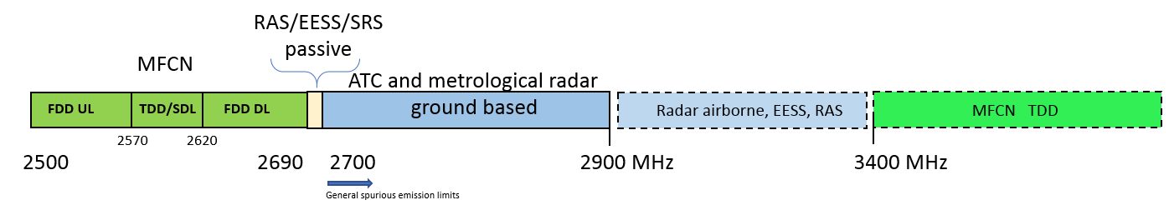
Figure 2: Adjacent services above the 2600 MHz MFCN band

In-band coexistence
3GPP TR 37.840 [15] studied coexistence between AAS (LTE/NR) system and LTE/NR-non-AAS (Legacy passive Antenna System) systems at 2 GHz. Related conclusions can be extended to the 2600 MHz band provided the similarities of propagation conditions.
3GPP concluded in TR37.840, that Cell average and 5% CDF throughput loss caused by aggressor AAS Legacy victim are consistent with that caused by legacy non-AAS BS to Legacy non-AAS BS with the same ACLR (per connector) assuming a value of 45 dBc. Besides, for a single column AAS system, the blocking power level for each individual receiver channel of the AAS system was similar to the in-band blocking level for a legacy BS installed with an assumed typical reference passive antenna array.
In addition 3GPP developed TR 37.842 with the objective of establishing whether the radiated adjacent channel emissions pattern for an AAS BS aggressor system, which differs from a non-AAS BS aggressor system, impact coexistence KPIs such as mean and 5th percentile throughput losses in the context of the coexistence simulation framework developed for non-AAS in 3GPP TR 25.942.
TR37.842 concluded that in all of the cell and user specific scenarios that were modelled, the spatial pattern of an AAS BS aggressor system did not increase the mean or 5th percentile throughput loss in the victim system beyond what is experienced with a passive system. Therefore, 3GPP concluded that the existence of a different spatial distribution of adjacent channel interference that arises from an AAS BS compared to non-AAS BS does not necessitate any additional type of requirement.
The above conclusions apply to coexistence between two adjacent FDD systems in the band or to two adjacent and synchronised TDD systems in the band.
Regarding FDD/TDD coexistence in this report: coexistence simulation results in ANNEX 1: between FDD and TDD in the 2600 MHz band including AAS to non-AAS and AAS to AAS scenarios, show that there is a need for a TRP Out-of-Block limit corresponding to TRP Baseline value of -52 dBm/MHz to ensure coexistence (assuming the usual target value of ≤5% UL mean throughput loss).
It is important to highlight that from regulatory perspective, there is no necessity to set an obligatory In-Block limit to support such TRP out-of-block limit of -52 dBm/MHz.
Similar to other bands (e.g. 2100 MHz, 3400-3800 MHz) and relevant ECC decisions (i.e. ECC Decision (06)01 [22] and ECC Decision (11)06 [23]), flexibility should be left to operators on how to fulfil such OTA Out-of-Block limits necessary for coexistence between 2 adjacent operators.
Setting an obligatory limit for In-Block power in 2.6 GHz band may limit deployments in terms of coverage and capacity.
It is also important to highlight that no specific coexistence study or reports for non-AAS show the necessity of the e.i.r.p. In-Block limit for non-AAS BS of 61 up to 68 dBm/5 MHz (CEPT Report 19, ECC Report 174, other past ECC work, etc.). Such limit was derived based on 43 dBm TX power at the BS antenna connector and 17 dBi antenna gain (+1 dB conversion from 3.84 MHz to 5 MHz channel).
Therefore, similarly to other bands, it is recommended to remove such obligatory e.i.r.p. in-block limit for non-AAS BS in ECC Decision (05)05. Administrations may still choose to set, if needed, an e.i.r.p. in-Block limit for non-AAS. For AAS BS, administrations may also choose to set a TRP in-block limit between 53 and 60 dBm/(5 MHz) if needed.

Adjacent band coexistence
In this Report, the interference difference towards RAS and radar is studied for AAS and non-AAS. It was decided that this should be done on a relative basis as there are existing non-AAS BS operating in 2600 MHz band and the detailed protection/coordination procedure towards radar is done on existing national licenses. The introduction of AAS systems will be only on the base station side as it is not foreseen for the UE side.
From ECC Report 174 for non-AAS and radar it is noted [6]:
- For distances >1 km the required isolation difference due to antenna configuration and for typical BS and radar antenna heights can be neglected.
- For sector pointing towards radar station the minimum distance to radar for 0 dB additional required isolation is about 35 to 45 km. The studies were done for rural, urban environment with antenna downtilts of 2.5/5 degree, respectively, IMT antenna heights of 30 metres for urban case and 45 metres for rural case. Spurious emission with -30 dBm/MHz per Tx. For radar Type 1 to 4 and assuming worst case with MCL and LOS assumption.
Further it is stated in that report: “It should be noted that the worst-case assumptions used in this Report may not be encountered in a large number of actual situations”
From ECC Report 45 for non-AAS and RAS it is noted [5]:
- The study was based on a worst case single interference scenario with a MCL of up to 190 dB. The MCL can be used to calculate the coordination distance.
Further it is stated in that report: “Taking into account the location of the relevant RAS sites, an assumption is that the required coordination is expected to be entirely within a national boundary” and “the size of the co-ordination will be site specific”.
Some of the possible mitigation procedures proposed in these reports which may be relevant to exiting installations [6]:
- Site specific deployment (antenna boresight direction and natural shielding NLOS);
- Increase of the frequency separation (Spurious emission may be considerably lower at e.g. 2730 MHz than at 2700 MHz);
- Increase of the distance separation.
This will also affect the relative comparison for AAS/non-AAS.

Parameters and scenarios for the relative AAS/non-AAS compatibility study
The parameters can be found in ANNEX 2 Some of the more important parameters for this study are:
- LOS for macro rural, macro suburban and urban (cell radii, antenna tilt and antenna heights);
- AAS and non-AAS antenna pattern and gain;
- Number of transmitters for non-AAS deployments, implying different levels of OOB and spurious emissions.
For radar, the main focus was on the scenario “Case 1” below with BS sector pointing towards radar sites within boresight ±60 degree. Case 2 is for sectors not pointing towards radar/RAS sites and Case 3 is for cellular ring/grids around radar or RAS sites.
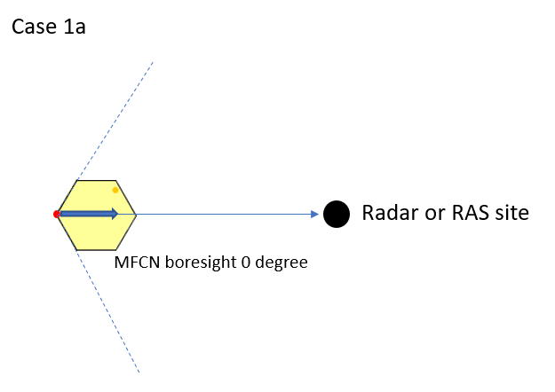 | 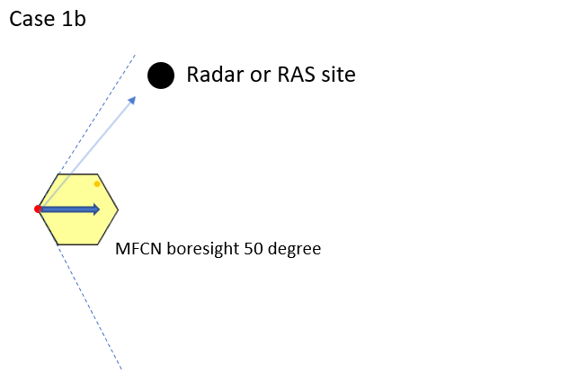
Figure 3: Case 1 with cellular BS sector (±60 degree) towards radar. In (a) with BS antenna boresight 0 degree towards radar and (b) boresight 50 degrees towards radar
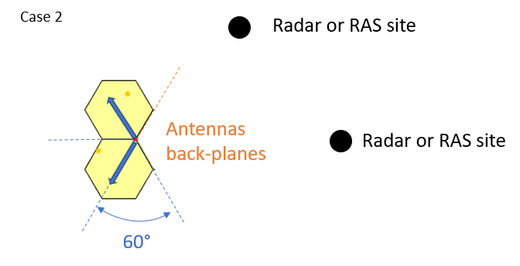 | 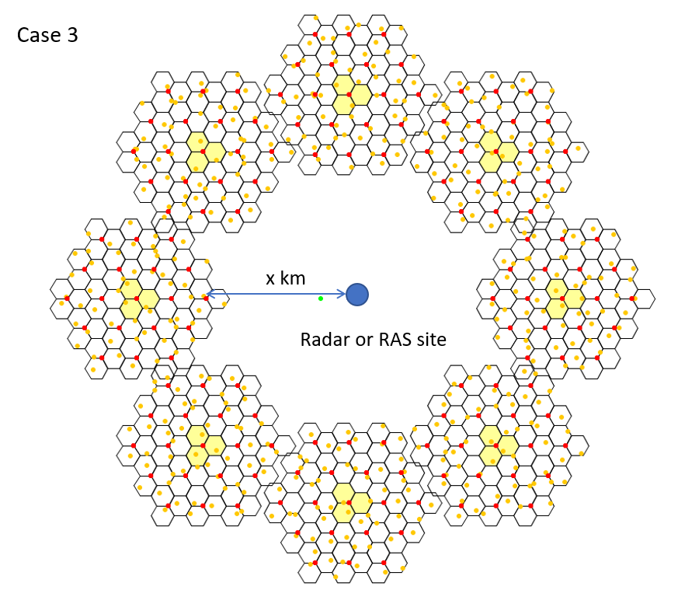
Figure 4: Case 2 with cellular BS sectors not towards radar within ±60 degree of boresight. Case 3 with cellular ring/grids around radar/RAS sites

Technical summary
Various stakeholders provided simulation results and the details are given in ANNEX 3 to ANNEX 7.
Case 1 radar: For cellular BS sectors pointing in the direction of radar station within ±60° from the boresight of the IMT antenna
Table 9 and Table 10 give the Δe.i.r.p./ΔiRSS from Study #1 and #2 for sector pointing towards radar within ±60 degrees boresight of the antenna for different areas. The Baselines in order to compare the values are given below the tables. The following conclusions can be made:
- The fully uncorrelated AAS beamforming case gives always less interference towards radar than the fully correlated AAS case. How well the beam for AAS is beamformed mainly depends on the separation in frequency between cellular and radar.
- The range ΔiRSS observed for rural/suburban and urban area is mainly due to the different boresights (0 to ±60 degrees) of the single sector towards radar. Larger interference or higher ΔiRSS value means the boresight of the sector is pointing directly towards the radar (0 degree).
- Other reasons for the differences observed in Case #1 for the same area between Study #1, Study #2 and Study #3 are due to: Different UE heights, actual distance between BS and radar, number of UEs sharing bandwidth per snapshot and difference in Baseline assumption as number of non-AAS Tx, general spurious emission and non-AAS feeder loss.
It is noted that the study did not evaluate the minimum distances for these cases where interference towards radar may matter.
It is further observed (see ANNEX 5) that for results with the radar in the boresight direction 0 degrees, when 5 degrees downtilt is used for the macro urban scenario (for AAS and non-AAS) as in ECC Report 174, the ΔiRSS is decreased by 7 dB compared to 10 degrees downtilt, as used in Report ITU-R M.2292 [20]. For the case with the radar in the direction of 50 degrees the difference is 4-5 dB (see ANNEX 3).
In table 9 and table 10 the terms Δe.i.r.p and ΔiRSS are used, Δe.i.r.p. = e.i.r.p.AAS – e.i.r.p.non-AAS in dB and ΔiRSS = iRSSAAS – iRSSnon-AAS in dB, where iRSS is the interfering Received Signal Strength.
Table 9: Δe.i.r.p./ΔiRSS for AAS (@CDF 98%) fully correlated case (ρ = 1) pointing towards radar within ±60° (0 and 50 degrees) from the boresight of the IMT antenna
 | Macro rural (non-AAS 2.5 to 3 and AAS 10 degree downtilt) | Macro suburban (non-AAS 5 to 6 and AAS 10 degree downtilt) | Macro urban (non-AAS and AAS 10 degree downtilt)
Study #1:  (Δe.i.r.p. for 1 single non-AAS Tx) | 12.4 to 13.4 dB | 15.3 to 17.6 dB | 20 to 21.6 dB
Study #2:  (ΔiRSS for 4 non-AAS Tx) | 0 to 4 dB | 1 to 9 dB | -1 to 13 dB

Table 10: Δ e.i.r.p./ΔiRSS for AAS uncorrelated case (ρ = 0) pointing towards radar within ±60° (0 and 50 degrees) from the boresight of the IMT antenna
 | 2.5 to 3 degree downtilt (macro rural) | 5 to 6 degree downtilt (macro suburban) | 10 degree downtilt (macro urban)
Study #1:  (Δ e.i.r.p. for 1 single non-AAS Tx) | -4 dB | -2 to +1 dB | +3 to +6 dB
Study #2:  (ΔiRSS for 4 non-AAS Tx) | -14 to -13 dB | -9 to -8 dB | -3 dB
The above studies have been performed with UE deployed uniformly over the cells. Different UE distributions could lead to a different Δe.i.r.p./ΔiRSS (see ANNEX 5:) In addition, the base station antenna height will impact the results. As an example in ANNEX 5, when considering 30 meters BS antenna height for the urban scenario as in ECC Report 174, instead of 20 meters as in Report ITU-R M.2292 [20], Δe.i.r.p./ΔiRSS would be reduced by 3-4 dB. It should be noted that Report ITU-R M.2292 was adopted after ECC Report 174 [6].
Baselines for comparing the results in the tables above:
Baseline Study #1: Spurious emissions for non-AAS: -30 dBm/MHz per Tx with 1Tx baseline, feeder loss 3 dB. Spurious emissions for AAS: -30 dBm/MHz and ΔGain @CDF AAS value 98%
Baseline Study #2: Spurious emissions for non-AAS: -30 dBm/MHz per Tx with 4Tx baseline, feeder loss 1 dB. Spurious emissions for AAS: -30 dBm/MHz and i iRSSAAS @CDF AAS value 98%
Assuming a full scaling of the number of transmitters, the difference between Study #1 and #2 should be roughly 8 dB (2 dB feeder loss, 6 dB for difference in the number of transmitters), noting that there are some minor differences on top of those presented in the baseline definitions (see further ANNEX 3 and ANNEX 4).
Case 2 radar: For cellular BS sectors NOT pointing in the direction of a radar/RAS station within ±60° from the boresight of the antenna
For non-AAS antenna model the back-lobe difference to the max antenna gain is about 28 dB. For AAS the front-to-back ratio Am = 30 dB for correlated case (ANNEX 2). This attenuation is due to ground plane in the antennas and depends on the actual design. The back lobe will get further attenuation to the front in real installations due to e.g. mast and other mountings/equipment in the back of the antenna.
For macro cellular BS sectors (rural/suburban/urban) NOT pointing in the direction of a radar/RAS station within ±60° from the boresight of the antenna it is expected that AAS (-30 dBm/MHz spurious emissions) will not cause more interference than non-AAS.
Case 3 RAS: Single sector and cellular grids around RAS
In ANNEX 4, simulation results with relative comparison between AAS/non-AAS interference (ΔiRSS) for worst-case scenario with single sector pointing towards RAS showed:
          - For wide area FDD BSs without upper power restriction the AAS iRSS can be higher compared to non-AAS. Site specific engineering solution can be used for these sites (sector direction, spatial filtering, etc) or reducing BS OOB emission.
          - For the unpaired frequency band which can be either TDD or SDL (2570-2620 MHz) the difference in AAS/non-AAS (ΔiRSS) is marginal and no restriction is needed. Options in order to limit OOB emission into the 2690-2700 MHz band are:
            - Relative suppression as a function of spectrum mask and ACLR; function of BS power and BS class, following 3GPP specification.
            - Operator/band specific implantation of BS affecting the upper two FDD 5 MHz blocks (2680-2690 MHz) increasingly.
ANNEX 5 proposes for specific areas with regard to RAS coordination, an additional OOBE limit in 2690-2700 MHz for the AAS FDD BS. This is based on equivalence with non-AAS BS with 8 antennas. Concerns are raised that stricter requirements are likely to result in significant complexity of AAS BS design and possibly prevent usage of AAS wide area BS in the upper two 5 MHz blocks of the FDD band. The proposed limits are to be combined with complementary mitigation techniques.
In ANNEX 6, RAS is studied in a single interferer worst-case scenario, as well as in an aggregation scenario. Monte Carlo simulations showed that the aggregated OOB emission from AAS (@98% CDF) can be 16.4 dB higher than for non-AAS, mostly owing to the higher OOB power. The influence of the antenna patterns (and beam-forming) alone is only a 4 dB increase. Both, generic and specific case studies show that the required coordination zone sizes can exceed 200 km and thus may require cross-border coordination.
ANNEX 7 provides a study which shows that due to the MFCN BS AAS characteristics (assumption are referring to TRP limits in OOB domain of AAS base stations which are 17 dB higher than the OOB limits of non-AAS base stations), the additional baseline reduces the size of the coordination zone (where national measures may include coordination distances or compliance with the maximum pfd level at the radio astronomy sites, for example). This study concluded that a -3 dBm/10 MHz conducted power limit in 2690-2700 MHz maintains the coordination zone in the same magnitude as it is for non AAS systems. As example, the geographical impact on the coordination zone with different baselines in 2690-2700 MHz for 0 dBm/10 MHz, 9 dBm/10 MHz, 17 dBm/10 MHz AAS conducted power limit per cell, is provided in ANNEX 7:.

Recommended updates to the Regulatory Framework

Recommended Band plan
In the context of ensuring suitability for 5G and AAS in the 2500-2690 MHz band, the recommended band plan for MFCN is aligned with the current harmonised spectrum scheme in ECC Decision (05)05 (amended July 2015):
- The frequency band 2500-2570 MHz is paired with 2620-2690 MHz for FDD operation with the mobile transmit within the lower band and base station transmit within the upper band;
- Administrations may assign the unpaired frequency band 2570-2620 MHz either for TDD or for Supplemental Downlink. Any guard bands required to ensure adjacent band compatibility at 2570 MHz and 2620 MHz boundaries will be decided on a national basis and taken within the band 2570-2620 MHz;
- Assigned blocks shall be in multiple of 5 MHz;
- The MFCN channelling arrangements blocks in the band 2500-2690 MHz are depicted in Figure 5.
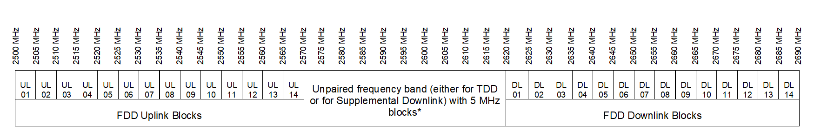
*Any guard bands required to ensure adjacent band compatibility at 2570 MHz and 2620 MHz boundaries will be decided on a national basis and taken within the band 2570-2620 MHz.
Figure 5: Recommended MFCN channelling arrangements blocks in the band 2500-2690 MHz for 5G NR and AAS

Applicable technical conditions

Unrestricted BEM for BS

In-block power limits
The in-block power limit for non-AAS of 61 dBm/5 MHz is derived from macro BS with 44 dBm/5 MHz and single transmit antenna with 17 dBi gain (see CEPT Report 19 [2]). For non-AAS CEPT administration can relax this limit in areas where this does no significantly increase the risk of terminal station receiver blocking, [2]. In ECC Report 119, the BS-MS interference was studied for the 2600 MHz band, [16]. In 3GPP specifications for macro BS, no upper bound is specified and for non-AAS up to 8 antennas are specified [14]. In recently updated ECC Decisions for 3.4 GHz ((11)06), [23]) and 2. 1 GHz ((06)01, [22]) the in-block power limit is given as "not obligatory" for non-AAS and AAS. For locations where coordination procedure with adjacent services applies an upper bound on output power can be set by administrations.
Table 11: Updated in-block power limits for non-AAS e.i.r.p. and AAS TRP
BEM element | Frequency range | non-AAS e.i.r.p limit | AAS TRP power limit
In-block | Block assigned to the operator | Not obligatory.  In case an upper bound is desired by an administration, a value between 61 and 68 dBm/5 MHz per antenna may be applied. | Not obligatory.  In case an upper bound is desired by an administration, a value between 53 and 60 dBm/(5 MHz) per cell (note 1)/sector may be applied.
Note 1: In a multi-sector base station, the radiated power limit applies to each one of the individual sectors.

Note: For locations where coordination procedure with adjacent services applies an upper bound on output power can be set by administrations

Out-of-block power limits: Interference between FDD/TDD MFCNs
For the AAS BS in-band Baseline BEM requirement the approach from ECC Report 281 for 5G MFCN operation in the 3400-3800 MHz band is followed. Table 12 describes the relationship between the proposed out-of-block BEM limits and the 3GPP unwanted emission mask from TS 38.104 for the 2600 MHz band [14].
Table 12: ECC limits and the 3GPP unwanted emission limits for unrestricted BEM
From TS 38.104, Table 6.6.4.2.2-2 |  |  |  | Comparison between 3GPP and ECC limits
Frequency offset (MHz) | 3GPP UEM  (note 1) | Mean power over 5 MHz block | Units | 3GPP:  Tx Power (dBm/5 MHz) | 3GPP TRP power limits (note 2) (dBm/5 MHz) | Proposed AAS TRP power limit dBm/5 MHz per cell/sector
0-5 MHz | -7 to -14 | -10.02 | dBm/(100 kHz) | 6.97 | 15.97 | 16
5-10 MHz | -14 | -14 | dBm/(100 kHz) | 2.99 | 11.99 | 12
≥ 10 MHz | -15 | -15 | dBm/MHz | -8.01 | 0.99 | 1
Note 1: Wide Area BS operating band unwanted emission limits (NR bands above 1 GHz) for Category B
Note 2:_Assuming a maximum of eight beam forming antenna elements
In alignment with the specification of unwanted emission conducted power (TRP) for AAS base stations in 3GPP TS 38.104 [14] and the analysis made in ECC Report 281 [12], it is proposed to specify the out-of-block TRP limits to a value that correspond to a total of eight beam forming antenna elements. Table 13 gives the proposed out-of-block TRP transitional region limits for the update of ECC Decision (05)05.
Table 13: Proposed out-of-block TRP limits for AAS MFCN Base Stations
BEM element | Frequency range | AAS TRP power limit  per cell (note 2)
Transitional region | -5 to 0 MHz offset from lower block edge (note 1) | +16 dBm/5 MHz
Transitional region | 0 to 5 MHz offset from upper block edge (note 1) | +16 dBm/5 MHz
Note 1: The BS transitional region BEM elements are based on the assumption that the emissions come from a Macro BS. It should be noted that small cells may be deployed at lower heights and thus closer to UEs which can result in higher levels of interference if the above power limits are used. For such cases, administrations could establish lower maximum mean TRP on a national level.
Note 2: In a multi-sector base station, the radiated power limit applies to each one of the individual sectors.
From the coexistence simulation results in ANNEX 1 between FDD and TDD in the 2600 MHz band, the baseline value for AAS to non-AAS BS and AAS to AAS BS it can be concluded that a TRP value of -52 dBm/MHz for a target value of ≤5% UL mean throughput loss. Table 14 gives the proposed out-of-block TRP baseline limits for the update of ECC Decision (05)05.
Table 14: Proposed TRP BS Baseline requirement
BEM element | Frequency range | AAS TRP power limit  per cell (note 1)
Baseline | FDD DL blocks (including SDL blocks), TDD blocks synchronised with the interfering TDD block (note 2) , or used for downlink only operation (note 3) . It further applies to 2615-2620 MHz | +5 dBm/MHz (note 4)
Baseline | Frequencies in the band 2500-2690 MHz not covered by the definition in the row above. | -52 dBm/MHz
Note 1: In a multi-sector base station, the radiated power limit applies to each one of the individual sectors.
Note 2: Synchronised operation in the context of this Decision means operation of TDD in two different systems, where no simultaneous UL reception and DL transmissions occurs.
Note 3: Introduction of FDD AAS does not impact the SDL usage condition for non-AAS/AAS.
Note 4: The BS baseline BEM elements calculated for protection of spectrum used for downlink transmissions is based on the assumption that the emissions come from a Macro BS. It should be noted that small cells may be deployed at lower heights and thus closer to UEs which can result in higher levels of interference if the above power limits are used.

Examples of combining BEM elements for non-AAS/e.i.r.p. and AAS/TRP
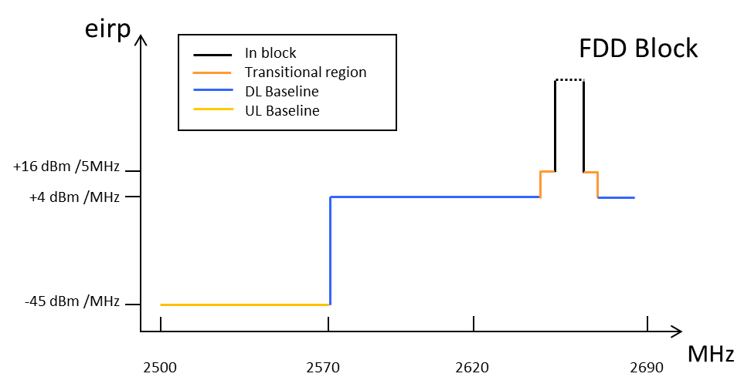
Figure 6: Combined BEM elements for an FDD block above 2620 MHz with downlink only operation within 2570-2620 MHz for non-AAS

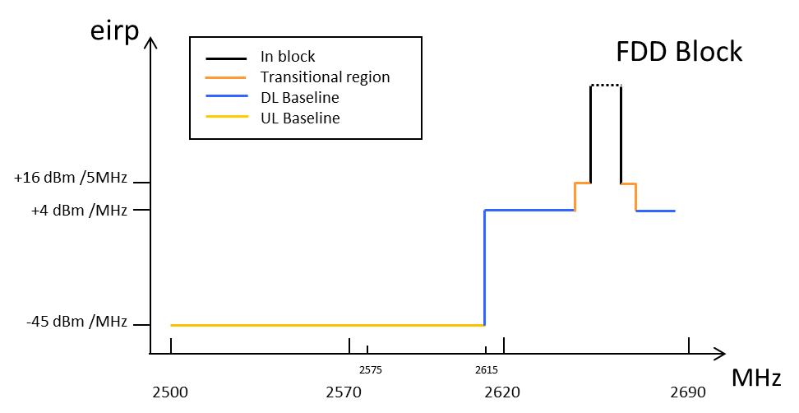
Figure 7: Combined BEM elements for an FDD block with TDD (synchronised/unsynchronised) networks within 2570-2620 MHz for non-AAS

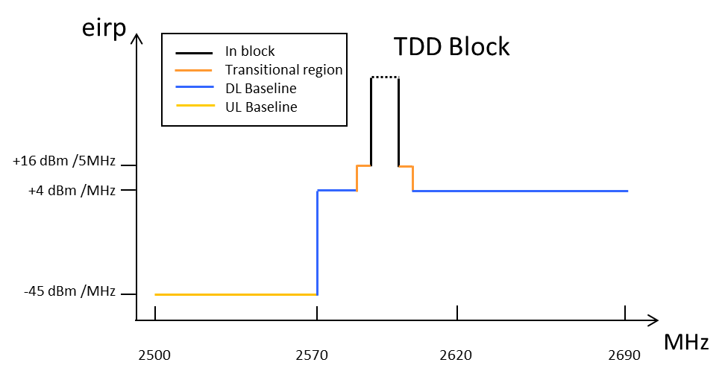
Figure 8: Combined BEM elements for synchronised TDD blocks / downlink only blocks for non-AAS

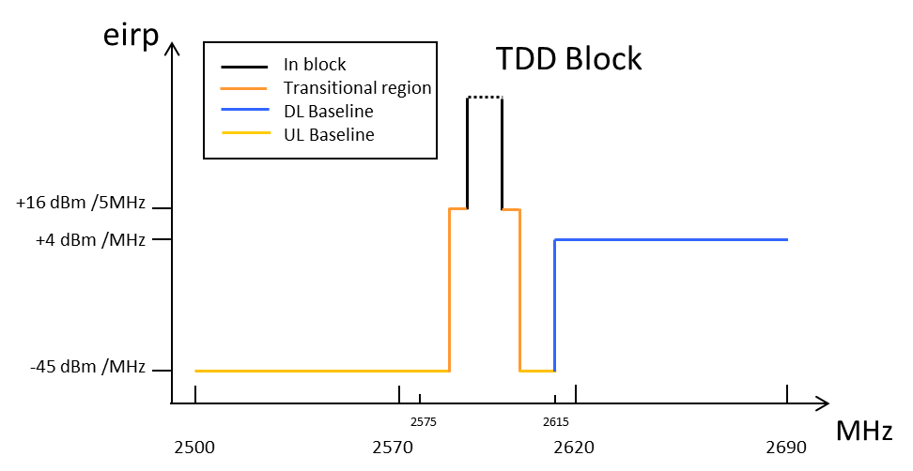

Figure 9: Combined BEM elements for unsynchronised TDD blocks for non-AAS
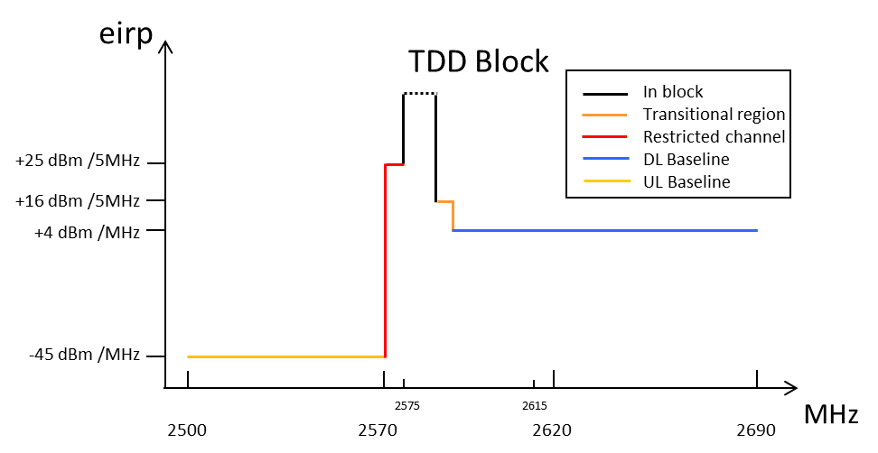
Figure 10: Combined BEM elements for synchronised TDD/downlink only blocks and a restricted spectrum block in 2570-2575 MHz for non-AAS
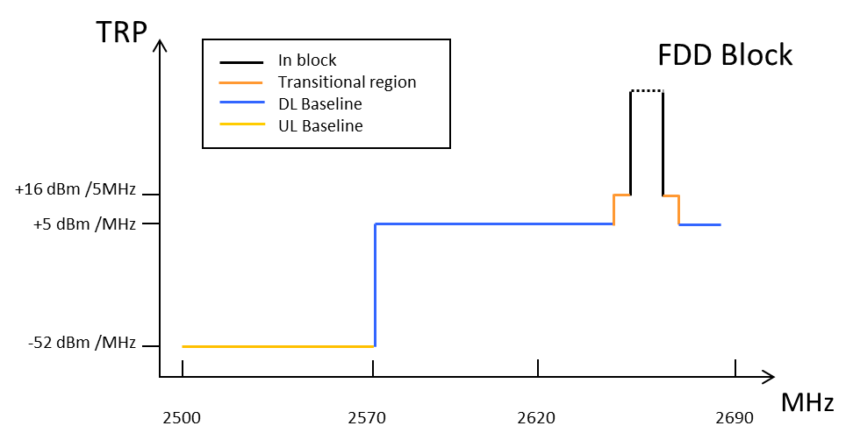
Figure 11: Combined BEM elements for an FDD block above 2620 MHz
with downlink only operation within 2570-2620 MHz for AAS

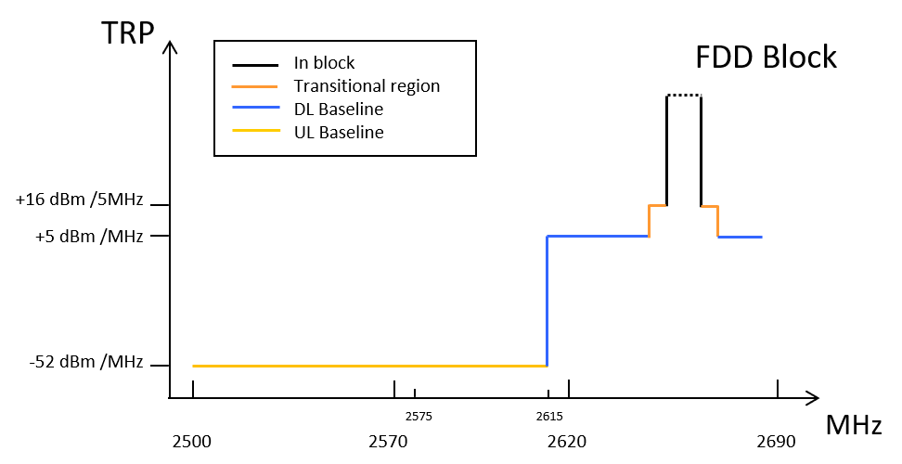
Figure 12: Combined BEM elements for an FDD block with TDD
(synchronised/unsynchronised) networks within 2570-2620 MHz for AAS
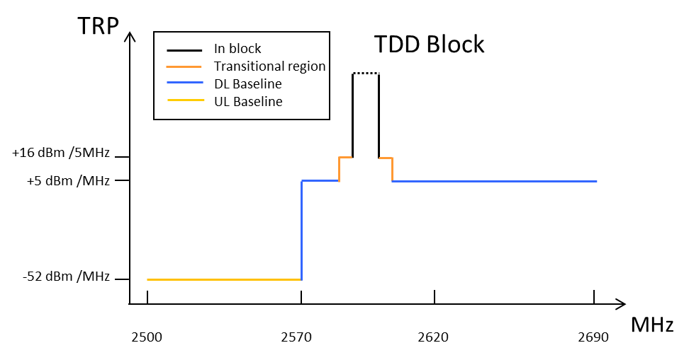
Figure 13: Combined BEM elements for synchronised TDD blocks/downlink only blocks for AAS

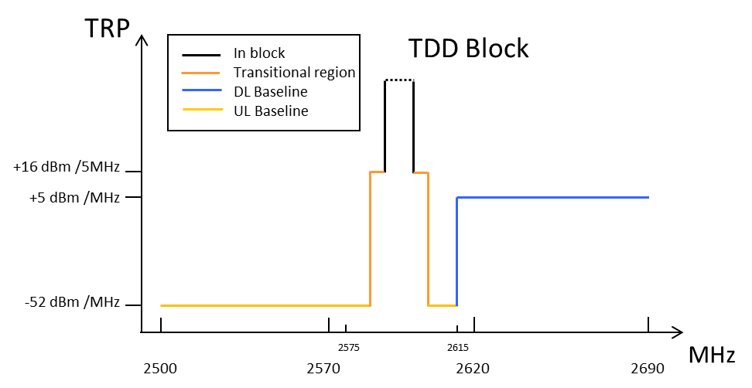
Figure 14: Combined BEM elements for unsynchronised TDD blocks for AAS
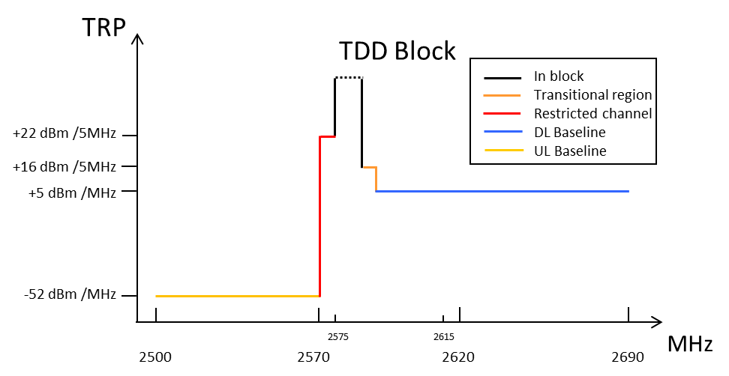
Figure 15: Combined BEM elements for synchronised TDD/downlink only blocks and a restricted spectrum block in 2570-2575 MHz for AAS

TDD unsynchronised operation
For FDD/TDD coexistence: the restricted blocks are 2570-2575 MHz (except in UL mode operation in that block). This is applicable for all configurations of FDD AAS adjacent to TDD non-AAS and FDD non AAS adjacent to TDD AAS. It should also be noted that the 5 MHz TDD block (2615-2620 MHz) immediately adjacent to a FDD DL block may suffer an increased risk of interference due to the emissions from the FDD DL.
For Indoor AAS BSs or AAS BS with restrictions on antenna placement, alternative measures compared to Table 14 or Table 15 may be required on a case by case basis and on a national basis ( see section 5.2.4).
Concerning usage of 2570-2620 MHz under the LRTC, it shall be noted that CEPT has studied and developed a toolbox in 3400-3800 MHz to address the synchronised and unsynchronised operation and help administrations, operators and spectrum rights users understand coexistence topics and performance impacts related to synchronised and unsynchronised TDD operations. This could be reused for this band.
Concerning synchronised TDD operation, in addition to the unrestricted BEM developed for synchronised TDD blocks, a general framework could be defined at the national level, specifying technical parameters and the scope of their applicability, and administrations may facilitate the process to ensure fair and timely agreements in cases where agreements could be more challenging.
A possible alternative to the synchronised approach implies respecting the unrestricted BEM level for unsynchronised MFCN combined with 5 MHz restricted block between 2 TDD unsynchronised blocks. Respecting the TRP baseline limit of -52 dBm/MHz between 2 unsynchronised blocks would imply the introduction of an additional internal filter within the AAS TDD base station. Since the implementation of such filter would depend on the operator's specific spectrum assignment, the filter (and the AAS base stations) would become operator-specific which would not be economically sustainable.

Restricted BEM for BS
For the restricted block the rated TRP in-block power is given by a 3 dBi antenna gain factor (see Reference [2] section A.4.4.3).
The BEM for a restricted spectrum block is built up by combining Table 14 and Table 15 in such a way that the limit for each frequency is given by the higher value out of the baseline requirements and the block specific requirements.
The restricted blocks are 2570-2575 MHz (except in UL mode operation in that block) and any 5 MHz block between unsynchronised TDD networks. This is applicable for all configurations of FDD AAS adjacent to TDD, both AAS and non-AAS.
Concerning the AAS TDD usage in 2570-2620 MHz the OOB performance of the restricted block for unsynchronised TDD operation needs very high isolation to the adjacent block. Such isolation is not feasible for AAS unless part of this isolation comes from indoor loss, significant geographical separation or special site engineering (see section 5.2.4).
It should also be noted that a 5 MHz TDD block (2615-2620 MHz) immediately adjacent to a FDD DL block may suffer an increased risk of interference due to the emissions from the FDD DL.
Table 15: Updated BS In-block power limit for restricted spectrum blocks
BEM element | Frequency range | Non-AAS e.i.r.p limit | AAS TRP power limit per cell (note 2)
In-block | Restricted Block spectrum | + 25 dBm/5 MHz (note 1) | + 22 dBm/5 MHz (note 1)
Note 1:) It is noted that in some deployment scenarios this in-block power limit may not guarantee interference free UL operation in adjacent channels, although this would typically be mitigated by building penetration loss and/or difference in antenna height. Other mitigation methods may also be applied.
Note 2: In a multi-sector base station, the radiated power limit applies to each one of the individual sectors.

Restricted BEM for BS with restrictions on antenna placement
The existing non-AAS values also apply for 5G NR for non-AAS operation. For Indoor AAS BSs or AAS BS with restrictions on antenna placement, alternative measures compared to Table 14 or Table 15 may be required on a case by case basis and on a national basis. Therefore, it is proposed not to add any specific AAS TRP values to the decision for AAS BS with restrictions on antenna placement.

Limits at 2690-2700 MHz for FDD AAS base station
Cases for an additional baseline which may be applied between 2690-2700 MHz for AAS BS in specific geographical areas with regard to RAS usage are provided in Table 16. There are two cases described in Table 16: Case A where the additional baseline limit is applied in order to reduce the necessary coordination zone with RAS station(s) and Case B where the additional baseline limit is not considered necessary by the concerned administration (e.g. where there is no nearby RAS station or situations where no coordination zone is required).
Table 16: Cases for additional baseline to be applied between 2690-2700 MHz for AAS BS in areas where necessary to reduce the size of the coordination zone with RAS
Case | BEM element | Frequency range | AAS TRP power limit  per cell
A | Additional Baseline | 2690-2700 MHz | 3 dBm/10 MHz
B | Additional Baseline | 2690-2700 MHz | Not applicable
Case A: This additional baseline limit yields a reduced coordination zone with respect to RAS stations (see Figure 16).
Case B: In situations where additional baseline is not considered necessary by the concerned administration (e.g. where there is no nearby RAS station or situations where no coordination zone is required).
Note: Additional measures may be needed on a national basis in order to protect the RAS station(s). Depending on the size of the necessary coordination zone to protect RAS station(s) cross border co-ordination may also be necessary.
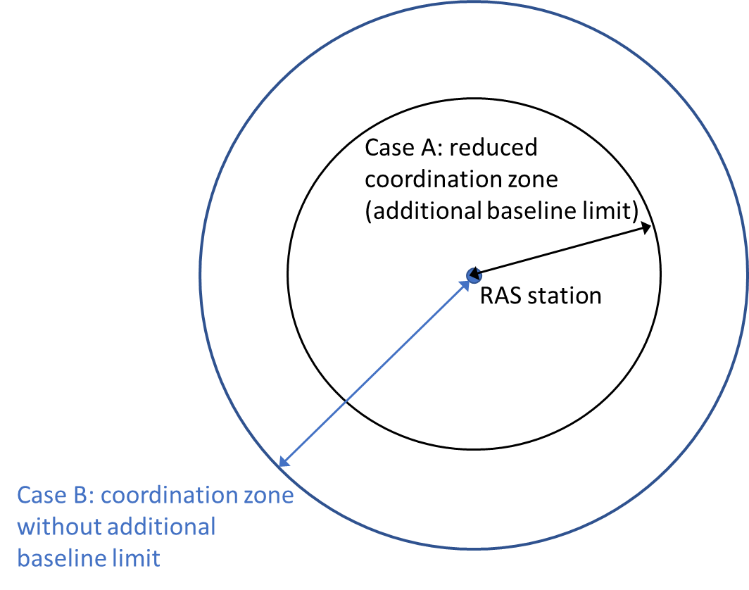
Figure 16: Simplified example of coordination zones around RAS station for AAS base stations
Measures applicable at national level, such as pfd limits in order to protect the various types of radars would remain applicable, noting that it may be more complex for operators to comply with the pfd limit since AAS systems cannot be fitted with additional external filters.

Limits for terminal stations
The 5G terminal characteristics defined in TS 38.101-1 [4] for the MFCN band 2500-2690 MHz are similar to LTE terminal characteristics. The AAS feature in 3GPP for this band applies to the BS side and does not impact the terminal side specification.
Based on the above and in the context of ensuring suitability for 5G and AAS in the 2500-2690 MHz band, the recommended limits for terminal stations for MFCN are aligned with the limits in current ECC Decision (05)05:
Table 17: In-block power limits for terminal stations
BEM element | Maximum mean power  (including Automatic Transmitter Power Control (ATPC) range)tic Transmitter Power Control (ATPC) range)
In-block | 31 dBm/5 MHz (TRP)
In-block | 35 dBm/5 MHz (e.i.r.p.)

Conclusions
This ECC Report recalled the current harmonised technical conditions defined for the 2500-2690 MHz band in the ECC Decision (05)05 approved in March 2005 and amended in July 2015 and studies their suitability for 5G. The 5G terminal characteristics defined in TS 38.101-1 for the MFCN bands 2500-2690 MHz [4] are similar to LTE terminal characteristics. The introduction of AAS systems will only be effective on the base station side as it is not foreseen for the user equipment. The findings in this Report and recommended updates of the existing ECC Decision (05)05 include:
- BS unrestricted BEM for AAS with TRP;
- BS restricted BEM in-block power for AAS with TRP;
- In-band coexistence between FDD and TDD AAS and non-AAS;
- Measures for the coexistence with other services; radar above 2700 MHz [6]
There is possibility of higher interference for AAS compared to existing non-AAS for sectors pointing towards such other services stations for frequencies close to the upper edge of the DL band where the beam is still more likely to be beamformed. When AAS is not pointing towards such other services stations (i.e. outside ±60 degree of AAS antenna boresight), AAS is not expected to cause more interference than non-AAS BSs.
- Measures for the coexistence with other services; RAS (2690-2700 MHz) [5]
An additional baseline has been developed at 2690-2700 MHz for AAS FDD base stations to reduce the size of the coordination zone with radio astronomy sites where considered necessary by the concerned administration. The feasibility of implementation of wide area outdoor AAS base stations in the highest two 5 MHz blocks taking into account the additional baseline limit may require evolution of filtering capabilities for AAS. However, these two upper blocks would remain usable for BS with lower power.
However, additional measures may be needed on a national basis in order to protect the RAS. Depending on the size of the necessary coordination zone to protect RAS cross border co-ordination may also be necessary.
This Report concludes on the need to update regulatory framework to support the introduction of 5G in the 2500-2690 MHz band and recommends an updated framework. CEPT concluded that there is no need to update current band plan for 2500-2690 MHz in ECC Decision (05)05. The recommended framework in this report is fully in line with the July 2019 revision of ECC Dec (05)05 and CEPT Report 72.
When considering 5G usage, the analysis confirms that the current BEM remains applicable for non-AAS and the need for a new BEM for AAS in order to ensure coexistence intra-band and with adjacent services. It is noted that the spurious domain for the base station in this frequency band starts 10 MHz from the band edge and that the corresponding limits are defined in current ERC Recommendation 74-01 [7] (i.e. -30 dBm/MHz, which was assumed in this Report).
Identification of required amendments to the existing framework for the 2500-2690 MHz frequency band are defined in section 5.

- AAS (LTE/NR) coexistence study between FDD and TDD networks within 2500-2690 MHz
  - Simulation scenarios
This contribution considers the impact of base station to base station interference between MFCNs with non-time-aligned UL and DL transmission is considered in terms of the resulting degradation in UL throughput of the victim MFCN. The MFCNs are considered to consist of macro base stations.
Two scenarios are addressed according to whether the interferer and victim base stations use AAS technology or not are addressed, namely:
- Interference from “AAS to non-AAS” base stations;
- Interference from “AAS to AAS” base stations.
Note that an AAS base station is considered to form a beam towards the serving UE (assumed to be uniformly distributed within a cell), whereas a non-AAS base station is assumed to have a fixed antenna directional pattern.
The MFCNs consist of base stations in a hexagonal grid with an inter-site distance (ISD) of 500 metres.
The victim MFCN consists of base stations in a hexagonal grid that is shifted by 70 metres with respect to the interfering MFCN.
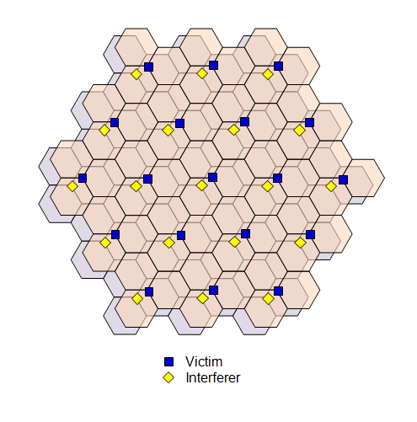
Figure 17: Interferer-victim separation of 70 metres
  - Simulation Parameters
Table 18 and Table 19 show parameters used in simulating the various scenarios. Note that free space path loss is considered for the modelling of signal propagation from an interfering base station to a victim base station. The antenna directional pattern for non-AAS base stations is modelled as per described in ECC Report 203 [24]. Table 20 shows the antenna array characteristics modelled for AAS base stations.
Table 18: Parameters for “AAS to non-AAS” scenario
Interferer |  | Victim
Beamforming towards UEs with (8×8) array.  UEs uniformly distributed in each hexagonal cell |  | Fixed directional pattern  (effectively single antenna)
Network Deployment | Hexagonal cells  ISD = 500 m. | Network Deployment | see above
Element gain | 8 dBi | Maximum antenna gain | 17 dBi
Channel bandwidth | 20 MHz | Channel bandwidth | 20 MHz
Effective channel bandwidth | 90% | Effective channel bandwidth | 90%
TRP power | 53 dBm/(20 MHz) | Noise figure | 5 dB
Table 19: Parameters for “AAS to AAS” scenario
Interferer |  | Victim
Beamforming towards UEs with (8×8) array.  UEs uniformly distributed in each hexagonal cell |  | Beamforming towards UEs with (8×8) array.  UEs uniformly distributed in each hexagonal cell
Network deployment | Hexagonal cells  ISD = 500 m. | Network deployment | see above
Element gain | 8 dBi | Element gain | 8 dBi
Channel bandwidth | 20 MHz | Channel bandwidth | 20 MHz
Effective channel bandwidth | 90% | Effective channel bandwidth | 90%
TRP power | 53 dBm/(20 MHz) | Noise figure | 5 dB
Table 20: Parameters for AAS
Parameters for AAS
Antenna element  directional pattern $a_{E dB}\left(θ,φ\right)$ | According to 3GPP TR 37.840 (section 5.4.4.2):  $$a_{E dB}\left(θ,φ\right)=-min\left\{-\left[A_{E,V dB}\left(θ\right)+A_{E,H dB}\left(φ\right)\right],{ A}_{m dB}\right\},$$  $$A_{E,H dB}\left(φ\right)=-min\left\{12{\left(\frac{φ}{φ_{3dB}}\right)}^{2},A_{m dB}\right\},$$  $$A_{E,V dB}\left(θ\right)=-min\left\{12{\left(\frac{θ-90°}{θ_{3dB}}\right)}^{2},{SLA}_{V dB}\right\},$$  where:  - 3 dB elevation beamwidth θ3dB = 65°;  - 3 dB azimuth beamwidth ϕ3dB = 80°;  - Front-to-back ratio Am = 30 dB;  - Side-lobe ratio SLAV = 30 dB.  NOTE: $a_{E}\left(θ,φ\right)≤1$.  NOTE: Each antenna element is larger in size in the vertical direction, and so θ3dB < ϕ3dB (see 3GPP TR 37.840).
Antenna element gain $G_{E dB}$ | 8 dBi
Number of base station beamforming elements  (NV, NH) | (8,8)
Element spacing | 0.9λ vertical separation.  0.6λ horizontal separation.  NOTE: Larger vertical spacing provides narrower array beamwidth in elevation (see 3GPP TR 37.840 (Table 5.4.4.2.1-1)).
  - Simulation Results
    - AAS BS interference to non-AAS BS
Figure 18 below shows the estimated degradation of the mean uplink throughput of the victim MFCN due to base station to base station interference from the interfering MFCN, presented as a function of ACIR.

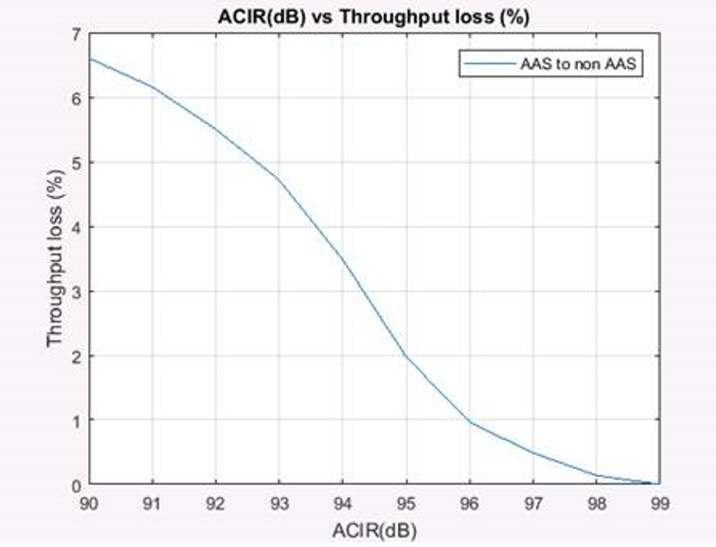
Figure 18: Impact of AAS base station to non-AAS base station interference
As expected, the impact of interference on network performance diminishes with increasing values of ACIR. In order to get less than 5% average throughput loss, 92.5 dB ACIR is necessary.
Table 21 presents the implied restrictions on the out-of-block radiations based on a target 5% degradation in the mean UL throughput of the victim MFCN. Note that the required ACLR is assumed to be nominally equal to the required ACIR, with the understanding that interference is not dominated by the adjacent channel selectivity (ACS) of the victim base station.
Table 21: Out-of-block emission limits which would result in 5% degradation in mean uplink throughput of victim MFCN
Scenarios | Interferer BS bandwidth | Victim BS bandwidth | In-block Radiated power | ACIR Required (~ACLR) | Out-of-block  radiated power
(1)  AAS to non-AAS | 20 MHz | 20 MHz | TRP:  53 dBm/20 MHz  47 dBm/5 MHz | 92.5 dB | TRP:  -45.5 dBm/5 MHz  -52.5 dBm/1 MHz
    - AAS BS interference to AAS BS
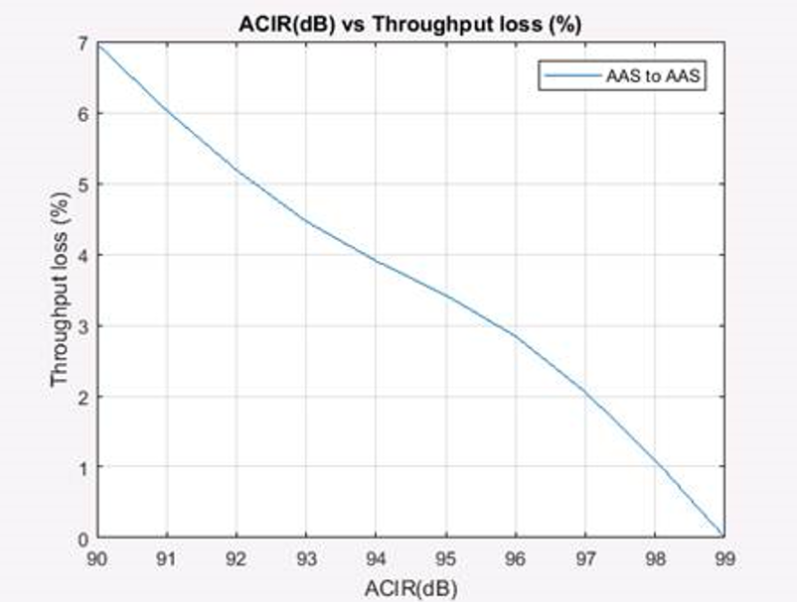
Figure 19: Impact of AAS base station to AAS base station interference
As expected, the impact of interference on network performance diminishes with increasing values of ACIR. In order to get less than 5% average throughput loss, 92.2 dB ACIR is necessary. Table 22 presents the implied restrictions on the out-of-block radiations.
Table 22: Out-of-block emission limits which would result in 5% degradation in mean uplink throughput of victim MFCN
Scenarios | Interferer BS bandwidth | Victim BS bandwidth | In-block radiated power | ACIR required (~ACLR) | Out-of-block radiated power
(2)  AAS to AAS | 20 MHz | 20 MHz | TRP:  53 dBm/20 MHz  47 dBm/5 MHz | 92.2 dB | TRP:  -45.2 dBm/5 MHz  -52.2 dBm/1 MHz
  - Conclusions
The impact of base station to base station interference between FDD and TDD MFCNs has been characterised. Specifically, “AAS to non-AAS” and “AAS to AAS” interferer to victim scenarios has been considered.
For each scenario, separation between a victim base station and the nearest interfering base station of 70 metres consistent with the analyses that were driven for 3400-3800 MHz has been considered.
Based on the results, and assuming a target 5% degradation in UL throughput in the victim MFCN, one may conclude that for AAS base stations, the results indicate that a baseline TRP limit of -52 dBm/ MHz would be appropriate.
This results is consistent with the current BS Baseline e.i.r.p. limit of -45 dBm/MHz defined for non-AAS BS in ECC Decision (05)05.
It is proposed to update the existing restricted baseline limit in line with the simulations results provided in this annex, and to express this in terms of TRP as indicated below.
Table 23: Updated unrestricted BS baseline requirement for AAS base stations
BEM element | Frequency range | Maximum Mean AAS  TRP per cell (dBm/MHz)
Baseline | Frequencies in the band 2500-2690 MHz not covered by the definition in the row above | -52 dBm/MHz

- Parameters for the interference study in the 2600 MHz MFCN band between non-AAS and AAS and adjacent services above 2690 MHz (RAS and radar)
  - LTE/NR parameters
Table 24: LTE/NR Base Station specific parameters (from ECC Report 45 [5], ECC Report 174 [6], ECC Report 281 [13] and 3GPP specification [15])
Parameter | Values | Used for this study
OOB emissions, TRP  (0 to 10 MHz from DL band edge) | For non-AAS MSR mask is used (ECC Report 45 [5])  Average power per connector: -69.7 dBm/Hz  Scales up with number of antennas | -69.7 dBm/Hz  (per Tx TRP)
OOB emissions, TRP  (0 to 10 MHz from DL band edge) | For AAS NR mask (3GPP TS 38.104 [15])  Average TRP power: -52.54 dBm/Hz  TRP power is independent of number of antenna elements for AAS | -52.54 dBm/Hz  (TRP)
Spurious emission limits, TRP | ERC Recommendation 74-01 [7]. For 10 MHz from band edge: -30 dBm/MHz | -30 dBm/MHz
    - Background information on the OOB emission assumptions
For more details on 3GPP mask (see section A2.7).
      - The MSR mask (non-AAS)
Average OOB TRP power (0 to 10 MHz): -69.7 dBm/Hz
Assuming lossless antenna system and for 1 Tx

Table 25: ECC limits for unrestricted BEM and the 3GPP UEM
From TS 37.104 Table 6.6.2.1-1 [8]:  Wide Area operating band unwanted emission mask (UEM) for BC1 and BC3 |  |  |  | Comparison between 3GPP and ECC limits
Frequency offset (MHz) | 3GPP unwanted emission mask | Average Tx power | Units | 3GPP:  Tx Power  (dBm/(5 MHz)) |  | 3GPP:  e.i.r.p.* | ECC  e.i.r.p.
0 to 0.2 | -14 | -14.0 | dBm/(30 kHz) | 8.2 | -0.7 | +16.3 dBm/  (5 MHz) | +16 dBm/  (5 MHz)
0.2 to 1 | -14 to -26 | -18.5 | dBm/(30 kHz) | 3.7 | -0.7 | +16.3 dBm/  (5 MHz) | +16 dBm/  (5 MHz)
1 to 5 | -13 | -13.0 | dBm/MHz | -6.0 | -0.7 | +16.3 dBm/  (5 MHz) | +16 dBm/  (5 MHz)
5 to 10 | -13 | -13.0 | dBm/MHz | -6.0
*using 17 dBi antenna gain for non-AAS
      - For NR mask (AAS)
Average OOB TRP power (0 to 10 MHz): -52.54 dBm/Hz
Assuming lossless antenna system, minimum number of antennas ≥8

Table 26: Proposed out-of-block TRP limits for AAS MFCN Base Stations
BEM element | Frequency range | AAS TRP power limit per cell/sector
Transitional region | -5 to 0 MHz offset from lower block edge  0 to 5 MHz offset from upper block edge | +16 dBm/5 MHz
Transitional region | -10 to -5 MHz offset from lower block edge  5 to 10 MHz offset from upper block edge | +12 dBm/5 MHz
From ECC Report 281, [12]:

Table 27: ECC limits and the 3GPP unwanted emission mask
From TS 38.104, Table 6.6.4.2.2-2 |  |  |  | Comparison between 3GPP and ECC limits
Frequency offset (MHz) | 3GPP unwanted emission mask (TS 38.104, Table 6.6.4.2.2-2) (Note 1) | Mean power over 5 MHz block | Units | 3GPP:  Tx Power (dBm/5 MHz) | AAS TRP power limit dBm/5 MHz per cell/sector
0-5 MHz | -7 to -14 | -10.02 | dBm/(100 kHz) | 6.97 | 16
5-10 MHz | -14 | -14 | dBm/(100 kHz) | 2.99 | 12
≥ 10 MHz | -15 | -15 | dBm/MHz | -8.01 | 1
Note 1: Wide Area BS operating band unwanted emission limits (NR bands above 1 GHz) for Category B
  - non-AAS and AAS parameters
Table 28: non-AAS parameters (Mainly from Report ITU-R M.2292 and Recommendation ITU-R F.1336 [20] but also from ECC Report 174 and 281, 3GPP specification and actual network deployment non-AAS)
Parameter | Range examples | Used for this study
Number of antennas | 1, 2, 4 and 8  (3GPP specified 8x8 MIMO in DL for non-AAS, cross-polarised BS antennas are usually used in LTE networks) | 2 or 4
Feeder loss  Remote Radio Head | 1 to 3 dB  (from Report ITU-R M.2292 [20] and actual network) | 1 and 3 dB
Max. Antenna gain dBi (3-sector sites assumed for macro) | 17 to 20 dBi | 18 dBi
Antenna type | Sectoral (3 sectors) | 3 sectors
Antenna Pattern | Recommendation ITU-R F.1336-4  (Add ref to the appropriate parameters in Report ITU-R M.2292) | Recommendation ITU-R F.1336 - 4
3 dB antenna beamwidth in elevation | Calculated by using Recommendation ITU-R F.1336-4 formula and 65 degrees azimuth.)
3 dB antenna beamwidth in azimuth (from Report ITU-R M.2292) | 65° | 65°
Polarisation | ± 45° cross-polarised | ± 45° cross-polarised

Table 29: AAS parameters (from Recommendation ITU-R M.2101 [10], Report ITU-R M.2292 [20] and ECC Report 281) [12] )
Parameter | Range | Used for this study
Antenna element  directional pattern $a_{E dB}\left(θ,φ\right)$ | Model: Recommendation ITU-R M.2101  Parameters:  According to 3GPP TR 37.840 (section 5.4.4.2) where  3 dB azimuth beamwidth ϕ3dB = 80°  3 dB elevation beamwidth θ3dB = 65°  Front-to-back ratio Am = 30 dB  Side-lobe ratio SLAV = 30 dB  NOTE: $a_{E}\left(θ,φ\right)≤1$.  NOTE: Each antenna element is larger in size in the vertical direction, and so θ3dB < ϕ3dB (see 3GPP TR 37.840). |   (Take left column)
Element spacing | 0.9λ vertical separation.  0.6λ horizontal separation. |   (Take left column)
Beam forming and UE distribution | At each Monte Carlo trial, in each sector a single beam is steered in azimuth and elevation toward a UE which is dropped randomly within the sector.  (at this stage analysis with several simultaneous UEs is not excluded)  In the macro-cell urban scenario, 70% of UEs will be considered indoor (see Report ITU-R M.2292, with a height above ground that is uniformly distributed with values of 1.5 + {0, 3, 6, 9, 12, 15} metres.  In the micro-cell urban scenario, 70% of UEs will be considered indoor (see Report ITU-R M.2292), with a height above ground that is uniformly distributed with values of 1.5 + {0, 3, 6} metres.  In rural areas, 50% of UEs will be considered indoor, with a height of 1.5 m above ground.  Outdoor UEs in all cases are assumed to be at a height of 1.5 m above the ground. | Radar: macro-cell urban scenario and rural  RAS: suburban (add) and rural
Sectorisation | Each macro base station would have three independent sectors (120° each) (see 3GPP TR 37.840). The orientation of the sectors need not change from one Monte Carlo trial to the next.  Micro base stations will not be sectorised.  The previously preferred methodology is based on a single sector, in which case the above isn’t necessary. Some studies will be based on Monte Carlo simulations though, at least for RAS. | (Take left column, if methodology requires several sectors)
Mechanical down tilt | Macro-cell: 10°  NOTE: For macro-cell (see Report ITU-R M.2292) | Macro-cell: 10°
Correlation (antenna beamforming) | ρ = 0 and 1 | 0 and 1
Antenna element gain $G_{E dB}$ | 8 dBi | 8 dBi
Number of base station beam forming elements | 32, 64 (8*8) | 64
  - Ras and radar parameters
It is not proposed to use the actual radar rotating/scanning and antenna pattern. AAS and non-AAS in the 2600 MHz band are studied on same basis when it comes to interference to radars and RAS sites. In ECC Report 174 four different types of radars are listed.
Table 30: Radar/RAS specific parameters (from Recommendation ITU-R F.1245 [25], ITU-R .RA.769 [26] and ECC Reports 174 [6], ECC Report 281 [12] and ECC Report 45 [5])
Parameter | Values | Used for this study
Antenna height above ground | Antenna height for radar above ground 4 to 30 meter. In ECC Report 281 10 meter was taken for some study | Met radar: 13 m (above the ground)
Antenna height above ground | RAS are typically located in rural areas (see ECC Report 45 Section A.4.2) | 50 m
Antenna type and pattern ( see A2.5 ) | Antenna patterns are given in ECC Report 174 and ECC Report 281 for ground radars  It can be in the analysis that the meteorological radar is fixed in one azimuthal direction and 0.5 degrees elevation above the horizon  For RAS 0 dBi was assumed for the antenna receive (see ECC Report 45 Section A.3). | For meteorological radar antenna pattern use Recommendation ITU-R F.1245 [27] (see also ECC Report 174 [6]) (noting that Recommendation ITU-R F.1245-1 was used in ECC Report 174, but there is no relevant difference related to Recommendation ITU-R F.1245-2, for our purposes.)  For RAS (ECC Report 45 [5])  0 dBi antenna gain
Protection level | For I/N = -10 dB  ECC Report 174 [6] Table 5 „Radar characteristics“, protection level given as -122 dBm/MHz  ECC Report 281 [13] Table 37 “Radar interference thresholds” with -121 dBm/MHz | For meteorological radar:  I/N:-10 dB which is equivalent to -122 dBm/MHz  For RAS:  Recommendation ITU-R RA.769 [28]  -207 dBW/10 MHz  Percentage of time of allowed exceedance: 2%
  - Other parameters
Table 31: Simulation result targets
Target | Value | Used for this study
CDF acceptable %  With e.g. interference exceeding the acceptable interference level or AAS antenna gain distribution towards victim | RAS single emitter and aggregate (MCL) simulations | Percentage of time of allowed exceedance: 2%
Table 32: Propagation model parameters
Parameters | Values | Used for this study
Frequency | 2690-2900 MHz | 2600 MHz
Median path loss and clutter loss | Macro-cell:  a) Free space (Recommendation ITU-R P.525 [27])  b) Recommendation ITU-R P.452 [24]  NOTE: The random clutter loss for micro-cells has a CDF that is specified by Recommendation ITU-R P.2108-0 [30]  NOTE: Building (clutter) height of 18 metres in urban and 5 metres in rural  Note: for a comparison between AAS and non-AAS (radar analysis) clutter loss is not necessary, it applies equally to both cases. | For radar:  Free space (Recommendation ITU-R P.525 [29]) and Recommendation ITU-R P.452 [26] if necessary.  Clutter loss as applicable.  For RAS:  Recommendation ITU-R P.452

Table 33: 5G MFCN Base Station deployment parameters (from Report ITU-R M.2292, ECC Report 281, ECC Report 174 and ECC Report 45 mainly)
Parameters | Values | Used for this study
Cellular grid/sector as used for radar | Comment: Cell radius in ECC Report 174 [6] is different defined than in Report ITU-R M.2292 [21] (“Cell radius _ECC Report 174” = “Cell radius Report ITU-R M.2292” / 2)  For the simulation follow the cell-radius definition from Report ITU-R M.2292 as shown in the figure below with “A” cell radius and “B” ISD  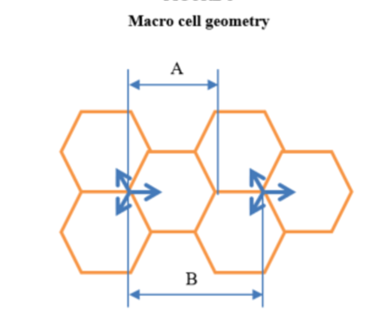 | For radar  Min distance cellular surrounding grid to radar: [1 to 10 km]  For Macro-cell rural, suburban and urban scenario (see Table 3 in Report ITU-R M.2292 [21] for bands between 2 and 3 GHz and ECC Report 174 [6])  Report ITU-R M.2292: For example macro urban cell radius typical 0.4 km corresponding to ISD = 0.6 km  ECC Report 174 contains, ISD has 12990 m (rural) and 660 m (urban)  UEs are placed in that rings randomly within the cellular grid/cell as defined by the ISD/cell radius
Antenna height above ground | Use Report ITU-R M.2292 [21] values and ECC Report 174 [6] for non-AAS  Macro-cell: 45 metres (rural)  Macro-cell: 30 metres (urban) | From Report ITU-R M.2292 [21] for rural, suburban and urban scenario 30, 25 m and 20 m, respectively  ECC Report 174 [6] with 45 m (rural), 30 m (urban)
Mechanical downtilt | Use Report ITU-R M.2292 [21] and  From ECC Report 174 [6] for non-AAS  Macro-cells: 2.5 degrees (rural)  Macro-cells: 5 degrees (urban)  use Report ITU-R M.2292  From ECC Report 281 [13] for AAS  Macro-cells: 10 degrees (suburban/urban) | From Report ITU-R M.2292 [21] for rural, suburban and urban scenario 3, 6 and 10 degrees, respectively. From ECC Report 174 [6] with 2.5 degrees (rural), 5 degrees (urban)  AAS  Macro-cells: 10 degrees (suburban/urban)

  - Appendix A: Additional info from ECC Report 174
Table 34: Radar characteristics (ECC Report 174)
Parameter | Unit | ATC and defense |  |  |  | Meteorology
Parameter | Unit | Type 1 | Type 2 | Type 3 |  | Type 4
Category |  | Frequency hopping | 2 to 4 frequencies |  |  | Single frequency
Maximum antenna gain | dBi | >40 | 34 |  |  | 43
Antenna pattern |  | Not given | Vertical pattern cosecant-squared (see ECC Report 174 Figure 5) |  |  | ITU-R F.1245[22]
Antenna height | m | 5-40 (normal 12) |  |  |  | 7-21 (normal 13)
Polarisation |  | Circular |  |  |  | H/V
Feeder loss | dB | <1 |  | Not given |  | 2
Minimum elevation angle | ° | Not given | 2 (see ITU-R M.1851[38],  see also ECC Report 174 Figure 13) |  |  | 0.5
Protection level (Note 1) | dBm/MHz | -122
1 dB compression point | dBm | -20 (see ITU-R M.1464[39]) |  |  |  | 10
Blocking level | dBm | Not given | See ECC Report 174 Figure 13 |  |  | ECC Report 174 Annex 3
Transmission power | kW | 1000 | 400 | 30 |  | 794
Reference bandwidth | kHz | 2500 | 1000 | 800 |  | 1000
40 dB bandwidth | MHz | 9.5 | 20 | 4 | 2 | ECC Report 174 Annex 1
Out of band roll off | dB/decade | 20 | 20 | 20 |  | 40
Spurious level | dBc | -60 | -60 | -60 |  | -60 for old radars and -75 to -90 for new radars
Unwanted emission mask |  | To be calculated using elements above + Annex 2 for actual examples |  |  |  | ECC Report 174 Annex 1
Pulse repetition rate | Hz | <300 | ~1000 | 825 |  | 250 - 1200  (See ITU-R M.1849[21])
Pulse duration | µs | 20 and 100 | 1 | 1 | 100 | 0.8-2
Rise and fall time | % of pulse length | 1% | 10% | 16.9% | Not given | 10%
Antenna rotation | rpm | 6-12 | 12-15 | 15 |  | See ITU-R M.1849[21]
Scan in elevation |  | Not given | Fixed |  |  | See ITU-R M.1849[21]
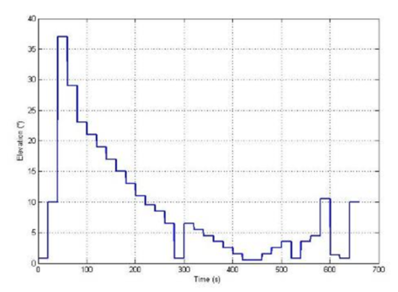
Figure 20: From ECC Report 174 "Meteorological radars, typical elevation variation over time"
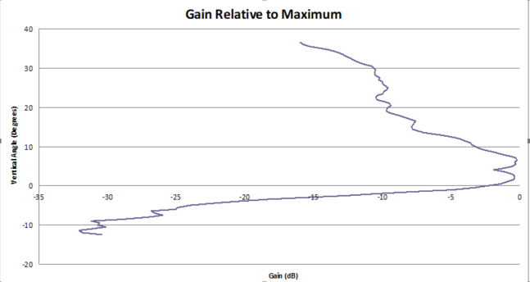
Figure 21: From ECC Report 174 "ATC radar antenna pattern in elevation"

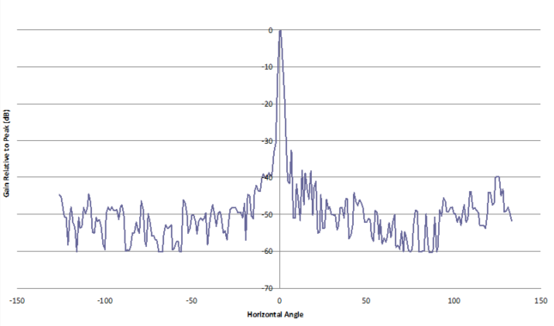
Figure 22: From ECC Report 174 "ATC radar antenna pattern in azimuth"
  - Appendix B: Additional info from ECC Report 281
Table 35: 5G MFCN Base Station deployment parameters (extract from ECC Report 281 Table 23)
Parameters | Value
Base station coordinates (xBS, yBS) | Approach-1: Random deployment of small cells  At each Monte Carlo trial, NBS base stations are distributed randomly over a ring of width D, centred at the radar receiver coordinate (0,0), where xBS and yBS have uniform distributions, and each base station is located a distance d from the radar receiver where dmin ≤ d ≤ dmax, dmin = 1000 or 3000 metres, and  dmax = 5000 metres.  NOTE: D = dmax − dmin.  NOTE: dmin of 3000 & 1000 metres respectively correspond to the protection & exclusion distance for “category 1” (high level of protection) sites in France.  NOTE: The appropriate value of dmax should be evaluated through sensitivity analysis to quantify the impact on aggregated interference.  The number of base stations NBS is given by  $N_{BS}=\text{BS density} × R_{a}×R_{b}×\text{Area}$ (1)  BS density = n × macro site density (km−2) where n is between  1 and 3, and the macro site density is based on an ISD of  1.5 × 300 = 450 metres (see Report ITU-R M.2292 [21]);  Ra (ratio of hotspot areas to built-up areas)  = 0.4 (urban), 0.01 (rural)  Rb (ratio of built-up areas to total area)  = 0.9 (urban) or 0.1 (rural).  Area (area of ring) = π (dmax2 − dmin2)  NOTE: The chosen values of Ra are between the values approved by WP 5D (ITU-R TG5/1 [29] document 36) for 26 GHz (suburban vs. urban: 0.03 vs. 0.07) and a nominal value of 1 for lower frequencies such as sub-1 GHz.  NOTE: The chosen values of Rb are a compromise between urban areas (near 1) and rural areas (near 0), and also the size of the area analysed.  Approach-2: Hexagonal deployment of macro-cells  NBS base stations are distributed on a hexagonal grid with a given ISD, and where each base station is located a distance d from the radar receiver where dmin ≤ d ≤ dmax,  dmin = 3000 metres, dmax = 5000 metres.  Macro-cell ISD: 1.5 × 300 = 450 metres (see Report ITU-R M.2292 [21])
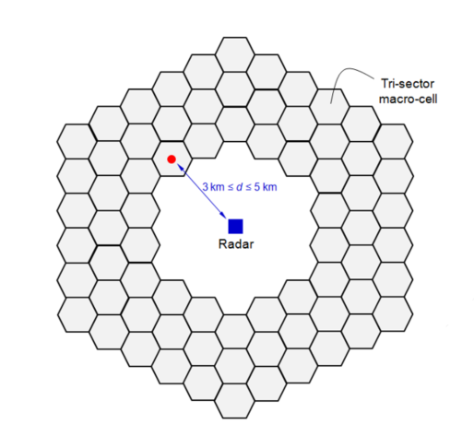
Figure 23: From ECC Report 281 "A radar receiver is surrounded by 5 rings of 272 tri-sectored MFCN macro base stations (only three rings are shown)"
  - Appendix C: operating band unwanted emission limits/mask (UEM)
From 3GPP TS 37.104. MSR power per connector:
Table 36: Wide Area operating band unwanted emission mask (UEM) (3GPP TS 37.104 Table 6.6.2.1-1)
Frequency offset of measurement filter -3dB point, Δf | Frequency offset of measurement filter centre frequency, f_offset | Minimum requirement (Note 1, 2) | Measurement bandwidth
0 MHz ≤ Δf < 0.2 MHz | 0.015 MHz ≤ f_offset < 0.215 MHz | -14 dBm | 30 kHz
0.2 MHz ≤ Δf < 1 MHz | 0.215 MHz ≤ f_offset < 1.015 MHz | (Note 4) | 30 kHz
 | 1.015 MHz ≤ f_offset < 1.5 MHz | -26 dBm (Note 4) | 30 kHz
1 MHz ≤ Δf ≤  min(Δfmax, 10 MHz) | 1.5 MHz ≤ f_offset < min(f_offset_{max}, 10.5 MHz) | -13 dBm (Note 4) | 1 MHz
10 MHz ≤ Δf ≤ Δfmax | 10.5 MHz ≤ f_offset < f_offsetmax | -15 dBm (Note 4) | 1 MHz
NOTE 1: For MSR BS supporting non-contiguous spectrum operation within any operating band the minimum requirement within sub-block gaps is calculated as a cumulative sum of contributions from adjacent sub-blocks on each side of the sub-block gap, where the contribution from the far-end sub-block shall be scaled according to the measurement bandwidth of the near-end sub-block. Exception is Δf ≥ 10MHz from both adjacent sub-blocks on each side of the sub-block gap, where the minimum requirement within sub-block gaps shall be -15dBm/MHz (for MSR BS supporting multi-band operation, either this limit or -16dBm/100kHz with correspondingly adjusted f_offset shall apply for this frequency offset range for operating bands <1GHz).
NOTE 2: For MSR BS supporting multi-band operation with Inter RF Bandwidth gap < 2×Δf_{OBUE} the minimum requirement within the Inter RF Bandwidth gaps is calculated as a cumulative sum of contributions from adjacent sub-blocks or RF Bandwidth on each side of the Inter RF Bandwidth gap, where the contribution from the far-end sub-block or RF Bandwidth shall be scaled according to the measurement bandwidth of the near-end sub-block or RF Bandwidth.
NOTE 3: For operation with a standalone NB-IoT carrier adjacent to the Base Station RF Bandwidth edge, the limits in Table 6.6.2.1-1a apply for 0 MHz ≤ Δf < 0.15 MHz.
NOTE 4: For MSR BS supporting multi-band operation, either this limit or -16dBm/100kHz with correspondingly adjusted f_offset, whichever is less stringent, shall apply for operating bands <1GHz.
From 3GPP TS 38.104. NR power per connector:
Table 37: Wide Area BS operating band unwanted emission limits (NR bands above 1 GHz) for Category B (3GPP TS 38.104 Table 6.6.4.2.2-2)
Frequency offset of measurement filter -3 dB point, Δf | Frequency offset of measurement filter centre frequency, f_offset | Emission limit (Note 1, 2) | Measurement bandwidth
0 MHz ≤ Δf < 5 MHz | 0.05 MHz ≤ f_offset < 5.05 MHz |  | 100 kHz
5 MHz ≤ Δf <  min(10 MHz, Δfmax) | 5.05 MHz ≤ f_offset < min(10.05 MHz, f_offsetmax) | -14 dBm | 100 kHz
10 MHz ≤ Δf ≤ Δfmax | 10.5 MHz ≤ f_offset < f_offsetmax | -15 dBm (Note 3) | 1 MHz
From 3GPP TS 38.104 section 9.7.4 (OTA out-of-band emissions):
9.7.4.1 (General): “The OTA limits for operating band unwanted emissions and Spectrum emissions mask are specified as TRP per RIB unless otherwise stated.”
9.7.4.2 (Minimum requirement for BS type 1-O): “Out-of-band emissions in FR1 are limited by OTA operating band unwanted emission limits. Unless otherwise stated, the operating band unwanted emission limits in FR1 are defined from ΔfOBUE below the lowest frequency of each supported downlink operating band up to ΔfOBUE above the highest frequency of each supported downlink operating band.
The OTA operating band unwanted emission requirement for BS type 1-O is that for each applicable basic limit in subclause 6.6.4.2, the power of any unwanted emission shall not exceed an OTA limit specified as the basic limit + X, where X = 9 dB, unless stated differently in regional regulation.”

- STUDY #1 for AAS/non-AAS 2600 MHz MFCN band and RAS/radar
  - Comparison of MFCN 5G unwanted emissions impact
It is proposed to address the impact of MFCN 5G (AAS) unwanted emissions (in particular spurious emissions) on a differential manner, i.e. to address the impact on other services from the current MFCN networks compared to the impact from new MFCN 5G (AAS) networks.
Under the general principle that these impacts will need to be similar, this can be handled in an easy way by considering only one single BS and calculating, for both situations, the corresponding unwanted e.i.r.p. in the direction of the victim service (i.e. horizontal path for radars and Space services earth stations or upward for Space services satellite receiver.
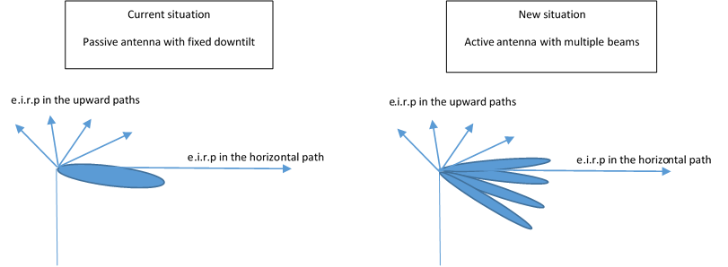
Figure 24: Passive antenna with fixed downtilt and active antenna with multiple beams
The present study is limited to the consideration of the horizontal paths. Although it is mainly focused to the 2.6 GHz MFCN issue vs radars above 2.7 GHz, it is band agnostic and is hence also valid for the 2.1 GHz MFCN vs EESS/SRS Earth stations above 2.2 GHz.
  - MFCN parameters
For both current and new MFCN cases, the necessary base stations parameters are (under the assumption that AAS techniques will not be applied to UEs):
- Antenna height (considering that current MFCN stations will be replaced by 5G AAS, same antenna height will be assumed for both cases);
- Antenna gain;
- Antenna tilt (for current case);
- Antenna pattern;
- Emission mask;
- Feeder losses (for current case);
- Cell radius (for new case).
The agreed parameters are given in ANNEX 2 of this Report.
    - Current MFCN
Information about current MFCN can be taken from ITU-R Report M.2292, leading to the following parameters (for bands between 2 and 3 GHz):
- Antenna height: 30 m (rural), 25 m (suburban) and 20 m (urban);
- Antenna gain: 18 dBi;
- Antenna tilt: 3° (rural), 6° (suburban) and 10° (urban);
- Antenna pattern: Recommendation ITU-R F.1336-4 [21] (with 65° horizontal aperture) avec ka=kp=kh=0.7 and kv=0.3;
- Feeder losses: 3 dB.
It is noted that 2.5° (rural) and 5° (urban) elevation cases were considered in ECC Report 174 [6]. It should be noted that ITU-R Report M.2292 [20] has been adopted after ECC Report 174 and hence should be considered as more representative for up-to-date IMT parameters.
However, if it can be shown that 2.5° (rural) results are very close to those obtained with 3° (rural) and hence has not be used, for comparison purposes, some calculations have been performed with 5° elevation (urban).
    - New AAS MFCN
The following parameters are used for new AAS MFCN:
- Antenna height: 30 m (rural), 25 m (suburban) and 20 m (urban);
- Cell radius: 4000 m (rural), 800 m (suburban) and 400 m (urban);
- Antenna tilt: 10° (mechanical);
- Antenna pattern: Recommendation ITU-R M.2101 [10] (beamformed and single element) with the following parameters:
Elevation beamwidth: 65°;
Horizontal beamwidth: 80°;
Front to back ratio: 30 dB;
Side-lobe ratio: 30 dB;
Vertical spacing: 0.9 λ;
Horizontal spacing: 0.6 λ;
Single element gain: 8 dBi;
Number of antenna elements: 8x8.
For the AAS case, the UE deployment over the cell will impact the antenna gain distribution (either for the horizontal path or the upward paths). The following information can be taken from ECC Report 281 [12]:
- Outdoor UE antenna height: 1.5 m;
- Indoor UE antenna height: (the possible impact of such indoor UE antenna height is addressed in A3.6);
Macro urban: 70% with antenna height uniformly distributed with values of 1.5 + {0, 3, 6, 9, 12 and 15} metres;
Macro suburban: 70% with antenna height uniformly distributed with values of 1.5 + {0, 3 and 6} metres;
Rural: 50% with antenna height of 1.5 metre.
- UE deployment: random (uniform) over the cell
    - Discrimination angles between BS and victim
Calculations have been performed to determine the variation of discrimination angles with the relative BS and victim system antenna heights, considering the following:
- Similar assumptions as in ECC Report 174 [6], i.e. Victim antenna height from -25 to +25 m compared to BS
- 3 different distances, i.e. 1, 5 and 10 km.
Corresponding discrimination angles are depicted on the following figure:
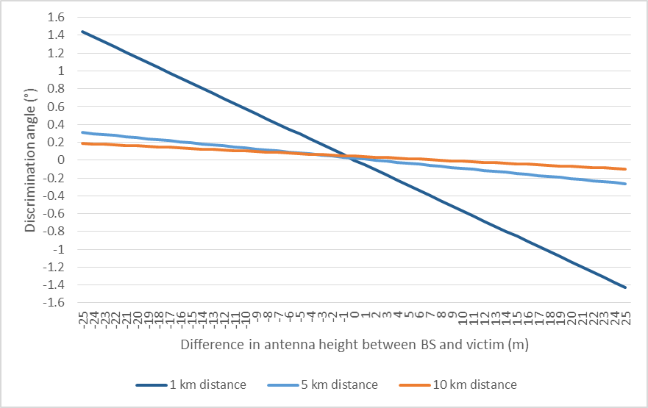
Figure 25: Discrimination angles between BS and victim for difference in antenna height between BS and victim
The discrimination angles vary from:
- +1.44 to -1.43 ° (at 1 km distance);
- +0.31 to -0.26 ° (at 5 km distance);
- +0.19 to -0.1 ° (at 10 km distance).
It appears that a typical value of 0° is representative.
    - Antenna gain distributions
When considering a “random (uniform) over the cell” deployment, the following UE deployment can be depicted (for Urban Macro case):
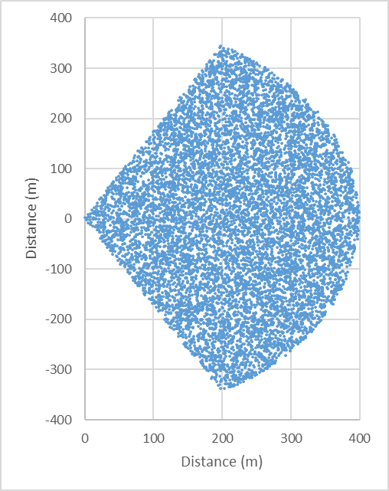
Figure 26: UE random uniform distribution used for the study
In addition, when considering current non-AAS MFCN networks antenna (based on Recommendation ITU-R F.1336-4 [21], peak pattern), the antenna gain is not constant over the cell azimuths, in particular at the horizon. The following figure depicts these gains for the 3 cases under considerations:
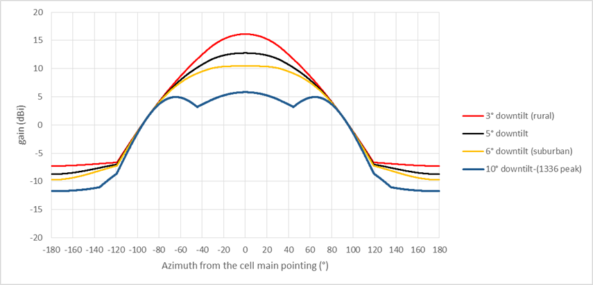
Figure 27: Antenna gain for non-AAS in horizon as a function of azimuth and different antenna downtilts
This figure shows that over the non-AAS MFCN cell azimuths (-60 to +60°), there is a rather important variation of the gain at the horizon:
- Rural case: 8.7 to 16.1 dBi (i.e. 7.4 dB range);
- Suburban case: 7.5 to 10.4 dBi (i.e. 2.9 dB range);
- Urban case: 4.8 to 5.8 dBi (i.e. 3.6 dB range).
Therefore, calculations in the present document have been made considering the azimuths 0° and 50° (i.e. that the potential victim station is seen in these azimuths from the MFCN base station), leading to the following antenna gains at the horizon:
Table 38: Non-AAS antena gain for 0 and 50 degree azimuth and different downtilts
Azimuth | Urban case(10° downtilt) | Suburban case(5° downtilt) | Suburban case(6° downtilt) | Rural case(3° downtilt)
0° | 5.8 dBi | 12.7 dBi | 10.4 dBi | 16.1 dBi
50° | 4 dBi | 9.5 dBi | 8.7 dBi | 10.7 dBi
On this basis, the following MFCN AAS antenna gain distribution (beamformed in the horizontal path) are calculated, compared with the AAS antenna value for single element as well as corresponding non-AAS pattern using Recommendation ITU-R F.1336 [21].
      - Urban case
0° azimuth:
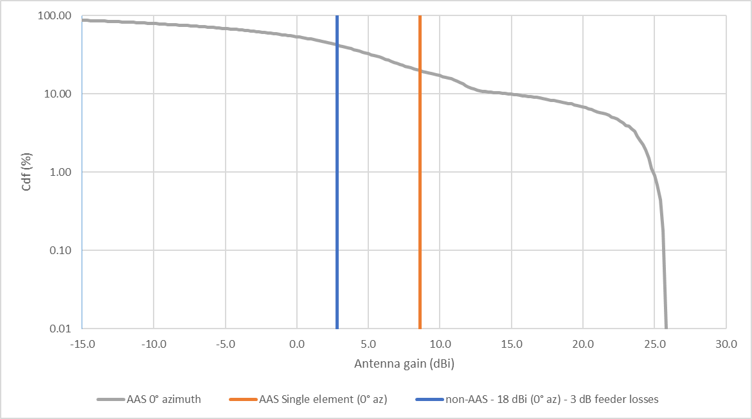
Figure 28: Antenna gain comparison (urban case at 0° azimuth)
50° azimuth:

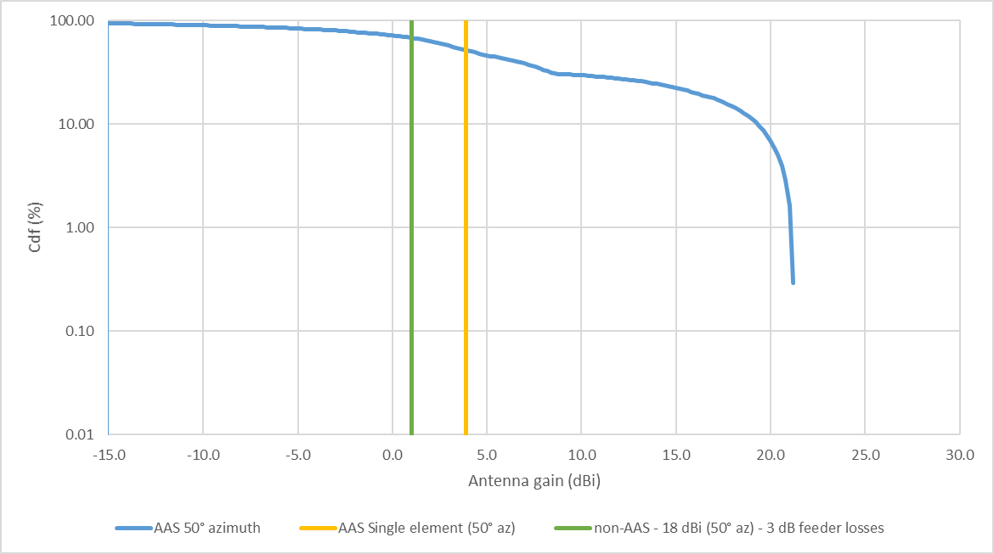
Figure 29: Antenna gain comparison (urban case at 50° azimuth)
      - Suburban case
0° azimuth:
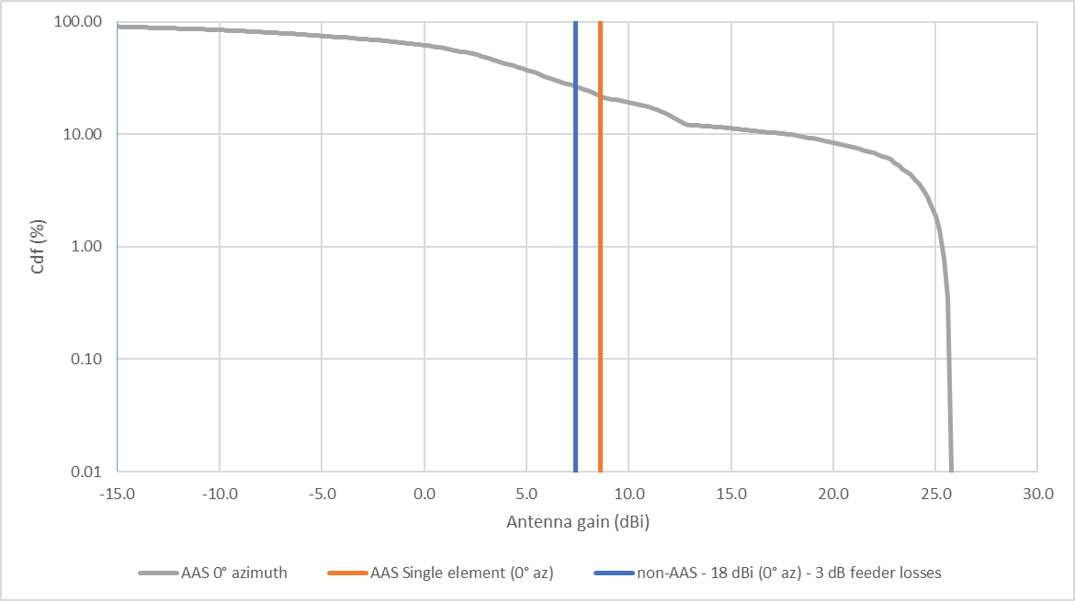
Figure 30: Antenna gain comparison (suburban case at 0° azimuth)
50° azimuth:
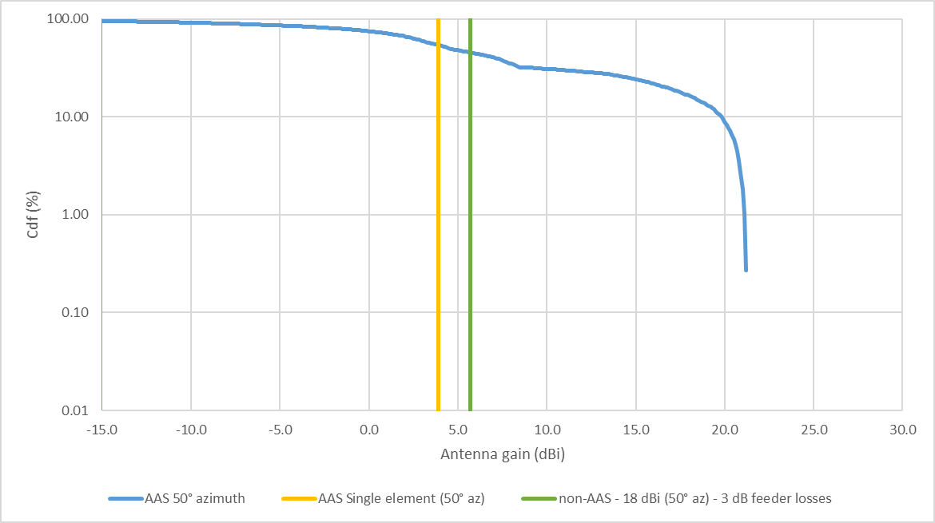
Figure 31: Antenna gain comparison (suburban case at 50° azimuth)
      - Rural case
0° azimuth:
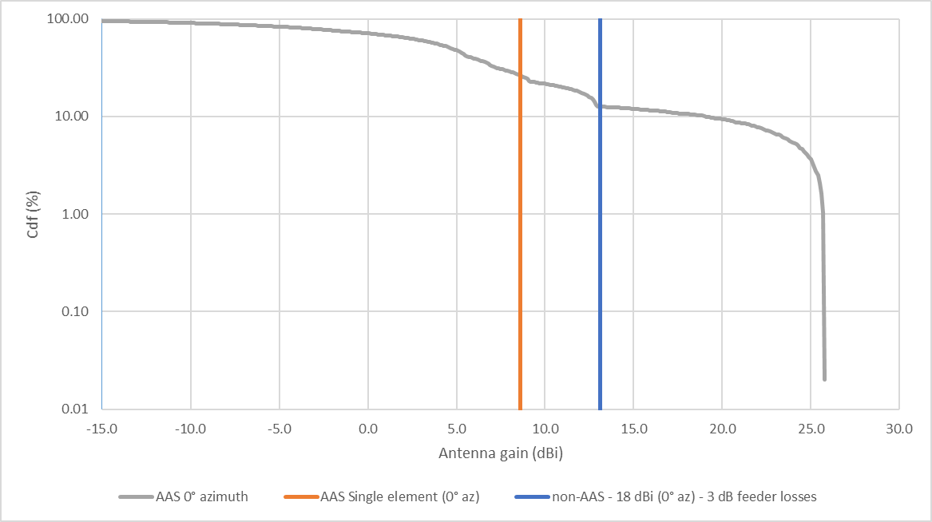
Figure 32: Antenna gain comparison (Rural case at 0° azimuth)
50° azimuth:

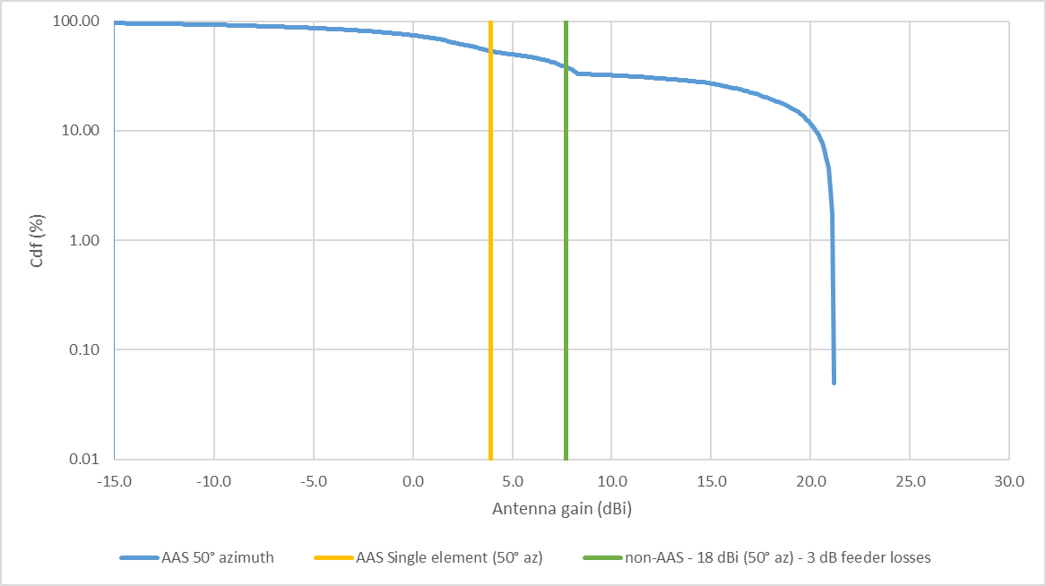
Figure 33: Antenna gain comparison (rural case at 50° azimuth)
    - Emission masks
The following figure makes a schematic comparison of unwanted emission masks for the current non-AAS case with proposed AAS case:
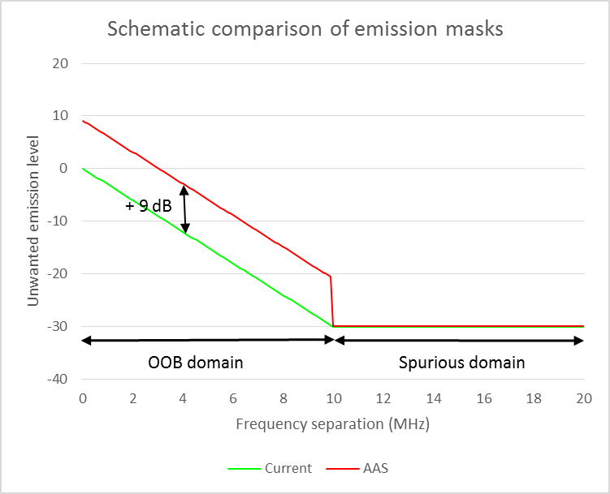
Figure 34: Schematic comparison of unwanted emission masks for the current non-AAS case with proposed AAS case
Comments:
- For non-AAS, the unwanted emissions are conducted power at Tx output;
- For AAS, the unwanted emissions are TRP;
- OOB domain:
the proposed OOB emissions for AAS is 9 dB (10log(8)) higher than the one for non-AAS
- Spurious domain:
it is agreed in ECC/PT1 that the spurious domain will start from 10 MHz to the band edge, with similar level (-30 dBm) for non-AAS and AAS;
It is however still unclear whether this level will apply to the same reference bandwidth for both cases?
It is also noted that some views were expressed that the spurious level should also be increased by 9 dB (10log(8)).
  - Calculations
The unwanted emissions e.i.r.p. in the direction of the victim is the combination of the IMT antenna gain in the direction of the victim (see section A3.2.4above) and the IMT emission mask (see section A3.2.5 above).
Only the spurious domain is considered below, assuming the same reference bandwidth.
    - Urban case
The following figure provides the calculated e.i.r.p. in the direction of the victim (horizontal path) for spurious emissions (for the urban case) for both the 0° and 50° azimuth:
0° azimuth
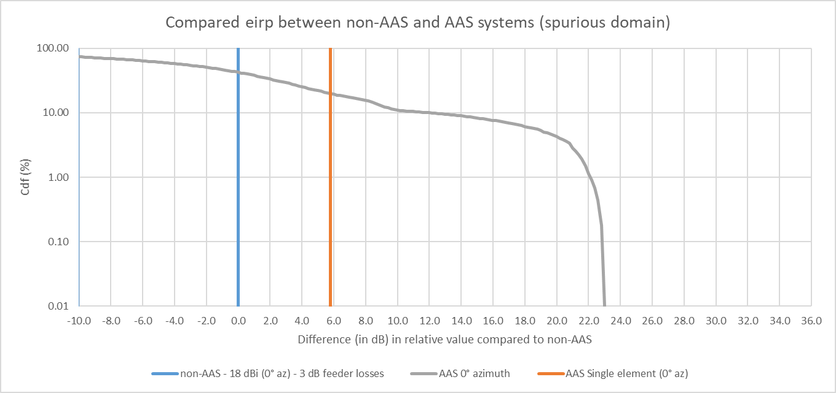
Figure 35: Compared e.i.r.p. between non-AAS and AAS systems for urban case and 0° azimuth
Potential interference from IMT AAS to victim service in the spurious domain is:
- Around 6 dB higher than for non-AAS assuming a single element pattern;
- Higher than for non-AAS for 55% of the time, up to around 26 dB higher.
50° azimuth
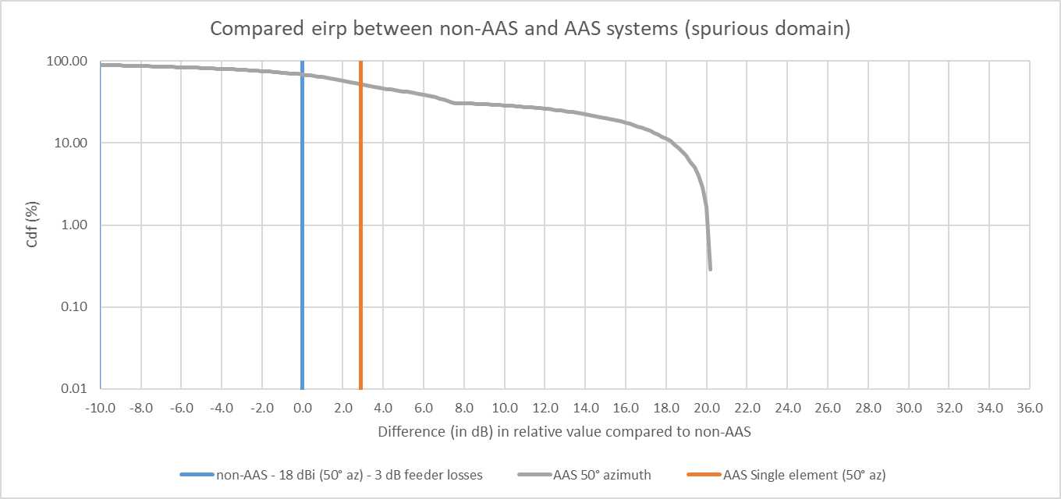
Figure 36: Compared e.i.r.p. between non-AAS and AAS systems for urban case and 50° azimuth
Potential interference from IMT AAS to victim service in the spurious domain is:
- Around 3 dB higher than for non-AAS assuming a single element pattern;
- Higher than for non-AAS for 70% of the time, up to around 20 dB higher.
It should be noted that these figures depicts current situation (non-AAS) for a single Tx. On the assumption that AAS may replace from 2 to 4 non-AAS Tx, the blue curve may have to be shifted to the right by a value that needs to be studied.
    - Suburban case
The following figure provides the calculated e.i.r.p. in the direction of the victim (horizontal path) for spurious emissions (for the Suburban case) for both the 0° and 50° azimuth:
0° azimuth:
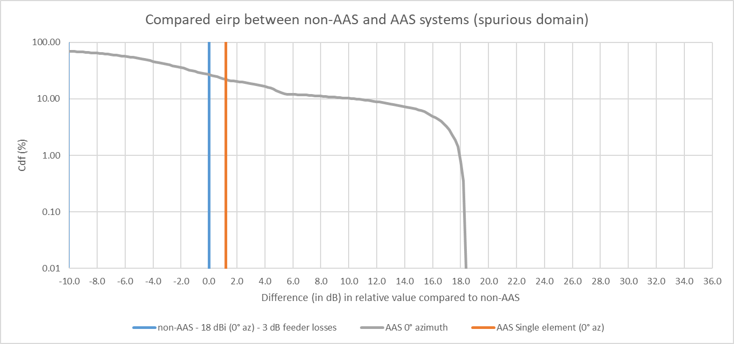
Figure 37: Compared e.i.r.p. between non-AAS and AAS systems for suburban case and 0° azimuth
Potential interference from IMT AAS to victim service in the spurious domain is:
- Around 1 dB higher than for non-AAS assuming a single element pattern;
- Higher than for non-AAS for 25% of the time, up to around 18 dB higher.
50° azimuth:
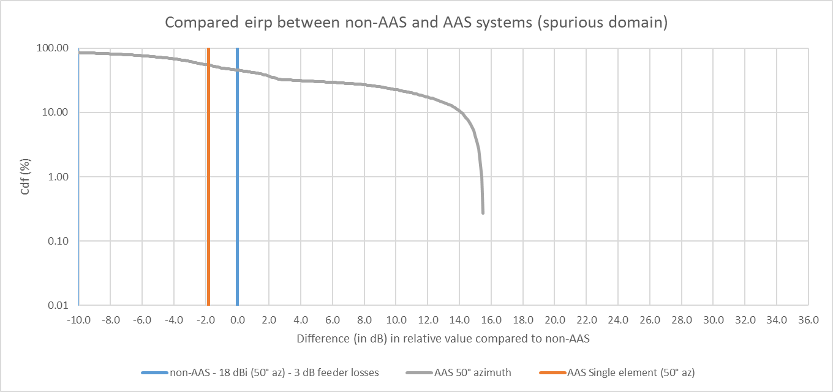
Figure 38: Compared e.i.r.p. between non-AAS and AAS systems for urban case and 50° azimuth
Potential interference from IMT AAS to victim service in the spurious domain is:
- Around 2 dB lower than for non-AAS assuming a single element pattern;
- Higher than for non-AAS for 45% of the time, up to around 15 dB higher.
It should be noted that these figures depicts current situation (non-AAS) for a single Tx. On the assumption that AAS may replace from 2 to 4 non-AAS Tx, the blue curve may have to be shifted to the right by a value that needs to be studied.
    - Rural case
The following figure provides the calculated e.i.r.p. in the direction of the victim (horizontal path) for spurious emissions (for the rural case) for both the 0° and 50° azimuth:
0° azimuth:
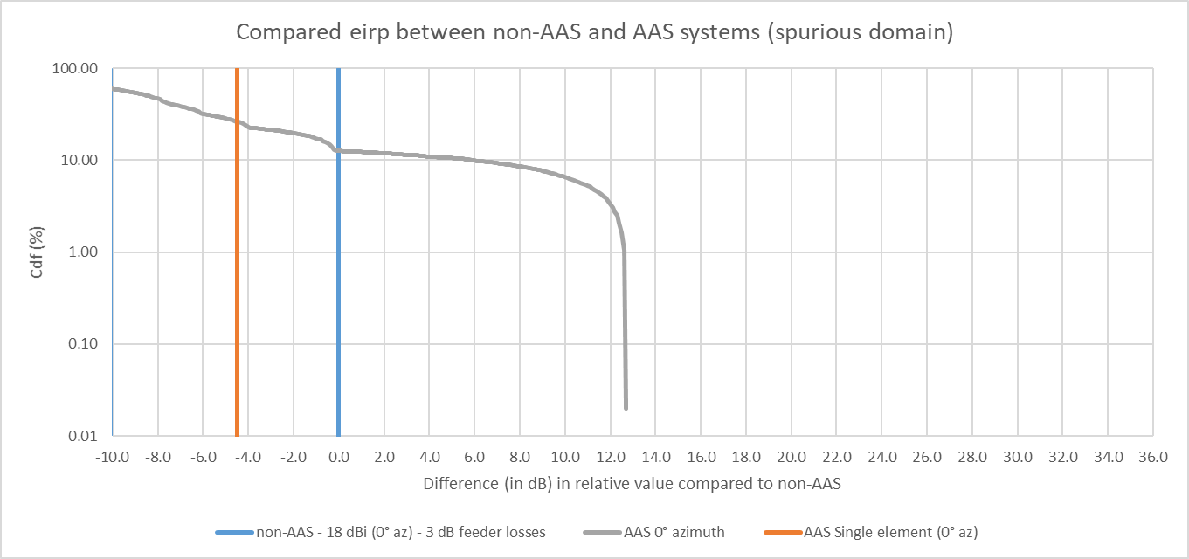
Figure 39: Compared e.i.r.p. between non-AAS and AAS systems for rural case and 0° azimuth
Potential interference from IMT AAS to victim service in the spurious domain is:
- Around 4 dB lower than for non-AAS assuming a single element pattern;
- Higher than for non-AAS for 10% of the time, up to around 13 dB higher.
50° azimuth:
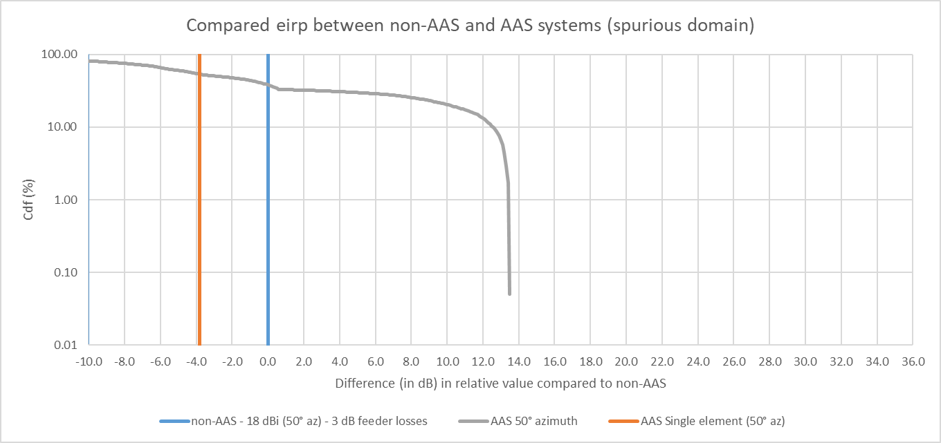
Figure 40: Compared e.i.r.p. between non-AAS and AAS systems for urban case and 50° azimuth
Potential interference from IMT AAS to victim service in the spurious domain is:
- Around 4 dB lower than for non-AAS assuming a single element pattern;
- Higher than for non-AAS for 40% of the time, up to around 13 dB higher.
It should be noted that these figures depicts current situation (non-AAS) for a single Tx. On the assumption that AAS may replace from 2 to 4 non-AAS Tx, the blue curve may have to be shifted to the right by a value that needs to be studied.
  - Impact on separation distances
As explained in the introduction of the present study, although it is mainly focused to the 2.6 GHz MFCN issue vs radars above 2.7 GHz, it is by principle band agnostic and is hence also valid for the 2.1 GHz MFCN vs EESS/SRS Earth stations above 2.2 GHz.
In order to assess the impact of AAS on separation distances in the spurious domain, calculations on have been performed considering the following assumptions:
- -30 dBm/MHz spurious emissions
- Emissions distributions as given in sections 3.1 (Urban), 3.2 (suburban) and 3.3 (rural) above.
- Case of a satellite earth stations at 2.2 GHz
The methodology used is the one from the recommendation under public consultation for 26 GHz (see Annex 2 of this Recommendation). Recommendation ITU-R P.452 [24] has been used for the propagation model, assuming a flat terrain. The location taken is Kiruna in Sweden, and the EESS ES is tracking a NGSO satellite on a polar orbit at 400 km altitude. Its maximum gain is 50 dBi and its minimum elevation angle 5°. The EESS antenna height is 10 m. A 3 dB feeder loss has been assumed for the EESS ES. The protection criterion is -216 dBW/Hz not to be exceeded more than 0.1% of the time.
These calculations are summarised in the table below:
Table 39: Impact of AAS on separation distance
 | Azimuth 0° |  |  | Azimuth 50°
Scenario | non-AAS (single Tx) | AAS | Ratio | non-AAS (single Tx) | AAS | Ratio
Rural  (3° elevation) | 23.8 km | 73.5 km | 3.1 | 15 km | 50 km | 3.3
Suburban  (6° elevation) | 18.3 km | 57.7 km | 3.2 | 8.6 km | 38.1 km | 4.4
Urban  (10° elevation) | 8.2 km | 45.7 km | 5.6 | 4.8 km | 33.5 km | 7
They show that even considering a -30 dBm/MHz spurious emission for AAS, the impact on necessary separation distance with potential victim from other services can be quite high, with distances increased by a factor from 3 to 7.
It should be noted that these figures depicts current situation (non-AAS) for a single Tx. On the assumption that AAS may replace from 2 to 4 non-AAS Tx, the necessary distances and corresponding ratio will decrease.
Additional calculations using the same assumptions have been further performed to consider (only for azimuth 0°), an possible additional factor that could be representative of multiple Tx (assuming that their spurious emission would add linearly, which is however far from being realistic) or lower non-AAS feeder losses.
These calculations are summarised in the table below:
Table 40: Impact of AAS on separation distance (values in km)
 | non-AAS |  |  |  |  | AAS
 | Single Tx | +3 dB  (potentially 2 Tx) | +4 dB | +6 dB  (potentially 4 Tx) | +8 dB
Urban (10°) | 8.2 | 13.2 | 15.5 | 20.7 | 27.1 | 45.7
Suburban (6°) | 18.3 | 27.5 | 31.2 | 36.5 | 47.3 | 57.7
Suburban (5°) |  |  |  |  | 59.8 | 57.7
Rural (3°) | 23.8 | 47 | 53.3 | 67.4 | 83.7 | 75.5
These additional calculations show that when considering a -30 dBm/MHz spurious emission for AAS, consideration of an additional factor to take into account multiple Tx or lower non-AAS feeder losses could improve the situation and tend, at the best, to similar separation distances for rural and suburban cases, although it would still lead to higher distance (with a ratio lower than 2) for urban case.
  - Conclusions
The above analysis shows that the upgrade to 5G (AAS) of current MFCN networks in bands below 3 GHz (either 2.1 GHz or 2.6 GHz) may lead to increased interference to systems in adjacent bands for the spurious domain cases (considering value of -30 dBm and no change of reference bandwidth), at least when considering horizontal paths.
In such case, the potential interference from IMT 5G AAS to victim service in the spurious domain is:
- From -4 dB lower to 6 dB higher than for non-AAS assuming a single element pattern;
- Always Higher than for non-AAS, from 10% to 70% of the time, up to a range of 13 to 23 dB exceeding.
Considering the Baseline assumptions (i.e. non-AAS and AAS spurious of -30 dBm/MHz per Tx with 1Tx, non-AAS feeder loss 3 dB and percentile of @CDF AAS value of 98%), the following table summarises the exceeding:
Table 41: Potential interference exceeding from non-AAS to AAS scenario for rural, suburban and urban case
Macro rural  (non-AAS 2.5 to 3 and AAS 10 degree downtilt) | Macro suburban  (non-AAS 5 to 6 and AAS 10 degree downtilt) | Macro urban  (non-AAS and AAS 10 degree downtilt)
12.4-13.4 dB  (AAS gain higher than non-AAS between 10 and 40% of the time) | 15.3-17.6 dB  (AAS gain higher than non-AAS between 25 and 45% of the time) | 20-21.6 dB  (AAS gain higher than non-AAS between 40 and 70%of the time)
It should be noted that these figures depicts current situation (non-AAS) for a single Tx. On the assumption that AAS may replace from 2 to 4 non-AAS Tx, these figures would decrease by few dBs. Additional calculations show that considering such multiple Tx impact could lead, at the best, to similar separation distances for the rural and suburban cases, although it would still lead to higher distance (with a ratio lower than 2) for urban case.
It is noted that these conclusions are consistent with results provided in study #2.
As a conclusion, the present analysis concludes that a maximum spurious emission TRP value of -30 dBm for AAS 5G systems may be sufficient. But it should not be increased above -30 dBm in particular to -21 dBm.
  - Appendix 1 to Study #1
Study #1 calculations take into account the agreed assumptions on UEs antenna height (randomly distributed within a certain range for urban and suburban cases) whereas other does not.
The following figure shows that the difference is within few dBs for urban case and very low for suburban case.
Urban:
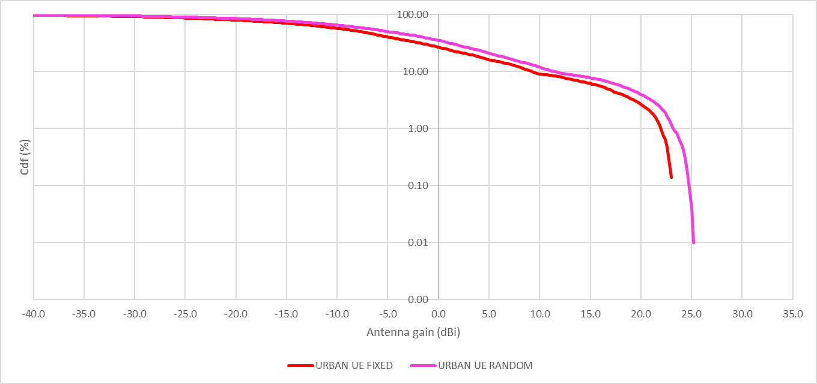
Figure 41: AAS antenna gain towards radar for fixed UE height and random height distribution for urban case

Table 42: AAS antenna gain towards radar for fixed UE height and random height distribution for urban case. Values in dBi.
 | UE FIXED | UE RANDOM
50% | -7.7 | -4.9
90% | 9.3 | 11.5
95% | 16.7 | 18.8
98% | 20.9 | 22.3
99% | 22 | 23.2
Suburban:
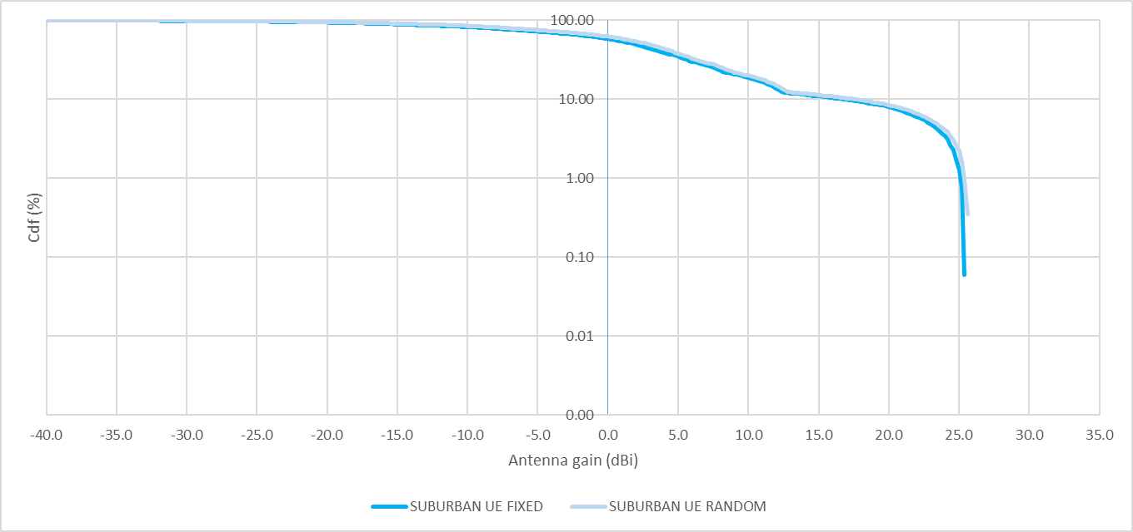
Figure 42: AAS antenna gain towards radar for fixed UE height and random height distribution for suburban case

Table 43: AAS antenna gain towards radar for fixed UE height and random height distribution for suburban case. values in dBi
 | UE FIXED | UE RANDOM
50% | 1.8 | 2.8
90% | 16.8 | 17.5
95% | 22.8 | 23.3
98% | 24.7 | 25.1
99% | 25.1 | 25.4

- STUDY #2 for AAS/non-AAS 2600 MHz MFCN band and RAS/radar
  - LTE/NR AAS/non-AAS parameters
For the simulation/calculation the SEAMCAT tool was used. The following main cases for AAS and non-AAS are simulated:
- Single sector worst-case scenario towards radar with fixed azimuths and elevation close to horizon of the radar antenna
- More realistic case with cellular ring/grids around the radar station. With UEs dropped randomly in the grids and radar station scanning in different azimuth direction but still with fixed elevation in vertical plane
For 1, 3, 5 and 10 km distances and for macro rural and macro suburban deployment following antenna heights, antenna tilts as can be found in M.2292. Antennas as agreed in ANNEX 2: for AAS/non-AAS and for radar (see also M.1849, Recommendation ITU-R M.2101 [10], Report ITU-R M.2292 [20], F.1245 [25]). More specifically the metrological radar system was the focus. The following parameters were used in this study:
- Unwanted emission (OOB/spurious emission):
For non-AAS -30 dBm/MHz for 46 dBm BS power scaling with #of Txs and assuming 4Tx;
For AAS assume -30 dBm/MHz for 46 dBm BS power.
The relative iRSS (interfering Received Signal Strength) between AAS and no-AAS is given. Further parameters which matter to the relative comparison are: non-AAS feeder loss 1 dB (Remote Radio Head common practice in cellular networks since years), 18 dBi non-AAS antenna gain. UE outdoor with 1.5 m antenna height for all cases beside one case with 9+1.5 m antenna height for comparison. LOS condition for all cases.
With the difference in the interfering Received Signal Strength (iRSS) given as ΔiRSS = iRSSAAS – iRSSnon-AAS in dB. Single sector is used for non-AAS/AAS with antenna boresight at 0 degree to radar/RAS. For the case with sector 50 degree offset in boresight to the radar station the iRSS from all three sectors is considered. The #of snapshots in the simulation are chosen that the accuracy in the results is within ±1 dB.
It is further noted that most of the parameters above have been already used/agreed for the AAS introduction in the 2100 MHz band.
  - Simulation results for radar
    - Macro rural
Macro rural area with AAS -10 degree, non-AAS -3 degree and radar +0.5 degree antenna tilt, cell-radii “typically” 4 km (ISD 6 km), antenna height 30 m and 13 m for AAS/non-AAS and radar respectively. Antenna gain non-AAS 18 dBi with 1 dB feeder loss and radar 43 dBi with 2 dB feeder loss. LOS condition and UEs at 1.5 antenna height outdoor. Antenna with boresight towards radar.

      - Worst-case scenario with single sector pointing towards radar (boresight 0 degree)
Table 44: Macro rural case ΔiRSS for fully correlated case (ρ= 1) and single UE using full bandwidth per snapshot
 |  | 1 km | 3 km | 5 km | 10 km
ΔiRSS in dB | @50% CDF | -14.1 | -14.2 | -13.9 | -14.3
ΔiRSS in dB | @90% CDF | 2.1 | 2 | 2.4 | 2.5
ΔiRSS in dB | @95% CDF | 3.2 | 3.7 | 4 | 3.8
ΔiRSS in dB | @98% CDF | 3.5 | 4.2 | 4.3 | 4.4

Table 45: Macro rural case ΔiRSS for fully correlated case (ρ = 1) and three UEs sharing bandwidth per snapshot
 |  | 1 km | 3 km | 5 km | 10 km
ΔiRSS in dB | @50% CDF | -8.1 | -9.6 | -7.4 | -8.1
ΔiRSS in dB | @90% CDF | -1 | -0.4 | -0.3 | -0.2
ΔiRSS in dB | @95% CDF | 0.4 | 0.3 | 0.4 | 0.9
ΔiRSS in dB | @98% CDF | 0.9 | 1.5 | 1.8 | 2

Table 46: Macro rural case ΔiRSS for uncorrelated case (ρ = 0)
 | 1 km | 3 km | 5 km | 10 km
ΔiRSS in dB | -14.2 | -13.5 | -13.4 | -13.3
      - Realistic case with ring/cluster around radar station
- For ring around radar with 4 two-tiers tri-sectors (3GPP type) for 5 and 10 km distance to radar station
- UEs dropped randomly in the grids
- Radar antenna scanning in horizontal plane but fixed in vertical plane with 0.5 degree (worst-case)
Table 47: Macro rural case ΔiRSS for fully correlated case (ρ = 1) and single UE with full bandwidth per snapshot
 |  | 1 km | 3 km | 5 km | 10 km
ΔiRSS in dB | @50% CDF | - | - | -13.5 | -14.4
ΔiRSS in dB | @90% CDF | - | - | -13.5 | -14.3
ΔiRSS in dB | @95% CDF | - | - | -13.2 | -14.4
ΔiRSS in dB | @98% CDF | - | - | -13.1 | -14.8

Table 48: Macro rural ΔiRSS for uncorrelated case (ρ = 0) and single UE with full bandwidth per snapshot
 |  | 1 km | 3 km | 5 km | 10 km
ΔiRSS in dB | @50% CDF | - | - | -13.2 | -14
ΔiRSS in dB | @90% CDF | - | - | -13.3 | -14.1
ΔiRSS in dB | @95% CDF | - | - | -13.1 | -13.9
ΔiRSS in dB | @98% CDF | - | - | -12.9 | -13.9
    - Macro Suburban
Macro suburban area with AAS -10 degree, non-AAS -6 degree and radar +0.5 degree antenna tilt, cell-radii “typically” 0.8 km (ISD 1.2 km), antenna height 25 m and 13 m for AAS/non-AAS and radar respectively. Antenna gain non-AAS 18 dBi with 1 dB feeder loss and radar 43 dBi with 2 dB feeder loss. LOS condition and UEs at 1.5 antenna height outdoor in all tables apart from Table 52 where the UE heights is 9+1.5 m. Antenna with boresight towards radar.
      - Worst-case scenario with single sector pointing towards radar (boresight 0 degree)
Table 49: Macro suburban case ΔiRSS for fully correlated case (ρ = 1) and single UE with full bandwidth per snapshot
 |  | 1 km | 3 km | 5 km | 10 km
ΔiRSS in dB | @50% CDF | -12.3 | -13 | -12 | -12.7
ΔiRSS in dB | @90% CDF | 5.8 | 5.9 | 6.2 | 5.9
ΔiRSS in dB | @95% CDF | 7.4 | 7.9 | 8 | 8.1
ΔiRSS in dB | @98% CDF | 8.1 | 8.7 | 9 | 9

Table 50: Macro suburban case ΔiRSS for fully correlated case (ρ = 1) and three UEs sharing bandwidth per snapshot
 |  | 1 km | 3 km | 5 km | 10 km
ΔiRSS in dB | @50% CDF | -5.4 | -7.5 | -5.9 | -7
ΔiRSS in dB | @90% CDF | 3.3 | 4.1 | 4.3 | 4.2
ΔiRSS in dB | @95% CDF | 4.5 | 4.6 | 4.8 | 4.9
ΔiRSS in dB | @98% CDF | 5.9 | 5.7 | 5.9 | 6.1

Table 51: Macro suburban ΔiRSS for uncorrelated case (ρ = 0)
 |  | 1 km | 3 km | 5 km | 10 km
ΔiRSS in dB |  | -9.1 | -8 | -7.8 | -7.6

Table 52: Macro suburban case ΔiRSS for fully correlated case (ρ = 1) with UE at 9 + 1.5 m height and three UEs sharing bandwidth per snapshot
 |  | 1 km | 3 km | 5 km | 10 km
ΔiRSS in dB | @50% CDF | -3.4 | -3.4 | -4.8 | -2.8
ΔiRSS in dB | @90% CDF | 4 | 4.8 | 4.8 | 4.9
ΔiRSS in dB | @95% CDF | 5.3 | 5.8 | 5.6 | 6.1
ΔiRSS in dB | @98% CDF | 6.3 | 7.1 | 7.2 | 7.4
      - Realistic case with cellular ring/cluster around radar station
- For ring around radar with 8 two-tiers tri-sectors (3GPP type) for 5 and 3 km distance to radar station
- UEs dropped randomly in the grids
- Radar antenna scanning in horizontal plane but fixed in vertical plane with 0.5 degree (worst-case)
It is further noted adding more grids (dense deployment) around the radar did not change the relative interference given below noticeable.
Table 53: Macro suburban case ΔiRSS for fully correlated case (ρ = 1) and single UE with full bandwidth per snapshot
 |  | 1 km | 3 km | 5 km | 10 km
ΔiRSS in dB | @50% CDF |  | -10 | -10
ΔiRSS in dB | @90% CDF |  | -9.5 | -9.4
ΔiRSS in dB | @95% CDF |  | -9.6 | -9.6
ΔiRSS in dB | @98% CDF |  | -9.6 | -9.4

Table 54: Macro suburban case ΔiRSS for uncorrelated case (ρ = 0) and single UE with full bandwidth per snapshot
 |  | 1 km | 3 km | 5 km | 10 km
ΔiRSS in dB | @50% CDF |  | -9.8 | -9.7
ΔiRSS in dB | @90% CDF |  | -9.2 | -9.2
ΔiRSS in dB | @95% CDF |  | -9.4 | -9.4
ΔiRSS in dB | @98% CDF |  | -9.5 | -9.2
    - Macro urban
Macro suburban area with AAS -10 degree, non-AAS -10 degree and radar +0.5 degree antenna tilt, cell-radii “typically” 0.4 km (ISD 0.6 km), antenna height 20 m and 13 m for AAS/non-AAS and radar respectively. Antenna gain non-AAS 18 dBi with 1 dB feeder loss and radar 43 dBi with 2 dB feeder loss. LOS condition and UEs is at 1.5 antenna height outdoor. Antenna with boresight is towards radar.

      - Worst-case scenario with single sector pointing towards radar (boresight 0 degree)
Table 55: Macro urban case ΔiRSS for fully correlated case (ρ = 1) and single UE with full bandwidth per snapshot
 |  | 1 km | 3 km | 5 km | 10 km
ΔiRSS in dB | @50% CDF | -11.7 | -12.1 | -13.2 | -13
ΔiRSS in dB | @90% CDF | 9 | 8.8 | 8.3 | 7.4
ΔiRSS in dB | @95% CDF | 11.5 | 11.7 | 11 | 10.6
ΔiRSS in dB | @98% CDF | 12.8 | 12.9 | 12.2 | 12.2

Table 56: Macro urban case ΔiRSS for fully correlated case (ρ = 1) and three UEs sharing bandwidth per snapshot
 |  | 1 km | 3 km | 5 km | 10 km
ΔiRSS in dB | @50% CDF | -4.2 | -4.5 | -4.3 | -4.9
ΔiRSS in dB | @90% CDF | 7.9 | 8 | 7.1 | 7.3
ΔiRSS in dB | @95% CDF | 8.6 | 8.5 | 8 | 7.8
ΔiRSS in dB | @98% CDF | 9.2 | 9.7 | 8.5 | 8.4

Table 57: Macro urban ΔiRSS for uncorrelated case (ρ = 0)
 | 1 km | 3 km | 5 km | 10 km
ΔiRSS in dB | -3 | -2.9 | -2.9 | -2.8
    - macro rural / suburban / urban with sector direction radar @50 degree boresight for 3 km
Below are the results for one single sector with 50 degree offset in boresight to the radar station. Considering UEs within ±60 degree of each sector and connected to that BS sector. The iRSS from all three sectors towards radar. No handover area is considered.
Table 58: Macro urban case ΔiRSS for fully correlated case (ρ = 1) and single UE with full bandwidth per snapshot. Sector towards radar @50 degree from boresight. For 3 km distance BS to radar
 |  | Rural | Suburban | Urban
ΔiRSS in dB | @50% CDF | -14.3 | -12.8 | -11.1
ΔiRSS in dB | @90% CDF | -1.6 | 0.6 | -1.2
ΔiRSS in dB | @95% CDF | 1.3 | 2.9 | 0.8
ΔiRSS in dB | @98% CDF | 2.4 | 3.9 | 1.5
Table 59: Macro urban case ΔiRSS for fully correlated case (ρ = 1) and three UEs sharing bandwidth per snapshot. Sector towards radar @50 degree from boresight. For 3 km distance BS to radar
 |  | Rural | Suburban | Urban
ΔiRSS in dB | @50% CDF | -8.7 | -5.9 | -8.4
ΔiRSS in dB | @90% CDF | -2.1 | -0.5 | -2.8
ΔiRSS in dB | @95% CDF | -1.6 | 0.3 | -2
ΔiRSS in dB | @98% CDF | -0.4 | 1.3 | -0.9

Table 60: Macro urban case ΔiRSS for uncorrelated case (ρ = 0). Sector towards radar @50 degree from boresight. For 3 km distance
 | Rural | Suburban | Urban
ΔiRSS in dB | -13.7 | -12.5 | -9.9
    - Single sector, tri-sector and ring/cluster results
The single sector results have to be considered with care as in real network there are neighbour sectors and neighbour cells which share traffic and have handover areas. The possible interference depends on boresight angle of non-AAS/AAS BS towards radar. This can change the AAS iRSS and ΔiRSS statistic towards radar especially for CDF values <99%. That can be seen from the figures below and for the cellular ring/grid in Table 47, Table 48, Table 53, Table 54 and Figure 51 giving the more realistic case in an overall network with more sectors and grids around radar station.
Figure 43: Probability of iRSS for tri-sector macro urban and fully correlated case (ρ = 1) and single UE with full bandwidth per snapshot (a) Boresight towards radar from sector 1 (b) Boresight 50 degree offset to radar from sector 1
    - Discussion of the radar simulation results
From the results the following has been observed in general:
- For different distances between BSs to radar (1 to 10 km) the difference in ΔiRSS for all scenarios is small;
- UE at 1.5 m and 10.5 m height above ground shows negligible difference in the results as would be expected;
- AAS in general causes much less interference than non-AAS to radar systems above2700 MHz. This is especially apparent in the results of realistic network rings/grids around radar location;
- For single sector pointing towards radar station and CDF probability >90% AAS can cause more interference than non-AAS towards radar;
- For three UEs sharing bandwidth (BW) per snapshot the iRSS AAS towards radar is about 3 dB lower for 98% CDF probability compared to single UE using full bandwidth; The cellular ring/grid around radar is a better indicator for the overall probability of interference towards radar. The ΔiRSS is <0 dB even if compared with single non-AAS antenna and for AAS @CDF 98% for macro and suburban scenario with cellular grid around radar at >3 km distance. For the cellular ring around the radar the difference in ΔiRSS between correlated and uncorrelated AAS case is small;
- For the cellular grid the ΔiRSS is about the same as for the uncorrelated case with single sector pointing towards radar (see also Figure 51).
  - RAS
For RAS, larger coordination zones may be needed depending on the actual RAS protection level required (Continuum/VLBI). Different site solutions for BS deployment in the coordination zone exist already for non-AAS:
- BS sector not pointing towards RAS station;
- Setting power limitations/restriction in the upper two 5 MHz blocks of the FDD spectrum. This Report gives different options how OOB power into 2690-2700 MHz can be limited for AAS;
- BS class, antenna height and indoor/outdoor deployment and antenna tilt.
Furthermore:
- AAS due to the statistical nature can give further possibility in order to avoid interference to such adjacent services by avoiding e.g. beam in direction towards the RAS station. This is called spatial filtering and would be vendor/BS implementation specific.
    - BS OOB emission for 2690-2700 MHz range
In order to limit the OOB into the 2690-2700 MHz different options are discussed below:
- Relative suppression as a function of spectrum mask and ACLR for different regions in 2690-2700 MHz. Function of BS power and BS class, following 3GPP specification, section A4.3.1.1.
- Same as in (1) but giving the relative suppression over 5 MHz average power in that range. Function of BS class, following 3GPP specification, section A4.3.1.2.
- Further OOB limits with operator/band specific implantation of BS affecting upper two FDD 5 MHz blocks, section A4.3.1.3.
- Restricted upper two FDD 5 MHz blocks in order to fulfil in 2690-2700 MHz spurious emission limit of -30 dBm/MHz. Upper two 5 MHz blocks are basically limited to non-AAS usage, section A4.3.1.4.
The upper values in the equation for BSs with no upper power restriction can be also found in Table 7 and Table 12 (see also Annex A2.7). In the case of the TDD part (2570- 2620 MHz) in the 2600 MHz band which is B38/n38 in the 3GPP specifications the maximum spurious emission limit is -30 dBm/MHz per antenna connector for non-AAS and per sector for AAS which would apply for frequencies above 2690 MHz.
      - Relative suppression from spectrum masks and ACLR
For the OOB AAS the relative suppression as a function of BS type and output power can be calculated and is given in the table below (see ECC Report 203 Section 3.3.8 [24]). The table is of importance in order to understand the OOB emission from BSs for 2690-2700 MHz. The ACLR as given below is for a measurement filter with bandwidth of 3.84 MHz centred at 2.5 MHz and 5 MHz offset from the 2690 MHz DL upper edge as defined in 3GPP specifications for UTRA channels. The given ACLRs for 0-5 MHz and 5 to 10 MHz range consider also the actual filter bandwidth:
- In the first row, the BS power is given per 5 MHz indicating also the BS type/class;
- In the first column, the OOB emission for (1) 2690-2695 MHz (0-5 MHz) and (2) 2695 MHz to 2700 MHz (5 to 10 MHz) is of main interest.
- From the table, it can be understood that: In general, the OOB emission level (2690-2700-MHz) gets lower for BS with lower transmission power (BS type);
- For the first 0.58 MHz (2690-2690.58 MHz) the OOB emission is defined by the SEM (“Integrated SEM 0-0.58 MHz (dBm)” in the table);
- For 0.58 MHz to 5 MHz (2690.58-2695 MHz) the ACLR will set the limit for the absolute power (for the power ranges given) and gets lower for less BS transmission power for the same BS type (“Min of integrated SEM and ACLR for 0.58-5 MHz” in the table):
The OOB emission (0-5 MHz) for macro BS (<59 dBm/5 MHz) will be smaller but not linearly with the BS power reduction.
- For the 2695 to 2700 MHz range the OOB emission is determined by the ACLR for macro BS power < 56 dBm/5 MHz;
- For FDD DL 5 MHz blocks further away than 10 MHz to the upper DL band edge the OOB emission (2690-2700 MHz) is further reduced compared to the adjacent two 5 MHz blocks:
For B7/n7 BS ≥ 58 dBm/5 MHz output power the unwanted emission (2690-2700 MHz) for such blocks (<2680 MHz) is >10 dB lower with respect to the two upper blocks;
For B38/n38 the general spurious emission of -30 dBm/MHz applies for frequencies above 2690 MHz.
Table 61: Calculation of relative suppression from spectrum masks and ACLR from 3GPP TS 38.104 for Wide Area BS and Medium Range BS for OTA AAS/TRP
Parameter | Calculated value
BS type | macro |  |  | micro >40 dBm |  | micro≤40 dBm
BS Power /5 MHz | 58 | 52 | 48 | 47 | 41 | 40 | 36
(a) Integrated SEM 0-0.58 MHz (dBm) | 9.4 | 9.4 | 9.4 | 1.4 | -4.6 | -5.6 | -5.6
(i) Integrated SEM 0.58-5 MHz (dBm) | 14.8 | 14.8 | 14.8 | 6.8 | 0.8 | -0.2 | -0.2
ACLR (dB) considering measurement filter | 44.1 | 44.1 | 44.1 | 44.1 | 44.1 | 44.1 | 44.1
(ii) Absolute power from ACLR (dBm) | 13.9 | 7.9 | 3.9 | 2.9 | -3.1 | -4.1 | -8.1
(b) Min(i,ii) of integrated SEM and ACLR for 0.58-5 MHz (dBm) | 13.9 | 7.9 | 3.9 | 2.9 | -3.1 | -4.1 | -8.1
(a) + (b) Sum of 0-0.58 MHz and 0.58-5 MHz for 0-5 MHz (dBm) | 15.2 | 11.7 | 10.5 | 5.2 | -0.8 | -1.8 | -3.7
1) Sum converted to relative suppression in dB for 0-5 MHz | 42.8 | 40.3 | 37.5 | 41.8 | 41.8 | 41.8 | 39.7
Integrated SEM 5-10 MHz (dBm) | 12 | 12 | 12 | 4 | -3 | -3 | -3
Integrated SEM converted to suppression (dB) | 46 | 40 | 37 | 43 | 44 | 43 | 43
ACLR (dB) considering measurement filter | 43.6 | 43.6 | 43.6 | 43.6 | 43.6 | 43.6 | 43.6
2) Strictest of SEM and ACLR for 5-10 MHz in dB | 46.0 | 43.6 | 43.6 | 43.6 | 44.0 | 43.6 | 43.6
Integrated SEM 10-15 MHz (dBm) | 1 | 1 | 1 | 1 | 4 | -3 | -3
Integrated SEM converted to suppression (dB) | 57 | 51 | 47 | 46 | 37 | 43 | 39
3) Strictest of SEM and value (2) for 10-15 MHz (dB) | 57.0 | 51.0 | 47.0 | 43.6 | 43.6 | 43.6 | 43.6
      - Relative suppression from spectrum masks
From Table 61 the OOB emission limits for 2690-2700 MHz can be calculated as a function of BS type with average value over 5 MHz bandwidth and the equations are given in Table 62. Function of BS class, following 3GPP specification, with the upper values in the equation for BSs with no upper power restriction can be found in Table 7 and Table 12 (see also Annex A2.7).
Table 62: Possible additional power limits from Table 61 for 2690-2700 MHz for AAS base stations to limit interference towards RAS
BEM element | Frequency range | AAS TRP limit  dBm/(5 MHz) per cell (note 1))
Additional Baseline | 2690-2695 MHz | Min(PMax−37, 15) (note 2)
Additional Baseline | 2695-2700 MHz | Min(PMax−43, 12) (note 2)
Note 1: In a multi-sector base station, the radiated power limit apples to each one of the individual sectors.
Note 2:) PMax is the maximum mean carrier power in dBm for the base station measured as TRP per carrier in a given cell
      - BS/operator specific implementation
Further OOB limits with operator/band specific implantation of BS affecting upper two FDD 5 MHz blocks.
Table 63: AAS base station additional baseline power limits for 2690-2700 MHz OOB region. For country specific implementation to protect RAS(1) and operator/band specific implantation of BS affecting upper two FDD 5 MHz blocks
Case |  | BEM element | Frequency range | AAS TRP limit  dBm/5 MHz per cell (note 2)
A | CEPT countries with RAS in 2690-2700 MHz | Additional Baseline | 2690-2695 MHz (note 3) | 8
A | CEPT countries with RAS in 2690-2700 MHz | Additional Baseline | 2695-2700 MHz (note 3) | 3
B | CEPT countries without RAS usage | Additional Baseline | 2690-2700 MHz (note 3) | Not applicable
Note 1: Alternative measures may be required on a case by case basis.
Note 2:) In a multi-sector base station, the radiated power limit applies to each one of the individual sectors
Note 3: In cases where CEPT administrations have already implemented a guard band when issuing licences for MFCN before the adoption of this ECC Decision and in accordance with ECC Decision (05)05 (Approved 18 March 2005, amended 03 July 2015), these CEPT administrations may apply the additional baseline only below such guard band, provided it complies with the protection of RAS in the adjacent band and with cross-border obligations.
Table 64: MFCN BS BEM elements
In-block | Block for which the BEM is derived.
Baseline | Spectrum used for TDD and FDD UL, DL and SDL, except from the operator block in question and corresponding transitional regions
Transitional region | For FDD DL blocks, the transitional region applies 0 to 5 MHz below and above the block assigned to the operator. For TDD blocks, the transitional region applies 0 to 5 MHz below and above the block assigned to the operator. Transitional regions do not apply to TDD blocks allocated to other operators, unless networks are synchronised. The transitional regions do not apply below 2570 MHz or above 2690 MHz.
Guard bands | Any guard bands required to ensure adjacent band compatibility at 2570 MHz and 2620 MHz boundaries will be decided on a national basis and taken within the band 2570-2620 MHz.
Additional Baseline | Above 2690 MHz to 2700 MHz to protect RAS
      - Restricted upper two FDD 5 MHz blocks
Further OOB limits with operator/band specific implantation of BS affecting upper two FDD 5 MHz blocks in order to fulfil spurious emission limit. Restricted upper two FDD 5 MHz blocks in order to fulfil in 2690-2700 MHz the spurious emission limit of -30 dBm/MHz. Upper two 5 MHz blocks are basically limited to non-AAS usage. Such limits cannot be recommended on a European level for several reasons:
- Spectrum efficiency of 2600 MHz band gets lower;
- Operator/ band specific implementation for such BSs. Adding complexity to such BSs even for sectors not pointing towards RAS where such measures are most likely not needed;
- AAS due to the statistical nature can also give further possibility in order to avoid interference to such adjacent services by avoiding e.g. beam in direction towards the victim in the OOB towards RAS station. This is called spatial filtering and could be used to avoid interference to such locations much more effectively.
Table 65: AAS base station additional baseline power limits for 2690-2700 MHz OOB region. For country specific implementation to protect RAS (Note 1). Restricted upper two FDD 5 MHz blocks in order to fulfil in 2690-2700 MHz the spurious emission limit of -30 dBm/MHz.
Case |  | BEM element | Frequency range | AAS TRP limit  dBm/5 MHz per cell (Note 2)
A | CEPT countries with RAS in 2690-2700 MHz | Additional Baseline | 2690-2700 MHz (Note 3) | -23
B | CEPT countries without RAS usage | Additional Baseline | 2690-2700 MHz (Note 3 | Not applicable
Note 1: Alternative measures may be required on a case by case basis.
Note 2: In a multi-sector base station, the radiated power limit applies to each one of the individual sectors
Note 3: In cases where CEPT administrations have already implemented a guard band when issuing licences for MFCN before the adoption of this ECC Decision and in accordance with ECC Decision (05)05 (Approved 18 March 2005, amended 03 July 2015), these CEPT administrations may apply the additional baseline only below such guard band, provided it complies with the protection of RAS in the adjacent band and with cross-border obligations.
    - RAS interference criteria with respect to AAS and path loss modell used
For RAS the parameters in ANNEX 2 are used and additional the parameters for the Recommendation ITU-R P.452-16 model [24], in Table 63. For RAS ITU-R RA.769-2 [26] and ITU-R RA.1513 states the following[28]:
- For evaluation of interference, a criterion of 2% (pRAS) be used for data loss to the RAS due to interference from any one network, in any frequency band which is allocated to the RAS on a primary basis;
- The protection limit of -207 dBW/10 MHz (Continuum Measurements) is valid for an integration time of 2000 seconds (~33 min);
- For VLBI the protection limit is -165 dBW/10 MHz. VLBI is a type of astronomical interferometry which allows observations of an object that are made simultaneously by many radio telescopes to be combined.
For the Recommendation ITU-R P.452-16 model [24] the following is found:
- The models within Recommendation ITU-R P.452 are designed to calculate propagation losses not exceeded for time percentages over the range 0.001 ≤ pP.452 ≤ 50%. This assumption does not imply the maximum loss will be at pP.452-max = 50%.
- The range for pP.452 gives a rather large uncertainty in path loss to real environment especially with respect to single RAS stations. Actual terrain information will improve the model.
For AAS the probability percentage parameter pAAS describes the antenna gain probability over time/space in % on the azimuth under consideration and is defined by pAAS = 100% - CDFAAS in this Annex. Due to UE distribution and sharing of its bandwidth it can be said:
- UE drop (time duration/position) depends on location e.g. indoor the user can be expected more static than outdoor when e.g. in a vehicle;
- The number of UEs which are connected in the cell will change the CDF, especially at low values, as can be seen in Table 67 and Table 68 for one and three UEs per snapshot, respectively;
- UEs can use higher order MIMO in such sub 3 GHz suburban bands which will change the gain distribution.
In ECC Recommendation (19)01, the convolution for P(AP.452) × P(BAAS) is given with the following time-variant gain (TVG) equations:
$$p_{P.452} = \left\{\begin{matrix}\begin{aligned}100 p_{RAS}/p_{AAS} \\ \end{aligned} & \begin{aligned}\text{for} p_{AAS} ≥ 2p_{RAS} \\ \end{aligned} \\ 50 & \text{ for} p_{AAS} < 2p_{RAS} \end{matrix} \right.\%$$
The convolution has to be used with care as:
- pRAS with 2% assumes very large time integration whereas the beamforming variance in AAS networks changes on much shorter timescale. Meaning averaging will occur smoothing the CDF;
- pAAS threshold depends on the actual time integration for the given pRAS;
- pP.452-max gives a large uncertainty with respect to actual environment and possible BS location. Actual terrain information will improve the model.
- The 50% over time limitation of the P.452 model will limit/bias the outcome involving two independent random variables
Despite the concerns above on using the TVG with P.452 and AAS we may estimate for the corner cases with pRAS = 2%:
- pP.452 = 4% pAAS = 50%
- pP.452 = 50% pAAS = 4%
Due to the large uncertainties the relative comparison between AAS/non-AAS with ΔiRSS is a much better indicator than the absolute iRSS. If the OOB power is known and the distance of an existing non-AAS BS to the RAS station is known the time percentage parameter pP.452 could be estimated. For shorter distances < 50 km and sectors pointing towards RAS with no additional filtering, stronger downtilt will be used at rural BS, from that the pP.452 can be expected to be smaller than for larger distances for most cases.
Table 66: RAS additional parameters and conventions
Parameter | Value
Surface pressure | 1013.25 hPa
Surface temperature | 20 degree Celsius
Time percentage parameter in Recommendation ITU-R P.452 model [26] | pP.452 with max 50%
Probability percentage parameter (time / space) for AAS for beamforming | pAAS  (pAAS = 100% - CDFAAS)
    - RAS simulation results
For worst-case scenario with single sector pointing towards RAS with boresight 0 degree. Macro rural area, suburban and urban case with parameters as agreed in ANNEX 2 are used. Antenna gain non-AAS 18 dBi with 1 dB feeder loss. LOS condition and UEs at 1.5 antenna height outdoor. ΔiRSS is independent of the the time percentage parameter.
      - Non-AAS and AAS BS probability of interference towards RAS station
For larger distances between BS and RAS station the Recommendation ITU-R P.452-16 [24] model is used. The following statements can be made:
- The sector pointing towards RAS (omni-antenna assumption) is the worst case for AAS and non-AAS, (see also Section A4.2 for analysis done for radar ground stations).
- The relative comparison of non-AAS/AAS is of interest in this Report because there are national guidelines on coordination procedures/zones and there are existing non-AAS 2600 MHz installations in such areas:
For AAS and non-AAS the time percentage parameter pP.452 does not change the result in the relative comparison for single BS sector with direction towards RAS.
- For single sector the change in BS antenna gain towards RAS due to non-AAS/AAS random boresight direction within ±60° is small compared to the AAS beamforming and resulting probability of interference towards RAS:
This can be seen from Figure 44 where the difference in iRSS or antenna gain towards RAS for 0 and 60 degree boresight is about ~7 dB for non-AAS and AAS. For AAS the CDF from 0 to ~100% gives a range of about 30 dB independent of the boresight angle. The variance (CDF) is therefore mainly/only influenced by the AAS beamforming in a single sector with different boresights to the RAS station.
- The actual path loss and resulting possible coordination distance is a complicated function of BS, RAS antenna height, actual environment, etc. (Recommendation ITU-R P.452 [24]) influencing LOS/NLOS distance as indicated in Figure 45:
The breakpoint between LOS/NLOS for typical BS antenna height and RAS antenna height is about at 40 km (see Figure 46);
The breakpoint where the time percentage parameter matters is for > ~40 km (see Figure 47).
- For large distances between BS and RAS station (>~40 km) and the cell radii of the BS much smaller than the distance to the RAS stations:
Change in pP.452 value will give increasing difference in path losses for the same distance (see Figure 47);
The propagation path loss and AAS BS antenna gain towards RAS station can be assumed to have uncorrelated probabilities P(ARAS) and P(BAAS).
        - AAS/non-AAS ΔiRSS CDF threshold for large distances between BS and RAS station - single sector
For RAS stations at distance >~40 km from the BS and sectors pointing towards the RAS within ±60° boresight of the BS antenna. The propagation path loss from Recommendation ITU-R P.452 [24] and AAS BS antenna gain towards RAS station can be assumed to have uncorrelated probabilities P(ARAS) and P(BAAS).
The time percentages assumptions of occurrence with pP.452 = 4% and pAAS = 50% seems to be sufficient in order to give protection to RAS (pRAS = 2%) for most cases
This is also as in this Annex AAS/non-AAS is compared relative with respect to existing non-AAS BS locations (actual environment) and the protection limit of -207 dBW/10 MHz (Continuum Measurements) assumes very long integration time.
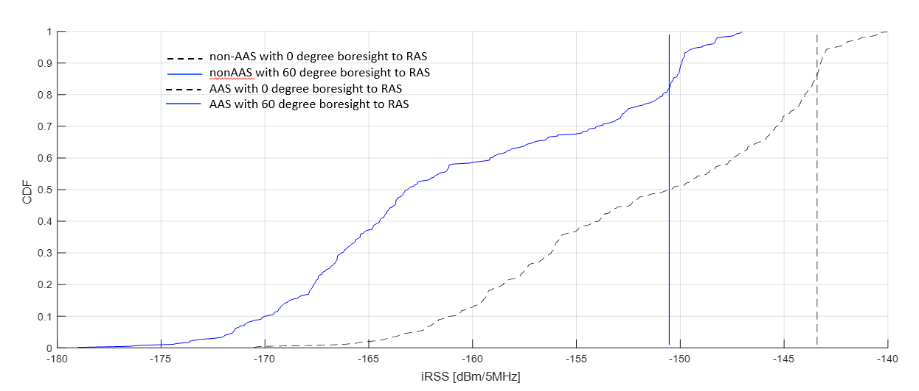
Figure 44: iRSS for RAS at 60 km distance with boresight BS antenna to RAS 0 and 60 degree for single sector, pP.452 = 2% and three UEs sharing bandwidth per snapshot (Table 72)

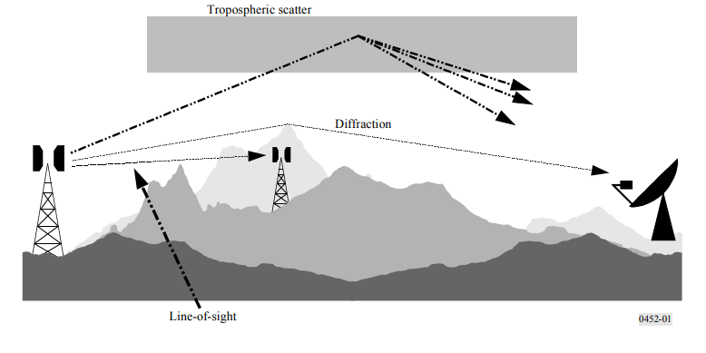
Figure 45: Long-term interference propagation mechanisms from Recommendation ITU-R P.452 [24]
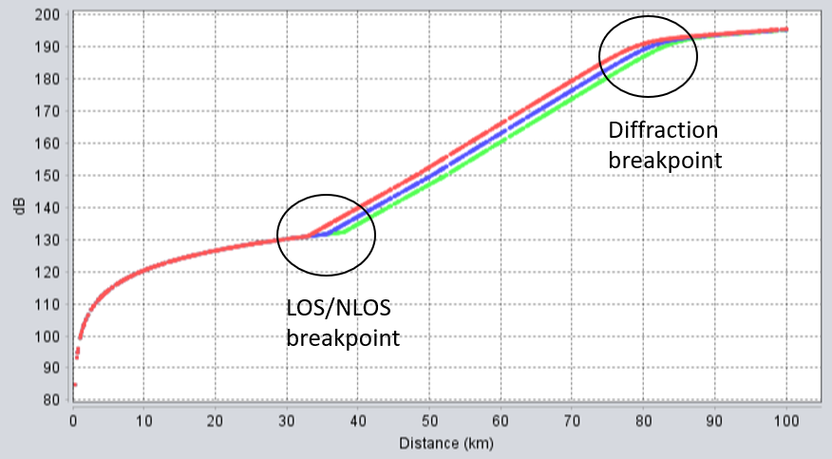
Figure 46: Path loss versus distance for Recommendation ITU-R P.452 [24]. For different BS antenna heights above ground with 20 m (red), 25 m (blue) and 30 m (green) and RAS with fixed 50 m height above ground. Showing LOS/NLOS breakpoint between 30 and 40 km and diffraction breakpoint around 75 to 85 km for these cases
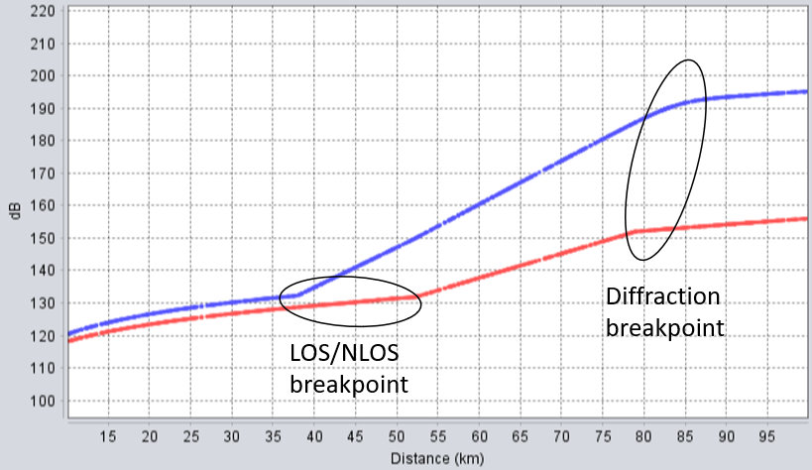
Figure 47: Path loss versus distance for Recommendation ITU-R P.452 [24] model. For pP.452 = 2% (red) and 50% (blue) with BS antenna height 30 m and RAS antenna height 50 m above ground
      - Simulation results for BS with different output powers and OOB unwanted emissions - single sector
        - BS with no upper restriction in output power
For macro BS the OOB unwanted emissions for 2690-2700 MHz is given in Table 7 for non-AAS per connector and in Table 63 for AAS per sector. Assuming the worst case in average OOB power over 5 MHz for the upper two 5 MHz blocks (see section A4.3.1):
- non-AAS BS with 4Tx and no upper restriction in output power for the upper two 5 MHz blocks the average OOB power is ~-5 dBm/MHz;
- AAS BS with no upper restriction in output power for the upper two 5 MHz blocks the average OOB power is ~7 dBm/MHz.
For macro rural sites it can be observed in the results below that:
- for such large distances the change in ΔiRSS with distance is negligible and the small difference in the tables is due to limited #of snapshots;
- For AAS/non-AAS ΔiRSS @50% CDF (Table 67 and Table 68) the AAS is 4 to 10 dB higher than for a non-AAS BS;
- If reducing the macro BS transmission power by 10 dB for the two upper 5 MHz blocks from e.g. 58 to 48 dBm/5 MHz TRP (see Table 61 and Table 62). The ΔiRSS in Table 67 to Table 69 would scale with 5 dB down.
Table 67: Macro rural case ΔiRSS for fully correlated case (ρ= 1) and single UE using full bandwidth per snapshot
 |  | 20 km | 40 km | 60 km | 100 km
ΔiRSS in dB | @50% CDF | 3.9 | 4.0 | 4.2 | 4
ΔiRSS in dB | @90% CDF | 20.6 | 20.6 | 20.8 | 20.8
ΔiRSS in dB | @95% CDF | 21.9 | 22.0 | 22.0 | 22.2
ΔiRSS in dB | @98% CDF | 22.4 | 22.4 | 22.4 | 22.5
Table 68: Macro rural case ΔiRSS for fully correlated case (ρ = 1) and three UEs sharing bandwidth per snapshot
 |  | 20 km | 40 km | 60 km | 100 km
ΔiRSS in dB | @50% CDF | 9.5 | 9.3 | 10.7 | 8.1
ΔiRSS in dB | @90% CDF | 17.8 | 17.9 | 17.9 | 17.8
ΔiRSS in dB | @95% CDF | 18.4 | 19.0 | 19.0 | 19.0
ΔiRSS in dB | @98% CDF | 19.9 | 20.1 | 19.6 | 19.9
Table 69: Macro rural case ΔiRSS for uncorrelated case (ρ = 0)
 | 20 km | 40 km | 60 km | 100 km
ΔiRSS in dB | 4.9 | 4.9 | 4.9 | 4.9
        - AAS/non-AAS BS with equal OOB emission for B7/n7 and B38/n38
The following cases for OOB emission (2690-2700 MHz) are considered:
- Equal OOB emission for non-AAS with 4Tx and AAS per sector which could be achieved by using e.g. lower transmission power (BS type) or additional filtering.
- For TDD part of the 2600 MHz spectrum (2570-2620 MHz) with -30 dBm/MHz for non-AAS per connector and 4Tx and per sector for AAS/TRP.
          - Macro rural site with BS at 20-100 km distance towards RAS
For macro rural site, it can be observed in the tables below that:
- for such large distances the change in ΔiRSS with distance is negligible and the small difference in the tables is due to limited #of snapshots;
- The results for ΔiRSS are basically the same as found for radar in Table 44;
- For AAS correlated case the ΔiRSS is small even for 98% CDF. Which could be of interest for distance <~40 km between BS and RAS station;
- for AAS uncorrelated case ΔiRSS is negative meaning interference from AAS is less than from non-AAS towards RAS station.
Table 70: Macro rural case ΔiRSS for fully correlated case (ρ= 1) and single UE using full bandwidth per snapshot
 |  | 20 km | 40 km | 60 km | 100 km
ΔiRSS in dB | @50% CDF | -14.1 | -14.3 | -13.7 | -14
ΔiRSS in dB | @90% CDF | 2.8 | 3 | 2.5 | 2.8
ΔiRSS in dB | @95% CDF | 4.1 | 4.2 | 4 | 4
ΔiRSS in dB | @98% CDF | 4.5 | 4.5 | 4.4 | 4.5
Table 71: Macro rural case ΔiRSS for fully correlated case (ρ = 1) and three UEs sharing bandwidth per snapshot
 |  | 20 km | 40 km | 60 km | 100 km
ΔiRSS in dB | @50% CDF | -8.3 | -8.2 | -7.9 | -8.6
ΔiRSS in dB | @90% CDF | -0.1 | 0 | -0.2 | -0.2
ΔiRSS in dB | @95% CDF | 1 | 1 | 1 | 0.9
ΔiRSS in dB | @98% CDF | 2.2 | 2.1 | 1.8 | 2.1
Table 72: Macro rural case ΔiRSS for uncorrelated case (ρ = 0)
 | 20 km | 40 km | 60 km | 100 km
ΔiRSS in dB | -13.1 | -13.1 | -13.1 | -13.1
          - Macro rural / suburban / urban @40 km distance towards RAS
For macro/suburban/urban rural site, it is observed in the tables below that:
- The difference in the AAS/non-AAS @50% CDF for macro rural, suburban and urban is small. For higher CDF thresholds the difference is larger and needs to be considered;
- For urban sites at distances <~40 km between BS and RAS site further OOB restriction for 2690-2700 MHz for the AAS BS may be needed;
- for AAS uncorrelated case ΔiRSS is negative meaning interference from AAS is less than from non-AAS.
Table 73: Macro rural, suburban and urban case for 40 km distance to RAS, ΔiRSS for fully correlated case (ρ= 1) and single UE using full bandwidth per snapshot
 |  | Macro rural | Suburban | Urban
ΔiRSS in dB | @50% CDF | -14.3 | -13.1 | -13
ΔiRSS in dB | @90% CDF | 3 | 6.1 | 7.9
ΔiRSS in dB | @95% CDF | 4.2 | 8.1 | 10.6
ΔiRSS in dB | @98% CDF | 4.5 | 9 | 12
Table 74: Macro rural, suburban and urban case for 40 km distance to RAS, ΔiRSS for fully correlated case (ρ = 1) and three UEs sharing bandwidth per snapshot
 |  | Macro rural | Suburban | Urban
ΔiRSS in dB | @50% CDF | -8.2 | -7.3 | -5.3
ΔiRSS in dB | @90% CDF | 0 | 4.2 | 7.1
ΔiRSS in dB | @95% CDF | 1 | 4.8 | 7.8
ΔiRSS in dB | @98% CDF | 2.1 | 6.5 | 8.7
Table 75: Macro rural, suburban and urban case for 40 km distance to RAS, ΔiRSS for uncorrelated case (ρ = 0)
 | Macro rural | Suburban | Urban
ΔiRSS in dB | -13.1 | -7.5 | -3.2
      - Summary RAS results
RAS is studied for AAS/non-AAS single BS sector pointing towards RAS Recommendation ITU-R P.452 [24] model (including time percentage parameter). The results depend strongly on the time percentage parameter assumption for the path loss model.
For single sector pointing towards the RAS and non-AAS 4Tx assumption. For macro BS in rural areas with no upper power limit and the upper two B7/n7 FDD blocks:
- For pP.452 = 4% and pAAS = 50%: The ΔiRSS is about 4 to 10 dB.
- For pP.452 = 50% and pAAS = 4%: The ΔiRSS is about 18 to 23 dB.
AAS may need further filtering and/or mitigation compared to non-AAS.
For single sector pointing towards the RAS and non-AAS 4Tx assumption. For macro BS with equal OOB emission for AAS and non-AAS for rural, suburban and urban area:
- For pP.452 = 4% and pAAS = 50%: The ΔiRSS is about -4 to -15 dB.
- For pP.452 = 50% and pAAS = 4%: The ΔiRSS is about 1 to 12 dB with the larger value from the urban case.
No further restriction to non-AAS case needed for the AAS BS as the overall expected interference towards RAS is about the same considering the simulation scenarios.

  - For macro cellular BS sectors (rural/suburban/urban) NOT pointing in the direction of a radar or RAS station within ±60° from the boresight of the antenna
For non-AAS antenna model the back-lobe difference to the max antenna gain is about 28 dB. For AAS the front-to-back ratio is Am = 30 dB for correlated case. This attenuation is due to ground plane in the antennas and depends on the actual design. The back lobe will get further attenuation to the front in real installations due to e.g. mast and other mountings/equipment in the back of the antenna.
For macro cellular BS sectors (rural/suburban/urban) NOT pointing in the direction of a radar station within ±60° from the boresight of the antenna. It is expected that AAS (-30 dBm/MHz spurious emissions) will not cause more interference than non-AAS.
  - appendix – figures
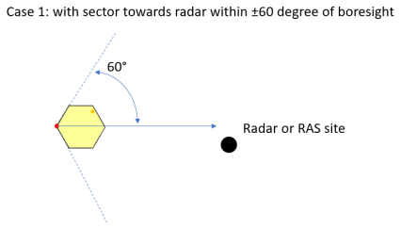 | 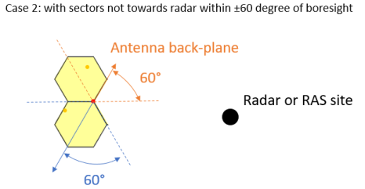
Figure 48: Case 1 with sector towards radar within ±60 degree of boresight. Case 2 sectors not towards radar within the ±60 degree of boresight

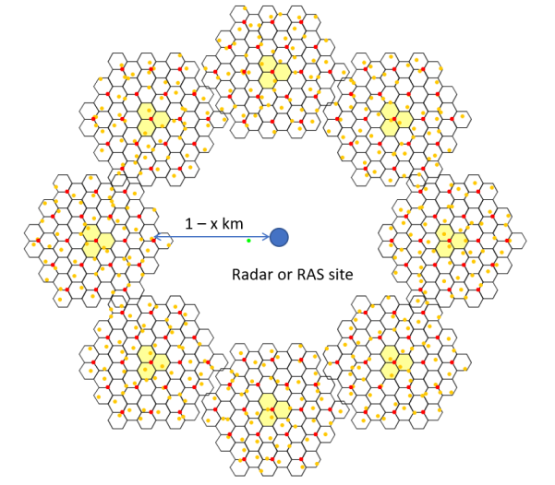
Figure 49: Case 3 Realistic case of cellular ring/grids around radar station with 8 two-tiers tri-sectors
Figure 50: Probability of ΔiRSS for worst-case single sector assumption pointing towards radar station. (a) Macro rural and (b) suburban case three UEs sharing bandwidth per snapshot and ρ = 1
Figure 51: Probability of interference for ΔiRSS for realistic case of ring/grid around radar station with distance separation ~5 km. Macro rural case single UE per snapshot and full RB allocation for ρ = 1 and ρ = 0. The fluctuation of about ±0.5 dB is within the accuracy in the simulation with the chosen #of of snapshots
- STUDY #3 for AAS/non-AAS 2600 MHz MFCN band and RAS/radar
  - AAS (LTE/NR) Coexistence with Meteorological Radars in 2600 MHz: simulation scenarios and assumptions
    - Simulation scenarios
The band 2700-2900 MHz is allocated on primary basis to Aeronautical Radionavigation, and restricted to ground-based radars (and to associated airborne transponders) by RR 5.337. The weather radars are included by RR 5.423:
“In the band 2 700-2 900 MHz, ground-based radars used for meteorological purposes are authorised to operate on a basis of equality with stations of the aeronautical radionavigation service.”
Also Radiolocation is listed with secondary status in the RR frequency table in the band 2700-2900 MHz.
This Annex provides a simple MCL analyses to evaluate the impact of AAS to radars in comparison with non-AAS effect analysed in ECC Report 174.
In the analyses below, the MFCN system is considered as interferer while the Radar is considered as the victim system.
In ECC Report 174 there are 4 different radar types are studied. Type 1 to type 3 ATC and Defence and type 4 for Meteorology. For the simple MCL cross checking analyses provided below only the Meteorological radars (type 4) is used as an example.
The parameters used in our study for such radars are those used in ECC Report 174 (Table 5). In particular the antenna height of 13 m and protection level of -122 dBm/MHz were used for meteorology Radar.
    - Simulation Parameters
Tables below show the parameters used in our MCL analyses for both AAS (ECC Report 281 and ECC Report 174) and no-AAS (Aligned with ECC Report 174):
- AAS and non-AAS BS Antenna height: 30 m (urban) as in ECC Report 174;
- AAS and non-AAS BS Inter-site distance ISD: 660 m (urban) as in ECC Report 174;
- Antenna tilt: AAS 10° (mechanical), non-AAS: 5° (Urban scenario in ECC Report 174);
- NR and LTE systems are defined in 3GPP for 2600 MHz band (FDD band 7 and TDD band 38) with a maximum channel bandwidth of 20 MHz. This is similar to the maximum channel bandwidth defined for LTE non-AAS in the same bands. Therefore, the spurious limit applies 10 MHz from the band edge;
- For AAS BS the antenna pattern from Recommendation ITU-R M.2101 [10] was considered in our MCL calculation with Beam formed Antenna pattern.
Spurious Emission
for AAS:
- Case 2.A: AAS Spurious TRP of -30 dBm/MHz.
for non-AAS:
Spurious Emission for the non-AAS, the analysis considers a conducted spurious emission limit of -30 dBm/MHz defined at antenna connector. Different scenarios are evaluated for the non-AAS to allow comparison with the AAS on equivalent basis:
- Case 1A: non-AAS with single passive Antenna;
- Case 1B: non-AAS with 4 passive Antennas;
- Case 1C: non-AAS with 8 passive Antennas.
For non-AAS the same antenna pattern as in ECC Report 174 is reused (based on Recommendation ITU-R F.1336-3 [23]):
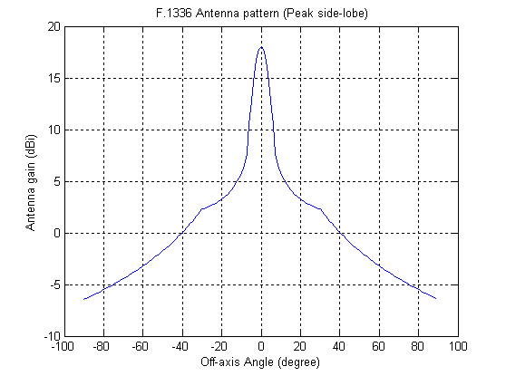
Figure 52: Non-AAS antenna pattern based on Recommendation ITU-R F.1336-3
In these calculations, only outdoor UEs were considered. The outdoor UE uniformly distributed and dropped based on 660 m ISD based on the following figure.
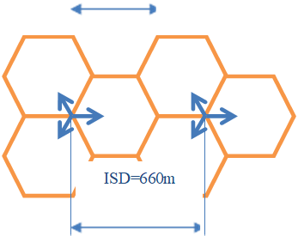
Figure 53: Illustration of the geometry for a 3-sector deployment and defines the parameters cell
Note that free space path loss is considered for the modelling of signal propagation from an interfering base station to the victim radar.
Table 76: Parameters for the “AAS” and “non-AAS” systems used for the comparison
Interferer AAS (Case 2) |  | Interferer non-AAS (Case 1)
Beamforming towards UEs with (8×8) array.  UEs uniformly distributed in each hexagonal cell |  | Fixed directional pattern  (see figure above)
Network deployment | Hexagonal cells  ISD = 660 m. | Network Deployment | see above
Element gain | 8 dBi | Maximum antenna gain | 18 dBi
Channel bandwidth | 10 MHz | Channel bandwidth | 10 MHz
Effective channel bandwidth | 90% | Effective channel bandwidth | 90%
TRP spurious emission limit above 2700 MHz | spurious emissions limit applicable at 10 MHz from the band edge:  - Case 2: -30 dBm/MHz | Conducted spurious emission limit above 2700 MHz | -30 dBm/MHz applies per antenna 10 MHz from the band edge  3 cases for the non-AAS have been evaluated:  - Case 1A:  1 antenna per sector  - Case 1B:  4 antennas per sector  - Case 1C:  8 antennas per sector
The table below shows the antenna array characteristics modelled for AAS base stations, aligned with Table 22 of ECC Report 281.
Table 77: Parameters for AAS
Parameter | Value
Antenna element  directional pattern $a_{E dB}\left(θ,φ\right)$ | According to 3GPP TR 37.840 (section 5.4.4.2) [15]:  $$a_{E dB}\left(θ,φ\right)=-min\left\{-\left[A_{E,V dB}\left(θ\right)+A_{E,H dB}\left(φ\right)\right],{ A}_{m dB}\right\},$$  $$A_{E,H dB}\left(φ\right)=-min\left\{12{\left(\frac{φ}{φ_{3dB}}\right)}^{2},A_{m dB}\right\},$$  $$A_{E,V dB}\left(θ\right)=-min\left\{12{\left(\frac{θ-90°}{θ_{3dB}}\right)}^{2},{SLA}_{V dB}\right\},$$  Where:  - 3 dB elevation beamwidth θ3dB = 65°;  - 3 dB azimuth beamwidth ϕ3dB = 80°;  - Front-to-back ratio Am = 30 dB;  - Side-lobe ratio SLAV = 30 dB.  NOTE: $a_{E}\left(θ,φ\right)≤1$.  NOTE: Each antenna element is larger in size in the vertical direction, and so θ3dB < ϕ3dB. (see 3GPP TR 37.840)
Antenna element gain $G_{E dB}$ | 8 dBi
Number of base station beamforming elements (NV and NH) | (8,8)
Element spacing | 0.9λ vertical separation.  0.6λ horizontal separation.  NOTE: Larger vertical spacing provides narrower array beamwidth in elevation (see 3GPP TR 37.840 (Table 5.4.4.2.1-1)).

    - Simulation results
      - Non-AAS BS interference to type 4 radars
Table 78: Non-AAS BS additional isolation requirements to type 4 radars
Case 1A | non-AAS Urban 1 km  Single antenna | non-AAS Urban 10 km  Single Antenna
IMT bandwidth (MHz) | 10 | 10
IMT Transmitter
TX power (dBm) | -20.00 | -20.00
Tx antenna gain (dBi) | 14.60 | 12.80
Feeder loss (dB) | -3.00 | -3.00
Tx antenna gain with feeder loss (dBi) | 11.60 | 9.80
Transmitter factor (dB) | 0.00 | 0.00
e.i.r.p. (dBm) | -8.40 | -10.20
Radar
Rx antenna gain (dBi) | 43 | 43
Rx feeder loss (dB) | -2 | -2
Rx antenna gain with feeder loss (dBi) | 41 | 41
Max. tolerable interference (dBm) | -112.00 | -112.00
Propagation loss (dB)
Path loss (dB) | 100.96 | 120.96
Radar single entry interference (dBm) | -68.36 | -90.16
Additional isolation requirement (dB) | 43.64 | 21.84
A feeder loss of 3 dB has been included in the analysis as in ECC Report 174, this assumes that a traditional ground based BS is used. Remote Radio Head (RRU) technology is most likely today at 2.6 GHz and places the BS RF and the antenna connector at the top of the mast and hence feeder loss could be almost eliminated.
Provided that the spurious emission level of -30 dBm/MHz for non-AAS BS applies per antenna connector, and based in the MCL evaluation above, the following results can be derived for a non-AAS with more than one antenna per sector.
Table 79: Non-AAS BS with 1, 4 and 8 antennas per sector additional isolation requirements to type 4 radars
non-AAS Case
Additional isolation requirement (dB)
 | Single antenna per sector | 4 antennas per sector | 8 Antennas per sector
1 km separation distance | 43.64 dB | 49.66 dB | 52.67 dB
10 km separation distance | 21.84 dB | 27.86 dB | 30.87 dB
      - AAS BS interference to type 4 radars
The 2 figures below show the AAS BS antenna gain CDF toward the type 4 radar respectively for 1 km and 10 km separation distance between the AAS BS and the radar.
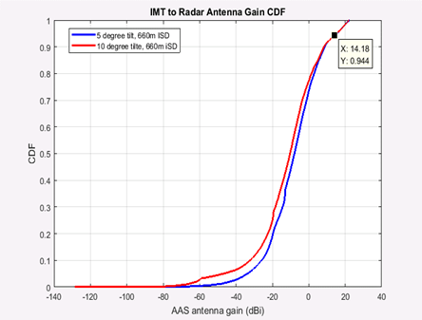 | 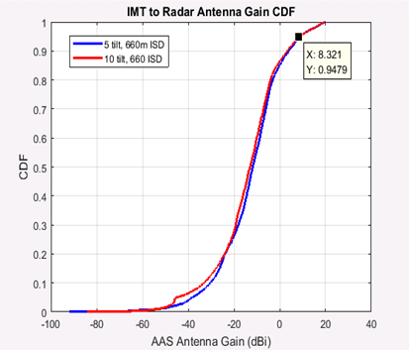
Figure 54: Case 1: 1 km Separation distance (left); Case 2: 10 km Separation distance (right)
For our MCL calculation, the AAS BS TX antenna gain used corresponds to the 95% CDF value from the tables above.
It can be noted that this gain represents the full beam forming gain of the AAS BS assuming that the interference is beam formed in the same way as the wanted signal. This relies on the assumption that the interference is fully correlated with the wanted signal. The MCL below hence represents a worst case calculation.
The table below shows the estimated additional isolation required between the AAS and type 4 radar in urban environment for separation distance (AAS BS to Radar) of 1 km and 10 km.
Table 80: Additional isolation required between the AAS and type 4 radar in urban environment for 1 and 10 km
Case 2 | Case 2A
 | AAS Urban  1 km | AAS Urban  10 km
IMT Bandwidth (MHz) | 10 | 10
IMT Transmitter
TX power (dBm) | -20.00 | -20.00
Tx antenna gain (dBi) | 14.18 | 8.31
Feeder loss (dB) | 0.00 | 0.00
Tx antenna gain with feeder loss (dBi) | 14.18 | 8.31
Transmitter factor (dB) | 0.00 | 0.00
e.i.r.p. (dBm) | -5.82 | -11.69
Radar
Rx antenna gain (dBi) | 43 | 43
Rx feeder loss (dB) | -2 | -2
Rx antenna gain with feeder loss (dBi) | 41 | 41
Max. tolerable interference (dBm) | -112.00 | -112.00
Propagation loss (dB)
Path loss (dB) | 100.96 | 120.96
Radar single entry interference (dBm) | -65.78 | -91.65
Additional isolation requirement (dB) | 46.22 | 20.35
    - Analyses and Conclusions
From the above MCL calculations the following can be derived
Table 81: Additional isolation requirements for non-AAS and AAS for 1 and 10 km separation distance
 | non-AAS Case  Additional isolation requirement (dB) |  |  | AAS Case  Additional isolation requirement (dB)
 | Single antenna per sector | 4 antennas per sector | 8 antennas per sector | TRP Spurious limit  -30 dBm/MHz
1 km separation distance | 43.64 dB | 49.66 dB | 52.67 dB | 46.22 dB
10 km separation distance | 21.84 dB | 27.86 dB | 30.87 dB | 20.35 dB
If TRP spurious limit for AAS BS is defined as -30 dBm/MHz:
- For 1 km separation distance, the AAS BS requires 2.6 dB more isolation than a non-AAS BS with a single antenna. This is mainly due to the fact that here 3 dB feeder loss for non-AAS and 0 for AAS were considered.
- For 10 km separation distance, the AAS BS requires 1.5 dB less isolation than a non-AAS BS with 8 antennas offering slightly better coexistence conditions
- For 10 km separation distance, the AAS BS requires 7.5 dB Less isolation than a non-AAS BS with 4 antennas. This is a major advantage of AAS compared to non-AAS with multiple antennas. Non-AAS with 4 antennas are already deployed on the field and didn’t show any coexistence issues with adjacent systems
- For 10 km separation distance, the AAS BS requires 7.5 dB Less additional isolation than a non-AAS BS with 4 passive antennas and 10,5 dB less additional isolation than a non-AAS with 8 passive antennas. This is a major difference of AAS compared to non-AAS with multiple antennas. Non-AAS with 4 antennas are already deployed on the field and didn’t show any coexistence issues with adjacent systems
As it can be seen, even with 2 worse case assumptions in the favour of the non-AAS BS analysis (i.e. 3 dB feeder loss assumption for the non-AAS and 0 dB for AAS and fully correlated interference for the AAS) the AAS interference compares favourably with the non-AAS.
  - AAS (LTE/NR) Coexistence with Meteorological Radars in 2600 MHz: further analyses
    - UE distribution impact
The study below considers the effect of UE distribution on the AAS antenna gain evaluation for the urban scenario. The other studies for AAS/radar coexistence in 2.6 GHz band assume random uniform distribution in fan shape area as follows:

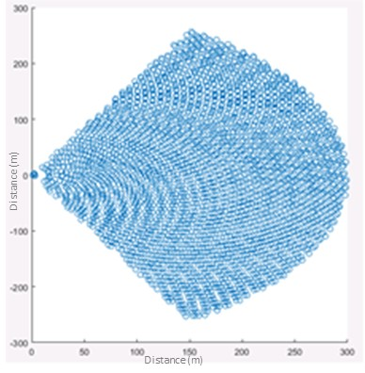
Figure 55: UE random uniform distribution assumption
In reality, the density of users would not be uniform and would be higher in the cell centre compared to cell border as operators’ locate their BS where they can better serve/absorb the traffic.
The contribution of the different UEs to the AAS antenna gain CDF was analysed when using the fan shape topology with random uniform UE distribution. It appears that the 5% worst (Top) AAS antenna gains are produced by UE that are in the red area below. This corresponds to the boresight direction of the sector and mainly in the part closer to cell border.

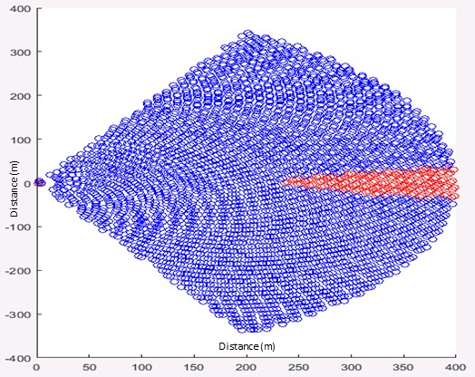
Figure 56: Urban case using random uniform in fan shaped topology
In ITU-R TG5/1 [29], two UE distribution methods are accepted. One is Rayleigh distribution for urban hotspot, another is log-normal distribution for suburban open space scenario. Two methods both have the common feature that the edge UE density will be smaller than the cell centre.
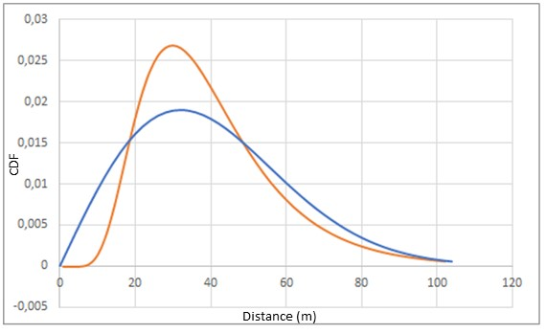
Figure 57: TG5/1: Comparison between Rayleigh (Red curve) and Log-Normal distributions
The above figure is the comparison between lognormal and Rayleigh distribution for the same coverage, it can be found Rayleigh distribution (orange curve) is more representative for hotspot because more UEs are allocated in the centre area.
For suburban open space scenario, Log-Normal distribution was considered in TG5/1 to be more relevant compared to Rayleigh (see the following figure from TG5/1).
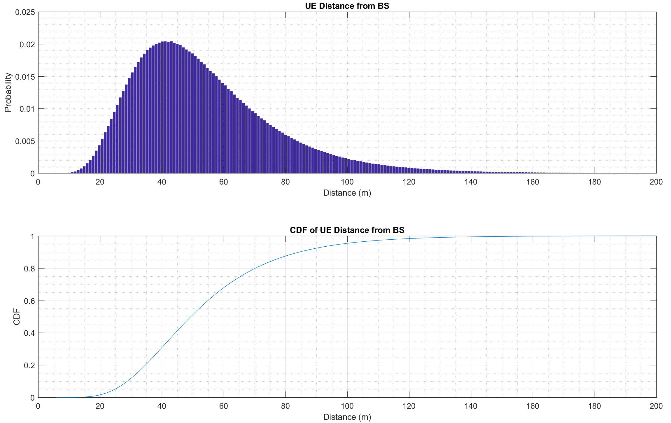
Figure 58: Log-normal distribution as was considered in TG5/1 [29]
In the following, it is proposed to consider for the Urban Macro scenario for 2.6 GHz band the log-normal distribution (more conservative than Rayleigh) and adapt it based on the cell radius and the IMT antenna pointing used in our radar coexistence study.
Urban scenario
When considering Report ITU-R M.2292 [20] parameters (10° downtilt for urban scenario and 400 m cell radius) for the 2600 MHz AAS/radar coexistence, it has been found that the IMT antenna points to about 105 m meters away from the BS. This is considered to be the cell centre.
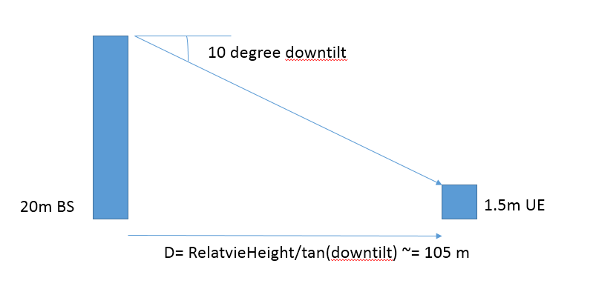
Figure 59: Cell center for antenna with 10 degree downtilt and BS height of 20 m
Supposing the UE distribution follows log-normal distribution which is more conservative than Rayleigh distribution, the case μ = 4.8, σ = 0.35 values for the log-normal distribution were proposed. The resulting distribution is shown below:
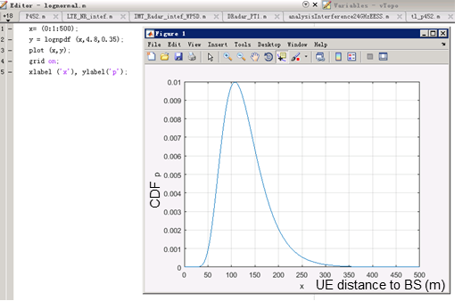 | 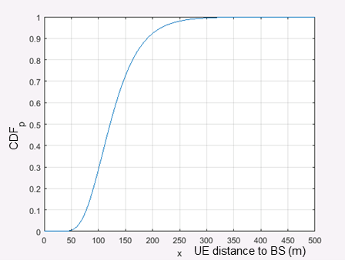
Figure 60: (left) PDF of proposed log-normal distribution; (right) CDF of proposed log-normal distribution
This distribution is consistent with both cell centre being about 105 m and the cell radius 400 m. The following figures show the actual UE distribution inside the cell and the AAS antenna gain towards to Radar considering the proposed log-normal distribution. The red colour highlights the location of UEs producing the top 5% AAS antenna gains:
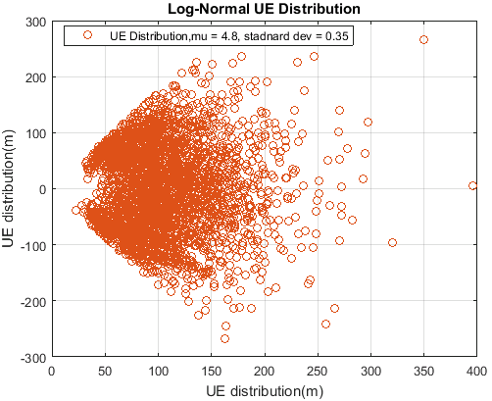 | 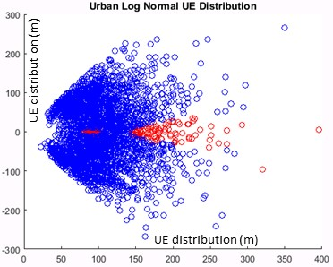
Figure 61: (left) Urban scenario log-normal UE distribution; (right) Location of the 5% top AAS antenna gains for the Urban scenario log-normal UE distribution
The results are the following:
Table 82: AAS antenna gain towards radar for 95% CDF and fan topology log-normal distribution
AAS antenna gain towards to Radar (95% CDF)
Fan topology with proposed log-normal distribution
Radar height 13 m | 1 km 1 UE | 10 km 1 UE
IMT BS height 20 m | 9.02 dBi | 8.18 dBi
    - Comparison of Impact of Report ITU-R M.2292 parameters and ECC Report 174 parameters
Analyses is provided to try to explain the difference between the additional isolation to radar evaluated for AAS BS (based on Report ITU-R M.2292 parameters [20]) in comparison to that evaluated based on ECC Report 174 parameters [6]. These analyses focus mainly on the urban scenario.
In the following, it is shown that the impact of different parameters on the AAS antenna gain toward the radar:
- IMT BS antenna Height (20 m versus 30 m) and cell radius (400 m versus smaller radius 300 m)
- Down tilt (10° versus 5° for urban scenario)
Impact of IMT antenna height and cell radius:
The following figure provides the sensitivity analysis for different case and it can be seen be seen that the bottle neck is the cell radius.
For Urban case 1 km distance to Radar
For 30 m IMT BS antenna height (urban scenario in ECC Report 174)
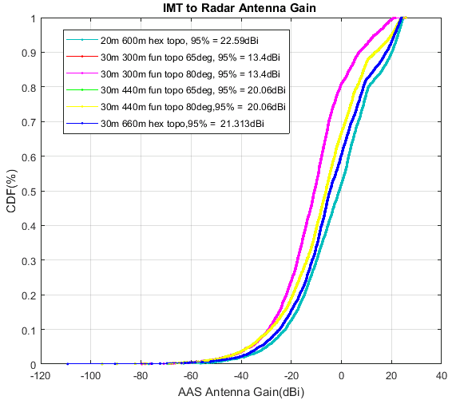
Figure 62: IMT to radar AAS antenna gain
For 20 m IMT BS antenna height (urban in Report ITU-R M.2292 [20])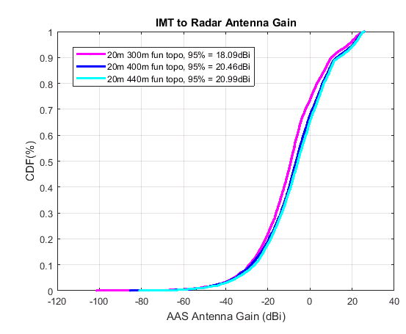
Figure 63: IMT to radar AAS antenna gain for urban scenario for urban scenario and 20 m BS antenna height
When the Urban IMT BS antenna height increases from e.g. 20 m (Report ITU-R M.2292) to 30 m (ECC Report 174) the 95% CDF AAS antenna gain decreases by 3 to 4 dBs (400 m Radius). This factor is bigger for smaller cell radius (example 300 m).
For Urban case 20 m heights when the cell radius decreases e.g. from 400 m to 300 m, the 95% CDF AAS antenna gain decreases by roughly 2 dB. However, this factor is higher when 30 m antenna height are considered (around 5 dB)
Impact of Down tilt:
The effect of down tilt on AAS BS gain discrimination has been evaluated previously.
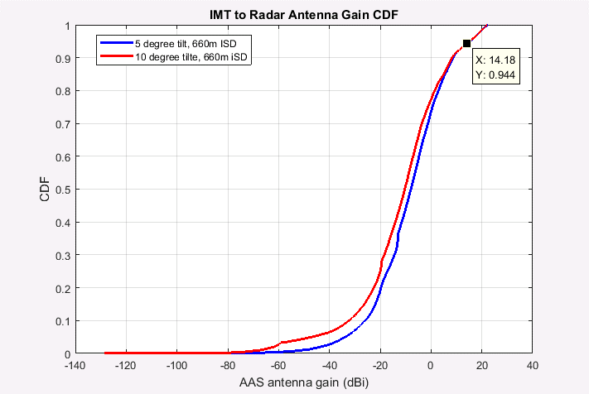
Figure 64: Down tilt effect on AAS Antenna gain (hexagonal topology from ECC Report 174)
It appears that changing down-tilt from 5° (ECC Report 174 [6]) to 10° (Report ITU-R M.2292 [21]) does not influence much the AAS antenna gain (for CDF >80%). This is very different from the non-AAS antenna gain which drastically changes with down-tilt as in the following figure:
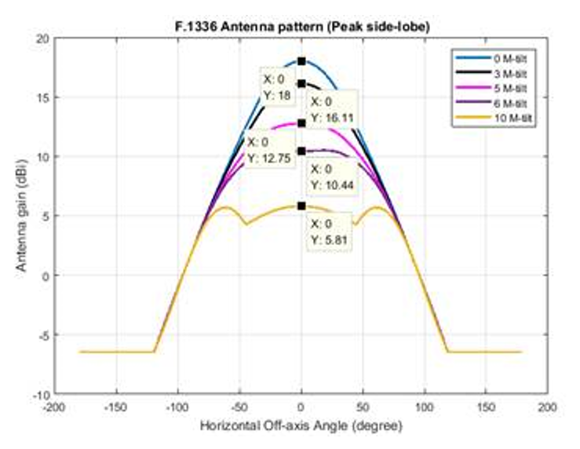
Figure 65: Antenna pattern for non-AAS: based on F.1336-4 [22]
Consequently, the difference in isolation needed for the urban scenario for AAS BS compared to non-AAS BS would be almost 7 dB smaller when ECC Report 174 parameter (5° down-tilt) is used compared when Report ITU-R M.2292 parameter is used (10° down-tilt).
    - Summary of results
Based on the above analysis, the following has been observed:
- When random uniform distribution is used, the UEs leading to the 5% worst AAS antenna gain results are located in the boresight direction of the sector and mainly in the part closer to cell border;
- The UE distribution has considerable impact on the AAS antenna gain CDF. Log-normal UE distribution would lead for the urban case to 95% CDF AAS gain toward the radar in the order of 9 dBi;
- When the Urban IMT BS antenna height increases from e.g. 20 m (Report ITU-R M.2292) to 30 m (ECC Report 174) the 95% CDF AAS antenna gain decreases by 3 to 4 dBs (400 m Radius). This factor is bigger for smaller cell radius (example 300 m);
- For Urban case 20 m heights when the cell radius decreases e.g. from 400 m to 300 m, the 95% CDF AAS antenna gain decreases by roughly 2 dB. However, this factor is higher when 30 m antenna height are considered (around 5 dB);
- Considering for the urban scenario a BS down-tilt value of 10° (Report ITU-R M.2292) instead of 5° (ECC Report 174) would increase the difference between additional isolation required for AAS BS compared to non-AAS BS by roughly +7 dB.
  - Considerations regarding AAS (LTE/NR) coexistence with RAS
Based on the analyses above in section A5.2, regarding AAS BS and variability of its impact depending on parameters used, the following points propose some elements for consideration in order to define proportionate mitigation techniques to solve the AAS/RAS coexistence, in areas/countries where such coexistence is justified/needed:
- As stated in A5.2 different assumptions regarding IMT deployment of AAS BS (e.g. IMT antenna pointing or not to the victim, UEs number and distribution, environment rural/Urban, IMT antenna height, etc) influence the results;
- For VLBI measurements (protection criteria -165 dBW/10 MHz) the coordination zone is drastically smaller compared to continuum measurements (protection criteria -207 dBW/10 MHz, i.e. -185 dBm/MHz) provided that the protection criteria is roughly 40 dB better. The RAS community indicated in Annex 6 of this Report that VLBI stations also need to perform calibration scans, which are done in continuum mode;
- The impact of AAS toward RAS should not be considered in isolation of current non-AAS operation that supports multiple antennas (e.g. MiMO 4TX, 8TX) already deployed in some European countries;
- Proportionate measures are to be recommended to solve the RAS issues in countries/regions where mitigation is needed and should consider the positive margins implied by sensitivity studies above;
- Any additional OOB limits applied to AAS above 2690 MHz (applicable in 2690-2700 MHz) should consider the values proposed in the Table 83 below to ensure implementation feasibility and viability of AAS BS implementation in 2.6 GHz band;
- Any additional OOBE limits above 2690 MHz (applicable in 2690-2700 MHz) should be limited to geographical area or countries where additional mitigation is needed.
Complementary site specific engineering solutions are to be discussed at national level and where necessary, including: AAS antennas not pointing to RAS station, lower power BS deployment, electronically fixed down-tilting, etc,
Table 83: Additional out of band emission power limits to be applied above 2690 MHz for AAS base stations for country specific cases
 | Frequency range | AAS TRP limit  dBm/(5 MHz) per cell (note 1)
CEPT countries with RAS operation above 2690 MHz | 2690-2695 MHz | 8 dBm/(5 MHz)
CEPT countries with RAS operation above 2690 MHz | 2695-2700 MHz | 3 dBm/(5 MHz)
CEPT countries without adjacent RAS usage or with usage that does not need extra protection | 2690-2695 MHz | Not Applicable
 | 2695-2700 MHz | Not Applicable
Note 1: In a multi-sector base station, the radiated power limit applies to each one of the individual sectors
- From product implementation perspective any stricter additional filtering requirements (absolute requirements) in the 10 MHz zone are likely to result in significant complexity of the AAS BS design and could very easily make implementation of AAS BS infeasible or not viable:
The 10 MHz transition region above the band edge is needed to guarantee performance in the in-band and spurious domain emissions limits at 10 MHz). It is very difficult to guarantee filter slop performance in such region;
Filters ‘move’ over frequency so the attenuation slope is unlikely to be a linear interpolation between in- band and spurious domain emissions limits.

- STUDY #4 Compatibility between non-AAS and AAS MFCN in 2600 MHz and RAS in 2690-2700 MHz
  - Introduction
This compatibility study concerns the protection of the radio astronomy service (RAS) in the frequency range 2.69-2.70 GHz from unwanted emissions of IMT base stations (BS) operating in the frequency band 2.50-2.69 GHz. It is assumed that the RAS will be affected in the out-of-band (OOB) and spurious domain of the emission mask of the IMT devices. A comparison is made between LTE (4G) non-AAS MFCN and 5G AAS, the latter being capable of actively steering BS beams towards UE devices.
For the analysis, a full Monte-Carlo simulation had been set-up, modelling an IMT network consisting of BS and UE (but for the results, only the aggregated BS power is considered). The deployment of the IMT devices obviously plays an important role and is (exactly) the same for both simulations, non-AAS MFCN and AAS 5G, respectively. The simulations were done with the methodology described in ECC Report 281 (Annex 5). Here, only the differences to the study in that report are highlighted and for the discussion of the results the focus is on the comparison of AAS vs. non-AAS.
In some cases, it is expected that individual RAS site conditions, such as hilly or mountainous terrain will have a significant impact on the path propagation. Therefore, in a second part of the study, the single-interferer (worst-case) scenario is studied for two of the major European radio observatories operating in the 2.7 GHz band, the 100 m Effelsberg telescope (Germany) and the Nançay radio telescope (France).
  - Study parameters
    - RAS station parameters
The frequency range 2.69-2.70 GHz is extremely important to the RAS for continuum observations, both in single-dish mode and with VLBI. A large variety of astronomical objects can be studied, from galaxies and their active cores (powered by super-massive black holes), to super-nova remnants and pulsars, to name a few.
The list of CEPT countries with radio astronomy stations operating in the frequency range 2.69-2.70 GHz is as follows: France (Nancay), Germany (Effelsberg, Wettzell), Greece (Penteli), Italy (Medicina), Latvia (Irbene), Netherlands (Westerbork), Portugal (Porto), Russia (Nirfi Zimenky, Fian Puschino, Sao Zelenchukskaya), Spain (Yebes), Sweden (Onsala), Switzerland (Bleien), UK (Jodrell bank, Defford, Pickmere, Darnhall, Cambridge, Knockin), Ukraine (Kao Simeiz).
The IMT frequency band 2.50-2.69 GHz is adjacent the frequency band 2.69-2.70 GHz which is used by the radio astronomy service (RAS) and to which Footnote RR No. 5.340 applies, which prohibits all emissions in this band.
Threshold levels for interference detrimental to RAS observations are listed in Table 84; they are based on Recommendation ITU-R RA.769. In this study only the case of continuum RAS observations is considered. For the RAS station an isotropic antenna with a height of 50 m above the ground and a gain of 0 dBi is assumed, because the antenna pointing distributions of the existing RAS telescopes are highly variable, depending on the time of year and the current research targets. The pointing distribution is not uniform across the sky, as the astronomical sources of interest are also not uniformly distributed (for example, many objects are located in the “Galactic plane”). Furthermore, due to Earth’s rotation, most astronomical sources move in the topocentric observer frame (Azimuth/Elevation), such that the telescopes need to track them. Even if statistical information was available about the sources, which a telescope has observed (e.g., in the past years), incorporating the telescope pointing positions into the simulation would add another dimension to the Monte-Carlo approach and increase the necessary computing time a lot. Consequently, as pointed out in ECC Report 45 [5], “Recommendation ITU-R RA.769 [29] assumes that the chance that the interference is received by the main lobe of the antenna is low, and therefore assumes in the calculation of the levels of detrimental interference that this is received in a side-lobe, i.e. at a level of 0 dBi at 19° from boresight (see also Recommendation ITU-R SA.509 [35]; see also Recommendation ITU-R RA.1031 [36]) .
Some radio telescopes are operating almost exclusively in VLBI mode today. For them, less strict thresholds would theoretically apply (see Table 84). However, it must be pointed out that pure VLBI stations still need to perform calibration measurements, which are usually performed in total-power mode. The priorities of research for individual RAS stations change with time, adapting to the progress of science. It is therefore not appropriate to assume that the proportion of VLBI to continuum work will stay the same. Increasing threshold levels for such stations will impair their function as multi-purpose scientific instruments and restrict the future freedom of choice for their research topics.
No modification has been applied to the interference threshold levels based on apportionment of interference between services, following the opinion expressed by the RAS expert group, WP 7D (see document 5-1/176).
Table 84: Protection criteria for radio astronomy observations in the frequency range 2.69-2.70 GHz
RAS allocation status  RR Footnotes (note 1)  RAS use (note 2)  IMT/RAS band situation | RAS protection criteria according to Recommendation ITU-R RA.769-2
Primary allocation  RR No. 5.340  Broadband |  | Power entering receiver | Spectral PFD
Primary allocation  RR No. 5.340  Broadband | Continuum measurements) | -207 dB(W/10 MHz) | -247 dB(W/m2 Hz)
Primary allocation  RR No. 5.340  Broadband | VLBI measurements | -165 dB(W/10 MHz) | -205 dB(W/m2 Hz)
Primary allocation  RR No. 5.340  Broadband | Antenna noise temp. (K) | 12
Primary allocation  RR No. 5.340  Broadband | Receiver noise temp. (K) | 10
Note 1: RR No. 5.340 states “All emissions are prohibited in the following bands: […] 2690-2700 MHz except those provided for by No. 5.422 […]”.
Note 2: The term “Broadband” corresponds to “continuum” observations (see Table 1 of Recommendation ITU-R RA.769-2) and “narrowband” to “spectral line” observations (see Table 2 of Recommendation ITU-R RA.769-2) respectively. Both in-band emissions in these RAS bands and emissions from outside these RAS bands falling into them should remain below the thresholds for detrimental interference given in Recommendation ITU-R RA.769-2, subject to Recommendation ITU-R RA.1513 which provides with 2% data loss to the RAS due to interference by all stations of one service, and with an aggregate data loss of 5% in any band from all services.
    - IMT Parameters
The IMT technical parameters used for this study (see Table 85) were mainly adopted from the ANNEX 2: and otherwise from ECC Report 281 (in Annex 5) pertaining to compatibility studies with IMT systems for the 3.4-3.8 GHz band .The typical deployment densities are defined as a function of the environment of the IMT BS and UE, urban or rural hotspots. The base stations are usually not operating at 100% of their maximum capacity. In the calculations a network loading factor of 50% is assumed. Antenna patterns are taken from Recommendation ITU-R M.2101-0 (5G AAS) [10] and Recommendation ITU-R F.1336-4 (4G non-AAS) [22].
The total integrated gain correction (TIGC) factors listed in Table 85 are based on the guidelines provided in Annex 1 to ITU-R Document 5-1/478. For the AAS antenna patterns the factors in Table 85 are presented for the case were the beam is formed in forward direction, only. However for the simulation, the TIGC was derived for each individual beam direction. The correction factors are visualised in Figure 66 for the case $ρ=1$, for $ρ=0$ the TIGC has constant value (as no beam is formed), likewise for the non-AAS pattern. One of the study aims is also to compare the pure influence of the antenna pattern, mechanical down-tilt, and beam-forming of the AAS with respect to non-AAS. Therefore, in one simulation the output TRP power of the non-AAS was increased by 14.2 dB to have both, AAS and non-AAS emitting the same TRP. For this particular analysis, however, it needs to take into account for fact that the Recommendation ITU-R F.1336-4 [21]non-AAS antenna pattern is not normalised (i.e., integrated gain is not 0 dBi). A factor of -1.85 dB was applied to non-AAS for the direct comparison of the antenna pattern influence.
Table 85: IMT technical parameters for base stations
Parameters | AAS | non-AAS
Frequency | 2.6 GHz | 2.6 GHz
Antenna | 3 sectors (120°)  8×8 array elements  80°/65° 3-dB width, Gelem=8 dBi  30 dB f/b ratio  spacing: dH=0.6λ, dV=0.9λ  ρ=0 or 1  [ITU-R M.2101-0] | 3 sectors (120°)  single element  65°/7.6° 3-dB width, G0=18 dBi  k_p=0.7, k_h=0.7, k_v=0.3  [ITU-R F.1336-4; Section 3.1.1 (peak side-lobe)]
Total integrated gain correction | +0.35 dB (composite beam, ρ=1)  +0.93 dB (single-element, ρ=0) | n/a
Antenna normalisation | n/a | -1.85 dB
Mechanical down-tilt | -10° (urban, rural) | -5° (urban), -2.5° (rural)
BS antenna height | 20/30 m (urban/rural) | 20/30 m (urban/rural)
UE antenna height | 1.5 m | 1.5 m
Tx spectral power (TRP) | 7.5 dBm/MHz (OOB)  -30 dBm/MHz (spurious) | -9.7 dBm/MHz (OOB)  -30 dBm/MHz (spurious)
# Tx antennas; correction factor | 1; 0 dB | 4; +6 dB (OOB), +3 dB (spurious)
Feeder loss | n/a | 3 dB
Tx power into RAS band (TRP) | 17.5 dBm/(10 MHz) (OOB)  -20 dBm/(10 MHz) (spurious) | 3.3 dBm/(10 MHz) (OOB)  -20 dBm/(10 MHz) (spurious)
Network loading factor | 50% | 50%
ISD | 600 m | 600 m
Rb (housing ratio) | 5% | 5%
Ra (ratio of hotspot area to housing area) | 40% (urban), 1% (rural) | 40% (urban), 1% (rural)
Ri (indoor ratio of UE) | 70% (urban), 50% (rural) | 70% (urban), 50% (rural)
BS deployment density | 1.8 km-2 (nominal)  0.035 km-2 (urban)  0.001 km-2 (rural) | 1.8 km-2 (nominal)  0.035 km-2 (urban)  0.001 km-2 (rural)
UE deployment density | 35.4 km-2 (nominal)  0.212 km-2 (urban)  0.009 km-2 (rural) | 35.4 km-2 (nominal)  0.212 km-2 (urban)  0.009 km-2 (rural)
Distribution of user equipment (relative to base station)
Scenario I (“AI 1.13”) | Distance [m] ~ Rayleigh(0, 250) (urban), Rayleigh(0, 370) (rural)  Angle [°] ~ Uniform(-60, 60)
Scenario II (“Uniform”) | X [m], Y [m] ~ Uniform over ISD sphere

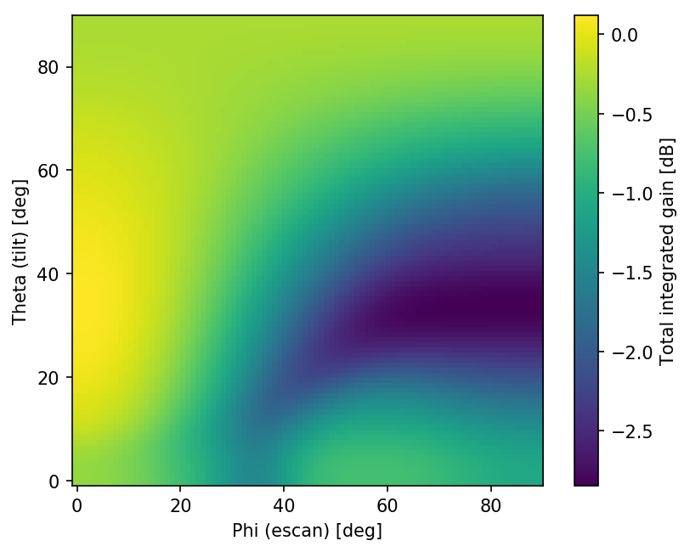
Figure 66: Total integrated gain correction for AAS
    - Other parameters
As for ECC Report 281 Annex 5, path propagation was calculated according to the model in Recommendation ITU-R P.452-16 , using three different values for the ”time percent” parameter (2%, 10%, and 50%). Clutter loss was inferred with Recommendation ITU-R P.2108-0 [30] formulas.
The deployment densities employed in this study are somewhat smaller compared to the 3.4-3.8 GHz study in ECC Report 281 Annex 5, as the inter-site distance (ISD) is slightly larger (600 m vs. 450 m). Because the resulting coordination-zone sizes (or separation distances) are very large, the simulated area had to be significantly larger: a box with 2000 km × 2000 km with 1 km × 1 km grid cells was used. The total number of BS in the simulation exceeds 140 thousand in each iteration/Monte-Carlo run (and more than 2.5 million UE devices were placed into the sectors around the BS). Although the UE contribution to the aggregated power is not of interest, the positions of the UE devices must be simulated in order to calculate the directions of the formed beams of the AAS antennas. For the simulations, on average 20 UE devices were assigned to each BS (subject to the indoor ratio - only outdoor UE was considered), which means that a certain BS gain averaging takes place over the different locations of the UE. This is realistic, because Recommendation ITU-R RA.769-2 thresholds are given for a time interval of 2000 seconds, in which certainly more than one beam direction is formed at the BS antenna. It is noted, however, that owing to the huge simulation area, the effect of sampling one vs. several UE per BS is negligible.
Using uniform deployment densities leads to the somewhat unrealistic scenario that urban areas would often be found in single grid pixels only. Therefore, in ECC Report 281 Annex 5 a method was introduced to obtain a “clustered” distribution of urban areas, which resembles the typical distribution in Central Europe better. The details of the algorithm are described in ECC Report 281, the chosen parameters are given in Table 86 examples for both scenarios are in Figure 67 (“uniform”) and Figure 68 (“clustered”).
Table 86: Other parameters
Parameters | Values
Path propagation model: Recommendation ITU-R P.452-16
Frequency | 2.6 GHz
Temperature | 20 °C
Pressure | 1013 hPa
Time_percent | 2%
RAS antenna height | 50 m (note 1)
RAS antenna gain | 0 dBi
Dn, N0 | 38 km-1, 324
Clutter loss | Recommendation ITU-R P.2108-0 [30]
Simulation box
Box size | 2000 km × 2000 km
Cell size | 1 km
Total number of BS | 141 K (urban), 3.5 K (rural)
Total number of UE | 2.55 M (urban), 0.1 M (rural)
Deployment model (clustering); (see ECC Report 281, A5.1.5.1)
Model 1 (“Uniform”) | σk = [0.1], Arel = [1]
Model 2 (“Clustered”) | σk = [2, 5, 15], Arel = [0.3, 0.3, 0.4]
Note 1: For the single-interferer scenario, an Rx antenna height of 10 m was assumed for Nançay radio telescope.

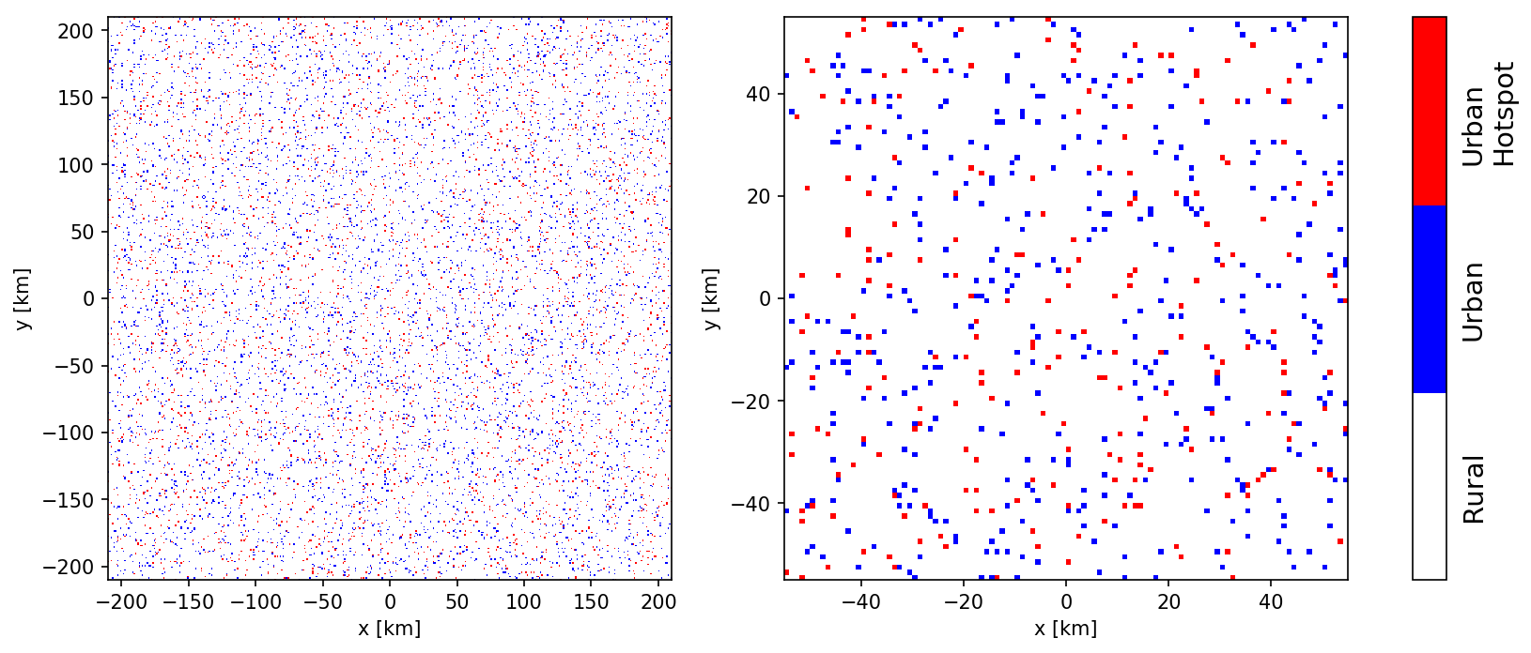
Figure 67: "Uniform" deployment density used in the simulation (cut-out)

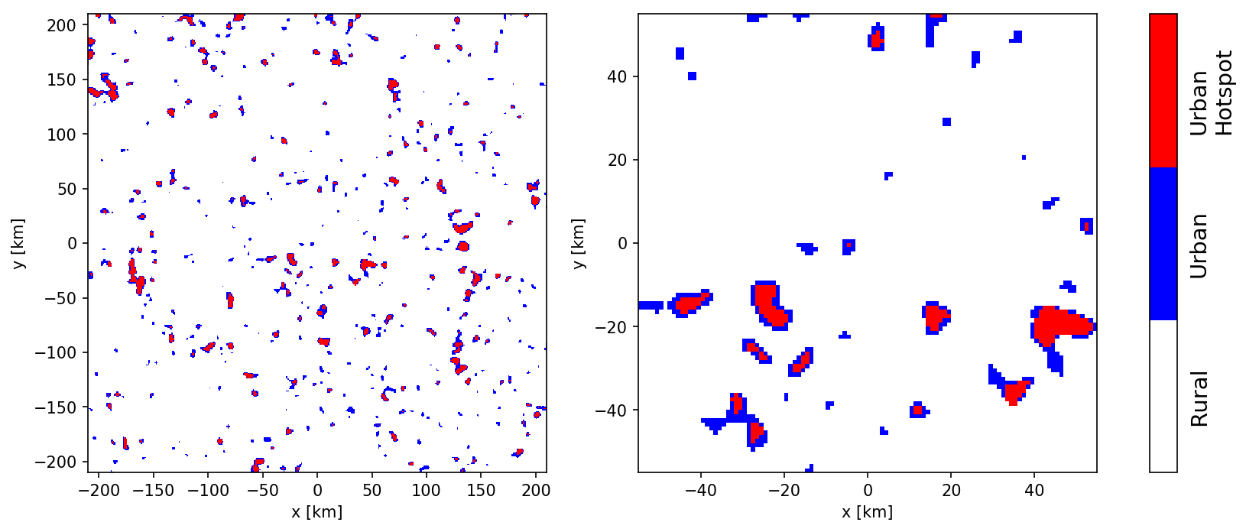
Figure 68: "Clustered" deployment density used in the simulation (cut-out)
    - Simulation Results
Some of the parameters in the previous section are not fixed, but two variants are possible. This is the case for the AAS antenna correlation parameter, ρ (0 or 1), the deployment model (“Uniform” or “Clustered”) and the UE distribution in the BS sectors (”Uniform” or ”AI 1.13”). Furthermore, of interest is the spurious and OOB cases, for both, AAS and non-AAS. All valid combinations lead to a total number of 24 scenarios (16 AAS, 8 non-AAS), which were computed.
It was found that the impact of the deployment model and UE distribution functions was minor, which is attributed to the large simulated area. Therefore, the focus is on the comparison between AAS (ρ=0 and 1) and non-AAS for both, spurious and OOB.
For all of the simulations, the 98% percentile of the aggregated power, which marks the max. data loss rate of 2% that is acceptable for RAS, was derived from the 500 iterations (Monte-Carlo runs) that were carried out. In all cases, this power exceeds the RAS thresholds given by Recommendation ITU-R RA.769-2 [26] by several orders of magnitude. Therefore, coordination zones around the RAS station were considered – with increasing radii – and the aggregated power as a function of radius was calculated.
It is noted that it is not clear, which “time percent” parameter, $p$, would optimally being used in the propagation model. On the one hand, as RAS has to accept 2% data loss, one could be inclined to use $p=2\%$, which refers to the 2% ”worst cases” (i.e., the best propagation conditions). However, if another 2% cut is applied to the Monte-Carlo simulation results (the posterior distribution), the joint probability of both effects would be smaller than 2%. On the other hand, using a distribution of $p$ values in the simulation is also questionable: the propagation conditions are most certainly not fully random during an observing session but are subject to longer-term fluctuations linked to atmospheric conditions. Therefore, an astronomer having successfully applied for precious telescope time (usually in a challenging proposal committee process – many telescopes are heavily overbooked) might end up with a much larger fraction of unusable data. Furthermore, especially in urban areas atmospheric conditions tend to be different from the large-scale average that is assumed in Recommendation ITU-R P.452. To explore the impact of the time percent parameter, the simulations were repeated with three different values of $p$: 2%, 10%, and 50%.
    - Aggregated power for non-AAS MFCN networks
Figure 69 and Figure 70 contain the results for the non-AAS scenarios ($p=2\%)$. All curves show the CDF@98% percentile of the simulated posterior distribution (which marks the 2% acceptable RAS data loss value).

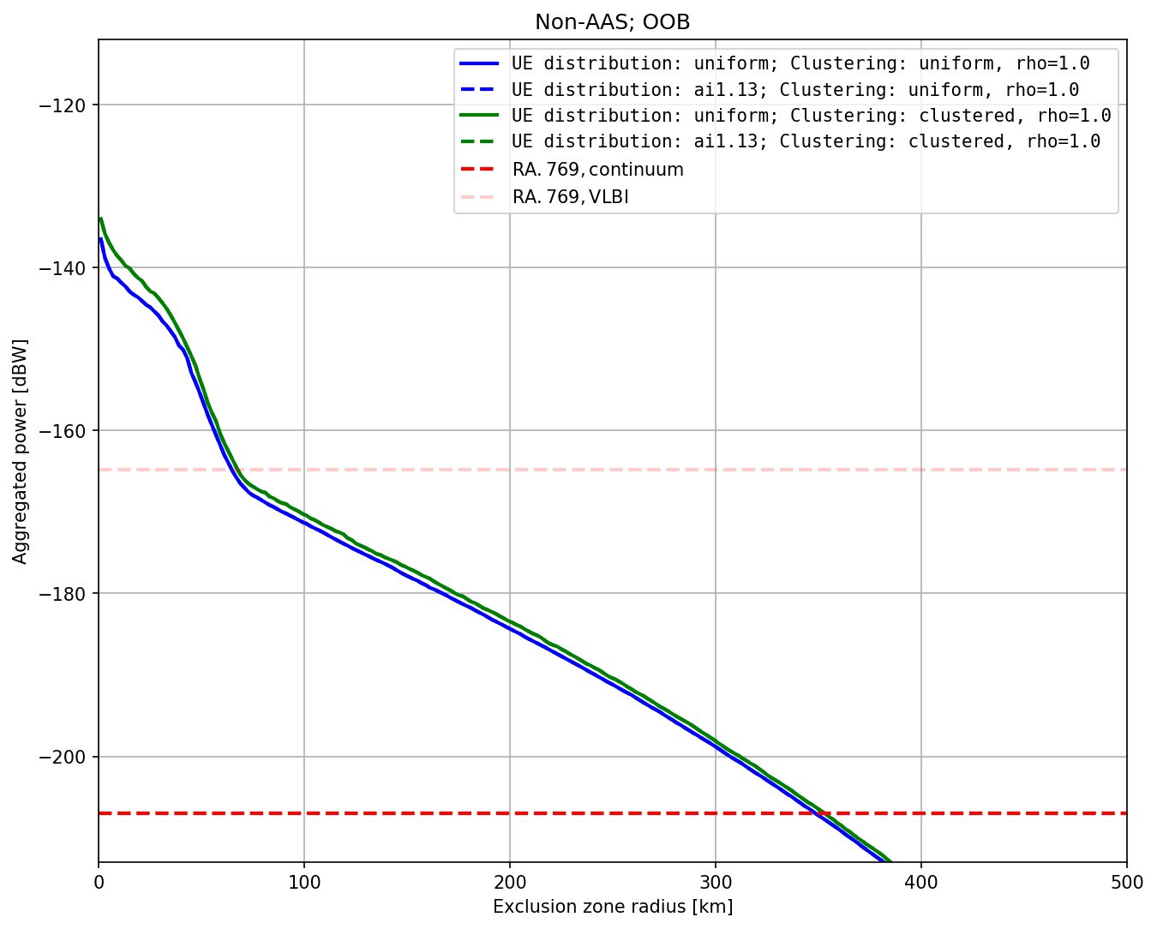
Figure 69: Aggregated power vs. coordination zone radii, non-AAS, OOB, $p=2\%$

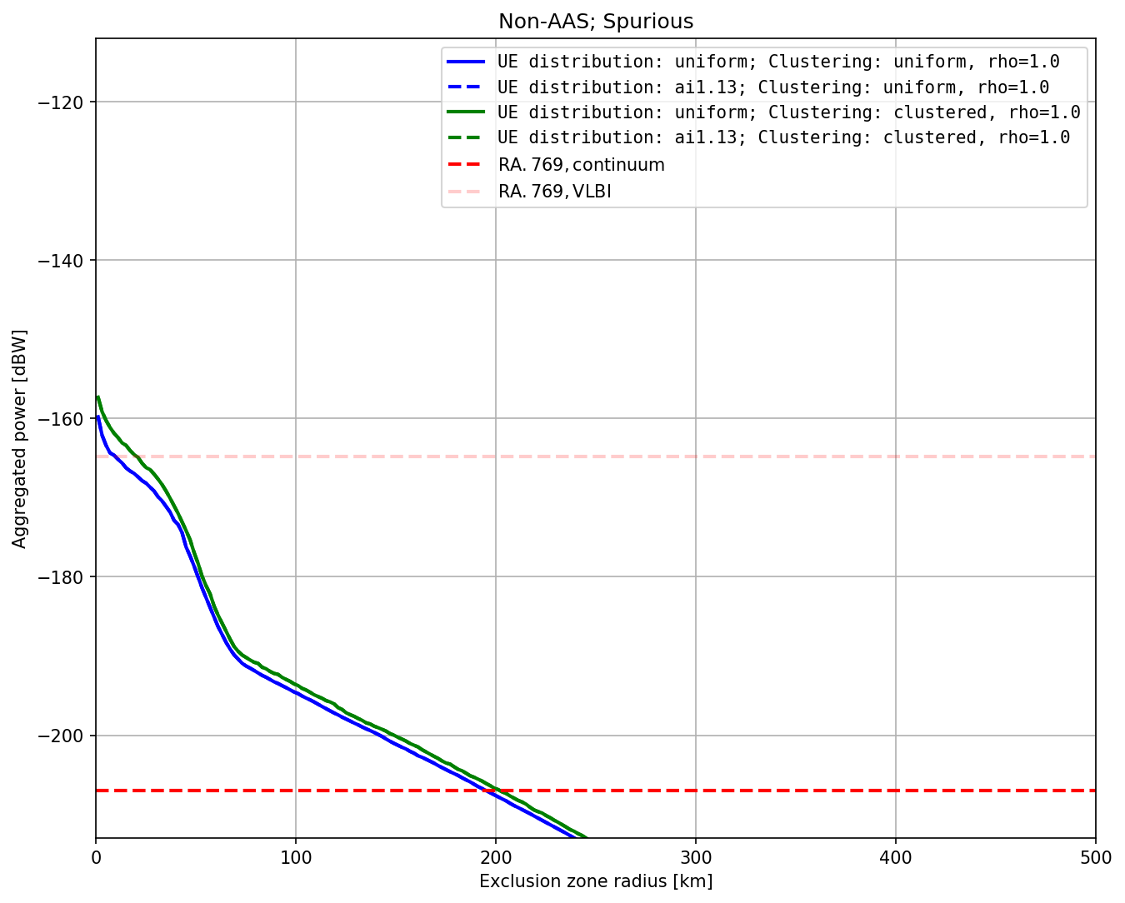
Figure 70: Aggregated power vs. coordination zone radii, non-AAS, spurious, $p=2\%$
    - Aggregated power for AAS 5G networks
Figure 71 and Figure 72 contain the results for the AAS scenarios.
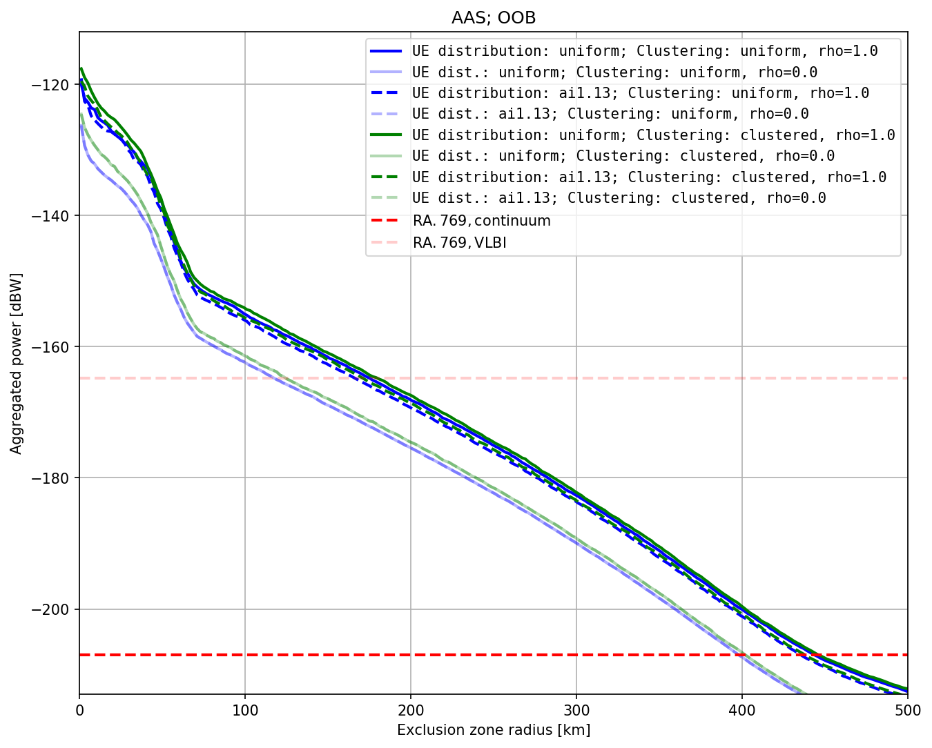
Figure 71: Aggregated power vs. coordination zone radii, AAS, OOB, $p=2\%$

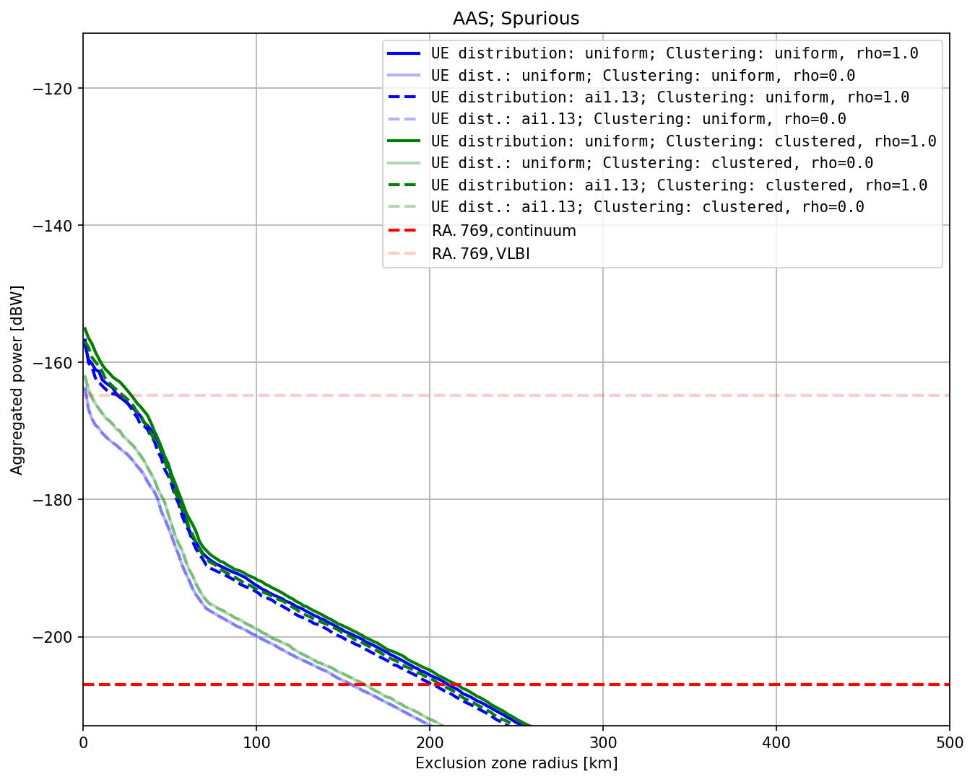
Figure 72: Aggregated power vs. coordination zone radii, AAS, spurious, $p=2\%$
    - Comparison between AAS and non-AAS results
For easier comparison between the two antenna-type systems, in Figure 73 the same results are displayed, but AAS and non-AAS results are put into the same plot. As the deployment model and UE distribution have no significant impact on the outcome, only the uniform deployment/UE distribution is shown.
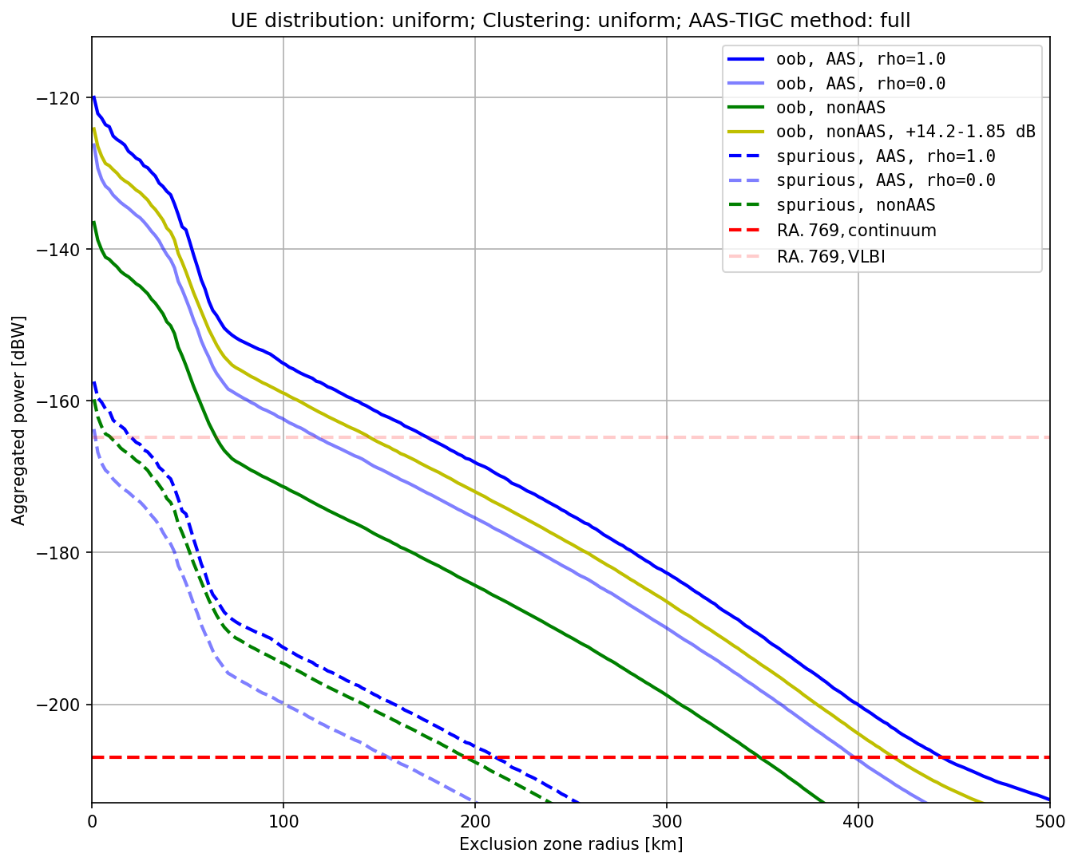
Figure 73: Aggregated power vs. coordination zone radii, deployment: uniform, UE dist.: uniform, $p=2\%$
To allow a comparison of the pure antenna-type properties, Figure 73 also includes a curve for non-AAS/OOB aggregated power, increased by (14.2–1.85) dB, which is the difference of the total TRP powers going into the RAS band between AAS and non-AAS scenarios (accounting for the antenna pattern normalisation of the non-AAS pattern). Even with the same transmitted TRP powers, AAS antennas would lead to about 4 dB higher aggregated power at the RAS station, if TIGC is applied fully (i.e., for each beam direction) and thus to somewhat larger necessary separation distances, as is seen in Figure 74. For the single-element AAS pattern ($ρ=0$) the situation is different. Here, 5G leads to lower aggregated power (if the same TRP is fed into the simulation) than 4G.
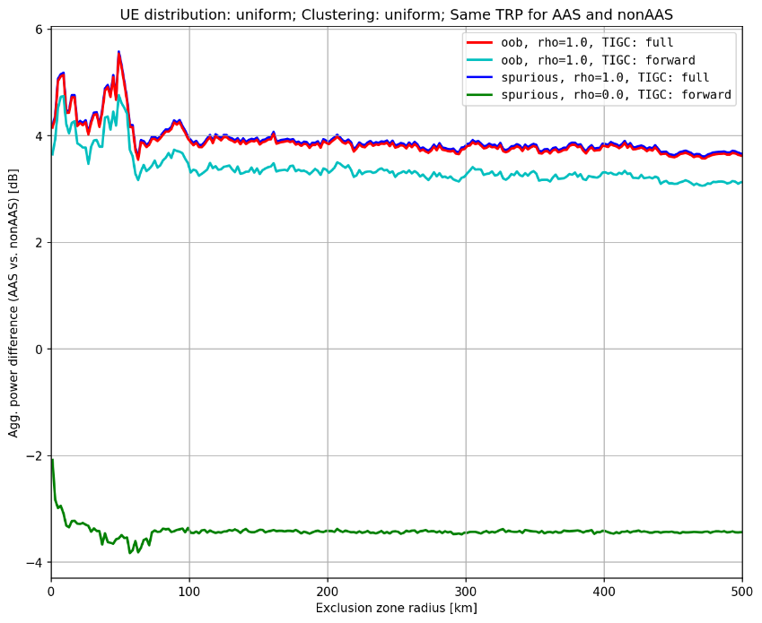
Figure 74: Difference in aggregated power between AAS and non-AAS as a function of distance for various scenarios
    - Influence of the Time Percent Parameter
In Figure 75 and Figure 76, the results for $p=10\%$ and $p=50\%$ are displayed (as for Fig. 5, which is for $p=2\%$). The necessary separation distances (coordination zone radii) are significantly smaller than for $p=2\%$, but still exceed 200 km (AAS 5G, OOB) even for $p=50\%$. The difference between AAS and non-AAS stays the same as for p=2%.
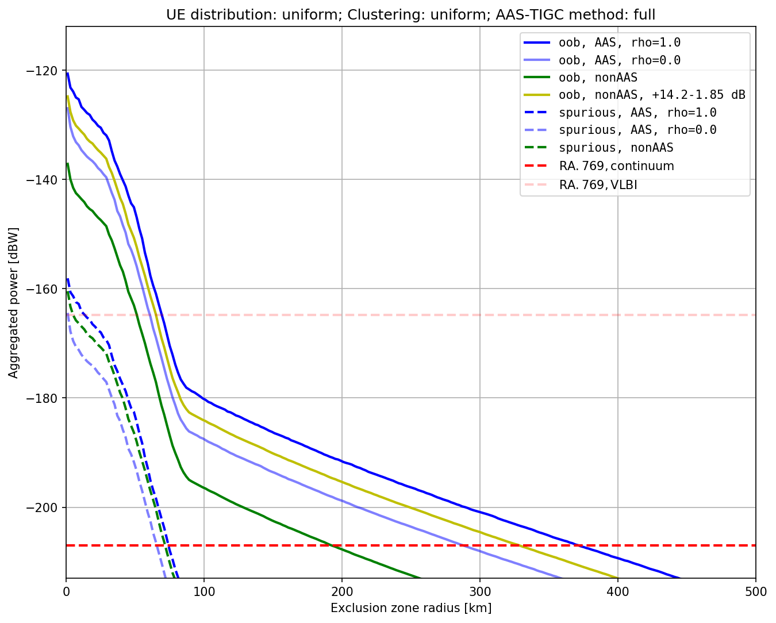
Figure 75: Aggregated power vs. coordination zone radii, deployment: uniform, UE dist.: uniform, $p=10\%$

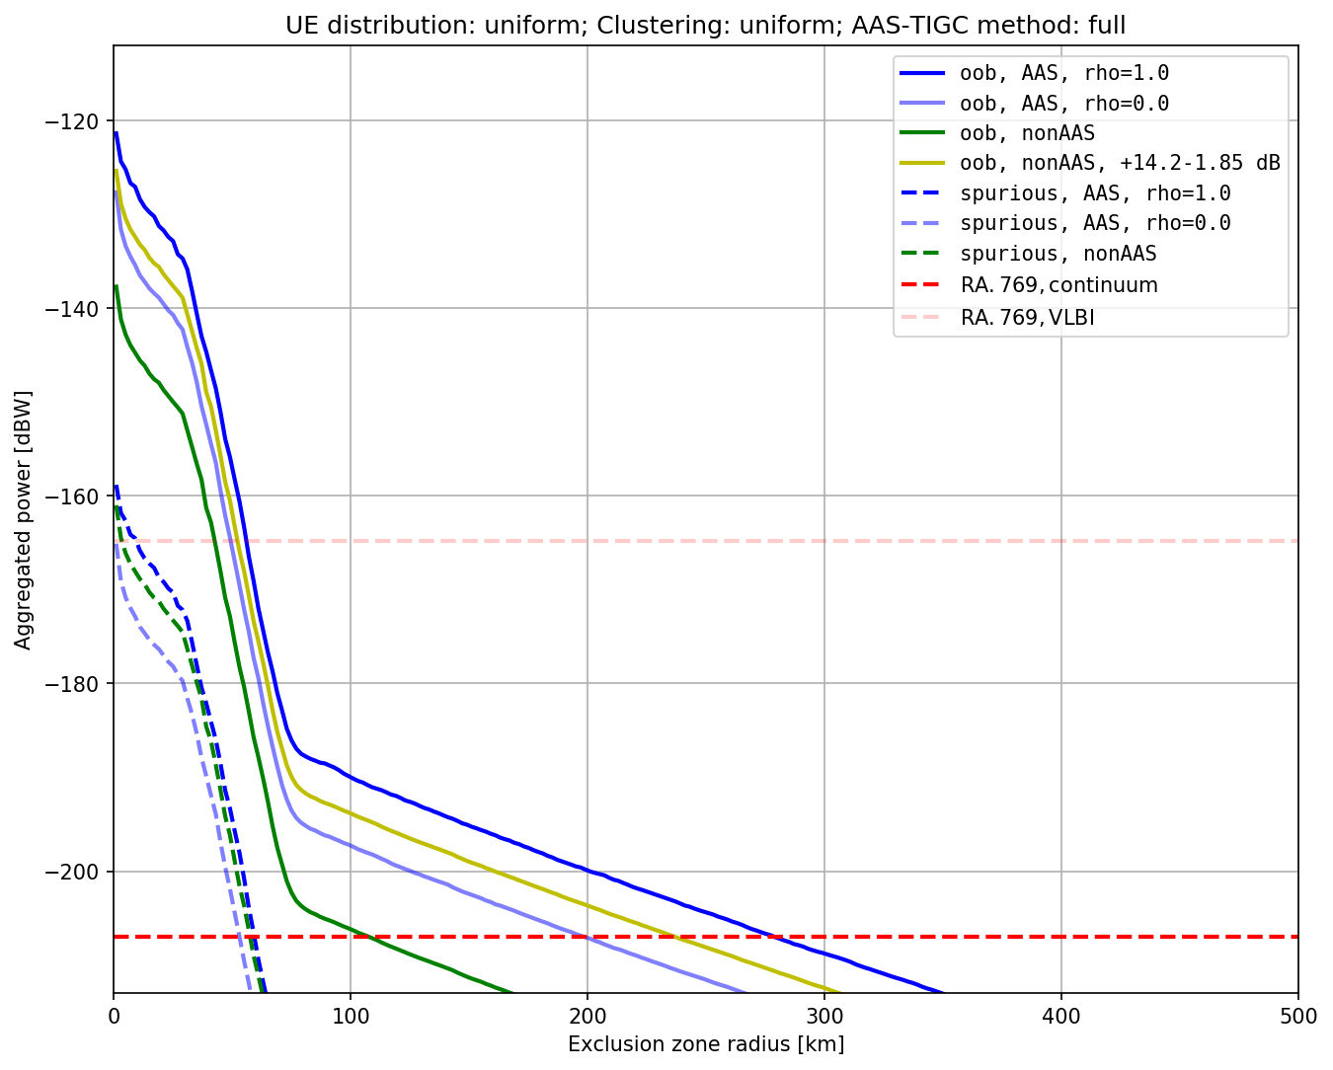
Figure 76: Aggregated power vs. coordination zone radii, deployment: uniform, UE dist.: uniform, p=50%
  - Single-interferer case studies
The generic aggregation study in the previous section assumes a flat-Earth scenario, i.e., zero terrain height around the RAS station. Some of the European radio telescopes are located in rather mountainous environments and it can be expected that hill or mountain tops can provide some level of additional interference shielding. Therefore, two example case studies are analysed in this section, looking at the Effelsberg 100 m telescope in Germany and the Nançay radio telescope in France. However, information about the expected deployment densities in the area around these two RAS stations was not previously provided. Since both telescopes are in relatively remote locations, employing the random distributions used in the previous section would lead to false conclusions as sub-/urban zones are not in direct vicinity of the two observatories. Therefore, only a single-interferer worst-case study is performed for the individual case study.
In the framework of such a single-interferer approach, it is assumed that for 5G AAS in a worst case the BS antenna beam points towards the most problematic direction, i.e., with maximum gain towards the azimuth and elevation that the propagation path to the RAS station defines. It is important to note that the antenna array is still subject to the mechanical downtilt, which in many cases leads to the situation that the formed beam is substantially off-set (10-20 degrees) from the antenna boresight. As for the aggregation study, for each beam direction, a total-integrated-gain correction (TIGC) needs to be applied to ensure that the TRP stays constant. In Figure 77, the resulting AAS gain ($ρ=1$) as a function of the propagation path elevation angle (i.e., offset from antenna boresight) is displayed. The black curve includes the TIGC, while the blue curve does not. Based on this (worst-case) effective antenna it is possible to calculate the minimal coupling loss as a function of the propagation path elevation angle; see Figure 78 and Figure 79 for OOB and spurious domains.
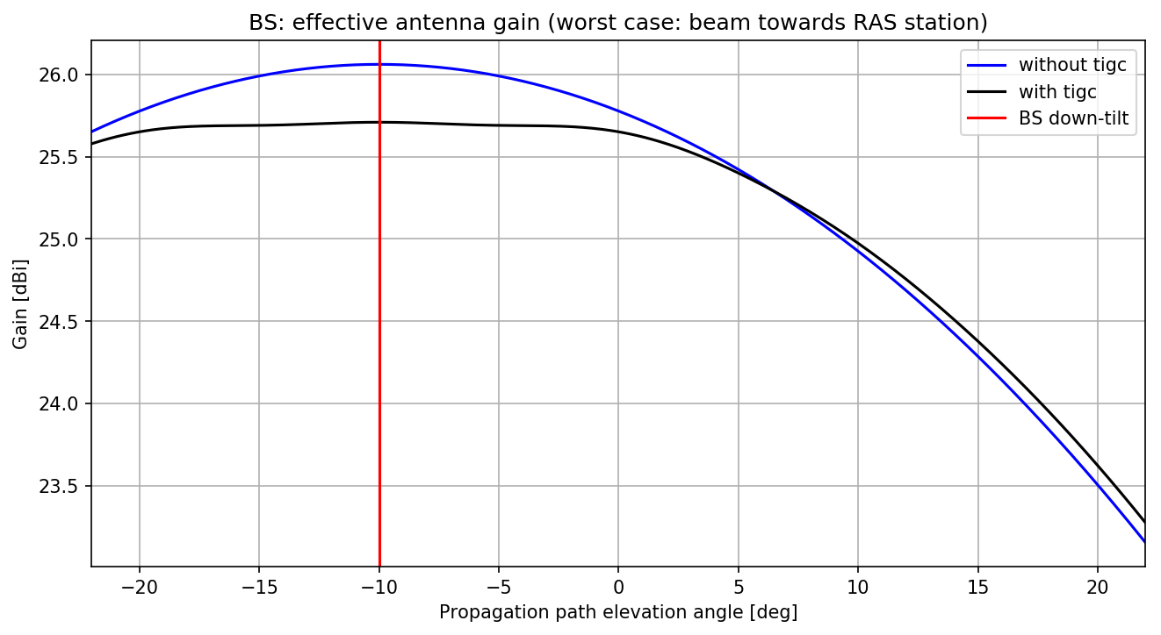
Figure 77: Effective 5G AAS antenna gain as a function of propagation path elevation angle
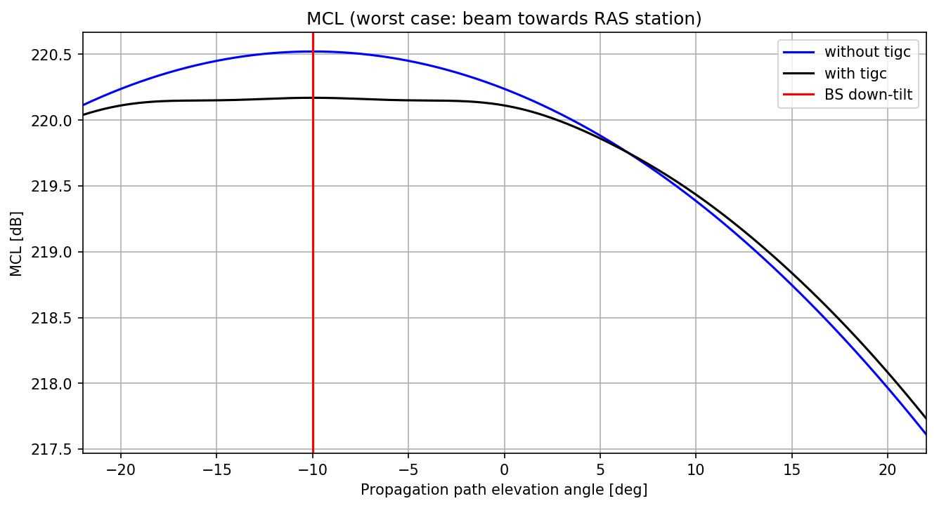
Figure 78: MCL (OOB, 5G AAS) as a function of propagation path elevation angle
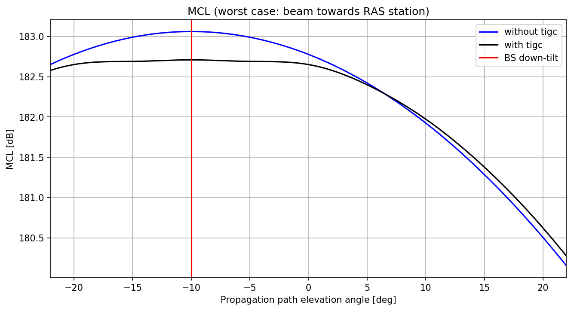
Figure 79: MCL (spurious, 5G AAS) as a function of propagation path elevation angle
Likewise, the effective BS antenna gain for 4G non-AAS can be calculated (Figure 80) as well as the resulting MCL for OOB (Figure 81) and spurious domains (Figure 82).
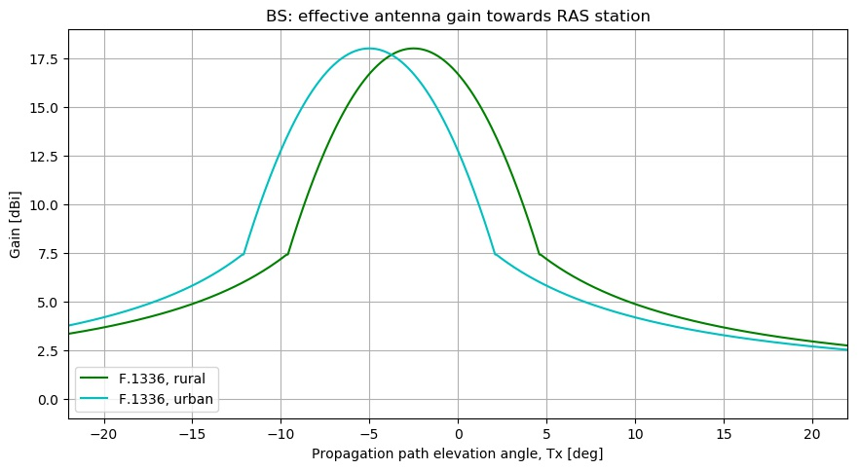
Figure 80: Effective 4G non-AAS antenna gain as a function of propagation path elevation angle
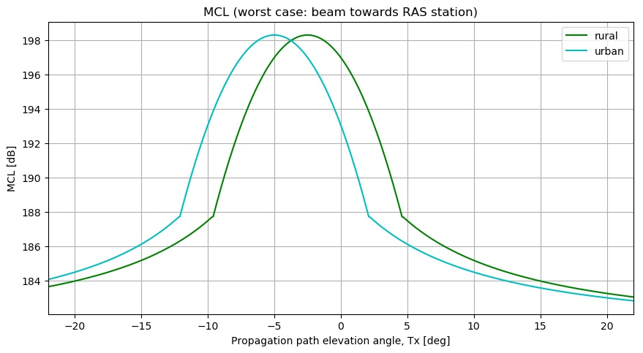
Figure 81: MCL (OOB, 4G non-AAS) as a function of propagation path elevation angle
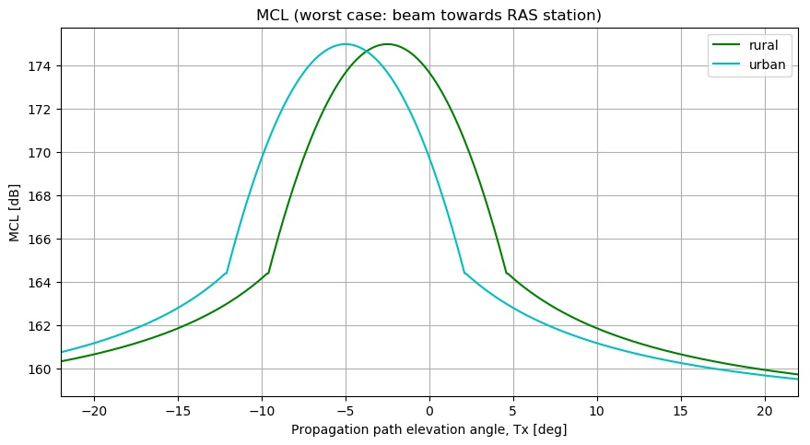
Figure 82: MCL (spurious, 4G non-AAS) as a function of propagation path elevation angle
For the two example stations, attenuation maps ($p=2\%$) were calculated based on the Recommendation ITU-R P.452-16 propagation model and terrain height data from the Space Shuttle RADAR mission (SRTM; [18]). In this worst-case calculation, no clutter correction was accounted for, as it is not unlikely that BS Tx are installed at heights fairly above local roof tops. For completeness the attenuation maps are shown in Figure 83 and Figure 84 (the grey circles mark distances in steps of 50 km), and a map with the propagation path elevation angles around Effelsberg is in Figure 85. By comparing the required MCL with the actual attenuation, one can identify the zones in which RAS thresholds would be exceeded. In Figure 86 to Figure 93 (for 5G AAS) and (for 4G non-AAS) this is visualised with the red solid contour lines, which are displayed on top of the terrain heights. As administrations and IMT may want to apply mitigation measure in problematic cases, curves for 10 dB (orange line) or 20 dB (blue line) lower TRP powers are also provided. The grey line on the other hand shows the result if the actual TRP power was 10 dB higher.
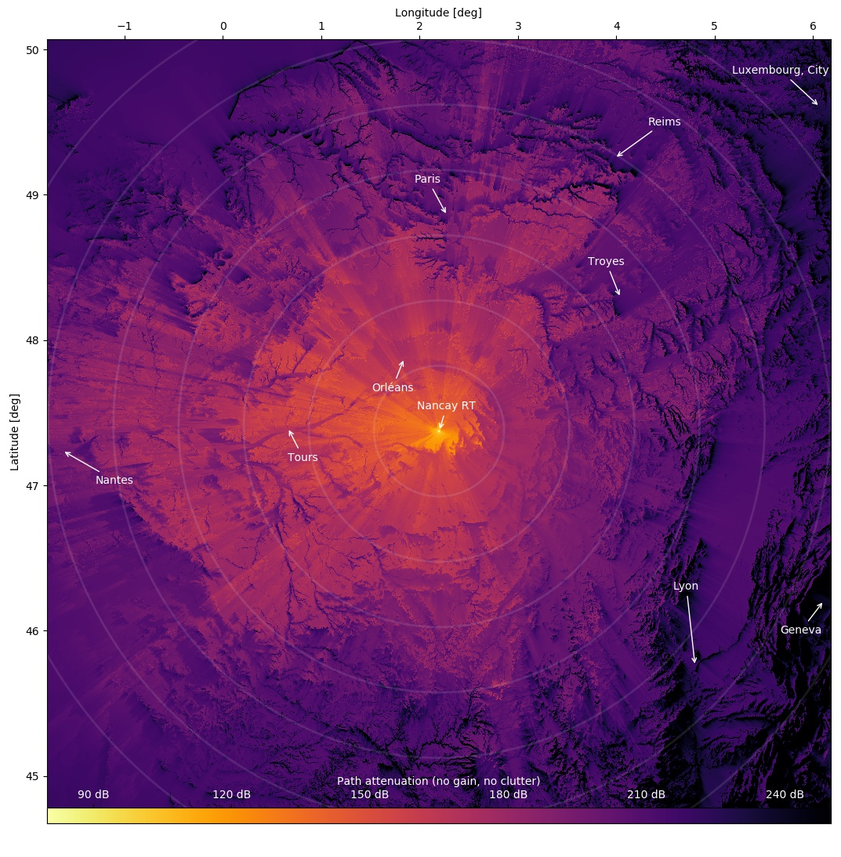
Figure 83: Attenuation map around Nançay radio telescope in France
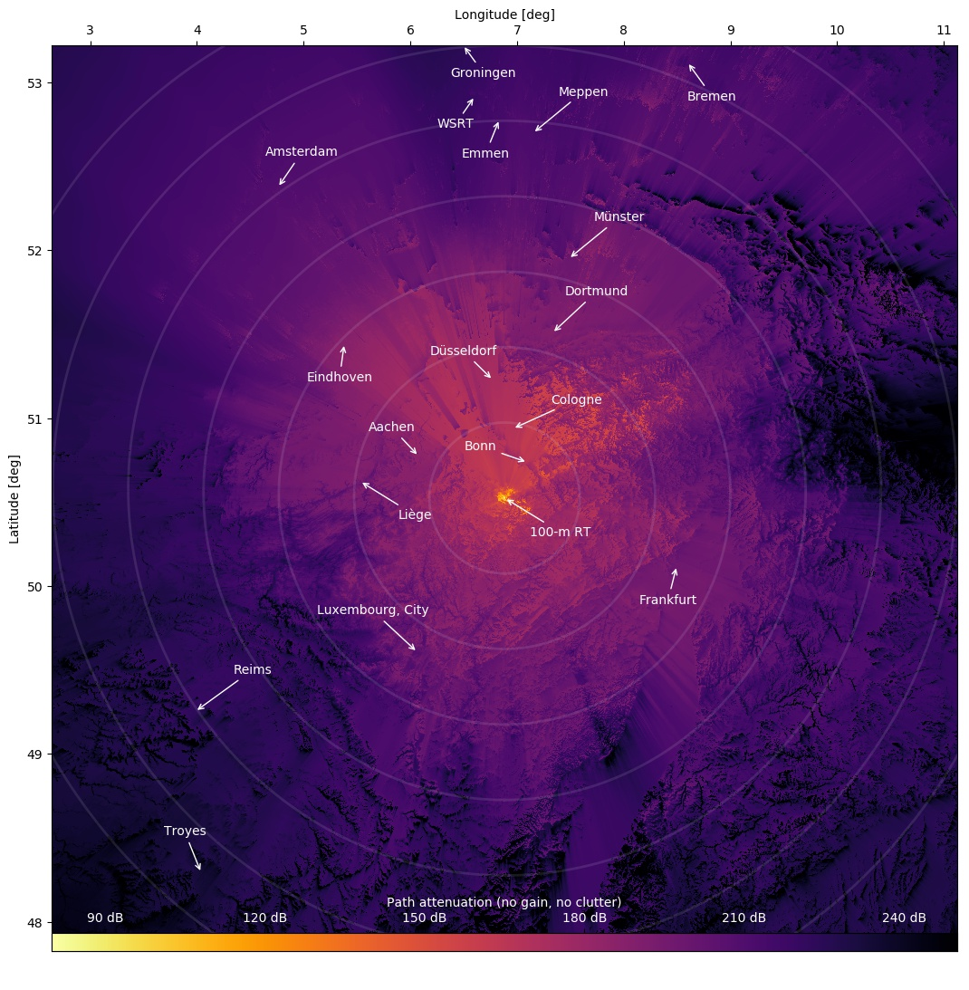
Figure 84: Attenuation map around 100 m telescope in Effelsberg, Germany
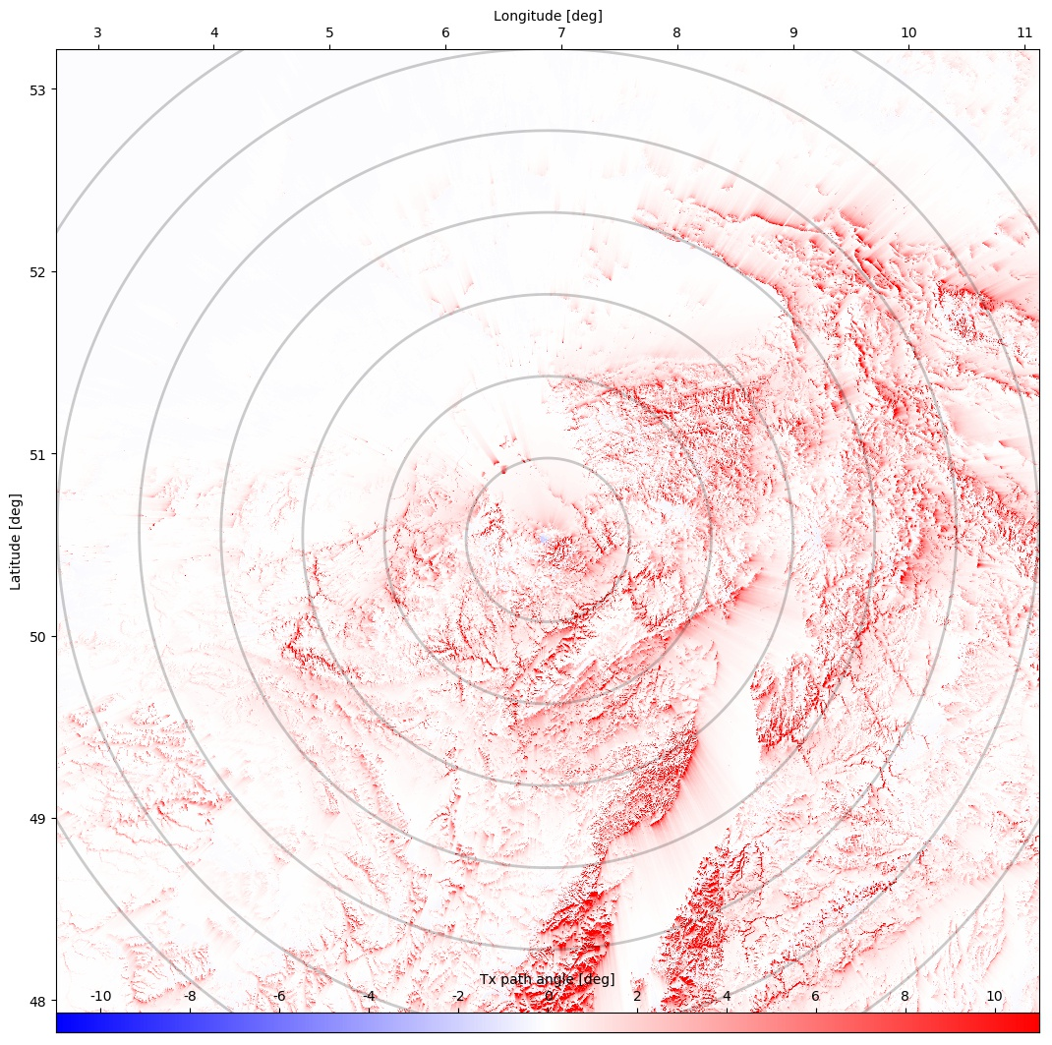
Figure 85: Map of the propagation path elevation angle around 100 m telescope in Effelsberg
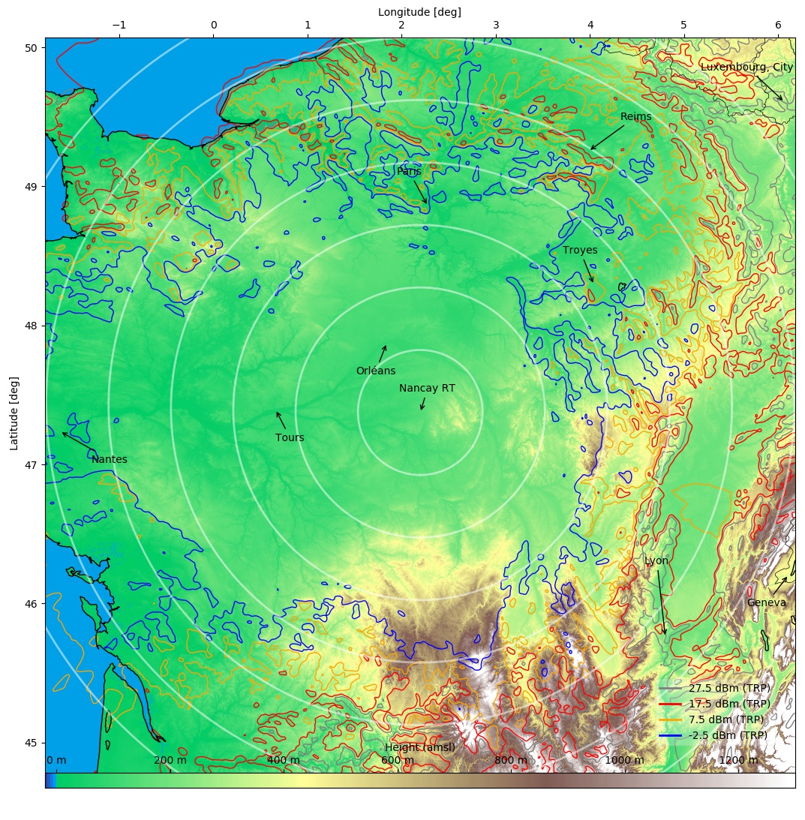
Figure 86: Proposed coordination zones (OOB, 5G AAS) around Nançay radio telescope in France
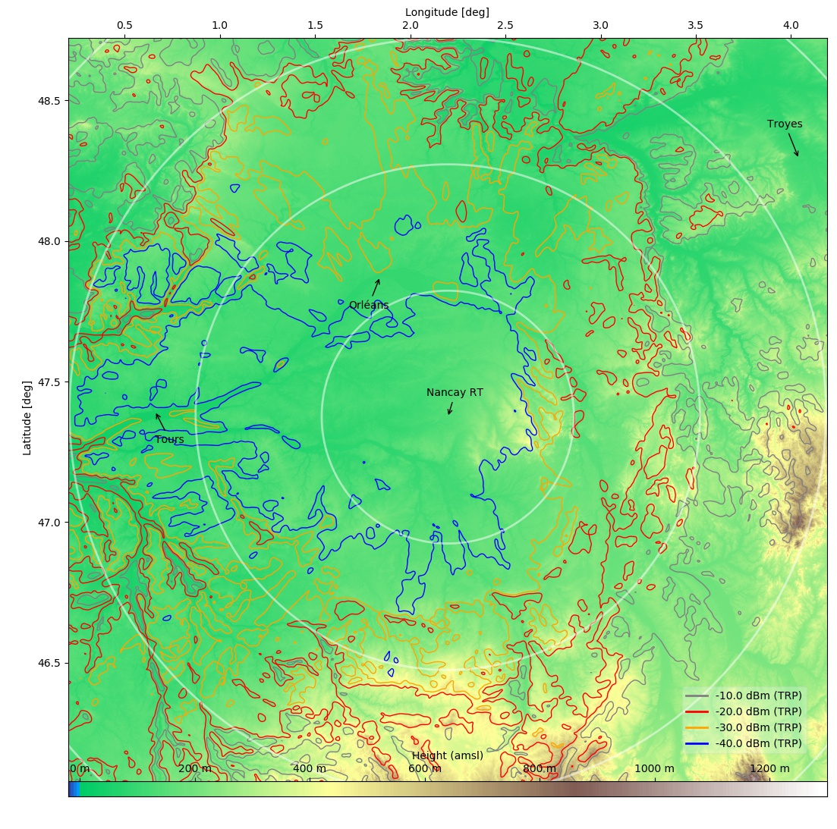
Figure 87: Proposed coordination zones (spurious, 5G AAS) around Nançay radio telescope in France
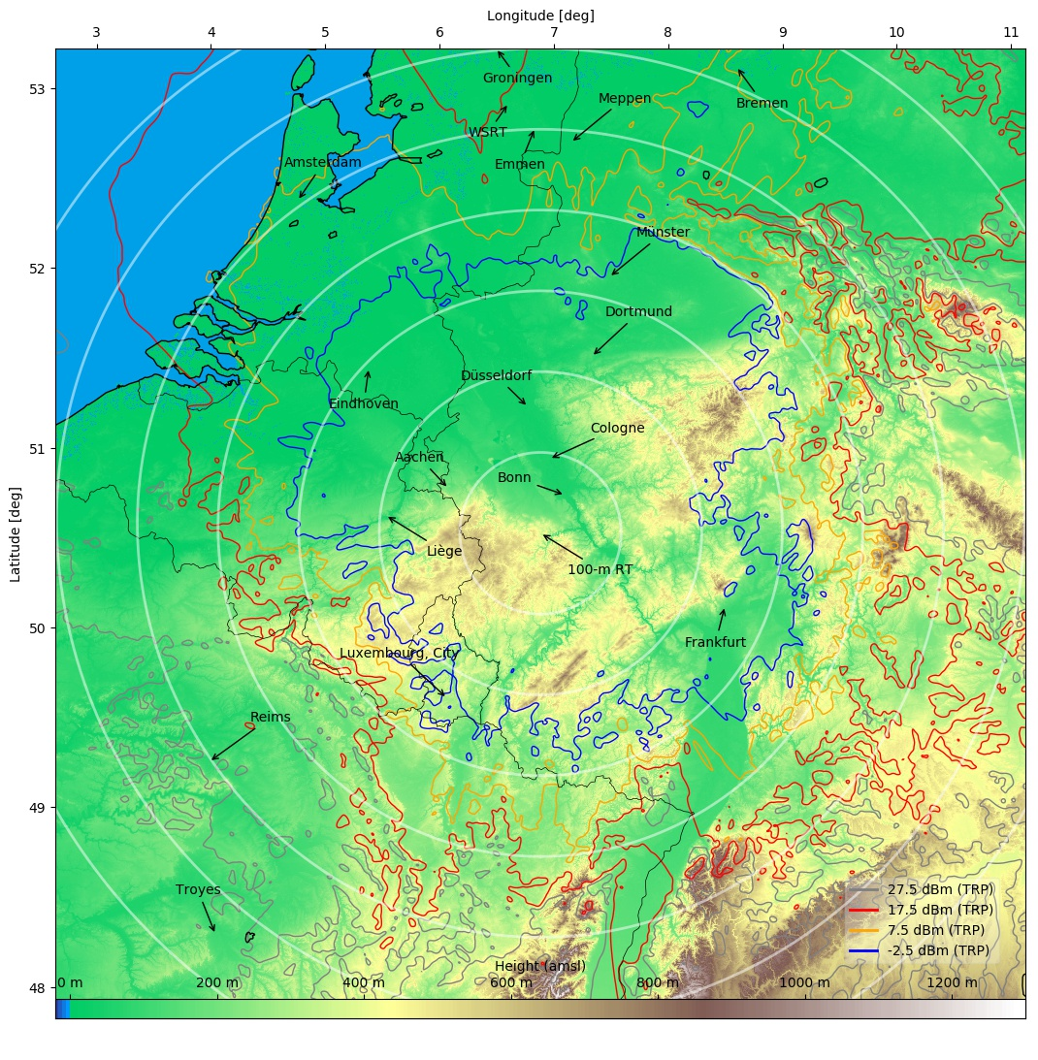
Figure 88: Proposed coordination zones (OOB, 5G AAS) around 100 m telescope in Effelsberg, Germany
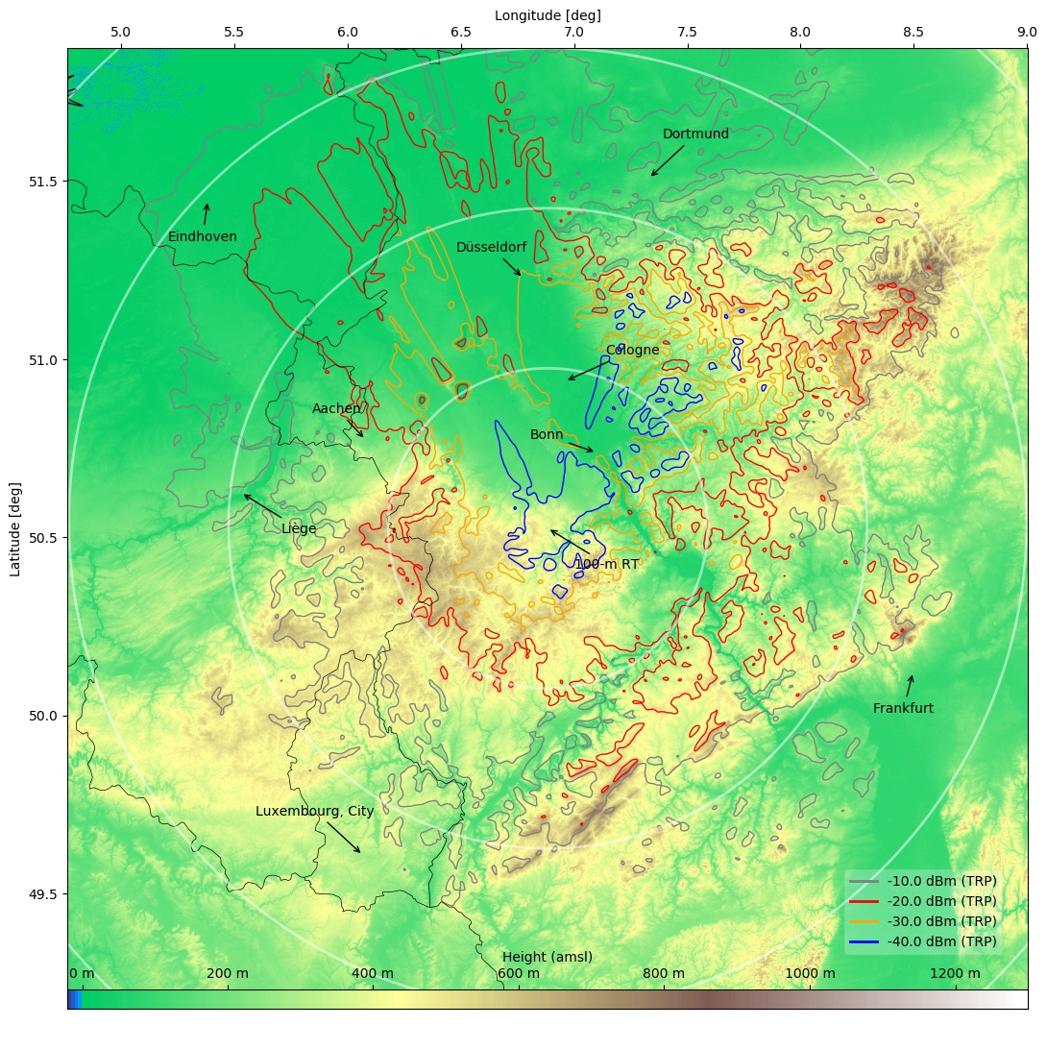
Figure 89: Proposed coordination zones (spurious, 5G AAS) around 100 m telescope in Effelsberg, Germany
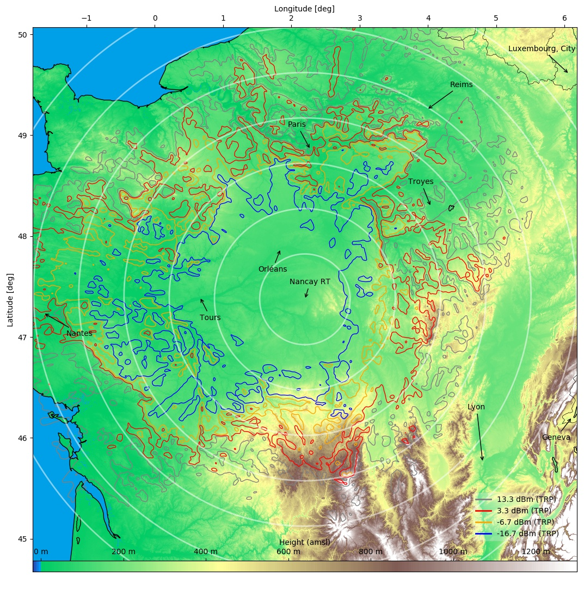
Figure 90: Proposed coordination zones (OOB, 4G non-AAS) around Nançay radio telescope in France
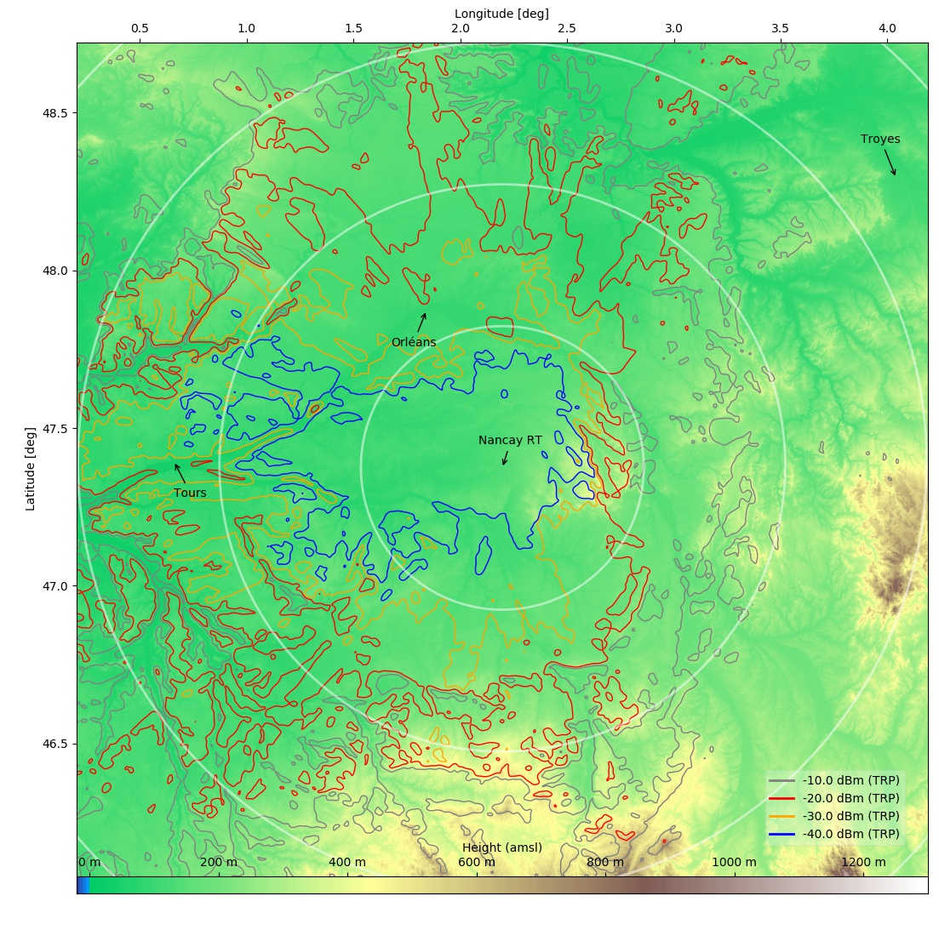
Figure 91: Proposed coordination zones (spurious, 4G non-AAS) around Nançay radio telescope in France
Figure 92: Proposed coordination zones (OOB, 4G non-AAS) around 100 m telescope in Effelsberg, Germany
Figure 93: Proposed coordination zones (spurious, 4G non-AAS) around 100 m telescope in Effelsberg, Germany
The results demonstrate that even for remote RAS sites with high levels of terrain shielding both, OOB and spurious TRP, can be subject to interference from 5G BS located in neighbouring countries, if BS AAS beams point into a worst-case direction and no clutter loss applies. For 4G non-AAS the situation is different. Not only the output TRP power is significantly lower, but due to the lack of beamforming the worst-case antenna gain is lower than for AAS.
    - Possible mitigation measures
The results in the previous section are based on the assumption of a worst-case scenario, where the AAS beam points towards the direction of the propagation path (i.e., the local horizon) and possible clutter loss was neglected. In the following the potential effect of typical mitigation measures is discussed, which administrations would apply to allow BS locations closer to RAS stations. The most important aspect is certainly the effective antenna gain for less atypical beam directions. As a BS antenna mostly serves user devices in a sector on the ground in front of it, one could argue that the maximal beam elevation is that to the cell edge. In Figure 94, the impact of limiting the maximal beam elevation is displayed, for two cases, urban (Tx height: 20 m, cell size: 400 m) and rural (Tx height: 30 m, cell size: 4000 m). It is obvious that for increasing propagation path elevations the effective gain drops substantially.
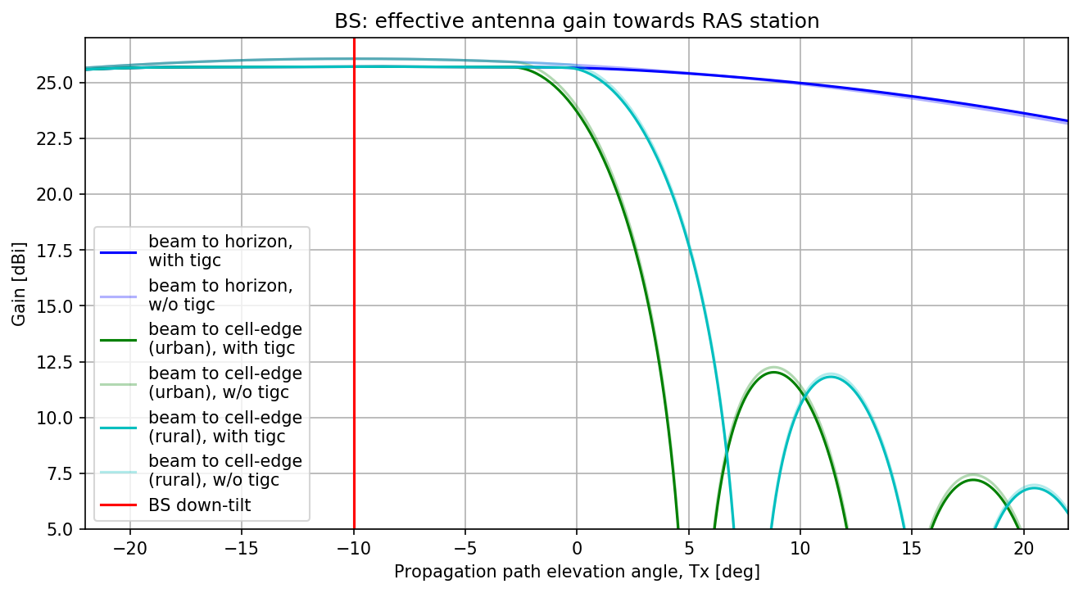
Figure 94: Effective antenna gain change due to limiting the max. beam elevation to cell edge
However, this should be compared to the typical propagation path elevations in the vicinity of the RAS stations. This can be calculated from Figure 85 by calculating the histogram and is shown in Figure 95 and Figure 96 for the two example RAS stations. For cases where the necessary coordination zones exceed the size of dozens if not hundreds of kilometres, the median path elevation angles are close to zero (Nançay: 0.17 deg, Effelsberg: 0.19 deg; calculated over a map of 600 km × 600 km; Tx antenna height: 20 m). That means that the potential mitigation effect of limiting the beam elevation to the cell edge is less than 3 dB for more than 50% of the cases. It is furthermore very likely to find at least few BS (of the thousands in the area) that form a beam for a sufficiently long time towards the cell edge.
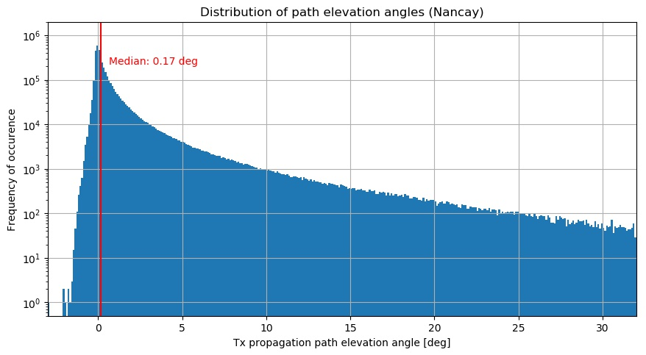

Figure 95: Histogram of propagation path elevation angles (Tx) around Nançay observatory
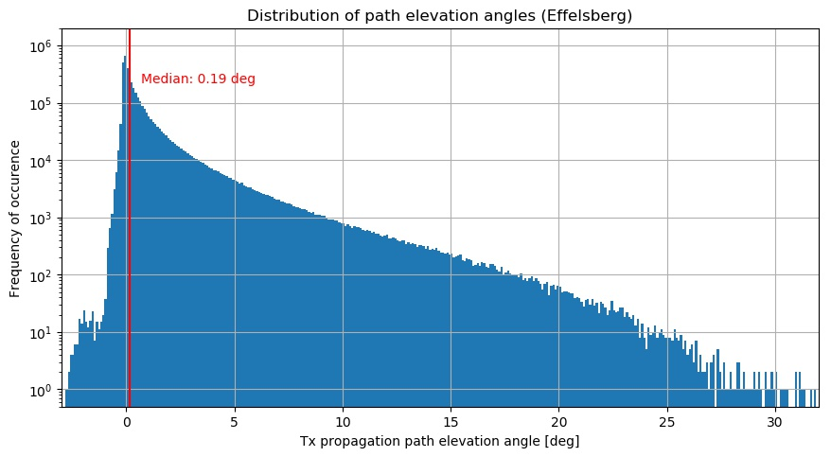
Figure 96: Histogram of propagation path elevation angles (Tx) around Effelsberg observatory
Another interesting information would be the difference of the more worst-case antenna gains to the average effective antenna gain. To assess this, the average antenna pattern was calculated by sampling user devices into the sector in front of the AAS (uniform or according to AI 1.13 distribution) (see Figure 97). Then the patterns can be calculated with the beam pointing to each of the UE positions. After averaging (in the linear domain) the pattern in Figure 98 is obtained. The apparent distortion in the pattern is due to the mechanical down-tilt of the pattern (which is displayed in the non-tilted reference frame). Strong grating lobes above and below the “main beam” appear. Finally, Figure 99 shows some azimuthal slices through the pattern at azimuths of 0, 10, and 60 deg. If the azimuthal separation is not too large (e.g., less than 10 deg), the effective gain towards the horizon is still about 13 dBi, which is not much lower than for the worst case. We concluded the difference between worst-case and average antenna gain is also found to be typically not more than 10-15 dB over the entire sector.
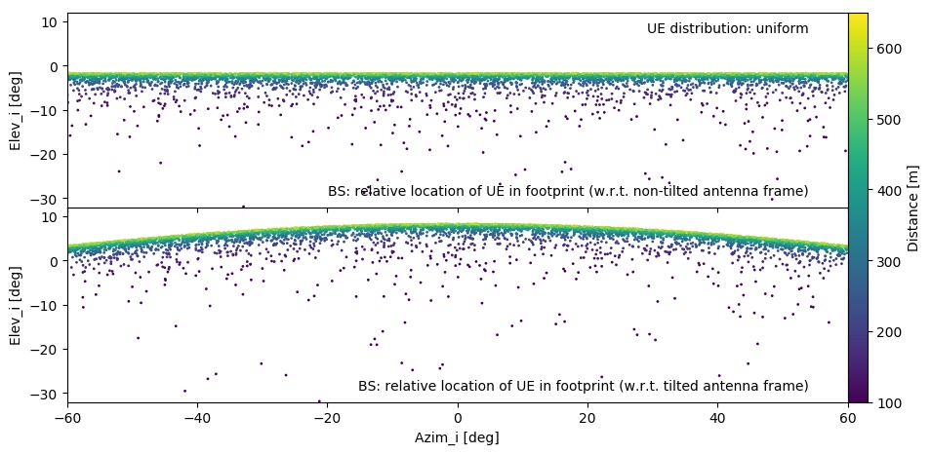
Figure 97: UE position relative to BS antenna frame for uniform UE distribution

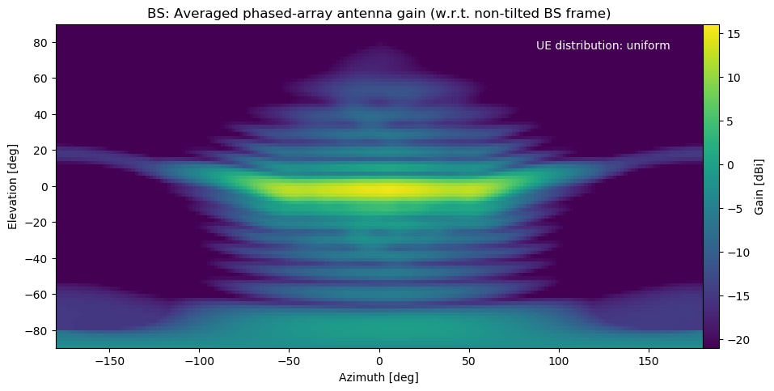
Figure 98: Average antenna gain of AAS for the uniform UE distribution shown in Figure 97
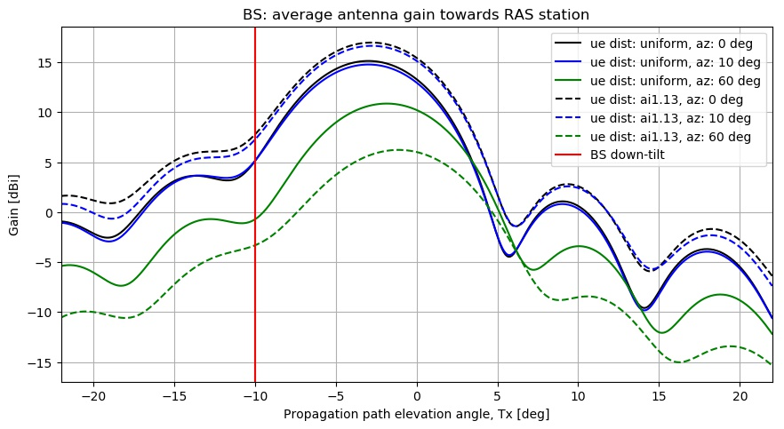
Figure 99: Average antenna gain for three different azimuthal separation angles
To analyse clutter loss two models have been compared, which are suitable for IMT scenarios, the Recommendation ITU-R P.452-16 clutter model and the one presented in Recommendation ITU-R P.2108-0 [30] . The latter "[...] defines categories for clutter environments and provides methods for estimating path loss between the rooftop and a terminal within the clutter" and thus it is at least questionable if it is a good choice for compatibility calculations of IMT vs. RAS. Nevertheless, it has been applied to a number of aggregation studies (e.g., ECC Report 281 [12]; ITU-R Document 5-1/478-E, study E [19]) and also for the aggregation simulation in this study. An example of a single-interferer study can also be found in ITU-R Document 5-1/478-E (study N [19]) for which a value of 1% for the location percentage was used, which can be thought of a worst-case. For a frequency of 2.7 GHz, the clutter loss predicted by Recommendation ITU-R P.2108-0 would then be 13.5 dB. On the other hand, base stations at low frequencies are usually installed fairly above the roof tops and Recommendation ITU-R P.452-16 predicts zero or very small clutter losses of not more than few dB for such cases. Again, looking at the large number of BS in the area, it is likely that at significant number of BS will be located such that clutter loss does not play a role. It could even be argued that there is a correlation of BS that have high effective gain towards the RAS station and locations with little clutter, e.g., rural installations on church spires or local hill/mountain tops.
  - Summary and conclusions
Monte-Carlo simulations to study the compatibility of RAS and nonAAS-4G / AAS-5G MFCN were performed. Both, out-of-band (OOB) and spurious domain emissions into the RAS band 2.69-2.70 GHz was analysed. The main purpose of the simulations was to explore the difference that comes from replacing non-AAS base stations (BS) with AAS BS, which are capable to form beams to the user equipment. The pure influence of the antenna patterns is not large, with AAS leading to about 4 dB higher aggregated power levels at the RAS receiver. However, the nominal OOB power of 5G for this frequency band is significantly larger than for 4G BS, so that effectively 5G/AAS leads to 16.4 dB higher aggregated power (OOB) at the RAS station (@98% CDF). This result is independent on the “time percent” parameter, $p$, which parametrizes atmospheric conditions in the propagation model (Recommendation ITU-R P.452). Although the main purpose of this study was to compare the 4G and 5G equipment, it is also the first time that the aggregated power at a RAS receiver at 2.7 GHz produced from a full BS network (4G/5G) was determined. Even for the unlikely case of $p=50\%$ (time percent) AAS 5G BS will lead to necessary coordination zones of 200 km. For the spurious-domain cases separation distances are smaller.
A second, complementary study was carried out to assess the potential interference situation caused by AAS-5G at individual European RAS sites (here the Nançay radio telescope in France and the 100 m telescope at Effelsberg, Germany) with different amount of natural terrain shielding and geographical surroundings. Owing to the lack of actual deployment densities around the two sites, only a single-interferer worst-case study could be performed. For the OOB domain, and without mitigation measures applied, RAS thresholds could be exceeded at both telescopes due to IMT BS located in neighbouring countries. For the spurious domain, only Effelsberg may be affected by cross-border interference.
It was also noted that several mitigation measures are possible, which would allow to place IMT equipment closer to a RAS station, e.g., using the active beam forming capabilities to decrease the gain towards the RAS station, improve spectral side-lobe suppression by means of better filters, decrease output power and/or carrier bandwidth, or even leave out a full antenna sector. Furthermore, local clutter around base stations could creatively be used to increase the effective path propagation loss.

- STUDY #5 Protection of Radioastronomy service from adjacent emission of 2.6 GHz MFCN using AAS
  - Introduction
The aim of this contribution is to analyse the compatibility between MFCN in 2500-2690 MHz and RAS in adjacent band (2690-2700 MHz). This passive band is under RR 5.340. The MFCN (either 4G or 5G) used in this study is bases on BS using AAS (beamforming antenna). The gain of this kind of antenna point in different directions is in function of time. In order to take this behaviour into account in simulation and to ensure a mathematical compliance with the propagation losses defined by propagation model, a Time Variant Gain (TVG) method is performed. This study provides, as example, the impact of the protection of the RAS site in France located in Nançay. The conclusion of this example could be replicated to any other RAS site in CEPT countries.
  - Characteristics of Radioastronomy service in 2.6 GHz
The following Table 87 provides the protection criteria of RAS receiver. The antenna gain in all this contribution is taken equal to 0 dBi.
Table 87: Protection criteria of RAS in 2590-2600 MHz
RAS allocation status  RR Footnotes 1  RAS use 2  IMT/RAS band situation | Type of measurement | RAS protection criteria according to Recommendation ITU-R RA.769-2
Primary allocation  RR No. 5.340  Broadband |  | Power entering receiver  dB(W/10 MHz) | Spectral PFD  dB(W/m2 Hz)
Primary allocation  RR No. 5.340  Broadband | Continuum | -207 | -247
Primary allocation  RR No. 5.340  Broadband | VLBI | -165 | -205
  - Characteristics of MFCN in 2.6 GHz using AAS
    - Parameters of AAS
Only the parameter of BS in rural environment is used. Rural deployment appear to be the worst case of interference for a radio astronomy station (higher station and no clutter is available in order to reduce emission by building diffraction). Only useful parameter for the studies is presented in Table 88.
Table 88: Parameter of AAS used in study
Parameters | AAS
Parameter of Antenna in M.2101 | 3 sectors (120°)  8×8 array elements  80°/65° 3 dB width, Gelem=8 dBi  30 dB f/b ratio  spacing: dH=0.6λ, dV=0.9λ  ρ=0 or 1
Antenna normalisation | Used for each pointing (see Figure 101)
Mechanical down-tilt | -10°
BS antenna height | 30 m
UE antenna height | 1.5 m
Tx spectral power (TRP) | 7.5 dBm/MHz (OOB)  -30 dBm/MHz (spurious)
# Tx antennas; correction factor | 1; 0 dB
Tx power into RAS band (TRP) | 17.5 dBm/10 MHz (OOB)  -20 dBm/10 MHz (spurious)
Network loading factor | 50%
Cell radius | 4000 m
Deployment over the cell | Uniform
In order to ensure a physical behaviour of the antenna model defined in the Recommendation ITU-R M.2101, a normalisation factor is applied for every electrical of pointing. The normalisation factor to apply is shown in the Figure 100 below.
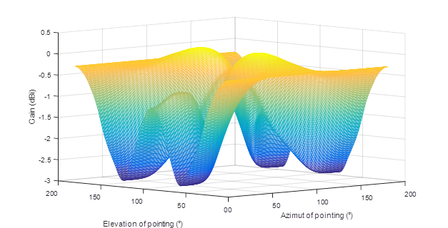
Figure 100: Representation of the normalisation factor
    - Distribution of gain towards horizon of AAS
In this part, the gain distribution of BS towards horizon is studied. The BS is considered as deployed in a rural environment and the distribution of gain is calculated for different azimuth. A BS present 3 sector of 120°. Each sector could point in azimuth from -60 to 60°. The RAS station could be located in his range of angle. The figure below (Figure 101) present the different distributions of gain towards horizon for different position of the RAS station (from 0° to 60°). The RAS station is considered to be in one sector of the IMT BS station. The parameter used to provide this figure are depicted in Table 88.
Figure 101: Distribution of gain towards horizon
  - Methodology
The time-variant gain (TVG) method described in section 4 of Annex 6 to RR Appendix 7 is used. The TVG method closely approximates the convolution of the distribution of the horizon gain of the Base Station (BS) antenna (it gain evolved in space in function of time) and the propagation loss. This method may produce slightly smaller distances than those obtained by an ideal convolution. An ideal convolution cannot be implemented due to the limitations of the current model for propagation loss. The required minimum propagation loss is then given by the following equation:
 | $$L_{req}\left(p_{v}\right)= P_{t}+G_{t}(p_{n}) + G_{r} - I\left(p\right)$$ | (2)
Where,
- 𝑃𝑡 is the total transmitting power level (dBW) in the reference bandwidth of a transmitting IMT-2020 base station;
- 𝐼(𝑝) is the protection threshold (dBW) in the reference bandwidth to be exceeded for no more than 𝑝% of the time at the input of the antenna of the receiving RAS earth station that may be subject to interference;
- 𝐺𝑡(𝑝𝑛) is the gain towards the horizon of the transmitting antenna (dBi) that is exceeded for 𝑝𝑛% of the time on the azimuth under consideration;
- 𝐺𝑟 is the gain towards the physical horizon for a given azimuth (dBi) of the victim RAS earth station antenna; This gain is always taken equal to 0 dBi (see section 3);
- (𝑝𝑣) is the minimum required propagation loss (dB) for 𝑝𝑣% of the time; this loss must be exceeded by the propagation path loss for all possible 𝑝𝑣% values retrieved from the considered gain complementary cumulative distribution function. 𝑝𝑣 is the time percentage that approximates the convolution between the variable horizon gain and the propagation mode path loss and is given by the following equation:
(3)
The limitation to 50% comes from the propagation model used, Recommendation ITU-R P.452, which is limited to percentages of time up to 50%.
  - Results of TVG
In order to take into account the loading factor of BS (50%), the probabilities given by the gain distribution of BS towards horizon are divided by a factor 2. It should be noted that, the TVG methodology present generic results of distance (no terrain) and should be taken with caution. These results have to translate on a real site of radio astronomy. Considering the Table 89, the worst case of separation distance appear for a combination of a BS maximum gain of 26 dB and a percentage of time of 50% in the propagation model. It can be concluded that, the simulation of separation distance for specific location have to take into account these two parameters (26 dBi of Bs gain and 50% in model from Recommendation ITU-R P.452).
Table 89: Detailed results of TVG
Pt (dBm/10 MHz) | Gt (dBi) | Gr (dBi) | pn (%) | p (%) | pv (%) | Lb (dB) | Distance (km)
17.5 | -25 | 0 | 50 | 2 | 4 | 169.5 | 108.5
17.5 | -20 | 0 | 48.02 | 2 | 4.16 | 174.5 | 133
17.5 | -15 | 0 | 46.73 | 2 | 4.28 | 179.5 | 160.7
17.5 | -10 | 0 | 44.61 | 2 | 4.48 | 184.5 | 187.6
17.5 | -5 | 0 | 41.4 | 2 | 4.83 | 189.5 | 211.5
17.5 | 0 | 0 | 36.07 | 2 | 5.54 | 194.5 | 228.1
17.5 | 5 | 0 | 26.4 | 2 | 7.5 | 199.5 | 224.3
17.5 | 10 | 0 | 13.4 | 2 | 14.9 | 204.5 | 213.3
17.5 | 15 | 0 | 8.4 | 2 | 23.9 | 209.5 | 240.6
17.5 | 20 | 0 | 4.8 | 2 | 41.3 | 214.5 | 260.7
17.5 | 26 | 0 | 0.3 | 2 | 50 | 220.5 | 291
  - Results for different radioastronomy sites
In the case of specific location, the results of TVG are used to develop the separation distance. Only Macro Bs are used. No clutter is introduced in these analyses. The Report ITU-R M.2292 [20] explain in Table 89 that no deployment of BS will be made below the roof top for macro in rural and suburban environment. In the case of urban environment, 50% of the macro in the band between 2 and 3 GHz could be deployed below the roof top. The single entry simulation have to take into account the worst case of location (i.e, macro above roof top). The Figure 102 and Figure 103 present the result of losses around The radio astronomy site of Nançay and Westerbork considering 50% in model from Recommendation ITU-R P.452 and the use of terrain profile from SRTM (with a resolution of 3 arc second). In Figure 102, Figure 103 and Figure 104, the shape of the losses around Nançay (closed to circle) could be easily explained by the percentage of time used (50%) in simulation. For transhorizon path, the losses are managed by troposcatter effect and in LOS by diffraction.
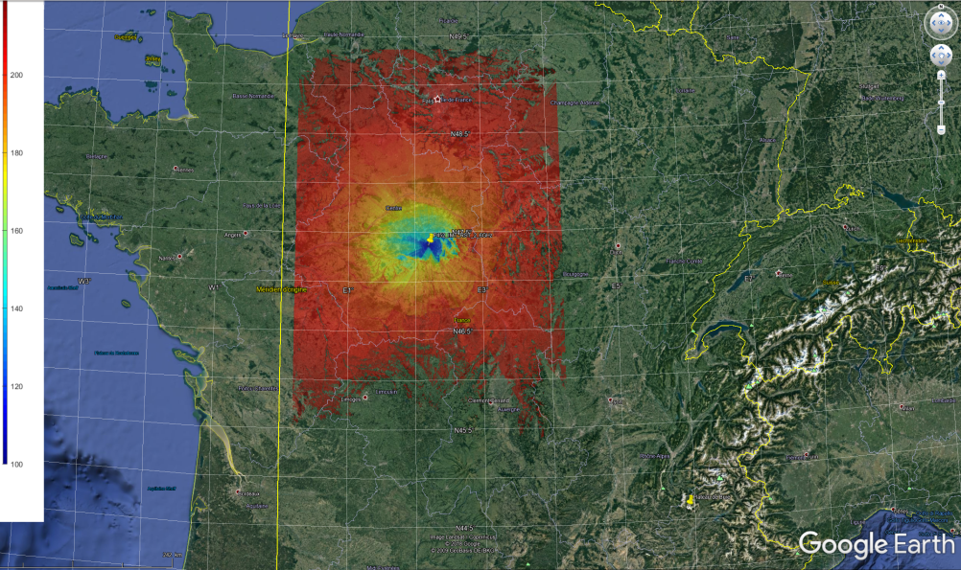
Figure 102: Propagation Losses at 50% around the radio astronomy site of Nançay. Limited to 220 dB of losses (220 dB is exceeded outside of red colour – No colour)
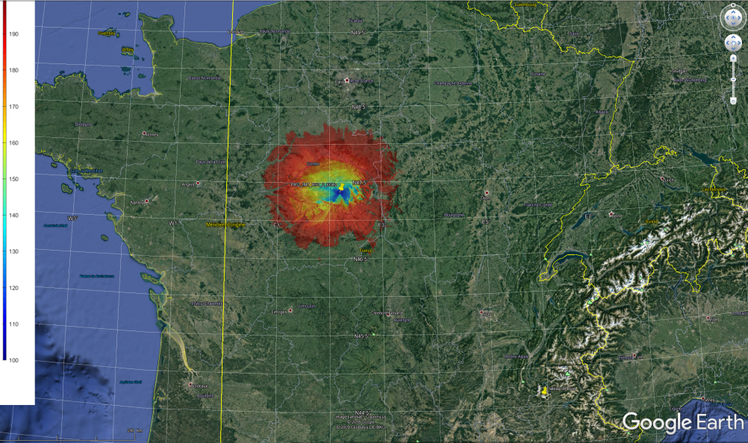
Figure 103: Propagation Losses at 50% around the radio astronomy site of Nançay. Limited to 200 dB of losses (200 dB is exceeded outside of red colour – No colour)
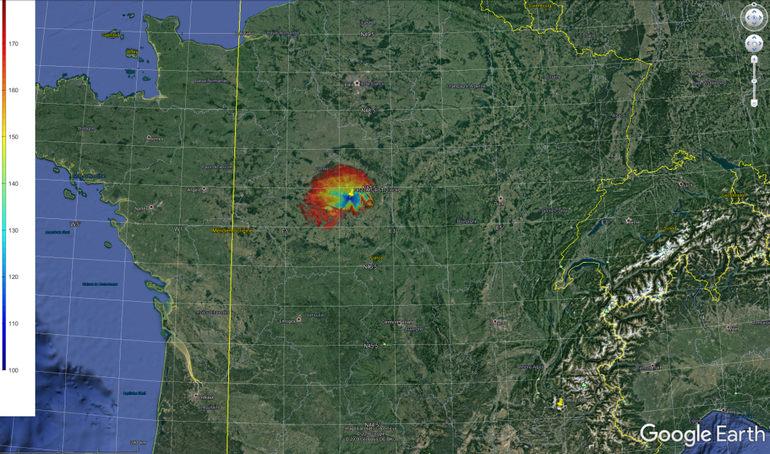
Figure 104: Propagation Losses at 50% around the radio astronomy site of Nançay. Limited to 180 dB of losses (180 dB is exceeded outside of red colour – No colour)

Table 90: Distance approximation around the RAS station of Nançay considering terrain and relevant TVG
Pt (dBm/10 MHz) | Gt (dBi) | Gr (dBi) | Lb (dB) | Distance (km) | reference | Comment
17.5 | 26 | 0 | 220.5 | 200 | Figure 3 | Normal BEM
-2.5 | 26 | 0 | 200.5 | 100 | Figure 4 | BEM-20 dB
-23.5 | 26 | 0 | 180.5 | 50 | Figure 5 | Closed to spurious
  - Conclusion
Considering the results of simulation provided in Table 90 and Figure 102 to Figure 104, without improvement of MFCN BS BEM at 2690 MHz, no deployment of AAS will be possible in the city of Paris and in the rural environment around this city. This study confirms the result of the RAS study already included in this Report and the preliminary conclusion of the report. The protection of RAS is resulting in a significant increase of restriction in 5G AAS BS deployment.
In consequence, in order to ensure a larger deployment of MFCN BS with AAS, France propose to impose additional attenuation to the BEM by at least 20 dB. The average value of OOB from BS in the band 2690-2700 MHz shall no exceed -2.5 dBm/10 MHz. An inferior value could of course improve the compatibility and the required distance to protect RAS. This limit should be included as a BEM at 2690 MHz for MNFC BS with AAS, as has been done at 3800 MHz (additional baseline in Table 6 of ECC Decision (11)06 [26]).
Considering MFCN BS AAS to be developed for the European market, this additional attenuation has to be imposed to all types of base station, regardless of the location of its deployment (rural, urban and suburban).
- List of References

- ECC Decision (05)05: “Harmonised utilization of spectrum for Mobile/Fixed Communications Networks (MFCN) operating within the band 2500-2690 MHz”, approved 18 March 2005, amended 03 July 2015
- CEPT Report 19: “Report from CEPT to the European Commission in response to the Mandate to develop least restrictive technical conditions for frequency bands addressed in the context of WAPECS” October 2008
- ECC Report 131: “Derivation of a block edge mask (BEM) for terminal stations in the 2.6 GHz frequency band (2500-2690 MHz)”, January 2009
- 3GPP TS 38.101-1: “Technical Specification Group Radio Access Network; NR; User Equipment (UE) radio transmission and reception; Part 1: Range 1 Standalone”
- ECC Report 45: “Sharing and adjacent band compatibility between UMTS/IMT-2000 in the band 2500 – 2690 MHz and other services”, February 2004
- ECC Report 174: “Compatibility between the mobile service in the band 2500-2690 MHz and the radiodetermination service in the band 2700-2900 MHz”, March 2012
- ERC Recommendation 74-01: “Unwanted emissions in the spurious domain”, amended May 2019”
- 3GPP TS 37.104: “Technical Specification Group Radio Access Network: E-UTRA, UTRA and GSM/EDGE; Multi-Standard Radio (MSR) Base Station (BS) radio transmission and reception”
- 3GPP TS 37.105: “Technical Specification Group Radio Access Network: Active Antenna System (AAS) Base Station (BS) transmission and reception”
- 3GPP TS 25.104: “Technical Specification Group Radio Access Network; Base Station (BS) radio transmission and reception (FDD)”
- Recommendation ITU-R M.2101 (02/2017): “Modelling and simulation of IMT networks and systems for use in sharing and compatibility studies”
- CEPT Report 67: “Report A from CEPT to the European Commission in response to the Mandate
“to develop harmonised technical conditions for spectrum use in support of the introduction of next-generation (5G) terrestrial wireless systems in the Union” - Review of the harmonised technical conditions applicable to the 3.4-3.8 GHz ('3.6 GHz') frequency band”
- ECC Report 281: “Analysis of the suitability of the regulatory technical conditions for 5G MFCN operation in the 3400-3800 MHz band”
- 3GPP TS 25.105: “Technical Specification Group Radio Access Network: E-UTRA, Base Station (BS) radio transmission and reception (TDD)”
- 3GPP TS 38.104: “Technical Specification Group Radio Access Network; NR; Base Station (BS) radio transmission and reception”
- 3GPP TR 37.840: “Study of Radio Frequency (RF) and Electromagnetic Compatibility (EMC) requirements for Active Antenna Array System (AAS) base station”
- ECC REPORT 119: “Coexistence between mobile systems in the 2.6 GHz frequency band at the FDD/TDD boundary” , February 2008
- 3GPP TR 37.842: “Radio Frequency (RF) requirement background for Active Antenna System (AAS) Base Station (BS)”
- T. G. Farr, P. A. Rosen, E. Caro, R. Crippen, R. Duren, S. Hensley, M. Kobrick, M. Paller, E. Rodriguez, L. Roth, D. Seal, S. Shaffer, J. Shimada, J. Umland, M. Werner, M. Oskin, D. Burbank and D. Alsdorf, “The Shuttle Radar Topography Mission,” Reviews of Geophysics, vol. 45, 2007.
- Document 5-1/478-E: "Sharing and compatibility of passive services in adjacent frequency bands and IMT operating in the 24.25-27.5 GHz frequency range", 2018
- Report ITU-R M.2292-0 (12/2013): “Characteristics of terrestrial IMT-Advanced systems for frequency sharing/interference analyses”
- Recommendation ITU-R F.1336-4 (02/2014): Reference radiation patterns of omnidirectional, sectoral and other antennas for the fixed and mobile service for use in sharing studies in the frequency range from 400 MHz to about 70 GHz
- Recommendation ITU-R F.1336-3 (03/2012): “Reference radiation patterns of omnidirectional, sectoral and other antennas in point-to multipoint systems for use in sharing studies in the frequency range from 1 GHz to about 70 GHz”
- ECC Decision (06)01: “The harmonised utilisation of the bands 1920-1980 MHz and 2110-2170 MHz for mobile/fixed communications networks (MFCN) including terrestrial IMT systems”
- ECC Report 203: “Least Restrictive Technical Conditions suitable for Mobile/Fixed Communication Networks (MFCN), including IMT, in the frequency bands 3400-3600 MHz and 3600-3800 MHz”, November 2013
- ECC Decision (11)06: “Harmonised frequency arrangements and least restrictive technical conditions (LRTC) for mobile/fixed communications networks (MFCN) operating in the band 3400-3800 MHz”
- Recommendation ITU-R P.452: “Prediction procedure for the evaluation of interference between stations on the surface of the Earth at frequencies above about 0.1 GHz”
- Recommendation ITU-R F.1245: “Mathematical model of average and related radiation patterns for point-to-point fixed wireless system antennas for use in interference assessment in the frequency range from 1 GHz to 86 GHz”
- Recommendation ITU-R RA.769: “Protection criteria used for radio astronomical measurements”
- Recommendation ITU-R P.525: “Calculation of free-space attenuation”
- ITU-R RA.1513: “Levels of data loss to radio astronomy observations and percentage-of-time criteria resulting from degradation by interference for frequency bands allocated to the radio astronomy service on a primary basis”
- ITU-R TG5/1 176
- Recommendation ITU-R P.2108-0: “Prediction of clutter loss”
- ECC Recommendation (19)01: “Technical toolkit to support the introduction of 5G while ensuring, in a proportionate way, the use of existing and planned EESS/SRS receiving earth stations in the 26 GHz band and the possibility for future deployment of these earth stations”, March 2019
- Recommendation ITU-R SA.509: “Space research earth station and radio astronomy reference antenna radiation pattern for use in interference calculations, including coordination procedures
- DIRECTIVE 2014/53/EU OF THE EUROPEAN PARLIAMENT AND OF THE COUNCIL, "on the harmonisation of the laws of the Member States relating to the making available on the market of radio equipment and repealing Directive 1999/5/EC", 16 April 2014

Although CEPT Report 19 mentions potential risk of interference to terminals due to blocking.

