Guidance to administrations for Coexistence between 5G and Fixed Links in the 26 GHz band ("Toolbox")
Approved 05 July 2019
ECC Report 303
ECC Report 303
ECC Report 303
ECC Report 303

Executive summary
The 24.25-27.5 GHz band (“26 GHz band”) has been harmonised for MFCN in CEPT by ECC Decision(18)06 [1], under the assumption of an individual authorisation framework, and it is recognised to be the 5G pioneer millimetre wave band in Europe. The ECC Decision does not preclude the use of the band by other services to which the band is allocated. Nevertheless, according to this ECC Decision, CEPT administrations shall make available by the end of 2020 at least 1 GHz for MFCN in this band, subject to market demand.
This ECC Report (“toolbox”) is intended to help CEPT administrations in the national decision process supporting introduction of 5G systems in 26 GHz with FS in operation providing mechanisms which allow for continued FS operation, where appropriate. This report has been developed under the assumption of an individual authorisation framework for 5G MFCN. Knowledge of the locations and parameters of the 5G base stations is necessary in order to manage national coordination with fixed services.
The guidelines are based on sharing and compatibility studies carried out to evaluate the possibility of coexistence between 5G systems and the FS and the necessary conditions in the 26 GHz band.
The results of all studies for the outdoor 5G network deployment scenarios show that coexistence between both services is possible but requires coordination. However, the amount of spectrum available for 5G systems at individual locations might be reduced by the existing FS usage. The feasibility of a successful outcome under such a coordination approach is a separate matter that would require further consideration based on national circumstances including density of fixed link deployment.
One study shows that coexistence conditions between indoor 5G systems and outdoor FS improve significantly due to higher values of building entry loss at 26 GHz compared to lower bands.
As the national situation in the various European countries will be different with respect to the FS usage density, FS licences duration and the future spectrum demand in 26 GHz for 5G systems in different areas, different approaches to support the implementation of 5G systems might be needed.
The two main options are either to maintain the use of the FS in the 26 GHz band or to clear, fully or partially, the band from the FS usage. Each option contains several approaches of sharing with FS or migration of the FS to enable the implementation of 5G systems. In this Report the approaches will be described in general. Depending on national circumstances administrations may choose among the approaches or combinations their off.
Section 4 presents the assumptions and the main results of the coexistence studies between FS and 5G networks.
Section 5 provides several potential mitigation techniques, for both services, that could help to reduce the interference and to make as much as possible spectrum available for the introduction of 5G systems. It also provides information on the impact of non-contiguous blocks on 5G systems performance.
Section 6 provides examples of possible approaches to make the 24.25-27.5 GHz band available for 5G networks.
In the shared approach the fixed links will continue to operate in the 26 GHz band; coexistence analysis is undertaken to determine sharing conditions between 5G networks and FS services. Further different ways of sharing are described:
- Sharing in frequency and space;
- Sharing in frequency, separation in space;
- Sharing in space, separation in frequency;
- Separation in space and frequency.
The shared approach requires interference calculations to determine the conditions for newly implemented applications. Therefore, information on incumbent service applications (e.g. location, technical parameters of individual FS sites) must be available and might be provided in a database. Due to confidential requirements in some cases, it may not be possible to make data publicly available.
In the phased approach, the FS will continue to operate in the 26 GHz band for a period of time. Coexistence analyses are undertaken to derive sharing conditions between 5G systems and the FS services. Gradually, the FS will be migrated out from the 24.25-26.5 GHz band to other frequency bands. Further, the FS backhaul links to base stations could be exchanged by fibre optic communication, where feasible, to clear the band continuously from an FS use.
In the migration approach, the FS service will be migrated completely or partially out of the band before the introduction of 5G networks. Due to national situation and number of FS links this could lead to delay the availability of spectrum for 5G systems. It should be noted that some administrations may wish to consider a combination of the shared and clearance options. This includes for example establishing sharing approaches between 5G systems and FS within some areas and migration of FS to other frequency bands in other areas.
Within this Report the studies assumed a long term protection criterion for FS as ratio of I/N = -10 dB, not exceeded for >20% of time has been taken as a FS protection requirement.

TABLE OF CONTENTS

0 Executive summary 2
1 Introduction 7
2 Background 8
2.1 ITU-R Context 8
2.2 European context 9
3 The usage of the band 24.25-27.5 GHz by the Fixed service 10
4 Assumptions and results of the coexistence studies between FS and 5G systems 11
4.1 Deployment scenarios and propagation models 11
4.1.1 Deployment scenarios 11
4.1.2 Methodology 11
4.1.3 Propagation models 12
4.2 Coexistence studies main results 12
4.2.1 Summary of the studies 13
4.2.1.1 Study 1 13
4.2.1.2 Study 2 13
4.2.1.3 Study 3 14
4.2.1.4 Study 4 14
4.2.1.5 Study 5 15
4.2.1.6 Comparison of the results of the studies gained by Monte Carlo or MCL 16
5 Operational guidelines for administrations on coexistence between 5G Systems and FS 17
5.1 General provisions 17
5.1.1 Criteria for the protection of the FS receivers 17
5.1.2 Impact of block fragmentation on 5G network performance 18
5.2 coexistence approaches between 5G systems and FS in 26 GHz 18
5.2.1 Separation in space 19
5.2.2 Separation in frequency 19
5.2.3 Separation in angle 20
5.2.4 Combined distance and angular separation 20
5.2.5 BS coverage layout scenario 22
5.3 Potential mitigation techniques For FS and 5G Systems 23
5.3.1 FS mitigation techniques 23
5.3.2 5G system mitigation techniques 23
6 Possible approaches for the introduction of 5G systems in the 24.25-27.5 GHz band 25
6.1 General approach 25
6.2 Implementation examples 25
6.2.1 The shared approach 25
6.2.2 The phased approach 27
6.2.3 Migration approach 28
6.2.4 The combined approach 29
6.2.5 Summary of the approaches 29
6.3 Possible methods for an administration to communicate the protection requirements 29
7 Conclusions 31
ANNEX 1: Case studies 33
ANNEX 2: Maximum separation distance to deploy outdoor 5G around fixed link in LoS interference environment 42
ANNEX 3: Interference reduction due to indoor 5G deployent as mItigation approach to protect fixed links in the 26 GHz 45
ANNEX 4: Summary table of MCL results 47
ANNEX 5: SUMMARY TABLE MONTE CARLO RESulTS 52
ANNEX 6: Example of fixed service usage in the 24.25-27.5 GHz band in certain countries and cities 57
ANNEX 7: List of references 69

LIST OF ABBREVIATIONS

Abbreviation | Explanation
5G MFCN | 5G Mobile/Fixed Communications Networks (see ECC Decision (18)06)
AAS | Active Antenna System
BS | Base Station
CEPT | European Conference of Postal and Telecommunications Administrations
CS | Central Station
ECC | Electronic Communications Committee
EDRS | European Data Relay System
EESS | Earth Exploration-Satellite Service
EFIS | ECO Frequency Information System
ENG/OB | Electronic News Gathering/Outside Broadcasting
FS | Fixed Service
FSS | Fixed-Satellite Service
IMT-2020 | International Mobile Telecommunication 2020
ISS | Inter-Satellite Service
ITU-R | International Telecommunication Union - Radiocommunication
LoS | Line of sight
MCL | Minimum Coupling Loss
MFCN | Mobile/Fixed Communications Networks
NFD | Net Filter Discrimination
NLoS | Non line of sight
NRA | National Regulatory Authority
PP | Point to Point
P-MP | Point-to-Multipoint
SAP/SAB | Service Ancillary to Program Making/Service Ancillary to Broadcasting
SRS | Space Research Service
TS | Terminal Station
UE | User Equipment

Introduction
The ECC Decision (18)06 [1] on harmonised technical conditions for mobile/fixed communications networks (MFCN) in the band 24.25-27.5 GHz (26 GHz) reflects the objective of the CEPT to harmonise the 26 GHz band in Europe for 5G MFCN [2]. The technical conditions related to coexistence with other services attached to the Decision were developed on the assumption of an individual authorisation framework.
However, in a number of CEPT countries, fixed point-to-point and point-to-multipoint links are in operation in the 24.5-26.5 GHz band. In many countries the band is used to deploy fixed point-to-point backhaul links for cellular networks and governmental usage.
ECC approved a comprehensive list of actions regarding the fifth generation of mobile technology (5G) named “CEPT roadmap for 5G” [2]. One of the actions is to develop additional guidelines to support the implementation of ECC Decision (18)06, including a toolbox to help the national decision process supporting the introduction of MFCN (5G) in 26 GHz with the FS in operation providing mechanisms which allow for continued FS operation, where necessary.
In response to this action, CEPT has developed this ECC Report that is intended to facilitate and provide guidelines to administrations on the development of future national plans concerning fixed links usage in 26 GHz to maximize the introduction of 5G systems in 26 GHz. Factors to be taken into account include spectrum efficiency and high level of flexibility in order to adapt to national circumstances as well as to meet the changing needs and demand for capacity in time and geography.
Based on the situation regarding the usage of the band, the Report focuses on coexistence options between 5G systems and existing Point-to-Point (P-P) and Point-to-Multipoint (P-MP) systems in the Fixed Service (FS).
Coexistence studies in the 26 GHz frequency band have been performed between Fixed Links (point to point and point to multi-point) and 5G systems in the frequency band 24.25-27.5 GHz and adjacent bands. They were performed in order to respond to the objective to support the introduction of 5G systems in 26 GHz according to the harmonised technical conditions (ECC Decision (18)06) while enabling administrations to consider national circumstances and FS deployment. As a consequence, CEPT has developed a toolbox to help the implementation of the various possible national scenarios.
This toolbox is based on sharing and compatibility studies. The analysis has been focused on the impact from 5G systems to FS (incumbent use in 26 GHz). Most studies indicate that a co-frequency sharing might be problematic, but depends on the national deployment of FS. Sharing between indoor 5G systems and outdoor FS could be feasible in most situations. The situation is improved for adjacent band scenarios. The introduction of a guard band between the 5G usage and the FS further mitigates their mutual impact to enable coexistence.
This report has been developed under the assumption of an individual authorisation framework for 5G MFCN. Knowledge of the locations and parameters of the 5G base stations is necessary in order to manage national coordination with fixed services.

Background

ITU-R Context
ITU Radio Regulations allocates the band 24.25-27.5 GHz or parts thereof in Region 1 on a primary basis to the fixed, fixed-satellite, inter-satellite, earth exploration-satellite, space research and mobile services [3]. In Region 1, the fixed service is allocated in the whole frequency band 24.25-27.5 GHz on a primary basis.
This band is within the scope of the Agenda Item 1.13 of the WRC-19.
Table 1: ITU-R Radio Regulations allocation of the 24.25–27.5 GHz band
Region 1 | Region 2 | Region 3
24.25 - 24.45  FIXED | 24.25 - 24.45  RADIONAVIGATION | 24.25 - 24.45  RADIONAVIGATION  FIXED  MOBILE
24.45 - 24.65  FIXED  INTER-SATELLITE | 24.45 - 24.65  INTER-SATELLITE  RADIONAVIGATION | 24.45 - 24.65  FIXED  INTER-SATELLITE  MOBILE  RADIONAVIGATION  5.533
24.65 - 24.75  FIXED  FIXED SATELLITE  (Earth-to-space) 5.532B  INTER-SATELLITE | 24.65 - 24.75  INTER-SATELLITE  RADIOLOCATION  SATELLITE (Earth-to-space) | 24.65 - 24.75  FIXED  FIXED SATELLITE  (Earth-to-space) 5.532B  INTER-SATELLITE  MOBILE  5.533
24.75 - 25.25  FIXED  FIXED SATELLITE  (Earth-to-space) 5.532B | 24.75 - 25.25  FIXED SATELLITE  (Earth-to-space) 5.532B | 24.75 - 25.25  FIXED  FIXED SATELLITE  (Earth-to-space) 5.532B  MOBILE
25.25 - 25.5
FIXED
INTER-SATELLITE 5.536
MOBILE
Standard frequency and time signal - satellite (Earth-to-space)
25.5 - 27
EARTH EXPLORATION - SATELLITE (space to Earth) 5.536B
FIXED
INTER-SATELLITE 5.536
MOBILE
SPACE RESEARCH (space to Earth) 5.536 C
Standard frequency and time signal - satellite (Earth-to-space)
5.536A
27 - 27.5  FIXED  INTER-SATELLITE 5.536  MOBILE | 27 - 27.5  FIXED  FIXED-SATELLITE (Earth-to-space)  INTER-SATELLITE 5.536 5.537  MOBILE

European context
The frequency band 24.25-27.5 GHz is currently used by fixed links across CEPT. Other uses of the band include EESS, SRS, FSS, ISS (including European data relay system, EDRS).
CEPT has developed harmonised technical conditions for 5G MFCN in this band in the ECC Decision 18(06) [1]. The technical conditions address sharing and compatibility conditions to ensure protection of other services in this band and in adjacent bands. These harmonised technical conditions were developed on the assumption of an individual authorisation framework applicable to 5G MFCN.
Due to the nature of 5G systems and depending on market demand and on national circumstances, fixed links, including those supporting the development of mobile broadband, may be maintained in the band or migrated to other bands. This CEPT toolbox provides guidance on how to manage coexistence issues between fixed service and 5G systems at a national level.
This toolbox can facilitate a progressive deployment of 5G systems in the 26 GHz band while allowing for continued FS operation, where appropriate.
Due to the possible different approaches in neighbouring countries to the deployment of 5G systems in parts of the 26 GHz band, bilateral or multilateral cross-border coordination may be necessary between 5G systems and Fixed Service.
In order to manage coexistence with fixed services, an authorisation framework where the locations and parameters of the 5G base stations are known is the preferred approach.

The usage of the band 24.25-27.5 GHz by the Fixed service
Figure 1 below depicts the current services use of the 26 GHz band within the CEPT.
In the frequency range 24.25-26.5 GHz both Point-to-Point (P-P) and Point-to-Multipoint (P-MP) systems are operated under the fixed service (see ECC Recommendation (11)01) [5].
ECC Report 173 [6] gives a regional picture of fixed links in different frequency bands in Europe. In 2017, a new revision was produced to update the information on effective spectrum use and expectations, also in view of the impact of 5G systems on FS, including technology trends and licensing regimes. The FS usage confirms a continuous trend in increase of FS use in Europe.
For the fixed links in 26 GHz band, the ECC Report 173 indicated that most of the occupied band is from 24.25 to 26.5 GHz. A total of about 51711 P-P links and 4277 P-MP central stations are in service in more than 30 countries. 95% of hop length indicated as “typical” is about 9 km (4.8 km for those indicated as “minimum”). In the 26.25-27.5 GHz band, very limited use (30 links reported) is declared for this band, used for military/NATO needs also. In some countries the band below 26.5 GHz (24.25-26.5 GHz) is also used by military fixed services.
For the frequency range 24.25-24.5 GHz the Recommendation T/R 13-02 [4] indicates that this band may be used by the CEPT administrations at national level for unidirectional links as ENG/OB SAP/SAB applications.
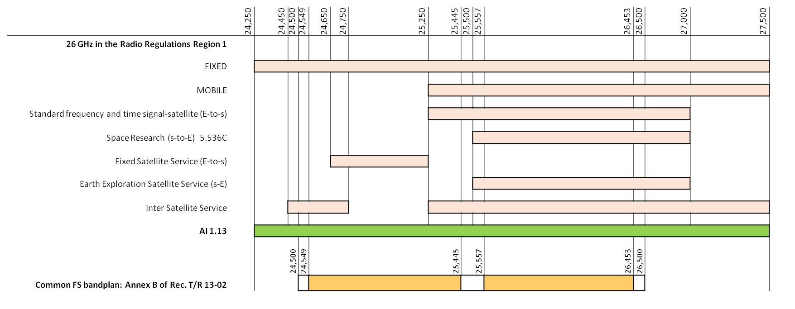
Figure 1: Usage of 26 GHz in CEPT
The following conclusions from the ECC PT1 questionnaire of 2016 on the bands under AI 1.13 could be pointed out:
- 26 GHz band is mainly used by fixed links – all responding administrations have fixed service allocations in at least a part of the band;
- 12 administrations note heavy usage (>1000 links or nationwide licences) for fixed links (mainly point-to-point, some point-to-multipoint). Usage is generally noted as nationwide with higher concentrations in urban areas.
Further information on the fixed links usage of the 26 GHz band in some countries is provided in ANNEX 6. Information is provided on the licensing approach (block and/or link-by-link licensing), licence duration, frequency distribution of licences, and density of deployments and geographic distribution of deployments such as illustrations of concentrations in some cities.

Assumptions and results of the coexistence studies between FS and 5G systems
Part of the frequency band 24.25-27.5 GHz is heavily used for point to point (P-P) and point to multi-point (P-MP) fixed links in some countries and some areas.
In the 26 GHz band, 5G systems are anticipated to support mainly urban and suburban hotspot areas with deployment expected to target cells with a small range. Currently in this frequency band there is no expectation of contiguous wide area coverage. There may be a need for a limited number of hotspots in rural areas. 5G systems at 26 GHz could be deployed both indoor and outdoor.
A number of coexistence studies between fixed services (P-P and P-MP) and 5G systems in the frequency band 24.25-27.5 GHz have been performed based on Minimum Coupling Loss (MCL) and Monte Carlo methodologies.
The studies were carried out for an interference scenario caused by 5G systems to fixed links, in accordance with the long-term protection criteria for FS:
- Interference to Noise Ratio (I/N) = -10 dB not to be exceeded for 20% of time.

Deployment scenarios and propagation models
In this section, the deployment scenarios and the propagation models used in the relevant studies are analysed.
The FS in the band 24.5-26.5 GHz are deployed on P-P and P-MP links. Co-channel and adjacent channel coexistence between 5G systems and FS have been considered.

Deployment scenarios
Coexistence studies are based on the four scenarios summarised in Table 2.
Table 2: 5G systems and FS coexistence scenarios
Scenario | Environment | Interference paths
1 | Urban (BS antenna at 6 m) | 5G BS&UE to FS receiver
2 | Sub-urban open space (BS antenna at 15 m) | 5G BS&UE to FS receiver
3 | Sub-urban (BS antenna at 6 m) | 5G BS&UE to FS receiver
4 | Indoor (same base station antenna height as fixed link) | 5G BS to FS receiver
In all studies, only a single 5G BS versus a single FS receiver has been considered. Due to the very high directivity of the FS receiving antenna the impact of interference aggregation by multiple interferers might be considered as being minor.
The studies have been performed mainly considering 5G BS interference towards FS receiver.

Methodology
Two methodologies are used in the coexistence studies between FS and 5G systems - the Minimum Coupling Loss (MCL) calculation and the Monte Carlo simulation.
The MCL method includes the calculation of interference from a single 5G BS or UE to a FS receiver. In case of single entry BS interference, MCL calculations evaluate the minimum protection distance needed to ensure that the level of interference respecting the long term protection criteria of fixed service.
The MCL investigation applies electrical steering of the BS antenna such that maximum gain is towards a UE at the edge of the cell, using appropriate UE distribution as defined in [7]. Minimum clutter loss (i.e. maximum interference) is accounted for with percentage of locations of 1% from Recommendation ITU-R P.2108 [10] as a worst case assumption. Note that clutter loss is considered only at the 5G system side of the interfering link since FS antennas are usually mounted for LoS operation. As an assumption, in the MCL calculation the 20% of time is taken into account in the propagation path loss.
Monte Carlo simulations take into account
  - the dynamic pointing of 5G BS Active Antenna System (AAS) antenna pattern whose main beam follows the UE positions which are distributed randomly within the coverage area;
  - Clutter loss is accounted with percentage of locations uniformly distributed between 0% and 100%.
In the Monte Carlo simulations, the 20% of time is taken into account in the propagation path loss. Monte Carlo simulations are performed over a large number of simulation runs. At each simulation run, the UE positions and the clutter location probability are randomly generated. Following the large number of simulation runs, at different separation distances between the interfering 5G BS and the victim FS receiver, the distribution of I/N not exceeding more than 20% of time are plotted for different separation distances.

Propagation models
The propagation models to be used for the sharing studies on the candidate bands for 5G systems (IMT-2020) are recommended by ITU-R SG 3. In the study between 5G systems and FS links, outdoor BS and UE are considered. The propagation models used for the wanted link is the UMi-street Canyon model as described in 3GPP TR 38.900 section 7.4 [8].
ITU-R SG 3 recommends the use of two propagation models for the interference links, one for short paths and one for long paths. For long paths (distance > 1 km) the Recommendation ITU-R P.452 [9] propagation model is used combined with the terminal clutter correction specified in Recommendation ITU-R P.2108 [10] for BS and UE. According to Recommendation ITU-R P.2108, clutter refers to objects, such as buildings or vegetation, which are on the surface of the Earth but not actually terrain. The additional path loss caused by clutter along the path (specific-path clutter) at these high frequencies is not negligible and can be additionally considered. For short paths (distance < 1 km) the Recommendation ITU-R P.1411 [11] propagation model was used in some studies which include both specific-path clutter correction and the terminal clutter correction.
Recommendation ITU-R P.2109 [12] has been used to calculate the building entry loss for the sharing studies when 5G BS are assumed to be deployed indoor.

Coexistence studies main results
A number of studies on coexistence between Fixed Links (P-P and P-MP) and 5G systems in the frequency band 24.25-27.5 GHz and adjacent bands have been performed based on MCL and Monte Carlo methodologies.
A number of different scenarios have been addressed and assumptions on system parameters have been considered according to the technical characteristics of 5G systems and FS. For each different considered scenario and different parameters, results of the studies provide possible conditions of coexistence in terms of frequency separation, distance separation, angle separation and exclusion zones.
The impact of different parameters (e.g. 5G usage scenarios, propagation effects, FS antenna height) on coexistence conditions has been investigated. Also the effect of antenna beamforming on the interference level at FS receiver has been addressed. As it can be expected, coexistence conditions strongly depend on the considered scenario and system parameters. Therefore, a coordination process based on sharing conditions between 5G systems and FS is needed to ensure coexistence of both systems in the same band and/or in adjacent bands.

Summary of the studies
Summaries of main results of the studies are described in the following sections.
The following Table 3 summarises the different scenarios, calculation methods, separation methods and propagation models considered by the different studies.
Table 3: Overview of the different studies
Study | Scenario |  |  | Calculation method |  | Separation method |  |  | Propagation model  (ITU-R Recommendation)
 | Urban | Suburban | Indoor | MCL | Monte Carlo | Space | Frequency | Angle | D <1 km | D ≥ 1 km
Study 1 | X |  |  | x |  | x |  |  | P.1411 | P.452 + P.2108
Study 2 | X | X |  | X | X | X | X |  | P.1411 | P.452 + P.2108 (clutter loss on both sides)
Study 3 | X |  |  | X |  | X | X | X | P.452 + P.2108
Study 4 | X | X |  | X |  | X | X | X | P.452 + P.2108
Study 5 | X |  | X | X | X | X |  |  | P.1411 | P.452 + P.2108+P.2109

Study 1
Based on assumptions in the study (co-channel and MCL), the results show that a separation distance of between 20 and 70 km would be required to meet the protection criteria for FS receivers. If the deployment of FS is dense and is in a similar urban environment, it is expected that co-channel sharing is unlikely to be possible without the introduction of some form of detailed coordination approach. This study has focussed on 26 GHz 5G systems roll-out in an urban environment. It is expected that the distances at which a BS could cause interference to a FS may increase in a rural environment due to reduced clutter loss.

Study 2
Monte Carlo simulations and MCL calculations have been performed to address the potential interference from a single 5G BS to a FS receiver in six coexistence scenarios in urban and suburban environment.
The studies concluded that without coordination between 5G base stations and FS receivers the coexistence between the two services could be achieved only under the following conditions:
Urban scenario
In the co-channel case, for the baseline 8x8 antenna configuration and typical BS and FS antenna heights of 6 m and 15 m respectively, coexistence is feasible, mainly due to clutter loss on both sides, with separation distances > 1 km (Monte Carlo) and about 2.6 km (MCL). In the sensitivity analysis of the 16x16 antenna configuration (Monte Carlo) coexistence is also feasible but with a much larger separation distances, e.g. 10 km for NLoS and 15 m and 30 m FS antenna height scenarios. But for 60 m FS antenna height scenario, more than 10 km separation distance is required.
In the adjacent channel case (Monte Carlo), coexistence is feasible in urban area when the separation distance is no less than 1 km for NLoS 8x8 and 16x16 antenna configurations for all analysed FS antenna heights. Sharing is difficult with separations smaller than 1 km, in particular if there is LOS path between 5G BS and FS receiver, even in urban environment. To achieve coexistence, a careful coordination in angle separation may be necessary (not considered in this study).
Suburban scenario
Coexistence is very difficult in a suburban area, even for the adjacent channel case (Monte Carlo). More than 10 km separation distance is required but the study does not provide the necessary separation distance. The MCL calculation results for the co-channel case showed that the required separation distance is from 38 to 52 km when the 5G BS is placed in front of the FS receiver antenna. When the 5G BS is placed at the back of the FS receiver antenna, the required separation distance is between 4 and 5 km.

Study 3
The obtained protection distances are summarised in Table 4 below, for off-axis angle of the FS antenna being 0 and 5 degrees respectively. For the co-channel case, the obtained separation distances between the 5G BS and the FS station, with an off-axis azimuth angle of 0 degrees, vary from 22.4 km to 38.7 km, depending on the height of the FS antenna. An off-axis angle of 5 degrees between the 5G BS and FS station would reduce the protection distances to a range of 3.83 km to 5.48 km, for the different heights of the FS antenna. When the interference is caused by the 5G UE into the FS station, the protection distances in the co-channel case with an off-axis angle of 0 degrees range from 6.2 to 10.4 km. An off-axis angle of 5 degrees would reduce the protection distances to a range between 0.72 km and 1.07 km, depending on the height of the FS antenna.
Further reduction of the protection distances can be achieved by increasing the off-axis azimuth angle or the frequency separation, as the results in Table 4 indicate.
Table 4: Protection distances for different coexistence scenarios
Off-axis azimuth angle  (degree) | Scenario | Protection distance (km)
Off-axis azimuth angle  (degree) | Scenario | Co-channel |  |  | Adjacent channel |  |  | Guard band  (20 MHz)
Off-axis azimuth angle  (degree) | FS antenna height (m) | 15 | 30 | 60 | 15 | 30 | 60 | 15 | 30 | 60
0 | 5G BS -> FS | 22.4 | 28 | 38.7 | 1.9 | 1.6 | 0.27 | 0.63 | 0.27 | 0
0 | 5G UE -> FS | 6.2 | 6.15 | 10.4 | 1.23 | 0.56 | 0.26 | 0.69 | 0.32 | 0.25
5 | 5G BS -> FS | 5.48 | 5.43 | 3.83 | 0.55 | 0.51 | 0.26 | 0.27 | 0.26 | 0
5 | 5G UE -> FS | 1.07 | 1.04 | 0.72 | 0.45 | 0.4 | 0.26 | 0.3 | 0.27 | 0

Study 4
The results of the study show that coexistence between 5G systems and the FS in general is possible when a coordination procedure is used. With coordination between both systems, coexistence can be reached within close separations of distance and frequency.
A separation in frequency and/or distance is needed to ensure coexistence as shown in Figure 2 and Figure 3 below). Site specific coordination, considering e.g. shielding by buildings, plants or terrain might allow combinations of closer distances and smaller angles.

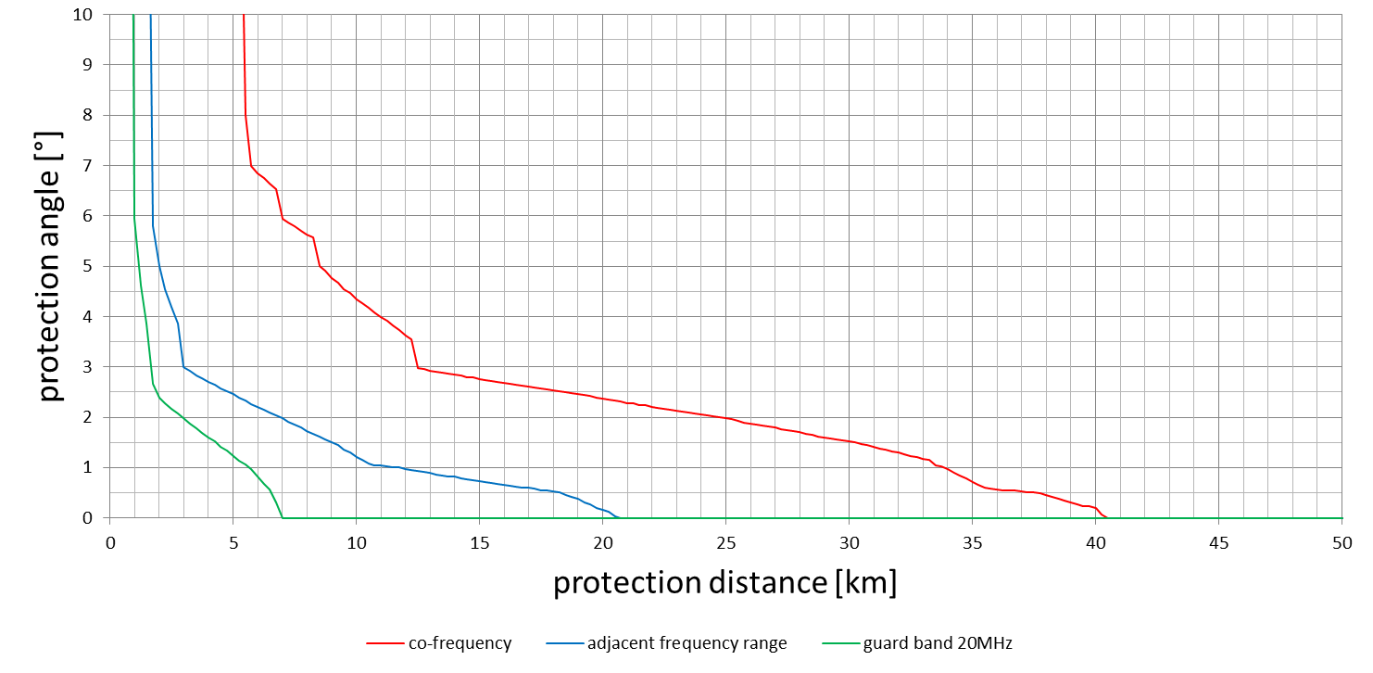
Figure 2: Angles and distances of coexistence between 5G systems and the FS for different frequency separations
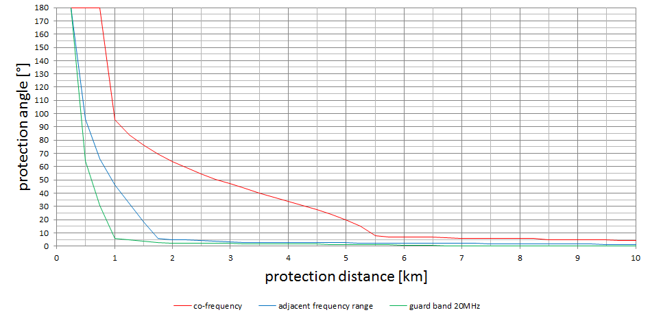
Figure 3: Angles and distances of coexistence between 5G systems and the FS for different frequency separations (distance looped)

Study 5
This study results in the separation distances between a single 5G BS and FS according to configurations of co-frequency BS deployments (outdoor and indoor):
Outdoor 5G
- Randomly horizontal main beam direction of BS: 5.5 km;
- Horizontal main beam direction of BS toward FS link station: 12.6 km;
- The worst case configuration between BS and FS: 28 km.
Indoor 5G
Table 5: Indoor 5G separation distances
Building entry loss percentage | Traditional building type |  | Thermal efficient building type
Building entry loss percentage | BEL (dB) | Separation distance (km) | BEL (dB) | Separation distance (km)
1% | 1.4 dB | 0.68-1.91 km | 9 dB | 0.32-0.91 km
20% | 10.4 dB | 0.27-0.77 km | 25.9 dB | 0.05-0.13 km
50% | 20 dB | 0.093-0.261 km | 41 dB | 0.008-0.023 km

Comparison of the results of the studies gained by Monte Carlo or MCL
MCL based studies usually identify the most critical conditions which can occur in scenarios. In the sharing and compatibility studies performed on the coexistence options between 5G systems and the FS the UE was assumed to be located at the edge of the cell. That produces the most critical elevation condition when considering the impact of the BS AAS beam towards the FS receiving antenna.
Investigations based on the Monte Carlo procedure benefit from considering more realistic usage scenarios if proper statistical variations on several parameters in the study are applied. The positions of UEs are simulated as random within the cell which produces the above mentioned critical elevation condition in only rare cases.
Thus results gained on a Monte Carlo basis will usually be less critical.
The following results selected from study 4 and study 5 confirm that for the outdoor scenario.
Table 6: Comparison of Study 4 (MCL) and Study 5 (Monte Carlo)
Condition | Study 4 (MCL) | Study 5 (Monte Carlo)
Worst-case protection distance | 40.5 km | -
BS AAS main beam directed towards FS | - | 12.6 km
BS AAS main beam random | - | 5.5 km
Administrations might take into account that results produced using MCL analysis are conservative.

Operational guidelines for administrations on coexistence between 5G Systems and FS

General provisions
As 26 GHz has been identified as a pioneer band for 5G systems, it is already harmonised in CEPT and administrations are planning to make available at least 1 GHz by 2020.
In many CEPT administrations the 26.5-27.5 GHz frequency range is less used by incumbent systems than the 24.5-26.5 GHz frequency range. Therefore, initial 5G system deployments in many CEPT administrations are expected in the 26.5-27.5 GHz frequency range.
The 26 GHz band will mainly be used for urban and suburban hotspot areas. However there may be a need for a limited number of hotspots in rural areas. It is not expected that the band will be used for contiguous wide/nationwide coverage of 5G systems.
It should be noted that the industry recommended MFCN bandwidth in the 26 GHz band in order to enable 5G services should be at least 400-500 MHz per network [13].
Administrations should consider the different options for coexistence with the existing FS when designing national plans for the introduction of 5G systems in the 26 GHz band.
CEPT conducted relevant sharing studies, under the assumption of an authorisation framework with known 5G base station locations and parameters, which confirmed a need for national considerations to manage the incumbent FS services in the 24.25-26.5 GHz frequency range while introducing 5G systems in the 24.25-27.5 GHz band. If it is decided that the FS services should be maintained in the band an approach using coordination between 5G base stations and FS sites is required.
In case of co-frequency coexistence between FS and outdoor 5G networks in close locations, there is a reduction of spectrum availability for 5G MFCN due to the different granularity of the channel bandwidths of the two systems: multiple of 28 MHz for FS, multiple of 50 MHz for 5G systems. As a consequence in this scenario, when assigning spectrum blocks to 5G MFCN in the presence of FS channels only an integer number of 50 MHz 5G MFCN channels could be placed outside the spectrum used by the existing FS channels.
CEPT countries are able to manage the coexistence at national level according to market demands. National targets to clear the 26 GHz band from FS could take time. The regulatory framework should allow the possibility to manage the coexistence between the fixed service and 5G systems.
An evaluation of the need of migration of fixed links to other bands will have to be managed at a national level and are subject to a national decision. Frequency shared deployment between 5G systems and fixed links will remain possible based on a coordination approach but will depend on national situations.
The possibility of coexistence (co channel, adjacent channel)) between Fixed Links (PP and P-MP) and 5G systems in the frequency band 24.25-26.5 GHz strongly depends on the considered scenario.
Different scenarios should be addressed. Assumptions on system parameters should be considered according to the technical characteristics of 5G systems and fixed services. For each different considered scenario and different parameters, the conditions of coexistence may be expressed in terms of frequency, distance, angular separations or a combination of these.

Criteria for the protection of the FS receivers
For the coexistence between 5G systems and FS in 26 GHz band, it was agreed to use the long-term protection criteria for FS [24]: interference to Noise Ratio I/N = -10 dB to not be exceeded over 20% of time.

Impact of block fragmentation on 5G network performance
Due to the possible need for sharing of the 26 GHz band between 5G systems and FS, fragmentation of available spectrum for 5G might occur.
According to ECC Report 287 [21] and ETSI TS 138 104 [17] the performance of 5G systems is degraded if the frequency blocks are not contiguous due to spectrum fragmentation.
This section provides information on the implications of using non-contiguous blocks, to ease the decision of an administration on which approach of deployment for 5G will be most appropriate under their specific national situation.
Below a description of the drawbacks related to the use of non-contiguous frequency blocks, based on the properties of 5G NR in 26 GHz is provided based on information contained in ECC Report 287 (Annex 1).
In particular, for a given overall spectrum bandwidth, contiguous assignments present significant advantages over non-contiguous blocks:
- Spectrum efficiency. In case of 120 kHz subcarrier spacing there is a reduction in spectrum efficiency (around 3%) when two non-contiguous 50 MHz blocks are used for 5G compared with one contiguous block of 100 MHz (this is due to the fact that 26 GHz technical specifications define smaller number of PRBs (physical resource blocks) available in two separate 50 MHz channels compared with one 100 MHz channel). In case of 60 kHz subcarrier spacing there is no reduction in spectrum efficiency;
- Signalling overhead. A single wide carrier can save overhead cell configuration/addition/deletion compared to a two carrier configuration;
- Activation/deactivation latency performance. A carrier aggregation (CA) configuration may increase the delay to adapt the bandwidth.
- Base station implementation. A base station has usually a certain operational bandwidth; in case the overall spectral occupancy which includes non-contiguous fragments is not within the operational bandwidth, two different radio units would be needed;
- UE implementation. Uplink CA (especially non-contiguous UL CA) is more complex thus might not be supported by all UEs. Moreover UL CA requires more power consumption to the UE.
If it is not possible for administrations to assign contiguous spectrum block to an operator, administrations may consider to assign additional spectrum to compensate for the spectrum required (e.g. for signalling overhead) for non-contiguous blocks.
Compared to contiguous blocks an addition of spectrum per additional block may be required, noting that the minimum channel bandwidth is 50 MHz. A concrete amount of spectrum depends on the number of assigned blocks and also on the throughput requirements of the operator.

coexistence approaches between 5G systems and FS in 26 GHz
The following approaches or a combination of these approaches could be considered to manage co-channel or adjacent channel coexistence between 5G systems under the assumption of an individual authorisation framework, and FS at 26 GHz:
- Separation in space:
Protection distance within the same area (e.g. city);
Geographical separation between the deployment areas of 5G systems and FS;
Isolation between indoor 5G hotspots and FS outdoor sites.
- Separation in frequency:
Adjacent frequency range;
Guard band.
- Separation in angle:
Antenna directivity;
5G system beamforming;
- BS height and coverage area (hotspots)
The feasibility of the different approaches depends on the national situation regarding e.g. the density of FS-links, the band fragmentation and the ownership of FS links (e.g. only mobile operators). Therefore administrations should choose which approach or combination of approaches might be most suitable for the national strategy to deploy 5G systems in 26 GHz.

Separation in space
All studies carried out give large separation distances to protect FS from 5G BS in the co-channel in the main beam direction, in particular for LoS situation. The situation is improved when the adjacent channel scenario and/or guard band is considered. Also the situation improves significantly when the 5G BS is not in the FS main beam direction. See section 5.2.3.
The main parameters affecting the protection distance are:
- Deployment scenario (urban hotspots and suburban hotspots);
- LoS or NLoS condition;
- FS antenna (gain and height);
- Clutter loss (percentage of locations).
- 5G BS characteristics
In general, the higher the number of obstacles between the 5G BS transmitter and the FS receiver, the lower the required separation distance:
- Going from urban to suburban to rural, the required separation increases;
- NLoS and high clutter loss lead to smaller separation distance;
- The higher the FS antenna height/gain, the larger the required separation distance in the main beam.
Even in the most favourable case of urban deployment with high clutter and FS above the roof with the 5G BS at a low height (6 m), a protection distance in the order of several hundreds of metres to several kilometres would be necessary for co-channel coexistence, which in high density 5G system deployments and high density of FS-links could be more complex and may need different mitigation techniques.

Separation in frequency
All studies showed that the co-channel scenario is the most critical case, particularly in LOS situation. The coexistence situation for adjacent channel scenarios improves significantly and is even better for guard band scenarios.
Mitigation techniques described in section 5.3 might help to reduce the probability of interference. If the band usage is highly fragmented by incumbent FS links it may be beneficial to reorganise the assignment plan and therefore enable larger contiguous blocks of spectrum for 5G systems.
Band segmentation between FS and 5G systems might provide sufficient spectrum for both services and reduce the coordination effort.
It should be noted that if channel aggregation is used by 5G systems this can lead to higher flexibility of spectrum use.

Separation in angle
Due to the directivity of the 5G BS antenna but especially of the FS antenna, the angular discrimination in both elevation and azimuth planes has a significant impact on the possible coexistence:
- due to the high directivity of the FS antenna the probability of a 5G BS located in the main beam of a FS antenna is very low (i.e. due to the narrow beamwidth (3 dB beamwidth: 36.6 dBi (Ø=0.3 m): 2.7°, 42 dBi (Ø=0.6 m): 1.3°));
- 5G BS using an AAS also provide a narrow beamwidth, compared to common (non-AAS) sectoral antennas. Taking into account dynamic electrical steering functionality towards the UE, the consequential antenna pattern gain of the 5G BS does not exceed the antenna gain (shown in the in thick red line in Figure 4below) due to the maximum coverage angle of 5G BS in the horizontal plane (i.e. 120 degree). For example, a side lobe gain of the BS antenna towards 90 or more than 120 degrees does not exceed -4.46 dBi or -6.938 dBi, respectively. -4.46 dBi for more than 90 degrees of 5G BS toward FS link corresponds to at least 27.46 dB interference relaxation on the assumption of ITU-R baseline array antenna characteristics, i.e. 8x8 elements (3 dB beamwidth of about 13-14°).
Figure 4: BS antenna angle in azimuth (degrees)
Outside the main beam of the FS antenna the necessary separation distance in all cases (Co-channel, adjacent channel and guard band) reduces drastically. For example from about 40 km in 0° to 12.5 km in 3° and 6 km for 6.8° in co-channel case (see Figure 2).
For adjacent channel and guard band case the distance can be reduced when reaching 5° to below 1 km in guard band case and below 2 km in adjacent channel case.
In the case of an incumbent P-MP system the central station has sectorial antenna and consequently separation in angle is not easily feasible. However it should be noticed that the gain of the P-MP antenna is lower than the one of the PP antenna. Thus the protection distance in the main beam is lower.

Combined distance and angular separation
The coexistence between 5G systems and the FS with respect to the separation distance in combination with the angular separation, was investigated for an environment of a highly dense FS use (city with 1100 FS stations in the 26 GHz frequency range).
As an example, ten stations are considered as future 5G sites and are placed at various locations in the area. Applying the criteria given in Figure 2 and Figure 3, the coexistence conditions for each 5G BS is checked versus all FS stations.
Figure 5: Scenario to derive the coexistence options between 5G systems and the FS
For each location the coexistence situation is given in Table 7. It can be observed that even for a co-frequency usage scenario the probability of coexistence between 5G BS and the FS might be considerably high, depending on the specific location.
As an example the following results were found for 10 virtual 5G BS locations shown on Figure 5 above.

Table 7: Probability of coexistence of a5G BS site in a highly dense used FS environment
NR sta-tion | Longitude | Latitude | Probability of coexistence in case of usage: |  |  | Spectrum  available | Maximum continuous block size
NR sta-tion | [degree] | [degree] | in a co- frequency range | in adjacent frequency ranges | with a guard band of 20 MHz | [MHz] | [MHz]
1 | 13.29 | 52.50 | 94.7% | 98.2% | 99.2% | 1012 | 683
2 | 13.4 | 52.51 | 88.1% | 96.9% | 98.5% | 826 | 465
3 | 13.15 | 52.60 | 99.2% | 99.7% | 100.0% | 1330 | 819
4 | 13.70 | 52.40 | 98.5% | 99.8% | 100.0% | 1380 | 819
5 | 13.45 | 52.55 | 93.5% | 98.9% | 99.6% | 776 | 339
6 | 13.31 | 52.49 | 95.5% | 99.4% | 100.0% | 1081 | 728
7 | 13.54 | 52.43 | 96.6% | 99.6% | 99.8% | 1235 | 728
8 | 13.35 | 52.55 | 93.3% | 98.0% | 99.6% | 881 | 318
9 | 13.55 | 52.55 | 95.7% | 99.4% | 100.0% | 1186 | 707
10 | 13.2 | 52.45 | 97.7% | 99.5% | 100.0% | 1137 | 707
on average: |  |  | 95.3% | 99.0% | 99.7% | 1084 | 631
This kind of coordination requires the relevant data of fixed services and 5G BS to be known such as position, carrier, antenna height and its pointing. The 5G network planning and deployment has to consider the spectrum locally available and must contain an inter service coordination.

BS coverage layout scenario
Both co-channel and adjacent channel coexistence conditions between 5G systems and FS at 26 GHz may be improved significantly for hotspot deployment as the impact on FS victim receivers significantly depends on several 5G BS characteristics such as the antenna pattern, height and beam steering, or the indoor/outdoor location.
It is expected that separation distances decrease significantly in case of hotspot 5G BS which are characterised by lower transmitted powers and antenna heights.
In particular, interference in the indoor 5G BS scenario is significantly reduced due to lower transmitter power, side-lobe beam pattern of AAS and building entry loss. Consequently, the separation distance also significantly decreases meaning an interference reduction. Table 8 and Table 9 shows the interference reduction and corresponding relative required separation distance (relative to interference scenario with line-of-sight) for a traditional building and thermally efficient building respectively.
Based on TG5/1 parameters [7], transmitter power in the indoor scenario is reduced by up to 5 dB and the antenna gain of 5G BS toward FS link is reduced by at least 16.2-25.2 dB due to lower side-lobe pattern gain of the 5G BS AAS by setting the mechanical main beam of BS against outdoor.

Table 8: Indoor 5G BS in a traditional building
Building Entry Loss (Recommendation  ITU-R P.2109) |  | Interference reduction  Incl. Tx power, ant pattern | Relative separation distance reduction
Percentage | Loss | Interference reduction  Incl. Tx power, ant pattern | Relative separation distance reduction
1% | 2.7 dB | 23.9-32.9 dB | 93.62-97.74%
20% | 10.6 dB | 31.8-40.8 dB | 97.43-99.09%
50% | 20 dB | 41.2-50.2 dB | 99.13-99.69%

Table 9: Indoor 5G BS in thermally efficient building
Building Entry Loss (Recommendation.  ITU-R P.2109) |  | Interference reduction  Incl. Tx power, ant pattern | Relative separation distance reduction
Percentage | Loss | Interference reduction  Incl. Tx power, ant pattern | Relative separation distance reduction
1% | 9.2 dB | 30.4-39.4 dB | 96.98 - 98.93%
20% | 25.9 dB | 47.1-56.1 dB | 99.56 - 99.84%
50% | 41 dB | 62.2-71.2 dB | 99.92 - 99.97%
The 1% building entry loss is considered as the most relevant to adopt a cautious approach.
The detailed analysis is shown in ANNEX 3:

Potential mitigation techniques For FS and 5G Systems

FS mitigation techniques
A distinctive measure for FS in order to reduce the mutual impact outside the main beam is to increase the FS antenna gain. This will generally improve both the side lobe suppression and the front-to-back-ratio of the FS antenna leading to a decrease in the susceptibility of the FS system outside the main beam. This approach would imply a change of the antenna. For traditional P-MP systems, this measure might not be applicable.

5G system mitigation techniques
A list of possible mitigation techniques that can be adopted by 5G systems to reduce the interference at the FS receiver includes:
- Beamforming, beam steering;
- Site location;
- Antenna height;
- Transmitter power;
- Antenna tilt;
- Antenna gain;
- BS emission mask;
- Microcells, picocells (low antenna height and low transmitter power);
- NLoS propagation 5G BS-FS;
- Indoor Base Stations where appropriate;
- Avoiding use of spectrum blocks used by FS, including channel aggregation of non-contiguous blocks.
The reduction of the BS antenna height (microcells and picocells) which is generally lower than FS antenna heights could further favour the coexistence especially in urban areas due to greater buildings obstruction and higher probability of NLoS propagation between 5G systems and FS.
The indoor scenario is characterised by a low power deployment.
Additional path loss and consequently a reduction of the interference at the outdoor FS incumbent receivers can be achieved considering the indoor 5G system deployment scenario. Recommendation ITU-R P.2109 [12] provides a method for estimating building entry loss at frequencies between about 80 MHz and 100 GHz. The method is not site-specific, and is primarily intended for use in sharing and compatibility studies.
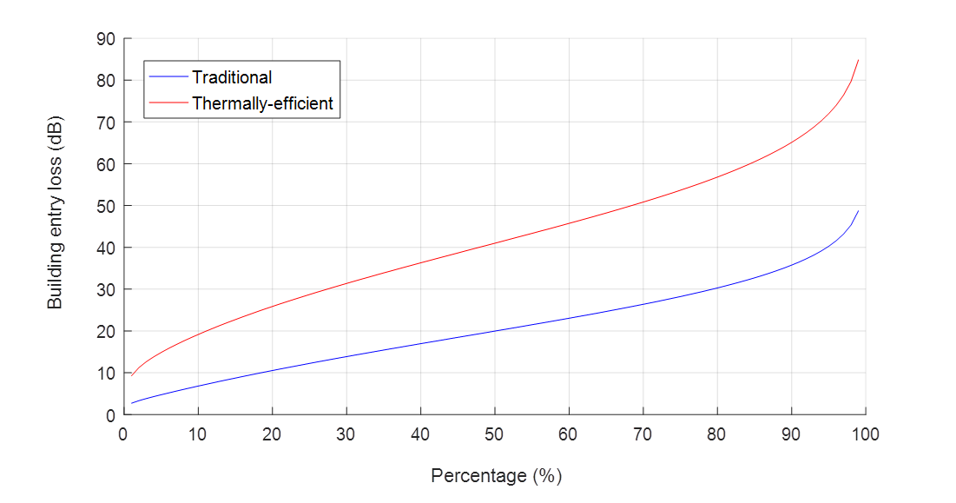
Figure 6: Building entry loss at the frequency 26 GHz predicted at
horizontal incidence (Recommendation ITU-R P. 2109)

Figure 6 plots the building entry loss (BEL) returned by the Recommendation ITU-R P.2109 model for two building classes.

Possible approaches for the introduction of 5G systems in the 24.25-27.5 GHz band

General approach
There are a number of approaches, some of which could be combined, that could be considered by national administrations to enable 5G system deployments. Two general options could be described as follows:
  - Approach I: Shared option
This option implies that the incumbent FS service remains in the band while introducing 5G systems on a shared basis. The deployment parameters of both FS applications and 5G systems are required. These parameters are used for coexistence analysis and result in specific technical conditions enabling coexistence. This option may be based on the coexistence conditions expressed in terms of frequency or geographical separations between 5G systems and FS.
  - Approach II: Clearance option
This option implies the clearance of the band of FS deployments in the area where 5G systems are to be deployed with the FS either migrated to other FS bands or replaced by fibre. The migration could be carried out progressively.
Administrations may consider any combination of the shared and migration options. For example, this includes establishing sharing between 5G systems and FS within some areas and migrates of FS in other areas. More detailed examples of the implementations of these high level approaches are provided in section 6.2.

Implementation examples

The shared approach
The idea of the “shared approach” is to have the assignment of 24.25-27.5 GHz band to 5G MFCN while the fixed service will continue to operate in the 24.25-26.5 GHz band.
In order to allow the shared use of spectrum in a given band, a proper spectrum sharing framework has to be defined, which is a set of sharing rules and coexistence conditions whose development should involve all relevant stakeholders, including the incumbents.
If sharing is based on coordination between the two services, knowledge about the existing and the new applications is needed. If this coordination approach is based on interference calculation, several technical parameters of both applications are needed (e.g. locations, technical parameters of individual FS sites). These parameters need to be known by the administrations.
Individual 5G base station site specific coexistence analysis is undertaken to determine if sharing is possible and how much spectrum could be made available for 5G systems in each specific base station location.
Besides the individual coordination based on the single 5G base station characteristics, an area related interference calculation with a defined limit at the border of the area may also be considered for certain cases. The area would be defined by the operator. If it is found to be relevant, administrations may apply a possible restriction to certain 5G base stations to ensure coexistence with fixed service, e.g. a restriction in output power, antenna height or azimuth to guarantee the compliance of the limit at the border of the area. Administrations would need to define an appropriate limit (i.e. field strength trigger value) accordingly, for example to guarantee I/N=-10 dB at the FS locations.
In some cases the direct involvement of numerous incumbent FS licensees could be impractical. The administration can act instead as the focal point representing the FS incumbent users and granting them due protection. This choice allows the investigation on the actual opportunities to open spectrum on a shared basis also in the presence of multiple incumbents.
In general, a sharing framework can be set up by a national administration taking the following principals into account:
The administration should maintain a database with the location of FS and 5G systems in operation and identify the incumbent applications to be protected (locations and technical characteristics, FS protection criterion: I/N = -10 dB, not exceeded for >20% of time)
The administration should define the type of assignment (individual, regional, national) taking into account the FS usage in the country. For example, if the frequency band 24.25-26.5 GHz is largely used by FS across the country, in a first step individual (site/area specific) assignment may be adopted.
Depending on the national situation several sharing approaches are possible.
Sharing of frequency and space
With this approach FS and 5G systems may coexist in the same area and in the same frequency band. Due to the nature of FS with local occupation of limited parts of the spectrum and 5G applications which are also limited in area (hotspots) and spectrum required by 5G systems, sharing with this approach may satisfy the needs of both services.
With this approach a sharing based on a case-by-case/area interference calculation is envisaged. Therefore, current technical parameters of both services are needed. Calculation might be done by administration, by operators or by a third party. This approach may give flexibility to the administrations but may reduce the spectrum available to FS and 5G systems (compared to cleared bands), depending on national situation.
Sharing of frequency, separation in space
With this approach a separation of both services in space while using the same spectrum is foreseen. Due to the envisaged implementation of 5G systems in urban areas in the first step, the highest demand on spectrum for 5G systems will be in these areas while the demand of spectrum in rural and suburban areas is considered to be low. To provide the whole spectrum for 5G systems in urban areas the FS needs to be migrated to other bands. In rural and suburban areas the FS may remain in the band and share spectrum and space with 5G systems. Depending upon the national situation and the implementation of this approach, mitigation techniques like power limits or buffer zones might be needed. Also coordination between FS links and 5G base stations might be needed to reduce the probability of interference.
Sharing of space, separation in frequency
With this approach deployment of both services in the same area within exclusive parts of the band is envisaged. Due to the nature of FS which uses limited parts of the band in a defined location, parts of the spectrum (e.g. former P-MP blocks) might be in general available for 5G systems or might be made available by reframing of the FS in the band. By defining exclusive parts of the spectrum for both applications the probability of interference can be reduced. Depending national situation and the implementation of this approach mitigation techniques like power limits or guard bands might be needed. Also coordination between FS links and 5G base stations might be appropriate to reduce the probability of interference.
Separation in space and in frequency in the same band
This approach is a combination of sharing in frequency, separation in space and/or sharing of space, separation in frequency. In urban areas a migration of FS to other bands might be needed to provide full spectrum for 5G systems. To reduce the probability of interference, also in suburban or rural areas exclusive parts of the spectrum might be defined for both services. Depending upon the national situation and the implementation of this approach, mitigation techniques such as power limits, buffer zones or guard bands might be needed. Also coordination between FS links and 5G BS might be appropriate to reduce the probability of interference.
Depending upon the national situation and implementation of FS and 5G systems, several forms of the described approaches are possible.
Especially for approaches that include a frequency separation, the implementation of a guard band to reduce the probability of interference or coordination between applications using the adjacent frequency might be needed.
For all approaches possible aggregation of non-contiguous blocks for 5G systems might increase flexibility and spectrum availability for 5G systems while also considering limitations of non-contiguous operation (see section 5.1.2).
An example for the shared approach “Sharing of space, separation in frequency” is the implementation of 5G systems in the upper 1 GHz of the band from 26.5-27.5 GHz, as a first step. This approach enables to maintain the FS in the lower part of the band in the same geographical area and gives administration the freedom to develop further their national strategy for the implementation of 5G systems while monitoring market demands.
The potential advantages of the “shared approach” are:
- Availability of more spectrum for 5G systems within a faster time scale, compared to the clearance option, in areas where there are fixed links, in the initial phase;
- FS can remain in the band for backhaul of mobile networks;
- Flexibility for administration to consider market demand and development of 5G in their country;
- Limited need for the national administration to identify possible bands for FS migration and administrative resource in place to manage rearrangement of licences;
- Limited need for the national administrations to identify migration policies (such as compensation) for the migration of FS (e.g. assignment of new spectrum in alternative bands);
- No need for MNOs to replace FS equipment and to re-plan their FS network;
- It enables 5G systems to be deployed on a case-by-case basis quickly, since there is no risk of litigation, as can be the case when bands are cleared.

The possible constraints of the “shared approach” are:
- Technical parameters and locations of FS and 5G systems are required for coordination;
- Information for coordination that might be confidential and therefore cannot be published in a public database;
- 5G system operator might not use the same frequency block at all locations;
- In some areas with high density of FS, aggregation of non-contiguous blocks of 5G spectrum resources might be needed to provide sufficient bandwidth, as described in sub clause 5.1.2.

The phased approach
The 5G deployment in 26 GHz in two phases is being currently considered by a number of European countries, leveraging on the low usage of the upper 1 GHz of the 26 GHz band by FS and on the strategic indications on 5G provided by RSPG in its complementary draft Opinion on Spectrum for 5G [14]:
- “Member States should make by 2020 a sufficiently large portion of the 26 GHz band, e.g. 1 GHz, available for 5G in response to market demand, taking into account that 5G deployment in this frequency range is expected to be used for local coverage.”
- “Regulatory flexibility for the progressive release of the 26 GHz band will facilitate an efficient introduction of 5G without having an unnecessary negative impact on the current users of the band. Member States should plan any migration of fixed links necessary for ensuring the availability of the band for 5G, taking into account the geographical dimension of the market demand for 5G.”
The idea of the “phased approach” in time is to have:
- An initial phase to make 1 GHz available (for example 26.5-27.5 GHz band) to 5G systems while the fixed service will continue to operate in the 24.25-26.5 GHz band with relevant adjacent frequency band coexistence conditions should be defined.
- The fixed links could be gradually migrated out of the remaining part of the band intended for deployment of 5G systems , where necessary and possible (e.g. in cities), to other FS frequency bands. Alternatively FS links could be replaced by optical fibre.
- A second phase to make available the remaining part of band (e.g. 24.25-26.5 GHz) to 5G systems which may include a possible re-arrangement of the spectrum assignment within 24.25-27.5 GHz in order to maximise the available contiguous blocks.

The phased approach may imply a restricted new assignment and new planning of FS links from administrations’ and operators’ side respectively.
Another implementation option of the phased approach could be from the perspective of geography. In this case the band intended for5G systems could be made available in certain areas (e.g. in big cities) after the migration of FS links from these areas, if needed.
Adjacent channel coexistence (i.e. between 5G systems and FS operating in an adjacent band) needs to be considered in order to assess the feasibility of this approach.
The essential parameters to be specifically taken into account are:
- Tx spectrum mask and spurious emission of 5G systems (BS and UE);
- Rx selectivity (NFD approach) of FS [15];
- The guard band between the FS operating within 24.5-26.5 GHz and 5G systems operating above 26.5 GHz will be at least 47 MHz. The uppermost channel according to [4] stops at 26.453 GHz.
The potential advantages of the “phased approach” are:
- 1 GHz is made available immediately;
- Only adjacent channel coexistence issues in the initial phase;
- Additional time to prepare the possible migration strategy of FS from 26 GHz and to cope with possible litigation;
- Possibility for early evaluation of 5G technology operating in mmWaves;
- Easier network planning for 5G operators without constraints from FS avoidance in case of FS migration;
- Minimal effort for national administration to manage coordination between FS and 5G systems in case of FS migration.
The possible constraints of the “phased approach” are:
- Only a couple of sufficiently large contiguous blocks of spectrum may be assigned to each 5G network (with the likely need to re-arrange spectrum holdings at the start of the second phase to achieve large contiguous blocks as recommended by Recommendation ITU-R M.2083 [16]); in those situations where only a limited channel bandwidth is available, it will have an important impact on user experience;.
- Possible need in some specific cases to temporarily re-arrange the usage of FS within the 24.25-26.5 GHz (e.g. in the case of a light use of the upper part of this band and the need to increase the guard band with 5G systems for certain deployment scenarios);
- Need for the national administration to identify possible bands for FS migration and administrative resource in place to manage rearrangement of licences;
- Need for the national administrations to identify migration policies (such as compensation) for the migration of FS (e.g. assignment of new spectrum in alternative bands);
- Need for MNOs to replace FS equipment and to re-plan their FS network.

Migration approach
This approach describes the possibility of migration of the FS to other suitable bands, depending on national situation and the density of FS in the band. It requests national administrations to identify migration policies (such as compensation) for the migration of the FS (e.g. assignment of new spectrum in alternative bands). It implies the need for MNOs to replace FS equipment and to re-plan their FS network. The FS migration will need additional time, mainly in countries with a large number of fixed links, and therefore spectrum for 5G systems will not be available in a sufficient amount during the migration phase.

The combined approach
Administration may consider various combinations of elements of the approaches described above depending on the national situation.

Summary of the approaches
Three different examples of implementation approaches have been presented in section 6. Both shared and phased approaches will allow for an early deployment of 5G systems in the 26 GHz band, while allowing the continuation of FS operations according to some sort of coordination procedure. However, the amount of spectrum available for 5G systems at individual locations might be reduced by the FS usage.
The migration approach would, on the other hand, provide the largest amount of spectrum for 5G systems but may be associated with a delay of authorising the 26 GHz band for 5G systems, mainly in countries with a large number of fixed links.
An overview of the different possible implementation approaches for various coexistence scenarios is shown in the following figure.

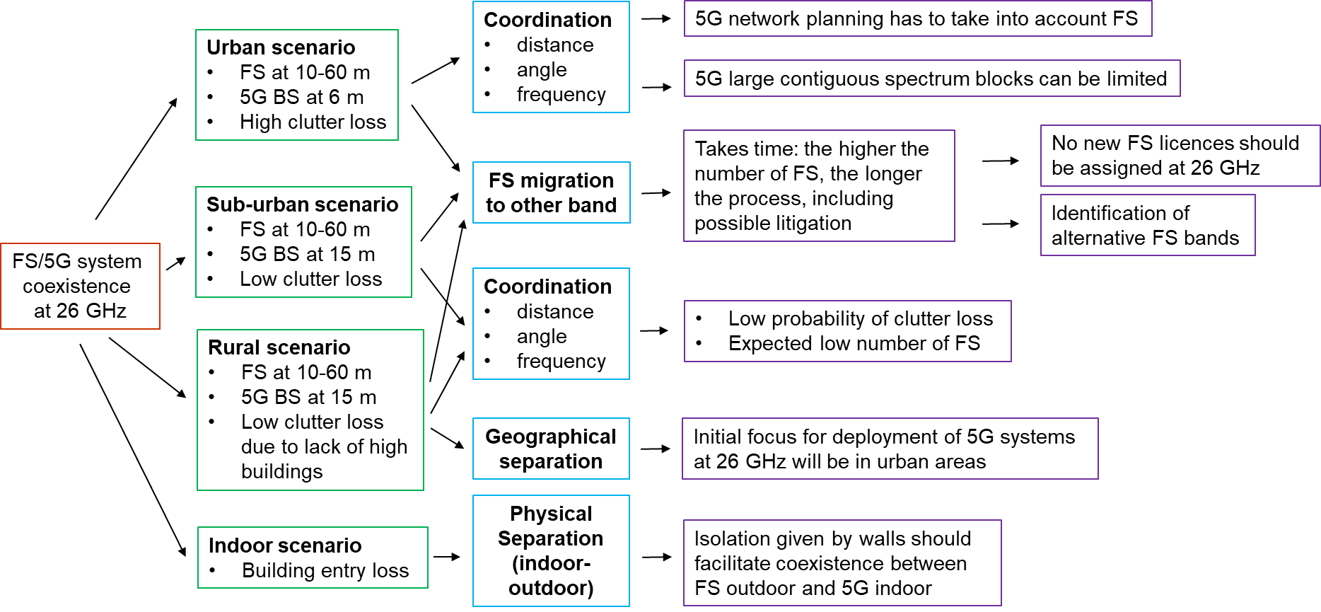
Figure 7: Indicative example of the possible implementation approaches in various scenarios

Possible methods for an administration to communicate the protection requirements
Different methods are possible for an administration to communicate the FS protection requirements to 5G system operators assuming that the locations of the FS stations are known by the administration:
- Method I: specifying direct restrictions on the deployments of 5G systems in some specific and limited areas based on one or any combination of the following parameters: separation in distance, exclusion zone, separation in frequency, guard band, separation in angle, 5G BS height, 5G BS transmit power;
- Method II: specifying the maximum permitted interference powers or electric field strengths at the FS receivers and allowing flexibility to the 5G operators to comply with the specified limits.
Based on national circumstances an administration might apply one of the Methods I or II or a combination thereof, also in different geographical areas.
All the approaches require the management of information of FS incumbent users (e.g. database on locations of FS receivers and technical characteristics). Some information may be confidential and thus not publicly available.
Calculations are needed to determine the restrictions on deployment of 5G systems for the protection of the incumbents in both Methods I and II.
Method I requires the administration to perform interference calculations on a case by case basis to determine coexistence conditions. Calculations can be performed by the administration or by a third party acting on the administration's behalf, with the possible involvement of the 5G system operators and the incumbents with ex-post regulatory oversight.
Under Method II, interference calculations are also needed to verify the respect of maximum permitted interference powers. Calculations can be performed by the 5G system operators or by a third party acting on the 5G system operators’ behalf under the supervision of the administration, with the possible involvement of the incumbents, with ex-ante qualification and/or ex-post regulatory oversight. However, information on incumbent locations where interference thresholds must be guaranteed should be provided to the operators. In some circumstances this is not possible due to confidentiality issues. A database of FS links has to be maintained by the administration and provided to the operators.

Conclusions
The 24.25-27.5 GHz band (“26 GHz band”) has been harmonised for MFCN in CEPT by ECC Decision(18)06 [1], under the assumption of an individual authorisation framework, and it is recognised to be the 5G pioneer millimetre wave band in Europe. The ECC Decision does not preclude the use of the band by other services to which the band is allocated. Nevertheless, according to this ECC Decision, CEPT administrations shall make available by the end of 2020 at least 1 GHz for MFCN in this band, subject to market demand.
This ECC Report (“toolbox”) is intended to help CEPT administrations in the national decision process supporting introduction of 5G systems in 26 GHz with FS in operation providing mechanisms which allow for continued FS operation, where appropriate. This report has been developed under the assumption of an individual authorisation framework for 5G MFCN. Knowledge of the locations and parameters of the 5G base stations is necessary in order to manage national coordination with fixed services.
The guidelines are based on sharing and compatibility studies carried out to evaluate the possibility of coexistence between 5G systems and the FS and the necessary conditions in the 26 GHz band.
The results of all studies for the outdoor 5G network deployment scenarios show that coexistence between both services is possible but requires coordination. However, the amount of spectrum available for 5G systems at individual locations might be reduced by the existing FS usage. The feasibility of a successful outcome under such a coordination approach is a separate matter that would require further consideration based on national circumstances including density of fixed link deployment.
One study shows that coexistence conditions between indoor 5G networks and outdoor FS improve significantly due to higher values of building entry loss at 26 GHz compared to lower bands.
As the national situation in the various European countries will be different with respect to the FS usage density, FS licences duration and the future spectrum demand in 26 GHz for 5G systems in different areas, different approaches to support the implementation of 5G systems might be needed.
The two main options are either to maintain the use of the FS in the 26 GHz band or to clear, fully or partially, the band from the FS usage. Each option contains several approaches of sharing with FS or migration of the FS to enable the implementation of 5G networks. Depending on national circumstances administrations may choose among the approaches or combinations their off.
Section 4 presents the assumptions and the main results of the coexistence studies between FS and 5G networks.
Section 5 provides several potential mitigation techniques, for both services, that could help to reduce the interference and to make as much as possible spectrum available for the introduction of 5G systems. It also provides information on the impact of non-contiguous blocks on 5G systems performance.
Section 6 provides examples of possible approaches to make the 24.25-27.5 GHz band available for 5G networks.
In the shared approach the fixed links will continue to operate in the 26 GHz band; coexistence analysis is undertaken to determine sharing conditions between 5G networks and FS services. Further different ways of sharing are described:
- Sharing in frequency and space;
- Sharing in frequency, separation in space;
- Sharing in space, separation in frequency;
- Separation in space and frequency.
The shared approach requires interference calculations to determine the conditions for newly implemented applications. Therefore, information on incumbent service applications (e.g. location, technical parameters of individual FS sites) must be available and might be provided in a database. Due to confidential requirements in some cases, it may not be possible to make data publicly available.
In the phased approach, the FS will continue to operate in the 26 GHz band for a period of time. Coexistence analyses are undertaken to derive sharing conditions between 5G systems and the FS services. Gradually, the FS will be migrated out from the 24.25-26.5 GHz band to other frequency bands. Further, the FS backhaul links to base stations could be exchanged by fibre optic communication, where feasible, to clear the band continuously from an FS use.
In the migration approach, the FS service will be migrated completely or partially out of the band before the introduction of 5G networks. Due to national situation and number of FS links this could lead to delay the availability of spectrum for 5G systems.
It should be noted that some Administrations may wish to consider a combination of the shared and clearance options. This includes for example establishing sharing approaches between 5G systems and FS within some areas and migration of FS to other frequency bands in other areas.
Within this Report the studies assumed a long term protection criterion for FS as ratio of I/N = -10 dB, not exceeded for >20% of time has been taken as a FS protection requirement.
- Case studies
  - MCL STUDIES
    - Study 1
This study provides the simulation results of potential interference from a single 5G BS, deployed in an urban environment, to microwave FLs in the 26 GHz (24.5-26.5 GHz) band. The study followed the MCL methodology as defined in Section 5 of the study, analysing the interference to 3 generic and 3 site-specific FLs from a BS connecting to a UE at the edge of the cell (142 m away from the BS). Based on assumptions in the study, the results show that a separation distance between 20 and 70 km would be required to meet the protection criteria for FLs. Therefore, if the deployment of FL is dense and is in a similar urban environment, it is expected that co-channel sharing is unlikely to be possible without the introduction of some form of detailed coordination approach. The feasibility of such a coordination approach is a separate matter that would require further consideration. This study has focussed on 26 GHz 5G roll-out in an urban environment. It is expected that the distances at which a BS could cause interference to a FL could increase drastically in a rural environment.
    - Study 2
This MCL study considered only the co-channel coexistence between 5G BS and FS receiver. In the study 2, six scenarios are considered, the required separation distances for the six scenarios are summarised in the table below.
Table 10: Required Separation distance (km) between 5G BS and FS receiver
Azimuth angle [°] | Scenario-1 Urban  (BS ant. at 6 m  FS ant at 15 m) | Scenario-2 Urban  (BS ant. at 6 m  FS ant at 30 m) | Scenario-3 Urban  (BS ant. at 6 m  FS ant at 60 m) | Scenario-4 Suburban  (BS ant. at 15 m  FS ant at 15 m) | Scenario-5 Suburban  (BS ant. at 15 m  FS ant at 30 m) | Scenario-6 Suburban  (BS ant. at 15 m  FS ant at 60 m)
0°  (BS in front of FS receiver) | 2.6 | 27.1 | 28.8 | 38.9 | 44.7 | 52.2
180°  (BS in the back of FS receiver) | - | - | - | 4.7 | 4.6 | 4.2
The results in the table above show that:
- The MCL calculation result for scenario-1 take into account the clutter loss on both 5G BS side and on FS receiver side, the required separation distance is 2.6 km when the BS is placed in front of the FS receiving antenna. The coexistence between 5G systems and FS is little bit easier when they are not in line of sight;
- In urban area, for the scenario-2 and 3, 5G BS antenna is at 6 m, FS receiver antenna at 30 and 60 m, clutter loss of 1% location probability is applied only to 5G BS, the required separation distance is respectively 27.1 km and 28.8 km when the 5G BS is placed in front of the FS receiving antenna;
- The three scenarios (1, 2, and 3) in urban area, when the 5G BS at 6m height is placed in the back of FS receiver antenna, no separation distance is required;
- The worst coexistence scenarios are in sub-urban area, when the 5G BS is placed at 15 m, no clutter loss applied, the required separation distances are respectively 38.9 km, 44.7 km, and 52.2 km when the 5G BS is placed in front of the FS receiving antenna. When it is placed in the back of the FS receiving antenna, the required separation distance is between 4 and 5 km.

All of these MCL calculation results show that the co-channel coordination between 5G BS and FS can only be done on a case by case basis. When they are not in visibility, the coordination should be feasible with the angle discrimination and separation distance. When they are in visibility, the coordination may become difficult since the required separation distance is quite large.
    - Study 3
This study investigates sharing and compatibility of 5G systems operating at 26 GHz with Fixed Service (FS) operating either at the same frequency, or in an adjacent channel, with and without a guard band. These studies are performed with FS parameters in line with the LS of SE19 (Document ECC PT1(17)119).
Two scenarios are analysed:
- 5G base station (BS) as interferer;
- 5G user equipment (UE) as interferer.
Minimum coupling loss (MCL) calculations are performed to evaluate the minimum protection distance needed to ensure that the level of interference is below the required limits.
The studies were performed for FS antenna heights of 15 m, 30 m and 60 m, with the FS antenna maximum gain of 42 dBi for the antenna with 60 m height, and of 36.6 dBi for the other two cases. For 5G BS an antenna height of 6 m was used, which is applicable in an urban and suburban scenario [22]. The propagation model ITU-R P.452-16 was used in combination with Recommendation ITU-R P.2108-0 [10] for the clutter loss, which was applied only at the 5G system side.
The obtained protection distances are summarised in Table 11 and Table 12 for off-axis angle of the FS antenna being 0 and 5 degrees, respectively. Additional graphs with the variation of the protection distances as a function of the off-axis angle of the FS antenna are provided in the complete study attached to this Report for angles up to 60 degrees.
Table 11: Protection distances obtained for the sharing studies between 5G systems and FS. H₁, H_{2,} and H₃ correspond to a FS antenna height of 15 m, 30 m, and 60 m, respectively, and off-axis angle 0 degrees
Scenario | Protection distance [km]
Scenario | Co-channel |  |  | Adjacent channel |  |  | Guard band (20 MHz)
 | H₁ | H₂ | H₃ | H₁ | H₂ | H₃ | H₁ | H₂ | H₃
5G BS -> FS | 22.4 | 28 | 38.7 | 1.9 | 1.6 | 0.266 | 0.63 | 0.27 | 0
5G UE -> FS | 6.2 | 6.15 | 10.4 | 1.23 | 0.56 | 0.26 | 0.69 | 0.32 | 0.25

Table 12: Protection distances obtained for the sharing studies between 5G systems and FS. H₁, H_{2,} and H₃ correspond to a FS antenna height of 15 m, 30 m, and 60 m, respectively, and off-axis angle 5 degrees
Scenario | Protection distance [km]
Scenario | Co-channel |  |  | Adjacent channel |  |  | Guard band (20 MHz)
 | H₁ | H₂ | H₃ | H₁ | H₂ | H₃ | H₁ | H₂ | H₃
5G BS -> FS | 5.48 | 5.43 | 3.83 | 0.55 | 0.51 | 0.264 | 0.27 | 0.26 | 0
5G UE -> FS | 1.07 | 1.04 | 0.72 | 0.45 | 0.4 | 0.258 | 0.3 | 0.27 | 0
    - Study 4
The approach of this study is to show the impact of single parameters on the interference situation between 5G systems and FS (PP and P-MP) in the 26 GHz band.
The following parameters have been considered as static:
- FS bandwidth;
- Frequency separation between 5G systems and FS system including single element and composite pattern for 5G systems;
- 5G system geometry;
- Propagation effects;
- FS antenna height;
- FS antenna type;
- Spurious limits for 5G system.
These parameters have been investigated to identify their impact on the distance and azimuth of the FS antenna towards the 5G BS, necessary for interference-free coexistence of both systems.
As dynamic investigation parameters have therefore been used:
- the azimuth of the victim link receiver (VLR(FS)) to the interfering link transmitter (ILT(5G));
- the distance between ILT and VLR.
These parameters are considered as most important to decide on future administrative deployment approaches.
      - Conclusions for PP studies
In general, it can be concluded that, unless having a large frequency or distance separation of the 5G system and the FS system, a kind of coordination process will be needed for interference-free deployment of both systems in the 26 GHz band. Also the results studies show, that by coordination a close coexistence in distance and frequency and therefore high spectrum efficiency may be reached.
For this study the 5G system antenna has been assumed with a beamforming characteristic not only in the co-channel case but also in case of frequency shift between the two signals. This assumption differs from the recommendation in ITU-R M.2101 [18], but reflects the current discussion and outcome of investigations which has been made during the study period.
If the characteristic of the 5G system antenna is assumed to be the characteristic of a single element in non-co-channel cases the results of the studies differ significantly.
It should be noted that the studies have been made with spurious limits of -30dBm/MHz for the 5G system. However, this value has no impact on the results unless the frequency shift between the centre frequencies of both systems is larger than 250% of the bandwidth of the 5G system.
The impact of the different values according to Recommendation ITU-R SM.329 [19] and ERC Recommendation 74-01 (Unwanted emissions in the spurious domain) [20] or to the LS from ITU-R WP 5D to ITU-R TG5/1 (document 5-1/36) [22] is evaluated in chapters “7.1.3 Impact related to spurious limits of IMT-2020 system” and “8.1.2 Impact of spurious limits for IMT-2020 systems”.
It is shown that a less stringent spurious emissions limit will have a significant impact on the results and it will lead to a worse frequency decoupling.
The MCL method considers only single static cases. Further investigations, e.g. Monte Carlo based study, are needed which also takes time and location probability into account and simulates a more realistic scenario.
      - Antenna
The used antenna has a high impact on the interference scenario. In the main beam the necessary separation distance is depending on the antenna gain. Higher gain results in a larger separation distance.
The most critical scenario is, in all cases, the one where the 5G system is located in the main beam of the FS antenna.
However, the probability of interference (main beam to main beam coupling) is very low due to the narrow main beam of FS antenna and the different deployment scenarios of 5G versus FS (down tilt base station antenna, deployment below/above roof top). Therefore the directivity characteristic of the antenna is crucial.
The antenna height of the FS also has an impact on the interference scenario. Above all, in close proximities the higher antennas show a greater decoupling performance in the azimuth. By increasing the distance, this effect vanishes and the height of the antenna loses its relevance in combination with a high directive antenna, closer separation distances or angle off sets are possible.
      - Bandwidth and frequency separation
The results show that the bandwidth of the FS system only has a significant impact in the adjacent frequency case. Therefore it has to be taken into account that smaller bandwidths have a higher risk of interference in the adjacent frequency case.
Nevertheless, the frequency separation of both systems has a major impact of their possible coexistence. By introducing a frequency separation the necessary separation distance can be reduced drastically. The results show, that introducing a guard band of 20 MHz will reduce the necessary separation distance in the main beam of the FS antenna to 3.5 km. In order to enable an interference free coexistence of both systems in the same location, only by frequency separation, the introduction of a much bigger guard band would be needed. Considering this, the high demand of spectrum for different services and the respective value for e.g. spurious emissions have to be taken into account.
      - Propagation related effect
It can be seen that the impact is remarkably high and the results of the studies as well as possible interference calculation strongly depend on the parameters for percentage of location. It is therefore necessary to find clarification which value for the probability of location is appropriate for studies and interference calculations.
Also the influence of clutter is remarkable and needs further clarification. For the study the clutter is only considered for the -side of the path. It was assumed that the FS station, due to its necessity of line-of-sight is located above clutter. But in the interference path, obstacles close to the FS station are also possible. Connecting the clutter to the antenna height and the type of morphology may be a possible approach. In case of consideration of clutter, also for the FS side of the path, the results will lead to a higher possibility of coexistence.
Therefore, further discussion and clarification on the values for clutter and probability of location parameters is needed. In addition, the procedures of combining the time and location probabilities need further clarification.
      - Conclusions for Point-to-Multi-Point studies
Similar to the results of the investigation of P-P versus 5G systems the analyses show the impact of the different parameters for the coexistence between 5G systems and P-MP FS in the 26 GHz band.
Unless having a large frequency or distance separation of the 5G system and the FS system a kind of coordination process will be needed for interference-free deployment of both systems in the 26 GHz band. Also the results of the studies show, that by coordinating the systems, a close coexistence in distance and frequency and therefore high spectrum efficiency may be reached.
In general it can be concluded, that the variation of the different factors like frequency separation, antenna height, 5G system scenario and spurious limits have a very similar effect on the results of the investigated scenarios.
The most significant difference of the investigated P-P and the P-MP systems is the antenna pattern. The P-MP base station antenna has a lower gain and is less beamforming than the P-P antenna. This leads in general to a much smaller possible separation distance between the P-MP and the 5G system while less directive pattern leads to a worse decoupling by azimuth.
    - Study 5
The worst case is considered based on co-channel coexistence scenario-1, where the main beam direction of BS is toward antenna of fixed link station when UE is located at 1% of line between 5G BS and Fixed link station. In this configuration, the separation distance from MCL calculation not to exceed I/N = -10 dB for protection of Fixed link from 5G BS is about 28 km.
It is assumed that heights of 5G BS and fixed link station are 6 m and 15 m, respectively..
  - monte-carlo simulation Studies
    - Study 2
The Monte Carlo simulations have been performed for 6 coexistence scenarios in urban and suburban environment following the methodology described in section 5. The both co-channel and adjacent band coexistence cases between a single 5G BS and a FS receiver is simulated for each scenario. Only a worst case situation was assumed where a 5G BS is placed in front of the victim FS receiver antenna even though the 5G BS antenna is not always physically pointing to the FS victim receiver antenna.
Below the results of simulations are presented using two 5G BS antenna configurations (8x8 as baseline (except LoS co-channel urban) and 16x16 as sensitivity analysis), normalised, for the following scenarios:
- Co-channel: NLoS urban and LoS suburban cases;
- Adjacent channel: 0, 28 and 56 MHz guard bands for NLoS urban and LoS suburban cases. As additional sensitivity analysis for short separation distances (less than 1 km), the LoS urban scenario was analysed in addition to the NLoS.
Co-channel results:
The table below provides 8x8 5G antenna array case results (normalised) for the six coexistence scenarios.
Table 13: The probability that the interference is less than the protection criterion (normalised) (in-band, 8x8)
Urban | FS height |  |  | Suburban | FS height
Separation distance | 15 m | 30 m | 60 m | Separation distance | 15 m | 30 m | 60 m
0.3 km | 16.35% | 58.35% | - | 0.3 km | 1.6% | - | -
1 km | 99.38% | 45.44% | 83.21% | 1 km | 3.2% | 4.0% | 10.82%
5 km | 100% | 80.45% | 73.99% | 5 km | 14.04% | 14.37% | 10.1%
10 km |  | 93.27% | 85.22% | 10 km | 26.44% | 26.5% | 17.02%
The table below provides 16x16 5G antenna array case results for the 6 in-band coexistence scenarios, as a sensitivity analysis.
Table 14: The probability that the interference is less than the protection criterion (in-band, 16x16, sensitivity analysis)
Urban | FS height |  |  | Suburban | FS height
Separation distance | 15 m | 30 m | 60 m | Separation distance | 15 m | 30 m | 60 m
0.3 km | 8.3% | 42.5% |  | 0.3 km | 0.8% | - | -
1 km | 97.8% | 26.8% | 69.6% | 1 km | 2% | 2.3% | 5.9%
5 km | 100% | 65.4% | 57.0% | 5 km | 7.98% | 7.9% | 5.8%
10 km | - | 82.9%: | 71.2% | 10 km | 15.5% | 15.5% | 9.8%
Adjacent band results:
The table below provides 8x8 5G system antenna array case results for the 6 adjacent band coexistence scenarios with 0 MHz guard band
Table 15: The probability that the interference is less than the protection criterion
(adjacent band, 8x8, 0 MHz guard band)
Urban | FS height |  |  | Suburban | FS height
Separation distance | 15 m | 30 m | 60 m | Separation distance | 15 m | 30 m | 60 m
0.3 km | 10% | 56.6% |  | 0.3 km | 0 | - | -
1 km | 100% | 66.8% | 99.4% | 1 km | 0 | 0 | 0
5 km | 100% | 99.5% | 99.6% | 5 km | 0 | 0 | 0
10 km |  | 99.9% | 99.9% | 10 km | 0 | 0 | 0
The table below provides 16x16 5G system antenna array case results for the six adjacent band coexistence scenarios with 0 MHz guard band

Table 16: The probability that the interference is less than the protection criterion (adjacent band, 16x16, 0 MHz guard band, sensitivity analysis)
Urban | FS height |  |  | Suburban | FS height
Separation distance | 15 m | 30 m | 60 m | Separation distance | 15 m | 30 m | 60 m
0.3 km | 9% | 53.1% |  | 0.3 km | 0 | - | -
1 km | 100% | 61.9% | 99.3% | 1 km | 0 | 0 | 0
5 km | 100% | 99.1% | 98.8% | 5 km | 0 | 0 | 0
10 km |  | 99.9% | 99.9% | 10 km | 0 | 0 | 0
The table below provides 8x8 5G system antenna array case results for the six adjacent band coexistence scenarios with 28 or 56 MHz guard band.
Table 17: The probability that the interference is less than the protection criterion (adjacent band, 8x8, 28 MHz guard band (for 15 m and 30 m)/56 MHz guard band (for 60 m))
Urban | FS height |  |  | Suburban | FS height
Separation distance | 15 m | 30 m | 60 m | Separation distance | 15 m | 30 m | 60 m
0.3 km | 60% | 96.2% |  | 0.3 km | 0 | - | -
1 km | 100% | 98.5% | 100% | 1 km | 0 | 0 | 0
5 km | 100% | 100% | 100% | 5 km | 0 | 0 | 0
10 km |  | 100% | 100% | 10 km | 0 | 0 | 0
Table 18 below provides 16x16 5G system antenna array case results for the six adjacent band coexistence scenarios with 28/56MHz guard band.
Table 18: The probability that the interference is less than the protection criterion (adjacent channel, 16x16, 28 MHz guard band (for 15 m and 30 m)/56 MHz guard band (for 60 m))
Urban | FS height |  |  | Suburban | FS height
Separation distance | 15 m | 30 m | 60 m | Separation distance | 15 m | 30 m | 60 m
0.3 km | 31.7% | 84% |  | 0.3 km | 0 | - | -
1 km | 100% | 90% | 100% | 1 km | 0 | 0 | 0
5 km | 100% | 100% | 100% | 5 km | 0 | 0 | 0
10 km |  | 100% | 100% | 10 km | 0 | 0 | 0
As a sensitivity analysis for short separation distances (less than 1 km), the LOS urban scenario was analysed in addition to the NLoS urban scenario, and the results are summarised in the Table 19 below.

Table 19: The probability that the interference is less than the protection criterion (LoS Urban scenario with 0, 28 and 56 MHz guard band)
 | FS height
Adjacent band (8x8, 0 MHz guard band)
Separation distance | 15 m | 30 m | 60 m
0.3 km | 0 | 0 | 0
0.7 km | 0 | 0 | 0
Adjacent band (16x16, 0 MHz guard band)
0.3 km | 0 | 0 | 0
0.7 km | 0 | 0 | 0
Adjacent band (8x8, 28 MHz guard band(for 15 m and 30 m) / 56 MHz guard band(for 60 m))
0.3 km | 0 | 0 | 30%
0.7 km | 0 | 0 | 8%
Adjacent band (16x16, 28 MHz guard band(for 15 m and 30 m) / 56 MHz guard band(for 60 m))
0.3 km | 0 | 0 | 0
0.7 km | 0 | 0 | 0
The simulation results show that the interference level at FS receiver depends on the following factors:
- Separation distance;
- Angle discrimination between the boresights of the interfering transmitter antenna and victim receive antenna which depends on the antenna heights of 5G BS antenna and FS receiver antenna;
- Transmit antenna beamforming;
- Clutter loss;
- FS system channel bandwidth;
- Guard band for the adjacent band case.
The following conclusions could be made based on the results of the Monte Carlo simulations.
Co-channel case:
The worst coexistence scenarios are those when an 5G BS antenna is at 15 m and FS receiver antenna is at 15, 30, and 60 m in a sub-urban area (scenarios 4, 5 and 6): there is no clutter loss on both sides, and even at 10 km separation distance, for 8x8 antenna configuration only for up to 51% (up to 26% when using a normalised 5G system antenna pattern) of cases the required long term protection criterion of I/N<=-10 dB for 20% of time can be met. Thus, the in-band coexistence between a 5G BS deployed at 15 m at the roof edge and FS system in a suburban area appears to be very difficult. For 16x16 antenna array sensitivity case, the required separation distances are even greater.
The coexistence situation is better in an urban area where a 5G BS antenna is placed at 6m and FS antenna – at 15 m height, when the clutter loss happens both on 5G BS and FS receiver sides (scenario-1) when they are not in line of sight. For the separation distances 1 km or greater, FS receiver is sufficiently protected (over 99.4% and 97.8% of cases for 8x8 and 16x16 configurations respectively, either with or without applying a normalised antenna pattern) based on the long term protection criterion of I/N<=-10 dB for 20% of time.
For the FS receiver antenna heights of 30 m and 60 m (scenarios 2 and 3), the vertical plan discrimination angle improves the coexistence situation on one hand, but on the other hand, there is no more clutter loss at the FS receiver antenna side. For example, for an 8x8 antenna array case in scenario 2 with 5 km separation distance, the FS receiver is protected in 83% of cases (80% when using a normalised antenna pattern) and with 10 km separation distance, the FS receiver is protected in 93% of cases (94% - normalised) based on the same protection criterion of I/N<=-10 dB for 20% of time.
Adjacent band case:
Coexistence is feasible in urban area when the separation distance is no less than 1 km for NLoS 8x8 and 16x16 antenna configurations for all analysed FS antenna heights. Coexistence is difficult with separations smaller than 1 km, in particular if there is LoS path between 5G base station and FS receiver, even in urban environment. To achieve coexistence, a careful and complex coordination in azimuth angle separation may be necessary (not considered in this study). Coexistence is very difficult in suburban area even for the adjacent channel case. More than 10 km separation distance is required but the study does not provide the necessary separation distance.
Only the interference from a single 5G BS to FS receiver where a 5G BS is placed in front of the victim FS receiver antenna is simulated and calculated, the vertical plan angle discrimination and transmit antenna beamforming are considered in the Monte Carlo simulations. If interference from multiple base stations is accounted for, even with randomly distributed main beam antenna directions in the azimuth plane, this could lead to greater required separation distances than those calculated in this study due to the multiple interference aggregation effect.
The overall conclusion of this study is that clearance of the 26 GHz band from FS links is a viable option for administrations that do not have resources to implement complex coordination for achieving the necessary FS links protection with a combined distance and angular separation. Even with the coordination between individual FS links and 5G base stations, it can be anticipated that not the whole band identified for 5G MFCN in the 26 GHz could be used by 5G systems which would significantly limit the potential capability of 5G systems in the mmWaves bands where large contiguous bandwidths would be the most appropriate frequency arrangement.
    - Study 5
Two configurations are considered in the co-channel coexistence scenario-1; according to mechanical main beam direction for 5G BS antenna toward fixed link in horizontal domain. One case is that mechanical main beam direction of 5G BS is random in horizontal domain. The other case is that mechanical main beam direction of 5G BS is toward a fixed link station in horizontal domain. On the other hand, the UE is distributed from BS based on distribution from ITU-R TG5/1. As result of simulation from those configurations, the separation distance between a 5G BS and a fixed link station not to exceed 1% location probability and 20% time percentage for protection of fixed link are follows:
- Horizontally random mechanical angle of BS: 5.5 km;
- Horizontal mechanical angle of BS toward FS link: 12.6 km.
It is assumed that heights of 5G BS and fixed link stations are 6m and 15 m, respectively, the characteristic for PP fixed links are applied

- Maximum separation distance to deploy outdoor 5G around fixed link in LoS interference environment
This annex provides a protection contour composed of the maximum separation distances to deploy outdoor 5G BS according to azimuth angle of FS link antenna towards a 5G BS. It means that any deployment of BS with ITU-R IMT-2020 characteristics outside the protection contour does not causes unacceptable interference to FS a FS link. Furthermore, if mitigation approach can be applied, such as NLoS with clutter, indoor, antenna mismatch of 5G BS antenna and so on. This protection contour would be reduced. The methodology for protection contour, based on Interference exceeded noise level of fixed link (I/N), can be derived as below
$\frac{I}{N}\left(θ,d\right)=P_{Tx conducted}^{BS}+L_{Ohmic}^{BS}+G_{to FS}^{BS}+F_{BS Loading}+F_{TDD}-PL\left(d\right)+ G_{toBS}^{FS}\left(θ\right)-(N^{FS}+{NF}^{FS})$
Where,
- $P_{Tx conducted}^{BS}$ is normalised transmitting power of BS with 1MHz as TRP;
- $L_{Ohmic}^{BS}$ is ohmic loss of BS, 3dB;
- G^{BS} is antenna gain of BS;
- G^{FS}(ϴ) is antenna gain of FS given ϴ to BS;
- F_{BS loading} is BS loading factor, 1;
- F_{TDD} is TDD factor, 0.8 for BS;
- N^{FS} is -114dBm/MHz (= 10*log₁₀(1.38x10⁻²³ x 293 K x10⁶ Hz));
- NF^{FS} is noise figure of FS, 6.5dB.
Additionally, PL is composed of Free space loss (PL_{FSL}), correction factor (PL_{CF}), atmosphere loss(PL_{AL}), clutter loss (PL_{CL})
- ${PL}_{FSL}(f, d)=92.44+10\log_{10}\left(f\right)+20\log_{10}\left(d\right)$ , (referred from Rec. ITU-R P.452 [9]);
- ${PL}_{AL}=0.1 ×d$;
- ${PL}_{CF}(p)=2.6×\left(1-e^{-0.1×d}\right)×\log_{10}\left(\frac{p}{50}\right)$ (referred from Rec. ITU-R P.452);
- ${PL}_{CL}\left(d, p=0.01\right)=-5\log_{10}\left({10}^{-2×\left(23.5+9.6\log_{10}{f}\right)}+{10}^{-2×\left(32.98+23.9\log_{10}{d}+3\log_{10}{f}\right)}\right)+N^{-1}\left(p=0.01,σ=6\right)$. (referred from Rec. ITU-R P.2108 [10])
Finally, distance is driven to meet I/N = -10 dB for each ϴ
$$D_{protection}\left(θ\right)= d when \frac{I}{N}\left(θ,d\right) equal to -10dB$$
The antenna gain of BS toward FS link is set as maximum so that the deployment of BS is not restricted. It means that main-beam of BS sees FS link station and as BS antenna is set up in 1% location probability of UE below figures.

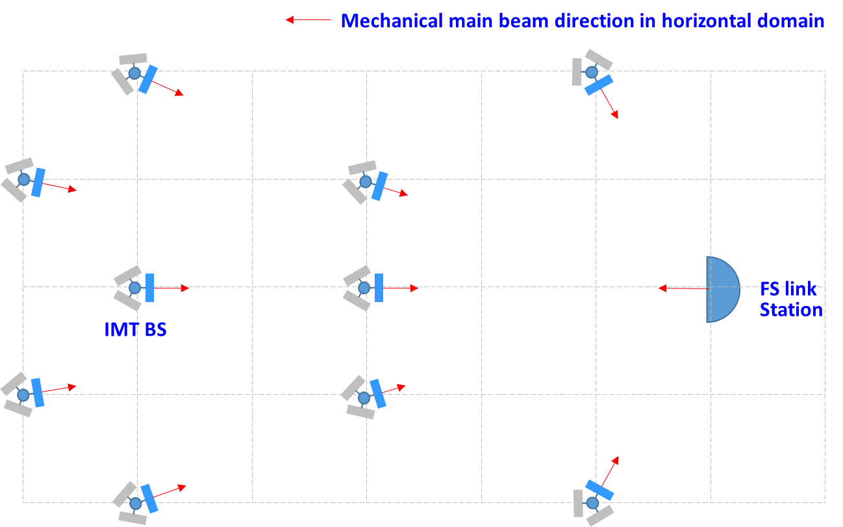
Figure 8 Main beam directions of BSs and FS horizontal domain
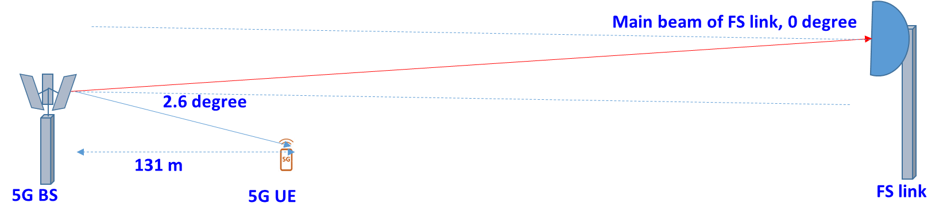
Figure 9: Main beam directions of BS and FS vertical plane

Table 20: Values
Parameters |  | Value | Note
5G BS
$$P_{Tx conducted}^{BS}$$ | Normalised transmitting power of BS (TRP) | 2.3515 dBm/MHz
$$L_{Ohmic}^{BS}$$ | Ohmic loss of BS | 3 dB
$$G_{to FS}^{BS}$$ | Antenna gain of BS toward FS link  (H_{BS}: 15 m, H_{FS}: 50 m) | 17.97~20.27 dBi | See Figure 10
$$F_{BS Loading}$$ | BS loading factor | 10log₁₀(0.5)
$$F_{TDD}$$ | TDD factor | 10log₁₀(1)
N^{FS} | Noise of FS link | -114 dBm/MHz
NF^{FS} | Noise figure of FS link | 6.5 dB
Figure 10 Antenna gain of BS toward FS link

The results for each max antenna gain of FS link [23] shows protection contour for FS link (Figure 11).
Figure 11: Protection contour for FS link

- Interference reduction due to indoor 5G deployent as mItigation approach to protect fixed links in the 26 GHz
Indoor 5G is one of mitigation approach to reduce interference to FS link due to lower transmitter power and building entry loss, antenna side lobe gain if cooperatively deployed.
Additional building entry loss (L building entry):
The losses from two building class are given in Recommendation ITU-R P.2109-0 [12], traditional building and thermal efficient building (Figure 12).

Figure 12: Building entry loss for traditional and thermally efficient building
For instance, when p = 1%, traditional building entry loss is 2.7 dB, thermal efficient building loss is 9.2 dB. On the other hand, when p = 20%, traditional building entry loss is 10.6 dB, thermal efficient building loss is 25.9 dB, In case of median BEL, traditional building entry loss is 20 dB, thermal efficient building loss is 41 dB.
Lower transmitter power:
Conducted power of 5G deployed at indoor is 5 dB less than outdoor 5G, i.e. 5 dBm/(200 MHz)
Side lobe beam gain of BS to FS by main beam direction of BE into inside (Figure 13):
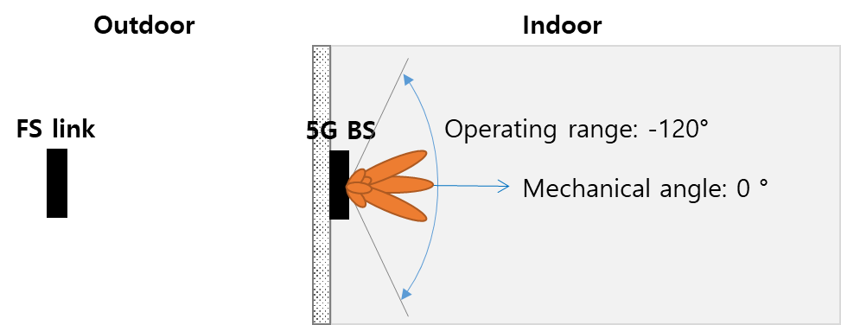
Figure 13: Indoor 5G BS beam direction
Under indoor deployment scenarios depicted above (Figure 13), maximum side lobe gain could be 1.6 dBi (16.2 dB reduction with respect to maximum gain at 90 degrees), or in some cases, maximum sidelobe gain -7.2 dBi could be (25.2 dB reduction with respect to maximum gain at 130 degrees) taking into account electronic steering toward UE in horizontal within -60 to 60 degrees.
Figure 14: 5G indoor BS antenna diagram
Finally, interference reduction by indoor 5G is summarised according to two building classes below.
Table 21: Indoor 5G in traditional building
Building Entry Loss (Recommendation.  ITU-R P.2109) |  | Interference reduction  Incl. Tx power, ant pattern | Relative separation distance reduction | Required separation distance for indoor 5G based on 30 km for outdoor 5G
Percentage | Loss | Interference reduction  Incl. Tx power, ant pattern | Relative separation distance reduction
1% | 2.7 dB | 23.9-32.9 dB | 93.62-97.74 % | 30km → 0.68-1.91 km
20% | 10.6 dB | 31.8-40.8 dB | 97.43-99.09 % | 30km → 0.27-0.77 km
50% | 20 dB | 41.2-50.2 dB | 99.13-99.69 % | 30km → 0.093-0.261 km
Table 22: Indoor 5G deployed in thermally efficient building
Building Entry Loss (Recommendation.  ITU-R P.2109) |  | Interference reduction  Incl. Tx power, ant pattern | Relative separation distance reduction | Required separation distance for indoor 5G based on 30 km for outdoor 5G
Percentage | Loss | Interference reduction  Incl. Tx power, ant pattern | Relative separation distance reduction
1% | 9.2 dB | 30.4-39.4 dB | 96.98 - 98.93 % | 30km → 0.32-0.91 km
20% | 25.9 dB | 47.1-56.1 dB | 99.56 - 99.84 % | 30km → 0.05-0.13 km
50% | 41 dB | 62.2-71.2 dB | 99.92 - 99.97 % | 30km → 0.008-0.023 km
- Summary table of MCL results
MCL | Scenario
MCL | Urban |  | Suburban
Study 1 | Co-channel, 5G BS FS,  d: 20-70 km
Study 2 | Co-channel, Azimuth angle 0°, 5G BS FS,  BS h=6 m | FS h=15 m, d=2.6 km | Co-channel, Azimuth angle 0°, 5G BS FS,  BS h=15 m | FS h=15 m, d=38.9 km
Study 2 | Co-channel, Azimuth angle 0°, 5G BS FS,  BS h=6 m | FS h=30 m, d=27.1 km | Co-channel, Azimuth angle 0°, 5G BS FS,  BS h=15 m | FS h=30 m, d=44.7 km
Study 2 | Co-channel, Azimuth angle 0°, 5G BS FS,  BS h=6 m | FS h=60 m, d=28.8 km | Co-channel, Azimuth angle 0°, 5G BS FS,  BS h=15 m | FS h=60 m, d=52.2 km
Study 2 |  |  | Co-channel, Azimuth angle 180°,5G BS FS,  BS h=15 m | FS h=15 m, d=4.7 km
Study 2 |  |  | Co-channel, Azimuth angle 180°,5G BS FS,  BS h=15 m | FS h=30 m, d=4.6 km
Study 2 |  |  | Co-channel, Azimuth angle 180°,5G BS FS,  BS h=15 m | FS h=60 m, d=4.2 km
Study 3 | Co-channel, Azimuth angle 0°, 5G BS FS,  BS h=6 m | FS h=15 m, d=22.4 km
Study 3 | Co-channel, Azimuth angle 0°, 5G BS FS,  BS h=6 m | FS h=30 m, d=28 km
Study 3 | Co-channel, Azimuth angle 0°, 5G BS FS,  BS h=6 m | FS h=60 m, d=38.7 km
Study 3 | Co-channel, Azimuth angle 0°, 5G UE FS,  UE h=1.5 m | FS h=15 m, d=6.2 km
Study 3 | Co-channel, Azimuth angle 0°, 5G UE FS,  UE h=1.5 m | FS h=30 m, d=6.15 km
Study 3 | Co-channel, Azimuth angle 0°, 5G UE FS,  UE h=1.5 m | FS h=60 m, d=10.4 km
Study 3 | 5G -channel, Azimuth angle 5°, 5G BS FS,  BS h=6 m | FS h=15 m, d=5.48 km
Study 3 | 5G -channel, Azimuth angle 5°, 5G BS FS,  BS h=6 m | FS h=30 m, d=5.43 km
Study 3 | 5G -channel, Azimuth angle 5°, 5G BS FS,  BS h=6 m | FS h=60 m, d=3.83 km
Study 3 | Co-channel, Azimuth angle 5°, 5G UE FS,  UE h=1.5 m | FS h=15 m, d=1.07 km
Study 3 | Co-channel, Azimuth angle 5°, 5G UE FS,  UE h=1.5 m | FS h=30 m, d=1.04 km
Study 3 | Co-channel, Azimuth angle 5°, 5G UE FS,  UE h=1.5 m | FS h=60 m, d=0.72 km
Study 3 | Adjacent channel, Azimuth angle 0°, 5G BS FS,  BS h=6 m | FS h=15 m, d=1.9 km
Study 3 | Adjacent channel, Azimuth angle 0°, 5G BS FS,  BS h=6 m | FS h=30 m, d=1.6 km
Study 3 | Adjacent channel, Azimuth angle 0°, 5G BS FS,  BS h=6 m | FS h=60 m, d=0.27 km
Study 3 | Adjacent channel, Azimuth angle 0°, 5G UE FS,  UE h=1.5m | FS h=15 m, d=1.23 km
Study 3 | Adjacent channel, Azimuth angle 0°, 5G UE FS,  UE h=1.5m | FS h=30 m, d=0.56 km
Study 3 | Adjacent channel, Azimuth angle 0°, 5G UE FS,  UE h=1.5m | FS h=60 m, d=0.26 km
Study 3 | Adjacent channel, Azimuth angle 5°, 5G BS FS,  BS h= 6 m | FS h=15 m, d=0.55 km
Study 3 | Adjacent channel, Azimuth angle 5°, 5G BS FS,  BS h= 6 m | FS h=30 m, d=0.51 km
Study 3 | Adjacent channel, Azimuth angle 5°, 5G BS FS,  BS h= 6 m | FS h=60 m, d=0.26 km
Study 3 | Adjacent channel, Azimuth angle 5°, 5G UE FS,  UE h= 1.5 m | FS h=15 m, d=0.45 km
Study 3 | Adjacent channel, Azimuth angle 5°, 5G UE FS,  UE h= 1.5 m | FS h=30 m, d=0.4 km
Study 3 | Adjacent channel, Azimuth angle 5°, 5G UE FS,  UE h= 1.5 m | FS h=60 m, d=0.26 km
Study 3 | Guard band (20 MHz), Azimuth angle 0°, 5G BS FS, BS h= 6 m | FS h=15 m, d=0.63 km
Study 3 | Guard band (20 MHz), Azimuth angle 0°, 5G BS FS, BS h= 6 m | FS h=30 m, d=0.27 km
Study 3 | Guard band (20 MHz), Azimuth angle 0°, 5G BS FS, BS h= 6 m | FS h=60 m,  d=0 km
Study 3 | Guard band (20 MHz), Azimuth angle 0°, 5G UE FS,  UE h=1.5 m | FS h=15 m, d=0.69 km
Study 3 | Guard band (20 MHz), Azimuth angle 0°, 5G UE FS,  UE h=1.5 m | FS h=30 m, d=0.32 km
Study 3 | Guard band (20 MHz), Azimuth angle 0°, 5G UE FS,  UE h=1.5 m | FS h=60 m, d=0.25 km
Study 3 | Guard band (20 MHz), Azimuth angle 5°, 5G BS FS,  BS h=6 m | FS h=15 m, d=0.27 km
Study 3 | Guard band (20 MHz), Azimuth angle 5°, 5G BS FS,  BS h=6 m | FS h=30 m, d=0.26 km
Study 3 | Guard band (20 MHz), Azimuth angle 5°, 5G BS FS,  BS h=6 m | FS h=60 m,  d=0 km
Study 3 | Guard band, Azimuth angle 5°, 5G UE FS,  UE h=1.5 m | FS h=15 m, d=0.3 km
Study 3 | Guard band, Azimuth angle 5°, 5G UE FS,  UE h=1.5 m | FS h=30 m, d=0.27 km
Study 3 | Guard band, Azimuth angle 5°, 5G UE FS,  UE h=1.5 m | FS h=60 m,  d=0 km
Study 4½ | Co-channel, Azimuth angle 0°, 5G BS FS,  BS h=6 m | FS h=20 m, d=20 km | Co-channel, Azimuth angle 0°, 5G BS FS,  BS h=15 m | FS h=20 m, d=31 km
Study 4½ | Co-channel, Azimuth angle 0°, 5G BS FS,  BS h=6 m | FS h=30 m, d=31.25 km | Co-channel, Azimuth angle 0°, 5G BS FS,  BS h=15 m | FS h=30 m, d=34.5 km
Study 4½ | Co-channel, Azimuth angle 0°, 5G BS FS,  BS h=6 m | FS h=40 m, 40 m, d=34 km | Co-channel, Azimuth angle 0°, 5G BS FS,  BS h=15 m | FS h=40 m, 40 m, d=37.75 km
Study 4½ | Co-channel, Azimuth angle 0°, 5G BS FS,  BS h=6 m | FS h=50 m, d=36.5 km | Co-channel, Azimuth angle 0°, 5G BS FS,  BS h=15 m | FS h=50 m, d=40.5 km
Study 4½ | Co-channel, Azimuth angle 5°, 5G BS FS,  BS h=6 m | FS h=20 m, d=6.25 km | Co-channel, Azimuth angle 5°, 5G BS FS,  BS h=15 m | FS h=20 m, d=3.92 km
Study 4½ | Co-channel, Azimuth angle 5°, 5G BS FS,  BS h=6 m | FS h=30 m, d=6.25 km | Co-channel, Azimuth angle 5°, 5G BS FS,  BS h=15 m | FS h=30 m, d=3.84 km
Study 4½ | Co-channel, Azimuth angle 5°, 5G BS FS,  BS h=6 m | FS h=40 m, 40 m, d=6.25 km | Co-channel, Azimuth angle 5°, 5G BS FS,  BS h=15 m | FS h=40 m, 40 m, d=3.76 km
Study 4½ | Co-channel, Azimuth angle 5°, 5G BS FS,  BS h=6 m | FS h=50 m, d=6.25 km | Co-channel, Azimuth angle 5°, 5G BS FS,  BS h=15 m | FS h=50 m, d=3.64 km
Study 4½ | Adjacent channel, Azimuth angle 0°, 5G BS FS,  BS h=6 m | FS h=20 m, d=20.75 km | Adjacent channel, Azimuth angle 0°, 5G BS FS,  BS h=15 m | FS h=20 m, d=14 km
Study 4½ | Adjacent channel, Azimuth angle 0°, 5G BS FS,  BS h=6 m | FS h=30 m, d=20.75 km | Adjacent channel, Azimuth angle 0°, 5G BS FS,  BS h=15 m | FS h=30 m, d=13.75 km
Study 4½ | Adjacent channel, Azimuth angle 0°, 5G BS FS,  BS h=6 m | FS h=40 m, 40 m, d=20.75 km | Adjacent channel, Azimuth angle 0°, 5G BS FS,  BS h=15 m | FS h=40 m, 40 m, d=13.75 km
Study 4½ | Adjacent channel, Azimuth angle 0°, 5G BS FS,  BS h=6 m | FS h=50 m, d=20.5 km | Adjacent channel, Azimuth angle 0°, 5G BS FS,  BS h=15 m | FS h=50 m, d=13.5 Km
Study 4½ | Adjacent channel, Azimuth angle 5°, 5G BS FS,  BS h=6 m | FS h=20 m, d=1.49 km | Adjacent channel, Azimuth angle 5°, 5G BS FS,  BS h=15 m | FS h=20 m, d=3.92 m
Study 4½ | Adjacent channel, Azimuth angle 5°, 5G BS FS,  BS h=6 m | FS h=30 m, d=1.46 km | Adjacent channel, Azimuth angle 5°, 5G BS FS,  BS h=15 m | FS h=30 m, d=3.84 km
Study 4½ | Adjacent channel, Azimuth angle 5°, 5G BS FS,  BS h=6 m | FS h=40 m, 40 m, d=1.42 km | Adjacent channel, Azimuth angle 5°, 5G BS FS,  BS h=15 m | FS h=40 m, 40 m, d=3.76 km
Study 4½ | Adjacent channel, Azimuth angle 5°, 5G BS FS,  BS h=6 m | FS h=50 m, d=1.35 km | Adjacent channel, Azimuth angle 5°, 5G BS FS,  BS h=15 m | FS h=50 m, d=3.64 km
Study 4½ | Guard band (20 MHz), Azimuth angle 0°, 5G BS FS,  BS h=6 m | FS h=20 m, d=6.5 km | Guard band (20 MHz), Azimuth angle 0°, 5G BS FS,  BS h=15 m | FS h=20 m,  d=4 km
Study 4½ | Guard band (20 MHz), Azimuth angle 0°, 5G BS FS,  BS h=6 m | FS h=30 m, d=6.25 km | Guard band (20 MHz), Azimuth angle 0°, 5G BS FS,  BS h=15 m | FS h=30 m, d=3.75 km
Study 4½ | Guard band (20 MHz), Azimuth angle 0°, 5G BS FS,  BS h=6 m | FS h=40 m, 40 m, d=6 km | Guard band (20 MHz), Azimuth angle 0°, 5G BS FS,  BS h=15 m | FS h=40 m, 40 m, d=3.4 km
Study 4½ | Guard band (20 MHz), Azimuth angle 0°, 5G BS FS,  BS h=6 m | FS h=50 m, d=5.8 km | Guard band (20 MHz), Azimuth angle 0°, 5G BS FS,  BS h=15 m | FS h=50 m, d=0.25 km
Study 4½ | Guard band (20 MHz), Azimuth angle 5°, 5G BS FS,  BS h=6 m | FS h=20 m, d=0.67 km | Guard band (20 MHz), Azimuth angle 5°, 5G BS FS,  BS h=15 m | FS h=20 m, d=0.5 km
Study 4½ | Guard band (20 MHz), Azimuth angle 5°, 5G BS FS,  BS h=6 m | FS h=30 m, d=0.61 km | Guard band (20 MHz), Azimuth angle 5°, 5G BS FS,  BS h=15 m | FS h=30 m, d=0.4 km
Study 4½ | Guard band (20 MHz), Azimuth angle 5°, 5G BS FS,  BS h=6 m | FS h=40 m,40 m, d=0.51 km | Guard band (20 MHz), Azimuth angle 5°, 5G BS FS,  BS h=15 m | FS h=40 m, 40 m, d=0 km
Study 4½ | Guard band (20 MHz), Azimuth angle 5°, 5G BS FS,  BS h=6 m | FS h=50 m, d=0 km | Guard band (20 MHz), Azimuth angle 5°, 5G BS FS,  BS h=15 m | FS h=50 m, d=0 km
Study 4½ | Co-channel, Azimuth angle 0°, 5G UE FS,  BS h=1.5 m | FS h=20 m, d=17 km
Study 4½ | Co-channel, Azimuth angle 0°, 5G UE FS,  BS h=1.5 m | FS h=30 m, d=19.75 km
Study 4½ | Co-channel, Azimuth angle 0°, 5G UE FS,  BS h=1.5 m | FS h=40 m, 40 m, d=21.75 km
Study 4½ | Co-channel, Azimuth angle 0°, 5G UE FS,  BS h=1.5 m | FS h=50 m, d=21.75 km
Study 4½ | Co-channel, Azimuth angle 5°, 5G UE FS,  BS h=1.5 m | FS h=20 m, d=1.625 km
Study 4½ | Co-channel, Azimuth angle 5°, 5G UE FS,  BS h=1.5 m | FS h=30 m, d=1.625 km
Study 4½ | Co-channel, Azimuth angle 5°, 5G UE FS,  BS h=1.5 m | FS h=40 m, 40 m, d=1.61 km
Study 4½ | Co-channel, Azimuth angle 5°, 5G UE FS,  BS h=1.5 m | FS h=50 m, d=1.585 km
Study 4½ | Adjacent channel, Azimuth angle 0°, 5G UE FS,  BS h=1.5 m | FS h=20 m, d=12 km
Study 4½ | Adjacent channel, Azimuth angle 0°, 5G UE FS,  BS h=1.5 m | FS h=30 m, d=11.75 km
Study 4½ | Adjacent channel, Azimuth angle 0°, 5G UE FS,  BS h=1.5 m | FS h=40 m, 40 m, d=11.75 km
Study 4½ | Adjacent channel, Azimuth angle 0°, 5G UE FS,  BS h=1.5 m | FS h=50 m, d=11.5 km
Study 4½ | Adjacent channel, Azimuth angle 5°, 5G UE FS,  BS h=1.5 m | FS h=20 m, d=0.995 km
Study 4½ | Adjacent channel, Azimuth angle 5°, 5G UE FS,  BS h=1.5 m | FS h=30 m, d=0.98 km
Study 4½ | Adjacent channel, Azimuth angle 5°, 5G UE FS,  BS h=1.5 m | FS h=40 m, 40 m, d=0.945 km
Study 4½ | Adjacent channel, Azimuth angle 5°, 5G UE FS,  BS h=1.5 m | FS h=50 m, d=0.895 km
 | Guard band (20 MHz), Azimuth angle 0°, 5G UE FS,  BS h=1.5 m | FS h=20 m, d=6.5 km
 | Guard band (20 MHz), Azimuth angle 0°, 5G UE FS,  BS h=1.5 m | FS h=30 m, d=6.5 km
 | Guard band (20 MHz), Azimuth angle 0°, 5G UE FS,  BS h=1.5 m | FS h=40 m, 40 m, d=6.25 km
 | Guard band (20 MHz), Azimuth angle 0°, 5G UE FS,  BS h=1.5 m | FS h=50 m, d=5.95 km
 | Guard band (20 MHz), Azimuth angle 5°, 5G UE FS,  BS h=1.5 m | FS h=20 m, d=0.54 km
 | Guard band (20 MHz), Azimuth angle 5°, 5G UE FS,  BS h=1.5 m | FS h=30 m, d=0.615 km
 | Guard band (20 MHz), Azimuth angle 5°, 5G UE FS,  BS h=1.5 m | FS h=40 m, 40 m, d=0.645 km
 | Guard band (20 MHz), Azimuth angle 5°, 5G UE FS,  BS h=1.5 m | FS h=50 m, d=0.68 km
Study 5 | Co-channel, main beam, 5G BS FS  BS h=6 m, FS h=15 m  d=28 km
Study 5 | Indoor
Study 5 | (Required separation distance in case of 30 km for outdoor) |  | Traditional building
Study 5 |  |  | BEL 1%: 1.91-0.68 km  BEL 20%: 0.77-0.27 km  BEL 50%: 0.261-0.093 km
Study 5 |  |  | Thermally efficient building
Study 5 |  |  | BEL 1%: 1.91-0.68 km  BEL 20%: 0.13-0.05 km  BEL 50%: 0.023-0.008 km

MCL | Scenario
 | Indoor
Study 5 | Co-channel, 5G BS FS,  Indoor 5G in traditional building: 1.91~0.68 km (1%)  0.77~0.27 km (20%)  0.261~0.093 km (50%)  Indoor 5G in thermal efficient building  0.91-0.32 km (1%)  0.13-0.05 km (20%)  0.023-0.008 km (50%)

- SUMMARY TABLE MONTE CARLO RESulTS
Monte Carlo | Scenario
 | Urban |  | Suburban
Study 2 | NLoS |  | LoS
Study 2 | Co-channel, Azimuth angle 0°, 5G BS FS  8x8 5G antenna array  FS h=15 m | d=0.3 km, P=16.35% | Co-channel, Azimuth angle 0°, 5G BS FS  8x8 5G antenna array  FS h=15 m | d=0.3 km, P=1.6%
Study 2 |  | d=1 km, P=99.38% |  | d=1 km, P=3.2%
Study 2 |  | d=5 km, P=100% |  | d=5 km, P=14.04%
Study 2 |  |  |  | d=10 km, P=26.44%
Study 2 | Co-channel, Azimuth angle 0°, 5G BS FS  8x8 5G antenna array  FS h=30 m | d=0.3 km, P=58.35% | Co-channel, Azimuth angle 0°, 5G BS FS  8x8 5G antenna array  FS h=30 m
Study 2 |  | d=1 km, P=45.44% |  | d=1 km, P=4%
Study 2 |  | d=5 km, P=80.45% |  | d=5 km, P=14.37%
Study 2 |  | d=10 km, P=93.27% |  | d=10 km, P=26.5%
Study 2 | Co-channel, Azimuth angle 0°, 5G BS FS  8x8 5G antenna array  FS h=60 m |  | Co-channel, Azimuth angle 0°, 5G BS FS  8x8 5G antenna array  FS h=60 m
Study 2 |  | d=1 km, P=83.21% |  | d=1 km, P=10.82%
Study 2 |  | d=5 km, P=73.99% |  | d=5 Km, P=10.1%
Study 2 |  | d=10 km, P=85.22% |  | d=10 Km, P=17.02%
Study 2 | Co-channel, Azimuth angle 0°, 5G BS FS  16x16 5G antenna array  FS h=15 m | d=0.3 km, P=8.3% | Co-channel, Azimuth angle 0°, 5G BS FS  16x16 5G antenna array  FS h=15 m | d=0.3 km, P=0.8%
Study 2 |  | d=1 km, P=97.8% |  | d=1 km, P=2%
Study 2 |  | d=5 km, P=100% |  | d=5 km, P=7.98%
Study 2 |  |  |  | d=10 km, P=15.5%
Study 2 | Co-channel, Azimuth angle 0°, 5G BS FS  16x16 5G antenna array  FS h=30 m | d=0.3 km, P=42.5% | Co-channel, Azimuth angle 0°, 5G BS FS  16x16 5G antenna array  FS h=30 m
Study 2 |  | d=1 km, P=26.8% |  | d=1 km, P=2.3%
Study 2 |  | d=5 km, P=65.4% |  | d=5 km, P=7.9%
Study 2 |  | d=10 km, P=82.9% |  | d=10 km, P=15.5%
Study 2 | Co-channel, Azimuth angle 0°, 5G BS FS  16x16 5G antenna array  FS h=60 m |  | Co-channel, Azimuth angle 0°, 5G BS FS  16x16 5G antenna array  FS h=60 m
Study 2 |  | d=1 km, P=69.6% |  | d=1 km, P=5.9%
Study 2 |  | d=5 km, P=57.0% |  | d=5 m, P=5.8%
Study 2 |  | d=10 km, P=71.2% |  | d=10 km, P=9.8%
Study 2 | Adjacent channel, Azimuth angle 0°, 5G BS FS  0 MHz guard band  8x8 5G antenna array  FS h=15 m | d=0.3 km, P=10% | Adjacent channel, Azimuth angle 0°, 5G BS FS  0 MHz guard band  8x8 5G antenna array  FS h=15 m | d=0.3 km, P=0%
Study 2 |  | d=1 km, P=100% |  | d=1 km, P=0%
Study 2 |  | d=5 km, P=100% |  | d=5 km, P=0%
Study 2 |  |  |  | d=10 km, P=0%
Study 2 | Adjacent channel, Azimuth angle 0°, 5G BS FS  0 MHz guard band  8x8 5G antenna array  FS h=30 m | d=0.3 km, P=56.6% | Adjacent channel, Azimuth angle 0°, 5G BS FS  0 MHz guard band  8x8 5G antenna array  FS h=30 m
Study 2 |  | d=1 km, P=66.8% |  | d=1 km, P=0%
Study 2 |  | d=5 km, P=99.5% |  | d=5 km, P=0%
Study 2 |  | d=10 km, P=99.9% |  | d=10 km, P=0%
Study 2 | Adjacent channel, Azimuth angle 0°, 5G BS FS  0 MHz guard band  8x8 5G antenna array  FS h=60 m |  | Adjacent channel, Azimuth angle 0°, 5G BS FS  0 MHz guard band  8x8 5G antenna array  FS h=60 m
Study 2 |  | d=1 km, P=99.4% |  | d=1 km, P=0%
Study 2 |  | d=5 km, P=99.6% |  | d=5 km, P=0%
Study 2 |  | d=10 km, P=99.9% |  | d=10 km, P=0%
Study 2 | Adjacent channel, Azimuth angle 0°, 5G BS FS  0 MHz guard band  16x16 5G antenna array  FS h=15 m | d=0.3 km, P=9% | Adjacent channel, Azimuth angle 0°, 5G BS FS  0 MHz guard band  16x16 5G antenna array  FS h=15 m | d=0.3 km, P=0%
Study 2 |  | d=1 km, P=100% |  | d=1 km, P=0%
Study 2 |  | d=5 km, P=100% |  | d=5 km, P=0%
Study 2 |  |  |  | d=10 km, P=0%
Study 2 | Adjacent channel, Azimuth angle 0°, 5G BS FS  0 MHz guard band  16x16 5G antenna array  FS h=30 m | d=0.3 km, P=53.1% | Adjacent channel, Azimuth angle 0°, 5G BS FS  0 MHz guard band  16x16 5G antenna array  FS h=30 m
Study 2 |  | d=1 km, P=61.9% |  | d=1 km, P=0%
Study 2 |  | d=5 km, P=99.1% |  | d=5 km, P=0%
Study 2 |  | d=10 km, P=99.9% |  | d=10 km, P=0%
Study 2 | Adjacent channel, Azimuth angle 0°, 5G BS FS  0 MHz guard band  16x16 5G antenna array  FS h=60 m |  | Adjacent channel, Azimuth angle 0°, 5G BS FS  0 MHz guard band  16x16 5G antenna array  FS h=60 m
Study 2 |  | d=1 km, P=99.3% |  | d=1 km, P=0%
Study 2 |  | d=5 km, P=98.8% |  | d=5 km, P=0%
Study 2 |  | d=10 km, P=99.9% |  | d=10 km, P=0%
Study 2 | Adjacent channel, Azimuth angle 0°, 5G BS FS  28 MHz guard band  8x8 5G antenna array  FS h=15 m | d=0.3 km, P=60% | Adjacent channel, Azimuth angle 0°, 5G BS FS  28 MHz guard band  8x8 5G antenna array  FS h=15 m | d=0.3 km, P=0%
Study 2 |  | d=1 km, P=100% |  | d=1 km, P=0%
Study 2 |  | d=5 km, P=100% |  | d=5 km, P=0%
Study 2 |  |  |  | d=10 km, P=0%
Study 2 | Adjacent channel, Azimuth angle 0°, 5G BS FS  28 MHz guard band  8x8 5G antenna array  FS h=30 m | d=0.3 km, P=96.2% | Adjacent channel, Azimuth angle 0°, 5G BS FS  28 MHz guard band  8x8 5G antenna array  FS h=30 m
Study 2 |  | d=1 km, P=98.5% |  | d=1 Km, P=0%
Study 2 |  | d=5 km, P=100% |  | d=5 km, P=0%
Study 2 |  | d=10 km, P=100% |  | d=10 km, P=0%
Study 2 | Adjacent channel, Azimuth angle 0°, 5G BS FS  56 MHz guard band  8x8 5G antenna array  FS h=60 m |  | Adjacent channel, Azimuth angle 0°, 5G BS FS  56 MHz guard band  8x8 5G antenna array  FS h=60 m
Study 2 |  | d=1 km, P=100% |  | d=1 km, P=0%
Study 2 |  | d=5 km, P=100% |  | d=5 km, P=0%
Study 2 |  | d=10 km, P=100% |  | d=10 km, P=0%
Study 2 | Adjacent channel, Azimuth angle 0°, 5G BS FS  28 MHz guard band  16x16 5G antenna array  FS h=15 m | d=0.3 km, P=31.7% | Adjacent channel, Azimuth angle 0°, 5G BS FS  28 MHz guard band  16x16 5G antenna array  FS h=15 m | d=0.3 km, P=0%
Study 2 |  | d=1 km, P=100% |  | d=1 km, P=0%
Study 2 |  | d=5 km, P=100% |  | d=5 km, P=0%
Study 2 |  |  |  | d=10 km, P=0%
Study 2 | Adjacent channel, Azimuth angle 0°, 5G BS FS  28 MHz guard band  16x16 5G antenna array  FS h=30 m | d=0.3 km, P=84% | Adjacent channel, Azimuth angle 0°, 5G BS FS  28 MHz guard band  16x16 5G antenna array  FS h=30 m
Study 2 |  | d=1 km, P=90% |  | d=1 km, P=0%
Study 2 |  | d=5 km, P=100% |  | d=5 km, P=0%
Study 2 |  | d=10 km, P=100% |  | d=10 km, P=0%
Study 2 | Adjacent channel, Azimuth angle 0°, 5G BS FS  56 MHz guard band  16x16 5G antenna array  FS h=60 m |  | Adjacent channel, Azimuth angle 0°, 5G BS FS  56 MHz guard band  16x16 5G antenna array  FS h=60 m
Study 2 |  | d=1 km, P=100% |  | d=1 km, P=0%
Study 2 |  | d=5 km, P=100% |  | d=5 km, P=0%
Study 2 |  | d=10 km, P=100% |  | d=10 km, P=0%
Study 2 | LoS (distance < 1 km)
Study 2 | Adjacent channel, Azimuth angle 0°, 5G BS FS  0 MHz guard band  8x8 5G antenna array  FS h=15 m | d=0.3 km, P=0%
Study 2 |  | d=0.7 km, P=0%
 | Adjacent channel, Azimuth angle 0°, 5G BS FS  0 MHz guard band  8x8 5G antenna array  FS h=30 m | d=0.3 km, P=0%
 |  | d=0.7 km, P=0%
 | Adjacent channel, Azimuth angle 0°, 5G BS FS  0 MHz guard band  8x8 5G antenna array  FS h=60 m | d=0.3 km, P=0%
 |  | d=0.7 km, P=0%
 | Adjacent channel, Azimuth angle 0°, 5G BS FS  0 MHz guard band  16x16 5G antenna array  FS h=15 m | d=0.3 km, P=0%
 |  | d = 0.7 km, P=0%
 | Adjacent channel, Azimuth angle 0°, 5G BS FS  0 MHz guard band  16x16 5G antenna array  FS h=30 m | d = 0.3 km, P=0%
 |  | d = 0.7 km, P=0%
 | Adjacent channel, Azimuth angle 0°, 5G BS FS  0 MHz guard band  16x16 5G antenna array  FS h=60 m | d = 0.3 km, P=0%
 |  | d = 0.7 km, P=0%
 | Adjacent channel, Azimuth angle 0°, 5G BS FS  28 MHz guard band  8x8 5G antenna array  FS h=15 m | d = 0.3 km, P=0%
 |  | d = 0.7 km, P=0%
 | Adjacent channel, Azimuth angle 0°, 5G BS FS  28 MHz guard band  8x8 5G antenna array  FS h=30 m | d = 0.3 km, P=0%
 |  | d = 0.7 km, P=0%
 | Adjacent channel, Azimuth angle 0°, 5G BS FS  56 MHz guard band  8x8 5G antenna array  FS h=60 m | d = 0.3 km, P=30%
 |  | d = 0.7 km, P=8%
 | Adjacent channel, Azimuth angle 0°, 5G BS FS  28 MHz guard band  16x16 5G antenna array  FS h=15 m | d = 0.3 km, P=0%
 |  | d = 0.7 km, P=0%
 | Adjacent channel, Azimuth angle 0°, 5G BS FS  28 MHz guard band  16x16 5G antenna array  FS h=30 m | d = 0.3 km, P=0%
 |  | d = 0.7 km, P=0%
 | Adjacent channel, Azimuth angle 0°, 5G BS FS  56 MHz guard band  16x16 5G antenna array  FS h=60 m | d = 0.3 km, P=0%
 |  | d = 0.7 km, P=0%
Study 5 | Co-channel, main beam, 5G BS FS  LP=1%, Time Percentage=20%  BS h=6 m, FS h=15 m  d=12.6 km
Study 5 | Co-channel, main beam random in horizontal domain, 5G BS FS  LP=1%, Time Percentage=20%  BS h=6 m, FS h=15 m  d=5.5 km

- Example of fixed service usage in the 24.25-27.5 GHz band in certain countries and cities
This annex provides a summary of the independent results of Analysis Mason's research on fixed wireless services in the 26 GHz in Europe. This analysis is based on publicly available information at the time of this analysis so is subject to change and is not necessarily complete. Therefore, this information does not necessarily represent complete and accurate information of the situation in administrations mentioned below. Background details of the standard FS channelling arrangements implemented in CEPT countries in the 26 GHz bands are first provided. The licensing approach, licence duration, frequency distribution of licences and geographical distribution of licences are then compared in some countries to provide illustrative examples.
  - Channelling arrangements for FS in Europe
The standard channelling arrangement used by CEPT countries for FS in the 26 GHz is defined in CEPT Recommendation T/R 13-02. For the 26 GHz band, the Recommendation defines a 2×896 MHz channel arrangement for use by FS, with TX/RX separation fixed as 1008 MHz. This is shown in Figure 15.
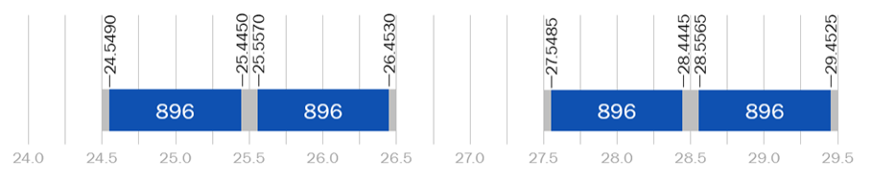
Figure 15: FS 26 GHz band plans recommended for CEPT countries [4]
The standard channelling arrangement for FS applications splits the 2×896 MHz block into paired channels of 2×112 MHz, 2×56 MHz, 2×28 MHz, 2×14 MHz, 2×7 MHz and 2×3.5 MHz (8, 16, 32, 64, 128 and 256 channels respectively).
  - Licensing approach
There are two main licensing approaches for fixed wireless links in the 26 GHz band in Europe:
Individual licensing | Under this approach, P-P/P-MP links (or FWA sites) are licensed on an individually coordinated, link-by-link (or site-by-site) basis. The licences are coordinated by the NRA; a licence application will only be approved if the location and frequency is available.
Area (or ‘block’) licensing | Under this approach, a block of spectrum is exclusively assigned to a licensee in a particular geographical area. The licensee may then deploy equipment as it chooses, within its designated frequency range and area. The area may vary from the entire country (i.e. nationwide licensing) to a smaller sub-national region. In several European markets, block licences have been awarded by auction.
The licensing approaches adopted in the countries surveyed for this study (our ‘benchmark countries’) are shown in Figure 16 below. Information is also included on the permitted use of each block of spectrum (P-P, P-MP, FWA or a combination).
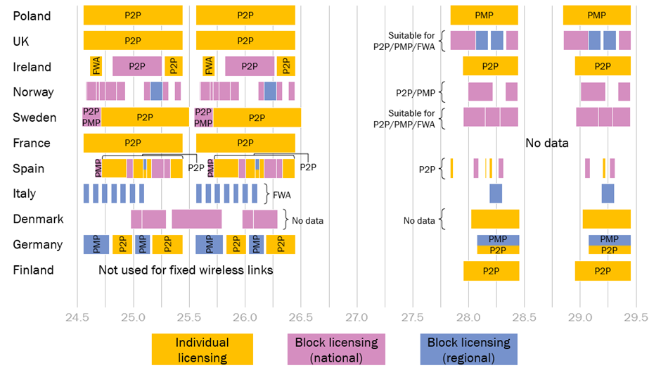
Figure 16: Licensing approaches and permitted use in benchmark countries
[Source: NRAs, EFIS]
As can be seen, there is a mixture of individual and block licensing, both between countries as well as within countries. Indeed, in most cases, countries make use of both types of licensing in different portions of the two band(s), reflecting different approaches to awarding the spectrum as well as different services that are permitted.
For example, in Germany, the 24.549-24.773/25.557-25.781 GHz and 25.025-25.137/26.033-26.145 GHz sub-ranges of the 26 GHz band are used for P-MP services, and these are licensed on a regional basis. The 24.801-24.997/25.809-26.005 GHz and 25.165-25.445/26.17-26.453 GHz sub-ranges are used for P-P links, and these are licensed on an individually coordinated basis. Generally, FWA services and P-MP links (where deployment over an area is necessarily required) have been made available under a block licensing arrangement, though this is not always the case.
  - Licence duration
The expiry dates for fixed wireless link licences is relevant for regulators to consider when assessing timeframes for making spectrum in the 26 GHz for 5G use. Duration of current licences, along with sharing considerations between fixed wireless links and 5G, will inform decisions relating to options for continuation of fixed wireless link use in the 26 GHz.
Table 23 below provides expiry date information of current licences for fixed wireless links in selected European countries in the 26 GHz band.

Table 23: Expiry date information for fixed wireless link licences in the 26 GHz bands [Source: NRAs, EFIS]
Country | Expiry date of 26 GHz licences
Poland | On average, licences expire in 2023
UK | Licences are indefinite, and subject to annual renewal and ongoing compliance with terms and conditions of the licence. Ofcom may revoke licences with a 5-year notice period under certain circumstances.
Ireland | Lower (FWA) and upper (P-P) block – licences renewed annually. Central (P-P) block – licences expire in 2028
Norway | Most licences expire in December 2018 or December 2019
Sweden | Licences expire in December 2021
France | Licences are usually issued for 10 years. On average, licences expire in 2023
Spain | Block (P-MP) licences expire in December 2019. On average, individual (P-P) licences expire in 2020
Italy | Licences expire in July 2022
Denmark | Licences expire in 2025/26
Germany | Around 90% of the regional P-MP licences and 20-25% of the individual P-P licences are assigned for an unlimited period
Finland | Not used for fixed wireless links
As can be seen, in most cases, licences for fixed wireless links have a fixed term, although this may vary significantly between countries from a few years to 15 years or more (10 and 15 year licence durations are common). In cases where licences are awarded individually with a fixed term (rather than simultaneously in a single assignment procedure), there is a distribution of expiry dates across the issued licences; in such cases, an average expiry date has been quoted. Generally, the (average) expiry date of licences in our benchmark countries is still a significant number of years away from the present; licences will expire in the next 1-2 years in only a handful of countries (e.g. Norway and Spain).
In several instances, licences for fixed wireless links have an indefinite duration. This is the case, for example, in the UK where individually coordinated link licences are indefinite and subject to payment of an annual fee and ongoing compliance with terms and conditions of the licence; the NRA (Ofcom) may revoke licences for spectrum management purposes subject to a 5-year notice period.
  - Frequency distribution of licences
A further issue of critical importance in making spectrum in the 26 GHz band available for 5G, is the level of current use of those bands for fixed wireless links.
Figure 17 below shows the number of bi-directional fixed wireless links which are currently deployed across the 26 GHz band. Where detailed frequency assignment data is available in the public domain has been found, larger contiguous blocks of spectrum have been split into 2×112 MHz channels. Blocks have been colour-coded according to the number of links (or transmitters) which have been deployed per 2×112 MHz.
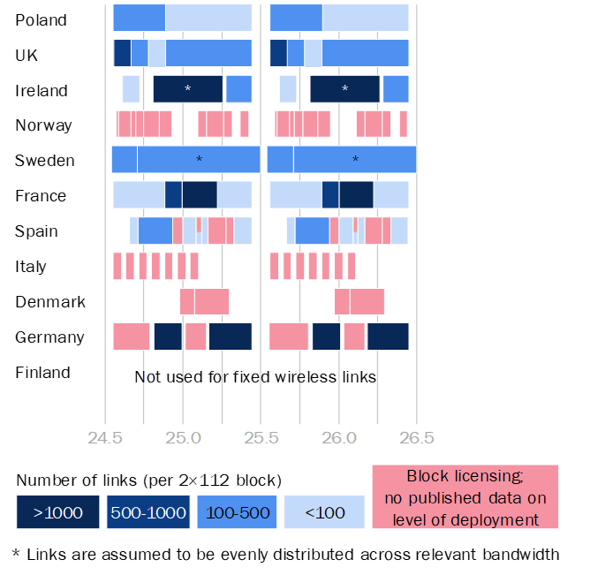
Figure 17: Density of fixed wireless links use across the 26 GHz band
[Source: NRAs, EFIS]
As can be seen, the amount of bandwidth used for fixed wireless links within the 26 GHz band varies significantly. In some countries (e.g. Poland and the UK), the entire 2×896 MHz range is used, while in others (e.g. Denmark, Italy), only a portion is used.
Furthermore, the level of usage also varies significantly between (and within) countries. Countries such as France, Germany and Ireland heavily use certain sub-ranges – for example, in Germany over 18 000 links have been deployed in the two sub-ranges where P-P links are individually coordinated. On the other hand, there appears to be less intensive use in countries such as Poland – less than 100 P-P links are deployed in Poland in each of the upper five 2×112 MHz channels. In Finland, the band is entirely unused for fixed wireless links.
Figure 18 below shows data on current fixed wireless link use in both the 26 GHz and 28GHz bands in a single chart. In cases where spectrum is being used via block-assigned licences, data is generally not available on the level of use in specific locations. This prevents a complete comparison. However, it is clear that there is significant use of both bands, and that the 26 GHz band is generally more heavily used than the 28GHz band in European countries. It should be noted that this probably reflects the shared use of the 28GHz band with FSS, meaning that the bandwidth available for fixed wireless links use is less.
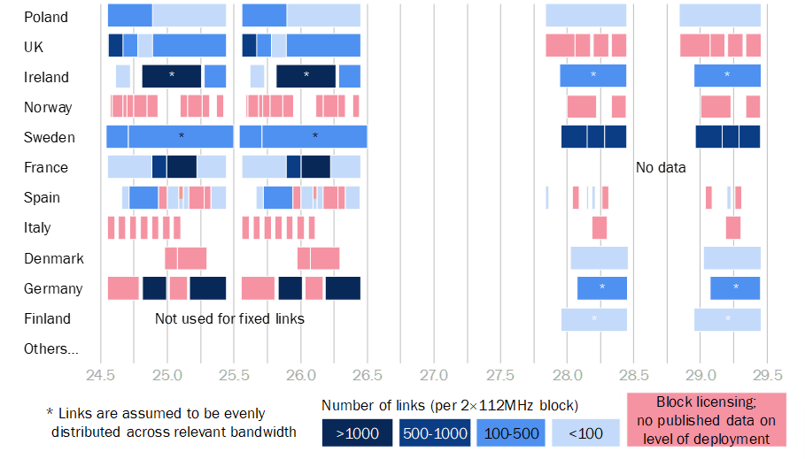
Figure 18: Density of fixed wireless link deployment across both the 26 GHz and 28 GHz bands [Source: NRAs, EFIS]
  - Geographical distribution of licences
The geographical distribution of incumbent licences is another essential consideration to the potential assignment of spectrum in the 26 GHz band to 5G (which is likely to initially focus on key urban locations).
Figure 19, Figure 20 and Figure 21 below provide nationwide maps of fixed wireless link deployments in the 26 GHz and 28 GHz bands for three countries (Poland, France and Ireland) for which we have found that full geographical information is available.

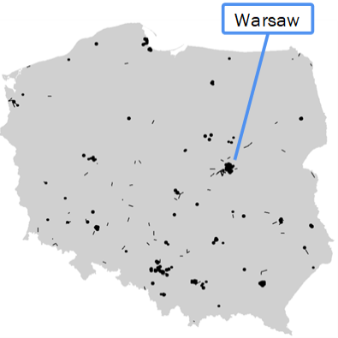
Figure 19: Geographical distribution of fixed wireless link deployments in Poland
[Source: NRA, 2018]

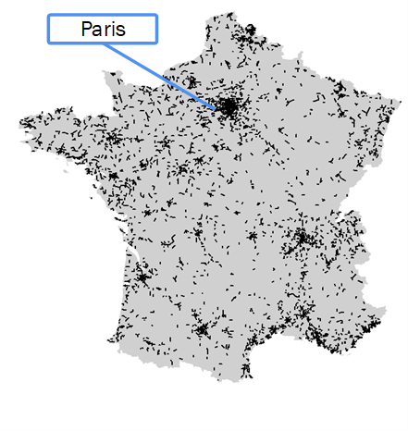
Figure 20: Geographical distribution of fixed wireless link deployments in France
[Source: NRA, 2018]

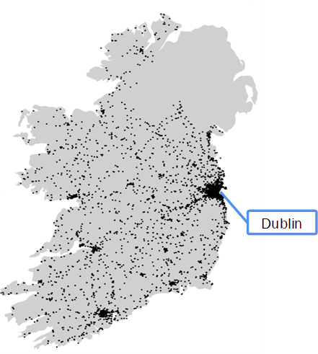
Figure 21: Geographical distribution of fixed wireless link deployments in Ireland
[Source: NRA, 2018]

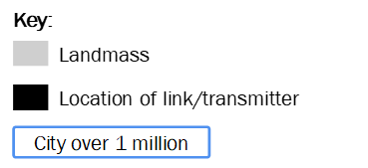
Figure 22: Key for maps
The maps highlight the similarities in the geographical distribution of fixed wireless links in the bands across European countries: links are generally distributed across the country, but most densely deployed in key urban areas.
Poland represents a country with a relatively low number of deployments, with fixed wireless links not installed in these bands across large areas of the country. Ireland and France represent two countries with a very large number of deployments, which are spread across both rural and urban areas. However, in all countries surveyed for which information was available, the highest density of deployment is in major cities (as illustrated above by the clusters of deployments around Warsaw, Paris and Dublin).
    - City-level mapping
This section provides visualisations of the 26 GHz fixed wireless link deployments in various European cities. London is considered, for which detailed information is available along with Berlin, Dublin, Paris and Warsaw.
London
Figure 23 below shows the geographical distribution of (bi-directional) P-P links at 26 GHz deployed in the UK. According to Ofcom’s most recently published Wireless Telegraphy Register (WTR), there are 2335 such links, which are widely distributed across the UK, covering both rural and urban areas. Figure 25 zooms in to show the deployments in Greater London; a scale-bar of 10 km provides a sense of the typical P-P hop-length. Links have been colour coded according to the eight 2×112 MHz channels of the 26 GHz band.

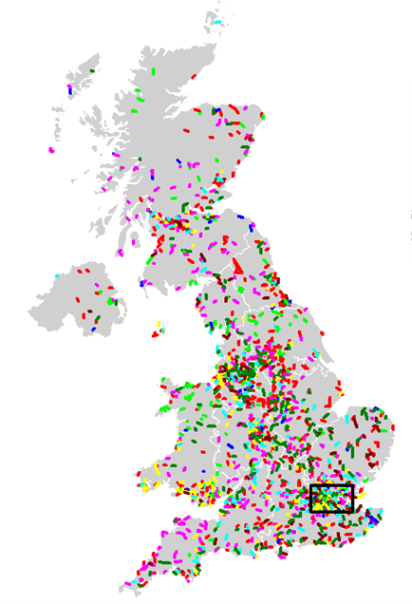
Figure 23: P-P links at 26 GHz in the UK
[Source: Ofcom WTR, 2018]

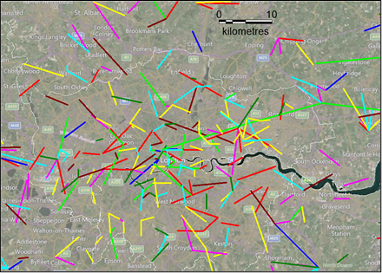
Key:
 | UL frequency (MHz) | DL frequency (MHz) | UK count
 | 24549–24661 | 25557–25669 | 617
 | 24661–24773 | 25669–25781 | 243
 | 24773–24885 | 25781–25893 | 73
 | 24885–24997 | 25893–26005 | 414
 | 24997–25109 | 26005–26117 | 366
 | 25109–25221 | 26117–26229 | 208
 | 25221–25333 | 26229–26341 | 159
 | 25333–25445 | 26341–26453 | 255
Total |  |  | 2335
Figure 24: P-P links at 26 GHz in Greater London
[Source: Ofcom WTR, 2018, Bing Maps]:

Figure 25 below zooms in further to show a 12 km×12 km area of Central London; a 500 m×500 m grid provides a scale relevant to the deployment of 5G small cells.

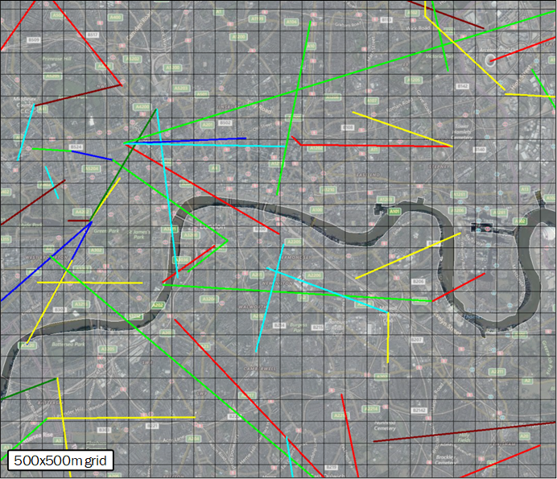
Figure 25: P-P links at 26 GHz in Central London
[Source: Ofcom WTR, 2018, Bing Maps]
As can be seen, there are a significant number of links in this area, distributed both geographically and across the 26 GHz band.
Berlin
Germany has deployed ~18 000 P-P links (more than any other country surveyed) in sub-ranges of the 26 GHz band; over 1000 of these links are in Berlin, as shown in Figure 26 below. Germany also has ~160 regional P-MP licences in separate sub-ranges of the 26 GHz band.
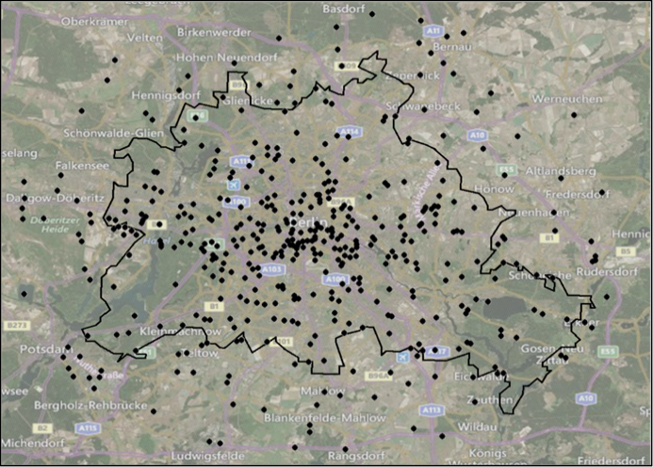
Figure 26: 26 GHz P-P deployments in Berlin
[Source: ECC PT1 #60 document – Toolbox 26 GHz (Germany), Bing Maps]
Dublin
In Dublin, there is a high density of P-P links in both the 26 GHz band. As shown in Figure 27 below, there is a particularly high density in central Dublin.
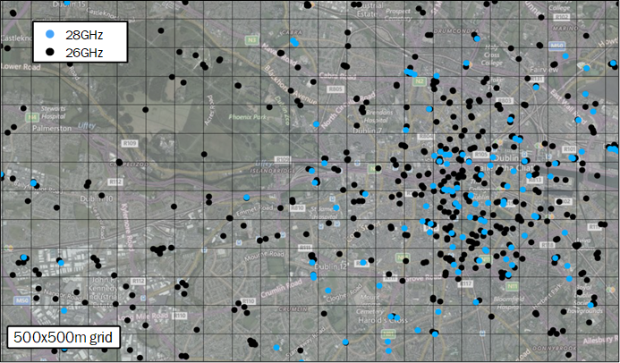
Figure 27: 26 GHz and 28GHz P-P deployments in Dublin city centre
[Source: ComReg, 2018]
Paris
As shown in Figure 28 below, there is a significant number of P-P links deployed at 26 GHz in Paris. Detailed information regarding the exact frequency of individual links is not publicly available; all links have been shown as black.
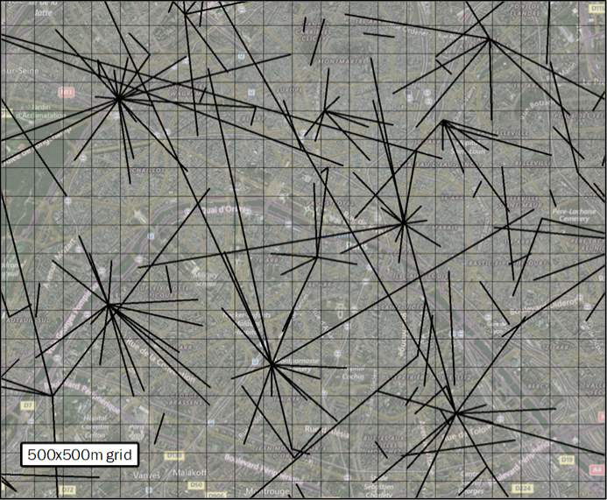
Figure 28: 26 GHz P-P links in Paris city centre
[Source: https://carte-fh.lafibre.info/index.php?no_sup_init=684560, 2018]

Warsaw
In contrast to Berlin, Dublin and Paris, the level of fixed wireless link deployment in Warsaw is much more limited. As shown in Figure 29 below, the 26 GHz band is relatively lightly used for P-P and P-MP links.

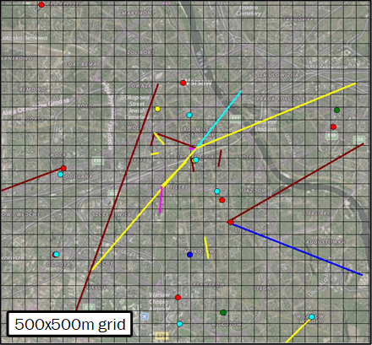 | Key:
   | UL frequency (MHz) | DL frequency (MHz)
   | 24549–24661 | 25557–25669
   | 24661–24773 | 25669–25781
   | 24773–24885 | 25781–25893
   | 24885–24997 | 25893–26005
   | 24997–25109 | 26005–26117
   | 25109–25221 | 26117–26229
   | 25221–25333 | 26229–26341
   | 25333–25445 | 26341–26453
Figure 29: P-P links and P-MP transmitters in the 26 GHz band, Warsaw
[Source: UKE, 2018, Bing Maps]
- List of references

- ECC Decision (18)06: “Harmonised technical conditions for Mobile/Fixed Communications Networks (MFCN) in the band 24.25-27.5 GHz”
- CEPT 5G Roadmap, updated March 2019: https://www.cept.org/ecc/topics/spectrum-for-wireless-broadband-5g
- Final Acts WRC-15 World Radiocommunication Conference, Geneva, 2015
- Recommendation T/R 13-02 (Montreux 1993, amended Troms, May 2010), “Preferred channel arrangements for fixed service systems in the frequency range 22.0 - 29.5 GHz”
- ECC Recommendation (11)01: “Guidelines for assignment of frequency blocks for fixed wireless systems in the bands 24.5-26.5 GHz, 27.5-29.5 GHz AND 31.8-33.4 GHz”
- ECC Report 173: “Fixed Service in Europe Current use and future trends post 2016”, approved 4 April 2012, amended: 27 April 2018]
- TG5/1 Doc 92 Annex 1: https://www.itu.int/md/R15-TG5.1-C-0092/en
- ETSI TR 138 900 V14.3.1 (2017-08) “LTE;5G;Study on channel model for frequency spectrum above 6 GHz (3GPP TR 38.900 version 14.3.1 Release 14)”
- Recommendation ITU-R P.452-16 (07/2015): “Prediction procedure for the evaluation of interference between stations on the surface of the Earth at frequencies above about 0.1 GHz”
- Recommendation ITU-R P.2108-0 (06/2017): “Prediction of clutter loss”
- Recommendation ITU-R P.1411-9 (06/2017): “Propagation data and prediction methods for the planning of short-range outdoor radiocommunication systems and radio local area networks in the frequency range 300 MHz to 100 GHz”
- Recommendation ITU-R P.2109-0 (06/2017): “Prediction of building entry loss”
- “Making 26 GHz a successful band in Europe”, GSA, September 2017
- Radio Spectrum Policy Group: “Strategic Spectrum Roadmap towards 5G for Europe” of 30 January 2018; ref RSPG18-005 FINAL; https://circabc.europa.eu/sd/a/fe1a3338-b751-43e3-9ed8-a5632f051d1f/RSPG18-005final-2nd_opinion_on_5G.pdf
- ETSI TR 101 854 V1.3.1 (2005-01): Fixed Radio Systems; Point-to-point equipment; Derivation of receiver interference parameters useful for planning fixed service point-to-point systems operating different equipment classes and/or capacities
- Recommendation ITU-R M.2083
- ETSI TS 138 104 V15.3.0 (2018-10): " 5G; NR; Base Station (BS) radio transmission and reception” (3GPP TS 38.104 version 15.3.0 Release 15)
- Recommendation ITU-R M.2101-0 (02/2017) Modelling and simulation of IMT networks and systems for use in sharing and compatibility studies
- Recommendation ITU-R SM.329-12 (09/2012) Unwanted emissions in the spurious domain
- CEPT/ERC/Recommendation 74-01: “Unwanted emissions in the spurious domain”
- ECC Report 287: "Guidance on defragmentation of the frequency band 3400-3800 MHz"
- ITU-R TG5/1 Doc 36 (‘”Characteristics of terrestrial IMT systems for frequency sharing/interference analysis in the frequency band between 24.25 GHz and 86 GHz”, 5-1/36, Attachment 2)
- ITU-R F.699-8 (01/2018): “Reference radiation patterns for fixed wireless system antennas for use in coordination studies and interference assessment in the frequency range from 100 MHz to 86 GHz”
- Recommendation ITU-R F.758-6 (09/2015): “System parameters and considerations in the development of criteria for sharing or compatibility between digital fixed wireless systems in the fixed service and systems in other services and other sources of interference”
- “Wireless Telegraphy General Licence Conditions Booklet”, Ofcom, February 2006: https://www.ofcom.org.uk/__data/assets/pdf_file/0032/89744/General-Licence-Conditions.pdf

An exception of this occurs at a close distance between the 5G BS and the FS receiver if a large height of the 5G BS transmitter antenna shifts it outside the main beam of the FS receiving antenna. Reducing the antenna height under such conditions may increase the interference potential significantly.
See https://www.ecodocdb.dk/download/2dce417c-b219/TR1302.PDF.
Annex B of the Recommendation deals with the 26 GHz band.
ECO Frequency Information System: www.efis.dk
For example, FWA deployments in Ireland and P-MP licences in Poland use individually coordinated frequency assignments, whereas 28GHz block-assigned licences in the UK can be used for either point to point or P-MP links, including FWA.
This could be shorter in certain circumstances. See Ofcom’s General Conditions Booklet [25]
Individually licensed links are generally bi-directional, though this is not always the case. In cases where a one-way link has been licensed, this is counted as half a link.
The number shown is the number of bi-directional links plus the number of P-MP or FWA transmitters. These are collectively referred to as ‘links’ in both Figure 17 and Figure 18.
Where data is unavailable (i.e. all that is known is the total number of links which are deployed across a frequency range), links have been assumed to be evenly distributed across the relevant bandwidth.
Circle of radius 25.6km centred on co-ordinate lat. 52.516367, long. 52.516367.
Only P-P links of SFR and Bouygues are displayed. There are ~5000 fixed links in France, ~96% of which are owned by these two operators.
In Poland there is an individual licensing regime in the 26GHz band; P-P and P-MP licences are available. P-P links are represented by lines and P-MP transmitter stations are represented by dots.

