Best practices for Video Programme Making and Special Event (PMSE) in the 2700-2900 MHz band
approved 28 September 2018
ECC Report 285

Executive summary
This ECC Report defines best practice on usage of 2700-2900 MHz band by video PMSE, taking into account incumbent users in band and also cross-border coordination aspects.
It aims to provide tools to facilitate the introduction of Video PMSE in the 2700-2900 MHz band by developing a step-by-step spectrum sharing framework between incumbent systems and video PMSE before setting up a national framework. It does not consider interference into video PMSE from incumbent services.
This Report covers only the case when individual temporary licences are issued for PMSE video in the 2700-2900 MHz band as confirmed by CEPT in CEPT Report 51 [1] and CEPT Report 61 [4].
In addition, coordination agreements of incumbents are also necessary after defining coordination distances or other technical options of sharing (i.e. exclusions zones and/or protection zones). With these agreements, the duration of the authorisation process for the use of the 2700-2900 MHz band by video PMSE could be reduced considerably by limiting interactions with the relevant incumbents only when it is really necessary (for example, no public information on the number and location of some incumbent transmitters is available).
Administrations that decide to make the 2700-2900 MHz band available for video PMSE on a national level can use the guidance provided in the present Report and also take additional measures to guarantee the quality of service of video PMSE when spectrum is available in a given area.
This Report includes an indication of the amount of spectrum potentially available for video PMSE in the frequency band 2700-2900 MHz in specific locations in France when applying the guidance given in this Report to the French national plan.

TABLE OF CONTENTS

0 Executive summary 2
1 Introduction 7
2 Description and technical characteristics of video PMSE applications considered in this Report 8
2.1 Description of video PMSE applications considered in this Report 8
2.2 Technical characteristics of video PMSE in the band 2700-2900 MHz 10
3 Radio services and technical characteristics of incumbent systems using the band 2700-2900 MHz and the adjacent bands 11
3.1 Use of the band 2700-2900 MHz 11
3.2 Use of the band above 2900 MHz 12
3.3 Use of the band 2690-2700 MHz 12
3.3.1 Technical characteristics of Earth exploration-satellite (passive) 12
3.3.2 Technical characteristics of radio astronomy 12
3.3.3 Technical characteristics of space research (passive) 13
3.4 Use of the band below 2690 MHz 13
4 Summary of the technical conditions for video PMSE in the frequency band 2700-2900 MHz 14
5 Spectrum sharing framework for the use of video PMSE in the band 2700-2900 MHz 17
5.1 Technical considerations for developing a sharing framework between incumbents and video PMSE within 2700-2900 MHz 17
5.1.1 Step 1: Estimation of the operational footprint of incumbents 17
5.1.1.1 Estimation of the operational footprint of radars 17
5.1.1.2 Estimation of the operational footprint of other incumbents 18
5.1.2 Step 2: Technical conditions of the sharing framework 18
5.1.2.1 Technical characteristics of incumbents 18
5.1.2.2 Separation distances to protect incumbents 19
5.1.2.3 Technical options for sharing 19
5.1.3 Step 3: Operational conditions for the sharing framework 20
5.1.3.1 Implication on video PMSE 21
5.1.3.2 Provision of required information 22
5.1.4 Step 4: Verification of compliance with conditions of the sharing framework 22
5.2 Regulatory consideration for implementing A sharing framework for the use of video PMSE in the band 2700-2900 MHz 22
5.2.1 National sharing framework approach for the use of video PMSE in the band 2700-2900 MHz 22
5.2.2 Functional blocks and interactions 23
5.3 Operational Process for the use of video PMSE in the band in 2700-2900 MHz 24
5.3.1 Update of the National Table of Frequency Allocation (NTFA) 24
5.3.2 Coordination agreement 25
5.3.3 Frequency licencing/authorisation 25
6 Cross-border coordination aspects regarding the frequency band 2700-2900 MHz 26
7 Conclusions 27
ANNEX 1: Operational and regulatory aspects for ATC radars 28
ANNEX 2: ATC/defence and meteorological radar characteristics 30
ANNEX 3: spectrum potentially available for video PMSE in the frequency band 2700 – 2900 MHz in Paris and in Le Mans (France) 32
ANNEX 4: List of reference 35

LIST OF ABBREVIATIONS

Abbreviation | Explanation
ANSP | Air Navigation Service Provider
ASR | Airport surveillance radars
ATC | Air traffic control
ATM | Air traffic management
CAA | Civil Aviation Authority
CEPT | European Conference of Postal and Telecommunications Administrations
e.i.r.p. | equivalent isotropically radiated power
EC | European Commission
ECC | Electronic Communications Committee
ESE | Extraneous Signal Environment
E-UTRA | Evolved - Universal Terrestrial Radio Access
FAQ | Frequently Asked Questions
ITU | International Telecommunication Union
LTE | Long Term Evolution
MFCN | Mobile/Fixed Communications Networks
NATO | North Atlantic Treaty Organization
NJFA | NATO Joint civil/military frequency agreement
NRA | National Regulatory Authority
NSA | National Supervisory Authority
NTFA | National Table of Frequency Allocations
OB | Outside Broadcasting (link)
Pd | Probability of Detection
PMSE | Programme Making and Special Events
PSR | Primary Surveillance Radar
REC | Recommendation
RR | Radio Regulations
SSR | Secondary Surveillance Radar
VLBI | Very Long Baseline Interferometry
WGS84 | World Geodetic System 1984

Introduction
In response to an EC mandate on PMSE dated 15 December 2011 which included cordless video-cameras, CEPT Report 51 [1] identified the band 2700-2900 MHz and other bands as possible new bands for temporary use by cordless cameras and video links subject to appropriate geographical constraints to protect radar applications.
ECC Report 243 [2] addressed compatibility studies between wireless video links and all existing or planned services allocated in the frequency bands 2700-2900 MHz and 2900-3400 MHz and the adjacent bands.
CEPT Report 61 [4] was developed in response to the Mandate [3] issued by the EC dated 14 July 2015 to study and identify harmonised compatibility and sharing conditions for video PMSE in the band 2700-2900 MHz, taking into account the requirements of radars in this band as well as existing radio services in the adjacent bands.
The purpose of this Report is to exchange best practices for Video PMSE in the 2700-2900 MHz band taking into account the harmonised compatibility and sharing conditions described in the CEPT Report 61 [4].
This Report covers only the case when individual temporary licences are issued for PMSE video in the 2700-2900 MHz band as confirmed by CEPT in CEPT Report 51 [1] and CEPT Report 61 [4].
In section 2, this Report describes categories and technical characteristics of PMSE video links to be used in the band 2700-2900 MHz.
Section 3 describes radio services and technical characteristics of systems using the band 2700-2900 MHz and the adjacent bands.
Derived from results of studies in CEPT Report 61 [4], section 4 presents relevant technical conditions for video PMSE that ensure efficient spectrum use in the band 2700-2900 MHz.
Section 5 details the spectrum sharing framework for the use of video PMSE in the band 2700-2900 MHz and provides an example of operational process to be implemented during the roll-out of the video PMSE in this band. Furthermore, the frequencies potentially available for video PMSE in the frequency band 2700-2900 MHz in Paris and Le Mans (France) are indicated in Annex 3 with respect to the coordination agreement planned in France. Additional national considerations with Aviation authorities may need to be taken into account when developing a national sharing framework such as the consideration of relevant safety cases.
Finally, section 6 presents cross-border coordination requirements.

Description and technical characteristics of video PMSE applications considered in this Report

Description of video PMSE applications considered in this Report
The main type of PMSE applications foreseen in the 2700-2900 MHz band is related to temporary video links, i.e. portable and terrestrial mobile video up-link uses (airborne transmission excluded) and cordless cameras as referred to in Recommendation 25-10 [5], ECC Report 204 [6] and CEPT Report 51 [1]. Digital video links are now the industry standard for video PMSE use.
Cordless cameras and associated video links often also carry the associated radio microphone audio, service links and telemetry. There may be more than one wireless link required to deliver the signal from a cordless camera to the production studio. In some cases, all the requirements of video, audio and control may be combined into a single IP link.
The band 2700-2900 MHz is not appropriate for temporary point-to-point links, with high directivity antennas. Those links, which are used for carrying broadcast quality video/audio signals, are preferably deployed in higher frequency bands (higher than 5 GHz). Their usage may be possible on a national basis depending on local conditions.
In addition, compatibility studies included in ECC Report 243 [2] between airborne video downlinks (air-to-ground link) and radars show that the use of such video PMSE is not possible in the band 2700-2900 MHz, due to the required separation distance.
This Report deals with cordless camera links, portable video links and terrestrial mobile video uplinks (air-to-ground transmission excluded) as defined in Table 1.
Table 1: Categories of PMSE video links considered in this Report
Type of link | Definition
Cordless camera link | Handheld or otherwise mounted camera with integrated or Clip-on transmitter, power pack and antenna for carrying broadcast-quality video together with sound signals over short-ranges (line-of-sight and non-line-of-sight).
Portable video link | Small transmitter, for deployment over greater ranges, typically up to 2 km.
Terrestrial mobile video uplink (airborne transmission excluded) | Video transmission system employing radio transmitter mounted in/on motorcycles, racing motorbikes, pedal cycles, cars, racing cars or boats. One or both link terminals may be used while moving.
Cordless camera link
These are handheld cameras with integrated transmitter, power pack and antenna. Normally, they are used by a cameraman to send a video link to an OB vehicle at short distance. The emitted power is therefore lower than in other cases.
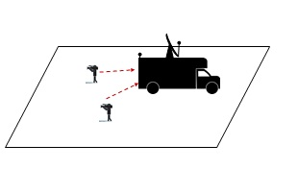
Figure 1: Cordless camera link
Portable video link
Portable video links are mostly handheld cameras with a separate body worn transmitter, power pack and antenna. The emitted power is normally greater than in the case of cordless camera but lower than in the case of mobile links.
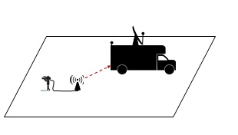
Figure 2: Portable video link
Terrestrial mobile video up-link (airborne transmission excluded)
These are camera links where, for the uplink, the transmitter is on a ground-based vehicle, typically on a motorcycle, and the receiver is on the ground or on a helicopter/aircraft.
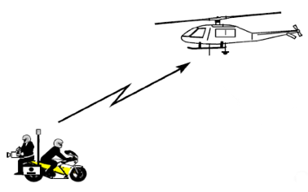
Figure 3: Mobile video up-link (airborne transmission excluded)
The band 2700-2900 MHz is contained in ERC Recommendation 25-10 [5] and video PMSE equipment should be capable of being operated within the whole tuning range in order to provide flexibility for operation in different countries.

Technical characteristics of video PMSE in the band 2700-2900 MHz
PMSE digital video link technical characteristics may be defined according to the typical values given in ECC Report 219 [7] and CEPT Report 61 [4] or they can be defined based on the national usage by the administration.
Technical characteristics of PMSE video links in the band 2700-2900 MHz are summarised in Table 2.
Table 2: Technical characteristics of PMSE video links in the band 2700-2900 MHz
Type of link | Cordless camera link | Portable video link | Terrestrial mobile video link
Transmitter
Range of e.i.r.p. (dBW) (Note 1) | -7/0 | -7/0 | 3/6
Typical transmitter antenna height (m) over the ground | 1.5 | 2 | 1.5
Transmitter Antenna Gain (dBi) (Note 2) | 0/3 | 6/14 | 3/9
Note 1: Range of radiated power generally used by operators in order to extend battery life, etc.
Note 2: Typical and maximum value.
Receiver
Receiver antenna height (m) (Note 3) | 2/60 | 2/60 | 2/60  150/6 km (Note 4)
Receiver antenna gain (dBi) (Note 3) | 3/13 | 9/17 | 10/13  4/9 (Note 4)
Receiver Noise Figure (dB) | 4 | 4 | 4
C/N (dB) | 9 | 9 | 9
I/N (dB) | -10 or -6 (Note 5) | -10 or -6 (Note 5) | -10 or -6 (Note 5)
Adjacent Channel Selectivity (dB) | 30 | 30 | 30
Receiver threshold (dBm) | -92 | -92 | -92
Note 3: Typical and maximum value.
Note 4: Ground-to-air link.
Note 5: See Recommendation ITU-R F.1777 [23] and Recommendation ITU-R M.1824 [24] for further information.

Radio services and technical characteristics of incumbent systems using the band 2700-2900 MHz and the adjacent bands

Use of the band 2700-2900 MHz
The frequency band 2700-2900 MHz is allocated on primary basis to Aeronautical Radionavigation, and restricted to ground-based radars (and to associated airborne transponders…) by RR 5.337. The meteorological (weather) radars are included by RR 5.423: “In the band 2700-2900 MHz, ground-based radars used for meteorological purposes are authorised to operate on a basis of equality with stations of the aeronautical radionavigation service.”
Also Radiolocation service is listed with secondary status in the RR frequency table in the band 2700-2900 MHz.
The frequency use in the band 2700-2900 MHz, according to the Radio Regulations, is provided in Figure 4.
5.337 The use of the bands 1 300-1 350 MHz, 2 700-2 900 MHz and 9 000-9 200 MHz by the aeronautical radionavigation service is restricted to ground-based radars and to associated airborne transponders which transmit only on frequencies in these bands and only when actuated by radars operating in the same band.
5.423 In the band 2 700-2 900 MHz, ground-based radars used for meteorological purposes are authorised to operate on a basis of equality with stations of the aeronautical radionavigation service.
5.424A In the band 2 900-3 100 MHz, stations in the radiolocation service shall not cause harmful interference to, nor claim protection from, radar systems in the radionavigation service. (WRC-03)
5.425 In the band 2 900-3 100 MHz, the use of the shipborne interrogator-transponder (SIT) system shall be confined to the sub-band
2 930 -2 950 MHz.
5.426 The use of the band 2 900-3 100 MHz by the aeronautical radionavigation service is limited to ground-based radars.
5.427 In the bands 2 900-3 100 MHz and 9 300-9 500 MHz, the response from radar transponders shall not be capable of being confused with the response from radar beacons (racons) and shall not cause interference to ship or aeronautical radars in the radionavigation service, having regard, however, to No. 4.9.
Figure 4: Frequency use in the band 2700-2900 MHz, according to the Radio Regulations [8]
As mentioned in ECC Report 6 [9], the band 2700-2900 MHz is used by radars for both civil and military applications.
For the aeronautical radionavigation service, there are three types of radar operating within the CEPT:
- Ground-based systems for air traffic control (ATC) for civil purposes (also addressed as civil S-band radars);
- Ground-based systems for ATC for military purposes;
- Mobile bird-strike radars, designed to detect the flight of birds, which may collide with aeroplanes.
For the radiolocation service, radars are ground-based meteorological systems; the aim of these radars is to measure and predict precipitation (rain, snow, hail and sleet).
Moreover, the band 2700-2900 MHz is identified to answer to permanent NATO needs as a 'Class A' band in the NATO Joint civil/military frequency agreement (NJFA) [25], for aeronautical, for land and naval applications in the aeronautical radio navigation and radiolocation service, specifically for airport surveillance radars (ASR) and air defence radars. No public information on the number and location of military radar sites is available. The diversity and especially the operation of aeronautical radiolocation radars may make coordination very difficult or even not possible in practice between military radars and video PMSE.
ATC radars are mainly deployed close to airports; maritime radars on sea or on bigger rivers; defence and meteorological radar are more likely being deployed in rural areas. A study conducted for the European Commission in 2012 reported a total of 112 civilian ATC radars in the Union operating in the 2700-2900 MHz band, with between 1 and 42 radars in each Member State. 14 Member States operate aeronautical radars at fewer than five sites in the entire country (usually airports) and most Member States having less than 20 national radar sites in operation.

Use of the band above 2900 MHz
The upper adjacent band is used for radiolocation, navigation and maritime radars. Some systems using the band 2700-2900 MHz are also operating in the band 2900-3100 MHz.

Use of the band 2690-2700 MHz
The band 2690-2700 MHz is allocated to Earth exploration-satellite (passive), radio astronomy and space research (passive) services, and associated with RR 5.340 and 5.422 [8].
5.340: “All emissions are prohibited in the (…) [band] (…) 2690-2700 MHz, except those provided for by No. 5.422 (…)”.

Technical characteristics of Earth exploration-satellite (passive)
Since there is no characteristic available in Recommendation ITU-R RS.1861 [15] for the band 2690-2700 MHz, it is assumed that this band is currently not used by Earth exploration-satellite (passive) systems.

Technical characteristics of radio astronomy
The frequency band 2690-2700 MHz should be protected from any emission by RR 5.340 [8].
The Recommendation ITU-R RA.769-2 [16] provides the criteria for the protection of radio astronomy receivers as described in Table 3.
Table 3: Characteristics and protection of radio astronomy receivers
Centre frequency (MHz) | Bandwidth (MHz) | Minimum antenna noise temperature (K) | Receiver noise temperature (K) | Temperature (mK) | Spectral density (dBW/Hz) | Input power (dBW) | Surface power (dBW/m²)
2695 | 10 | 12 | 10 | 0.16 | -267 | -207 | -177
It has to be noted that the values are calculated using the equation (4) of the Recommendation ITU-R RA.769-2 [16] with Preceived = 0.1∆P∆f. This power received with a bandwidth of 10 MHz is then calculated for a bandwidth of 1 MHz.

Technical characteristics of space research (passive)
The space research (passive) allocation is used by space-based radio astronomy observatories on highly elliptical orbits. These sensors perform VLBI observations in conjunction with terrestrial observatories. It is expected that PMSE would have much less impact in these space-based observatories than the much more powerful radar systems currently using the band 2700-2900 MHz.

Use of the band below 2690 MHz
The band 2500-2690 MHz is allocated to terrestrial mobile service. ECC Decision (05)05 [17] and Commission decision 2008/477/EC [18] aim at harmonising this band for MFCN, including E-UTRA/LTE. The MFCN channelling arrangement blocks, provided by ECC Decision (05)05, are depicted in Figure 5.
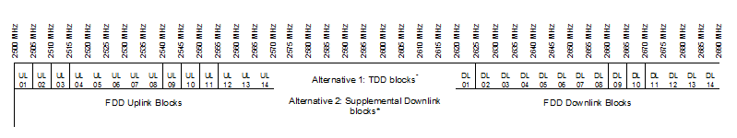
*Any guard bands required to ensure adjacent band compatibility at 2570 MHz and 2620 MHz boundaries will be decided on a national basis and taken within the band 2570-2620 MHz.
Figure 5: MFCN channelling arrangement blocks in the band 2500-2690 MHz
Note that other frequency arrangements in the band 2500-2690 MHz may apply on a national basis.

Summary of the technical conditions for video PMSE in the frequency band 2700-2900 MHz
Based on the studies documented in ECC Report 243 [2], CEPT Report 61 [4] proposes technical conditions for video PMSE in the band 2700-2900 MHz, taking into consideration radar use in the band and other services in adjacent bands.
Table 4 and Table 5 are adapted from those in CEPT Report 61 [4] taking into account technical characteristics of PMSE video links in the band 2700-2900 MHz described in Table 2. Some clarification regarding the radar receiver bandwidth is provided in Table 4. It should be noted that radar receiver designs have bandwidths that vary according to the equipment and may vary from around 10 MHz to more than 25 MHz. Radars can also operate on any frequency in the band and can operate on 2 or more frequencies simultaneously (see ANNEX 1). The required frequency separations between PMSE and radar in the table below are deemed to be measured from the -60 dBc point of the radar receiver to the centre frequency of the considered PMSE channel. In addition, administrations may conduct additional studies to better calculate appropriate coordination distances.
Table 4: Compatibility for cordless camera links, portable video links and terrestrial mobile video links in the band 2700-2900 MHz (from CEPT Report 61 [4] Table 2)
Compatibility between video PMSE (10 MHz channel, note) and radars (ATC, terrestrial and meteorological) in the band 2700-2900 MHz, with a radar selectivity of 60 dBc
Co-channel scenario | In the co-channel scenario, a separation distance between PMSE transmitter and radar receivers of 100 km or even more (182 km) may be necessary. Hence, a co-channel sharing is in general not feasible.  However, co-channel operation may be possible, only after coordination on a case-by-case basis, for a video PMSE with a maximum e.i.r.p. of 0 dBW and an antenna height of 1.5 m. The coordination should take into account shielding loss (in accordance with the Recommendation ITU-R P.1411-8 [19]), brought for example by an urban environment and by a building loss.
Adjacent channel scenarios | Separation distances (km) required for one single video PMSE (no aggregated interference) with e.i.r.p. between -7 and 6 dBW
Offset between PMSE centre frequency and edge of receiver radar bandwidth between 5 MHz and 25 MHz | 3 km for ATC radar and 6.5 km for meteorological radar
Offset between PMSE centre frequency and edge of receiver radar bandwidth ≥ 25 MHz | ≤ 1.5 km for ATC radar and ≤ 3 km for meteorological radar

Table 5: Compatibility between video PMSE in the band 2700-2900 MHz and services in adjacent bands
Compatibility between video PMSE in the band 2700-2900 MHz and radars above 2.9 GHz
Adjacent channel scenario | The usage of the upper two channels (i.e. 2x10 MHz in the band 2880-2900 MHz) of the band 2700-2900 MHz by video PMSE is not possible on a European harmonised framework but can be authorised at national level, after coordination on a case-by-case basis.
Compatibility between video PMSE in the band 2700-2900 MHz and radio astronomy in the band
2690-2700 MHz, the propagation model used is the Recommendation ITU-R P.452-13 [20] with a percentage of time of 2%and a flat Earth
Adjacent channel scenarios |  | Separation distances (km) for one single video PMSE (no aggregated interference)
10 MHz PMSE channel, centre frequency 2705 MHz |  | 125
10 MHz PMSE channel, centre frequency 2715 MHz |  | 85
10 MHz PMSE channel, centre frequency 2725 MHz |  | 60
Note: The frequency offset considered should be amended if multiple 10 MHz PMSE channels are aggregated.
CEPT Report 61 [4] additionally addresses a number of issues, as follows:
- CEPT confirms that the use of the band 2700-2900 MHz by video PMSE must be subject to an individual authorisation granted after a coordination procedure;
- The separation distances may be larger, if aggregated interference or more sensitive radars or other propagation conditions such as rural or suburban have to be taken into account. The separation distances may also vary depending on the deployment scenario of the video PMSE (such as indoor use) and the radar (such as antenna height and terrain);
- CEPT confirms that it is not required to define harmonised conditions to ensure compatibility between video PMSE in the band 2700-2900 MHz and E-UTRA/LTE user equipment in the band 2500-2690 MHz. Only some specific cases can require, on a national basis, the implementation of conditions to facilitate adjacent band coexistence, including the reduction of transmission power of PMSE, applying a sufficient separation distance and/or increasing the frequency separation between video PMSE and LTE user equipment;
- In some countries, there are radio astronomy stations using frequencies in the band 2700-2900 MHz. Administrations in those countries may need to implement specific measures for the use of video PMSE, after coordination on a case-by-case basis;
- It should be noted that, where a high number of PSR in the band from 2700-2900 MHz exists, PSR stations are already operating close to the probability of detection of aircraft specified by Eurocontrol for civil and military ATC. The national coordination for a potential introduction of video PMSE would be more complex in this case;
- In such cases, administrations may define relevant specific conditions in their authorisation for use of frequencies. The opportunities for sharing of the 2700-2900 MHz band between incumbent radar and video PMSE contain limitations and assignments in this band will generally not be sufficient to compensate for loss of other bands;
- It should also be noted that the necessary separation distances may lead to cross-border coordination requirements, depending on the location where the video PMSE will operate. These requirements are relevant on national level and may have an impact on the coordination process for video PMSE. This issue has not been studied in detail in this Report as it is not included in the tasks of the Mandate [3];
- The studies in CEPT Report 61 focused on the protection of incumbent services and applications against PMSE signals and the report provides limited information for required quality of video PMSE. Regarding the interference from radar into PMSE, it is expected that the flexibility of video PMSE for adjusting the frequency offset would help in reducing the required separation distance to respect the C/I protection criteria. Concerning the impact on video PMSE from a short radar pulse, the main issue concerns the capability of the video PMSE receiver front-end to handle the input signal power and the time needed to recover a sync state of the video signal.
This ECC Report addresses best practice of how to deal with these issues.

Spectrum sharing framework for the use of video PMSE in the band 2700-2900 MHz
A spectrum sharing framework can be understood as a set of sharing rules and conditions and its development will require the involvement of all relevant stakeholders, including the incumbents. Such rules would be incorporated in the relevant national licence conditions, as is common practice today, and may include procedures to be followed during the roll-out of the video PMSE in the band 2700-2900 MHz.
The following sections explain how to develop national spectrum sharing framework step-by-step. This should be done initially when developing the national framework.

Technical considerations for developing a sharing framework between incumbents and video PMSE within 2700-2900 MHz
Figure 6 illustrates steps to be undertaken when developing an appropriate sharing framework to allow for sharing and coexistence between incumbents and video PMSE systems.
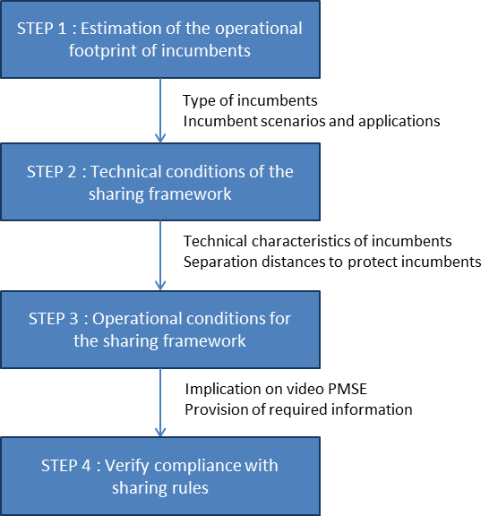

Figure 6: Step-by-step approach

Step 1: Estimation of the operational footprint of incumbents

Estimation of the operational footprint of radars
In the first step, the administration considers the incumbent use and their usage pattern in terms of spectrum utilisation across a certain geographic area. The knowledge on how spectrum is actually used is essential and the extent of the radar use should be determined at the national level. However, it is necessary to identify radar uses in neighbouring countries in order to estimate the footprint of radar cross-borders. Thus, it will be possible to determine the availability of spectrum resources that can be shared.
In order to estimate the operational footprint for radars, several parameters need to be known:
- Type of radars: civil S-band radars, military radars, mobile bird-strike radars, meteorological radars;
- The location of the radar sites: The radar ground station is normally fixed at a given location;
- The type of usage: permanent or temporary use;
- The frequency bands which need protection, usually known in advance.
The information on the radar usage may be gathered at national level using Table 6 below.
Table 6: Example of reference table to identify radars
Type of radar | Location of radar  (Note 1) | Radar coordinate latitude (WGS84) | Radar coordinate longitude (WGS84) | Altitude above mean sea level (m) | Type of usage | Applicable frequency range  (MHz)
Note 1: In case of mobile radar or if the specific location of the radar cannot be provided, the area in which the radar may be deployed needs to be defined.

Estimation of the operational footprint of other incumbents
In some countries, there are radio astronomy stations using frequencies in the band 2700 -2900 MHz. The information on the radio astronomy usage may be gathered at national level using Table 7 below.
Table 7: Example of reference table to identify radio astronomy
Lo-  ca- ti-  on | Coordi-nate latitude (WGS  84) | Coordi-nate longitude (WGS  84) | Altitude above mean sea level (m) | Centre fre-quency (MHz) | Band-width (MHz) | Mini-mum anten-na noise temperature (K) | Recei-ver noise temperature (K) | Tem-pera-ture (mK) | Spec-tral den-sity (dBW/Hz) | In-  put po-  wer (dBW) | Sur-face power (dBW/m²)

Step 2: Technical conditions of the sharing framework
In step 2, the rules and conditions for sharing are determined. For this, there is a need to identify technical characteristics of the incumbent users and to define the protection criteria, as well as the mechanisms that need to be implemented in order to fulfil the protection of the incumbent services.

Technical characteristics of incumbents
Based on the information on radars gathered in step 1, administrations should identify the relevant radar technical characteristics to be used in the process of determining the protection criteria for the radar based on the national usage.
In absence of this information, administrations may refer to the technical characteristics described in ANNEX 2:, using the worst case parameters.

Separation distances to protect incumbents
According to CEPT Report 61 [4], incumbent radar applications can coexist with video PMSE applications at the same time through the use of either geographic separation if co-frequency operation is expected or a combination of separation distance and frequency separation if co-located operation is anticipated.
In order to protect radars from harmful interferences, separation distances are needed. Examples of the separation distances defined for radar stations are given in section 4 (see Table 4).
However, the separation distances may be larger, if aggregated interference or more sensitive radars or other propagation conditions such as rural or suburban have to be taken into account. The separation distances may also vary depending on the deployment scenario of the video PMSE (such as indoor use) and the radar (such as antenna height and terrain).
As a result, for each radar to be protected, it is preferable to perform a case-by-case analysis, for example using the technical options presented in the following section.

Technical options for sharing
In order to protect radars (e.g. the incumbent) from harmful interferences, an exclusion zone and a protection zone may be defined for each radar’s site. An exclusion zone (or protection zone) is typically defined as a circle of few kilometres centred on the radar location.
A definition for each type of zone is given below:
Exclusion Zone: A geographical area within which interferers are not allowed to have active radio transmitters. An exclusion zone is normally applicable for a defined frequency range.
A practical implementation would be to list all exclusion zones in a reference table with the following information:
Table 8: Example of reference table to identify exclusion zones
Reference or site name | Center point or perimeter of the site | Site coordinate latitude (WGS84) | Site coordinate longitude (WGS84) | Applicable frequency range (MHz) | Time period when the restriction is applicable, if relevant

Protection Zone: A geographical area within which victim receivers will not be subject to harmful interference caused by interferer transmissions. A protection zone is normally applicable for a defined frequency range.
Determination of the protection zone: NRA imposes that the electromagnetic field (E) emitted by all interferer transmitters operating in co-channel and/or adjacent channels of the victim receivers does not exceed a level dBµV/m/MHz within the defined protection zones i.e. a mean field strength that does not exceed a defined value in dBµV/m/MHz at a defined receiver antenna height above ground level.
The victim receiver sensitivity is converted from receiver’s received power level in dBm to field strength E (in dBµV/m) using the following equation, in accordance with Recommendation ITU-R P.525 [22]:
E (dBµV/m) = (IC – Gr + Pfr) + 20 log10 (freq(MHz)) + 77,21 (1)
with:
- IC is the Interference Criterion at the receiver (dBm);
- Gr is receiver antenna gain in the direction of the interfering site;
- Pfr is cable and feeder loss at receiver (dB).
E (dBµV/m) above is given for co-channel situation. For adjacent channel situation, a computed correction factor should be added.
A practical implementation would be to list all protection zones in a reference table with the following information:
Table 9: Example of reference table to identify protection zones
Reference or site name | Centre point or perimeter of the site | Site coordinate latitude (WGS84) | Site coordinate longitude (WGS84) | Altitude above mean sea level (m) | Receiver antenna height above ground level (m) | Maximum allowable E (dBµV/m) | Applicable frequency range (MHz) | Time period when the restriction is applicable

Figure 7 illustrates the exclusion zone and the protection zone of incumbent as described above:
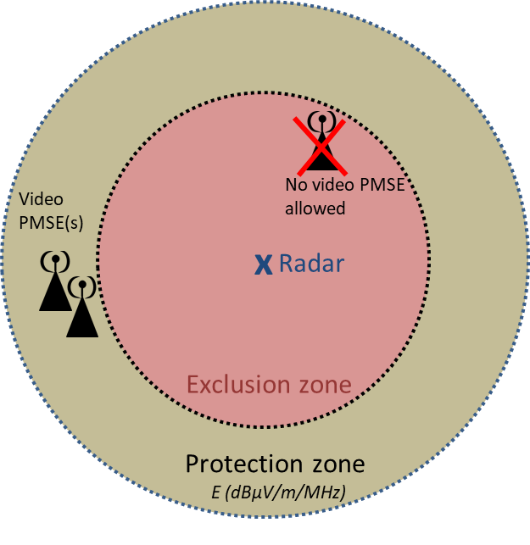 | Exclusion zone of radar(s) within which video PMSE(s) are not allowed to have active radio transmitters.  Protection zone of radar(s) within which the aggregate of video PMSE transmissions does not exceed the defined maximum permitted electric field strength (in dBµV/m/MHz) at a defined receiver antenna height above ground level in order to protect the incumbents from harmful interference
Figure 7: Exclusion zone and the protection zone of incumbent

Step 3: Operational conditions for the sharing framework
In Step 3, the administration sets the authorisation process in a fair, transparent and non-discriminatory manner, in accordance with the sharing framework. Different national administrations might adopt different approaches in defining the licence conditions, depending on their available resources and national circumstances.
In some countries, administrations may need to implement specific measures for the use of video PMSE on a case-by-case basis in order to protect radio astronomy stations in the band 2700-2900 MHz.
The operation of the radar at a given position is to be protected from the interference arising from the video PMSE transmitters. In order to guarantee the protection zone around the radar receiver, it is necessary to perform interference calculations.

Implication on video PMSE
The implications on the protection zone and video PMSE transmitters depend on the information on the considered radar gathered using Table 6. National databases or ad-hoc information on the radar receiver positions might be required and updated. Cross-border issues should also be considered (see section 6).
Furthermore, the amount of spectrum available for video PMSE depends upon a number of factors including decisions on the level of protection given to the incumbent services and how well the video PMSE can cope with interference from these incumbent services and other video PMSE.
In consequence, the exact amount of available spectrum at any location will be dependent upon each national situation or circumstances (e.g. ATC civil and military uses, Radar Meteorological use and Radio Astronomy use).
Required separation distances are defined in section 4 to insure the protection of incumbents. However, a greater distance may be needed to guarantee the quality of the service of video PMSE with regards to the C/I protection criteria for the protection of video PMSE in a worst-case configuration.
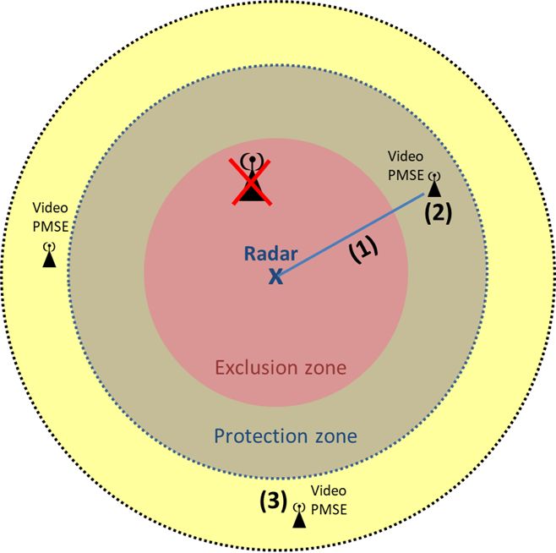 | (1) Separation distance required between incumbents and video PMSE(s).  (2) Geographical area within which the video PMSE is not protected from harmful interference from incumbents if the C/I protection criterion is not respected  (3) Geographical area within which the quality of the service of video PMSE may be acceptable if the C/I protection criterion is respected
Figure 8: Exclusion zone, protection zone and impact on video PMSE

In many cases, due to its nature, the use of video PMSE will require quick and efficient process (hours rather than days) to issue the licence/authorisation. Accordingly, provision of required information must be carried out prior to any interference calculations allowing administration/NRA to respond to requests for licence/authorisation in a very short time.

Provision of required information
The information required by the video PMSE for the protection of the radars can be categorised into information which can be provided only once during the sharing framework and into information that is needed when a new protection zone is required.
The values for the maximum field strength are defined in the beginning of the sharing framework. The values may vary between different radar types. However they should remain stable throughout the sharing arrangement and may be made available in a database.
For administrations considering the dynamic protection of radar receivers (e.g. mobile radars), some information needs to be provided by the radar user upon each of its requests for a new protection zone. This kind of information includes at minimum the type, location and frequency of the radar receiver to be protected and may also include further information relevant for the process.
A secure means is needed so that the radar user can provide dynamic information on a scheduled protection zone beforehand. This could be done e.g. via mobile phone or a web browser.
Automatic or on-demand tracking of the radars could be used for gathering the information in the case of immediate need for the protection zone. It would also aid in supporting the mobility of the radar receiver.

Step 4: Verification of compliance with conditions of the sharing framework
In Step 4, the administration may adopt methods to verify that the use of the band 2700-2900MHz by video PMSE is in compliance with the sharing rules. All the possible approaches might be complemented by prior measurement results and/or monitoring of the additional video PMSE users’/new entrants’ deployments and appropriate regulatory action (e.g. enforcement measures already provided in the licence) in response to cases of possible interference. These include, for instance, field monitoring systems or the adoption of specific validation process to be applied before a new video PMSE enters in operation. Challenges to the effectiveness of field monitoring methods arise from low incumbent protection levels, time dependency as well as aggregate interference from multiple base stations. This needs to be considered and may require regulatory oversight. The administration should implement all necessary measures to ensure that conditions in the licence are fulfilled by the video PMSE during each event.
Such operational conditions shall benefit from a legal basis ,i.e. reference in National Frequency Table Allocation (NFTA) or any other national legal tools, and such national framework shall be made publicly available with relevant details (such as contact point, explanation, FAQ, timing to apply and to access to the available spectrum, etc.).

Regulatory consideration for implementing A sharing framework for the use of video PMSE in the band 2700-2900 MHz

National sharing framework approach for the use of video PMSE in the band 2700-2900 MHz
Administrations wishing to implement video PMSE in the band 2700-2900 MHz are advised to conduct national studies in order to get a more efficient sharing and to consider in their studies the coexistence between video PMSE and incumbents (see section 5.1) as well as cross-border coordination aspects as described in section 6.
Respective technical studies have to be performed at national level. This may require considering, as appropriate, interference in both directions, and the co-frequency and adjacent frequency compatibility scenarios.
The national sharing framework will define the spectrum with corresponding technical and operational conditions that can be made available for Video PMSE. National administrations should decide which existing applications in their country need to be considered as incumbents while carrying out sharing studies.
Several stakeholders must cooperate closely together at national level in order to introduce video PMSE in the band 2700-2900 MHz:
- The administration/NRA;
- The incumbent(s) (i.e. Air Navigation Service Providers (ANSPs); Civil Aviation Authority (CAA), Military, National Supervisory Authority (NSA) and affected Airports, Meteorological Radars, …);
- The prospective video PMSE user(s).
The exact nature and implementation of video PMSE in the band 2700-2900 MHz is likely to differ from country to country, in order to adapt to national circumstances.
In any case, the introduction of video PMSE in the band 2700-2900 MHz will always require:
- An extensive coordination involving administration/NRA, Incumbent(s) and prospective video PMSE Licensees, in order to define a successful sharing framework;
- The administration/NRA issuing an individual temporary licence to the video PMSE user.
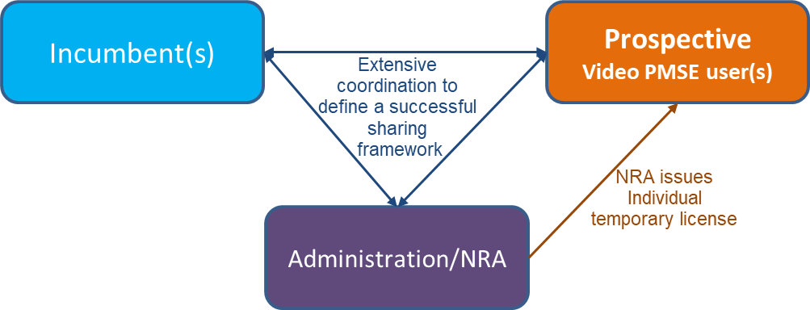
Figure 9: Regulatory process required before the introduction of video PMSE
in the band 2700-2900 MHz
It should be noted that this process would require that the three parties are clearly identified.
It is important to note that the quality of the service that can be delivered by a video PMSE operator is dependent on the situation in the band and will be determined by the usage scenarios of the incumbent(s). Video PMSE users need to have knowledge of the level of interference they may face including the use of mobile radars.
Furthermore, as the band 2700-2900 MHz is used for air traffic control (ATC) for civil and military purposes as well as meteorological radars, the introduction of video PMSE in this band would change the RF environment. In consequence, safety case, safety risk and security assessments of the Air Traffic Management (ATM) infrastructure will need to be conducted. This will involve input and participation of NRA, the CAA and NSA and other competent parties (e.g. Military, ANSPs, etc.).

Functional blocks and interactions
The use of one or several national databases may be required when implementing video PMSE in the band 2700-2900 MHz on a national basis. These databases may be managed by administration, the NRA or the incumbent. Their main functionalities are:
- To deliver information on spectrum availability and associated conditions when this information is subject to changes over time;
- To manage the access to the spectrum made available to the video PMSE user based on sharing rules and information on the incumbent’s use. It retrieves information about spectrum from the database through a secure and reliable communication path. This task could be carried out by a person instead of database(s).
Such databases would contain in particular the relevant information on spectrum sharing that must be protected, together with the level of protection provided by the incumbent(s).
Figure 10 below depicts an example of spectrum sharing functional blocks and interactions in the band 2700-2900 MHz.
Steps should be taken such that appropriate confidentiality and information sensitivity/security requirements are met.
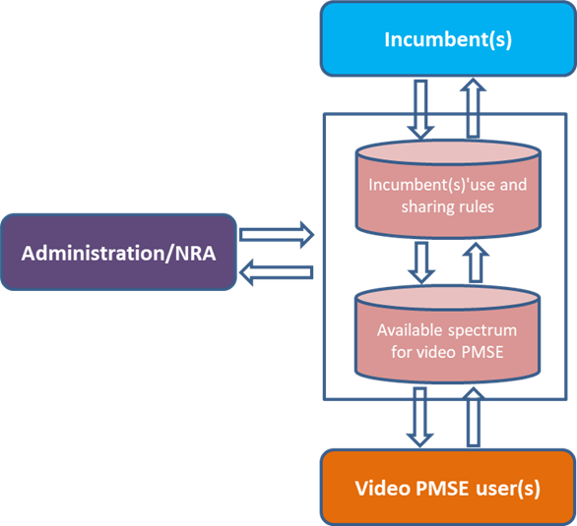
Figure 10: An example of spectrum sharing functional blocks and interactions

Operational Process for the use of video PMSE in the band in 2700-2900 MHz
This section aims to assist administrations in deciding the national framework for sharing spectrum between incumbent systems and video PMSE in the band in 2700-2900 MHz. The following operational process provides information on the process applied for the introduction of video PMSE in the band in 2700-2900 MHz by one administration.

Update of the National Table of Frequency Allocation (NTFA)
Setting-up the national framework for the use of the band 2700-2900 MHz by Video PMSE could be complex and depends on national context. After defining its national regulatory framework, the administration updated its NTFA to allow the use of video PMSE in this band.

Coordination agreement
If the sharing conditions are set out in the form of "coordination distances" for the protection of incumbents, it is possible to have geographical areas in which authorisation of Video PMSE is accepted under the coordination agreement between the administration/NRA and the incumbents. Outside of these agreed areas, a more detailed process of coordination will be required before authorisation can be given.
The coordination agreement with the incumbents with respect to a given transmitter is considered as implicit for any video PMSE use beyond the coordination distance and in compliance with associated conditions of use (antenna height, maximum e.i.r.p. and frequency) by the administration. Also, the agreements provide the necessary legal certainty that allowed the administration to decide on a frequency authorisation usage for video PMSE in the band 2700-2900 MHz based on the criteria of "implicit coordination agreement", i.e. without requiring interaction with the concerned incumbent.

In other cases, a compatibility calculation is carried out by the administration, or a formal coordination will be necessary with the concerned incumbent. This occurs when no public information on the number and location of radar sites is available (e.g. military radars). The latter provides the exclusion and/or protection zones and frequencies that will not be available for video PMSE use.
Any changes to exclusion and/or protection zones related to the protection of fixed, mobile and sea radars and the creation of temporary exclusion and/or protection zones for the protection of mobile radars are, in normal situations, communicated to the administration with prior notice of at least 30 days for their effect. An exceptional situation may require military to deploy radars with fewer than 30 days' notice. In this case, the exclusion and/or protection zones may have to be taken into account with immediate effect.
Finally, the administration takes an anticipatory approach, especially when dates and locations of major events are known in advance.
With regard to the coordination agreement described above, a non-exhaustive list of potential frequencies available for video PMSE in the frequency band 2700 – 2900 MHz is given in Annex 3.

Frequency licencing/authorisation
Frequency licencing/authorisation are subject to technical coordination with incumbent systems (see section above). Individual temporary licences (e.g. not exceeding two months duration) are required for video PMSE to use the band 2700-2900 MHz.

Cross-border coordination aspects regarding the frequency band
2700-2900 MHz
The necessary separation distances need to take terrain height above sea level into account and may lead to cross-border coordination requirements, depending on the location and operational characteristics where the video PMSE will operate. In cases where technical parameters do not allow calculations to be made (for example when a list of radars is not available, or their technical parameters are unavailable), an exclusion zone may be appropriate. Cross-border coordination is usually conducted through bilateral agreements contracted between relevant administrations/NRAs. Temporary individual licences for video PMSE in the band 2700-2900 MHz issued at national level should include the terms and conditions of such coordination agreements. CEPT may conduct studies and produce guidelines in order to support administrations/NRAs in their bilateral or multilateral negotiations.
The following steps can be used to define the coordination trigger levels:
  - Identify in cooperation with the administration of the neighbouring countries the incumbent systems operating in the 2700-2900 MHz band as services required to be addressed in the coordination process;
  - Determine in which sub-bands of the 2700-2900 MHz band the identified systems are used;
  - Conduct studies on a case-by-case basis in order to define frequency coordination conditions.
Referring to the ECC Recommendation (02)09 [21], an administration is considered to be affected if the field strength produced by a video PMSE transmitter exceeds the trigger level value of -2 dBµV/m at a height of 1.5 meters above the ground level at or within its border.
The field strength is to be calculated using the latest version of Recommendation ITU-R P.452, assuming p= 0.001%, considered together with a topographical data base.
The victim receiver sensitivity is converted from receiver’s received power level in dBm to field strength E (in dBµV/m) using the equation (1) in section 5.1.2.3.
When coordination is requested, the following characteristics of video PMSE transmitters should be provided to the administration(s) affected unless otherwise laid down in bilateral or multilateral agreements:
- Carrier frequency (MHz);
- Name of transmitter station;
- Country of location of transmitter station;
- Geographical coordinates (W/E, N) (location, or route/area of mobile operation);
- Peak terrain height;
- Effective antenna height (m) a.g.l.;
- Antenna polarisation;
- Antenna azimuth (deg);
- Directivity in antenna systems or antenna gain (dBi);
- Effective radiated power (dBW);
- Expected coverage zone or radius (km);
- Start and end of licence (date, month, year).

Conclusions
This ECC Report defines best practice on usage of 2700-2900 MHz band by video PMSE, taking into account incumbent users in band and also cross-border coordination aspects.
It aims to provide tools to facilitate the introduction of Video PMSE in the 2700-2900 MHz band by developing a step-by-step spectrum sharing framework between incumbent systems and video PMSE before setting up a national framework. It does not consider interference into video PMSE from incumbent services.
This Report covers only the case when individual temporary licences are issued for PMSE video in the 2700-2900 MHz band as confirmed by CEPT in CEPT Report 51 [1] and CEPT Report 61 [4].
In addition, coordination agreements of incumbents are also necessary after defining coordination distances or other technical options of sharing (i.e. exclusions zones and/or protection zones). With these agreements, the duration of the authorisation process for the use of the 2700-2900 MHz band by video PMSE could be reduced considerably by limiting interactions with the relevant incumbents only when it is really necessary (for example, no public information on the number and location of some incumbent transmitters is available).
Administrations that decide to make the 2700-2900 MHz band available for video PMSE on a national level can use the guidance provided in the present Report and also take additional measures to guarantee the quality of service of video PMSE when spectrum is available in a given area.
The report includes an indication of the amount of spectrum potentially available for video PMSE in the frequency band 2700 – 2900 MHZ in specific locations in France when applying the guidance given in this Report to the French national plan.

- Operational and regulatory aspects for ATC radars
This annex provides additional information on operational and regulatory aspects for ATC radars, also by taking into account the requirements from the ITU Radio Regulations, which are also relevant for the case by case compatibility considerations on national level:
- The technical and operational aspects related to Primary Surveillance Radars (PSR) used for the Air Traffic Control (ATC) are provided in ECC Report 243 [2];
- According to the ITU Radio Regulations [8], PSR is operated under the primary allocation to the Aeronautical Radionavigation service in the band 2.7-2.9 GHz whilst there is no allocation to the mobile service in this band;
- Video PMSE equipment shall not cause harmful interference to radars and cannot claim protection from these radars;
- ECC Report 243 identified a maximum separation distance of 182 km between an ATC PSR and a video PMSE transmitter under specific conditions; this would require a cross-border coordination between administrations;
- Where a high number of PSR exists in the band 2700-2900 MHz, PSR stations are already operating close to the probability of detection of aircraft specified by Eurocontrol for civil and military ATC. The national coordination for a potential introduction of video PMSE would be more complex in this case to meet the required detection probability;
- Loss of detection of PSR aircraft target is insidious, because there is no warning display technically possible to warn ATC controllers that one or more aircrafts have not been detected due to PMSE interferences. PSR unreliable for target detection would reduce the overall traffic capacity because higher aircraft separation would have to be implemented;
- ATC PSR is the only means for ATC control to detect and control aircraft undetectable for ATC Secondary Surveillance Radar (SSR), e.g. during solar storms, when SSR transponders are defective, aircraft not mandated to be equipped with SSR transponder, or when the SSR transponder has been disabled intentionally, e.g. as a result of hostile actions;
- ATC PSR requires simultaneous operation of 2 or more frequencies to achieve the required detection ranges of up to 222 km. PSR are mostly but not only located at or nearby airports. Airports are often in or close to areas with a high density of population, where more than 4 PSR could have overlapping coverage. Therefore in some countries a high probability to be in a co-channel interference situation has to be assumed, while in other countries the opportunities for video PMSE would be more optimistic.
The band 2700-2900 MHz is used for civil and military Air Traffic Control (ATC) by using Primary Surveillance Radar (ATC-PSR), for detection of all aircraft. It works as a fall-back to Secondary Surveillance Radar (SSR) detection, when SSR detection fails.
Aircraft that are undetectable by SSR, during times of strong solar flares like those occurring in November 2015 in Northern Europe, whenever aircrafts are not are equipped with SSR transponder, when aircraft transponder are dysfunctional, e.g. due to over-interrogation as it occurred on several days in June 2014, or when the transponder are defective or have been deactivated intentionally by hostile action.
Non-Cooperative Surveillance Sensors (NCS) or Primary Surveillance Radars as they are traditionally known as, are essential components of a safe and efficient civilian and military ATM infrastructure. Their use is required enroute and in Major TMA airspace in order to meet the requirements of the Eurocontrol surveillance standard published in 1997. Implementing Regulation EU 1207-2011 published by the European Commission requires Air Navigation Service Providers to conduct a safety case assessment of their ATM infrastructure to be able to provide a safe separation between aircrafts and UAV’s. The findings of which normally require non-cooperative surveillance in order to detect aircraft without SSR or ADS-B avionics infringing in to controlled airspace or to support controllers mitigate the effects of an avionics failure on board their aircraft. Aviation makes a major contribution to the economies of a State. It is essential that ATM supports safe and efficient operations – NCS are crucial and their role and importance in achieving this should not be underrated or compromised. If a country can’t provide safe air traffic control, it has to introduce restrictions in the number of aircrafts that will be allowed to enter the airspace.
Interference free operation of PSR is therefore the necessary prerequisite in providing the safety of life service for Air Traffic Control. Primary surveillance target losses due to interference are insidious, because they do not cause any indication on an ATC display, which would inform an ATC controller of lost targets. An extremely high sensitivity and at least dual frequency operation (frequency diversity) is required, to allow Detection of aircraft in distances of up to 120 NM with a radar cross section of 1 m² or larger under all operational weather conditions and anomalous propagation conditions is therefore the prerequisite for the safety of life ATC service.
Due to the high sensitivity it is important to provide sufficient distance and frequency separation, between the existing and new S-Band ATC radar within confinements of the band 2700-2900 MHz. Frequencies for ATC S-Band PSR systems are not assigned based on a channel system, but are assigned in 0.5 MHz steps within the band 2700-2900 MHz on any frequency that allows safe operation within the existing environment in the S-Band. Coordination of S-Band ATC PSR, account among other factors for existing S-Band PSR radars around a location, terrain, e.i.r.p., and technical differences between designs, e.g. frequency offset between the diversity centre frequencies, transmission of short pulse or pulse compressed signals. It also does not account for propagation probabilities, 95% of the time for ATC radar and 5%of the time probabilities for the interferer PMSE, using the aeronautical propagation Model ITU-R P.528 (based on IF-77 by Gierhart-Johnson).
Radar systems do operate on any frequency in the band 2700-2900 MHz that allows compatibility to other radar stations.
Therefore, in all cases where the bandwidth frequency of PSR overlaps totally or partially some PMSE channels, these channels have to be considered as co-channel with PSR. Alternatively, it may be possible to shift PMSE centre frequency to avoid overlap and to consider them as adjacent channels. While most S-Band ATC PSR are located at and around airports, where they are already subject to a very high number of undesired echoes, e.g. from ground or airborne surfaces (e.g. clouds, birds, vehicles, MM- and land based structures), they can be found also on exposed locations like mountains.
An assessment requires measurements on S-Band ATC PSR under normal operational conditions, for all the different operational S-Band ATC PSR designs in use, including measurements of those S-Band ATC PSRs available on the market, since many states (e.g. Germany, Switzerland and , The Netherlands) are in the process to renew PSR ATC radar sensors.
Interference in radar is not just a function of the energy received within the receiver pass band and its impact onto the radar receiver. Impact depends to a large degree on the design of the radar receiver, e.g. type of preselector, LNA or type of stages used for processing. Technical parameters of radar, e.g. selectivity, vary from radar design to design and the detection requirements, like range and radar cross section of targets that a design has to be able to detect. This is the reason why some S-Band ATC PSR system radars therefore even have been designed with a bandwidth of a few hundred MHz for multiple frequency diversity PSR designs.
Furthermore, only measurements allow establishing the interference parameter for a given PSR design, when the measurements are conducted when the radar is operating in the normal operational Extraneous Signal Environment (ESE). The impact of an interfering signal in an already dense signal requirement will lead to a faster degradation of the Probability of Detection (Pd) and in consequence to target losses. Purely theoretical studies do not account for interference mechanism of PSR designs that can only be measured on a case-by-case basis at an operational PSR, and in an operational RADAR ESE which already operates in challenged conditions.
- ATC/defence and meteorological radar characteristics
The characteristics of the ATC/defence and meteorological radars in the band 2700-2900 MHz are summarised in Table 9. They originate from CEPT Report 61.
The technical and operational aspects related to Primary Surveillance Radars (PSR) used for the Air Traffic Control (ATC) are provided in ECC Report 243 [2] (see also ANNEX 1).
Table 11: ATC/defence and meteorological radar characteristics
Parameter | Unit | ATC /defence |  |  |  | Meteorology
Parameter | Unit | Type 1 | Type 2 | 3 |  | Type 4
Category |  | Frequency hopping | 2 to 4 frequencies |  |  | Single frequency
Maximum antenna gain | dBi | > 40 | 34 |  |  | 43
Antenna pattern |  | Not given | Vertical pattern cosecant-squared |  |  | Recommendation ITU-R F.1245-2 [11]
Antenna height | m | 5-40 (normal 12) |  |  |  | 7-21 (normal 13)
Polarisation |  | Circular |  |  |  | H/V
Feeder loss | dB | < 1 |  | Not given |  | 2
Minimum elevation angle | ° | Not given | 2 (Recommendation ITU-R M.1851 [12]) |  |  | 0.5
Protection level | dBm/MHz | -122 (for I/N = -10 dB)
1 dB compression point | dBm | -20 (Recommendation ITU-R M.1464-2 [13]) |  |  |  | 10
Blocking level | dBm | -36 | -36 | -36 |  | -36
Transmission power | kW | 1000 | 400 | 30 |  | 794
Reference bandwidth | kHz | 2500 | 1000 | 800 |  | 1000
40 dB bandwidth | MHz | 9.5 | 20 | 4 | 2 | Annex 1 of ECC Report 174 [10]
Out-of-band roll off | dB/decade | 20 | 20 | 20 |  | 40
Spurious level | dBc | -60 | -60 | -60 |  | -60 for old radars and -75 to -90 for new radars
Unwanted emission mask |  | To be calculated using elements above + Annex 2 of ECC Report 174 [10] |  |  |  | Annex 1 of ECC Report 174 [10]
Pulse repetition rate | Hz | < 300 | ~ 1000 | 825 |  | 250-1200  (Recommendation ITU-R M.1849-1 [14])
Pulse duration | µs | 20 and 100 | 1 | 1 | 100 | 0.8-2
Rise and fall time | % of pulse length | 1 % | 10 % | 16.9 % | Not given | 10 %
Antenna rotation | rpm | 6-12 | 12-15 | 15 |  | Recommendation ITU-R M.1849-1 [14]
Scan in elevation |  | Not given | Fixed |  |  | Recommendation ITU-R M.1849-1 [14]
Selectivity | dBc | -60 | -60 |  |  | -60

- spectrum potentially available for video PMSE in the frequency band 2700 – 2900 MHz in Paris and in Le Mans (France)
This Annex indicates the amount of spectrum potentially available for video PMSE in the frequency band 2700 – 2900 MHZ in Paris and in Le Mans (France) with respects to the coordination agreement described in section 5.3.2.
  - Coordination distances
Exemplary national coordination agreements specifying the provisions of sharing conditions for the protection of radar systems in the 2700-2900 MHz band and radio astronomy station of Nançay in the 2690-2700 MHz and 2700-2735 MHz bands are presented in Table 11:
Table 11: Reference coordination distances to ensure the protection of ATC and meteorological radars
Video PMSE equipment |  | Coordination distance
Maximum transmitter antenna height (m) over the ground | e.i.r.p. (dBW) | Co-channel | Offset between PMSE centre frequency and edge of receiver radar bandwidth between 5 MHz and 35 MHz | Offset between PMSE centre frequency and edge of receiver radar bandwidth ≥ 35 MHz
1.5 m | 0 dBW | $$>d_{horizon radio}$$  (Note 1) | ATC: 3 km  Meteorological radars: 6 km | 0 km
10 m | 20 dBW | $$>d_{horizon radio}$$  (Note 1) | ATC: 16 km  Meteorological radars: 33 km | 0 km
Note 1: $d_{horizon radio}=\sqrt{2 ×H ×{Re}^{2}}$ is the geometrical distance from the radar to the horizon taking into account the height H of the radar above sea-level, and the radius of the earth Re (approximately 6.4 x103 km). In co-channel, the $d_{horizon radio}$ with respect to the radar defines its exclusion zone. In consequence, co-channel sharing with Video PMSE beyond the radio horizon over radar is possible. In other cases, coordination agreement with ATC and meteorological radars will be considered as implicit for any video PMSE use beyond the coordination distances provided above and respecting the associated conditions of use (antenna height, power emission and frequency of video PMSE).

Table 12: Reference coordination distances to ensure the protection of radio astronomy station of Nançay
Video PMSE equipment |  | Coordination distance
Maximum transmitter antenna height (m) over the ground | e.i.r.p. (dBW) | 2700-2735 MHz  (co-channel) | 2735-2745 MHz | 2745-2755 MHz | 2755-2900 MHz
1.5 m | 0 dBW | Coordination is required  (Note 1) | 125 km | 90 km | 60 km
Note 1: For the co-channel case, compatibility studies to protect the radio astronomy station of Nançay will be necessary. In accordance with Recommendation ITU-R RA.769 the maximum power received in the 2700-2735 MHz band is -202 dBW/35MHz, or -187 dBm/MHz for 98% of the time.

For adjacent channel cases, the coordination agreement with radio astronomy will be considered as implicit for any video PMSE use beyond the coordination distances provided in Table 12 and respecting the associated conditions of use (antenna height, power emission and frequency of video PMSE).
  - Resulting spectrum potentially available
Four locations were investigated as events are known in advance and occur each year:
- Rolland Garros stadium in Paris for French Open tennis tournament
- Saint-Denis stadium (Stade de France) for regular football matches and shows
- Champs Elysées in Paris for the Military parade of 14th of July
- Le Mans for the “24h du Mans” and the “Grand-Prix de France Moto”
In order to ensure the protection of the existing systems, distance of each site from ATC, Military, meteorological radars and Radio Astronomy are defined in the table below:
Table 13: Corresponding distance of each site from ATC, Military, meteorological radars
and Radio Astronomy
Radar Station |  | Rolland Garros | Champs Elysées | Stade de France | Le Mans
Civil Aviation | Charles de Gaulle | 32 km | 27 km | 20 km | 213 km
Civil Aviation | Orly | 16 km | 16 km | 22 km | 183 km
Radio Astronomy | Nançay | 160 km | 165 km | 180 km | 162 km
Meteorology | Bordeaux | > 500 km | > 500 km | > 500 km | > 350 km
Military | (fixed station) | 75 km | 81 km | 80 km | 68 km
The coordination with Military (as detail information are confidential) and Radio Astronomy are necessary but should not be an issue with regards to the separation distance required for the protection of these stations.
The results of studies on frequencies potentially available for video PMSE in the band 2700 – 2900 MHz are provided in the following tables:

Table 14: Details of frequencies potentially available for video PMSE
in the frequency band 2700- 2900 MHz in Paris and in Le Mans
Centre Frequency (MHz) | Rolland Garros | Stade de France | Champs Elysées | Le Mans
2705 | COO RST | COO RST | COO RST | COO RST
2715 | COO RST | COO RST | COO RST | COO RST
2725 | COO RST | COO RST | COO RST | COO RST
2735 | COO RST | COO RST | COO RST | COO RST
2745 | Not available | Not available | Not available | Available
2755 | Not available | Not available | Not available | Available
2765 | Not available | Not available | Not available | Available
2775 | Not available | Not available | Not available | Available
2785 | Not available | Not available | Not available | Available
2795 | Available | Available | Available | Available
2805 | Available | Available | Available | Available
2815 | Not available | Not available | Not available | Available
2825 | Not available | Not available | Not available | Available
2835 | Not available | Not available | Not available | Available
2845 | Available | Available | Available | Available
2855 | Available | Available | Available | Available
2865 | Available | Available | Available | Available
2875 | Available | Available | Available | Available
2885 | Available | Available | Available | Available
2895 | Available | Available | Available | Available
COO RST: Available spectrum under coordination with Radio Astronomy
Table 15: Amount of spectrum potentially available for video PMSE
in the frequency band 2700- 2900 MHz
Amount of Spectrum | Rolland Garros | Stade de France | Champs Elysées | Le Mans
Non available spectrum | 80 MHz (40%) | 80 MHz (40%) | 80 MHz (40%) | 0%
Spectrum under coordination with Radio Astronomy (1) | 40 MHz (20 %) | 40 MHz (20 %) | 40 MHz (20 %) | 40 MHz (20 %)
Available spectrum (2) | 80 MHz (40%) | 80 MHz (40%) | 80 MHz (40%) | 80 MHz (60%)
Video PMSE (1)+(2) | 120 MHz (60%) | 120 MHz (60%) | 120 MHz (60%) | 200 MHz (100%)
Conclusion: 60% of amount of spectrum are potentially available for video PMSE
in the frequency band 2700- 2900 MHz in Paris and 100% in Mans subject to non-deployment of Military mobile radars during each event.

- List of reference
- CEPT Report 51: "Report B from CEPT to the European Commission in response to the Mandate “On technical conditions regarding spectrum harmonisation options for wireless radio microphones and cordless video-cameras” - Technical conditions for ensuring the sustainable operation of cordless video-cameras", November 2013
- ECC Report 243: "Wireless video links in the frequency bands 2700-2900 MHz and 2900-3400 MHz", January 2016
- Mandate to CEPT to study and identify harmonised compatibility and sharing conditions for Video PMSE in the 2.7 – 2.9 GHz frequency band, taking into account radar use, 14 July 2015
- CEPT Report 61: "Report from CEPT to the European Commission in response to the Mandate "Harmonised compatibility and sharing conditions for video PMSE in the 2700-2900 MHz", June 2016
- ERC Recommendation 25-10: "Frequency ranges for the use of terrestrial audio and video Programme Making and Special Events (PMSE) applications", amended October 2016
- ECC Report 204: "Spectrum use and future requirements for PMSE", February 2014
- ECC Report 219: "Characteristics of PMSE digital video links to be used in compatibility and sharing studies", October 2014
- ITU Radio Regulations - Edition of 2016
- ECC Report 006: "Technical impact on existing primary services in the band 2700–2900 MHz due to the proposed introduction of new systems", June 2002
- ECC Report 174: "Compatibility between the mobile service in the band 2500-2690 MHz and the radiodetermination service in the band 2700-2900 MHz", March 2012
- Recommendation ITU-R F.1245-2 (03/2012): "Mathematical model of average and related radiation patterns for line-of-sight point-to-point radio-relay system antennas for use in certain coordination studies and interference assessment in the frequency range from 1 GHz to about 70 GHz"
- Recommendation ITU-R M.1851 (06/2009): "Mathematical models for radiodetermination radar systems antenna patterns for use in interference analyses"
- Recommendation ITU-R M.1464-2 (02/2015): "Characteristics of radiolocation radars, and characteristics and protection criteria for sharing studies for aeronautical radionavigation and meteorological radars in the radiodetermination service operating in the frequency band 2 700-2 900 MHz"
- Recommendation ITU-R M.1849-1 (09/2015): "Technical and operational aspects of ground-based meteorological radars"
- Recommendation ITU-R RS.1861 (01/2010): "Typical technical and operational characteristics of Earth exploration-satellite service (passive) systems using allocations between 1.4 and 275 GHz"
- Recommendation ITU-R RA.769-2 (1992-1995-2003): "Protection criteria used for radio astronomical measurements"
- ECC Decision (05)05: "Harmonised utilisation of spectrum for Mobile/Fixed Communications Networks (MFCN) operating within the band 2500-2690 MHz", approved March 2005 and amended July 2015
- Commission decision 2008/477/EC of 13 June 2008 on the harmonisation of the 2 500-2 690 MHz frequency band for terrestrial systems capable of providing electronic communications services in the Community
- Recommendation ITU-R P.1411-8 (07/2015): "Propagation data and prediction methods for the planning of short-range outdoor radiocommunication systems and radio local area networks in the frequency range 300 MHz to 100 GHz"
- Recommendation ITU-R P.452-16 (07/2015): "Prediction procedure for the evaluation of microwave interference between stations on the surface of the Earth at frequencies above about 0.1 GHz"
- ECC Recommendation (02)09: "Protection of aeronautical radio navigation service in the band 2700- 2900 MHz from interference caused by the operation of digital cordless cameras frequency band, taking into account radar use", June 2003
- Recommendation ITU-R P.525-3 (09/2016): "Calculation of free-space attenuation"
- Recommendation ITU-R F.1777-2 (01/2018): System characteristics of television outside broadcast, electronic news gathering and electronic field production in the fixed service for use in sharing studies
- Recommendation ITU-R M.1824-2 (02/2015): “System characteristics of television outside broadcast, electronic news gathering and electronic field production in the mobile service for use in sharing studies”
- NATO Joint Civil/Military Frequency Agreement (NJFA) - Extract for Public Disclosure, 02/2017

Inventory and review of spectrum use: Assessment of the EU potential for improving spectral efficiency", WIK-Consult study for the European Commission, 11 September 2012

