Point-to-Point Radio Links in the Frequency Ranges 92-114.25 GHz and 130-174.8 GHz
approved 14 September 2018
ECC Report 282

Executive summary
This Report provides supporting information and considerations on deployment of Point-to-Point (PP) radio links in the frequency ranges 92-114.25 GHz (referred to as W-band) and 130-174.8 GHz (referred to as D-band).
Considerations on general assumptions are discussed to allow flexible and efficient use of these bands.
Around 15 GHz of spectrum is available in the W-band and more than 30 GHz of spectrum is available in the D-band. Optimised trade-off between very wide channels and spectrum efficiency allows achieving very compact and low power consumption for ultra-high capacity for backhauling and fronthauling and possible Fixed Wireless Access (FWA), depending on administration regulatory regime.
The target capacities expected for these systems are in the order of 1 Gbit/s to more than 10 Gbit/s (40 Gbit/s requirements are currently envisioned), depending on selection of network.
Current high capacity commercial systems in the E-band (71-76 GHz and 81-86 GHz range) have a capacity in the order of 6 Gbit/s per link with a distance of up 1.5 km (depending on the antenna size and required availability). Clearly new spectrum and new technical approach are needed to meet the future requirements.
Continuous frequency slot raster of 250 MHz channels is used across all sub-bands without specifically defining either paired or unpaired use as the better approach for flexible Frequency Division Duplex (FDD) / Time Division Duplex (TDD) deployment and without setting strict limitations on the number of aggregate channels (i.e. no limitation on the maximum channel bandwidth is set).
In this Report, some examples of use cases and deployment scenarios are briefly described highlighting their expected requirements for future wireless transport links and networks. These include 5G mobile transport network which is considered as the main use case for future PP radio network.
Given the very stringent requirements in terms of capacity, latency and availability for 5G, combined with sites densification, it’s likely that in the access and pre-aggregation network segments a mix of different transmission technologies (fibre, millimetric wave (mmW) links and microwave (MW) links) will be needed to connect all radio sites in the network.
The Report presents detailed requirements for 5G networks taking into consideration the deployment scenarios and applications such as macro-cell/small-cell backhauling/fronthauling in both urban/sub-urban environments and including fixed access application. The reported required capacity ranges from 1 Gbit/s to n x10 Gbit/s, with various degrees of latencies and link distances depending on each scenario and application.
It is noted in the Report that the Federal Communication Commission (FCC) considers regulation for Fixed Service (FS) links above 95 GHz and the administration of Japan studies future regulation for the D-band.
The Report also considers licensing aspects for the new bands which are currently unused and discusses appropriate licensing regimes that may be considered for these bands, taking into account that the major foreseen application is the backhauling/fronthauling in mobile networks in both line of sight and street level deployment scenarios with possible additional Fixed Wireless Access (FWA) application.
Propagation characteristics and models available for each band are then considered and used for the analysis of system behaviour aspects when operating in these bands. The following system performance is captured in the Report:
- W-band and D-band gross system gain vs. max hop length for different availabilities and 60 mm/h rain rate;
- Overview of the W-band and the D-band reachable distances for different rain rates, capacity and availabilities.
Technology specific considerations for each band are also presented, giving insight into the feasibility of equipment design and implementation and taking into account the technological state of the art and its readiness to be adopted for the radio systems intended to operate in these bands.
The Report shows that these frequency bands have a great potential to fulfil future demand and requirements of radio links and networks in terms of capacity, latency and availability for 5G transport network, combined with sites densification and deployment flexibility.

TABLE OF CONTENTS

0 Executive summary 2
1 Introduction 7
2 Definitions 8
3 Basic consideration 9
3.1 General assumptions for flexible use of the bands 9
4 Propagation characteristics 10
4.1 GaseouS Attenuation 10
4.2 Rain Attenuation 11
4.2.1 Preliminary experimental data from field trial at the Politecnico of Milan 12
5 Regulation overview 16
5.1 W-Band status in the Radio Regulations 2016 16
5.2 D-band Status in Radio Regulations 2016 16
5.3 frequency bands covered by RR Footnote 5.340 16
5.4 Sharing and Protection of adjacent services 16
5.5 FCC PLan for D-band: 17
5.6 Japan Plan for D-band 17
5.7 License aspects 17
5.7.1 Licensed/license-exempt 17
5.7.2 Review of currently known licensing methods 18
5.7.2.1 Generality 18
5.7.2.2 Link-by-link planning licensing 18
5.7.2.3 License exempt 18
5.7.2.4 Light licensing 18
5.7.2.5 The light block assignment 19
5.7.3 Paired versus unpaired blocks 19
5.7.4 Guidelines on licensing for D-band and W-band 20
6 Applications and use cases 21
6.1 D-band: Backhauling, Fronthauling and Fixed Wireless Access 21
6.2 Use case #1: 5G Mobile Backhauling tail link 21
6.3 Use case#2: Indoor application for Internal Connection of a Data Centre (Inter-Server) 22
6.4 Requirements for future applications in mmwave radio 23
6.5 Future Transport Requirements 24
7 System Behaviours 27
7.1 D-band system simulation 27
8 Technical band specific aspects 31
8.1 New technological possibilities in High Frequencies 31
8.1.1 Possible uses 31
8.2 Traditional allocation of frequencies 31
8.3 Bands and Carrier Aggregation in W-Band and D-Band 33
8.4 92-114.25 GHz band specific aspects 34
8.4.1 General assumptions for flexible use of the bands 34
8.4.1.1 Use of conventional FDD in the range 92-114.25 GHz 35
8.4.1.2 Conclusions on FDD use of 92-114.25 GHz range of frequency 35
8.5 130-174.8 GHz Band specific aspects 37
8.5.1 Frequency limitation 37
8.5.2 Relative BW 37
8.5.3 Diplexer related 37
8.5.4 Separate Tx/Rx antennas 37
9 Conclusions 39
ANNEX 1: Measurement result on D-band 40
ANNEX 2: Impact of reflection study on flexible reduced duplexing 42
ANNEX 3: List of Reference 50

LIST OF ABBREVIATIONS

Abbreviation | Explanation
ACM | Adaptive code and Modulation
BCA | Bands and Carrier Aggregation
BW | Bandwidth
CEPT | European Conference of Postal and Telecommunications Administrations
CS | Channel Spacing
DSD | Drop size distribution
ECC | Electronic Communications Committee
FCC | Federal Communications Commission
FDD | Frequency Division Duplex
fFDD | Flexible FDD
FS | Fixed Service
FWA | Fixed Wireless Access
ITS | Intelligent Transport System
LOS | Line of sight
mmW | Millimetric waves
MW | Microwaves
PP | Point-to-point
PMP | Point-to-multipoint
QoS | Quality of Service
RF | Radio frequency
RR | Radio Regulations
Rx | Receiver
SRD | Short Range Device
TDD | Time Division Duplex
Tx | Transmitter
WAS/RLAN | Wireless Access Systems/Radio Local Access Networks

Introduction
This ECC Report examines new requirements for fixed link applications for covering the demands of forthcoming 5G transport networks and multi-Gigabit/s fixed wireless access.
Large capacity in urban deployment also in both street level and line-of-sight conditions will be needed with stringent requirement in terms of capacity latency and availability in dense deployment scenarios.
Focus has been given to the two allocated bands to the Fixed Service in the frequency ranges in the W-band and D-bands which look attractive for their large spectrum availability and their propagation characteristic perfectly suited for short link with ultra-high capacity in urban and suburban environments.
This Report considers all the above conditions and examines the potential technical characteristics of equipment including innovative technologies made possible by the compact size and highly integrated form factor.
The deployment characteristics and consequently best suitable authorisation regimes are also considered.

Definitions

Term | Definition
W-Band | 92-94 GHz; 94.1-95 GHz; 95-100 GHz; 102-109.5 GHz and 111.8-114.25 GHz
D-Band | 130-134 GHz; 141-148.5 GHz; 151.5-164 GHz and 167-174.7 GHz.
E-Band | 71-76 GHz and 81-86 GHz
V-Band | 57-64 GHz

Basic consideration
The following general considerations are assumed as key driver for the need of new spectrum for Fixed Service (FS):
- Transport capacities in the order of 1 Gbit/s to more than 10 Gbit/s (40 Gbit/s requirements are currently envisioned), depending on the section of network, are often referred to in literature, and are expected to represent a reasonable target;
- Possibility of allowing more than 1 operator (3-4) in same geographical context is also desirable, at least in most real situations;
- Due to this high capacity demand, the need of proper modulation schemes has to be considered as a priority to allow that available bandwidth is sufficient;
- Efficient use of spectrum should be pursued,;
- Current technology allows transport of 1 Gbit/s in a channel size of about 250 MHz, with modulation in the order of 128 QAM. Capacity demand can require aggregating channels for at least 500 MHz to a 2 GHz bandwidth;
- Current high capacity commercial systems in the E-band (71-76 GHz and 81-86 GHz) have the following specifications and capabilities:
- Capacity up to 6 Gbit/s using Dual Polarisation Multiplexing
- Modulation up to 256 QAM
- Channel Separation 250 MHz / 500 MHz
- Efficiency up to 12 bit/s/Hz
- Link Distance up to 1.5 km (depending on the antenna size and required availability)
These do not meet the requirements for the foreseen future applications and use cases. Hence the systems in the new bands must be able to support the new use cases requirements indicated in this Report.
The channel arrangements in ECC/REC/(18)01 [5] and ECC/REC/(18)02 [6] take into consideration specific attenuation due to atmospheric gases which may have a significant impact on the link budgets while ensuring compliance with current regulations.
Continuous frequency slot raster of 250 MHz channels is chosen as the appropriate approach for flexible FDD/TDD deployment:
New approach such as Bands and Carrier Aggregation (BCA) may also be considered for the W-band and D-band to improve capacity and link availability.

General assumptions for flexible use of the bands
- Minimum frequency channel (slot) size: considering the present successful use of E-band and potential higher capacity delivered in those higher bands a 250 MHz size is considered appropriate.
- No strict limitation on the number of aggregate channels (i.e. no limitation on the maximum channel bandwidth) is considered by the relevant Recommendations in ECC/REC/(18)01 [5]and ECC/REC/(18)02 [6][.
- Continuous channel raster extended to all the bands in the two blocks without required paired/unpaired use.
- Maximisation of the possible paired use of the available bands for permitting effective design of conventional FDD implies the coupling of different bands.

Propagation characteristics
The propagation of electromagnetic waves in millimetre-waves and microwaves along terrestrial paths is mainly affected by gaseous attenuation and rain attenuation, with the latter phenomenon being predominant when present.

GaseouS Attenuation
Oxygen and water vapour are the gaseous components of the atmosphere influencing the electromagnetic wave propagation in the frequency range from 10 up to 350 GHz.
The oxygen absorption is mainly due to the resonance of oxygen molecules, which occurs in specific bands with peaks around 60 GHz and 120 GHz. The oxygen concentration depends on the air pressure and temperature.
The water vapour absorption, due to the interaction with water molecules, is associated to three main peaks around 22, 183 and 325 GHz but it is also given by a linear term providing, in general, more attenuation than the one induced by oxygen. Water vapour absorption depends on pressure, temperature and water vapour density.
As the attenuation due to gases is very stable in space (tens of kilometres) and in time (hours), the specific attenuation (dB/km) is typically considered to be constant along terrestrial propagation paths, especially for short links (e.g. less than 1 km).
Under this assumption, the model for the calculation of specific attenuation due to gases is described in Recommendation ITU-R P.676-11 [1].
The following Figure 1 provides accurate information on specific attenuation due to atmospheric gases for the following standard reference meteorological parameters:
- Temperature (T) = 15 °C;
- Pressure (P) = 1013.25 mbar;
- Water vapour density (ρ) = 7.5 g/m³.
Figure 1: Specific attenuation due to atmospheric gases according to Recommendation ITU-R P.676-11
As it can be seen, the gaseous attenuation is quite negligible in the W-band and is below 5 dB/km in the D-band.

Rain Attenuation
Rain represents the main drawback to electromagnetic waves propagation at frequencies above 10 GHz because the hydrometeor size is comparable with the wavelength of the incident wave. Each rain drop causes scattering and absorption on electromagnetic waves, with a consequent attenuation which depends on the Drop size distribution (DSD) within a certain volume (the number of rain drops with given diameter contained in 1 m³).
The rain rate (mm/h) is a function of the drop size distribution and the specific attenuation due to rain can be modelled as γ = kR^{α} as described in Recommendation ITU-R P.838-3 [2].
The behaviour of the specific attenuation as a function of frequency at different rain rates is displayed in the following Figure 2:
Figure 2: Specific attenuation due to rain according to Recommendation ITU-R P.838-3
As it can be seen the rain attenuation is quite flat in frequency and dominant with respect to gaseous attenuation in both W-band and D-bands.
Other types of precipitation such as hail and snow are not considered in this report because their effects on the propagation of the electromagnetic waves are marginal and their occurrence probability well below the one of rain.
It’s important to note that the specific attenuation values depicted in Figure 2 are actually just a reference to give a hint about how intense the fades caused by rain can be; an accurate evaluation should take into account the actual drop size distribution. This is one of the targets of the experimentation currently ongoing in D-band and E-band at the Politecnico of Milan, Italy.

Preliminary experimental data from field trial at the Politecnico of Milan
Since November 2016 a field trial has been setup at the Politecnico of Milan with two parallel radio links over a distance of 325 m, one operating in E-band and the other in D-band, with the goal of characterising the features of the propagation channel at millimetre wave and specifically:
- Calculation of rain attenuation statistics (typically, exceedance probability function), to be submitted to ITU-R for inclusion into the experimental database of ITU-R Study Group 3 as well as to test and improve the rain attenuation model for terrestrial links currently adopted by the Recommendation ITU-R P.530-17 [3];
- Investigation of the impact of the drop size distribution on rain attenuation, in order to compare the results with the outcome of Recommendation ITU-R P.838-3 [2], which provides specific attenuation as a function of the rain rate for a fixed DSD.
The measurement system is constituted by:
- A disdrometer, which is able to measure drop size distribution and rain intensity;
- An atmospheric station, which is able to measure pressure, temperature, relative humidity, wind direction and speed.
In particular the disdrometer operates by means of an infrared laser diode, which generates a 785 nm beam over an area of 4560 mm². A photodiode receiver monitors fluctuations in the received signal power as precipitating particles cross the beam. Using this information, the rain drops diameter is derived from the magnitude of the signal attenuation.
The experimental data collected till now are under proper statistical evaluation in order for them to be significant over at least one year of continuous recording. Nevertheless some interesting preliminary results [18] are already available, highlighting the impact of DSD on rain attenuation.
A comparison is made among:
- The estimation based on the model included in Recommendation ITU-R P.838-3 [2];
- The estimation based on disdrometric data [4];
- The actual measured data.
The main finding is that the disdrometric model is more accurate than the ITU-R model in evaluating the rain attenuation, due to the very different impact of small (e.g. around 0.5 mm) and large (e.g. around 3 mm) rain drops: knowledge of rain rate only is not sufficient for a good estimation of attenuation.
This effect can be appreciated in the following figures, describing a rain event occurred on 29 June 2017 (D-band, 148 GHz): in Figure 3 the measured rain rate, in Figure 4 the measured and calculated rain attenuation.
Figure 3: Rain event registered in Milan on 29 June 2017

Figure 4: Rain attenuation measured and estimated according to different models
The detail of the DSD is given in Figure 5, where it can be seen that the first rain event (at t₁) had a lower content of small drops than the second rain event (at t₂), but some more content of large drops (even if not many in absolute terms).
Figure 5: Rain drop distribution during the rain event registered in Milan on 29 June 2017
This simple example definitely highlights the importance of using DSD data to achieve a high accuracy in predicting rain attenuation, in particular at millimetre waves.
Another interesting feature that is under evaluation in the field trial is the so called wet radome effect which is basically an additional attenuation due to the presence of a surface water film induced by rain on the radome; this effect is not related to propagation but is anyway relevant at millimetre wave frequencies.

Regulation overview

W-Band status in the Radio Regulations 2016
The following frequency ranges are allocated to FS as primary service:
- 92-94 GHz (total 2000 MHz)
- 94.1-95 GHz (total 900 MHz)
- 95-100 GHz (total 5000 MHz)
- 102-109.5 GHz (total 7500 MHz)
- 111.8-114.25 GHz (total 2450 MHz)

D-band Status in Radio Regulations 2016
The following frequency ranges are allocated to FS as primary service.
- 130-134 GHz (total 4000 MHz)
- 141-148.5 GHz (total 7500 MHz)
- 151.5-164 GHz (total 12500 MHz)
- 155.5-158.5 GHz (total 3000 MHz )
- 167-174.8 GHz (total 13800 MHz)

frequency bands covered by RR Footnote 5.340
It is noted that the following frequency bands are covered by the Radio Regulations (RR) Footnote 5.340 stating that “All emissions are prohibited” and are therefore not available for any FS deployments:
- 86-92 GHz
- 100-102 GHz
- 109.5-111.8 GHz
- 114.25-116 GHz
- 148.5-151.5 GHz
- 164-167 GHz,
Suitable measures for protection of those passive services are describes in section 5.4 .

Sharing and Protection of adjacent services
As noted in the aforementioned sections some adjacent bands are allocated to services covered by RR with a footnote No. 5.340. This is same situation as for the FS operating in the E-band. Thus the same approach adopted in ECC Recommendation (05)07 [12] for the E-band is also adopted in ECC Recommendation (18)01 [5] and ECC Recommendation (18)02 [6] for the protection of EESS (Passive) operating in adjacent bands where RR Footnote 5.340 applies.

FCC PLan for D-band:
The Federal Communication Commission (FCC) is beginning to see an uptick in interest in bands above 95 GHz.
FCC, through a Notice of Proposed Rulemaking (“Spectrum Horizons” [7]) seeks to comment on a plan to make the spectrum above 95 GHz more readily accessible for new innovative services and technologies.
The goal of this Spectrum Horizons proceeding would be to enable innovators and entrepreneurs to develop technology that can make effective use of this spectrum. Because the FCC cannot predict how technology will develop in this space, it would propose multiple options (licensed, unlicensed and experimental) to encourage the deployment of new services and devices in this space and promote innovation.
The FCC has proposed to authorize three types of operations: regular licensing, unlicensed systems, and experimental licensing. The structure for licensed systems would be based on the existing system for the 70, 80, and 90 GHz bands, where licenses for Point-to-Point systems will be issued to anyone who wants them, all for nationwide operation, and without limit on the number of licenses available. All operators will be required to register each of their Point-to-Point links with one or more private database managers, with protection of links from interference given on a first-come, first-served basis. In other words, each new link must protect those that were registered earlier. The amount of spectrum the FCC hopes to open up for licensed use is 102.2 GHz.
The Notice seeks comment on proposed rules to permit licensed fixed Point-to-Point operations in a total of 102.2 GHz of spectrum; on making 15.2 GHz of spectrum available for unlicensed use; and on creating a new category of experimental licenses to increase opportunities for entities to develop new services and technologies from 95 GHz to 3 THz with no limits on geography or technology.

Japan Plan for D-band
In Japan, the authorities are studying future regulation for the D-band for fixed services. Therefore, they are monitoring the European development for the D-band. They are considering in their study to base the authorisation for the D-band in Japan on the one from the European regulation.

License aspects
Even if the licensing methods are not in the scope of ECC Recommendations, the development of radio frequency channel arrangement in the W-band and D-bands, currently unused, needs a careful analysis on which licensing might be the more appropriate for the successful application of the Recommendations [5][6] (i.e. the one likely favouring the higher use of the band). The analysis is based on the assumption that the major foreseen application is still the backhauling/fronthauling in mobile networks.,
Therefore, this ECC Report contains such analysis as technical guidelines for administrations consideration at the national level when developing authorisation for these bands.
The analysis is based on different level of choices to be done on the basis of pro and contra arguments.

Licensed/license-exempt
Since the beginning of FS development and still now, link-by-link licensing was satisfactorily practiced in all bands below about 50 GHz; only in the last 10 years, some bands above 50 GHz have been made available for FS with different licensing conditions. Cases of simpler light licensing, link registration or even license-exempt are here considered.
For the past experience of license-exemption (as well as light or simple registration of links) bands (e.g. 58 GHz first then 57-64 GHz; 65 GHz, E-band), it would be more accurate refer to planned/unplanned situation.
It should be noted that some administrations, usually for some national legal binding reasons, are not free to use the unplanned deployment for FS, unless joined to licensing requirements.
Anyhow, whenever an operator´s interest rose for large number of backhauling links, it was evident that, for conventional roof-to-roof high capacity links, the need for guaranteed interference-free overrides that for virtual fees-free. Actually, the E-band, initially used in some countries as light, has been migrated to conventional planned/licensed situation for satisfying the market demand.
The interest for unlicensed regime remains only for V-band, where the street level application, with inherent reflection/diffraction problematic, de facto cannot guarantee an interference-free situation. Therefore, the license/fee-exemption seems still attractive. However, the V-band situation is peculiar for FS due to presence of other users (undefined SRD and, most of all, WAS/RLAN and ITS in the 63-64 GHz portion).
In addition, the free choice of frequencies implies also that interference from FS links of other operators should be taken into account. Therefore, unless the operators would coordinate among them, optimisation of the use of the band would be difficult.

Review of currently known licensing methods

Generality
It should be taken into account that, the bands in W and D range have different conditions with respect to V band. They are also allocated to FS on primary basis, but not affected by any significant gas absorption and, in addition, are presently not affected by other major license-exempt SRD users.

Link-by-link planning licensing
The conventional link-by-link planning is usual for roof-to-roof LOS links (free from reflections/diffraction/obstruction phenomena). However, it is hardly applicable in the expected urban and mixed non deterministic propagation effects. Mixing all operators in all channels would imply a high probability of unsolved mutual interference. In addition, link-by-link assignment may limit future technology evolution different to the conventional PP links.
From the above discussion it seems that conventional license of street level links would not meet the backhauling/fronthauling needs.

License exempt
On the other hand, also any form of licensed exempt or light licensing, without further dedicated regulatory measures, would avoid the need of certain degree of coordination among various operators for minimising interference among them.
Therefore, a more balanced licensing approach might be better to address the needs in these bands.

Light licensing
It is universally recognised that the link-by-link planning is the most spectrum efficient method for high QoS PP FS links.
In principle, from the QoS point of view, the light licensing (as first introduced in ECC Report 80) [8] should not be different from the conventional link-by-link; therefore it should be considered first choice for the bands under consideration, assuming that:
- Only PP network topology is considered (i.e. each link can be specifically identified);
- No PMP networks (or any form of point-to-area) are considered.
However, the light licensing approach is worth more analysis because under that tag there are a number of variants that can make the method effective or not under the interference and potential abuse/misuse point of view. Actually, the debate around the light licensing is not yet fully solved; some administrations have implemented it and some others have not. On the other hand, as already said, there are cases where it was implemented and proofed not much successful for responding to mobile operators needs in term of QoS.

The light block assignment
This is not specifically mentioned in ECC Report 80; however, it might be considered as extension of light licensing combining some benefits of block assignment.
As a matter of fact, the light licensing method might not be well applicable in some conditions such as:
- The street-level planning method is not considered enough confident (reflection/diffraction). It should be recalled that in W-band and D-bands there is not the benefit of oxygen absorption on interferences;
- Mixed PP and point-to-area networks are also considered.
An example of another balanced approach is here described under the concept of light block assignment.
The conventional block assignment licensing method is already well known and practiced in particular for mobile access systems; few examples of this methodology for FS case are also present in ECC/REC(04)05 [9] and ECC/REC(01)04 [10].
However, the practical implementation of conventional block assignment usually requires a formal auction of the blocks with all legal and procedural burdens for setting such public auction. It also requires the definition of legally binding inter-blocks compatibility rules.
With the auction, the administration formally gives to the user the ownership of the block and usually renounces to control the use of the block.
The light block assignment concept, even if not specifically considered in ECC Report 80, is actually in use in many countries where each bigger operator is given a number of channels for building up its network on nationwide or more limited geographical areas. They plan their links with the same rules agreed with the administration and from time to time they send the links data for updating the national data base (and calculating the relevant fees). The operator is the exclusive users of that block of channels and would necessarily coordinate with the known neighbour blocks operators; therefore, no unexpected interference is possible.
The administration maintains the ownership of the spectrum (i.e. it might ask the block user of coordinating few specific links of other smaller users within the given block of channels); however, for limiting such event, the administration could keep a number of channels free for giving further assignment to smaller users.

Paired versus unpaired blocks
This analysis has already been done in other ECC deliverable (e.g. ECC/REC/(04)05 [9], ECC/REC/(01)04 [10]) and the conclusion was that, unless a specific technology (i.e. TDD or FDD) is specified, the technology neutral method is forcefully the paired licensing blocks.
Paired blocks are also future proof for operators that might swap from FDD to TDD and vice versa, whenever a more convenient radio system becomes available on the market.
Nevertheless, provided that TDD and FDD compatibility at the blocks boundaries might be more difficult, an initial segmentation of the paired blocks between initial applicant looking to FDD or TDD as first deployment (e.g. FDD starting from bottom frequency up and TDD starting from upper frequency down) can be considered.
Another option is to segment the whole available band(s) between FDD ranges and TDD ranges (i.e. giving TDD applicants a single unpaired block); however, this would reduce the future flexibility aspect.
Within the given blocks also innovative solutions such as fFDD and FD might be deployed .PMP applications might be deployed too, provided that inter-blocks coordination between concerned users is ensured.

Guidelines on licensing for D-band and W-band
From the above background the solution of paired block assignment (either with conventional auction or in the light block assignment described above) seems the most attractive for permitting any innovative FS technology to be deployed whenever it might become available in future.
However, the national experience may vary from country to country and administrations should take into account the above considerations in developing the most appropriate solution according to their experience.

Applications and use cases
Some example of use cases and deployment scenarios are briefly listed in this section together with their expected requirements for future wireless transports link and network.

D-band: Backhauling, Fronthauling and Fixed Wireless Access
More than 30 GHz of spectrum is available in the D-band. Optimised trade-off between very wide channels and spectrum efficiency allows achieving very compact and low power consumption for Fixed Wireless Applications and ultra-high capacity for backhauling and fronthauling, Figure 6.
Figure 6: D-band possible application scenario (blue lines; E-band represented by the pink lines)

Use case #1: 5G Mobile Backhauling tail link
In this use case, high density short links are used for mobile backhauling and fronthauling under 200 m and used for carrying backhauling capacity of over 10 Gbit/s. Figure 7 illustrates the deployment scenarios and applications for this use case.

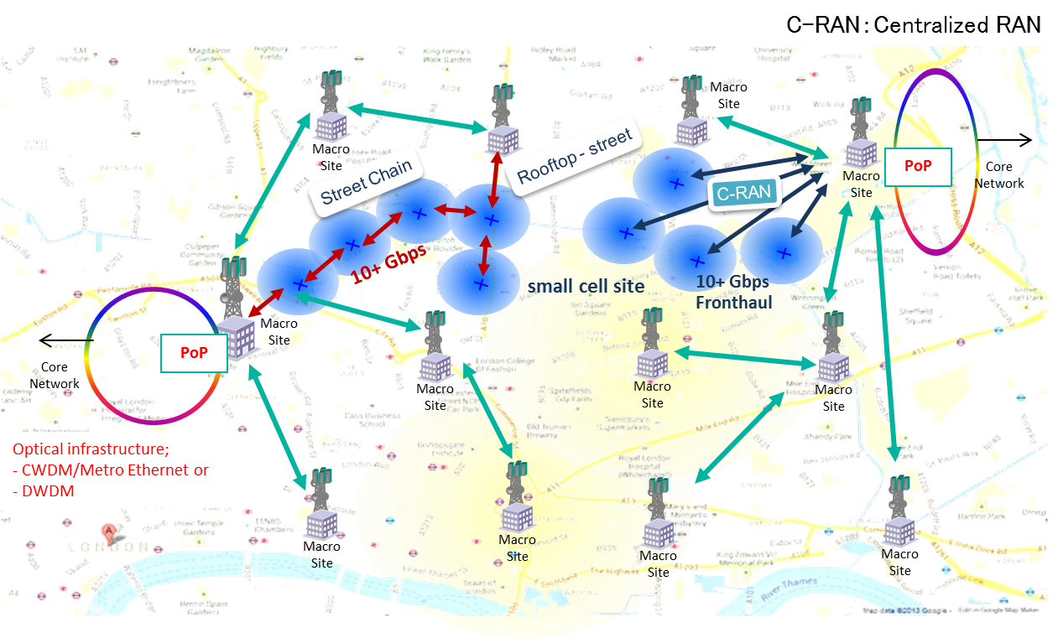
Figure 7: Mobile backhauling/fronthauling network overview

Requirements for 5G mobile backhauling tail links are summarised in Table 1.

Table 1: Requirements for 5G mobile Backhauling tail links
Basic requirements for 5G backhauling tail link
Capacity | >10 Gbit/s
Link distance | < 200 m

Use case#2: Indoor application for Internal Connection of a Data Centre (Inter-Server)
In this use case, servers in the data centre are interconnected with high capacity links. Current data-centres use optical fibre 10 GbE links and are installed indoor.
In the future, link capacity in the order of 100 Gbit/s is planned. MmW radio operating in the D-band can be used for this type of short links in the order of tens of metres, providing capacity around 40 Gbit/s. With the deployment being mainly indoor (see Figure 8), it will be possible to provide links with availability of 99.999%.
The inter-link capacity requirements in the data centre are in the order of 10 GbE and mainly deployed indoor. High availability is required up to 99.999% in order to consider the radio links as an alternative to fibre. Indoor use is free from rain attenuation and such availability will be possible. Furthermore, such indoor D-band applications are characterised by very high density of links with much shorter distances of tens of metres. As such as long as indoor deployment of D-band ensures no interference leakage to the outdoor environment, their use may be allowed under different national authorisation regime.
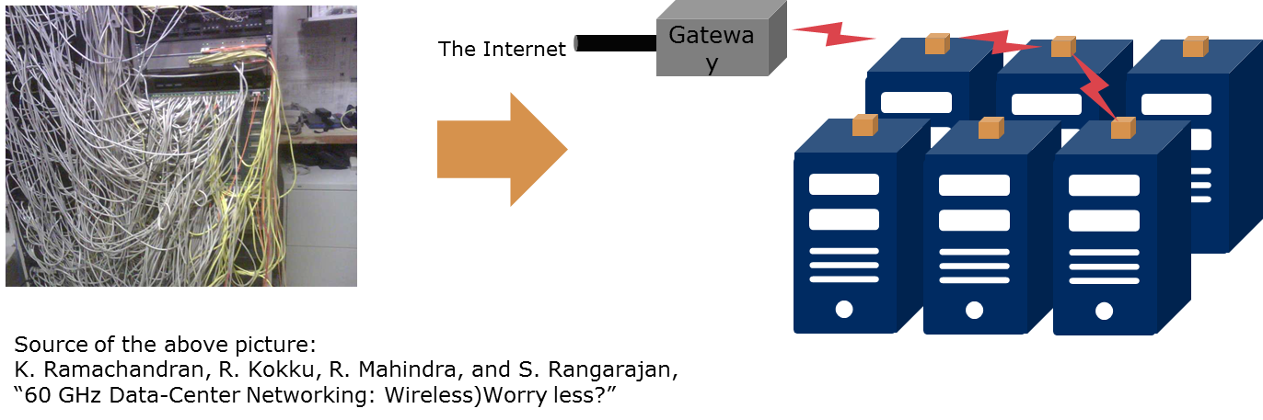
Figure 8: Millimetric waves connectivity in data centres

Requirements for future applications in mmwave radio
Examples of use cases and deployment scenarios for using links in the D-band are presented.
It is expected that more new applications and deployment scenarios will emerge in the future.
Requirements for radio links operating in the D-band to fulfil future applications must support high capacity of over 10 Gbit/s. The target capacity is 40 Gbit/s considering 40 GbE for an inter-server connection in data centres.
Medium link distance is up to several hundreds of meters.
Dual-directional communication is required for both symmetrical/asymmetrical and FDD/TDD duplexing.
The set of requirements shown in Table 2 implies big changes in the network topology, requiring very high throughputs in very dense networks at an extremely high availability.
Table 2: Prospect of requirements for future applications in mmW radio
Main Requirements
High capacity | >10 Gbit/s | Target capacity is 40 Gbit/s considering 40 GbE for a server connection
Medium link distance | Up to several hundreds of metres | Short range is to be covered
High availability | Up to 99.999% | As an alternative of fibre cable
High availability | Up to 99.999% | Indoor use is free from rain attenuation
Dual-directional communication | Symmetrical/asymmetrical
Dual-directional communication | FDD/TDD
Large volume applications in the backhauling and fronthauling, which are able to support all services requiring very high speed wireless transmission, drive to the higher part of the spectrum.
Given the very stringent capacity, latency and availability 5G targets, combined with sites densification, it’s likely that in the access and pre-aggregation network segments, a mix of different transmission technologies (fibre, mmW links, and MW links) will be needed to reach a radio site.
In section 6.5 a table with the applications and use cases relevant to transmission networks evolution is provided. An additional table is included, that points out which use cases can be served by the D-band and which ones need additional support from microwave or lower mmW bands.

Future Transport Requirements
The following Table 3 and Table 4 present the foreseen set of requirements aimed to support future 5G transmission networks. Applications and use cases are reported for different segments of the network: macro layer, small cell layer and fixed access. Moreover, backhauling and fronthauling applications are indicated, even if new generation XHAUL requirements have still to be defined.
The second table distinguishes which use cases can be served by the D-band only and which ones can be covered by other mmW, possibly also taking advantage of BCA.

Table 3: Application and use cases for 5G networks

Table 4: D-band solution mapping within applications and use cases for 5G networks

System Behaviours

D-band system simulation
In order to evaluate covered distances and available throughputs, extensive system simulations have been carried out. As a result, estimation is given of the maximum hop length that can be reached, in the W-band and in the D-band, for different 1 Gbit/s solutions in different conditions and frequency bands. Moreover, estimation of the maximum hop length that can be reached for a 10 Gbit/s solution is provided, derived with the same approach used for the 1 Gbit/s cases.
The model is for pure Line of Sight (LOS) applications. The urban environmental impact hasn’t been taken into account.
Estimation of a reasonable level of system gain to reach 1 Gbit/s and 10 Gbit/s throughputs is provided, scaling the solution that is today in place.
The maximum antenna gain considered is up to 40 dBi.
The related standards under which the calculations have been carried out are here reported:
- Recommendation ITU-R P.530-15 - Same formulas as ITU-R P.530-16 [3] ;
- Recommendation ITU-R P.838-3 [2];
- Recommendation ITU-R P.676-11 [1]: specific attenuation due to atmospheric gases (dB/km) is derived from Figure 5 in Annex 2 (Pressure = 1 013.25 hPa; Temperature = 15°C; Water Vapour Density = 7.5 g/m³).
It should be mentioned that Recommendation ITU-R P.530-15 provides models up to 100 GHz, namely “The prediction procedure ... is considered to be valid in all parts of the world at least for frequencies up to 100 GHz ...”. This means that trials with real equipment at these extremely high frequency bands aim also to validate the ITU-R models for frequencies above 100 GHz.
The following conditions apply:
- Gross system gain accounts for system gain and antenna gain (estimation of gross system gain range g_{SyGain} to reach 1 Gbit/s solution);
- Rain rate of 30, 60 and 90 mm/h are taken into account;
- Three cases are considered: 250 MHz, 500 MHz and 1000 MHz channel;
- Antenna gain is from 30 to 40 dBi;
- No substantial difference between horizontal (H) and vertical (V) polarisation;
- Less than 1 dB (110 GHz) and less than 0.5 dB (150 GHz) of g_{SYGain} for cases of 20-2000 meter/ rain rate 10-120 mm/h.
The results obtained can be easily scaled for different cases and assumptions. It is also shown that no substantial difference is envisaged between H and V polarisations.
Figure 9 shows the relation between gross system gain and maximum hop length in the W- and in the D-bands with different availabilities.

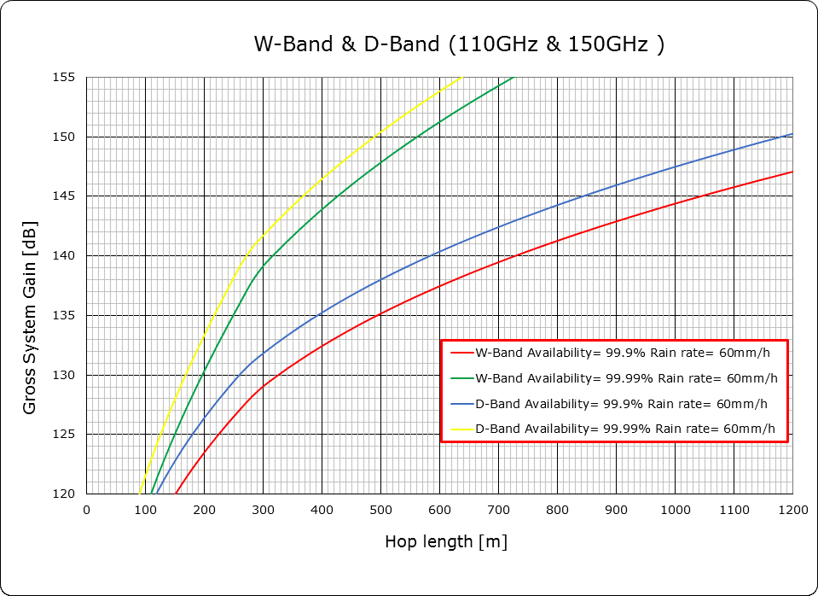
Figure 9: W-band and D-band – Gross system gain vs. max hop length for different availabilities and
60 mm/h rain rate
In the same conditions, antenna and system gain, differences in hop length are close to 20%.
The following Figure 10, Figure 11, Figure 12, and Figure 13 provide an overview of the W-band and the D-band reachable distances for different rain rates and availabilities.
Figure 10: Achievable distances in the D-band with 1 Gbit/s throughput
Figure 11: Achievable distances in the W-band with 1 Gbit/s throughput

Figure 12: Achievable distances in the D-band with 1 Gbit/s throughput and different modulation schemes

Figure 13: Achievable distances in the W-band and D-band with 10 Gbit/s throughput

Technical band specific aspects

New technological possibilities in High Frequencies
In relation with W-band and D-band, the short wavelength and the technological evolution allows design of very compact antennas (few cm size for about 30 dBi gain) with technical characteristics in line with expected use.
Preliminary measurements have shown that decoupling values higher than 80 dB can easily be obtained within two antennas placed side by side, while such decoupling increases, increasing gap between the two devices.
High decoupling is possible within two antennas spaced a quite shorter distance than it is necessary at lower frequencies to have same values.
In principle integration into one single set of equipment is achievable, such as an alternative can be seen on the need of separating “go” and “return” sub-bands by means of a traditional duplexer.
From the installation perspective, such arrangement will not need asking for specific permissions for installation of two antennas in same site and will not practically increase windload on structures.

Possible uses
Such kind of architecture allows to decouple Tx from Rx side, making available different uses, such as:
- traditional use: FDD with fixed duplex, when all the band is available in a specified country;
- extended use: FDD flexible, with “go” and “return” directions, with settable duplex, depending on the needs of administrations (not all parts of a RF Band could be available in some administration’s domain, so different duplex could be necessary in different countries);
- Flexible use could be in principle useful also in some node to reduce interference, having more frequencies available;
- Traditional TDD;
- Full Duplex (FD) Bidirectional use of same frequency for 100% time.
Such flexibility could be beneficial in both cases of traditional link–by-link licence (interference calculations provided by a central organisation), or of block licence. In this case, the possibility to assign to each operator a continuous block of channels can result more manageable than having separate blocks of frequencies, potentially associated to difference of propagation (limited in relation with expected lengths) or more complexity for planning.

Traditional allocation of frequencies
In traditional bands, channels are often allocated, for FDD, in a lower (“go”) part and an higher part (“return”) within a RF band such as a specified number of contiguous channels of same bandwidth appears in the lower part and the higher part, so that each channel in lower part can be associated to a corresponding one in the higher part.
Each couple of corresponding (paired) channels are separated by a fixed frequency interval (duplexer). Paired channels can be used for bidirectional links, providing 100% time transmission in both directions.
In case lower part is as wide as higher part, all channels are paired.
An example of such arrangement is given in Figure 14, from ERC Recommendation 12-12 [11] (duplex 616 MHz).

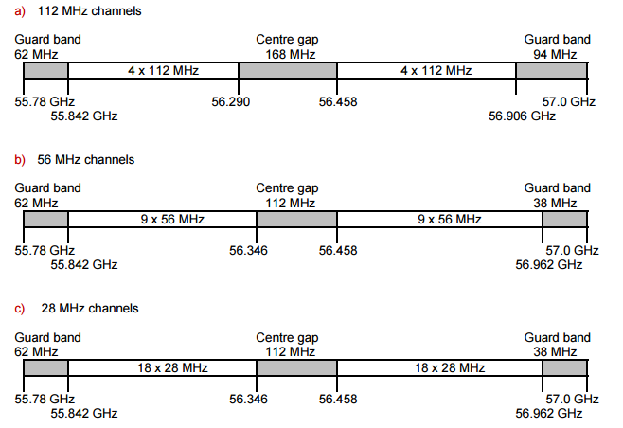
Figure 14: Example of FDD channel use (from ERC Recommendation 12-12, Radio frequency channel arrangement for fixed service systems operating in the bank 55.78 - 57.0 GHz [11])
In general, in order to limit impairments due to local interference and facilitate frequency reuse, transmitters in same sub-band (“go” or “return”) are used in the same station, such as “go” and “return” locations can be identified. An example is given in Figure 15.

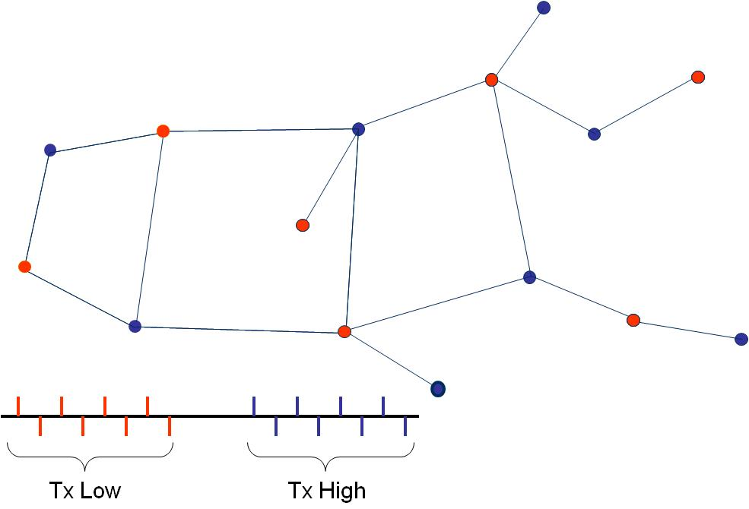
Figure 15: Interference scenario – high-low rule
In TDD applications only RF channels are defined, without duplex, since the same channel bandwidth is used for both directions in different time.
The same use can be allowed for unpaired channels in FDD channel schemes (if any), as well as for unidirectional transmission, if there is the need.
An example of such arrangement is given in Figure 16, from ERC Recommendation 12-12 [11].
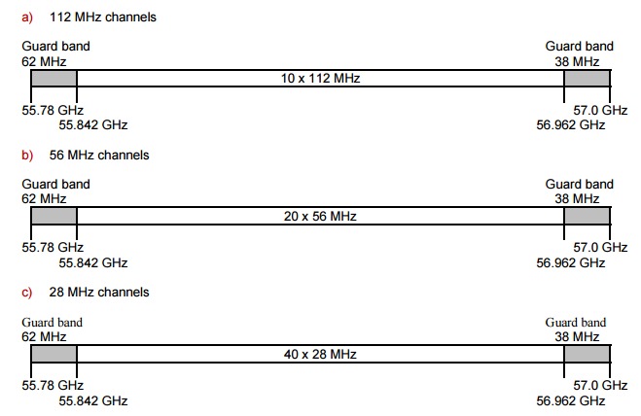
Figure 16: Example of TDD channel use (from ERC Recommendation 12-12, Radio frequency channel arrangement for fixed service systems operating in the band 55.78 - 57.0 GHz)

Bands and Carrier Aggregation in W-Band and D-Band
Bands and Carrier Aggregation (BCA) is a new approach that is taking place in the mobile backhauling area. The main idea behind the BCA is to build-on a Point-to-Point connection, using two or more “carriers”, which may implement the Adaptive code and Modulation (ACM) over different (or equal) Channel Spacing (CS) can even belong to different frequency bands. In most of the cases, BCA can be arranged using a single antenna (dual bands antenna when feasible) resulting from the appearance point of view as a traditional single carrier approach.
From the traffic perspective, what could be obtained using BCA looks like a single carrier connection with ACM working on a very wide CS, so providing a huge capacity level with a high number of modulation steps. Figure 17 shows an example of behaviour obtained.
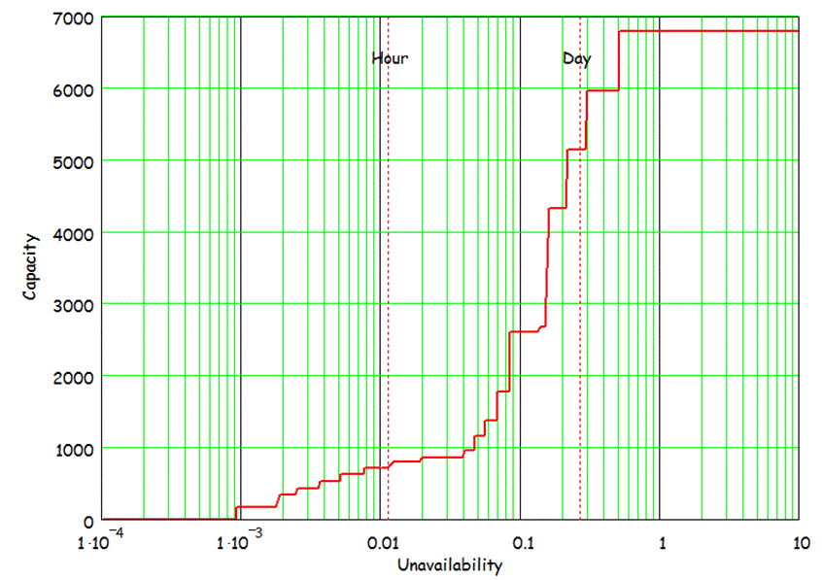
Figure 17: Typical capacity versus availability performance behaviour
The main novelty here is that with respect to the single carrier ACM, BCA offers more and different degrees of freedom, in link budget and in using different channels size as well. A general implementation of BCA includes a carrier aggregation engine and different physical radio channels. Most of BCA benefits can be obtained thanks to the BCA engine which may consider both the required traffic QoS and the conditions/peculiarities of the radio channels.
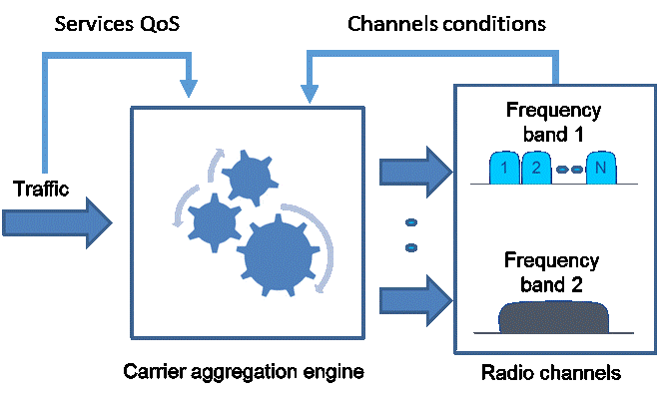
Figure 18: BCA concept
In the specific context of W-band and D-band, two main use cases are enabled by the BCA:
- The feasibility of the transport of huge capacity level: to transport a huge capacity level with a single carrier solution may requires both a wide channel, that could be not available as continuous spectrum, and a high modulation scheme, not easily supported in a such a wide channel.
- The feasible of sub-urban links in W-band and D-band: By using channels in lower frequencies bands (i.e. 32-38 GHz) aggregated with channels in W-band or D-bands with BCA, will extend the potential use of W-band or D-band in sub-urban area, where required distances are usually longer than what can be normally achieved in W-band or D-band link.

92-114.25 GHz band specific aspects
This section presents some views on channels subdivisions for this band.
Key argument should be the contemporaneous availability of all (or most) of the various blocks mentioned in the ranges (i.e. 92-114.25 GHz).
This section considers:
- the detailed subdivision of 250 MHz slots;
- the possible coupling of the various bands available in the lower range 92 - 114.25 GHz when the pairing of conventional FDD channels is sought.

General assumptions for flexible use of the bands
General assumptions for flexible use of the bands are:
- Minimum frequency channel (slot) size: considering the present successful use of the E-band and potential higher capacity delivered in those higher bands a 250/500 MHz size is considered appropriate;:
- Continuous channel raster extended to all the bands in the two blocks without required paired/unpaired use;
- Maximisation of the possible paired use of the available bands for permitting effective design of conventional FDD implies the coupling of different bands.

Use of conventional FDD in the range 92-114.25 GHz
According to RR and ECA Table [14], in this range five formally separate bands are available to FS:
- 92-94 GHz (total 2000 MHz)
- 94.1-95 GHz (total 900 MHz)
- 95-100 GHz (total 5000 MHz)
- 102-109.5 GHz (total 7500 MHz)
- 111.8-114.25 GHz (total 2450 MHz)

It should be noted that, even if formally separated in RR and ECA (i.e. different services allocations) bands 94.1 - 95 GHz and 95-100 GHz can be considered as a contiguous band (94.1-100 GHz) from the FS point of view.

Conclusions on FDD use of 92-114.25 GHz range of frequency
From the above considerations it is believed that:
The bands 92-94 GHz and 94.1-95 GHz already subject to published ECC Recommendations [5], [6] and [13] are not worth to be considered in developing paired use of the FS range up to 114.25 GHz.
The possible use of small part of upper portion of 94.1-95 GHz may be possibly considered for pairing the above bands with 500 MHz minimum channels.
It should also be noted that bands 92-94 GHz and 94.1-95 GHz are already regulated by Recommendation ITU-R F.2004 [15] and ECC/REC(14)01 [13] and their additional use should also be reflected in those Recommendations.
Several options for the ECC Recommendation on channel arrangement for the bands in the W-range were considered, however the one most appropriate for the W-band has been selected using for FDD the whole range from 92 GHz to 114.8 GHz as illustrated in Figure 19, which shows the filters requirements for FDD as follows:
- Asymmetrical passbands T/R 8/10 GHz with interband of 4.25 GHz;
This is different to the current E-band solution (symmetrical T/R 5 GHz with interband 5 GHz). This makes its feasibility more challenging than the current solution used for E-band equipment. In any case, an easier solution would be splitting the design into two filters;
- These three duplex splits might add some complexity in the planning tool, but from equipment point of view it’s not a determinant factor for the choice.

Figure 19: Illustration of filtering possibility in the W-band

130-174.8 GHz Band specific aspects
The considerations in this section apply to the D-band only.

Frequency limitation
Due to high frequency limits (174.8 GHz Fmax), most existing technologies cannot cover today all the range, with proper characteristics, especially in terms of linearity and output power. In order to facilitate opening of the market, suggested work plan should contain applications compatible with coverage of most technologies (i.e. TDD or FDD sub-bands with higher frequency around 160 GHz)

Relative BW
Most of existing components cannot cover all RF band, due to high relative bandwidth (44.8/174.8 ≈ 25%). Relative bandwidth up to about 20% is considered possible. Channel plans considering sub-bands with such characteristics allow coverage with single realisation equipment, with economy of scale.

Diplexer related
It has been reported by a filter manufacturer the following estimated diplexer performance for D-band (130-174.8 GHz band):
- Technical possibilities, technological challenges and limits are contained;
- Difficulties can be expected to produce D-band filters with a traditional manufacturing process, due to strict required mechanical tolerances (+/-2μm);
- Concerning insertion loss, a value of 2dB for diplexer is expected not to be exceeded in the overall band; such value appears reasonable, from the technical point of view, but can be a limiting factor for link budget, considering the limited power available from amplifiers in this band;
- Regarding Tx/Rx isolation, a value of about 50 dB could be achievable for 10% GHz duplex spacing, even in highest bands.

Separate Tx/Rx antennas
A measurement campaign was performed in a vendor labs in Italy, on a prototype developed for D-band, covering the 140-160 GHz band.
As it can be seen from ANNEX 1:, where some further information is made available, measurement confirmed the value of a Tx/Rx isolation in the order of 80 dB based on lab measurements at lower frequency (V-band).
The measured isolation is of the same order of the sensitivity of instruments used, so more accurate measure was not possible at the time of this Report.
Test execution on a real prototype shows that this architectural approach is valid in this frequency range, and results are in line with the expectations.
Furthermore negligible insertion loss is present between Tx/Rx amplifier and antenna, being beneficial to link planning.
It should be noted that such an arrangement could simplify the process of asking permissions for installation, and will decrease wind load on structures.
As a conclusion from the above, it is suggested that equipment architectures in D-band can be efficiently realised without the need of traditional diplexer, allowing a more flexible use of the spectrum.
As such, different partitioning of channels and blocks of channels, compared to lower frequencies where diplexer is mandatory, are worth to be analysed to evaluate potential advantages.
Considering the potential of these bands to support high capacity traffic, consisting in a real benefit for future FS applications, the limited current use of this band in Europe, the always increasing trend by several services/applications to claim interest on more and more RF bands, it is felt important within a limited time scale to establish rules that would allow starting frequency use and facilitate opening of the market without precluding new possibility of use enabled by technology evolution.
In view of this, it is considered necessary to give priority to the frequencies today available to be covered in a short time by a range of technologies/components as wide as possible. In view of this, particular attention should be given to the portions of bands from 141 to 164 GHz.

Conclusions
This Report provides supporting information and considerations on deployment of Point-to-Point (PP) radio links in the frequency ranges 92-114.25 GHz (referred to as W-band) and 130-174.8 GHz (referred to as D-band). Considerations on general assumptions are discussed to allow flexible and efficient use of these bands. Propagation characteristics for each band are considered and used for the analysis of system behaviour aspects when operating in these bands.
Radio Regulations for these bands are considered. License aspects for the new bands are discussed with a view looking towards the future demand.
Application and use cases are presented with detailed view from stake holders on their future transport demand requirements being the major foreseen applications.
Technology specific considerations for each band are also presented given insight into the feasibility of equipment design and implementation taking into account the technological state of the art and its readiness to be adopted for the radio systems intended to operate in these bands.
In conclusion, these frequency bands have a great potential to fulfil future demand and requirements of radio links and networks in terms of capacity, latency and availability for 5G, combined with sites densification and deployment flexibility.

- Measurement result on D-band
  - Technological considerations on antennas and diplexers in the D-band
In relation with the D-band, the short wavelength and the technological evolution allow design of very compact antennas, in the order of few centimetre size for about 30 dBi gain with technical characteristics in line with the expected use.
As a consequence, one Tx antenna and one Rx antenna can be integrated into one single equipment, spaced a quite shorter distance than it is necessary at lower frequencies to have comparable values of isolation.
Preliminary measurements (see Figure 20) on a D-band prototype, covering the range 140-160 GHz, shown in Figure 21, have shown that isolation values higher than 80 dB can be obtained between two antennas placed closely, while such decoupling increases when increasing the distance between the two devices.
This integration can be a viable alternative to the need of separating “go” and “return” sub-bands by means of a traditional diplexer, opening the way, where the need exists, towards a FDD functionality without the limitations imposed by the diplexer itself.
Figure 20: Measured isolation between two antennas (Tx and Rx) in D-band (a few cm spacing)

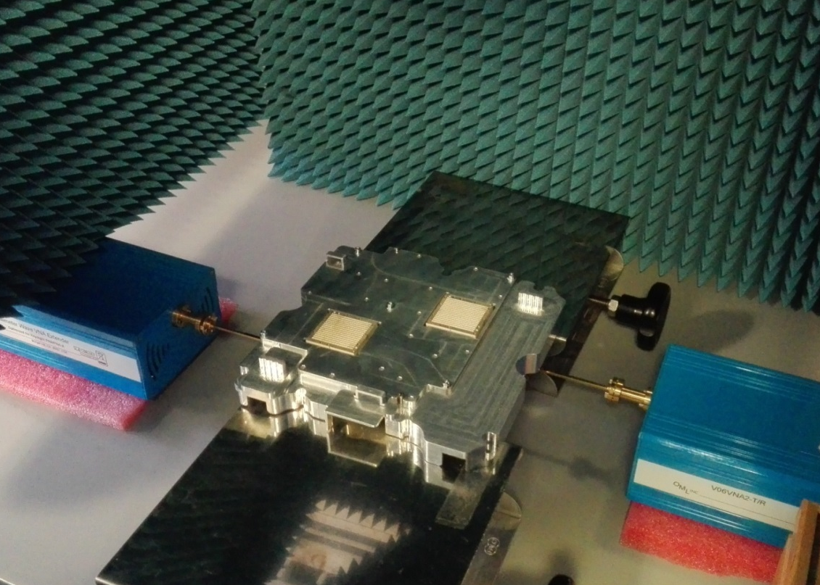
Tx
Rx

Figure 21: Measurement setup
  - Technological considerations on semiconductor technology in D-band
A recent white paper edited by ETSI (White Paper no. 15) [16] summarises the status and evolution of semiconductor technology in the millimetre wave range. Among other considerations, it is of interest to highlight here that the current technology, which is based on pHEMT GaAs, has a performance limit (transition frequency) around 160 GHz.
As a consequence any fixed duplex association with the higher part of D-band (167-174 GHz) would be an obstacle to the practical implementation of the first generation equipment, expected around 2020.

- Impact of reflection study on flexible reduced duplexing
This section contains a study on possible reflections affecting new kind of equipment without diplexer, which can be realised to operate in millimetre waves of sufficiently short wavelength such as the ones operating in the 130-174.8 GHz band.
Such equipment architecture adds new capabilities in frequency use to the ones achievable by traditional equipment, such as the so called “flexible frequency division duplex” (fFDD).
The main assumption adopted in this document is that main beams are expected to be completely free from obstructions by execution of proper installations.
α
H
D
Particular case
h

Generic case
β
H
D
α
Figure 22: Installation example
In Figure 22, a typical installation over a plane surface, such as a building roof /terrace is shown.
If we indicate α as the half of antenna main beam, β as the tilting of antenna respect to horizontal plane, H as the height of antenna respect to the highest object in front of it (such as a protection wall or railings), the maximum distance from object/building edge where the equipment can be located is a D point where tan(α+β)=H/D. Figure 23 shows relation between D and H for various α

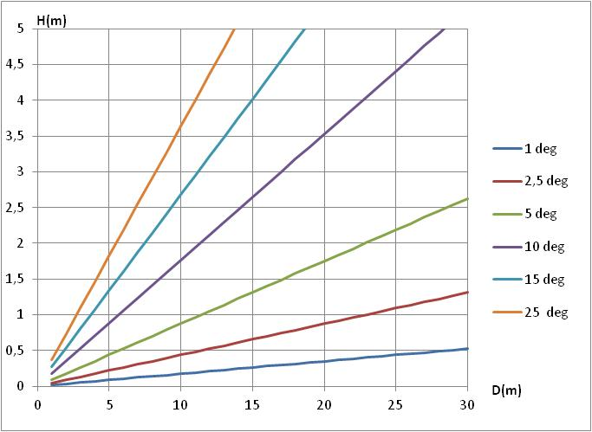
Figure 23: D / h relation
  - Technical assumptions:
In this analysis, equipment transmitting on channel F1 and receiving on channel F2, 250 MHz spaced from F1, is assumed. Such situation represents most challenging use of fFDD, where “go” and “return” are adjacent.
- Channel BW =250 MHz;
- F2 = F1+ 250 MHz;
- P_{Tx} = +5 dBm;
- Rx threshold: -49 dBm (64QAM) ; -62 dBm (QPSK) – 2 dB worse than 302 217-2 for E-band;
- C/I = same values as in ETSI EN 302 217-2 [17] for E-band from where the following extract comes:

5LB | 33,5 | 29,5 | -6 | -10
5LA | 33,5 | 29,5
Additional:
- Antenna gain =32 dBi;
- Antenna far field=3.36 m. (at 140 GHz, λ= 2.14 mm);
- Antenna second lobe attenuation= 18 dBi;
- Antenna size = 6x6 cm.
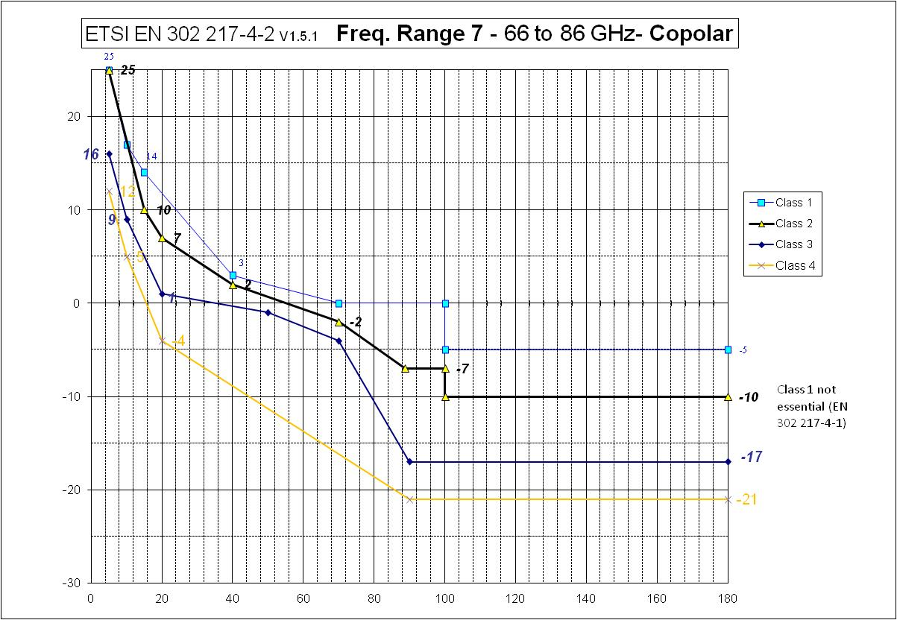
Figure 24: Antenna RPE: same as ETSI class 2 for E-band [17]
  - Tx/RX equipment decoupling
The Tx/Rx decoupling is a metric that represents the ratio between the transmitted power and the power received through the air/equipment. Such decoupling (Figure 25) determines the level of interference due to local transmitter in normal working conditions, constituting a fixed level of interference for most working time.

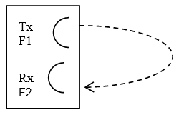

Figure 25: Equipment decoupling
Assuming a typical Tx/Rx decoupling of 80 dB, the interference level is expected to be Rx _{interf} ≈ -75 dBm, so C/I_{1ad} = 26 dB(5L) / 13 dB (QPSK). No degradation is expected from this source of interference.
  - Operations in field
    - Interference
Interference coming from other transmitters installed on same location of the victim can occur.
      - Interferer Tx on same direction
- Equipment on the same pole (Figure 26): distance between Tx and Rx is increased compared to single equipment, Tx/Rx decoupling is also increased consequently, so no degradation is foreseen.
- 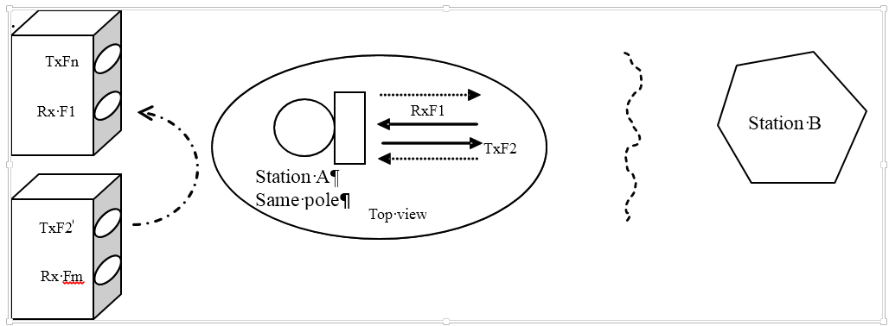
Figure 26: Interferer on the same pole
Equipment on different poles (Figure 27), this situation appears comparable to the case of equipment on a single pole, described above. Complex numerical computation is needed to estimate the exact level of interference. However, the general principle of decreasing interference level with increasing distance is valid. Due to low diffraction and Tx/Rx distance, such level is expected lower than single equipment case. In particular, case b) in Figure 27 is equivalent to equipment on the same pole.
Figure 27: Interferer on different poles

      - Interferer Tx on other directions
In case of installations of links with different directions in the same stations, set up is preferably adopted to minimise possibility of interference and reduce link length (Figure 28, case a).
If this condition is not possible, (Figure 28, case b), the risk of threshold degradation cannot be excluded if the “main lobe free condition” is not respected. As an example, if installations are at about 3 m distance, the main lobe to main lobe can reach levels of ≈ -44 dBm - link attenuation ≈85 dB.
Conclusion is that local interference is not expected to produce measurable degradations in practice.
Figure 28: Different links and directions in the same station
    - Reflections
Reflections can be generated locally (fixed interference) or remotely (variable interference).
      - Local reflections
In case of objects placed between the equipment and the edge of buildings (Figure 29), such as the usual protection barriers necessary for safety of people, part of the signal unintentionally transmitted towards this object can be reflected back to the equipment. The main assumption of main lobe free does not exclude possibility of reflections from side lobes.
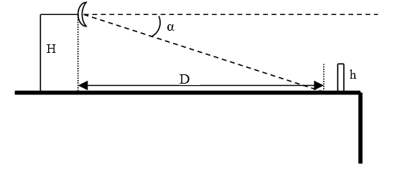
Figure 29: Installation
A detailed analysis of such situations for real cases is practically too complex, due to the many kinds of objects which can exist on a real locations Nevertheless some basic and worst case estimations can be done.
Adopted approach will be based on passive repeater theory. In general, case shown in Figure 30 will be considered, where reflections will be approximated by a connection using one passive repeater.
Worst case is assumed to be a passive repeater reflecting towards the victim all energy received from interferer; the size of the mirror will be fixed such as to include the area intercepted on main lobe by a vertical plane at the distance of the barrier (Figure 30).
Such kind of object is able to intercept more that 90% of incident power, so no further increase of reflected power is expected by a greater one. In this sense, it is considered as the worst case.
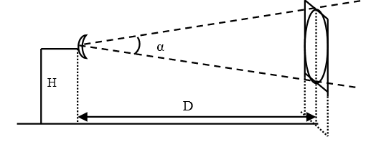

Figure 30: Mirror reflection
With such mirror, values of reflections computed on the axis, will be rearranged to take account of sidelobes being the originating signals (in particular, first sidelobe will be used).
In our condition of locally generated interferences, the distances are of the order of few meters up to few tens of meters. Resulting link is to be assumed in the far field region for the antennas, and in the near field for the reflector.
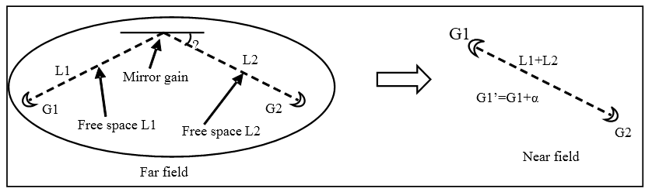
This case is described in literature, so that the system composed by direct link, reflected link and mirror can be studied as a single link, which length is the total length of two links, and the gain is obtained by adding to the gain of real antenna a value α which can be determined based on geometry (Figure 31).
Figure 31: Link equivalence
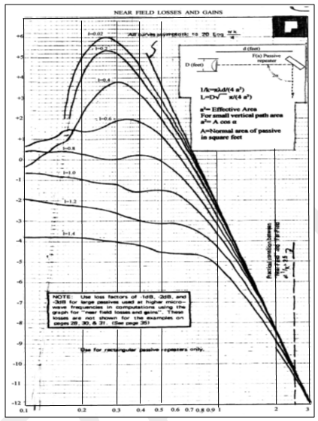
In particular, this value can be read on specific curve of available diagrams (Figure 32), once the value of the x-axis (1/k) is determined and the proper curve is selected, by means of a parameter l.
Figure 32: Near field loss and gain
Values for 1/k and l for usual length related to installations on same locations can be found in Figure 33.
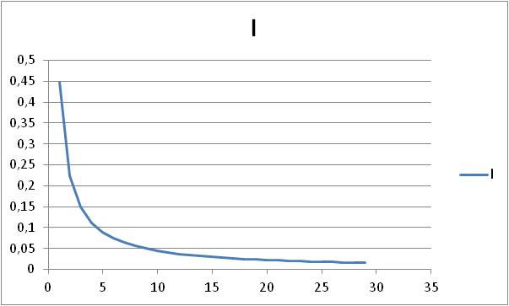
Figure 33: Values for 1/k and l for usual length
      - Calculation of reflected power (main beam).
Calculations assume that reflections happen at the limit of the antenna near field (both links will be 3 m long).
Mirror size is assumed to cover an angle of ±7 degrees, covering all main beam; its size 75x75 cm, far field >10 m; 1/k=0.04; l=0.15,
Rx field in point 2 (power of reflection) = +5-atten(6m)+G1’+G2 = +5-111+G1’+32 .
The diagram does not show very small values of 1/K, however the reduction of gain can be estimated from the shape of the curve, in the order of at least 5 to 10 dB, leading to an overall Rx field in the order of -47÷-52 dBm.
In order to account for the main assumption, the computed Rx reflection power should be decreased by 28 dB (attenuation of first sidelobe to boresight), resulting a value lower than -70 dBm.
As a consequence, considering that a real reflecting object should not produce a perfect reflection as in the assumption, no particular condition of danger arising from local reflection is expected.
The values of C/I, evaluated for the nearest distance Tx/Rx at threshold are well in line with the values required for certification. As such, physical duplexer is not necessary to counteract this phenomenon.
      - Reflections coming from field: locations at or after receiving site, same direction
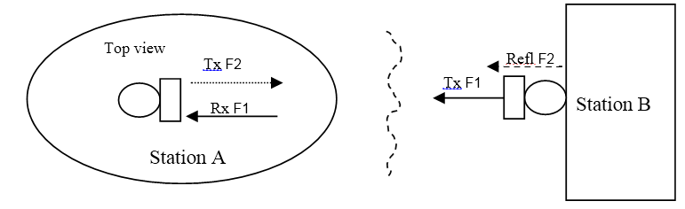
Figure 34: Reflection from field
The same assumptions as for the near reflections are used for evaluation of the far field reflections.
A square reflecting surface (mirror) of the same size of the radius including main beam (± 7 degree in this simulation) is assumed to reflect the incoming signal towards the source.
The situation intends to simulate the presence of a large reflecting surface in field (the equipment in station B is attached to a large glass wall of a building).
Due to specific combination of frequency and characteristics, the stations are always situated in the near field of the mirror, so that the replacement method used for the near field should be used.
Values for 1/k and l are reported for several each hop length from 50 m to 1 km in Table 5. Such values are out of diagrams, although a negative value for additional gain is expected.
Table 5: Values for 1/k and l for several each hop length from 50 m to 1 km
Hop length (m) | 1000 | 500 | 400 | 300 | 200 | 100 | 50
P_{Rx} F1(dBm) | -60 | -53 | -51 | -49 | -54,2 | -39,14 | -33,1
1/k | 0 | 0 | 0 | 0 | 0 | 0 | 0,001
l | 0 | 0 | 0,001 | 0,001 | 0,001 | 0,02 | 0,04
P F2 Refl (dBm) | -65,4 | -59,5 | -57,5 | -54,9 | -51,2 | -45 | -39
It should be however noted that the approximation of pure reflection of signal without any additional loss (equivalent to having a double length link – last row of Table 5) gives a C/I value of 6 dB.
Considering the correlation between useful signal and reflected signal, such ratio is felt as practically independent of propagation impairments.
No degradation is therefore expected from this kind of reflections.
      - Reflections coming from field: locations not in same direction
According to our main considerations (link in LoS), reflection not coming from same directions should be associated to sidelobes of antenna, so, in our assumptions, level of refection is expected to be decreased by at least 28 dB, for the same distance used in the “same direction” case.
  - Conclusion on reflections
Considering the results of simulations based on the assumptions described, mainly based on a high Tx/Rx antenna decoupling and Line of Sight link implementation, it can be assumed that reflections in the near or far field are not expected to contribute to degradations, even in case of Tx and Rx frequency separated by 250 MHz (or multiple).
In particular, the architectural choice undertaken, as it does not need physical duplexer, is felt sufficient to counteract these phenomena, without the need of any additional filtering.

- List of Reference
- Recommendation ITU-R P.676-11: “Attenuation by atmospheric gases”
- Recommendation ITU-R P.838-3: “Specific attenuation model for rain for use in prediction methods”
- Recommendation ITU-R P.530: “Propagation data and prediction methods required for the design of terrestrial line-of-sight systems
- H.Y. Lam, L. Luini, J. Din, C. Capsoni, A. D. Panagopoulos, 2012: “Investigation of Rain Attenuation in Equatorial Kuala Lumpur”, IEEE Antennas and Wireless Propagation Letters, vol. 11, Page(s): 1002-1005”
- ECC Recommendation (18)01:”Radio frequency channel/block arrangements for Fixed Service systems operating in the bands 130-134 GHz, 141-148.5 GHz, 151.5-164 GHz and 167-174.8 GHz”
- ECC Recommendation (18)02: “Radio frequency channel/block arrangements for Fixed Service systems operating in the bands 92-94 GHz, 94.1-100 GHz, 102-109.5 GHz and 111.8-114.25 GHz”
- Spectrum Horizons: “Notice of Proposed Rulemaking – ET Docket No. 18-21”
- ECC Report 80: “Enhancing harmonisation and introducing flexibility in the spectrum regulatory framework”
- ECC/REC(04)05: “Guidelines for accommodation and assignment of Multipoint Fixed Wireless systems in frequency bands 3.4-3-6 GHz and 3.6-3-8 GHz”
- ECC/REC(01)04: “Recommended guidelines for the accommodation and assignment of multimedia wireless systems (MWS) and point-to-point (P-P) fixed wireless systems in the frequency band 40.5 - 43.5 GHz”
- ERC Recommendation 12-12: “Radio frequency channel arrangement for fixed service systems operating in the band 55.78 - 57.0 GHz”
- ECC Recommendation (05)07: “Radio frequency channel arrangements for fixed service systems operating in the bands 71-76 GHz and 81-86 GHz”
- ECC/REC/(14)01: “Radio frequency channel arrangements for fixed service systems operating in the band 92-95 GHz”
- ERC Report 025: “The European table of frequency allocations and applications in the frequency range 8.3 kHz to 3000 GHz (ECA Table)”
- Recommendation ITU-R F.2004: “Radio-frequency channel arrangements for fixed service systems operating in the 92-95 GHz range”
- ETSI White Paper no. 15: “mmWave Semiconductor Industry Technologies: Status and Evolution”
- ETSI EN 302 217: “Fixed Radio Systems; Characteristics and requirements for point-to-point equipment and antennas”
- L. Luini, G. Roveda, M. Zaffaroni, M. Costa, C. Riva, "EM Wave Propagation Experiment at E Band and D Band for 5G Wireless Systems: Preliminary Results", IEEE EUCAP 2018, 9-13 April 2018 London

The primary allocation to the Earth Exploration-Satellite Service (passive) terminated on 1 January 2018.

