ECC Report 258

Guidelines on how to plan LoS MIMO for Point-to-Point Fixed Service Links
Approved 27 January 2017

Executive summary
This report shows that LoS (Line-of-sight) MIMO in point-to-point fixed service links is an efficient way of increasing capacity or availability without using more spectrum. The report presents technical background of LoS MIMO links operation and characteristics when compared with a typical SISO link.
When designing a LoS MIMO link, the design of the link should always try to satisfy the optimal antenna separation. It is possible to deviate from the optimal antenna separation distance without losing peak capacity. This will result in a reduced fading margin. Nevertheless, it could still be beneficial to use LoS MIMO to increase capacity even when using an antenna separation distance that is other than the optimal separation. There are a few things to consider during design and installation to achieve the full benefits. The optimal antenna separation distance, that can be symmetrical or not, should fulfil some basic conditions related to frequency band and link distance.
While optimal LoS MIMO antenna separation gives a potential “MIMO BER threshold” improvement (i.e. 3 dB as in space diversity operation), sub-optimal antenna separation implies a degradation of the BER threshold. However, digital techniques implementing the theoretical optimal performance may be used for reducing this effect.
Therefore, it is expected that the applicant licensee, for proper evaluation of the link availability, would state in the application form the LoS MIMO antenna separation and the expected “MIMO BER threshold”, i.e. improvement/degradation over each single standalone LoS MIMO link receiver performance due to the optimal /non-optimal antenna separation. The improved/degraded “MIMO BER threshold” could be used by administrations who wish to consider planning the desired LoS radio link's propagation availability.
This report shows that in most cases the interference planning of LoS MIMO links could be made in accordance with the following guidelines
Method A) LoS MIMO as two separate links
The LoS MIMO link is planned as two separate links. However, the “MIMO BER threshold” could be taken into account.
Method A is similar to existing standard radio planning procedures.
Method B) Alternative approach
In case administrations prefer to model the LoS MIMO link as an equivalent SISO link, two different planning scenarios have been considered. One scenario in case of a LoS MIMO enhancement of an already operating SISO link and another scenario in the case of authorising a brand new LoS MIMO link. This report contains some examples of this method's planning procedure.

TABLE OF CONTENTS

0 Executive summary 2
1 Introduction 5
1.1 Background 5
1.2 Introduction to MIMO 5
2 LOS-MIMO systems 7
2.1 MIMO Basic 7
2.2 Optimal Antenna Separation 10
2.3 Non-optimal antenna separation and link budget degradation 12
2.4 Impact of antenna separation 15
3 LoS MIMO Benefits 17
3.1 Higher spectral efficiency 17
3.2 Other benefits of LoS MIMO 17
4 LoS MIMO planing aspects 19
4.1 Installation scenarios 19
4.1.1 Horizontal Installation 19
4.1.2 Vertical Installation 21
4.2 Interference Calculation 23
4.2.1 LoS MIMO interference towards other links 23
4.2.2 Interferences from other links to LoS MIMO link 24
4.2.3 MIMO BER threshold to use in link performance and availability calculations 25
4.2.4 Summary of Interference effects 25
4.2.5 Impact of coordinate precision 25
4.2.6 Appropriate method for Interference Calculation using LoS MIMO links 26
4.2.6.1 Method A; LoS MIMO as two separate links 26
4.2.6.2 Method B; Alternative approach 26
4.2.6.3 Consideration of antenna heights in interference calculations 27
4.3 Diversity and Availability aspects 29
5 CONCLUSIONS 32
ANNEX 1: Results of MIMO Questionnaire 33
ANNEX 2: LoS MIMO Geometric impact on interference Planning 34
ANNEX 3: Examples of equivalent MIMO Radiation Pattern Envelope 46
ANNEX 4: List of Reference 53

LIST OF ABBREVIATIONS

Abbreviation | Explanation
ACDP | Adjacent Channel Dual Polarisation
AMR | Adaptive Multi-Rate
ATPC | Automatic Transmit Power Control
BER | Bit Error Rate
CCDP | Co-Channel Dual Polarisation
CEPT | European Conference of Postal and Telecommunications Administrations
ECC | Electronic Communications Committee
e.i.r.p. | effective isotropically radiated power
e.r.p. | effective radiated power
ETSI | European Telecommunications Standards Institute
FDD | Frequency Division Duplex
FS | Fixed Service
I/N | Interference to Noise ratio
LoS | Line-of-sight
LTE | Long Term Evolution
MIMO | Multiple-Input Multiple-Output
MW | Microwave
NFD | Net Filter Discrimination
RF | Radio Frequency
RPE | Radiation Pattern Envelope
P-P | Point-to-Point
Rx | Receiver
SG | System Gain
SNR | Signal to Noise Ratio
SISO | Single-Input Single-Output
TCO | Total Cost of Ownership
Tx | Transmitter
W/I | Wanted Signal to Interference ratio
XPIC | Cross Polar Interference Cancellation
WLAN | Wireless Local Area Network

Introduction
Over the last years network operators and manufacturers have seen an increasing interest in MIMO technology. To encourage investments and deployment for this technology, more information about the regulatory framework was needed and a questionnaire addressed to the CEPT administrations was elaborated in 2014. It included questions about the licensing regime, fees, need for technical details of the requested MIMO link - especially the antenna separation and calculation matters.
The results of the questionnaire are presented in Annex 1. Although not all CEPT administrations answered, these results show that there are different views not only on the licensing regime but also on the technical information required for planning calculation and on the interference calculation method itself.

Background
Microwave is a cost-efficient technology for flexible and rapid backhaul deployment to almost any location. It is the dominant backhaul media for mobile networks in the world today and is expected to maintain this position during the rapid evolution of mobile broadband networks. A typical mobile backhaul network has thousands of hops, and operators must be able to increase microwave capacity without having to change frequency planning and replace equipment across their entire network.
Many advanced microwave technologies already enable operators to satisfy the growing demand for capacity. Co-channel dual polarisation (CCDP) with XPIC technology, utilising the different polarisations of a frequency channel, was the last advance that boosted spectral efficiency by an order of 100%. Since then, incremental improvements such as high modulation schemes (1024QAM, 2048QAM) and header compression have been used to improve spectral efficiency and, possibly coupled with link aggregation techniques, to boost microwave capacity.

Introduction to MIMO
In this report, Multiple-Input Multiple-Output (MIMO) technology applied to Point-to-Point (P-P) is described in comparison to the Single-Input Single-Output (SISO) technique, which represents the conventional P-P link application.
Multiple-Input Multiple-Output (MIMO) technology offers the possibility to significantly increase the transmission capacity of a radio channel. It is a technique extensively used in radio access systems such as wireless local area networks (WLANs) and mobile networks including long-term evolution (LTE). It is well known that a MIMO system can offer either multiplexing gain, improving spectral efficiency, or SNR gain. MIMO technology can also be applied to increase transmission capacity in high frequency point-to-point microwave radio links, as desired in the next generation wireless backhaul networks. This type of MIMO system as a rule uses highly directive antennas and operates in line-of-sight (LoS) conditions. A MIMO system operating under these conditions is often referred to as a LoS MIMO communication system.
Line-of-Sight Multiple-Input-Multiple-Output (LoS MIMO) is the latest development in microwave technology enabling operators to improve spectral efficiency in normal operational conditions. LoS MIMO is inspired by, but inherently different from, the well-known non-line-of-sight MIMO technology, widely used in access networks, which exploit orthogonality in the multipath transmission; LoS MIMO would offer microwave communication an additional technology to improve capacity and spectral efficiency by exploiting the orthogonality due to a tuned spatial separation of multiple antennas at the transmitter and receiver side.
In NLoS MIMO, some techniques such as Eigen decomposition is used to resolve the orthogonal MIMO channels which are exploited for enhancing the efficiency of transmission. In LoS microwave, the non-LoS multipath signal is weak and unusable for the purpose of LoS MIMO. Instead, LoS MIMO achieves spatial multiplexing by creating an artificial multi-path not caused by physical objects, but rather by deliberate separation of antennas in such way that at normal propagation condition, it (the multipath) could be considered as deterministic and constant.

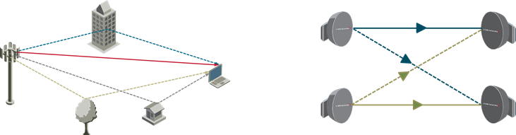
Figure 1: NLoS MIMO (left) vs. LoS MIMO (right)

LOS-MIMO systems

MIMO Basic
In principle, LoS MIMO requires N transmitters and M receivers, all using the same frequency channel to improve capacity and/or system gain. A practical configuration involving only two antennas at each side is presented in the following Figure 2:
Figure 2: General LoS MIMO antenna setup
All considerations hereafter are made in one direction only; in bidirectional links the same applies also to the opposite path.
Spatial separation between antennas at the two terminals is denoted by d1 and d2, respectively. The distance between transmitter j and receiver i is denoted by rij. The distance between the centre of the antenna arrays of the two terminals is denoted by R.
At the receiving side, each antenna receives a mixture of the all transmitted signals. A signal processing algorithm is then applied in order to separate the mixture into individually transmitted signals.
The main difference between LoS MIMO systems and traditional MIMO systems is that a LoS MIMO system, having highly directive antennas and operating in LOS conditions, as a rule does not use random multipath propagation in order to perform the MIMO signal processing required to recover transmitted data. Instead, a LoS MIMO communication system relies on different phase shifts along the different propagation paths between transmitter (Tx) and receiver (Rx) antennas. The MIMO phase difference must satisfy certain conditions in order to enable the LoS MIMO receiver to remove interference and recover transmitted data, i.e., the phase shifts together must provide a proper MIMO channel.
Figure 3 depicts a 2 x 2 spatially separated LoS MIMO transmission system, i.e. two antennas at each site operating at the same radio frequency (RF). In real deployment, the antenna separation can take place in either horizontal or vertical directions; it is not limited to the simplified rectangular geometry as in Figure 3, but any combination of different spatial separation could be valid, provided that it satisfies the proper phase shifts required.
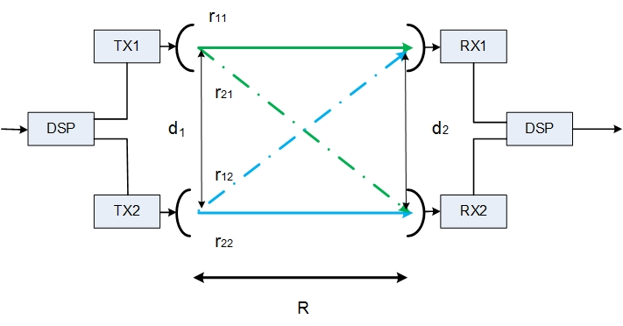
D
C
B
A
Figure 3: A 2 x 2 spatially separated LoS MIMO system, where d₁ (dt) and d₂ (dr) denote the antenna separation at the transmitter (Tx) and the receiver (Rx), respectively

In a 2 x 2 LoS MIMO system, there are two possible paths between one transmitter and two receivers. As illustrated in Figure 3, the signal from one transmitter antenna travels through two different paths and arrives at the two receiver antennas.
At the receiver, the interference from the other transmitter antennas can be removed using signal processing techniques, see an example in Figure 4.

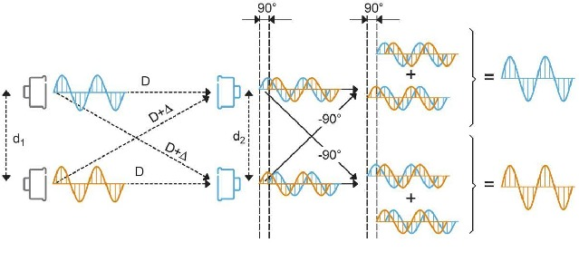
Figure 4: An illustrative example of a 2 x 2 LoS MIMO system of rectangular geometry

In particular, the example in Figure 4 illustrates optimal cancellation. By using ideal transmitter and receiver characteristics, the interference is completely removed; thereafter, the two copies of signal from the same transmitter to the different receiver antennas can be coherently added, which provides additional 3 dB fade margin (similar to space diversity receiver gain) with respect to a single receiver antenna. Hence, given the same overall sum of transmitter output power and same frequency bandwidth, an optimal LoS MIMO system can support multiple streams with equally good performance as one single stream link (SISO configuration).
A 2 x 2 LoS MIMO microwave link comprises two transmitters and receivers connected to two antennas on each side.
As shown in Figure 5 for different N x N LoS MIMO cases, the nominal allowed output power (and corresponding e.i.r.p.) of the SISO case is equally divided to the multiple transmitting antenna connectors. Nonetheless, the availability planned for that specific link is maintained, due to the combination gain of the multiple receiver antennas, (i.e. without increasing the overall e.i.r.p. of the LoS MIMO system). In this case, the external interference, evaluated on the SISO case, is also generally preserved. Alternatively, if the nominal allowed output power per antenna connector (and corresponding e.i.r.p.) may be maintained as in the SISO case, the increase of fade margin may permit a more stringent availability objective. However, the external interference to other links will increase accordingly as would be if the e.i.r.p. were increased by the same level in a conventional SISO system,
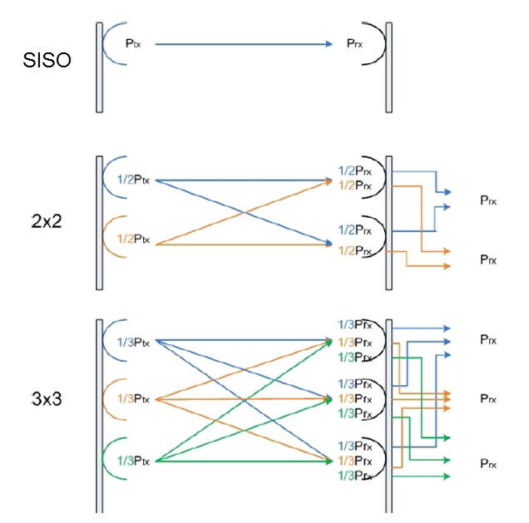
Figure 5: Tx and Rx power for 1 x 1, 2 x 2 and 3 x 3 systems. Ptx denotes the maximum possible transmitter power. For the same frequency and power resources,
an NxN LoS MIMO system provides N times data capacity
In order to simplify the presentation, this report considers 2 x 2 LoS MIMO with single polarisation. However, combined configuration of LoS MIMO with XPIC operation could double the capacity.

Optimal Antenna Separation
With reference to Figure 3, in order to perform optimal interference cancellation the antenna separations at both sites, d1 (at transmitter) and d2 (at receiver), are critical since the signal travelling between Antenna A of Tx1 and Antenna C of Rx1 must be significantly different than the signal travelling between Antenna B of Tx2 and Antenna C of Rx1 and of course the signals received by Antenna D of Rx2 must fulfil similar requirements in order to allow the digital combination/cancellation processing of the receiver to properly recover the signals sent by A and B. The inter-antenna distances must be carefully set as a function of transmission frequency and path length in order to provide suitable phase shifts along the different propagation paths, which allow a LoS MIMO receiver to successfully recover transmitted data. One example of optimal antenna separation is when the relative phase difference between the two paths arrived at the same receiver antenna is of 90 degrees, see details in Figure 4 and Figure 7.
As explained earlier, at optimal antenna separation the receiver can fully remove the crosstalk interference and coherently add the receiver power from the multiple receiver antennas. The MIMO channel can be considered as multiple orthogonal SISO channels. In the 2 x 2 case, the optimal MIMO channel can support two independent signal streams which correspond to double data capacity. If the same data stream is transmitted though the MIMO channel, the received power is doubled.
It is also worth mentioning that if dual polarisation is included, the system can support four independent signal streams which correspond to quadrupled data capacity.
The optimal antenna separation can be derived based on the carrier frequency and the hop geometry, by assuming the radio signal travels in a straight line between the transmitter and the receiver.
With reference to Figure 3, optimal separation between signals can be achieved by satisfying the following condition:
$\left(r_{12}-r_{11}\right)+\left(r_{21}-r_{22}\right)=\left(2⋅k+1\right)⋅\frac{λ}{2}$ , (1)
where $λ$ denotes the carrier wavelength. The parameter $k$ is a variable that gives many possible solutions to equation (1). The $k$ value is normally selected as zero for minimum optimal antenna separation. The k value could be any other integer value for other larger antenna separations.
Based on the condition above one can obtain the following simplified expression, which formulates the minimal antenna separation required for optimal LoS MIMO operation:
$d_{1}∙d_{2}≅\frac{R∙c}{2f}=\frac{R∙λ}{2}$ (2)
where $c$ denotes the speed of light (3 x 108 m/s), $R$ the link length and $f$ denotes the link frequency.
For the special case of equally separated antennas on both sides of the link, we obtain the following expression for the optimal separation between them:
$d_{optimal}[m]=\sqrt{\frac{R∙c}{2f}}=\sqrt{\frac{R\left[km\right]*300}{2*f[GHz]}}$. (3)
Figure 6 gives some examples of the optimal antenna separation (d_{opt}) for varied frequency and hop length assuming the symmetrical geometry, i.e., dr_{opt}=dt_{opt}

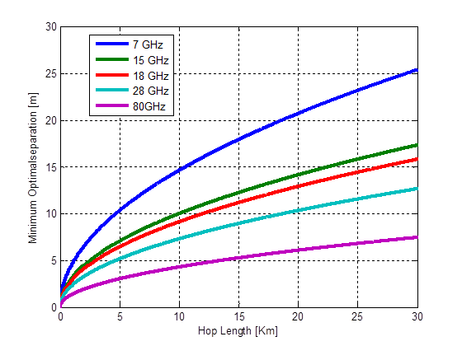
Figure 6: Minimum optimal antenna separation for a 2 x 2 LoS MIMO system
at varied carrier frequency and hop length, rectangular deployment
In general, the optimal separation increases for decreased carrier frequency and increased hop length. In addition, there is a trade-off between the optimal antenna separation at the transmitter site and the receiver site, which provides flexibility to practical deployment. Figure 7 provides two examples of optimal antenna separation for a 2 x 2 LoS MIMO link of 5 km, operating at 32 GHz.
The first example depicts symmetrical hop geometry, and the second example shows asymmetrical hop geometry.
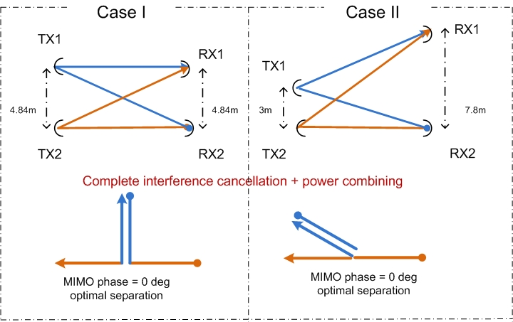
Figure 7: Two examples of optimal antenna separation for a 2 x 2 LoS MIMO link
operating at 32 GHz and 5 km
After total cancellation, the two copies of signal from the same transmitter to different receiver antennas can be coherently added.
It should be noted that for a FDD system the antenna separations can never be perfectly optimal for both go and return channels.
The optimum distances are calculated for just one frequency; however, FDD systems use one frequency for each direction. The best compromise is to calculate with the average frequency. Examples of difference in optimal antenna separation due to duplex distance frequency separation can be found in the table below.
Table 1: Difference in Optimal antenna separation due to frequency duplex
Band | Frequency (MHz) | Link Distance (km) | Doptimal (m)
7 GHz | 7425 | 35 | 26.59
7 GHz | 7579 | 35 | 26.32
70/80 GHz | 71125 | 2 | 2.05
70/80 GHz | 81125 | 2 | 1.92
The practical impact of this compromise could be regarded to be negligible using normal Fixed Service channel arrangements.

Non-optimal antenna separation and link budget degradation
In outdoor deployment it is often not possible to mount the antennas at arbitrary positions and non-optimal antenna separation installation is expected to be common. From practical point of view, it is also desirable to employ small antenna separation to reduce the installation cost.
In the previous sections it is explained how to achieve the optimal spatial separation in LoS MIMO for practical installations. In common situations of real scenarios the optimal calculated separations $d_{1}$and $d_{2}$ cannot be physically applied in the sites. For example, the masts/poles are not long enough or the rooftops are not large enough for applying the optimal separation. These situations usually appear in long haul systems where lower frequency bands are used and the link distance can reach dozens of kilometres. Such conditions require large separations between the antennas, as depicted in Figure 6.
In such situations, antennas can be installed in a sub–optimal separation. Sub-optimal separation degrades performance in terms of capacity and system gain but, in a wide range of cases, the degradation can be relatively small and still maintains significant improvement with respect to a SISO system. Most implemented LoS MIMO receivers employ cancellation-based techniques, which work well in real-world environment owing to the large rain-fading margin typical for microwave links. For cancellation-based LoS MIMO receivers, the power penalty due to non-optimal antenna separation for a 2 x 2 system is illustrated in Figure 8.
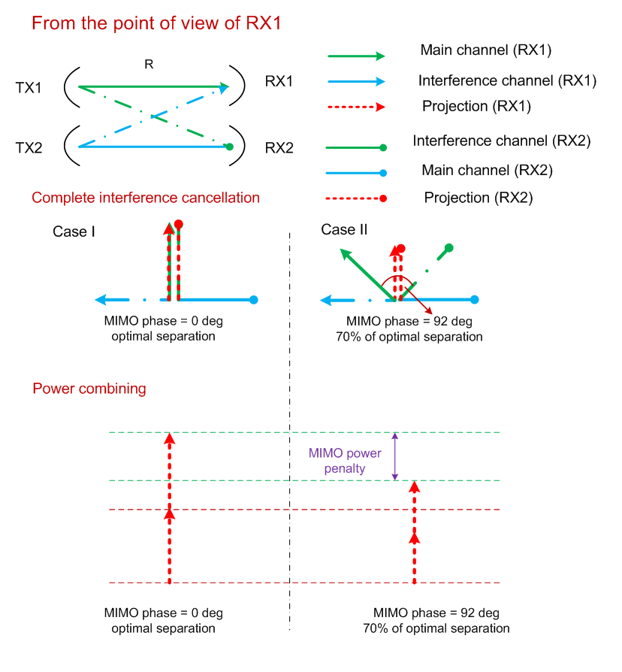
Figure 8: Examples of MIMO power penalty and MIMO phase variation caused by
non-optimal antenna separation
After total interference cancellation, the sum (vector addition) of two copies of received power from different receiver antennas determines the fading margin and the link availability. As illustrated in the figure, hop geometry will specify phase relation between the received power vectors and thereby determines the sum of the power vectors.
In Figure 9 the theoretical SNR gain, for a LoS MIMO 2 x 2 link is compared with a SISO link, considering the MIMO transmitter output power limited to a "Sum power constraint"
(Ptx1MIMO = Ptx2MIMO = 1/2 PtxSISO). The blue line graph describes the “optimal” average SNR that can be achieved related to the SISO case under the same conditions, see section 4.4 of TR 102 311 [1] for more details. The red line represents same SNR gain for a practical implementation described in this report.
In Figure 9 and Figure 10 the theoretical optimal implementation corresponds to the closed loop MIMO, while the practical linear implementation corresponds to open loop MIMO as described in section 4.5 of TR 102 311 [1].
Note that in case of using "Per-antenna power constraint", (Ptx1MIMO = Ptx2MIMO = PtxSISO), the SNR is improved by up to 3 dB. This could have impact on MIMO link planning if the nominal e.i.r.p. would be imposed by the license condition as overall power “per site” or as “per antenna”.
Figure 9: SNR gain for a LoS MIMO 2 x 2 system

If suboptimal antenna separation is used, the loss of SNR shown in Figure 9 should be appropriately taken into account in the planning of the radio link.
Figure 10 describes the theoretical capacity gain of the LoS MIMO, using sum power constraint (Ptx1MIMO = Ptx2MIMO = 1/2 PtxSISO), relative to SISO. The plot is given for several SNR values related to a reference SISO capacity of 6 bits/s/Hz (64QAM), 8 bits/s/Hz (256QAM) and 10 bits/s/Hz (1024QAM), see section 4.4 of TR 102 311 [1] for more details. The dotted lines are referring to a practical implementation, which is described above.
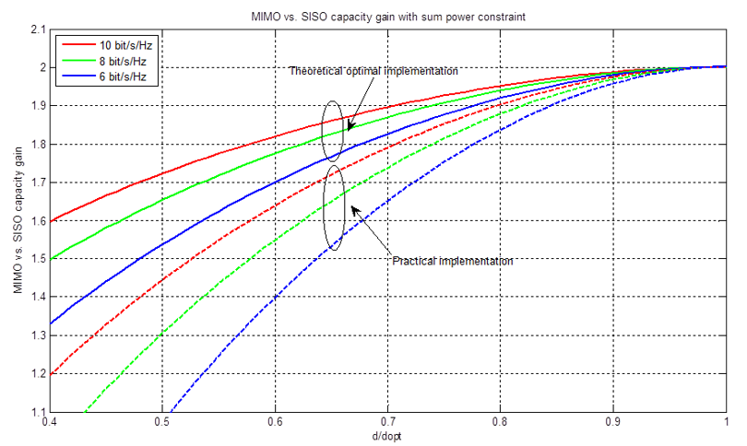
Figure 10: LoS MIMO performance; capacity improvement over SISO
With reference to Figure 10, at an optimum relative antenna spacing of 1.0 the capacity of a LoS MIMO link will be twice the capacity of a SISO link using the same modulation. If the relative antenna spacing is reduced, the relative capacity of a LoS MIMO link will drop more slowly for higher modulations.
The performance of LoS MIMO shown in Figure 10 represents the best capacity that can be achieved with the same overall power (“per site” limitation) of a SISO station and related to antenna spacing. Practical implementation of MIMO should achieve the double capacity in optimal antenna separation but may have steeper sensitivity to antenna spacing, for example see the next section.

Impact of antenna separation
Figure 11 gives a practical example of MIMO phase and corresponding power penalty in terms of varied antenna separation. In the example, symmetrical deployment is considered where the separation at the transmitter and receiver sites changes equally. The figure shows that both the MIMO phase and power penalty have a periodical variation as antenna separation increases.
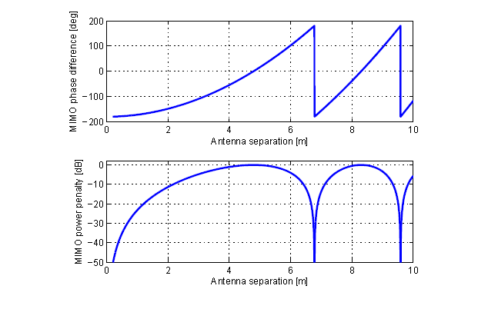Figure 11: Impact of antenna separation on MIMO phase and MIMO power penalty
for a symmetrical LoS MIMO deployment of 32 GHz and 5 km. Antenna separation varies
from 0 m to 10 m at both transmitter and receiver sites
The preferred configuration is to have an optimum antenna separation. The LoS MIMO system will take full benefit of the increased link budget. However, some capacity increase is still available even with non-optimal separation. The link budget degradation that follows the non-optimal separation can be mentioned by applicant in the licensing request for due consideration in the planning process.
In practice, the capacity/cost ratio is used to determine the offset separation between antennas from the optimal distance. The reduced efficiency can then be considered in combination with full occupation of the frequency and polarisation.

LoS MIMO Benefits
Microwave radio links operating with LoS MIMO provide a set of optional benefits, which include a capacity boost.
It should be noted that the stated benefits in this section can only be achieved as trade-off between them, i.e. the benefits cannot be achieved simultaneously, and the stated benefits can only be achieved under certain conditions.

Higher spectral efficiency
LoS MIMO enables transmission of two independent signals over the same frequency and same polarisation. This doubles the capacity in a 2 x 2 LoS MIMO configuration compared to a 1+0 SISO link without occupying additional spectrum resources.
Using both polarisations of a frequency channel, i.e. employing a 2 x 2 LoS MIMO + XPIC scheme enables transmission of four independent signals over the same frequency channel and provides four times the capacity of a standard 1+0 SISO link (1+0, i.e. one working traffic carrying radio channel without redundancy hardware protection) or two times the capacity of a 2+0 SISO XPIC link (2+0, i.e. two working traffic carrying radio channels without redundancy protection).

Other benefits of LoS MIMO
In additional to the use of conventional techniques (e.g. XPIC, space diversity, high power, higher antenna gain) for increasing capacity and improving system gain, MIMO may also be used as an alternative solution when convenient.
The possible overall costs, investment in hardware, cost of installation, spectrum use, infrastructure etc., related to a LoS MIMO link should be carefully examined when considering the trade-off between the mentioned possible benefits of a LoS MIMO link compared to other techniques (e.g. XPIC, space diversity). In addition to the capacity enhancement, the system gain of a LoS MIMO can be increased in comparison with a normal SISO link by dividing the SISO capacity into two bitstreams transmitted over the LoS MIMO link. Each bitstream could use a lower modulation rate than in the case of a SISO link, thus being able to increase transmitter power and use a lower receiver threshold. The increase of system gain could allow the usage of longer link distances for a given antenna size, or reduce antenna sizes for the same link distance. It should also be noted that MIMO system gain would degrade to below that of SISO in case the antenna separation is less than 70% of the optimal separation stated in section 2.3for the practical linear implementation. For example, when only one channel is available, in SISO configuration, the needed capacity would require 256 QAM; however, for the QoS required the link needs a system gain unreachable for that modulation format. In this case, an improvement up to about 12 dB (up to 15dB for per-antenna power constraint) in system gain may be taken in account by splitting the signal into two 16 QAM independent links transmitted with LoS MIMO. This would cost up to twice for equipment and antennas, but the link may become feasible. However, the same result could be obtained in a similar way using XPIC link where convenient at a reduced cost compared with MIMO system. The same example for XPIC compared to XPIC+MIMO can be seen in Figure 12.

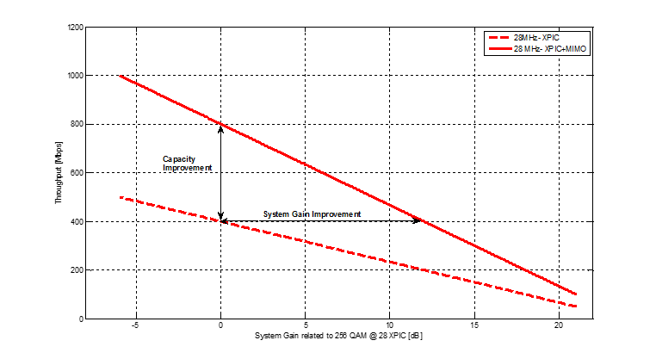
Figure 12: Example of throughput versus system gain compare to reference link
with 28 MHz Bandwidth
The dashed curve shows 28 MHz XPIC throughput (assuming 25 MHz baud rate) versus system gain (normalized to 256QAM). The solid line shows the same for XPIC-MIMO link. The maximum achievable system gain and capacity trade off can be observed as indicated at the figure.
Another possible benefit is that a LoS MIMO link could provide inherent protection against system failures similar to 1+1 configuration. A 2 x 2 LoS MIMO link will provide inherent redundancy since the LoS MIMO link comprise of double the equipment (antennas, transmitters, receivers etc.) compared to a normal SISO link. Under normal operation, the LoS MIMO link will use both transmitters in order to double the transmission capacity, and in case of a single hardware failure, the capacity over the MIMO link is reduced to a normal SISO link capacity.

LoS MIMO planing aspects
In the following section several aspects of LoS MIMO planning will be covered:
- How to choose the correct installation in order to maximise the capacity / system gain by choosing the spatial installation (vertical / horizontal) and choosing the best effective distance between the antennas;
- Understand the effect of LoS MIMO link as a part of the whole network, which means taking into consideration how the link interferes with other links in the network and how others links affects the LoS MIMO link (e.g. adjacent channel or Co channel);
- Diversity aspects, elaborate on the aspects of diversity for both flat and dispersive channels in LoS MIMO installations.

Installation scenarios
In real scenarios of LoS MIMO, the environmental conditions and the installation constraints (antennas placement) dictate the spatial separation between the antennas and their location.
Generally, there are many alternatives for how to implement the optimal spatial separation between the antennas such that the capacity of a LoS MIMO system is maximised, however in real sites, there are practically two main installation alternatives: horizontal installation (e.g. rooftop installation) and vertical installation (e.g. install both antennas on the same mast or pole).
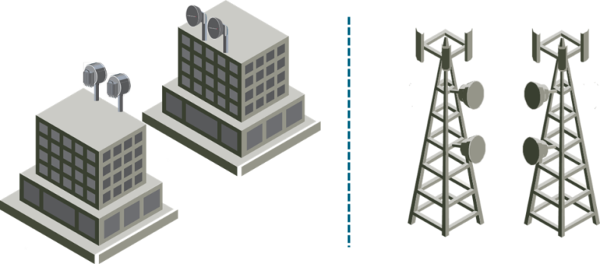
Figure 13: LoS MIMO- real scenarios installations
In Figure 13 the two main alternatives are described. In these alternatives, the calculation of the optimal spatial separation is simple and is done according to the optimal distance equation.

Horizontal Installation
Figure 13 presents a simple example of horizontal installation, while in real scenarios the two rooftops may not be completely facing each other, in other words, there is a tilt between the fronts of the buildings as depicted in the upper chart of Figure 14.
The lower chart of Figure 14 presents a schematic drawing of such horizontal installation where the two rooftops are not facing each other and are inclined with angles $θ_{1}$ and$θ_{2}$.

Figure 14: Horizontal installation; the upper chart presents two rooftops, which are not facing each other; the lower chart presents a schematic drawing for such installation
Generally, the rule for horizontal installation or vertical installation is to plan the optimal distances using the separation distances of $d_{1}$and $d_{2}$ which are calculated on the two parallel imaginary lines which are perpendicular to the imaginary line connecting the two centres of the antenna arrays in both sites, as depicted in the schematic drawing in Figure 14. In this drawing, the two parallel imaginary lines (red lines) are perpendicular to the imaginary line connecting the two centres of the antenna arrays in both sites (blue line). The optimal distances ${\tilde{d}}_{1}$and ${\tilde{d}}_{2}$should be achieved on these lines.
In such situations, a slight modification to the optimal distance equation is needed. In order to compute ${\tilde{d}}_{1}$ and ${\tilde{d}}_{2}$ we need to use the modified equation
${\tilde{d}}_{1}⋅{\tilde{d}}_{2}=\frac{d_{1}⋅d_{2}}{\cos\left(θ_{1}\right)⋅cos⁡(θ_{2})} =\frac{R⋅C}{2⋅f_{carrier} }⋅\frac{1}{\cos\left(θ_{1}\right)⋅cos⁡(θ_{2})}$ (4)
In the example discussed above optimal installation is achieved by locating the antennas using enlarged separations ${\tilde{d}}_{1}$ and ${\tilde{d}}_{2}$ so that on the two parallel imaginary lines connecting the antennas the separations $d_{1}$ and $d_{2}$ satisfy the optimal equation.
Another interesting aspect in horizontal installations is that in some cases, relocation of the antenna over the roofs can achieve better distances $d_{1}$ and$d_{2}$. Figure 15 demonstrates the example from above with the antennas installed in different locations over the roofs.
Figure 15: Horizontal installation; the antennas are installed in different locations over the roof

Vertical Installation
As in horizontal installation, also in vertical installations there are some additional parameters that should be taken into consideration when determining the optimal separation between the antennas. For instance, the masts upon which the antennas are installed might be tilted and/or the two sites can be located in different geographical heights. In the upper chart of Figure 16 an example of a situation in which the two sites are not the same height is illustrated.

Figure 16: Vertical installation; the upper chart presents two sites in different heights; the lower chart presents a vertical section of such installation

As explained in the previous section, the separations ${\tilde{d}}_{1}$ and ${\tilde{d}}_{2}$ are selected such that the optimal distances $d_{1}$ and $d_{2}$ on the imaginary parallel lines (red lines) are obtained.
${\tilde{d}}_{1}$ and ${\tilde{d}}_{2}$ should be calculated, as in the horizontal case, according to the modified equation (2).
${\tilde{d}}_{1}⋅{\tilde{d}}_{2}=\frac{d_{1}⋅d_{2}}{\cos\left(θ_{1}\right)⋅cos⁡(θ_{2})} =\frac{R⋅C}{2⋅f_{carrier} }⋅\frac{1}{\cos\left(θ_{1}\right)⋅cos⁡(θ_{2})}$ (5)
It is important to note that vertical installations are much simpler than horizontal installations because in most real scenarios the environmental limitations are minor. In vertical installation usually the differential height between the sites is significantly smaller than the geographical distance ($h≪R$) which leads to small tilt angels ($θ_{1}$ and $θ_{2}$). For example, for a 5 km link with a differential height of 300 metres between the sites the tilting angles are $θ_{1}$=$θ_{2}=\operatorname{asin}\left(\frac{0.3}{5}\right)\sim {3.5}^{o}$. In this case the correction factor $cos\left(θ_{i}\right)=0.998$ can be approximated as 1. Hence in most cases, the differential height can be neglected. Similarly the tilt of the masts on which antennas are mounted can be neglected in most cases. On the other hand, in horizontal installations the environmental conditions can dictate large tilt angles ($θ_{1}$ and $θ_{2}$), and therefore need to be taken into consideration when planning the installation.

Interference Calculation
The LoS MIMO link is often installed as a part of a large network. We should examine the mutual effects, if any, between the LoS MIMO link and the complete network. The examination should consider two aspects: "external" and "internal" interferences. External interference relates to the interference transmitted from the LoS MIMO link to other links in the network. Internal interference relates to the interference received from other links in the network into the LoS MIMO link.
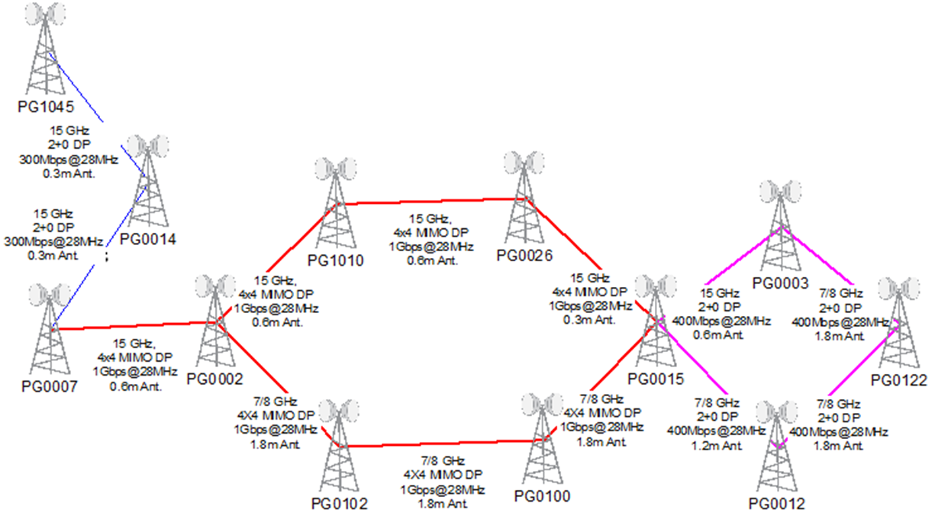
Figure 17: Example of backhaul network with LoS MIMO links

LoS MIMO interference towards other links
A LoS MIMO link consists of two transmitting elements. We shall now define an equivalent SISO link where equivalency is in terms of interference to other links in the network.
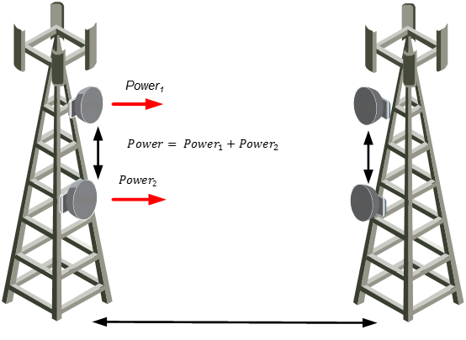
Figure 18: LoS MIMO link described as SISO link with a different transmitted power level

The power of the equivalent SISO system depends on the power of the individual signals transmitted by the LoS MIMO system and on the correlation between them. In most cases the transmitted signals are uncorrelated. In these cases the equivalent power of the SISO system equals the sum of the transmitted power levels.
Relating to Figure 18, this means a total power of ${Power}_{1}+{Power}_{2}$. In cases for which the individual power levels are equal this implies an increase of 3 dB in the interference level relative to the interference of a single transmitter.

Interferences from other links to LoS MIMO link
Interference generated by other links to the LoS MIMO link affects all the received signals as illustrated in Figure 19.
Figure 19: Adjacent-Channel / Co-Channel interference

We assume that the interference as received by both antennas has the same power level but an arbitrary phase. In the worst case scenario, the arbitrary phase can have an effect of increasing the effective interference level by 3 dB.
As in the opposite case to section 4.2.1, when the interfering station is very close or co-located with the LoS MIMO station, deviation from the 3 dB rule may be expected. Also in this case the 3 dB rule can be conservatively maintained if the planning is made with reference to the position of the LoS MIMO antenna closest (vertically or horizontally, depending on LoS MIMO implementation) to the interfering antenna. The numerical considerations in Annex 2, while geometrically described for the opposite direction, are also valid for this case.

MIMO BER threshold to use in link performance and availability calculations
Optimal LoS MIMO separation gives a potential “MIMO BER threshold” improvement, i.e. 3 dB as in space diversity operation. Sub-optimal antenna separation implies a degradation of the BER threshold. However, modern non-linear digital techniques may be used for reducing this effect (section 2.3 gives the technical background of this effect).
Therefore, it is expected that the applicant licensee, for proper evaluation of the link availability, would state in the application form the LoS MIMO antenna separation and the expected “MIMO BER threshold”, i.e. improvement/degradation over each single standalone LoS MIMO link receiver performance due to the optimal/non-optimal antenna separation.

Summary of Interference effects
Table 2 summarises the effects of upgrading SISO link to LoS MIMO 2 x 2 (to achieve double capacity)
In the case where the total e.i.r.p. of the LoS MIMO link is the same as for a SISO link (i.e. with sum power constraints), the interference transmitted to other links be the same as in the SISO case. The LoS MIMO receiver could achieve an increase of received interference power level of up to 3 dB, depending on the actual geometry. The 3 dB value could be regarded as a worst case scenario for one LoS MIMO receiver during which time the other LoS MIMO receiver will have a negligible interference. Under most realistic scenarios the 3 dB value will be a safe and conservative additional margin.
Table 2: Summary of upgrading effects
Configuration | Tx power per carrier | Relative e.i.r.p. | W/I from interferer for MIMO link | W/I toward victim for MIMO link | Relative System gain per carrier
SISO (reference system) | P | 0 | - | - | 0
MIMO 2 x 2 sum power constraint | P-3 dB | 0 | 0 | -3 dB | 0
W/I – wanted signal to interference level

Impact of coordinate precision
The optimal separation distance between antennas, especially for higher bands, can be only a few metres, as mentioned in section 2.2. For that reason, in the case of horizontal antenna separation, it is necessary to take into account the precision of coordinates to clearly distinguish between the on-site antenna locations. For instance, a difference of one integer second of longitude or latitude represents separation distance of approximately 30 metres, which may be too low a resolution for exact distinction of antennas. This may set additional requirements on necessity for higher coordinate precision.

Appropriate method for Interference Calculation using LoS MIMO links
The most appropriate way to calculate interference for LoS MIMO links can be divided into two different methods;

Method A; LoS MIMO as two separate links
Based on the critical cases described in this report and/or on the expected precision of available geographic coordinates (see section 4.2.5), administrations may plan LoS MIMO links as two separate SISO links. The antennas of the two SISO links might be licensed with individual emission parameters for each antenna. However, the “combined MIMO BER threshold” should be taken into account.

Method A is similar to existing standard radio planning procedures.

Method B; Alternative approach
In case administrations prefer to model the LoS MIMO link as an equivalent SISO link, two different planning scenarios could be considered. One scenario in case of a LoS MIMO enhancement of an already operating SISO link and another scenario in the case of authorising a brand new LoS MIMO link.
The planning of a LoS MIMO enhancement of an already operating SISO link could follow the flow chart procedure described in the Figure 20 below. In this scenario it is assumed that an already operating SISO link with one existing antenna per station is upgraded with one additional new LoS antenna per station, giving a total of two LoS MIMO antennas per station.

Figure 20: Flow chart, LoS MIMO enhancement of already operating SISO link

If the source of interference and the victim receiver are relatively close to each other it is required to identify the "closest" LoS MIMO antenna. The "closest" LoS MIMO antenna is the one antenna, out of the LoS MIMO antennas at the station, that will present the highest interference contribution towards the victim receiver. Considerations regarding LoS MIMO geometric impact on interference planning can be found in ANNEX 2:.
The "new" MIMO antenna is the additional antenna that is added to the existing SISO radio link in order to form a MIMO system.
The case of planning a brand new LoS MIMO link could follow the flow chart procedure described in the Figure 21 below:
Figure 21: Flow chart, planning of a new LoS MIMO link

The simplifications and approximations used in method B are related to the positioning of the LoS MIMO antennas and the antenna discrimination to be used in the interference calculations.

Consideration of antenna heights in interference calculations
When planning a LoS MIMO link in accordance with method B, the "closest" LoS MIMO antenna needs to be identified in order to determine the level of antenna discrimination to use in the interference calculations (see Annex 2 for examples). Since the LoS MIMO station's antennas are physically separated, with a difference in antenna position, the signal paths between the source of interference and victim receivers could experience different obstruction losses.
Figure 22 below shows a typical interference scenario where an obstacle is located between the LoS MIMO transmitters and a victim receiver. If the direct line-of-sight between the path ends is obstructed by a single object (of height hobst), such as a mountain or building, the attenuation caused by diffraction over such an object could be estimated by treating the obstruction as a diffracting knife-edge. Real obstacles and terrain profiles have of course more complex forms, so that the indications provided in the following section should be regarded only as an approximation.
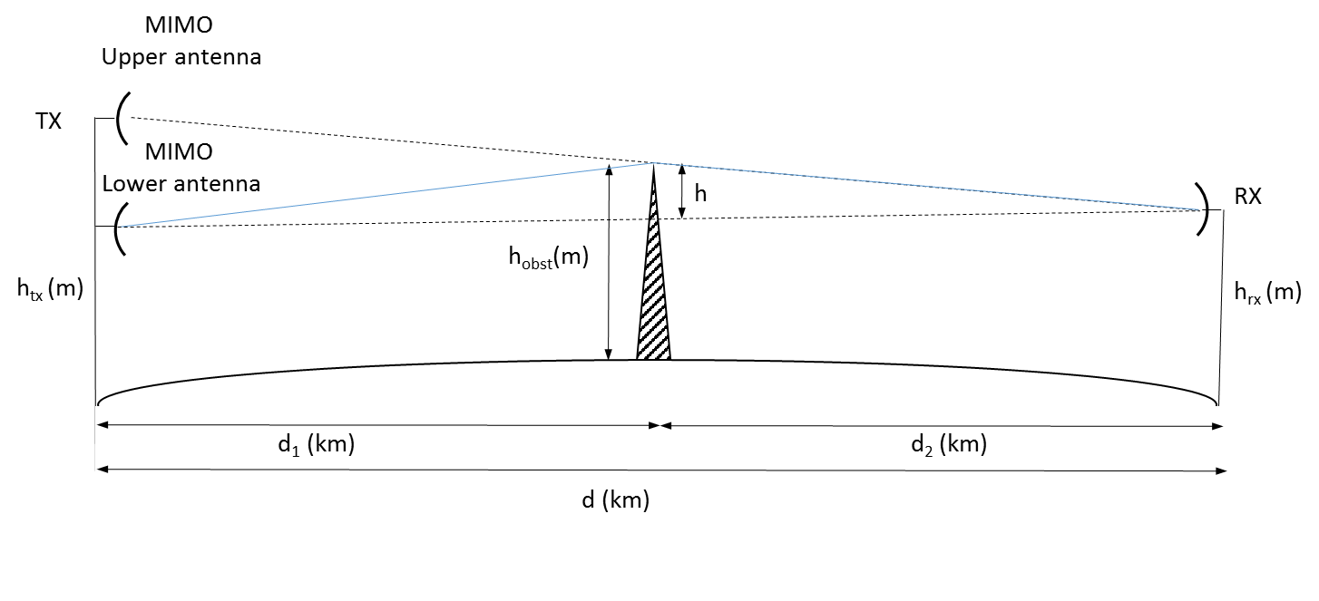
Figure 22: Typical path over a knife edge
The standard method in accordance with ITU-R recommendation P.526-13 [3] for calculating the transmission loss due to a single knife edge obstacle is as follows;
(6)
where
(7)
h – Height of the obstacle relative to a straight line between transmitter and victim receiver (m)
d1, d2 – distance of the two path ends to the obstacle (km)
d – Path length (km)
λ – Wavelength (m).
The LoS MIMO link configurations under consideration are given in the table below.
Table 3: LoS MIMO link configuration
Frequency (GHz) | Link Distance (km) | Doptimal [m]
7 | 35 | 27.4
18 | 8 | 8.2
38 | 2 | 2.8
The calculated knife edge diffraction loss, for the LoS MIMO link configurations given in Table 3, can be found in Figure 23. The knife edge obstacle is in this scenario assumed to be located at the middle of the path between the LoS MIMO transmitter and the receiver victim.

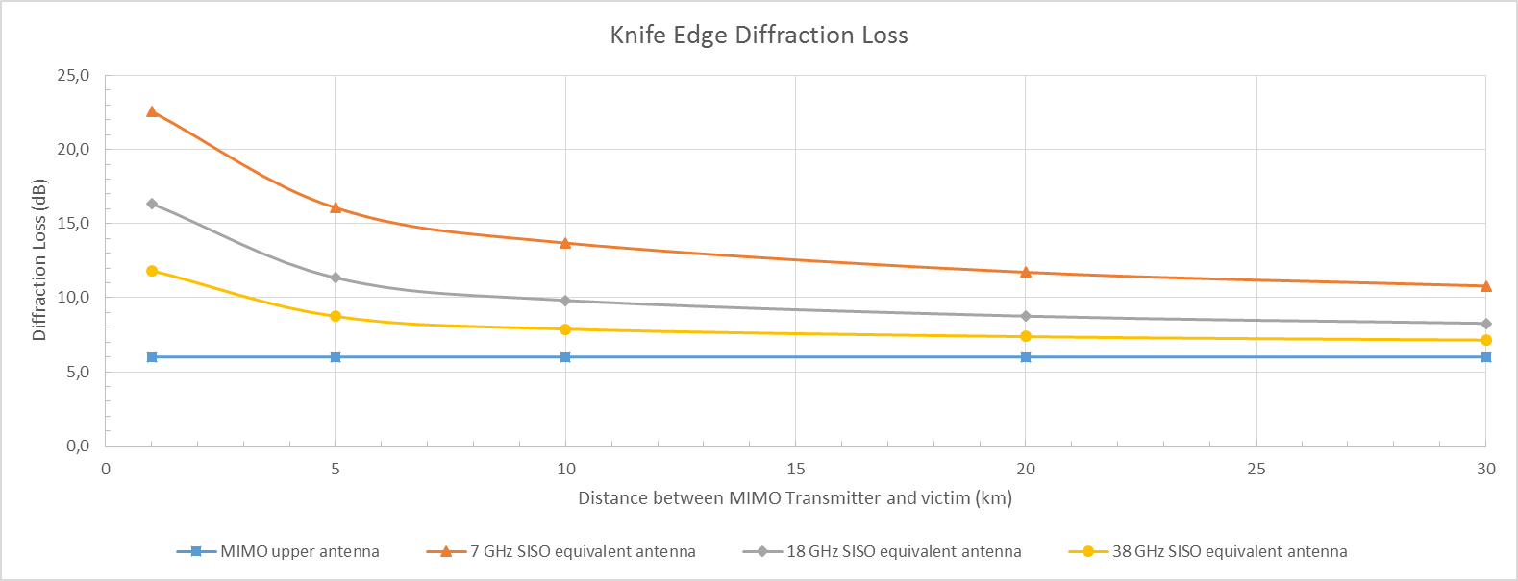
Figure 23: Knife edge diffraction loss
The blue line, “MIMO upper antenna”, give the knife edge diffraction loss as a function of distance between the upper LoS MIMO transmitter antenna and the receiver victim. The height of the obstacle is variable in the scenarios and have been selected to give diffraction loss of 6 dB for all distances between upper LoS MIMO transmitter and victim receiver.
The orange line, “7 GHz SISO equivalent antenna”, give the knife edge diffraction loss between an equivalent 7 GHz SISO transmitter antenna, with an antenna height of 13.7 m below the upper LoS MIMO antenna, and the victim receiver. The grey line, “18 GHz SISO equivalent antenna”, shows the knife edge diffraction loss for a 18 GHz SISO transmit antenna with an antenna height 4.1 m below the upper LoS MIMO antenna. The yellow line “38 GHz SISO equivalent antenna”, shows the diffraction loss for a 38 GHz SISO transmit antenna with an antenna height 1.4 m below the upper MIMO antenna.
It can be noted that the difference between the calculated knife edge diffraction loss for the upper LoS MIMO antenna and the SISO antenna increases when the distance between the transmitter and the victim receiver decreases. At a 30 km distance between the LoS MIMO transmitter and the victim receiver, the difference in diffraction loss of a 18 GHz upper LoS MIMO antenna and a 18 GHz SISO is 2.3 dB. The difference in diffraction loss is around 16 dB at a distance of 1 km.
In case of clear line-of-sight, with no obstacles between LoS MIMO transmitters and victim receivers, there will be no need to consider the terrain effects when identifying the "closest" LoS MIMO antenna. On the other hand, if the signal path between the "closest" LoS MIMO antenna and the victim receiver has additional obstruction loss larger than the difference in antenna discrimination between the two interference paths, the other LoS MIMO antenna should be evaluated in the interference calculations (i.e. use method A).

Diversity and Availability aspects
In long haul solutions where low carrier frequencies are used, and the link distance can reach 10s of kilometres, the effects of dispersive channels and flat fading must be taken into account. In such situations Space Diversity (SD) is deployed (1 transmitter and 2 receivers) in order to compensate these effects by the diversity provided by the receivers.
In order to achieve sufficient diversity between the receivers the two antennas are installed with a sufficiently large distance between them. In most long-haul SD installations the antennas are separated by a distance in the range of 10 to 20 metres.
An SD system is illustrated in Figure 24. For simplicity only one direction of the link is shown. The receiving antennas are installed with separation of $d_{SD}$ between them. This distance decorrelates the dispersive fading effects at the two receivers. The probability of a dispersive fading event which disrupts the communication link becomes significantly smaller than with no diversity. This probability is being used in link planning and availability estimation and shall be denoted by $p_{SD}$ in the following expressions.

Figure 24: Space Diversity installation
In order to evaluate the probability of a dispersive fade which disrupts the communication in a LoS MIMO system we use the following arguments.
Figure 25 demonstrates 4 connections in a 2 x 2 LoS MIMO system.
Figure 25: LoS MIMO system; the system transmits 10 bits per symbol, 5 in each stream

For a 2 x 2 LoS MIMO link to be disrupted it is required that one of the following combination of connections will experience fading:
r11 and r12 (signals to the upper receiver fade)
r11 and r21 (signals from the upper transmitter fade)
r22 and r21 (signals to the lower receiver fade)
r22 and r12 (signals from the lower transmitter fade)
The probability of each of the events listed above is equal to the $p_{SD}$.
Therefore the probability of a disruptive fade event is $\sim 4∙p_{SD}$.
Consider now two systems with identical throughput.
One is a SISO system and the other a LoS MIMO system.
As an example – a 1024 QAM SISO system which provides the same capacity as a 32 QAM 2 x 2 MIMO system.
The fade probability in the SISO system is $p_{SD,1024 QAM}$.
The fade probability in the LoS MIMO system is ${4∙p}_{SD,32 QAM}$.
These values may be calculated with a planning tool. In the example provided above it is obvious that ${4∙p}_{SD,32 QAM}$ is significantly smaller than${ p}_{SD,1024 QAM}$ for identical transmitters.

CONCLUSIONS
This report shows that LoS (Line-of-Sight) MIMO in point-to-point fixed service links is an efficient way of increasing capacity or availability without using more spectrum. The report presents technical background of LoS MIMO links operation and characteristics when compared with a typical SISO link.
When designing an LoS MIMO link, the design of the link should always try to satisfy the optimal antenna separation. It is possible to deviate from the optimal antenna separation distance without losing peak capacity. This will result in a reduced fading margin. Nevertheless, it could still be beneficial to use LoS MIMO to increase capacity even when using an antenna separation distance that is other than the optimum separation. There are a few things to consider during design and installation to achieve the full benefits. The optimal antenna separation distance, which can be symmetrical or not, should fulfil some basic conditions related to frequency band and link distance.
While optimal LoS MIMO antenna separation gives a potential “MIMO BER threshold” improvement (i.e. 3 dB as in space diversity operation), sub-optimal antenna separation implies a degradation of the BER threshold. However, digital techniques implementing the theoretical optimal performance may be used for reducing this effect.
Therefore, it is expected that the applicant licensee, for proper evaluation of the link availability, would state in the application form the LoS MIMO antenna separation and the expected “MIMO BER threshold”, i.e. improvement/degradation over each single standalone LoS MIMO link receiver performance due to the optimal /non optimal antenna separation. The improved/degraded “combined LoS MIMO BER threshold” could be used by administrations who wish to consider planning the desired LoS radio link's propagation availability.
This report shows that in most cases the interference planning of LoS MIMO links might be made in accordance with the following guidelines
Method A) LoS MIMO as two separate links
The LoS MIMO link is planned as two separate links. However, the “MIMO BER threshold” could be taken into account.
Method A is similar to existing standard radio planning procedures.
Method B) Alternative approach
In case administrations prefer to model the LoS MIMO link as an equivalent SISO link, two different planning scenarios have been considered. One scenario in case of an LoS MIMO enhancement of an already operating SISO link and another scenario in the case of authorising a brand new LoS MIMO link.
- Results of MIMO Questionnaire
CEPT administrations answered the Questionnaire “MIMO status in 2014”, some general impressions was derived and presented in ETSI TR 102 311 V1.2.1 (2015-11), Annex C [1].
Question 1: Possibility to deploy MIMO technology on licensed Fixed Service point to point links.
13 countries provide a positive answer, 4 don’t allow MIMO at the moment but few are considering the issue.
Of the few countries allowing MIMO requests, some require info on antennas and other are still considering the issue. Potential difficulties of obtaining authorisations for placing multiple antennas have been raised.
Question 2: Need of knowing correct antenna separation to accept the application for licensing.
12 administrations indicated necessity of having this info available, 7 indicate no need for it and 1 gave no indications. In case a need is indicated, in general it will be subsequently quoted on the granted license.
Question 3: Licensing options.
8 administrations indicate that they license a whole multi-antenna installation as a single FS station, 4 indicate that they license each antenna individually by prescribing individual emission parameters for each antenna and 7 indicate they are still considering the issue.
Question 4: Need of executing additional interference analysis because of the two (or more) parallel co-channel transmission paths.
9 administrations are of the opinion that such analysis is necessaries and 8 are of opposite view.
Question 5: Possibility to deploy MIMO in all fixed service bands.
8 administrations allow MIMO use in all frequency bands and 3 indicate limitations for MIMO suitable frequency bands (i.e. above 13 GHz).
Question 6: Charge of a MIMO link compared to a single transmitter link.
Approximately 10 administrations indicate to use the same charge as used for a single link, 5 indicate double charge and 5 are still under decision.
Question 7: Existence of further restrictions to deploy MIMO link (similar to space diversity links).
Approximately 10 administrations indicate that no further restrictions are foreseen, the need of a separate construction permits are indicated by one administration and the others are still considering the issue.

- LoS MIMO Geometric impact on interference Planning
  - Background
The question of whether it is necessary to separate plan either both LoS MIMO parallel links or, more simply, only one with 3 dB higher e.i.r.p. is the basic question to define a suitable approach for licensing of those links.
Technically, the answer lies in the potentially different antenna discrimination between the two interfering paths.
The scope is to determine cases where the planning made with single antenna (the antenna closer to the interfered Rx) and 3 dB higher e.i.r.p. (simulating the double antenna emission) would exceed the expected 3 dB increase in the I/N at the victim receiver.
  - Simulation with horizontal MIMO antenna spacing
The scenario is graphically shown in Figure 26 when MIMO antennas are spaced horizontally and in Figure 27 when the MIMO antennas are spaced vertically.
Figure 26: Geometric representation of the interfering scenario (horizontal spacing)
Figure 27: Geometric representation of the interfering scenario (vertical spacing)
In the calculation, the victim station (Vs) is placed at constant distance from the first MIMO antenna (i.e. Xms1 and Yms are kept constant for each calculation). The victim boresight angle is rotated (from −90 degrees to + 150 degrees) with respect to the 0 degree reference assumed normal to the MIMO link direction. The following points then apply.
It is important to note that calculations are made with reference to the MIMO antenna “closest to victim” (i.e. in the horizontal plane for horizontal MIMO or in the vertical plane for vertical MIMO).
In horizontal spacing (Figure 26), angles α1 and α2 are variable with boresight offset, while β1 and β2 are fixed as atan(Xms1/Yms) and atan(Xms2/Yms), respectively. These are the angles that determine the antenna discrimination of the victim (Vs) and interfering (Ims) stations.
However, the difference α0 = α1−α2 is constant:
(8)
In vertical spacing (Figure 27), angles α1H (in the horizontal plane) and α2< (in the angled plane) are variable with boresight offset, while β1H and β2V are fixed as atan(Xms1/Yms) and atan(DmsY/√(Xms12+Yms2)), respectively. The angle α2< is calculated (annex 3 in ITU-R F.1336-4 [5]) as:
(9)
I/N ≤ −10 dB has been used as the planning criterion, and considering that the worst situation is certainly when the Vs and Ims stations are close each other, it is also assumed that co-channel operation cannot be practical (large frequency spacing or hi/low deployment is necessary otherwise the I/N criterion is never met); therefore, an additional 45 dB discrimination (NFD) is generally added.
The MIMO antenna separation distance has been kept at the “optimum”; this is considered the wider possible distance and therefore that giving the maximum potential difference in the two antenna interference contribution.
Antenna RPEs (assumed equal for Vs and Ims stations) are described as joint envelope of ITU-R F.699 [2] (main lobe) and ETSI EN 302 217-4-2 [3] class 2 RPE; Figure 28 shows the antenna RPE used for the examples considered.
I/N are calculated for both antennas (I/N1 and I/N2) and its combination (I/Ntotal) as well as the difference (I/Ntotal – I/N1), which is expected to be typically close to 3 dB or less (MIMO antenna 1 is the closest to Vs station so on average produces higher interference).
Please note that spikes in the graphs in the range of steep RPE variation are due to the “finite granularity” of the RPE description. If a continuous function were to be used the spikes would be smoothed down.
Figure 28: Antennas RPE (Recommendation ITU-R F.699 joint to ETSI class 2) [2]
    - 7 GHz band example
The following parameters have been used:
Table 4: 7 GHz Parameter values
Parameter | Value
MIMO (I) data
I Hop length (km) | 35.0
Optimum distance (m) | 27.4
Pout I (dBm) | 30.0
CS (MHz) | 56.0
Pout density (dBm/MHz) | 12.5
Victim (V)
V Noise figure (dB) | 5.0
(V Noise density +NF) (dBm/MHz) | -109.0
Permitted I/N (dB) | -10.0
Xms1 (m) | 100.0
Yms1 (m) | 10000/1000/500/100
General
Additional decoupling (NFD) (dB) | 45.0
Antenna size (m) / Gain (dBi) | 3 / 44.5

      - Horizontal MIMO spacing
Figure 29 shows four cases of different victim receiver placing with respect to the MIMO interfering station, Xms1 is constant at 100 m, while Yms is variable from very close to relatively far away.
(Xms1=100 m; Yms=10 km) (Xms1=100 m; Yms=1 km)
(Xms1=100 m; Yms=500 m) (Xms1=100 m; Yms=100 m)
Figure 29: I/N evaluation horizontal MIMO spacing (7 GHz)

      - Vertical MIMO spacing
Figure 30 shows four cases of different victim receiver placing with respect to the MIMO interfering station, Xms1 = Xms2 is constant at 100 m, while Yms is variable from very close to relatively far away.
(Xms1=100 m; Yms=10 km) (Xms1=100 m; Yms=1 km)
(Xms1=100 m; Yms=500 m) (Xms1=100 m; Yms=100 m)
Figure 30: I/N evaluation vertical MIMO spacing (7 GHz)

    - 18 GHz band example
The following parameters have been used:
Table 5: 18 GHz Parameter values
Parameter | Value
MIMO (I) data
I Hop length (km) | 8.0
Optimum distance (m) | 8.2
Pout I (dBm) | 25.0
CS (MHz) | 56.0
Pout density (dBm/MHz) | 7.5
Victim (V)
V Noise figure (dB) | 6.0
(V Noise density +NF) (dBm/MHz) | -108.0
Permitted I/N (dB) | -10.0
Xms1 (m) | 10.0
Yms1 (m) | 1000/100/50/10
General
Additional decoupling (NFD) (dB) | 45.0
Antenna size (m) / Gain (dBi) | 0.6 / 39

      - Horizontal MIMO spacing
Figure 31 shows four cases of different victim receiver placing with respect to the MIMO interfering station, Xms1 is constant at 10 m, while Yms is variable from very close to relatively far away.
(Xms1=10m; Yms=1km) (Xms1=10m; Yms =100m)
(Xms1=10m; Yms =50m) (Xms1=10m; Yms =10m)
Figure 31: I/N evaluation horizontal MIMO spacing (18 GHz)

      - Vertical MIMO spacing
Figure 32 shows four cases of different victim receiver placing with respect to the MIMO interfering station, Xms1 = Xms2 is constant at 10 m, while Yms is variable from very close to relatively far away.
(Xms1=10m; Yms=1km) (Xms1=10m; Yms=100m)
(Xms1=10m; Yms=50m) (Xms1=10m; Yms=10m)
Figure 32: I/N evaluation vertical MIMO spacing (18 GHz)

    - 38 GHz band example
The following parameters have been used:
Table 6: 38 GHz Parameter values
Parameter | Value
MIMO (I) data
I Hop length (km) | 2.0
Optimum distance (m) | 2.8
Pout I (dBm) | 25.0
CS (MHz) | 56.0
Pout density (dBm/MHz) | 7.5
Victim (V)
V Noise figure (dB) | 8.0
(V Noise density +NF) (dBm/MHz) | -106.0
Permitted I/N (dB) | -10.0
Xms1 (m) | 10.0
Yms1 (m) | 1000/100/50/10
General
Additional decoupling (NFD) (dB) | 45.0
Antenna size (m) / Gain (dBi) | 0.3 / 39.3

      - Horizontal MIMO spacing
Figure 33 shows four cases of different victim receiver placing with respect to the MIMO interfering station, Xms1 is constant at 10 m, while Yms is variable from very close to relatively far away.
(Xms1=10 m; Yms=1 km) (Xms1=10 m; Yms=100 m)
(Xms1=10 m; Yms=50 m) (Xms1=10 m; Yms=10 m)
Figure 33: I/N evaluation horizontal MIMO spacing (38 GHz)

      - Vertical MIMO spacing
Figure 34 shows four cases of different victim receiver placing with respect to the MIMO interfering station, Xms1 is constant at 10 m, while Yms is variable from very close to relatively far away.
(Xms1=10 m; Yms=1 km) (Xms1=10 m; Yms=100 m)
(Xms1=10 m; Yms=50 m) (Xms1=10 m; Yms=10 m)
Figure 34: I/N evaluation vertical MIMO spacing (38 GHz)

  - Results of analysis
From the above graphs the following can be derived:
- If the Ims and Vs stations are relatively far away, the planning assumption of using a single MIMO antenna (the closest one to Vs station) with 3 dB higher e.i.r.p. results are generally conservative in the sector of angles where I/N1 is below the objective.
- However, in the horizontal MIMO case as Ims and Vs stations become closer, the sector of angles where the antenna RPE drops is steeper, and an inversion appears which is due to the relatively larger variation between angles α1 and α2 and β1 and β2. Larger I/Ntotal (of few dB, e.g. at 7 GHz, 5 dB instead of 3 dB enhancement) is experienced.
- However, in the vertical MIMO case, even when antennas are very close, the angle variation is more contained and, most of all, the vertically closer antenna contribution is always the larger one; therefore, its calculated influence with 3 dB higher e.i.r.p. is always conservative (up to the same 3 dB) versus the I/Ntotal.
- The 7 GHz case might need further consideration because MIMO spacing optimum (27 m) implies different antenna infrastructure (horizontal) or very high towers (vertical). However, when sub-optimum spacing is acceptable, it can still be considered within a number of existing infrastructures.
The cases presented are limited and made with specific assumptions (i.e. 45 dB NFD, optimal MIMO spacing); however, they seem sufficient to confirm that:
- Where vertical MIMO stations are concerned, their planning can in all cases be done “conservatively” considering only the antenna “closest” to victim station with 3 dB higher e.i.r.p..
- Where horizontal MIMO stations are concerned (this case is generally assumed to be less frequent) care should only be taken when stations are collocated (higher bands) or relatively very close (lower bands). Also in this case, deviations are minimised considering only the antenna “closest” to victim station with 3 dB higher e.i.r.p.
- For both cases, vertical and horizontal separation, interfering calculations with various numbers of interferer or victim stations at different locations should consider both antennas and not only the “closest” one.
- Provided that planning tools are automated, it might be possible to apply a common approach based on the known geometric data of the links for finding the "closest" MIMO antenna
- Examples of equivalent MIMO Radiation Pattern Envelope
  - Background
This contribution shows some example of calculated interference from a MIMO P-P station towards a conventional receiver placed at certain distance.
The scope is to determine cases where the planning made with single antenna (the middle point of the two antennas) and 3 dB higher e.i.r.p. (simulating the double antenna emission) would exceed the expected 3 dB increase in the I/N in the victim receiver. The calculation is based on the equivalent RPE from the two antennas related to a RPE from a SISO transmitter located in the middle point. The parameters of the victim (and the location of the system) are not considered here since they are similar for both calculations.
  - Simulation with Vertical MIMO antenna spacing
The scenario is graphically shown in Figure 35 when MIMO antennas are spaced vertically (a similar figure can be sketched for the horizontal scenario).
d is the distance between the MIMO antennas.
Figure 35: Geometric representation of the interfering scenario (vertical spacing)

The equivalent point of the MIMO antenna defined as the middle point between the two antennas (d/2) and this is the point that we shall refer as the place of an equivalent SISO antenna.
The victim receiver is placed at distance Rmv from this point with angle α referring to the boresight of the MIMO link. The received power of the MIMO interference in the victim receiver depends on the location of the victim system and the angle between boresight (victim and MIMO). Since we intend to find equivalent RPE of the MIMO link as interference we only care of the angle between MIMO boresight and the victim location.
Main assumptions:
- Calculations are made with reference to the equivalent place (d/2) of the MIMO antenna;
- We calculate the equivalent RPE as a sum of two independent signals from the two antennas;
- In vertical spacing we check only the elevation RPE, since the azimuth RPE is similar between the SISO case and MIMO case (both antenna on the same pole). In the horizontal case we check the azimuth and assume that the difference in elevation is negligible. We also assume that the RPE in elevation is similar to the azimuth RPE;
- The MIMO antenna distance has been checked for typical distances: 4 m for 38GHz, 10 m for 18 GHz and 25 m for 7 GHz;
- The minimal distance for the victim antenna was set to the Fraunhofer far field distance
($R_{min}=2∙\frac{{Dant}^{2}}{λ})$;
- Antenna RPEs are taken from Andrew standards data sheet. 1 ft for 38 GHz, 2 ft for 18 GHz and 6 ft for 7 GHz case.
    - 7GHz band example
The following parameters were simulated:
Table 7: 7 GHz parameters
Parameter | Value
Frequency | 7 GHz
Antenna size | 6 ft (1.8 m)
Distance between MIMO antennas | 25 m
Victim range | 150 m

The original RPE of the basic antenna is shown with 3 dB offset. The red curve is the calculated combined RPE from the two antennas referring to the middle point between the two antennas calculated for the minimal distance.
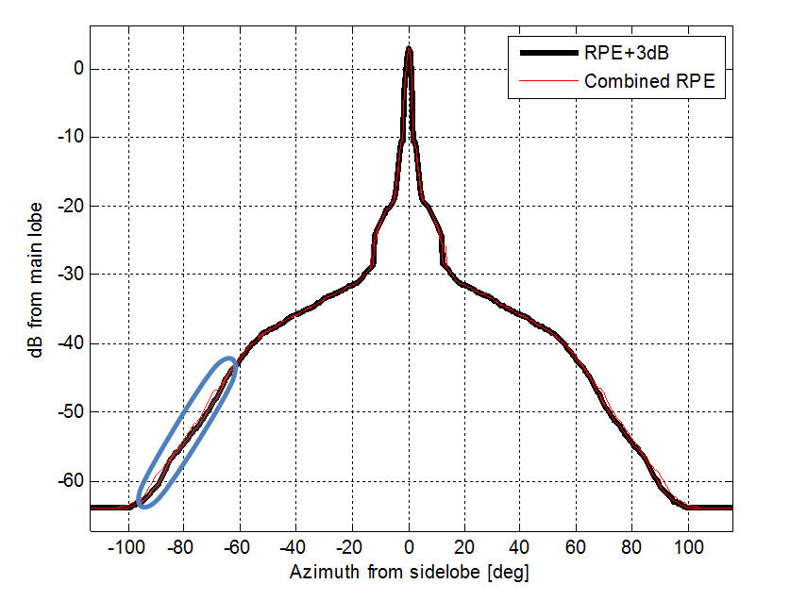
Figure 36: 7 GHz antenna RPE
There is a slight expansion between 60 to 100 degrees.
For victim distances above 500 m the original RPE+3 dB is similar to the combined case.
Table 8: 7 GHz comparison
Distance_between MIMO -Victim | 150 m | 500 m | 5000 m
Combined RPE referring to single RPE+3 dB | <1.8 dB | <0.3 dB | 0

    - 18 GHz band example
The following parameters were simulated:
Table 9: 18 GHz parameters
Parameter | Value
Frequency | 18 GHz
Antenna size | 2 ft (0.6 m)
Distance between MIMO antennas | 10 m
Victim range | 43 m
Figure 37: 18 GHz antenna RPE
For 18 GHz, 2 ft, the 3 dB expansion looks OK, there is very slight change in angles above 80 to 90 degrees. For 100 m and above the combined RPE is similar to the original RPE+3 dB.
Table 10: 18 GHz comparison
Distance between MIMO-Victim | 100 m | 500 m | 5000 m
Combined RPE referring to single RPE+3dB | <1 dB | <0.2 dB | 0
    - 38 GHz band example
The following parameters were simulated.
Table 11: 38 GHz parameters
Parameter | Value
Frequency | 38 GHz
Antenna size | 1 ft (0.3 m)
Distance between MIMO antennas | 4 m
Victim range | 23 m
Figure 38: 38 GHz antenna RPE
For the 38 GHz case there is very small expansion above 75 degrees and again for victims above 100 m the changes disappear.
Table 12: 38 GHz comparison
Distance between MIMO-Victim | 100 m | 500 m | 5000 m
Combined RPE referring to single RPE+3 dB | <0.3 dB | 0 | 0

  - Conclusions
From the above graphs it can be derived that:
- As long as the stations are relatively far away (>500 m for 7 GHz and even >100 m for 18 GHz and above), the planning assumption of using a single MIMO antenna (at the middle) with 3 dB higher e.i.r.p. results generally conservative in the sector of angles.
- When the range to the victim is very short and near to the Fraunhofer far field distance there is slight gain in angles of 60 to 100 degrees.
For short range to victim receivers, there are several options that can be used:
- Simulate with two antennas, or update the tool to calculate this accurately.
- Use single antenna and compensate by expanding the RPE by 7% (see an example below) or add 2dB more to the RPE.
Figure 39: Comparison of antenna RPE, short range
For very short ranges between MIMO link and victim station below Fraunhofer far field distance, the recommendation is to calculate it with two separate antennas. In the example below, we can see the combined RPE of an 18 GHz link with 10 m distance between the antenna and 10 m range to the victim. However in this case, the models for calculating the two antennas may be not accurate enough also for SISO case.

Figure 40: Comparison of antenna RPE, very short range

- List of Reference
- ETSI TR 102 311 V1.2.1 (2015-11) - Fixed Radio Systems; Point-to-point equipment; Specific aspects of the spatial frequency reuse method
- Recommendation ITU-R F.699: Reference radiation patterns for fixed wireless system antennas for use in coordination studies and interference assessment in the frequency range from 100 MHz to about 70 GHz
- Recommendation ITU-R P.526: Propagation by diffraction
- ETSI EN 302 217-4-2 v1.1.3: Fixed Radio Systems; Characteristics and requirements for point-to-point equipment and antennas; Part 4-2: Harmonized EN covering essential requirements of Article 3.2 of R&TTE Directive for antennas
- Recommendation ITU-R F.1336-4: Reference radiation patterns of omnidirectional, sectoral and other antennas for the fixed and mobile service for use in sharing studies in the frequency range from 400 MHz to about 70 GHz

In case the Tx power per antenna is the same as in the SISO case on the same link, the theoretical value of average SNR gain is 3 dB when adding two signals of equal strength, i.e. at the optimal antenna separation. When the antenna separation is shorter than the optimal, in real radio equipment there will inevitably be some additional loss compared to the theoretical value. The actual increase of fade margin depends on the radio equipment implementation. MIMO with closed loop can reduce the loss. However, it requires an increased linearity for the same output power of the transmitter, and introduction of a feedback loop for the transmitter control process with long delay. Sometimes, these additional conditions limit the MIMO performance.

