ECC Report 253

Compatibility studies on audio PMSE at
1492-1518 MHz and 1518-1525 MHz
Approved 30 September 2016

Executive summary
This ECC Report was originally intended to investigate the compatibility between wireless microphones and other systems in the frequency ranges 1492-1518 MHz and 1518-1525 MHz. These studies were initiated to investigate how wider adoption of audio PMSE (Programme Making and Special Events) amongst CEPT member states for these bands could be achieved.
This report considered only body worn, handheld and IEM (In-Ear-Monitoring) audio PMSE transmitters. Floor tripod and table tripod operations are not considered in the study. Audio PMSE devices are assumed to be limited to indoor operation and to operate under a licensing regime.
Co-channel sharing between the fixed service - coordinated and wireless microphones is feasible with the separation distances given in Table 1 below. For guard bands >1 MHz, there will be no interference to the Fixed Service.
With regard to the Fixed Service uncoordinated, there is an acceptable risk of interference in case of handheld/body worn equipment. The risk of interference is more significant in case of IEM devices when considering the more stringent interference criterion (I/N = -20 dB).
In case of TRR (Tactical Radio Relay), the risk of interference is low for the body worn, hand held equipment and IEM, therefore, there is no need to implement mitigation techniques if the audio PMSE systems are deployed only indoors.
Separation distances could be implemented in order to ensure the compatibility between the Aeronautical Telemetry and audio PMSE.
ECC/DEC/(13)03 [1] states that “CEPT administrations shall designate the frequency band 1452-1492 MHz to MFCN SDL…” and since WRC-15 the frequency bands 1427-1452 MHz and 1492-1518 MHz are identified for IMT for all three Regions. Given that the band 1492-1518 MHz is expected to be used by CEPT countries for IMT, sharing studies between PMSE and IMT within 1492-1518 MHz are not considered in this report.
Compatibility studies between audio PMSE above 1518 MHz and IMT below 1518 MHz (adjacent band compatibility) have shown that handheld audio PMSE creates slightly higher probability of interference into LTE UE than body worn audio PMSE due to higher emission levels (considering body loss). The probability of interference differs depending on the separation between the audio PMSE and LTE equipment. Some methods to reduce the interference is to specify a minimum physical separation between victim and interferer or to keep a frequency offset above 1518 MHz to reduce the unwanted emissions as well as blocking impact. In addition, an e.i.r.p. limit would also reduce the blocking effect and the definition of a block edge mask would limit the unwanted emissions impact.
The implementation of a possible guard band for IMT and MSS (Mobile Satellite Service) compatibility was not considered in this study.
There is no harmful interference from the MSS downlinks to audio PMSE systems.
With regard to potential interference from audio PMSE devices to land based MSS systems, simulations have shown that the probability of interference to MES (Mobile Earth Station) is dependent on the density of audio PMSE operations in any given area and the assumed wall loss and body loss values. See Section 4.1.3 for audio PMSE densities.
Therefore, administrations should consider the density of audio PMSE deployment within a given area when assessing interference into MESs. However, some administrations do allow PMSE and other services to share in the band 1517-1525 MHz, e.g. as outlined in ANNEX 3:.
With regard to potential interference from audio PMSE devices to airborne MSS systems, MCL (Minimum Coupling Loss) calculations have shown that the risk of interference to aircraft MES is dependent on assumed wall loss and body loss values and on aircraft height.
The following table provides an overview of the sharing conditions.
Table 1: Overview of the sharing conditions
Service | Body worn / Hand held | IEM
IMT (downlink)  (1492-1518 MHz)2 | For audio PMSE within 1518-1525 MHz, define minimum physical separation between LTE UE and audio PMSE or to keep a frequency offset above 1518 MHz, or to limit the maximum e.i.r.p. and define a block edge mask | For audio PMSE within 1518-1525 MHz, define minimum physical separation between LTE UE and audio PMSE or to keep a frequency offset above 1518 MHz, or to limit the maximum e.i.r.p. and define a block edge mask
Fixed Service – coordinated  (1492-1525 MHz)  (Note 1) | Co-channel separation distances  Main lobe: 20 km  Side lobe: 1 km  For guard bands >1 MHz, there will be no interference to the Fixed Service | Co-channel separation distances  Main lobe: 21 km  Side lobe: of 2.5 km  For guard bands >1 MHz, there will be no interference to the Fixed Service
Fixed Service – uncoordinated  (1492-1525 MHz)  (Note 1) | No mitigation techniques required | Mitigation techniques may be needed on a national basis depending on the sensitivity of the systems
Mobile Service – TRR  (1492-1525 MHz) | No mitigation techniques required | No mitigation techniques required
Aeronautical Telemetry  (1492-1525 MHz) | Separation distance of 3 km.  Exact frequencies used by Aeronautical systems are not known therefore a guard band cannot be considered | Separation distances of 5 km.  Exact frequencies used by Aeronautical systems are not known therefore a guard band cannot be considered
MSS (s-E)  (1518-1525 MHz) | For sharing with respect to Land MES: Feasibility of sharing depends on typical audio PMSE density and deployment conditions as specified in section 4.1.3.  For sharing with respect to aeronautical MESs: Feasibility of sharing depends on assumptions regarding key parameters such as building penetration loss and aircraft altitude. No firm conclusions are drawn in this Report. See section 5.6.3 | Not considered

Note 1: Co-channel sharing between the Fixed Service and wireless microphones at the same geographical location would be problematic because of the disruptive effect on the wireless microphone receivers from the Fixed Service signals. The implementation of a scanning procedure to identify the parts of spectrum which are in use by other transmitter(s) and the parts of the spectrum, which are available for successful audio PMSE operation will reduce the risk of interference between audio PMSE operations and Fixed Service systems.

TABLE OF CONTENTS

0 Executive summary 2
1 Introduction 9
2 Definitions 11
3 Technical characteristics of audio PMSE systems 12
3.1 Audio PMSE DEScription 12
3.1.1 Audio PMSE Transmitters 13
3.1.2 Audio PMSE Receivers 17
4 Parameters and characteristics relevant for the Compatibility studies in the frequency band 1492-1525 MHz 18
4.1 Audio PMSE Deployment 18
4.1.1 Operation 18
4.1.2 Use case scenarios 18
4.1.3 Density 18
4.1.4 Wall attenuation 18
4.2 Fixed Service Characteristics 20
4.3 Mobile Service 22
4.3.1 Description of LTE 22
4.3.2 Description of Tactical Radio Relay systems 25
4.4 Aeronautical Telemetry characteristics 27
4.5 Mobile Satellite service 28
4.5.1 Current usage of MSS in Europe in the band 1518-1525 MHz 28
4.5.2 MSS characteristics 29
4.5.3 MSS design objectives 31
5 Compatibility studies in the band 1492-1518 Mhz and 1518-1525 MHz 32
5.1 Audio PMSE impact on Fixed service - coordinated 32
5.1.1 Considerations on the co-frequency case 32
5.1.1.1 MCL calculations 32
5.1.1.2 SEAMCAT simulations 33
5.1.2 Considerations on the non-co-frequency case 34
5.1.2.1 Impact of the unwanted emissions 34
5.1.2.2 Impact on the blocking 35
5.1.2.3 Conclusions 35
5.2 PMSE impact on Fixed Service – Uncoordinated 36
5.2.1 Considerations on the co-frequency case 36
5.2.1.1 MCL calculations 36
5.2.1.2 SEAMCAT simulations 37
5.2.2 Considerations on the non-co-frequency case 38
5.2.3 Conclusions 38
5.3 Audio PMSE impact on Mobile service (TRR) 38
5.3.1 Considerations on the co-frequency case 38
5.3.1.1 MCL calculations 38
5.3.1.2 SEAMCAT simulations 39
5.3.2 Considerations on the non-co-frequency case 39
5.3.2.1 Impact of the unwanted emissions 39
5.3.2.2 Impact on the blocking 40
5.3.2.3 Conclusions 40
5.4 PMSE impact on Mobile service (IMT) 40
5.4.1 Simulation scenarios 40
5.4.2 Simulation assumptions 41
5.4.3 Conclusions 41
5.5 PMSE impact on Aeronautical Telemetry 43
5.5.1 Simulations 43
5.5.2 Results of simulations 43
5.5.3 Identification of white spaces in frequency for PMSE in country using the Aeronautical Telemetry 44
5.5.4 Conclusions 44
5.6 PMSE impact on Mobile Satellite Service MES 44
5.6.1 Path loss calculation 44
5.6.2 Land MES 45
5.6.2.1 Propagation model assumptions 45
5.6.2.2 MCL calculations 46
5.6.2.3 SEAMCAT simulations for GSPS and BGAN MESs 54
5.6.2.4 Sensitivity analysis 56
5.6.3 Aeronautical MES 56
5.6.3.1 MCL calculations for aircraft at 1000m, 3000m and 13000m altitude 57
5.6.4 Mobile Satellite Service impact on audio PMSE 67
5.6.5 Summary of considerations for the audio PMSE and MSS compatibility at 1518-1525 MHz 68
6 Conclusions 69
ANNEX 1: Audio PMSE Body loss 71
ANNEX 2: Wall loss 88
ANNEX 3: Examples of PMSE and other services operating in the band 1517-1525 MHz 93
ANNEX 4: Audio PMSE density 94
ANNEX 5: LIST OF REFERENCE 97

LIST OF ABBREVIATIONS

Abbreviation | Explanation
3GPP | 3rd Generation Partnership Project
ACS | Adjacent Channel Selectivity
AMS (R)S | Aeronautical Mobile Satellite (Route) Service
AV | Audiovisual
BGAN | Broadband Global Area Network
BR | Blocking Response
BS | Base Station
BSS | Broadcasting Satellite Service
BW | Bandwith
CEPT | European Conference of Postal and Telecommunications Administrations
DAA | Detect and Avoid
DEC | Decision
DL | Downlink
ECC | Electronic Communications Committee
e.i.r.p. | equivalent isotropically radiated power
ERC | European Radiocommunications Committee
ESOA | European Satellite Operator Association
ETSI | European Telecommunications Standards Insitute
FS | Fixed Service
GAN | Global Area Network
GMDSS | Global Maritime Distress and Safety System
GSO | Geostationary Satellite Orbit
GSPS | Global Satellite Phone Service
IEM | In-Ear-Monitoring
I/N | Interference to Noise
IMO | International Maritime Organization
IMT | International Mobile Telecommunications
ITU | International Telecommunication Union
LTE | Long Term Evolution
MES | Mobile Earth Station
MFCN | Mobile Fixed Communication Network
MSS | Mobile Satellite Service
NA | Not Available
NF | Noise Figure
PFD | Power Flux Density
PMSE | Programme Making and Special Events
PWMS | Professional Wireless Microphone Systems
QoS | Quality of Service
REC | Recommendation
SDL | Supplemental Downlink
S-E | Space-to-Earth
SEAMCAT | Spectrum Engineering Advanced Monte Carlo Analysis Tool
SRD | Short Range Device
TRR | Tactical Radio Relay
TV | Television
TX | Transmitter
UE | User Equipment
WRC | World Radiocommunication Conference

Introduction
The aim of this Report is to provide further compatibility studies between indoor use of low power audio PMSE applications (wireless microphones and in ear monitors used in places such as theatres, concert halls, trade shows etc.) not performed within the scope of ECC Report 121 [2]. These studies were initiated to investigate how wider adoption of audio PMSE amongst CEPT member states for the band 1492-1518 MHz band could be achieved. Furthermore, this Report includes compatibility studies investigating whether the audio PMSE tuning range can be widened to additionally cover the band 1518-1525 MHz. For the band 1492-1518 MHz, studies with the Tactical Radio Relays (TRR) are addressed in this Report. Additional studies were conducted for the Fixed Service. Revised assumptions were considered for the audio PMSE characteristics (body loss, polarisation…).
During the preparation of this report, WRC-15 took place. The frequency band 1492-1518 MHz was identified for IMT for all three Regions. The band 1492-1518 MHz is expected to be used by CEPT countries for IMT. Given the process of harmonisation of the 1427-1518 MHz band for MFCN, the frequency band
1492-1518 MHz may no longer be a long-term prospect for audio PMSE.
Table 2 shows the services allocated in the considered bands in ITU Radio Regulations in Region 1.
Table 2: Service allocation in the bands under consideration
Frequency Band (MHz) | SERVICES
1452-1492 | FIXED | MOBILE except aeronautical mobile (5.341A)
1492-1518 | FIXED | MOBILE except aeronautical mobile (5.341A) | Aeronautical Telemetry (5.342)
1518-1525 | FIXED | MOBILE except aeronautical mobile | MOBILE-SATELLITE (s-E) | Aeronautical Telemetry (5.342)

Footnote 5.341A of the Radio Regulations states that In Region 1, the frequency bands 1427-1452 MHz and 1492-1518 MHz are identified for use by administrations wishing to implement International Mobile Telecommunications (IMT) in accordance with Resolution 223 (Rev.WRC-15) [4]. This identification does not preclude the use of these frequency bands by any other application of the services to which it is allocated and does not establish priority in the Radio Regulations. The use of IMT stations is subject to agreement under No. 9.21 with respect to the aeronautical mobile service used for aeronautical telemetry in accordance with No. 5.342.
Since 2013, audio PMSE applications have been included in the ERC/REC 70-03 [5] Annex 10 in the frequency range 1492-1518 MHz. Table 3 provides the technical and regulatory requirements of the band.
Table 3: Regulatory parameters in ERC/REC 70-03 (Annex 10)
Frequency Band | Power / Magnetic Field | Spectrum access and mitigation requirements | Channel spacing | Notes
1492-1518 MHz | 50 mW e.i.r.p | No requirement | No spacing | On a tuning range basis.  Individual licence required.  Restricted to indoor use

Several CEPT administrations have implemented audio PMSE on national basis in the band 1492-1518 MHz: Albania, Austria, Germany, Luxembourg, Moldova, Slovenia, the United Kingdom (for 1517-1518 MHz); Liechtenstein and Switzerland are studying implementation according to ERC/REC 70-03 [5].
Austria is currently implementing audio PMSE in the band 1518-1525 MHz for time-limited applications with a maximum of 50 mW e.i.r.p.
The United Kingdom licenses PMSE applications in the frequency range 1517 MHz to 1525 MHz with an e.r.p. of up to 20 dBW. (See some examples in Annex 3.)
ECC Reports 121 [2] and 147 [6] provide background for the requested studies and contain the following:
- ECC contains results of sharing and compatibility studies between PMWS and other services in the bands 1452 MHz -1492 MHz, 1492 MHz -1530 MHz and 1533 MHz to 1559 MHz;
- Report 121 and ECC Report 147 [6] was developed with the aim to consider improved sharing between fixed indoor installed PWMS and MSS. In particular, in the band 1518 -1530 MHz by using mitigation techniques like Detect and Avoid (DAA).

The studies concluded that compatibility with FS/Mobile/BSS and Aeronautical telemetry can be achieved with mitigation techniques and restrictions listed in ECC Report 121.
Based on the assumptions made in ECC Reports 121 [2] and 147 [6] the compatibility studies between PWMS devices and the Mobile Satellite Service (MSS) in concluded that sharing was not feasible even considering the potential use of the DAA technique.
The band 1518-1525 MHz is designated to the MSS through ECC Decision ECC/DEC/(04)09 [20]. In the band 1518-1525 MHz, the studies could take into account the fact that expected deployment density of MSS near to PMSE use is expected to be quite low. Currently, there is one satellite in operation covering this frequency range (the 'Alphasat' satellite) and provides service in Europe, the Middle East and Africa. The analyses in ECC Report 121 so far suggested that where there is a low density of both MSS and PMSE compatibility may be possible.
However, it is also to be understood that in most cases audio PMSE applications (indoor, under individual authorisation and at locations such as theatres or concert halls) are unlikely to be at the same location and time and used together with users of MSS.

Definitions
Term | Definition
MCL | Minimum Coupling Loss
PMSE | Programme Making and Special Events  The term includes all wireless equipment used at the front-end of all professional productions; e.g. audio, video and effect control. PWMS are intended for use in the entertainment and installed sound industry by Professional Users involved in stage productions, public events, and TV programme production, public and private broadcasters’ installation in conference centres / rooms, city halls, musical and theatres, sport / event centres or other professional activities / installation.
PWMS | Professional Wireless Microphone Systems  The term includes all wireless audio equipment used at the front-end of all professional audio productions; like wireless microphones or In-Ear-Monitoring (IEM). PWMS are intended for use in the entertainment and AV content industry by Professional Users involved in stage productions, public events, and TV programme production, public and private broadcasters’ installation in conference centres / rooms, city halls, musical and theatres, sport / event centres or other professional activities / installation.

Technical characteristics of audio PMSE systems
Sharing studies conducted in this Report take into account only scenarios where specific types of audio PMSE systems are operating under particular regulatory conditions e.g. indoor usage and under an individual licensing regime. The following classes of equipment should be considered. Programme Audio Links, monophonic or stereophonic music and speech signals only.
The studies contained in this report are undertaken to investigate the feasibility to widen the national implementation of the frequency range 1492-1518 MHz and further consider the frequency range 1518-1525 MHz. ECC Report 121 [2] carried out studies based on ETSI TR 102 546 (Technical characteristics for Professional Wireless Microphone Systems (PWMS)).
The Harmonised Standard EN 300 422 [8] provides updated information compared to ETSI TR 102 546 [7] (PMSE mask has been changed compared to the older documentation, i.e. inclusion of new masks for digital PMSE equipment).
The following scenarios may improve compatibility with incumbent services where audio PMSE is operating in the environments where there could be higher wall attenuation:
- Theatres;
- Concert halls;
- Conference and studio buildings.

In the framework of this report, a licensing regime is considered. This may allow widening the national implementation in the frequency ranges under considerations by:
- Enforcing the separation distances which may be required to protect some services;
- Limiting the deployment of audio PMSE to some type of buildings if it is found necessary and practical;
- Allowing the administration to monitor and control the deployment of audio PMSE in case existing services in the bands are extended or new services/systems are implemented.

In particular, it is proposed to consider use of individually licensed audio PMSE applications inside buildings where the total wall attenuation is normally at the upper end of the attenuation in Table 8 such as stages in theatres, concert halls, trade show halls or conference centres. The consideration of the attenuation of buildings can reduce the probability of interference to the primary services used outside such venues.
The following scenarios can also be considered in order to improve the sharing conditions:
- Use of 'downtilt' antennas, in a way to minimise interference to the outside environment;
- Time limited or temporary use;
- Overall tuning range 1492-1525 MHz;
- Locations for this type of PMSE use normally occurs at locations with well-established terrestrial communications facilities and predominantly in metropolitan areas/ urban scenarios.

It should be noted that ERC/REC 70-03, Annex 10 [5] provides only one limit 50 mW for the frequency range 1492-1518 MHz (see Table 3), however, a subdivision similar to the bands 1785-1795 MHz, 1795-1800 MHz and 1800-1804.8 MHz could be considered (i.e. the deployment of PMSE operating at the higher power (50 mW) is limited to body worn equipment).

Audio PMSE DEScription
The audio PMSE applications considered in this Report are radio microphones and in ear monitors. Radio microphones are used to provide high quality, short range, wireless links for use in audio performance for professional use in broadcasting, concerts, etc. In ear monitoring equipment is used by stage and studio performers to receive personal fold back (monitoring) of the performance. This can be just their own voice or a mix of sources. The bandwidth requirement of professional in ear monitoring equipment is similar to those of radio microphones.
IEMs are proposed to be considered for additional studies in the frequency range 1492-1518 MHz.

Audio PMSE Transmitters
The tables below show parameters for the handheld and body worn audio PMSE transmitter. The case with an audio PMSE transmitter on a stand is not considered since it is not representative of real cases (see section 4.1.2).
This report considered only body worn, handheld and IEM audio PMSE transmitters.

Table 4: Parameters for handheld audio PMSE
Parameter | Unit | Value | Comment
Bandwidth (BW) | MHz | 0.2
Antenna height | m | 1.5
Body loss | dB | Minimum value 6 dB  Median value 11 dB | In this Report, minimum value is used in MCL calculation, median value for SEAMCAT simulation
Maximum e.i.r.p. | dBm | 13 | ERC/REC 70-03, Annex 10
Antenna polarisation | NA | Vertical

Table 5: Parameters for body worn audio PMSE
Parameter | Unit | Value | Comment
Bandwidth (BW) | MHz | 0.2
Antenna height | m | 1.5
Body loss | dB | Minimum value 11 dB Median value 21 dB | In this Report, minimum value is used in MCL calculation, median value for SEAMCAT simulation.
Maximum e.i.r.p. | dBm | 17 | ERC/REC 70-03, Annex 10
Antenna polarisation | NA | Vertical

The usual configuration for IEM transmitter antennas is to mount them above the stage at a height of at least
2 meters.
Table 6: Parameters for audio IEM
Parameter | Unit | Value | Comment
Bandwidth (BW) | MHz | 0.2
Antenna height | m | 2 | 1 to 6 m
Antenna pattern | dB | See Figure 1
Maximum antenna gain | dBi | 8
Maximum e.i.r.p. | dBm | 17 | ERC/REC 70-03, Annex 10
Antenna polarisation | NA | Vertical

IEM transmitting antennas on the stage are then angled down towards the stage at approximately 45º. This reduces interference to nearby systems as propagation in a horizontal direction is via a combination of the side lobes of the antenna and scatter from the stage. Considering the pointing downward of the IEM antenna, for the MCL calculations, an e.i.r.p of 9 dBm is considered (9 dBm output power and 0 dB antenna gain). Figure 1 provides the horizontal and vertical pattern of IEM antennas.

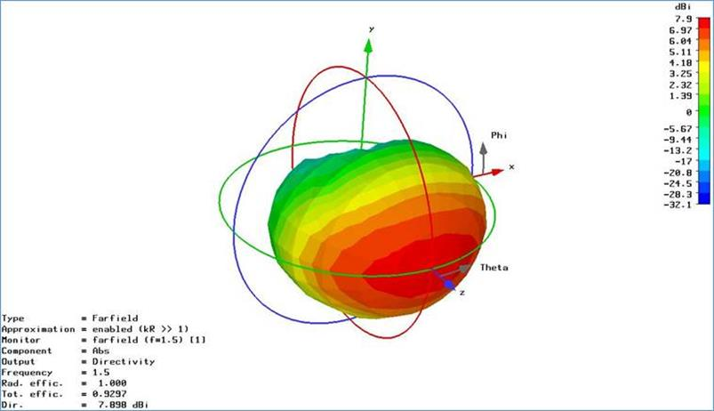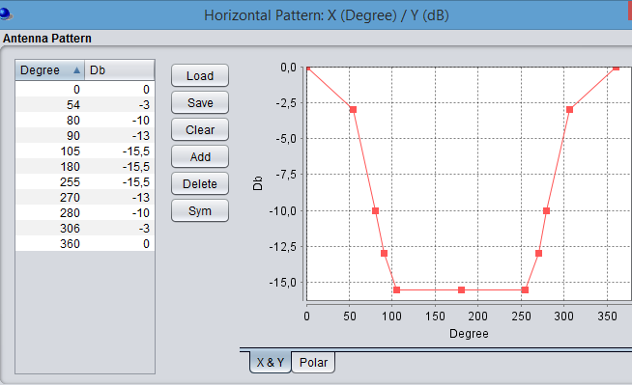 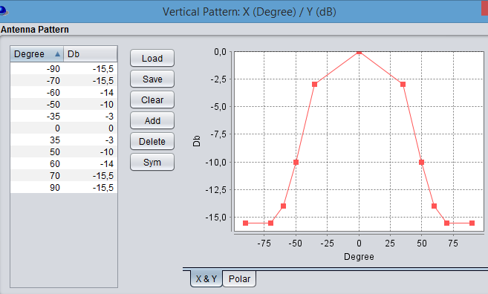Figure 1: PWMS IEM Antenna Pattern
The spectrum masks for analogue and digital audio PMSE systems are given in Figure 2 and Figure 3 below. (ETSI EN 300 422 (V1.5.0 /2015-01 [8]).

Figure 2: Spectrum mask for analogue systems in all bands
(measurement bandwidth is 1 kHz)
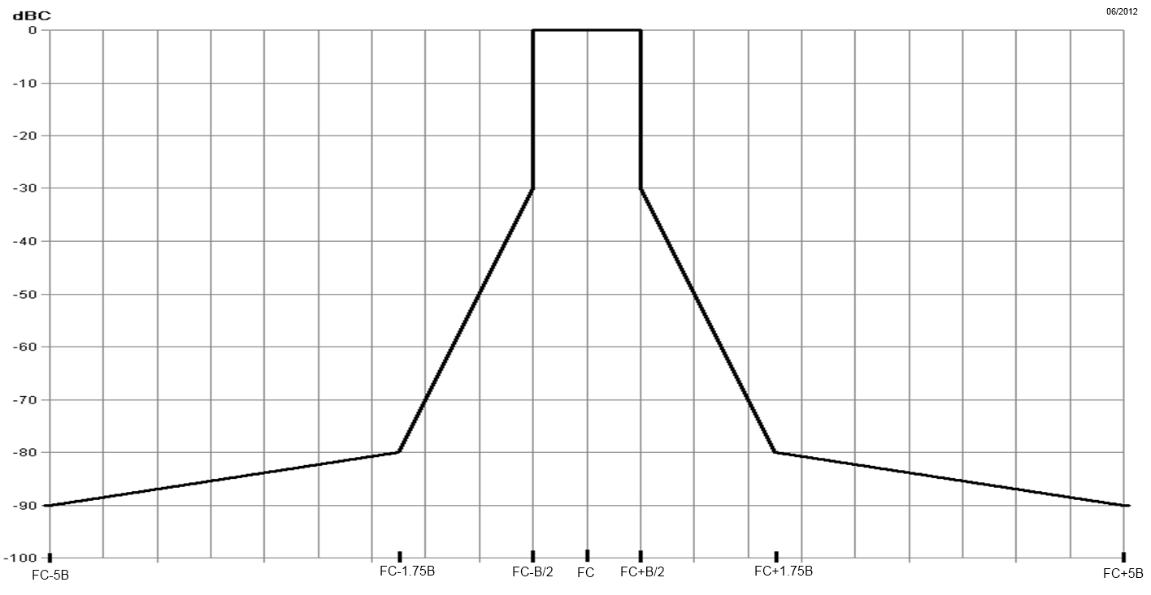
Figure 3: Spectrum mask for digital systems below 2 GHz
(measurement bandwidth is 1 kHz)
The spectrum mask for digital system is above the mask for analogue system and therefore, may need to be used in the compatibility studies, if the worst case only is considered.

Audio PMSE Receivers
Table 7: Parameters for audio PMSE receivers
Parameter | Unit | Value | Comment
Bandwidth (BW) | MHz | 0.2
Reference Sensitivity | dBm | -90 | ETSI TR 102 546 [7], Section B.4.1.3
Noise Figure (NF) | dB | 3 | The Noise Figure value is representing typically single channel audio links. If multi-channel PMSE are operated in a splitter architecture the noise figure will be increased by few dB
Noise Floor (N) | dBm | -118 | 10∙log(k∙T∙BW∙[Hz]) + NF
Standard desensitization D_{STANDARD} | dB | 3 | D_{TARGET} = D_{STANDARD}
Interference level | dBm | -118
Blocking Response | dB | 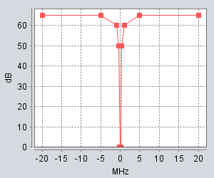 | ETSI TR 102 546  Attachment 2, Applicable Receiver Parameter for PWMS below 1 GHz
Antenna height | m | 3
Antenna gain | dBi | 0 | Omni directional

Parameters and characteristics relevant for the Compatibility studies in the frequency band 1492-1525 MHz

Audio PMSE Deployment

Operation
Traditionally, for event and content production audio PMSE applications have operated in interleaved spectrum, between the televisions transmissions in Bands III, IV and V on a geographical basis. ERC/REC 70-03 [5] identifies this spectrum on a ‘tuning range’ basis, allowing different administrations to authorise these systems where and when they are needed. This maintains maximum flexibility and avoids ‘sterilizing’ spectrum.
Many Administrations allow licenced exempt use of the tuning range 470-790 MHz relying on the fact that audio PMSE cannot occupy the same spectrum as a primary service transmitter in a given geographical area as this would interfere with the audio PMSE systems.
In general, if a frequency is already in use, then audio PMSE systems must be set to a different frequency. Otherwise, the high audio quality criteria of PMSE cannot be achieved. This procedure could reliably be used in any other audio PMSE spectrum bands using the tuning range approach. This type of behaviour could offer increased protection for the primary services. In order to avoid the implementation of separation distances for the protection of PMSE, PMSE users need to scan their assigned spectrum in order to identify the parts of spectrum, which are in use by other transmitter(s) and the parts, which are available for successful PMSE operation (see Annex 5 to ECC Report 191 [16]).

Use case scenarios
Real world PMSE wireless microphone operations can be split into the following use case scenarios based on feedback from the PMSE community:
- 25 % hand-held operation;
- 60 % body-worn operation;
- 14 % floor tripod close to the user's body; (not studied in this report);
- 1 % table tripod; (not studied in this report).

Density
The density of active audio PMSE devices in this study is 1-2 per MHz at the same time in a given area of 10 km radius in urban area and 25 km radius in rural area (which is seen to be typical density of devices in this band). For the compatibility studies with the MSS (see Section 5.6), alternative densities are considered to study the impact of higher or lower densities. (For example 1.7 km radius is considered, see ANNEX 4:.)

Wall attenuation
The value of 10 dB for the wall loss attenuation was considered in ECC Report 121 [2] for most of the compatibility analyses.

The ETSI TR 102 546 (2007) [7] considered a range of values based of a campaign of measurements, which are provided below:

Table 8: Wall Attenuation values
Wall type / material | Absorption @1450MHz
Lime sandstone 24 cm | 34 dB
Lime sandstone 17 cm | 29 dB
Ytong 36.5 cm | 23 dB
High hole brick 24 cm | 19 dB
Reinforced concrete 16 cm | 13 dB
Lightweight concrete 11.5 cm | 9 dB
ThermoPlane | 6 dB

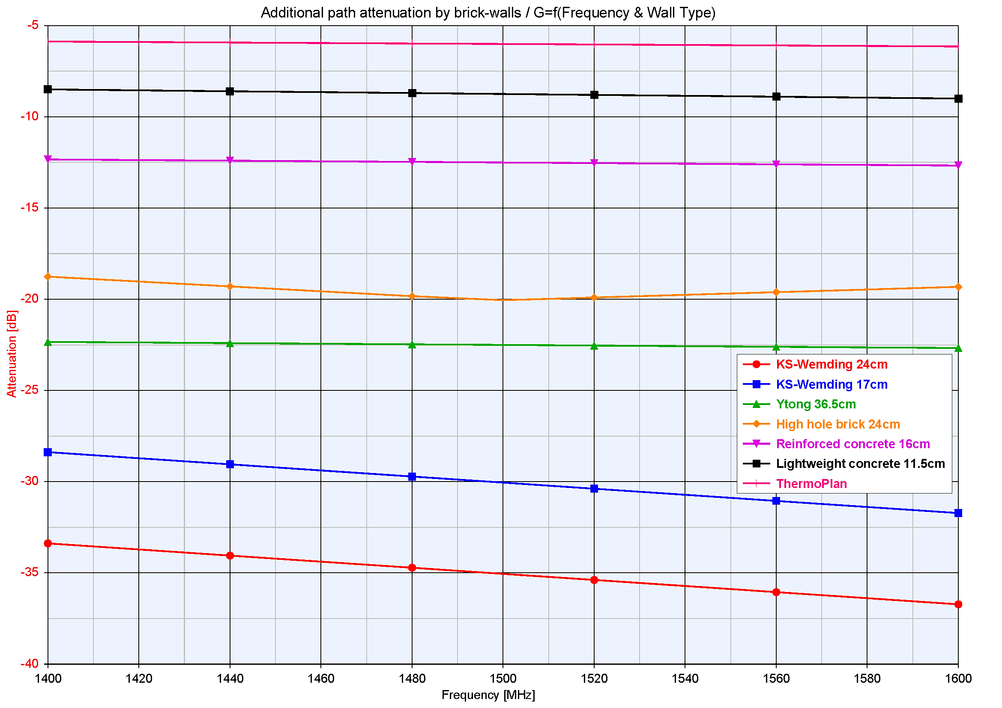
Figure 4: Wall attenuation (dB) for different wall materials at 1400-1600 MHz

The graph was recalculated based on the ECC Report 121 [2] values. As the graphics shows, the measured values of wall loss for the materials tested range from 6 dB to about 34 dB and the majority of wall materials have an attenuation value above 10 dB.
Wall attenuation (or penetration loss) values ranging from 15 dB (rural) to 20 dB (suburban and urban) were suggested for studies related to WRC-15 agenda item 1.1, as shown in Report ITU-R M.2292-0 [9], Table 9. ITU-R Report P.2346-0 [11] contains a compilation of measurement data relating to building entry loss. This contains measurement data covering a wide range of frequency bands and building types. For example, Figure 5 of that Report shows a range of values applicable for 1.6 GHz ranging from 0 dB to 35 dB (considering only the 5-95 percentile values).
Additional information about wall loss is also available in ANNEX 2:.
In the light of the wide range of values of wall loss that would exist in practice, studies in this Report have been conducted with a range of different values, from 6 dB to 34 dB.

Fixed Service Characteristics
The Fixed Service has primary status in the bands 1492-1518 MHz and 1518-1525 MHz in the ITU-R Radio Regulations.
The band 1350-1375 MHz paired with the band 1492-1517 MHz (see ERC/REC 13-01 [12]) are used by fixed service for a variety of applications including broadcasting, oil & gas, public safety and utilities. The following Table 10 provides representative fixed link parameters for the Fixed Service systems deployed in those two frequency ranges.
Table 10: Coordinated fixed links characteristics
Parameter | Value | Remark
Antenna Height | 20 m
Bandwidth (B) | 0,5 MHz | Recommendation ITU-R F.758 [13] and ERC/REC T/R 13-01
Noise Figure (F) | 4 dB
Receiver noise level (N) | -113 dBm | N = -174 + 10*log (B) + F
Target Interference to Noise Ratio | -6 dB,  Note 1 | Recommendation ITU-R F.758
Blocking Response (BR) | BR1 = 25 dB  BR2-5 = 50 dB  BR>5 = 55 dB
Antenna (Option 1) | Type: Yagi  D = 0.5 m  G_{max}= 16 dBi
Antenna (Option 2) | Type: Dish  D = 2 m  G_{max} = 30 dBi
Note 1: The calculations performed are based on a protection criterion commonly used for coordination among applications of primarily assigned services.

Figure 5 shows the antenna radiation patterns for both antennas derived from Recommendation ITU-R F.1245 [14].

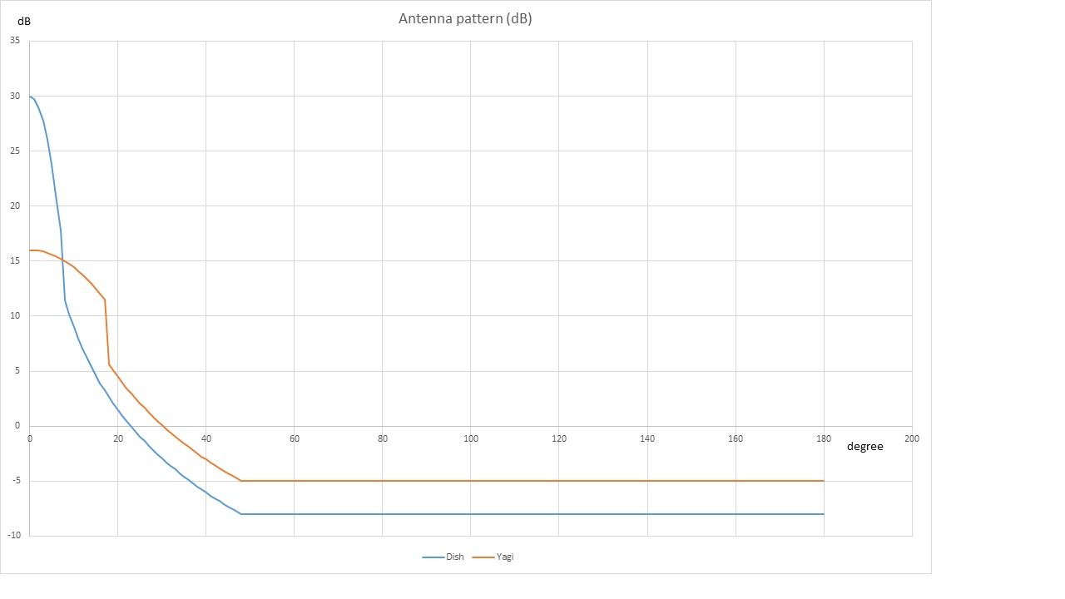
Figure 5: FS antenna patterns derived from Recommendation ITU-R F.1245
In addition, in this frequency range, some Fixed Service links are deployed without coordination for military purposes.

Table 11: Uncoordinated fixed links characteristics
Parameter | Value
Antenna Height | 20 m
Bandwidth | 1 MHz³
Receiver noise level | -110 dBm/MHz⁴
Target Interference to Noise Ratio | -20 dB
Blocking Response | BR1 = 25 dB  BR2-5 = 55 dB  BR>5 = 60 dB
Antenna | Type: Dish (mesh reflector)  D = 1.2 m  G_{max} = 20.5 dBi
Minimum distance to the MFCN BS | 250 m

According to the ITU-R Radio Regulations, the Fixed Service is provided between two specified points:
1.20 fixed service: A radiocommunication service between specified fixed points.
Furthermore, any new station should ensure that existing stations are not interfered by the new station:
4.3 Any new assignment or any change of frequency or other basic characteristic of an existing assignment (see Appendix 4) shall be made in such a way as to avoid causing harmful interference to services rendered by stations using frequencies assigned in accordance with the Table of Frequency Allocations in this Chapter and the other provisions of these Regulations, the characteristics of which assignments are recorded in the Master International Frequency Register.
However, fixed links may operate in some countries in an uncoordinated manner, which means that these links do not have specific operation locations. For such a scenario, referred to as ‘uncoordinated fixed links’ in this report, the parameters adopted for studies are provided in Table 11.

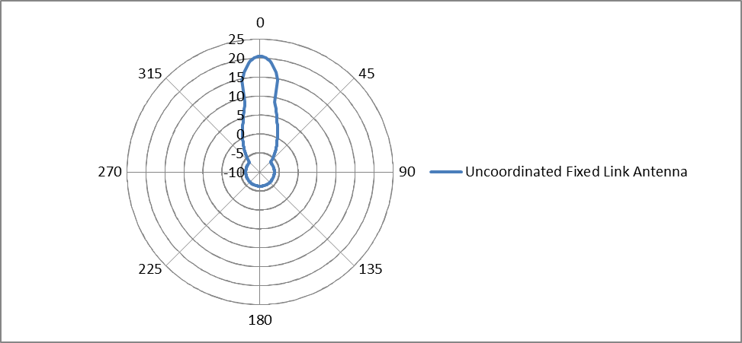
Figure 6: Antenna pattern for uncoordinated Fixed Links

Mobile Service
ECC/DEC/(13)03 [1] decides that “CEPT administrations shall designate the frequency band 1452-1492 MHz to MFCN SDL…” and since WRC-15 the frequency bands 1427-1452 MHz and 1492-1518 MHz are identified for IMT for all three Regions. The band 1492-1518 MHz is expected to be used by CEPT countries for IMT.
According to footnote EU15A of the European Common Allocation table, the use of the band 1518-1525 MHz by the mobile service is currently limited to tactical radio relay applications and tactical video reporting systems.

Description of LTE
The spectrum 1452-1492 MHz is defined for SDL in the CEPT countries (ECC/DEC/(13)03). A 3GPP band has been defined to reflect this decision, i.e. Band 32. In this study, we consider 1492-1518 MHz as DL spectrum and use the 3GPP Band 32 minimum requirements. Table 12 to Table 15 include the LTE BS TX parameters considered in this study. Table 16 contains the LTE UE RX characteristics. The audio PMSE parameters are contained in Table 4 and Table 5.

Table 12: LTE Wide Area BS, Transmitter characteristics
Parameter | Value | Comment
Channel bandwidth | 10 / 20 MHz
BS output power | 46 dBm
Spectrum Emission mask | See Table 13 | 3GPP TS 37 104, Table 6.6.2.1-1 [17]
Horizontal antenna pattern | 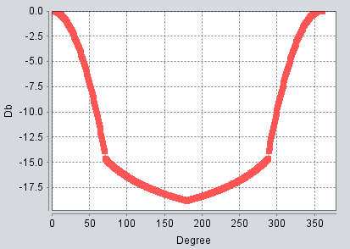 | SEAMCAT 4.1.0, Library Antenna, 3GPP Tri-Sector Antenna
Vertical antenna pattern | 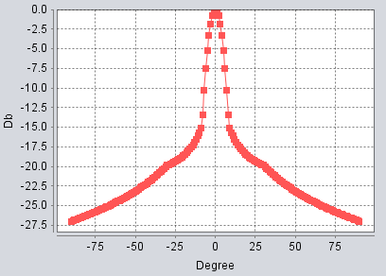 | SEAMCAT 4.1.0, Library Antenna, 3GPP Tri-Sector Antenna
Down-tilt | 3°
Antenna height | 30 m
Antenna Gain | 15 dB

Table 13: Emission mask for an LTE macro BS (wide area)
Frequency offset of measurement filter -3dB point, Δf | Frequency offset of measurement filter centre frequency, f_offset | Minimum requirement  (Note 1, 2) | Measurement bandwidth  (Note 4)
0 MHz ≤ Δf < 0.2 MHz | 0.015 MHz ≤ f_offset < 0.215 MHz | -14 dBm | 30 kHz
0.2 MHz ≤ Δf < 1 MHz | 0.215 MHz ≤ f_offset < 1.015 MHz |  | 30 kHz
(Note 3) | 1.015 MHz ≤ f_offset < 1.5 MHz | -26 dBm | 30 kHz
1 MHz ≤ Δf ≤  min(Δf_{max}, 10 MHz) | 1.5 MHz ≤ f_offset < min(f_offset_{max}, 10.5 MHz) | -13 dBm | 1 MHz
10 MHz ≤ Δf ≤ Δf_{max} | 10.5 MHz ≤ f_offset < f_offset_{max} | -15 dBm (Note 5) | 1 MHz

Table 14: Parameters for an LTE pico BS (local area)
Parameter | Value | Comment
Channel bandwidth | 10 / 20 MHz
BS output power | 24 dBm
Spectrum Emission mask | See Table 15 | 3GPP TS 37 104,  Table 6.6.2.1-4 [17]
Horizontal antenna pattern | Omni
Vertical antenna pattern | Omni
Down-tilt | 0°
Antenna height | 3 m
Antenna Gain | 0 dB

Table 15: Emission mask for an LTE pico BS
Frequency offset of measurement filter -3dB point, Δf | Frequency offset of measurement filter centre frequency, f_offset | Minimum requirement  (Note 1, 2) | Measurement bandwidth
0 MHz ≤ Δf < 5 MHz | 0.05 MHz ≤ f_offset < 5.05 MHz |  | 100 kHz
5 MHz ≤ Δf < min(10 MHz, Δf_{max}) | 5.05 MHz ≤ f_offset < min(10.05 MHz, f_offset_{max}) | -37 dBm | 100 kHz
10 MHz ≤ Δf ≤ Δf_{max} | 10.05 MHz ≤ f_offset < f_offset_{max} | -37 dBm (Note 5) | 100 kHz

Table 16: Parameters for an LTE UE RX
Parameter | Value |  | Comment
Channel bandwidth | 10 MHz | 20 MHz
Transmission Bandwidth | 9 MHz | 18 MHz
Noise figure | 9 dB |  | 3GPP TR 36.942, Table 4.8 [18]
Noise Floor | -95.4 | -92.4 | 10∙log(k∙T∙BW∙1000) + NF
Reference sensitivity | -97 dBm | -94 dBm | 3GPP TS 36 101, section 7.3.1A [19]
ACS | 33 dB | 27 dB | 3GPP TS 36 101, section 7.5.1A
Antenna height | 1.5 m
Antenna Gain | 0 dB

It should be noted that studies are taking place in the ECC related to adjacent band compatibility between IMT systems below 1518 MHz and MSS systems operating above 1518 MHz, which may impact on the parameters (such as emission towards the victim) used in this study.

Description of Tactical Radio Relay systems
Table 2 shows serviceallocations in the frequency band 1492-1518 MHz . These services should be protected from emissions from other services or applications. A number of compatibility studies have already been carried out in this frequency band and reported in the ECC Report 121 [2]. However, Tactical Radio Relays systems were not addressed in that report.
Tactical radio relay services are mesh networks deployed in different locations on a short notice. Each TRR contains multiple point to point links. The separation distances between each transmitter are variable.
Table 17: Technical characteristics of TRR systems
Tactical radio relay
Operating frequency | 1492-1518 MHz
Transmit power | 34 dBm
Bandwidth | 1.5 MHz
Receiver noise level | -105 dBm/1.5 MHz
I/N | 0 dB
Antenna polarisation | Circular
Antenna gain | 21 dB  Pattern see below
Antenna directivity | ±5°
Feeder loss | 4 dB
Antenna height | 10 to 15 m
Blocking Response | BR1 = 27 dB  BR2 = 45 dB  BR3 = 70 dB

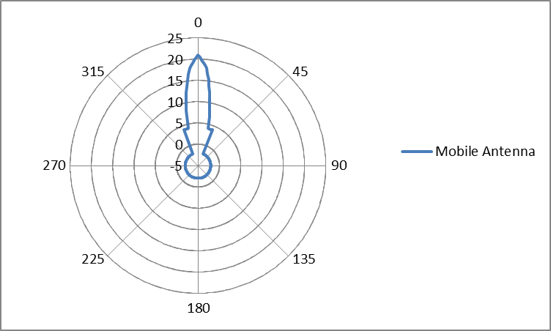
Figure 7: FS antenna patterns for Tactical Radio Relay, where Maximum Gain = 21 dBi

Illustration of operation layout of tactical radio relay systems is on Figure 8:

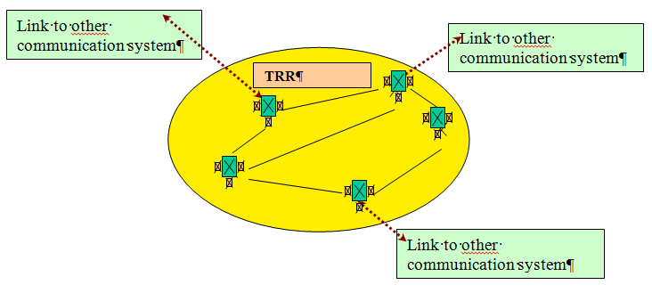

Figure 8: Typical usage scenario

Aeronautical Telemetry characteristics
The deployment of aeronautical telemetry services is limited to some CEPT countries, in accordance with ITU Radio Regulation footnote 5.342. For the purpose of this Report, Aeronautical telemetry is limited to ground stations and considered appropriate parameters.
The characteristics in Table 18 are based on ECC Report 121 [2].
Table 18: Aeronautical Telemetry characteristics
Parameter | Value
Antenna height | 50 m
Receiver noise level | -112 dBm/MHz
Protection criteria (I/N) | -3 dB
Antenna gain | 41.2 dBi
Antenna pattern | Recommendation ITU-R M.1459
Elevation | 3 to 80 degrees

Figure 9: Aeronautical System Antenna Pattern given by
Recommendation ITU-R M.1459 [15]

Mobile Satellite service

Current usage of MSS in Europe in the band 1518-1525 MHz
The band 1518-1525 MHz is designated to the MSS through ECC Decision ECC/DEC/(04)09 [20]. In the band 1518-1525 MHz, the studies do not take into account the deployment density of MSS near to PMSE.
Table 19 below (from ECC Report 147 [6]) gives an overview about the worldwide deployment of relevant MSS terminals of one global MSS operator.

Table 19: Overview about the worldwide deployment of relevant MSS terminals
(one global operator)
As at 26th April 2016
Maritime | 337 000
Land mobile | 762 100
Aeronautical | 28 700
Total active terminals | 1 127 800

Currently, there is one satellite in operation covering this frequency range (the 'Alphasat' satellite) and provides service in Europe, the Middle East and Africa.
It is intended that a follow-on satellite/(s) will continue provision of Mobile Satellite Service in this band. Important aspects of L-Band MSS are in particular the provision of Global Maritime Distress and Safety System (GMDSS) services in accordance with IMO Resolution 1001, the provision of AMS(R)S services as per WRC Resolutions 222 and 422 and MSS services are typically used by market segments such as ships and aircraft for which there is no alternative means of communication. However, it is noted that under footnote 5.353A of the ITU Radio Regulations priority is given to GMDSS in the band 1530-1544 MHz and footnote 5.357A to AMS(R)S in the band 1545-1555 MHz.
Communications in all of the sub-bands is largely critical communications, either because it is used by aid and rescue workers when other terrestrial infrastructure is wiped out or overloaded or by industries of strategic importance such as oil and gas.
Given that MSS provides mission critical connectivity, where terrestrial networks are not present or challenged, and that audio PMSE use will mainly occur in built up urban and suburban areas (indoor, under individual authorisation and at locations such as theatres or concert halls), it is assumed that the intended use of audio PMSE applications is unlikely to occur at the same location and time as MSS, thereby reducing the probability of interference from audio PMSE into MSS.

MSS characteristics
There is a large variety of terminal types in operation, but the set of parameters below are typical. Land, sea and aeronautical terminals may operate in the band 1518-1525 MHz.
Table 20: Typical MES characteristics
Parameter | Unit | Value
Receiver tuning range | MHz | 1518-1559 MHz
Reference bandwidth | kHz | 200
Receiver noise temperature | K | 316
Receiver thermal noise level | dBW | -150.6
Receiver thermal noise level for 200 kHz ref. BW | dBm/200 kHz | -120.6
Receiver thermal noise level for 1 MHz ref. BW | dBm/MHz | -113.6
Maximum antenna gain | dBi | (see Table 21)
Polarization | - | circular
Land MES antenna height a.g.l. | m | 2
Sea (maritime) MES antenna height a.s.l. | m | 10
Air (aeronautical) MES antenna height a.g.l. | m | 0-13000

For each of the three scenarios, it is considered appropriate to study one “omni” or low gain antenna and one “high gain” antenna. Examples of these are presented in Table 21 and representative antenna patterns are given in Figure 10, Figure 11 and Figure 12. Terminals with low gain antennas can be assumed to point vertically, while those with high gain antennas are pointed at the MSS satellite.
Table 21: MES maximum antenna gain for the different scenarios
Scenario | Type | Value | Antenna gain | Inmarsat service | Antenna pattern
Land | Low gain | dBi | 3 | GSPS | Figure 12
Land | High gain | dBi | 17.5 | BGAN class 1 | Figure 11
Sea (maritime) | Low gain | dBi | 3 | Inmarsat-C | Figure 12
Sea (maritime) | High gain | dBi | 21 | Fleet-77 | Figure 10
Air (aeronautical) | Low gain | dBi | 3 | Aero-L | Figure 12
Air (aeronautical) | High gain | dBi | 12 | Aero-H | Figure 17

For the Inmarsat range of services, the e.i.r.p from the MSS satellite is dependent on the particular service but the current maximum value is about 49 dBW in a bandwidth of 200 kHz. The maximum p.f.d. on the ground is therefore about -114 dBW/m² in 200 kHz (assuming distance to satellite of 40.000 km).

MES example ANTENNA PATTERNS:
Note that all patterns are average sidelobe levels.
Figure 10: Inmarsat-B/F-77, Fleet broadband antenna (peak gain = 21 dBi)

Figure 11: BGAN Class 1 (peak gain = 17.5 dBi)
Figure 12: Inmarsat-C/GSPS (peak gain = 3 dBi)

MSS design objectives
There are many ITU-R recommendations relating to MSS interference and performance criteria that are necessary to take into account when considering the feasibility of sharing and compatibility analysis on the basis of probability of interference. Examples of these recommendations are M.828 [27], M.1037 [28], M.1180 [29], M.1181 [30], M.1183 [31], M.1228 [32], M.1229 [33], M.1234 [34], M.1476 [35], and M.1636 [36]). Many of these recommendations are for particular applications (e.g. AMS(R)S, ISDN, and store and forward data).
MSS link budgets are commonly designed on the basis of some margin for external interference from other MSS and FSS networks, and all other systems
The portion of interference from all other systems, like PMSE interference into MSS systems, will impact the availability requirements of MSS services.
The availability objectives for some MSS applications are defined in ITU-R recommendations, including 99.94 % for AMS(R)S (see Recommendation ITU-R M.1180), 99.9 % for ISDN applications (see Recommendation ITU-R M.1476 [35]).
The total allowable unavailable time should be apportioned between different sources of interference, including propagation effects, and hence the percentage of unavailable time that could be attributed to any one source should be less than the aggregate value.

Compatibility studies in the band 1492-1518 Mhz and 1518-1525 MHz

Audio PMSE impact on Fixed service - coordinated

Considerations on the co-frequency case

MCL calculations
Considering the assumptions given in section 4, it is possible to determine the minimum separation distances in order to meet the Fixed Service interference criterion.
Table 22: Co-frequency Separation distances – Dish antenna – Fixed Service Coordinated
Parameter | Body worn | Handheld | IEM
e.i.r.p | 17 dBm | 13 dBm | 9 dBm
Body loss | 11 dB | 6 dB | 0 dB
Wall loss | 6 dB; 10 dB; 15 dB; 34 dB | 6 dB; 10 dB; 15 dB; 34 dB | 6 dB; 10 dB; 15 dB; 34 dB
Receiver noise level | -113 dBm | -113 dBm | -113 dBm
Target Interference to Noise Ratio | -6 dB | -6 dB | -6 dB
Interference level | -119 dBm | -119 dBm | -119 dBm
Antenna | Type: Dish  G_{max}= 30 dBi | Type: Dish  G_{max}= 30 dBi | Type: Dish  G_{max}= 30 dBi
Path loss to meet the protection criterion | 149 dB; 145 dB; 140 dB; 121 dB | 150 dB; 146 dB; 141 dB; 122 dB | 152 dB; 148 dB; 143 dB;124 dB
Separation distances in  the main lobe | 20 km (6 dB to 15 dB) ; 9.4 km (34 dB) | 20 km ⁹ (6 to 15 dB);  10 km (34 dB) | 21 km (6 to 15 dB); 11 km (34 dB)
Separation distance in the main lobe considering Extended Hata (Rural) | 16.5 km (6 dB); 13 km (10 dB); 9 km (15 dB) ; 2.7 km (34 dB) | 17.5 km (6 dB) ;13.5 km (10 dB); 10 km (15 dB); 2.8 km (34 dB) | 22 km (6 dB);18 km (10 dB); 13 km (15 dB); 3.8 km (34 dB)
Separation distance in the main lobe considering Extended Hata  (Sub urban) | 4.5 km (6 dB); 3.5 km (10 dB); 2.5 km (15 dB); 0.8 km (34 dB) | 4.8 km (6 dB); 3.7 km (10 dB); 2.7 km (15 dB) ; 0.8 km (34 dB) | 6.5 km (6 dB); 5 km (10 dB); 3.6 km (15 dB); 1.1 km (34 dB)
Path loss to meet the protection criterion in the side lobe | 111 dB;107 dB;102 dB; 83 dB | 112 dB; 108 dB; 103 dB; 84 dB | 114 dB; 110 dB; 105 dB; 86 dB
Separation distances in the side lobe | 5.3 km (6 dB); 3.6 km (10 dB); 2 km (15 dB); 0.2 km (34 dB) | 5.6 km (6 dB); 4 km (10 dB); 2.2 km (15 dB); 0.3 km (34 dB) | 6.3 km (6 dB); 5 km (10 dB); 2.8 km (15 dB); 0.3 km (34 dB)
Separation distance in the side lobe considering Extended Hata (Rural) | 1.4 km (6 dB) ; 1.1 km (10 dB); 0.75 km (15 dB) ; 0.22 km (34 dB) | 1.5 km (6 dB);1.2 km (10 dB); 0.8 km (15 dB) ; 0.24 km (34 dB) | 2 km (6 dB);1.5 km (10 dB); 1.1 km (15 dB); 0.31 km (34 dB)
Separation distance in the side lobe considering Extended Hata  (Sub urban) | 0.38 km (6 dB); 0.3 km (10 dB); 0.21 km (15 dB); 0.073 km (34 dB) | 0.4 km (6 dB); 0.32 km (10 dB); 0.23 km (15 dB); 0.075 km (34 dB) | 0.55 km (6 dB); 0.42 km (10 dB); 0.31 km (15 dB); 0.09 km (34 dB)

Table 23: Co-frequency Separation distances -Yagi antenna - Fixed Service Coordinated
Parameter | Body worn | Handheld | IEM
e.i.r.p | 17 dBm | 13 dBm | 9 dBm
Body loss | 11 dB | 6 dB | 0 dB
Wall loss | 6 dB; 10 dB;15 dB; 34 dB | 6 dB; 10 dB;15 dB; 34 dB | 6 dB; 10 dB;15 dB; 34 dB
Receiver noise level | -113 dBm | -113 dBm | -113 dBm
Target Interference to Noise Ratio | -6 dB | -6 dB | -6 dB
Interference level | -119 dBm | -119 dBm | -119 dBm
Antenna | Type: Yagi  G_{max}= 16 dBi | Type: Yagi  G_{max}= 16 dBi | Type: Yagi  G_{max}= 16 dBi
Path loss to meet the protection criterion | 135 dB; 131 dB; 126 dB; 107 dB | 136 dB; 132 dB; 127 dB; 108 dB | 138 dB; 134 dB ; 129 dB; 110 dB
Separation distances in the main lobe ⁸ | 20 km (6 dB); 17 km (10 dB); 13 km (15 dB) ⁹; 3.6 km (34 dB) | 20 km ⁹ (6 dB); 18 km (10 dB); 13 km (15 dB) ; 4 km (34 dB) | 21 km ¹⁰ (6 dB); 20 km (10 dB); 15 km (15 dB); 5 km (34 dB)
Separation distance in the main lobe considering Extended Hata (Rural) | 6.5 km (6 dB); 5 km (10 dB); 3.7 km (15 dB); 1.1 km (34 dB) | 7 km (6 dB); 5.5 km (10 dB); 4 km (15 dB) ; 1.15 km (34 dB) | 9.5 km (6 dB); 7.3 km (10 dB); 5.3 km (15 dB); 1.5 km (34 dB)
Separation distance in the main lobe considering Extended Hata  (Sub urban) | 1.9 km (6 dB); 1.4 km (10 dB); 1 km (15 dB); 0.3 km (34 dB) | 2 km (6 dB); 1.5 km (10 dB); 1.1 km (15 dB); 0.32 km (34 dB) | 2.7 km (6 dB); 2 km (10 dB); 1.5 km (15 dB); 0.42 km (34 dB)
Path loss to meet the protection criterion in the side lobe | 114 dB;110 dB;105 dB; 86 dB | 115 dB; 111 dB; 106 dB; 87 dB | 117 dB; 113 dB; 108 dB; 89 dB
Separation distances in the side lobe | 6.3 km (6 dB); 5 km (10 dB); 2.8 km (15 dB); 0.3 km (34 dB) | 6.7 km (6 dB); 5.3 km (10 dB); 3.2 km (15 dB); 0.4 km (34 dB) | 7.5 km (6 dB); 6 km (10 dB); 4 km (15 dB); 0.4 km (34 dB)
Separation distance in the side lobe considering Extended Hata (Rural) | 1.7 km (6 dB) ; 1.3 km (10 dB); 0.92 km (15 dB); 0.29 km (34 dB) | 1.8 km (6 dB) ;1.4 km (10 dB); 0.98 km (15 dB); 0.31 km (34 dB) | 2.4 km (6 dB); 1.9 km (10 dB); 1.35 km (15 dB); 0.39 km (34 dB)
Separation distance in the side lobe considering Extended Hata  (Sub urban) | 0.47 km (6 dB); 0.36 km (10 dB); 0.26 km (15 dB); 0.08 km (34 dB) | 0.5 km (6 dB); 0.38 km (10 dB); 0.28 km (15 dB); 0.085 km (34 dB) | 0.67 km (6 dB); 0.52 km (10 dB); 0.37 km (15 dB); 0.11 km (34 dB)

SEAMCAT simulations
The approach is based on the simulations described in ECC Report 121 [2], a separation distance between the Fixed Service receiver and the audio PMSE transmitters is considered. It should be noted that in a given 1 MHz the density of audio PMSE devices in this frequency range is expected to be rather low. No more than 2 devices are expected to be deployed in a given area in a given 500 kHz. The victim / interfering frequency is 1492.5 MHz.
In order to consider a coordinated deployment, it is assumed the Fixed Service receiver is not pointing in the direction of the audio PMSE transmitters or that the audio PMSE are located in an area not located in the main beam of the Fixed Service antenna. If a coordination process is implemented in order to identify areas where audio PMSE could be deployed, one could expect that the Fixed Service receiver is unlikely to point in the direction of an audio PMSE transmitter. Therefore, in the scenario, the Fixed Service receiver is deployed in the area centered on the Fixed Service transmitter limited to 0 to 90 degrees.
Simulations are using the Extended Hata Model (rural) and considering the median value of the body loss.

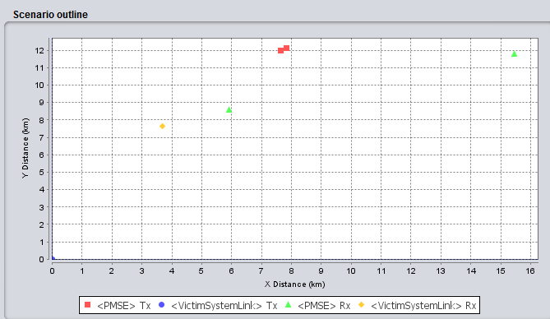
Figure 13: FS receiver not pointing in the direction of a PMSE transmitter
For a Yagi antenna, a separation distance of about:
- For body worn: 1 km (6 dB), 730 m (10 dB), 510 m (15 dB) and 0 m (34 dB);
- For handheld: 1,6 km (6 d B), 1.17 km (10 dB), 800 m (15 dB) and 100 m (34 dB);
- For IEM: 4,7 km (6 dB), 3,5 km (10 dB), 2,4 km (15 dB) and 550 m (34 dB);

is necessary, in order to reach a percentage of interference equals to 1 %.
For a Dish antenna, a separation distance of about:
- For body worn: 790 m (6 dB), 590 m (10 dB), 410 m (15 dB) and 0 m (34 dB);
- For handheld: 1.26 km (6 dB), 920 m (10 dB), 630 m (15 dB) and 0 m (34 dB);
- For IEM: 2.4 km (6 dB), 1,75 km (10 dB), 1,2 km (15 dB) and 410 m (34 dB);
is necessary, in order to reach a percentage of interference equals to 1 %.

Considerations on the non-co-frequency case
Administrations may consider deploying audio PMSE in an area where the Fixed Service is operated but with a frequency offset between the two systems. This section provides considerations for such a case.
As a first step and in order to make easier the consideration of this case, we may assume that the center of the audio PMSE is at a frequency offset of 1 MHz compared to the edges of the channel operated by the Fixed Service and the channel operated by the audio PMSE systems.

Impact of the unwanted emissions
Under this assumption, there will be a rejection of 60 dBc in 1 MHz between the in band power of the audio PMSE device and the unwanted emissions level falling into the receiver of the Fixed Service.
With regard to the impact of unwanted emissions, the results given in the previous tables can be translated by 63 dB in order to determine the necessary path loss.
For body worn (best case):
- For the Yagi antenna, in the main beam case, the necessary path loss will be of the order of 72 dB to 44 dB corresponding to a distance of about 50 m in the worst case, indicating that even if the PMSE are operated nearby the Fixed Service antenna, there would be no risk of interference.

- For the Dish antenna, in the main beam case, the necessary path loss will be of the order of 86 dB to 58 dB corresponding to a distance of about 320 m (6 dB) to 0 m (34 dB) (assuming the free space model). In any case, audio PMSE devices are unlikely to be located in the main beam of the FS antenna if located in their vicinity. For the side lobe case, in the worst case, the necessary path loss will be of the order of 50 dB, indicating that even if the audio PMSE devices are operated nearby the Fixed Service antenna, there would be no risk of interference.
For handheld: the results are very similar to the body worn case.
For IEM (worst case):
- For the Yagi antenna, in the main beam case, the necessary path loss will be of the order of 75 to 47 dB corresponding to a distance of about 90 m (6 dB) to 0 m (34 dB) (assuming the free space model and considering the difference of the antenna heights). For the side lobe case, in the worst case, the necessary path loss will be of the order less than 54 dB (6 dB), indicating that even if the audio PMSE devices are operated nearby the Fixed Service antenna, there would be no risk of interference.

- For the Dish antenna, in the main beam case, the necessary path loss will be of the order of 89 dB to 61 dB corresponding to a distance of about 450 m (6 dB) to 2 m (34 dB) (assuming the free space model). For the side lobe case, in the worst case, the necessary path loss will be of the order of 53 dB, indicating that even if the audio PMSE devices are operated nearby the Fixed Service antenna, there would be no risk of interference.

Impact on the blocking
In order to assess the impact of PMSE on the blocking of the Fixed Service receiver, it would be necessary to have additional information on the distribution of the received power. As an initial step, the power received by the Fixed Service receiver is assumed to be equal to −87 dBm/MHz (see Annex 5 to ECC Report 202 [3]).
If body worn devices (best case) are deployed with a guard band of 1 MHz, nearby the channel operated by the Fixed Service a BR of 50 dB should be considered (see ECC Report 202). This implies that a path loss of:
- -87 dBm + 50 dB – (6 dBm + 16 dBi - L_{wall}) = -59 dB + L_{wall} should be considered in the main beam for the Yagi antenna. Then, no interference is expected;
- -87 dBm + 50 dB – (6 dBm) + 30 dBi - L_{wall}) = -73 dB + L_{wall} should be considered in the main beam for the Dish antenna. Then, no interference is expected since audio PMSE devices are not going to be located in the main beam of the FS link considering the corresponding distances (70 m).

If IEM devices (worst case) are deployed with a guard band of 1 MHz, nearby the channel operated by the Fixed Service a BR of 50 dB should be considered (see ECC Report 202[3]). This implies that a path loss of:
- -87 dBm + 50 dB – ((9 dBm) + 16 dBi - L_{wall}) = -62 dB - L_{wall} should be considered in the main beam for option 1 (Yagi antenna). Then, no interference is expected;
- -87 dBm + 50 dB – (9 dBm) + 30 dBi - L_{wall}) = -76 dB - L_{wall} should be considered in the main beam for option 2 (Dish antenna) corresponding to a distance of from 0 m (34 dB) to 120 m (0 dB) (considering the free space model). No interference is expected since IEM devices are not going to be located in the main beam of the FS link considering the corresponding distances.

Conclusions
In the case of co-frequency operation, separation distance could be implemented. Separation distances are shorter for body worn/handheld equipment (1 km for indoor deployment) than for IEM (2.5 km for indoor deployment) when located in the side lobes of the Fixed Service antenna. In the main lobe, separation distances of about 21 km are needed.
If a guard band of 1 MHz is considered between the edge of the channels used by the audio PMSE and the Fixed Service receiver respectively, there will be no interference on the Fixed Service.
For smaller guard bands, a combination of guard band associated with a separation distance may need to be considered.

PMSE impact on Fixed Service – Uncoordinated

Considerations on the co-frequency case

MCL calculations
Considering the assumptions given in section 4.2, it is possible to determine the minimum separation in order to meet the Fixed Service interference criterion.
It should be noted that in the following Table 24, a Target Interference to Noise Ratio of -20 dB is considered while in ECC Report 202 [3], - 6 dB and -20 dB were considered.

Table 24: Separation distances – Fixed Service uncoordinated
Parameter | Body worn | Handheld | IEM
e.i.r.p | 17 dBm | 13 dBm | 9 dBm
Body loss | 11 dB | 6 dB | 0 dB
Wall loss | 6 dB; 10 dB;15 dB; 34 dB | 6 dB; 10 dB;15 dB; 34 dB | 6 dB; 10 dB;15 dB; 34 dB
Receiver noise level | -110 dBm/MHz | -110 dBm/MHz¹¹ | -110 dBm/MHz¹¹
Target Interference to Noise Ratio | -20 dB | -20 dB | -20 dB
Interference level | -116 dBm/MHz | -116 dBm/MHz | -116 dBm/MHz
Antenna | Type: Dish  G_{max}= 30 dBi | Type: Dish  G_{max}= 30 dBi | Type: Dish  G_{max}= 30 dBi
Path loss to meet the protection criterion | 150.5 dB; 146.5 dB; 141.5 dB; 122.5 dB | 151.5 dB; 147.5 dB; 142.5 dB; 123.5 dB | 153.5 dB; 149.5 dB; 144.5 dB; 125.5 dB
Separation distances in the main lobe | 20 km; 20 km; 20 km;  10 km | 20 km; 20 km; 20 km;  11 km¹² | 21 km; 21 km; 21 km;  12 km¹²
Separation distance in the main lobe considering Extended Hata (Rural) | 20 km (6 dB); 15 km (10 dB); 11 km (15 dB); 3.2 km (34 dB) | 21 km (6 dB); 16 km (10 dB);12 km (15 dB); 3.4 km (34 dB) | 24.5 km (6 dB); 20 km (10 dB); 14.5 km (15 dB); 4.2 km (34 dB)
Path loss to meet the protection criterion in the side lobe | 120.5 dB; 116.5 dB; 111.5 dB; 92.5 dB | 121.5 dB;117.5 dB;112.5 dB; 93.5 dB | 123.5 dB; 119.5 dB; 114.5 dB; 95.5 dB
Separation distances in the side lobe | 7.3 km; 5.8 km; 3.8 km; 0.4 km | 7.3 km;5.8 km;3.8 km;  0.4 km | 10.9 km; 8.7 km; 6.5 km; 1 km
Separation distance in the side lobe considering Extended Hata (Rural) | 2.8 km (6 dB); 2.1 km (10 dB) ; 1.5 km (15 dB); 0.45 km (34 dB) | 3 km (6 dB); 2.3 km (10 dB); 1.6 km (15 dB); 0.47 km (34 dB) | 3.7 km (6 dB); 2.8 km (10 dB); 2 km (15 dB); 0.6 km (34 dB)

SEAMCAT simulations
The victim / interfering frequency is 1492.5 MHz. 2 audio PMSE transmitters are deployed around the Victim receiver in a radius of 25 km.
The Extended Hata model (rural) is considered. A protection distance of 250 m is implemented in order to model the fact that the FS system can detect some of the interferers.
The following tables provide the probability of interference for the different wall attenuation, also considering the two possible interference criteria. For the body losses, the median values are considered.
Table 25: Probability of interference – body worn - Fixed Service uncoordinated
I/N | Wall attenuation
I/N | 6 dB | 10 dB | 15 dB | 34 dB
-20 dB | 2.2 % | 1.3 % | 0.8 % | 0.04 %
-6 dB | 0.34 % | 0.17 % | 0.1 % | 0 %

Table 26: Probability of interference – handheld - Fixed Service uncoordinated
I/N | Wall attenuation
I/N | 6 dB | 10 dB | 15 dB | 34 dB
-20 dB | 5.14 % | 3 % | 1.45 % | 0.16 %
-6 dB | 0.7 % | 0.46 % | 0.31 % | 0 %
Table 27: Probability of interference – IEM - Fixed Service uncoordinated
I/N | Wall attenuation
I/N | 6 dB | 10 dB | 15 dB | 34 dB
-20 dB | 16 % | 11 % | 6.3 % | 0.67 %
-6 dB | 3.7 % | 2.25 % | 1.3 % | 0 %

Considerations on the non-co-frequency case
Considering the results given in the previous tables, it is clear that if audio PMSE devices are operated with a guard band of, for example 1 MHz, providing a rejection of 60 dB, from the FS uncoordinated, there will be no risk of interference for the FS uncoordinated.

Conclusions
There is an acceptable risk of interference in case of handheld/body worn equipment. The risk of interference is more significant in case of IEM devices when considering the more sensible interference criterion (I/N =-20 dB).

Audio PMSE impact on Mobile service (TRR)

Considerations on the co-frequency case

MCL calculations
Considering the assumptions given in sections 2 and 3, it is possible to determine the minimum separation in order to meet the Mobile Service interference criterion.
Table 28: Co-frequency separation distances – TRR
Parameter | Body worn | Handheld | IEM
e.i.r.p | 17 dBm | 13 dBm | 9 dBm
Body loss | 11 dB | 6 dB | 0 dB
Wall loss | 6 dB; 10 dB;15 dB; 34 dB | 6 dB; 10 dB;15 dB; 34 dB | 6 dB; 10 dB;15 dB; 34 dB
Receiver noise level | -105 dBm/1.5 MHz | -105 dBm/1.5 MHz | 105 dBm/1.5 MHz
Target Interference to Noise Ratio | 0 dB | 0 dB | 0 dB
Interference level | -105 dBm/1.5 MHz | -105 dBm/1.5 MHz | -105 dBm/1.5 MHz
Antenna | G_{max}= 21 dBi | G_{max}= 21 dBi | G_{max}= 21 dBi
Feeder Loss | 4 dB | 4 dB | 4 dB
Polarisation discrimination  (linear to circular) | 3 dB | 3 dB | 3 dB
Path loss to meet the protection criterion | 119 dB; 115 dB; 110 dB; 91 dB | 120 dB; 116 dB; 111 dB; 92 dB | 122 dB; 118 dB; 113 dB; 94 dB
Separation distances in the main lobe. (Note 1) | 8 km (6 dB); 7 km (10 dB); 5 km (15 dB); 1 km (34 dB) | 9 km (6 dB); 7 km (10 dB); 5 km (15 dB); 1 km (34 dB) | 10 km (6 dB); 8 km (10 dB); 6 km (15 dB); 1 km (34 dB)
Separation distance in the main lobe considering Extended Hata (Rural) | 2 km (6 dB); 1.5 km (10 dB); 1.1 km (15 dB); 0.32 km (34 dB) | 2.1 km (6 dB); 1.6 km (10 dB); 1.2 km (15 dB); 0.34 km (34 dB) | 2.6 km (6 dB); 2 km (10 dB); 1.65 km (15 dB); 0.42 km (34 dB)
Path loss to meet the protection criterion in the side lobe (23dB rejection is assumed) | 96 dB; 92 dB; 87 dB; 68 dB | 97 dB; 93 dB; 88 dB; 69 dB | 99 dB; 95 dB; 90 dB; 71 dB
Separation distances in the side lobe (Note 1) | 1 km (6 dB); 0.6 km (10 dB); 0.4 km (15 dB); 0.04 km (34 dB) | 1.1 km (6 dB); 0.7 km (10 dB); 0.4 km (15 dB); 0.04 km (34 dB) | 1.4 km (6 dB); 0.9 km (10 dB); 0.5 km (15 dB); 0.06 km (34 dB)
Separation distance in the main lobe considering Extended Hata (Rural) | 0.44 km (6 dB); 0.34 km (10 dB); 0.24 km (15 dB); 0.035 km (34 dB) | 0.47 km (6 dB); 0.36 km (10 dB); 0.26 km (15 dB); 0.33 km (34 dB) | 0.58 km (6 dB);0.48 km (10 dB); 0.33 km (15 dB); 0.077 km (34 dB)
Note 1; Resulting protection distances are calculated using a dual slope free space model (20 log for distances up to 5 km and 40 log above) (see ECC Report 121 [2]) also considering the Line of sight is calculated using: 3.57*
(h_{t} m)^{0.5}+3.57*(h_{r} m)^{0.5}, where the results is in km.

SEAMCAT simulations
In order to consider the aggregated impact of audio PMSE devices operating on the same frequency of a Mobile Service station additional simulations may need to be conducted using SEAMCAT.
Simulations were run considering the scenarios built for ECC Report 202 [3] and replacing the interferer by audio PMSE devices. The propagation model is Extended Hata - rural environment. For the body losses, the median values are considered.
Table 29: Probability of interference –PMSE – TRR
 | Wall attenuation
 | 6 dB | 10 dB | 15 dB | 34 dB
Body worn | 0.13 % | 0 % | 0 % | 0 %
Handheld | 0.9 % | 0.35 % | 0 % | 0 %
IEM | 4 % | 2 % | 1.15 % | 0 %

Considerations on the non-co-frequency case
Administrations may consider deploying audio PMSE in an area where the Mobile Service is operated but with a frequency offset between the two systems. This section provides consideration for such a case.
As a first step and in order to make easier the consideration of this case, we may assume that the center of the audio PMSE device is at a frequency offset of 1 MHz compared to the edges of the channel operated by the Fixed Service.

Impact of the unwanted emissions
Under this assumption (see Figure 3), there will be a rejection of 60 dBc in 1 MHz between the in band power of the audio PMSE device and the unwanted emissions level falling into the receiver of the Mobile Service.
With regard to the impact of unwanted emissions, the results given in Table 28 can be translated by 60 dB in order to determine the necessary path loss.
In the main beam case, the necessary path loss will be of the order of 62 dB corresponding to a distance of less than 10 m (assuming the free space model), indicating that even if the audio PMSE are operated nearby the TRR antenna, there would be no risk of interference.

Impact on the blocking
In order to assess the impact of audio PMSE on the blocking of the Mobile Service receiver, it would be necessary to have additional information on the distribution of the received power. As an initial step, the power received by the Mobile Service receiver is assumed to be equal to −87 dBm in 1.5 MHz.
If audio PMSE devices are deployed with a guard band of 1.5 MHz, nearby the channel operated by the Mobile Service a BR of 45 dB should be considered This implies that a path loss of:
- -87 dBm + 45 dB – ((5 dBm) + 21 dBi) = 68 dB should be considered in the main beam corresponding to a distance less than 40 m (considering the free space model), 45 dB in the sidelobes.

Conclusions
In case of TRR, the risk of interference is quite low for the body worn, hand held and IEM audio equipment, therefore, there is no need to implement mitigation techniques if the systems are deployed only indoors.

PMSE impact on Mobile service (IMT)
WRC-15 has identified the spectrum 1492-1518 MHz for a possible use of IMT, see section 4.3 for more information. Adjacent band compatibility is considered in this section. IMT is considered to be deployed with its highest frequency at 1518 MHz while audio PMSE lowest frequency is considered to be at 1518 MHz (adjacent band and adjacent channel compatibility).

Simulation scenarios
Table 30 contains the list of simulated scenarios. Figure 14 illustrates how the distance range is included in the simulations.
Table 30: Overview of scenarios
Scenario | Outdoor/  Indoor | Interferer | Victim | Distance range  (Monte-Carlo Simulations) | Propagation model  (Interfer to Victim)
1 | Outdoor | PMSE | LTE UE | 1-5 m  1-10 m  1-30 m  5-15 m | IEEE 802.11 Model C, break-point at 5 m
2 | Outdoor | LTE  macro BS (wide area BS) | PMSE | 100-350 m | Extended Hata, Urban
3 | Indoor | PMSE | LTE UE | 1-5 m  1-10 m  1-30 m  5-15 m | IEEE 802.11 Model C, break-point at 5m
4 | Indoor | LTE  pico BS  (local area BS) | PMSE | 1-50 | IEEE 802.11 Model C, break-point at 5m
5 | LTE macro BS  (outdoor), UE(indoor), PMSE (outdoor) | LTE  BS | PMSE | 100-350 m | Extended Hata, Urban  Wall loss average:11 dB, standard deviation 5 dB
6 | LTE macro BS  (outdoor), UE(indoor), PMSE (indoor) | PMSE | LTE UE | 1-5 m  1-10 m  1-30 m  5-15 m | IEEE 802.11 Model C, break-point at 5 m

Figure 14: Illustration of the distance range

Simulation assumptions
The LTE parameters included from Table 12 to Table 16 (for 10 MHz channel bandwidth) and the parameters from Table 4, Table 5, Table 7, Figure 2 and Figure 3 are used in the simulations and calculations in this section.

Conclusions
Table 31 to Table 33 summarize the probability interference of handheld PMSE operating above 1518 MHz to adjacent LTE UE below 1518 MHz, for a 3 dB desensitization criteria on the LTE UE, due to the unwanted emission levels from audio PMSE. The simulations were performed with SEAMCAT. It can be observed that handheld PMSE creates slight higher probability of interference than body worn audio PMSE devices because of the higher emission levels (considering body loss). The probability of interference differs depending on the separation distances between victim and aggressor. For example, if the handheld audio PMSE is expected to be between 1 and 10 m from the LTE UEs, the probability of interference is around 50 %. This probability increases if the expected separation is between 1 and 5 m and decreases for distances between 1 and 30 m. The interference could be reduced by ensuring a minimum physical separation between victim and aggressor or by keeping a frequency offset above 1518 MHz or by specifying a block edge mask for the protection of LTE.
Table 31: Summary of results for different scenarios, Handheld audio PMSE
(minimum values are considered for the body losses) interference to LTE UE
Scenario | Indoor/Outdoor | Interferer | Victim | Probability of interference due to audio PMSE unwanted emissions (%)
 |  |  |  | 1-5 m | 1-10 m | 1-30 m | 5-15 m
1 | Outdoor | PMSE | LTE UE | 95.2 | 50.8 | 16.0 | 7.2
3 | Indoor | PMSE | LTE UE | 94.8 | 50.0 | 15.7 | 7.3
6 | Outdoor/ Indoor | PMSE | LTE UE | 95.6 | 50.6 | 15.6 | 7.3
Table 32: Summary of results for different scenarios, Handheld audio PMSE
(median values are considered for the body losses) interference to LTE UE
Scenario | Indoor/  Outdoor | Interferer | Victim | Probability of interference due to audio PMSE unwanted emissions (%)
 |  |  |  | 1-5 m | 1-10 m | 1-30 m | 5-15 m
1 | Outdoor
3 | Indoor | PMSE | LTE UE | 55.3 | 24.3 | 7.4 | 0
6 | Outdoor/Indoor
Table 33: Summary of results for different scenarios, Body Worn audio PMSE
(minimum values are considered for the body losses) to LTE UE
Scenario | Indoor  /Outdoor | Interferer | Victim | Probability of interference due to audio PMSE unwanted emissions (%)
 |  |  |  | 1-5 m | 1-10 m | 1-30 m | 5-15 m
1 | Outdoor | PMSE | LTE UE | 91.5 | 45.4 | 14.2 | 3.7
3 | Indoor | PMSE | LTE UE | 91.4 | 44.3 | 13.7 | 3.4
6 | Outdoor/Indoor | PMSE | LTE UE | 91.4 | 44.7 | 14.2 | 3.5
Table 34: Summary of results for different scenarios, Body Worn audio PMSE
(median values are considered for the body losses) to LTE UE
Scenario | Indoor  /Outdoor | Interferer | Victim | Probability of interference due to audio PMSE unwanted emissions (%)
 |  |  |  | 1-5 m | 1-10 m | 1-30 m | 5-15 m
1 | Outdoor |  |  |  | 6.7 | 2 | 0
3 | Indoor | PMSE | LTE UE | 15.2
6 | Outdoor/Indoor
Table 35 shows the probability of interference from LTE BS to audio PMSE devices, considering C/(I+N) = 25 dB due to unwanted emissions. The indoors scenario is the worst case.
Table 35: Summary of results for different scenarios, LTE BS to audio PMSE
Scenario | Indoor/  Outdoor | Interferer | Victim | Probability of interference due to LTE BS unwanted emissions (%)
2 | Outdoor | LTE macro BS | PMSE | 6.62
4 | Indoor | LTE pico BS | PMSE | 36.16
5 | Outdoor/Indoor | LTE macro BS | PMSE | 6.76

In addition, MCL calculations indicate that 29 m and 27 m separations are needed to avoid blocking interference from handheld and body worn audio PMSE, respectively, for a 5 % probability of interference. The interference could be reduced by ensuring a minimum physical separation larger than the above distances calculated with MCL or by keeping a frequency offset above 1518 MHz or by limiting the maximum PMSE e.i.r.p..

PMSE impact on Aeronautical Telemetry

Simulations
Simulations based on the scenario given in ECC Report 121 [2] were developed, considering the audio PMSE characteristics given in the previous section.
The regulations, in this frequency range, is limited to indoor case, therefore, there is a need to define a value for the wall attenuation.
The values of 6 dB and 30 dB were considered in the previous studies addressing compatibility between audio PMSE and Aeronautical Telemetry. It should be noted that the conclusions were based on the separation distances calculated with 6 dB wall attenuation.
Since at this stage there is no agreement on a single value to be considered, several values from 6 dB to 34 dB are considered for the wall loss.
It should be noted that for the simulations relating to the compatibility between audio PMSE and the Aeronautical Telemetry, ECC Report 121 [2] considered only one type of audio PMSE.

Results of simulations
The following tables provide separation distances in order to reach the 1 % criterion as given in ECC Report 121.
ECC Report 121 calculated separation distances considering an attenuation of 6 dB and 30 dB for the wall losses.
The SEAMCAT scenarios developed with ECC Report 121 are considered. It should be noted that for the simulations relating to the compatibility between audio PMSE and the Aeronautical Telemetry, ECC Report 121 considered only one type of audio PMSE.
Table 36: Results – Body Worn
Environment | ECC Report 121 | New calculations
Rural | 28 km (6 dB); 6 km (30 dB) | 3 km (6 dB); 2.2 km (10 dB); 1.6 km (15dB)  0.55 km (30 dB); 0.31km (34 dB)
Suburban | 8 km (6 dB); 1.5 km (30 dB) | 0.8 km (6 dB); 0.6 km (10 dB); 0.45 km (15 dB); 0.1 km (30 dB); 60 m (34 dB)
Urban | 3.5 km(6 dB); 0.7 km (30 dB) | 0.35 km (6 dB); 0.27 km (10 dB); 0.16 km (15 dB); 42 m (30 dB); 10 m (34 dB)

Table 37: Results – Handheld
Environment | ECC Report 121 | New calculations
Rural | 28 km (6 dB); 6 km (30 dB) | 4.5 km (6 dB); 3.5 km (10 dB); 2.5 km (15dB);  0.9 km (30 dB) ; 0.7 km (34 dB)
Suburban | 8 km (6 dB); 1.5 km (30 dB) | 1.2 km (6 dB); 0.9 km (10 dB); 0.65 km (15 dB); 0.2 km (30 dB); 0.15 km (34 dB)
Urban | 3.5 km (6 dB); 0.7 km (30 dB) | 0.55 km (6 dB); 0.41 km (10 dB); 0.3 km (15 dB); 65 m (30 dB); 50 m (34 dB)

Table 38: Results – IEM (2 m / 8 dBi antenna gain)
Environment | ECC Report 121 | New calculations
Rural | 28 km (6 dB); 6 km (30 dB) | 7 km (6 dB); 5.5 km (10 dB); 4 km (15dB); 5.5 km (15 dB); 1.5 km (30 dB); 1.2 km (34 dB)
Suburban | 8 km (6 dB); 1.5 km (30 dB) | 3 km (6 dB); 2.3 km (10 dB); 1.6 km (15 dB);  0.55 km (30 dB); 0.4 km (34 dB)
Urban | 3.5 km (6 dB); 0.7 km (30 dB) | 1.4 km (6 dB); 1.1 km (10 dB); 0.8 km (15 dB); 270 m (30 dB); 200 m (34 dB)

Identification of white spaces in frequency for PMSE in country using the Aeronautical Telemetry
ECC Report 121 [2] indicated that since “the exact frequencies used by Aeronautical systems are not known, these separation distances will have to applicable over the whole frequency range used by aeronautical systems (i.e. 1492-1518 MHz for the PWMS indoor case)“. The same statement applies to the frequency range 1518-1525 MHz.
Therefore, it seems to indicate that the whole frequency range 1492-1525 MHz is reserved for the usage of the Aeronautical Telemetry and that the implementation of a guard band between the two systems operating at a given location should not be considered.

Conclusions
Coordination distances could be implemented in order to ensure the compatibility between the Aeronautical Telemetry and audio PMSE:
- 3 km for body worn and handheld equipment;
- 5 km for IEM.

PMSE impact on Mobile Satellite Service MES
The study focuses on Land MESs and Aeronautical MESs. The band is also used for maritime MESs, but it is anticipated that sharing with maritime MESs would be better than sharing with land MESs.
It should be noted that the following calculations assumed that the MES receiver and the PMSE device are operating using the same channel. This may not be representative of the reality, since it is likely that the overlap between the audio PMSE channel and the MES will only be partial, resulting in a significant decrease of the power received by the MES receiver.

Path loss calculation
The required path loss L_{PATH} to meet the protection criterion is given by:
$$L_{PATH}=P_{PMSE}- L_{body}-L_{wall}-I_{MSS}+ G-D_{POL},$$
where:

P_{PMSE} = e.i.r.p. of the PMSE (dBm)
L_{body} = Body loss/absorption (dB)
L_{wall} = Building penetration (wall) loss (dB)
I_{MSS} = Interference level for MSS receiver (dBm/200 kHz)
G = Gain (dBi) (either G_{MAX} for studies in the main lobe of the MSS receive antenna or G_{MIN} for the side lobe)
D_{POL} = Polarisation discrimination (dB)

Land MES

Propagation model assumptions
Separate from the assumptions for building penetration loss, it is necessary to consider assumptions for the propagation model. ECC Report 121 [2] considered two models: a) “dual slope” model, defined as 20 log (4.π.d/λ) for distances up to 5 km and 40 log (4.π.d/λ) above; and b) the Hata model.
As there is a wide range in the results from these two propagation models, third model is used, which is to use the ITU-R P.452 [21] propagation model, assuming a smooth earth. In the urban environment, an additional clutter loss of 19 dB is added, and in the rural environment, an additional 10 dB clutter loss is added. The values of propagation loss given by these models are shown in the figures below.
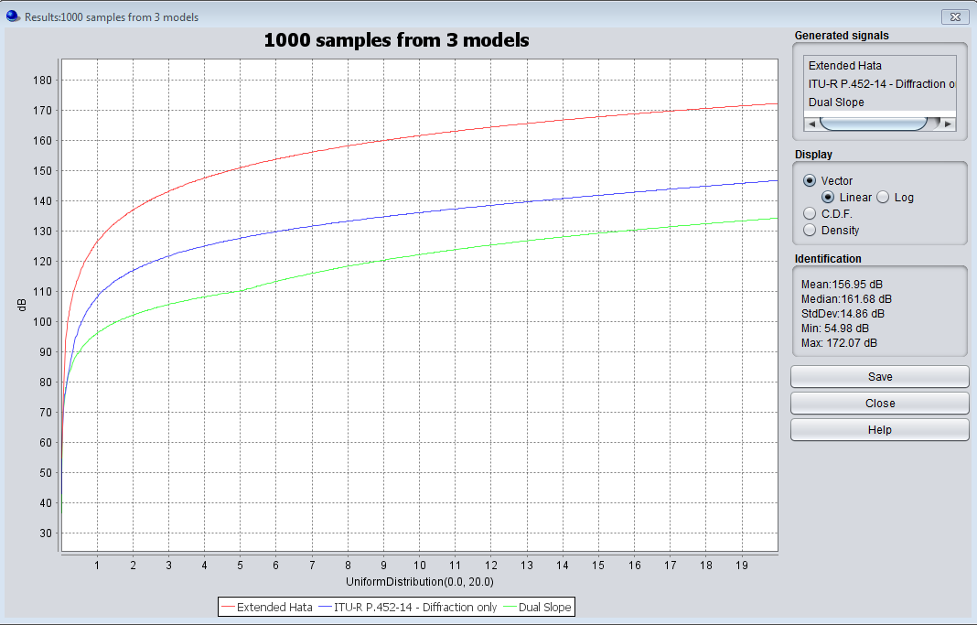
Figure 15: The trend of the path loss Vs separation distance is depicted. Three different models are considered: Extended Hata (red), ITU-R P.452-14 (blue) and Dual Slope (green).
The study is done in a rural scenario

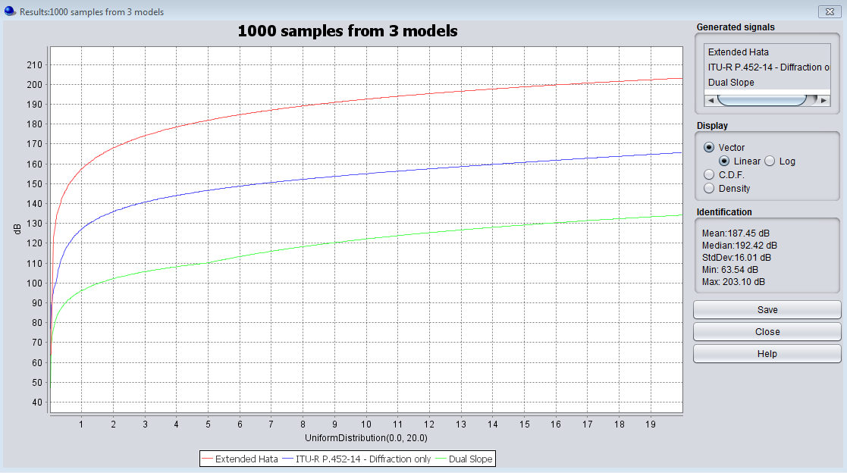
Figure 16: The trend of the path loss Vs separation distance is depicted. Three different models are considered: Extended Hata (red), ITU-R P.452-14 (blue) and Dual Slope (green).
The study is done in an urban scenario
Note: no clutter has been taken into account in ITU-R P.452 [21] curve in Figure 16 above.
In addition, the model given in Recommendation ITU-R P.1411 [22] is considered in the MCL calculations.

MCL calculations
Considering the assumptions given in section 4, it is possible to determine the minimum separation in order to meet the MES interference criterion.
In the following table, a Target Interference to Noise Ratio (I/N) of -20 dB is considered.
Table 39: Separation distances; MES - GSPS (I/N = -20 dB)
Parameter | Handheld | Body worn
e.i.r.p | 13 dBm | 17 dBm
Body loss | 6 dB | 11 dB
Wall loss | 6 dB;10 dB; 15 dB; 20 dB; 34 dB | 6 dB;10 dB; 15 dB;20 dB; 34 dB
Receiver noise level | -120.6 dBm/200 kHz | -120.6 dBm/200 kHz
Target Interference to Noise Ratio | -20 dB | -20 dB
Interference level | -140.6 dBm/200 kHz | -140.6 dBm/200 kHz
Antenna | G_{max}= 3 dBi | G_{max}= 3 dBi
Polarisation discrimination (linear to circular) (dB) | 3 dB | 3dB
Path loss to meet the protection criterion | 141.6 dB; 137.6 dB; 132.6 dB; 127.6 dB; 113.6 dB | 140.6 dB; 136.6 dB; 131.6 dB; 126.6 dB; 112.6 dB
Separation distances in the main lobe | 9.4 km (6 ;20 dB); 6.1 km ⁸ (34 dB) | 9.4 km (6 ;20 dB); 5.8 km ⁸ (34 dB)
Separation distances in the main lobe ;P.1411 | 0.53 km (6 dB); 0.42 km (10 dB); 0.32 km (15 dB); 0.24 km (20 dB); 0.1 m (34 dB) | 0.5 km (6 dB); 0.4 km (10 dB); 0.3 km (15 dB); 0.22 km (20 dB); 0.1 m (34 dB)
Separation distances in the main lobe ;Extended Hata (Urban) | 0.36 km (6 dB); 0.28 km (10 dB); 0.2 km (15 dB); 0.15 km (20 dB); 73 m (34 dB) | 0.34 km (6 dB); 0.26 km (10 dB); 0.19 km (15 dB); 0.14 km (20 dB); 72 m (34 dB)
Path loss to meet the protection criterion in the side lobe | 138.1 dB; 134.1 dB; 129.1 dB; 124.1 dB; 110.1 dB | 137.1 dB; 133.1 dB; 128.1 dB; 123.1 dB - 109.1 dB
Separation distances in the side lobe | 9.4 km (6 ;20 dB); 5.0 km (34 dB) | 9.4 km (6 - 20 dB); 4.5 km (34 dB)
Separation distances in the side lobe ;P.1411 | 0.43 km (6 dB); 0.34 km (10 dB); 0.26 km (15 dB);0.1 km (20 dB); 0.06 m (34 dB) | 0.41 km (6 dB); 0.32 km (10 dB); 0.24 km (15 dB); 0.1 8 km (20 dB); 0.08 m (34 dB)
Separation distances in the side lobe ;Extended Hata (Urban) | 0.3 km (6 dB); 0.22 km (10 dB); 0.16 km (15 dB); 0.12 km (20 dB); 0.082 km (34 dB) | 0.28 km (6 dB); 0.21 km (10 dB); 0.15 km (15 dB); 0.11 km (20 dB); 0.08 km (34 dB)

Table 40: Separation distances; MES - BGAN (I/N= -20dB)
Parameter | Handheld | Body worn
e.i.r.p | 13 dBm | 17 dBm
Body loss | 6 dB | 11 dB
Wall loss | 6 dB ; 10 dB ; 15 dB ;20 dB ; 34 dB | 6 dB ; 10 dB ;15 dB ; 20 dB 34 dB
Receiver noise level | -120.6 dBm/200 kHz | -120.6 dBm/200 kHz
Target Interference to Noise Ratio | -20 dB | -20 dB
Interference level | -140.6 dBm/200 kHz | -140.6 dBm/200 kHz
Antenna | G_{max}= 17.5 dBi | G_{max}= 17.5 dBi
Polarisation discrimination (linear to circular) (dB) | 3 dB | 3 dB
Path loss to meet the protection criterion | 156.1 dB; 152.1 dB; 147.1 dB; 142.1 dB; 128.1 dB | 155.1 dB; 151.1 dB; 146.1 dB; 141.1 dB; 127.1 dB
Separation distances in the main lobe | 9.4 km ¹³ (6- 34 dB) | 9.4 km ¹³ ( (6 ;34 dB)
Separation distances in the main lobe ;P.1411 | 1.2 km (6 dB); 0.97 km (10 dB); 0.73 km (15 dB); 0.54 km (20 dB); 0.24 km (34 dB) | 1.15 km (6 dB); 0.91 km (10 dB); 0.68 km (15 dB); 0.51 km (20 dB); 0.23 km (34 dB)
Separation distances in the main lobe ;Extended Hata (Urban) | 0.93 km (6 dB); 0.72 km (10 dB); 0.51 km (15 dB); 0.37 km (20 dB); 0.15 km (34 dB) | 0.87 km (6 dB); 0.67 km (10 dB); 0.48 km (15 dB); 0.36 km (20 dB); 0.14 km (34 dB)
Path loss to meet the protection criterion in the side lobe | 131.6 dB; 127.6 dB; 122.6 dB; 117.6 dB; 103.6 dB | 130.6 dB; 126.6 dB; 121.6 dB; 116.6 dB; 102.6 dB
Separation distances in the side lobe | 9.4 km ¹³ (6 ;15 dB); 7.7 km (20 dB); 2.4 km (34 dB) | 9.4 km ¹³ (6 ;15 dB); 7.3 km (20 dB); 2.1 km (34 dB)
Separation distances in the side lobe ;P.1411 | 0.3 km (6 dB); 0.24 km (10 dB); 0.18 km (15 dB); 0.13 km (20 dB); 0.06 m (34 dB) | 0.28 km (6 dB); 0.22 km (10 dB); 0.17 km (15 dB); 0.1 25 km (20 dB); 0.06 m (34 dB)
Separation distances in the side lobe ;Extended Hata (Urban) | 0.2 km (6 dB); 0.15 km (10 dB); 0.11 km (15 dB); 0.094 km (20 dB); 0.073 km (34 dB) | 0.19 km (6 dB); 0.14 km (10 dB); 0.1 km (15 dB); 0.093 km (20 dB); 0.072 km (34 dB)

In the following table, a Target Interference to Noise Ratio (I/N) of -6 dB is considered.

Table 41: Separation distances; MES - GSPS (I/N = -6 dB)
Parameter | Handheld | Body worn
e.i.r.p | 13 dBm | 17 dBm
Body loss | 6 dB | 11 dB
Wall loss | 6 dB;10 dB; 15 dB; 20 dB; 34 dB | 6 dB; 10 dB; 15 dB; 20 dB; 34 dB
Receiver noise level | -120.6 dBm/200 kHz | -120.6 dBm/200 kHz
Target Interference to Noise Ratio | -6 dB | -6 dB
Interference level | -126.6 dBm/200 kHz | -126.6 dBm/200 kHz
Antenna | G_{max}= 3 dBi | G_{max}= 3 dBi
Polarisation discrimination (linear to circular) (dB) | 3 dB | 3 dB
Path loss to meet the protection criterion | 127.6 dB; 123.6 dB; 118.6 dB; 113.6 dB; 99.6 dB | 126.6 dB; 122.6 dB; 117.6 dB; 112.6 dB; 98.6 dB
Separation distances in the main lobe | 9.4 km ¹³ (6; 10 dB); 8.2 km (15 dB); 6.1 km (20 dB);1.5 km (34 dB) | 9.4 km ⁸ (6 ;10 dB); 7.7 km (15 dB); 5.8 km (20 dB); 1.3 km (34 dB)
Separation distances in the main lobe; P.1411 | 0.23 km (6 dB); 0.19 km (10 dB); 0.14 km (15 dB); 0.11 km (20 dB); 0.06 km (34 dB) | 0.23 km (6 dB); 0.18 km (10 dB); 0.13 km (15 dB); 0.1 km (20 dB); 0.06 km (34 dB)
Separation distances in the main lobe; Extended Hata (Urban) | 0.14 km (6 dB); 0.11 km (10 dB); 0.095 km (15 dB); 0.073 km (20 dB); 0.068 km (34 dB) | 0.13 km (6 dB); 0.11 km (10 dB); 0.095 km (15 dB); 0.073 km (20 dB); 0.068 km (34 dB)
Path loss to meet the protection criterion in the side lobe | 124.1 dB; 120.1 dB; 115.1 dB; 110.1 dB; 96.1 dB | 123.1 dB; 119.1 dB; 114.1 dB; 109.1 dB; 95.1 dB
Separation distances in the side lobe | 9.4 km (6 dB); 8.9 km (10 dB); 6.7 km (15 dB); 5.0 km (20 dB); 1.0 km (34 dB) | 9.4 km (6 dB); 8.4 km (10 dB); 6.3 km (15dB); 4.5 km (20 dB); 0.9 km (34 dB)
Separation distances in the side lobe; P.1411 | 0.19 km (6 dB); 0.15 km (10 dB); 0.15 km (15 dB); 0.11 km (20 dB); 0.1 m (34 dB) | 0.18 km (6 dB); 0.145 km (10 dB); 0.11 km (15 dB); 0.08 km (20 dB); 0.055 m (34 dB)
Separation distances in the side lobe; Extended Hata (Urban) | 0.12 km (6 dB); 0.097 km (10 dB); 0.089 km (15 dB); 0.082 km (20 dB); 0.065 km (34 dB) | 0.11 km (6 dB); 0.096 km (10 dB); 0.087 km (15 dB); 0.08 km (20 dB); 0.064 km (34 dB)

Table 42: Separation distances; MES - BGAN (I/N= -6dB)
Parameter | Handheld | Body worn
e.i.r.p | 13 dBm | 17 dBm
Body loss | 6 dB | 11 dB
Wall loss | 6 dB; 10 dB -15 dB; 20 dB; 34 dB | 6 dB; 10 dB -15 dB; 20 dB; 34 dB
Receiver noise level | -120.6 dBm/200 kHz | -120.6 dBm/200 kHz
Target Interference to Noise Ratio | -6 dB | -6 dB
Interference level | -140.6 dBm/200 kHz | -140.6 dBm/200 kHz
Antenna | G_{max}= 17.5 dBi | G_{max}= 17.5 dBi
Polarisation discrimination (linear to circular) (dB) | 3 dB | 3 dB
Path loss to meet the protection criterion | 142.1 dB; 138.1 dB; 133.1 dB; 128.1 dB; 114.1 dB | 141.1 dB; 137.1 dB; 132.1 dB; 127.1 dB; 113.1 dB
Separation distances in the main lobe | 9.4 km ¹³ (6 dB; 20 dB); 6.3 km (34 dB) | 9.4 km (6 dB ;20 dB); 5.9 km (34 dB)
Separation distances in the main lobe ;P.1411 (Urban) | 0.54 km (6 dB); 0.43 km (10 dB); 0.32 km (15 dB); 0.24 km (20 dB); 0.11 km (34 dB) | 0.51 km (6 dB); 0.41 km (10 dB); 0.31 km (15 dB); 0.23 km (20 dB); 0.1 km (34 dB)
Separation distances in the main lobe ;Extended Hata (Urban) | 0.37 km (6 dB); 0.29 km (10 dB); 0.21 km (15 dB); 0.15 km (20 dB); 0.088 km (34 dB) | 0.35 km (6 dB); 0.27 km (10 dB); 0.2 km (15 dB); 0.14 km (20 dB); 0.086 km (34 dB)
Path loss to meet the protection criterion in the side lobe | 117.6 dB; 113.6 dB; 108.6 dB; 103.6 dB; 89.6 dB | 116.6 dB; 112.6 dB; 107.6 dB; 105.2 dB; 88.6 dB
Separation distances in the side lobe | 7.7 km (6 dB); 6.1 km (10 dB); 4.2 km (15 dB); 2.4 km (20 dB); 0.5 km (34 dB) | 7.3 km (6 dB); 5.8 km (10 dB); 3.8 km (15 dB); 2.1 km (20 dB); 0.4 km (34 dB)
Separation distances in the side lobe ;P.1411 | 0.13 km (6 dB); 0.105 km (10 dB); 0.08 km (15 dB); 0.06 km (20 dB); 0.05 m (34 dB) | 0.125 km (6 dB); 0.1 km (10 dB); 0.075 km (15 dB); 0.06 km (20 dB); 0.05 m (34 dB)
Separation distances in the side lobe ;Extended Hata (Urban) | 0.093 km (6 dB); 0.087 km (10 dB); 0.08 km (15 dB); 0.073 km (20 dB); 0.058 km (34 dB) | 0.091 km (6 dB); 0.085 km (10 dB); 0.078 km (15 dB); 0.072 km (20 dB); 0.057 km (34 dB)

Note: Inmarsat is not using the same gain in the side lobe therefore, the tables are provided separately:
Table 43: Separation distances; MES - GSPS (I/N = -20 dB)
Parameter | Handheld | Body worn
e.i.r.p | 13 dBm | 28 dBm
Body loss | 6 dB | 11 dB
Wall loss | 6 dB ;10 dB; 15 dB ;20 dB; 34 dB | 6 dB ;10 dB; 15 dB ;20 dB ;34 dB
Receiver noise level | -120.6 dBm/200 kHz | -120.6 dBm/200 kHz
Target Interference to Noise Ratio | -20 dB | -20 dB
Interference level | -140.6 dBm/200 kHz | -140.6 dBm/200 kHz
Antenna | G_{max}= 3 dBi, 0 dBi in the sidelobe | G_{max}= 3 dBi, 0 dBi in the sidelobe
Polarisation discrimination (linear to circular) (dB) | 3 dB | 3dB
Path loss to meet the protection criterion in the main lobe | 141.6 dB; 137.6 dB; 132.6 dB; 127.6 dB; 113.6 dB | 151.6 dB; 147.6 dB; 142.6 dB; 137.6 dB; 123.6 dB
Separation distances in the main lobe (Dual slope propagation model) | 30.7 km (6 dB); 24.4 km (10 dB); 18.3 km (15 dB); 13.7 km (20 dB); 6.1 km (34 dB) | 54.6 km (6 dB); 43.3 km (10 dB); 32.5 km (15 dB); 24.4 km (20 dB); 10.9 km (34 dB)
Separation distances in the main lobe; ITU-R P.452-14 (rural). Note: no clutter has been taken into account when using this propagation model. | 14.85 km (6 dB);11.31 km (10 dB); 7.63 km (15 dB); 5.01 km (20 dB); 1.53 km (34 dB) | 25.53 km (6 dB); 21.02 km (10 dB); 15.88 km (15 dB); 11.31 km (20 dB); 3.55 km (34 dB)
Separation distances in the main lobe; ITU-R -14 (urban) | 3.26 km (6 dB); 2.36 km (10 dB); 1.53 km (15 dB); 1.04 km (20 dB); 0.45 km (34 dB) | 7.63 km (6 dB); 5.45 km (10 dB); 3.55 km (15 dB);2.36 km (20 dB); 0.78 km (34 dB)
Separation distances in the main lobe; Extended Hata (Rural) | 4.2 km (6 dB); 3.238 km (10 dB); 2.335 km (15 dB); 1.684 km (20 dB); 0.674 km (34 dB) | 8.085 km (6 dB); 6.225 km (10 dB); 4.489 km (15 dB); 3.238 km (20 dB); 1.297 km (34 dB)
Separation distances in the main lobe; Extended Hata (Urban) | 0.353 km (6 dB); 0.272 km (10 dB); 0.196 km (15 dB); 0.141 km (20 dB); 87 m (34 dB) | 0.679 km (6 dB); 0.523 km (10 dB); 0.377 km (15 dB); 0.272 km (20 dB); 0.109 km (34 dB)
Path loss to meet the protection criterion in the side lobe | 138.6 dB; 134.6 dB; 129.6 dB; 124.6 dB; 110.6 dB | 148.6 dB; 144.6 dB; 139.6 dB; 134.6 dB; 120.6 dB
Separation distances in the side lobe (Dual slope model) | 25.8 km (6 dB); 20.5 km (10 dB); 15.4 km (15 dB); 11.5 km (20 dB); 5.1 km (34 dB) | 45.9 km (6 dB); 36.5 km (10 dB); 27.3 km (15 dB); 20.5 km (20 dB); 9.2 km (34 dB)
Separation distances in the side lobe; ITU-R P.452-14 (rural) | 12.15 km (6 dB); 8.98 km (10 dB); 5.94 km (15 dB); 3.89 km (20 dB); 1.2 km (34 dB) | 22.13 km (6 dB); 17.85 km (10 dB); 13.02 km (15 dB); 8.98 km (20 dB); 2.74 km (34 dB)
Separation distances in the side lobe; ITU-R P.452-14 (urban)¹⁴ | 2.53 km (6 dB); 1.78 km (10 dB); 1.2 km (15 dB); 0.88 km (20 dB); 0.45 km (34 dB) | 5.94 km (6 dB); 4.22 km (10 dB); 2.74 km (15 dB); 1.78 km (20 dB); 0.64 km (34 dB)
Separation distances in the side lobe; Extended Hata (Rural) | 3.456 km (6 dB); 2.661 km (10 dB); 1.919 km (15 dB); 1.384 km (20 dB); 0.554 km (34 dB) | 6.645 km (6 dB); 5.116 km (10 dB); 3.69 km (15 dB); 2.661 km (20 dB); 1.066 km (34 dB)
Separation distances in the side lobe; Extended Hata (Urban) | 0.29 km (6 dB); 0.224 km (10 dB); 0.161 km (15 dB); 0.116 km (20 dB); 0.083 km (34 dB) | 0.558 km (6 dB); 0.43 km (10 dB); 0.31 km (15 dB); 0.224 km (20 dB); 0.097 km (34 dB)
Table 44: Separation distances; MES - BGAN (I/N= -20dB)
Parameter | Handheld | Body worn
e.i.r.p | 13 dBm | 28 dBm
Body loss | 6 dB | 11 dB
Wall loss | 6 dB; 10 dB; 15 dB; 20 dB; 34 dB | 6 dB; 10 dB; 15 dB; 20 dB; 34 dB
Receiver noise level | -120.6 dBm/200 kHz | -120.6 dBm/200 kHz
Target Interference to Noise Ratio | -20 dB | -20 dB
Interference level | -140.6 dBm/200 kHz | -140.6 dBm/200 kHz
Antenna | G_{max}= 17.5 dBi, -7 dBi in the far side lobe | G_{max}= 17.5 dBi, -7 dBi in the far side lobe
Polarisation discrimination (linear to circular) (dB) | 3 dB | 3 dB
Path loss to meet the protection criterion | 156.1 dB; 152.1 dB; 147.1 dB; 142.1 dB; 128.1 dB | 166.1 dB; 162.1 dB; 157.1 dB; 152.1 dB; 138.1 dB
Separation distances in the main lobe (Dual slope model) | 70.7 km (6 dB); 56.1 km (10 dB); 42.1 km (15 dB); 31.6 km (20 dB); 14.1 km (34 dB) | 125.7 km (6 dB); 99.8 km (10 dB); 74.9 km (15 dB); 56.1 km (20 dB); 25.1 km (34 dB)
Separation distances in the main lobe; ITU-R P.452-14 (rural)  Note: no clutter has been taken into account when using this propagation model. | 30.93 km (6 dB); 26.18 km (10 dB); 20.47 km (15 dB); 15.33 km (20 dB); 5.23 km (34 dB) | 44.06 km (6 dB); 38.62 km (10 dB); 32.19 km (15 dB); 26.18 km (20 dB); 11.72 km (34 dB)
Separation distances in the main lobe; ITU-R P.452-14 (urban)¹⁴¹⁴ | 10.88 km (6 dB); 7.97 km (10 dB); 5.23 km (15 dB); 3.4 km (20 dB); 1.06 km (34 dB) | 20.47 km (6 dB); 16.33 km (10 dB); 11.72 km (15 dB); 7.97 km (20 dB); 2.4 km (34 dB)
Separation distances in the main lobe; Extended Hata (Rural) | 10.85 km (6 dB); 8.353 km (10 dB); 7.63 km (15 dB); 5.01 km (20 dB); 1.74 km (34 dB) | 20.625 km (6 dB); 16.06 km (10 dB); 11.583 km (15 dB); 8.353 km (20 dB); 3.345 km (34 dB)
Separation distances in the main lobe; Extended Hata (Urban) | 0.911 km (6 dB); 0.702 km (10 dB); 0.506 km (15 dB); 0.365 km (20 dB); 0.146 km (34 dB) | 1.752 km (6 dB); 1.349 km (10 dB); 0.973 km (15 dB); 0.702 km (20 dB); 0.281 km (34 dB)
Path loss to meet the protection criterion in the side lobe | 131.6 dB; 127.6 dB; 122.6 dB; 117.6 dB; 103.6 dB | 141.6 dB; 137.6 dB; 132.6 dB; 127.6 dB; 113.6 dB
Separation distances in the side lobe (Dual slope model) | 17.3 km (6 dB); 13.7 km (10 dB); 10.3 km (15 dB); 7.7 km (20 dB); 2.4 km (34 dB) | 30.7 km (6 dB); 24.4 km (10 dB); 18.3 km (15 dB); 13.7 km (20 dB); 6.1 km (34 dB)
Separation distances in the side lobe; ITU-R P.452-14 (rural) | 7.02 km (6 dB); 5.01 km (10 dB); 3.26 km (15 dB); 2.14 km (20 dB); 0.74 km (34 dB) | 14.85 km (6 dB); 11.31 km (10 dB);.63 km (15 dB);5.01 km (20 dB); 1.53 km (34 dB)
Separation distances in the side lobe; ITU-R P.452-14 (urban)¹⁴ | 1.4 km (6 dB); 1.04 km (10 dB); 0.74 km (15 dB); 0.5 km (20 dB); 0.24 km (34 dB) | 3.26 km (6 dB); 2.36 km (10 dB); 1.53 km (15 dB); 1.04 km (20 dB); 0.45 km (34 dB)
Separation distances in the side lobe; Extended Hata (Rural) | 2.187 km (6 dB); 1.684 km (10 dB); 1.214 km (15 dB); 0.876 km (20 dB); 0.351 km (34 dB) | 4.205 km (6 dB); 3.238 km (10 dB); 2.335 km (15 dB);.684 km (20 dB); 0.674 km (34 dB)
Separation distances in the side lobe; Extended Hata (Urban) | 0.184 km (6 dB); 0.141 km (10 dB); 0.102 km (15 dB); 0.093 km (20 dB); 0.075 km (34 dB) | 0.353 km (6 dB); 0.272 km (10 dB); 0.196 km (15 dB); 0.141 km (20 dB); 0.087 km (34 dB)

In the following table, a Target Interference to Noise Ratio (I/N) of -6 dB is considered.

Table 45: Separation distances; MES - GSPS (I/N = -6 dB)
Parameter | Handheld | Body worn
e.i.r.p | 13 dBm | 28 dBm
Body loss | 6 dB | 11 dB
Wall loss | 6 dB ;10 dB; 15 dB; 20 dB; 34 dB | 6 dB; 10 dB; 15 dB; 20 dB; 34 dB
Receiver noise level | -120.6 dBm/200 kHz | -120.6 dBm/200 kHz
Target Interference to Noise Ratio | -6 dB | -6 dB
Interference level | -126.6 dBm/200 kHz | -126.6 dBm/200 kHz
Antenna | G_{max}= 3 dBi, 0 dBi in the side lobe | G_{max}= 3 dBi, 0 dBi in the side lobe
Polarisation discrimination (linear to circular) (dB) | 3 dB | 3 dB
Path loss to meet the protection criterion in the main lobe | 127.6 dB; 123.6 dB; 118.6 dB; 113.6 dB; 99.6 dB | 137.6 dB; 133.6 dB; 128.6 dB; 123.6 dB; 109.6 dB
Separation distances in the main lobe (Dual slope model) | 13.7 km (6 dB); 10.9 km (10 dB); 8.2 km (15 dB); 6.1 km (20 dB); 1.5 km (34 dB) | 24.4 km (6 dB); 19.4 km (10 dB); 14.5 km (15 dB); 10.9 km (20 dB); 4.7 km (34 dB)
Separation distances in the main lobe; ITU-R P.452-14 (rural)  Note: no clutter has been taken into account when using this propagation model. | 5.01 km (6 dB); 3.55 km (10 dB); 2.36 km (15 dB); 1.53 km (20 dB); 0.55 km (34 dB) | 11.31 km (6 dB); 8.27 km (10 dB); 5.45 km (15 dB); 3.55 km (20 dB); 1.12 km (34 dB)
Separation distances in the main lobe; ITU-R P.452-14 (urban) 14 | 1.04 km (6 dB); 0.78 km (10 dB); 0.55 km (15 dB); 0.45 km (20 dB); 0.14 km (34 dB) | 2.36 km (6 dB); 1.63 km (10 dB); 1.12 km (15 dB); 0.78 km (20 dB); 0.24 km (34 dB)
Separation distances in the main lobe; Extended Hata (Rural) | 1.684 km (6 dB); 1.297 km (10 dB); 0.935 km (15 dB); 0.674 km (20 dB); 0.27 km (34 dB) | 3.238 km (6 dB); 2.493 km (10 dB); 1.798 km (15 dB); 1.297 km (20 dB); 0.519 km (34 dB)
Separation distances in the main lobe; Extended Hata (Urban) | 0.141 km (6 dB); 0.109 km (10 dB); 0.094 km (15 dB); 0.087 km (20 dB); 0.07 km (34 dB) | 0.272 km (6 dB); 0.209 km (10 dB); 0.151 km (15 dB) ; 0.109 km (20 dB); 0.082 km (34 dB)
Path loss to meet the protection criterion in the side lobe | 124.6 dB; 120.6 dB; 115.6 dB; 110.6 dB; 96.6 dB | 134.6 dB; 130.6 dB; 125.6 dB; 120.6 dB; 106.6 dB
Separation distances in the side lobe (Dual slop model) | 11.5 km (6 dB); 9.2 km (10 dB); 6.9 km (15 dB); 5.1 km (20 dB); 1.1 km (34 dB) | 20.5 km (6 dB); 16.3 km (10 dB); 12.2 km (15 dB); 9.2 km (20 dB); 3.3 km (34 dB)
Separation distances in the main lobe; ITU-R P.452-14 (rural) | 3.89 km (6 dB); 2.74 km (10 dB); 1.78 km (15 dB); 1.2 km (20 dB); 0.46 km (34 dB) | 8.98 km (6 dB); 6.47 km (10 dB); 4.22 km (15 dB); 2.74 km (20 dB); 0.9 km (34 dB)
Separation distances in the main lobe; ITU-R P.452-14 (urban) 14 | 0.88 km (6 dB); 0.64 km (10 dB); 0.46 km (15 dB); 0.45 km (20 dB); 0.14 km (34 dB) | 1.98 km (6 dB); 1.32 km (10 dB); 0.9 km (15 dB); 0.64 km (20 dB); 0.24 km (34 dB)
Separation distances in the main lobe; Extended Hata (Rural) | 1.384 km (6 dB); 1.066 km (10 dB); 0.769 km (15 dB); 0.554 km (20 dB); 0.222 km (34 dB) | 2.661 km (6 dB); 2.049 km (10 dB); 1.478 km (15 dB); 1.066 km (20 dB); 0.427 km (34 dB)
Separation distances in the side lobe; Extended Hata (Urban) | 0.116 km (6 dB); 0.097 km (10 dB); 0.09 km (15 dB); 0.083 km (20 dB); 0.066 km (34 dB) | 0.224 km (6 dB); 0.172 km (10 dB); 0.124 km (15 dB); 0.097 km (20 dB); 0.078 km (34 dB)

Table 46: Separation distances; MES - BGAN (I/N=-6dB)
Parameter | Handheld | Body worn
e.i.r.p | 13 dBm | 28 dBm
Body loss | 6 dB | 11 dB
Wall loss | 6 dB; 10 dB; 15 dB; 20 dB; 34 dB | 6 dB; 10 dB; 15 dB; 20 dB 34 dB
Receiver noise level | -120.6 dBm/200 kHz | -120.6 dBm/200 kHz
Target Interference to Noise Ratio | -6 dB | -6 dB
Interference level | -126.6 dBm/200 kHz | -126.6 dBm/200 kHz
Antenna | G_{max}= 17.5 dBi, -7 dBi in the far side lobe | G_{max}= 17.5 dBi, -7 dBi in the far side lobe
Polarisation discrimination (linear to circular) (dB) | 3 dB | 3 dB
Path loss to meet the protection criterion | 142.1 dB; 138.1 dB; 133.1 dB; 128.1 dB; 114.1 dB | 152.1 dB; 148.1 dB; 143.1 dB; 138.1 dB; 124.1 dB
Separation distances in the main lobe (Dual slope model) | 31.6 km (6 dB); 25.1 km (10 dB); 18.8 km (15 dB); 14.1 km (20 dB); 6.3 km (34 dB) | 56.1 km (6 dB); 44.6 km (10 dB); 33.4 km (15 dB); 25.1 km (20 dB); 11.2 km (34 dB)
Separation distances in the main lobe; ITU-R P.452-14 (rural)  Note: no clutter has been taken into account when using this propagation model. | 15.33 km (6 dB); 11.72 km (10 dB); 7.97 km (15 dB); 5.23 km (20 dB); 1.58 km (34 dB) | 26.18 km (6 dB); 21.57 km (10 dB); 16.33 km (15 dB); 11.72 km (20 dB); 3.73 km (34 dB)
Separation distances in the main lobe; ITU-R P.452-14 (urban)¹⁴ | 3.4 km (6 dB); 2.4 km (10 dB); 1.58 km (15 dB); 1.06 km (20 dB); 0.45 km (34 dB) | 7.97 km (6 dB); 5.7 km (10 dB); 3.73 km (15 dB); 2.4 km (20 dB); 0.79 km (34 dB)
Separation distances in the main lobe; Extended Hata (Rural) | 4.345 km (6 dB); 3.345 km (10 dB); 2.412 km (15 dB); 1.74 km (20 dB); 0.697 km (34 dB) | 8.353 km (6 dB); 6.431 km (10 dB); 4.638 km (15 dB); 3.345 km (20 dB); 1.34 km (34 dB)
Separation distances in the main lobe; Extended Hata (Urban) | 0.365 km (6 dB); 0.281 km (10 dB); 0.203 km (15 dB); 0.146 km (20 dB); 0.088 km (34 dB) | 0.702 km (6 dB); 0.54 km (10 dB) ;0.39 km (15 dB) ;0.281 km (20 dB) ;0.113 km (34 dB)
Path loss to meet the protection criterion in the side lobe | 117.6 dB;113.6 dB; 108.6 dB; 103.6 dB; 89.6 dB | 127.6 dB; 123.6 dB; 118.6 dB; 13.6 dB; 99.6 dB
Separation distances in the side lobe (Dual slope model) | 7.7 km (6 dB); 6.1 km (10 dB); 4.2 km (15 dB); 2.4 km (20 dB); 0.5 km (34 dB) | 13.7 km (6 dB); 10.9 km (10 dB); 8.2 km (15 dB); 6.1 km (20 dB); 1.5 km (34 dB)
Separation distances in the main lobe; ITU-R P.452-14 (rural) | 2.14 km (6 dB); 1.53 km (10 dB); 1.04 km (15 dB); 0.74 km (20 dB); 0.24 km (34 dB) | 5.01 km (6 dB); 3.55 km (10 dB); 2.36 km (15 dB); 1.53 km (20 dB); 0.55 km (34 dB)
Separation distances in the main lobe; ITU-R P.452-14 (urban)14 | 0.5 km (6 dB); 0.45 km (10 dB); 0.24 km (15 dB); 0.24 km (20 dB); 0.06 km (34 dB) | 1.04 km (6 dB); 0.78 km (10 dB); 0.55 km (15 dB); 0.45 km (20 dB); 0.14 km (34 dB)
Separation distances in the main lobe; Extended Hata (Rural) | 0.876 km (6 dB); 0.674 km (10 dB); 0.486 km (15 dB); 0.351 km (20 dB); 0.14 km (34 dB) | 1.684 km (6 dB); 1.297 km (10 dB); 0.935 km (15 dB); 0.674 km (20 dB); 0.27 km (34 dB)
Separation distances in the side lobe; Extended Hata (Urban) | 0.093 km (6 dB); 0.087 km (10 dB); 0.081 km (15 dB); 0.075 km (20 dB); 0.059 km (34 dB) | 0.141 km (6 dB); 0.109 km (10 dB); 0.094 km (15 dB); 0.087 km (20 dB); 0.07 km (34 dB)

SEAMCAT simulations for GSPS and BGAN MESs

The following tables provide the probability of interference for the different wall attenuations, also considering two possible interference criteria (as considered in ECC Report 147 [6]).

Case 1: Handheld - Urban

Four different audio PMSE densities are assumed in the studies.
Table 47: Audio PMSE density
 | PMSE density
Area radius (km) | 20 | 10 | 4 | 1.7
Surface area (km2) | 1257 | 314 | 50 | 9
Number of active PMSE devices/ 200 kHz | 1 | 1 | 1 | 1

Probability of interference is calculated using two different propagation models.
Table 48: Probability of interference; Handheld; GSPS - urban - Extended Hata
Density of active PMSE | I/N | Wall attenuation
Density of active PMSE | I/N | 6 dB | 10 dB | 20 dB | 34 dB
1 in 20 km radius | -20 dB | 0.02 % | 0.0% | 0.0 % | 0 %
1 in 20 km radius | -6 dB | 0.00 % | 0.0 % | 0 % | 0 %
1 in 10 km radius | -20 dB | 0.04 % | 0.02% | 0.0 % | 0 %
1 in 10 km radius | -6 dB | 0.00 % | 0.0 % | 0 % | 0 %
1 in 4 km radius | -20 dB | 0.3 % | 0.19 % | 0.06 % | 0.03 %
1 in 4 km radius | -6 dB | 0.04 % | 0.03 % | 0.02 % | 0.01 %
1 in 1.7 km radius | -20 dB | 1.6 % | 1.0 % | 0.3 % | 0.26 %
1 in 1.7 km radius | -6 dB | 0.3 % | 0.25 % | 0.2 % | 0.1 %

Table 49: Probability of interference; Handheld; GSPS - urban; ITU-R P.452
Density of active PMSE | I/N | Wall attenuation
Density of active PMSE | I/N | 6 dB | 10 dB | 20 dB | 34 dB
1 in 20 km radius | -20 dB | 0.7 % | 0.36 % | 0.08 % | 0.01 %
1 in 20 km radius | -6 dB | 0.1 % | 0.04 % | 0.02 % | 0.0 %
1 in 10 km radius | -20 dB | 2.7 % | 1.44 % | .37 % | 0.07 %
1 in 10 km radius | -6 dB | 0.31 % | 0.23 % | 0.08 % | 0.01 %
1 in 4 km radius | -20 dB | 17.6 % | 9 % | 2.3 % | 0.4 %
1 in 4 km radius | -6 dB | 2.11 % | 1.31 % | 0.38 % | 0.03 %
1 in 1.7 km radius | -20 dB | 92 % | 51.6% | 12.13 % | 2.2 %
1 in 1.7 km radius | -6 dB | 12.1 % | 6.9 % | 2.3 % | 0.14 %

Case 2: Handheld - Rural

Probability of interference is calculated using two different propagation models.
Table 50: Probability of interference; Handheld - rural
(1 active PMSE device at 200 kHz in a 25 km radius); Extended Hata
MES system | I/N | Wall attenuation
MES system | I/N | 6 dB | 10 dB | 15 dB | 34 dB
GSPS | -20 dB | 0.37 % | 0.28 % | 0.18 % | 0 %
GSPS | -6 dB | 0.07 % | 0.06 % | 0.01 % | 0 %
BGAN | -20 dB | 0.17% | 0.12 % | 0.08 % | 0.00 %
BGAN | -6 dB | 0.04 % | 0.02 % | 0.0 % | 0 %

Table 51: Probability of interference; Handheld - rural
(1 active PMSE device at 200 kHz in a 25 km radius); ITU-R P.452 (clutter 10 dB)
MES system | I/N | Wall attenuation
MES system | I/N | 6 dB | 10 dB | 15 dB | 34 dB
GSPS | -20 dB | 2.1 % | 0.95 % | 0.53 % | 0.03 %
GSPS | -6 dB | 0.16 % | 0.07 % | 0.06 % | 0.01 %
BGAN | -20 dB | 0.61% | 0.34 % | 0.16 % | 0.00 %
BGAN | -6 dB | 0.06 % | 0.04 % | 0.02 % | 0 %

Case 3: Body worn - Urban
Probability of interference is calculated using two different propagation models.
Table 52: Probability of interference; body urban 1 in 10 km; Extended Hata
MES system | I/N | Wall attenuation
MES system | I/N | 6 dB | 10 dB | 20 dB | 34 dB
GSPS | -20 dB | 0.02 % | 0.01 % | 0.0 % | 0.00 %
GSPS | -6 dB | 0.0 % | 0 % | 0 % | 0 %
BGAN | -20 dB | 0.0 % | 0.0 % | 0.0 % | 0.0 %
BGAN | -6 dB | 0.0 % | 0 % | 0 % | 0 %

Table 53: Probability of interference; body worn; urban 1 in 10 km; ITU-R P.452 (clutter 19 dB)
MES system | I/N | Wall attenuation
MES system | I/N | 6 dB | 10 dB | 20 dB | 34 dB
GSPS | -20 dB | 1.1 % | 0.61 % | 0.19 % | 0.03 %
GSPS | -6 dB | 0.2 % | 0.15 % | 0.01 % | 0 %
BGAN | -20 dB | 0.48 % | 0.31 % | 0.09 % | 0.0 %
BGAN | -6 dB | 0.06 % | 0.04 % | 0 % | 0 %

Case 4: Body worn - Rural
Probability of interference is calculated using two different propagation models.

Table 54: Probability of interference; body worn; GSPS; rural 1 in 25 km - Extended Hata & P.452
Propagation model | I/N | Wall attenuation
Propagation model | I/N | 6 dB | 10 dB | 15 dB | 34 dB
Extended Hata | -20 dB | 0.2 % | 0.09 % | 0.04 % | 0 %
Extended Hata | -6 dB | 0.05 % | 0.01 % | 0.00 % | 0 %
ITU-R P.452 (clutter 10 dB) | -20 dB | 0.81 % | 0.36 % | 0.17 % | 0.01 %
ITU-R P.452 (clutter 10 dB) | -6 dB | 0.1 % | 0.06 % | 0.02 % | 0 %

Sensitivity analysis
Sensitive analysis for GSPS (worst case compared to BGAN) using three different PMSE densities.
Table 55: Probability of interference; body worn; GSPS - urban - Extended Hata
Density of active PMSE | I/N | Wall attenuation
Density of active PMSE | I/N | 6 dB | 10 dB | 20 dB | 34 dB
1 in 20 km radius | -20 dB | 0.0 % | 0.0 % | 0.0 % | 0.0 %
1 in 20 km radius | -6 dB | 0.0 % | 0 % | 0 % | 0 %
1 in 10 km radius | -20 dB | 0.02 % | 0.01 % | 0.0 % | 0.00 %
1 in 10 km radius | -6 dB | 0.0 % | 0 % | 0 % | 0 %
1 in 1.7 km radius | -20 dB | 0.6 % | 0.32 % | 0.2 % | 0.16 %
1 in 1.7 km radius | -6 dB | 0.25 % | 0.2 % | 0.17 % | 0.08 %

In order to consider possible variations in the value of body loss that may exist in practise, the sensitivity analysis provided in this section considers a median value for the body loss of 13 dB instead of 21 dB.
Table 56: Probability of interference; body worn; GSPS; urban; radius of simulations:
1 in 20 km and 1.7 km; ITU-R P.452 (clutter 19 dB)
Density of active PMSE | I/N | Wall attenuation
Density of active PMSE | I/N | 6 dB | 10 dB | 20 dB | 34 dB
1 in 20 km radius | -20 dB | 0.97 % | 0.45 % | 0.08 % | 0.02 %
1 in 20 km radius | -6 dB | 0.1 % | 0.08 % | 0.04 % | 0 %
1 in 1.7 km radius | -20 dB | 100 % | 72 % | 16.8 % | 3.03 %
1 in 1.7 km radius | -6 dB | 16.4 % | 9.6 % | 2.7 % | 0.3 %

It should be noted that the median value of 13 dB for the body loss results in radiated power, which is 2 dB higher than in the handheld case, therefore the results are similar.

Aeronautical MES
In the case of interference to aeronautical MESs, free-space loss is assumed, with the addition of building penetration loss. (Additional attenuation resulting from the clutter was not included in the studies.)
The case where the on-board antenna is pointing directly toward a PMSE device is not considered realistic, therefore, only the side-lobe case is considered in this section.
Aeronautical MESs may operate in the band 1518-1525 MHz in CEPT.
Although there are no radio regulatory restrictions on the altitude at which an aeronautical MES may operate, for this study, altitudes of 1000 m, 3000 m and 13000 m are considered.
Separation distances for aeronautical MESs, if operated on ground, are very similar to those obtained with Land MES (see section 5.6.2.2), so there is no need to study it separately.
Regarding the antenna gain of the aeronautical earth station, Figure 17 shows the gain curves measured in a calibrated antenna test facility, in an anechoic environment, with a ground plane added to simulate the fuselage. As can be seen from the plot, at 15 degree below the horizon (20° off-axis) there is 2 dB of antenna discrimination, with antenna gain of 10 dBi.

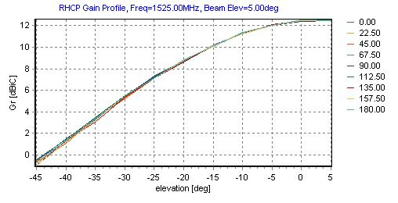
Figure 17: Gain curves measured in a calibrated antenna test facility, in an anechoic environment
The antenna gain for angles more than 45° below the horizon is not available and is assumed to be less than -5 dBi. Therefore for antenna angles less than 45° below the horizon an antenna gain of -5 dBi has been applied. The corresponding gains for elevation angles less than 45 degrees considering the fuselage are likely to be less than -5 dBi.

MCL calculations for aircraft at 1000m, 3000m and 13000m altitude
Based on the assumptions given in previous sections about the MSS and PMSE parameters, it is possible to determine the ground distance separation required between PMSE and Aeronautical MES in order to meet the interference criterion. The interference to aeronautical MES terminals from PMSE occurs by co-channel interference and the interference criterion of I/N = -6 dB and -20 dB are used as interference criteria.
The propagation model used in this scenario is based on the free-space propagation model. Three aircraft altitudes at 1000 m, 3000 m and 13000 m above ground level are considered. Then the path loss required to meet the protection criterion is calculated for each of the three aircraft altitudes for both the handheld and body worn types of PMSE devices.
For each of the three scenarios (aircraft altitudes), it is considered appropriate to study the low gain antenna “Omni”, as this is the worst case given the lack of antenna directivity and consequently lower level of side lobe discrimination against interference compared to an antenna with higher directivity. Therefore, it is reasonable to assume for such type of antenna, the side-lobe gain at which the PMSE interferer incidents is typically about -5 dBi (Case 1). In addition, another pattern is also considered with a side-lobe of -10 dB (Case 2).
Table 57: Ground Distance Separation for Aeronautical MES at Altitude of 1 km, I/N = -20 dB
(Case 1)
Parameter | Handheld | Body worn
e.i.r.p | 13 dBm | 17 dBm
Body loss | 6 dB | 11 dB
Wall loss | 6 dB; 10 dB; 15 dB; 20 dB; 34 dB | 6 dB; 10 dB; 15 dB; 20 dB; 34 dB
Receiver noise level | -120.6 dBm/200 kHz | -120.6 dBm/200 kHz
Interference to Noise Ratio | -20 dB | -20 dB
Interference level | -140.6 dBm/200 kHz | -140.6 dBm/200 kHz
Side lobe antenna gain | G = -5 dBi | G = -5 dBi
Polarisation discrimination (linear to circular) (dB) | 3 dB | 3 dB
Path loss to meet the protection criterion | 133.6 dB; 129.6 dB; 124.6 dB; 119.6 dB; 105.6 dB | 132.6 dB; 128.6 dB; 123.6 dB; 118.6 dB; 104.6 dB
Path loss at 1 km | 96 dB | 96 dB
Ground distance separation between aircraft and PMSE | 76 km (6 dB); 48 km (10 dB);  27 km (15 dB); 15 km (20 dB);  2.7 km (34 dB) | 67 km (6 dB); 43 km (10 dB);  24 km (15 dB); 13.4 km (20 dB); 2.3 km (34 dB)

Table 58: Ground Distance Separation for Aeronautical MES at Altitude of 1 km, I/N = -20 dB
(Case 2)
Parameter | Handheld | Body worn
e.i.r.p | 13 dBm | 17 dBm
Body loss | 6 dB | 11 dB
Wall loss | 6 dB; 10 dB; 15 dB; 20 dB; 34 dB | 6 dB; 10 dB; 15 dB; 20 dB; 34 dB
Receiver noise level | -120.6 dBm/200 kHz | -120.6 dBm/200 kHz
Interference to Noise Ratio | -20 dB | -20 dB
Interference level | -140.6 dBm/200 kHz | -140.6 dBm/200 kHz
Side lobe antenna gain | G = -10 dBi | G = -10 dBi
Polarisation discrimination (linear to circular) (dB) | 3 dB | 3 dB
Path loss to meet the protection criterion | 128.6 dB; 124.6 dB; 119.6 dB; 114.6 dB; 100.6 dB | 127.6 dB; 123.6 dB; 118.6 dB; 113.6 dB; 99.6 dB
Path loss at 1 km | 96 dB | 96 dB
Ground distance separation between aircraft and PMSE | 42 km (6 dB); 27 km (10 dB);  15 km (15 dB); 8.4 km (20 dB); 1.4 km (34 dB) | 38 km (6 dB); 24 km (10 dB); 13.4 km (15 dB); 7.4 km (20 dB); 1.1 km (34 dB)

Table 59: Ground Distance Separation for Aeronautical MES at Altitude of 1 km, I/N = -6 dB
(Case 1)
Parameter | Handheld | Body worn
e.i.r.p | 13 dBm | 17 dBm
Body loss | 6 dB | 11 dB
Wall loss | 6 dB; 10 dB; 15 dB; 20 dB; 34 dB | 6 dB; 10 dB; 15 dB; 20 dB; 34 dB
Receiver noise level | -120.6 dBm/200 kHz | -120.6 dBm/200 kHz
Interference to Noise Ratio | -6 dB | -6 dB
Interference level | -140.6 dBm/200 kHz | -140.6 dBm/200 kHz
Side lobe antenna gain | G = -5 dBi | G = -5 dBi
Polarisation discrimination (linear to circular) (dB) | 3 dB | 3 dB
Path loss to meet the protection criterion | 119.6 dB; 115.6 dB; 110.6 dB; 105.6 dB; 91.6 dB | 118.6 dB; 114.6 dB; 109.6 dB; 104.6 dB; 90.6 dB
Path loss at 1 km | 96 dB | 96 dB
Ground distance separation between aircraft and PMSE | 15 km (6 dB); 9.4 km (10 dB);  5.2 km (15 dB); 2.8 km (20 dB); NA (34 dB) | 13.5 km (6 dB); 8.4 km (10 dB); 4.6 km (15 dB); 2.5 km (20 dB); NA (34 dB)

Table 60: Ground Distance Separation for Aeronautical MES at Altitude of 1 km, I/N = -6 dB
(Case 2)
Parameter | Handheld | Body worn
e.i.r.p | 13 dBm | 17 dBm
Body loss | 6 dB | 11 dB
Wall loss | 6 dB; 10 dB; 15 dB; 20 dB; 34 dB | 6 dB; 10 dB; 15 dB; 20 dB; 34 dB
Receiver noise level | -120.6 dBm/200 kHz | -120.6 dBm/200 kHz
Interference to Noise Ratio | -6 dB | -6 dB
Interference level | -126.6 dBm/200 kHz | -126.6 dBm/200 kHz
Side lobe antenna gain | G = -10 dBi | G = -10 dBi
Polarisation discrimination (linear to circular) (dB) | 3 dB | 3 dB
Path loss to meet the protection criterion | 114.6 dB; 110.6 dB; 105.6 dB; 100.6 dB; 86.6 dB | 113.6 dB; 109.6 dB; 104.6 dB; 99.6 dB; 85.6 dB
Path loss at 1 km | 96 dB | 96 dB
Ground distance separation between aircraft and PMSE | 8.4 km (6 dB); 5.2 km (10 dB); 2.8 km (15 dB); 1.7 km (20 dB); NA (34 dB) | 7.4 km (6 dB); 4.6 km (10 dB); 2.5 km (15 dB); 1.1 km (20 dB); NA (34 dB)

Table 61: Ground Distance Separation for Aeronautical MES at Altitude of 3 km, I/N = -20 dB
(Case 1)
Parameter | Handheld | Body worn
e.i.r.p | 13 dBm | 17 dBm
Body loss | 6 dB | 0 dB
Wall loss | 6 dB; 10 dB; 15 dB; 34 dB | 6 dB; 10 dB; 15 dB; 34 dB
Receiver noise level | -120.6 dBm/200 kHz | -120.6 dBm/200 kHz
Interference to Noise Ratio | -20 dB | -20 dB
Interference level | -140.6 dBm/200 kHz | -140.6 dBm/200 kHz
Slide lobe antenna gain | G = -5 dBi | G = -5 dBi
Polarisation discrimination (linear to circular) (dB) | 3 dB | 3 dB
Path loss to meet the protection criterion | 133.6 dB; 129.6 dB; 124.6 dB; 119.6 dB; 105.6 dB | 132.6 dB; 128.6 dB; 123.6 dB; 118.6 dB; 104.6 dB
Path loss at 3 km | 105.6 dB | 105.6 dB
Ground distance separation between aircraft and PMSE | 76 km (6 dB); 47 km (10 dB); 27 km (15 dB); 14.7 km (20 dB); NA (34 dB) | 67 km (6 dB); 43 km (10 dB); 23.5 km (15 dB); 13 km (20 dB); NA (34 dB)

Table 62: Ground Distance Separation for Aeronautical MES at Altitude of 3 km, I/N = -20 dB
(Case 2)
Parameter | Handheld | Body worn
e.i.r.p | 13 dBm | 17 dBm
Body loss | 6 dB | 11 dB
Wall loss | 6 dB; 10 dB; 15 dB; 20 dB; 34 dB | 6 dB; 10 dB; 15 dB; 20 dB; 34 dB
Receiver noise level | -120.6 dBm/200 kHz | -120.6 dBm/200 kHz
Interference to Noise Ratio | -20 dB | -20 dB
Interference level | -140.6 dBm/200 kHz | -140.6 dBm/200 kHz
Side lobe antenna gain | G = -10 dBi | G = -10 dBi
Polarisation discrimination (linear to circular) (dB) | 3 dB | 3 dB
Path loss to meet the protection criterion | 128.6 dB; 124.6 dB; 119.6 dB; 114.6 dB; 100.6 dB | 127.6 dB; 123.6 dB; 118.6 dB; 113.6 dB; 99.6 dB
Path loss at 3 km | 105.6 dB | 105.6 dB
Ground distance separation between aircraft and PMSE | 42 km (6 dB); 26.5 km (10 dB); 14.5 km (15 dB); 7.9 km (20 dB); NA (34 dB) | 38 km (6 dB); 23.5 km (10 dB); 13 km (15 dB); 6.9 km (20 dB); NA (34 dB)

Table 63: Ground Distance Separation for Aeronautical MES at Altitude of 3 km, I/N = -6 dB
(Case 1)
Parameter | Handheld | Body worn
e.i.r.p | 13 dBm | 17 dBm
Body loss | 6 dB | 11 dB
Wall loss | 6 dB; 10 dB; 15 dB; 20 dB; 34 dB | 6 dB; 10 dB; 15 dB; 20 dB; 34 dB
Receiver noise level | -120.6 dBm/200 kHz | -120.6 dBm/200 kHz
Interference to Noise Ratio | -6 dB | -6 dB
Interference level | -140.6 dBm/200 kHz | -140.6 dBm/200 kHz
Side lobe antenna gain | G = -5 dBi | G = -5 dBi
Polarisation discrimination (linear to circular) (dB) | 3 dB | 3 dB
Path loss to meet the protection criterion | 119.6 dB; 115.6 dB; 110.6 dB; 105.6 dB; 91.6 dB | 118.6 dB; 114.6 dB; 109.6 dB; 104.6 dB; 90.6 dB
Path loss at 3 km | 105.6 dB | 105.6 dB
Ground distance separation between aircraft and PMSE | 14.7 km (6 dB); 9 km (10 dB); 4.4 km (15 dB); NA (20; 34 dB) | 13.5 km (6 dB); 7.9 km (10 dB); 3.7 km (15 dB); NA (20; 34 dB)

Table 64: Ground Distance Separation for Aeronautical MES at Altitude of 3 km, I/N = -6 dB
(Case 2)
Parameter | Handheld | Body worn
e.i.r.p | 13 dBm | 17 dBm
Body loss | 6 dB | 11 dB
Wall loss | 6 dB; 10 dB; 15 dB; 20 dB; 34 dB | 6 dB; 10 dB; 15 dB; 20 dB; 34 dB
Receiver noise level | -120.6 dBm/200 kHz | -120.6 dBm/200 kHz
Interference to Noise Ratio | -6 dB | -6 dB
Interference level | -126.6 dBm/200 kHz | -126.6 dBm/200 kHz
Side lobe antenna gain | G = -10 dBi | G =-10 dBi
Polarisation discrimination (linear to circular) (dB) | 3 dB | 3 dB
Path loss to meet the protection criterion | 114.6 dB; 110.6 dB; 105.6 dB; 100.6 dB; 86.6 dB | 113.6 dB; 109.6 dB; 104.6 dB; 99.6 dB; 85.6 dB
Path loss at 3 km | 105.6 dB | 105.6 dB
Ground distance separation between aircraft and PMSE | 7.9 km (6 dB); 4.4 km (10 dB); NA (15 to 34 dB) | 6.9 km (6 dB); 3.7 km (10 dB); NA (15 to 34 dB)

Table 65: Ground Distance Separation for Aeronautical MES at Altitude of 13 km, I/N = -20 dB
(Case 1)
Parameter | Handheld | Body worn
e.i.r.p | 13 dBm | 17 dBm
Body loss | 6 dB | 0 dB
Wall loss | 6 dB; 10 dB; 15 dB; 20 dB; 34 dB | 6 dB; 10 dB; 15 dB; 20 dB; 34 dB
Receiver noise level | -120.6 dBm/200 kHz | -120.6 dBm/200 kHz
Interference to Noise Ratio | -20 dB | -20 dB
Interference level | -140.6 dBm/200 kHz | -140.6 dBm/200 kHz
Slide lobe antenna gain | G = -5 dBi | -5 dBi
Path loss to meet the protection criterion | 133.6 dB; 129.6 dB; 124.6 dB; 119.6 dB; 105.6 dB | 132.6 dB; 128.6 dB; 123.6 dB; 118.6 dB; 104.6 dB
Path loss at 13 km | 118.3 dB | 118.3 dB
Ground distance separation between aircraft and PMSE | 74 km (6 dB); 46 km (10 dB); 29 km (15 dB); NA (20 to 34 dB) | 66 km (6 dB); 40 km (10 dB); 20 km (15 dB); NA (20 to 34 dB)

Table 66: Ground Distance Separation for Aeronautical MES at Altitude of 13 km, I/N = -20 dB
(Case 2)
Parameter | Handheld | Body worn
e.i.r.p | 13 dBm | 17 dBm
Body loss | 6 dB | 11 dB
Wall loss | 6 dB; 10 dB; 15 dB; 20 dB; 34 dB | 6 dB; 10 dB; 15 dB; 20 dB; 34 dB
Receiver noise level | -120.6 dBm/200 kHz | -120.6 dBm/200 kHz
Interference to Noise Ratio | -20 dB | -20 dB
Interference level | -140.6 dBm/200 kHz | -140.6 dBm/200 kHz
Side lobe antenna gain | G = -10 dBi | G = -10 dBi
Polarisation discrimination (linear to circular) (dB) | 3 dB | 3 dB
Path loss to meet the protection criterion | 128.6 dB; 124.6 dB; 119.6 dB; 114.6 dB; 100.6 dB | 127.6 dB; 123.6 dB; 118.6 dB; 113.6 dB; 99.6 dB
Path loss at 13 km | 118.3 dB | 118.3 dB
Ground distance separation between aircraft and PMSE | 40 km (6 dB); 23 km (10 dB); NA (15 to 34 dB) | 35 km (6 dB); 20 km (10 dB); NA (15 to 34 dB)

Table 67: Ground Distance Separation for Aeronautical MES at Altitude of 13 km, I/N = -6 dB
(Case 1)
Parameter | Handheld | Body worn
e.i.r.p | 13 dBm | 17 dBm
Body loss | 6 dB | 11 dB
Wall loss | 6 dB; 10 dB; 15 dB; 20 dB; 34 dB | 6 dB; 10 dB; 15 dB; 20 dB; 34 dB
Receiver noise level | -120.6 dBm/200 kHz | -120.6 dBm/200 kHz
Interference to Noise Ratio | -6 dB | -6 dB
Interference level | -140.6 dBm/200 kHz | -140.6 dBm/200 kHz
Side lobe antenna gain | G = -5 dBi | G = -5 dBi
Polarisation discrimination (linear to circular) (dB) | 3 dB | 3 dB
Path loss to meet the protection criterion | 119.6 dB; 115.6 dB; 110.6 dB; 105.6 dB; 91.6 dB | 118.6 dB; 114.6 dB; 109.6 dB; 104.6 dB; 90.6 dB
Path loss at 13 km | 118.3 dB | 118.3 dB
Ground distance separation between aircraft and PMSE | 7,5 km (6 dB); NA (10 dB; 34 dB) | 3 km (6 dB); NA (10 dB; 34 dB)

Table 68: Ground Distance Separation for Aeronautical MES at Altitude of 13 km, I/N = -6 dB
(Case 2)
Parameter | Handheld | Body worn
e.i.r.p | 13 dBm | 17 dBm
Body loss | 6 dB | 11 dB
Wall loss | 6 dB; 10 dB; 15 dB; 20 dB; 34 dB | 6 dB; 10 dB; 15 dB; 20 dB; 34 dB
Receiver noise level | -120.6 dBm/200 kHz | -120.6 dBm/200 kHz
Interference to Noise Ratio | -20 dB | -20 dB
Interference level | -140.6 dBm/200 kHz | -140.6 dBm/200 kHz
Side lobe antenna gain | G = -10 dBi | G = -10 dBi
Polarisation discrimination (linear to circular) (dB) | 3 dB | 3 dB
Path loss to meet the protection criterion | 114.6 dB; 110.6 dB; 105.6 dB.;100.6 dB; 86.6 dB | 113.6 dB; 109.6 dB; 104.6 dB; 99.6 dB; 85.6 dB
Path loss at 13 km | 118.3 dB | 118.3 dB
Ground distance separation between aircraft and PMSE | NA | NA

The following plots below depict the interference in terms of I/N against ground distance separation between aircraft and the audio PMSE for three different aircraft altitudes, for both the handheld and body worn audio PMSE device types and with range of assumed wall attenuation values.
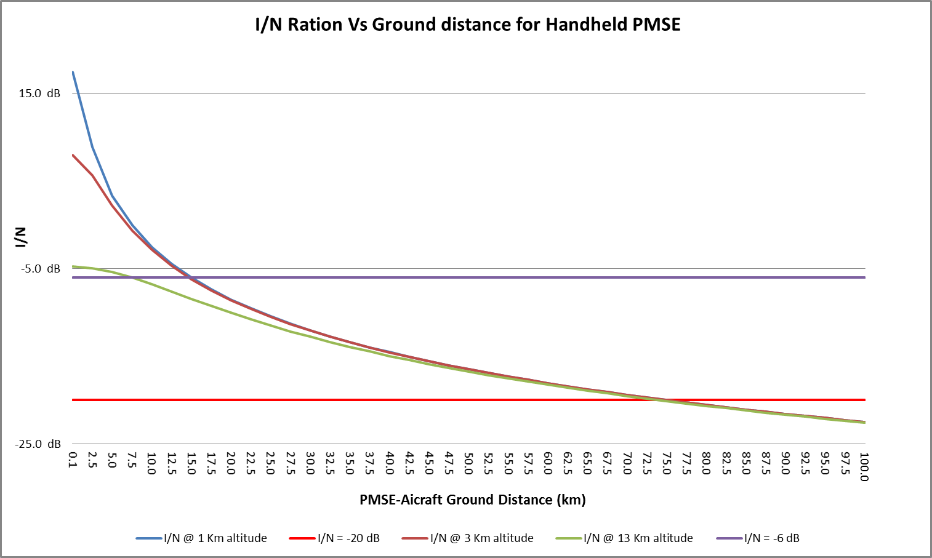
Figure 18: Results for Handheld PMSE with wall Loss = 6 dB

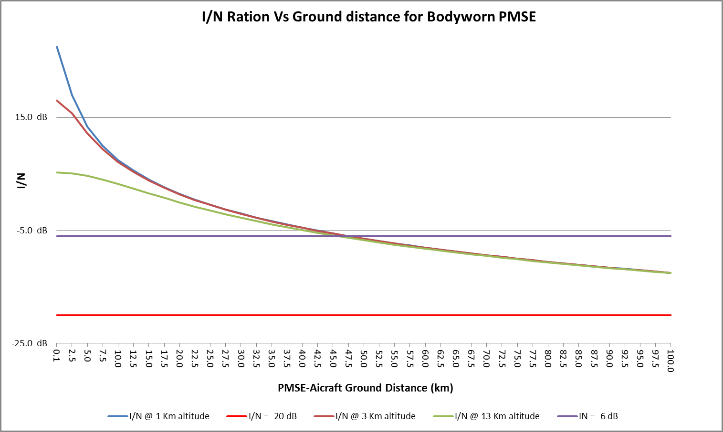
Figure 19: Results for Body Worn PMSE with wall Loss = 6 dB
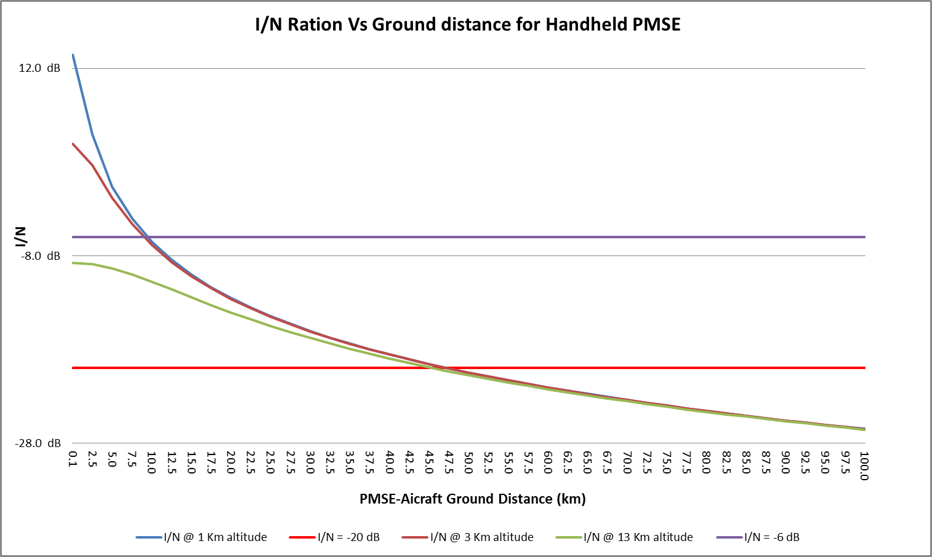
Figure 20: Results for Handheld PMSE with wall Loss = 10 dB

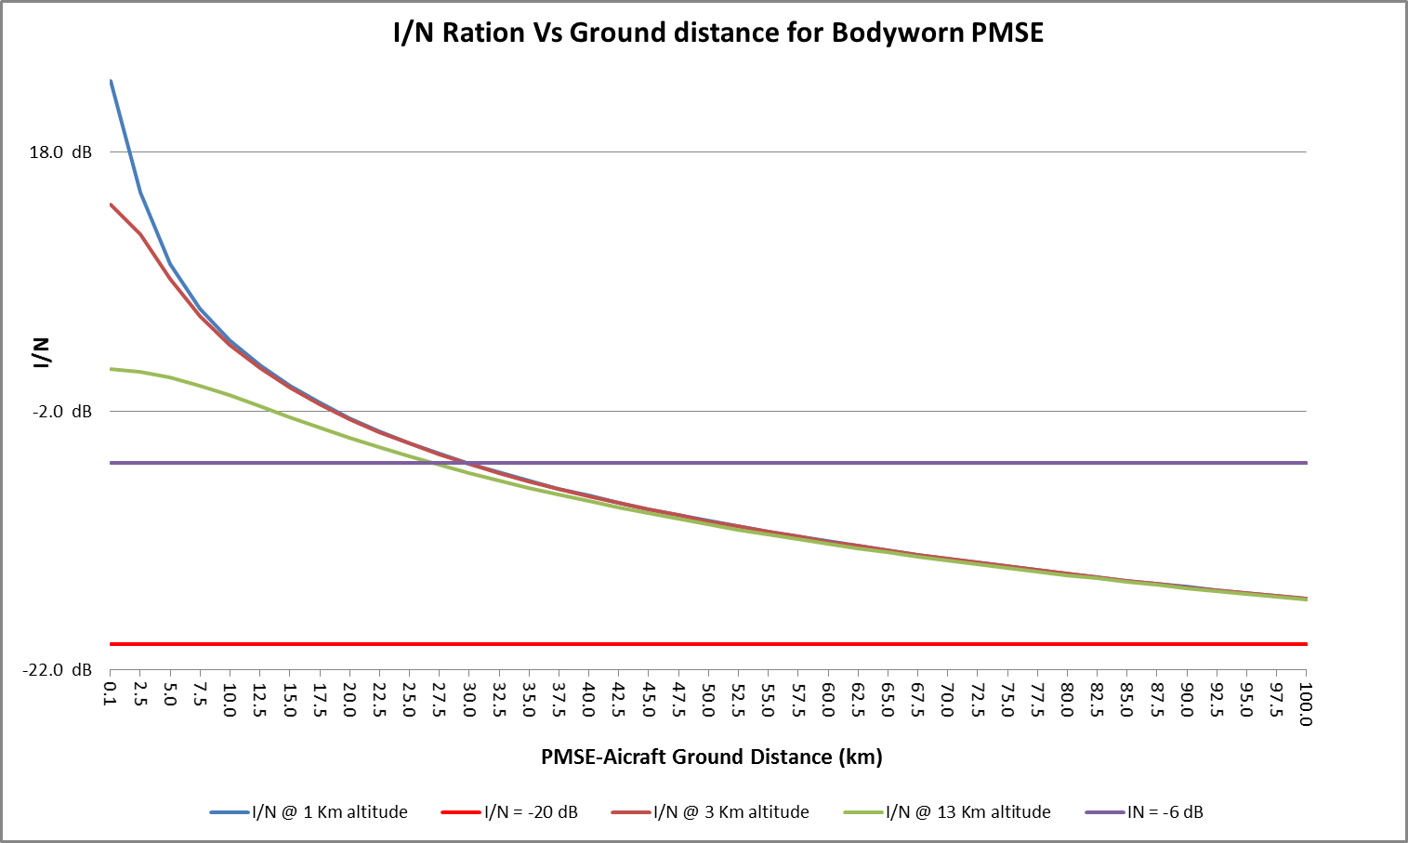
Figure 21: Results for Body Worn PMSE with wall Loss = 10 dB
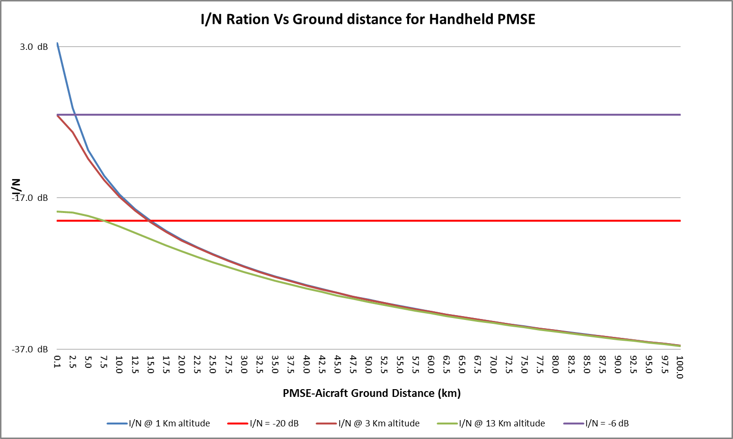
Figure 22: Results for Handheld PMSE with wall Loss = 20 dB

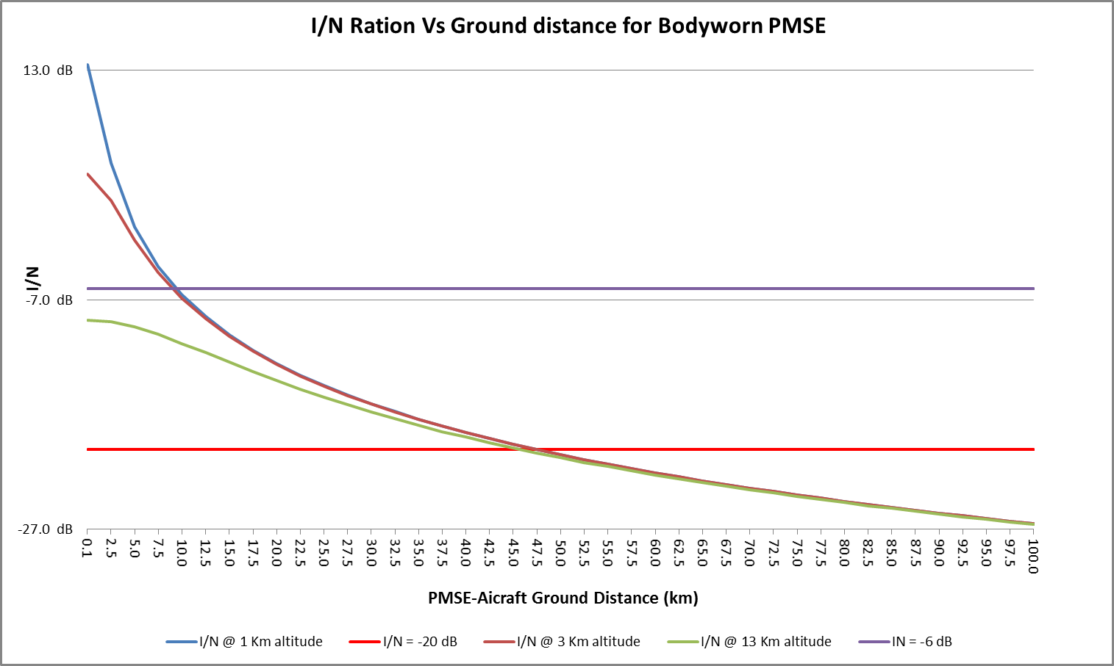
Figure 23: Results for Body Worn PMSE with wall Loss = 20 dB
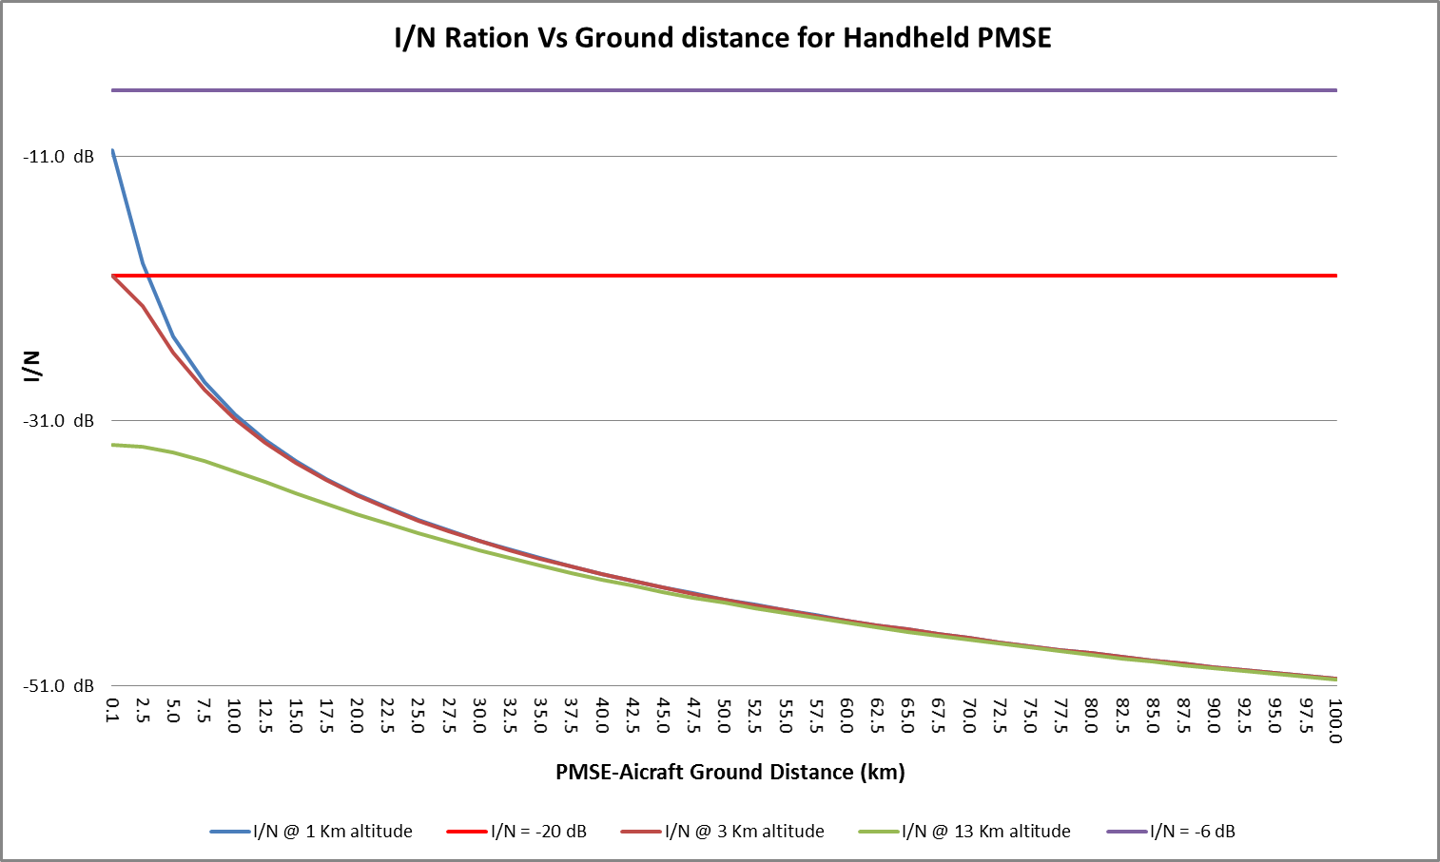
Figure 24: Results for Handheld PMSE with wall Loss = 34 dB

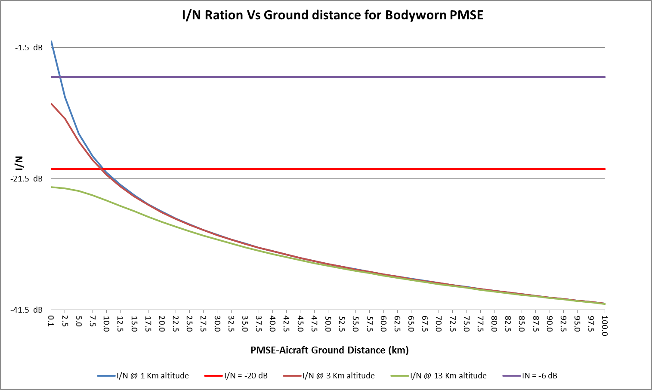
Figure 25: Results for Body Worn PMSE with wall Loss = 34 dB

Mobile Satellite Service impact on audio PMSE
Example below shows an analysis of calculations of impact of MSS downlink into PMSE receiver. Parameters of victim and interfering systems presented in Table 69 and Table 70.
Table 69: Assumed PMSE (wireless microphone) parameters
PMSE link parameters
Frequency | 1518 MHz
Reception Bandwidth (B) | 200 kHz
Antenna gain | Omni 0 dBi
Noise Figure, dB | 3 dB
Noise PWMS dBW (N)  (kTB) (with T = 300 K) (200 kHz) | -147.8 dBW
Interference threshold dBW in 200 kHz | -147.8 dBW

For the Inmarsat range of services, the e.i.r.p from the MSS satellite is dependent on the particular service but the current maximum value is about 49 dBW in a bandwidth of 200 kHz. The maximum p.f.d. on the ground is therefore about -114 dBW/m² in 200 kHz. Typical values are given below.

Table 70: Typical MSS power levels - Inmarsat Carrier Parameters
Carrier Type |  | Max e.i.r.p. *  dBW | BW  kHz
GAN | Inmarsat-3 | 31.3 | 60
BGAN | Inmarsat-4 | 44.8 | 200
Hand-held | Inmarsat-4 | 43 | 50
* Typical operational beam peak levels
Table 71: Received power (200 kHz receiver)
Received power
Frequency | 1518 MHz
Typical e.i.r.p | 44.8 dBW
Slant Range to Satellite | 40000 km
Spreading loss | 163.0
Typical PFD, dBW/(m² MHz) | -118.2
Received power λ²/(4(π)) | -25.1 dB
Bandwidth factor (1 MHz to 200 kHz) | 7 dB
Received Interference dBW 200 kHz (outdoor) | -150.2 dBW
Wall attenuation | 6 dB; 10 dB ;20 dB ;34 dB
Received Interference dBW 200 kHz (indoor) | -156.2 dBW (6 dB); -160.2 dBW (10 dB);  -170.2 dBW (20 dB); -184.2 dBW (34 dB)

From the above calculations, it appears that the MSS transmission will not cause interference to audio PMSE devices (more than 8 dB margin). It should be noted that those calculations did not consider the polarisation of the two systems, resulting in additional margin.

Summary of considerations for the audio PMSE and MSS compatibility at 1518-1525 MHz
There is no harmful interference from the MSS downlinks to audio PMSE systems used indoor.
With regard to potential interference from audio PMSE devices to land based MSS systems, simulations have shown that the probability of interference to MES is highly dependent on the density of audio PMSE operations in any given area and the assumed wall loss and body loss values. See Section 4.1.3 for audio PMSE densities.
When considering potential interference to land based MESs, administrations would need to ensure that the density of audio PMSE operations within a given area does remain sufficiently low, in order not to cause unacceptable interference to MESs.
With regard to potential interference from audio PMSE devices to airborne MSS systems, MCL calculations have shown that the risk of interference to aircraft MES is highly dependent on assumed wall loss and body loss values and on aircraft height. Depending on the assumptions used in the studies, in some cases the interference criteria are exceeded, whereas in other cases they are not.

Conclusions
This ECC Report was originally intended to investigate the compatibility between wireless microphones and others systems in the frequency ranges 1492-1518 MHz and 1518-1525 MHz. These studies were initiated to investigate how wider adoption of audio PMSE (Programme Making and Special Events) amongst CEPT member states for these bands could be achieved.
This report considered only body worn, handheld and IEM (In-Ear-Monitoring) audio PMSE transmitters. Floor tripod and table tripod operations are not considered in the study. Audio PMSE devices are assumed to be limited to indoor only operation and to operate under a licensing regime.
Co-channel sharing between the fixed service - coordinated and wireless microphones is feasible with the separation distances given in the Table 72 below. For guard bands >1 MHz, there will be no interference to the Fixed Service.
With regard to the Fixed Service uncoordinated, there is an acceptable risk of interference in case of handheld/body worn equipment. The risk of interference is more significant in case of IEM devices when considering the more stringent interference criterion (I/N = -20 dB).
In case of TRR (Tactical Radio Relay), the risk of interference is low for the body worn, hand held equipment and IEM, therefore, there is no need to implement mitigation techniques if the audio PMSE systems are deployed only indoors.
Separation distances could be implemented in order to ensure the compatibility between the Aeronautical Telemetry and audio PMSE.
ECC/DEC/(13)03 [1] states that “CEPT administrations shall designate the frequency band 1452-1492 MHz to MFCN SDL…” and since WRC-15 the frequency bands 1427-1452 MHz and 1492-1518 MHz are identified for IMT for all three Regions. Given that the band 1492-1518 MHz is expected to be used by CEPT countries for IMT, sharing studies between PMSE and IMT within 1492-1518 MHz are not considered in this report.
Compatibility studies between audio PMSE above 1518 MHz and IMT below 1518 MHz (adjacent band compatibility) have shown that handheld audio PMSE creates slightly higher probability of interference into LTE UE than body worn audio PMSE due to higher emission levels (considering body loss). The probability of interference differs depending on the separation between the audio PMSE and LTE equipment. Some methods to reduce the interference is to specify a minimum physical separation between victim and interferer or to keep a frequency offset above 1518 MHz to reduce the unwanted emissions as well as blocking impact. In addition, an e.i.r.p. limit would also reduce the blocking effect and the definition of a block edge mask would limit the unwanted emissions impact.
The implementation of a possible guard band for IMT and MSS (Mobile Satellite Service) compatibility was not considered in this study.
There is no harmful interference from the MSS downlinks to audio PMSE systems.
With regard to potential interference from audio PMSE devices to land based MSS systems, simulations have shown that the probability of interference to MES (Mobile Earth Station) is dependent on the density of audio PMSE operations in any given area and the assumed wall loss and body loss values. See Section 4.1.3 for audio PMSE densities.
Therefore, administrations should consider the density of audio PMSE deployment within a given area when assessing interference into MESs. However, some administrations do allow PMSE and other services to share in the band 1517-1525 MHz, e.g. as outlined in Annex 3.
With regard to potential interference from audio PMSE devices to airborne MSS systems, MCL (Minimum Coupling Loss) calculations have shown that the risk of interference to aircraft MES is dependent on assumed wall loss and body loss values and on aircraft height.
The following table provides an overview of the sharing conditions.
Table 72: Overview of the sharing conditions
Service | Body worn / Hand held | IEM
IMT (downlink)  (1492-1518 MHz) 2 | For audio PMSE within 1518-1525 MHz, define minimum physical separation between LTE UE and audio PMSE or to keep a frequency offset above 1518 MHz, or to limit the maximum e.i.r.p. and define a block edge mask | For audio PMSE within 1518-1525 MHz, define minimum physical separation between LTE UE and audio PMSE or to keep a frequency offset above 1518 MHz, or to limit the maximum e.i.r.p. and define a block edge mask
Fixed Service – coordinated  (1492-1525 MHz)  (Note 1) | Co-channel separation distances  Main lobe: 20 km  Side lobe: 1 km  For guard bands >1 MHz, there will be no interference to the Fixed Service | Co-channel separation distances  Main lobe: 21 km  Side lobe: of 2.5 km  For guard bands >1 MHz, there will be no interference to the Fixed Service
Fixed Service – uncoordinated  (1492-1525 MHz)  (Note 1) | No mitigation techniques required | Mitigation techniques may be needed on a national basis depending on the sensitivity of the systems
Mobile Service – TRR  (1492-1525 MHz) | No mitigation techniques required | No mitigation techniques required
Aeronautical Telemetry  (1492-1525 MHz) | Separation distance of 3 km.  Exact frequencies used by Aeronautical systems are not known therefore a guard band cannot be considered | Separation distances of 5 km.  Exact frequencies used by Aeronautical systems are not known therefore a guard band cannot be considered
MSS (s-E)  (1518-1525 MHz) | For sharing with respect to Land MES: Feasibility of sharing depends on typical audio PMSE density and deployment conditions as specified in section 4.1.3.  For sharing with respect to aeronautical MESs: Feasibility of sharing depends on assumptions regarding key parameters such as building penetration loss and aircraft altitude. No firm conclusions are drawn in this Report. See section 5.6.3 | Not considered
Note 1: Co-channel sharing between the Fixed Service and wireless microphones at the same geographical location would be problematic because of the disruptive effect on the wireless microphone receivers from the Fixed Service signals. The implementation of a scanning procedure to identify the parts of spectrum which are in use by other transmitter(s) and the parts of the spectrum, which are available for successful audio PMSE operation will reduce the risk of interference between audio PMSE operations and Fixed Service systems.

- Audio PMSE Body loss
A simulation study which examines the body loss effect on wireless microphones as a function of the frequency, the type of microphone, and the size of the human body has been carried out by the IT'IS (Information Technology In Society) foundation of the ETHZ and financed by OFCOM (CH):
E. Cabot and M. H. Capstick, "The effect of the human body on wireless microphone transmission," IT'IS Foundation, Zürich, July 2015.
The links to the report and presentation can be found on the following web page of OFCOM (CH):
https://www.bakom.admin.ch/bakom/en/homepage/frequencies-and-antennas/facts-and-figures/the-effect-of-the-human-body-on-wireless-microphone-transmission.html
(The following information in this Annex is reproduced from Annex 1 of the ECC Report 245 [23], January 2016).
  - Introduction
Bands in the frequency range 1350 to 1400 MHz have been studied for the compatibility of audio PMSE usage with a number of primary services. For this investigation the body loss parameter is an important characteristic. This summarizes information that has been obtained from CEPT and ITU documents.
  - Explanation of the term body loss
The term “body loss” refers to the additional radiation losses as a result of the microphone antenna being in the vicinity of the body and to the equipment mismatch. It is measured using as a reference the power radiated by an ideal dipole when connected to a transmitter of equal power to the PMSE device. This effect is greater for body worn microphones compared with hand held microphones as the antenna is just a few millimetres from the body.
  - PMSE wireless microphone operation
Based on feedback from the PMSE community PMSE wireless microphone operations can be split into the following use-case scenarios:
- 60% body-worn operation;
- 25% hand-held operation;
- 14% floor tripod close to the user's body; (not studied in this report);
- 1% table tripod (not studied in this report).

These live situation pictures represent typical audio PMSE use.

Figure 26: Hand-held (left), body-worn (middle) and tripod (right) operated devices

When an audio PMSE device is used without body contact, for example by performing artists, speakers at conventions etc, the body loss for such a scenario can intuitively be expected to be lower than for the handheld or the body worn scenario.
  - Summary of existing information on PMSE body loss
The ERC REPORT 42 [24] and its successor CEPT Report 30 [25] show body loss plots.
Body loss for hand held devices: 8dB | Body loss for body-worn devices: 18dB
Figure 27: Body loss
Note: ERC Report 42 refers to 650 MHz and CEPT Report 30 to 800 MHz.
    - Anechoic Chamber Measurements of Cobham Technical Services
In 2009 Cobham presented the results of measurement undertaken for Ofcom UK in a West End Theatre to evaluate the loss on a transmitted signal from a belt-pack PMSE transmitter.
This picture refers to the results in ERC Report 42 [24] identified by Cobham:
Figure 28: Polar plot of body loss as a function of angle measured inside an anechoic chamber

“The results performed under ideal conditions in the anechoic chamber suggest body loss values of 22 to 25 dB along the main vertical axis. These results are similar to that shown in ERC Report 42 for a transmitter operating at a frequency of 650 MHz.”
    - Conclusion
Changes in frequency significantly change the body loss, thus one cannot transfer this results to 1350-1525 MHz. Therefore, additional information will be provided on the following pages.
    - Median body loss
Section 6.2 of Recommendation ITU-R P.1406-1 [26] summarises:
"The presence of the human body in the field surrounding a portable transceiver, cellular phone, or paging receiver can degrade the effective antenna performance ;the closer the antenna to the body the greater the degradation. The effect is also frequency dependent as shown in Fig. 2, which is based on a recent detailed study on portable transceivers at four commonly used frequencies.”
    - Measurements of German DKE provided in 2012 and 2015 PMSE measurements
Several measurements were taken in a shielded and reflection-free test chamber and present frequency-depended body absorption effect for PMSE. The PMSE equipment was operated on a rotary plate. The distance from PMSE to the test lab receiver antenna was 3m. The device under test (DUT) was first operated fixed to a Styrofoam block and later mounted on a man- representing a practical application.
      - Test at 800 MHz
Unmounted hand held transmitter 800 MHz (P=30mW)
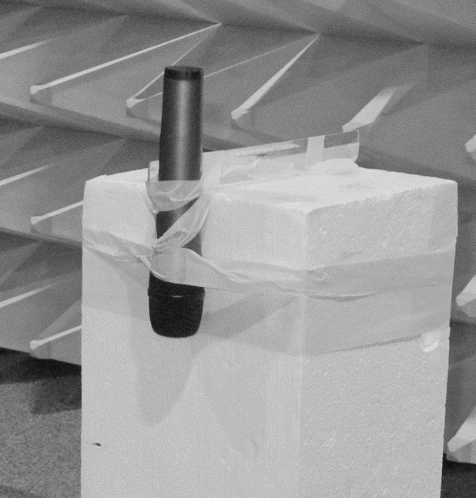 | 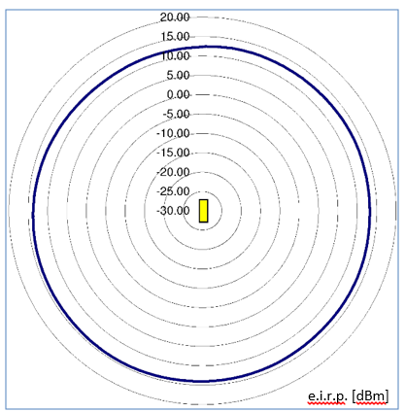
Figure 29:device under test at Styrofoam block | Figure 30:polar pattern of radiated device power
Note: This test scenario is also shown in Figure 8 by the long-dashed line circle

Hand held transmitter 800 MHz (P=30mW)
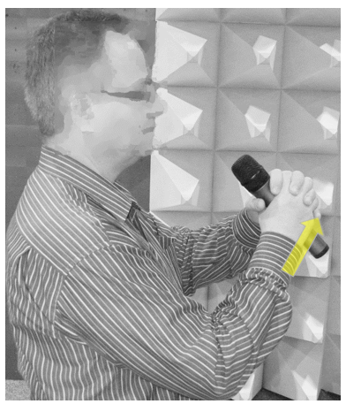 | 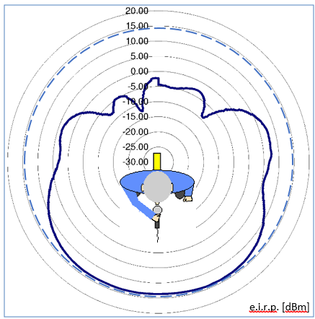
Figure 31: Hand held device under test | Figure 32: Polar pattern of radiated device power

Body-worn transmitter 800 MHz (P=30mW)
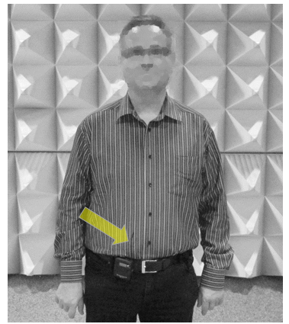 | 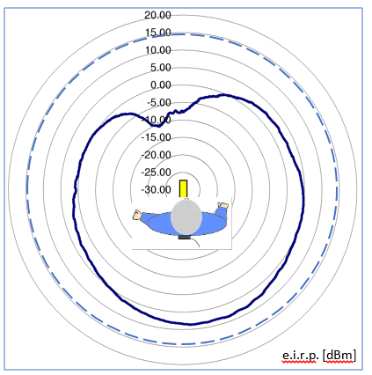
Figure 33: Device under test at human body | Figure 34: Polar pattern of radiated device power

      - Test at 1800 MHz
Unmounted hand held transmitter 1800 MHz (P=10mW)
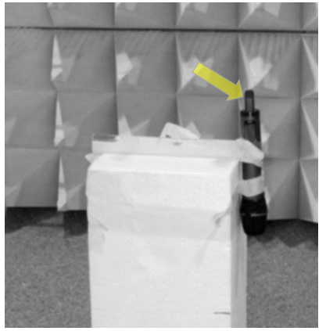 | 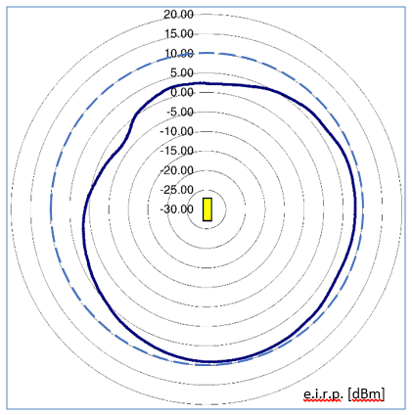
Figure 35: Device under test at Styrofoam block | Figure 36: Polar pattern of radiated power
Note: Each object in the immediate neighbourhood influences the radiation, which includes the Styrofoam block.
Hand held transmitter 1800 MHz (P=10mW)
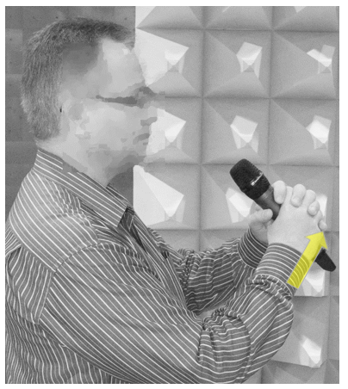 | 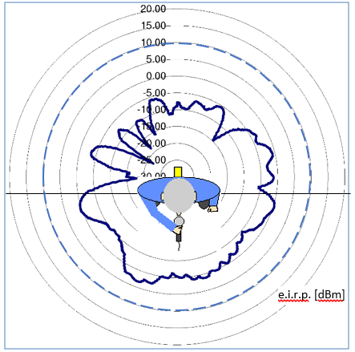
Figure 37: Hand held device under test | Figure 38: Polar pattern of radiated power

Unmounted body worn transmitter 1800 MHz (P=10mW)
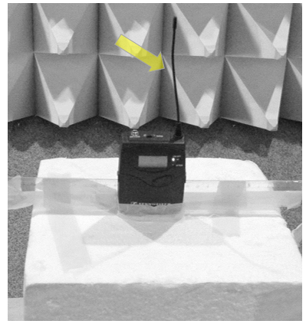 | 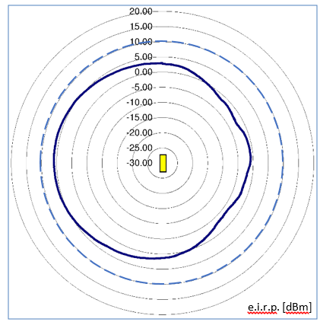
Figure 39: Device under test at Styrofoam block | Figure 40: Polar pattern of radiated device power
Body worn transmitter 1800 MHz (P=10mW)
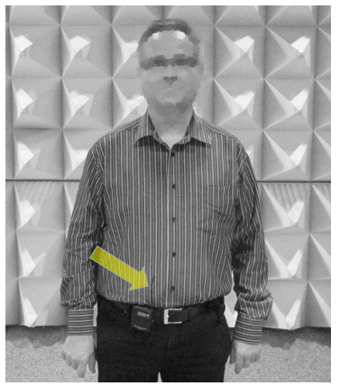 | 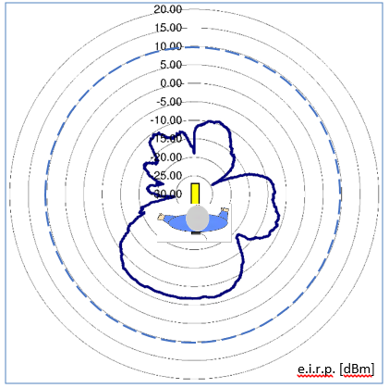
Figure 41: Device under test at human body | Figure 42: Polar pattern of radiated device power

      - Limitation of these Audio PMSE measurements
Each Audio PMSE unit has a different antenna characteristic. The short audio PMSE antenna does not represent the gain of a standard dipole. Therefore the DUT on a Styrofoam block has limited suitability as a reference. Although the hand-held and body-worn measurements show real-live scenarios if compared with a standard dipole antenna would lead to higher body absorption results.
Different Audio PMSE mounting positions on the human body will lead to different results. Best-case or worst-case assessments were not the subject of these tests.
The test was carried out with devices from just one manufacturer.
      - Test output parameter for the minimum body loss effect of PMSE
The following graphics show the test lab measurement of the receiver input power provided by a fixed measurement antenna. This level is dependent on the rotary plate angle. The distance from PMSE transmitter to the test lab receiver antenna was 3 m. The device under test (DUT) was first operated fixed to a Styrofoam block and later mounted on a man in a practical application position.
PMSE operated at 800 MHz
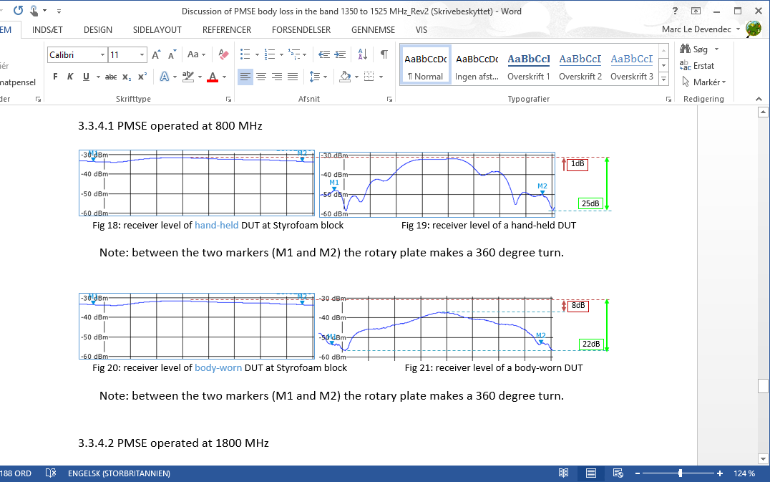
Figure 43: Receiver level of hand-held DUT at Styrofoam block | Figure 44: Receiver level of a hand-held DUT
Note: Between the two markers (M1 and M2) the rotary plate makes a 360 degree turn.

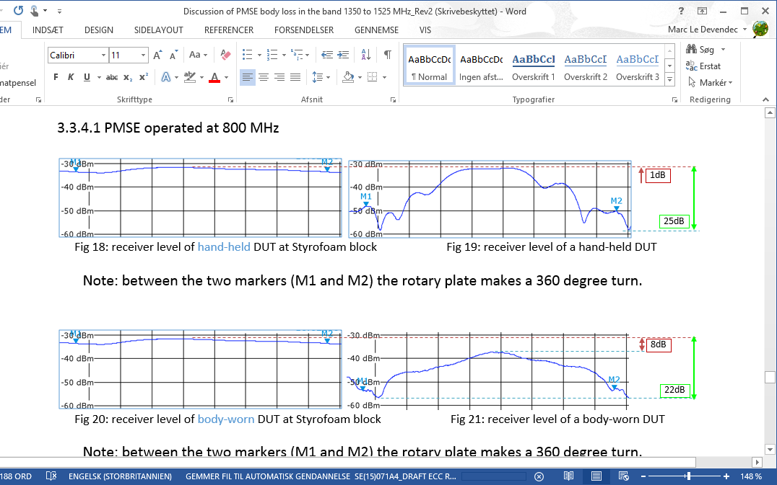
Figure 45: Receiver level of body-worn DUT at Styrofoam block | Figure 46: Receiver level of a body-worn DUT
Note: Between the two markers (M1 and M2) the rotary plate makes a 360 degree turn.

Audio PMSE operated at 1800 MHz
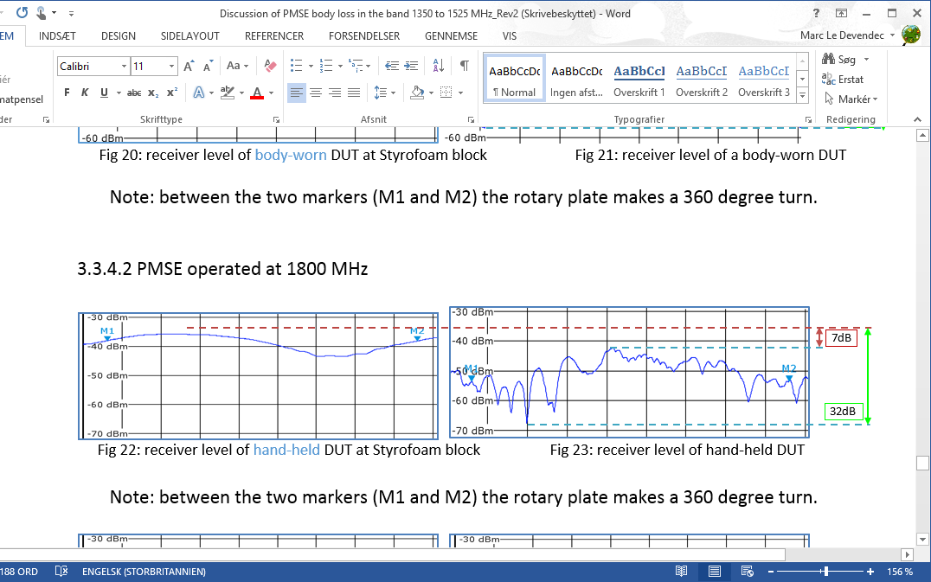
Figure 47: Receiver level of hand-held DUT at Styrofoam block | Figure 48: Receiver level of hand-held DUT
Note: Between the two markers (M1 and M2) the rotary plate makes a 360 degree turn.

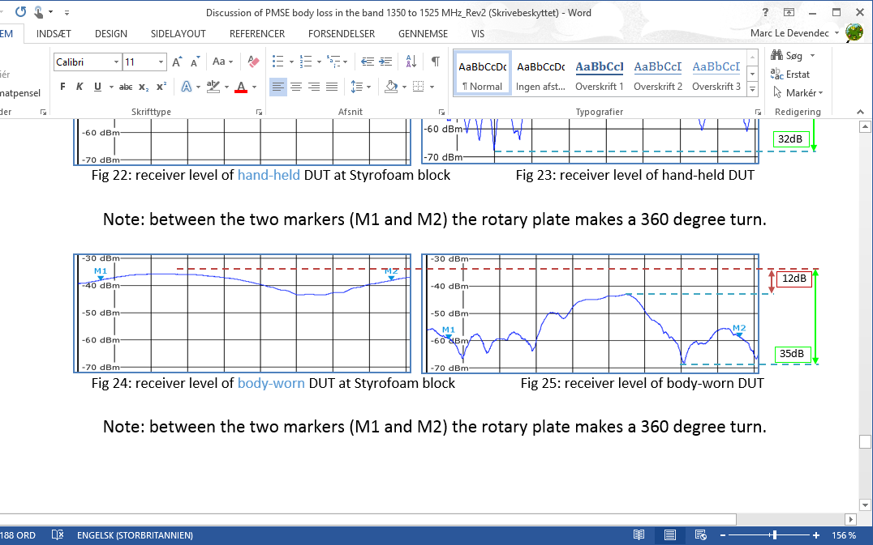
Figure 49: Receiver level of body-worn DUT at Styrofoam block | Figure 50: Receiver level of body-worn DUT
Note: Between the two markers (M1 and M2) the rotary plate makes a 360 degree turn.
    - Median body loss effect of PMSE
      - Result transfer to 1350-1525 MHz of minimum body loss effect of PMSE
Because Recommendation ITU-R P.1406 [26] is referring to median values of body loss we present a similar information in the table and the graphic below. The median value for PMSE body loss was calculated from test lab receiver measurement:
Table 73: Median value for PMSE body loss
PMSE use form | Median body loss effect
 | 800 MHz | 1800 MHz
Hand-held | 9.7 | 12.3
Body-worn | 15.7 | 21.6
  - Measurement of the radiated power of 1455 MHz body-worn PMSE
    - Purpose of measurement
Expanding on previous measurement at 800 and 1800 MHz body loss by DKE in 2012.
Additional information on frequency dependant effect of body absorption.
    - Measurement setup
The lab test was carried out in the EMC test chamber of Sennheiser Electronic at Wedemark (D):
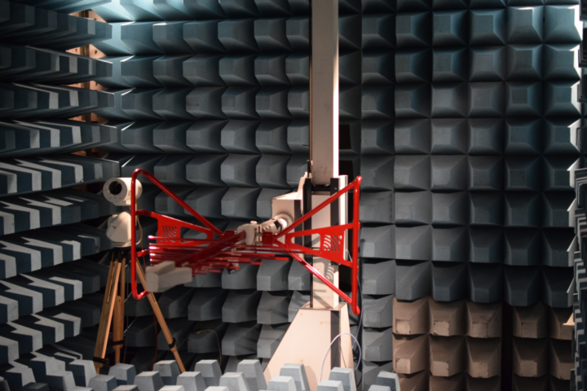
Figure 51: Test setup
    - Reference Dipole measurement
A typical wide-band dipole (SBA 9119, see Figure 52) was mounted in the non-anechoic test chamber, placed on a wooden rotating test platform. Radiated RF power was measured at different antenna heights of 1.1 m and 1.5 m and show a significant effect of mounting position.

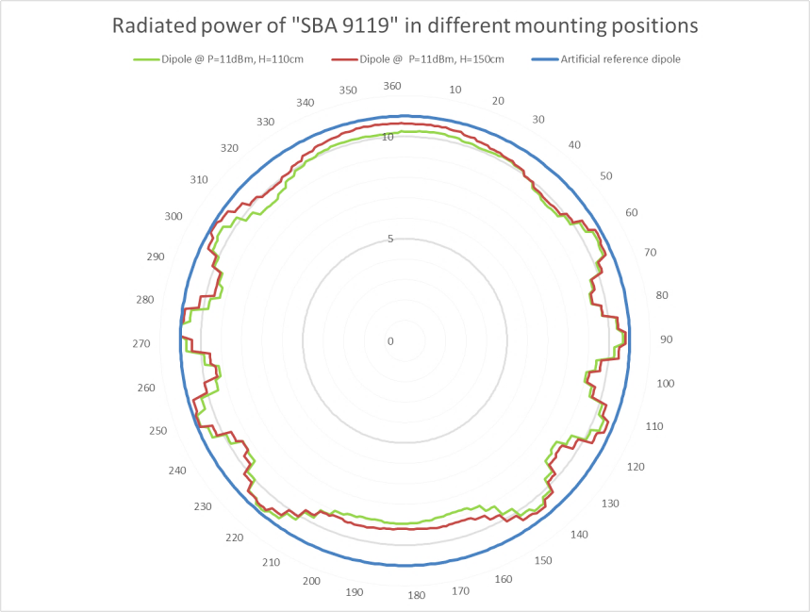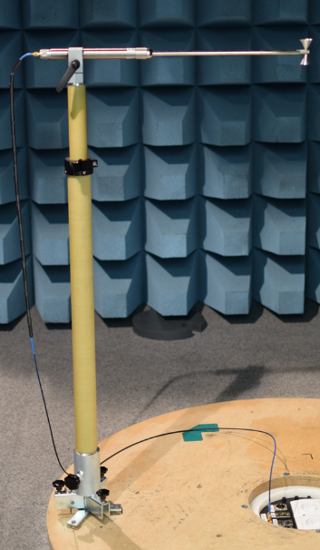
Figure 52: Radiated power of typical wide band dipole
    - Body-worn transmitter in free space
Body-word PMSE devices are optimised for maximum radiated power when close to the human body. Without the body effect and due to the incorrectly matched antenna the 10 mW test transmitter radiates a significantly lower RF field:
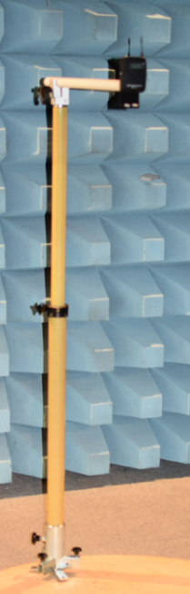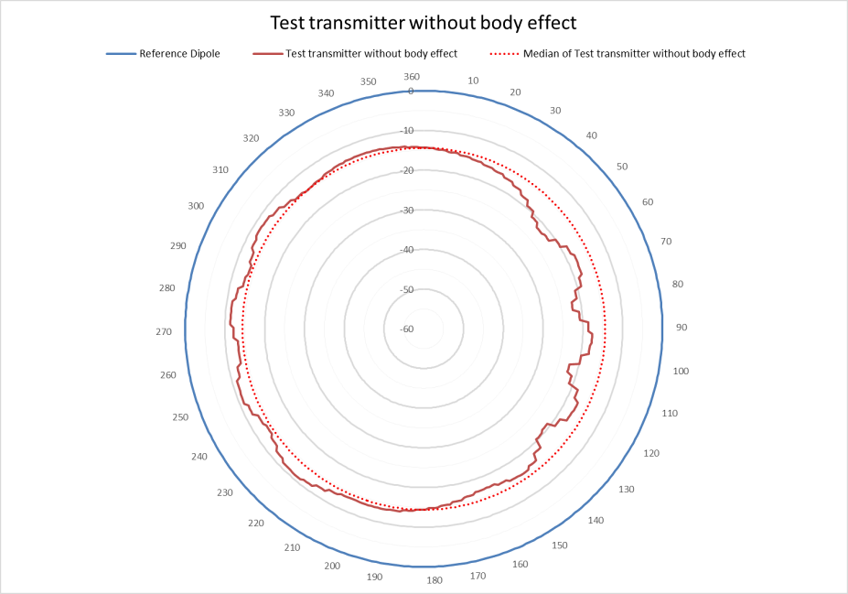
Figure 53: Test transmitter without body effect
The well-known vertical antenna characteristic is almost round. The real scenario differs from it, also in this test. This can be seen above in the graph of RF attenuation distribution and compares with the reference dipole measurement. The diagram unbalance mainly arise from the test transceiver design and the laboratory fastening.
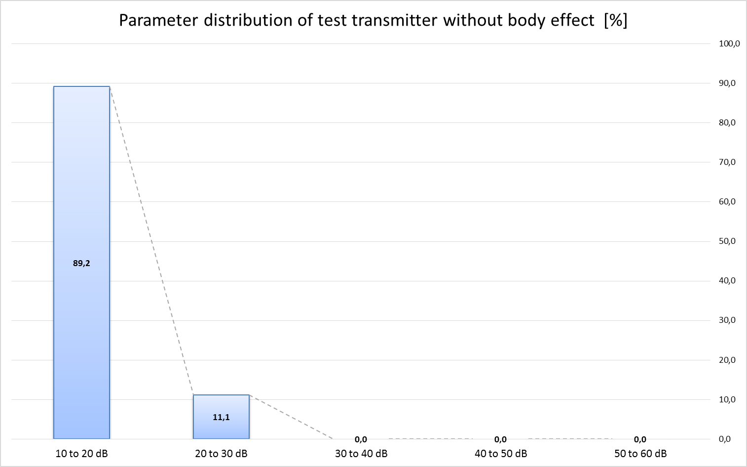
Figure 54: Parameter distribution of test transmitter without body effect
    - Body-worn transmitter
The test transmitter was mounted on a male and female test subject in two positions: on the front and then on the back.
      - Test transceiver mounted in body position on male test subject
PMSE device can be fixed on different position on the human body. In this scenario a typical body position was choose. Section A1.5.7 discusses the body effect in a symmetrical mounting position.

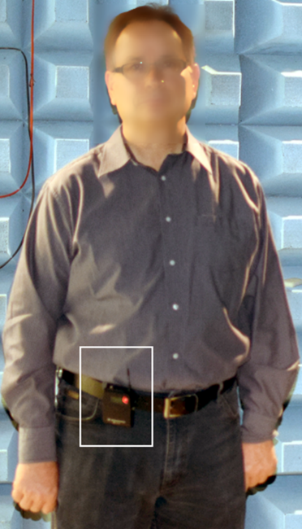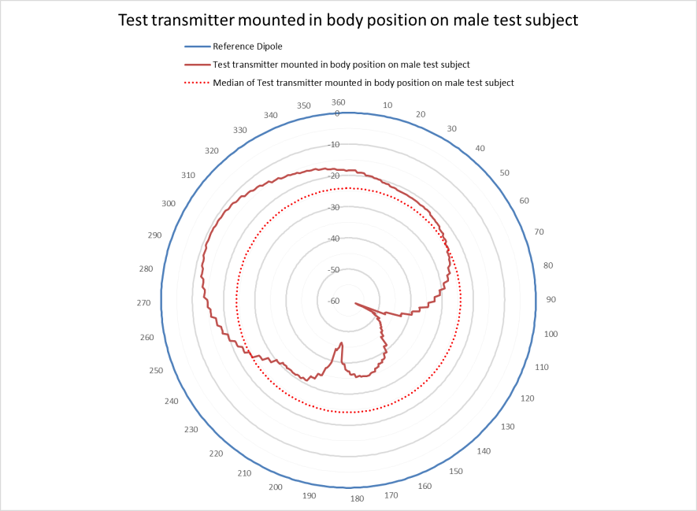
Figure 55: Test transmitter in body position on male test subject
The body absorption has a significant effect on the antenna polar diagram. This is also clearly shown in the graph of body loss parameter distribution.
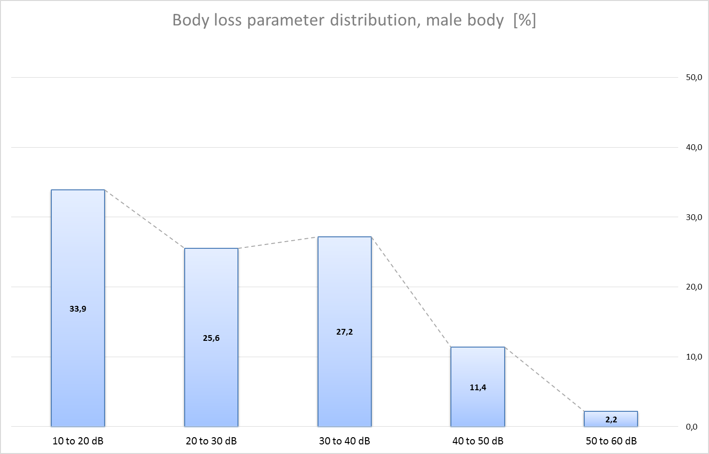
Figure 56: Body loss parameter distribution (male body)
Summary of variance of measured body attenuation

Min= 11 dB / Max= 58 dB / Delta= 47 dB / Median= 24 dB / Mean= 27 dB

Note: All results were rounded on integer numbers.
      - Test transceiver mounted on body position of female test subject
PMSE device can be fixed on different position at human body. In this scenario typical body position was choose. Section A1.5.6 discusses the body effect/absorption in a symmetrical mounting position.
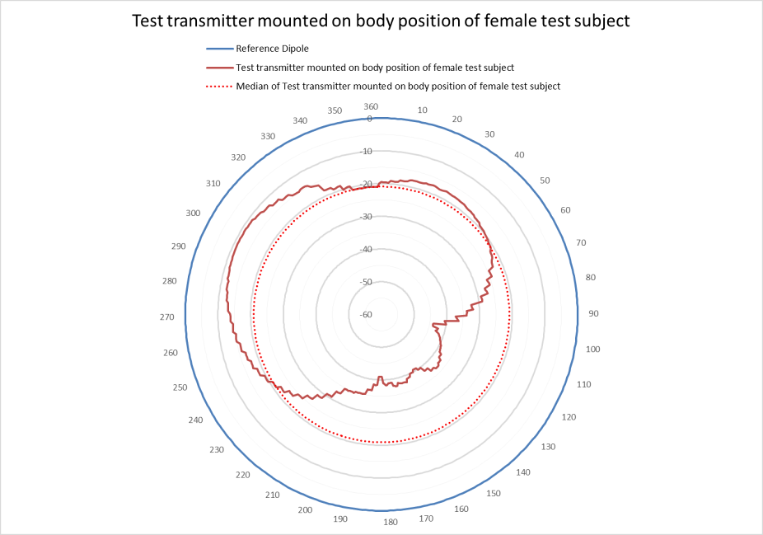
Figure 57: Test transmitter in body position on female test subject
The body absorption has a significant effect on the antenna polar diagram. This is also clearly shown in the graph of body absorption parameter distribution:
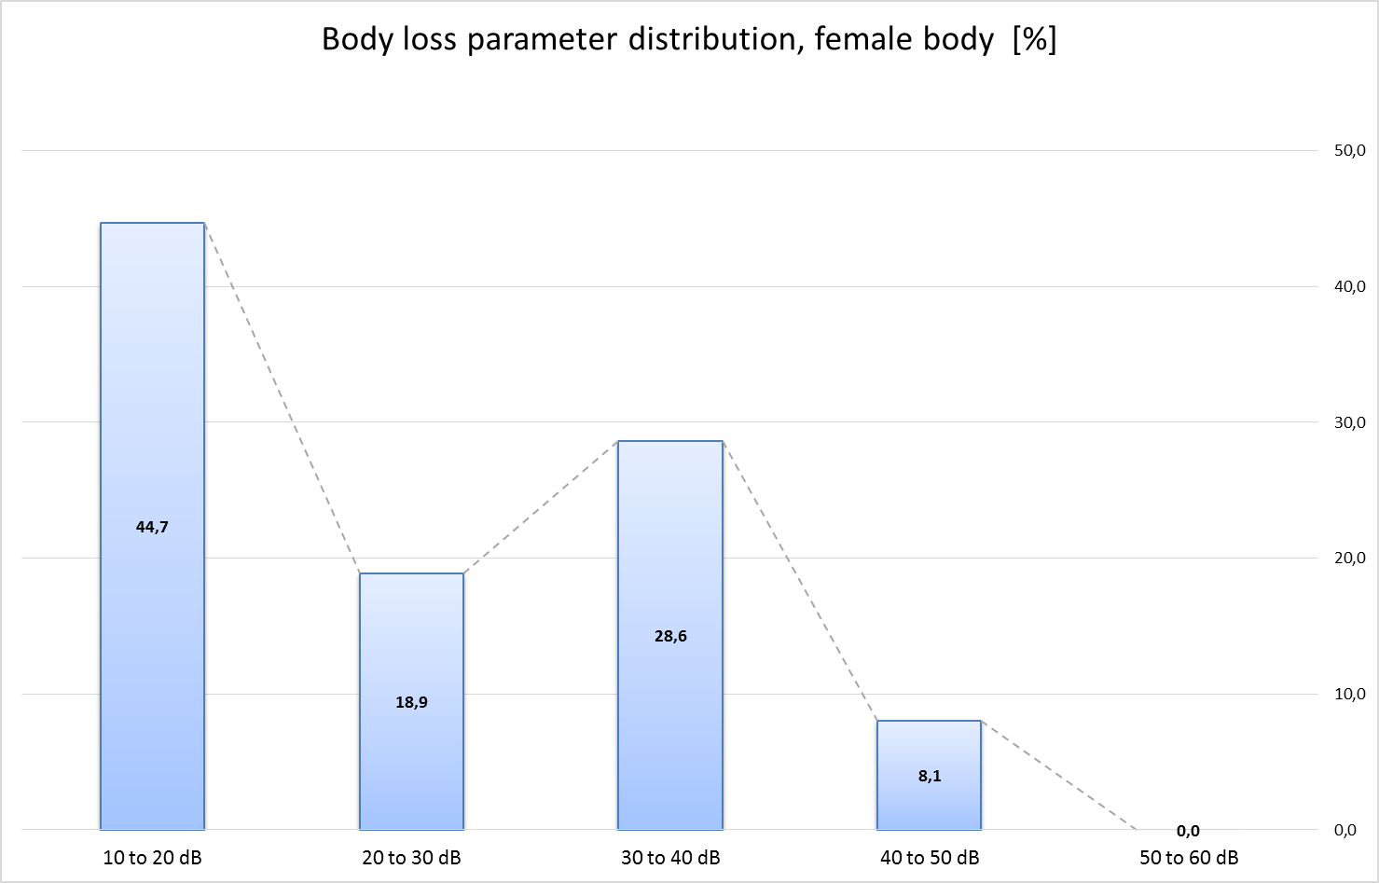
Figure 58: Body loss parameter distribution (female body)
Summary of variance of measured body attenuation

Min= 11 dB / Max= 44 dB / Delta= 33 dB / Median= 21 dB / Mean= 25 dB

Note: All results were rounded on integer numbers.
      - Test transceiver mounted in back position of male test subject
In general a PMSE device can be fixed on different position at human body. In this scenario typical back position was choose. Section A1.5.6 discusses the body effect in a symmetrical mounting position.

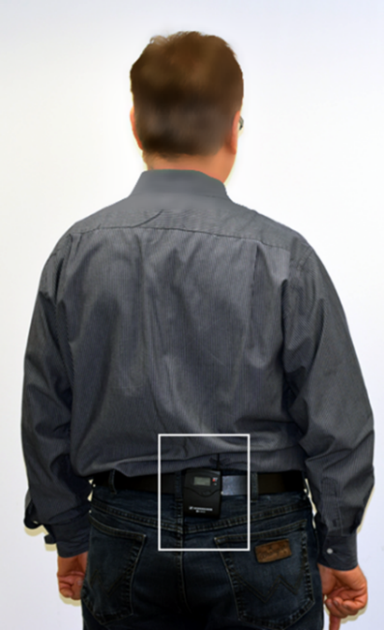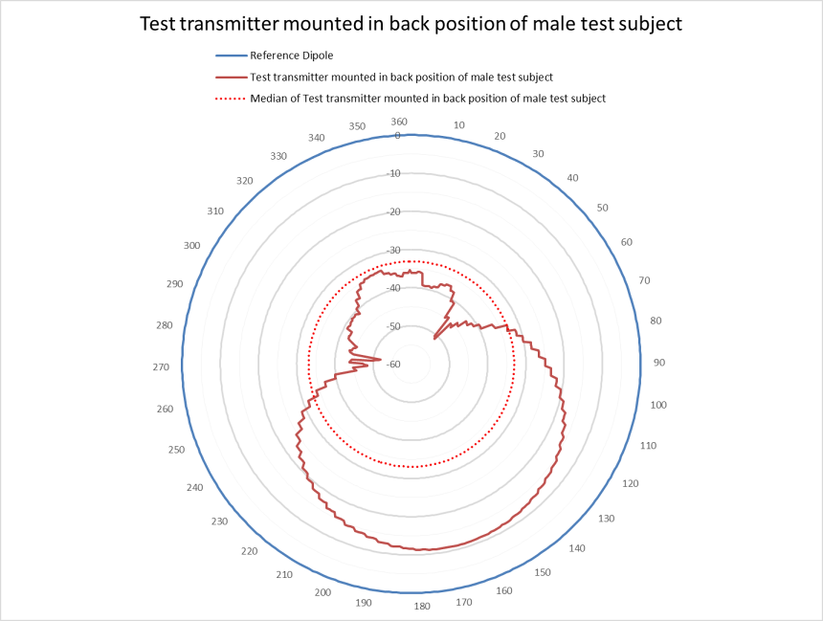
Figure 59: Test transmitter mounted in back position of male test subject
The body absorption has a significant effect on the antenna polar diagram. This is also clearly shown in the graph of body loss parameter distribution:
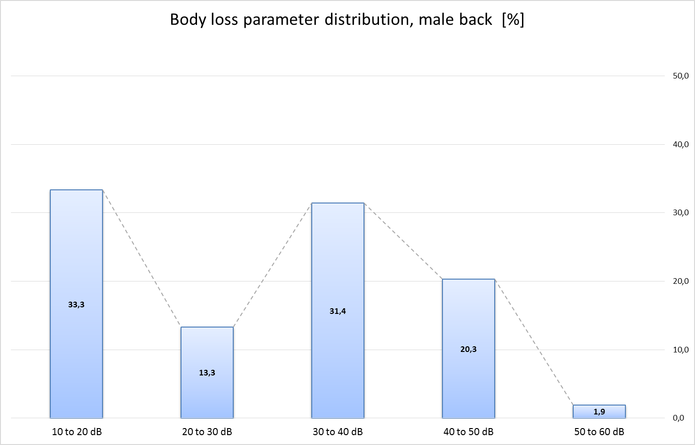
Figure 60: Body loss parameter distribution (male back)
Summary of variance of measured body attenuation
Min= 11 dB / Max= 52 dB / Delta= 41 dB / Median= 33 dB / Mean= 29 dB
Note: All results were rounded on integer numbers.
      - Test transceiver mounted in back position of female test subject
In general a PMSE device can be fixed on different position at human body. In this scenario typical back position was choose. Section A1.5.6 discusses the body effect in a symmetrical mounting position.
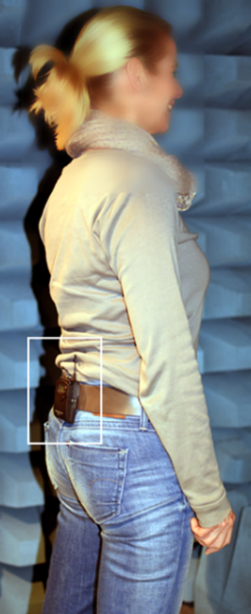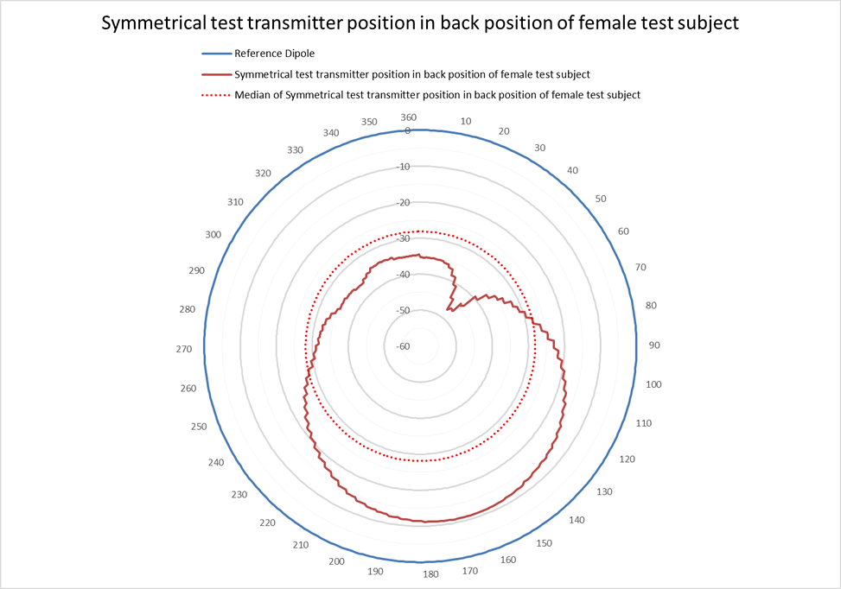
Figure 61: Test transmitter mounted in back position of female test subject
The body absorption has a significant effect on the antenna polar diagram. This is also clearly shown in the graph of body loss parameter distribution:
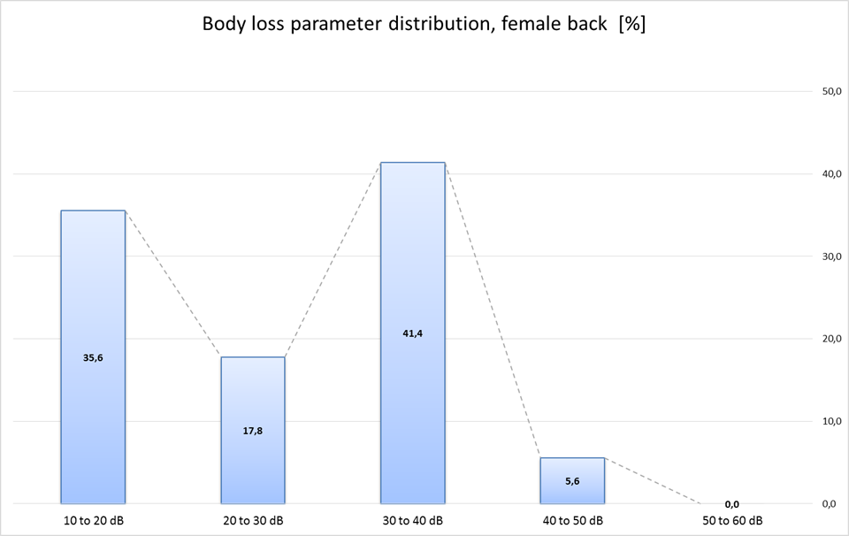
Figure 62: Body loss parameter distribution (female back)
Summary of variance of measured body attenuation
Min= 11 dB / Max= 47 dB / Delta= 36 dB / Median= 28 dB / Mean= 26 dB
Note: All results were rounded on integer numbers.
      - Summary table of all measured body absorption values
In practice the measured body loss absorption is used for different purposes:
Maximum values are used for compatibility assessments.
Median and maximum body absorption values are used to estimate the safe frequency and physical separation for the required production quality.
Note: the median and mean values are used in a number of study groups, e.g. for CEPT SEAMCAT calculations.
Table 74: Summary of measured data
Test case | Section | Min (dB) | Max (dB) | Delta (dB) | Median (dB) | Mean (dB)
Male test subject - body | 5.1 | 11 | 58 | 47 | 24 | 27
Female test subject - body | 5.2 | 11 | 44 | 33 | 21 | 25
Male test subject - back | 5.3 | 11 | 52 | 41 | 33 | 29
Female test subject - back | 5.4 | 11 | 47 | 36 | 28 | 26
Amplitude of variation | -- | about 11 | 44 to 58 | 33 to 47 | 21 to 33 | 25 to 29
Note: All results were rounded on integer numbers.
    - Discussion of asymmetries in the radiated power
In section A1.5.4 and A1.5.5, we noted unsymmetrical radiation characteristics. For clarification additional tests were carried out with a test transceiver position in the centre on human body.

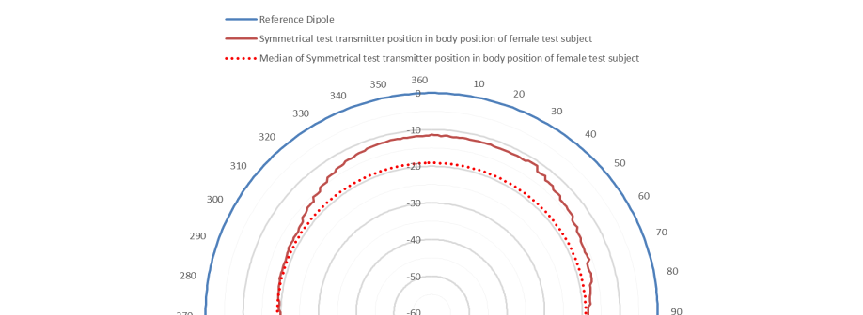

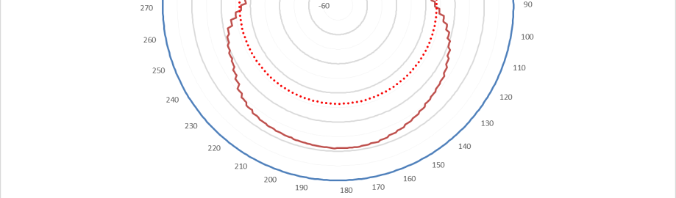
Figure 63: Asymmetries in the radiated power
    - Summary
The results of this lab test show significant body effect on body-worn audio PMSE, the scenarios are presented in sections A1.5.4 to A1.5.6. In every scenario the minimum body absorption exceeds 11 dB @ 1455 MHz (see the “Min” row in Table 74). The test results distribution shows that in 43 to 66 % of all directions the body absorption exceeds 20 dB.
The median body absorption measured was typically 26 dB (see the “Median” row in Table 74). The maximum measured body absorption, up to 58 dB, represents in worst-case a very high body effect in this frequency band.
      - Hand-held audio PMSE
Figure 64: Minimum and median body loss effect of hand-held PMSE
      - Body-worn audio PMSE
Figure 65: Minimum and median body loss effect of body-worn PMSE
  - Conclusion
It is suggested the following body loss values for simulations in the band from 1350 to 1525 MHz:
- Hand-held microphones: Minimum: 6 dB and Median: 11 dB;
- Body-worn microphones: Minimum: 11 dB and Median: 21 dB.
- Wall loss
(The following information in this Annex is reproduced from Annex 2 of the ECC Report 245 [23], January 2016:)
  - RF Insertion Loss in new and old building materials
New building materials such as walls and windows are improved with respect to thermal energy loss. Modern windows are coated with a thin metallic layer to improve indoor comfort in the summer and to prevent indoor thermal loss in the winter. This has a disadvantage with respect to insertion loss of incoming radio waves in the frequency area of 1 to 5 GHz.
To get some figures quantifying the problem a measurement program was initiated at CMI (Center for Communication, Media and Information Technology, Aalborg University) covering RF (radio frequency) measurements on new and old building materials. The purpose was to investigate the increasing problem of mobile telephone and internet communication in new buildings and to come up with some solutions to the problem.
The measurement setup is shown in Figure 66, using 2 horn antennas shown in Figure 67. Measuring S-parameters give accurate results for insertion loss and reflection coefficients. See Figure 68.
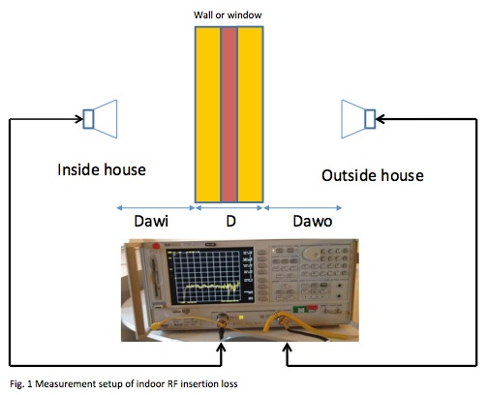
Figure 66: Measurement setup of indoor RF insertion loss
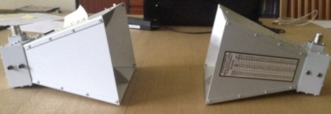
Figure 67: Horn antennas ensure a focused measurement beam reducing sorrounding reflections

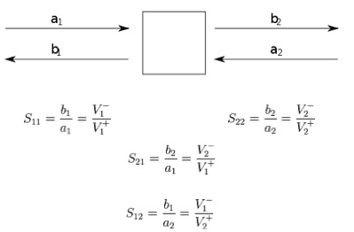
Figure 68: Definition of S parameters (S11 is the reflection coefficient and S22 is the insertion loss)
    - Measurements at Danish Building Information Centre
Measurements on new building materials were performed at “Middelfart Byggecenter” (Figure 69 shows a double coated glass window). The measurements showed a significant increase in penetration loss compared to old building materials.
Reference measurements of insertion loss without any building material inserted between the 2 horn antennas, was carried out initially (see Figure 70). To calculate the loss, this reference measurement was subtracted from all the measurements to give the real insertion loss of the building material. See Figure 71 and Figure 72.
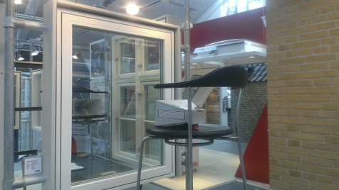
Figure 69: Measurement of the insertion Loss of a coated window at "Middelfart Bygge Centrum"

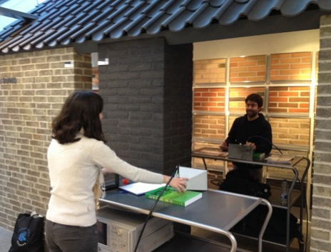
Figure 70: Measurement of the "reference Loss" without any material between the antennas
It can be seen on the Figure 72 (subtracting Figure 71) that a new double coated window has an insertion loss from 26 dB to - 35 dB in the frequency interval 1 GHz to 5 GHz. This should be compared to old uncoated windows which have an insertion loss of < 3 dB to 10 dB. Below is shown the insertion losses new and old building materials:
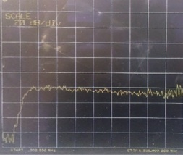 | 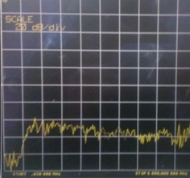
Figure 71: reference loss (air - no glass)  Range: 0.03 MHz to 6 GHz. Each grid section equals to: horizontally 600 MHz, vertically 20 dB | Figure 72: Insertion Loss of a double coated window  Range: 0.03 MHz to 6 GHz. Each grid section equals to: horizontally 600 MHz, vertically 20 dB
    - Preliminary results
The values are different for different building materials and different frequencies. Below a table is presented showing the results of the measurements:
Table 75: Insertion losses of new and old building materials
Insertion Loss in Building Materials (dB) | 900 MHz | 2.4 GHz | 5 GHz
“Air”. Reference at 1m distance | 20 | 23 | 25
Single-glazed Window. Middelfart BC | 10 | 16 | 35
Double-glazed window with silver coating. Middlefart BC | 25 | 28 | 30
Double-glazed window with silver coating and one layer sun protection. Middlefart BC | 30 | 42 | 55
Double-glazed window with silver coating and two layer sun protection. Middlefart BC | 30 | 42 | 55
Triple-glazed window with silver coating. Middlefart BC | 20 | 20 | 25
Brick wall (two layers and empty space). Middlefart BC | 10 | 17 | 25
Brick wall (two layers & insulation space) Venstre Paradisvej 8. Opført 1966 | 10 | 10 | 20
Thermo glass door from 2010 connecting the kitchen and the garden | 20 | 20 | 25
Old thermos window from 1996 in the living room of Venstre Paradisvej 8 | < 3 | < 3 | 10

Looking at Table 75, it can be seen that new building materials adds an extra RF Loss penalty of 7 - 28 dB compared to old building materials.
From Table 75 we can see that new building material RF loss at 2.4 GHz, is in the range of 17 dB to 28 dB (55 dB when all windows are covered with sun shutters) compared to old building materials which exhibits a loss from <3dB to 10 dB at 2.4 GHz.
The problems increases at 5 GHz where the highest RF loss was measured to 35 dB ( 55 dB when all windows are covered with sun shutters). The biggest problem is the coated windows due to the thin conductor material applied to the window to prevent heat radiation in and out of the building. But also the building brick materials exhibit an increasing loss penalty of an extra 7 dB comparing new materials from Middelfart Bygge Center to bricks from 1966.
The literature reports RF attenuation values of 15 dB for armed concrete with a thickness of 26 mm and at a frequency of 2.3 GHz, and up to 35 dB for a thickness of 305 mm.
A final remark should be that buildings are not build of pure bricks or pure coated glass (even though new architects are very satisfied with glass), and therefore the RF attenuation in a building as a whole, would be something in between the range of 7 - 28 dB attenuation, depending on the number, material and thickness of internal walls and doors.

- Examples of PMSE and other services operating in the band 1517-1525 MHz
This Annex is only for information and care should be taken as this could provide a misleading picture of the use of frequencies in CEPT overall.
Similar information related to the services operating in the band 1492-1517 MHz has not been provided in this Report
  - Slovenia
Slovenia has point-to-point links for studio to transmitter links:

Preferable Frequency Band(s) : 1518-1530 MHz;
Bandwidth (typical) : modulation bandwidth 300 kHz, channel grid 500 kHz;
Modulation type (analogue or digital) : analogue FM.
  - Switzerland
Swiss Radio Interface Specification (fixed service, point-to-point radio links):
http://www.ofcomnet.ch/cgi-bin/rir.pl?id=0302;nb=03
  - United Kingdom
The frequency range 1518-1525 MHz is used for a range of outdoor PMSE link applications:
Bandwidths: 0.125 -6 MHz
RF Power: 1-20 dBW
Modulation: analogue and digital

- Audio PMSE density
For the purpose of the compatibility studies and in order to assess the impact of the density of audio PMSE, using the SEAMCAT analysis, different test areas were defined, ranging from 1 device in an area of 25 km radius to 1 device in an area of 1.7 km radius was considered in the urban environment. A single radius was considered in the rural case. This Annex provides information on how those radii were derived and information on the number of usable audio PMSE channels in the band 1518-1525 MHz.
  - Locations for audio PMSE usage
According to Wikipedia, there are 181 venues in London for which the use of audio PMSE devices can be expected (consisting of “West End Theatres”, “Outside the West End”, “Opera Houses”, and “Live Music Venues” and “Conference Venues”). Theatres in London close from time to time and other new theatres open, so this Wikipedia list is not 100% accurate. Nevertheless, it gives a good estimate of the number of potential locations for the operation of PMSE devices. TV studios are not included, despite being likely locations for PMSE devices. The area of Greater London is 1572 km², which gives an average of 1 location every 8.7 km². This is equivalent to an area with radius of 1.7 km.
In Rural areas, likely venues for PMSE are community centres and village halls. While there could also be open locations where PMSE could be deployed (e.g. open theatres, open air music venues, sporting events) but as it is expected that PMSE devices would be limited to indoor use only, such venues are not considered. The following tables give an indication of the possible density of PMSE locations in rural areas for the UK. There are estimated to be around 10,000 village halls in the England of which we estimate about 5% are in rural areas and may be potential regular users of wireless microphones.
Table 76: Possible density of PMSE locations in rural areas for the England
Parameter | Value
No of villages | 1000
Villages using PMSE | 5 %
No of locations of Rural PMSE | 500
Area of England (km²) | 130.395
km² per location | 260

Summarising the above, the assumed density of audio PMSE devices is the following:
Table 77: Assumed density of audio PMSE devices
 | Density of locations operating audio PMSE | Radius of test area for montecarlo analysis
Urban | 1/8.7 km² | 1.7 km
Rural | 1/260 km² | 9 km

While these figures are based on data for the UK, the density of use is not expected to be significantly different in other CEPT countries.
Moreover, a quick investigation (performed the 16th of March 2016) over some theatres provided in the list shows the following:
- Some venues are closed or open during summer time;
- Some venues have very limited actvities (i.e. no calendar providing a list of forthcoming events was found on the internet);
- Some places are not providing shows on a regular basis:
Landor theatre: performances the 13 March and 27 March;
Kenneth More theatre: performances 16-19 March, 26 March, nothing the remaining days up to 31st of March;
Oval House: performances 24 March, 29-30 March.

Among the list of theatres, some of them are providing regular performances during the day (Oval House, Puppet Theatre Barge), some of them “matinees” but only two days a week (for example Wednesday and Saturday starting at 14h00, 14h30 or 15h00 for about 2 hours show and one interval).
Most of the theatres are providing performances in the evening but with different starting times: 19h00, 19h30, 20h00, 20h30 (about 2 hours show and one interval).
Some of the theatres are closed on Sunday, some are closed both Sunday and Monday.
The list of “Opera Houses”, and “Live Music Venues” and “Conference Venues” were not investigated but it should be noted that the Jazz Café is closed up to May 2016.
  - Usable audio PMSE channels
Considering that the band 1518-1525 MHz provides 7 MHz spectrum, the audio PMSE channel bandwidth of 200 kHz could lead to up to 35 channels being available in this band. Information provided related to current use of audio PMSE devices in the UK indicates that a musical stage production will often need more than 50 channels for microphones, IEMs and intercom. Further, major TV productions have a peak demand of around 100 channels. As the worst case, it can be therefore assumed that all possible channels in this band would be used simultaneously, noting that other bands would also be required to meet the overall spectrum requirement.
It is understood that when multiple radio microphones are used, the high level of intermodulation products means that not all channels are usable (an efficiency of 1 MHz per radio microphone is mentioned in the Cambridge Consultants report). However, a trend towards the introduction of digital audio PMSE systems may reduce the impact of intermodulation issues, allowing greater spectrum efficiency in the future. Furthermore, the generation of intermodulation products on certain frequencies may also cause interference to MESs (whether the products are generated by the audio PMSE system or within the MES receiver). For these two reasons, an assumption that each 200 kHz channel is occupied at the audio PMSE location would give an upper estimate for the interference probability from audio PMSE to MSS.
However, audio PMSE requirements in the 7 MHz spectrum needs to be considered in conjunction with the existing available bands. Audio PMSE devices are expected to be deployed in the future in both the UHF (470-694 MHz, 823-832 MHz) and part of the L-band (1350-1400 MHz, 1518-1525 MHz,1785-1805 MHz). The UHF will still be the primary band for their usage.
The major factors explaining this assumption:
- The difference in cost between equipment currently deployed in the UHF band and equipment currently or to be deployed in the L band;
- The licensing regime which is proposed for the frequency range 1518-1525 MHz will be a burden for many of the audio PMSE users. For example, for smaller venues pubs and clubs, the licence exempt VHF and 863-865 MHz bands are available free of charge. Furthermore, the use of Channel 38 in the UK is the next best cost-effective choice for such venues as the equipment is readily available and will not be affected by the introduction of the 700 MHz band for mobile.
  - Conclusion
The density of active audio PMSE devices is expected to be low in the L band (1-2 active devices per MHz in a given area (10 km radius in urban area / 25 km radius in rural area) at a given time).
As it was not possible to resolve the different perspectives regarding the assumed density of PMSE devices, this Report examines the impact of different assumptions, in urban areas only, showing the impact of different densities on the results.
- LIST OF REFERENCE
- ECC Decision (13)03: on the harmonised use of the frequency band 1452-1492 MHz for Mobile/Fixed Communications Networks Supplemental Downlink (MFCN SDL), July 2015.
- ECC Report 121: Compatibility studies between Professional Wireless Microphone Systems (PWMS) and other services/systems in the bands 1452-1492 MHz, 1492-1530 MHz, 1533-1559 MHz also considering the services/systems in the adjacent bands (below 1452 MHz and above 1559 MHz), September 2008.
- ECC Report 202: Out-of-Band emission limits for Mobile/Fixed Communication Networks (MFCN) Supplemental Downlink (SDL) operating in the 1452-1492 MHz band, September 2013.
- ITU-R Resolution 223 (rev. WRC-15): Additional frequency bands identified for IMT, November 2015.
- ERC Recommendation 70-03: Relating to the use of Short Range Devices (SRD), September 2015.
- ECC Report 147: Additional compatibility studies relating to PWMS in the 1518.1559 MHz excluding the band 1543.45-1543.95 MHz and 1544-1545 MHz, May 2010.
- ETSI TR 102 546: Technical characteristics for Professional Wireless Microphone Systems (PWMS), 2007.
- ETSI EN 300 422 Wireless microphones in the 25 MHz to 3 GHz frequency range, 2008
- ITU-R Report M.2292-0: Characteristics of terrestrial IMT-Advanced systems for frequency sharing/interference analyses, 2013.
- ITU-R Report BT.2338: Services ancillary to broadcasting/services ancillary to programme making spectrum use in Region 1 and the implication of a co-primary allocation for the mobile service in the frequency band 694-790 MHz
- ITU-R Report P.2346-0: Compilation of measurement data relating to building entry loss, 2015.
- ERC Recommendation T/R 13-01: Preferred channel arrangements for fixed service systems operating in the frequency range 1-2.3 GHz, February 2010.
- Recommendation ITU-R F.758-0: System parameters and considerations in the development of criteria for sharing or compatibility between digital fixed wireless systems in the fixed service and systems in other services and other sources of interference, 2015.
- Recommendation ITU-R F.1245-2: Mathematical model of average and related radiation patterns for line-of-sight point-to-point fixed wireless system antennas for use in certain coordination studies and interference assessment in the frequency range from 1 GHz to about 70 GHz, 2012.
- Recommendation ITU-R M.1459-0: Protection criteria for telemetry systems in the aeronautical mobile service and mitigation techniques to facilitate sharing with geostationary broadcasting-satellite and mobile-satellite services in the frequency bands 1452-1525 MHz and 2 310-2 360 MHz, 2000.
- ECC Report 191: Adjacent band compatibility between MFCN and PMSE audio applications in the 1785-1805 MHz frequency range, September 2013.
- 3GPP TS 37.104: E-UTRA, UTRA and GSM/EDGE; Multi-Standard Radio (MSR) Base Station (BS) radio transmission and reception.
- 3GPP TR 36.942: Evolved Universal Terrestrial Radio Access (E-UTRA); Radio Frequency (RF) system scenarios.
- 3GPP TS 36.101: Evolved Universal Terrestrial Radio Access (E-UTRA); User Equipment (UE) radio transmission and reception.
- ECC Decision (04)09: on the designation of the bands 1518-1525 MHz and 1670-1675 MHz for the Mobile-Satellite Service, November 2004.
- Recommendation ITU-R P.452-16: Prediction procedure for the evaluation of interference between stations on the surface of the Earth at frequencies above about 0.1 GHz, 2015.
- Recommendation ITU-R P.1411-8: Propagation data and prediction methods for the planning of short-range outdoor radiocommunication systems and radio local area networks in the frequency range 300 MHz to 100 GHz, 2015.
- ECC Report 245: Compatibility studies between a PMSE and other systems / services in the band 1350-1400 MHz, January 2016.
- ERC Report 42: Handbook on radio equipment and systems radio microphones and simple wide band audio links, October 1996
- CEPT Report 30: The identification of common and minimal (least restrictive) technical conditions for 790 - 862 MHz for the digital dividend in the European Union, October 2009
- Recommendation ITU-R P.1406-1: Propagation effects relating to terrestrial land mobile and broadcasting services in the VHF and UHF bands, July 2015.
- Recommendation ITU-R M.828: Definition of availability for radiocommunication circuits in the mobile-satellite service
- Recommendation ITU-R M.1037: Bit error performance objectives for aeronautical mobile-satellite (R) service (AMS(R)S) radio link
- Recommendation ITU-R M.1180: Availability of communication circuits in the aeronautical mobile-satellite (R) services (AMS(R)S)
- Recommendation ITU-R M.1181: Minimum performance objectives for narrow-band digital channels using geostationary satellites to serve transportable and vehicular mobile earth stations in the 1-3 GHz range, not forming part of the ISDN
- Recommendation ITU-R M.1183: Permissible levels of interference in a digital channel of a geostationary network in mobile-satellite service in 1-3 GHz caused by other networks of this service and fixed-satellite service
- Recommendation ITU-R M.1228: Methodology for determining performance objectives for narrow-band channels in mobile satellite systems using geostationary satellites not forming part of the ISDN
- Recommendation ITU-R M.1229: Performance objectives for the digital aeronautical mobile-satellite service (AMSS) channels operating in the bands 1525 to 1559 MHz and 1626.5 to 1660.5 MHz not forming part of the ISDN
- Recommendation ITU-R M.1234: Permissible level of interference in a digital channel of a geostationary satellite network in the aeronautical mobile-satellite (R) service (AMS(R)S) in the bands 1545 to 1555 MHz and 1646.5 to 1656.5 MHz and its associated feeder links caused by other networks of this service and the fixed-satellite service
- Recommendation ITU-R M.1476: Performance objectives for narrow-band digital channels using geostationary satellites to serve transportable and mobile Earth stations in the 1-3 GHz range forming part of the integrated services digital network
- Recommendation ITU-R M.1636: Basic reference models and performance parameters of Internet Protocol packet network transmission in the mobile-satellite service
- Recommendation ITU-R F.1334: Protection criteria for systems in the fixed service sharing the same frequency bands in the 1 to 3 GHz range with the land mobile service

During the studies, the WRC-15 identified the band 1427-1518 MHz for IMT. Therefore, given the process of harmonisation of the 1427-1518 MHz band for MFCN, the frequency band 1492-1518 MHz may no longer be a long-term prospect for audio PMSE.
There are ongoing studies within CEPT considering a possible guard band between the IMT and the MSS. The implementation of a guard band within the IMT band will result in a reduction of the level of the unwanted emissions from PMSE operating above 1518 MHz on IMT systems.
The term “body loss” refers to the additional radiation losses as a result of the microphone antenna being in the vicinity of the body and to the equipment mismatch. It is measured using as a reference the power radiated by an ideal dipole when connected to a transmitter of equal power to the audio PMSE device. This effect is greater for body worn microphones compared with hand held microphones as the antenna is just a few millimetres from the body.
The values of body loss assumed in this Report for the body worn devices are based on measurements described in detail in ANNEX 1:.
It should be noted that the FS protection criteria may be different from country to country.
Pattern from Recommendation ITU-R F.1245 [14][14], max gain is reduced by 2.7 dB.
For coordination issues the provisions of the ITU RR 5.342 as well as of the Maastricht Special Arrangement 2002 as revised in Constanta 2007 should be applied.
Resulting protection distances are calculated using a dual slope free space model (20 log for distances up to 5 km and 40 log above) (see ECC Report 121)
Line of sight is calculated using: 3.57*(20 m)^0.5+3.57*(1,5 m)^0.5, the results is in km.
Line of sight is calculated using: 3.57*(20 m)^0.5+3.57*(2 m)^0.5, the results is in km.
Recommendation ITU-R F.1334 [37] and Recommendation ITU-R F. 758-5 [13].
Resulting protection distances are calculated using a dual slope free space model (20 log for distances up to 5 km and 40 log above) (see ECC Report 121).
Line of sight is calculated using: 3.57*(2 m)^{0.5}+3.57*(1,5 m)^{0.5}, the results is in km.
Taking into account of the clutter losses according to ITU-R P.452-14 [21].
During the studies, the WRC-15 identified the band 1427-1518 MHz for IMT. Therefore, given the process of harmonisation of the 1427-1518 MHz band for MFCN, the frequency band 1492-1518 MHz may no longer be a long-term prospect for audio PMSE.
There are ongoing studies within CEPT considering a possible guard band between the IMT and the MSS. The implementation of a guard band within the IMT band will result in a reduction of the level of the unwanted emissions from PMSE operating above 1518 MHz on IMT systems.
http://www.apwpt.org/downloads/dke_pmse_822mhz_1800mhz.pdf
https://en.wikipedia.org/wiki/List_of_London_venues

