ECC Report 228

Compatibility studies between Intelligent Transport Systems (ITS) in the band 5855-5925 MHz and other systems in adjacent bands
Approved 30 January 2015

Executive summary
In response to a request from ETSI to update the spectrum regulation for Intelligent Transport Systems (ITS) in the band 5855-5925 MHz (ETSI TR 103 083 [4]), compatibility studies were conducted between these systems and existing users based on the results of existing ECC Report 101 [5]. In addition to the assumptions used in ECC Report 101 the existing ETSI specification for the ITS system (ETSI EN 302 571 [17]) have been taken into account in this report. Especially the mitigation factors included in the actual ETSI standards for ITS like duty cycle limitations (Duty cycle in the range of 1% per hour with a peak of 3% per second used by CAM and DENM messages) and mitigation techniques defined in TS 102 792 [6] have been taken into account in this report. In addition the ETSI specifications related to the CAM messages [23] are relevant for the presented investigations.
Compatibility studies between the unwanted emissions of ITS and the following services/systems were conducted in this report:
- Road tolling systems between 5795 MHz and 5815 MHz;
- Fixed Service (point-to-point links above 5925 MHz).

ECC Report 101 and this report do not consider the ITS unwanted emissions impact on stations of fixed wireless access operating above 5925 MHz.
European Directive 2004/52/EC [31], and subsequent Decision 2009/750/EC [32] on the European Electronic Tolling Service consider two 5.8 GHz DSRC Tolling systems. This report only takes into consideration the CEN DSRC system according to EN 300 674 [29]. The tolling system according to ES 200674-1 [26] used in one country is not considered in this report.
No additional investigations for ITS as victim have been carried out in the scope of these study. Here the existing results in ECC Report 101 are regarded as sufficient.
In the following a summary of the compatibility investigations is given.
Road tolling (CEN DSRC)
ITS is assumed to be compatible with road tolling regarding unwanted emissions provided that it has an unwanted emission power between 5795 MHz and 5815 MHz of less than -45 dBm/MHz with some duty cycle restrictions to ITS messages:
- A maximum duty cycle of 1% in one hour and a maximum message length of 1 ms;
- In addition event-based emergency messages (e.g. DENM) with a peak duty cycle of maximum 2% in one second with a message duration of 2 ms length is acceptable by road tolling for a limited duration;
- Applications requiring higher duty cycles or higher unwanted emissions levels have to implement further mitigation techniques defined in the corresponding ETSI specifications [6].

Without mitigation techniques unwanted emissions of -65 dBm/MHz e.i.r.p truck installation and -60 dBm/MHz e.i.r.p for car installation at the ITS antenna would protect the RSU in all cases in the interference zone.
Fixed Service

The studies dealing with the impact of ITS unwanted emissions on the Fixed Service concluded that ITS unwanted emissions of -40 dBm/MHz e.i.r.p. are able to avoid harmful interference to the FS, when considering the recommended FS protection criterion from Recommendation ITU-R F.758 [27] of I/N -20 dB. A limit of -30 dBm/MHz e.i.r.p. may be sufficient to ensure the FS protection when considering FS antenna heights of 75m and above.
It has to be noted that the above conclusion is drawn based on some worst case assumptions, which if taken into account, can reduce the occurrence probability:
- the ITS emission in the direction of the FS receiver and at the location with a critical FS link.
- OOB and spurious emissions are very much time, location and frequency dependent; they are likely below the specification (see Figure 1). Also, the ITS systems use a power control mechanism with a dynamic range of 30 dB. That means the unwanted emissions are only at the maximum when the link requires the maximum power;
- Finally the ITS systems works typically with a duty cycle below 1% per second, whereas the study took into consideration a 100% duty cycle.
- FS Links are built with a certain margin to account for fading effects (e.g. see [30]).
Where the above mitigations are employed an unwanted emission limit of -30 dBm/MHz may be sufficient to avoid harmful interference to the Fixed Service.
The aggregated impact of ITS into FS has not been considered in this report. However, those aggregated scenarios are expected not to have a higher impact as the considered single entry calculations due to the Duty Cycle of ITS between 1 % and 3 %.

TABLE OF CONTENTS

0 Executive summary 2
1 Introduction 6
2 Description of ITS 7
2.1 Overview 7
2.2 Technical Characteristics 7
2.3 Propagation model 9
2.4 ITS Antennas 10
2.5 Receiver parameters 12
2.6 Typical ITS safety related applications 12
2.6.1 Overview 12
2.6.2 Workzone warning 14
2.6.3 Emergency vehicle approaching 15
2.6.4 Hazard warning with car-to-car communication 15
2.6.5 Pedestrian Activity Alert 15
2.7 Market penetration estimations 16
3 Compatibility between ITS and other services/systems 17
3.1 Introduction 17
3.2 Results from ECC report 101 17
3.3 Compatibility between ITS and road tolling in the band 5795 MHz to 5815 MHz 17
3.3.1 General considerations 17
3.3.2 Technical characteristics of CEN DSRC Road tolling Road Side Units (RSU) 18
3.3.2.1 RF characteristics 18
3.3.2.2 Antenna 19
3.3.3 Detailed MCL calculations - Interference zone 20
3.3.4 Road tolling Protocol (CEN DSRC) 24
3.3.5 Consideration of the Duty Cycle limitations for ITS 26
3.3.6 Conclusion CEN DSRC 30
3.4 Compatibility between ITS and FS in the band above 5925 MHz 31
3.4.1 General 31
3.4.2 Technical Characteristics of the FS 32
3.4.2.1 Overview 32
3.4.2.2 OCCUPIED SPECTRUM: 5925 - 6425 MHz 32
3.4.3 Impact of ITS on the FS - Study 1 (MCL) 33
3.4.4 Impact of ITS on the FS - Study 2 36
3.4.5 Summary of studies with the FS in the band above 5925 MHz 43
4 Conclusions 45
ANNEX 1: FS antenna height and link length 46
ANNEX 2: List of references 49

LIST OF ABBREVIATIONS

Abbreviation | Explanation
ACEA | Association des constructeurs Européens d'Automobiles
AF | Activity Factor
CEPT | European Conference of Postal and Telecommunications
CAM⁽¹⁾ | Cooperative Awareness Message
DENM⁽²⁾  DSRC | Decentralized Environmental Notification Message  Dedicated Short Range Communications
ECC | European Electronic Communications
e.i.r.p. | effective isotropic radiated power
ETSI | European Telecommunications Standards Institute
FCC | Federal Communications Commission
FS | Fixed Service
ITU | International Telecommunication Union
ITS | Intelligent Transport System
ITS-G5 | Intelligent Transport Systems operating in the 5GHz band
IVC | Inter-Vehicle-Communication
LBT | Listen Before Talk
MCL | Minimum Coupling Loss
OBU | On-Board Unit
OoB | Out Of Band emissions
P-MP | Point-to-Multipoint
P-P | Point-to-Point
PSD | Power Spectral Density
RL | Radiolocation Service
RSU | Road Side Units
RTTT | Road Transport and Traffic Telematics
R2V | Roadside-to-Vehicle Communications
SRD | Short Range Devices
TPC  V2V | Transmitter Power Control  Vehicle-to- Vehicle Communications
V2R | Vehicle-to-Roadside Communications
WAS/RLANs | Wireless Access Systems including Radio Local Area Networks
(1): | CAM: ITS facilities layer PDU (packet data unit) providing periodic ITS-Station status and attributes messages
(2) | DENM: ITS facilities layer PDU (packet data unit) providing event driven (mostly safety related) ITS-Station status and attributes messages

Introduction
This report is intended to analyse the compatibility between Intelligent Transport Systems (ITS) within the frequency band 5855-5925 MHz, in accordance with ETSI TR 103 083 [4] and road tolling in the band between 5795 MHz and 5815 MHz and Fixed service above 5925 MHz taking into account ITS system characteristics defined in the corresponded ETSI specification [6] [17] [23] . The report is intended as the basis for the review of the existing ITS regulation [1][2].
European Directive 2004/52/EC [31], and subsequent Decision 2009/750/EC [32] on the European Electronic Tolling Service consider two 5.8 GHz DSRC Tolling systems. This report only takes into consideration the CEN DSRC system according to EN 300 674 [29]. The tolling system according to ES 200674-1 [26] used in one country is not considered in this report.

Description of ITS

Overview
Various projects and groups have investigated a broad set of applications for Vehicle-to-Vehicle (V2V) and Vehicle-to-Roadside (V2R) Communications. Europe was pioneering the use of radio communications with the road tolling system at 5.8 GHz. The WLAN (IEEE 802.11-2012 [8]) technology, now available as a mass product, fulfils technical as well as business requirements. Therefore, radio communications systems in the 5 GHz range can today offer communications with a high data rate, ranges up to 1 000 m, low weather-dependence, and global compatibility and interoperability.

Technical Characteristics
Table 1: System parameter of ITS
Parameter | Value | Comments
Frequency ranges | 5875-5925 MHz according to ECC/DEC(08)01 [1]  5855-5875 MHz according to ECC/REC(08)01 [2]
Maximum radiated power (e.i.r.p.) | 33 dBm, 23 dBm/MHz with TPC of 30 dB | According to existing regulation [1][2]
Antenna beam shape/gain | For RSU and OBU  use antenna model  ITU-R F.1336-1 [12] with parameters G0 5 dB, k 1.2, max gain in +10 deg elevation. | See figure 2. In ECC Report 101 [5] there are 2 possible antennas, one very directional and one omnidirectional ITU-R F.1336-1.[12] However actual ITS systems development shows that the omnidirectional will be the dominant type and therefore only this should be used in these compatibility studies. There is a new version of models in ITU-R F.1336-1 [25], which should be used. Both versions 1 and 3 results in exactly the same antenna performance with these parameter settings.
Polarization | Vertical linear | The antenna performance is not described in ETSI ITS however the vertical linear polarization is dominant.
Modulation scheme | BPSK QPSK 16QAM 64QAM | According to ETSI EN 302 571 V1.2.1 (2013-09) [17] and ETSI EN 302 663 V1.2.1 (2013-07) [20]
Data rates | 3/4.5 /6/9/12/18 /24/27 Mbit/s Mandatory: 3/6/12 Mbit/s | According to ETSI EN 302 571 V1.2.1 (2013-09) [17] and ETSI EN 302 663 V1.2.1 (2013-07) [20]
Channel Bandwidth | 10 MHz | According to ETSI EN 302 571 V1.2.1 (2013-09) [17] and ETSI EN 302 663 V1.2.1 (2013-07) [20]
Communication mode | Half-duplex, broadcast | Half-duplex and broadcast are believed to be adequate for the applications considered to date.
Receiver noise power | -100 dBm | Typical performance, same value is used with the RLAN technology.
Receiver sensitivity | -92dBm/MHz | Based on -82 dBm for a bandwidth of 10 MHz. ETSI EN 302 571 V1.2.1 (2013-09) [17] specifies minimum required sensitivity.
Duty Cycle | Typically < 1.0% over one hour, maximum 3% in one second | The duty cycle of the ITS systems is under control of mandatory congestion control and dynamic message generation rules in order to guarantee an access to the channel for safety critical message.  The average duty cycle value of 1% over one hour is assumed for the periodic awareness messages (CAM) of an ITS station.  The peak value of 3% is assumed to be related to safety critical event based messages like DENM. In addition to the periodic CAM messages.  Higher duty cycle for specific application might be required in the future. The presented duty cycles are will cover the day one application requirements.
Additional Mitigation techniques | See ETSI TS 102 792 [6] | ETSI TS 102 792 defines a set of mitigation techniques to protect CEN DSRC tolling systems in the band 5795-5815 MHz. These techniques are mandatory included in the harmonised standard ETSI EN 302 571 [17]  In addition a specific message set has been specified in the CAM specification [23] which will allow for the protection of a tolling station.  Those additional mitigation techniques are not considered in this report.
Message length | Cooperative awareness messages (CAM): < 1ms  Decentralized Environmental Notification Message (DENM): < 2ms

Communication channels will be open for the applications within the respective usage category (either road safety related or not, i.e. used for traffic management). The required power levels (e.i.r.p.) range from 3 dBm to 33 dBm to achieve communication distances of up to 1000 m. To avoid collisions of radio messages in areas with a lot of vehicles, a DCC (distributed congestion control) mechanism in the ITS-G5 radios will, when necessary, reduce the output power level and the available time to transmit.
Specific mitigation techniques are already considered in order to protect the operation of CEN DSRC based road tolling systems in close vicinity (see above). These mechanisms are included in the relevant ETSI standards (e.g. ETSI EN 302 571). This report will analyse what the required unwanted limit with those mitigation techniques are.
Unwanted emission levels are given in ETSI EN 302 571 V1.2.1 (2013-09) [17] for the out of band domain and ITU-R Rec SM.329 [10] and ERC Recommendation 74-01 [11] for the spurious domain.
Table 2: Transmitter unwanted emission limits inside the 5 GHz ITS bands (e.i.r.p.)
Power spectral density at the carrier center fc (dBm/MHz) | ±4,5 MHz  Offset  (dBm/MHz) | ±5,0 MHz  Offset  (dBm/100kHz) | ±5,5 MHz  Offset  (dBm/100kHz) | ±10 MHz  Offset  (dBm/100kHz) | ±15 MHz  Offset  (dBm/100kHz)
23 | 23 | -13 | -19 | -27 | -37

In Figure 1 a typical TX spectrum of an actual ITS device operating in the band 5895 MHz to 5905 MHz is depicted. The existing spectrum mask is depicted in the figure as red line.
Figure 1: Typical measured TX spectrum of actual ITS device operating in the band 5895 MHz to 5905 MHz and existing ITS unwanted emissions limits

Propagation model
This report assumes for the Road Tolling studies (section 3.3) the free space loss model and for the Fixed Service Studies (section 3.4) the below three slope propagation model from ECC Report 68[13].
if (1)

Table 3: Parameters for the propagation model
 | Urban | Suburban | Rural
Breakpoint distance d₀ (m) | 64 | 128 | 256
Pathloss factor n₀ beyond the first break point | 3.8 | 3.3 | 2.8
Breakpoint distance d₁ (m) | 128 | 256 | 1024
Pathloss factor n₁ beyond the second breakpoint | 4.3 | 3.8 | 3.3

ITS Antennas
Three kinds of ITS devices are expected:
- OBU (On Board Unit): mobile ITS device mounted on a car;
- RSU (Road Side Unit): fixed ITS device placed on the ground;
- Portable ITS devices: Omnidirectional.

Examples of ITS antenna elevation pattern for the OBU and RSU are shown in figure 2.

Figure 2: Example for ITS OBU and RSU antenna patterns
In azimuth the RSU and OBU antennas are having normally an omni-directional pattern.
Figure 3 shows a typical OBU antenna fixed on the vehicle roof. It can be seen that the antenna patter has it highest gain at an elevation angle of around 10° to 15° above the plain. At an angle of 20° and more the antenna gain is already around 8dB lower than at the main beam.

Figure 3: Example of a commercially developed antenna pattern

For the compatibility studies with road tolling the antenna pattern specified in Recommendation ITU-R F.1336 [12] has been used. The expression of antenna gain in dBi at elevation angle θ in degrees is given by:

(2)
with
(3)
(4)

where:
θ: absolute value of the elevation angle relative to the angle of maximum gain (degrees)
θ ₃: the 3 dB beamwidth in the vertical plane (degrees)
k= 1.2 the sidelobe factor

The relationship between the gain (dBi) and the 3 dB beamwidth in the elevation plane (degrees) is:
for omni-directional antenna (5)

There are commercially developed, roof mount antennas for the US DSRC spectrum from 5850-5925 MHz. Figure 7 shows how such an antenna is fixed on the vehicle roof. The antenna pattern for this assembly is shown in Figure 6. The Omni-directionality is fully achieved and the elevation beam peak is near 10°.
The figure below shows an existing typical antenna pattern compared with the antenna pattern recommended by ITU-R F.1336 [12] with k=1.2 as a relevant side lobe factor.
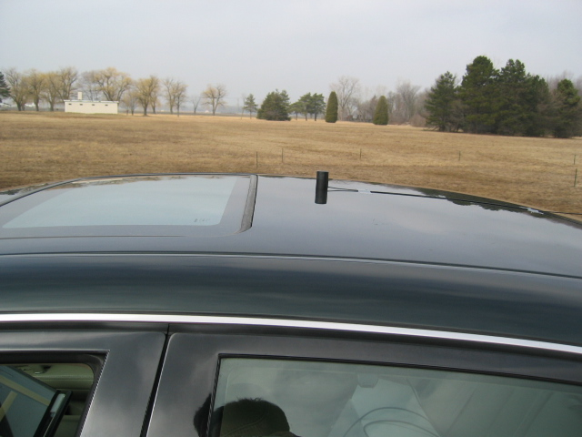
Figure 4: Ground-plane radio antenna with magnet roof mount (left side) and antenna pattern

Receiver parameters
In the scope of this report no ITS receiver parameter are required.

Typical ITS safety related applications

Overview
Various projects and groups have investigated a broad set of applications for Vehicle-to-Vehicle (V2V) and Vehicle-to-Roadside (V2R) Communications. Some safety related applications are listed in Table 4. Most of these applications are included in the set of applications standardized by ETSI and CEN or will be standardized in the near future.
The connectivity required by the applications can be summarized as:
- Vehicle-Vehicle (this includes multi-hop routing involving several vehicles):
  - Linear (e.g. for convoys of vehicles).
  - Vehicle cluster covering several lanes, co-directional (e.g. for lane management, overtaking assist).
  - Vehicle cluster including opposite direction of travel.

- Vehicle to roadside (uplink) and roadside to vehicle (downlink):
  - Individual vehicle to beacon.
  - Beacon to individual vehicle.
  - Beacon to many vehicles (broadcast, short range and long range).
  - Beacon to a selected set of vehicles.

- Cluster of vehicles communications including roadside beacon.

- Portable ITS stations for pedestrian users participating in road traffic:
  - Awareness applications at pedestrian crossings.
  - Deployment on bicycles and motor cycles.
  - Vehicle-Pedestrian:
  - Periodic safety messages from pedestrians (only the pedestrians close to the road and/or walking along the road).
  - Event-driven messages from pedestrians for lane cross assist.

Table 4 depicts an extraction of a list of safety-related ITS applications already standardized or under standardisation.
Table 4: Some Safety – related applications
Application | Description
Cooperative Collision Warning | Cooperative collision warning collects surrounding vehicle locations and dynamics and warns the driver when a collision is likely.
Work Zone Warning | Work zone safety warning refers to the detection of a vehicle in an active work zone area and the indication of a warning to its driver.
Approaching Emergency Vehicle Warning | This application provides the driver a warning to yield the right of way to an approaching emergency vehicle.
Traffic Signal Violation Warning | Traffic signal violation warning uses infrastructure-to-vehicle communication to warn the driver to stop at the legally prescribed location if the traffic signal indicates a stop and it is predicted that the driver will be in violation.
Pedestrian Activity Alert | This application aids in preventing collisions between pedestrians and vehicles by warning the drivers the presence of potentially dangerous pedestrian situations.
Emergency Vehicle Signal Pre-emption | This application allows an emergency vehicle to request right of way from traffic signals in its direction of travel.
In-Vehicle Signage | The in-vehicle signage application provides the driver with information that is typically conveyed by traffic signs.
Road Condition Warning | Road condition warning is used to provide warning messages to nearby vehicles when the road surface is icy, or when traction is otherwise reduced.
Low Bridge Warning | Low bridge warning is used to provide warning messages especially to commercial vehicles when they are approaching a bridge of low height.
Highway/Rail Collision Warning | Railroad collision avoidance aids in preventing collisions between vehicles and trains on intersecting paths.
Wrong Way Driver Warning | This application warns drivers that a vehicle is driving or about to drive against the flow of traffic.
Emergency Electronic Brake Lights | When a vehicle brakes hard, the Emergency Electronic Brake light application sends a message to other vehicles following behind.
Left/Right Turn Assistant | The Left/Right Turn Assistant application provides information to drivers about oncoming traffic to help them make a left/right turn at a signalized intersection without a phasing left turn arrow.
Curve Speed Warning | Curve speed warning aids the driver in negotiating curves at appropriate speeds.
Vehicle-Based Road Condition Warning | This in-vehicle application will detect marginal road conditions using on-board systems and sensors (e.g. stability control, ABS), and transmit a road condition warning, if required, to other vehicles via broadcast.
Low Parking Structure Warning | This application provides drivers with information concerning the clearance height of a parking structure.
Lane Change Warning | This application provides a warning to the driver if an intended lane change may cause a crash with a nearby vehicle.
Highway Merge Assistant | This application warns a vehicle on a highway on-ramp if another vehicle is in its merge path (and possibly in its blind spot).
Cooperative Glare Reduction | This application uses C2C-C to allow a vehicle to automatically switch from high-beams to low-beams when trailing another vehicle.
Intelligent Intersection Control | Alerts driver to other vehicles at intersections.
Lane Crossing Assist | Enables pedestrians with special needs to safely cross the road.

Workzone warning
Many accidents occur in work zones. Special cones in work zones can be equipped as communicating beacons to warn upcoming traffic about lane closures or speed limits (green cars have ITS).
Since this is frequently changing information, it cannot be provided by digital maps.
Figure 5: Workzone warning

Figure 6: Emergency vehicle approaching

Emergency vehicle approaching

Hazard warning with car-to-car communication
Vehicles switching on their warning lights send out a warning message to the following traffic to avoid rear-end collisions.
The communication might be initiated by an airbag-sensor, switching on warning lights, etc.
This information reaches upcoming traffic much faster than conventional methods.
Figure 7: Hazard warning

Pedestrian Activity Alert
Pedestrians equipped with mobile ITS devices transmit periodic status messages when they are deemed to be participating in the roadways.
When vehicles approach pedestrians, (e.g. pedestrian walking along a highway, pedestrian crossing lanes in places not defined for crossing, people with disabilities, etc.) the messages are used to identify the approach is potentially dangerous by inspecting the received messages.
The warnings are communicated to the driver and/or used to enable driver assist systems.

Figure 8: Pedestrian warning

Market penetration estimations
The initial market introduction of ITS-G5 systems is planned for the year 2015. In Figure 9 an optimistic estimation of the penetration rate of ITS equipped vehicles are given based on result of the German simTD project.
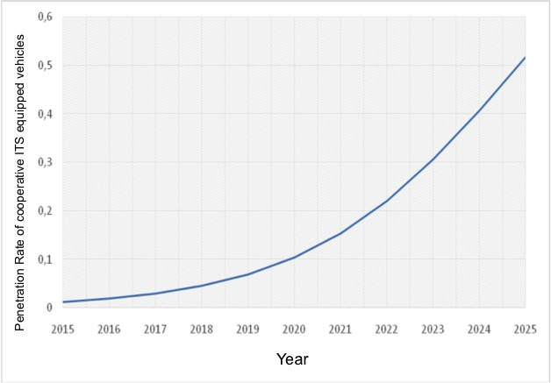
Figure 9: Estimation of ITS station penetration rate; optimistic view;
based on figures from simTD [24]
Here it can be seen that the optimistic estimation of the penetration rate will be in the range of 10% in the year 2020 and in the range of 50% in the year 2025. A 100% penetration rate is only realistic starting from the year 2030. However, the studies only considered 100 % penetration.

Compatibility between ITS and other services/systems

Introduction
In the scope of this report only the compatibility of ITS systems towards the following systems are investigated:
- Road tolling between 5795 MHz and 5815 MHz (see section 3.3);
- Fixed Service (above 5925 MHz) (see section 3.4).

Results from ECC report 101
ECC Report 101 concludes that ITS between 5855 MHz and 5925 MHz will be compatible with

- Road tolling, if their unwanted emissions power below 5815 MHz is less than -65 dBm/MHz or alternatively, a mitigation technique would be to switch off ITS while within the road tolling communications zone;
- Fixed Service, if the unwanted emissions power above 5925 MHz is less than -65dBm/MHz.

ECC Report 101 [5] concludes in addition that between 5875 MHz and 5905 MHz ITS will not suffer from excessive interference resulting from other systems/services. Mitigation techniques like Duty Cycle restrictions have not been considered in ECC Report 101.

Compatibility between ITS and road tolling in the band 5795 MHz to 5815 MHz

General considerations
In this section the potential interference from ITS-G5 systems onto the CEN DSRC road tolling system will be investigated. Since only the out-of-band emissions will be investigated the main focus of the evaluation will be on the potential interference into the road toll Road Side Units (RSU) operating in the band 5795MHz to 5815MHz with an operational bandwidth of 500 kHz. The impact of ITS unwanted emissions on the road tolling OBU (On-Board-Unit) has not been considered. Due to the limited sensitivity of the OBU of around -50dBm no harmful interference towards the road tolling OBU is expected from the unwanted emission of ITS.
Three main tolling station applications need to be differentiated due their different operational conditions:
- Free-Flow tolling stations and enforcement stations with a maximum of 6 parallel lanes (typical 3 lanes to 4 lanes in each traffic direction). Here the speed of the mobiles can be high. No specific speed limit is given during the tolling operation. See Figure 10;
- Toll plazas with an automatic barrier with up to 40 parallel lanes (Typical around 5 lanes to 20 lanes in each traffic direction). Here the vehicular speed is very limited. See Figure 11, left part;
- Toll plazas with automatic lanes (reduced speed) with up to 40 parallel lanes (typical around 1 lane to 10 lanes in each traffic direction). Here the speed limit is in the range of 30 km/h. See Figure 11, right part.
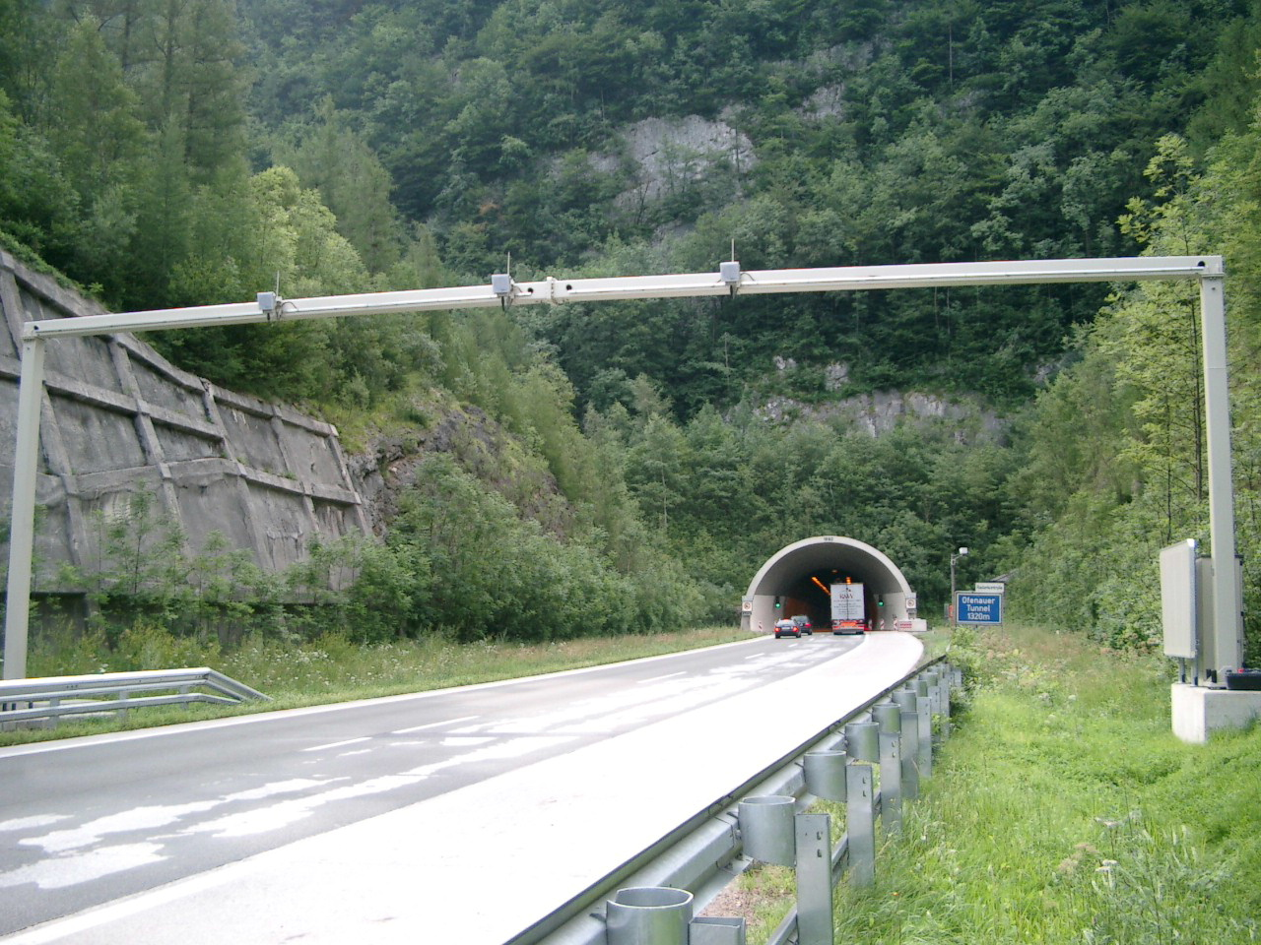
Figure 10: Typical free-flow installation with three lanes

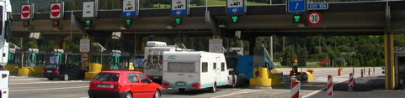
Figure 11: Typical toll plaza with an automatic barrier (left) and a single automatic lane (right)

Technical characteristics of CEN DSRC Road tolling Road Side Units (RSU)

RF characteristics
Detailed characteristics are defined in Table 5.

Table 5: Parameters of a typical CEN DSRC Road Toll RSU
Road Toll Road Side Unit (RSU) | Value | Units
Receiver bandwidth | 500 | kHz
Receiver sensitivity (at the receiver input) | -104 | dBm
Receiver Noise level in 500KHz | -115 | dBm
RX-Antenna gain bore sight | 13 | dBi
RX-Antenna gain outside RSU active angle (inside Azimuth +/- 50°) | -2 | dBi
RX-Antenna gain to the back side of the RSU (outside Azimuth +/- 50°) | -7 | dBi
Antenna polarization | LHCP (Polarisation mitigation 2 dB)
cross-polar discrimination,  ellipticity of polarization | 10 | dB
TX output power level, EIRP | 33 | dBm
RSU mounting height above ground | 2,5 to 7,5 | m
Protection criterion (I/N) | -6 | dB
TX Frequency/Bandwidth | 500 kHz

Antenna
The Road Toll RSU RX antenna is tilted downside by 45° for the interrogation of the on-board units. A Road Toll RSU is typically installed in a height of 6 m to 7 m. Outside of the main beam the antenna has reduced gain by a factor of around between 15 dB (inside an azimuth angle +/- 50°) and 20dB (outside an azimuth angle +/- 50°). A typical road toll installation is shown in Figure 12.


Height typically 6 – 7 m
Typically 45deg
RSU
OBU
Figure 12: Typical road toll setup, blue line: RX antenna main beam
In a multilane setup with several parallel lanes a single RSU will cover more than a single lane. This leads to an overlap between two adjacent RSUs. By doing so, a better coverage can be guaranteed.

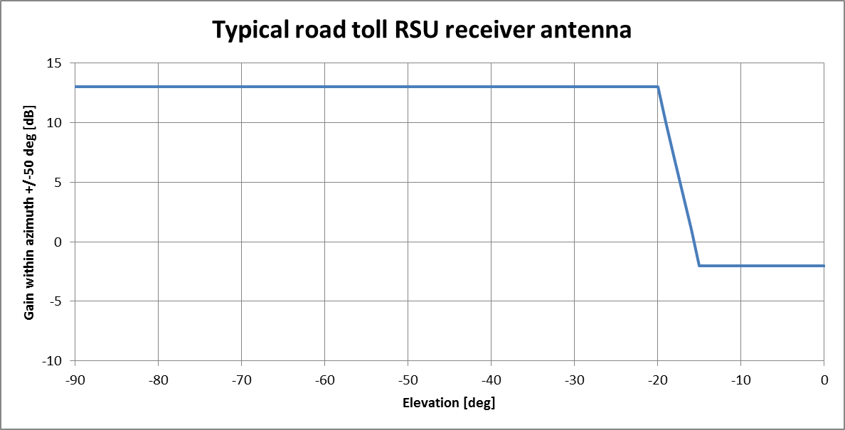
Figure 13: Typical road toll RX-antenna gain variation as function of the
Elevation angle inside of an azimuth angle of +/- 50°

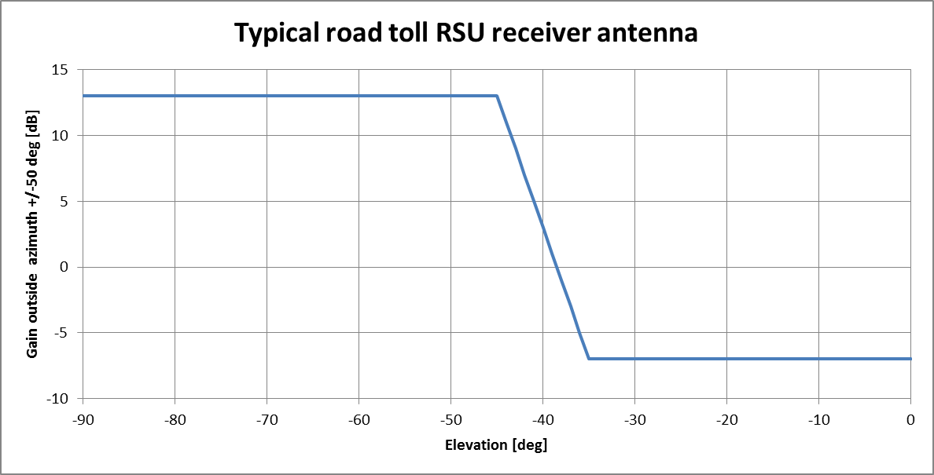
Figure 14: Typical road tolling RX-antenna gain variation as function of the
Elevation angle outside of an azimuth angle of +/- 50°

Figure 13 and Figure 14 shows typical antenna gain variation of road toll receiver antennas. Inside an azimuth angle of +/- 50° (pointing toward approaching vehicles) we assume a side lobe attenuation of 15 dB and for other directions outside the azimuth we assume side lobe attenuations of 20 dB.

Detailed MCL calculations - Interference zone
The interference zone (zone where the ITS unwanted emission can interfere with the CEN DSRC road tolling RSU receiver) is highly dependent on the antenna characteristics of both systems.
Detailed interference power calculations, using antennas from Figure 4, Figure 13 and Figure 14 are given in Figure 15 to Figure 19. In the figures different use cases are considered (car mounted and truck mounted ITS stations). The blue lines in the figures depict the interference behaviour inside of the +/- 50° azimuth angle and the green line the corresponding behaviour outside of the azimuth angle of +/- 50°.
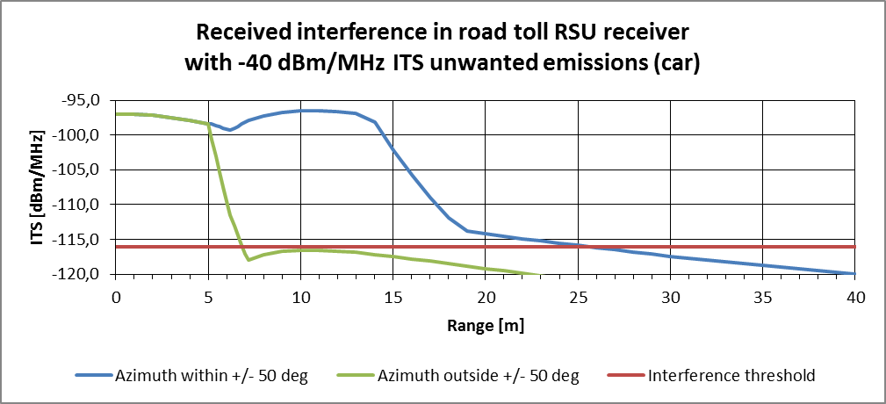
Figure 15: Received Interference range, depending on the azimuth, for -40 dBm/MHz e.i.r.p.
ITS unwanted emissions

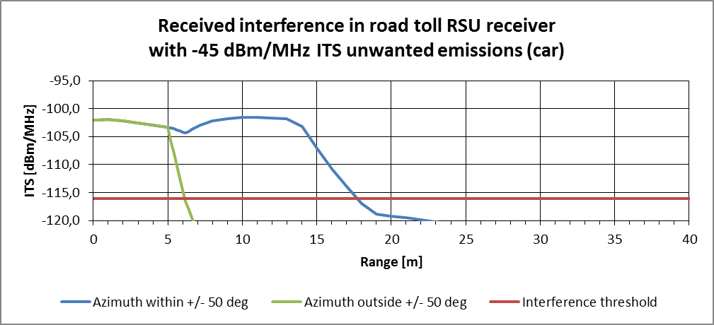
Figure 16: Received Interference range, depending on the azimuth, for -45dBm/MHz e.i.r.p.
ITS unwanted emissions

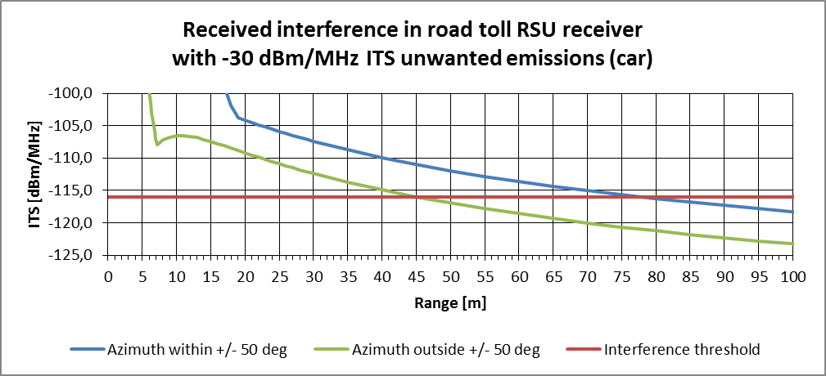
Figure 17: Received Interference range, depending on the azimuth, for -30dBm/MHz e.i.r.p.
ITS unwanted emissions

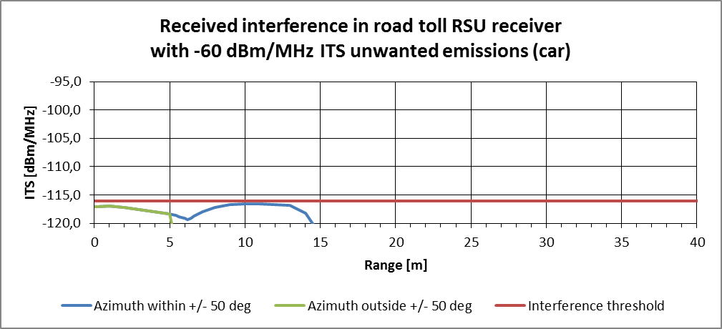
Figure 18: Received Interference range, depending on the azimuth, -60dBm/MHz e.i.r.p.
ITS unwanted emissions, here: car ITS station
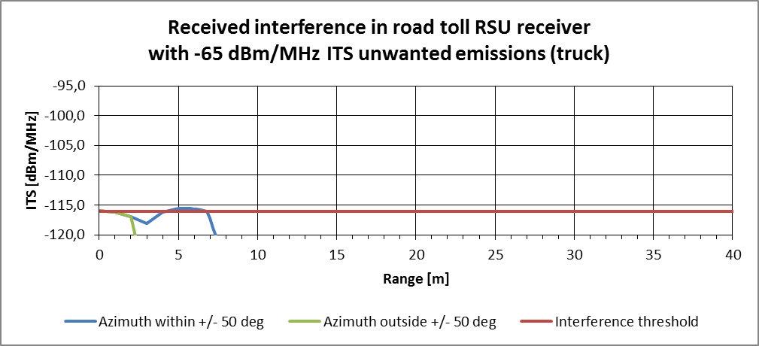
Figure 19: Received Interference range, depending on the azimuth, for -65dBm/MHz e.i.r.p.
ITS unwanted emissions, here: truck ITS station
With ITS unwanted emissions of -40 dBm/MHz the interference free distance between ITS and RSU within azimuth +/-50° is 25 m and 7m for directions outside of an azimuth angle of +/-50°, see Figure 15.
With ITS unwanted emissions of -45dBm/MHz the interference free distance between ITS and RSU within azimuth +/-50° is 18 m and 6m for directions outside of an azimuth angle of +/-50°, see Figure 16.
With ITS unwanted emissions of -30dBm/MHz the interference free distance between ITS and RSU within azimuth +/-50° is 78 m and 45 m for directions outside of an azimuth angle of +/-50°, see Figure 17.
The interference distances from Figure 15 and Figure 16 are used to calculate the interference zone shown in Figure 20. Each rectangle in the figure shows typical needed area for one vehicle, width 5 m (lane width) length 6 m (vehicle length plus space). In Figure 21 the interference zone for an ITS unwanted emission level of -30dBm/MHz is depicted based on the results depicted in Figure 17.
To achieve the protection criterion used in the above calculations (I/N protection criterion of -6 dB without any mitigation techniques (e.g. duty cycle reduction) it seems necessary to limit unwanted emissions in the band 5795-5815 MHz from the ITS antenna to -60 dBm/MHz e.i.r.p. for cars (1,5m above ground), see Figure 18 and -65 dBm/MHz e.i.r.p. for trucks (4,0m above ground), see Figure 19. This is in line with the results of ECC Report 101 [5]
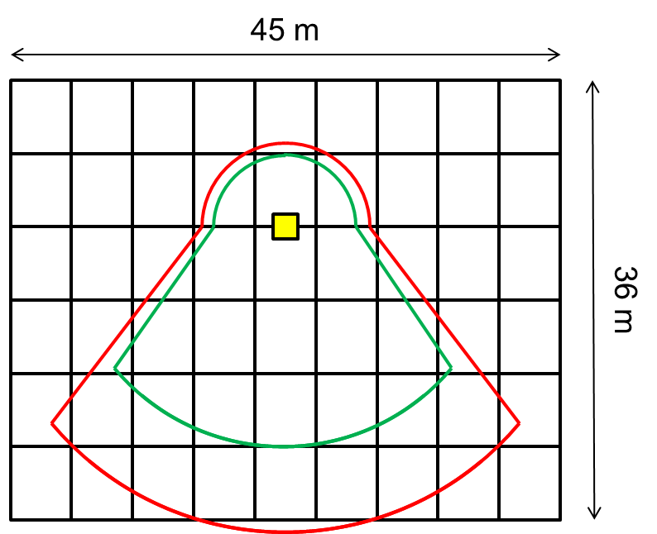
Figure 20: Interference zone, the road toll RSU is marked with yellow,
ITS unwanted emissions -40 dBm/MHz is within the red area and -45dBm/MHz is within the green area

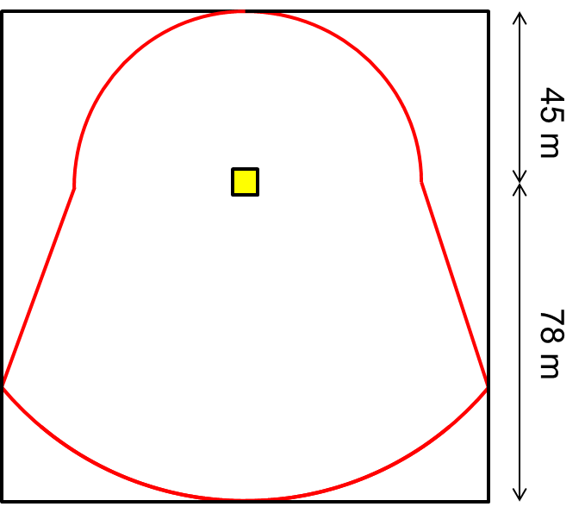
Figure 21: Interference zone, the road toll RSU is marked with yellow,
ITS unwanted emissions -30 dBm/MHz is within the red area
Mitigations on the ITS side will be analysed in the following sections.

Road tolling Protocol (CEN DSRC)
The communication protocol of the CEN DSRC tolling system is based on a packet exchange between the RSU and the OBU. In the protocol some degree of redundancy is built in by simple repetition in case a packet has been disturbed by interference. In general the RSU sends out a general non-personalised request to all active OBUs in its range. The first OBU answering with its ID will then be processed further by sending out a personalised request only addressing this single OBU. During this communication then several packets are exchanged and at the end the transaction is closed.
In case an uplink packet (OBU to RSU) will not be received by the RSU (Interference into the RSU) the RSU will retransmit the request packet after a certain waiting time in the range of some ms. This can be repeated several times. The transaction is defined as failed after a number of retrials, which is depending on the individual parameter settings in the RSU. It can be seen in the following that a single interference event during a transaction can only delay the transaction but will not lead to a fail of the transaction. Only when a number of interference events occur during a transaction a transaction failure might be generated.
A part of a typical transaction scheme is depicted in Figure 22. Here the transaction is not depicted for the complete time duration. The typical distribution of transaction durations is given in Figure 23. In Figure 22 an interference event occurs during a downlink (RSU and OBU) communication, thus the OBU has not been able to receive the RSU packet. I can be seen that after a waiting time the RSU repeats the TX packet and then receives the answer from the OBU with some delay. The timing given here is only tentative and might be different for different installation and systems.
Based on the presented protocol it can be assumed that an interfering system with properly chosen limitation in duty cycle will not harmfully interfere with the tolling system.
Figure 22: Part of a typical transaction scheme between RSU and OBU in CEN DSRC
(*): ITS message interfering with tolling transaction.

Figure 23: Typical tolling transaction duration

Consideration of the Duty Cycle limitations for ITS
The assumptions and calculations in the following clause are based on an extensive work performed in ETSI TC ITS documented in the technical specification TS 102 792 [6] and the technical report TR 102 960 [19].
The duty cycle limitations of an ITS systems will lead to a significant mitigation factor to be taken into account in the interference evaluation process. The evaluation needs to be done by taking into account the number of vehicles, which could contribute to the interference towards the RSU. Furthermore, the CEN DSRC communication protocol properties need to be taken into account. Basic principles of the protocol haven been presented in section 3.3.4 of this document.
In Figure 24 to Figure 28 different traffic mobility scenarios are given for information.
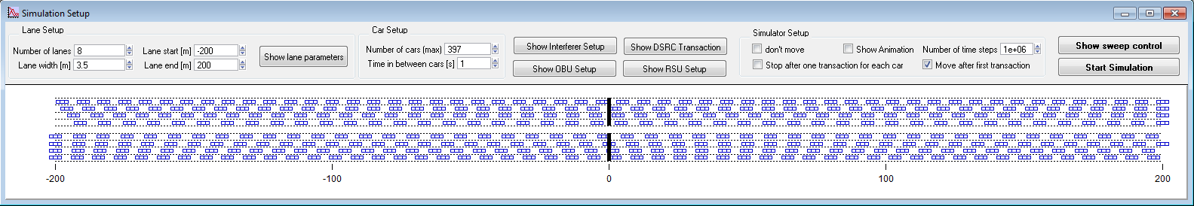
Figure 24: Slow traffic mobility scenario taken from ETSI TR 102960 [19]
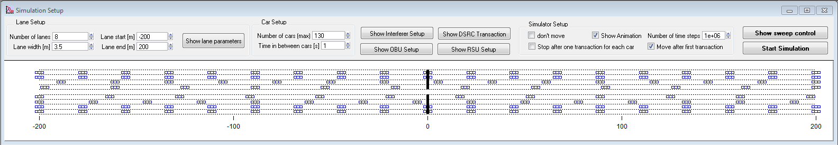
Figure 25: Fast traffic mobility scenario taken from ETSI TR 102960 [19]
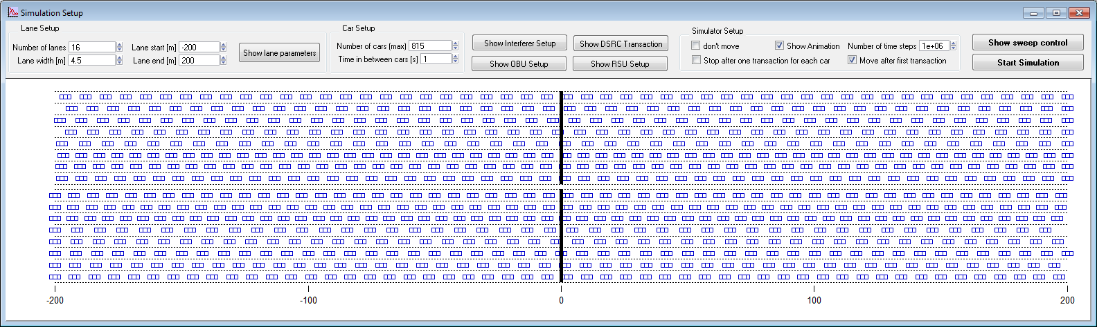
Figure 26: Toll plaza mobility scenario taken from ETSI TR 102960 [19]
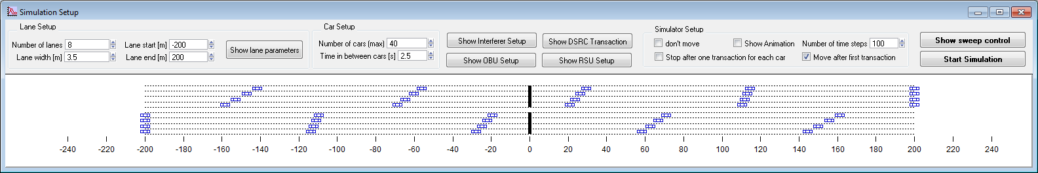
Figure 27: Light traffic mobility scenario taken from ETSI TR 102960 [19]
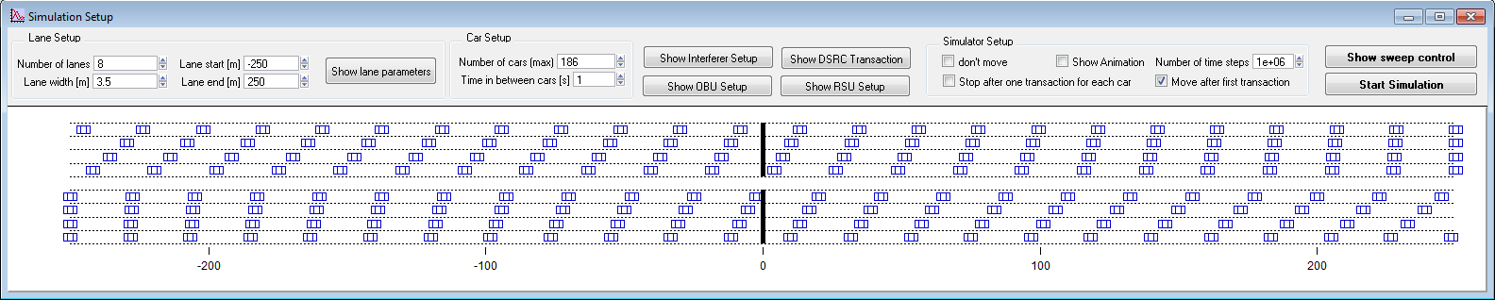
Figure 28: Truck scenario mobility scenario taken from ETSI TR 102960 [19]
ETSI TR 102960 [19] contains several compatibility investigations based on the protocol parameter of CEN DSRC and ITS-G5 systems. Some of these results are given in the following section.
For a given number of active ITS-G5 stations in the interference range a minimum T_{off} time between two consecutive packet transmissions can be evaluated. The worst-case results are given in Figure 29 taken from the ETSI technical specification TS 102 792 [6]. Here it can be seen that up to a number of 3 ITS station in the interference range and a T_{off} time of 100 ms between two packets no harmful interference will occur to the CEN DSRC link. With an increased number of ITS station in the interference range the required minimum T_{off} time has to be increased, e.g. for 25 ITS stations in the interference range the T_{off} values is around 1000ms.

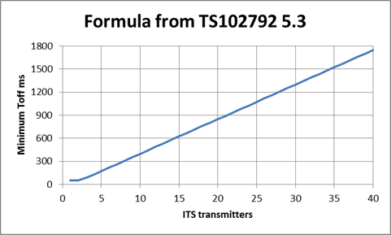
Figure 29: Required T_{off} time between two packets for a given number of ITS stations for interference free operation of tolling RSU [6]
Taking into account the ITS message length of 1ms Figure 30 depicts the maximum allowed packet rate for each ITS station for a give number of ITS stations in the interference range. These values can be taken into account in the evaluation of the interference risk in the different scenarios.
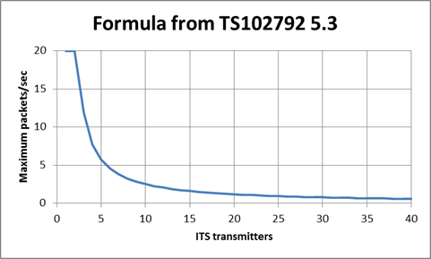
Figure 30: Maximum allowed packet rate as function of the ITS stations in the interference range, packet length 1ms (CAM)
The main message transmitted by an ITS-G5 system will be the so called CAM (Cooperative Awareness Message) [23], which is generated based on the dynamic behaviour of the vehicle. For high dynamic vehicles (high speed > 140km/h) the CAM generation rate can reach a maximum value of 10Hz, which translates into a maximum duty cycle of 1% taking into account a maximum message length of 1ms. The minimum CAM message rate of 1Hz is reached below a vehicular speed of around 15km/h.
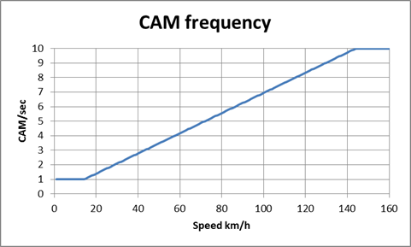
Figure 31: Specified CAM message rate as function of the vehicle speed
In the following section three different interference scenarios have been considered in more detail taking into account the MCL calculations in Table 5 and a ITS penetration rate of 100%. The following scenarios have been taken into account:
- Toll Plaza scenario (see Figure 32) with a vehicular speed of < 10km/h and a distance of below 1m between vehicles:
  - CAM rate 1Hz
  - maximum allowed number of ITS stations in interference range: 25

- Free flow toll scenario with 75 km/h vehicular speed (see Figure 31) and a distance of 24m between vehicle:
  - CAM rate 5Hz
  - maximum number of ITS stations in interference range: 6

- Free flow toll scenario with 130 km/h vehicular speed (see Figure 34) and a distance of > 45m between the vehicles:
  - CAM rate 10Hz
  - maximum allowed number of ITS stations in interference range: 4

In all cases an interference range based on Figure 20 have been used. The red area shows the interference zone for -40 dBm/MHz and the green area shows the interference zone for -45 dBm/MHz.

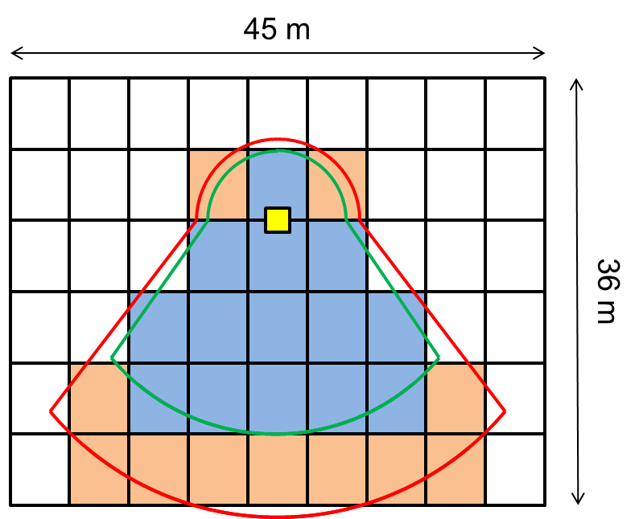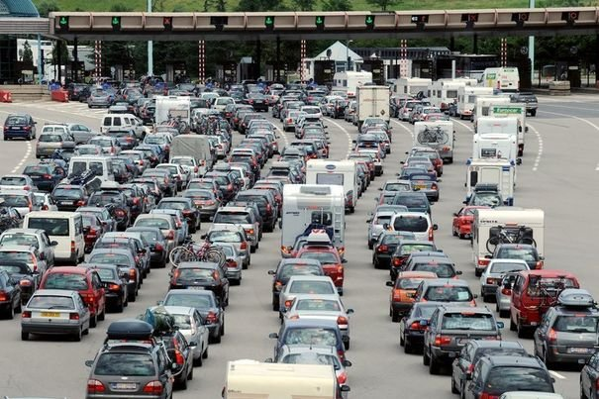
Figure 32: Toll plaza scenario: Number of potential interferer at 100% penetration rate,
worst case interference range
In Figure 32 it can be seen that a maximum of 25 ITS stations can contribute to the interference towards the CEN DSRC link at -40 dBm/MHz. This number is the same as the value of 25 allowed stations based on the CAM generation rule.

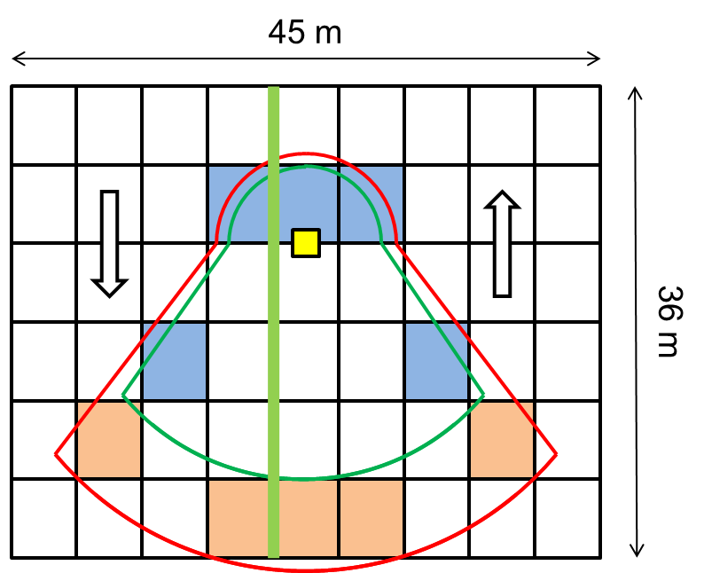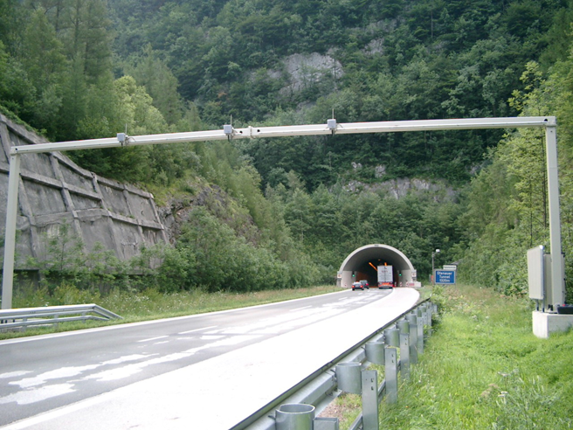
Figure 33: Free-flow scenario, with 75 km/h speed, worst case interference range
In Figure 33 up to 10 ITS stations can be in the worst case interference range with unwanted emissions of -40 dBm/MHz and 5 with -45 dBm/MHz. Under this conditions up to 6 stations would be allowed without any harmful interference. With an unwanted emissions limit of -45 dBm/MHz the condition is fulfilled.

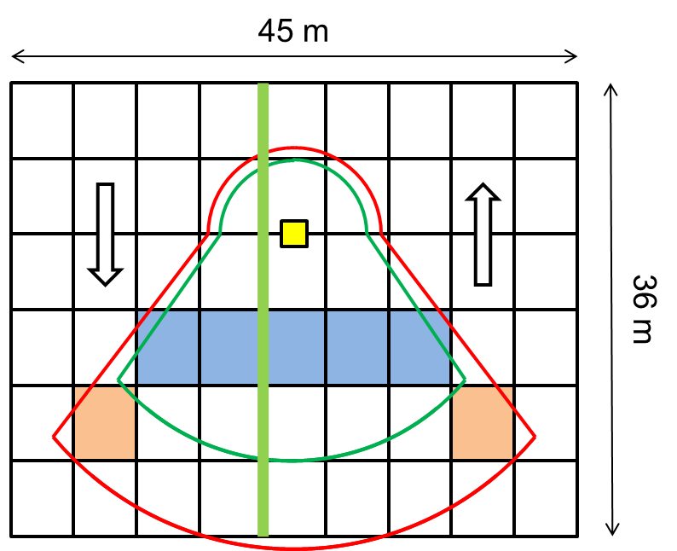
Figure 34: Freeflow scenario: 130 km/h, worst case interference range
In Figure 34 a number of 7 ITS stations would contribute in the worst case scenario with unwanted emissions of -40 dBm/MHz and 5 with -45 dBm/MHz. The maximum supported number of stations would be 4 in this case. With unwanted emissions -45 dBm/MHz the conditions are almost fulfilled.

Conclusion CEN DSRC
Compatibility regarding unwanted emissions can be assumed with an unwanted emissions limit of
-45 dBm/MHz e.i.r.p. taking into account the specification given for ITS in ETSI (EN 302 637 -2 [23], EN 302 571 [17]) without additional mitigation methods for the tolling UL, taking into account that
- the ITS duty cycle is based on the standard of CAM messages, maximum 10 messages per second with maximum length of 1 ms leading to a duty cycle of 1% in average in one hour.
- the DENM messages with duty cycle maximum 2% with maximum length of 1 ms were not included in the interference study however DENM are only transmitted temporary on traffic incidents such as emergency braking (leading to a peak of 3% in a second including the regular CAM messages)
- for applications with higher duty cycles or higher unwanted emission levels than -45dBm/MHz additional mitigation techniques like tolling station detection (e.g. beaconing solution included in the CAM specification [23]) including corresponding mitigation techniques (e.g. power and/or duty cycle reduction) are required.
- without mitigation techniques ITS unwanted emissions of -65 dBm/MHz e.i.r.p would protect the RSU in all cases in the interference zone.
- ITS stations outside the interference zone (see Figure 21) for the unwanted emissions can operate without specific mitigation techniques with a spurious emission limit of -30dBm/MHz.

These investigations and the corresponding conclusions only cover the unwanted emissions of ITS stations into the road tolling operational band from 5795 to 5815 MHz.

Compatibility between ITS and FS in the band above 5925 MHz

General
In this section the fixed systems operating in the band above 5925 MHz will be considered. The focus in this section will be the systems operating in the band 5925 to 6425MHz based on the ERC Recommendation ERC/REC 14-01[15] .
This frequency range is used in Europe for high capacity P-P links, in accordance with the frequency plans contained in the ERC/REC 14-01 [15] and ERC/REC 14-02 [21] mainly forming part of fixed and mobile and broadcasting infrastructure.
After a negative trend towards the end of the 20th century, mainly due to the migration from analogue to digital links, the trend from the 2010 questionnaire has changed from 2001 report and seems to show a stable situation for the two bands, as indicated in the figure below.

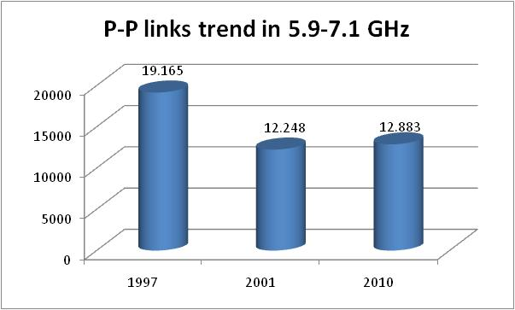
Figure 35: Trend for the P-P links in the band 5.9-7.1 GHz in the
19 CEPT countries available for comparison [22]
The results of the questionnaire for the whole 31 CEPT countries indicated 20242 links declared active in this range, which has been traditionally used for P-P links since quite a long time.
Significant number of countries indicates a moderate trend to increase the usage of this range in the years to come (10 to 30% increases), some report even a higher percentage, and some other indicates the band is congested or close to congestion.
ANNEX 1:provides information on realistic FS antenna heights for the studies in this report.

Technical Characteristics of the FS

Overview
The required protection range is estimated using the maximum allowable interference at the antenna input when applying the long-term interference criteria. Typical FS parameters can be found in Table 6 (from ECC Report 101[5]).
Table 6: Typical system parameters for point-to-point FS systems
Frequency band (GHz) | 5.925-6.425 GHz
Modulation | 128QAM
Channel spacing (MHz) | 29.65
Feeder/multiplexer loss (minimum) (dB) | 3.3 dB
Antenna type and gain (maximum and minimum) (dBi) | 44.8 / 34.5
Receiver noise bandwidth (MHz) | 22.3
Receiver noise figure (dB) | 4.0
Nominal long-term interference threshold (dBm/MHz) assuming I/N=-20 dB | -130.00
Nominal long-term interference threshold (dBm/MHz) assuming I/N=-10 dB | -120.00
Antenna height | See Annex 1

OCCUPIED SPECTRUM: 5925 - 6425 MHz

In Figure 36 the band allocation of the considered systems is given based on the specification in ERC/REC 14-01 [15].
Figure 36: Band allocation according to ERC/REC 14-01 [15]

Impact of ITS on the FS - Study 1 (MCL)

Table 7: MCL calculation ITS FS with I/N of -20dB

LINK BUDGET | Units | Urban | Suburban | Rural
Emission part: ITS
Bandwidth | MHz | 10 | 10 | 10
Tx power eirp | dBm/MHz | -40 | -40 | -40
Frequency (GHz) | MHz | 5900 | 5900 | 5900
Reception part: FS
Receiver Noise bandwidth | MHz | 22,6 | 22,6 | 22,6
Long term interference criteria (I/N = -20 dB) | dBm/MHz | -130 | -130 | -130
Feeder loss | dB | 3.3 | 3.3 | 3.3
Antenna gain | dBi | 44 | 44 | 44
Allowable Interfering power level 'I' at receiver antenna input (for FS mainlobe) | dBm/MHz | -170.7 | -170.7 | -170.7
Propagation models | See section 2.3
MAIN LOBE ITS - MAIN LOBE FS
Allowable Interfering power level at receiver antenna input | dBm/MHz | -170.7 | -170.7 | -170.7
Required Attenuation (dB) |  | 130.7 | 130.7 | 130.7
Separation distance ITS->FS (m) | m | 848 | 1654 | 3558
MAIN LOBE ITS - SIDE LOBE FS
Sidelobe attenuation (dB) | dB | 50 | 50 | 50
Allowable Interfering power level at receiver antenna input | dBm/MHz | -120.7 | -120.7 | -120.7
Required Attenuation (dB) | dB | 80.7 | 80.7 | 80.7
Separation distance ITS->FS (m) | m | 44 | 44 | 44
SIDE LOBE ITS - MAIN LOBE FS
Sidelobe attenuation (dB) | dB | 12 | 12 | 12
Allowable Interfering power level at receiver antenna input | dBm/MHz | -158.7 | -158.7 | -158.7
Required Attenuation (dB) | dB | 118.7 | 118.7 | 118.7
Separation distance ITS->FS (m) | m | 526 | 950 | 1657
SIDE LOBE ITS - SIDE LOBE FS
Sidelobe attenuation (dB) | dB | 62 | 62 | 62
Allowable Interfering power level at receiver antenna input | dBm/MHz | -108.7 | -108.7 | -108.7
Required Attenuation (dB) | dB | 68.7 | 68.7 | 68.7
Separation distance ITS->FS (m) | m | 11 | 11 | 11

Table 8: MCL calculation ITS FS with I/N of -10dB
LINK BUDGET | Units | Urban | Suburban | Rural
Emission part: ITS
Bandwidth | MHz | 10 | 10 | 10
Net Tx Out eirp | dBm/MHz | -40 | -40 | -40
Frequency (GHz) | MHz | 5900 | 5900 | 5900
Reception part: FS
Receiver Noise bandwidth | MHz | 22.6 | 22.6 | 22.6
Long term interference criteria (I/N = 10dB) (ITS as Coprimary service) | dBm | -106.5 | -106.5 | -106.5
Antenna gain | dBi | 44 | 44 | 44
Feeder Loss | dB | 3.3 | 3.3 | 3.3
Allowable Interfering power level 'I' at receiver antenna input | dBm/MHz | -160.7 | -160.7 | -160.7
Propagation models | See section 2.3
MAIN LOBE ITS - MAIN LOBE FS
Allowable Interfering power level at receiver antenna input | dBm/MHz | -160.7 | -160.7 | -160.7
Required Attenuation (dB) |  | 120.7 | 120.7 | 120.7
Separation distance ITS->FS (m) | m | 496 | 903 | 1771
MAIN LOBE ITS - SIDE LOBE FS
Sidelobe attenuation (dB) | dB | 50 | 50 | 50
Allowable Interfering power level at receiver antenna input | dBm/MHz | -110.7 | -110.7 | -110.7
Required Attenuation (dB) | dB | 70.7 | 70.7 | 70.7
Separation distance ITS->FS (m) | m | 14 | 14 | 14
SIDE LOBE ITS - MAIN LOBE FS
Sidelobe attenuation (dB) | dB | 12 | 12 | 12
Allowable Interfering power level at receiver antenna input | dBm/MHz | -148.7 | -148.7 | -148.7
Required Attenuation (dB) | dB | 108.7 | 108.7 | 108.7
Separation distance ITS->FS (m) | m | 287 | 473 | 728
SIDE LOBE ITS - SIDE LOBE FS
Sidelobe attenuation (dB) | dB | 62 | 62 | 62
Allowable Interfering power level at receiver antenna input | dBm/MHz | -98.7 | -98.7 | -98.7
Required Attenuation (dB) | dB | 58.7 | 58.7 | 58.7
Separation distance ITS->FS (m) | m | 3 | 3 | 3

The FS side lobe conditions can guarantee a sufficient mitigation distance with an ITS unwanted emission limit of -40 dBm/MHz even under the consideration of 100% duty cycle for the ITS devices. Based on the figured calculated in the MCL calculation above it can be assumed that only the FS main lobe conditions might lead to some interference situations. Taking into account the low duty cycle of the ITS devices (below 2.5%) and the mobile character of the majority of the ITS stations it can be assumed that the long-term interference criterion of the FS can be reached under all investigated conditions.

Impact of ITS on the FS - Study 2
The following parameters were used in the below calculations:
- ITS OOB Tx power: -40, -30, -20, -10 dBm/MHz e.i.r.p.
- FS noise figure: 4 dB (kTBF=-110 dBm/MHz)
- ITS antenna height: 1m
- FS antenna: ITU-R F.1245 (with a diameter of 1m, 2m, 3m)
- Path loss model: three slope model from section 2.3 and Free Space Loss
- Angle between FS link and road: δg=0°, road runs parallel to the fixed link
- FS antenna height: hz=10 m to 55 m (info on Antenna heights in Annex 1)
- X-offset between road and FS antenna: X0=0 m, in the simulation the road runs parallel to the fixed link
- Y-offset between road an antenna: Y0=0 m

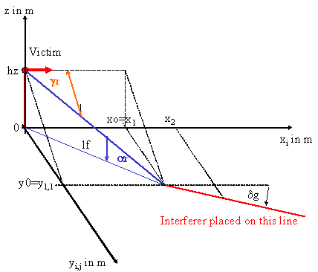
Figure 37: Parameter description of the scenario
In Figure 37 the set of parameters used in the simulation and calculations are depicted. In all simulation the offset between the fixed link antenna and the road was 0m and the fixed link connection is in parallel to the road.
In Figure 38 the antenna gains of two different Fixed Link antennas are given. The red curve presents the antenna gain of a 3 m antenna with a maximum gain of around 43dBi. The dotted blue curve depicts the antenna gain of a 1m antenna with a maximum gain of around 35dBi. These two antennas have been used in the following evaluations.

Figure 38: Antenna gain according to ITU-R F.1245 (dish diameter 1 m and 3 m)
Figure 39 depicts the path loss in dB as a function of the distance for the path loss models presented in Table 3.

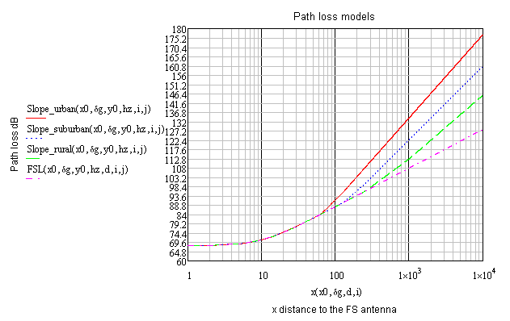
Figure 39: Considered path loss models (three slope model from section 2.3 and Free Space Loss)
In the following figures the I/N ratio is shown over the horizontal distance between the car and the FS antenna. Figure 40 shows the I/N values as function of the OOB power for a 43 dBi FS antenna at 35 m height, under line of sight propagation conditions.
The format INR_path(P_{its}, δ_{g}, hz, x, y, D) is used in the below figures to identify the used parameters. The parameters are explained below:
- INR: Interference to noise ratio I/N in dB at the FS receiver
- Path: path loss model from figure 39 (LOS, rural, suburban, urban)
- P_{its}: ITS transmitted power dBm/MHz e.i.r.p.,
- δ_{g}: angle in degree between road and FS Link,
- hz: FS antenna height above ground in m,
- x, y: variables for x and y axis
- D: FS antenna diameter m
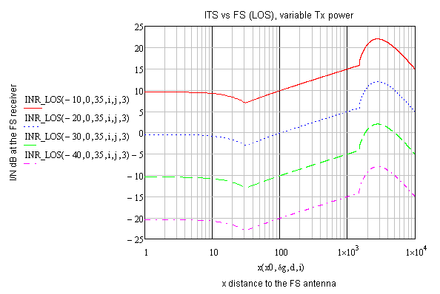
Figure 40: I/N results for variable OOB power (-10 to -40 dBm/MHz),
Free space loss and 3m antenna (43 dBi)
Figure 41 shows the I/N values with -40 dBm/MHz OOB power as function FS antenna diameter (and thus the gain) for the FS antenna at 35 m height, under line of sight propagation conditions.

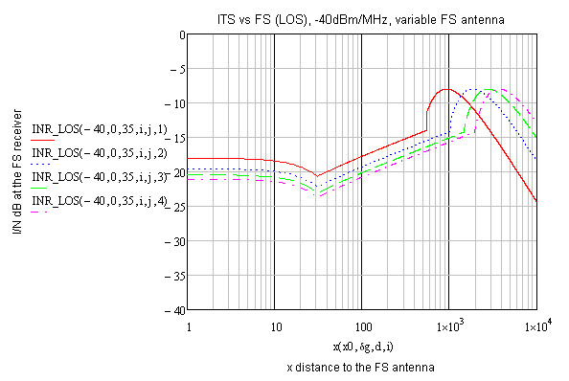
Figure 41: I/N results for -40 dBm/MHz OOB power with LOS and variable antenna
(1 m to 4 m diameter)
Figure 42 to Figure 45 show the I/N values with -40 dBm/MHz OOB power for the FS antenna at 10m, 20m, 25 m, 35m and 55 m height, and variable path loss model.

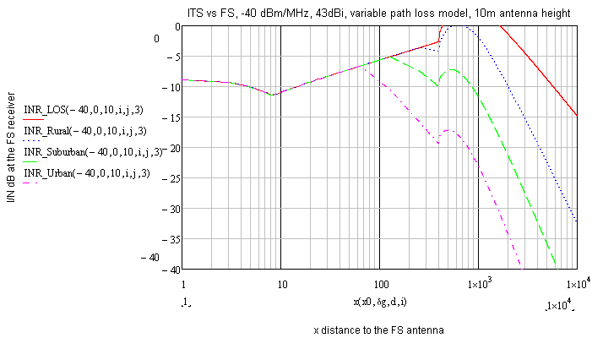
Figure 42: -40 dBm/MHz, 43 dBi, 10m FS antenna height

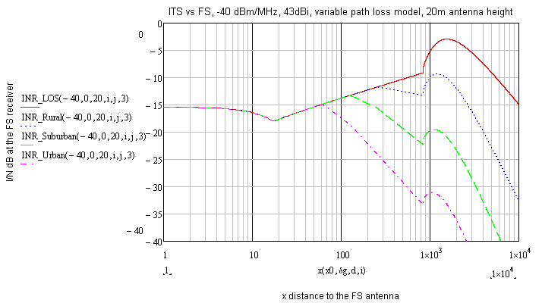
Figure 43: -40 dBm/MHz, 43 dBi, 20m FS antenna height

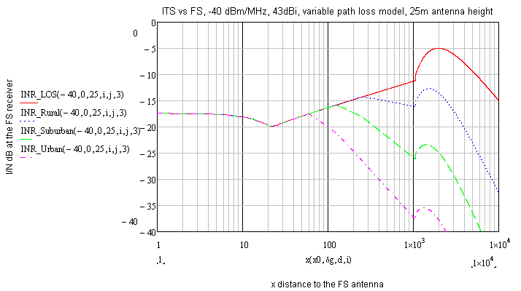
Figure 44: -40 dBm/MHz, 43 dBi, 25m FS antenna height, variable path loss

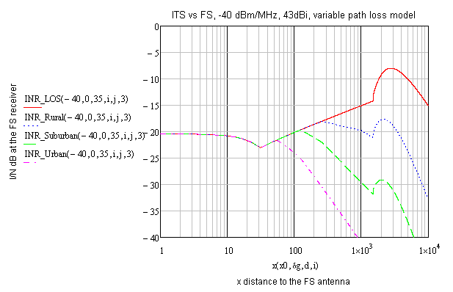
Figure 45: -40 dBm/MHz, 43 dBi, 35m FS antenna height, variable path loss

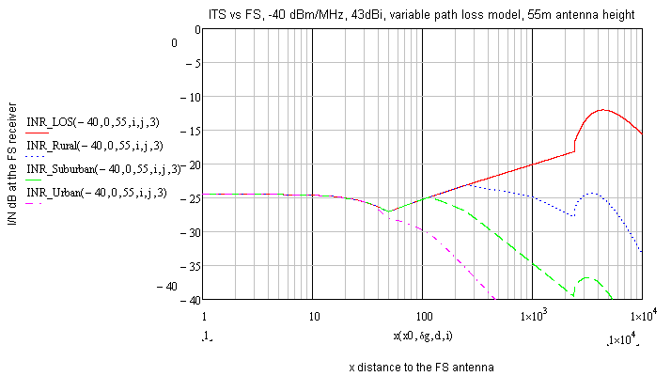
Figure 46: -40 dBm/MHz, 43 dBi, 55m FS antenna height, variable path loss
Figure 46 and Figure 47 show the I/N values with -30 dBm/MHz OOB power for the FS antenna at 35 m and 55 m height, and variable path loss model.

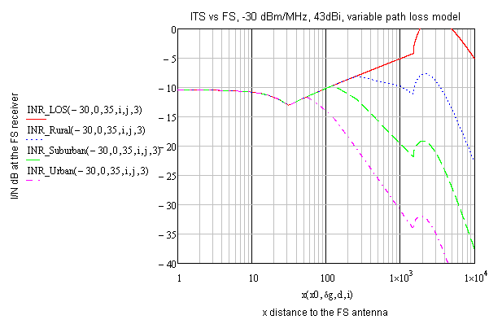
Figure 47: -30 dBm/MHz, 43 dBi, 35m FS antenna height, variable path loss

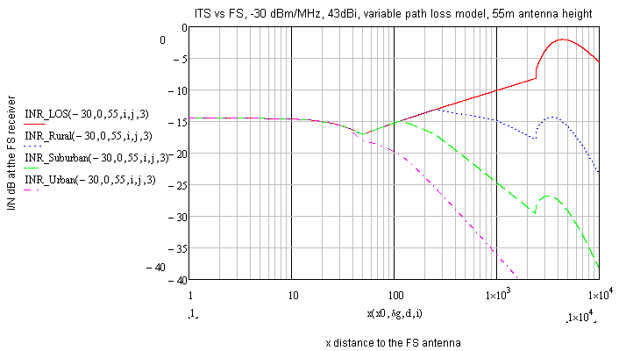
Figure 48: -30 dBm/MHz, 43 dBi, 55m FS antenna height, variable path loss
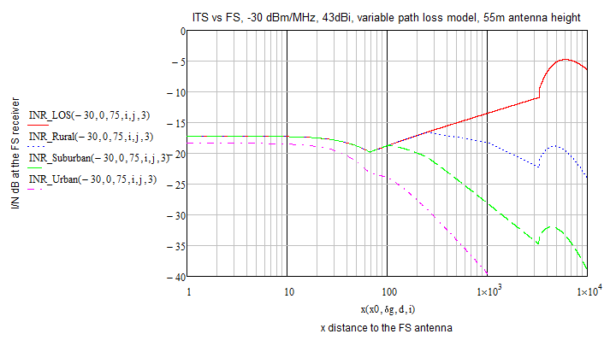
Figure 49: -30 dBm/MHz, 43 dBi, 75m FS antenna height, variable path loss

Summary of studies with the FS in the band above 5925 MHz
The results of the studies with the Fixed Service are summarised in the below Table.
Table 9: Summary of FS studies
Path loss model |  | Rural |  |  |  | Suburban |  |  |  | Urban
P_{its} dBm/MHz e.i.r.p. |  |  | -40 | -30 |  |  | -40 |  |  | -30 |  | -40
FS Antenna height hz m |  |  | Resulting I/N dB
 | 10 |  | 0 |  | 10 |  |  | -5 | 5 |  | -7 |  | 3
 | 20 |  | -10 |  | 0 |  |  | -13 | -3 |  | -15 |  | -5
 | 25 |  | -13 |  | -3 |  |  | -16 | -6 |  | -17 |  | -7
 | 35 |  | -18 |  | -8 |  |  | -20 | -10 |  | -21 |  | -11
 | 55 |  | -23 |  | -13 |  |  | -24 | -14 |  | -24 |  | -14
 | 75 |  |  |  | -17 |  |  |  | -17 |  |  |  | -18

It can be seen that with ITS unwanted emissions of -40 dBm/MHz e.i.r.p. an I/N value of -10dB can be achieved with FS antenna heights of ≥20 m in all environments; An I/N -20 dB can be achieved with FS antenna heights of ≥35 m in all environments. With ITS unwanted emissions of -30 dBm/MHz e.i.r.p. an I/N of -10 dB can be achieved with FS antenna heights of ≥35m and I/N -20 dB with FS antenna heights ≥75 m.
One administration provided information on FS antenna heights in that band (see Annex 1), which shows a range between 10 m and 160 m (55 m average).
Low antenna heights up to 35 m (height above ground level - where ITS is considered to be operated) are assumed to be installed on top of hills and tall buildings in Urban/Suburban areas. In rural areas, because of the expected long link lengths and with the requirement of a free Fresnel zone (see Annex 1), antenna heights above 55m (between 75-83m) are also assumed.
From the above analysis it can be concluded that ITS unwanted emissions of -40 dBm/MHz e.i.r.p. are able to avoid harmful interference to the FS, when considering the recommended FS protection criterion from Recommendation ITU-R F.758 [27] of I/N -20 dB. A limit of -30 dBm/MHz e.i.r.p. may be sufficient to ensure the FS protection when considering FS antenna heights of 75m and above.
It has to be noted that the above conclusion is drawn based on some worst case assumptions, which if taken into account, can reduce the occurrence probability:
- the ITS emission in the direction of the FS receiver and at the location with a critical FS link.
- OOB and spurious emissions are very much time, location and frequency dependent; they are likely below the specification (see Figure 1). Also, the ITS systems use a power control mechanism with a dynamic range of 30 dB. That means the unwanted emissions are only at the maximum when the link requires the maximum power;
- Finally the ITS systems works typically with a duty cycle below 1% per second, whereas the study took into consideration a 100% duty cycle.
- FS Links are built with a certain margin to account for fading effects (e.g. see [30]).

Where this above mitigations are employed an unwanted emission limit of -30 dBm/MHz may be sufficient to avoid harmful interference to the Fixed Service.
The aggregated impact of ITS into FS has not been considered in this report. However, those aggregated scenarios are expected not to have a higher impact as the considered single entry calculations due to the Duty Cycle of ITS between 1 % and 3 %.

Conclusions
CEN DSRC Road tolling
ITS is assumed to be compatible with road tolling regarding unwanted emissions provided that it has an unwanted emission power between 5795 MHz and 5815 MHz of less than -45 dBm/MHz with some duty cycle restrictions to ITS messages:
- A maximum duty cycle of 1% in one hour and a maximum message length of 1 ms.
- In addition event-based emergency messages (e.g. DENM) with a peak duty cycle of maximum 2% in one second with a message duration of 2 ms length is acceptable by road tolling for a limited duration.
- Applications requiring higher duty cycles or higher unwanted emissions levels have to implement further mitigation techniques defined in the corresponding ETSI specifications [6].

Without mitigation techniques unwanted emissions of -65 dBm/MHz e.i.r.p truck installation and -60 dBm/MHz e.i.r.p for car installation at the ITS antenna would protect the RSU in all cases in the interference zone.
Fixed Service

The studies dealing with the impact of ITS unwanted emissions on the Fixed Service concluded that ITS unwanted emissions of -40 dBm/MHz e.i.r.p. are able to avoid harmful interference to the FS, when considering the recommended FS protection criterion from Recommendation ITU-R F.758 [27] of I/N -20 dB. A limit of -30 dBm/MHz e.i.r.p. may be sufficient to ensure the FS protection when considering FS antenna heights of 75m and above.
It has to be noted that the above conclusion is drawn based on some worst case assumptions, which if taken into account, can reduce the occurrence probability:
- The ITS emission in the direction of the FS receiver and at the location with a critical FS link.
- OOB and spurious emissions are very much time location and frequency dependent; they are likely below the specification (see Figure 1). Also, the ITS systems use a power control mechanism with a dynamic range of 30 dB. That means the unwanted emissions are only at the maximum when the link requires the maximum power;
- Finally the ITS systems works typically with a duty cycle below 1% per second, whereas the study took into consideration a 100% duty cycle.
- FS Links are built with a certain margin to account for fading effects (e.g. see [30]).

Where the above mitigations are employed an unwanted emission limit of -30 dBm/MHz may be sufficient to avoid harmful interference to the Fixed Service.
The aggregated impact of ITS into FS has not been considered in this report. However, those aggregated scenarios are expected not to have a higher impact as the considered single entry calculations due to the Duty Cycle of ITS between 1 % and 3 %.
- FS antenna height and link length

In Figure 49 the antenna heights distribution above the ground of Fixed Systems are depicted for Sweden.

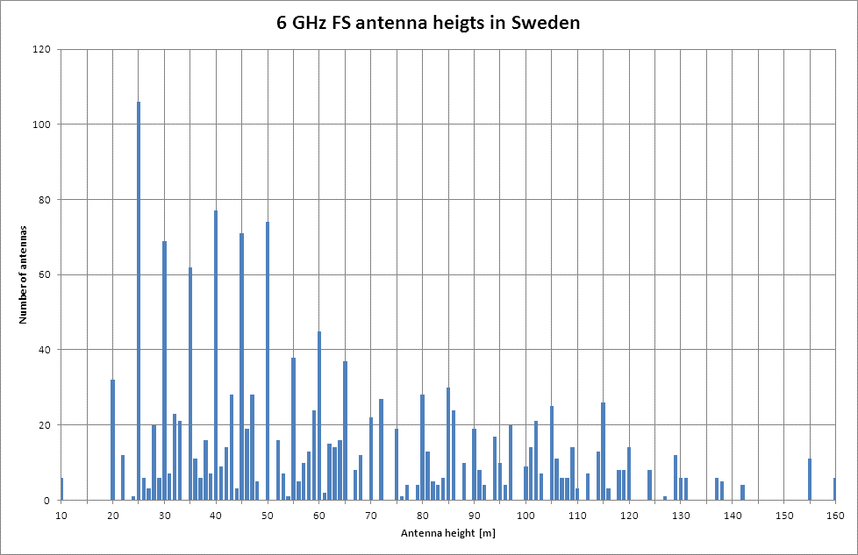
Figure 49: Antenna heights distribution for FS in Sweden

It can be seen that the minimum heights is 10m. The maximum number of antennas has heights of 25m and the average number is at 55m.
ECC Report 173 [22] indicates that 95% percentile of hop length is “typical” 55 km (36 km for those indicated as “minimum”).
In Figure 50 a fixed link is depicted including the earth curvature and the Fresnel zone for a link length of 55km. It can be seen that here the 1. Fresnel one is not free of obstacles and that it can be assumed that for a link length of 55 km even the 55 m antennas need to be installed on a hill to reach obstacle free the Fresnel zone. Similar results can be seen with other configuration below.

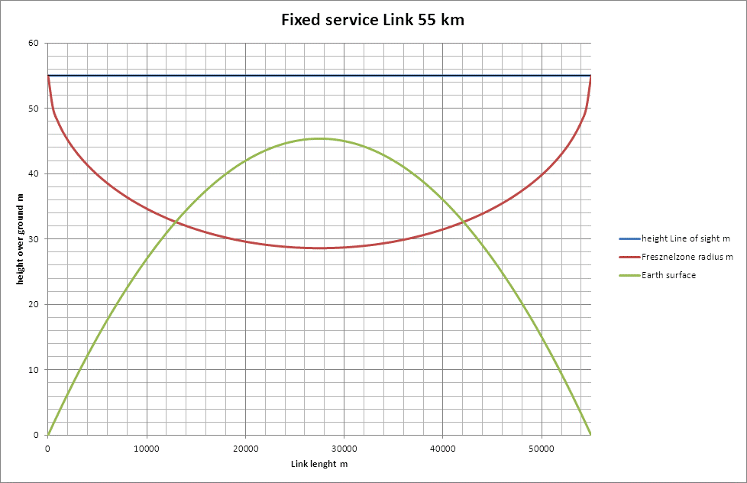
Figure 50: Earth's curvature vs Fresnel zone for a 55km FS Link and FS antenna heights of 55m
The above figure shows the radius of the Fresnel zone. This means, that the realistic antenna height to be considered in the calculations should be above 60m.
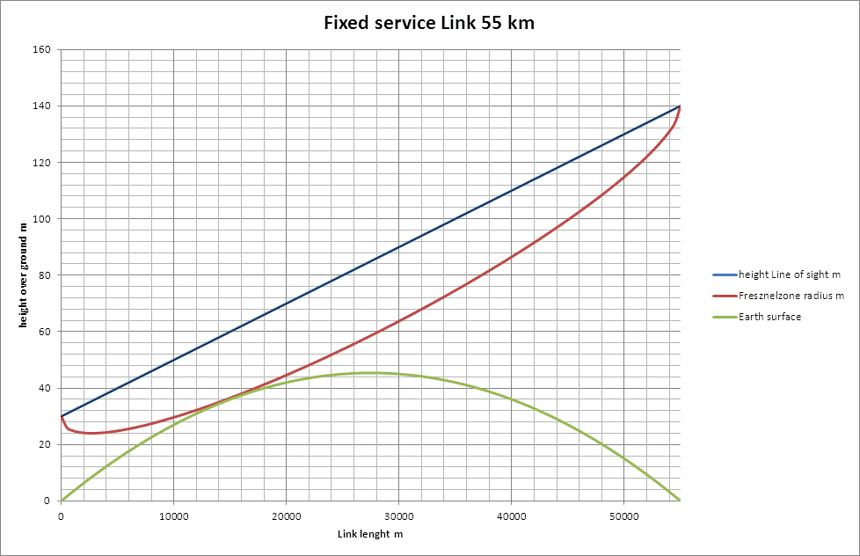
Figure 51: earth's curvature vs Fresnelzone for a 55km FS Link and realistic antenna heights
In Figure 52 and Figure 53 the same results as above are shown for a 36 km link length.

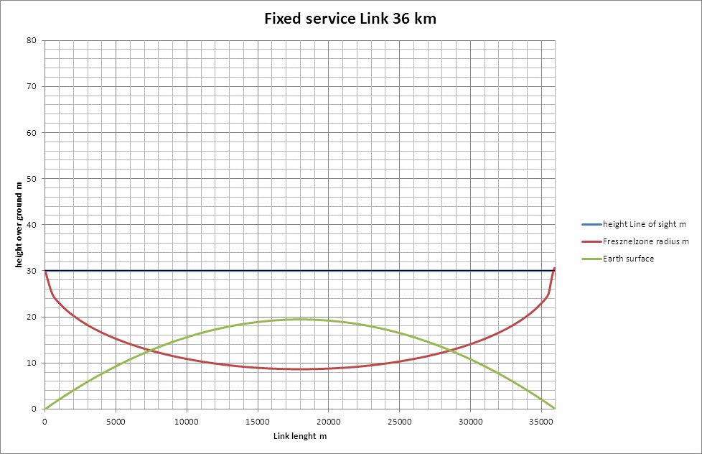
Figure 52: earth's curvature vs Fresnel zone for a 36km FS Link and unrealistic antenna heights

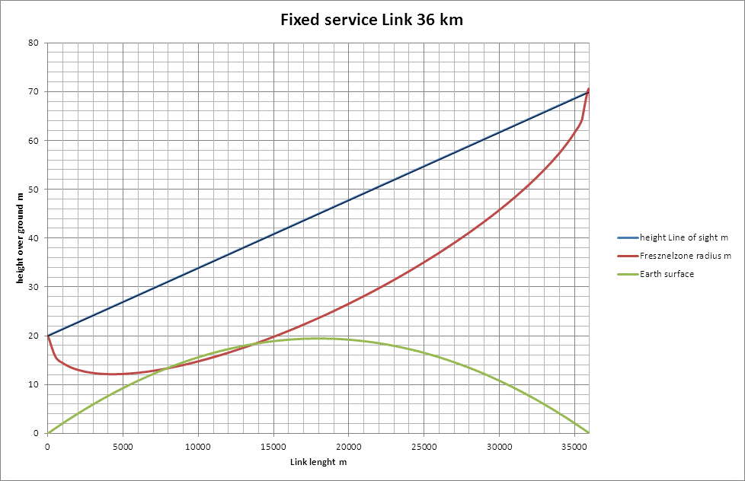
Figure 53: earth's curvature vs Fresnel zone for a 36km FS Link and realistic antenna heights
It can be concluded that FS antenna heights of less than 30m are unrealistic for the calculations in this report; such low antenna heights are only expected to be installed on top of a hill.
- List of references
- ECC Decision (08)01 on the harmonised use of the 5875-5925 MHz frequency band for Intelligent Transport Systems (ITS)
- ECC Recommendation (08)01 on the use of the band 5855-5875 MHz for Intelligent Transport Systems (ITS).
- Commission Decision 2008/671/EC of 5 August 2008 on the harmonised use of radio spectrum in the 5 875-5 905 MHz frequency band for safety-related applications of Intelligent Transport Systems (ITS).
- ETSI TR 103 083:” Electromagnetic compatibility and Radio spectrum Matters (ERM); System Reference document (SRDoc); Technical characteristics for pan European harmonized communications equipment operating in the 5,855 GHz to 5,925 GHz range intended for road safety and traffic management, and for non-safety related ITS applications”
- ECC Report 101: "Compatibility studies in the band 5855- 5925 MHz between Intelligent Transport Systems (ITS) and other systems", Bern, February 2007.
- ETSI TS 102 792: "Intelligent Transport Systems (ITS); Mitigation techniques to avoid interference between European CEN Dedicated Short Range Communication (CEN DSRC) equipment and Intelligent Transport Systems (ITS) operating in the 5 GHz frequency range".
- ETSI EN 302 665: "Intelligent Transport Systems (ITS); Communications Architecture".
- IEEE 802.11-2012: "IEEE Standard for Information technology–Telecommunications and information exchange between systems Local and metropolitan area networks–Specific requirements Part 11: Wireless LAN Medium Access Control (MAC) and Physical Layer (PHY) Specifications".
- Recommendation ITU-R SM.1541: “Unwanted emissions in the out-of-band domain”
- Recommendation ITU-R SM.329: “Unwanted emissions in the spurious domain”
- CEPT/ERC Recommendation 74-01E: “Spurious Emissions”
- Recommendation ITU-R F.1336-1: “Reference radiation patterns of omni-directional, sector and other antennas in point-to-multipoint systems for use in sharing studies in the frequency range from 1 GHz to about 70 GHz”
- ECC Report 68: “Compatibility studies in the band 5725-5875 MHz between Fixed Wireless Access (FWA) systems and other systems”
- Recommendation ITU-R F.1094-2 (2007-09): “Maximum allowable error performance and availability degradations to digital radio-relay systems arising from interference from emissions and radiations from other sources”
- ERC Recommendation 14-01: “Radio-frequency channel arrangements for high capacity analogue and digital radio-relay systems operating in the band 5925 MHz - 6425 MHz”
- Recommendation ITU-R F.383: “Radio-frequency channel arrangements for high capacity radio-relay systems operating in the lower 6 GHz band”
- ETSI EN 302 571 (V1.2.1): "Intelligent Transport Systems (ITS); Radiocommunications equipment operating in the 5 855 MHz to 5 925 MHz frequency band; Harmonized EN covering the essential requirements of article 3.2 of the R&TTE Directive".
- ETSI TR 102 654: "Electromagnetic compatibility and Radio spectrum Matters (ERM); Road Transport and Traffic Telematics (RTTT); Co-location and Co-existence Considerations regarding Dedicated Short Range Communication (DSRC) transmission equipment and Intelligent Transport Systems (ITS) operating in the 5 GHz frequency range and other potential sources of interference".
- ETSI TR 102 960: "Intelligent Transport Systems (ITS); Mitigation techniques to avoid interference between European CEN Dedicated Short Range Communication (RTTT DSRC) equipment and Intelligent Transport Systems (ITS) operating in the 5 GHz frequency range Evaluation of mitigation methods and techniques".
- ETSI EN 302 663 (V1.2.1) (11-2012): "Intelligent Transport Systems (ITS); Access layer specification for Intelligent Transport Systems operating in the 5 GHz frequency band".
- ERC Recommendation 14-02: “Radio-frequency channel arrangements for high, medium and low capacity digital fixed service systems operating in the band 6425-7125 MHz”; Bonn, 1995, Revised Dublin 2009.
- ECC Report 173: “Fixed Service in Europe, current use and future trends post 2011”, March 2012.
- ETSI EN 302 637-2: Intelligent Transport Systems (ITS); Vehicular Communications; Basic Set of Applications; Part 2: Specification of Cooperative Awareness Basic Services”.
- SimTD deliverable: “TP5-Abschlussbericht – Teil B-1B, Volkswirtschaftliche Bewertung: Wirkung von simTD auf die Verkehrssicherheit und Verkehrseffizienz”
- Recommendation ITU-R F.1336-1: “Reference radiation patterns of omni-directional, sector and other antennas in point-to-multipoint systems for use in sharing studies in the frequency range from 1 GHz to about 70 GHz”
- ETSI ES 200 674-1, V2.1.1 (2007-10), Road Transport and Traffic Telematics (RTTT);Part 1: Technical characteristics and test methods for High Data Rate (HDR) data transmission equipment operating in the 5,8 GHz Industrial, Scientific and Medical (ISM) band
- Recommendation ITU-R F.758-5 (2012-03), System parameters and considerations in the development of criteria for sharing or compatibility between digital fixed wireless systems in the fixed service and systems in other services and other sources of interference
- Fading Duration in Line-of-sight Radio Links at 6 GHz, Jan Bogucki and Ewa Wielowieyska, National Institute of Telecommunications, Warsaw, Poland, Journal of Telecommunications and Information technology, 2/2013
- ETSI EN 300 674-1, V1.2.1 (2004-08), Road Transport and Traffic Telematics (RTTT); Dedicated Short Range Communication (DSRC) transmission equipment (500 kbit/s / 250 kbit/s) operating in the 5,8 GHz Industrial, Scientific and Medical (ISM) band; Part 1: General characteristics and test methods for Road Side Units (RSU) and On-Board Units (OBU)
- Recommendation ITU-R P.530-12, Propagation data and prediction methods required for the design of terrestrial line-of-sight systems
- European Directive 2004/52/EC Directive 2004/52/EC of the European Parliament and of the Council of 29 April 2004 on the interoperability of electronic road toll systems in the Community
- Decision 2009/750/EC COMMISSION DECISION of 6 October 2009 on the definition of the European Electronic Toll Service and its technical elements (notified under document C(2009) 7547) (2009/750/EC).

