ECC Report 212

Evolution in the Use of E.212 Mobile Network Codes
Approved 09 April 2014

Executive summary
ITU-T Recommendation E.212 “The international identification plan for public networks and subscriptions” defines the structure of the International Mobile Subscription Identity (IMSI), which is primarily used by Mobile Network Operators (MNOs) to identify individual subscriptions on mobile networks. Every SIM card in every mobile device in the world is programmed with a unique IMSI number of 15-digits in length. The first 3 digits identify the subscriber’s home country. This is called the Mobile Country Code (MCC). The next 2 or 3 digits identify the subscriber’s home network. This is called the Mobile Network Code (MNC) and is configured in most countries with only 2 digits. The remaining 9 or 10 digits make up the Mobile Subscription Identification Number (MSIN) which is used to identify individual subscribers.
The IMSI is an integral identifier used in mobile networks. The E.212 concept was developed at a time when MNOs were the only stakeholders in the mobile value chain with a justifiable need for MNC resources to facilitate authentication, roaming, billing and routing.
As business models have evolved, the IMSI is increasingly being used for alternative purposes. An entity in the mobile value chain (other than a MNO) which has its own MNC can generate its own IMSI range independent of the underlying MNO. This provides alternative options for the entity thereby allowing it to use the IMSI for network fail-over and the avoidance of operator lock-in.
The ECC is cognisant that appropriate solutions for facilitating demand for E.212 resources must be found so that competition and service innovation can continue to be facilitated while avoiding exhaustion of E.212 resources.
This report therefore identifies emerging demand for MNC resources and describes possible options, both administrative and technical, for traditional and emerging business models and assesses different options to:
- extend the available capacity of MNCs;
- use MNCs more efficiently; and
- relax the strict rules which are used in most CEPT countries, and by the ITU (detailed in Rec. E.212), to assign MNC resources.
The report then draws a number of conclusions on the various options and makes proposals to the administrations of CEPT countries and to the ITU. The objective of these proposals is open discussion with policy makers and standards bodies so that future action can be taken to ensure the availability of MNCs for existing and new market players with a justifiable need for MNC resources while also safeguarding future supply.

TABLE OF CONTENTS

0 Executive summary 2
1 Introduction 7
2 Scope 8
3 International Mobile Subscription identity (imsi) 9
3.1 IMSI Structure 9
3.2 Assigned MCCs 9
3.3 Assigned MNCs 10
3.4 Compliance with the ITU Recommendations 10
3.5 2-digit and 3-digit Mobile Network Codes 11
3.5.1 Mixing 2-digit and 3-digit MNCs under the same Geographic MCC 11
3.5.2 Migrating from 2-digit and 3-digit MNCs under the same Geographic MCC 11
3.5.3 Migrating from 2-digit and 3-digit MNCs to n-digit MNCs for newly assigned Geographic MCCs 12
3.6 Remaining capacity of E.212 resources and future demand 12
3.7 Other guidance on E.212 12
3.7.1 Extra-Territorial use of E.212 resources 12
3.7.2 Shared MCC 901 13
3.7.3 ITU-T Recommendation E.214 13
4 TECHNICAL DEVELOPMENTS affecting changes in MNC Usage 14
4.1 Identifiers for Next Generation Networks 14
4.2 Remote provisioning of IMSIs 15
4.2.1 Soft-SIM 15
4.2.2 Embedded SIM 15
4.3 Multi-SIM and Multi-IMSI technologies 15
4.4 Technical proxy solutions to facilitate MNC sharing 15
5 emerging demand for MNC RESOURCES 17
5.1 The traditional mobile value chain 17
5.1.1 The Mobile Network Operator 17
5.1.2 MVNOs 17
5.1.3 Resellers 18
5.1.4 Mobile Virtual Network Enabler (MVNE) 18
5.1.5 Conclusion on the traditional mobile value chain 18
5.2 Emerging Business Models 18
5.2.1 M2M Business Models 18
5.2.1.1 M2M customers (with own MNC assignment) 18
5.2.1.2 Intermediate Specialised Service Providers for M2M (MVNO for M2M) 20
5.2.1.3 Global M2M services provided by MNOs using existing international roaming agreements 20
5.2.2 Public Networks using pico or femto cells: 22
5.2.3 Private Networks using pico or femto cells: 23
5.2.4 SMS Service Providers (SMS-SP) 23
5.2.5 Independent Roaming Service Providers/ Alternative Roaming Provider (ARP) 24
6 Analysis of proposed options 25
6.1 Technical Options 25
6.1.1 Over-The-Air (OTA) Provisioning 25
6.1.2 Location Area Code (LAC) 25
6.1.3 HLR-proxy or MVNE option 26
6.1.4 Extend existing 2-digit or 3-digit MNCs to n-digit MNCs 26
6.1.5 Multi-SIM and Multi-IMSI technologies 26
6.2 Administrative Options 26
6.2.1 Use of an IMSI range from an existing MNO 27
6.2.2 Assignment of a unique national MNC 27
6.2.3 A MNC dedicated for shared use 27
6.2.4 A unique MNC under MCC 901 28
6.2.5 A new shared MCC 90X for M2M, and SMS-SPs 28
6.2.6 A unique MNC per public femto/pico cell network 28
6.2.7 MNCs for private femto/pico cell networks 28
7 Conclusions 29
7.1 The ECC concludes that: 29
7.2 The ECC would encourage the ITU-T to: 29
ANNEX 1: Different approaches to MNC allocations in CEPT countries 30

LIST OF ACRONYMS AND DEFINITIONS

Abbreviation | Explanation
ARP | Alternative Roaming Provider
AUC | Authentication Centre
3GPP | The 3rd Generation Partnership Project
BEREC | Body of European Regulators for Electronic Communications
CEPT | European Conference of Postal and Telecommunications Administrations
DECT | Digital Enhanced Cordless Telecommunications
E.212 | The ITU-T Recommendation on “The international identification plan for public networks and subscriptions”
ECC | Electronic Communications Committee of CEPT
GSM | Global System for Mobile communications
GSMA | GSM Association
HLR | Home Location Register
HPP | HLR Proxy Provider
IP | Internet Protocol
IMSI | International Mobile Subscription Identity
ITU-T | International Telecommunication Union –Standardization Sector
LAC | Location Area Code
M2M | Machine-to-machine
M2M Service Provider | An entity offering M2M communications at the service level which utilises one or more underlying communications networks.
MCC | Mobile Country Code
MVNE | Mobile Virtual Network Enabler. A mobile service provider with a minimum level of core network infrastructure usually without its own licensed frequencies and radio access network providing a wholesale service to resellers. This type of mobile service provider does not provide a retail offering to customers
MNC | Mobile Network Code
MNO | Mobile Network Operator. A company that has frequency allocation(s) and the entire required infrastructure to run an independent mobile network.
MSIN | Mobile Subscription Identification Number
MVNO | Mobile Virtual Network Operator. A mobile service provider with a minimum level of core network infrastructure but without its own licensed frequencies and radio access network. This type of mobile service provider has a retail offering to its customers.
NRA | National Regulatory Authority
OECD | Organisation for Economic Co-operation and Development
OSS | Operational Support Systems
PLMN | Public Land Mobile Network
Private Network | Communications network used wholly for the provision of private electronic communications services, including or excluding interoperability with public communications networks
PT FNI | Project Team on Future of Numbering (within CEPT/WG NaN)
Public Communications Network | An electronic communications network used wholly or mainly for the provision of electronic communications services available to the public which support the transfer of information between network termination points.
RAN | Radio Access Network
Reseller | An entity providing a mobile service using wholesale inputs, including network elements, from an existing MNO
SIM | Subscriber Identification Module
SMS | Short Message Service
SS7 | ITU-T Signalling System No. 7
TSB | Telecommunications Standardization Bureau (within the ITU-T)
WG NaN | Working Group Numbering and Networks (within the CEPT/ECC)
Wi-Fi | Wireless fidelity (Wireless Local Area Network – WLAN)

Introduction
ITU-T Recommendation E.212 “The international identification plan for public networks and subscriptions” defines the structure of the International Mobile Subscription Identity (IMSI), which is primarily used by Mobile Network Operators (MNOs) to identify individual subscriptions on mobile networks. Every SIM card in every mobile device in the world is programmed with a unique IMSI number of 15-digits in length. The first 3 digits identify the subscriber’s home country. This is called the Mobile Country Code (MCC). The next 2 or 3 digits identify the subscriber’s home network. This is called the Mobile Network Code (MNC) and is configured in most countries with only 2 digits. The remaining 9 or 10 digits are used as an individual subscriber identifier. This is called the Mobile Subscription Identification Number (MSIN). The ITU assigns MCCs to countries (usually one MCC per country only), and the relevant national authorities subsequently assign MNCs to entities who meet the eligibility criteria. The ITU also assigns MNCs with 2 digits directly from a shared MCC 901 to entities who meet the eligibility criteria according to Annex A in ITU-T Rec. E.212.
The IMSI is an integral identifier that enables international roaming between different networks as its structure easily facilitates the identification of the home country and the home network. The E.212 concept was developed at a time when MNOs were the only stakeholders in the mobile value chain with a justifiable need for MNC resources to facilitate authentication, roaming, billing and routing. As business models have evolved, the IMSI is increasingly being used for alternative purposes as illustrated in this Report
An entity in the mobile value chain which has its own MNC can generate its own IMSI range independent of the underlying MNO thereby allowing it to use the IMSI for reasons such as the avoidance of operator lock-in and for network fail-over. For example, if a machine to machine (M2M) customer changes operator the SIM-card must be physically replaced in each M2M device which may be cost prohibitive and logistically impracticable in situations where there are a large number of M2M devices installed over a wide geographic area.
In most countries in the world, the IMSI is implemented with a 2 digit rather than a 3 digit MNC configuration. This means that there are only 100 MNCs available for allocation under each MCC. A 2 digit MNC allows the identification of 10¹⁰ terminals. As MNCs are a scarce resource, regulations or number allocation rules in most CEPT countries (see Annex 1) restrict the assignment of MNCs to MNOs only or MNOs and Mobile Virtual Network Operators (MVNOs) with a minimum level of network infrastructure.
Another relevant development driving additional demand for MNC resources is the use of technologies such as pico and femto cells in public or private wireless networks. Femto cells are mainly used to improve in-building network coverage by using a fixed technology (DSL or fibre) for backhaul purposes. These networks may be used for the provision of private electronic communications services including or excluding interoperability with public electronic communications networks. Alternatively, MNOs may use femto cells in buildings as an extension of their public networks where there is sufficient demand for enhanced indoor coverage. Both of these scenarios could require additional MNC resources.
As there may be a large variety of services delivered by different service providers with a need for MNCs, the existing stock available for every country could become exhausted. In order to prepare for the possibility of MNC resources becoming exhausted, the ECC has decided to analyse the issue and develop possible options for ensuring a sufficient supply of E.212 numbering resources for existing and future communications services.

Scope
This report describes the structure of the IMSI as set out in ITU-T Rec. E.212. These resources are traditionally assigned to MNOs to identify subscriptions and to facilitate authentication, roaming, routing and billing on a national and international basis.
The use of E.212 numbering resources is evolving. New business models are emerging and this trend is stimulating demand for MNC resources from entities other than MNOs. The ECC is cognisant that appropriate solutions for facilitating demand for E.212 resources must be found so that competition and service innovation can be facilitated while avoiding exhaustion of E.212 resources.
This report describes possible options, both administrative and technical, for each business model identified and assesses different options to:
- extend the available capacity of MNCs;
- use MNCs more efficiently; and
- relax the strict rules which are used in most CEPT countries, and by the ITU (as detailed in ITU-T Rec. E.212), to assign MNC resources.
The report also draws a number of conclusions on the various options and makes proposals to the administrations of CEPT countries and to the ITU with the objective of ensuring the availability of MNCs for market players with a justifiable need for MNC resources in the future while also safeguarding future supply.

International Mobile Subscription identity (imsi)

IMSI Structure
ITU-T Recommendation E.212 describes in detail the IMSI structure. The IMSI is a string of decimal digits, up to a maximum length of 15 digits, which identifies a unique subscription on a mobile network. The IMSI consists of three fields: the Mobile Country Code (MCC), the Mobile Network Code (MNC), and the Mobile Subscription Identification Number (MSIN).
The IMSI structure and format is illustrated in Figure 1 below:

MCC |  | MNC |  | MSIN
3 digits |  | 2 or 3 digits |  | Maximum of 10 digits
------------------------------------------------ IMSI - Maximum of 15 digits ------------------------------------------------------

- The IMSI structure and format
The IMSI enables:
- Identification of the home country using the first 3 digits (the MCC).
- Identification of the home network using the next 2 or 3 digits (the MNC). It should be noted that the majority of countries have implemented the IMSI with a 2-digit MNC.
- Identification of the individual subscriber using the last 9 or 10 digits, the MSIN.
The IMSI is essential to facilitate national and international roaming. Once a subscriber has been identified by the network, the process of authenticating and registering the mobile terminal can proceed and signalling, routing and billing can then take place between the home network and the visited network for any calls originated by, or terminated to, the roaming mobile terminal. The IMSI is not a number that can be dialled on public communications networks and it is not commonly a number that the subscriber would be aware of.

Assigned MCCs
The ITU-T maintains a database of assigned MCCs. According to the online database (as at 10 March 2014) the following information on assigned MCCs is provided:

- There are 1000 MCCs possible in accordance with E.212 (3-digit codes from 000-999).
- MCCs that begin with the digits 0, 1 and 8 are reserved for future use (300 MCCs are reserved).
- Currently 239 MCCs are assigned (including MCC 901). This leaves an available stock of 461 MCCs for future assignment (1000 – (300 + 239) = 461).
- Six countries have more than 1 MCC (underlined MCCs are currently not in use):
  - China: 2 (460, 461)
  - India: 3 (404, 405, 406)
  - Japan: 2 (440, 441)
  - United Arab Emirates: 3 (424, 430 [Abu Dhabi], 431 [Dubai])
  - United Kingdom of Great Britain & Northern Ireland: 2 (234, 235)
  - United States of America: 7 (310, 311, 312, 313, 314, 315, 316)

Assigned MNCs
The ITU-T also maintains a database of MNC assignments under each MCC as announced by each of the Member States. According to the online database (as at 10 March 2014) the following information on assigned MNCs is available:
- 3-digit MNCs are in use in 25 countries:
  - Anguilla (MCC 365)
  - Antigua and Barbuda (MCC 344)
  - Argentina (MCC 722)
  - Barbados (MCC 342)
  - Bermuda (MCC 350)
  - British Virgin Islands (MCC 348)
  - Canada (302)
  - Cayman Islands (MCC 346)
  - Colombia (MCC 732)
  - Dominica (MCC 366)
  - Falkland Islands (Malvinas) (MCC 750)
  - Grenada (MCC 352)
  - Guyana (MCC 738)
  - Honduras (MCC 708)
  - India (MCC 405)
  - Jamaica (MCC 338)
  - Mexico (MCC 334)
  - Montserrat (MCC 354)
  - Panama (MCC 714)
  - Saint Kitts and Nevis (MCC 356)
  - Saint Lucia (MCC 358)
  - Saint Vincent and the Grenadines (MCC 360)
  - Trinidad and Tobago (MCC 374)
  - Turks and Caicos Islands (MCC 376)
  - United States (MCCs 310, 311 and 316)

- 3-digit and 2-digit MNCs are in use in at least four countries under the same MCC:
  - Guyana (MCC 738 – MNC 01 and MNC 002)
  - India (MCC, 404 – all 2-digit MNC assignments. MCC 405 – multiple assignments of 2-digit and 3-digit MNCs)
  - Panama (MCC 714 – MNC 020, other MNCs two digits)
  - Trinidad and Tobago (MCC 374 – MNCs 12, 130 and 140)

- All MNC assignments under shared MCC 901 are 2-digit.

Compliance with the ITU Recommendations
The assignment and management of international telecommunication numbering, naming, addressing and identification resources is the responsibility of the Director of the ITU Telecommunication Standardization Bureau (TSB) in accordance with the requirements of Resolution 20 which inter-alia requires consultation with ITU-T SG2, the relevant administrations and the authorised applicant/assignee when required.
MCCs are allocated by the Director of TSB to each country. MNCs are then administered by the National numbering plan administrator within each country in accordance with the principles in Annex B of the ITU-T Rec. E.212. These principles provide for the assignment of MNCs under assigned geographic MCCs.
According to ITU-T Rec. E.212 Annex B, MNCs are only to be assigned to and used by “public networks offering public telecommunication services”. Annex 1 of this report provides an overview of assignment conditions in some CEPT countries.

2-digit and 3-digit Mobile Network Codes
According to ITU-T Recommendation E.212, a MNC, under a geographic MCC, consists of 2 or 3 digits and the length of the MNC is a decision for the National Numbering Plan Administrator. A 2-digit configuration provides an available capacity of 100 MNCs (00-99) while a 3-digit configuration provides an available capacity of 1000 MNCs (000-999). Most countries have opted for a 2-digit MNC configuration for historical reasons. In the USA 2-digit and 3-digit MNCs are in use under the same MCC. The largest US operators use those 3-digit MNCs not ending with zero mainly for US domestic use. However, practically all operators have their 3-digit MNCs as format XY0 (the 3rd digit is zero) allowing them to be recognised also as a 2-digit MNC (i.e. by dropping the zero in the context of international roaming). It is possible that this principle also applies for the examples given in chapter 4.3 but we don’t have any evidence of that.
In order to cater for additional demand by maximising the capacity available under the existing Recommendation, there are two possible options that could be considered. These options would not appear to be straightforward and operators may have to modify IMSI numbering analyses and translation tables in their network elements to recognise 3-digit MNCs as well as the existing 2-digit MNCs.

Mixing 2-digit and 3-digit MNCs under the same Geographic MCC
The ECC understands that, in principle, there are no key technical issues to mixing 2 and 3 digit MNCs under the same MCC other than those issues associated with configuration changes that would be required in network elements. Nevertheless, some key stakeholders have concerns as outlined by an ITU-T SG2 circular which suggests that it might be problematic to mix 2-digit and 3-digit MNCs under the same geographic MCC and also that retrofitting a 3 digit solution on existing infrastructure could be cost prohibitive and widely disruptive. The circular also sought feedback from industry and standards bodies on the practicalities of implementing a mixed 2/3 digit MNC solution. Responses from 3GPP, 3GPP2 and GSMA suggested that it is unclear what the technical consequences might be for already deployed networks.
There may also be some problems with very old GSM terminal equipment (manufactured before 1997).These old devices are unable to recognise the third digit of the MNC. e.g. 3-digit MNC 248 and 2-digit MNC 24 would both be treated as MNC 24 by these devices.
It should also be noted that mixing 2-digit and 3-digit MNCs would require a revision to 3GPP standards as its TS 23.122 standard generally assumes that a mixture of 2 and 3 digit MNCs within a single MCC area will not occur and that compliance of all network components with updated specifications would need to be verified.

Migrating from 2-digit and 3-digit MNCs under the same Geographic MCC
In order to avoid the complexities of mixing 2-digit and 3-digit MNCs under the same MCC, an alternative approach could be to migrate all 2-digit MNCs under the same MCC to 3-digits. In order to avoid widespread disruption for service providers already assigned 2-digit MNCs, their existing 2-digit MNC assignments would automatically become and assignment of 10 x 3-digit MNCs. E.g. A mobile network operator using 2-digit MNC 24 would, after the migration have an assignment of 10 x 3-digit MNCs. 240 – 249.
During the transitional period all new assignments should be done as 3-digits, while still allowing the use of existing assignments of 2-digit MNCs. In order to do that, the assignments should be done in a range (identified by the first two digits) where there are no existing assignments of 2-digit codes to other operators.
From a numbering plan management perspective this approach allows for remaining capacity of MNCs to be increased by a factor of 10 and some CEPT countries are currently investigating the feasibility of this approach.
Both approaches described in this section aim to maximise the capacity under already assigned MCCs. If either approach were implemented then the ITU-T should consider measures to ensure that future assignments of Geographic MCCs should be implemented using 3-digit MNCs only. A move to 3-digit MNCs would seem to be an obvious first step as the E.212 Recommendation already allows for this. However, the technical consequences need to be clarified and further study is therefore required.

Migrating from 2-digit and 3-digit MNCs to n-digit MNCs for newly assigned Geographic MCCs
Section 7.1.4 describes a more radical approach where the MNC is extended beyond 3 digits to n digits. This would require a fundamental change to the current E.212 Recommendation.

Remaining capacity of E.212 resources and future demand
A contribution to ITU-T SG2 meeting of January 2013 provides the status of existing E.212 MCC and MNC assignments under Rec. E.212. In summary (and based on figures at the time the study conducted):
- There is a median value of approximately 6 MNCs assigned per assigned MCC.
- 24 MCCs have between 11 and 100 MNCs assigned.
- If all those countries that currently have 11 or more assigned MNCs were to run out of capacity under their existing MCCs, the ITU would then receive 24 requests for subsequent assignments of MCCs which would increase the number of assigned MCCs to 259 out of total 1000. Likewise, if the demands were so large that all those countries with 10 or more MNCs assigned justified the assignment of two additional MCCs, the overall percentage of assigned MCCs would then increase from the 23.5% to 28.5% of available capacity (285 MCCs).
The study shows that given their overall distribution within the plan the current MNC format may easily accommodate more MNC assignments even if the assignment criteria were made ‘reasonably’ more flexible. The relevance or benefits of relaxing the assignment criteria as discussed in this report were outside of the scope of this ITU-T contribution.

Other guidance on E.212

Extra-Territorial use of E.212 resources
Annex E to ITU-T Recommendation E.212 describes the extra-territorial use of E.212 resources as a situation where a MCC+MNC assigned to an operator in one country ("Country A") is used in another country ("Country B") through a base station established in Country B. Extra-territorial use does not include situations where a subscriber in one country receives service from a base station in another country nor to address roaming issues.
The ITU advises operators wishing to implement the extra-territorial use of an MCC+MNC, to seek approval of the relevant administrations of both Country A and Country B. The administrations should then confer together on the extra-territorial use of the MCC+ MNC and notify the applicant and all other PLMNs operating in Country A and Country B of their decision.
The administrations should also notify the ITU and the special arrangement will then be made known through the appropriate media (e.g., ITU website, Operational Bulletin). It is expected that normal roaming practices, tariffing, and other country identification mechanisms of Country B will be followed.
Extra-territorial use, as described in the E.212 recommendation, does not include the situation where the IMSIs generated using the MCC+MNC of Country A are used to address terminals in Country B where services are provided based on existing international roaming agreements. As M2M services continue to emerge, this practice, which is already taking place, is likely to proliferate. The business model associated with this type of extra-territorial use is further described in Section 6.2.1.3.
Moreover, it is possible that the E.164 numbers of Country A will also be used with these IMSI resources and this kind of use of E.212 resources could have consequences for managing the available capacity of E.164 numbers on a national basis. The ECC has identified this as an area for further study.

Shared MCC 901
While extra-territorial use of MNCs can be accommodated through special arrangements and bilateral agreements between administrations, a more practical approach might be to apply to the ITU for a MNC under shared MCC 901 that can then be used in a ‘country agnostic’ manner. An MNC under MCC 901 could be the best options for service providers with large M2M customers with a need for coverage in several countries. The assignment criteria for MNCs under MCC 901, as defined in Recommendation E.212, are set out in Annex A of that Recommendation.

ITU-T Recommendation E.214
In order to permit land mobile subscribers to roam, there is a need to transfer information, e.g. the mobile subscriber roaming number between Public Land Mobile Networks (PLMNs). This transfer of information can be accomplished by the use of Mobile Application Part (MAP) over the Signalling System No. 7 (SS7) using the layered protocol stack (Message Transfer Part (MPT), Signalling Connection Control Part (SCCP) and Transaction Capabilities Application Part (TCAP)). When a mobile subscriber roams to a foreign PLMN, it registers with a Visited Location Register (VLR) within that PLMN. The only information available to the VLR to address the mobile's Home Location Register (HLR) is its International Mobile Subscription Identity (IMSI).
The purpose of Recommendation E.214 therefore is to define the structure of the Mobile Global Title (MGT) used in SCCP-addressing of PLMNs, and to establish the relationship and translation rules between the MGT and the IMSI as defined in ITU-T Rec. E.212.
Although it is possible for the mobile network to route calls based on the IMSI number a more efficient approach is to use Global Title Translation (in SS7 networks) as defined in E.214.
As there is a relationship between E.212 and E.214, any changes to the future structure of E.212 must take account of the impact on E.214.

TECHNICAL DEVELOPMENTS affecting changes in MNC Usage

Identifiers for Next Generation Networks
An ETSI document on “Identifiers (IDs) for NGN” provides an overview of the identifiers used within Next Generation Networks (NGN).
The mobile equipment (ME) in NGNs will reside on a Universal Integrated Circuit Card (UICC) comparable with the SIM card in, for example, MEs in 3G networks. However, whereas the SIM is seen as the physical card together with the software to authenticate, authorize, and identify the subscriber, the UICC merely defines the physical characteristics of the smart card. Figure 2 illustrates the UICC.
- Key NGN identifiers
The UMTS Subscribers Identity Module (USIM) and IM Services Identity Module (ISIM) are seen as software applications resident on the UICC. A USIM must be present and an ISIM may be present in an UICC. The USIM's private ID is based on the IMSI which contains the Mobile Network Code (MNC) allocated by the appropriate country's NRA. It is recommended that the format of the identifiers stored in the ISIM are based on E.164 and/or E.212 formats.
A 3GPP document 3rd Generation Partnership Project; Technical Specification Group Core Network and Terminals; Numbering, addressing and identification (Release 11) identifies the IMSI as an important identifier also in future networks.
This technical specification demonstrates that E.212 resources will be needed, and used in the traditional way, in the NGN environment.

Remote provisioning of IMSIs
At least 2 technical options are currently being discussed for M2M services to allow remote provisioning of IMSIs. In principle these two options could also be used for existing mobile services.

Soft-SIM
A first solution sometimes mentioned in studies would be to use a software emulation of a UICC in a secure part of the mobile device. This solution is often referred as the “soft-SIM”. As of today this solution does not have the capability to answer the same security requirements of a regular UICC in particular in terms of certification. This “soft-SIM” approach has not been considered by the GSMA as it is currently unacceptable for MNOs until valid security concerns can be addressed.

Embedded SIM
The second solution is called the “embedded UICC” (eUICC) which is currently being discussed both in ETSI SCP and in GSMA, The GSMA has approved the architecture and the technical specification documents for remote provisioning that could be deployed by the MNOs for M2M applications. The timeframe for implementation of this solution is for the time being uncertain as testing and certification of this solution remains to be carried out. Using this approach, the eUICC keeps all the security features of a regular UICC while adding the capability to securely provision a new “profile” containing all the data required (including the IMSI) to represent a mobile subscription. The update of embedded UICC is made via over-the-air (OTA) technique. The GSMA documents describe the procedure for changing the eUICC profiles.

Multi-SIM and Multi-IMSI technologies
Another solution to the operator “lock-in” and network redundancy problems is the use of equipment with multi-SIM or multi-IMSI technologies.
Multi-SIM devices have the capacity to have two or more SIM cards installed so that the services of more than one operator can be obtained. This approach may not be a very efficient use of IMSI resources as several IMSIs would be used for a single device while only a single IMSI would be active at any one time. Logic in the software would also be required to determine the conditions for switching between available service providers.
Multi-IMSI technique, in opposition to a single IMSI, allows the storage of more than one unique IMSI on the same SIM-Card. Multi–IMSI solutions could resolve the same problems as multi-SIM but it has the same disadvantages - inefficient use of IMSI resources and logic in the software would also be required to determine the conditions for switching between available service providers (normally the active service provider shall, using the OTA functionality, switch to another IMSI or this could be done via a command in the communication module of the equipment).

Technical proxy solutions to facilitate MNC sharing
In order to facilitate the sharing of a MNC and therefore reduce the need for many national-level MNC assignments, a technical proxy solution could be used. This approach is currently being considered in the Netherlands. In this solution, a MNC is reserved for shared use by a central entity known as the HLR Proxy Provider (HPP). The HPP function can be managed by a consortium consisting of one or more participating companies, company associations or MVNEs, each of them capable of concluding (wholesale) contracts for network use with MNOs or MVNOs. The MNC is then split into MSIN ranges and each of the participating companies or company associations is assigned an MSIN range according to their capacity needs. Successful implementation of the HLR proxy solution could result in more efficient use of MNC resources at a national level as there is a possibility of several service providers sharing a single MNC resource where individual service providers are identified by the leading digits of the MSIN range.
From a technical perspective, the HPP performs the same functions as an MVNE. This solution is illustrated in Figure 3 below.
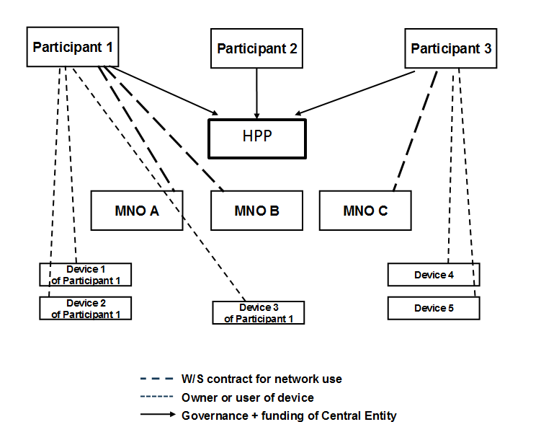
- Shared MNC Concept, technical and organisation/governance
(source: Gedeeld gebruik MNC’s voor M2M toepassingen,
Rapport uitgebracht aan het Ministerie van Economische Zaken, Stratix, 2013)
Notwithstanding the technical issues, governance is a key issue in setting up this type of arrangement. Participating partners will want their interests represented by the HPP and there is a distinct possibility of having diverging interests between different partners. As users are contractually bound to cooperate within this scheme, they will require assurances from the outset that their interests are taken into account.

emerging demand for MNC RESOURCES
The mobile value chain is evolving and new business models are driving demand for additional MNC resources. In order to illustrate this trend, the following chapter examines some traditional and emerging business models. The need for a unique MNC for each business model is examined and various options are proposed. An analysis of the proposed options is then discussed in Chapter 7.

The traditional mobile value chain
Figure 4 provides an overview of traditional business models.
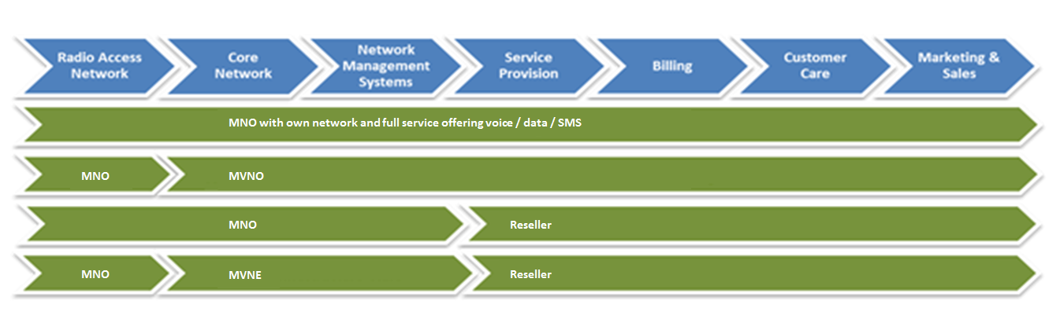
- The traditional mobile value chain

The Mobile Network Operator
The original business model for mobile has an operator with its own radio frequency allocation, a radio access network (RAN), a core network, network management systems and the infrastructure and resources to provide a retail offering to customers. In this model, an IMSI is used to identify and authenticate subscribers for network access. In a roaming situation, the IMSI allows the home network to identify the country and network of a visiting subscriber and bilateral roaming agreements will be in place with foreign networks to facilitate communications services and billing.
As LTE/4G network deployments continue, there is an emerging trend of infrastructure sharing. This entails two or more MNOs setting up a joint venture to roll out RANs. This collaborative approach is considered to be a cost effective options to providing the widest possible geographic coverage while making the most efficient use of radio spectrum. These entities (infrastructure/network sharing providers) may also have a requirement for MNCs to identify these new networks and in some countries, such as Sweden, MNCs have been assigned for these types of joint ventures.
The assignment of a MNC to a MNO or a joint venture between MNOs for infrastructure sharing in the same country is not violating the assignment criteria in the E.212 recommendation.
For some services, especially M2M services, MNOs are entering into agreements with large companies to provide communications connectivity for M2M devices on a global scale using national resources to generate the necessary IMSI ranges. This approach is described in Section 4.7.1 and 6.2.2 and is an area that the ECC has identified for further study.

MVNOs
The Mobile Virtual Network Operator (MVNO) provides a service to customers but does not have its own RAN. The mobile value chain (Figure 4) describes a number of elements from radio spectrum allocations to sales and marketing activities and MVNOs will typically only have the capacity to fulfil some of these elements.
An MVNO can be defined as an operator with a minimum set of core network infrastructure such as a Mobile Switching Centre (MSC), Home Local Register (HLR) or Authentication Centre (AUC) or a combination of some of these elements. MVNOs enter into agreements with MNOs to provide services to customers using the RAN of the underlying MNO. A MVNO will typically have a dedicated MNC and the ability to generate an IMSI range and SIM cards. Assigning the MNC directly to the MVNO (rather than to the underlying MNO) provides a level of independence for the MVNO. With its own IMSI range it is possible that an MVNO could choose to change its underlying MNO without having to change the SIM cards in the devices of all its customers. This approach enables greater competition within the wholesale mobile communications market. The allocation of a MNC to a MVNO is clearly in line with the E.212 assignment criteria.

Resellers
Resellers do not have network infrastructure and may not even have billing or customer care facilities. Network capacity, SIM cards, network management, billing and customer care (or a subset of these services) is normally sourced from the underlying MNO thereby allowing the Reseller to focus on generating and increasing its customer base through sales and marketing activities. As Resellers do not have any network infrastructure, MNCs are not normally assigned.

Mobile Virtual Network Enabler (MVNE)
A MVNE is a facilitator that enables an entity to gain MVNO functionality. An MVNE is characterised by having some network operation facilities and no retail customers. The assignment of MNCs to MVNEs has been considered to be in line with the ITU-T Recommendation E.212 by several CEPT countries given the different interpretations of the concept of providing a public communication service.

Conclusion on the traditional mobile value chain
Based on the available capacity of MCCs and MNCs, there are sufficient E.212 resources available to cater for the needs of these traditional market players as concluded in Section 4.6. However, as demand for MNCs increases due to evolving business models, then a review of the assignment criteria and planning for additional capacity in the future is required. The next section examines those evolving business models.

Emerging Business Models
The examples given in this section of the report are not exhaustive.

M2M Business Models
According to Recommendation ECC/REC/(11)03 on “Numbering and Addressing for Machine-To-Machine (M2M) Communications”, M2M is a communication technology where information can be transferred in an automated way with little or no human interaction between devices and applications.
Machine-To-Machine (M2M) communications offer promising opportunities for new and existing market players and the M2M supply chain may vary depending on the nature of the service, the size of the M2M customer (i.e. number of M2M devices) and whether services are provided on a national or global basis. For illustrative purposes we use three examples where E.212 resources are required and where the MNC assignment may be made directly to the end customer, to a specialist intermediary or using the existing MNC and IMSI resources of the underlying mobile network operator.

M2M customers (with own MNC assignment)
It should be noted that some M2M applications may use other types of addressing resources such as IPv6 addresses. However, for those M2M applications where there will be many devices deployed over a wide geographic area, access to a mobile network will be required for reliable communications. Some of these services will require mobility and roaming while others will need to use the mobile network as adequate fixed network infrastructure may not be available (e.g. utility smart metering in rural areas). It is possible for these types of M2M services to be provided by a MNO. However, competition in the market may be hindered if barriers to switching service provider are introduced. One way of preventing this type of operator lock-in is to assign MNCs directly to the M2M customer so that they have their own IMSI range for addressing devices. This point is illustrated using the examples of smart metering and eCall below.
Smart Metering
A utility company may deploy millions of smart meters at customer premises over a wide geographic area. If the utility company wishes to move to a new MNO on better commercial terms or for improved network coverage it would need to swap out the SIM card in each of its millions of meters. Visiting each meter would be cost prohibitive and logistically impracticable. Therefore a network “lock-in” effect is introduced which could have a distortive effect on competition in the market. If the utility company has its own MNC and unique IMSI range then the barrier to switching could be reduced as changes to network systems could be made to facilitate the change rather than through the physical replacement of SIM cards.
Communications for smart metering is essential to facilitate customer billing but it is also an integral component in the development of smart grids. In the future, communications with smart meters will become more critical and utility companies will demand uninterrupted communications by having network redundancy arrangements in place through national roaming agreements. By having its own MNC and unique IMSI range, the utility company could enter into national roaming agreements with all the available network operators to ensure uninterrupted communications. The social and economic benefits of smart metering and smart grids should be considered in assessing the need for MNCs for this purpose.
It should be noted that there are technical considerations related to the security mechanism of the mobile protocols that need to be resolved in the case the utility company doesn´t have its own registration/authentication platform (e.g. HLR, AUC) since, if this function is provided by another player (MNO or MVNE), the transfer of secret codes and security algorithms will be necessary to facilitate switching (see section 5.2).
eCall
eCall is a European initiative intended to bring rapid assistance to motorists involved in a collision anywhere in the European Union. It works using in-vehicle sensors which, when activated, automatically establish voice and data connections directly with the relevant Public Safety Answering Points (PSAPs). The European Commission is currently pursuing an initiative for mandatory deployment of an eCall system by in all new, type-approved cars and in all Member States. There is also a difference of opinion between stakeholders regarding the classification of eCall as an M2M service.
In theory, IMSI resources may not be technically required for services like eCall as the relevant standards provide an option to implement eCall without using SIM cards, including for callback, similar to the way that mobile phones without SIM cards can still make calls to the emergency services in countries where this is permitted. In practice, however, eCall devices will use IMSIs (for network registration in countries where calls to emergency services are not allowed without a SIM card) and moreover MSISDN/E.164 numbers (for emergency services call-back). Both the IMSI and the E.164 number will be statically assigned to an eCall subscription.
It is currently unclear which country’s resources will be used to address eCall devices. Car manufacturers would undoubtedly prefer to install the communications module at the point of manufacture in order to generate efficiencies and leverage economies of scale. If a Geographic MCC+MNC is used to generate the IMSIs for eCall then the same extra-territorial situation arises as described previously in Section 4.7.1.
Furthermore, the same problems described above in relation to smart metering (i.e. operator lock-in and network redundancy) also apply to eCall.
To eliminate the competition barriers associated with operator lock-in, to facilitate network fail-over and to avoid extra-territorial use of IMSI ranges for addressing purposes there is an argument for making MNCs available to large M2M customers as illustrated in the examples above for smart metering and eCall. For M2M services operating across borders, an international solution under a shared MCC would seem to be a more appropriate alternative option.
Possible Options for M2M customers:
- A shared national MNC for M2M customers;

- A unique national MNC for each M2M customer;

- A unique MNC under MCC 901 for each M2M customer that requires roaming or who operates in at least two different countries;

- A unique MNC under a new shared MCC 90X for these types of services.

Intermediate Specialised Service Providers for M2M (MVNO for M2M)
Intermediate Specialised Service Providers for M2M are essentially MVNOs but they specialize in the provision of M2M communications services to M2M customers only. The assignment of a MNC to a MVNO for M2M would be in line with the E.212 recommendation as the service would be publically available to M2M customers.
Possible Options for Intermediate Specialised Service Providers:
- A shared MNC for these types of services;

- A unique national MNC for each M2M MVNO;

- A unique MNC under MCC 901 for each M2M MVNO that requires roaming or who operates in at least two different countries;

- A unique MNC under a new shared MCC 90X for these types of services.

Global M2M services provided by MNOs using existing international roaming agreements
Mobile network operators have been quick to recognise, and are keen to exploit, the huge opportunity that global M2M services provides. The opportunity covers the automotive, healthcare, security, logistics and supply chain sectors of the economy amongst others. These types of services can be provided by relying on existing infrastructure and roaming agreements that are in place in over 200 countries and between over 700 operators around the world. The business model for these types of services is entirely different from the existing handset business. M2M is a high volume, low margin business and therefore the input costs are extremely sensitive.
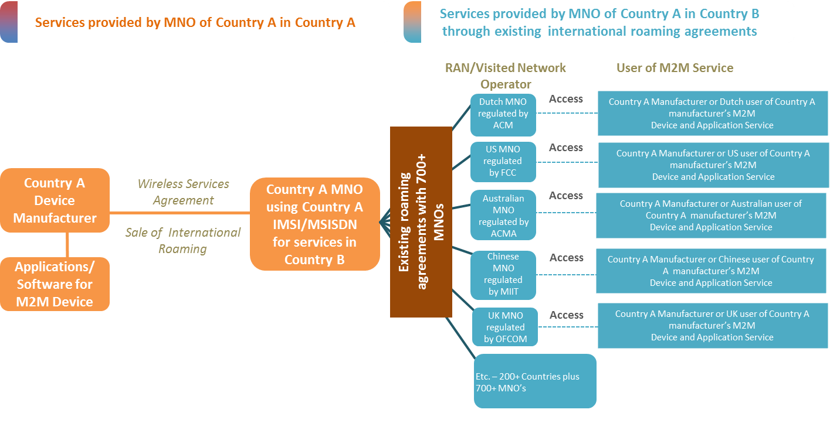
- Global M2M services provided using national E.212 numbering resources (Source: AT&T)
Figure 5 above illustrates this business model. If for example a car manufacturer in Country A enters into an agreement with a Mobile Network Operator in Country A to provide connectivity for its products on a global basis. The cars are then exported around the world and connectivity is provided using existing roaming agreements that are in place in 200+ countries and between 700+ operators. The advantage of this from the car manufacturer’s point of view is that they only need to have one commercial agreement in place in their home country for all vehicles manufactured and exported. The advantage for the Mobile Network Operators is the ability to provide additional services for M2M on top of existing roaming agreements. It also promotes efficient use of E.212 resources as there is no need to use additional MNCs for each destination country.
However, this approach does raise some questions from a numbering plan management perspective.
- Is this type of use in conformance with the existing ITU-T Recommendation E.212?
- Are there any other issues associated with this kind of extra-territorial use of E.212 numbers?
- If E.164 numbers from Country A are also used, is there a risk of exhausting certain numbering ranges in Country A?
- Can the E.164 numbers used in these devices be recovered for recycling?
- What are the implications for privacy, legal interception and access to emergency services?
Notwithstanding that these types of service are already available on the market it would seem to be more efficient to use an international shared resource such as an MNC under the shared MCC 901. This approach may not be preferred by all mobile network operators as new roaming agreements would need to be established. Given the scale involved (200+ countries and 700+ mobile networks) and the need for testing it would take a considerable amount of time and investment to implement a solution under a shared MCC 901. Nevertheless, some mobile network operators are pursuing this strategy and have been assigned an MNC under MCC 901 by the ITU-T. The implications of using a Geographic MCC+MNC for global services has been identified as an area for further study by the ECC.
Possible Options for Global M2M services provided using National E.212 numbering resources:
- Use geographic MCC+ MNCs already assigned to MNOs for services provided on a global basis;

- A unique MNC under shared MCC 901 for these types of services;

- A unique MNC under a new shared MCC 90X for these types of services.

Public Networks using pico or femto cells:
For 3G mobile networks the concept of “Home Node B” can be used for better coverage in the home or business environment. Small access points called femto cells are optimised for deployment in the home and are used to connect mobile devices to the mobile core network using a DSL or fibre connection for backhaul purposes.
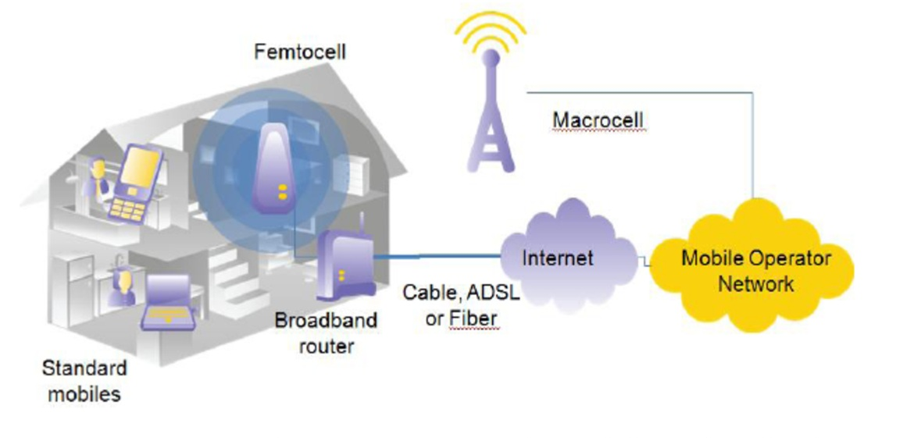
- Mobile Communications using femto cells (Source: Small Cell Forum)
For this use of femto cells, provided by the MNO, there might be a need for a separate PLMN ID (MCC+MNC) that is different from the PLMN ID used by macro cells in the network. As these types of supplementary networks are deployed, NRAs could receive applications from MNOs for additional MNCs for this purpose.
However, there may be an alternative method of identifying the supplementary network using the Location Area Code (LAC) as defined in the relevant GSM standards. PLMNs can be divided into locations where each location has a unique identifier known as the LAC. The LAC can be used to enable location updating of mobile terminals and consists of the MCC+MNC+16bit LAC number. The 16 bit LAC allows a maximum of 65,536 location areas to be defined within the same PLMN. Therefore the Home Node B network could be identified by using the LAC as an extension of an existing network rather than as a separate network which would require its own MNC.
Possible Options for public networks using pico or femto cells:
- An additional unique MNC per MNO to address all of its femto cell networks;

- Use of LAC to identify HomeNodeB network.

Private Networks using pico or femto cells:
A network, providing private cellular connectivity within the home or business could be connected to a public network (fixed line or VoIP for example) via an existing subscriber connection such as DSL or fibre. This example is similar to the public example described in the previous section and illustrated in Figure 6 except that the service provider is not the MNO. A subscriber to this service could, when in the home area, roam onto the private cellular network to make calls using a mobile handset with a mobile subscription. This is essentially roaming between the private cellular network and the public mobile network.
These types of private networks could become commonplace with the emergence of replacement technologies for Digital Enhanced Cordless Telecommunications (DECT). DECT phones are common with residential and business customers to achieve a level of mobility within the home or office environment. The availability of license exempt spectrum could act as a catalyst to realising this trend.
For the network to function correctly there may be a need to use MNCs to identify these private wireless networks in order to distinguish them from PLMNs. If all end users with private networks are assigned MNCs then available resources will very quickly become exhausted. Alternatively a shared MNC could be a feasible solution (where different networks are identified using the leading digits of the MSIN) but there is a risk that this shared MNC could clash with a valid MNC being used by another network operator unless the shared MNC is designated as a “public MNC for shared use” by the NRA.
For private network-internal communications, an MNC could be used that is not unique across different networks as long as roaming is never required. However, in order to have the flexibility to roam in the future it would be necessary to use a unique MNC for each private network.
Possible Options for Private Networks using pico or femto cells:
- A MNC designated for shared use by the NRA;

- Use of an IMSI range from an existing MNO;

- A unique MNC per private network;

- A unique MNC under a new shared MCC 90X for these types of services.

SMS Service Providers (SMS-SP)
Some NRAs have already been approached by SMS-SPs who provide SMS traffic for termination towards a mobile end user via a “signalling service provider”. In some cases the SMS-SP will need a MNC to make it possible for originating operators to terminate SMS traffic to SMS-SP end users over SS7. The MNC may also be needed for billing purposes.
These types of services allow end-users to send and receive SMS independently of their mobile subscription over a data (IP) connection which can be carried over Wi-Fi or mobile internet. Typical applications include the sending and receiving of SMS from connected devices (e.g. PC or smartphone) or providing bulk SMS from a business to its customers. Some versions of the service may be national-only, but most SMS-SPs offer services across borders.
The assignment criteria for MNCs may differ across CEPT countries. Therefore, a SMS-SP may not be assigned a MNC in all countries where it wishes to provide a service. As the majority of SMS-SPs typically operate internationally an international solution seems appropriate such as a MNC under MCC 901 or another new global MCC. This would be a more efficient use of numbering resources as a single global MNC would be preferred over many national level MNC assignments. However, the existing assignment criteria for MNCs under MCC 901 require that the applicant must demonstrate that its international network infrastructure will contain connecting physical nodes in two or more countries. This is not always the case nor is it needed for these types of services. If a MNC under MCC 901 is not possible then the ITU should consider a new MCC from which it could assign MNCs for this type of service. Sweden has already made a contribution (COM 2 C 4) to the ITU-T for a new MCC 902 for these types of services with a suggestion for a new Annex G to Recommendation E.212 for assignment criteria for international mobile messaging services.
Possible Options for SMS-SPs:
- Assignment of a MNC under MCC 901;

- A new MCC 90X for these types of services.

Independent Roaming Service Providers/ Alternative Roaming Provider (ARP)
In 2013, BEREC held a public consultation, on the draft BEREC Guidelines in relation to regulated retail roaming services under Article 4 and 5 of the Roaming Regulation. Decoupling measure obligations are defined in articles 4 and 5 of the EC proposal for a regulation on roaming on public mobile communications networks within the EU. As stated in these articles, home network providers shall enable their subscribers to access regulated voice, SMS and data roaming services of any interconnected Alternative Roaming Provider (ARP) from 1 July 2014.
The EC, after obtaining an Opinion from BEREC and taking account of the views of the EU Member States expressed in COCOM has a responsibility to prepare an “Implementing Act” which sets out more explicitly than the Regulation the detailed rules and specific technical solutions that would meet the criteria defined in the regulation.
If there are new ARPs entering the market there may be a need for the assignment of additional MNCs and given the international context, an international solution would appear to be the most pragmatic solution in this case. VoIP based voice-roaming may be offered too. In this case the provider does not need an IMSI for the roaming subscriber but an MNC will probably be needed for concluding the necessary roaming agreements especially if the provider of voice-roaming is able to offer data-roaming as well. This may become a commercially interesting business model with many providers.
Possible Options for Independent Roaming Service Providers:
- Assignment of a MNC under MCC 901;

- A new MCC 90X for these types of services.

Analysis of proposed options
This chapter analyses the administrative and technical solutions identified in this report.

Technical Options
A summary of the proposed technical options for each emerging business model identified in Chapter 6 is contained in the Table below:
- Summary of Technical Options
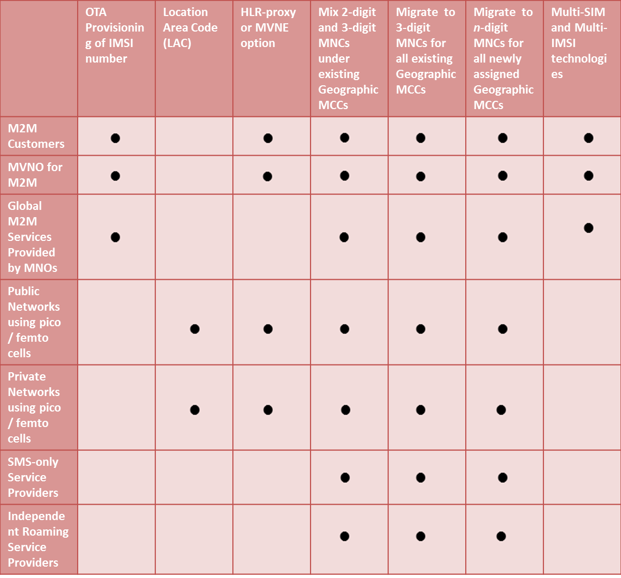

Over-The-Air (OTA) Provisioning
OTA provisioning of IMSI numbers would appear to be an option for reducing demand for MNCs for all mobile services, not just M2M services, as OTA enables switching without replacement of SIM cards, the issue of operator lock-in is addressed. Resolving the security issues associated with OTA should therefore be a priority for standards bodies.

Location Area Code (LAC)
As already described in Section 6.2.3, PLMNs can be divided into locations where each location has a unique identifier known as the LAC. The LAC can be used to enable location updating of mobile terminals and consists of the MCC+MNC+16bit LAC number. The 16 bit LAC allows a maximum of 65,536 location areas to be defined within the same PLMN.
The use of LACs to identify supplementary networks of existing PLMNs could provide a possible solution to addressing femto cell and pico cell networks without the need for additional MNC resources. If this solution can be implemented, there will be no need for additional MNCs to address these supplementary networks.

HLR-proxy or MVNE option
This approach, currently being considered in the Netherlands, would appear to be a viable solution to facilitate the needs of multiple market players using the same MNC. If implemented successfully this approach is an efficient use of MNC resources from a technical perspective.
However, the challenge associated with putting appropriate governance structures in place for such an approach cannot be underestimated given that the possible diverging interests of the participating parties. The needs, interests and requirements of each participating party must be clearly defined at the outset and the responsibilities and obligations of each participating party must also be clearly set out in formal contracts.

Extend existing 2-digit or 3-digit MNCs to n-digit MNCs
Mixing 2-digit and 3-digit MNCs or migrating from 2-digit to 3-digit MNCs under the same MCC is discussed in Chapter 4. The benefits of these approaches are that there is the prospect of maximising capacity under already allocated MCCs without the need for amending the existing E.212 Recommendation.
In the longer term, ITU-T should study the feasibility of amending ITU-T Rec. E.212 so that all newly assigned MCCs operate on n-digit MNCs only, with n being greater than 3. This would increase the number of operators that can receive MNCs by 10^ (n-2). Such an approach would require a fundamental change to the current IMSI concept and is proposed here as a long term solution as the implementation of n-digit MNCs would be very disruptive on existing networks.

Multi-SIM and Multi-IMSI technologies
When compared with OTA provisioning, Multi-SIM and multi-IMSI technologies only provide a limited solution to the problems of operator lock-in and facilitating network redundancy. If the device can be programmed with, for example, 5 IMSI numbers, then the user may be able to switch services between 5 operators. The ability to move services to a new market entrant can only be facilitated by physically changing the SIM card. In the M2M environment, there will also be an additional per unit cost to have multi-SIM or multi-IMSI capability. The additional costs may make this an unattractive option for M2M.
Another major drawback of these types of technologies is that they use IMSI resources inefficiently with only one IMSI being active at any one time.

Administrative Options
A summary of the proposed administrative options for each emerging business model identified in Chapter 6 is contained in the Table below:
- Summary of Administrative Options
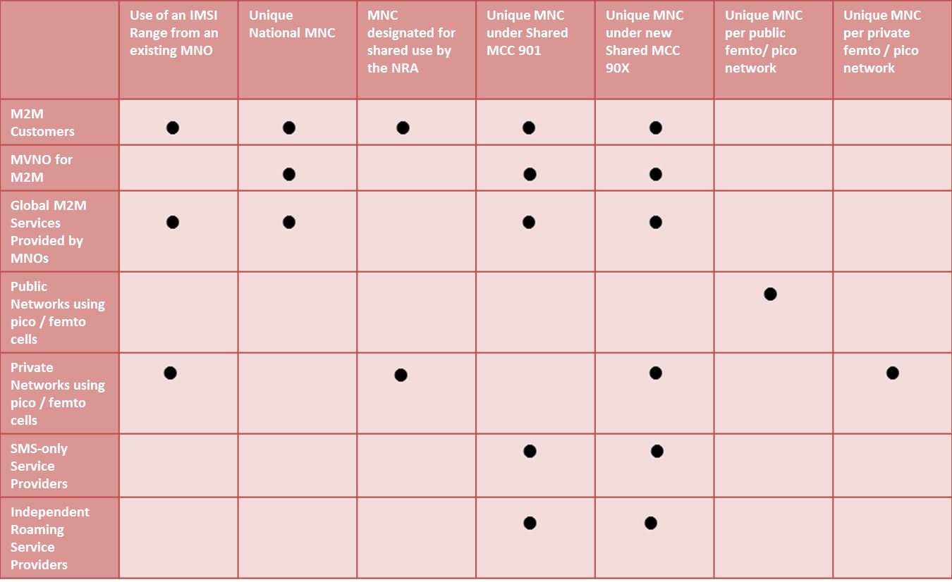

Use of an IMSI range from an existing MNO
This solution works very well for Resellers and would also be suitable for M2M customers with a limited number of M2M devices. However it is not considered to be an appropriate solution for large scale M2M deployments as there is a risk of operator lock-in and network redundancy is limited in terms of its flexibility to any agreements the MNO has with other MNOs.

Assignment of a unique national MNC
The current version of ITU-T Rec. E.212 only allows MNCs to be assigned to, and used by, public networks offering public telecommunication services. In Section 4.6 of this report, a contribution to ITU-T SG2 is introduced which concludes that there is sufficient capacity within the current E.212 framework to cater for future demand even if the assignment criteria are made “reasonably” more flexible. However, if the assignment criteria were relaxed to such an extent so as to provide MNCs for many different emerging business models the remaining capacity could very quickly become exhausted. If capacity in an existing MCC runs out (i.e. more than 80 % of MNCs assigned), it would be possible for the country to apply to the ITU TSB for an additional geographic MCC.
There are no identified drawbacks to this solution other than that the available stock of MCCs administered by the ITU is also finite. If the ITU decided to adopt this solution it should investigate the feasibility of only 3-digit MNCs for all future assignments of MCCs in order to conserve capacity further. The ITU could also consider a revision of Rec. E.212 to move to n digit MNCs (where n > 3). If the transition phase is well planned and long enough the additional costs to adapt the operational systems are expected to be reasonably low.

A MNC dedicated for shared use
The shared use of an MNC is in accordance with Annex D of ITU-T Rec. E.212. Using this approach the NRA would designate an MNC for use by multiple networks. The distinction between these networks would be made through analysis of the leading digits of the MSIN. While this approach could lead to a more efficient use of the entire IMSI range there are technical and management issues to consider.
From a technical perspective, an MNC is essentially used to identify a network and the network will broadcast the MCC+MNC so that mobile terminals can connect to it. Which network would the shared MNC identify? If multiple networks, whether public or private, broadcast the same MCC+MNC then a device from service provider A may try to connect to the network of service provider B (with the same MCC+MNC). Authentication to the network would fail and upon rejection, the device may not try to connect to network A anymore. Therefore, the “shared MNC” should never be broadcast by multiple networks using the same MCC+MNC combination because of the widespread disruption this could cause.
From a management perspective, there would be an additional administrative burden for the NRA to set assignment criteria and to manage the assignment of the MSIN ranges. This solution does not appear to be practicable and guidance should be sought from the ITU on how it envisages the sharing of MNC resources in practice in accordance with Annex D of ITU-T Rec. E.212.

A unique MNC under MCC 901
This report identifies several emerging business models where services are offered to customers in more than one country by a single provider. In this case an international solution would be much more appropriate such as an MNC under the shared MCC 901.

A new shared MCC 90X for M2M, and SMS-SPs
A new MCC 90X would provide a viable solution to providing MNCs for these types of services. All of these applications could operate across borders. One international MNC per operator appears to be more efficient than many national level allocations. If an additional shared MCC was made available by the ITU, the assignment criteria should be flexible enough to cater for the emerging business models discussed in this report. ITU-T SG2 is currently considering the need for a new shared MCC 90X for SMS-SPs.

A unique MNC per public femto/pico cell network
This solution requires the assignment of an additional MNC to every MNO deploying supplementary networks using femto/pico cell technology. The supplementary network is essentially an extension of an existing network but if an MNC is required then NRAs are likely to assign additional MNCs as the eligibility criteria will be met.
Similarly, MNOs sharing infrastructure (infrastructure sharing on rollout of 4G networks) may also have a requirement for MNCs to identify these new networks and the eligibility criteria for an additional MNC would also be met.
As already described in Section 7.1.2 the use of LACs could provide a technical solution that would mitigate the need for additional MNC assignments in such cases.

MNCs for private femto/pico cell networks
This is simply not a feasible option as there may be potentially thousands of private networks and there are not enough MNCs available. An alternative approach might be to use a shared MNC but this requires further study as it may not be technically possible as only one SIM card with a specific MNC and IMSI subscriber number can be authorized to the public network at one time, creating possible technical exclusion of users of other private networks than the authorized user of the private network.

Conclusions

The ECC concludes that:
- Multi-IMSI and multi-SIM appears not to be a viable solution to negating the impact of operator lock-in as without physically changing the SIM-card the IMSI can only be changed between predefined values. It is a static solution and due to the need for multiple IMSIs in each device it is not considered an efficient use of E.212 resources.
- Secure solutions for remote provisioning of IMSIs appear to be an option in the near future and should therefore be implemented in a non-discriminatory way as soon as possible for all mobile services.
- CEPT countries should review the assignment criteria for E.212 Mobile Network Codes (MNC’s) and consider introducing more flexibility regarding the assignment of MNCs for:
  - Traditional market players such as MVNOs, MVNEs and Resellers; and
  - Emerging business models such as M2M service providers and SMS Service Providers.
- The ECC should further analyse the possibilities of harmonizing the assignment criteria of E.212 MNCs in CEPT countries and if appropriate develop an ECC Recommendation.
- The ECC should further analyse the concepts of roaming and extra-territorial use of E.212 resources to examine the implications of such use on national numbering plan management.
- For private networks (e.g. using pico and femto cell technology), where roaming is not required, the preferred solution might be to allocate one or more MNCs for shared use but this requires further study.
- The use of an E.212 MNC of which MSIN ranges are assigned to different private networks (i.e. HLR Proxy Solution described in section 5.4) is considered to be an efficient use of MNC resources.

The ECC would encourage the ITU-T to:
- Consider introducing shared MCCs (i.e. 90X) to provide MNCs for emerging business models such as M2M service providers and SMS service providers.
- To amend the relevant Annexes to E.212 to explicitly allow the assignment of MNCs to cater for the needs of market players as mentioned in this Report other than “public networks offering public telecommunication services” as described in Annex B of E.212.
- Provide further clarification on how it envisages the mixing of 2-digit and 3-digit MNCs under already-assigned Geographic MCCs.
- Consider mandating the use of 3-digit E.212 MNCs only in all newly assigned geographic MCCs in order to conserve existing capacity.
- Consider the possibility of amending ITU-T Rec. E.212 to allow for n-digit MNCs (with n>3) to accommodate future demand for MNCs. A long term plan within a clear timeframe should be developed in order to minimise the cost of implementation.
- Provide clarification on how it envisages the implementation of national MNCs for shared use as described Annex D of E.212.

- Different approaches to MNC allocations in CEPT countries
This section provides a brief summary of the assignment criteria for MNCs in some CEPT countries (as at 9 April 2014).
  - Belgium
MNCs are only assigned to MNOs and MVNOs who can demonstrate that they have their own network infrastructure and have a justifiable need for their own MNC. One exception is GSM-R. To date, 6/7 MNCs have been assigned. In Belgium, 2-digit MNCs are used.
  - Denmark
MNOs, MVNOs and service providers may apply for an assignment of a MNC. An MNC has also been assigned for GSM-R. To date 19 MNCs have been assigned. In Denmark, 2-digit MNCs are used.
  - France
MNCs are assigned to MNOs and MVNOs (full and light). One exception is GSM-R. Up to now, 45 MNC have been assigned in France (including overseas department). In France, 2 digits MNCs are used.
  - Germany
MNCs are only assigned to MNOs with radio frequency spectrum assignments. Mobile Virtual Network Operators obtain their IMSI ranges from their underlying MNO. A review of the rules may be conducted in the future. There is one exception to the assignment criteria where manufacturers of network and CPE equipment may apply to the NRA for an assignment of a MNC for equipment testing purposes. Presently, there are 23 MNCs assigned. In Germany, 2-digit MNCs are used.
  - Ireland
MNOs, MVNOs (with control over infrastructure), fixed line SMS providers and GSM-R operators have been assigned MNCs. In addition, a MNC has been allocated to the incumbent operator for the provision of a fixed cellular service. This service is available to those in very remote areas where providing physical fixed line access is cost prohibitive. This MNC was assigned to ensure that the requirements of the Universal Service Directive were met. To date, 14 MNCs have been assigned. In Ireland, 2-digit MNCs are used.
  - Italy
On the basis of the national numbering plan, MNC codes can be assigned to subjects that provide mobile and personal services, including specialized type (e.g. GSM-R) or satellite, fixed services also integrated with mobile, as well as to mobile virtual network operators. It is to be noted that the mobile virtual operators are not classified on the basis of their infrastructures: i.e. there is no difference in rights depending on their infrastructure or agreements. In general, the subject requesting a number or a code (including MNC) could be requested to show that the asking number or code is useful for providing its electronic communication service.
MNC codes are useful also for mobile virtual network operators without infrastructure. In fact, at present, if they want to evolve to become an MVNO with infrastructure, they should change all the SIMs of their clients.
Until now no MNC has been assigned to fixed network operator.
A total of 14 MNCs are assigned:
- MNO: Telecom Italia (3), Vodafone(2), Wind, H3G ;
- Satellite: Intermatica, Telespazio;
- GSM-R: Ferrovie dello stato;
- Mobile virtual operators: Noverca, Lycamobile, BT Italia, Poste Mobile S.p.A.

In Italy, 2-digit MNCs are used.
  - Latvia
Only MNOs are eligible to receive an allocation of a MNC. To date, 8 MNCs have been assigned. In Latvia, 2-digit MNCs are used.
  - Lithuania
Only MNOs with radio frequency spectrum allocations are eligible to receive a MNC. A MNC has also been assigned for GSM-R. To date, 5 MNCs have been assigned. In Lithuania, 2-digit MNCs are used.
  - Malta
In Malta, the MNC assignment criteria specify that operators have to operate and to provide a service within the Maltese territory. The MCA currently only assigns MNCs to MNO and MVNOs and each request for an MNC is analysed on a case by case basis. The MCA does not envisage exhaustion of the MNC range assigned for Malta in the near future.
  - Norway
MNOs and MVNOs may apply for a MNC. There are some exceptions with one allocation for GSM for Railway (GSM-R) and a temporary assignment of another MNC to a private network. This latter assignment is a temporary allocation for a trial period which expires in 2014. In Norway, 2-digit MNCs are used. 11 MNCs have been assigned in Norway.
  - Portugal
MNOs and MVNOs may apply for a MNC if they are offering public telecommunication services over public networks. There is an exception with one allocation for GSM for Railway (GSM-R). NOs (e.g. fixed operators) offering services based on the mobile standards and interoperability of the service to end-users (e.g. SMS) may also apply for MNC. It was allocated a second MNC to a MNO in order to serve a large utility company that uses a M2M service over mobile networks. There are until now 11 MNC allocated (4 MNO, 4 MVNO, 1 GSM-R, 1 SMS Service Provider and 1 fixed operator).
  - Romania
MNOs and MVNOs with infrastructure may apply for an assignment of a MNC. We had also two cases of assignment of MNCs to fixed operators for certain services in “fixed networks emulating applications of the cellular mobile networks such as SMS or TEXT messaging” conf. pt. F.3/Annex F of ITU-t Rec. 212. One MNC was reserved for GSM-R application. To date, 12 MNCs have been assigned. In Romania, 2-digit MNCs are used.
  - SPAIN
MNOs and MVNOs with infrastructure (full MVNO) may apply for a MNC. Recently, 3 MNCs have been allocated to fixed networks emulating applications of the cellular mobile networks (SMS services) or to facilitate authentication and verification of a user request for service. To date, 29 MNCs have been assigned. In Spain, 2-digit MNCs are used.
  - Sweden
MNOs, MVNOs, MVNEs, SMS service providers, M2M service providers and infrastructure/network sharing providers have been assigned MNCs. MNCs have also been assigned to one GSM-R provider. To date (2014-01-29), 38 MNCs have been assigned. In Sweden, 2-digit MNCs are used.
There are also 5 MNCs allocated for specific use. These MNCs are not assigned to any provider and a shared use is applicable. The specific usage is the following:
- Allocated for shared use for closed networks (2 MNCs allocated – e.g. for DECT-replacement);
- Allocated for shared use for test purpose (2 MNCs allocated);
- Allocated for crisis management after determination by the NRA.
  - Switzerland
In Switzerland, 3 categories of applicant are defined.
- MNOs including GSM-R;
- MVNOs with an agreement with a national MNO to use the radio access network to provide mobile services;
- SMS brokers and fixed line SMS.

First two categories are also eligible for E.164 numbers. The third category is not. To date, approximately 12 MNCs have been assigned. In Switzerland, 2-digit MNCs are used.
  - The Netherlands
MNOs, MVNOs (with HLR), GSM-R, fixed SMS providers and the Ministry of Defence all have MNC assignments. Local private wireless networks (i.e. where a public operator creates and builds a local private network) are also eligible where unlicensed radio frequency spectrum is used. In this scenario, a MNC is allocated to a private network offering public network services to third parties. To date, 3/4 MNCs have been assigned to this last group and 30 MNCs have been assigned in total. In The Netherlands, 2-digit MNCs are used.
  - United Kingdom
MNCs may be allocated to applicants who:
- Operate a communications network that supports mobility.
- Have an agreement with an existing MNO to offer services over the MNO’s radio access network.
- Have a minimum level of network infrastructure.

MNCs have also been allocated to service providers using the DECT guard band. The UK has two MCCs. 48 MNCs have been allocated under the first MCC assignment and 8 MNCs have been allocated under the second MCC assignment. In the UK, 2-digit MNCs are used.

ITU-T Recommendation E.212: The international identification plan for public networks and subscriptions (May 2008)
Although it should be noted that there are already SIM cards available in the market which can be programmed with multiple IMSI numbers – Multi-IMSI SIM cards.
https://www.itu.int/net/itu-t/inrdb/secured/e212mcc.aspx (Note: it is necessary to have a TIES account)
https://www.itu.int/net/itu-t/inrdb/secured/e212mnc.aspx (Note: It is necessary to have a TIES account)
http://www.itu.int/ITU-T/wtsa/resolutions04/Res20E.pdf
For more information see TSB Circular 285, Possibility of parallel usage of 2 and 3 digit E.212 Mobile Network Codes (MNCs) under one geographic Mobile Country Code (MCC).
ITU-T SG2 contribution number COM-C2 “Status of E.212 Assignments – August 2012” (contributed by France Télécom Orange)
It should be noted that already 40% of this shared MCC is assigned.
www.itu.int/rec/dologin_pub.asp?lang=e&id=T-REC-E.214-200502-I!!PDF-E&type=items
ETSI TS 184 002 V1.1.1 (2006-10) Telecommunications and Internet converged Services and Protocols for Advanced Networking (TISPAN) Identifiers (IDs) for NGN
3GPP TS 23.003
www.gsma.com/connectedliving/embedded-sim
We assume in this Report that eCall is classed as an M2M service.
On the basis of 3GPP TS23.271, Paragraph 6.4.3
This was confirmed to the ECC by correspondence with HeERO and GSMA in January 2014.
3GPP TS 23.003 Numbering, addressing and identification, clause 12.1.
3GPP TR 25.820 3G Home NodeB Study Item Technical Report (Release 8), clause 6.1.5.
http://www.etsi.org/index.php/technologies-clusters/technologies/mobile/gsm
If a public mobile network and a private mobile network were broadcasting the same MCC+MNC combination then this could cause problems mainly for the users of the public mobile network if their mobile terminals attempted to connect to the private network.
http://www.itu.int/md/T13-SG02-C-0004/en (A TIES account is required)
BoR (13)53 - BEREC Guidelines on the Separate Sale of Regulated Retail Roaming Services and the Implementation of Separate Sale of Regulated Retail Roaming Services under Article 4 and 5 of the Roaming Regulation – A Consultation
BoR (13)54 - International Roaming Regulation BEREC Guidelines on Roaming Regulation (EU) No 531/2012 (Third Roaming Regulation) (Articles 4 & 5 on Separate Sale of Roaming Services)
http://ec.europa.eu/information_society/activities/roaming/docs/roaming_recast11.pdf

